MINISTRY OF TRANSPORT & INFRASTRUCTURE (MT&I)
SECRETARIAT-GENERAL FOR INFRASTRUCTURE
DIRECTORATE-GENERAL FOR TRANSPORT INFRASTRUCTURE
DIRECTORATE FOR ROAD INFRASTRUCTURE (DRI)

Road Project Design Instructions
(RPDI)

Road Safety Barriers
(RPDI – RSB)

Volume 1
Vehicle restraint systems – railings

May 2021

Working group: “Vehicle Restraint Systems”
2010 Version
Kasappi Eva, P.M. Head of DMEO/e/SGDE/MYMEDI, Chair Drimalitou Despina, ATM Transport specialist, member
Nikolaidou Charikleia, E.M., STUDIES OF CONSTRUCTION PROJECTS OF THE CONCESSIONS ATTIKI AND IONIA ODOSSGDE/PYMEDI, member

On the basis of Decision ΔΜΕΟ/οικ/5309/ε/917/14.10.2010.

In addition, in order to develop instructions for vehicle restraint systems, the following have been working together in another working group from 2003 to 2004, in order to bring them into line with the European standard ELOT EN 1317:
Vagias Ioannis, Professor of NTUA, member
Gonides Irene, P.M. D3/SGDE, member
Drymalitou Despina, A.T.M. Transport specialist, member
Zacharias Georgios, A.T.M. D3/SGDE, member
Karaiskos Evangelia, P.M. EYDE/PATHE/SGDE, member
Pooriotis Nikolaos, P.M. Transport specialist, member
Sakki Maria, P.M. Transport specialist, member
Tsigros Georgios, P.M. DESC Director of the Region of Central Macedonia, chair

On the basis of Decision Δ1α/ο/14/26/19.4.2003 within the Special Committee on the Processing of Trans-European Network Matters.

Furthermore, account was taken of the instructions concerning the Vehicle Restraint Systems for Concession Projects, which were drawn up by NAMA S.A. in the framework of its contract of the Traffic Adviser of the EYDE/OAP.

Working group: “Vehicle Restraint Systems – railings” – Volume 1

2021 Version
Dimitrakopoulos Nikolaos, P.M. with A.B., Head of the Directorate for Road Infrastructure.
Hatzidakis Antonios, Double. Civil Engineer NTUA, Transport specialist
Vasileios Psarianos, Professor at the National Technical University of Athens

Members of the Committee:
Dimitrakopoulos Nikolaos, P.M. with A.B. representative of the Directorate for Road Infrastructures, Coordinator of the Working Group
Anagnostopoulou Aristea, P.M. with A.B. – representative of the Directorate for Fixed Wheel Infrastructure, member
Fournarou Catherine, P.M. with A.B. – representative of the Directorate for Quality and Standardisation, member
Houliaras Generalula, P.M. with A.B. – representative of the Directorate for the Operation, Maintenance and Exploitation of Transport Infrastructures under a Concession Agreement, Member
Sigalas Ioannis, P.M., Designer, President of the Greek Department of the IASSE, member

Introduction

The instructions on Road Safety Barriers (RPDI-RSB), 2021 Edition, refer to vehicle restraint systems (vehicle safety barriers) and railings and replace the existing instructions on barriers, RPDI-RSB, Edition 2010.

The application of standard EN 1317 which refers exclusively to safety barriers, after its approval and adoption by ELOT, becomes mandatory in Greece as regards its harmonised parts, in accordance with Greece’s commitments as a member of the European Committee for Standardisation (CEN). The Directive resulting from the Technical Report of the competent CEN Committee shall apply to railings: CEN/TR 16949:2016.

The most harmonised national instructions on passive road protection concern vehicle restraint systems (safety barriers) and in particular the general requirements to be met by them and the criteria for their application in accordance with the European standard ELOT EN 1317. In particular, these

- indicate the criteria by which it is decided whether the installation of a vehicle restraint system is required on the side of the road,
- identify and categorise lateral obstacles and hazardous positions according to whether their existence poses a risk to third parties or only to occupants;
- reference the selection criteria of the minimum required performance classes according to ELOT EN 1317, i.e., restraint capacity, operational width, vehicle intrusion and impact severity independently of design, materials and dimensions of the restraint system and
- the criteria for determining the minimum length of application of safety barriers shall be indicated.

This will allow the characteristics of vehicle restraint systems to be selected according to the requirements of the road sections, taking into account traffic safety, functionality and economy.

According to ELOT EN 1317, the selection and design of passive safety systems is based on the knowledge of their actual operation and behaviour characteristics on impact with them. These characteristics or other performance classes must be demonstrated by the relevant certificates.

The suitability of a system shall be demonstrated by a certificate of stability performance (formerly compliance) by a certification body (notified body) and the system file by ELOT EN 1317 and possibly additional relevant certificates or confirmations, as defined by decisions of the Ministry of Infrastructure and Transport, which must always be requested from the competent bodies when procuring safety systems.

Therefore, the new systems installed in road projects must be certified and have passed the tests provided for in the ELOT EN 1317 standard or possibly satisfy the relevant additional or other technical requirements, set by the Ministry of Transport and Infrastructure which bears the sole responsibility for the safety of Greek road users. The criteria in this regard are road safety, technical excellence and economy when choosing the appropriate road safety system.

The instructions and Technical Specifications relating to road restraint systems must comply with the legislation on free and non-discriminatory competition, so as not to impede free competition and the movement of goods in a Member State of the EU, provided that vehicle restraint systems comply with the ELOT EN 1317 standard.
Goods lawfully marketed in another Member State of the European Union or in Turkey, or originating in and lawfully disposed of in the Contracting Parties to the EEA Agreement, shall be deemed to be compatible with these regulations. The application of those regulations is subject to Regulation (EU) 2019/515 of 19 March 2019 on the mutual recognition of goods lawfully marketed in another Member State.

All the Volumes relating to the instructions and Technical Specifications relating to road restraint systems are set forth in the table below.

S/n | Type | No. Volume | Title
1 | Road safety barriers  (RPDI-RSB) | Volume 1 | instructions for road construction projects  Vehicle Restraint Systems – railings
2 | Road safety barriers  (RPDI-RSB) | Volume 2 | Instructions for the installation and repair of vehicle restraint systems
3 | Road safety barriers  (RPDI-RSB) | Volume 3 | Instructions for receipt and control of barrier assemblies
4 | CONDITIONS  Issuing a declaration of performance of concrete safety barriers (CSBs) | Volume 4 | Instructions for application on site of cast concrete safety barriers
5 | Instructions for the implementation of special safety studies against roadside barriers on interurban roads with a single carriageway | Volume 5 | Special instructions for the application of road safety barriers for protection against trees and other roadside barriers on interurban roads with a single carriageway

Contents

Introduction 3
Contents 5
1. Types of restraint systems 12
2. Definitions 13
3. Performance classes of restraint systems 16
3.1. General 16
3.2. Safety barriers 17
3.3. Safety barriers start and end terminations 18
3.4. Safety barrier assemblies 19
3.5. Impact Energy Absorption Systems (IEAS) 19
3.6. Configuration of the surroundings of vehicle restraint systems 20
3.7. Additional structures 21
3.8. Protection of cyclists and motorcyclists 21
4. Requirement for permanent safety barriers 22
4.1 General 22
4.2 Chance of diversion 23
4.3 Hazardous positions and risk classes in external boundary lines 24
4.4 Critical distances 25
5. Selection of performance classes of permanent safety barriers 29
5.1 General 29
5.2 Safety barriers on the outer carriageway boundary line 29
5.2.1 Restraining capacity 29
5.2.2 Operational width and vehicle intrusion 32
5.2.3 Impact severity 34
5.3 Safety barrier on retaining bridge and wall boundary lines 34
5.4 Safety barrier on the central and lateral separator islets 37
5.4.1 General 37
5.4.2 Restraining capacity 39
5.4.3 Operational width 40
5.4.4 Impact severity 42
5.5 Safety barrier in wall and tunnel front areas 44
6. Procedure for selecting the performance classes of permanent safety barriers 45
7. Lengths of application of safety barriers 47
7.1 Lengths on the outer carriageway boundary line 47
7.2 Lengths on bridge and retaining wall boundaries 53
8. Temporary (portable) safety barriers 58
8.1 General 58
8.2 Restraining capacity 58
8.3 Operational width 60
8.4 Passive protection 62
9. Breaks in safety barriers 62
10. Safety barriers start and end terminations 65
11. Technical criteria for selecting vehicle restraint systems 67
11.1 General 67
11.2 Technical criteria for selecting safety barriers 68
11.3 Additional requirements for technical elements of safety barriers 71
11.4 Requirements for IEASs 74
11.5 Requirements for barrier assemblies 74
11.6 Requirements for barrier terminations 75
11.7 Additional requirements in project notices 75
11.8 Safety studies 76
Annex 1 79
Annex 2 79
Annex 3 81
Annex 4 90
Annex 5 94
Annex 6 96
Annex 7 97
Annex 8 85
Annex 9 86
Annex 10 88
Annex 11 89
Annex 12 90

Types of restraint systems
‘Vehicle Restraint Systems’ means passive safety systems fulfilling the requirements of European standard ELOT EN 1317. The types of vehicle restraint systems are shown in Figure 1.
Impact Energy Absorption Systems (IEAS)

Temporary safety barriers

Assemblies

Barrier start and end terminations

Safety barriers

Vehicle Restraint Systems

Fig. 1: Definition of vehicle restraint systems in accordance with ELOT EN 1317

Vehicle Restraint Systems should limit the consequences of accidents as far as possible. These are aimed at
  - the protection of third parties, i.e., persons not directly involved in road accidents, or areas on either side of the road requiring protection or the oncoming traffic on roads with separated carriageways,
  - the protection of occupants from the consequences of diverting the vehicle from the road, e.g., due to a drop or impact with an obstacle adjacent to the road.
The instructions are applicable
- to protective measures in road sections or locations during the construction of new roads, to reconstruct or improve existing roads¹,
- to measures to protect locations or parts with new obstacles on existing roads;
- sections of existing roads where existing vehicle restraint systems need to be renewed due to age. Repairs to vehicle restraint systems due to vehicle collision with them are not considered to be renewal in this respect,
- to improve road safety on sections of existing roads, where there is a high incidence of accidents that are prevalent in the type of first collision “diversion”²,
- To improve road safety on sections of existing roads where there is a high incidence of accidents in general (accident black spot).
In areas of surface water and groundwater protection, it may be necessary to install safety barriers with greater requirements in terms of their technical performance classes.
The obligation to apply the harmonised instructions stems from Directive 98/34/EC of the European Parliament and of the Council of 22 June 1998 laying down a procedure for the provision of information in the field of technical standards and regulations on information society services (OJ 1998 L 204, p. 37), as amended by Directive 98/48/EC of the European Parliament and of the Council of 20 July 1998 (OJ L 217, p. 18) and finalised by Directive 2015/1535 of 9 September 2015.

1 The concept of road includes Bridge Techniques
2 Principally fields 9, 10, 13, 14, 15 Section 14 of DOTA 2017 of ELSAT or as updated and completed each time

In general, vehicle restraint systems must be maintained in accordance with the specifications or installation instructions, as defined by the manufacturer (producer) of the safety barrier, provided that the existing systems bear a CE marking or, where appropriate, additional certificates/confirmations based on relevant decisions of the Ministry of Transport and Infrastructure.

Certification of the performance of a safety barrier is obtained by applying the ELOT EN 1317 standard under clear and specific laboratory conditions for impact tests (system layout, system and foundation material, type and manner of foundation, surrounding area, etc.). A CE mark of conformity shall be granted for safety barriers classified as construction products. The actual conditions of installation of a safety barrier in road infrastructure generally deviate from the laboratory conditions of impact tests according to ELOT EN 1317 (safety barrier installation not straight-line but curved, longitudinal slope and inclination, speed limits incompatible with tests, etc.) with the result that the reported performance of safety barriers in their certificates is not always identical under the actual operating conditions of safety barriers. It is a question of their behaviour under their actual operating conditions. If appropriate, theoretical calculations and appropriate mathematical simulations may be applied to predict the behaviour of the safety barrier in deviation from those of ELOT EN 1317 tests. In any case, the application of a safety barrier aims to create acceptable levels of road safety on a road for all its users and for third parties.

The present instructions of Volume 1 apply in conjunction with Volumes 2, 3, 4 and 5 as well as with any other instructions to be issued, which will directly or indirectly refer to road safety. In addition, these instructions also provide suggestions for solutions for cases of application of safety barriers for which no certified safety barriers are available according to the ELOT EN 1317 standard. All relevant decisions concerning the design of the safety of a road at the stage of the final design of the road and the design for the application of safety at the construction stage of the project shall be recorded in a special Road Safety File, which shall be saved and kept by the Contracting Service, a copy of which shall also be available to the competent Maintenance Department.

Definitions

Performance of a construction product
The performance in relation to the essential characteristics, expressed in levels or classes or descriptively.

Harmonised technical specifications
Harmonised standards and European Assessment Documents.

European Assessment Document
Document issued by the Organisation of Technical Assessment Bodies (OTA) for the purpose of issuing European Technical Assessments.

European Technical Assessment
The documented assessment of the performance of a construction product, in relation to its essential characteristics, in accordance with the relevant European Assessment Document.

Exit box
The movement of the vehicle after impact at a barrier start and end termination, determined during the ELOT EN 1317 impact test.

Critical distance
The distance within which it must be examined whether it is necessary to install vehicle restraint systems, where there are either areas in need of protection or lateral obstacles.

Determinant distance
The distance between the carriageway boundary line and the face of the hazardous position (area requiring protection, lateral obstacles).

Safety barriers start and end terminations
The configurations and anchorings of the beginning and the end of the restraint systems.

Impact Energy Absorption Systems (IEAS)
Systems fitted before solid obstacles to reduce the severity of an impact and thus to receive the kinetic energy of impacting vehicles.

Impact severity
Theoretical nominal size for determining physical stress, severity of injuries or risk of loss of life of occupants in passenger cars (TB test type 11).

Operational width
Is the distance between the front face of the safety barrier before impact and the position of any essential part of the system after the ELOT EN 1317 impact test. It shall be obtained as a sum of the construction width and the dynamic displacement of the restraint system.

Vehicle intrusion
Is the distance between the front face of the barrier before impact and the position of the outer upper edge of the vehicle gauge measured at a height of 4 metres from the running surface of the vehicle during the ELOT EN 1317 impact test.

Restraining capacity
Restraining capacity characterises the worst typical impact case that a vehicle restraint system can successfully cope with. It is a function of the vehicle type, impact angle and impact velocity and is determined in ELOT EN 1317 impact tests.

Permanent lateral displacement
The residual lateral distortion of the energy absorption systems (IEAS) as well as the barrier start, and end terminations determined by an ELOT EN 1317 impact test.

Dynamic distortion
The dynamic deformation of vehicle restraint systems, determined by an ELOT EN 1317 impact test. Corresponds to the maximum lateral dynamic displacement of the (front) view of the restraint system.

Vehicle Restraint Systems
Systems installed on the roads to restrain vehicles diverted from their course and/or bring them back smoothly to the carriageway.

Dangerous locations
Locations or parts of areas close to carriageways, in need of protection for third parties and persons on board vehicles when diverted from their course.

Railings (Pedestrian safety barrier)
Systems installed alone or in combination with vehicle restraint systems on bridges, retaining walls or similar structures for pedestrians or other users that are not vehicle restraint systems.

Performance classes of safety barriers and fittings according to ELOT EN 1317
The Performance classes of safety barriers and joints are defined by the restraint capacity, the operational width and the impact severity class.

Performance classes of impact energy absorption systems according to ELOT EN 1317
The performance classes of impact energy absorption systems (IEAS) are defined by the speed class, lateral displacement, recovery zone and impact severity class.

Termination performance classes according to EN 1317
The performance classes of barrier start and end terminations shall be defined by the performance class demonstrated by impact tests, lateral displacement, clearance zone and impact severity class.

Essential characteristics
The characteristics of the construction product related to the basic requirements for construction works.

Safety barriers
Vehicle Restraint Systems, which are located adjacent to the outer boundary of the carriageway or on the central and lateral separating islets.

Safety barrier assemblies
Connections between restraint systems, of different types and/or different dynamic deformation during vehicle impact, as well as connections between restraint systems and solid structures (walls, rock traps, pedestals, tunnel linings, etc.).

Deformation classes
The deformation classes define different deformations and displacements of the impact energy absorption systems (IEAS) in impact tests according to ELOT EN 1317.

Recovery area
The recovery area shall be determined during the ELOT EN 1317 impact test. It is the area from which the test vehicle is not allowed to leave after impact.

Performance classes of restraint systems

General
Vehicle Restraint Systems shall comply with the requirements of ELOT EN 1317 “Road Restraint Systems”. The fulfilment of the requirements is demonstrated by corresponding test results from accredited laboratories.

Products lawfully marketed in another Member State of the European Union or in Turkey, or originating in and lawfully marketed in the Contracting Parties to the EEA Agreement, shall be treated as equivalent if they have been manufactured in those countries and/or lawfully disposed of and which have been proven to achieve permanently and to the same extent the level of protection imposed by these instructions with regard to road safety, health and suitability for use.

Vehicle Restraint Systems are characterised by performance classes according to ELOT EN 1317 test results (Figure 2).

 |  | Vehicle Restraint Systems
Safety barriers  (permanent and temporary) |  | Barrier start and end terminations |  | Assemblies |  | Impact Energy Absorption Systems (IEAS)
- restraining capacity  - operational width class  - impact severity class  - vehicle intrusion class |  | - performance class  - exit box class  - permanent lateral displacement class  - impact severity class |  | - restraining capacity  - operational width class  - impact severity class |  | - performance class /  speed class  - permanent lateral displacement class  - recovery zone class  - impact severity class

Fig. 2: Definition of the performance classes according to ELOT EN 1317

Vehicle Restraint Systems must be installed exactly as during the impact test (e.g., islet concrete barrier, in which during the impact test there was no filling of the islet with soil, plant or other products at the time and the islet during the installation of the barrier on the road must be without filling material).

Since the impact tests according to ELOT EN 1317 were carried out under predetermined conditions (foundation, type of soil, manner of inserting uprights, etc.), which cannot cover all possible cases during their application, it is possible that no certified Vehicle restraint system is available for this particular case. In these cases, a certified Vehicle restraint system may be selected, showing a similar way of installation to the actual conditions.

Deviations from these instructions (paragraph 4.1) must be formulated in writing and in an appropriate manner (receipt protocols, checklists, etc.) and recorded in the Project File.

The number of different types of barriers on a road section should be as few as possible, in order to avoid the many necessary barrier assemblies and to limit the extent and cost of repairs and maintenance of the barriers.
Of particular importance and gravity for the Managing Service is the supply of safety barriers from producers whose products are interchangeable (modular type).

Safety barriers are stored and transported in accordance with the manufacturer’s instructions and by application of the corresponding standard ELOT EN ISO 1461, ELOT EN 10346 and ELOT EN 13369. Minor damage to the galvanisation of steel barriers will be repaired according to the ELOT EN ISO 1461 standard.

When using special patented vehicle restraint systems, attention should be paid to the short-term availability of system components in the case of repairs. This requirement may, for example, be taken into account in the description of the system in the relevant notice.

Safety barriers
The performance of safety barriers shall be determined in accordance with ELOT EN 1317 by four main criteria:

    - restraining capacity,
    - the operational width,
    - vehicle intrusion (height 4 metres); and
    - the impact severity class

The required restraining capacity depends on the application criteria set forth in Chapters 5 and 8.

The maximum operational width depends on the local conditions referred to in chapters 5 and 8.

The maximum width of the intrusion of heavy vehicles is valid for a height greater than 4 m and depends on the local conditions as referred to in Chapters 5 and 8.

The physical stress of occupants in a vehicle during impact with a safety barrier shall be described in accordance with the criterion of impact severity. Impact class A gives a lower burden to occupants of a vehicle which deviates from its course than the impact severity class B and is preferred when the other conditions are the same. In particularly hazardous positions where the restraint of a vehicle (e.g., a heavy vehicle) is of primary importance, a class C impact restraint system, which causes maximum stress on the occupants of vehicles, may be selected.

In addition, Chapters 5 and 8 describe the reference sizes for determining the length of the restraint systems.

Safety barriers start and end terminations
The start and end terminations shall be connected to the main safety barrier in such a way that the operational characteristics of one system do not adversely affect the corresponding characteristics of the other system. The manufacturer (producer) of safety barrier terminations shall provide proof of the essential characteristics of the barrier terminations.

The performance of the barrier terminations shall be determined, in accordance with the European standard ELOT EN 1317, by the following criteria:
    - the performance class,
    - the vehicle exit box class
    - permanent lateral displacement class; and
    - the impact severity class.

The requirements for barrier terminations performance classes are given in Table 1.

Table 1: Requirements for safety barrier start and end terminations

Road type | Performance class
Single carriageway road | at least T80 A (previously P2 A)
Road with separated carriageway | at least T80 U (previously P2 U)
Α barrier start and end terminations in both traffic directions
U: terminations in one traffic direction

The class of the vehicle exit box and the class of permanent lateral displacement shall be determined according to local conditions. The class of permanent lateral displacement shall be selected so that the barrier start and end termination that is deformed does not extend beyond the inner boundary of the road marking.

Impact severity class A provides greater safety for occupants of a vehicle that deviates from its course than the impact severity class B and is preferred when the other conditions are the same.

If no barrier terminations that have undergone a physical impact test according to ELOT EN 1317 are available for the selected safety barriers, prior to the final selection, an investigation shall be made of whether a termination of another barrier, which has been subjected to an ELOT EN 1317 impact test, is available, which shall be connected by means of an appropriate barrier assembly, if this solution proves technically feasible and at the same time economical. The safety application study and the related project notice must include the criteria for selecting the barrier terminations as an integral part of the safety application study.

Barrier terminations can be configured by lowering (immersion) or without lowering. Depending on the way in which the end is constructed, it shall be considered whether slipping over the safety lip associated with the safety barrier termination is effectively avoided. This property is a criterion when determining the required length of safety barrier preceding or following a termination in a safety application study when checking slip over or passing behind the barrier.

In the following figures, for simplicity the safety barrier terminations are marked as “BT”.

Safety barrier assemblies
Safety barrier assemblies shall be installed where they have to be connected in a functionally acceptable way in a different manner of construction and/or a different dynamic mode. The performance of the assemblies shall be determined in accordance with ELOT EN 1317 by the following criteria:
    - restraining capacity,
    - the operational width,
    - the impact severity class.
The restraining capacity of the safety barriers shall be a function of the restraining capacity of the safety brackets they attach to and shall be determined in accordance with Table 2. Any impact tests according to the ELOT EN 1317 standard are related to the side-connected safety barriers. Safety barrier assemblies tested for impact in accordance with ELOT EN 1317 are a criterion for selection and preference over barriers without physical testing. In addition, the performance of the assemblies shall be taken into account for their selection and implementation and those included in the relevant Volume 3 relating to the procurement and control of the assemblies of safety barriers in addition to this Volume 1 of instructions. Assembly coupling elements (links) (e.g., simple connections between barriers) are also to be classified as barrier assemblies without distinction as a special type of assembly. In the safety application study, the selection criteria for the safety barrier assemblies are taken into account in parallel with the selection criteria for the safety barrier assemblies on both sides.

Table 2: Retaining capacities of safety barrier assemblies

Transition to a safety system with restraining capacity  by a safety system with retaining capacities | N2 | H1 | Η2 | H4b
N2 | N2 | N2 | H1 | Η2
H1 | N2 | H1 | H1 | Η2
H2 | H1 | Η1 | Η2 | Η2
H4b | H2 | Η2 | Η2 | H4b

The maximum operational width of an assembly depends on local conditions. The impact severity class of an assembly shall not exceed one of the corresponding impact severity classes of the safety barriers to which it is attached.

Connections of safety barriers in technical works, e.g., abutments, retaining walls, rock traps, etc., are considered and studied as barriers on the basis of the restraining capacity of the assemblies connected to the unwavering construction of the barriers and zero dynamic deformation of the construction (D = 0, w1, see figure 9).

Impact Energy Absorption Systems (IEAS)
Impact energy absorption systems shall be connected to the following safety barriers so that the functional characteristics of one system do not adversely affect the corresponding characteristics of the other system (coupling/connecting part, passive safety, force transfer, etc.). The manufacturer (producer) of IEAS must provide proof of the functional characteristics of the systems connected in this way, with reference to the IEAS in question.
Impact energy absorption systems shall fulfil the requirements of ELOT EN 1317. The performance of IEAS shall be determined in accordance with ELOT EN 1317 by the following criteria:
    - the performance class/speed class,
    - the permanent lateral displacement class
    - the recovery zone class; and
    - the impact severity class.

The requirements for the performance classes of recovery impact energy absorption systems are given in Table 3.

Table 3: Performance classes for impact energy absorption systems of type R (recovery) in relation to permissible speed

Vperm [km/h] | Performance class
Vperm [km/h] | 50 (R) | 80 (R) | 100 (R) | 110 (R)
50 | x
60 |  | x
70 |  | x
80 |  | x
90 |  |  | x
100 |  |  | x
> 100 |  |  |  | x
The permanent lateral displacement class and the recovery zone class shall be reported in the impact test report and the requirements shall be determined in relation to the local conditions and the available lateral space. The permanent lateral displacement class shall be chosen in such a way that the deformed IEAS does not extend beyond the internal boundary of the carriageway marking.

The geometric configuration of impact energy absorption systems (e.g., parallel, trapezoids) shall be adapted to the geometric data of the installation area.

Impact severity class A provides greater safety for occupants of a vehicle that deviates from its course than the impact severity class B and is preferred when the other conditions are the same.

Configuration of the surroundings of vehicle restraint systems
The operation of vehicle restraint systems shall not be hampered by the configuration of their surroundings. The surrounding area of the restraint systems is defined as the area between the carriageway and the restraint system to which the operational width of the system is added.
The area before and under the restraint system shall be sufficiently stabilised to enable it to bear passenger vehicle loads.
The arrangement of curbs and sewers in front of restraint systems shall be avoided when their height is greater than 7.5 cm above the carriageway boundary line. Height breaks in front of IEAS must also be avoided. The operation of vehicle restraint systems shall not be hampered by vegetation, pedestals, signposts and other equipment on the road which are within the range of the operational width of the restraint system. Excludes passive equipment, which complies with ELOT EN 12767.

Additional structures
The additional structures that can be fitted to vehicle restraint systems are:
    - the railings
    - anti-glare screens,
    - signposts or uprights,
    - barrier climbing aids,
    - etc.
Additional structures shall not adversely affect the operation of vehicle restraint systems. Furthermore, additional structures may not pose a risk to persons on board or to third parties. If this cannot be excluded, an overall system check is required, in accordance with ELOT EN 1317. Additional structures, such as railings, which are functionally part of vehicle restraint systems, must always be subjected to impact tests together with vehicle restraint systems as a whole and as a single system, in accordance with ELOT EN 1317.

For barrier climbing aids, reference shall be made to the relevant product performance certificates and, respectively, to the manufacturer's performance declarations. These aids shall be attached to the barriers during the impact test and shall have been designated as additional structures in the relevant certificates. If no mention is made in the ELOT EN 1317 impact test reports of the existence of climbing aids, they may be accepted as attachments to the road safety system, provided that it is ensured that their parts (e.g. steps, anti-glare, etc.) are fixed to the safety system in such a way that it is not possible to detach parts of this additional structure with a mass exceeding 2 kg when impacting a vehicle.

Protection of cyclists and motorcyclists
Bodily injuries to cyclists deflected from their course during their impact with vehicle restraint systems can be substantially reduced by

    - a barrier with declared additional protection for cyclists; or
    - suitable additional structures on the barriers.

The performance of systems for the protection of cyclists shall be determined in accordance with the European standard ELOT EN 1317, ELOT TS 17342:2019-10, ELOT SPEC 18193:2019-10 for the following criteria:
    - the speed class; and
    - the impact severity class.

Vehicle Restraint Systems providing additional protection for two-wheelers must be configured in such a way (see Technical Criteria) that

    - the components of the system (safety barriers) do not have sharp edges in order to significantly reduce the impact of the cyclist impact on them; or
    - by means of additional structures to cover critical parts of the safety barrier or to prevent transverse slip under the system by uniform longitudinal surfaces/layers with no edges and protrusions.

Additional structures in steel vehicle restraint systems can be
    - sheaths of the steel safety barriers made of plastic foam, which significantly reduce the impact of the human body on safety barriers (effective only at low speeds),
    - an additional sheet placed lower than the main corrugated sheet of the safety barrier,
    - other structures that will be certified as suitable for a special and specific safety barrier according to ELOT EN 1317 impact tests.
The characteristics for the separation of these restraint systems are mentioned in the relevant chapter of the Technical Criteria. These systems are divided into two classes:
    - Class I Safety barrier with protection against slip under the barrier, which have been subjected to an impact test according to ELOT EN 1317 or have been modified and have undergone a special impact test, in accordance with ELOT TS 17342:2019-10 and ELOT SPEC 18193:2019-10,
    - Class II Safety barrier with protection against slip under the barriers, tested or modified in accordance with ELOT EN 1317.

Safety barriers that do not have additional test certificates in accordance with standards ELOT 17342:2019-10 and ELOT SPEC 18193:2019-10 nor any additional relevant instructions mentioned in the installation manual, can only be equipped with a special structure for protection against slip below the barrier as referred to in Volume 2 of these instructions.

The installation of a slip protection below an existing barrier may be an improvement for the two-wheelers, but at the same time a disadvantage for other vehicles when impacting the barrier (change in impact behaviour). A negative impact on the operational width or the restraining capacity or a significant increase in the level of impact severity through the retrofitting of a protection against slip below the barrier is not expected to take place on the basis of relevant experience so far.

In addition to the above criteria, it is possible for the Ministry of the Environment, Regional Planning and Public Works to issue additional instructions for the protection of cyclists as a result of research and experience.

For additional structures, paragraph 3.7 shall apply.

Requirement for permanent safety barriers

General
Road safety barriers are by their very nature obstacles in the cross-section of a road. Their necessity arises on the basis of the principle of reducing the impact on vehicle occupants or third parties as a result of vehicle impact on artificial or natural obstacles or entering dangerous areas, e.g., water areas, cliffs, etc. Prior to the installation of vehicle restraint systems, consideration shall be given to whether, by taking measures, it is possible to remove lateral obstacles or to improve the configuration in the area of dangerous locations. For example, such measures can be
      - sufficient distance of the road from the area in need of protection;
      - the removal of obstacles;
      - the use of roadside energy absorbing or detachment equipment (base) during vehicle impact, in accordance with ELOT EN 12767 (e.g., signposts);
      - the formation of flat slopes and rounding of their edges.

The creation of new obstacles in areas requiring the installation of vehicle restraint systems runs counter to this basic principle.

In areas with isolated obstacles, consideration should be given to whether the installation of impact energy absorption systems (IEAS) has more advantages than the installation of barriers. Compared to safety barriers, IEAS have the following advantages:

      - on average accidents with less severe consequences;
      - availability of side space for emergency vehicles or for collision avoidance manoeuvres;
      - facilitating work crews and services for the operation and maintenance of the road.

In exceptional and documented cases, it is possible that a comparative assessment between road safety data and other project design data may lead to a deviation from the criteria for applying vehicle restraint systems, as set forth below. Where local conditions do not make it possible to satisfy the typical solutions for the application of vehicle restraint systems in accordance with these instructions, solutions based on the principles of these instructions should be sought which result in the best possible level of protection under the given and real road conditions.

Since the criteria for selecting the installation of a safety barrier in a position on the road, as described in these instructions, are based on economic and technical criteria, the competent Contracting or Managing Safety Department or the Authority Head may decide to install safety barriers on a road in addition to the selection criteria of these instructions, if considered appropriate.

Chance of diversion
The chance of diversion should be taken into account when selecting a safety barrier. Areas with an increased chance of diversion of vehicles from their course are considered to be road sections with

      - successive curves with an unacceptable radial relationship,
      - multiple consecutive curves with radii less than 1.5 times the minimum permitted radius,
      - curves with unusually high curvature (major change of direction),
      - high frequency of accidents, classified as ‘vehicle diversion’ as well as
      - where there is a high incidence of accidents, in general.

When carrying out such a test or analysis of accidents, the decisive vehicle for the protection of third parties is the heavy vehicle, and for the protection of the occupants of a vehicle, vehicles of all types.

Hazardous positions and risk classes in external boundary lines
‘Hazardous position’ means a solid lateral barrier, e.g., tree, post or bridge pedestal, as well as areas where there is a risk of a vehicle being diverted from its course and the existence of which poses a danger to third parties or only to occupants.

The criteria, according to which side barriers and hazardous positions are classified in risk class are a function of whether their existence poses a risk to third parties or only to occupants.

The positions in which barriers are required shall be derived from the frequency or chance of road accidents caused by the diversion of vehicles from their course, or as a precaution at the discretion of the competent road maintenance service. These positions are divided into four risk classes:
      - Risk class 1: areas in need of protection with a particular risk to third parties, e.g.,
        - chemical installations, where there is a risk of explosion
        - areas with intense use of stay, such as a service station
        - high-speed side rail lines (SGYT with V_{perm} > 160 km/h)
        - bearing elements of technical works with a risk of collapse in the event of an impact. Bridge pedestals on islets calculated on the basis of ELOT EN 1991-2 and ELOT EN 1992-2 against vehicle impact or due to the sufficient dimensions of their cross-section are not classified as elements with a risk of collapse.
      - Risk class 2: areas in need of protection at risk for third parties, e.g.,
        - roadside pedestrian paths and cycle paths
        - roadside railways tracks with load > 30 trains/24h
        - roadside roads with load > 500 vehicles/24h
      - Risk class 3: obstacles with a particular risk to occupants of a vehicle, e.g.,
        - non-deformable obstacles perpendicular to the traffic direction (on the road)
        - non-deformable isolated obstacles such as trees, street lighting posts, etc.
        - sound barriers
        - railings
      - Risk class 4: obstacles with a risk to occupants of a vehicle, e.g.,
        - deformable individual isolated obstacles that do not absorb energy or are removed from their base according to ELOT EN 12767
        - ditches
        - trench slopes with a slope of n > 1:3
        - embankment slopes H > 3 m and gradient n > 1:3
        - culverts
        - water depth > 0.5 m
        - streams, rivers.

High and wide concrete bridge pedestal markings are not classified as technical works with a risk of collapse, but as non-deformable surface barriers and therefore in risk class 3. Upright posts for small and medium signs (steel tubes with an external diameter >76.1 mm and a ring thickness >2.9 mm) are classified as deformable barriers but not for energy absorption and are therefore classified in risk class 4. Other supporting sign structures (e.g., tubular type) are classified as non-deformable individual obstacles and thus in risk class 3.

Energy-absorbing posts (passive posts), easily deformable or detachable from their base, do not constitute obstacles in accordance with these instructions. The same applies to traffic light posts installed before 2012 and street lighting independently of their construction configuration at signalled junctions.

Sloping trenches with gradient > 1:3 shall be classified in risk class 4, where there is insufficient rounding or rocky slopes, slopes with boulders or other stone structures.

Critical distances
The need to install safety barriers is largely determined by the existence of a hazardous position or obstacle within the critical distance limit from the road. Starting from the basic rule, the protection of third parties not directly involved in a road traffic accident requires special attention and that, as a general rule, they suffer serious consequences as a result of road accidents, the critical distances are distinguished:

      - in the extended Distance AE, where measures to protect third parties or particularly adverse consequences of a road traffic accident are required as a result of a vehicle deviation from the road (risk class 1 and 2) and
      - in Distance A, where measures to protect the occupants of a vehicle are required as a result of falling on or impacting side barriers (risk class 3 and 4).

Critical distances A and AE are a function of the permissible speed (V_{perm}) and the elevation difference between the road and the front face of the obstacle and shall be determined

      - for roads with V_{perm} > 100 km/h and for standard highway as well as and for reduced-profile highway or arteries with separated carriageways with V_{perm} ≤ 100 km/h in fig. 3
      - for roads with V_{perm} = 80 km/h to 100 km/h in fig. 4
      - for roads with V_{perm} = 60km/h to 70km/h in fig. 5

The permitted speeds referred to above are valid only when these speeds are applied for long periods to determine driving behaviour on the road.

In road sections where the actual speeds of movement are significantly lower than the allowed speed, the operating speed (V₈₅) may alternatively be taken into account for determining the critical distance instead of V_{perm}

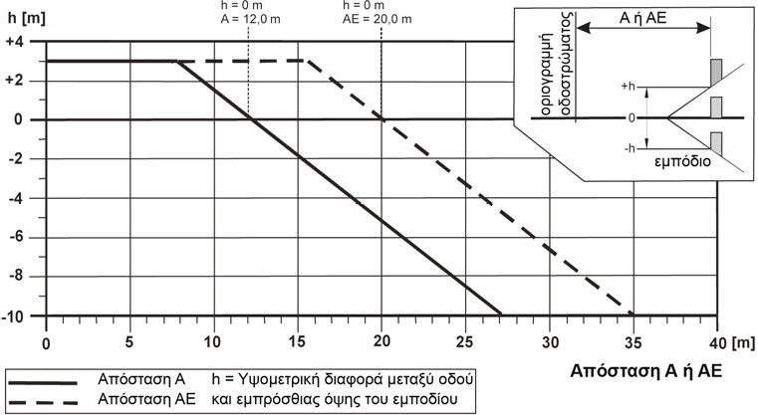

Fig. 3: Critical distances for roads with V_{perm} > 100 km/h and for typical highway or highway with reduced characteristics as well as highway with separated carriageways with V_{perm} ≤ 100 km/h
Οριογραμμή οδοστρώματος | Carriageway boundary line
Α ή ΑΕ | A or AE
εμπόδιο | Obstacle
Απόσταση Α | Distance A
Απόσταση ΑΕ | Distance AE
H= Υψομετρική διαφορά μεταξύ οδού και εμπρόσθιας όψης του εμποδίου | H= Height difference between road and front of the barrier
Απόσταση Α ή ΑΕ | Distance A or AE

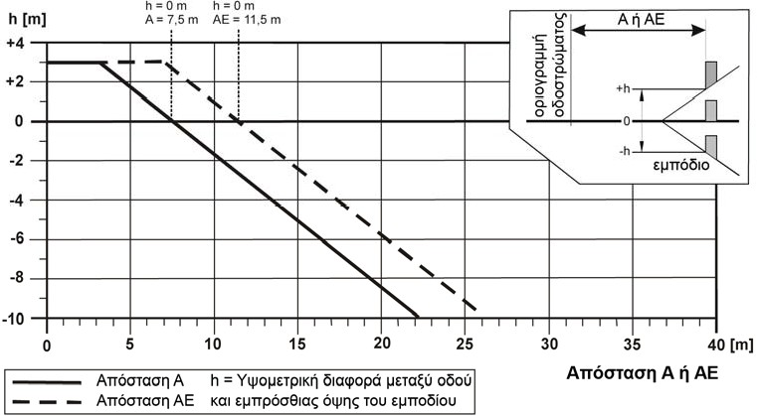
Fig. 4: Critical distances for roads with V_{perm} = 80 km/h to 100 km/h
Οριογραμμή οδοστρώματος | Carriageway boundary line
Α ή ΑΕ | A or AE
εμπόδιο | Obstacle
Απόσταση Α | Distance A
Απόσταση ΑΕ | Distance AE
H= Υψομετρική διαφορά μεταξύ οδού και εμπρόσθιας όψης του εμποδίου | H= Height difference between road and front of the barrier
Απόσταση Α ή ΑΕ | Distance A or AE

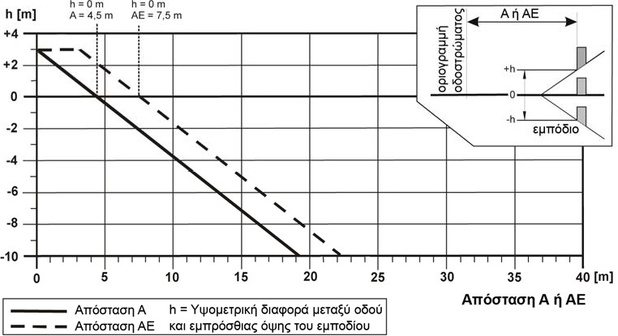

Fig. 5: Critical distances for roads with V_{perm} = 60km/h to 70km/h
Οριογραμμή οδοστρώματος | Carriageway boundary line
Α ή ΑΕ | A or AE
εμπόδιο | Obstacle
Απόσταση Α | Distance A
Απόσταση ΑΕ | Distance AE
H= Υψομετρική διαφορά μεταξύ οδού και εμπρόσθιας όψης του εμποδίου | H= Height difference between road and front of the barrier
Απόσταση Α ή ΑΕ | Distance A or AE

In order to decide whether a hazardous position is located in the critical distance zone, the distance between the carriageway boundary line and the face of the hazardous position (determinant distance) plays a decisive role. The determinant distance is determined on the basis of fig. 6.
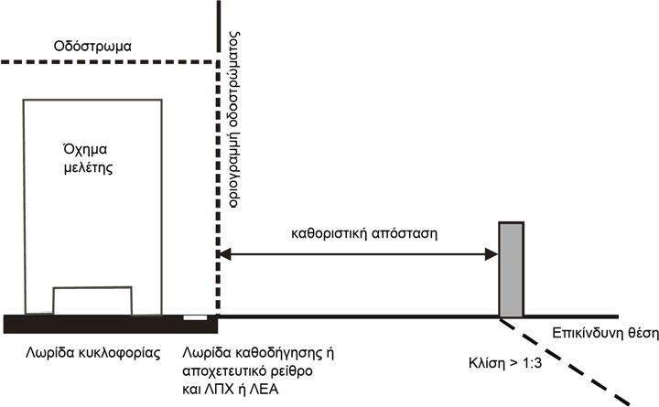
Fig. 6: Determination of determinant distance

Οδόστρωμα | Carriageway
Όχημα μελέτης | Study vehicle
Οριογραμμή οδοστρώματος | Carriageway boundary line
Καθοριστική απόσταση | Determinant distance
Επικίνδυνη θέση | Hazardous position
Κλίση > 1:3 | Incline > 1:3
Λωρίδα καθοδήγησης ή αποχετευτικό ρείθρο και ΛΠΧ ή ΛΕΑ | Guidance strip or drainage channel and LPX or LEA
Λωρίδα κυκλοφορίας | Traffic lane

In areas of connecting branches of uneven junctions, where no speed limits have been set, the following speed values shall be used in relation to the critical radius of the connecting branch:

Table 4: Determinant speeds of connecting branches of uneven junctions

Connecting branch critical radius  (m) | Determinant speed  (Km/h)
30 | 50
50 | 60
80 | 70
125 | 80
180 | 90
250 | 100

The carriageway boundary line is considered to be the lateral boundary of the traffic area and is normally the boundary of the asphalt. The traffic area includes traffic lanes, guide lanes and emergency lanes. Drainage gutters do not normally belong to the carriageway. In specific cases, such as interconnecting branches of uneven junctions, it is possible to configure the road section in such a way that the drainage gutters form part of the traffic area. However, it is also possible in these cases that these gutters can also be formed outside the traffic area by assimilating the width of the base or the islet. In any case, the determinant reference line for determining the critical distance in accordance with these instructions is the limit of the traffic area. The limit line of the hazardous position is considered for

      - solid obstacles, front edge of the obstacle,
      - areas in need of protection, the start of the area,
      - slopes and areas with water, their point of intersection with the soil,
      - retaining bridges/walls, the technical boundary line
      - railway lines, the limit of their gauge (typically 2.50 m from the middle of the rail)
      - roads and cycle paths, the boundary line of the traffic area.

If the determinant distance is less than or equal to the critical distance, it should be decided by means of the standard flow diagram of Figure 7 whether the installation of safety barriers is required and what is the minimum retraining capacity they should exhibit.

Deviation from the criteria and standard values of the flowchart of Figure 7 may be permitted, following a decision of the Contracting Authority/Managing Service or the Authority Head.

Selection of performance classes of permanent safety barriers

General
The requirements for vehicle restraint systems are a function of their position, i.e.,

      - External carriageway boundary line,
      - Boundary lines on bridges and retaining walls,
      - Central and lateral separating islet,
      - Tunnel walls and fronts

Safety barriers on the outer carriageway boundary line

Restraining capacity
The flowchart (Fig. 7) presents the procedure for assessing the economic necessity of installing safety barriers with minimum required restraining capacity, on the outer boundary line of the carriageway and the selection of the which must be presented in relation to

      - the type of side barrier or hazardous location and whether these pose a danger to third parties or to occupants. For obstacles or hazardous positions not mentioned in the examples of the risk classes in Figure 7, these must be classified in one of the classes indicated by the designer,
      - the permissible speed (V_{perm}),
      - the geometrical characteristics of the road and by extension of the frequency and/or probability of diversion of vehicles from their course; and
      - of traffic parameters, such as Average Daily Traffic (ADT) and Heavy Vehicle Load (HVL)1.

The restraining capacities H1, H2 and H4b referred to in Figure 7 include the corresponding restraining capacities L1, L2 and L4b according to ELOT EN 1317. The mandatory adoption of restraining capacities L1, L2 and L4b will take place in the future by decision of the DRI – MT&I.

1 Truck vehicles total weight > 3.5 T and buses

Parameters affecting traffic circulation

Dangerous locations
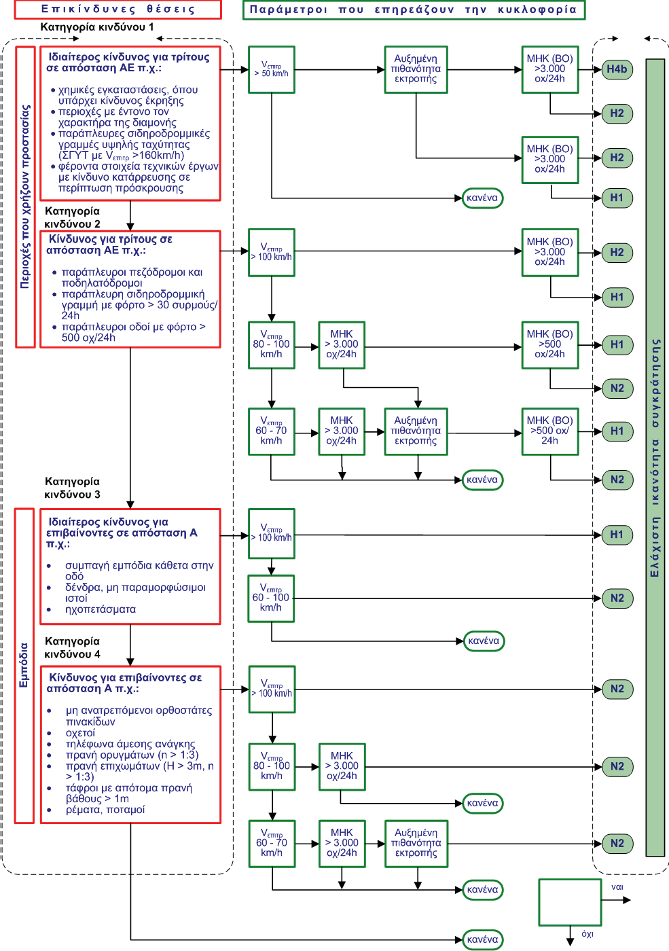
ADT > 3,000 v/24K

V_{perm} > 100 km/h
Minimum restraining capacity

Areas in need of protection
Obstacles

ADT (HV) > 500 v/24K

- upright signposts that do not tip
- culverts
- emergency phones
- trench slopes (n > 1:3)
- embankment slopes (H > 3 m, n>1:3)
- ditches with steep slope depth > 0.5m
- streams, rivers

- solid obstacles perpendicular to the road
- trees, non-deformable posts
- sound barriers

Risk to persons on board at an A distance e.g.:

Particular risk for persons on board at an A distance e.g.:

Risk class 4

Risk class 3

none

none

none

none

none

no

yes

none

Increased chance of diversion

Increased chance of diversion

ADT > 3,000 v/24K

ADT (HV) > 3000 v/24K

ADT (HV) > 3000 v/24K

ADT (HV) > 500 v/24K

ADT (HV) > 3000 v/24K

ADT (HV) > 3000 v/24K

ADT (HV) > 3000 v/24K

V_{perm} 60-70 km/h
V_{perm} 80-100 km/h
V_{perm} 60-70 km/h
V_{perm} 60-100 km/h
V_{perm} > 100 km/h
V_{perm} > 80-100 km/h
V_{perm} > 100 km/h
V_{perm} > 50 km/h
Increased chance of diversion

roadside pedestrian paths and
cycle paths
roadside rail
line with load > 30 trains/
24hrs
roadside roads with a load > 500 v/24hrs

Risk to third parties at an AE distance e.g.:

Risk class 1

Risk class 2

chemical installations, where there is a risk of explosion
areas with a strong residential character
high-speed side rail lines (GHS with n_{IP},r >1 THO gp/K)
bearing elements of technical works with a risk of collapse in the event of impact

Particular risk to third parties at an AE distance e.g.:

0.5 m

Fig. 7: Economic and technical criteria for applying safety barriers to the outer carriageway boundary line

Operational width and vehicle intrusion
The operational width W of a system is defined as the sum of the dynamic deformation and the structural width of the system. The choice of the appropriate vehicle restraint system also depends on the available distance from the side obstacles in order to normally ensure its operational width.

The smaller the space available, the more rigid the system to be installed must be. For this reason, there is a direct interdependence between the impact intensity and the space available for deformation, which determines the restraining capacity.

Vehicle Restraint Systems should therefore be selected such that their operational width and the width of vehicle intrusion, where required, are typically smaller or equal to the distance between the front face of the safety barrier and the front face of the obstacle (figure 8) unless these obstacles are classified as passive conforming to the standard ELOT EN 12767.
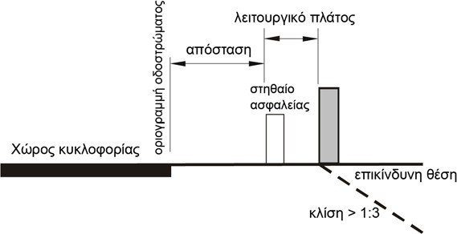
Fig. 8: Arrangement of safety barriers in relation to operational width and traffic area

Χώρος κυκλοφορίας | Traffic area
οριογραμμή οδοστρώματος | carriageway boundary line
απόσταση | distance
Λειτουργικό πλάτος | Operational width
στηθαίο ασφαλείας | safety barrier
επικίνδυνη θέση | hazardous position
κλίση > 1:3 | incline > 1:3

In determining the required operational width, the following shall be taken into account:
      - The distance of the front face of the barrier from the carriageway boundary line shall be not less than 0.50 m. A reduction of the minimum distance of 0.50 m of the front of the barrier from the carriageway boundary line shall be permitted only in exceptional cases, such as in cases of unavoidable presence of an obstacle in the zone of the operational width. Maintaining the required range of visibility may require longer distances.
      - The distance of the front face of the safety barrier from the carriageway boundary line may be increased by 1.00 m to 1.50 m if the conditions of the space available and the traffic conditions (e.g., roads without special walkways or cycling paths) permit. In such cases the support from the carriageway boundary line to the barrier must be adequately stabilised, e.g., gravel with grass covering, so that this zone is easily accessible to pedestrians including PWD. The term ‘sufficient stabilisation’ here does not mean that the support is constructed as a flexible or rigid carriageway.
      - In hazardous areas, such as slopes or water impediments, consideration shall be given to whether the next largest operational width class can be selected.
      - Safety barriers with an operational width class greater than the distance between the front face of the safety barrier and the front face of the obstacle, may be installed, when tested in accordance with ELOT EN 1317, that the vehicles can be restrained and the mode of operation of the system shall not change. This reference relates to the final determination of the width of the foundations and pedestrian paths of the bridges, so that

no over-dimension of these parts of the cross-section shall occur, as long as this does not result in a deviation from the objective of protection of a safety study.

It is possible in documented and exceptional cases, due to particular local conditions and space constraints, to result in commitments whereby the requirements for the necessary operational width and/or vehicle intrusion width in accordance with the above and/or the necessary minimum length of the vehicle restraint system cannot be fulfilled. In these cases, all alternative proposals, based on the basic principles of these instructions, should be explored and that solution which gives the highest level of protection for the given circumstances should be chosen.

If a barrier is not available on the outer carriageway boundary line to protect a hazardous position with the necessary restraining capacity and with an acceptable class of operational width (and/or vehicle intrusion, where required) then:
      - A vehicle restraint system with greater restraint capacity and operational width shall be selected according to these instructions; or
      - A vehicle restraint system with a higher restraint capacity shall be selected and with the next operational width class; or
      - A vehicle restraint system of the corresponding restraint capacity shall be selected with the next operational width class if the hazardous position does not constitute an obstacle with the risk of collapse; or
      - A speed limit shall be selected which either does not make it necessary to install a vehicle restraint system according to the flow diagram in Figure 7 or requires a vehicle restraint system with a lower restraint capacity. The application of the new speed limit requires the relevant approval provided for in the current Road Traffic Code; or
      - Placing the vehicle restraint system closer to the reference line. In this case, the standard distance of 0.50 m may be reduced to 0.25 m. This reduction has the disadvantage of providing smaller space for the dimensioning of work on the road and thus the possible impossibility of developing specific traffic regulations. Finally,
      - consideration shall be given to replacing the obstacle, in the case of a signpost or upright, with an appropriate passive post according to ELOT EN 12767.

On tunnel fronts, bridge piers, technical elements with a risk of collapse or other large and solid obstacles near the carriageway, it is necessary when designing safety and, in the case of a barrier with a retaining capacity of H1 and greater, to take into account in addition the criterion of vehicle intrusion (maximum lateral position of vehicle VI) up to a height of 4 m (fig. 9); The criterion of vehicle intrusions refers to ELOT EN 1317-2 (version 2011). Performance certificates for safety barriers issued after 2011 shall refer to the value of this parameter (parameter class VI in proportion to the operational width w, case (a) Figure 9). For older barriers for which this parameter is not available, this size shall be replaced by the size of the maximum lateral displacement (position) of the vehicle (case (b) Figure 9).

Case (a)-new RSB after 2011, VI>W
Case (b)-old RSB before 2011,
VI<W

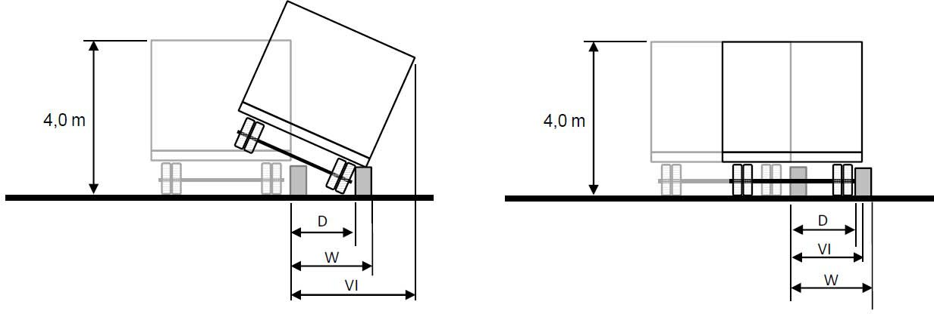
D= dynamic distortion [m] W= operational width [m]
VI= vehicle intrusion [m]
In the case of a bus (H2 restraint capacity), the actual height of the bus at the maximum lateral displacement of the vehicle shall be taken into account.

Fig. 9: Definition of parameter vehicle intrusion

Impact severity
The impact severity determines the physical stress, severity of injuries or risk of loss of life of occupants in passenger cars (TB test type 11). The more solid or rigid a system is, the greater the deceleration effected on the occupants of the vehicle. For this reason, the allowable values of the impact indices ASI and THIV of the occupant of the vehicle shall be in accordance with those set forth in Table 3 ‘Impact severity classes’ in ELOT EN 1317.

Systems with impact class A shall provide greater safety to occupants of a vehicle deviating from its course than those with impact severity class B and shall be preferred, when the other data are the same, for safety reasons. Systems with impact severity class B shall also be preferred to those with impact severity class C when the other data are the same. A system with impact severity class C may be selected only if the required performance classes are not fulfilled by systems with impact severity class A or even B.

Safety barrier on retaining bridge and wall boundary lines
The provisions referred to in this subparagraph concern technical elements (bridges with aperture of at least 10 m and retaining walls) with drop heights greater than 2 m. If this is not the case, account shall be taken of the considerations set forth in paragraphs 4.4, 5.1 and 5.2.

Barriers on the outer boundary of bridges and road crown walls shall be selected according to the risk class to which the area downstream of these technical works may be placed.

The load classes of safety barriers on bridges based on the applicable Eurocodes must be determined taking into account the loads measured during the ELOT EN 1317 impact test, which are transferred to the technical work through the barrier and the vehicle. In general, for restraint systems with restraining capacity up to H1 the determination of loads can be made reliably and by theoretical calculations. This theoretical approach is acceptable.

The typical widths of the lateral configurations of the bridges are 2.05 m. The free distance between the rear side of a barrier and the railing shall be an emergency corridor and shall not be less than 75 cm and on existing bridges this distance may be reduced to 50 cm.

The lengths of barriers shall apply as set forth in paragraph 7.1.

A safety upright with a restraining capacity shall be placed on the outer boundary of bridges and road crown walls, in accordance with Table 5.

Table 5: Required restraining capacity on bridges and retaining walls

Dangerous area under bridge or retaining wall | Roads with
Dangerous area under bridge or retaining wall | V_{perm} > 100 km/h and typical or reduced highway and arteries with separated carriageway  with V_{perm} ≤ 100 km/h | V_{perm} ≤ 100km/h and  ADT (HV) > 500  trucks/24h | V_{perm} ≤ 100 km/h  and ADT (HV) ≤ 500  trucks/24h | V_{perm} ≤ 50 km/h
Special protection of third parties (e.g., chemical installations with explosion risk, areas with a strong residential character, railway lines with V_{perm} > 160 km/h, highway, etc.) Risk class 1 | H4b | H2 | H2 | Η1
Other cases under risk classes 2 to 4 | H2 | H2 | H1 | curb height from 0.15 m to 0.20 m high and railing

For bridges with an aperture of less than 10 m and for culverts, apply the provisions of the outer carriageway boundary line and of the flow diagram of Figure 7.

On bridges with a permissible speed V_{perm} ≤ 50 km/h, if the hazardous area is classified as risk class 1, a safety barrier with restraining capacity H1 is normally required. Above-road bridges with separated carriageways as well as retaining walls along roads with a permissible speed of less than or equal to 50 km/h and position protection, classified as risk class 1, protection with a vertical curb of not less than 0.15 m to 0.20 m in height is sufficient in combination with a rail fitted with a cableway provided that there is no increased chance of vehicle diversion according to paragraph 4.2. A safety system consisting of a curb 0.20 m in height and a cable railing system is generally sufficient along bridges and retaining walls for agricultural and forestry roads.

For the purpose of determining the maximum operational width class, the bridge or retaining wall boundary shall be considered as the front of the side barrier, provided that no sound screen or other obstacle is fitted. The installation of safety barriers
in a larger class of operational width is permitted if the tests have shown, in accordance with ELOT EN 1317, that vehicles can be restrained and the purpose of protecting the occupants of vehicles or third parties against the barrier is ensured.

In the areas of bridge joints, restraint systems must be installed in such a way that it is proven that there is no significant loss of performance due to the movement caused by the technical element.

Barriers shall be installed where it is necessary to connect systems with different construction configuration and/or operating mode in accordance with the performance classes of paragraph 3.4 and in accordance with that described in Volume 2 (Instructions for the installation and repair of vehicle restraint systems) and Volume 3 of these instructions.

The selection and installation of the appropriate RSB on the boundaries of the bridges and related technical elements requires that the forces applied to the barrier in question and measured during the corresponding standard impact test, after appropriate reduction, can be safely received both locally by direct support members (e.g. pedestrian path, beam) and the reinforcement of their connection to the body, as well as universally by the supporting body of the technical element. The calculation of the intensity and the dimensioning of the abovementioned members and of the total body of the technical project shall be carried out in accordance with the requirements of ELOT EN 1991-2 4.7.3.3 (1), in accordance with the actions and charges specified therein, which are then included in the random combination ELOT EN 1990, A2.3.2 Table A2.5. In addition to the above general check, a specific adequacy check of the supporting part shall be carried out locally at the connection point of the barrier as defined in ELOT EN 1991-2 4.7.3.3 (2). In this check, the random action defined there will not be combined with any other variable action.

Maximum permitted values of the above actions may complement, in addition to the required performance parameters, criteria for selecting and accepting safety barriers in such a way that no issue of resistance to an already constructed body arises.

In this spirit, manufacturers of safety barriers are required to declare the class (A to D) of the transferred horizontal impact force, into which the safety barrier produced by them is classified, in accordance with Table 4.9 (n) of ELOT EN 1991-2, as obtained after appropriate reduction of the test standards measurements.

In order to avoid subsequent reinforcement interventions in the preparation of studies for new technical works, prescribing the use of a class C horizontal force (400kN), which, according to international special literature, covers the requirements of a large number of H2 and H3 safety barriers, is recommended. In this case, the use of barriers classified in classes A to C is allowed without specific checks. The application of Class D safety barriers but otherwise with desirable performance characteristics will be permitted only after it has been established that the technical element, as designed or constructed, has adequate reserve strength. This check will be carried out under the care and responsibility of the project contractor and submitted for approval by the Managing Service.

The standard lateral configuration of the bridges with a width of at least 2.05 m, a barrier distance of 0.50 m from the curb, placing a railing at a distance of 0.75 m from the rear of the safety barrier shall be sufficient to satisfy the requirements of the design and dimensioning stages of the technical works. In the event that these geometrical requirements cannot be fulfilled or there is no certified barrier for the installation on the bridge, it must be assessed on the basis of local conditions which deviations of the standard lateral configuration are appropriate. Such discrepancies must be explicitly mentioned in the study and design and in the corresponding contract notice for the safety barrier. In particular, where there are no suitable safety barriers with the required restraining capacity or operational width, the following procedure may be followed:

- Step 1: determination of restraining capacity according to Figure 7;
- Step 2: determination of the operational width (W) class and vehicle intrusion width (VI):
  - Selection of a certified barrier that fulfils local conditions, such as a barrier:
    - for bridge boundary lines,
    - combined with railing,
    - etc.
- Step 3: Review of the operational width and the vehicle intrusion width:
  - Possible replacement of the operational width class by the operational width value corresponding to the maximum lateral displacement of the system
- Step 4: Checking the application of any of the criteria in paragraph 5.2.2.
  - Assessment based on restraining capacity
  - Technical static proficiency check based on applicable loads
  - Impact assessment of other factors
- Step 5: Specific solutions and options

In the case of existing bridges, the process of new installation, renewal or replacement of safety barriers shall be preceded by a proficiency check against horizontal action of class C (400kN) as is or following appropriate reinforcement interventions. Deviations from this requirement with check for a lower class of horizontal transferred force due to impact, in accordance with Table 4.9 (n) of ELOT EN 1991-2, will be allowed only after approval by the Managing Service in cases where:
- A specific safety barrier of a lower class of impact force (A, B) has already been selected for installation or replacement, in which case the check may be carried out for the corresponding class,
- The required interventions are difficult, costly or even lead to the need to extend the interventions to other parts of the technical project in addition to the member directly affected (e.g., due to a significant increase in permanent loads).

Safety barrier on the central and lateral separator islets

General
Safety barriers must be installed on main and lateral road separating islets with separated carriageways and with permitted speed V_{perm} > 50 km/h. Safety barriers on the central islet aim to protect third parties (off-traffic) and their restraining capacity must not be less than H2.

There are four possibilities for placing safety barriers on central and separating islets:
      - placing of two-sided safety barriers in the middle of the islet;
      - installation of two-sided safety barriers on the islet,
      - installation of one-sided safety barriers along the islet’s boundary with a separate (autonomous) action; and
      - installation of one-sided safety barriers along the islet’s boundary with joint action.

In general, frequent change of types of barriers on the central islet should be avoided. Uniform barrier types without fittings are preferred. The choice of a type of barrier on the islet is based on road safety.

The two-sided systems are placed in the middle of the islet. In cases of obstacle, such as electromechanical equipment or sewers or maintenance of the required range of visibility, the two-sided safety barriers may be fitted in the centre.

If there is a dangerous barrier on the central or lateral separating islet, a one-sided barrier must be placed with separate action (fig. 10).

The two-sided barrier may be connected by a one-sided barrier before an obstacle by placement at an angle of ≤ 1:20. Frequent changes from a two-sided barrier in the middle of the islet to two one-sided barriers on the islet’s boundary should be avoided. During the interruptions or openings of the central separating islet, safety barriers shall be placed with the same performance as in the adjacent parts of the islet.

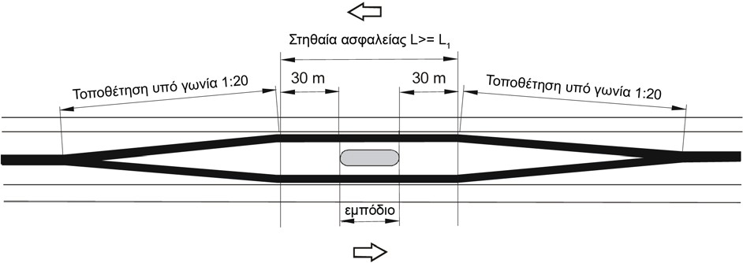
Fig. 10: Safety barrier in a barrier area on a central separating islet

Τοποθέτηση υπό γωνία 1:20 | Placement at an angle of 1:20
Στηθαία ασφαλείας L>=L₁ | Safety barrier L >= L₁
Τοποθέτηση υπό γωνία 1:20 | Placement at an angle of 1:20
εμπόδιο | obstacle

Both sides of the islet are symmetrical systems, which are accessible on both sides of the islet as opposed to one-sided systems. The ability to retain one-sided systems by joint action shall only be achieved through the cooperation of both systems, which shall be ensured in the construction configuration of the road.

Where the islet is sufficiently wide and the transverse slope of the central or lateral separating islet is ≤ 1:10, only one-sided systems shall be installed along the islet’s boundary lines with separate action. In this case, the second system operates as ancillary during the impact of heavier vehicles in order to prevent the vehicle entering the opposite traffic direction (reserve system). On islets with multiple obstacles or large transverse slopes, uniform systems with the required restraint capacity (e.g. H2) are selected, which due to their construction can be applied uniformly along the islet (e.g. a single barrier with the required small operational width and vehicle intrusion, otherwise certified systems are selected that are compatible with the islet’s constructional specificities).

Further implementation criteria for restraint systems on a central and lateral islet are:
        - the possibility of drainage
        - the location of drainage pipes
        - the possibility of placement in front of the obstacles
        - The possibility of placement in islet breaks
        - the possibility of placement on bridges
        - accepted assemblies according to ELOT EN-1317 in existing systems
        - the visibility length
        - the ease of repair and replacement
        - the frequency of cleaning (especially in closed systems)
        - the ease of carrying out maintenance tasks
        - the possibility of snow clearing
Road studies shall examine in a timely manner the compatibility of the road drainage system with its safety system.
In the case where a barrier with the required restraint capacity and adequate operational width and vehicle inlet width are not available, the criteria referred to in paragraph 5.2.2 shall apply.

Restraining capacity
The width of a central or lateral separating islet is defined as the distance between the boundary lines of the traffic area of the two carriageways.

The flow diagram in Figure 11 shows the economic selection criteria for the minimum required restraining capacity to be presented by safety barriers placed on central and lateral separating islets according to
- the risk class; and
- factors affecting traffic circulation, such as
the permissible speed (V>_{perm}),
 The Average Daily Traffic (ADT) of Heavy Vehicles (HV) and
 the increased chance of diversion.
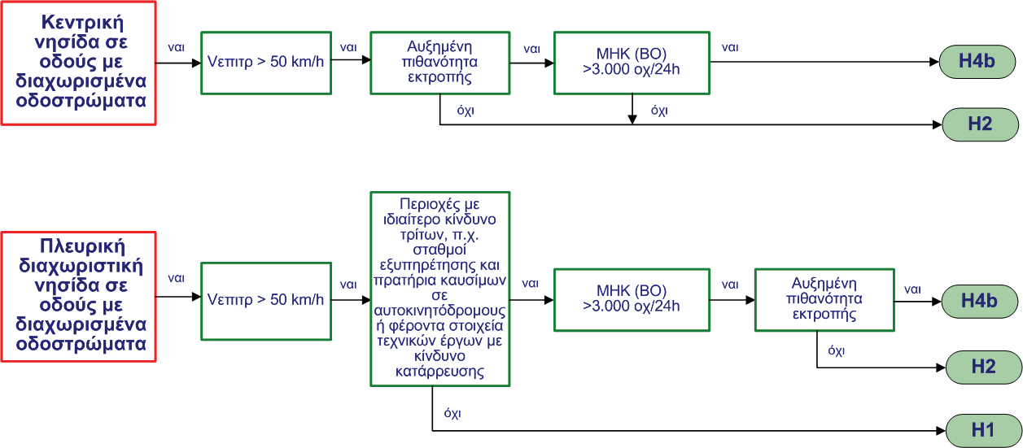
Areas with particular risk to third parties, e.g., service stations and petrol stations on highways or bearing elements of technical works with risk of collapse

Increased chance of diversion

ADT (HV) > 3,000 v/24h

V_{perm} > 50 km/h

V_{perm} > 50 km/h

ADT (HV) > 3,000 v/24h

Increased chance of diversion

no

no

no

no

yes

yes

yes

yes

yes

yes

yes

yes

yes

Central islet on roads with separated carriageways

Lateral separating islet on roads with separated carriageways

Fig. 11: Economic and technical criteria for applying safety barriers to central and lateral separating islets

The determining factor for selecting the restraining capacity of a safety barrier on islets is not the fact of whether or not a pedestal has been calculated with a vehicle impact prediction, since for these cases, H2 or H4b safety barrier restraining capacities are provided respectively. According to the ELOT EN 1991-2 and ELOT EN 1992-2 standards, either because of cross-sectional dimensions or because of calculation against impact, they are not classified as constructions with a risk of collapse (risk class 1).
Movements in the area of the mobile joints of the bridges must be received by means of special contraction-dilation parts of the safety barriers.

Operational width
On central or lateral separating islets without obstacles, the maximum operational width W shall be determined by reference to the width of the central or separating islet and the width of the safety barrier. In order to determine the required operational width, account shall also be taken of the type of safety barrier (two-sided or one-sided safety barrier with separate or joint action) and its position (in the middle of the islet or centrally within it).

When placing two one-sided safety barriers on the boundary of the central or lateral separating islet with separate action, safety barriers running parallel to one boundary line shall be placed within the operational width of the safety barriers parallel to the other boundary line of the islet shall not be permitted. In the case of different operational widths, the largest of them is the determining factor. This restriction does not apply to one-sided systems which have been subjected to an ELOT EN 1317 impact test together.

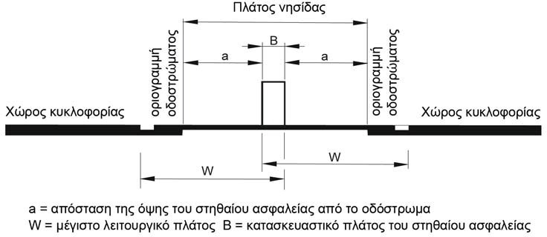

Fig. 12a: Two-sided barrier placed in the middle of the islet

Χώρος κυκλοφορίας | Traffic area
Οριογραμμή οδοστρώματος | Carriageway boundary line
Πλάτος νησίδας | Width of islet
a= απόσταση της όψης του στηθαίου ασφαλείας από το οδόστρωμα | A = distance of the face of the barrier from the carriageway
W = μέγιστο λειτουργικό πλάτος | W = maximum operational width
Β = κατασκευαστικό πλάτος του στηθαίου ασφαλείας | Β = structural width of the safety barrier

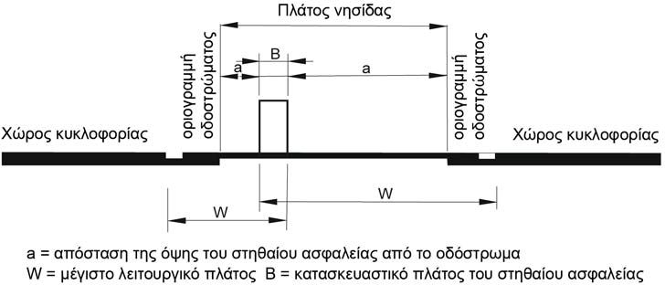
Fig. 12b: Two-sided barrier mounted centrally in the islet

Χώρος κυκλοφορίας | Traffic area
Οριογραμμή οδοστρώματος | Carriageway boundary line
Πλάτος νησίδας | Width of islet
a= απόσταση της όψης του στηθαίου ασφαλείας από το οδόστρωμα | A = distance of the face of the barrier from the carriageway
W = μέγιστο λειτουργικό πλάτος | W = maximum operational width
Β = κατασκευαστικό πλάτος του στηθαίου ασφαλείας | Β = structural width of the safety barrier

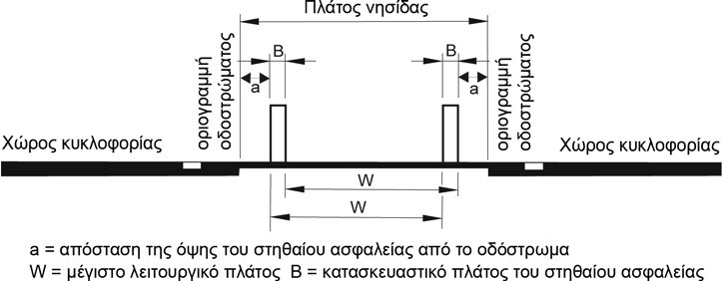

Fig. 12c: One-sided safety barrier with separate action placed on both boundary lines
Χώρος κυκλοφορίας | Traffic area
Οριογραμμή οδοστρώματος | Carriageway boundary line
Πλάτος νησίδας | Width of islet
a= απόσταση της όψης του στηθαίου ασφαλείας από το οδόστρωμα | A = distance of the face of the barrier from the carriageway
W = μέγιστο λειτουργικό πλάτος | W = maximum operational width
Β = κατασκευαστικό πλάτος του στηθαίου ασφαλείας | Β = structural width of the safety barrier

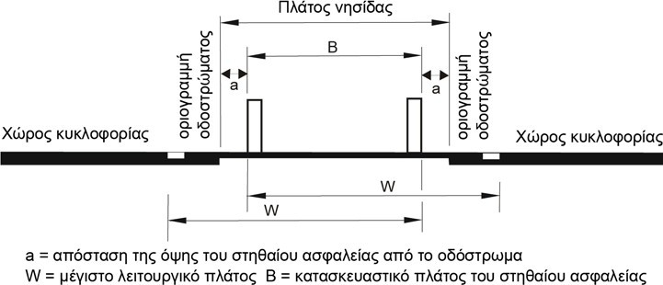

Fig. 12d: One-sided safety barriers with joint action placed on both boundary lines
Χώρος κυκλοφορίας | Traffic area
Οριογραμμή οδοστρώματος | Carriageway boundary line
Πλάτος νησίδας | Width of islet
a= απόσταση της όψης του στηθαίου ασφαλείας από το οδόστρωμα | A = distance of the face of the barrier from the carriageway
W = μέγιστο λειτουργικό πλάτος | W = maximum operational width
Β = κατασκευαστικό πλάτος του στηθαίου ασφαλείας | Β = structural width of the safety barrier

The distance of the front face of the safety barriers from the carriageway boundary lines shall be not less than 0.50 m. The minimum distance may be reduced only in exceptional cases. Maintaining the required length of visibility may require longer distances. In order to ensure the required length of visibility for stopping, it is possible to select a lower barrier or reduce the local speed limit outside the central installation of a barrier. Failure to fulfil the visibility length criterion for stopping at a length corresponding to 0.5sec of the movement of a vehicle at the speed limit shall be ignored.

Bridges with separate superstructures, whose elevation difference along the longitudinal joint and/or their horizontal distance is greater than 0.1 m, shall be treated as independent bridges. In this case, the provisions of paragraph 5.3 apply. In such cases, attention shall be paid to the fact that a superstructure situated above 0.1 m from the other constitutes an obstacle and that the higher superstructure may impose limitations on the choice of operational width of the lower superstructure.

On islets of typical highways and highways with reduced characteristics (design speed less than or equal to 110 km/h), in order to increase road safety and reduce traffic flow disturbances through less maintenance work, a barrier requiring minor maintenance and close to zero repairs shall be selected if the traffic load exceeds the value of 1500 vehicles/hour for each remaining lane, where lanes are blocked during work on the road. In this case account shall also be taken of the possible use of the LEA or the lateral separating islet as a traffic circulation surface.

Safety systems formed by planting require periodic maintenance work (foliage cutting, removal of plant land, etc.). Also in completely closed (solid form) safety barriers (e.g., concrete or metal barriers similar to concrete) increased road cleaning work is required due to concentration of load bearing materials in front of them.

The planting of islets in general is not required from the point of view of road safety. All kinds of features of a landscaping study on the islet can reduce the visibility lengths available. In addition, the planting of the islets can lead to increased maintenance and care needs resulting in lower road safety levels of the road. Closed receptacle systems that are not filled with plant earth may retain detachable parts of the safety system in the event of vehicle impact, as opposed to the case where they are filled with plant earth (increase of road safety level).

However, when it is desirable to plant closed safety barriers for aesthetic reasons, then the plants of the islet must be chosen appropriately so that they are low in height, are not dense, have no barbed foliage and do not have high care requirements. The filling of the islets with materials in general should not lead to the growth of the plants. The planting of closed barriers generally increases islet maintenance requirements and generally reduces the level of road safety on a road.

The planting of islets which requires metal posts should also be avoided. If the planting of an islet is necessary for reasons e.g., to prevent dazzling of drivers, plants, which grow slowly, as far as possible without barbed foliage and in any case with reduced care needs, should be selected.

When choosing the safety system, it may be necessary to consider whether there is a need for small animals, in particular, to cross the road. Open safety systems, such as metal barrier or concrete barrier with openings at their base, have the advantage of ensuring that animals can pass under them. It is generally not possible to ensure that the road can be crossed by fauna via specific structures retrospectively.

Islet Emergency Apertures (IEAs) must be selected with the same systems as each other, in order to avoid the installation of safety barrier assemblies. Alternatively, a portable barrier with a corresponding restraining capacity may be used, allowing quick dismantling. They shall be fitted with a barrier assembly to connect them to the barriers on either side of the road section. Barriers with uprights inside tubular sockets may only be used when they satisfy the ELOT EN-1317 impact test conditions and the Technical Criteria for their choice in the way they are installed (see Chapter 11).

On existing islets with a structure with performance H1 and on which new obstacles are installed, they shall be secured in accordance with the criteria set forth in these instructions (H2 or H4b). Since sliding over the barriers and entering behind them is excluded due to their configuration as continuous construction, the new safety barrier must begin 40 m before the obstacle and end 30 m after it. In addition, the safety barrier shall have the required minimum test length.

Impact severity
In central and lateral separating islets, preference should be given to the application of one-sided systems with a separate action and low impact severity class, insofar as possible A. The advantage of these systems is that they operate independently and therefore have safety reserves, since each system already has the minimum required restraining capacity.

Otherwise, paragraphs 3.2 and 5.2.3. apply.

Safety barrier in wall and tunnel front areas
Where no projections or recesses exceed 0.1 m, longitudinal solid walls shall not be considered as obstacles. The same applies to nests necessary for safety reasons in tunnels with a length of less than 4.0 m.

Tunnel fronts, the beginning and end of the two-sided walls, projections or recesses greater than 0.1 m and the end of nests of more than 4.0 m in length shall be considered as solid obstacles perpendicular to the traffic direction (risk class 3), if they are not so designed that an impact on them does not pose a risk to occupants of a passenger vehicle. Emergency exits, accesses and other facilities of the tunnel safety system, which must not be obstructed by the installation of a barrier, are exempt from the 4 m long rule.

Paragraph 5.2.2 shall apply to determine the operational width of safety barriers in this case.

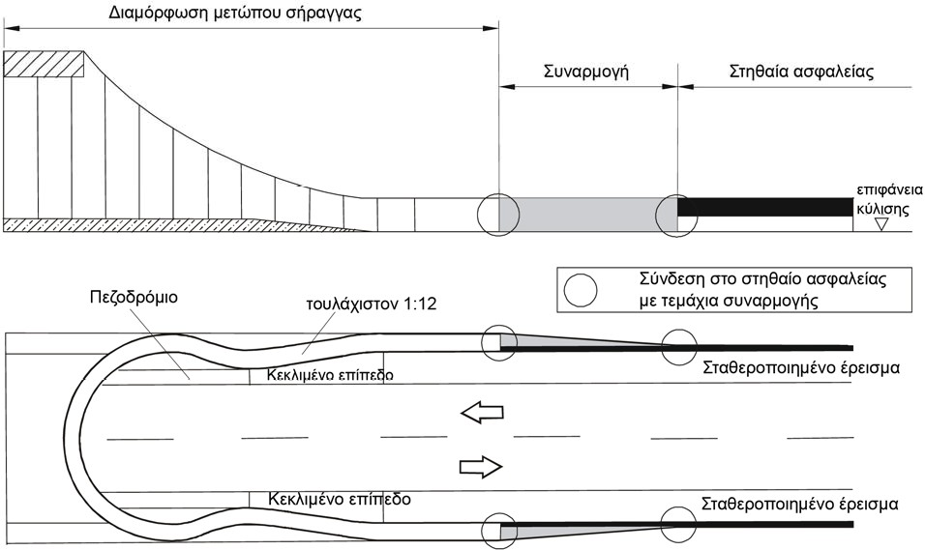
maximum value 1:12

Fig. 13: Example image of safety barriers before tunnel front
Διαμόρφωση μετώπου σήραγγας | Tunnel front configuration
Συναρμογή | Assembly
Στηθαία ασφαλείας | Safety barriers
Επιφάνεια κύλισης | Rolling surface
Σύνδεση στπο στηθαίο ασφαλείας με τεμάχια συναρμογής | Connection to safety barriers with assembly parts
Πεζοδρόμιο | Pedestrian path
Κεκλιμένο επίπεδο | Inclined level
Σταθεροποιημένο έρεισμα | Stabilised support

The required performance classes of assemblies are defined in Chapter 3.4.

At the beginning of the walls, tunnel fronts, and at the end of the nests in tunnels, impact energy absorption systems can be installed. The required performance classes are defined in paragraph 3.5.

On tunnel fronts and safety projections within them, which require fittings on the backs of a carriageway and tunnel gauge, the rule of incline of the tunnel wall/cladding may be exempted from the value of 1:12 and the wall incline value of ≤ 1:3 may be accepted in order that the wall is not considered as an obstacle and a safety barrier is required. If this is not possible, protection of the barrier of the wall by means of an appropriate safety barrier or IEAS is necessarily required.

The tunnel fronts must be shaped in accordance with Figure 13 so that they can be secured appropriately in accordance with the foregoing. For this reason, the design of the safety system must be integrated in the design of tunnels in a timely manner
as well as into the way in which emergency crews operate. In areas of construction joints in the fronts of the tunnels, the necessary widths of the pedestrian emergency corridors (tunnel pedestrian paths) must be observed.

At tunnel entrances and exits, attention shall be paid to the rapid dismantling of the barriers in order to ensure the creation of emergency openings or to select appropriate systems for this purpose such as temporary (portable) barriers or other special provisions.

In addition to Figure 13 in existing tunnels, the construction gradients appearing for the adjustment of the width can also be shaped by means of the installed safety barriers.

Procedure for selecting the performance classes of permanent safety barriers
The diagram in Figure 7 shall be used each time to determine the minimum required restraining capacity of a restraint system. The steps taken are as follows:
Step 1: Identification of the hazardous position and its classification with regard to the risk it poses, e.g., risk class 2 (third party risk) or risk class 3 (particular risk to occupants of a vehicle).
Step 2: Determination of the distance of the hazardous position from the carriageway boundary line (determinant distance).
Step 3: Determination of critical distance (AE or A) in relation to the risk class to which the obstacle belongs, the authorised speed (V_{perm}) and the elevation difference between the road and the front face of the obstacle.
Step 4: Identification of the factors affecting traffic, i.e., the permissible speed (V_{perm}), the Average Daily Traffic (ADT) of all vehicles, the Average Daily Traffic (ADT) of heavy vehicles (HV) and the increased chance of diversion. The ADT (HV) is given to vehicles/24h and concerns the participation of heavy vehicles in traffic, i.e., trucks > 3.5 T and buses.
Step 5: Determination of the minimum required restraining capacity of the restraint system in accordance with the previous steps.
Step 6: Determination of the operational width class and, where applicable, the vehicle’s inlet width (case HV for > H1) of the restraint system, in relation to its distance from the lateral obstacles. A system with a higher class of restraint capacity than required may be selected if the distance between the front of the safety barrier and the front face of the obstacle is short.
Step 7: Determination of the impact severity class of the Restraint System. Preference shall be given to restraint systems with impact severity class A when the other data are identical for safety reasons. In the absence of systems with impact severity class A, systems with impact severity class B shall be selected. The impact severity class C shall be selected only in very exceptional cases and if the required performance classes are not fulfilled by systems with impact severity class A or even B.

The above is summarised in the flow diagram of Figure 14, which assesses, in principle, the necessity of placing safety barriers in the area of influence of a given hazardous position and determines the minimum required restraining capacity.

38

1.
Choice of restraining capacity of safety barrier on the outer carriageway boundary line
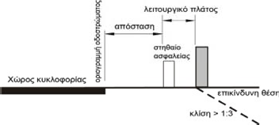
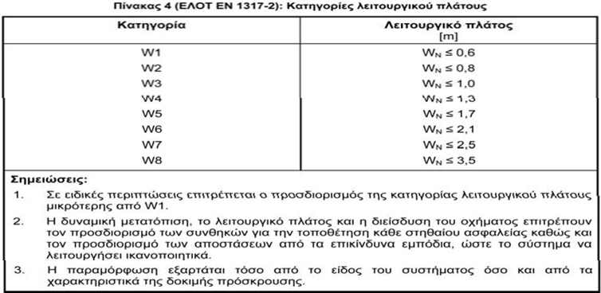
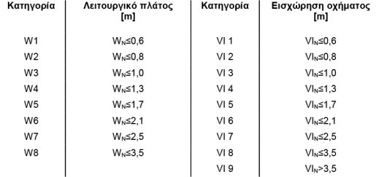
1
Table 4 (ELOT EN 1317-2): Operational width classes

2.
Selection of the required operational width class (W) and vehicle intrusion (VI) for heavy-duty vehicles (>H1)
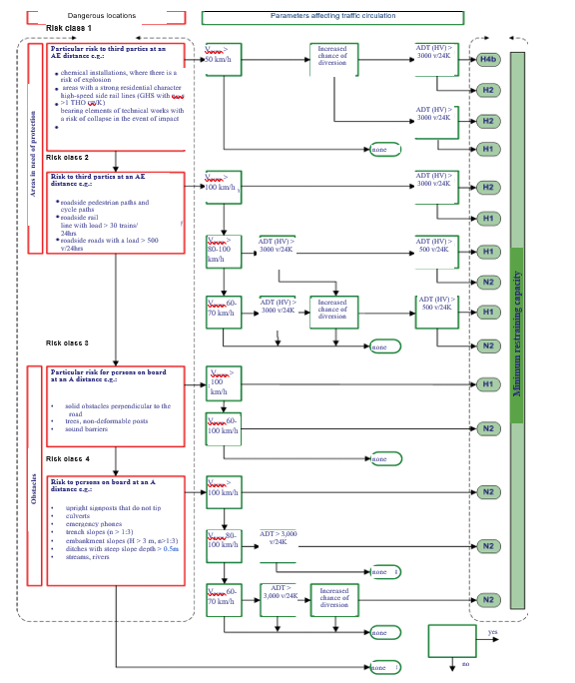
Operational width | class [m] | Operational width | class [m]
W1 | Wn ≤ 0.6 | VI 1 | VI_{n} ≤ O.6
W2 | Wn ≤ 0.8 | VI 2 | VI_{n} ≤ 0.8
W3 | Wn ≤ 1.0 | VI 3 | VI_{n} ≤ 1.0
W4 | Wn ≤ 1.3 | VI 4 | VI_{n} ≤ 1.3
W5 | Wn ≤ 1.7 | VI 5 | VI_{n} ≤ 1.7
W6 | Wn ≤ 2.1 | VI 6 | VI_{n} ≤ 2.1
W7 | Wn ≤ 2.5 | VI 7 | VI_{n} ≤ 2.5
W8 | Wn ≤ 3.5 | VI 8 | VI_{n} ≤ 3.5
 |  | VI 9 | VI_{n} > 3.5
Notes:
1. In special cases it is permitted to determine the operational width class less than W1
2. The dynamic displacement, operational width and vehicle intrusion make it possible to determine the conditions for the installation of each safety barrier and to determine the distances to the dangerous obstacles, so that the system can function satisfactorily.
3. The deformation depends on both the type of system and the characteristics of the impact test.

Carriageway boundary line
operational width

distance

Safety barrier
Traffic area

Hazardous position
Incline > 1:3

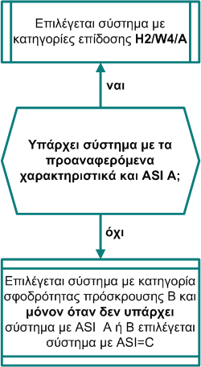
2
Select system with performance classes H2/W4/A

Impact severity class | Permissible indices values
A | ASI ≤ 1.0 | and | THIV ≤ 33 km/h
B | ASI ≤ 1.4 | and | THIV ≤ 33 km/h
C | ASI ≤ 1.9 | and | THIV ≤ 33 km/h

Table 3 (ELOT EN 1317-2): Impact severity classes

yes
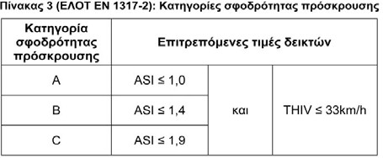
3
Is there a system with the abovementioned characteristics and ASI A?

no
Select a system with impact strength category B and only when there is no system with ASI Α or Β, select a system with ASI=C

0.5 m
3.
Impact severity class

Fig. 14: Procedure for selecting the performance classes of permanent safety barriers
Page 31

Lengths of application of safety barriers

Lengths on the outer carriageway boundary line
Safety barriers must have a given minimum length L₁ in order to be effective. This minimum length L₁ must be reported in the test report of each system according to ELOT EN 1317-2.

The length of the safety barriers before the hazardous position shall be at least L₂ (Table 6 and Figures 15a and 15b), so that vehicles that are diverted from their course
      - and slide along the ends and safety barriers do not collide with the obstacle when its distance from them is less than 1.5 m;
      - do not pass behind the barriers and encounter obstacles behind them or enter a protected area. This is the case when there is no possibility of the vehicle sliding over the barrier.

Sliding over the barrier usually occurs when an immersion is chosen at the beginning of an immersion.

The lengths of protection against passing a vehicle behind the L2 barrier shall be taken into account only if a vehicle can actually pass behind a safety barrier and access the hazardous position.

In the case of an embankment slope, the criterion of sliding is not decisive for the design of the barrier, because a vehicle sliding over the barrier, when it reaches the hazardous position (slope height > 3m) does not strike any obstacle, but simply continues to increase the height of the slopes. This case, however, applies only to the hazardous position of ‘embankment slope’ and not to the hazardous position of the bridge and retaining wall and which concerns the fall of a vehicle. When the boundary line of a bridge or a retaining wall is within the distance of 1.5 m from the front of the barrier, then the criterion of the vehicle’s slide on the barrier shall be valid and shall be taken into account.

Where, along a road section equipped with a continuous vehicle restraint system, a safety barrier with a greater restraining capacity is locally installed (e.g., due to a point obstacle with a higher risk class), a check for passing the vehicle behind the barrier shall be required. The reason is that during the impact of a heavy vehicle in the area of the restraint system with the lowest restraining capacity this may fail, in terms of performance, resulting in the vehicle finally encountering the obstacle with the highest risk class. Therefore, the regulations to prevent the vehicle from passing through the back of the barrier also apply, unless this situation can be ruled out.

There are three possibilities for placing safety barriers:
      - Placing the safety barrier parallel to the carriageway boundary line with the possibility of reducing the restraining capacity.
In order for safety barriers to be effective, they must be of a given length before and after the hazardous position. On single carriageway roads the length of the safety barriers before and after the obstacle shall be at least equal to L₂ (fig. 15a and 16a). On roads with a single carriageway and one traffic direction, the length of the barriers after the obstacle shall be at least 20 m. On roads with a separated road before the obstacle, the length of the safety barriers shall be equal to L₂ and after the obstacle equal to at least 30 m (fig. 15b and 16b).

Reduction of the restraining capacity by one class in the range of application length L₂ is possible in length of 0.5xL₂ before the hazardous position (fig. 15a, 15b, 16a, 16b). For example, the restraining capacity can be reduced after the length of 0.5xL₂ from H4b to H2. For the connection of safety barriers to a different construction mode and/or a different dynamic mode of operation, assemblies must be provided, the cost of which must be taken into account before the relative reduction of the restraining capacity.
The length on which a safety barrier with a lower restraint capacity of one class is placed shall be at least equal to the test length of the L₁ system. For this reason, it is possible that the overall length of barriers with reduced restraining capacity is greater than that applied, without impairing the restraining capacity. As a rule, reducing the restraining capacity makes sense when the required length L₂ is at least equal to 100 m.
On roads with a separated carriageway, it is possible to reduce the restraining class of the barriers 15 m after the obstacle (fig. 15b and 16b).
Since under real circumstances the above lengths may not be respected, then solutions similar to the criteria of these instructions are sought in these cases. In this context, there are two possibilities:
- Reduce lengths to an acceptable minimum length. The above lengths of 20 m or 30 m after the obstacle for roads with a single or separated road, respectively, do not depend on the performance of a barrier. These lengths shall be obtained on the basis of the impact tests in accordance with ELOT EN 1317, according to which the point of impact of the vehicle is in the position corresponding to 1/3 of the length L₁, resulting in the lengths of 20 m and 30 m being typical lengths. With reference to these lengths, it is clear that the choice of shorter lengths leads to a challenge to the functioning of the barrier.
- The choice of a IEAS or a protection of an individual obstacle, if this ensures that a vehicle is prevented from impacting the obstacle.

      - The placement of the safety barrier at an angle.
In the case where the safety barrier is placed at an angle of 1:20 to the carriageway boundary line and in exceptional cases up to 1:12 (Table 6) it is possible to reduce the length L₂. The safety barrier must run parallel to the carriageway boundary line before the beginning of the obstacle at least 10 m long on single roads and 15 m on roads with a separated road before the beginning of the barrier (figure. 16a and 16b).
In the case where the beginning of the barrier is connected to a slope, its length before the hazardous position need not be equal to L₂. In this case the safety barrier can be placed at an angle of 1:20 and in exceptional cases 1:12 and connected to the slope.

      - Blocking passage behind the safety barrier.
When it can be ensured that passage behind the safety barrier is blocked, e.g., high embankment with a steep incline and the possibility of vehicle slip along the restraint system is excluded, the length L₂ is reduced to 40 m according to Table 6.

Examples of blocking passage behind the safety barrier
- The flat terrain of the side space of the road shall be inclined, e.g., a slope > 3 m high and incline > 1:3. Does not apply to bridge and retaining wall boundaries.
- Obstacle at the end of a closed bend If a safety barrier is installed at a length of 40 m before the hazardous position, it shall not be possible to impact the obstacle.

Table 6: Required lengths L₂ versus slip and passage behind the barrier

Criterion | Road type | Installation of the safety barrier (SB)
Criterion | Road type | parallel to the road | lateral at an angle of 1:20 | crossing behind the is excluded.
Sliding on the barrier with an obstacle at a distance of ≤ 1.5 m from the front of the barrier | Single carriageway road | 100 m | - | -
 | Road with separated carriageway | 140 m | - | -
Pass behind the safety barrier when there is a slip on it | Single carriageway road | 80 m | 60 m | 40 m
Pass behind the safety barrier when there is a slip on it | Road with separated carriageway | 100 m | 60 m | 40 m

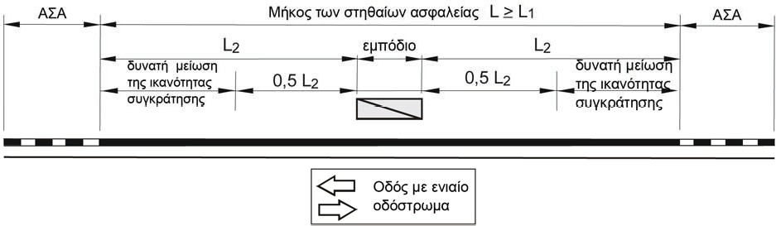

Fig. 15a: Lengths of safety barriers on single carriageway roads
Μήκος των στηθαίων ασφαλείας | Length of safety barriers
Δυνατή μείωση της ικανότητας συγκράτησης | Possible reduction of restraining capacity
εμπόδιο | obstacle
Οδός με ενιαίο οδόστρωμα | Single carriageway road

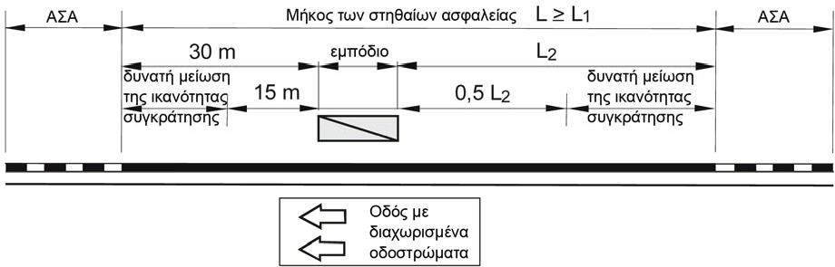
Fig. 15b: Lengths of safety barriers on separated carriageway roads

Μήκος των στηθαίων ασφαλείας | Length of safety barriers
Δυνατή μείωση της ικανότητας συγκράτησης | Possible reduction of restraining capacity
εμπόδιο | obstacle
Οδός με διαχωρισμένα οδοστρώματα | Separated carriageway road

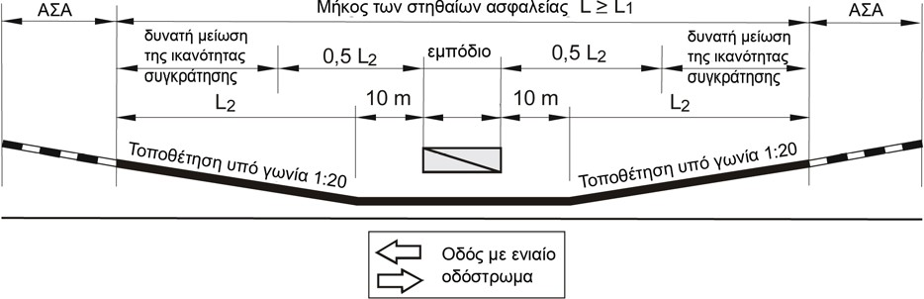

Figure 16a: Angled placement of a safety barrier before the obstacle (single carriageway road)
Μήκος των στηθαίων ασφαλείας | Length of safety barriers
Δυνατή μείωση της ικανότητας συγκράτησης | Possible reduction of restraining capacity
εμπόδιο | obstacle
Οδός με ενιαίο οδόστρωμα | Single carriageway road
Τοποθέτηση υπό γωνία 1:20 | Placement at an angle of 1:20
ΑΣΑ | ΑΣΑ

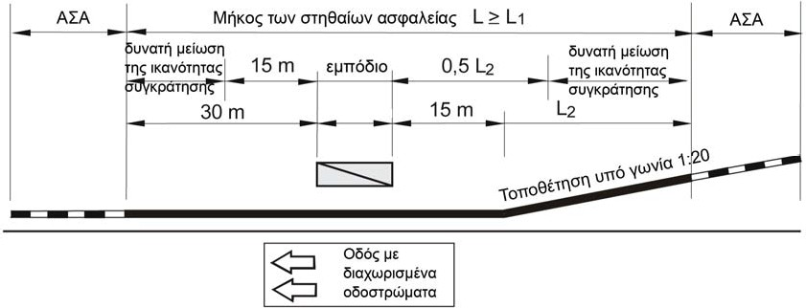

Figure 16b: Angled placement of a safety barrier before the obstacle (street with separated carriageways)
Μήκος των στηθαίων ασφαλείας | Length of safety barriers
Δυνατή μείωση της ικανότητας συγκράτησης | Possible reduction of restraining capacity
εμπόδιο | obstacle
Οδός με διαχωρισμένα οδοστρώματα | Separated carriageway road
Τοποθέτηση υπό γωνία 1:20 | Placement at an angle of 1:20

In the case of agricultural or forestry roads or cycle paths whose junction with the examined road cannot be moved and it is not possible to comply with the minimum lengths of the safety barriers in accordance with these instructions, the possibility in combination with the prevailing local conditions of the following alternatives shall be explored:
      - When length L₂ is not respected then the vehicle restraint system adapted to the local conditions must be installed with a selection of smaller lengths, but in such a way that the risk of slipping over or passing behind the barrier is very small; and
      - When the required length L₁ is not respected, select a vehicle restraint system with as short an operating length as possible L₁; or
      - When the required length L₁ is not respected, select a vehicle restraint system with the next highest restraint capacity and with reduced minimum lengths adapted to local conditions; or
      - Depending on the local conditions, when lengths L₁ or L₂ cannot be respected, the feasibility of installing impact energy absorption systems (IEASs) should be considered.

In the above cases, attention should be paid to the fact that these configurations have been selected in such a way that the associated start and end terminations can take over the tensile and compressive forces.

Safety barriers start and end terminations (BT) shall not be included in the application length L of the safety barriers.

In particular, in the case of terminations of barriers at their relative turn and their entry into sloping trenches, if certification of the terminations is provided, in this case, such certification may not be valid. In particular where the use of certified BT combined with a necessary change in the BT connected to the barrier (e.g., barrier with 12-metre BT) results in a large increase in the cost of safety. In such cases, it is necessary to ensure that in the area of turn of the termination, the foundation strip is sufficiently strengthened to enable it to adequately take over the resulting loads.

In the case of the installation of barriers in ditches or trenches and in order to ensure the functionality of the barrier, the required minimum and maximum installation height above the supporting surface must be respected (see Volume 2 Instructions for installation and repair of vehicle restraint systems of these instructions). The termination of the barrier shall be sufficiently anchored to the slope.

Where short gaps occur between the successive sections of the safety barriers, which do not require a safety barrier, it shall be considered whether a safety barrier is appropriate along these gaps.

When connecting different types of barriers which do not differ significantly from each other, they must be connected by the use of assembly elements (see Volume 3 of these Instructions : Instructions for receipt and control of safety barriers). In the case that between two different types of barriers which do not have a suitable assembly barrier for connection to each other, then one or more different safety barriers can be inserted, which can be connected to each other by appropriate and acceptable (connectors) assembly elements, in order to eventually create a transitional system of sequential safety barriers between the two original barriers, which satisfies the regulations for connecting the barriers to each other (paragraph 3.4). The individual barriers inserted between the original barriers on both sides , in order to ultimately form this appropriate transitional barrier system, do not need to have the required operating length L₁ according to their physical test, but may have a shorter length. This reduced operating length L_{1red} is given in Table 7 (see also Volume 2 - Instructions for installation and repair of vehicle restraint systems) as a function of the ability of safety barriers. The length of the assembly element is added to the lengths of Table 7.

Table 7: Minimum lengths of L_{1red} intervening barriers to create a transitional barrier system

N2 | 12 m
H1 | 16 m
H2 | 20 m
(H3) | (24 m)
H4b | 28 m

Lengths on bridge and retaining wall boundaries
For bridge safety barriers, the provisions of paragraph 7.1 shall apply, in particular as regards length L₂. For this reason, it should be borne in mind that the area in which the safety barrier has its full function should be at a far enough distance from the start of the bridge or the retaining wall so that a fall can be avoided (fig. 17a). No specific reference is made in this case to the assessment of length due to fall, as this
depends on local conditions, such as the height of a connecting branch or embankment, position of the length of the assembly between the technical element and the trench, and so on. When the distance of the outer boundary of the bridge or of the retaining wall is less than 1.5 m from the front/side of the barrier, then the regulations concerning the protection of a barrier against slipping onto the barrier due to the termination at the start of the barrier (see paragraph 7.1) shall apply.

This implies, that safety barriers placed on a bridge, as a rule, should continue after the end of the bridge. If this is not possible, the length of the barrier may be equal to the length of the bridge or the retaining wall, if it is connected to a barrier with the same restraining capacity (Fig. 17b). Paragraph 3.3 shall apply to assemblies. Paragraph 7.1 shall apply to the construction lengths of the connections.
Bridge
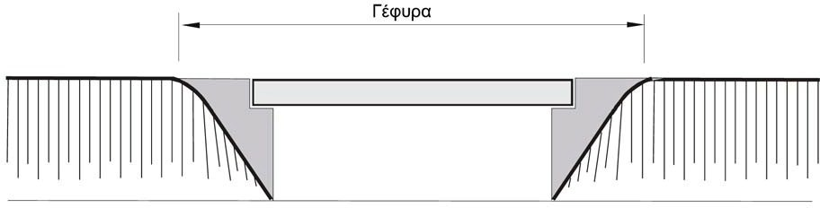
Case a: Safety barrier on bridge
Bridge
Safety barrier length
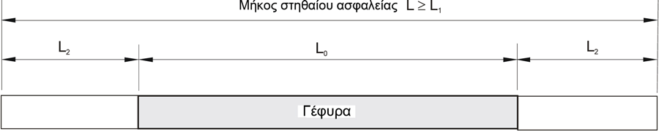
Case B: Safety barrier with construction of a bridge connection
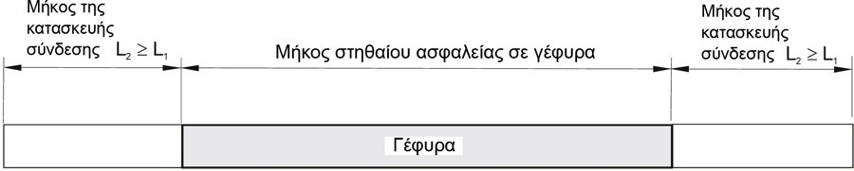
Length of connection construction
Length of connection construction
Length of barrier on bridge

Bridge

Fig. 17: Safety barriers in bridge areas

Movements in the area of mobile joints must be received by the contraction-expansion parts of the safety barriers, in order to avoid damage to the safety barriers.

Before the start and at the end of the bridges, their curbs shall be adjusted in height to the typical cross section of the road by forming a sloped plane with an incline of 1:10.

The performance classes of terminations are defined in paragraph 3.3.

In order to prevent the risk of a fall, an impact energy absorption system must be installed as far as possible in the area of the peaks of the separating islets of the bridge, (fig. 18). The required performance classes are defined in paragraph 3.5.

In areas of non-level highway junctions, the restraining capacity of a barrier depends on the risk position in question. For the boundary line of the technical element on which the main carriageway passes (main direction), restraining capacity H4b is required, if there is no distributional carriageway adjacent to the main road, separated from the main road by a safety barrier. H4b retaining systems may be required on the boundaries of bridges of connecting branches with two or more lanes, passing over the main roads or connecting branches with two or more lanes.

In the lateral configurations of bridges equipped with walls (contact protection panels with overhead electrical networks, sound barriers, etc.), these walls are classified as obstacles. The operational width and, where appropriate, the width of the vehicle intrusion shall not be greater than the distance of the operational width of the safety barrier from these obstacles. Safety barriers combined with railings are generally not suitable for these cases. The dimensioning of the lateral configuration shall take place on the basis of the required width of the safety barrier.

When separating a carriageway and a special pedestrian path or cycle path on the roads, care must be taken to ensure that safety barriers do not have sharp edges or protrusions which would pose a risk to cyclists or pedestrians (preferably a concrete safety barrier or especially suitable steel barriers). Special additions to the barriers, in order to protect these users, can be used if they have a performance certificate as a single system according to ELOT EN 1317.

Since technical safety barriers must be extended beyond their length in order to ensure their functionality (e.g., by switching from embedded systems to clamped systems or possibly by extension to the technical component by means of a foundation plate), close cooperation and coordination between a technical engineer and a road developer (e.g., at the pre-design or final design stage) must be ensured in a timely manner. In the context of this cooperation and coordination, it should also be explored whether the additional lengths of safety barrier can be implemented or any road junction can be shifted immediately before or after technical component and extensions Otherwise, the provisions of paragraph 4.1 apply.

If it is necessary to support a safety barrier on a special support beam by means of an anchoring (foundation strip), the layout of which has not been certified by an ELOT EN 1317 impact test, but the safety barrier has e.g., certification for anchoring to a bridge pedestrian path, it is sufficient for the producer to submit a certificate of static adequacy of the structural design based on the elements of the physical test (e.g., force measurements).

On bridges with a free opening of less than 10 m, on retaining walls of less than 25 m in length and in culverts and for drop heights of less than 2 m, Table 5 shall not apply. Railings are generally assigned to risk class 3.

Safety barriers and railings technically above or adjacent to electrified railway lines shall be protected against electrical conductivity. Depending on the position of the railway line and the electrification devices in relation to the bridge, electro-insulation joints shall be required for the barriers at the end of the bridges and electro-insulating fields consisting of two electro-insulating joints at a distance of at least 2.50 m from the railings. Relevant electro-insulation devices for safety barriers and railings of bridges must be made available under the responsibility of the competent railway operator, which must be integrated into the earthing system of the technical element.

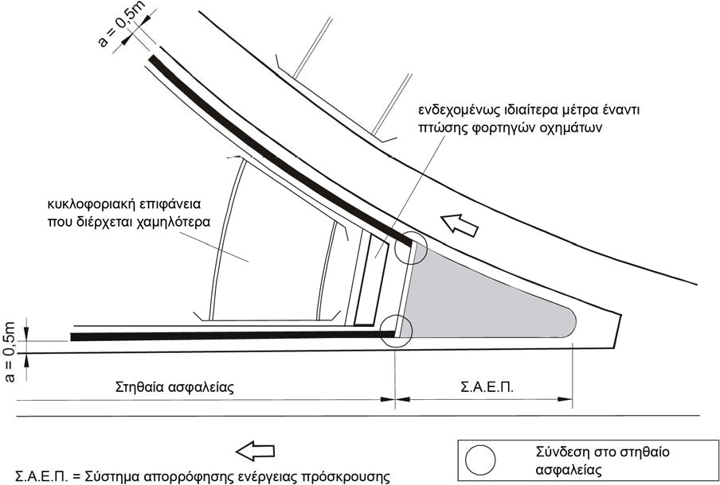

Fig. 18: Impact energy absorption system at the edge of a separating islet
Ενδεχομένως ιδιαίτερα μέτρα έναντι πτώσης φορτηγών οχημάτων | Possible special measures for falling lorries
Κυκλοφοριακή επιφάνεια που διέρχεται χαμηλότερα | Traffic area passing lower
Στηθαία ασφαλείας | Safety barriers
Σ.Α.Ε.Π. = Σύστημα απορρόφησης ενέργειας πρόσκρουσης | IEAS = Impact energy absorption system
Σύνδεση στο στηθαίο ασφαλείας | Connection to the safety barrier

If in the impact test the barrier was fitted with a handrail and during the test, the handrail was part of the repulsion manoeuvre or restraint capacity, the handrail shall be an integral part of the restraint system, which shall not be ignored in the safety design. In such cases, the installation of such a barrier on the central or lateral separating islet must also include the handrail.

For railings at technical elements the standards ELOT EN 1317, ELOT EN 1991-2, ELOT EN 1992-2, ELOT EN 1993-1-1, ELOT EN 1993-1-8, ELOT EN 1993-1-8, ELOT EN 1993-3, ELOT EN 1994-2 and for the construction and supply, the standards ELOT EN 1090 with a minimum class 2 apply.

If the technical element is more than 20 m in length between the edges of the wing walls, the handrails shall be equipped with wire rope of 20 mm diameter according to ELOT EN 12385-4 6x19- or 6x37-SFC 1770 A sZ. Technical elements not equipped with safety barriers will have crash barriers with ends that are sunk or curved in order to prevent them from entering the vehicles that impact with them.

The typical heights for the railings are:

  - 1000 mm for drop height < 12.00 m
  - 1100 mm for a drop height ≥ 12.00 m and
  - 1300 mm if the technical elements passes a cycle path or a combined pedestrian and cycle path.

The width of the handrail shall be at least 120 mm on road bridges; on pedestrian bridges this width may be reduced to at least 80 mm. The free distance between the metal columns may not exceed 120 mm.

For the loads on railings those referred to in the standard ELOT EN 1991-2 shall apply.

Producers of railings must submit the relevant certificates of performance in accordance with ELOT EN 1090-1 and for welds the certificates according to ELOT EN 1090-2 for steel and ELOT 1090-3 for aluminium railings respectively.

On bridge boundaries, the height of railings respects the following rule:

h railing+protection = h safety barrier + h-b-0.05≥h min

where
h _{railing+protection}= minimum required railing height including the additional height of protection against falling [m] ≤ 2.00 m,
h_{safety barrier}= height of a safety barrier above the surface of the emergency lane [m],
h = minimum railing height depending on drop height (1.00 or 1.10 m) [m],
B = distance between the rear side of a safety barrier at the height of its upper edge and a front railing edge [m]
h_{min}= minimum railing height as mentioned above [m].

In order to limit the height of the railing between barriers with the same characteristics, those with the lowest height shall be selected. The overall height of a railing and of the drop protection shall not exceed 2 m above the surface of the lateral configuration of the bridge.

The height of the railing shall be limited to a bridge boundary with a holding capacity H2 to a value of 1.20 m. The height of the safety barrier shall apply:

h_{safety barrier} ≤ h_{railing}-h + b + 0.05
with h_{railing} = selected railing height ≥ h_{min} and ≤ 1.20 m.

In exceptional cases, which can be properly documented, solutions may be chosen by way of derogation from the foregoing, after weighing road safety data and local constraints.

Temporary (portable) safety barriers

General
Temporary (portable) safety barriers must be placed in long-term project areas, for separation, guidance and overall safe operation of traffic.

The parts of temporary safety barriers shall be connected to each other and placed, in accordance with the manufacturer’s instructions, in order to provide protection to both the traffic in transit and the activities behind them. If they are not connected, in the event of a vehicle impact, they shall be expected to be displaced and/or overturned according to the speed, mass of the vehicle and angle of impact.

Restraining capacity
The areas of application of temporary safety barriers are shown in Figure 19 and the requirements to be fulfilled are given in Table 8.
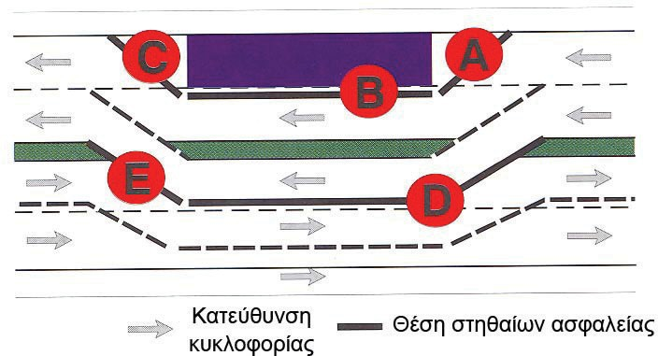
Fig. 19: Areas of application of temporary safety barriers

Κατεύθυνση κυκλοφορίας | Traffic direction
Θέση στηθαίων ασφαλείας | Position of safety barriers

In application areas A and B, the transverse displacement of temporary safety barriers may not be greater than the distance from them to the area where site personnel work, materials or equipment, such as scaffolding, are available.

There is no particular requirement for the application area C.

Table 8: Restraining capacity and operational width of temporary safety barriers

Application area as per Fig. 18 |  | Minimum restraining capacity  according to EN 1317 | Operational width according to EN 1317 | Dynamic transverse displacement  [cm]
 | Location of safety barriers | Minimum restraining capacity  according to EN 1317 | Operational width according to EN 1317 | Dynamic transverse displacement  [cm]
Α | between construction site and upcoming traffic | T21) | ≤ W4
B | between construction site and traffic in parallel | T11) | ≤ W4
C | between construction site and outbound traffic | no restraint system is required

Application area as per Fig. 18 |  | Minimum restraining capacity  according to EN 1317 | Operational width according to EN 1317 | Dynamic transverse displacement  [cm]
 | Location of safety barriers | Minimum restraining capacity  according to EN 1317 | Operational width according to EN 1317 | Dynamic transverse displacement  [cm]
D | between the opposite traffic flows | T12) | ≤ W4 | ≤ 50
E | between the opposite traffic flows in the diversion area | T22) | ≤ W4 | ≤ 50

1) If greater restraining capacity is required to provide adequate protection in the area of works being carried out for workers and/or machinery, a barrier with H1 and T3 restraining capacity should be provided in Areas A and B respectively. The operational width is determined according to the local conditions in accordance with EN 1317.
2) In case the participation of trucks in traffic is high and there is an increased risk of truck engagement in an accident, e.g., on a downhill, a T3 restraint system may also be selected if the available width of the carriageway is sufficient.

Temporary safety barriers shall be examined by means of impact tests, with regard to their ability to shift, the safety they provide during their break-up and the taking of protective measures for both traffic participants and third parties. As regards their restraining capacity, they must fulfil the requirements of ELOT EN 1317.

Operational width
Since the selection of the appropriate temporary barriers is a function of the distance available from the site and the available width of the islet, the operational width plays a particularly important role.

The width of the islet between the opposite traffic directions depends on the design width and/or the construction width of the temporary safety barrier, where:
      - construction width is the maximum section width of the temporary safety barrier and
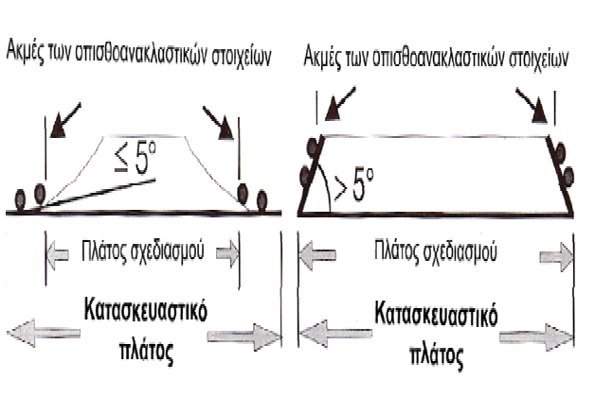
      - design width is the horizontal distance between the inner edges of the retro-reflective elements in the foot area of the temporary barrier which is formed with an angle of not more than 5º. If the angle between the base and the inner edges of the retro-reflective elements is greater than 5º, the construction width corresponds to the design width (figure. 20).

The design width corresponds to the required width of the separating islet

Fig. 20: Definition of the relevant widths of temporary safety barriers

Ακμές των οπισθοανακλαστικών στοιχείων | Edges of retro-reflective elements
Πλάτος σχεδιασμού | Design width
Κατασκευαστικό πλάτος | Construction width

Passive protection
Temporary safety barriers shall be examined by means of impact tests, with regard to stability, safety at breakage and protection for traffic participants and third parties. Otherwise, for example as regards restraint capacity, temporary safety barriers must fulfil the requirements of ELOT EN 1317.

In view of the specific conditions prevailing in the project areas, in addition to the operational width of the proposed restraint systems, in accordance with Table 4 of ELOT EN 1317, the dynamic transverse displacement should also be reported. A dynamic transverse displacement equal to or less than 50 cm shall be permitted between the opposite circulating traffic flows, regardless of the operational width.

For this reason, it is not permissible to cause damage to the vehicle during the impact of a vehicle so serious that the driver loses control of the vehicle.

Breaks in safety barriers
Breaks in safety barriers shall be permitted only in justified cases. These should be as short as possible. Other traffic safety requirements such as visibility, gauge, etc. should also be taken into account.

Breaks in safety barriers should be avoided in particular in road sections with small horizontal radius It shall always be considered whether it is possible for roads to contribute to locations where the installation of safety barriers is not necessary.

In areas where breaks in safety barriers are applied, the safety barriers must be overlapped according to fig. 21.
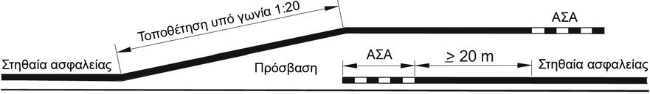
Fig. 21: Breaks in safety barriers

Στηθαία ασφαλείας | Safety barriers
Τοποθέτηση υπό γωνία 1:20 | Placement at an angle of 1:20
Πρόσβαση | Access
ΑΣΑ | BT

When there is no possibility of a vehicle falling into the area of interruption, the safety barriers may be positioned at an angle and connected to start and end terminations (fig. 22a and 22b). In this case the safety barrier and its start and end terminations, insofar as possible, shall be placed at an angle of 1:12.
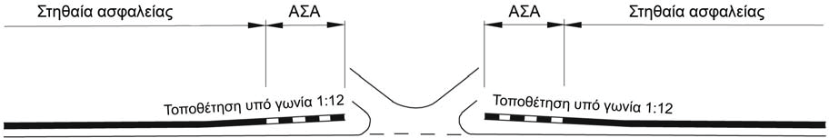
Fig. 22a: Breaks in safety barriers with placement and terminations at an angle
Στηθαία ασφαλείας | Safety barriers
Τοποθέτηση υπό γωνία 1:12 | Placement at an angle of 01:12
ΑΣΑ | BT

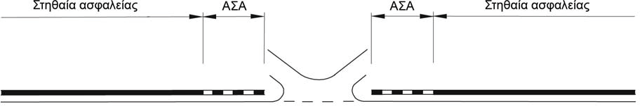

Fig. 22b: Break in safety barriers with terminations in the path of the safety barrier
Στηθαία ασφαλείας | Safety barriers
ΑΣΑ | BT

Curving (rounding) the barrier can prevent diverted vehicles from penetrating hazardous positions. Safety barriers must be curved with as large a radius as possible (fig. 23c and 23d). For this reason, safety barriers may be placed at an angle of 1:12. In any case, a curved safety barrier shall be connected to a start and end termination or a safety barrier. The curvature of a safety barrier must ensure its functionality. Annex 12 to this Volume describes in detail the relevant requirements for the curves of safety barriers.
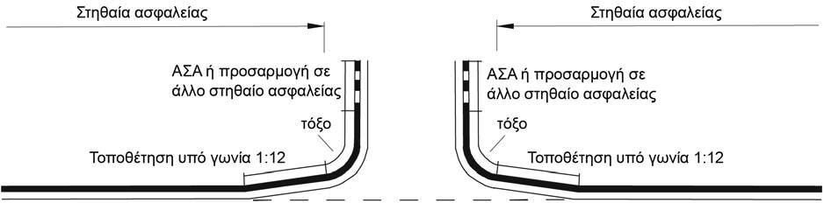

Fig. 23c: Configuration of the safety barrier with angled placement and curvature
Στηθαία ασφαλείας | Safety barriers
Τοποθέτηση υπό γωνία 1:12 | Placement at an angle of 01:12
ΑΣΑ ή προσαρμογή σε άλλο στηθαίο ασφαλείας | BT or adaptation to another safety barrier
Τόξο | Arch
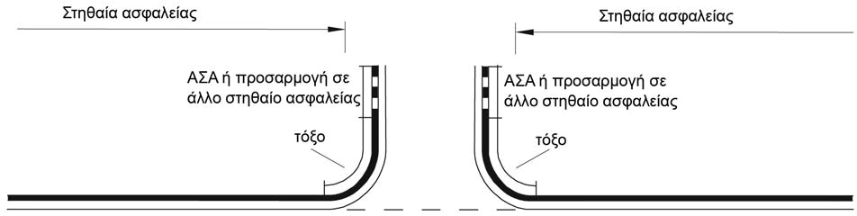

Fig. 23d: Configuration of the break in safety barrier with curvature but without angling
Στηθαία ασφαλείας | Safety barriers
ΑΣΑ ή προσαρμογή σε άλλο στηθαίο ασφαλείας | BT or adaptation to another safety barrier
Τόξο | Arch

Safety barriers start and end terminations
Safety barriers must always be provided with a start and end termination This applies mainly to the peaks of separating islets (fig. 24).
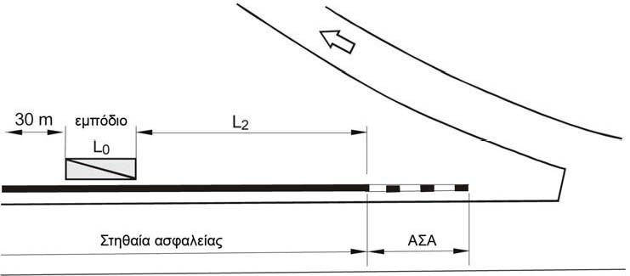
Fig. 24: Separating islet with safety barrier and start termination
Στηθαία ασφαλείας | Safety barriers
ΑΣΑ | BT
Εμπόδιο | Obstacle

If it is necessary to install safety barriers on both carriageway boundary lines the start and end terminations of the islets shall be at least 3 m apart (fig. 25).

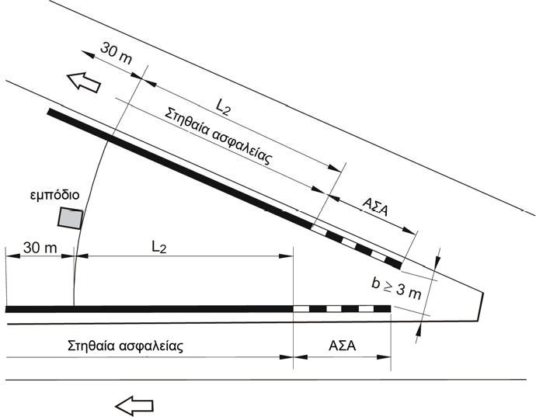
Fig. 25: Separating islet with safety barriers and start terminations
Στηθαία ασφαλείας | Safety barriers
ΑΣΑ | BT
Εμπόδιο | Obstacle

When obstacles are found within the critical distance (f. 26) and the necessary lengths L₂ are not available, impact energy absorption systems (IEAS) must be installed to achieve the required safety.

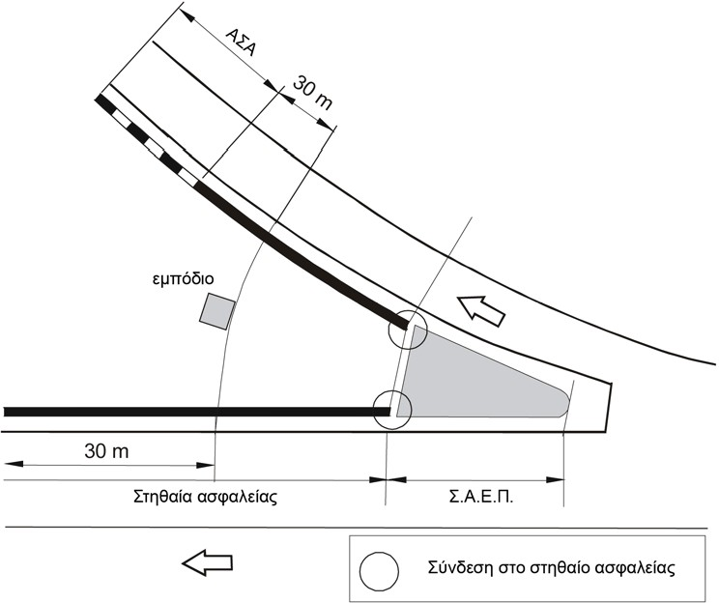

Fig. 26: Separating islet with pre-obstacle impact energy absorption system
Στηθαία ασφαλείας | Safety barriers
Σ.Α.Ε.Π. | IEAS
Εμπόδιο | Obstacle
Σύνδεση στο στηθαίο ασφαλείας | Connection to the safety barrier

At the beginning of the central or lateral separating islet, provision should be made for the application of start terminations. If obstacles exist, lengths L₂ (fig. 27).
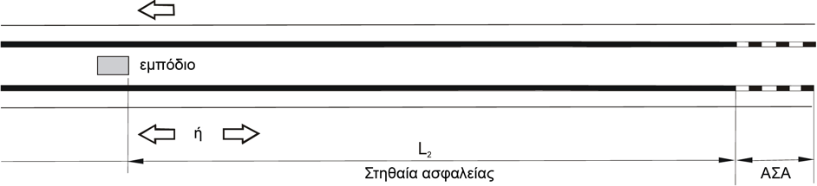

Fig. 27: Safety barrier with terminations (BT) at the start of a central or lateral separator islet
Στηθαία ασφαλείας | Safety barriers
ΑΣΑ | BT
Εμπόδιο | Obstacle
ή | or

In the event of a temporary opening of a central separating islet, provision should be made for the application of start and end terminations.

When the required length L₂ is not available at the start of the central or lateral separating islet, an impact energy absorption system shall be fitted (fig. 28).
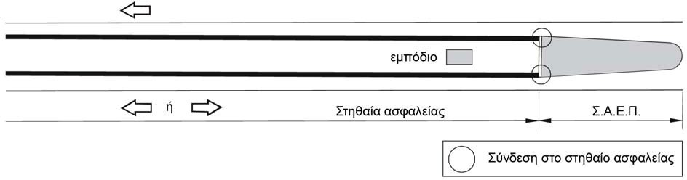
Fig. 28: Impact energy absorption system at the start a central or lateral separating islet

Στηθαία ασφαλείας | Safety barriers
Σ.Α.Ε.Π. | IEAS
εμπόδιο | obstacle
Σύνδεση στο στηθαίο ασφαλείας | Connection to the safety barrier

Similarly, where an obstacle of up to 50 m is present in the outage areas of the central separating islet and the permissible speed cannot be limited to 60 km/h, provision shall be made for the installation of an impact energy absorption system.

Technical criteria for selecting vehicle restraint systems

General
The Technical Criteria for selecting safety barriers aim to create an operational road safety system, characterised by the high quality of the system itself, as well as the characteristics and properties of its maintenance and replacement.

In order to ensure the high-quality characteristics of a safety barrier, its compatibility with the ELOT EN 1317 standard alone is not sufficient, but additional requirements adapted to the particular requirements of the construction of a road or its technical elements (e.g., narrow side configurations with road equipment and plumbing constructions or impassable curbs , etc.) must be fulfilled. Particular emphasis is placed in this case on the provision of an economic safety barrier that fully meets the desired levels of road safety, while at the same time the overall road safety system will be feasible for all those involved in the operation of the road, both in terms of availability, quality of material and performance, factory support, repair and replacement capacities, as well as tendering and award procedures.

For this purpose, the Technical Criteria set forth in this chapter have been formulated and may be used by the competent technical services in connection with the relevant notices for safety works or tendering for road construction works. The fulfilment of specific criteria by producers of safety barriers may be demonstrated by the submission of specific certificates or attestations. Alternatively, the producer of a safety barrier may include the specific certificates or attestations in the specifications of the safety system provided by it in order to avoid the procurement of the relevant certificates or confirmations and to facilitate the procedure for notices of construction works and awards for both the Managing Service and the producers.

A key feature of the Technical Criteria is the attempt to install, insofar as possible, a continuous and uniform safety system and avoid the fragmentation of the safety system into individual systems. Despite this, it is possible for some specific and limited construction work on a road to require safety schemes which fulfil the specific requirements of the specific road operations. Furthermore, any notice of a safety barrier should take into account the compatibility of the system with the safety systems to be connected in the course of subsequent road construction work and with existing systems. This means that future safety notices should fulfil the Technical Criteria for both the main systems and their assemblies and terminations at the same time. Of particular importance in this case for the Managing Services is the supply of safety barriers with interchangeable parts (modular-type barriers) from various producers, as this results in the rapid and economic repair or replacement of worn or damaged safety barriers.

The Technical Criteria are distinguished in these for main systems, IEASs, assemblies and terminations, as well as specific requirements for safety notices. Notices should check the correlation of the Technical Criteria with the specific construction works and projects and be appropriately incorporated into them.

Technical criteria for selecting safety barriers
The Technical Criteria for vehicle restraint systems are described in Table 9. Criteria S1 to S5 must be fulfilled and the fulfilment of criteria S6 to S9 depends on the specifics of road safety and are potentially included in the notices.

Table 9: Safety barrier requirements and system characteristics

Submission of certificates
 | Requirements | Supporting documents/certifications
S1 | All relevant evidence of the certification process (e.g., table of amendments, test reports, product performance certification documents by an Accredited Body, reports and documents  amendments, etc.) shall be submitted for certified safety barriers. | Stability performance certificate by an Accredited Body with annexes and producer's performance declaration. | Depending on the system
alternatively, | A performance certificate in accordance with ELOT EN 1317 as well as an additional certificate of durability in accordance with Volume 4 for a cast concrete barrier with all its relevant annexes (change list) shall be submitted for cast concrete barriers. The certificates will have been issued for both the product of the cast barrier as well as the process of its on-site manufacture. | Performance certificates according to ELOT EN 1317 and of durability (over 25 years) with the relevant annexes | Depending on the system
ELOT EN 1317 positive impact tests
 | Requirements | Supporting documents/certificates
S2 | Submission of test reports from an accredited laboratory and a performance certificate (stability) issued by an Accredited Body  in accordance with ELOT EN 1317 | Test control report | Depending on the test
S3 | Submission of impact videos (as a.avi or.mpeg file) for all downloads  according to ELOT EN 1317 | Video | Depending on the test
System and Installation Documents
 | Requirements | Supporting documents/certificates
S4 | Submission of safety data in accordance with the relevant Template (see Annex 8) | Data Sheet | Depending on the system
S5 | Submission of producer installation instructions with date, Volume number, number of pages and type-related data  construction | Installation instructions | Depending on the system
Road safety criteria
 | Requirements | Supporting documents/certificates
S6 | Indication of whether parts with a mass > 2 kg have been detached during the ELOT EN 1317 impact test | Reference to the test report according to Annex A of ELOT EN 1317-2 paragraph  5.2.15 or as issued in the future | Depending on the system
S7 | Indication whether the safety barrier has dangerously shaped parts (sharp)  uprights, unprotected wire ropes, projections, etc.) | Technical drawings of safety barriers | Depending on the system
S8 | Indication whether the safety barrier has additional motorcycle protection structures incorporated in the impact test and the performance certificate | Proof of tests of additional structures  and of the overall system | Depending on the system
S9 | Indication of whether the impact test was carried out in confined space conditions, such as near slopes, with various obstacles such as trees, base plates,  near bridge boundary line, manholes and various other obstacles or generally dangerous locations | Reference to test reports and data sheet (important: reference to distance  from the hazardous position or obstacle) | Depending on the system
Certificate S1
According to Regulation (EU) No 305/2011 of the European Parliament and of the Council of 9 March 2011, a safety barrier circulating in EU must bear the CE mark. Consequently, the relevant certificates of validity of the CE mark must be produced by the supplier (producer) of each system together with the corresponding annexes or accompanying documents. Special conditions may apply only in cases of concrete barriers cast in situ. This type of barrier, in addition to performance certificate according to ELOT EN 1317, must also have an additional certificate to ensure the stability of the performance of this type, relating to its durability (lifespan of at least 25 years) by a notified body (see Volume 2 – Instructions for installation and repair of vehicle restraint systems and the relevant Volume 4 – Instructions for the application of in situ cast concrete safety barriers) of these instructions.

ELOT EN 1317 positive impact tests (S2, S3)
According to these instructions, all barriers must fulfil the requirements of ELOT EN 1317. This is demonstrated by the relevant reports of a notified body according to ELOT EN 1317. For the suitability check of a specific safety barrier for its area of application in accordance with the notice, its full control test reports and videos must be submitted by the accredited laboratory. For example, a barrier may be considered suitable in accordance with these instructions or an acceptable deviation at a bulkhead position with a greater operational width, if the impact control shows that this safety barrier is working satisfactorily for the given lateral road configuration. It is therefore necessary to provide all control test reports and related videos of the impact tests showing the behaviour of the system during impact. Test reports and related videos are also necessary to assess e.g., elements of the barriers, showing the behaviour of safety barriers during the impact test.

System and installation documentation (S4, S5)
The documentation of the system and its installation is intended to inform all those involved in the design, study and installation of the safety barrier, such as designers and the Managing Service, of the relevant information. The manufacturer (producer) of a safety barrier must provide a complete sheet with the necessary details of the barrier. In addition, the manufacturer (producer) must provide all the necessary instructions for installing the safety barrier in accordance with ELOT EN 1317. These instructions shall include a full description of the system, as well as detailed technical drawings. This information is an essential basis for documenting the compatibility of the construction of the barrier with the contractual obligations and is therefore absolutely necessary for safety designers and the Managing Service, which will check and approve the safety barrier design.

This information is particularly necessary for the Managing Service, as the possibilities and limits for the application of the safety barrier are clearly established and the Managing Service can therefore check the quality and completeness of the installation of the safety system and of any possible reductions in its performance. The installation instructions must have been verified by the notified body which issued the performance certificate and recognised and accepted by it. Particular reference should be made to the relevant documentation in specific applications and installations under various conditions such as embankment slopes, steep slopes and foundation ground slopes, bridge pedestrian paths, a special foundation and support surface, existing high curbs, etc., as provided for by the current Instructions for road project studies or Regulation on studies and research for new or existing projects. Particular reference to additional structures in the manufacturer’s installation instructions and the notified body’s performance certificates are of particular importance in this case.

The manufacturer shall be responsible for the installation instructions and the operation of the safety barrier for the various conditions of application. In the event that the installed safety barrier is modular, the producer shall also provide a list of the types of barriers with which the various parts of the safety barrier are interchangeable as well as their producers.

Road safety criteria (S6 to S9)
With regard to the detachable parts of the barrier, ELOT EN 1317 requires the explicit reference to the control test report of the accredited testing laboratory. In particular, on the technical side, the central islet of separated roads or the safety barriers of roadside pedestrian paths and cycle paths, where there is a risk to third parties due to the removal of parts of the barrier, this problem must be handled with particular care. This may lead to the exclusion of the use of systems from which parts are detached for specific safety projects, as otherwise the required levels of road safety are not ensured.

System components with spikes can also become dangerous for motorcyclists. So far, this consideration has not been incorporated in the harmonised part of ELOT EN 1317, although motorcycles are considered as vehicles and therefore their behaviour in impacting barriers should be taken into account. From the point of view of road safety, therefore, the choice of a safety barrier which poses a potential risk to motorcyclists should be avoided. Also, systems equipped with unprotected steel wire ropes can cause serious injury to motorcyclists. All these structures which do not ensure the required levels of road safety and the best possible protection for road users should therefore be avoided (European Parliament Resolution of 27.9.2011 on European Road Safety 2011-2020 [2010/2235(INI)]).

Concrete safety barriers (cast in-situ or prefabricated) are generally a closed safety system. Therefore, no additional structures are required for the types of such safety barriers to prevent motorcyclists from sliding below the barriers.

The reference to possible special construction conditions during the impact test is not mandatory, but it is useful information for the designers and the Managing Services who announce the relevant works. Specific requirements for safety barriers must be indicated in the safety notices of works or tenders for road works in general and the relevant supporting documents must be submitted together with the producer’s bid.

Additional requirements for technical elements of safety barriers
Safety barriers installed on technical elements for reasons of technical safety must satisfy additional requirements. These concern anchorings and transferable forces and are listed in Table 10.

Table 10: Additional technical requirements for safety barriers

Additional technical requirements for safety barriers
 | Requirements | Supporting documents/certificates
ΤΕ1 | Positive impact test in relation to the lateral configuration of the bridge  construction. | Description in the test report | Depending on the system
ΤΕ2 | Force measurements during the impact test and classification according to ELOT EN 1991-2,  4.7.3.3 (1) for H2 and H4b restraining capacity. For restraining capacity H1 alternatively sufficient for the  theoretical calculations | Registration of the forces measured, their assessment and classification report. | Depending on the system
ΤΕ2a | Determination of the value of 1.25 of the local characteristic resistance of the safety barrier in accordance with ELOT EN 1991-2,  4.7.3.3 (2) | Static calculation including static proficiency check | Depending on the system
ΤΕ2b | Identification of the necessary load augmentation factors a _{safety barrier} | Static calculation | Depending on the system
ΤΕ3 | Support for the safety barrier on concrete | Entry in the control test report | Depending on the system
ΤΕ4 | Certificate of functional adequacy compatible with the operation of the respective movable joints (contraction-expansion) of the bridge | Checked calculation of transferred forces and, if possible, entry in the control  test report | Depending on the system
ΤΕ5 | Provision of a suitable safety barrier outside a technical element by connection by means of an attachment or construction of a barrier (see Volume 3) | Certificate of compliance with criteria for safety barriers other than technical elements and appropriate assembly elements or assembly structures  of barriers. | Depending on the system
ΤΕ6 | No detachable parts > 2 kg which will fall from the ends of the technical bridges at the risk of third parties (for restraining capacity H2 and H4b). For other restraining capacities see Criterion  S6 | Entry in the control test report and impact video | Depending on the system
ΤΕ7 | Installation instructions with additional instructions for installation on  technical elements | Installation instructions | Depending on the system

Screening of safety barriers in a structure similar to the lateral configuration of the bridge (TE1, TE2 and TE3)
Safety barriers shall demonstrate their suitability by means of impact tests on structural configurations which are commensurate with the lateral configuration of the bridges and the tests which will result in the forces carried to the technical element. In addition, there are requirements for anchoring the systems in the lateral configurations of concrete technical elements in order to avoid damage to the technical element and to ensure its operational and static adequacy. As regards the necessary static checks and calculations on existing old bridge technical elements, they will be carried out with the applicable regulations on calculations of static bridge studies.

Integration of mobile joint behaviour in control test (TE4)
Because on long bridges it is necessary to take into account the changes in length of safety barriers due to the contractions occurring in the joints of the bridges, it must be ensured that the moving joints do not significantly alter the functionality of the safety barrier in cases of vehicle impact and that the longitudinal forces are borne normally. In addition, a moving joint should be formed at 1/3 of the barrier test length during the impact test in order to demonstrate that the joint can transfer the expanding forces from the impact. This criterion shall be fulfilled for a safety barrier to be installed after 1.5.2022. The period up to that date shall be considered as a transitional period and the fulfilment of the criterion for installed barriers shall not be mandatory. Safety barriers satisfying this criterion during this transitional period have greater weight in the evaluation of tenders in the relevant project notices.

Availability of safety barriers other than technical elements (TE5)
These instructions require the selection of a safety barrier in addition to technical elements with the same restraining capacity. Depending on the barrier, the connection of the barrier inside and outside the technical element must take place by means of an assembly element (transitional element) or a barrier assembly (assembly construction) in accordance with Volume 3 of these instructions. Consequently, the choice of the technical element’s appropriate safety is directly linked to the existence of a suitable barrier apart from a technical element, which will also fulfil the relevant technical criteria.

Non-detachable parts of safety barriers > 2 kg (TE6)
In order to protect any third party under bridges, it is necessary in such cases for a barrier with H2 and H4b restraining capacity to select those systems from which >2 kg parts are not detached during the impact tests (TB 51 and TB 81) or systems which have undergone a recognised modification according to ELOT EN 1317 Part 5 to prevent the detachment of such parts. Parts with a mass > 2 kg may not be detached during the impact of passenger vehicles (TB 11 or TB 32). For a barrier with a H1 restraining capacity, this requirement for the TB 42 test is not generally set, but depends on the applicable case each time and the conditions under the bridge. The relevant requirement shall be indicated in the project notice if deemed appropriate by the Managing Service.

Additional requirements for the installation of the safety barrier (TE7)
In technical elements, the lateral configuration of which deviates from that of the impact test (e.g., incline change, etc.) the manufacturer (producer) is required to make explicit reference to them. In such cases, it is necessary to comply with the instructions for installing the manufacturer’s (producer’s) safety barrier and the various modifications or adaptations such as the incline of the uprights or the height of the safety barrier, etc. In this way, the manufacturer (producer) facilitates the application of the safety barrier if it makes a reference to it. In particular, the criteria and regulations referred to in Volume 2 (Instruction for installation and repair of vehicle restraint systems) of these instructions apply to these matters.

Requirements for IEASs
IEASs must bear a CE mark. The relevant requirements are set forth in Table 11.

Table 11: Requirements for IEASs

Submission of a certificate
 | Requirements | Supporting documents/certificates
SΑ1 | All supporting documents of the certification process (certification reports, amendments, etc.) shall be submitted. These documents should explicitly refer to the type of “recovery” IEAS (R type) | - Performance certificate with annexes  - Type-certificate  “recovery” – R – if not mentioned on the performance certificate | Depending on the system
Positive impact control test according to ELOT EN 1317
 | Requirements | Supporting documents/certificates
SΑ2 | Submission of check test reports of a notified body in accordance with ELOT EN 1317 | Test report | Depending on the system
SΑ3 | Submission of impact videos (type  .avi or.mpeg) for all download posts according to ELOT EN 1317 | Video | Depending on the system
System and Installation Documents
 | Requirements | Supporting documents/certificates
SΑ4 | Submission of IEAS data sheet | Data sheet | Depending on the system
SΑ5 | Submission of installation instructions  (date, Volume number, page number) with connection elements in the following safety barrier | Producer Installation Instructions | Depending on the system

Requirements for barrier assemblies
The connection between two safety barriers takes place via barrier assemblies, which must fulfil the requirements of ELOT EN 1317. As the implementation of standard EN 1317-4 is not yet harmonised, quality requirements and checks for these systems are regulated at national level. The requirements for barrier assemblies in the country are included in Volume 2 (Instructions for installation and repair of vehicle restraint systems) and Volume 3 (Instructions for receipt and control of safety barriers) of these instructions. Until the pan-European adoption of Part 4 of standard EN 1317, the manufacturer (producer) of safety barriers must submit operational performance certificates in accordance with Volume 2 and Volume 3 of these instructions. The relevant requirements for safety barriers and assembly elements are set forth in Table 12.

Table 12: Requirements for barrier assemblies (including transitional elements)

Submission of a certificate of operational characteristics of barrier assemblies and elements
 | Requirements | Supporting documents/certificates
SΥ1 | Submission of a certificate of compliance with operational requirements for barrier assemblies and transitional elements for  connection of two specific safety barriers | Certificate of proper operation⁴ | Depending on the system
SΥ2 | Submission of a data sheet | Data sheet | Depending on the system
SΥ3 | Submission of installation instructions including documents,  product description and technical drawings | Installation instructions | Depending on the system

4 Shapes for connection between safety barriers lawfully marketed in another EU Member State or in Turkey or in the Contracting Parties to the EEA Agreement shall be accepted for use in Greece if they fulfil the quality standards defined by the technical criteria.

Requirements for barrier terminations
Safety barrier terminations must comply with the requirements of ELOT EN 1317. As the implementation of standard EN 1317-4 is not yet a basis for certification of the system (non-harmonised standard), quality requirements and checks for these systems are regulated at national level. Until the adoption pan-European of Part 4 of EN 1317, the manufacturer (producer) of barrier terminations shall submit certificates of operational performance of the terminations. The relevant requirements for terminations are set forth in Table 13.

Table 13: Requirements for barrier terminations

Submission of confirmation of essential termination characteristics
 | Requirements | Supporting documents/certificates
AP1 | Submission of a certificate of compliance with operational requirements (essential characteristics) of barrier termination in conjunction with the  Safety barriers | Certificate of proper operation⁵ | Depending on the system
AP2 | Submission of a data sheet | Data sheet | Depending on the system
AP3 | Submission of installation instructions including description documents  product and drawings | Installation instructions | Depending on the system

Additional requirements in project notices
Additional requirements may be set forth in relevant project notices, which will be assessed accordingly for the selection of the appropriate system each time. Such could be:
      - Patent supporting documents, multiple manufacturing data requirements,
      - Availability of spare parts,
      - A contract for undertaking repairs;
      - Safety barrier for application to emergency opening of stabilised central islets;
      - Safety barrier for application in places with limited space, such as narrow bases or narrow side configurations of bridges, on slopes, etc.
      - Additional information (life cycle, certified installation workshops, quality checks, times and specifications of inspections, maintenance, repairs, etc.)
      - Other requirements on a case-by-case basis.

All documents and supporting documents will be submitted in electronic format (type Adobe Acrobat, Microsoft Word, JPEG, etc.)

The documents and supporting documents will be in Greek.

All documents and supporting documents will be dated, Volume number and page number.

5 Barrier terminations, lawfully marketed in another EU Member State or in Turkey or in the Contracting Parties to the EEA Agreement, which have concluded an economic agreement with the EU, shall be accepted for use in Greece if they fulfil the quality standards defined by the technical criteria.

In cases of deviations of local installation conditions with those of impact tests, additional information or clarifications may be required from the certification bodies on the content of the impact control test reports, which the manufacturer (producer) of the systems should ensure are available.

Safety studies
Safety studies include technical reports and drawings.
The drawings include:
- Horizontal drawing (fig. 29)
The selected or planned systems shall be scaled into horizontal drawings The completeness and detail of the information depends on the stage of the study (final or implementation study). In the implementation study, which shall form the basis for the construction of the selected safety system of a particular producer, it shall include in scale the location, method of installation, lengths, terminations and assemblies and the production code of each part of the safety barrier. The scale of the drawings will be 1:1000 or greater.
- Technical elements
For technical elements, such as bridges, tunnel fronts, etc. the horizontal drawing and detailed drawings for the configuration of the safety barrier on them as well as the connections of the system with that of the road before or after the technical elements will also be submitted.
- Longitudinal drawing (Fig. 30)
The implementation study shall also provide a longitudinal drawing containing all the details of the installation of the system. The validation will be on the side of the carriageway. Particular attention will be paid to the longitudinal drawing, the appearance of information concerning the support of uprights in conjunction with existing networks and utilities. Details of installation of joints, terminations, bridge joints, etc. will also be included. The drafting of the longitudinal drawing may require an on-site visit and inspection of the project in order, for example, to obtain the exact positions of the uprights with insertion or anchoring. The scale of the drawings will be 1:500/1:50 or more.
- As built drawings
The final construction of the safety system will be documented in specific final “as built” drawings, with complete tracing of the installed barrier, which will form the basis for maintenance, repair and replacement work in the future.

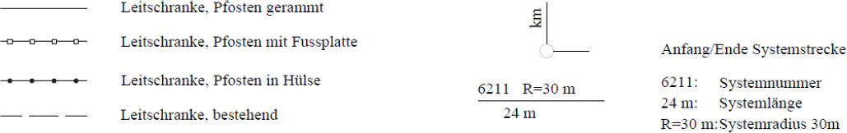
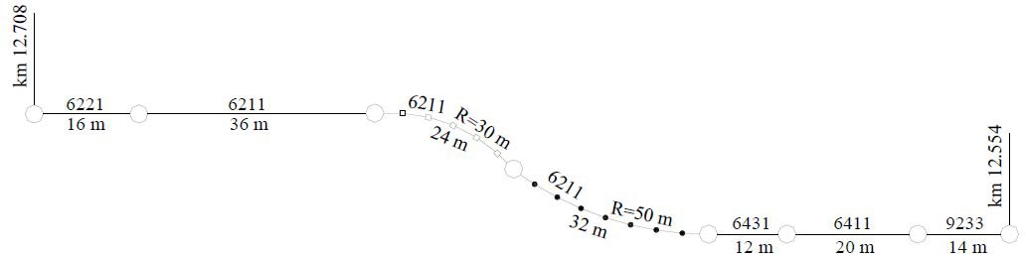
Safety barrier with inserted upright
X.T. 12.+708
X.T. 12.+554
safety barrier with anchored upright
safety barrier with upright in a tube
Existing safety barrier

Start/end design

Safety barrier production code
Safety barrier length 24 m
Safety barrier radius 30 m

Fig. 29: Model for a horizontal safety application design (scale 1:1000)

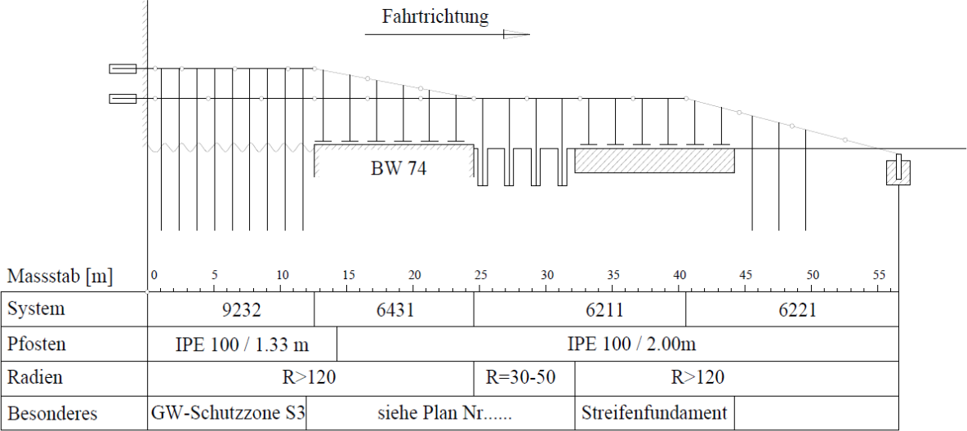
Direction of movement
Technical element 74
Aquifer Protection See Drawing.......
Foundation plate

Length [m]
Safety barriers
Uprights
Radius
Miscellaneous

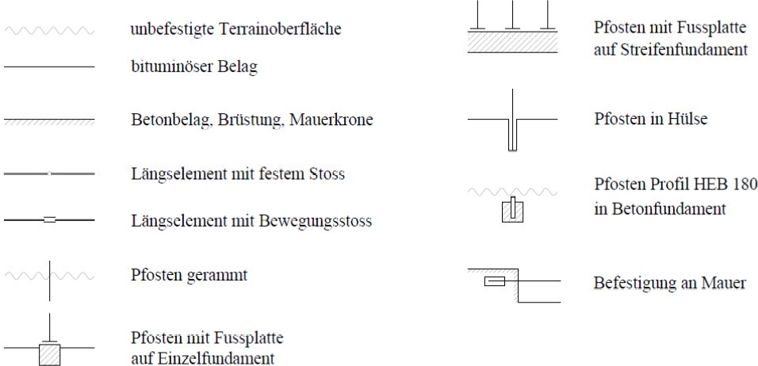
Upright with anchoring on foundation plate
Upright in tube
Upright with insertion/anchoring in concrete foundation
Support on wall
Upright with anchoring on individual foundation
Asphalt surface
Unstabilised surface
Upright with insertion
Longitudinal element with mobile connection
Longitudinal element with fixed connection
Concrete surface, wall crown

Fig. 30: Model Longitudinal design application (scale 1:500/1:50)

Annex 1

References
- European Standard (ELOT EN 1317-1:2010) Road restraint systems, Part 1: Terminology and general criteria for test methods
- European Standard (ELOT EN 1317-2:2010) Road restraint systems, Part 2: Performance classes, impact test acceptance criteria and test methods for safety barrier
- European Standard (ELOT EN 1317-3:2010) Road restraint systems, Part 3: Performance classes, impact test acceptance criteria and test methods for impact energy absorption systems
- Optional European Standard (ENV 1317-4:2001:) Road restraint systems, Part 4: Performance classes, impact tests acceptance criteria and test methods for safety ends and fits
- European Standard (ELOT EN 1317-5:2007+A2:2012/AC2012) Road restraint systems, Part 5: Durability criteria and performance certification
- CEN technical report (ELOT CEN/TR 16949:2016) Road restraint systems, railings
- European Technical Specification (ELOT CEN/TS 17342:2019) Road restraint systems, motorcycle restraint systems that reduce the impact of motorcycle impact on safety barrier.
- European Standard (ELOT EN 12767) Passive safety of road equipment structures – Terminology, performance classes, impact test acceptance criteria and test methods
- RPDI-RSB, Volume 2: Instructions for the installation and repair of vehicle restraint systems, MT&IME 2021
- RPDI-RSB, Volume 3: Instructions for receipt and control of safety barriers, MT&I 2021
- RPDI-RSB, Volume 4: Instructions for application on site of cast concrete barriers, MT&I 2021
- RPDI-RSB, Volume 5: Special instructions for the implementation of road barriers for protection against trees and other roadside barriers on interurban roads with a single carriageway, MT&I 2021
- Richtlinien für passiven Schutz an Straßen durch Fahrzeugrückhaltsysteme (RPS), 2009
- RAL-RG 620 Fahrzeugrückhaltsysteme an Straßen, Güte- und Prüfbestimmungen für Systeme, Konstruktionen und Montage, 2005
- Technische Lieferbedingungen fuer Transportable Schutzeinrichtungen, 1997
- Zusätzliche Technische Vertragsbedingungen und Richtlinien für Sicherungsarbeiten an Arbeitsstellen an Straßen (ZTV-SA), 1997
- Instructions for road project designs (RPDI), Volume 6: Vertical highway marking
(MOE-KSA), Part 4: Signpost support, 2003
- Bundesanstalt für Straßenwesen: Anforderungen an Nachweis der Leistungsfähigkeit von Betonschutzwänden in Ortbetonbauweise. Vergleichsverfahren BSW Ortbeton. Finale Fassung (inkl. Ergänzung E2), 2012
- Bundesanstalt für Straßenwesen: Zusätzliche Technische Vertragsbedingungen und Richtlinien für Ingenieurbauten (ZTV-ING), 2014
- Bundesanstalt für Straßenwesen: Technische Liefer- und Prüfbedingungen für Übergangskonstruktionen zur Verbindung von Schutzeinrichtungen (TLP ÜK), 2017
- Forschungsgesellschaft für Straßen- und Verkehrswesen: Zusätzliche Technische Vertragsbedingungen und Richtlinien für Fahrzeug-Rückhaltesysteme, Ausgabe 2013, (ZTV FRS 2013). FGSV Verlag, Köln, 2013.
- Bundesanstalt für Straßenwesen: Technische Kriterien für den Einsatz von Fahrzeugrückhaltesystemen in Deutschland, Stand 30.08.2017.
- Bundesanstalt für Straßenwesen: Einsatzempfehlungen für Fahrzeugrückhaltesysteme, Version 06, Stand 07/2020
- Bundesamt für Straßen ASTRA: Fahrzeugrückhaltesysteme, Teil B, Projektierung und Bauausführung, ASTRA 11005, Bern 2013
- Bundesanstalt für Straßenwesen: Sonderlösungen von Schutzeinrichtungen in Einmündungsbereichen, Referat V4 – Straßenausstattung, Köln 4.3.2020

Annex 2

Indications
Road safety is very important. For this reason, the descriptions of vehicle restraint systems, barring a few exceptions, should require an impact severity class A. This corresponds to a limited physical stress on the occupants of a vehicle that is diverted from its course.

Vehicle Restraint Systems must be successfully tested according to ELOT EN 1317, before being fitted to road sections, as regards technical elements and assemblies. The following characteristics should also be taken into account when assessing them:

  - Compatibility with already installed CE marked systems.
  - Minimise the number of required assemblies
  - Ability to place a system on a road section.
  - Submission of valid test reports and technical descriptions of the system.
  - Immediate availability of spare parts in case of repair.
  - Installation and maintenance by different companies.
  - Making available the installation and repairs manual(s) in accordance with ELOT EN 1317 by the manufacturer, so that repairs can also be carried out by other companies.
  - Existence of more than one company manufacturing restraint systems for the products concerned.
  - Availability of suitable spare parts for a period of 20 years.
  - Confirmatory and receipt checks in accordance with technical specifications, such as RAL-RG 620 or others.

Annex 3

Examples of categorisation of obstacles/hazardous positions
Installations where there is a risk of explosion, such as fuel tanks
Fuel tanks are located in areas of petrol stations and service stations or on the property of a company and private dwellings, i.e., in an area with a strong presence of persons. In the event of a vehicle impact there is a risk of explosion and therefore injury to persons (third parties) not involved in the event. Therefore, such an installation is in risk class 1.

Bridge boundary line – e.g., technical highway overpass
In line with the spirit of the instructions on passive protection on roads, a bridge shall have an opening of at least 10 m and a drop height greater than 2 m.

In the present case, the highway is a dangerous area under risk class 1, because the diversion of a vehicle and its fall from the bridge also poses a particular risk to third parties and not only to occupants.
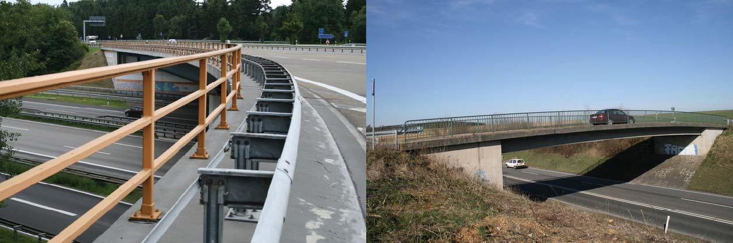
Risk class 1 Risk class 2

In general, when the areas downstream of the bridges are areas with particular risk to third parties, such as installations with the risk of explosion, areas with a strong residential character, high-speed railway lines, etc., then these areas fall under risk class 1.

If the area downstream of the technical element poses a risk to third parties in the event of a vehicle fall, such as pedestrian and cycle paths or single carriageway roads, it will fall under risk class 2.

In cases where there is no risk to third parties downstream of the technical element, e.g., a river bridging technical element or a valley bridge, it should be assessed whether the obstacles will fall under risk class 3 or even risk class 4.

In other words, the selection of barriers on the boundaries of a bridge must take into account the type of obstacles below it and, by extension, the risk class to which they may be assigned.

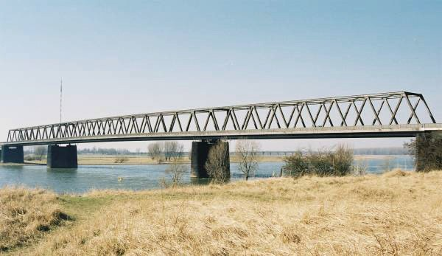
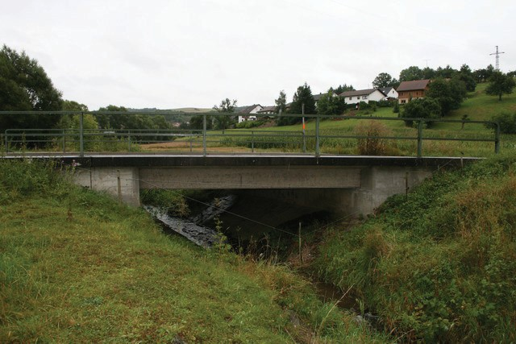
In the case of small-open bridges, where there is no particular risk to occupants of a vehicle, their railing may be assigned to risk class 3, because it is a non-deformable obstacle. The risk class 4 selected only if there is no particular risk to the occupants.
Risk class 3 Risk class 3

Bridge pedestals
A bridge pedestal poses a particular risk to third parties (risk class 1), when it has not been calculated for impact. All road bridges and pedestrian bridges shall be calculated and dimensioned against the impact of vehicles in accordance with ELOT EN 1992-2.
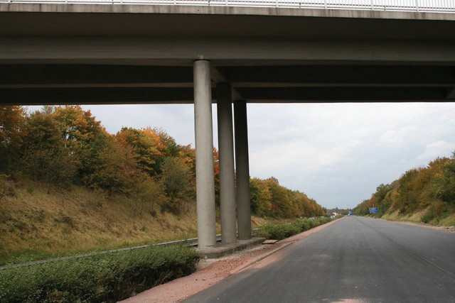
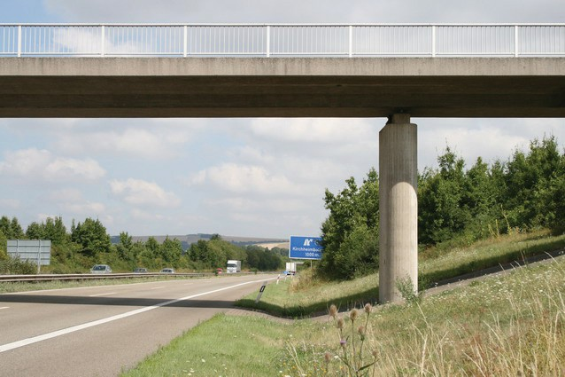

Pedestals not calculated for vehicle impact - Risk of collapse of load-bearing elements Risk category 1 Pedestals calculated for vehicle impact Risk category 3

When the pedestals of a bridge have been calculated and dimensioned against the impact of vehicles according to ELOT EN 1990, these pose a particular risk to occupants of a vehicle (risk class 3).

High-speed railway line – V_{perm} > 160 km/h
Railway lines with a maximum permissible speed greater than 160 km/h shall fall under risk class 1.

But all other railway lines on which run more than 30
trains per 24 hours and with maximum speed 160 km/h belong to risk class 2.

Signalling bridge uprights – concrete pedestals
Where signalling bridges are not calculated and dimensioned against vehicle impact according to the Eurocodes, there is a chance of collapse, therefore posing a particular risk to third parties (risk class 1).

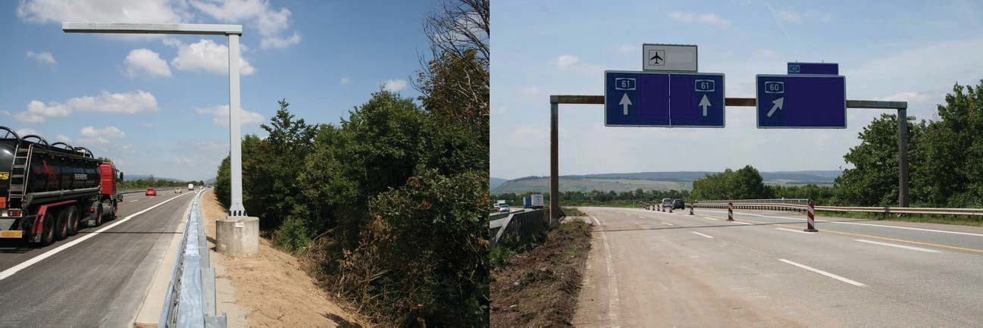
When reinforced concrete pedestals are intended to be constructed in accordance with the GMOE-CSAs, Part 4, then the signalling bridge poses a particular risk to occupants of a vehicle and falls under risk class 3.
Risk class 3 Risk class 1

Signalling bridges with a concrete pedestal of sufficient height and width, according to the GMOE-KSAs, part 4, should not be considered as “load-bearing elements of technical works” but as “solid obstacles”.

Side roads with a load > 500 vehicles/24h – cycle paths – pedestrian paths
A side road with a load > 500 vehicles/24h falls under risk class 2. Parallel carriageways at primary junctions or petrol stations and service stations shall not be considered as side roads. In the case of parallel carriageways, a barrier shall be placed on the foundations in accordance with the provisions of the central and lateral separating islets.

Safety barriers must not be placed on side roads with low loads, such as rural roads based on strict economic and technical criteria. In order to consider the necessity of installing safety barriers on a secondary road, consideration should be given to whether V _{perm} is greater than 50 km/h.

A cycle path or pedestrian path falls under risk class 2 when used extensively. Examples include cycle paths and pedestrian paths in a school area. In the case of minimal use, the installation of barriers shall not be required.

Areas with a strong residential character
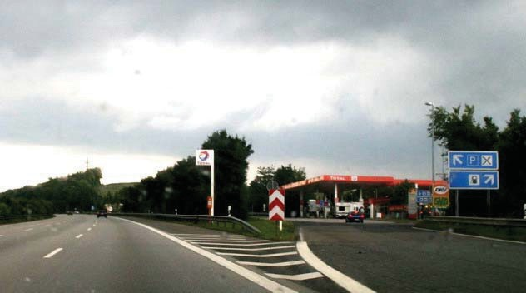
These are areas where people or groups of people congregate very often, such as playgrounds, gardens, viewing places, petrol stations and service stations, recreation areas etc.

Also, residential areas are located in areas with a strong residential character.

This is why these areas pose a particular risk to third parties (risk class 1)

Retaining walls
The criterion for selecting barriers on a retaining wall is the type of obstacles downstream of the wall and by extension the risk class which they fall under.

For example, if an area that poses a risk to third parties is located downstream of the retaining wall, such as railway line, single road or pedestrian road and cycle path used extensively, it falls under risk class 2. Conversely, if the downstream area falls under risk class 1, the retaining wall is considered to fall under risk class 1.

In the event that the area downstream of the retaining wall does not pose a risk to third parties in the event of a vehicle falling, for example a retaining wall in an area of water impediment or agricultural land, the wall falls under risk class 3 or risk class 4. Both options (risk class 3 and 4) lead to similar results.

A retaining wall up to 2 m high without any other risk is not a hazardous position according to the spirit of the instructions.

Trees
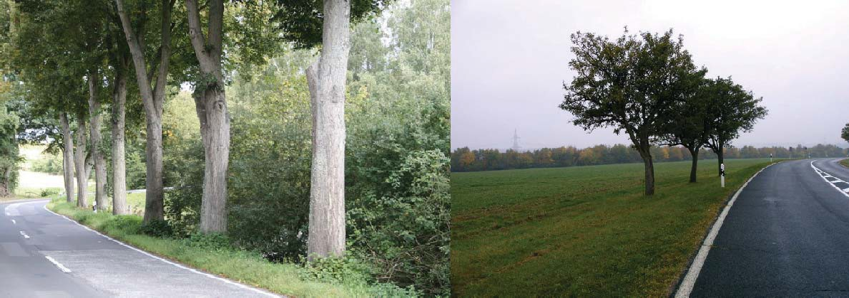
Trees pose a particular risk to the occupants of a vehicle because they do not deform in the event of a vehicle impact. When the diameter of the trunk of a tree is greater than 8 cm, it falls under risk class 3. Young trees typically have a smaller trunk diameter, but in the future will constitute a dangerous obstacle. For this reason, provision should be made for the installation of safety barriers at these locations and the planting of young trees on the pedestrian path boundary should not be recommended, in accordance with the aforementioned principle of removal of obstacles.

Sound barriers
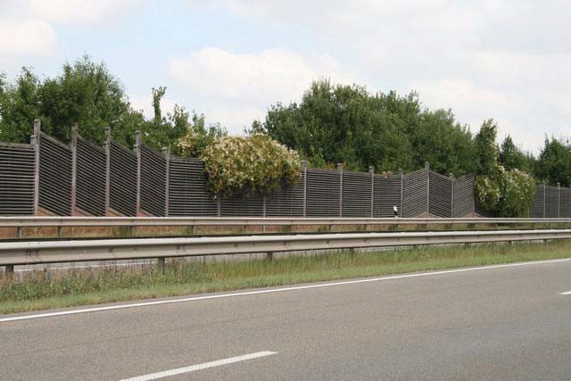
Sound barriers are usually hazardous positions, in risk class 3 The risk comes from the vertical uprights of the sound barriers which are neither deformable nor do they detach in the event of a vehicle impact.

Non-deformable solid obstacles perpendicular to the road
Solid obstacles are hazardous positions, which do not deform when impacted by a vehicle. Examples of solid obstacles perpendicular to the road are the starting point of a retaining wall, concrete pedestals, buildings, etc. Such obstacles fall under risk class 3.

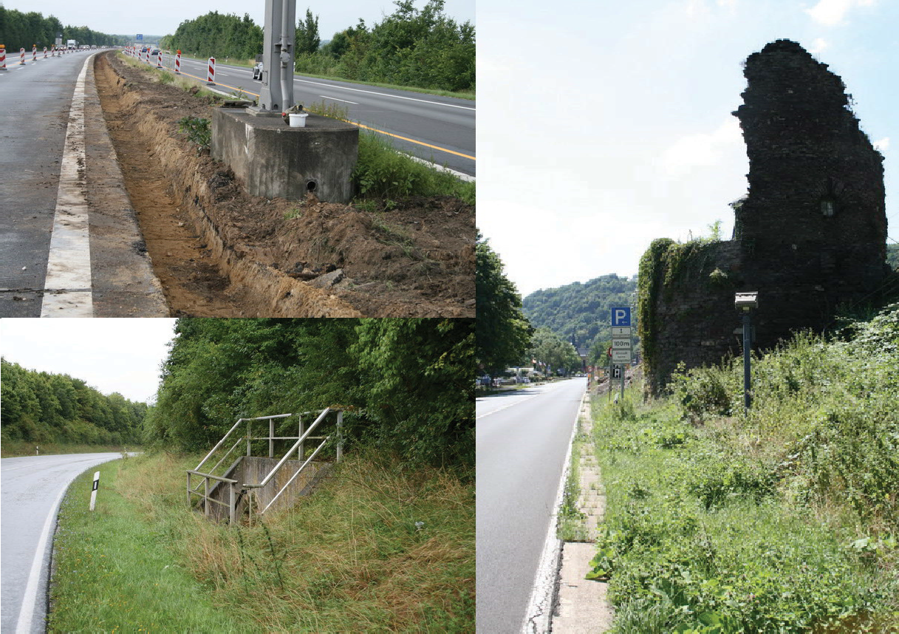

Solid street lighting posts, posts
Street lighting posts pose a particular risk to occupants of a vehicle (risk class 3) because during vehicle impact they do not deform and do not absorb energy (passive posts). For this reason, they are considered as “solid obstacles perpendicular to the road”.
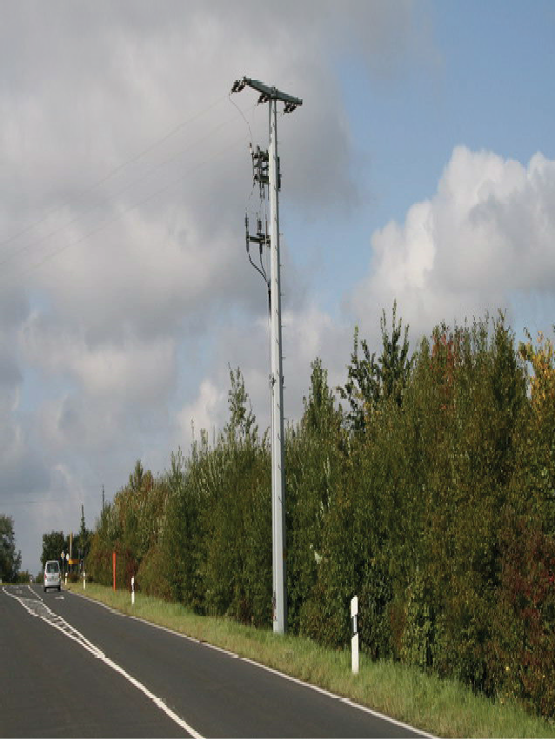
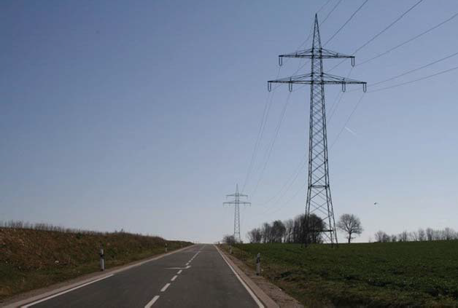
Solid posts – risk class 3

The behaviour of the posts during the impact of a vehicle shall be a function of the anchoring of the bearing point, its cross-section and its construction material. So, when the street lighting posts

during vehicle impact do not deform but deform, they fall under risk class 4.
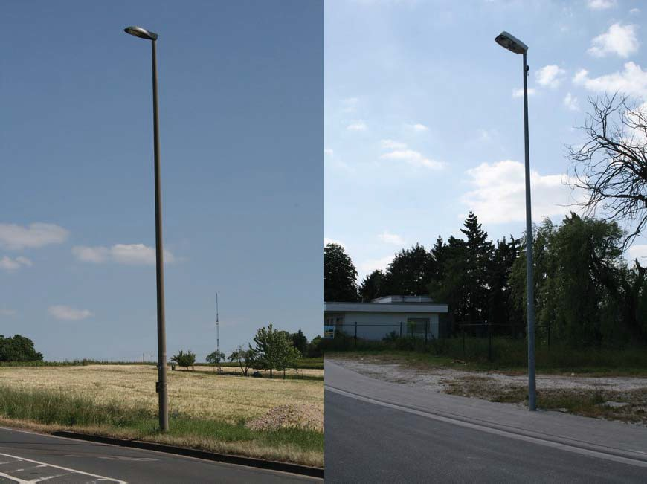
Solid street lighting post ⇒ deformable street lighting post ⇒
Risk class 3 Risk class 4

Solid signpost uprights
Uprights pose a particular risk to occupants of a vehicle (risk class 3), when they are not passive (neither detachable from their base nor deformable by absorption of kinetic energy). Their impact behaviour is a function of the anchoring of the bearing point, its cross-section and construction material.

The sign post uprights (load-bearing structures from beams or tubular structures) which during the impact of a passenger car do not deform, fall under risk category class 3.

The non-deformable uprights, for example with an external diameter >76 mm and wall thickness >2.9 mm, in case of impact essentially cannot receive energy and deform. For this reason, they are equivalent to ‘solid roadside barriers’ (risk class 3).

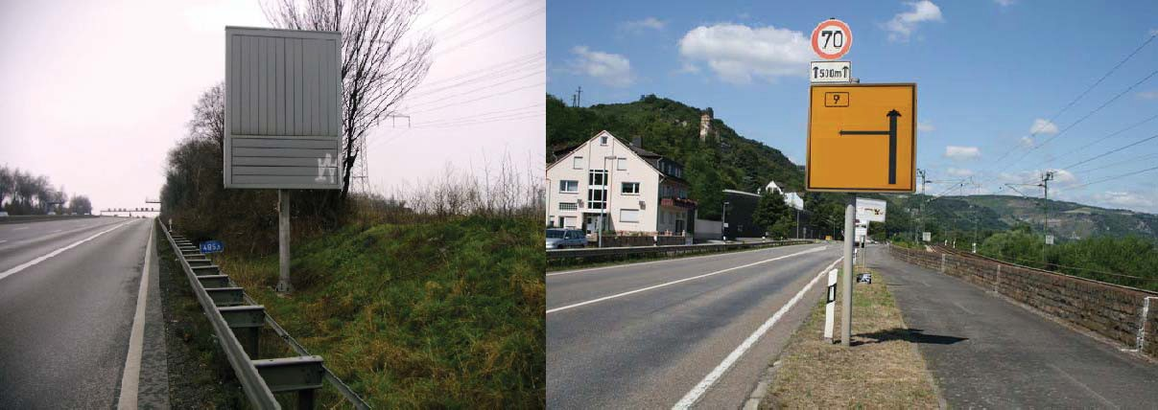
Solid signpost upright non-deformable signpost upright ⇒
detachable and non-deformable ⇒ Risk class 4
Risk class 3

Small and medium-sized signpost uprights which, during vehicle impact do not detach but deform, fall under risk class 4 while the uprights that can be detached from their base or absorb impact energy according to ELOT EN 12767 are not considered as obstacles, in the spirit of the instructions.

Reticulated uprights
Small and medium sized traffic sign uprights (tubular uprights and reticulated steel posts with external cross-sectional diameter > 76.1 mm and wall thickness > 2.9 mm or made of aluminium-alloy tubular cross-sections with outer diameter > 76.0 mm and wall thickness > 3.0mm) fall under risk class 4.
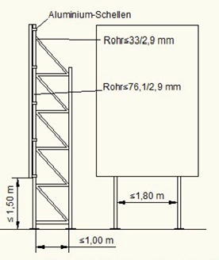
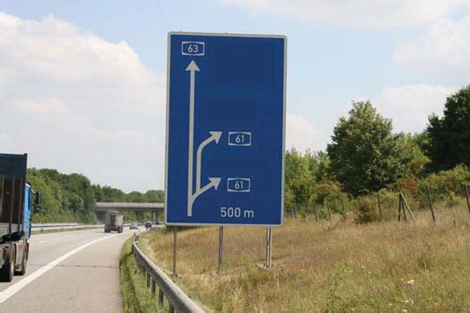

When to support large signs (> 2.2 m²) reticulated uprights with dimensions smaller than the above are used, these do not constitute a hazardous position in line with the spirit of the instructions and no safety barriers are required. Individual upright posts shall be at a distance of least 1.80 m and the distance of the bottom edge of the sign from the ground shall be at least 1.50 m. If these values are lower, then the reticulated uprights fall under risk class 4.

Note: The foundations of the signs shall not project more than 0.05 m above ground level. Otherwise, these could be a hazardous position.

Embankment and trench slopes
Embankment slopes are considered dangerous and fall under risk class 4, when their height is greater than 3 m and their incline is more than 1:3 (u:b).

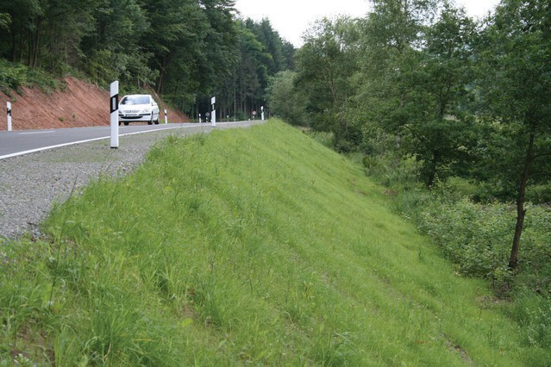
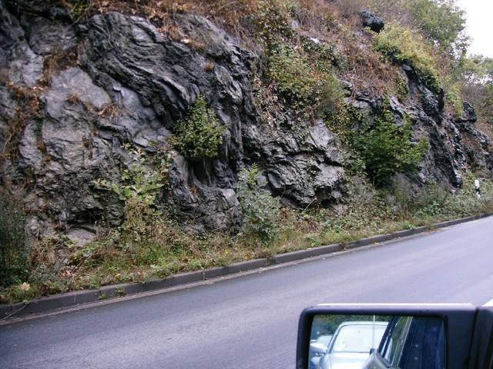
Trench slopes are considered hazardous positions and fall under risk class 4, when their incline is more than 1:3 (u:b) and the foot of the slope is not sufficiently rounded or contains rocky slopes.
Embankment slopes H > 3 m and trench with incline u:b > 1:3 – risk class 4

Annex 4

Examples of determining the length of application of safety barriers

Example 1:
➲ Hazardous position: high-speed railway line, V _{perm} > 160 km/h
➲ Hazardous position length: 20m
➲ Distance of hazardous position from the carriageway boundary line: 2 m (fulfils slip criterion, table 2)
➲ The hazardous position is on the same level as the street
➲ Chance of diversion: high
➲ Support width: 2m
➲ Minimum distance of the safety barrier from the carriageway boundary line: 0.50m
➲ Single carriageway road
➲ Permitted speed: 100 km/h
➲ ADT> 3000 v/24h
➲ ADT (HV) < 3000 v/24h

Result:
➲ Required restraining capacity: Η2
➲ System selected by Super-Rail with uprights distance
2m
➲ Performance class: H2-W4 (1.30 m)-B
➲ Test length: 52m
➲ Reference element: Catalogue RAL-No: S1.1-350

Option 1:
The safety barriers shall be placed parallel to the boundary line without reducing the restraining capacity. Length L₂ is equal to 100 m (Table 2). The 12 m long assembly is required according to the list reference: RAL-No S3.1-321 and the device of a system with restraining capacity H1 in length L₁ = 60 m (test length of the system).

SRI/2.0
BT EDSP/2.0 assembly assembly EDSP/2.0 BT
220.00 m
100.00 m

12.00 m

60.00 m
12.00 m
100.00 m 20.00 m 12.00 m

60.00 m
12.00 m

direction of movement

Option 2:
Safety barriers are placed parallel to the boundary line but with a reduction in restraining capacity. A system with restraining capacity H2 in length 0.5xL₂ = 50 m shall be placed. The length of a system with restraining capacity H1 (reduction of one class) shall be equal to the test length of the system L₁= 60 m.

SRI/2.0
BT EDSP/2.0 assembly assembly EDSP/2.0 BT
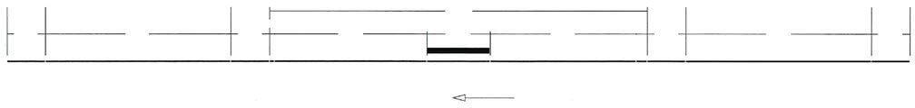
120.00 m
12.00 m
60.00 m
12.00 m
20.00 m
12.00 m
60.00 m
12.00 m
direction of movement
50.00 m
50.00 m

Example 2:
➲ Chance of diversion: limited

Result:
➲ Required restraining capacity: Η1
➲ System selected: single-sided protruding safety barrier (EDSP) with upright distance of 1.33 m
➲ Performance class: H1-W4 (1.30 m)-A
➲ Test length: 60 m
➲ Reference element: Catalogue RAL-No: S1.1-121

Option 1:

The safety barriers shall be placed parallel to the boundary line without reducing the restraining capacity. Length L₂ is equal to 100 m (Table 2).
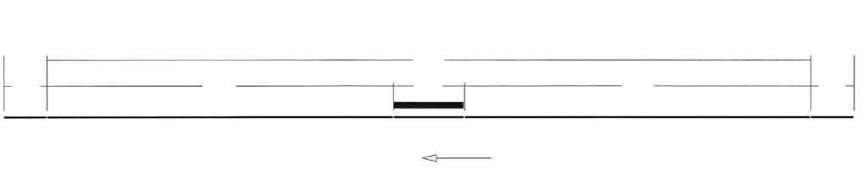
BT
EDSP/1.33
BT
220.00 m
12.00 m
20.00 m
12.00 m
direction of movement
100.00 m
100.00 m
Option 2:
Safety barriers are placed parallel to the boundary line but with a reduction in restraining capacity. A system with restraining capacity H1 in length of 0.5xL₂ = 50 m shall be placed. The length of a system with a N2 restraint capacity (reduction of one class) shall be at least equal to the test length of the system L₁ = 60 m. Length L₁ includes the 8 m long assembly in reference RAL-No : S3.1-126.

EDSP/1.33
BT ESP/4.0 assembly assembly ESP/4.0 BT
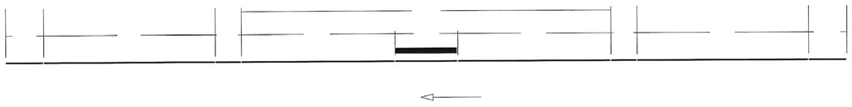
12.00 m
56.00 m
8.00 m
120.00 m
20.00 m
8.00 m
56.00 m
12.00 m
direction of movement
50.00 m
50.00 m

Example 3:
➲ Chance of diversion: limited
➲ Distance of hazardous position from the carriageway boundary line: 3 m (criterion of passing behind the safety barrier is fulfilled)

Result:
➲ Required restraining capacity: Η1
➲ System selected: single-sided protruding safety barrier (EDSP) with 2 m standing distance
➲ Performance class: H1-W5 (1.70 m)-A
➲ Test length: 60 m
➲ Reference element: Catalogue RAL-No: S1.1-120

Option 1:
Safety barriers shall be placed parallel to the boundary without reduction of the configuration capacity. Length L₂ is equal to 80 m (Table 2).
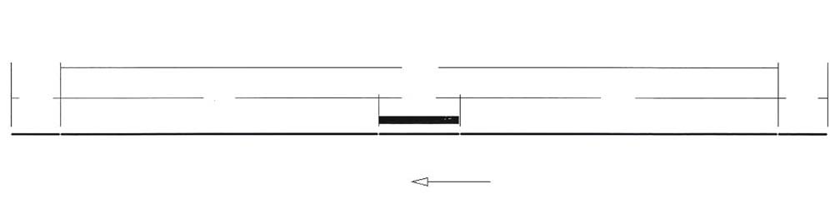
BT
EDSP/2.00
BT
12.00 m
80.00 m
20.00 m
80.00 m
12.00 m
direction of movement
180.00 m
Option 2:
Safety barriers are placed parallel to the boundary line but with a reduction in restraining capacity. A system with restraining capacity H1 in length of 0.5xL₂ = 40 m shall be placed. The length of a system with a N2 restraint capacity (one class) shall be equal to the test length of the system L₁= 60 m. Length L₁ includes the 8 m long assembly according to Catalogue reference RAL-No: S3.1-125.

EDSP/2.00
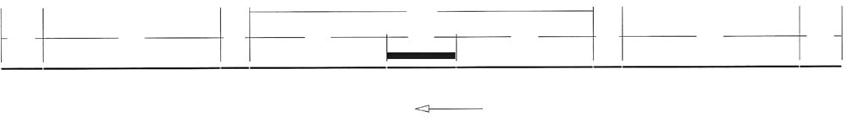
BT ESP/4.0 assembly assembly ESP/4.0 BT
100.00 m
12.00 m
8.00 m
8.00 m
12.00 m
52.00 m
40.00 m
20.00 m
40.00 m
52.00 m
direction of movement

Option 3:
Safety barriers are placed at an angle of 1:20. The length L₂ of the system is equal to 60 m (Table 2). This leads in parallel to the carriageway boundary line at a length of 10 m before and after the hazardous position and then at an angle of 1:20.

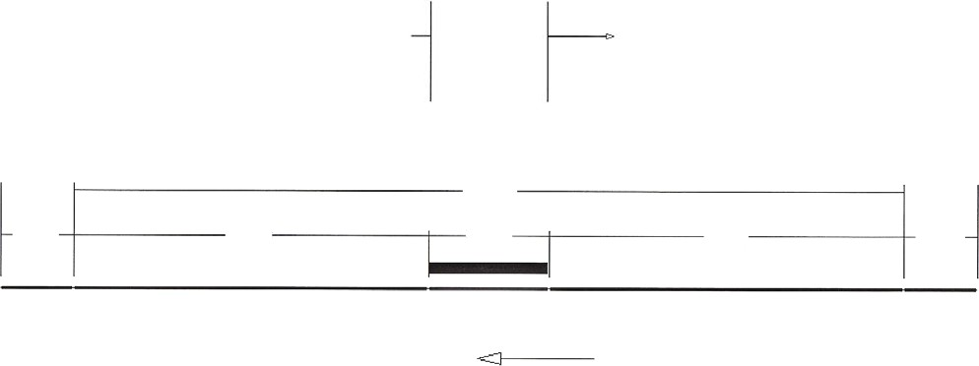
10m in parallel – then at an angle of 1:20
10m in parallel – then at an angle of 1:20
EDSP/2.00
BT
BT
140.00 m
12.00 m
60.00 m
20.00 m
60.00 m
12.00 m
direction of movement

Option 4:
When exclusion of the passage behind the safety barrier can be ensured and the slip criterion is not fulfilled, length L₂ is reduced to 40 m (Table 2).
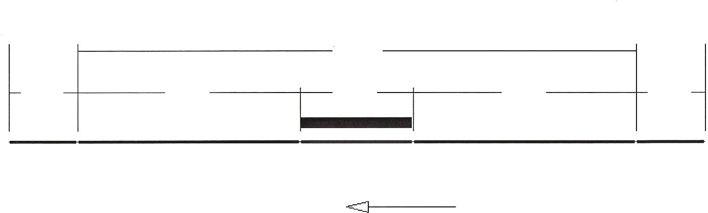
EDSP/2.00
BT
100.00 m
BT
12.00 m
40.00 m
40.00 m
12.00 m
direction of movement
20.00 m

Annex 5

Case of embankment slope
Where the passage of the back of the barrier does not permit the obstacle to impact and the slip on the barrier is not decisive, then the uniform length before and after the obstacle for single carriageway roads shall be uniform and equal to 40 m. In Fig. P5-1, the hazardous position occurs when the height of the embankment is 3 m and greater. The conditions of the hazardous position are such that passing behind the barrier will not allow the vehicle to impact the obstacle.

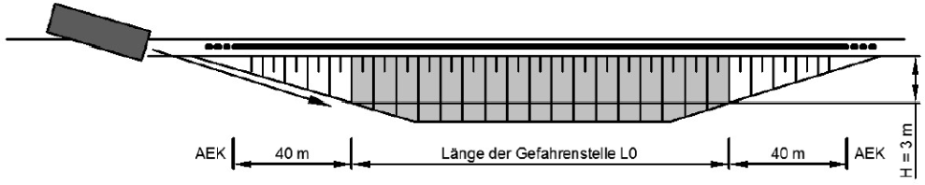
AEK = BT
Obstacle length L₀

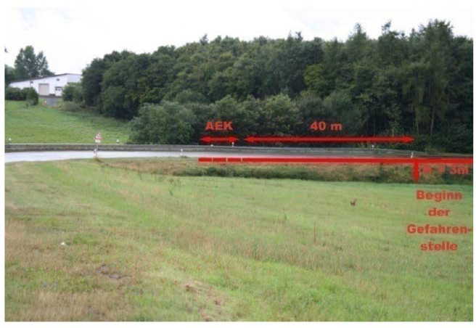
Start of hazardous position

Fig. P5-1: Hazardous position (obstacle) on basement slopes where the single safety barrier length equal to 40 m before the obstacle can be applied

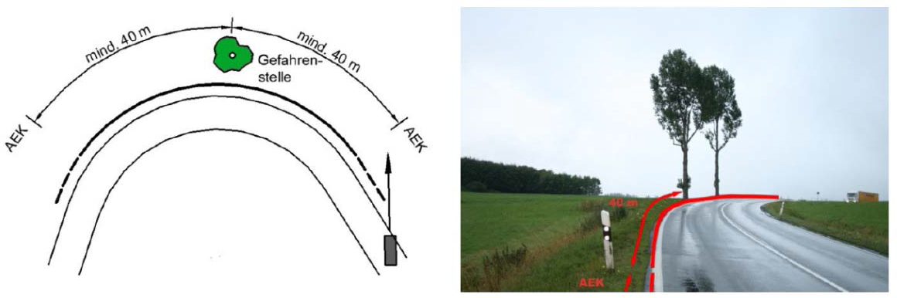
Min 40 m
Hazardous position
Min 40 m

Fig. P5-2: Hazardous position on a curve where the single safety barrier length equal to 40 m before the obstacle can be applied

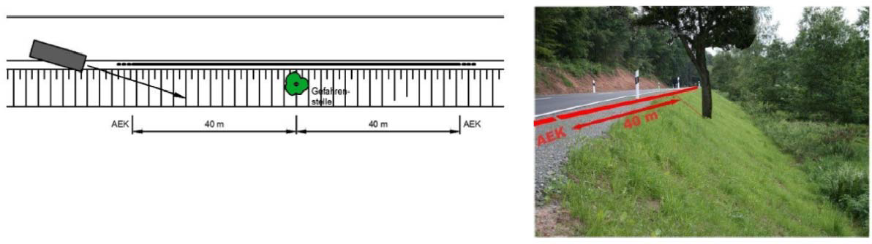
Hazardous position
Fig. P5-3: Hazardous position on a slope (applicable when no safety barrier is required due to the slope) where the uniform length of a safety barrier equal to 40 m before the obstacle can be applied

Note: The above does not apply to bridge and retaining wall boundaries. When the limit of a technical element is at a distance of up to 1.5 m from the front (face) of the barrier, the criterion of sliding on the barrier apply.

Annex 6

Example of option of restraining capacity at highway junction (system)

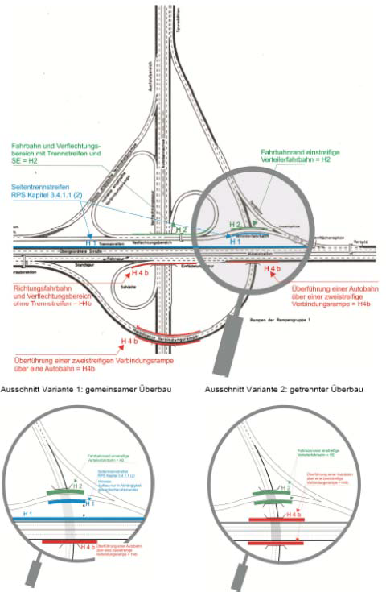
Distribution and carriageway with separating islet =H2

Single lane distribution =H2

Separate islet according to RPDI-RSB

Distribution and carriageway with separating islet =H4b
Upper crossing Α/D in branch 2
strip =H4b

Elevated branch crossing in A/DH4b

Case of joint superstructure
Case of separated superstructure

Annex 7
Standard lateral bridge configuration

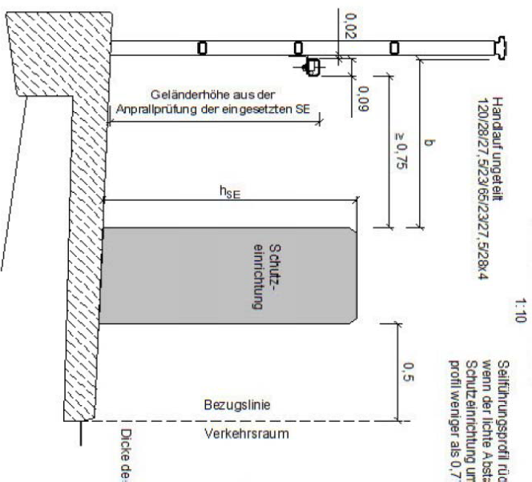

Reference line
Traffic area

SAFETY BARRIER
Railing height based on the safety barrier impact test

Annex 8

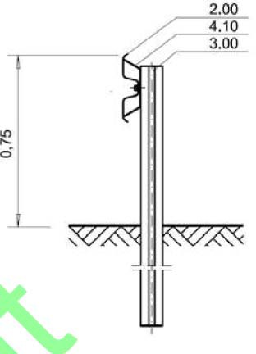
Safety Barrier Data Sheet Template

Manufacturer (Producer) | Safety barrier type |  | Production code
SAFETY BARRIER DESIGN WITH DIMENSIONS AND TYPE OF FOUNDATION (material, type and plate form, data connections, etc.). E.g.:
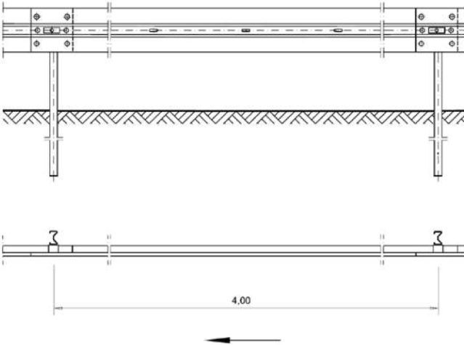

Description of key system features (properties, characteristics, installation, foundation)
Safety barrier type description | E.g., bilateral safety barrier with insertion of uprights every 2.00 m.
Initial Impact Test | E.g. ΤΒ11 | Relevant reference E.g. TSR PSG 47
Initial Impact Test | E.g. ΤΒ 32 | Relevant reference E.g. TSR PSG 48
CE Certificate/Confirmation
Characteristic safety barrier material | E.g. S235JR
System width [m] | E.g. 0.18
Height of system  rolling surface [m] | E.g. 075
Element length [m] | E.g. 4.0
Mass per running metre [kg/m] | E.g. 15
Maximum lateral displacement of safety barrier [m] | E.g. 1.7
Maximum lateral displacement of vehicle [m] | E.g. ---
Maximum dynamic displacement [m] | E.g. 1.6
Test length [m] | E.g. ----
Minimum force transfer length  [m] | E.g. 60
Certified foundation type | E.g. with insert
General remarks | E.g. the application of type A and B plates is equivalent
Additional Elements according to ELOT EN 1317-2 (2011 edition)
Reduced operational width W_{N} [m] | E.g. 1.7
Reduced operational width class | E.g. W7
Reduced vehicle intrusion VI_{N} [m] | E.g. ---
Reduced vehicle intrusion class | E.g. ---
Reduced dynamic displacement D_{N} [m] | E.g. 1.7

Restraining capacity | Operational width class | Vehicle intrusion class | Impact severity class
E.g. Ν2 | E.g. W5 | E.g. --- | E.g. Α

Annex 9

Example of bridge safety sign on an islet
Traffic area boundary

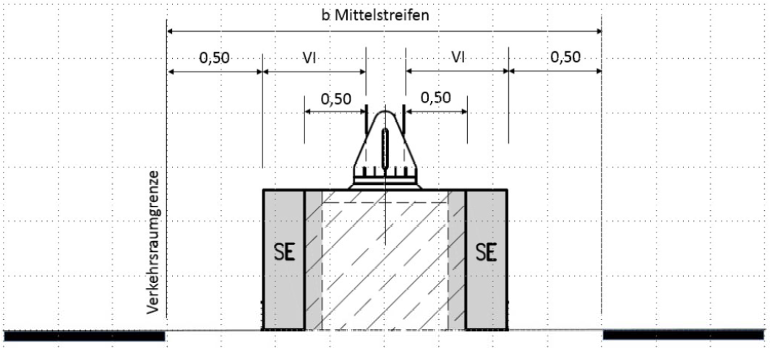
islet

Fig. P9-1: Example of a safety provision on a bridge sign on the central islet
Safety barriers
Safety barriers

A condition for the configuration of the provision as shown in Figure P9-1 is the existence of a barrier certified for this provision (corresponding impact test). Such a barrier is e.g. the SUPER RAIL – Signalling Bridge. Alternatively, a rigid barrier with a dynamic displacement = 0 could be used in front of the concrete support pedestal of the post.

For this provision, the determinant factor for the required minimum width of the islet is not the category of the operational width of the safety barrier, but the size of the vehicle intrusion (VI) and the construction width of the safety barrier.

A construction width of the barrier equal to 0.50 m and a class VI between 1 and 3 would be sufficient for an islet width of 3.3 m. For other safety barrier widths and VI values, the respective required width of the islet could be calculated on the basis of the above provision.
Example of calculation with SUPER RAIL type safety barrier
Signalling Bridge (Figure P9-2):
Minimum islet width = 6x0.50+ post width= 3 m + post width.
Vehicle intrusion class = VI3.

For a post width of 0.30 m a pedestal width of 1.30 m is obtained. For the specific barrier type SUPER RAIL-Signalling bridge results in a minimum width of a central islet of 3.30 m.

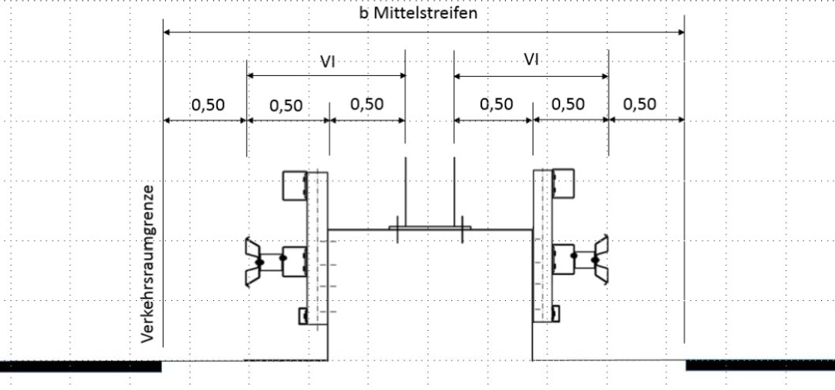
islet

Traffic area boundary

Fig. P9-2: Example of calculation of a minimum width of central islet for the application of a safety barrier type SUPER RAIL-Signalling bridge.

Annex 10

Example of safety on a bridge technical element within an urban area with a protective wall

A highway passes through an urban area with an elevated crossing over an urban highway (Figure P10-1). Parallel to the highway is a pedestrian path and a cycle path. The highway entry and exit connecting branches connect immediately after the bridge. V_{perm} = 70 km/h.
Fig.
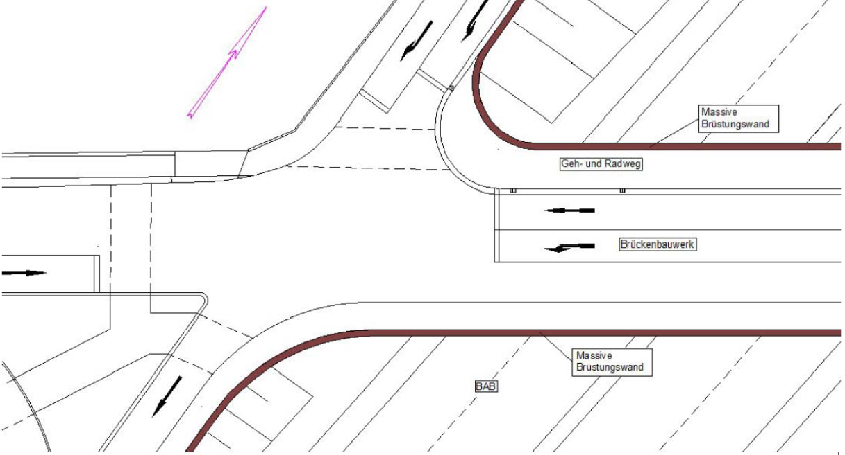
N/D
Solid wall
Bridge technical element
Pedestrian path and cycle path
Solid wall

Fig. P10-1: Example of road safety with a protective wall

In accordance with these instructions, an H2-restraining barrier is required on the bridge. A barrier with this performance for this lateral configuration is not available.

Solution 1: Reduce the speed limit to 50 km/h so as not to require the provision of a safety barrier.

Solution 2: At the ends of the lateral configurations with an extension of the technical solid wall of 1 m high calculated against a vehicle impact was fitted with railing on the crown. The walls were formed as smooth walls and therefore are not classified as obstacles according to these instructions. At the same time, a non-paved curb was formed 15 cm high. The wall was installed simultaneously on the SE side on the retaining wall along the connecting branch of entry.

Disadvantage: In the area of access, there are now solid obstacles, but these are accepted here because of the need to protect third parties (highway under the technical element), which has priority here.

Annex 11

Local road safety provision layout:
A local road with a side cycle path passes over a stream (Figure P11-1). The cycle path is configured in connect with the road carriageway after the end of the technical element, As a result, the provision of the safety barrier cannot continue. On the outer boundary line next to the cycle path there is no space to install a technical system between railing and cycle path.
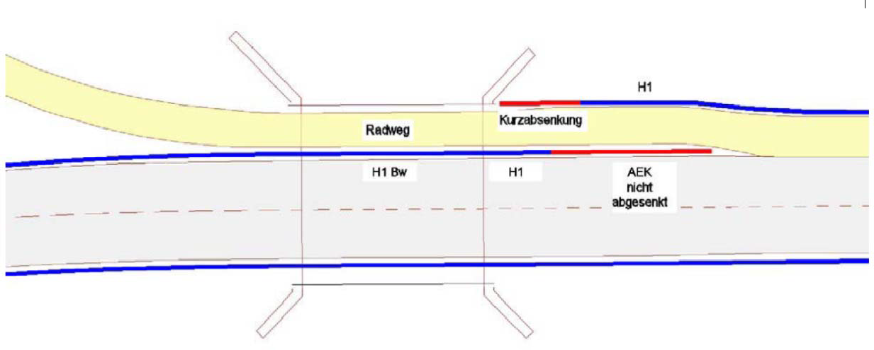
cycle path
Lowered BT
H1 Technical element
Non-lowered BT

Fig. P11-1: Example road safety with non-lowered barrier termination

The barrier from the right was installed next to the cycle path and up to the technical element and there it was lowered through a short end with sinking to ensure that the technical element is as close as possible and to ensure that the safety barrier is anchored with H1 performance. The short termination length is outside the traffic area so that a frontal impact is not possible. From the left, the barrier was placed between the road and the cycle path and on the technical element with a certified non-lowered barrier termination (Figure P11-2).
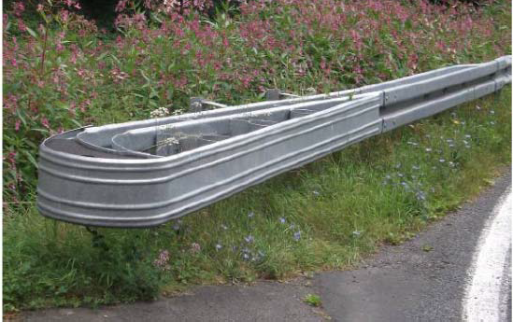
Fig. P11-2: Certified non-lowered barrier termination

By means of a shaped covering on the front and rear structure of the safety barrier, the risk of passing behind the barrier is reduced. The choice of a non-lowered termination of a barrier in the front safety barrier prevents slipping over the safety barrier in the technical element area.

Annex 12

Special solutions at road junctions

General
In road junction areas (including access roads and/or traffic connections), curbs subject to curvature (rounding) are a special case. Until now, there were no particular requirements for curved barriers, considering that the impact test of the barriers on straight sections according to ELOT EN 1317 was sufficient to ensure their functionality and performance in general and in their curves. This is now to be regarded as insufficient for the safety of a road. The following paragraphs of this Annex refer to the technical conditions and requirements established to improve the performance of the curves of the barriers and therefore of road safety in general.

From now on, the curves of the barriers will be treated as special solutions (SSRJ-Special Solution for road junctions) and not special constructions and become mandatory in all those positions where obstacles exist, which are classified in a risk class in accordance with these instructions.

Impact tests
Quotation marks
Safety barriers with small curvature radii similar to those applied to the rounding of carriageway boundary lines at level junctions must not themselves become the obstacles (hazardous positions) and must also be able to withstand the longitudinal forces which occur when connecting the safety barriers to straight sections. Safety barriers designed for placement at road junctions are special roadside barriers that fulfil the relevant requirements.

Because of their special form, SSRJs cannot be uniquely classified in one of the types of safety barriers. The SSRJs are composed of a combination of elements of various types of safety barriers in such a way that it is not yet possible to determine precisely the inclusion of SSRJs in a type of impact test included in the different parts of the standard according to ELOT EN 1317. It is therefore not yet possible to verify the performance of the essential characteristics of SSRJs with regard to ELOT EN 1317. The following paragraphs will therefore describe the terms and conditions for carrying out the appropriate impact tests on SSRJs as well as the acceptance criteria of SSRJs for installation on roads. The terms, conditions and acceptance criteria of SSRJs are based on the ELOT EN 1317 standard.

The objective of this approach is to describe the most unfavourable conditions for the implementation of SSRJs, in order to ensure the acceptable application of SSRJs in similar but less critical cases, e.g. in cases of other curve radii, etc. Relevant instructions for the treatment of SSRJs classified in some category of similar cases or conditions are given in the relevant paragraph “SSRJ Classes”.

An SSRJ starts in that position in which the associated certified barrier is modified as regards e.g. its foundation, the installation of additional parts or elements on the barrier, its height, its width, etc. The end of the SSRJ is determined at the actual end of the SSRJ (see Figure P12-1) or possibly at that position in which a safety barrier that fully complies with the details a conventional barrier according to ELOT EN 1317 begins. The length L of the SSRJ includes the overall length of this configuration. Length B corresponds to the net curved part of the rounded structure (Figure P12-1).

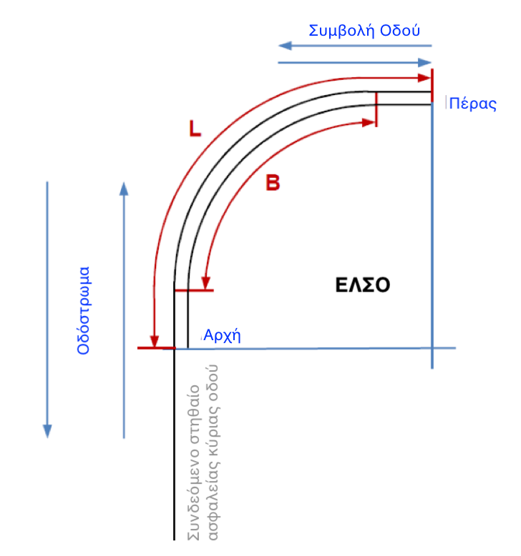

Οδόστρωμα | Carriageway
Συμβολή οδού | Road junction
Πέρας | End
ΕΛΣΟ | SSRJ
Αρχή | Start
Συνδεόμενο στηθαίο ασφαλείας κύριας οδού | Safety barrier connected to the main road

Fig. P12-1: Illustration of an SSRJ

The length of safety barriers associated with an SSRJ must be at least 1/3 of its minimum length (test length). The impact test conditions shall be provided for all tests with the same curvature radius, an angle of junction of the roads equal to 90º and for the formation of a standard slope incline of 1:1.5. An example of a typical slope configuration is presented in Figure P12-2. Typical values of curvature radii for rounding an SSRJ are taken between the range of 2.0 m and 7.5 m.

Fig. P12-2: Standard configuration for impact test of an SSRJ with a value of n=1.5 and a base width of 1.50 m.

In order to ensure the functionality of SSRJ during impact, SSRJs must undergo the impact tests based on the ELOT EN 1317 standard and the additional criteria of the following paragraph. In addition, attention should be paid to the following requirements:

- The physical impact tests according to ELOT EN 1317 must be carried out by a testing laboratory accredited according to ELOT EN 1317 for that purpose.
- The impact test on an SSRJ applies only to the safety barrier associated with the SSRJ. The connection of an SSRJ to a different barrier is essentially an unacceptable modification of the provision. The assessment of a modification of the distance of the uprights of an otherwise identical provision of safety barrier shall be carried out by the recognised organisation (Accredited Body) issuing a performance certificate.
- The impact tests and their results shall be described in a relevant test document (technical report). Further details are given in the next paragraph

The final evaluation of the results of the impact tests and of the content of the installation instructions shall be made on the basis of this document by the recognised certification body.

Impact test criteria
In order to attribute the most real impact conditions to an SSRJ so that a relevant producer declaration can be issued on the basis of ELOT EN 1317, the impact tests are defined as described below. The corresponding tracks of vehicles during their impact on an SSRJ are represented in Figure P12-3.

The critical point of impact for all three test cases depends on the construction of the SSRJ and is determined by the Accredited Body issuing a performance certificate of the barrier so that it is within the boundaries of a given area. The angle of impact refers to the tangent to the SSRJ at the critical point.

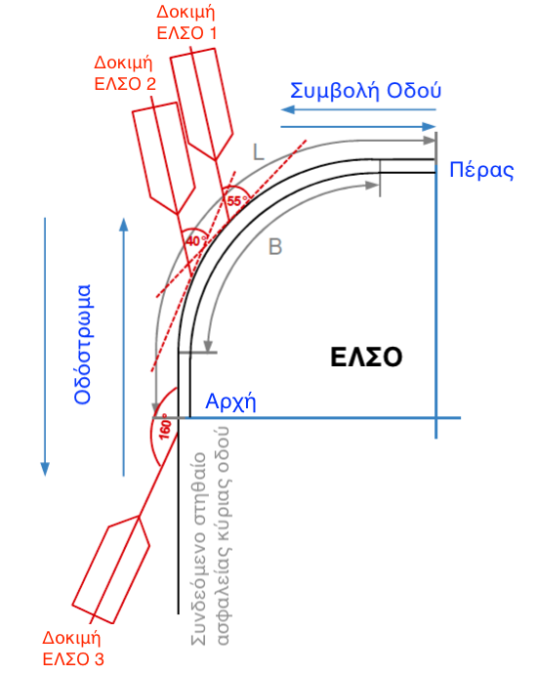

Οδόστρωμα | Carriageway
Συμβολή οδού | Road junction
Πέρας | End
ΕΛΣΟ | SSRJ
Αρχή | Start
Συνδεόμενο στηθαίο ασφαλείας κύριας οδού | Safety barrier connected to the main road
Δοκιμή ΕΛΣΟ 1 | SSRJ Test 1
Δοκιμή ΕΛΣΟ 2 | SSRJ Test 2
Δοκιμή ΕΛΣΟ 3 | SSRJ Test 3

Figure P12-3: Vehicle tracks during impact tests on an SSRJ

SSRJ Test 1:
The following parameters are derived from the adoption of test conditions TC 4.2.80, TC 4.2.80 and TC 1.2.80 of ELOT EN 1317-3 and non-harmonised Part 4 ENV 1317-4.

- Angle of impact: 55º (corresponds to a diversion angle of approximately 15º)
- Mass of the impact vehicle (test): 1300 kg
- Impact velocity: 80 km/h
- Critical point of impact between 1/3 B and between 1/3 L and 2/3 L of the SSRJ
- Reference axis for the critical point of impact: Longitudinal axis of vehicle symmetry.

SSRJ Test 2:
This test shall be oriented towards the standard impact tests for vehicle restraint systems in standard (linear) provision of barrier on a road. The following parameters are derived from the adoption of the TB11 impact tests in accordance with Part 2 of ELOT EN 1317.

- Angle of impact: 40º (corresponds to a diversion angle of approximately 20º)
- Mass of the impact vehicle: 900kg
- Impact velocity: 100 km/h
- Critical point of impact between the authority and 1/3 B and between the authority and 1/3 L of the SSRJ
- Reference axis for the critical point of impact: Longitudinal axis of vehicle symmetry.

SSRJ Test 3:
This test shall be oriented towards the standard impact tests for vehicle restraint systems in standard (linear) provision of barrier on a road. The following parameters are derived from the adoption of individual TB 32 tests in accordance with Part 2 of ELOT EN 1317. The impact velocity corresponds to that of ASOs and IEASs in accordance with ELOT EN 1317 Part 3 and ENV 1317-4 (non-harmonised Part 4).

- Angle of impact: 160º
- Mass of impact vehicle: 1500kg
- Impact velocity: 80 km/h
- Critical point of impact in the start area of SSRJ
- Reference axis for the critical point of impact: Longitudinal axis of vehicle symmetry

Collection and recording of impact test results
In order to assess the performance and behaviour of the barrier during the impact of a vehicle, the following values and characteristics of SSRJ must be collected and recorded:

- Impact strength (ASI and THIV values according to Part 1 of ELOT EN 1317 (ELOT EN 1317-1:2011)
- Maximum lateral deformation (operational width/dynamic deformation, etc.) with reference to the relevant tangent on the initial obstacle front of the barrier
- Mass and position (in relation to its initial position on the barrier) of detached parts with a mass greater than 2.0 kg
- Trajectory of a vehicle within the vehicle recovery area and its speed after impact and removal from the barrier as well as its speed when leaving the recovery area. The definition of the recovery area is shown in Figure P12-4.
- Recording of all photographs and video recordings on the basis of Part 2 of ELOT EN 1317, paragraph 5.6 and regarding the 5 positions of the camera as shown in Figure P12-5. The rotating camera shall record at least 24 images per second. All other cameras must be capable of recording at least 200 images per second.

In addition to the above, it is recommended that the forces transferred by the SSRJ in the associated safety barriers are recorded.

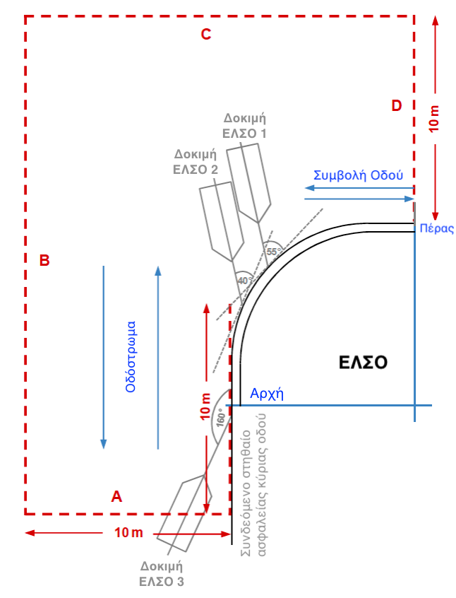

DEMARCATION OF THE RECOVERY AREA

Boundary A:

Vertical straight to the front of the associated safety barrier at a distance of 10 m in the traffic direction from the point of impact of the SSRJ 2 test.

Boundary B:

Straight parallel to the front of the associated safety barrier at a distance of 10 m.

Boundary C:

Straight parallel to Boundary A at a distance of 10 m in line with the end of the construction and contrary to traffic flow in SSRJ 1/SSRJ 2 tests.

Boundary D:

Straight parallel to Limit B from the end of SSRJ length 10 m.

Οδόστρωμα | Carriageway
Συμβολή οδού | Road junction
Πέρας | End
ΕΛΣΟ | SSRJ
Αρχή | Start
Συνδεόμενο στηθαίο ασφαλείας κύριας οδού | Safety barrier connected to the main road
Δοκιμή ΕΛΣΟ 1 | SSRJ Test 1
Δοκιμή ΕΛΣΟ 2 | SSRJ Test 2
Δοκιμή ΕΛΣΟ 3 | SSRJ Test 3

Figure P12-4: Demarcation of the recovery area for the description of vehicle tracks

The content of the test document shall include:
- Description of the tests, photographic material and video recordings of the impact tests as referred to in ELOT EN 1317.
- A certificate from the testing laboratory that the tested barrier and the associated barriers are in conformity with the technical drawings submitted and that its installation at the test site was carried out in accordance with the instructions of the manufacturer’s installation manual.
- Confirmation by the testing laboratory that all the components and parts of the barrier tested, with regard to the requirements of the construction materials and its assemblies and their dimensions, are in full conformity with the installation manual and the relevant drawings. The certificate shall also include the results of the material analysis to substantiate the quality of the main components of the barrier during the impact test.
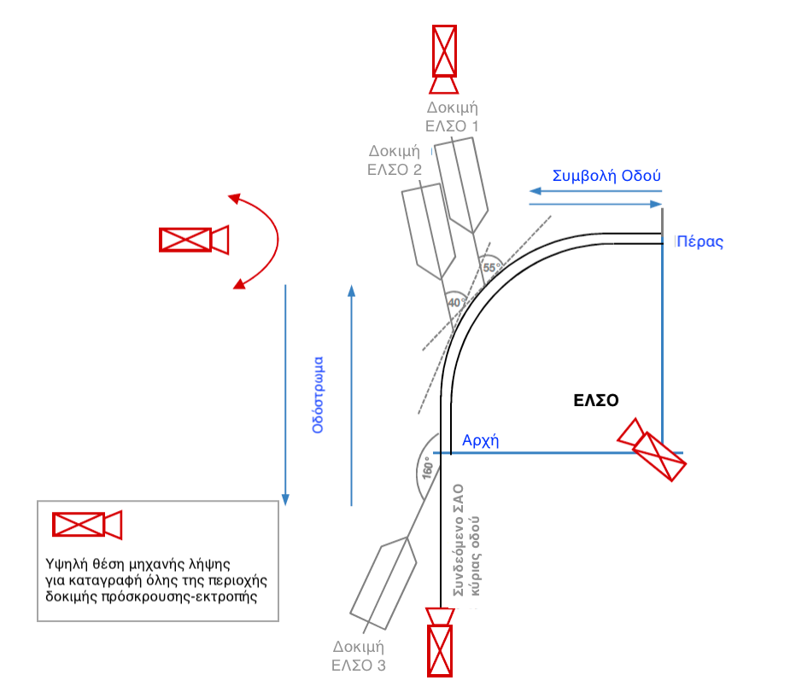

Οδόστρωμα | Carriageway
Συμβολή οδού | Road junction
Πέρας | End
ΕΛΣΟ | SSRJ
Αρχή | Start
Συνδεόμενο ΣΑΟ κύριας οδού | RSB connected to the main road
Υψηλή θέση μηχανής λήψης για καταγραφή όλης της περιοχής δοκιμής πρόσκρουσης-εκτροπής | High camera position for recording the entire impact-diversion test area

Figure P12-5: Position of cameras during the impact test

Acceptance and assessment criteria
For an impact test to be considered positive, the following criteria shall be fulfilled:

- The severity of collision for occupants shall be expressed by the ASI and THIV indicators in accordance with Table 12-1. The limit values included in the Table must not be exceeded.
- The test vehicle shall not be inclined laterally and overturned.
- The test vehicle shall not slide below the barrier.
- No fragments of the SSRJ must have entered inside the vehicle.
- The test vehicle shall not intrude into the SSRJ and pass over it in accordance with the requirements of ELOT EN 1317-2 (Annex A, paragraph 5.3.6).
- During the impact test, none of the main longitudinal elements of the SSRJ may be ruptured.

Table T12-1: Characteristic impact severity values of tests 1 to 3
Impact severity | Index values
Α | ASI≤1.0 | THIV ≤44 km/h in SSRJ 1 and SSRJ 2 test  THIV ≤33 km/h in SSRJ 3 test
B | ASI≤1.4 | THIV ≤44 km/h in SSRJ 1 and SSRJ 2 test  THIV ≤33 km/h in SSRJ 3 test

SSRJ family
An SSRJ family is characterised by a set of individual SSRJs which have the same elements and parts in the same form and differ from each other only in terms of radii of curvature, curved length B and/or the overall length of the SSRJ system. The structure of the SSRJs is identical. For the impact tests of an SSRJ family the following conditions apply:

- The SSRJ 1, SSRJ 2 and SSRJ 3 tests shall take place on the member of the SSRJ family with the smallest radius of curvature in accordance with the above paragraphs of this Chapter.
- For the member of an SSRJ family with the largest radius of curvature, the SSRJ 1 and SSRJ 2 tests are sufficient.
- Variation of the radii of curvature between the members of an SSRJ family with the shortest and longest radius of curvature is allowed without impact tests.

The declaration of the performance of an SSRJ can also be obtained through related simulation tests. The physical test in this respect is considered to be of higher reliability and the selection of an available system with a physical impact test takes precedence.

Modifications to SSRJs
No modifications (changes) are foreseen for SSRJs. Very small technical adjustments may be accepted with the agreement of the Accredited Body. Type A and B cross-section plates shall be treated as equivalent. It is not permitted to modify the cross-section of a plate within an SSRJ.

SSRJ Construction requirements
- An SSRJ must consist for the most part of elements and parts belonging to its associated barriers. The plate of the main road’s safety barrier continues within the SSRJ.
- The posts of the SSRJ must be identical to those of the associated safety barriers in order to facilitate the maintenance of the barriers.
- An SSRJ must not have protruding and sharp components, which may become dangerous for road users. Sharp parts and parts with sharp edges (e.g. covering joints with gaps of 2 cm or more/blunt joint coverings in the opposite direction of a traffic flow, parts of uprights or structures with wire ropes projecting or exposed to the traffic side, etc.) must be avoided. The covering of an SSRJ plate always takes place in the traffic direction.
- The height of an SSRJ is the same as that of the associated barrier. An exception is an appropriate lowering or sinking within the road junction for the purpose of providing a sufficient field of visibility.

- For a functionally acceptable use of an SSRJ this must be subject to regular maintenance in proportion to the rest of the safety barrier. Necessary construction interventions in an SSRJ due to the impact of a vehicle are not considered to be maintenance but repair.
- Ensuring the durability of an SSRJ is achieved by using materials and coverings in accordance with the applicable standards.
- With normal standard maintenance in proportion to the other safety barrier systems, if the construction and installation of SSRJ is correct, the lifespan of SSRJ must be at least 25 years.
- Until the adoption of relevant specific specifications for the materials and assemblies of safety of barriers, the use of:
- Steel type S 235 JR
- Low relaxation steel (minimum aluminium content equal to 0.02 %)
- Concrete at least C30/37 XC4, XD3, XF4, WA for prefabricated concrete barrier.
- For SSRJs, consisting of elements and parts and assemblies with these properties, it can be assumed that the lifespan of SSRJs together with their associated safety barriers is generally 25 years.
- The construction materials of an SSRJ may not affect each other negatively and in such a way as to reduce either the performance of the barrier during impact or its lifespan.
- All the required construction dimensions of an SSRJ refer to nominal values which may be exceeded or fall short of the nominal values within the tolerable tolerances unless explicitly stated otherwise.

Product document requirements
In order to ensure the correct use and installation of an SSRJ, the following documents must be available in Greek:

- Documentation of impact tests in accordance with paragraph 2.3 of ELOT EN 1317.
- Installation instructions in the form of assembly instructions or as a supplement to the installation instructions for the associated safety barriers. If available, the other application curvature radii and the corresponding SSRJ performance characteristics must be indicated, which must also be shown in drawings. The Installation instructions should also provide guidance on how to deal with deviations from the conditions of impact tests (e.g. high incline of connecting road, angle of connection different from 90º, connected safety barriers on either side of the SSRJ (see Figure P12-6)). The acceptance of the performance of the SSRJ in conditions other than impact tests can be achieved either by additional physical impact tests or by reliable impact simulations according to ELOT EN 16303:2020.
- A data sheet containing the essential construction characteristics and performance of SSRJ as well as a general drawing.
- A producer’s declaration that the mode of operation of the associated road safety barriers that connect is not adversely affected.

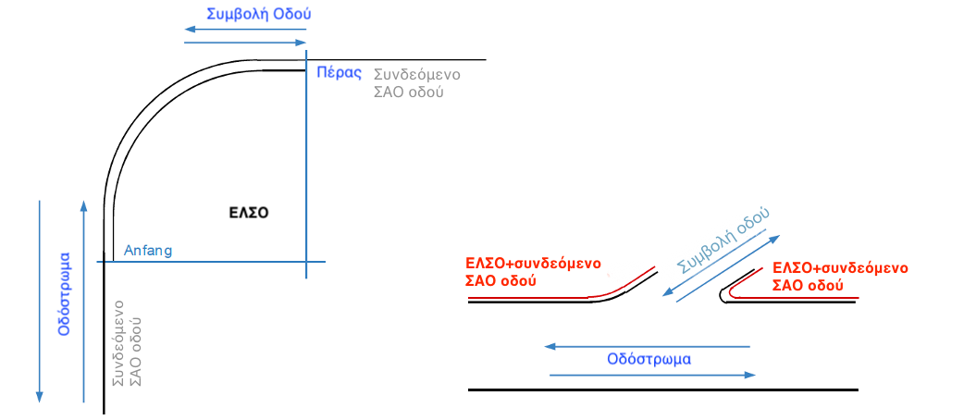

Start

RSB = Road Safety Barrier

Οδόστρωμα | Carriageway
Συμβολή οδού | Road junction
Πέρας | End
ΕΛΣΟ | SSRJ
Αρχή | Start
Συνδεόμενο ΣΑΟ οδού | RSB connected to road
ΕΛΣΟ | SSRJ Test 1
Υψηλή θέση μηχανής λήψης για καταγραφή όλης της περιοχής δοκιμής πρόσκρουσης-εκτροπής | High camera position for recording the entire impact-diversion test area
ΕΛΣΟ+συνδεόμενο ΣΑΟ οδού | SSRJ+RSB road connection

Figure P12-6: Examples of installation conditions deviating from test impact conditions

Miscellaneous
Production control
SSRJs and their components are produced in the producer’s production facilities for which valid certificates of continuous quality control and annual inspection by an Accredited Body are available, as provided for by ELOT EN 1317.

ΕLSΟ marking:
All SSRJs will be provided with appropriate permanent marking both at their start and at their end, in order to make it perfectly possible to trace the product and its parts in case of need for repair or replacement in relation to the assemblies of the safety barriers.

Indications with stickers shall not be considered as permanent marking of the product. Plastic plates firmly fitted by bolting to SSRJs, which will carry the required information to trace the product, can be accepted. During screwing it must be ensured that screw projections are located on the rear side of the SSRJ and not towards the traffic side. Traffic-side marking should not pose a risk to road users.

MINISTRY OF INFRASTRUCTURE & TRANSPORT
GENERAL SECRETARIAT FOR INFRASTRUCTURE
DIRECTORATE-GENERAL FOR TRANSPORT INFRASTRUCTURE
ROAD INFRASTRUCTURE DIRECTORATE

Road Project Design Instructions
(RPDI)

Road safety barriers
(RPDI - RSB)

Volume 2
Instructions for the installation and repair of vehicle restraint systems

May 2021

Working group: “Instructions for the installation and repair of vehicle restraint systems” – Volume 2

2021 Version
Dimitrakopoulos Nikolaos, P.M. with A.B., Head of the Directorate for Road Infrastructure.
Hatzidakis Antonios, Double. Civil Engineer NTUA, Transport specialist
Vasileios Psarianos, Professor at the National Technical University of Athens

Members of the Committee:
Dimitrakopoulos Nikolaos, P.M. with A.B. representative of the Directorate for Road Infrastructures, Coordinator of the Working Group
Anagnostopoulou Aristea, P.M. with A.B. – representative of the Directorate for Fixed Wheel Infrastructure, member
Fournarou Catherine, P.M. with A.B. – representative of the Directorate for Quality and Standardisation, member
Houliaras Generalula, P.M. with A.B. – representative of the Directorate for the Operation, Maintenance and Exploitation of Transport Infrastructures under a Concession Agreement, Member
Sigalas Ioannis, P.M., Designer, President of the Greek Department of the IASSE, member

Contents

1. General 110
2. Terminology 111
3. Application 114
4. Checks 114
4.1 Suitability Checks 114
4.2 Internal supervision of installation and placement of safety barriers 114
4.3 Inspection checks 115
4.4 Additional checks 115
4.5 Arbitration checks 115
5. Vehicle Restraint Systems 116
5.1 Materials 116
5.2 Execution of Works 116
5.2.1 Assembly staff 117
5.2.2 Machinery and Equipment 117
5.2.3 Storage and Transportation 118
5.2.4 General working arrangements for Vehicle Restraint Systems 118
5.2.5 Installation on bridges and other technical works 123
5.2.6 Designation – Marking 124
5.2.7 Completion of safety project 124
5.3 Additional constructions and provisions 125
5.4 Deficiencies 125
5.4.1 Addressing deficiencies 125
5.4.2 Limitation period 125
5.5 Receipt 125
6. Steel vehicle restraint systems 125
6.1 Materials 125
6.2 Installation 126
6.2.1 General regulations 126
6.2.2 Installation of a safety barrier with inserted uprights 127
6.2.3 Installation on bridges and other technical works 128
6.2.4 Installation of temporary steel safety barriers 128
6.2.5 Designation – Marking 129
6.2.6 Reuse of parts and components 129
6.3 Checks 129
6.3.1 Internal installation supervision 129
7. Prefabricated concrete vehicle restraint systems 129
7.1 Materials 129
7.2 Installation 130
7.2.1 General regulations 130
7.2.2 Application of drainage openings 131
7.2.3 Processing joints 131
7.2.4 Reuse of prefabricated concrete safety barrier 131
7.3 Checks 131
7.3.1 Internal installation checks 131
8. Vehicle Restraint Systems from cast concrete 131
8.1 Materials 132
8.2 Installation 132
8.2.1 Staff 132
8.2.2 General implementing regulations 132
8.2.3 Creation of drainage openings (holes) 134
8.2.4 Manhole coverage 134
8.2.5 Creation of joints in cases of cast concrete barriers with continuous reinforcement protected against corrosion 134
8.3 Checks 136
8.3.1 Internal supervision of the installation 136
9. Steel barrier in combination with concrete barrier 136
9.1 Materials 136
9.2 Installation 136
9.3 Checks 136
9.3.1 Internal supervision of the installation 136
10. Impact Energy Absorption Systems (IEAS) 136
10.1 Materials 136
10.2 Installation 136
10.2.1 Bearing surface 136
10.2.2 General regulations for installation 137
10.2.3 Reuse of IEAS parts 137
10.3 Checks 138
10.3.1 Internal installation checks 138
11. Safety barrier terminations (BT) 138
11.1 Materials 139
11.2 Installation 139
11.3 Checks 139
11.3.1 Internal installation checks 139
12. Barrier assemblies 139
12.1 Materials 139
12.2 Installation 139
12.3 Checks 140
12.3.1 Internal installation checks 140
13. Damage remediation (Repairs) 140
13.1 Special arrangements for the repair of old type safety barriers 140
13.2 Steel safety barrier repair 141
13.3 Repair of a prefabricated concrete safety barrier 142
13.4 Repair of a cast concrete safety barrier 142
13.5 Creation of joints with existing steel reinforcement 143
13.6 IEAS repair 144
13.7 Repair of barrier terminations 144
13.8 Repair of barrier assemblies 144
Annex A 145
Annex B 154
Annex C 0
Annex D 8
Bibliography 8

- General
These instructions form the 2nd Volume of the RPDI-RSB instructions and are an integral part of them. These instructions describe the requirements and regulations for the correct and effective installation and repair of permanent vehicle restraint systems, based on the relevant implementation study, which must have preceded and implemented in accordance with the principles and regulations set forth in Volume 1 of the instructions. The drafting of these instructions has taken into account the relevant mandatory and complementary European directives concerning the respective national instructions. Vehicle Restraint Systems include safety barriers, their terminations and assemblies as well as the Impact Energy Absorption Systems (IEASs).
All the Volumes relating to the instructions and Technical Specifications relating to road restraint systems are set forth in the table below.

S/n | Type | No. Volume | Title
1 | Road safety barriers  (RPDI-RSB) | Volume 1 | Instructions for studies of road construction Vehicle Restraint Systems – Railings
2 | Road Safety Barriers  (RPDI-RSB) | Volume 2 | Instructions for the installation and repair of vehicle restraint systems
3 | Road safety barriers  (RPDI-RSB) | Volume 3 | Instructions for receipt and control of barrier assemblies
4 | CONDITIONS  Issuing a declaration of performance of Concrete Safety Barriers (CSBs) | Volume 4 | Instructions for application on site of cast concrete safety barriers
5 | Instructions for the implementation of special safety studies against roadside barriers on interurban roads with a single carriageway | Volume 5 | Special instructions for the application of road safety barriers for protection against trees and other roadside barriers on interurban roads with a single carriageway

Safety barriers are construction products according to Regulation 305 on construction products, with the exception of cast concrete safety barriers, which are classified as Technical Works.
The texts referred to and presented in this Volume are ‘Recommended Instructions’. These must be taken into account by the competent Managing Services and Authority Heads when drafting the tender documents and awarding the projects, as well as when supervising and receiving the equipment and the way it is installed.
Goods lawfully marketed in another Member State of the European Union or in Turkey or originating in and lawfully disposed of in the Contracting Parties to the EEA Agreement shall be deemed to be compatible with these regulations. The application of those regulations is subject to Regulation (EU) 2019/515 of 19 March 2019 on the mutual recognition of goods lawfully marketed in another Member State.

- Terminology

Vehicle Restraint System Durability: Ability of a vehicle restraint system to maintain the essential performance characteristics identified during its impact test under the influence of predicted events over a long period of time. With normal maintenance and if properly installed, assembled and installed a vehicle restraint system must fulfil the requirements set forth for an economically acceptable and reasonable service life.
Barrier Terminations (BT): Terminal configuration and anchoring of a barrier.
Support base/bearing structure Area under the vehicle restraint system. This includes both the supporting surface under a vehicle restraint system (e.g. concrete barrier) as well as the subsoil for a safety barrier with inserted uprights (e.g. steel barrier) as well as the support beam (foundation strip).
Reference line: Lateral boundary of the traffic area, typically the edge of the stabilised (asphalted) surface.
Declaration of performance [EU declaration of performance]: A declaration issued by the manufacturer (producer) in accordance with the European Construction Products Directive, that the safety barrier fulfils the requirements of ELOT EN 1317. For cast concrete barriers, this declaration shall be supplemented by the manufacturer’s confirmation that the concrete barrier fulfils the specific durability requirements as referred to in the relevant comparative procedure referred to in Volume 4 of these instructions.
Lifespan: A period during which the characteristics and performance properties of the product are maintained in such a way that the product fulfils the requirements of ELOT EN 1317 (i.e. for all the essential properties of a product the prescribed minimum values are fulfilled or these are exceeded, without creating greater costs for repairing or replacing it). The shelf life of a product depends on its durability and normal maintenance.
Type Testing (TT): The checks prescribed by ELOT EN 1317 to determine the performance characteristics of an impact on a Vehicle Restraint System.
Short-Term Road Works (Construction Site): Road works that exist only for a limited number of hours of a calendar day, typically between sunrise and sunset, even if work continues in the following days.
Long-Term Road Works (Construction Site): Works on the road, which take place without interruption and in the same location and for at least one calendar day.
Foundation: Part of the road deck directly adjacent to the carriageway or the stabilised (asphalted) road foundation (LEA or OLP according to RPDI-D 2001). It may exist both laterally and in the middle of the road cross section.
Manufacturer: Organisation or undertaking, legally responsible for affixing the marking/CE marking to a construction product.
Technical License Holder or Certified Technician: Expert Technician (e.g. Concrete Technician) with additional expertise in concrete technology in accordance with the applicable regulation, certified by means of a special licence, attestation or certification by an
Accredited Body.
Assembly manufacture: Mechanical connection between two safety barriers in a different form of construction and/or different operational properties.
Railings Systems installed alone or in combination with vehicle Restraint Systems on bridges, retaining walls or similar structures for the protection of pedestrians or “other road users” and are not vehicle restraint systems.
Safety barrier expansion (contraction) joint Specially configured connections between safety barriers, which allow for a change in their length due to temperature changes (e.g. in areas of mobile assemblies (joints) of carriageways and bridges).
Permanent safety barriers Safety barriers permanently positioned on the road.
Installation instructions: Description of the manufacturer of the safety barrier and of the specific characteristics provided for when during its installation and placement on the road.
Old type barriers Safety barrier not conforming to ELOT EN 1317.
Certificate of (Stability) Performance [former Certificate of Compliance with EU Regulation): A certificate from a notified body for construction products that the safety barrier fulfils the requirements of ELOT EN 1317.
Prefabricated concrete barrier (PREFABCB): Concrete barriers with prefabricated parts or elements transported from the production plant to the location where the works are carried out on the road, where they are connected to each other.
Adaptive elements: Abbreviated standard safety barrier elements (including cut-off and adjustment of a typical longitudinal component of the cross-section of the system).
Additional constructions and provisions: Structures or provisions such as safety barrier support
railings, anti-glare screens, uprights or signposts, traffic installations and additional structures for the protection of motorcyclists in accordance with Volume 1 of these instructions.
Temporary (portable) Safety Barriers: Safety barriers used in road works (road construction works).
CE Marking: Characterisation of a manufacturing product by the manufacturer after successful completion of the technical assessment and performance control process of the product (certification process for stability performance) in accordance with Regulation 305 on construction products.
Safety Barriers: Vehicle restraint system, which is installed on its longitudinal side on the outer side of the road or on the central or lateral separating islet.
Concrete safety barrier from cast (in situ) concrete (CSB): A safety barrier for which a suitable type of fresh concrete is used for its installation and construction in the final form and position through special metal guides or mobile matrixes with road construction machinery during the execution of the road work.
Connecting element: Force transfer component connecting two prefabricated concrete barriers (e.g. steel connector).
Comparative procedure for cast concrete safety barrier Procedure for the identification and description of the essential characteristics of in situ cast (injected) concrete of concrete safety barrier (contains a process of compliance with EN 1317 and durability of at least 25-years).
Maintenance, special type (specific): Work related to the safety barrier itself and which is required to maintain its performance.
Maintenance, standard type (regular maintenance): Maintenance work in the surrounding area
of a safety barrier in order to maintain its performance (e.g. cutting bushes, cleaning of sewage manholes, etc.) and carried out by regular maintenance workshops.
Application recommendations for safety barriers: Additional recommendations on how to implement and place safety barriers, drawn up as appropriate by the Directorate for Road Infrastructure (DRI) and communicated in an official manner by means of circulars and other appropriate means (website of the Secretariat-General for Public Works, other Public Services, etc.).
Vehicle Restraint System: A system installed on roads that holds or restores or changes course of a vehicle that is deflected from the carriageway (safety barrier, barrier assembly, barrier terminations and IEAS).
Impact Energy Absorption Systems (IEASs): Special structures placed before obstacles in order to reduce the impact severity for a vehicle and to change this kinetic energy into a deformation work.
Wall forming systems: blocked and solid cross-sectional barrier in the impact area (e.g. concrete barrier, solid steel barrier - temporary barrier).
Technical Criteria for Installation of Safety Barriers: Technical criteria (requirements) to be taken into account when launching and selecting suitable safety barriers.
Technical Test Report: Document drawn up by the accredited impact test control body in accordance with ELOT EN 1317.
Installation/assembly technician: Person with special training for the installation and assembly of barriers in accordance with the applicable instructions and regulations.
Installation or placement height: Height of the safety barrier measured from the upper edge of the system in relation to a reference point (typically carriageway or in exceptional cases a ground surface situated before the safety barrier).

- Application
The instructions in this Volume shall apply to the placement, installation and maintenance of a barrier on surfaces with public traffic.
These instructions (Volume 2) may also be applied to other locations.
The repair methods due to the impact of vehicles on a safety barrier that do not fulfil the criteria of the ELOT EN 1317 standard (old type of barrier) are described in Chapter. 13.
In addition to these instructions, the relevant instructions and regulations will be adopted in the future.
Where discrepancies are found between the regulations set forth in this guidance in Volume 2 of the RPDI-RSBs and the instructions for the installation of a barrier, the regulations leading to the best performance in terms of road safety shall apply. In case of more than one parameter, e.g. height and distance, each parameter shall be considered and evaluated separately.
Where due to local circumstances the safety barrier cannot satisfy the standard solutions in accordance with Volume 1 of these instructions, solutions (possibly also special constructions or construction configurations) must be provided which are based on the principles set forth in Volume 1 and which achieve the best level of protection for the given conditions.

- Checks
  - Suitability Checks
The suitability of a barrier is confirmed by compliance with the ELOT EN 1317 standard and possibly through other relevant instructions or regulations in force each time (e.g. other Volumes of these instructions).
For specific structures and cases, compliance with the relevant instructions to be issued is required.

  - Internal supervision of installation and placement of safety barriers
Internal supervision of the installation and placement of a safety barrier is undertaken and carried out by the project contractor (own control). These are appropriate checks to determine whether the quality properties of the components, parts or components of the system, materials, mixtures of materials and means of connection, as well as the assembly and final performance of the installed system comply with the contractual obligations of the project.
When the system is delivered to the site of the work on the road, a visual check for damage to the equipment and parts of the system shall be carried out. The existence of the required certificates will also be checked.
The internal supervision of the positioning/installation of the system shall check whether the relevant installation work of a vehicle restraint system is carried out with due care and to the extent required. If deviations from the contractual obligations are found, the contractor must immediately remedy the relevant deficiencies. If this is not possible, the Management Service must be immediately informed.

For each day and working section a protocol shall be drawn up for internal supervision of operations on a safety barrier, whether they concern repairs, replacements or new fittings in accordance with Annex A, Forms A1 to A6. The connection anchors shall be checked in accordance with the following paragraph and shall always be entered in a protocol (Annex A, Form A7) during the construction of anchorings. In the case of CSBs, the relevant form shall always be completed in accordance with Annex A8.
Anchoring on foundation bases, bridges and other technical works shall be checked in accordance with the requirements of the anchorage instructions by means of a controlled application of the maximum torque when assembling the anchoring of safety barriers by means of a calibrated instrument or device (strength key). If the prescribed torque value for assembly is not reached when the anchoring pin is clamped, the event shall be characterised as a deficiency which must be immediately rectified. The achieved torque of at least 3 % of the anchorings shall then be checked by means of a calibrated dynamometer and the result entered in the checklist in accordance with Annex A, Form A7.
The conformity of the installed barrier with the manufacturer’s barrier performance declaration and its performance certificate in accordance with ELOT EN 1317 or the performance certificate in accordance with the comparative licensing method the cast concrete barrier must be checked on each occasion.
The cost of internal supervision of the placement of a safety barrier shall not be invoiced separately.

  - Inspection checks
The Managing Service shall carry out an inspection of the installation work and related checks to ascertain whether the quality characteristics of the components, their materials and their mixtures, the connecting equipment, the method of placement and installation in general and the relevant performance of the safety equipment comply with the contractor’s contractual obligations. The results of the relevant checks are a criterion and a basis for acceptance of the work of installing the safety barrier.
The Managing Service shall carry out the relevant work checks in the presence of the Contractor. The checks shall also take place in the absence of the contractor, provided that the contractor does not show up at the place and time of the check which has been duly notified.
Internal monitoring protocols drawn up by the contractor must be taken into account in this case.
The Managing Service shall determine the extent and timing of the inspection and related checks.
The cost of the inspection is borne by the Managing Service.

  - Additional checks
If it is considered that the result of a check does not represent the total quality of the work or part thereof, the contractor shall be entitled to require additional checks on specific individual operations. The positions where the relevant checks will be carried out shall be identified jointly between the contractor and the Managing Service.
The Management Service’s right to carry out further controls at its discretion remains inalienable.

The results of initial and additional checks become decisive only for receiving, compiling and submitting an account for the individual operations.
The cost of carrying out the additional checks requested by the contractor shall be borne by the contractor.

  - Arbitration checks
An arbitration check is the repetition of a check for which there is a substantiated challenge on the part of the contractor or the Managing Service as to its technical correctness (e.g. due to own checks). Arbitration checks shall be carried out at the request of one of the Parties by a commonly accepted body that has not carried out the initial check. The result of the arbitration check replaces the results of the initial check.
The costs of arbitration check, including additional related charges, shall be borne by the person whom the outcome of the arbitration check does not favour.

- Vehicle Restraint Systems
This chapter contains general conditions and regulations relating to all vehicle restraint systems. The specific conditions and regulations are set forth in Chapters 6 to 13.
Safety barriers must fulfil the relevant technical criteria set forth in Volume 1 of these instructions and set forth in the notice of the safety project. The fulfilment of the technical criteria for each specific case required by the Managing Service may be substantiated by specific certificates or confirmations produced by the person concerned.
The safety barriers installed must bear certificates and attestation of stability of performance in accordance with ELOT EN 1317. The cast concrete barriers shall bear additional certificates of identification and manufacturer’s declarations of their relative performance in addition to those relating to EN 1317 (Volume 4 of these instructions).
The durability of installed safety barriers should be presumed through the certification, recognition or report of relevant expertise, that it will last for at least 25 years for their average operating conditions in the country.
Only safety barriers whose operational use does not require any specific maintenance of the product may be installed. Maintenance or restoration work required by a vehicle impact is not considered to be typical maintenance work, but repairs.
When describing the performance of a safety barrier , special requirements may be set forth if necessary for the barrier itself (e.g. height of the barrier for visibility purposes) or its location (e.g. central/lateral, one-sided/two-sided, etc.).

  - Materials
All components, joints, materials, anti-corrosion and/or covering measures must be listed and described in detail in the installation instructions. All built-in components must be compatible with relevant requirements of the Managing Service and
they shall be identical to the data of the installation instructions and the technical reports, reports or certificates of relevant inspections.
Concrete and resin mortar as well as cement mortars with synthetic additives (PCCs) comply with the relevant specifications and regulations.

  - Execution of Works
The work on the road shall be carried out in accordance with the applicable 2010 RPDI-SEOs and relevant updates or additions thereto, where applicable.
Additional requirements or special details for the safety of works on the road are set forth in the technical specifications of the project or in the tender documents.

    - Assembly staff
The contractor must ensure that the assembly of the parts of the barrier will be performed by staff who have the required technical knowledge. This knowledge shall be referred to in the current instructions on safety barriers and the specific safety barriers installed.
Each installation project shall have at least one certified specialist or technician as a member of the workshop who has sufficient knowledge of the installation instructions, the requirements of the manufacturer and the permitted changes to the safety barrier.
The performance of assembly operations by the workshop will be continuously supervised by a certified specialist or technician. The qualification of the special assembly shall be certified by means of a certified copy of the relevant certificate or licence (see Annex B) submitted to the Managing Service. The certificate or licence may not be more than 4 years old.
Proof of a qualified assembly technician must be produced at the time of submission of the tender and at the latest before the start of the relevant procurement procedure. This shall be indicated at the time of the award notice.
The assembly technician shall supervise a maximum of three assembly workshops. This expert must be employed by the contractor’s company or a subcontractor active in the project.
The assembly crews must be spatially separated so that the special assembly technician can be quickly available (< 3 hours). To achieve this, the contractor must have a sufficient number of special assembly technicians throughout the installation of the safety barriers.
The contractor must immediately notify the Managing Service of the departure of an assembly technician and ensure that he is replaced immediately.

    - Machinery and Equipment
The technically correct installation and dismantling of safety barriers requires the availability of suitable and adequate machinery and equipment. All vehicles, machinery and equipment required for the installation and dismantling of safety barriers must be suitable and possess the relevant performance and characteristics with regard to their functionality, road safety and technical work. In addition, they must comply with the applicable safety standards against accidents.
The safety marking of works and factory protection vehicles shall comply with the relevant national and European standards or regulations.
    - Storage and Transportation
All parts of a safety barrier shall be properly stored and kept. They must be protected from any kind of pollution and deterioration.
For short-term road works, only the quantities of safety fittings and parts that will be used during the traffic arrangements may be deposited in the work area (on the road, on the islet and on the support).
For long-term road projects, vehicles, machinery, equipment, accessories and parts of barriers may be installed in the work area (on the carriageway, on the islet and on the support) outside the hours of assembly work for as long as traffic regulations are in force, provided that no specific obligations and arrangements are specified in the technical specifications for the project. Components and parts deposited for assembly must be assembled within a short period of time.
At the end of the work on the road, the contractor shall be obliged to restore the occupied surfaces to their original condition at their own expense.

    - General working arrangements for Vehicle Restraint Systems
Safety barriers shall be placed in accordance with their installation instructions.
The position of a barrier in the cross-section of the road shall be determined in accordance with the provisions of Volume 1 of these instructions. The Managing Service shall provide all the necessary data (e.g. relevant studies and road plans “as built”) to determine the reference line and the elevation of the safety barrier.
If the submission is foreseen of relevant plans for implementation or construction or existing status or as-built, then this provision shall be mentioned in the technical specifications for the project.
In curves with radii of less than 200 metres, particular attention shall be paid to the relevant instructions given in the installation instructions of the safety barrier, as appropriate. If use is required in accordance with the installation instructions of prefabricated curved parts or longitudinal elements of reduced length, then these parts shall be manufactured in the production plant. Information on the production and authorisation to install such parts is set forth in Annex 12 to Volume 1 of these instructions.
Curved sections with radius of less than 200 m are explicitly mentioned in the technical specifications of the project.

- Subsoil and support surface preparation
Before starting the works, the contractor must be aware of the location and route of ducts and cables of all kinds. The contractor shall ensure that the installation of a safety barrier does not result in any destruction, wear or damage to the pipelines. In addition, the contractor must take into account the instructions of the holder or owner of the cables, ducts, etc. for utilities.
If necessary, the contractor must, in consultation with the Managing Service, identify the location of the cables and pipes with special bodies and register this (documentation) appropriately.
The search, excavation and documentation of utilities facilities involve specific and additional tasks.
The supporting surface of a safety barrier shall be configured with sufficient strength and stability. Its configuration must fully ensure the functionality and performance.
of the safety barrier in accordance with the installation instructions.
The area in front and below the safety barrier shall be reinforced at least as much as the surface of the foundation (sufficient support strength of a passenger vehicle).
In the area behind the safety rail (functional safety rail area) the foundation surface shall be stabilised or reinforced in a way that the safety barrier behaves as well as in the impact test.
The Technical Specifications for the work must contain a detailed description of both the existing and planned foundation area in front and to the rear (operational area) of the safety barrier.
Specific work may be required in the Technical Specifications (e.g. when the ground does not have sufficient strength, the lateral area of the terminations is not suitable or when the construction of a bearing beam is planned or desirable, all the relevant works must be incorporated in the Technical Tenders).
If the existing or planned support area does not comply with the requirements of the installation instructions, the contractor must construct and form the support and foundation area appropriately (work relating to the proper functioning of the safety barrier, such as a surface asphalt layer, special foundation, base layer) at their own cost.

- Bearing beam / foundation beam (foundation strip)
In the case of a concrete beam, the concrete must fulfil the requirements of Eurocode 2 and the Greek Concrete Regulation (GCR 2016). As additional requirements (GCR A1.2.2), concrete may fulfil the requirements of DIN 1045-2.

The dimensioning of the beam depends on the safety barrier and takes place on the basis of the installation instructions.
During concreting, class 2 (supervisory engineer) supervision is required according to ELOT EN 13670 and DIN 1045-3. . For application quantities of less than 10 m³ for each application site it is not required that the supervision of the application be carried out by a recognised surveillance body (autonomous/supervisory engineer/special body), generally foreseen for supervision class 2.
For a non-reinforced concrete foundation (e.g. support base for a solid barrier) the supervision by a recognised operator of the works on the road, as foreseen for surveillance class 2, is also not required.

- Installation height and placement of sloping foundation
Safety blocks installed on typical road sections (outside areas of level and uneven junctions) shall be subject to screening tests, as a rule, on horizontal ground. The height h_{P} of the barrier over the carriageway during the test shall be indicated in the relevant test reports (documents) (Figure 1). When the safety barrier is installed under real conditions, where the support surface or the prefabricated surface is inclined, it may be necessary to adjust the elevation angle or the support surface.
In the case of flat ground, the measured height of the safety barrier at the position immediately before it h_{E} (over the ground) shall be equal to the test height h_{P}.

VEHICLE RESTRAINT SYSTEM
Horizontal soil

Carriageway surface

Height of VRS according to impact test (with reference to carriageway surface)

VRS = Vehicle restraint system

Fig. 1: Height definition of safety barrier h_{P} according to the impact test

In the case of a positive or negative ramp, the safety barrier shall be installed in accordance with Annex C, depending on the incline “s” of the base or islet, the distance of the safety barrier from the traffic area “a” and the type of safety barrier. The installation height h_{E} is the height of the safety barrier measured immediately before the safety barrier and above the ground at its position.
The existing value of the incline must be indicated in the technical specifications of the project. Specific construction measures (e.g. adaptation of the environment or use of specific components) may be required in cases of deviations exceeding 6 %. When the incline exceeds the value of 12 %, special measures are always required.

- Installation and placement height on technical projects
A barrier that has been tested for impact on Technical Projects, shaped with pedestrian paths with an incline of 4 % and a standard height of 7.5 cm, may be installed on technical projects with inclined pedestrian path of up to 6 % and a curb height of up to 10 cm without adjusting the height of the safety barrier (h_{E} in accordance with Figure 2).
VEHICLE RESTRAINT SYSTEM
Technical pedestrian path
Carriageway surface

Note:
h_{P}= VRS height according to the impact test (reference to carriageway surface)
h_{E}= height of installed VRS (measured right in front of the VRS). Here: real VRS height above the pedestrian path.
a_{P}= Distance of the VRS from the carriageway boundary line during the impact test
VRS = Vehicle restraint system

Fig. 2: Definition of the height of a vehicle restraint system according to the impact test h_{P} when installing the vehicle restraint system on technical pedestrian paths
- Installation and placement height on existing curbs
In cases of existing and unavoidable slopes along typical sections of roads (outside junctions area) or on special technical pedestrian paths(e.g. bridge pedestrian paths), which have a height h_{B} ≥10 cm above the surface of the road, the following regulations apply (Figure 3):

VEHICLE RESTRAINT SYSTEM

VEHICLE RESTRAINT SYSTEM
H
VEHICLE RESTRAINT SYSTEM

INSTALLATION HEIGHT

INSTALLATION HEIGHT
INSTALLATION HEIGHT
CARRIAGEWAY SURFACE
H
CARRIAGEWAY SURFACE
H
CARRIAGEWAY SURFACE
H

Fig. 3: Definition of installation height of vehicle restraint systems in cases of existing curbs

- With distances ‘s’ of the safety barrier up to 25 cm from the curb, the height of the safety barrier shall be constructed by reference to the carriageway surface. The height of the safety barrier must be adjusted accordingly (Figure 3a).
- With distances "s" of the safety barrier greater than 25 cm and less than or equal to 1.5 m from the curb, the height of the safety barrier shall be constructed with reference to the road surface by increasing its height by half the height of the curb (Figure 3b). For a wall type safety barrier, no adjustment of the height of the safety barrier shall normally take place if there is no case of a vehicle slipping under the safety barrier.
- With distances ‘s’ of the safety barrier greater than 1.5 m from the curb, the height of the safety barrier shall be constructed by reference to the bearing surface immediately before the safety barrier (Figure 3c).
The manufacturer’s instructions for installing the safety barrier shall also be taken into account.
It may be necessary to adjust the height of the safety barrier at the beginning or at the end of the curb or pedestrian paths of the Technical Works. This elevation adjustment shall be modulated with an incline of 1:20 or less.

- Installation Tolerances
The safety barrier shall not deviate from its horizontally prescribed position by more than ± 5 cm (distance from reference line). The minimum distance of 0.25 cm from the reference line shall also not deviate by the same horizontal tolerance.
A safety barrier shall not deviate by more than 2 cm over a length of 4 m from its alignment. The installation height shall also not vary by more than 2 cm over 4 m of the length of the safety barrier.
Even with respect to the installation tolerances of the safety barrier, no discontinuities and gaps greater than 2 cm may occur, which may cause some anchoring of a longitudinally sliding vehicle or two-wheeler riders.
The installation height of a safety barrier shall not deviate by more than ± 3 cm from its theoretical elevation.
In all cases where the height of the safety barrier refers to the surface of the foundation, it shall not be permitted that the height of the safety barrier deflects by more than ± 5 cm from its theoretical height.
In cases where the safety barrier has been subjected to an impact test in conjunction with a railing, the distance between the safety barrier and the railing shall not deviate by more than ± 10 cm from the corresponding distance during the impact test. If a higher deviation value is accepted, in the context of a structural change/modification of the safety barrier with a declaration from the Accredited Body, the installation of the safety barrier in its modified form shall also be accepted.
In-house safety technical works are normally placed at a distance of 0.5 m between the front (face) of the barrier and the curb. This distance may be reduced or increased taking into account the relevant elevation regulations referred to above.
All installation tolerances of a safety barrier shall be certified to comply with the above and/or with that imposed by the manufacturer’s (producer’s) installation manual and by the manufacturer or their legal representative.

- Special Construction of Vehicle Restraint Systems
Special constructions of safety barriers are permitted only if there are no safety barriers available that have undergone a relative positive impact test according to EN-1317 for the specific application case.
‘Special structures’ means safety barrier structures which are based on a specific safety barrier which has undergone a positive impact test according to EN 1317 and have been adapted to fulfil particular local road conditions but have not been subjected to an impact test for these conditions.
If special constructions are to be installed on a road the relevant requirements set for them must be clearly stated in the technical specifications of the project.
If special safety barrier structures are to be used, this must be communicated to the Managing Service in writing with the corresponding financial offer.
The contractor must provide technical drawings with dimensions of the specific structures, including all the components, comprising the special construction and their connections and a list of the parts of the construction.

    - Installation on bridges and other technical works
On bridges and technical works in general, the barriers and their supports shall be installed in accordance with the relevant impact test and the manufacturer’s installation instructions. In any case, the available thickness of the supporting element in technical works may not be less than the nominal length of the anchoring.
In order to ensure the support-anchoring depth, the anchoring thread may protrude above the nut a maximum of 15 mm.
Anti-corrosion protection is achieved through hot galvanising. Alternatively, a coating that has been tested for anti-corrosion protection C5-I, average duration of protection according to ELOT EN ISO 12944-6 and ELOT EN ISO 3231 or treatment with anti-rust steel type A4 or A5, Material No 1.4571 or 1.4401 is possible.
When fixing the steel or prefabricated concrete safety barrier on a concrete surface, any existing irregularities between the concrete surface and the anchoring plate shall be smoothed by means of a levelling layer of cement mortar with an addition of synthetic material or by means of an elastic insulating plate that is weather-resistant with an average thickness of 5 mm.
Holes opened on the pedestrian paths of the bridges must be permanently sealed (e.g. using adhesive anchors). The filler must be resistant to frost and de-icing salts.
In full safety barriers (wall type) in order to ensure adequate drainage of its bearing surface and depending on the configuration of its cross-section, openings of dimensions 5-10cm in height and 10-40cm in length must be provided (minimum requirement: 100 cm² per 4 m), if deemed necessary by the drainage study as recommended by the Managing Service.

All carriageway assemblies shall be constructed with expansion (contraction) joints on the safety barrier.
The construction of expansion joints on the carriageway assemblies is an additional task.
Movements of the bridge due to temperature changes shall be taken into account in the construction of the barrier at the position of the contraction-expansion joint of the bridge. For the pre-
adjustment of the range of expansion joints, in order to allow them to receive the expected movements, the average temperature of the technical element is decisive.
For the setting of expansion joints, the value of + 10º C as neutral value position is valid.
The function of the barrier shall not be adversely affected by the appropriate expansion. The side of the barrier, the traffic-facing side, shall be configured in such a way as to avoid any possibility of anchoring a vehicle or a motorcycle rider sliding along the barrier. The width of vertical split joints shall not exceed a value of 4 cm.
In cases of wall type safety barriers, the expansion joints are covered with hoods. The anti-corrosion protection of sheet metal of the covers takes place through hot galvanisation (ELOT EN ISO 1461). Alternatively, it is possible to coat with an anti-corrosion agent, class C5-I duration of protection on average according to ELOT EN ISO 12944-6 and ELOT EN ISO 3231 or treatment with antioxidant steel type A4 or A5, Material No 1.4571 or 1.4401.
In a safety barrier on bridges, where more expansion joints are required due to the construction, their creation is not a special or additional task.

    - Designation – Marking
The contractor shall ensure that the installed safety barrier bears the prescribed special designation mark.
The safety barrier marking shall be intended to ensure its unique identification and traceability and shall include as a minimum:
- The year of installation, in the case of non-availability of the manufacturing time of the parts and components of the safety barrier which are required to bear a special mark;
- The manufacturer’s logo and certificate number of the performance certificate of the barrier or the number of the specific certificate or certificate of recognition of cast concrete barriers with an indication on the barrier (Volume 4).
- The marking shall be permanently affixed (e.g. embossed) at the beginning and at the end as well as at intervals of 100 m and must be easily visible on the safety barrier installed in position.
- The marking shall also apply to the individual components of the safety barrier such as blades, brackets, handrails, etc.
In case of deviations from the installation instructions, the barrier shall be marked as a special structure in addition to the other marking.

    - Completion of safety project
The road safety project shall be considered to be completed, provided that the installed safety barrier provides all the characteristics of its performance without restriction, as well as its functionality in relation to road safety in accordance with the instructions for the installation of the safety barrier. Completion of the safety barrier is a prerequisite for the return of road traffic. Otherwise, additional security or safety measures are required.

  - Additional constructions and provisions
Additional structures and provisions shall be placed on the safety barriers in accordance with the installation instructions of the manufacturer of the barrier. In this case, account shall also be taken of the specific instructions for installation of the additional structures or provisions. Additional fixtures or marking s on the barrier of all kinds shall require the agreement of the manufacturer of the safety barrier and of the Accredited Body issuing the certificate of stability of the barrier performance.

  - Deficiencies
    - Addressing deficiencies
The deficiencies identified are appropriately addressed. The relevant provisions will be included in the contracts for the project by the Managing Service, provided that no specific instructions have been issued by the Directorate for Road Infrastructure (DRI) of the Ministry of Transport and Infrastructure (MT&I).

    - Limitation period
The relevant requirements to remedy the deficiencies identified are subject to time limitation after the expiry of the contractual period provided for, unless otherwise specified, by decisions of the Ministry of the Environment, Regional Planning and Public Works.

  - Receipt
The Managing Service shall be entitled to receive all or part of the entire safety project before formal acceptance of the project. In this case the service is liable for any damage caused by third parties. In the event of partial acceptance of the project, the installation workshop should provide all the forms set forth in the annexes to this Volume signed as in the case of final acceptance of the safety project.

- Steel vehicle restraint systems
  - Materials
The parts and components of safety barriers, screws and galvanising shall be in accordance with the data and references given in the control test reports. For the steel material, it shall have at least the properties steel type S 235 JR. Only full low relaxation steel may be used (minimum content of 0.02 %).
As a general rule, only parts or accessories for safety barriers which have not already been used and which are no more than one three years from the date of their production are permitted. Special parts such as radial blades may be 5-year from the date of their production. All parts must have the minimum thickness of zinc layer at the time of installation, required for new components and materials. Additional galvanising layers of steel safety barriers in accordance with Table 6-1 are required in coastal areas and in areas with snowfall of such duration and extent, which requires the systematic use of snow removal salts. If older parts or equipment are used, this must be explicitly stated in the contract between the Managing Service and the Contractor. All the
above materials and components should comply with the requirement of visibility and traceability.
The use of screwing materials already used (e.g. screws, discs) and other small items (e.g. gaskets) is not permitted.

Table 6-1: Additional layers of galvanising safety barriers in coastal areas and areas of systematic use of snow removal salts

Steel wall thickness t  [mm] | Fe/Zn 115 |  | Fe/Zn 165 |  | Fe/Zn 215
 | Minimum value  [μm] | Minimum average  [μm] | Minimum value  [μm] | Minimum average  [μm] | Minimum  value [μm] | Minimum average  [μm]
T ≥ 6 | 100 | 115 | 145 | 165 | 190 | 215
3 ≤ t ≤ 6 | 85 | 95 | 100 | 120 | 115 | 140
1.5 ≤ t ≤ 3 | 60 | 70 | 70 | 95 | NOT APPLICABLE | NOT APPLICABLE

  - Installation
    - General regulations
The longitudinal elements shall be connected to the joints in such a way as to avoid shackles of a sliding vehicle or a motorbike along the barrier (e.g. overlapping blades in the traffic direction).
All screws shall be applied perpendicular to the connected components and accessories and tightened in accordance with the installation instructions.
A support ring must be placed below each nut.
Various fittings (such as small lengths of blades, small extensions of uprights, etc.) can be constructed on site. In this case, account shall be taken of the following:
- Technically correct change of component length with a special machine or saw,
- Technically correct drilling of screw holes,
- Technically correct improvement of connection locations and screw holes with zinc powder coating according to ELOT EN ISO 1461,
- No change in the distance between the uprights,
- The shapes of holes in joint areas must correspond to the dimensions of non-reduced standard elements, in size and form of holes and circumferences, as well as distance between holes,
- The shapes of holes in areas of adjacent joints must maintain the connection function unchanged, as in the case of typical elements,
- The outer hole distance from the ends of the parts of the safety barrier shall be at least 40 mm.
- The diameter of the holes must not change (increased diameter in different ways such as mandrel, heated head, etc.)
The use of adjusting pieces should be limited to the minimum possible.
Avoid the use of fit pieces in barriers assemblies and expansion joints.
The various parts and components may be adapted in a technically correct manner using only drilling and separation equipment and devices. Working with welding and cutting devices and impact tools and hammers is not permitted.
Damage and damage to galvanised surfaces shall be avoided when aligning safety barriers. Hammer impact directly on galvanised surfaces is not allowed. Consequently, the mounting of the uprights should be carried out only by means of a special support part.
Wear positions of the galvanised surface of small dimensions are restored with a careful coating with zinc powder in accordance with ELOT EN ISO 1461.

    - Installation of a safety barrier with inserted uprights
The uprights are inserted vertically. Deviations from the vertical greater than ± 5 per cent shall not be allowed. Due to impediments in the subsoil (e.g. rocky subsoil) there may be discrepancies in individual uprights In such cases a greater deviation of the vertical of the individual upright is permitted if screwing is possible. If this is observed in more than 10 % of the number of uprights or if screwing is not possible, then the holes of the uprights must be drilled into the subsoil. The correct tightening of the screws shall be checked to a minimum of 10 %.
The type of ground on which the uprights are inserted can influence the behaviour and operation of the safety barrier. On existing roads when replacing old steel barriers, it is necessary to technically check the properties of the supporting terrain of the barrier, e.g. by the certified push-pull method. The soil within which the lifting of the posts will take place must therefore be indicated in the Technical Specifications of the Project in accordance with the following Soil Homogeneity Characteristics HB1-RSB, UK2-RSB and HB3-RSB (replacing the conventional soil classes):
Soil homogeneity HB1-RSB (replacement of soil class 3-5 according to old DIN 18300 standard) including:
- Coarse soil with relative deposition density 0.65 ≥ D > 0.3 and/or
- Mixed soil with consistency index 1.0 ≥ I_{C} > 0.5 and/or
- Fine soil with consistency index 1.0 ≥ I_{C} > 0.5 and/or
- Organic soil and soil with a density of 0.65 ≥ D > 0.3 or a consistency of 1.0 ≥ I_{C} > 0.5 and/or
- Soils with a percentage of rocky material.
Soil homogeneity HB2-RSB (replacement of soil class 6 according to old DIN 18300 standard) which includes:
- Coarse soil with relative deposition density D > 0.65 and/or
- Mixed soil with consistency indicator I_{C} >1.0 and/or
- Fine soil with consistency index I_{C} > 1.0 and/or
- Soils with a percentage of rocky/stone material.
Soil homogeneity HB3-RSB (replacement of soil class 7 according to old DIN 18300 standard, rocky or solidified materials (e.g. ash) with monoaxial pressure resistance (compression resistance) q_{u} >15 N/mm².
A safety barrier with uprights shall be tested on a horizontal ground. This test involves the uprights in soils with soil homogeneity HB1-RSB. Additional measures may be required when placed on soils which deviate from those of the impact test. The description of the class of the existing soil and the incline of the base must therefore be mentioned in the Technical Specifications of the Project. If the soil class is not mentioned in the Technical Specifications of the Project, then the soil properties and characteristics must be checked. By way of exception and with the agreement of the Managing Service
in this case it can be assumed that the soil is classified in HB1-RSB.
The minimum length of the uprights (e.g. installation on an inclined support) shall not differ by more than 10 per cent of the length during the impact test, as long as the uprights will not be subjected to a reduction in length as indicated below.
If any of the cases referred to in the following subparagraphs are not included in the Technical Specifications of the Project, then the special measures required jointly between the Managing Service and the Contractor must be agreed.
The abovementioned specific measures are additional work.
The distance between the uprights according to the impact test shall be respected. If this cannot be respected for a short length, e.g. in wells, then the distance of the uprights before and after the well can be reduced. The number of uprights per height of the safety barrier may not be reduced.
In soils, classified in HB1-RSB, the insertion of the upright must be done as during the impact test.
The minimum insertion time of the uprights shall not deviate from that indicated in the physical impact test. If, on the contrary, the upright is inserted into soil classified in class HB1-RSB, more than the maximum duration indicated in Annex D, then there is difficulty with inserting. This is a specific additional task. If deformation or wear of the heads of the uprights occurs, the position deviation of the upright or becomes unusable for impulse, a perforation is required for the posts.
In soils that do not possess the characteristic properties of the soil class HB1-RSB, specific measures must be taken in accordance with the installation instructions to ensure the performance of the safety barrier. These measures must be agreed jointly between the contractor and the Managing Service. If these measures are considered insufficient, the soil class should be changed by determining soil properties and characteristics (e.g. by the push-pull method). Alternatively, a bearing beam (foundation strip) can be applied with a corresponding certified safety barrier.
During installation on rock or solid construction materials (e.g. ash), which can be classified in the soil class HB3-RSB, either on concrete or on asphalt surfaces, special measures must be taken in accordance with the manufacturer’s installation instructions to ensure the performance of the safety barrier. These measures should be agreed with the Managing Service.
If it is necessary to drill holes for the posts and the opening time of each hole lasts more than 10 minutes, the length of individual uprights may be reduced in accordance with the manufacturer’s installation instructions. The requirements concerning the drilling device are set forth in Annex D, paragraph 2.
As an alternative to any drilling for the uprights, a beam can be applied in conjunction with a corresponding certified barrier.
Reductions in the length of the uprights shall be made in accordance with the installation instructions and with the written approval of the Managing Service. Reductions in the length of the uprights shall not lead to lengths less than 0.8 m. Damage to the hot-dip galvanising layer must be restored by coating of zinc mortar after careful preparation of the surface according to ELOT EN ISO 1461.
In cases of underground cables, ducts, underlying technical works, etc., so that the minimum length of the uprights cannot be applied, then bearing beam are constructed in conjunction with a corresponding certified barrier.
The encapsulation of concrete uprights is not permitted.

    - Installation on bridges and other technical works
The expansion joints are constructed symmetrically. During construction, attention should be paid to the fact that the application of the upright with a bearing beam must always begin with the expansion joint. The expansion joints are always pre-assembled and are disposed of at the locations of the works on the road, as such and are installed on the technical element with the required distance of the uprights.
The determinant distance between the uprights when installing the barrier is derived from the length of the expansion joint and the change in length due to temperature change.
The screws in the longitudinal elements of the expansion joints shall be tightened so as not to interfere with longitudinal movement. The nuts are tightened in an appropriate way.

    - Installation of temporary steel safety barriers
The temporary steel safety barriers shall be placed perpendicular to the inclined road in the longitudinal direction. The flatness of the supporting surface of temporary safety barriers shall be subject to the same commitments as the bearing surface of the prefabricated concrete safety barriers (see 7.2.1).
If the steel safety barriers are temporarily placed on the crown of the basement or on a non-condensed and reinforced bearing layer, this layer shall be at least 20 cm wider than the bearing beam e of the safety barrier, for the sake of better transport of the loads. When placed on a concentrated and reinforced bearing layer, the abovementioned dimension shall be at least 10 cm.
A temporary safety barrier used on a road construction site during construction works may be reused as a permanent safety barrier, in accordance with these instructions, provided that it fulfils the relevant performance requirements of the safety barrier and if it has been used for the first time on a construction site. Otherwise, the paragraphs (2) and (3) of paragraph 6.1 apply.

    - Designation – Marking
For safety barriers whose different parts and components come from different manufacturers (different manufacturers’ marking), the contractor must provide documentary evidence that the barrier so assembled fulfils the requirements of product designation in order to bear the CE mark. The declaration of performance of the barrier and the associated performance certificate of the Accredited Body must be submitted by the contractor.

    - Reuse of parts and components
Used parts and components of the safety barrier can be reused in a safety project upon agreement with the Managing Service if all the following conditions and limitations are fulfilled:
- The parts and equipment fulfil the requirements of the manufacturer’s installation instructions for the new safety barrier to be installed,
- The manufacturer’s marks and the identification of the period of time of the check shall be clearly identifiable and traceable;
- The parts and components are not more than 15 years old (year of manufacture),
- The parts and components do not show obvious deformation and/or damage (e.g.
cracking or expanded holes),
- Galvanised parts and components remain a thickness of galvanising layer of at least 30μm. Other zinc coatings shall have at least 80 % of the thickness of the original minimum coating.
The reuse of already impregnated uprights, detachable and loose fittings (shells, nuts, discs) is not allowed.
The use of regalvanised steel is not allowed.
When using used parts and components, the safety barrier shall not bear the CE mark.

  - Checks
    - Internal installation supervision
Connections and any other support and anchoring elements shall be checked on each working day and at least every 100 m and shall comply with the requirements of the installation instructions. The screw tightening torques shall be checked on each working day and at least every 100 m on each component and shall be in accordance with the installation instructions. If more than 10 % deviation of the screw tightening torques referred to in the installation instructions is detected, the screws of the adjacent parts of the safety barrier shall be checked and the problem shall be rectified immediately.

- Prefabricated concrete vehicle restraint systems
  - Materials
Prefabricated concrete safety barriers, their parts and assembly components and joint fillers shall be in accordance with the data of the test reports.
It is normally permitted to use and install new (non-used) parts and components of prefabricated concrete safety barriers which are not older than 3 years (in special constructions, e.g. radial elements with strong curvature, not older than 5 years). If older non-second-hand elements are to be used, this shall be done on a case-by-case basis after consultation between the Managing Service and the contractor of the safety project.
Only non-used coupling elements may be used as well as the use of non-used small fittings, for which the minimum prescribed thickness of galvanisation has been maintained for new elements and materials in accordance with ELOT EN ISO 1461.
Elements of prefabricated concrete barriers, already used in road works, may be reused as a permanent barrier as referred to in Volume 1 of these instructions, provided that they fulfil the relevant requirements of this Volume and have been used in the road project as non-second-hand elements for the first time. In addition to those criteria, the relevant provisions of the preceding two subparagraphs shall apply.
All prefabricated concrete safety barriers shall have the necessary identification and traceability data in proportion to the steel safety barriers.

  - Installation
    - General regulations
The prefabricated concrete safety barriers shall be placed along the road perpendicular to its inclined surface (the longitudinal incline of the bearing surface is identical to that of the road).
Before assembling the prefabricated concrete components, loose or detached parts of the bearing surface must be removed and cleaned from foreign or bearing materials.
If the safety barrier is placed on the crown of the pedestrian path base or on a non-condensed and reinforced bearing layer, this layer shall be 20 cm wider than the supporting surface of the barrier for better transport of the loads. When placed on a concentrated and reinforced bearing layer, the abovementioned dimension shall be 10 cm.
The flatness of the bearing area must be indicated in the Technical Specifications of the Project. A specific article may be required for the restoration of the flat surface of the prefabricated concrete barrier.
The prefabricated components of the concrete barrier shall be placed on a bearing surface with a flatness of ± 6 mm over a length of 4 m and ensure support throughout the surface. If the deviation of the level is greater than the abovementioned value, specific and appropriate measures must be provided by the project contractor (e.g. application of a levelling layer). These measures must be agreed with the Managing Service. Installation and placement tolerances must be respected.
Special adaptive items are manufactured in the factory. The use of adaptive elements should be limited.
Components that are easily disassembled are installed in well areas. These elements may be of reduced length.
The number of wells covered by a safety barrier must be limited.
Between two wells the minimum operating length (test length) of the safety barrier shall be respected. If this is not possible, then safety barriers, covering wells, which have been tested for reduced length impact in accordance with EN 1317 shall be used.
In areas of safety barriers and expansion joints, adaptive elements shall be avoided.
Loose elements of prefabricated concrete barriers shall be so adapted that they cannot be dismantled and removed by hand.

    - Application of drainage openings
Until such time as the relevant instructions are issued, the provisions of paragraph 8.2.3 shall apply.

    - Processing joints
The joints are configured on the basis of the instructions for installing the safety barrier.
The width of the vertical perpendiculars of the joints shall not exceed 4 cm.
When filling land behind concrete barriers, the joints that come into contact with the land filled shall be sealed so that filling materials and water cannot be enter through them.
    - Reuse of prefabricated concrete safety barrier
As a general rule, only non-used prefabricated concrete barriers in accordance with paragraph 7.1(1) may be used.
Prefabricated concrete safety barriers may be reused during a safety project only after consultation with the Managing Service. In such cases, all the subsequent conditions and limitations must be fulfilled:
- The parts and equipment of the barrier shall comply with the relevant requirements of the installation instructions for a new barrier;
- The manufacturer’s marks and the marking of the time period for performing the check (test) are clearly identifiable and traceable;
- The parts and components are not more than 15 years old (year of manufacture),
- The parts and components do not show obvious deformations (e.g. coupling elements) and/or damage (e.g. cracks, breakages of material);
- Galvanised coupling parts and components shall remain a thickness of a galvanising layer of not less than 80 % of the prescribed layer thickness and in any case a thickness of not less than 30 μm.
The reuse of connecting components (e.g. screws, nuts, discs) and small fittings (e.g. vibration inhibitors) is not permitted.

  - Checks
    - Internal installation checks
Coupling parts and any other attachments and anchorings shall be checked every working day and at least every 100 metres and shall comply with the requirements of the installation instructions. The screw tightening moments shall be checked every working day and at least every 100 metres in each component and shall be in accordance with the installation instructions. If more than 10 % deviation of the screw tightening torques referred to in the installation instructions is detected, the screws of the adjacent parts of the safety barrier shall be checked and the problem shall be rectified immediately. If the deviation of the clamping moments reaches more than 25 % then all coupling elements shall be checked again.

- Vehicle Restraint Systems from cast concrete
This chapter includes requirements for concrete safety barriers.

Cast concrete barriers must be manufactured in accordance with the certificate of approval or authorisation for the fitting of cast concrete containing in addition to the certificate of yield according to EN 1317 and the certificate of durability (lifetime) in accordance with the relevant comparative method of licensing a cast concrete barrier as referred to in Volume 4 of these instructions.

Concrete safety barriers may only be installed by the specialised construction workshop, as specified in the relevant approval certificate.

The approval certificate of for the placement of the solid concrete safety barrier in accordance with the foregoing shall be presented at the time of Submission of the manufacturer’s tender and at the latest before the safety project contract is awarded to a contractor.

  - Materials
For the construction of the cast concrete safety barrier, at least C30/37 XC4, XD3, XF4, WA according to ELOT EN 206 and Greek Concrete Regulation must be used, unless the manufacturer’s installation instructions provide for a higher class of concrete. The concrete shall fulfil at least the crushing strength class of the concrete during the impact test according to ELOT EN 1317.
All steel parts of the safety barrier (excluding reinforcement) shall be of type S 235 JR. Only low relaxation steel may be used (minimum aluminium content 0.02 %). Any additional relevant specifications will be issued by DRI of MYME.
The ELOT EN 206, ELOT EN 13670 standards and the Greek Concrete Regulation apply to the composition, manufacture and processing of concrete, unless other different or supplementary instructions and specifications have been issued by the MT&I DRI.
Concrete is classified in supervision class 2 according to the standard ELOT EN 13670.

  - Installation
    - Staff
The contractor manufacturer must have at least one qualified technician expert with a recognised concreting technician certificate (concrete certified).
The operator of the continuous concrete laying machine using the formwork must be specially trained. This qualification shall be obtained after successful attendance of an appropriate training seminar by the machine manufacturer.
The connection of the reinforcement by welding may only be carried out by qualified personnel with permission to do so. The welding requires a relevant welding certificate for the corresponding reinforcement steel, as well as the corresponding welding process and method (e.g. according to ELOT EN ISO 17660-1).
The certificates referred to above must be produced at the time of Submission of the tender and at the latest before the safety project contract is awarded.

    - General implementing regulations
On-site (cast) concrete safety barriers are placed perpendicular to the inclined carriageway (the longitudinal incline of the bearing surface is the same as that of the road). Deviations of up to ± 5 % are permitted.
The bearing base shall be properly prepared and in such a way that the bearing surface meets the relevant sizes and tolerances in the application instructions. The surface must, if necessary, have been cleaned and fragments and detached parts removed.
If the safety barrier is placed on the crown of the pavement base or on an insufficiently compacted pavement, this layer shall be 20 cm wider than the supporting surface of the safety barrier for transporting the loads. If the support layer is sufficiently compacted, this size shall be 10 cm.
The contractor of the safety project must certify by submitting the initial test results of the concrete, in accordance with ELOT EN 206 and Greek Concrete Regulation that the concrete to be used is suitable.
The position of the reinforcement shall correspond to the position during the impact test. It will be ensured
by appropriate measures (e.g. by means of a declaratory excision in which the concrete will be temporarily removed up to the position of the reinforcement), that the variations in position of the reinforcement are within the limits specified in the installation instructions. This check will be carried out on each working day using photography with scale and date, and shall be part of the internal check protocol in accordance with Chapter 4.
The minimum concrete coating (c_{min}= 40 mm) for XD3 according to ELOT EN 1992-1-1 and ELOT EN 1992-1-1/NA, paragraph 4.4.1.2 is mandatory (this also applies in the case of pseudo joints).
The laying of reinforcement will be done according to the application instructions. During installation, it must be ensured that the minimum reference lengths are respected (e.g. welds, anchoring ).
When using wire ropes as reinforcements, the wire ropes must be connected in a manner of correct force transfer (by friction).
The displacement of the overlap joints shall be carried out in accordance with the impact test.
The position of the reinforcement shall be presented in drawings of the implementation and installation instructions. The variations in application shall not exceed ± 6 mm in height. The distances between the reinforcements shall not deviate by more than ± 4 mm. The horizontal deviation shall also not deviate by more than ± 4 mm from the intended position. In addition, the required thickness of concrete cover must be respected.
The dimensions of the width of the reinforced concrete safety barrier shall not differ by more than -1 cm and + 5 cm from the theoretical required width.
If manual shaping of the form of the safety barrier is required, a formwork or metal formwork of the system shall be used.
The relevant instructions and regulations (ELOT IT 1501-01-01-01-00) must be complied with when using transported concrete produced and mixed on site.
The surface of the concrete shall have a closed, uniform and as flat a structure as possible. Processing operations may be carried out on the surface.
The following regulations apply in addition to those referred to in ELOT EN 13670 and Greek Concrete Regulation when constructing a safety barrier from cast concrete at high or low temperatures:
- The use of fresh concrete at a temperature below + 5ºC and above + 35ºC,
- During the first days of cement hydration, the concrete is allowed to freeze after its temperature has not fallen below 10ºC for at least 3 days or before its compression resistance has been given a value equal to fcm=5 N/mm²,
- At air temperatures from -3ºC or below no concrete casting is permitted,
- If concrete is required to be cast at air temperatures below + 5ºC, appropriate measures must be taken during the concrete preparation in order to avoid freezing the concrete in the first days. Such measures include, for example, an increase in cement content, the use of cement with increased initial durability, an increase in the temperature of fresh concrete.
If the above limitations and limit values cannot be fulfilled, certification of the strength of the concrete by the project contractor is required by the testing of test pieces.
In intense sunshine and air temperatures >25ºC it is necessary to treat concrete with a material with increased VH-W or VM-W whiteness.
Fresh concrete must be protected in cases of heavy rainfall.
The concrete must be treated with a uniform coating of its surface with
finishing materials. The quantity varies depending on the type of material used and the surface texture of the concrete, so as to create a closed thin surface with an S-class exclusion factor.
The surface of the concrete may not be treated with a film coating.

    - Creation of drainage openings (holes)
Where surface water drainage is necessary, drainage openings (holes) shall be created at the rectangular base of the barrier and depending on the shape of its cross-section, with dimensions of 5 to 10 cm in height and 10 to 40 cm lengthwise (minimum opening section requirement: 100 cm² per 4 m).
Distances and sections must be arranged in such a way that the incident surface water is easily drained and that the holes are properly maintained and cleaned without difficulty.
Drainage openings shall be constructed in accordance with the impact tests, provided that the openings do not result in a reduction of the bearing surface and the cross-sectional surface of the barrier by more than 15 % and there is no interruption of longitudinal reinforcement (stainless). The coverage of concrete reinforcement must be ensured.

    - Manhole coverage
In case of manholes, safety barrier elements and parts shall be installed which are easily dismantled. Suitable for this case is a prefabricated safety barrier of cast concrete less than the standard length of an element or a concrete barrier with gaps covered by steel hoods.
The assembly of the barrier between the cast concrete barrier and the prefabricated barrier shall have been subjected to an impact test and certified in accordance with ELOT EN 1317. Deviation from this rule is only permitted with the agreement of the Managing Service and the approval of the Authority Head.
The number of manholes covered by a cast concrete barrier shall be limited.
The minimum operational length of the safety barrier shall normally be respected for the manholes covered by a concrete intrusion. If this is impossible, injected or cast safety barriers that cover manholes should be used and certified according to ELOT EN 1317. If this is not practical or economically feasible, it is permissible to reduce the operating length of the barrier by half.

The width of vertical split joints shall not exceed 4 cm.

    - Creation of joints in cases of cast concrete barriers with continuous reinforcement protected against corrosion
In order to avoid unpredictable cracks and to mitigate variations in length during the hardening and contraction process of the concrete, the overall length of the barrier should be divided into individual sections by creating expansion (contraction) joints arranged perpendicular to the longitudinal axis of the safety barrier. Pseudo joints (Figure 4) are created with grooved indentations in the concrete.

Concrete surface
Notch for formation of expansion-contraction joint

Fig. 4: Indicative form of expansion-contraction joint (pseudo joint)

The notch is created mechanically. In exceptional cases, when the lengths are small, indentations can also be created manually.
The distance between the pseudo joints is 3 to 6 m. It is appropriate to place pseudo-joints in positions of existing or projected reduction of the barrier cross-section, e.g. in positions of drainage openings.
When the concrete safety barrier is installed on a concrete bearing beam, the position of the pseudo joints on the concrete surface coincides with the position of the indents/reinforcement of the underlying foundation element.
The pseudo joints in the cast barrier based on a rigid carriageway shall be created in the positions where the transverse joints of the rigid pedestrian path exist.
In the pseudo joints, the indentations are made perimetrically with a minimum width of 2-3 mm and a depth of 40 to 50 mm. For this purpose, devices capable of being straight and with no sharp cutting edges are used.
The minimum thickness of concrete covering of the reinforcement must also be respected in the positions of the joints.
Joints created at the end of the working day (interruption of work) are formed as contraction joints perpendicular to the surface and longitudinal axis of the cast concrete safety barrier. Their end is shaped vertically. In the joints at the end of the working day, the front surface of the barrier is formed as a rough surface (open grain structure). Stopping (termination) of reinforcement is prohibited at work stop joints. Stop joints will be formed as relief joints.

In cases of wide longitudinal cracks not more than 50 cm from or between the expansion joint, these shall be repaired if they have a width of > 0.4 mm. In cases of distances between a crack and a pseudo joint or between adjacent cracks greater than 50 cm, the cracks of a width >0.9 mm shall be repaired. Repair can be done by injecting epoxy resin using a cylindrical type of drill and applying a high-pressure injection using a “packer” technique.

In cases of more than 3 such non-standard wide cracks (cracks > 0.4 mm at distances of not more than 50 cm from a pseudo joint or an adjacent crack and cracks > 0.9 mm at distances greater than 50 cm from an expansion joint or an adjacent crack) per section (distances between 2 pseudo joints) this section must be replaced. During the re-installation of the section of the barrier, the continuity of the reinforcement should be restored again.

  - Checks
    - Internal supervision of the installation
The position of the steel placed shall be documented on each working day by means of a photo with readable scale and date and is part of the protocol of internal supervision in conjunction with Form A8 (see Annex).

- Steel barrier in combination with concrete barrier
  - Materials
The requirements of paragraph 6.1. shall apply to parts of steel barriers and the corresponding requirements of paragraphs 7.1 and 8.1 shall apply to the parts of the concrete barrier.

  - Installation
The installation of safety barriers that are a combination between steel barriers and concrete equivalents shall take place in accordance with the provisions of Chapters 5 to 8.

  - Checks
    - Internal supervision of the installation
Internal supervision of the installation shall take place in accordance with the provisions of Chapters 5 to 8.

- Impact Energy Absorption Systems (IEAS)
  - Materials
Parts and components, screws, nuts and galvanisation data shall be consistent with those included in the impact control reports and the relevant certificates of the system. In addition, the type of steel shall have characteristics of at least type S 235 JR. Only low relaxation steel may be used (minimum percentage of aluminium 0.02 %).
As a general rule, new (non-used) parts and components may be used, of a maximum age of 3 years and for which the requirements of the material and the minimum zinc layer thickness measured during the installation period fulfils the requirements of ELOT EN ISO 1461 and ELOT EN 10346 for new parts and components and materials. If previously used parts and components are used, this must be done on a case-by-case basis after consultation between the Managing Service and the contractor of the safety barrier project.
Only new (non-used) connecting parts (e.g. screws, discs) and non-used small components (e.g. fasteners, tongues, etc.) may be used.

  - Installation
    - Bearing surface
The dimensioning and quality of anchoring and bearing surfaces shall be carried out in accordance with the manufacturer’s installation instructions.
The entire extent of the anchoring and bearing surface under the IEAS shall be stabilised as a closed, non-maintenance asphalt surface or concrete surface (possibly reinforced).
The dimensions of the anchoring and bearing surface shall be determined in such a way that the external dimensions of the bearing surface exceed by at least 5 cm the exterior dimensions of the IEAS.
The foundation shall not interfere with the uninterrupted drainage of surface water.
The IEAS must be anchored in accordance with its installation instructions and impact control reports.
Additional special measures (e.g. additional reinforcement, anchor plates) may be required when anchoring on a bridge pedestrian path. The functionality and performance of the specific measures shall be demonstrated and documented by the manufacturer.
The minimum anchoring depth of the certified system as indicated in the installation instructions shall be ensured at anchoring of the IEAS.
When installing a IEAS with a lateral slope due to local conditions, its performance must not be affected. On inclines of up to 4 % no special measures are required when the IEAS is assembled. At higher elevation differences, consideration shall be given to whether it is possible to obtain the incline of the bearing area equal to 4 % by elevating its lower side. The vertical curb thus created shall not exceed the value of 7.5 cm. If this is not possible, additional specific measures should be taken in the non-energy-absorbing parts of the IEAS. Such measures shall have the agreement of the Management Service.
The anchoring and bearing surface in the front of the IEAS shall not project more than 4 cm above the surface of the carriageway or the stabilised foundation contour.
In the case of unmodifiable barriers, ramps shall be created in the direction of possible impact (with a slope of 1:10 if possible) especially in the area of the front of the IEAS.

    - General regulations for installation
The placement of IEASs shall take place in accordance with the data and requirements referred to in Volume 1 of these instructions as well as the installation instructions of the producer.
The installation plans shall be submitted to the contracting service for approval before the start of the construction works.
The overlap of the side parts of the system shall be installed in such a way as to avoid any anchoring of vehicles and riders/wheels in the joints when they slide along the IEAS (see paragraph 5.2.4.6).
Screws shall be arranged perpendicular to the associated surfaces of the parts of the IEAS and tightened in accordance with the installation instructions.
A corresponding base disk is placed below each nut.
If a screw is to be clamped on the side of the head, then a
disc must be fitted under the screw head.
Minor imperfections on the galvanising surface should be improved after careful preparation with a zinc mortar coating in accordance with ELOT EN ISO 1461.
Only new screwing materials may be used.

    - Reuse of IEAS parts
Only new (non-used) parts and fittings of IEASs up to 5 years old may be used (special parts and fittings such as filler tubes may be up to 10 years old) for which the minimum thickness of the galvanising layer has remained.
Parts and components may be reused only with the agreement of the Managing Service during the execution of a project provided that all the following conditions are fulfilled:
- The parts and components fully correspond to the instructions for installing a new IEAS,
- The parts and components required to bear relevant marks, the manufacturer’s mark and the test time reference mark are clearly identifiable and traceable;
- The parts and components shall not be older than 15 years (manufactured),
- The parts and components do not show any deformation and/or damage (e.g. torn or enlarged holes);
- Galvanised parts and components must still have a minimum galvanisation thickness of 30μm.
Regalvanised parts and components shall not be used.

  - Checks
    - Internal installation checks
The bolt tightening torques shall be checked at random and shall correspond to the reference values in the installation instructions.
If the sample check shows that more than 10 % of the sample number do not fulfil the tightening torque value, all screws shall be checked.
The internal check result per IEAS is recorded in a protocol (see Annex A).

- Safety barrier terminations (BT)
The safety barrier terminations are required at the beginning and at the end of a safety barrier.
The safety barrier terminations shall not adversely affect the performance and functionality of their associated safety barriers. Terminations in cast concrete safety barriers are typically formed with a 1:5 incline.

  - Materials
For steel parts and components the provisions of paragraph 6.1 shall apply, and for concrete parts and components the provisions of paragraphs 7.1 and 8.1 shall apply.

  - Installation
The installation of BTs shall take place in conjunction with the type of construction in accordance with the mentioned arrangements of Chapters 5 to 8.
The installation of the BTs shall be carried out in accordance with the provisions of Volume 1 of these instructions and the manufacturer’s installation instructions.

  - Checks
    - Internal installation checks
The result of the internal installation check is recorded in a protocol (see Annex A).

- Barrier assemblies
Mounting barriers are required when connecting two safety barriers having a different type of construction and/or performance and functionality.
The barrier assemblies shall not adversely affect the functionality and performance of their associated barriers.
The assembly blocks must comply with the relevant requirements and regulations contained in the relevant instructions in Volume 3 of these instructions.

  - Materials
For steel parts and components the provisions of paragraph 6.1 shall apply, and for concrete parts and components the provisions of paragraphs 7.1 and 8.1 shall apply.

  - Installation
The installation of the barrier assemblies shall take place in conjunction with the type of construction in accordance with the provisions of Chapters 5 to 8.
The placement of barrier assemblies shall be carried out in accordance with the provisions of Volume 1 of these instructions and the producer's installation instructions.

  - Checks
    - Internal installation checks
The result of the internal installation check is recorded in a protocol (see Annex A).
When constructing a barrier assembly, when attaching a cast concrete barrier to another type of barrier, the location, length of coating and concrete coating of the reinforcement prior to concrete must be checked by the project contractor and the result of the check must be documented by means of a measurement photograph with scale and date of receipt.

- Damage remediation (Repairs)
For repairs to barriers, all the arrangements and regulations referred to in Chapters 1 to 12 apply.
All parts and components shall satisfy the arrangements for their materials referred to in paragraphs 5.1, 6.1, 7.1 and 8.1.
Repairs to safety barriers caused by the collision of vehicles shall not be the subject of an examination of the regulations and regulations referred to in Volume 1 of these instructions. Existing safety barriers are normally reinstalled as originally installed.
For repairs to safety barriers that do not comply with ELOT EN 1317 (old-type barrier) the special provisions of paragraph 13.1 apply.

  - Special arrangements for the repair of old type safety barriers
Existing barriers are generally reinstalled as they were originally installed. This applies for the period of their availability from existing stocks. Old type barriers cannot be repaired in the following cases:

- Rounding or rounded terminations of barriers and vertically exposed parts of barriers without appropriate draughts, should be replaced by an agreement with the contracting service with appropriate barrier terminations or an installation of IEASs;
- Two-part anchored uprights, are to be replaced by two-part-mounted uprights, with additional screwing,
- Double T uprights with sharp edges (dangerous for motorcycle riders) are to be replaced by Sigma-type uprights with rounded edges.
- Barrier joints between steel and concrete barriers in which the transition from the concrete wall to the steel section has taken place through a prefabricated concrete safety barrier without ensuring the proper transfer of tensile forces to the wall.
- Uprights with insufficient anchoring depth (soil with characteristic values outside homogeneity ranges for soil type HB1-RSB: < 120cm, for homogeneity ranges HB1-RSB: < 100 cm and for areas of homogeneity HB2-RSB and HB3-RSB: < 80cm) which need to be replaced by sufficient anchoring depth or other special measures (e.g. with a bearing beam/foundation).
It is not permitted to encapsulate the uprights in concrete.
The use of anchor-based uprights with a repair length exceeding 16 m is not permitted In the surrounding area of dangerous obstacles (e.g. bridge platforms) the use of screwed uprights is generally not permitted.
When repairing double barriers (double plate), care shall be taken to ensure not to screw in the connecting elements of the uprights with the mounted uprights. In the case of anchored uprights and uprights with bearing plate as well as in the immersion areas, the connecting elements will be screwed to the uprights.
Connection of an old type of barriers to a barrier conforming to ELOT EN 1317 is not allowed without the insertion of special attachments.

  - Steel safety barrier repair
In principle, all parts and components with a permanent (plastic) deformation must be replaced.
Before launching the safety project, the Managing Service must examine the extent of the repair work and what parts and components are to be replaced.
Parts of the barrier which do not deviate from its alignment by more than 30 cm and are not permanently deformed can be aligned. When aligning, any resulting enlargement of the upright holes should be adequately filled and sealed. If the deviation from the alignment of the barrier is greater than 30 cm then all parts of the barrier, which are subject to it, shall be replaced.
When repairing steel barriers, only new (non-used) parts of the same manufacturer shall be used, as referred to in paragraph 6.1(1). Only new screw material may be used.
Adaptive barrier components are exceptionally allowed even if this results in a higher workload when disassembly and assembling adjacent parts of the barrier, which have not been damaged.
The necessary identification and traceability data will be available for all parts of the repair of a safety barrier.
If during the dismantling or repair of the barrier, the conditions of the foundation ground are such that it takes more time to penetrate than that permitted under Annex D when removing the uprights, then the removal of the uprights shall be classified as difficult.
This typical case occurs in soils in the soil homogeneity range corresponding to the soil type HB2-RSB or rocky/stone soil or stabilised construction materials (e.g. ash) belonging to the soil class HB3-RSB or other obstacles to penetration. These are additional tasks. The measures should be agreed with the Managing Service. A possibility of dismantling with a reasonable extent of work of the non-extractable uprights is obtained by prior removal of the uprights by means of free drilling around the upright (creating crater). In this case more than one perforation of fragmentation will be required, which should be created around the cross-section of the upright.

  - Repair of a prefabricated concrete safety barrier
The replacement of damaged prefabricated barriers becomes necessary if one of the following cases arises:
- Damage to the surface of the elements in the form of cuts, grooves, etc. on the side of the element facing the road with a depth exceeding 3 cm in relation to the surface of the element,
- Parts of concrete mass >2kg have been detached,
- There are more than three cracks (along the cross section of the barrier or with a cracking width > 0.9 mm) per element;
- The barrier has undergone a displacement of more than 10 % of the value of the dynamic deflection obtained during the heavy vehicle impact test (registered performance value in the performance stability certificate and in the performance declaration of the producer of the barrier);
- The reinforcement has been damaged, separated or discontinued;
- The coupling elements have been damaged or distorted.
If none of the abovementioned cases exist and the barrier has shifted to less than 10 per cent of the value of the dynamic deflection obtained during the heavy vehicle impact test, then the alignment of the elements of the barrier shall be restored.
Damage and cracks to the surface of the barrier, which do not lead to the replacement of the prefabricated elements, must be repaired in a technically correct manner in accordance with the manufacturer’s instructions.
Only new (non-used) coupling elements as well as new (non-used) small parts and components in accordance with paragraph 7.1 may be used in which the minimum thickness of the galvanised coating is available for new parts, accessories and materials in accordance with ELOT EN ISO 1461.

  - Repair of a cast concrete safety barrier
Damage repair or restoration to a cast concrete barrier becomes necessary if one of the following cases arises:
- Damage to the surface of the elements in the form of cuts, grooves, etc. on the side of the element facing the road with a depth exceeding 3 cm in relation to the surface of the element,
- Parts of concrete mass >2kg have been detached,
- There are more than three cracks (along the cross section of the barrier or with a cracking width > 0.9 mm) per element (section between two pseudo-shafts);
- The barrier has been shifted during impact;
- The reinforcement has been damaged, separated or discontinued;
- The coupling elements have been damaged or distorted.
Material detachments and surface damage are properly restored. In cases of other types of damage, the component of the barrier shall be replaced and for a length at least equal to that between two pseudo joints with a new barrier.

Joints in the case of a concrete barrier shall be constructed with reinforcement without corrosion protection along its entire length in accordance with the provisions of paragraph 13.4.1. Cracks in a concrete barrier shall be restored by reinforcement without anti-corrosion protection throughout its entire length as referred to in paragraph 13.4.1.
When replacing the damaged component, the concrete shall be detached in order to release its reinforcement and new reinforcements attached to the required length of coating as referred to in Chapter 8. Then place the metal formwork or formwork as referred to in Chapter 8, inject the concrete, remove the metal formwork or formwork, process the concrete and create the joint.
Upon completion of the repair, the contractor submits to the Managing Service an assembly protocol and a photographic documentation of the connection of the reinforcement.

  - Creation of joints with existing steel reinforcement
To avoid creating unwanted cracks and assimilate length changes during hardening, the concrete barrier is subdivided by creating pseudo joints vertical and perpendicular to the longitudinal axis of the barrier. Pseudo joints (Figure 5) are manufactured as incisions of grooved notches.
Filling of joint
Bottom filling material
Joint chamber
Grooved notch
Concrete surface

Fig. 5: Creation of a joint with existing steel reinforcement

Concrete on the sides of the joint may not be damaged when cutting the pseudo joint The method of making the slots must ensure that the notches maintain their intended dimensions throughout their depth and cross-section. The indentations must be made operational in a timely manner so that the concrete barrier remains free from unwanted cracks.
For the required filling of the joint the notch must be enlarged (creating joint chamber). The joint chamber will be 10 mm wide and 25 mm deep and the edges of the indents shall be clean and smooth. For filling the joint, the concrete must be at least 7 days old.
Permanent elasticity material shall be used as a joint filling material which can undertake 25 % expansion and contraction movements. Before filling, the grooves of the joint must be cleaned. The appropriate priming material (primer) is used in this case.
Cutting the groove is done mechanically. In exceptional cases, indentations in small segments may be cut manually.
The distance between the pseudo joints is 4 to 6 m. It is appropriate to select the position of the pseudo joints in corresponding reduction positions of the barrier, e.g. in areas of drainage openings.
When the barrier is installed on a concrete beam, the positions of the pseudo joint of the barrier shall be identical to those of the beam indents/joints.
The pseudo-joints of the infused concrete barrier placed on a rigid road shall be arranged in the same positions as the transverse joints of the rigid road.
During the construction of pseudo joints, the grooves shall be cut over the entire length of the section with a cutting width of 2 to 3 mm and a depth of 40 to 50 mm. The grooves are formed as straight and sharp edges.
The minimum coating thickness of the concrete reinforcement is maintained in the positions of the joints.
Joints manufactured at the end of the working day are manufactured as vertical and perpendicular to the longitudinal axis compressed joints. Their end is also vertical. The front of the barrier in the joints at the end of the working day is constructed as an irregular (rough) surface (open-type grain structure). In the joints at the end of the working day, ensure the continuity of the reinforcement. The joints at the end of the working day are formed as pseudo-joints.
Unintended cracks running through the cross section of the barrier >0.2 mm measured on the cracking side having the largest width (appearing from the front, upper and rear side) and unwanted cracks with a crack width >0.9 mm with a concrete coating of at least 8 cm and unprotected reinforcement constitute a defect. When the concrete coating is smaller, a specific suitability opinion is required. Cracks must be repaired by the contractor. Restoration is achieved by injecting epoxy resin using a packer-type drill with a high-pressure injection method.
When unwanted cracks in accordance with the previous paragraph amount to more than 3 per element (between two pseudo joints), then a replacement of the element is required. During the reconstructing of the barrier element, the continuity of the reinforcement must be restored.
Detachments or holes between the permanent rubber filling material of the joint and the concrete constitute a defect. The existing filling material of the joint and the lower filling material shall in this case be removed and renewed.

  - IEAS repair
The repair of IEASs takes place on the basis of the producer’s installation instructions. The extent and type of repair shall be determined by the Managing Service.

  - Repair of barrier terminations
The repair of barrier terminations takes place on the basis of the producer's installation instructions. The extent and type of repair shall be determined by the Managing Service.

  - Repair of barrier assemblies
Repair of the barrier assemblies takes place on the basis of the producer's installation instructions. The extent and type of repair shall be determined by the Managing Service.

Annex A

Installation – Assembly – Internal check

Α1: Installation/Assembly of steel barriers
01 | Contracting authority:
02 | Contractor:
03 | Contract/No Repair Contract/Date:
04 | Location of works with XT check area
05 | Responsible assembly technician  (name, mobile phone number):
06 | Names of workshop members/collaborators:
07 | Installed safety barrier:
07 | Type of work: | Consignment: Consignment and Assembly: Assembly/Reconstruction  Assembly/Repair:
08 | Weather conditions: |  | Dry: | Rainy: |  | Snow: | Temperature: ___ºC
Installation according to Volume 2 of the RPDI-RSB and manufacturer's installation instructions
09 | Proof of suitability, selection and installation of safety barriers
a) | Is there a valid safety barrier performance certificate?
b) | Are there installation instructions?
c) | Installation of safety barrier according to RPDI-RSB-2, Instructions and Certificate;
d) | CE mark placed;
10 | Safety barrier installation
a) | Are the joints overlapping in the traffic direction?
b) | Are the uprights closed in the traffic direction?
c) | Has the distance between the uprights been observed?
d) | Installation height according to RPDI-RSB-2/Installation instructions?
11 | Screws
a) | Have all the screws and mountings been installed?
b) | Are the screws according to the installation instructions?
c) | Were the tightening torques respected?
12 | Inserted uprights / Fixing technical elements
a) | Shortening of uprights (If yes, is written approval of the service required?)
b) | Were old upright holes filled before the new insertion?
c) | Has the connection anchor been shifted correctly and has a tensile test been carried out?
d) | Contraction-expansion joints according to installation instructions
13 | Subsequent on-site processing (e.g. Component adjustment)
a) | Has the minimum length of component adjustment been respected (750 mm)?
b) | Is the coating of joints at least 300 mm (without exceptions)?
c) | Is the distance of the outer holes from the end of barrier termination plate 40 mm?
d) | Was the diameter of the holes respected (without artificial increase-enlargement)?
14 | Engraving, RPDI-RSB-1, Miscellaneous
a) | Is the safety barrier aligned in height;
b) | Is the safety barrier aligned horizontally;
c) | Has the distance from the carriageway boundary line been respected?
d) | Is the operational width and possible vehicle intrusion width free of obstacles?
e) | Have the regulations referred to in the GMOE-RSB-1 been complied with?
COMMENTS:

15 | Name and signature of Contractor:  Name and signature of Project Manager:  Name and signature of Manufacturer or Legal Representative:
Place/Date:

Semiology checks + = correct, O = incorrect, – = not checked

Α2: Installation of prefabricated concrete barriers
01 | Contracting authority:
02 | Contractor:
03 | Contract/No Repair Contract/Date:
04 | Location of works with XT check area
05 | Responsible assembly technician  (name, mobile phone number):
06 | Names of workshop members/collaborators:
07 | Installed safety barrier:
07 | Type of work: | Consignment: Consignment and Assembly: Assembly/Reconstruction  Assembly/Repair:
08 | Weather conditions: |  | Dry: | Rainy: |  | Snow: | Temperature: ___ºC
Installation according to Volume 2 of the RPDI-RSB and manufacturer's installation instructions
09 | Proof of suitability, selection and installation of safety barriers
a) | Is there a valid safety barrier performance certificate?
b) | Are there installation instructions?
c) | Safety barrier installation according to RPDI-RSB-2;
d) | CE mark placed;
e) | Compliance with regulations according to RPDI-RSB-1?
(f) | Is the operational width and possible vehicle intrusion width free of obstacles?
10 | Safety barrier assembly
a) | The bearing plate is in accordance with the RPDI-RSB-2 and installation instructions
b) | Incline ≤ 6 %;
c) | Accessibility of connection elements
d) | Horizontal alignment of safety barrier
e) | Elevation alignment of safety barrier
11 | Safety barrier assembly - additional technical requirements
a) | Adjustment of safety barrier to the incline of the pedestrian path/side configuration
b) | Anchoring according to installation instructions
c) | Contraction-expansion joints according to installation instructions
12 | Safety barrier assembly - Special System Requirements
COMMENTS:

13 | Name and signature of Contractor:  Name and signature of Project Manager:  Name and signature of Manufacturer or Legal Representative:
Place/Date:

Semiology checks + = correct, O = incorrect, – = not checked

Α3: Installation-Assembly of cast barriers
01 | Contracting authority:
02 | Contractor:
03 | Contract/No Repair Contract/Date:
04 | Location of works with XT check area
05 | Responsible assembly technician  (name, mobile phone number):
06 | Names of workshop members/collaborators:
07 | Installed safety barrier:
07 | Type of work: | Consignment: Consignment and Assembly: Assembly/Reconstruction  Assembly/Repair:
08 | Weather conditions: |  | Dry: | Rainy: |  | Snow: | Temperature: ___ºC
Installation according to Volume 2 of the RPDI-RSB and manufacturer's installation instructions
09 | Proof of suitability, selection and installation of safety barriers
a) | Is there a valid safety barrier Certificate/Licence according to MT&I instructions?
b) | Are there installation instructions?
c) | Compliance with regulations according to RPDI-RSB-1?
d) | Has the CE Mark and the Special Certificate/Certificate of durability of a Notified Body been affixed?
e) | Installation of safety barrier according to RPDI-RSB-2 and installation instructions;
(f) | Is the operational width and possible vehicle intrusion width free of obstacles?
10 | Concreting supervision
a) | Type of concrete according to the specifications of the Contracting Service?
b) | Carrying out internal check and drawing up a protocol?
c) | Download tests for the Contracting Service?
d) | Has a third party/independent body performed a check?
11 | Qualifications of staff
a) | Name of certified welder
b) | Name of trained machine operator
12 | Installation check
a) | Bearing surface according to installation instructions?
b) | Correct fitting of reinforcement including welds;
c) | Correct operation of metalwork machine (sealing/automation)
d) | Photographic documentation of the reinforcement provision?
e) | Continuous checking of the tolerances/position of reinforcements and filling in the form “Tolerances for reinforcement provision”?
(f) | Completion of a concrete log and any other relevant technical instructions?
13 | Processing and special measures
a) | Smooth surface structure?
b) | Was it spread with the required materials?
c) | Were specific measures taken due to high/low temperatures?
14 | Joints
a) | Correct cutting of joints?
b) | The joints coincide with the indentations in the foundation
c) | Were the joints built at the end of the working day vertically and with a rough surface?
15 | Miscellaneous
a) | The working area has been cleaned, in particular from any concrete residues
COMMENTS:

16 | Name and signature of Contractor:  Name and signature of Project Manager:  Name and signature of Manufacturer or Legal Representative:
Place/Date:

Semiology checks + = correct, O = incorrect, – = not checked

Α4: Installation/Assembly of IEASs
01 | Contracting authority:
02 | Contractor:
03 | Contract/No Repair Contract/Date:
04 | Location of works with XT check area
05 | Responsible assembly technician  (name, mobile phone number):
06 | Names of workshop members/collaborators:
07 | Installed safety barrier:
07 | Type of work: | Consignment: Consignment and Assembly: Assembly/Reconstruction  Assembly/Repair:
08 | Weather conditions: |  | Dry: | Rainy: |  | Snow: | Temperature: ___ºC
Installation according to Volume 2 of the RPDI-RSB and manufacturer's installation instructions
09 | Procurement of materials/checks
a) | Completeness?
b) | Damage/wear caused by transport?
c) | Compliance with the study and drawings
d) | Bearing area is in accordance with installation instructions?
10 | Checking of the suitability, selection and installation of a system
a) | Is there a valid safety barrier performance certificate?
b) | Are there installation instructions?
c) | Assembly and installation of system according to installation instructions?
d) | Are there installation drawings?
e) | Adherence to assembly instructions?
(f) | Is there CE mark?
g) | Is there a system type plate?
11 | System Assembly/Check
a) | Completeness of parts and components
b) | Location of the foundation
c) | The anchoring was correctly assembled and a tensile test was performed
d) | Correct IEAS position and assembly
e) | Wire rope position check
(f) | System height alignment
g) | Distance from carriageway boundary line respected
h) | Compliance with regulations according to RPDI-RSB-1
12 | Construction of connections
a) | In concrete safety barrier
b) | In steel safety barrier
13 | Miscellaneous
a) | Has the minimum length of component adjustment been respected (750 mm)?
b) | Compliance with traffic safety measures and removal of equipment thereafter  Traffic safety drawing no.
c) | Removal of residual work in the foundation and around the IEAS
COMMENTS:

14 | Name and signature of Contractor:  Name and signature of Project Manager:  Name and signature of Manufacturer or Legal Representative:
Place/Date:

Semiology checks + = correct, O = incorrect, – = not checked

Α5: Installation of assemblies
01 | Contracting authority:
02 | Contractor:
03 | Contract/No Repair Contract/Date:
04 | Location of works with XT check area
05 | Responsible assembly technician  (name, mobile phone number):
06 | Names of workshop members/collaborators:
07 | Installed assembly:
07 | Connected safety barrier 1
07 | Connected safety barrier 2
07 | Type of work: | Consignment: Consignment and Assembly: Assembly/Reconstruction  Assembly/Repair:
08 | Weather conditions: |  | Dry: | Rainy: |  | Snow: | Temperature: ___ºC
Installation according to Volume 2 of the RPDI-RSB and manufacturer's installation instructions
09 | Proof of suitability, selection and installation of safety barriers
a) | Compliance with regulations according to RPDI-RSB-1
b) | Are there installation instructions?
c) | Safety barrier installation according to RPDI-RSB-2, Installation instructions;
d) | System mark placed?
e) | Is the operational width and possible vehicle intrusion width free of obstacles?
10 | Safety barrier installation check
a) | Does the bearing base comply with the installation instructions?
b) | Possibly correct fitting of reinforcement including welds?
c) | Are the screws in accordance with the installation instructions?
d) | Is the system aligned in height?
e) | Is the system aligned horizontally?
(f) | Is the distance from the carriageway boundary line respected?
11 | Construction of connections
a) | Connection to safety barrier 1
b) | Connection to safety barrier 2
COMMENTS:

12 | Name and signature of Contractor:  Name and signature of Project Manager:  Name and signature of Manufacturer or Legal Representative:
Place/Date:

Semiology checks + = correct, O = incorrect, – = not checked

Α6: Installation of barrier terminations
01 | Contracting authority:
02 | Contractor:
03 | Contract/No Repair Contract/Date:
04 | Location of works with XT check area:
05 | Responsible Assembly Technician  (name, mobile phone number):
05 | Names of workshop members/collaborators:
07 | Installed safety barrier termination:
07 | Connected safety barrier:
07 | Type of work: | Consignment: Consignment and Assembly: Assembly/Reconstruction  Assembly/Repair:
08 | Weather conditions: |  | Dry: | Rainy: |  | Snow: | Temperature: ___ºC
Installation according to RPDI-RSB Volume 2 and manufacturer's installation instructions
09 | Proof of suitability, selection and installation of safety barriers
a) | Compliance with regulations according to RPDI-RSB-1
b) | Are there installation instructions?
c) | Safety barrier installation according to RPDI-RSB-2, Installation instructions;
d) | System mark placed?
e) | Is the operational width and possible vehicle intrusion width free of obstacles?
10 | Safety barrier installation check
a) | Does the bearing base comply with the installation instructions?
b) | Are the screws in accordance with the installation instructions?
c) | Is the system aligned in height?
d) | Is the system aligned horizontally?
e) | Is the distance from the carriageway boundary line respected?
11 | Link to following/previous safety barrier
a) | Connection to the safety barrier constructed?
b) | Has the anchoring operation been checked?
COMMENTS:

12 | Name and signature of Contractor:  Name and signature of Project Manager:  Name and signature of Manufacturer or Legal Representative:
Place/Date:

Semiology checks + = correct, O = incorrect, – = not checked

Α7: Connector hook check
01 | Contracting authority:
02 | Contractor:
03 | Contract/No Repair Contract/Date:
04 | Location of works with XT check area:
05 | Responsible Assembly Technician  (name, mobile phone number):
06 | Names of workshop members/collaborators:
07 | Installed safety barrier:
07 | Type of work: | Consignment: Consignment and Assembly: Assembly/Reconstruction  Assembly/Repair:
08 | Weather conditions: |  | Dry: | Rainy: |  |  |  | Snow: | Temperature: ___ºC
Installation according to Volume 2 of the RPDI-RSB and manufacturer's installation instructions
09 | Details of hooks and tools/tightening devices
a) | Pin/bolt type and dimensions
b) | Specifications of the tools/tightening devices (torque wrench/torque spanner)
c) | Total number of hooks/anchors installed
d) | Assembly torque T_{max}
e) | Number of hooks checked
10 | Assembly torque check and documentation of incorrect hooks
No. | Description of the installation location |  |  |  |  | Measured T_{max} |  |  |  | Comments/measures taken
Implementation instructions: Controlled selection of the assembly torque according to the relevant certificate/licence by means of adjusted tool/tightening device. If the assembly torque is not achieved, corrective action should be taken. The achieved torque of at least 3 % of the hooks shall then be checked by means of an adjusted tightening tool (torque wrench) If it is found that more than 50 % of the hooks checked do not fulfil the requirements, all the anchoring of the technical element should be checked. If the number of incorrect hooks is less than 50 %, at least two additional hooks should be checked on the relevant problematic upright (steel safety barrier) or anchor point (concrete safety barrier) as well as on the left and right adjacent uprights (steel barrier) or equivalent anchoring points (concrete safety barrier). If, in this case, it is found that a hook does not fulfil the conditions for correct anchoring, all the hooks of the problematic upright or anchoring point and all the hooks of the adjacent uprights (steel safety barrier) or anchoring points (concrete safety barrier) shall be checked and the incorrect hooks replaced.
COMMENTS:

11 | Name and signature of Contractor:  Name and signature of Project Manager:  Name and signature of Manufacturer or Legal Representative:
Place/Date:

Semiology checks + = correct, O = incorrect, – = not checked

Α8: Tolerance Form, installation of cast concrete barrier

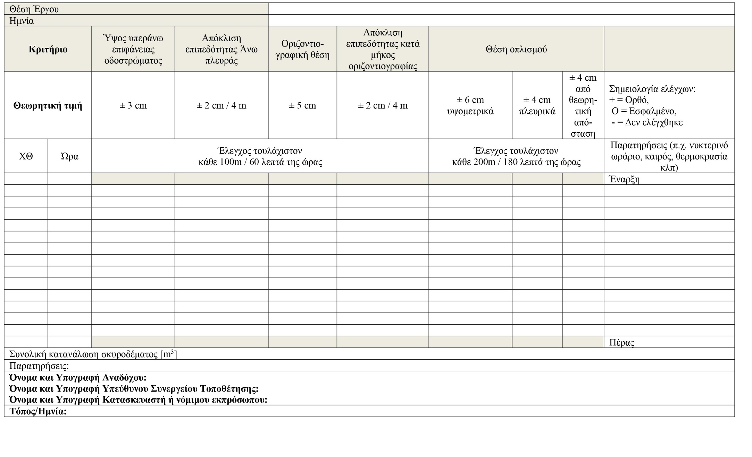

Project location
Date
Criterion |  | Height above carriageway surface | Upper side flatness deviation | Horizontal position | Flatness deviation along horizontal | Reinforcement position
Theoretical value |  | ± 3 cm | ± 2 cm/4 m | ± 5 cm | ± 2 cm/4 m | ± 6 cm elevation | ± 4 cm lateral | ± 4 cm from theoretical distance | Semiology checks  + = correct  O = incorrect,  - = not checked
XT | Time | Check at least every 100 m/60 minutes |  |  |  | Check at least every 200 m/180 minutes |  |  | Comments (e.g. night-time, weather, temperature, etc.)
 |  |  |  |  |  |  |  |  | Start
 |  |  |  |  |  |  |  |  | End
Total concrete consumption [m³]
Comments:
Name and signature of Contractor:
Name and signature of Project Manager:
Name and signature of Manufacturer or Legal Representative:
Place/Date:

Annex B

Skills and qualifications of vehicle restraint system technicians
The person responsible for assembling safety barriers must have the necessary knowledge of the applicable safety instructions and their installation. This requires attending and graduating from specially recognised training programmes which consist of a basic (general) cognitive unit as well as special cognitive units for the different types of barriers according to subsection (3) of this annex. The attendance of these recognised training programmes and successful participation in the relevant examinations shall lead to the granting of a relevant certificate or authorisation for the installation and assembly of safety barriers.
The Technician who is trained and certified for a particular type of barrier is the one who has successfully attended a training programme that includes, on the one hand, the Basic Cognitive Unit and also a special Cognitive Unit with reference to the specific types of barriers.
These training programmes are structured as follows:
- Basic cognitive unit for safety barrier
- Basic knowledge of standard ELOT EN 1317
- Content of RPDI-RSB-1 (Volume 1)
- Content of RPDI-RSB-2 (Volume 2)
- Content of RPDI-RSB-3 (Volume 3)
- Content of RPDI-RSB-4 (Volume 4)
- Barrier assemblies
- Accidents at work, marking of works carried out on roads (RPDI-SEO) and other site markings
- Earthworks, surface drainage and water drainage including underground pipelines
- CE mark
- Quality assurance, internal checks
- Other circulars and instructions from the DRI/MT&I
- Cognitive unit: Steel barrier system, assemblies, terminations
- Characteristics and operation of assemblies
- List of parts and components/Materials
- Geometric configuration design Engraving/Drawings
- Steel safety barrier assemblies
- CE mark
- Galvanising/Anti-corrosion protection/material and system durability
- Steel technology
- Quality assurance, internal checks
- Other circulars and instructions from the DRI/MT&I
- Possible instructions for a specific and/or specific type of steel barrier
- Cognitive unit: Prefabricated concrete barrier (PREFABCB), assemblies, terminations
- PREFABCB special instructions
- Characteristics and operation of assemblies
- List of parts and components/Materials
- Geometric configuration design Engraving/Drawings
- PREFABCB assembly
- CE mark
- Material and system durability
- Concrete technology
- Quality assurance, internal checks
- Other circulars and instructions from the DRI/MT&I
- Possible instructions for a special and/or specific type of PREFABCB
- Cognitive unit: Cast concrete barrier, assemblies, terminations
- RPDI-RSB-2 Chapter 8
- Characteristics and operation of assemblies
- Concrete technology
- Placement of reinforcements
- Geometric configuration design Engraving/Drawings
- Instructions for the Special National Certification of cast concrete barriers
- Installation of a cast concrete barrier
- Material and system durability
- Quality assurance, internal checks
- Other circulars and instructions from the DRI/MT&I
- Indicative instructions for special and/or specific type of cast concrete barriers
- Cognitive unit: IEAS
- List of parts and components/Materials
- Geometric configuration design Engraving/Drawings
- Installation of IEASs
- CE mark
- IEAS material technology
- Material and system durability
- Quality assurance, internal checks
- Other circulars and instructions from the DRI/MT&I
- Possible instructions for a specific and/or specific type of IEAS
The training programmes shall be drawn up by the relevant associations of safety barriers or by manufacturers of mathematics. A representative of the MT&I, the TEE and/or the European Barrier Certification Bodies must participate in the examination committee for the issuance of the relevant certificate or license of Technical Assembling and Installation of Safety Barriers It should be possible for all interested responsible assembly technicians to attend the basic unit on equivalent terms and conditions.
The basic cognitive unit must include at least 18 teaching hours. Each cognitive unit on a particular type of barrier should also include at least 18 teaching hours. The training burden for individual systems or types of barriers, e.g. IEASs, may be less than the abovementioned hours. An Assembly and Installation Technician of a particular type of barrier means a Technician who has attended the basic cognitive unit and at least one unit of a particular type of barrier and has passed the relevant certification or licensing examinations. Successful graduation from an educational programme is confirmed by the granting of the corresponding Certificate or Licence. Certified technicians of a type of barrier can also attend additional cognitive units for other types of barriers. And in this case the corresponding Certificate or License will be issued. A Certificate or License is valid for 4 years. The renewal of the Certificate or License requires the successful attendance of an informative seminar. This informative seminar will teach the new
instructions, updates and revisions, new developments in safety barriers and new instructions and circulars of the DRI/MT&I.
It is recommended that the staff of the contracting services responsible for the supervision of safety projects, quality control and the receipt of safety barriers have the necessary knowledge
concerning the basic cognitive unit and the cognitive unit of the specific type of barrier included in the road safety project.

Annex C

Determination of installation height on inclined foundation and slopes

General
On an inclined foundation the installation of barriers shall take place in accordance with the following subparagraphs, depending on the incline “s” of the foundation or central islet, the distance of the barrier from the traffic space “a” and the type of barrier. The installation height “h_{E”} is the height of the barrier measured right in front of the ground surface (reference surface). The height “h_{P}” is the height of the certified barrier that it had during the impact test over the carriageway/bearing surface.
The arrangements referred to in the following subparagraphs do not apply to Technical Projects. The relevant arrangements in this case are included in 5.2.4.4.
The following settings apply to a safety barrier tested for impact on flat ground (incline ± 2.5 %).
For a safety barrier for special applications, tested by installing a larger carriageway incline, e.g. in the case of a sawn-tooth cross section, such as mixed cross section, cross section with an unbalanced highway branch, etc., the permitted deviations must be assessed on a case-by-case basis and in relation to the behaviour of the safety barrier.
The values of the deviations referred to in the regulations described below refer to relative values between the pedestrian path and the foundation.

Steel safety barrier with inserted uprights
Steel barriers with inserted uprights shall be installed vertically.
The height of installation of the steel barrier with inserted uprights shall have as the reference surface the surface of the carriageway provided that the incline of the foundation does not exceed 12% and up to a distance equal to 0.6 m from the reference line. The inserted steel safety barriers are height-adjustable. During this adjustment, the uprights shall be extended as required to achieve the minimum insertion length in accordance with Chapter 6. At greater distances from the reference line the installation height has as its reference surface not the height of the carriageway but that of the embankment directly in front of the safety barrier (Figure C1 and Table C1)
Table C1: Determination of the height of an inserted barrier installation in cases of negative foundation incline
Foundation incline | Distance from a reference line | Installation of inserted barriers
foundation with negative incline (downhill)  s ≤ 12 % | a ≤ 0.6 m | vertical installation  reference of installation height on the surface of the carriageway, adapted to the height of the barrier: h_{E} = h_{P} + x
foundation with negative incline (downhill)  s ≤ 12 % | a > 0.6 m | vertical installation  height of barrier installation: h_{E} = h_{P}

Traffic area
VRS
Maximum incline
h_{P} = height of VRS according to impact test with reference to carriageway
h_{E} = installation height of VRS measured in front of the VRS (ground as reference surface)
x = elevation difference due to foundation incline
a = distance from reference line
carriageway

Traffic area
VRS
h_{E} = installation height of VRS measured in front of the VRS (ground as reference surface)
a = distance from reference line
carriageway

VRS = Vehicle restraint system

Fig. C1: Determination of installation height safety barrier t by inserted uprights on a negative incline (downhill) - Heavily distorted incline scale

For foundations with a positive incline (uphill) up to 12 % the installation height of the barrier shall have as reference surface the ground right in front of the barrier (h_{E} = h_{P}). The barrier is installed vertically, and its height is determined by the value in front of it (Figure C2).

Traffic area
VRS
Maximum incline
(uphill)
h_{E} = installation height of VRS measured in front of the VRS (ground as reference surface)

carriageway

VRS = Vehicle restraint system

Fig. C2: Determination of the height of a safety barrier on a positive incline (uphill) - Heavily distorted incline scale

On an inclined central islet and two-sided barrier, the height of the barrier is determined on the basis of Figure C3.

Traffic area
Maximum incline (uphill) 12 %
Traffic area
Two-sided
VRS
carriageway
carriageway
h_{E} = installation height of SOA measured on the symmetry axis of the VRS

VRS = Vehicle restraint system

Fig. C3: Determination of the height of the installation of a two-sided safety barrier on an islet with a positive incline (uphill) - Heavily distorted incline scale

Temporary steel safety barrier and prefabricated concrete safety barrier
If the bearing base is constructed at the same time as the temporary safety barrier and the prefabricated concrete barrier, the bearing base shall be constructed in such a way that the barriers can be mounted vertically (Figure C4).

Traffic area
VRS
bearing surface configuration for vertical positioning
carriageway
h_{P} = height of VRS according to impact test with reference to carriageway
h_{E} = installation height of VRS measured in front of the VRS (ground as reference surface)

VRS = Vehicle restraint system

Fig. C4: Adjustment of the bearing surface for vertical mounting of closed-type barriers (temporary steel and prefabricated concrete) - Heavily distorted incline scale

In the case of pre-existing bearing surfaces, temporary steel barriers and prefabricated concrete up to the value of the incline s ≤ 6 % (positive or negative) perpendicular to the bearing surface may be installed. The installation height of the safety barrier shall be determined in this case by reference to the ground in front of the safety barrier (Figure C5, h_{E}=h_{P}).
In cases of deviations with a value greater than 6 % (negative or positive) in foundation and islets, it is necessary to adjust the surface of the foundation or islet in consultation with the Managing Service. Otherwise, other appropriate measures should be taken.

Traffic area
carriageway
Maximum negative incline 6 %
VRS
Traffic area
VRS
carriageway
Maximum positive incline 6 %
h_{P} = height of VRS according to impact test with reference to carriageway
h_{E} = installation height of VRS measured in front of the VRS (ground as reference surface)
h_{P} = height of VRS according to impact test with reference to carriageway
h_{E} = installation height of VRS measured in front of the VRS (ground as reference surface)

VRS = Vehicle restraint system

Fig. C5: Determination of installation height of temporary steel safety barrier and prefabricated concrete safety barrier in existing foundation and islets slopes of up to 6% and on sloping islands with two single-sided barrier with independent operation - Heavily distorted incline scale

Cast concrete safety barrier
The cast concrete barriers are installed vertically.
The installation height of the cast barriers shall be measured in the case of negative slopes of the foundations up to 6 per cent and not more than 0.6 m from the reference line based on the surface of the carriageway In this case the height of the safety barrier shall be adjusted. At longer distances from the reference line, the height of the barrier shall not have the carriageway as reference surface of the but the ground directly in front of the barrier (Figure C6).
Traffic area
carriageway
VRS
h_{P} = height of VRS according to impact test with reference to carriageway
h_{E} = installation height of VRS measured in front of the VRS (ground as reference surface)
x = elevation difference due to foundation incline
a = distance from reference line
Maximum negative incline 6 %

Traffic area
carriageway
VRS
h_{P} = height of VRS according to impact test with reference to carriageway
h_{E} = installation height of VRS measured in front of the VRS (ground as reference surface)
a = distance from reference line
Maximum negative incline 6 %

VRS = Vehicle restraint system

Fig. C6: Determination of the installation height of cast concrete barriers on a negative foundation incline - Heavily distorted incline scale

Cast concrete barriers can be placed on bearing surfaces with a positive or negative incline of up to a value of 6 %.
In the case of positive or negative inclines in the range between 6 % and 12 %, after consultation with the Managing Service, the bearing area shall be adjusted to the range of the operational width, so as to create an incline with a maximum value of 6 %.
In cases of positive incline of foundations or islets up to 6 % the height of the barrier is measured right in front of it (Figure C7, h_{E} = h_{P}). In the event of positive deviations of foundation between 6 % and 12 %, an adjustment of the bearing area to the range of the operational width of the safety barrier shall be required after consultation with the Managing Service, in order to create an incline with a maximum value of 6 %. The height of installation of the safety barrier shall have as the reference surface the surface immediately in front of the safety barrier (h_{E}=h_{P}).

Traffic area

VRS

carriageway

Maximum positive incline 6 %

h_{E} = installation height of VRS measured in front of the VRS (ground as reference surface)

VRS = Vehicle restraint system

Fig. C7: Determination of the installation height of the concrete barrier on a foundation and islet with a positive incline - Heavily distorted incline scale

Special Installation of Steel Safety Barrier on embankment slope with insufficient foundation width
On interurban roads on an embankment with insufficient base width, the steel barrier can be placed on the embankment slope. The standard case of installation and measurement of the installation height of the barrier is shown in Figure C8. If the distance of the barrier from the edge of the road deck is less than 0.10 m, the height of installation of the barrier shall be measured from the surface of the slope (reference surface) directly in front of the barrier. Otherwise, the surface of the carriageway (extension of uprights).

reference height of barrier h_{E}
carriageway
h_{E} = height of a barrier installation measured in front of the barrier (the slope as reference surface)

Fig. C8: Determination of installation height of steel safety barrier in case of installation on the embankment slope due to insufficient foundation width

In a similar case where the embankment slope is between 1:4 and 1:2 the installation of the safety barrier and the measurement of its installation height may also take place on the basis of Figure C9. In this case, the height of the steel barrier shall be measured by reference to the slope incline of 1:3.

carriageway boundary line
foundation
0.75 m distance, slope 1:3
Height as at standard slope 1:3
Slope incline 1:4 to 1:2

Fig. C9: Installation of steel safety barrier and installation height measurement in case of embankment slope with incline 1:2 to 1:4

Annex D

INSTRUCTIONS FOR INSTALLATION OF UPRIGHTS AND OPENING HOLES FOR UPRIGHTS

Requirements for insertion devices and machines and insertion times
Standard devices and tools shall be used when determining the insertion time. For all types of safety barriers, a compressor with at least 3 m³ and a pressure of at least 6 bar shall be used in the case of compressed air insertion machines.
A pile driver with 400 to 600 impacts per minute with a pressure of 6 bar and an impact energy of at least 420Nm will be used for the assembly of uprights of Sigma type . A pile driver with 350 to 600 impacts per minute and 6 bar pressure with an impact energy of at least 480Nm (insertion times according to Table D1) will be used for the assembly of uprights of type C. When using a hydraulic pile driver, the typical values are the 1000 impacts per minute and 770Nm impact energy (insertion times according to Table D2).
If compressors/drivers with different specifications are used, the insertion time for the uprights should be recalculated. The recalculation shall be approximately linear in terms of the number of impacts and impact energy.
Table D1: Average insertion times for compressed air impact machinery and devices (with reference 350-600 impacts /min, impact energy >420Nm)
 | Maximum insertion time
Sigma type uprights, insertion length 1.0 m | 3.5 minutes
C125 type uprights, insertion length1.0 m | 4 minutes

Table D2: Average driving times for hydraulic pile drivers (referring to 1000 impacts/min, impact energy 770Nm)
 | Maximum insertion time
Sigma type uprights, insertion length 1.0 m | 3.5 minutes
C125 type uprights, insertion length1.0 m | 4 minutes

In cases of deviation from the insertion lengths or from the cross-section of the upright (approximately linear interpolation with reference to the cross-section surface), the above values of insertion times shall be adjusted proportionally.

Requirements for hole opening devices for uprights
Drilling devices shall fulfil the requirements of paragraph 6.2.2:
Drilling head diameter [mm] | 130 | 170 | 200
Torque [Nm] | 500 | 700 | 900
Dynamic pressure [N] | 2000–3000 | 3000–4000 | 4000–5000
Number of rotations [rpm] | 150 | 100 | 50
Compressor performance [m³/min] | 5 | 6 | 6

Bibliography
- Zusätzliche Technische Vertragsbedingungen und Richtlinien für Fahrzeug-Rückhaltesysteme, ZTV-FRS. Ausgabe 2013/Fassung 2017. Forschungsgesellschaft für das Straßen- und Verkehrswesen, Köln 2018.
- Richtlinie, Fahrzeugrückhaltesysteme, Teil B: Detailprojektierung und Bauausführung. Astra 11005, Bern 2013.
- Krav för Vägars och Gators Utformning. Trafikverket 2015:086, Borlänge 2015.

MINISTRY OF INFRASTRUCTURE & TRANSPORT
GENERAL SECRETARIAT FOR INFRASTRUCTURE
DIRECTORATE-GENERAL FOR TRANSPORT INFRASTRUCTURE
ROAD INFRASTRUCTURE DIRECTORATE

Road Project Design Instructions
(RPDI)

Road safety barriers
(RPDI - RSB)

Volume 3
Instructions for receipt and control of barrier assemblies

May 2021

Working group: “Instructions for the receipt and control of barrier assemblies” – Volume 3

2021 Version
Dimitrakopoulos Nikolaos, P.M. with A.B., Head of the Directorate for Road Infrastructure.
Hatzidakis Antonios, Double. Civil Engineer NTUA, Transport specialist
Vasileios Psarianos, Professor at the National Technical University of Athens

Members of the Committee:
Dimitrakopoulos Nikolaos, P.M. with A.B. representative of the Directorate for Road Infrastructures, Coordinator of the Working Group
Anagnostopoulou Aristea, P.M. with A.B. – representative of the Directorate for Fixed Wheel Infrastructure, member
Fournarou Catherine, P.M. with A.B. – representative of the Directorate for Quality and Standardisation, member
Houliaras Generalula, P.M. with A.B. – representative of the Directorate for the Operation, Maintenance and Exploitation of Transport Infrastructures under a Concession Agreement, Member
Sigalas Ioannis, P.M., Designer, President of the Greek Department of the IASSE, member

Contents

1. General 19
2. Definitions 20
3. Requirements for barrier assemblies 20
3.1. General requirements 20
3.2. Special case of assembly elements (Transitional elements) 22
3.2.1 Regulations for the application of assembly elements 22
3.2.2 Requirements for assembly elements 23
3.3. Requirements for construction materials 23
3.4. Requirements for documents accompanying products 24
3.5. Application of Marking - Characterisation 25
4. Checks and Certificates or Accreditations 26
4.1 Control tests on barrier assemblies 27
4.2 Certificate/confirmation of assembly elements based on detailed calculations 28
4.3 Construction modifications of safety barriers with certificate/confirmation of successful impact tests 28
4.4 Certification of the Inspection of the Factory or Manufacturing Plant 29
4.5 Procurement 29
5. Construction accessories in existing old barriers 30
ANNEX A: 31
ANNEX Β 32
ANNEX C 34
ANNEX D: 35

General
- Instructions for receipt and control of barrier assemblies (transitional barriers) include the requirements for construction materials, construction characteristics, durability, checks as well as receipt and maintenance during their permanent installation and application. The barrier assemblies shall connect two safety barriers to each other which are of a different type and/or have a different mode of operation.
- Instructions for receipt and control of barrier assemblies (O-PESS) are based on the regulations contained in the non-harmonised standard ELOT ENV 1317 Part 4 and are supplemented by specific regulations, referring to assembly elements as well as regulations for the evaluation of the results of their check process.
- The O-PESS do not include regulations for temporary barriers assemblies in road project areas.
- The construction materials of barrier assemblies used to connect safety barriers, lawfully marketed in another Member State of the European Union or in Turkey, or lawfully sourced and made available in the Contracting Parties to the EEA Agreement, shall be deemed to be compatible with these regulations. The application of those regulations is subject to Regulation (EU) 2019/515 of 19 March 2019 on the mutual recognition of goods lawfully marketed in another Member State.
- The O-PESS apply to all fittings of barriers, linking two safety barriers installed in Greece.
- These instructions do not apply to old-style barriers, which do not have a CE mark.
- The O-PESS have been brought to their knowledge and control and approval in accordance with Directive 2015/1535 of the European Parliament and of the European Council of 9 September 2015 laying down a procedure for the provision of information in the field of technical regulations and of rules on Information Society services.
- Deviation from the regulations contained in these Technical Instructions shall be permitted only on the basis of a substantiated proposal from the Managing Service responsible for the design, construction, maintenance or repair of the passive safety of a road and approval by the Head Authority.

All the Volumes relating to the instructions and Technical Specifications relating to road restraint systems are set forth in the table below.

S/n | Type | No. Volume | Title
1 | Road safety barriers  (RPDI-RSB) | Volume 1 | Instructions for studies of road construction Vehicle Restraint Systems – Railings
2 | Road safety barriers  (RPDI-RSB) | Volume 2 | Instructions for the installation and repair of vehicle restraint systems
3 | Road safety barriers  (RPDI-RSB) | Volume 3 | Instructions for receipt and control of barrier assemblies
4 | CONDITIONS  Issuing a declaration of performance of concrete safety barriers (CSBs) | Volume 4 | Instructions for application on site of cast concrete safety barriers
5 | Instructions for the implementation of special safety studies against roadside barriers on interurban roads with a single carriageway | Volume 5 | Special instructions for the application of road safety barriers for protection against trees and other roadside barriers on interurban roads with a single carriageway

Definitions
Sharp parts: Parts with horizontal or vertical sharp edges or projections or insufficiently rounded edges or projections, oriented without protection in the direction of traffic.
Durability: Ability of a barrier to maintain its performance for a long period of time as determined in the impact tests under the influence of predicted conditions or events.
Bearing plate: Area below the installed Vehicle Restraint System. This area includes both the bearing surface under the system (e.g. concrete safety barrier) as well as the subsoil in the case of inserted systems (e.g. steel barriers) as well as the foundation strips (foundation/mounting beams).
Longitudinal element: A component or accessory of the vehicle restraint system which is installed parallel to or approximately parallel to the carriageway boundary or is intended to align the vehicle restraint system or positioned parallel to the centreline of the barrier. As a rule, longitudinal elements are continuous or connected to each other to form a continuous straight sequence (e.g. plates, reinforcements, joints or body of concrete prefabricated concrete barriers or steel barriers, straps, etc.).
Longitudinal force: Force applied along the barrier.
Impact test: (TT, Type Testing) Specified in accordance with ELOT EN 1317 technical procedure for determining the performance of a barrier during impact of a vehicle.
Product documents: Documents issued by the manufacturer of the barrier assemblies.
Component or construction element: Component of a barrier assemblies or a safety barrier (e.g., uprights, plates, banners, nails attached to stands, elements of prefabricated concrete barriers, reinforcement, etc.). Fixings are not components.
Manufacturer (Producer): Organisation or company, which is responsible for the assembly of barriers.
Manufacturing (Production) unit: A unit or factory in which the barriers are produced and authorised for this purpose by its manufacturer.
Installation instructions: Instructions drawn up by the manufacturer (producer) of the assembly and relating to the description of the assembly and to the specific conditions and limitations relating to its correct installation and placement.
Safety barriers: Vehicle restraint system, fitted along the outer boundary of the carriageway, or the central or separating islet.
Barrier assembly element (Transitional element): Special case of construction of a barrier assembly used to connect similar types of barriers (in the sense of the type of construction and the mode of operation).
Barrier assembly (Typical): Mechanical connection between safety barriers with a different type of construction and/or different manner of operation.
Connectors Connections between two parts or components, which can be disconnected from the system without wear of parts or components (e.g. screws, discs, nuts) as well as the system anchors, plugs and pins.
Maintenance, normal/regular: Maintenance work by the competent operating service or organisation in the surrounding area of the vehicle restraint system to maintain and ensure the operation of the system (e.g. cutting bushes, cleaning of drainage outlets).
Vehicle restraint system: A safety system (equipment) fitted on roads designed to restrain or restore or change the direction of a vehicle deviating from the carriageway (safety barrier, barrier assembly, barrier termination and impact energy absorption system).
Maintenance, special: Special work on the vehicle restraint system necessary to maintain the operation of the system.
Organisation or body or firm issuing a Certificate/Check confirmation (impact test): Accredited Body or Organisation or Firm accepted by the Ministry of Transport and Infrastructure for the verification of compliance with the regulations set forth in these instructions for barrier assemblies and which issues the relevant certificate or performance certificate of an impact test. The certificate or performance certificate is not a certificate of conformity for the issue of a CE mark, as for barriers no CE marking is yet provided.

Requirements for barrier assemblies

General requirements
- Barrier assemblies shall connect two safety barriers of a different type and/or different manner of operation with each other.
- Barrier assemblies are also required to connect two barriers which have passed an impact test for different installation or placement cases (e.g. between barriers on a road other than a technical element and between barriers on a road with a technical element).
- When two identical safety barriers are connected, possessing different restraining capacity (e.g. between certified collision capacity H2 and H4b or L2 and L4b) then this is not a barrier assembly. In this case, the connection can be made without any particular technical requirements.
- Regarding the performance requirements, the connection of barriers to standard barrier assemblies (assembly constructions) and assembly elements (barrier) can be distinguished. According to this
distinction barrier assembly elements are a special class and case of standard barrier assemblies.
- All the regulations that follow and refer to the (normal) barrier assemblies also apply to the elements of the joints (barriers), as long as there is no need to satisfy special and different regulations from those of standard assemblies, but for which an explicit distinction must be made each time.
- With regard to restraining capacity, impact tests, operational width, dynamic deflection and impact severity, as well as acceptance criteria and control procedures, the same definitions and classification classes as defined in harmonised standard ELOT EN 1317-2 shall apply to barriers assemblies.
- The restraining capacity of a barrier assembly shall be neither less than the lowest performance nor greater than the highest performance of the connected barriers.
- The operational width of a barrier assembly shall not exceed the maximum operational width of the two interconnected safety barriers.
- Barrier assemblies should not display sharp or protruding parts or components which could be dangerous for road users. Parts and components with a dangerous shape (e.g. slotted expansion joints with an overlap equal to or greater than 2 cm /displaced blunt joints with an anti-traffic device, rectangles or wires partially or universally exposed to the traffic side, maximum vertical clearances of concrete joints with a width of more than 4 cm) should therefore be avoided. The overlap of the joints must be made in the direction of traffic circulation.
- A barrier assembly shall begin in the position where the connected certified safety barrier changes in its form, parts and foundations (e.g. type of foundation, attachment of additional components and components, change of height, width, etc.) and shall end in the position where the next certified barrier begins. The distance between these two positions is the length of the barrier assembly. If there are expansion joints, its length extends to the position of the next expansion joint.
- The width of the barrier assembly is defined as the maximum distance between the front and rear edges of the barrier, displayed over its entire length. In this case, the front end shall be considered to be the point of the barrier assembly, which is closest to the traffic of the vehicles and the rear end is the point, which is at the longest distance from it (Figure 1).
- Barrier assemblies shall not be lower than the lowest of the two connected safety barriers
- The barrier assembly shall not exceed by 10 cm higher than the highest of the two connected safety barriers.
- Adjustment of the width of the associated safety barriers by means of the barrier assembly shall be made with a maximum incline of 1:20 on the impact side. Adjusting the height through the barrier assembly should be as smooth as possible.
- Barriers may only be assembled if special maintenance is not required in order to render them operational. Necessary repair work on the barrier assemblies due to impact is not regarded as maintenance work.

rear end
front end
BA
SB1
SB2
width

traffic area
BA
SB1
SB2
width
rear end

front end

traffic area

Note: SB = Safety barrier, BA = Barrier assembly
Fig. 1: Definition of front, rear end and barrier assembly width (Up: front end SB1 is identical to that of SB. Down: front end SB1 different from that of SB2)

- Ensuring the durability of the barrier assemblies is achieved by applying the applicable standards for the materials and coatings used.
- Under normal conditions of maintenance and with proper construction and installation, a safety barrier must fulfil the requirements set forth therein for a long period of time.
- For barriers, the parts and components which fulfil the requirements as regards materials and connectors in accordance with § 3.3, shall be considered to be of sufficient strength for at least 25 years for the prevailing conditions in the country.
- The materials used shall not adversely affect each other or reduce the performance of the safety barrier during impact or resistance (e.g. no corrosion due to contact or significant differences due to temperature changes).
- All the figures referred to in these instructions refer to the nominal values and may be exceeded or fall within the tolerance areas unless otherwise specified.
- Barrier assemblies from which parts with a mass exceeding 2 kg have been detached during the impact test and which constitute a third-party risk do not comply with the requirements of these instructions and may not be applied.
- Barrier assemblies shall be constructed in such a way as to ensure a continuous change in the rigidity between the two associated safety barriers. Abrupt changes in rigidity must be avoided in their design and construction.

Special case of assembly elements (Transitional elements)
Assembly elements are a special case of barrier assemblies.

Regulations for the application of assembly elements
- When connecting two safety barriers, this connection relates to a barrier assembly (transitional element) if all of the following conditions are fulfilled. The manufacturer must provide all relevant documents and certificates (see Chapter (4) to justify restrictions (i) to (vii).
  - Certificates of conformity according to ELOT EN 1317 for the same restraining capacity in the impact test (e.g. H2 and H2) have been submitted for the two connected associated safety barriers.
  - The longitudinal elements between the two connected associated safety barriers and the intermediate transitional element shall consist of the same manufacturing materials.
  - The main longitudinal elements of the associated safety barriers shall be connected in such a way that only friction forces between the connecting surfaces occur.
  - The normalised (reduced) dynamic deformation of the connected safety barrier with the largest dynamic deflection deviates according to ΔD from the normalised dynamic deformation Dmin of the associated safety barrier with the least dynamic deformation not more than:
- for Dmin ≤0.7 m: ΔD = 0.2 m
- for 0.7 < Dmin ≤ 0.9 m: ΔD = 0.3 m
- for 0.9 m < Dmin ≤ 2.0 m: ΔD = 0.4 m
- for 2.0 m < Dmin: ΔD= unlimited
  - The connected safety barriers exhibit similar operational behaviour during the impact test.
  - The manner of construction of the connected safety barriers is similar (e.g. identical cross-section, i.e. the carriage of impact loads follow the same principles).
  - Adjustment in height and width through the assembly element shall be made with an incline of 1:20 or less The slope must be configured in such a way that large discontinuities or abrupt changes in the longitudinal section (along the sectional length) do not occur nor conditions of uncontrolled sliding of the vehicles on the barrier (e.g. do not create inclined levels).
- If the difference in dynamic deflection in accordance with condition (vi) of the previous subparagraph exceeds the reported value, then the connection shall be treated as an assembly element when all other conditions are fulfilled.
- The decision that an impact test is not required and that the assembly will be treated as an assembly element is left to the accredited assessment body and the relevant certificate/performance certificate of the assembly (without CE).
- The connection of two safety barriers, having the same structural configuration, the same restraint capacity and the same components and components, which differ only at the distances between the uprights and do not satisfy condition (1) vi for the assembly component, then the connection (assembly element) shall be checked by means of an impact test on the basis of only the heaviest vehicle.

Requirements for assembly elements
- The assembly elements (barriers) must be constructed in such a way that they do not adversely affect the functioning of the connected safety barriers The expected
operation of the assembly element shall be commensurate with the function of the associated safety barriers.
- The longitudinal elements of the associated safety barriers shall be connected by means of the assembly element in such a way that only friction forces between the connecting surfaces occur. Longitudinal elements which show that they are not sufficiently involved in the transfer of longitudinal forces shall not be taken into account in this case. These longitudinal elements are simply attached to the assembly elements. The assembly elements shall consist of the same materials of manufacture and components or accessories as are used in the connected safety barriers. Additional parts or accessories are only permitted for the height adjustment or adjustment of the attachment length.
- Modifications (conversions) of assembly elements are allowed without certification, provided that the amendments as defined in ELOT EN 1317 (Part 5) or in the corresponding comparative certification procedure for field castings (injectors) have been implemented.

Requirements for construction materials
- Construction materials and connectors must comply with the requirements of Volume 2 of these instructions (RPDI-RSB – Installation and Repair of Vehicle Restraint Systems) and other relevant instructions of the DRI of the Ministry of Transport and Infrastructure.
- The materials, components and connectors used shall be equivalent to those used in the impact tests or the permitted construction modifications.

Requirements for documents accompanying products
- The manufacturer (producer) is required to draft accompanying documents for the products of the barrier assemblies.
- The documents must be drafted in Greek.
- The documents accompanying the products of the barrier assemblies shall include:
  - A barrier assembly data sheet of the in accordance with Annex B or C;
  - Certificates/performance certificates based on the impact test in accordance with ELOT EN 1317 (see § 4.1) or confirmation of calculation results in the case of fitting elements in accordance with Annex A. Certificates of performance of assemblies based on calculation results (impact simulations) shall be accepted following a decision of the Managing Service and approval of the Authority Head.
  - Installation instructions (see Chapter 4
  - Certificate of the continuous annual production control inspection of the factory or manufacturing plant in accordance with ELOT EN 1317 (Part 5) and/or for structures for cast concrete barriers in accordance with Volume 4 of these instructions.
  - Confirmation by the manufacturer of the barrier assemblies that the functionality of the associated safety barriers will not be adversely affected.
- The instructions for installing the barrier assembly shall include the data listed in Table 1.
- For assembly elements, the installation of which does not differ from that of the associated safety barriers (e.g. zero-length assembly elements) no installation instructions are required or these may be concise with the agreement of the accredited certification/accreditation body of the assembly performance, in which case reference shall be made to the relevant instructions of the associated safety barrier assemblies.
- The accredited assembly performance certification/accreditation body may require from the manufacturer additional data on the content of the installation instructions, if it considers it necessary and required for the construction configuration of the assembly.
- Approved conversions/modifications by the accredited certification/accreditation body must be included as additional elements in the installation instructions with description and technical drawings of the conversions. No other descriptions of modifications, which are not mandatory and are not included in the organisation’s accreditations or performance certificates, shall be permitted.
- Each version of the installation instructions shall be kept by the manufacturer for a period of 25 years and shall be issued to the Managing Service in a readable format whenever requested.

Table 1: Minimum data required in installation instructions
General
● Editor/responsible manufacturer (producer)
● Date of drafting of instructions and unique version number
● Page number and total number of pages
● Used Standards with Date of Volume
● Unique characterisation of the barriers assemblies and connected safety barriers (assembly traceability data)
● Description of particular characteristics (e.g. replacement with components and accessories by other manufacturers)
Description of the barrier assembly
● 3-D or outlook images or photos of the overall assembly system
● General supervisory drawings of the assembly with descriptions of assembly and tolerances (including covered components and accessories such as reinforcements, anchors, pre-assembled components)
● Drawings of cross-sections, façades and barriers with foundation (including those applied in the impact test foundations, installation conditions, etc.)
● Designs of elements and components and with tolerances and with all material specifications
● Accurate data on materials, connectors (including tightening torques) and surface processing (including protective processing)
● Complete list of parts and components with weight data as well as material (including quality characteristics and corresponding standard) with dimensions
● Estimation of the expected durability of the barrier assemblies
● Pre-tensioning data (if applicable)
● Other important information (e.g. for recycling, environment, safety)
● Information on substances to be taken into consideration (toxic substances, hazardous materials)
Installation description
● Description of the assembly with work steps (e.g. with a series of photographs) including instructions and suggestions for measures and actions when installing the barrier assembly and connecting it to an existing barrier (e.g. possible partial removal of the existing barrier)
● Data on the equipment and tools required for installation as well as the qualifications of the staff
● Permitted weather conditions/temperatures at the time of installation and any additional measures required
● Pre-tensioning data (if required)
● Data on soil conditions, bearing plate, foundation, support
● Repair specifications (Description/Documents on the necessary measures for an operational repair due to damage caused by vehicle impact), inspection and maintenance
● Information necessary for recycling the materials used
Additional information
● A description of specific provisions when installing and using barriers with installation restrictions (under what local conditions the assembly of barriers becomes unsuitable or must be moved to another location) as well as the necessary explanations on how to deal with possible effects of specific local conditions (with a solemn declaration of good operation and responsibility)
● Application length and anchoring data
● How to deal with changes in soil data
● Permitted installation and installation tolerances (e.g. variations in placement position at height above the surface of the carriageway)
● Installation and placement height data in the case of prefabricated and existing curbs (e.g. up to what height of the curb can be used, when an adjustment of the structural configuration of the barrier assembly is required)
● Reference to special measures in case of an appropriate base plate with:
  - Description of the installation (vertical or horizontal;)
  - Reference to the maximum permissible incline of bearing base (e.g. barrier assembly support behaviour)
  - How to deal with alternating inclines

● Reference to the method of installation on slopes
● Reference to the method of installation and placement in case of directional changes (direction changes/speeds/curvatures along the barrier assemblies should normally be avoided)
● Reference to conversions in project areas (e.g. specific instructions for opening additional holes, length reduction of longitudinal elements)

Application of Marking - Characterisation
- The barrier assemblies shall have a relevant marking at the beginning and at their end. Instead of the certification number, as required in the case of barriers (with CE marking), the specific certification or attestation number assigned by the Accredited Body for barrier assemblies for which the CE marking is not required shall be used.
- The previous requirement does not apply to assembly elements. In such cases, it is sufficient to characterise the connected safety barriers at the beginning and at their end.
- Special marking shall be affixed to the components of the prefabricated concrete safety barriers.

Checks and Certificates or Accreditations
- All barrier assemblies must have an assembly certificate or performance certificate in accordance with the criteria set forth in ELOT EN 1317 and in these Instructions.
- The issuing body of the relevant certificate or performance certificate of the barrier assembly shall be an Accredited Body.
- The relevant test reports and videos of the impact tests and associated barriers shall be provided for the assessment of a barrier assembly in the context of the relevant certificate or performance certificate of the assembly.
- In order to obtain the certificate or performance certificate and the proper functioning of the assembly, at least the documents and supporting documents listed in Table 2 must be submitted to the Accredited Body.

Table 2: Required minimum documents and supporting documents for the granting of a certificate or confirmation of good operation of the barrier assembly
 | Paragraph of the Directive | Barrier assembly | Assembly element
Complete product documents | 3.4 | x | x
Complete test documents | 4.1 | x | -
Attestation based on analytical calculations/application of computational methods instead of physical impact tests | 4.2 | After acceptance of a Managing Service and approval of the Authority Head | x
Test and video reports from impact tests according to ELOT EN 1317 of connected safety barriers | 4 | x | x
Description and/or technical assessment reports of the modifications (if applicable) | 4.3 | x | x
Supervisory description of the elements/components and the manufacturer’s factories or units | 4.4 | x | x
Certification of applicable supervision of the manufacturer's factory or unit by an independent Accredited Body | 4.4 | x | x

- The issuing body of the performance or compliance certificate may require additional certificates or attestations and other documents which it considers necessary for the granting of the relevant certificate or performance certificate of the assembly elements
- The cost of obtaining the required certificate or attestation shall be borne by the manufacturer of the barrier assembly.

Control tests on barrier assemblies
- Barrier assemblies shall have undergone impact tests in accordance with ELOT ENV 1317-4 (non-harmonised Part 4) meeting the criteria for a successful test and resulting in at least one performance class. Physical impact tests may be replaced by impact simulations following a decision of the Managing Service and approval of the Authority Head. Safety barrier assemblies that have performance or compliance certificates based on physical tests shall be a selection criterion over barriers with a performance certificate by means of impact simulations. The Managing Service addresses the problem of selecting the road safety system (safety barrier-assemblies-termination) as a whole both during the installation of the system and during its lifetime (maintenance-repair-replacement).
- For assembly elements fulfilling the criteria of § 3.2.2, as a rule, certification/performance certification by means of an impact test as referred to in this paragraph shall not be required. The Accredited Body issuing a certificate/performance certificate of barrier assemblies shall make the decision.
- Prior to carrying out an impact test of a barrier assembly, consultation with the Accredited Body issuing the certificate or attestation shall be required. This Accredited Body shall identify, in agreement with the accredited testing laboratory, the critical points of impact and angles of impact.
- An impact test may be waived for a barrier assembly if the two associated safety barriers have significant similarities (e.g. differences only in the height of the barrier/length of the uprights, but with different retaining capacities – e.g. H1/H2) but not fully satisfying the requirements referred to in paragraph 1 of § 3.2.1 for assembly elements. When determining the points of impact, it is possible to determine the terms and conditions for not carrying out the impact tests on the barrier assemblies. One or more impact tests may be waived if the conformity certification/performance certification organisation expects that these new impact tests will not add any technical information other than that obtained from the tests to the connected safety barriers. This assessment should take into account the test results on the connected safety barriers. This assessment and the classification of the standard barrier assemblies of the assembly elements will
Be carried out by the Accredited Body issuing the relevant certificates/confirmations The criteria for assembly elements in accordance with paragraph 3.2.1(1) need not be fully fulfilled in this case.
- Safety collision tests according to EN 1317 shall be performed by an accredited testing laboratory (in this case Part 4 of the non-harmonised standard).
- The manufacturer of the barrier assembly must provide the following test documents to be prepared by the Impact Test Laboratory:
  - Test and video report of impact tests according to ELOT EN 1317.
  - A certificate from the Test Laboratory that the tested barriers and the associated safety barriers correspond to the technical drawings and have been installed in the test field in accordance with the relevant installation instructions.
  - Confirmation by the Test Laboratory that the construction elements and components of the tested barrier assembly, as regards the requirements for construction materials and connectors and their dimensions, comply with the data of the technical drawings and installation instructions, including the submission of a material analysis of the main components and components of the barrier assembly during the impact test.
  - Confirmation by the Test Laboratory that the provisions of the optional standard ELOT ENV 1317 Part 4 (non-harmonised part) as well as any other required and applicable sections of the standard have been complied with and that the barrier assembly meets the relevant requirements.
- For parts detached during impact and having a mass greater than 2.0 kg, the exact value of the mass and its position (in relation to its initial position in the barrier assembly) shall be recorded in the test report.
- During the impact test, the associated barriers shall be installed on both sides of the barrier attachment. The associated barriers shall be installed to the same length, if possible. The minimum length of the associated safety barriers shall not be less than 1/3 of the test length of the safety barrier with the longest test length.
- As the position of the front edge of the barrier assembly may vary, reference to the operational width and dynamic deformation should be based on the position of the front end, which is closest to the traffic area of the road. The operational width determined during the impact test shall thus denote the distance between the front edge closest to the traffic area and the furthest displacement point of the barrier assembly or one of the connected safety barriers during the impact on the barrier assembly (see Figure 2). The (dynamic) deflection shall be determined during the impact test in accordance with ELOT EN 1317 Part 2 and is the distance between the initial front edge of the barrier assembly to the point of the front edge of the maximum displacement of the barrier assembly.

BA
SB2
SB1
Operational width
rear end of BA
Dynamic distortion
Maximum displacement

front end of BA

Fig. 2: Displacements due to impact (definition of operational width and dynamic deformation)

- The impact test of a barrier assembly shall apply only to the safety barriers connected to it during impact. The connection to another barrier is a modification of the provision, subject to the granting of a certificate or performance certificate (see § 4.3).
- The cost of the impact test shall be borne by the manufacturer.

Certificate/confirmation of assembly elements based on detailed calculations
- For assembly elements for which a certificate or performance certificate from impact tests is not required, a certificate of detailed calculations for the transfer of forces in accordance with Annex A shall be submitted.
- The certificate of detailed calculations shall be drafted by a qualified engineer on the basis of the technical drawings and the description of the assembly element and the connected safety barriers to be provided by the manufacturer. The certificate must be endorsed by a structural engineer. The purpose of the confirmation of detailed calculations is to demonstrate that longitudinal forces can be transferred between the connected safety barriers.
- The cost of issuing the detailed calculation certificate shall be borne by the manufacturer.

Construction modifications of safety barriers with certificate/confirmation of successful impact tests
- For safety barriers which have passed impact tests in accordance with § 4.1, it shall be possible to modify their construction configuration.
- A condition for accepting a modification of a barrier assembly is that it has undergone positive impact tests according to ELOT ENV 1317 Part 4 and fulfils the regulations set forth in this Technical Directive.
- Construction modifications shall be assessed by an Accredited Body. To this end, the manufacturer must provide the description of the manufacturing modification, the technical drawings and a technical assessment of the manufacturing modification.
- Construction modifications are permitted, when the restrictions imposed by ELOT EN 1317 with regard to construction modifications to safety barriers are fulfilled and which are considered to apply to barrier assemblies.
- For the assessment of (manufacturing) modifications, the Accredited Body may request additional information, technical reports or expert reports from the manufacturer.
- In the case of more than one amendment, the accredited body must assess whether these amendments can be applied at the same time.
- All permitted modifications shall be reported and described in the relevant technical reports.
- The cost of checking and evaluating the modifications shall be borne by the manufacturer.
- The decision that a barrier assembly is not required to be subjected to impact tests and that it is an authorised modification of the assembly is subject to the assessment of the Accredited Body.

Certification of the Inspection of the Factory or Manufacturing Plant
- The (construction) elements and components of a barrier assembly shall be produced in factories or manufacturing plants for which a certificate of continuous annual inspection from the internal production control of the safety barrier factory or plant in accordance with ELOT EN 1317 Part 5 is available. The confirmations must be valid. Parts of in situ cast concrete barriers may be manufactured in factories and manufacturing plants which have a special certificate of inspection for cast barriers on the basis of those contained in Volume 5 of these instructions.
- The manufacturer shall provide the Accredited Body with a list of all the essential elements and components of barrier assemblies from the respective factories or manufacturing plants, accompanied by the valid inspection certificates of the factory or manufacturing plant.
- If the components and accessories of the barrier assembly do not correspond to the standard elements and components referred to in the inspection of the internal production control of the factory or plant, then the accredited inspection body must certify in addition to the internal production control inspection that the factory or manufacturing plant produces the specific elements and components in accordance with the provisions of ELOT EN 1317 Part 5 and that they are subject to internal production control.
- Where individual components or components are manufactured in factories or production units which do not have an internal production control according to ELOT EN 1317 Part 5, the producer must take necessary measures with the agreement of the Accredited Body for production quality control. The Accredited Body shall have the right to require specific certificates of supervision or inspection.

Procurement
A copy of the certification or compliance of the barrier assemblies (according to Chapter 4), the data sheet for the barrier assemblies in accordance with Annex B or C and the installation instructions manual, as well as the certificate of a valid inspection (according to § 4.4 must be presented to the Managing Service when supplying the barrier assemblies).

Construction accessories in existing old barriers
- In the case of certified safety barriers to be connected to existing old-type barriers not certified by impact tests in accordance with ELOT EN 1317 Part 2 and whose performance is not known, these connections shall not be classified as barriers but as construction accessories These construction accessories shall be treated as modifications to barrier assemblies which are applicable in specific cases. The accessories should be similar to a barrier assembly which has been subjected to successful impact tests. If the two safety barriers to be connected fulfil the requirements of subsection (1) of § 3.2.1 for assembly elements without including i, iii and iv, then an assembly element may also be used as a construction accessory. In such cases, it is not necessary to consider the connection of the safety barriers on either side as a barrier assembly with successful impact tests.
- The construction accessory shall be designed and configured to the standard of a barrier assembly. If this is not possible, the configuration of the construction accessory shall be as similar as possible to a barrier assembly that can undergo an impact test.
- A construction accessory shall not have any sharp parts or projections which pose a risk to vehicles impacting it. The construction accessory and the following (old-type) safety barriers must be connected in a functionally correct manner so that their essential characteristics (including clamp function, passive safety of barrier assembly, transfer of forces) are not adversely affected. In general, technical solutions based on the principles of these instructions should be sought which provide the best level of safety for road users for existing local conditions. All longitudinal elements must be connected in such a way that at least the developing longitudinal forces can in all cases be transferred by the weakest of the two connected barriers.
- Certification or confirmation of the functionally correct connection of the safety barriers, as regards the transfer of forces, shall be carried out on the basis of detailed calculations, as set forth in Annex A, in relation to the relevant certification or confirmation to be provided for the assembly element.

ANNEX A:
Conditions for granting a Certificate/confirmation for detailed calculation
- For longitudinal elements intended to connect longitudinal elements between two barriers holding certificates of conformity following successful impact tests, a certificate or confirmation of transfer of longitudinal forces shall not be required when all of the following conditions are fulfilled over the whole length of the assembly component:
  - at least the same cross-sectional area as in both connected longitudinal elements of safety barrier with successful impact tests,
  - the same types of steel according to applicable standards or minimum required concrete quality with respect to chemical composition tolerances and the same technological mechanical properties, with regard to their compliance with material standards, applicable to longitudinal elements of both the connected safety barriers, with successful impact tests;
  - Configuration of assemblies, as in the two connected longitudinal elements of both safety barriers by successful impact tests.
In this case, the manufacturer must draft and, where appropriate, justify conditions (i) to (iii) and submit supporting documents to the Accredited Body.
- For each longitudinal component of the assembly element, the maximum longitudinal force which can be transferred between the connected longitudinal elements and individually for each of the two sides shall be determined. In determining the maximum longitudinal forces, the connections in the assemblies of the elements should also be taken into account.
- The calculations are based on the ELOT EN 1992 and ELOT EN 1993 standards. Calculations are carried out with characteristic values, i.e. without taking into account individual safety factors.
- The determining size is the smallest value between the two longitudinal forces.
- The determining longitudinal force should be capable of being transferred from the connected longitudinal element and from all the assemblies to the connected longitudinal elements of the safety barriers and the assembly element.

ANNEX Β
Template data sheet for barrier assembly
O-PESS 2019 | Name of barrier assembly |  |  | Page X of Y
O-PESS 2019 |  |  |  | Version: Date
PHOTO OF BARRIER ASSEMBLY

Description of the barrier assembly

Description of the barrier assembly
First impact test |  | TB xx
 |  | TB yy
Certificate/confirmation in accordance with the instructions
Manufacturer
Connected safety barrier 1
Connected safety barrier 2
Characteristic assembly material
Assembly width [m]
Assembly height from carriageway [m]
Assembly length [m]
Maximum lateral position of the assembly [m]
Maximum lateral vehicle position [m]
Maximum dynamic deformation[m]
Foundation/placement of assembly[m]
Comments
Additional data according to ELOT EN 1317 Part 2
Operational width W_{N} [m]
Width category
Vehicle Intrusion VI_{N} [m]
Vehicle intrusion class
Dynamic deformation D_{N} [m]

Restraining capacity | Width category | Impact severity

Ο PESS 2019 | Name of barrier assembly | Page X of Y
Ο PESS 2019 | Name of barrier assembly | Version: Date
Technical drawing of barrier assembly
(connected section safety barrier 1, barrier assembly, connected section safety barrier 2, with start, end and length of the barrier assembly, transverse sections including foundation and dimension of the entire construction)

ANNEX C
Template assembly element data sheet
Ο PESS 2019 | Name of assembly element |  | Page X of Y
Ο PESS 2019 |  |  | Version: Date
PHOTO/IMAGE OF ASSEMBLY ELEMENT

Description of the assembly element

Description of the barrier assembly
Certificate/confirmation in accordance with TO
Manufacturer
Connected safety barrier 1
Connected safety barrier 2
Characteristic material of the element
Element width [m]
Height of element from carriageway [m]
Element length [m]
Foundation/placement of construction [m]
Comments
Technical drawing of the assembly element
(connected section safety barrier 1, barrier assembly , connected section safety barrier 2, with start , end and length of the barrier assembly, transverse sections including foundation and dimension of the entire construction)

ANNEX D:
Flow chart
No impact test required
Connection of identical
Safety barriers according to 3) § 3.1
yes

no

Assembly element according to § 3.2
No impact test required
yes

A barrier assembly test is required according to ELOT ENV 1317 Part 4, preferably or at least simulated impact test
Modification of a barrier assembly with a successful impact test (possibly certificate or confirmation with additional technical assessment/expert report)
Safety barrier of the same construction configuration, restraining capacity and with the same elements & components and only change the distance between uprights in accordance with 4) § 3.2.1. Zero-length barrier assembly
no
yes
Positive assessment report required
no
no
Impact test with a heavy vehicle only
yes

MINISTRY OF INFRASTRUCTURE & TRANSPORT
GENERAL SECRETARIAT FOR INFRASTRUCTURE
DIRECTORATE-GENERAL FOR TRANSPORT INFRASTRUCTURE
ROAD INFRASTRUCTURE DIRECTORATE

CONDITIONS
Granting a declaration of performance
Cast concrete safety barrier (CSB)

Volume 4
Instructions for application on site of cast concrete safety barriers

May 2021

Working group: "Instructions for application on site of cast concrete safety barriers" - Volume 4

2021 Version
Dimitrakopoulos Nikolaos, P.M. with A.B., Head of the Directorate for Road Infrastructure.
Hatzidakis Antonios, Double. Civil Engineer NTUA, Transport specialist
Vasileios Psarianos, Professor at the National Technical University of Athens

Members of the Committee:
Dimitrakopoulos Nikolaos, P.M. with A.B. representative of the Directorate for Road Infrastructures, Coordinator of the Working Group
Anagnostopoulou Aristea, P.M. with A.B. – representative of the Directorate for Fixed Wheel Infrastructure, member
Fournarou Catherine, P.M. with A.B. – representative of the Directorate for Quality and Standardisation, member
Houliaras Generalula, P.M. with A.B. – representative of the Directorate for the Operation, Maintenance and Exploitation of Transport Infrastructures under a Concession Agreement, Member
Sigalas Ioannis, P.M., Designer, President of the Greek Department of the IASSE, member

Contents
1. General 13
2. Definitions 14
3. Requirements for barrier assemblies 14
3.1. General requirements 14
3.2. Special case of assembly elements (Transitional elements) 16
3.2.1 Regulations for the application of assembly elements 16
3.2.2 Requirements for assembly elements 17
3.3. Requirements for construction materials 17
3.4. Requirements for documents accompanying products 18
3.5. Application of Marking - Characterisation 19
4. Checks and Certificates or Accreditations 20
4.1 Control tests on barrier assemblies 21
4.2 Certificate/confirmation of assembly elements based on detailed calculations 22
4.3 Construction modifications of safety barriers with certificate/confirmation of successful impact tests 23
4.4 Certification of the Inspection of the Factory or Manufacturing Plant 23
4.5 Procurement 24
5. Construction accessories in existing old barriers 24
ANNEX A: 25
ANNEX Β 26
ANNEX C 28
ANNEX D: 29
1. Applicability 39
2. Bibliographic Reports and Standards 39
3. Definitions 40
4. Requirements of participating organisations 43
4.6 Manufacturer Requirements 45
4.7 Manufacturing Plant Requirements 46
4.8 Accredited Test Laboratory Requirements 46
4.9 Accredited Body for Certification of Stability Performance Requirements 46
4.10 Competence of the Recognition Body 47
5. Technical Description Determination of the Cast Concrete Safety Barrier – Manual CSB 47
5.1 Differentiated Description of the Cast Concrete Safety Barrier for the Unambiguous Description 47
5.2 Description of recognised modification after the Type Test (TT) 48
6. Technical Description Construction of a Concrete Safety Barrier (CSB) – Construction Manual 48
6.1 General Construction Instructions to Ensure Technical Performance 49
7. Technical Performance of the Solid Concrete Safety Barrier – Testing and Documentation of the Type Test (TT) 49
7.1 Report on the Technical Assessment of Tests of a Strong Concrete Safety Barrier (CSB) 49
7.2 Technical Report of a Type Test (TT) for Determination of the Technical Performance of a Strong Concrete Safety Barrier 50
7.3 Use of Existing Data from previous Surveys, expertise and/or Sharing of Type Test Reports 50
8. Statement by the Accredited Body for the Construction of the Cast Concrete Safety Barrier-Inspection and Documentation of the In-situ Production Control (IPC) 50
8.1 General clarifications 50
8.2 Initial Inspection of Production Control (IPC) 52
8.2.1 Staff 52
8.2.2 Equipment 52
8.2.3 Basic materials 53
8.2.4 Traceability and marking 53
8.2.5 Deviations in the requirements of the Construction Process 53
8.2.6 Measures to avoid or remove discrepancies in the Construction Process 53
8.3 Initial Inspection of Production Control (IPC) 53
9. Instructions for drafting the manufacturer’s declaration of performance for the technical performance of the cast concrete safety barrier 54
10. Traceability and Marking Elements of a Cast Concrete Safety Barrier 55
10.1 Traceability 55
10.2 Signage 56
Annex A: Modifications 57
A1) Manufacturer’s modification declaration procedure 57
A2) Classification of the Amendment by the Recognition Body 58
A3) Evaluation and Recognition of the modification by the Recognition Body 58
A4) Examples of Modifications and their Classifications 60
Bibliography 61

1. Applicability

These regulations¹ set forth the requirements for the issuance of a Declaration of Performance and a Certificate of Stability Performance as well as the provision of an internal operational check during the construction (in situ) of cast concrete barrier/cast concrete barrier (CSB) for use in road and bridge sections in the country. The following applies to new constructions of cast concrete barriers (CSBs) and is a prerequisite for the unique characterisation of a cast safety barrier (with all the changes made by the TT) and provide the possibility of a comparative check on the essential performance characteristics of the barrier. At the same time, they ensure the individual (technical) performance and overall performance of the barrier through an appropriate process of checking its construction.² The conditions for ensuring the durability of the barriers are also included. The existence of a Declaration of Performance of a cast concrete safety barrier is a prerequisite for its use and application in the country.
The regulations contained in this Volume do not refer to prefabricated concrete safety barriers (pre-cast), for which the Certification of Stability of Performance with exclusive reference to the European Standard ELOT EN 1317 is sufficient.
The validity of a Recognition of a Cast Concrete Safety Barrier by an appropriate Accredited Recognition Body (or Agency) is of unlimited duration, provided that no modifications have been made to the construction, materials, procedure and method of construction of the barrier as well as check criteria and for as long as these regulations as formulated in this Volume continue to be in force.
Goods lawfully marketed in another Member State of the European Union or in Turkey, or originating in and lawfully disposed of in the Contracting Parties to the EEA Agreement, shall be deemed to be compatible with these regulations. The application of those regulations is subject to Regulation (EU) 2019/515 of 19 March 2019 on the mutual recognition of goods lawfully marketed in another Member State.

Bibliographic Reports and Standards
The following references to Bibliography and Standards are necessary for the application of the regulations in this Volume. In the absence of a specific reference or description different from the content of a particular literature or standard, the latest version of that reference shall be deemed to apply.
- ELOT EN 1317,
- RPDI-RSB, Volume 1, Volume 2 and Volume 3
- ELOT EN ISO 9001
- ELOT EN 206
- ELOT EN 1992

1 For these regulations, account has been taken of the obligations arising from Directive (EU) 2015/1535 of the European Parliament and of the Council of 9 September 2015 laying down a procedure for the provision of information in the field of technical regulations and of rules on Information Society services (codification) which was incorporated into Greek legislation by the President. Decree No 81 (Government Gazette, Series I, No 151/21.08.2018).
2 Goods lawfully marketed in another Member State of the European Union or in Turkey, or which originate and are lawfully marketed in the Contracting Parties to the EEA Agreement shall be deemed to be compatible with these regulations. The application of those regulations is subject to Regulation (EU) 2019/515 of 19 March 2019 on the mutual recognition of goods lawfully marketed in another Member State.

All the Volumes relating to the instructions and Technical Specifications relating to road restraint systems are set forth in the table below.
S/n | Type | No. Volume | Title
1 | Road safety barriers  (RPDI-RSB) | Volume 1 | Instructions for studies of road construction Vehicle Restraint Systems – Railings
2 | Road safety barriers  (RPDI-RSB) | Volume 2 | Instructions for the installation and repair of vehicle restraint systems
3 | Road safety barriers  (RPDI-RSB) | Volume 3 | Instructions for receipt and control of barrier assemblies
4 | CONDITIONS  Issuing a declaration of performance of concrete safety barriers (CSBs) | Volume 4 | Instructions for application on site of cast concrete safety barriers
5 | Instructions for the implementation of special safety studies against roadside barriers on interurban roads with a single carriageway | Volume 5 | Special instructions for the application of road safety barriers for protection against trees and other roadside barriers on interurban roads with a single carriageway

Definitions
Accredited Body (sometimes Body or Service) Recognition:
Accredited Body for the Evaluation and Recognition of the Declaration of Performance of a cast concrete safety barrier.
Concrete safety barrier consisting of prefabricated elements / concrete elements or parts (cast concrete):
A safety barrier of which the prefabricated components, elements or parts are received at the place where work is carried out on the road, where they are assembled for the construction of the barrier.
Cast Concrete (cast in situ) Safety Barriers (CSB):
A safety barrier for which a suitable type of fresh concrete is used to install and manufacture it in the final form and position through special metal guides (metal formwork) or mobile matrixes using road construction machinery during road work.
CSB Manual (Instructions):
A manual, drawn up by the manufacturer (producer) and aiming at the unique and universal identification of the cast concrete safety barrier (CSB). This shall include all necessary information and data for the change of name and alterations to the barrier that have occurred since its initial test.
Durability (Resistance over time):
Ability of a safety barrier to maintain its performance and overall performance unchanged as a result of its initial testing for a long period of time under the influence of foreseeable events and factors. By observing standard maintenance procedures, the safety barrier must, provided it is properly constructed and installed, meet its operating requirements for an economically acceptable period of time.
Initial Inspection I Annual Inspection:
Initial (first) inspection by the Accredited Body prior to construction as well as during the first installation of the cast concrete safety barrier in the field. Annual inspections shall be carried out by the Accredited Body in the period following construction
in order to maintain the certification of performance and the stability of performance of the barrier generally. The timing of this type of inspection shall not be more than one year from the initial (first) or previous (last) annual inspection.
Both types of inspections include a technical assessment of the organisational structure of the construction site, as well as of the flow of on-site construction work on the concrete safety barrier. Compliance with a regular, timely and exhaustive inspection is an essential condition for maintaining the validity of the declaration of performance of the barrier.
Type Testing (TT):
The test and testing procedures for determining the different performances and overall efficiency of the barrier in the vehicle impact procedure set forth in ELOT EN 1317.
Construction with sliding metal formwork or matrix:
A method for the manufacture of on-site parts of cast concrete or cast concrete safety barrier formwork, in which the concrete introduced into the metal is condensed with vibration mechanisms and takes its final form by means of continuous forward movement of the machine bearing the metal formwork.
Manufacturer (Producer):
Manufacturer in this Volume of regulations means the holder of the licences for the cast concrete safety barrier and holder of the type test (TT) certificate of the barrier in accordance with the requirements of ELOT EN 1317.
Manufacturing plant
A manufacturing plant in this Volume of regulations means the undertaking or company which manufactures the cast concrete safety barriers at the specific position on the road and which has been authorised by the manufacturer of the barrier for this construction.
Construction manual (instructions):
A manual drafted by the manufacturer to ensure the performance of the solid concrete safety barrier by correct application of a manufacturing process with appropriate materials and means of construction. The manufacturer shall include and make available complete details and data to the Accredited Body (Notified Agency) at the time of the first inspection. The information and data contained in the construction manual(s) are binding on the Manufacturing Plant
In Situ Production Control (IPC):
A manual drawn up by the manufacturing plant to document its suitability for the manufacture of cast concrete safety barriers and its on-site supervision (IPC) of their construction, so that the cast barrier placed on the market effectively delivers the technical performance established during the Type Test and declared by the manufacturer. The regulations and declarations required for this purpose shall be entered by the manufacturing plant in a Production Control Manual before the first inspection is carried out. This includes all instructions for the implementation of the manufacturing process, which have already been set forth in writing, regular inspections and checks as well as how to use the results of checks on basic materials, materials supplied, the whole of the ready-made construction and its parts, construction equipment and machinery and the manufacturing process. It also includes measures to be taken when the results of the checks do not meet the relevant requirements. All parts of the Production Control Manual shall be readable, easily recognisable and unambiguously understood.
Inspection (Control) of the Accredited Body– In Situ Production Control (IPC):
External Certification of the Internal (Self) check of the Manufacturing Plant by an
independent Accredited Body. The Accredited Body must check the suitability of the manufacturing plant for the construction of cast concrete safety barriers and the related manuals and the operation of the Internal Control of the construction, so that the cast concrete safety barriers available in the country have the technical performance declared by the manufacturer, as determined by the TT.
The inspection of the (internal) Production Control is carried out by a recognised (accredited) organisation and includes the parts “Initial Inspection of Production Control (IPC)” and “Annual Inspection of Production Control (IPC)”.
Modification:
Every change which occurs in a reinforced concrete safety barrier after the determination of its properties (performance, durability, etc.), determined during the type test of the barrier. Amendments must be assessed in accordance with the regulations set forth in Annex A to the regulations of this Volume and recognised by the Agency for the Recognition and Granting of a Certificate or Confirmation of Stability of Performance, before being applied in practice.
Additional Processing:
Measures to protect concrete by using additional processing agents in the initial phase of hardening, in order to give the concrete surface high strength and density and thereby ensure the durability of the cast concrete safety barrier during its time of use.
Surface treatment:
Manual measure in fresh concrete to ensure a closed, uniform and smooth surface of the injected concrete safety barrier.
Laboratory test (Product):
Laboratory test (Product) in this Volume of regulations means the organisation or body accredited for product testing on the basis of the criteria of ELOT EN 1317.
Tracking:
Elements according to which specific concrete safety barriers on a road or bridge lead to the identification of the origin of their construction, i.e. with regard, inter alia, to the Manufacturer and its Manufacturing Plant Tracking can be distinguished in this case between “Tracking from the cast concrete safety barrier to the Manufacturer/Manufacturing Unit” and “Tracking from the Manufacturing Plant to the injected concrete barrier”.
Accredited Evaluation Body:
The Accredited Evaluation Body in this Volume of regulations means the Accredited Body (based on the National Accreditation System) which assesses and verifies the stability performance of vehicle Restraint Systems in accordance with Regulation (EU) No 305/2011 laying down harmonised conditions for the marketing of construction products.
Comparative method for cast Concrete Safety Barriers:
Procedure for the identification and content of the Declaration of Performance of cast concrete safety barriers (CSBs).

Requirements of participating organisations
Figure 4.1 below shows the substantive procedure for recognition of the declaration of performance of solid concrete safety barriers, matching the responsibilities of the organisations involved in the whole process. Figure 4.2 illustrates the additional steps necessary for the temporal validity of the Declaration of Performance. The presentation of the sequence of the different steps should be read as a monitoring presentation of the organisational structure of the whole process. A deviation from the sequence of steps in this respect may take place through the parallel execution of specific steps of the procedure if appropriate. This possibility should be checked on a case-by-case basis.
In day-to-day practice, the actions of the Manufacturer and the Manufacturing Plant may be carried out by the same body, provided that they fulfil the relevant conditions.

MANUFACTURER
UNIT
CONSTRUCTION
TEST LABORATORY
CERTIFICATION BODY
RECOGNITION BODY
Development of CSB
Drawing up a CSB Manual
Drafting a Construction Manual
Submission of a Recognition Application and Manuals to the Recognition Body
Control
Completeness of documents
Start of Recognition Procedure
Mandate
Control Type Test by the Test Laboratory

Confirmation of CSB in the Impact Test = with CSB in the CSB Manual
CSB Construction Confirmation in the Impact Test = CSB Construction in the Construction Manual
Performance of tests
Drafting of a report
Type test
Submission of a test report to the manufacturer
Submission of a test report to the Recognition Body
Check and Evaluation of Documents
Compile IPC Manual
Assignment of an initial inspection to the Certification Body
Implementation of the Initial Inspection
Preparation of an Initial Inspection Report

Submission of an Initial Inspection Report to the Manufacturing Plant
Submission of an Initial Inspection Report to the Manufacturer

Submission of an Initial Inspection Report to the Recognition Body

Check and Evaluation of Documents

Recognition of a declaration for registration in documents relating to the performance of the CSB
Drafting and Submission of a Certificate of Recognition
Drawing up a manufacturer’s declaration and marking
Use of manufacturer’s declaration and marking

3rd Process Step
2nd Process Step
COMPARATIVE METHOD CSB – RECOGNITION PROCEDURE

1st Process Step

Fig. 4.1: Basic Workflow Chart Recognition of the Declaration of Performance of Infected Concrete Safety barrier

MANUFACTURER
MANUFACTURING PLANT
TEST LABORATORY
CERTIFICATION BODY
RECOGNITION BODY
Assignment of an annual inspection to the Certification Body
Implementation of the Annual Inspection
Submission of an annual inspection report to the Manufacturing Plant
Drafting of a report
Annual Inspection
Submission of an annual inspection report to the manufacturer
Submission of an annual inspection report to the Recognition Body
Check and Evaluation of Documents
Continued Validity of Recognition
COMPARATIVE METHOD CSB
RETENTION OF RECOGNITION POWER

Fig. 4.2: Key Workflow Chart to keep the Declaration valid
Performance of cast concrete safety barriers (CSB)

Manufacturer Requirements
The manufacturer in this Regulation Volume means the holder of the type test (TT) certificate of inspection in accordance with the provisions of ELOT EN 1317.
The manufacturer’s obligations under the Comparative Procedure for cast concrete safety barrier include:
• The application for recognition and submission of all documents to the Recognition Body (or body).
• The drafting of the Construction Manual (Instructions).
• The award (and execution) of the Type Test (TT) according to the ELOT EN 1317 standard to an accredited testing laboratory.
• Submission of the Type Test Report (TT) to the Recognition Body.
• The submission of the first inspection report of the Accredited Body of the Manufacturing Plant to the Recognition Body.
• Timely submission of the Accredited Certification Body’s annual inspection report (IPC) to the Recognition Body.
• Drawing up the manufacturer’s declaration of performance and the relevant special marking (mark). The conditions for granting CE marking are technically fulfilled by reference to the positive impact test. It can be added as an additional marking if the construction of the cast barrier is considered as a construction product and not as a technical construction.

Manufacturing Plant Requirements
The Manufacturing Plant in this Regulation Volume means an undertaking or company which manufactures the cast concrete safety barriers in the road (specific and defined position) and which has been authorised for this purpose by the manufacturer of the cast concrete safety barriers.
The Manufacture Unit’s obligations under the Comparative Procedure for Concrete Safety Surfaces include:
• The drafting of the Production Control Manual (IPC).
• The assignment of the first on-site inspection (control) to a recognised inspection body (Accredited Body).
• Submitting the report of the first on-site inspection (IPC) to the manufacturer.
• Entrusting the annual inspection of the on-site construction (IPC) to an Accredited Body.
• Submitting the annual on-the-spot inspection report (IPC) to the manufacturer.
• The use of the Manufacturer’s Declaration of Performance and Labelling.

Accredited Test Laboratory Requirements
The (Accredited) Test Laboratory in this Regulation Volume means an Accredited Body in accordance with ELOT EN 1317.
The responsibilities of the Test Laboratory in the context of the Comparative Procedure for Concrete Safety Corrugation include:
• The finding and confirmation that the cast concrete safety barrier (CSB) during the impact test corresponds to the cast concrete barrier referred to in the relevant CSB Manual.
• Ascertaining and confirming that the structure and construction of the CSB to undergo the impact test corresponds to the structure and construction of the specific concrete safety barrier described in the relevant construction manual.
• The execution of the Type Test (TT) in accordance with ELOT EN 1317.
• The drafting of a Technical Test Report on the Type Test (TT) in accordance with the ELOT EN 1317 standard.
• The submission of the Type Test (TT) test report of the safety barrier to the manufacturer or commander of the test.

Accredited Body for Certification of Stability Performance Requirements
The Accredited Body for the Certification of Stability Performance of the cast concrete safety barrier in this Regulation is the recognised organisation or body for the certification of vehicle restraint systems in accordance with the European Structural Products Regulation 305/2011/EU.
The Accredited Body must have been declared in advance to the Recognition Body as an Accredited Body for the control of the construction of the relevant concrete safety barrier with the declared essential characteristics and the verification of the suitability of the relevant on-site Production Control (IPC) by each Manufacturing Plant.
Any change of choice by the Accredited Body must be notified in writing and in advance to the Recognition Body by the Manufacturing Plant.
The responsibilities of the Accredited Body under the Comparative Procedure for Accredited Concrete barriers include:
• Carrying out the initial Inspection Production Control (IPC) in consultation with the Recognition Body.
• The drafting of the inspection report on the initial Inspection Production Control (IPC).
• The submission of the inspection report concerning the initial Inspection Production Control (IPC) to the Manufacturing Plant
• The execution of the Annual Construction check (IPC) inspection.
• The submission of the Inspection Report of the Annual Inspection Production Control (IPC).
• The submission of the IPC check Report to the Manufacturing Plant

Competence of the Recognition Body
The technical assessment and recognition of the declaration of performance of a solid concrete barrier shall be carried out by a body or organisation recognised by the Road Infrastructure Directorate of the Ministry of Transport and Infrastructure. The actions necessary to prepare the evaluation may be entrusted by this recognised body at its discretion to another Accredited Body.

Technical Description Determination of the Cast Concrete Safety Barrier – Manual CSB
For the unique and complete definition of a cast concrete safety barrier (CSB) the manufacturer must provide the following data and supporting documents, which will be recorded in a n CSB Manual. These data may be entered in the installation instructions in addition to the data on the construction of the concrete safety barrier (see Volume 2 of these Instructions).

Differentiated Description of the Cast Concrete Safety Barrier for the Unambiguous Description
• A complete and unambiguous description of the cast concrete safety barrier.

• General supervisory plans with dimensioning, construction tolerances and reference to all material specifications of the finished technical work.
• Drawings of components, parts and elements with dimensioning, tolerances and full material specifications.
• Detailed information on all materials and processes for surface treatment and processing.
• Complete list of parts and components with weight data.
• Plans for all pre-assembled elements (if any).
• An assessment of the expected durability of the cast concrete safety barrier (with reference to the applicable restrictive conditions) including the necessary information on the expected standard modifications (e.g. to materials, surface, etc.) during the life of the barrier and their impact on the performance of the barrier with the corresponding documentation³.
• Information and requirements regarding maintenance and care (e.g. for joints, connections, etc.).
• Important information on material recycling, environment, safety, etc.
• Information on various substances and elements or components and the areas of technical work which require surveillance.

Description of recognised modification after the Type Test (TT)
Details of the permitted modifications following the Type Test (TT) in accordance with ELOT EN 1317 and presented in a description text accompanied by supervisory and detailed technical drawings

Technical Description Construction of a Concrete Safety Barrier (CSB) – Construction Manual
In order to ensure the technical performance of the concrete safety barrier and its overall performance, the manufacturer must enter and make available the following data in a Construction Manual before the Type Test (TT) and before the initial inspection. The content of the Construction Manual is binding for the Manufacturing Plant This content, together with the technical description of the concrete safety barrier, may form the basis for drafting installation instructions for a general procedure for the approval of restraint systems of the Directorate for Road Infrastructures of the Ministry of Transport and Infrastructure if appropriate.

³ The effect of expected modifications on performance can be described e.g. by reference to the maintenance of performance by limiting modifications (e.g. by limiting the number and/or range of cracks displayed per area of the barrier and/or time interval). The corresponding documentation may take place through scientific research or specialised technical opinions or expert opinions on relevant technical reference works.

General Construction Instructions to Ensure Technical Performance
- Technical assembly drawings including manufacturing tolerances.
- A description of the manufacturing process including the necessary equipment or construction machinery and appliances and all related works for the completeness of the construction of the reinforced concrete safety barrier, which affect the performance or durability of the barrier (e.g. construction of necessary joints).
- Description of possible/authorised manufacturing processes (structure/installation, assembly, foundation, etc.) depending on the manufacturing conditions.
- Requirements for ambient temperature and bad weather conditions at the time of construction.
- Requirements with regard to the characteristic mechanical values of the individual components, assemblies and couplings between them: Details of pre-tensions, torques, etc.
- A description of the soil conditions and the appropriate foundation.
- Repair specifications.
- Other important information (recycling, toxic substances, hazardous materials, etc.).
- For cast concrete safety barriers on bridges: Description of specific conditions to be taken into account during construction on bridges.

Technical Performance of the Solid Concrete Safety Barrier – Testing and Documentation of the Type Test (TT)
The determination of the technical performance of the barrier shall be obtained by means of impact tests in accordance with the requirements of ELOT EN 1317 carried out by an accredited testing laboratory. The recording of the test results in the relevant documents by the Test Laboratory shall include the following details and data:

Report on the Technical Assessment of Tests of a Strong Concrete Safety Barrier (CSB)
- Confirmation that the materials of the cast concrete barrier correspond to the materials of the barrier as indicated in the corresponding CSB Manual.
- Confirmation that the geometric characteristics and dimensions of the reinforced concrete barrier during the impact test correspond to the geometric characteristics and dimensions mentioned in the CSB Manual.
• Confirmation that the surface treatment of the cast concrete barrier carried out during the impact test corresponds to the surface treatment of the cast concrete barrier referred to in the CSB construction manual. This confirmation is not
necessary if the Test Laboratory can demonstrate that any influence of the surface treatment of the CSB is excluded in the test procedure and from the performance of the cast concrete barrier. The relevant documentation must be attached to the Technical Report of the Press Test.
• Soil type exposure and foundation during impact tests.
• Confirmation that the cast concrete barrier was manufactured in accordance with the manufacturer’s instructions in the Construction Manual.

Technical Report of a Type Test (TT) for Determination of the Technical Performance of a Strong Concrete Safety Barrier
- Technical description of the cast concrete barrier submitted to the relevant Type Test (TT).
- Technical report of the impact test in accordance with the requirements of ELOT EN 1317.
- Reference to reports in accordance with paragraph 7.1.

Use of Existing Data from previous Surveys, expertise and/or Sharing of Type Test Reports
With the agreement of the Recognition Body, existing data from previous shared surveys or test reports may be used. In each of the cases mentioned above, the relevant authorisation of the holder or all the holders of the data or reports of the Recognition Body must be submitted.

Statement by the Accredited Body for the Construction of the Cast Concrete Safety Barrier-Inspection and Documentation of the In-situ Production Control (IPC)

8.1 General clarifications
The Manufacturing Plant is obliged to ensure its ability to carry out the construction of the cast concrete safety barriers and to create an appropriate and certified construction check, to record it in documents and to apply it. This procedure aims to ensure that the cast concrete safety barriers offered on the Greek market have the technical performance resulting from the Type Test (TT) and which are included by the manufacturer in the Declaration of Performance. The relevant regulations and certifications shall be submitted by the Manufacturing Plant before initial inspection in a Manual of Certified Production Control (IPC).
In this are registered
- all written instructions of the manufacturing process,
- regular inspections and checks as well as
- the use of check results in relation to
- basic materials,
- the materials supplied,
- the ready-made construction technical element and its parts,
- construction equipment and machinery or apparatus; and
- in the manufacturing process.
In addition, the measures to be taken in the event that the results of the checks do not fulfil the relevant requirements shall be recorded.
All components and parts of the technical element included in the (certified) Production Control Manual (IPC) must be readable, unambiguously identifiable and traceable.
The inspection by an Accredited Body shall comprise two parts:
Part 8.2: Initial Inspection of Production Control (IPC)⁴
Part 8.3: Annual Inspection of Production Control (IPC),
The initial and annual inspection of the construction control shall take place in two phases:
- An assessment of the organisational structure; and
- Assessment of the sequential steps (flow) of work of the on-site construction in an integrated construction project, leading to the construction of a strong concrete barrier.
It is possible, at the discretion of the Accredited Body, to consider that the organizational structures, in the context of the Production Control (IPC), fulfil the abovementioned requirements, when the Production Control (IPC) documented fulfils the requirements of EN ISO 9001, adapted to the regulations of this Volume. When assessing work steps, it is not necessary to consider all concrete safety barriers that may be built by the Manufacturing Plant The basic workflow may be assessed on a representative construction of a barrier, and it may be considered to be the same as the corresponding flow during construction of the other barriers, as long as the basic principles for the construction of the cast concrete safety barriers remain unchanged in other cases. The assessment of the scope of the inspection shall be left to the Accredited Body and to the Recognition Body, as the bodies responsible for this inspection.
The cast safety barriers, for which the results of the inspection of the construction of the barrier will be valid, should be explicitly mentioned in the Accredited Body’s report.

⁴ In individual cases, the initial inspection, with the Recognition Body’s permission, can be done through a certification of organisational structures. The recognition in this case is of a temporary nature and the workflow in a specific in situ construction of a cast concrete barrier needs to be confirmed as soon as possible.

The Production Control Manual (IPC) contains all the results of checks or evaluations, which require measures, as well as a description of those measures, which are in force during the relevant period of time, which have been established in the context of the construction inspection.

Initial Inspection of Production Control (IPC)
During the initial inspection, the Accredited Body shall examine whether the available means of construction, (staff, equipment, appliances, construction machinery, etc.) and Production Control are effectively able to ensure proper construction and to ensure the performance of the in situ concrete barrier (despite the existence of some construction tolerances) in accordance with the regulations of the construction inspection.
The initial inspection of the Manufacturing Plant must include (as a minimum) the assessment of the following construction factors:

Staff

The responsibilities, authorisations and powers, as well as the qualifications and relationships of all parties involved in the manufacturing process or those affecting the manufacturing process, must be described in detail, presented in a flow chart and recorded in documents. Employees or partners with the task of detecting divergences or avoiding them and taking the necessary measures are also taken into account. The qualifications of staff with respect to education, training or professional experience must be declared by the Manufacturing Plant, recorded in documents and kept on record.
Volume 2 of these instructions contains details of the required qualifications of the construction staff.

Equipment
The use of a specific machine is required for the construction of a cast concrete safety barrier. As a rule, cast concrete safety barriers are constructed using a sliding metal formwork.
The suitability of the construction machinery shall be examined and documented by the Manufacturing Plant. The machinery must have the required power and efficiency. Maintenance and inspection of the construction machinery shall be carried out in accordance with the instructions of the machine manufacturer. In addition, the requirements of the manufacturer of the cast safety barrier with regard to the manufacturing machinery referred to in the Construction Manual shall also be taken into account.
The Manufacturing Plant is responsible for carrying out an appropriate Production Control (IPC) to its required extent. The laboratory equipment required for this purpose must be available in sufficient quantity and quality.
The devices necessary for this purpose must be tested and calibrated according to a specific method and according to a specified and appropriate frequency.
All the laboratory equipment must fulfil the control requirements as defined by ELOT EN 206 and ELOT EN 1992.
In addition, the provisions set forth in Volume 2 of these instructions apply.

Basic materials
The required properties of the basic materials used and those supplied by third parties for the manufacturing process as well as the related control methods (control of incoming products) including the successive operations of the manufacturing process must be recorded in detail by the Manufacturing Plant in the relevant documents.
Where basic components of the barrier are manufactured in advance from basic materials, it shall be ensured that their properties are sufficient to construct the cast concrete barrier with the specific and declared performance by the manufacturer. The Manufacturing Plant is responsible for the adequate control and complete recording of these properties in the documents.
In the present case, account is also taken of those referred to in Volume 2 of these instructions.

Traceability and marking
Concrete intrusions placed on roads and bridges shall be clearly defined and traceable, as regards the safety barrier, the Manufacturer and the Manufacturing Plant The methods and procedures which fulfil the requirements of Chapter 10 shall be used.

Deviations in the requirements of the Construction Process
In cases where a discrepancy of data of the concrete safety barrier or some part of it with the data of the construction process, as registered in the Construction Manual, or errors in the construction process or in the Production Control (IPC), the Manufacturing Unit must prove that it is able to remove any discrepancy within the time remaining until the performance of the road section in traffic. In the event that the discrepancy is subsequently identified, the Manufacturing Plant must also demonstrate that it is able to return to the construction process and remove any discrepancy that it has been informed of. The necessary working steps to resolve any discrepancy identified must be detailed and recorded in the Production Control Manual (IPC).

Measures to avoid or remove discrepancies in the Construction Process
The Production Control Manual (IPC) also includes a description of the measures to be implemented except in the cases referred to in section 8.2.5. In addition, the IPC shows how all remedial measures regarding their type and the extent of their impact (degree of success) are recorded in documents and archived during the construction inspection. All these documents shall be archived and kept for at least 5 years by the Manufacturing Plant and presented to the Accredited Bodies as part of the annual checks (inspections).

Initial Inspection of Production Control (IPC)
The verification and evaluation of the Production Control (IPC), i.e. the process and the personnel involved in it, shall be carried out at least once a year by an Accredited Body
and it shall be valid or 12 months with an accuracy of one day. If the period between two annual inspections of the Production Control (IPC) exceeds 12 months, the recognition of the Production Control by the Recognition Body shall cease to be valid with all subsequent consequences (possible loss of the authorisation to market the cast concrete safety barrier).
The content of the annual inspection shall be based on the requirements of the initial inspection. The cast concrete safety barriers examined in the context of the annual inspection are explicitly mentioned in the inspection report. In the event that the Manufacturing Plant extends its construction activities to an additional number of cast concrete safety barriers during the period of validity of the check by the Accredited Body, the Accredited Body shall decide before the implementation of the first construction activity how to assess the Construction Test of these additional cast concrete safety barriers: If the same principles of construction and of the additional solid concrete barrier apply, as they apply in the case of the corresponding cast concrete safety barriers already built in the specific Manufacturing Plant and assessed during the relevant inspection, it is sufficient that these additional barriers are formally included in the barriers accepted by the Accredited Body and that they are reported to the Recognition Body and that they are assessed in the next pending annual inspection. If it is considered that there are deviations from the basic principles of the construction of these additional cast concrete safety barriers, then the Accredited Body shall carry out a separate inspection before or during the first construction of the cast concrete safety barrier.

Instructions for drafting the manufacturer’s declaration of performance for the technical performance of the cast concrete safety barrier
The manufacturer is obliged to declare the performance (essential characteristics) of the cast concrete safety barrier and thereby assume responsibility for reporting the specific performance of the barrier. The manufacturer’s declaration shall include information and data relating to

- Manufacturer’s name (name) and address
- Characterisation of the cast concrete safety barrier
- Elements of technical performance (essential characteristics) of the cast concrete safety barrier
- Instructions for use (Terms and Conditions)
- Recognition Body
- Recognition certificate number
- List of standards applied

The manufacturer’s declaration of performance shall be submitted to the Recognition Body and to the Employer/Contracting Authority immediately after the Certificate of Recognition has been issued. Figure 9.1 presents a template manufacturer’s declaration.
{Name and competence of the Signatory}
The number of the Certificate of Recognition shall have the following information:

e.g. BASt-VGVF BSW 0-2013001

The following Standards were used: Standards
Recognition Body Street XX
Postcode 99999 City
Country
Recognised by:
Hereby declares that the cast concrete safety barrier
Example – CSB
It has the performance of: Retention Capacity XX Impact Strength XX operational width XX Dynamic Deformation XX Vehicle Intrusion XX

with the limitations: Terms of Use
and fulfils the requirements regarding the declaration of performance for the cast concrete safety barriers in accordance with
Requirements regarding the declaration of performance of solid concrete safety barriers – Comparative CSB Method Version 2021
Company AE Company 1
Postcode 12345 City
MANUFACTURER’S DECLARATION
The Manufacturer

Fig. 9.1: Manufacturer’s declaration template

Traceability and Marking Elements of a Cast Concrete Safety Barrier

Traceability
Traceability means defining and reporting on the basis of which a reinforced concrete safety barrier installed on a road or bridge can be identified and traced with regard to the origin of its construction, i.e. not least by reference to the manufacturer and its Manufacturing Plant The Manufacturing Plant must have procedures in place which ensure that both the construction works and their flow in relation to the identification of the markings they bear can be checked. The relevant data on the construction works ensuring traceability must be available for at least five years from the date of manufacture. Traceability as such should be available for the entire time of use of the cast concrete safety barrier.

Traceability can be distinguished between the “traceability from the cast concrete safety barrier to the Manufacturer/Manufacturing Unit” and “traceability from the Manufacturing Plant to the cast concrete barrier”. In the first case, the components of the manufacturer and the Manufacture Unit must be permanently visible, including the time of construction of the barrier. In the latter case, the Manufacturing Plant shall record, in such a way that it can be permanently traced, the construction of the cast concrete barrier, its recognition details and the time of its construction. Alternatively, it indicates effective measures to address (including by informing the Managing Authority) a relevant error found during the construction of the cast concrete safety barrier.
All procedural methods and measures taken must be recorded in the Production Control Manual (IPC) and checked by the Certification Body both in the context of the initial inspection and in the corresponding annual inspections.

Signage
The manufacturer is responsible for the manufacture and display of the marking (mark). The Manufacturing Plant is responsible for the correct installation of the marking.
The marking shall be placed in a conspicuous position on the front of the reinforced concrete safety barrier. The distances between the locations of the marking shall not exceed 100 m. The marking shall be affixed by the Manufacturing Plant in accordance with the manufacturer’s instructions so as to be permanently (i.e. throughout the lifespan of the barrier) readable (including by selecting a sufficient letter size).
The marking shall contain the following references:
  - Name of the cast concrete safety barrier
  - Name or Logo of the Manufacturer with Address
  - Name or Logo of the Manufacturing Plant with Address
  - Year of Manufacture:
  - Recognition certificate number
The marking shall take the form as in Figure 10.1.

SYME -CSB 2021
Example – CSB
Manufacturer-A Ltd. Street Example 1  Postcode 12345 City | Manufacturing Plant-B LTD Road Example 2 PC 12345 City
2013 | XXX-VGVF BSW 0-013001*
* example of a Certificate of Recognition by Organisation XXX

Fig. 10.1: Marking of a cast concrete safety barrier

Annex A: Modifications

A1) Manufacturer’s modification declaration procedure
Any modification that will occur in a reinforced concrete safety barrier after the determination of its properties (i.e. performance, durability, etc.) with the Type Test (TT) by the Manufacturer or Manufacturing Plant is a “Modification”⁶. All modifications shall be assessed in accordance with the regulations set forth in this Annex and once recognised by the Recognition Body shall be entered in the Certificate of Recognition and the Manufacturer’s Declaration of Performance, before they are implemented in practice.
Upon recognition of the modification, the manufacturer must notify the Managing Service of the application of the specific modification (or additional ones if any) on a case-by-case basis.
Recognition of a modification may only be requested by the Manufacturer or the Manufacturing Plant following written and explicit approval of the Manufacturer of the Concrete Safety Barrier for which the Manufacturer or the Authorised Manufacturing Plant already holds a Certificate of Recognition
The modifications are classified into different classes (A, B and C) which give rise to different size influences on the properties of the cast concrete safety barrier and thus lead to different costs in terms of their assessment.
Responsibility for the entire identification procedure lies with the Manufacturer or the Authorised Manufacturing Plant This responsibility lies primarily in the collection of all necessary documents and supporting documents when submitting the application (and possibly during the recognition procedure if required by the Recognition Body), which should be clear, precise, unambiguous, relevant to the subject matter and have probative value such as (among others):
    - Presentation of the cast safety barrier as assessed during the Type Test (CSB Manual, Construction Manual, possibly Production Control Manual, Certificate of Recognition, Manufacturer’s Declaration, etc.).
    - Description of the modification (written description with drawing of modification, etc.).
    - A description of the impact on the performance of the cast concrete safety barrier determined by the Type Test.
    - Manufacturer’s assessment of the classification of the modification in one of the classes A, B or C with documentation.
All necessary documents and supporting documents will be requested from the Recognition Body when submitting the application and during the recognition procedure.
Entrusting the Recognition Body with the recognition of an amendment means checking all terms and conditions for a potential Recognition. The possibility of Recognition will occur during the Recognition process.

⁶ The simultaneous application of more than one amendment is an additional amendment in accordance with the regulations of this Volume, which must be recognised by the Recognition Body before they are allowed to find an application in practice.

A2) Classification of the Amendment by the Recognition Body
The final classification of an amendment into one of the three classes A, B or C shall be carried out by the Recognition Body on the basis of the documents and supporting documents submitted and the manufacturer’s assessment as well as the other necessary information and data. The cost is borne by the manufacturer. The results of these costs form the basis for a possible recognition of the amendment by the Recognition Body.
Figure AA.1 below contains a table with the possible classes of relevant cost information involved in the evaluation.

Operational width | Information
A | The modification will be explicitly described by the Manufacturer in the CSB Manual or Construction Manual.
B | The modification shall be examined and evaluated on the instructions of the manufacturer by an independent expert. The identified (potential) effects on CSB properties will be recorded in writing in a Technical Report describing the check and evaluation methodology¹⁾ The modification as well as the identified effects on the properties of the CSB since the type test was carried out will be recorded in the Manual and Construction Manual of the CSB.
C²⁾ | The modification will be checked by means of one or more impact tests according to ELOT EN 1317 by a Test Laboratory at the request of the Manufacturer The modification as well as the newly established performance of the solid concrete barrier will be recorded in the CSB Manual and Construction Manual.
- In the case of application of computational methods based on mathematical simulations, the provisions of ELOT EN 16303:2020 standard are taken into account.
- If a full type test is required to determine changes in the performance of the CSB, it should be considered that in this case a new CSB is involved with a corresponding modification of the designation/naming of the CSB.
Figure AA.1: Classes of modifications to an CSB with informative details and the associated evaluation costs

A3) Evaluation and Recognition of the modification by the Recognition Body
Recognition of an amendment shall be requested on the basis of a relevant document held by the Recognition Body. The manufacturer shall enter in it all the necessary information and data for the classification of an amendment by the Recognition Body (see paragraph A1 of this Annex).
Figure AA.2 shows the basic workflow during the process of identifying modifications to approved (with a certificate of stability performance) cast concrete safety barriers.

Submission of an application for Recognition of Modification by the Manufacturer or authorised Manufacturing Unit using

- a relevant form of the Recognition Body with a Request for Recognition of a modification to a cast concrete safety barrier
- complete, unambiguous, relevant, comprehensible and accurate documents (see paras. A1 of this Annex)
- assignment to the Recognition Body of the Recognition of the modification
- a first classification of the modification in class A, B, or C according to the manufacturer’s opinion with documentation¹⁾

The Certifying Body’s response with information regarding
- The form/application for Recognition of the modification
- The documents submitted and any additional necessary documents
- Suggestions for necessary certificates/Reports/Technical Assessments/Impact Tests
- Classification of the modification in class A, B or C

Class A |  | Class B  The Manufacturer shall order the determination of modifications to the performance of the CSB by a specialist. | Class C  The manufacturer is instructed by the Test Laboratory to carry out an impact test according to ELOT EN 1317 (to the extent required).
Manufacturer may collect missing additional documents
The Manufacturer submits the additional requested documents. |  | The manufacturer shall submit the expert reports to the Recognition Body. | The Manufacturer submits the Test Report to the Recognition Body.

The independent expert prepares an expert’s report and determines the results by describing the method of analysis in a Technical Report (with explicit reference to the effect of the modification).

The expert shall submit his report to the manufacturer.
The Test Laboratory performs the impact tests according to ELOT EN 1317 to the required area.

The Test Laboratory shall draw up the Test Report with explicit reference to the effect of the modification and submit it to the Manufacturer.

The Recognition Body is considering the possibility of recognising the modification.

In the event of a positive outcome of the proceedings: The manufacturer shall enter the amendment in full in the CSB Manual and Construction Manual of the CSB and shall adapt the manufacturer’s declaration of performance, marking and so on.
The Recognition Body rejects or approves the amendment by issuing a Certificate of Recognition
¹⁾ At this time without an opinion or other Report by the Expert

Fig. AA.2: Key Workflow of Recognition of a Modification

A4) Examples of Modifications and their Classifications

The following list is indicative and non-exhaustive:

Class A. | - The cast concrete safety barrier is to be painted in a different colour which will have no impact on its performance and durability.  - The name of the cast concrete safety barrier will be changed.
Class B | - The surface of the cast concrete barrier is to be treated (deviating from the normal procedure). The impact on the performance and durability of the barrier is not clear, in principle.  - Additional parts (climbing aids, etc.) will be installed whose impact behaviour has already been investigated in another barrier.  - Several individual modifications have already been adopted and are to be implemented in conjunction with each other. An additional effect of the simultaneous implementation of these modifications on the performance and durability of the CSB cannot be excluded.
Class C | - Additional parts (climbing aids, etc.) for which there is no knowledge of their behaviour in the event of a vehicle impact are to be installed.  - Essential parts of the construction (e.g. amount of reinforcement, location of the reinforcement) are modified to a large extent.

Bibliography

References
Anforderungen an Nachweis der Leistungsfähigkeit von Betonschutzwänden in Ortbetonbauweise-Vergleichsverfahren BSW Ortbeton (VGVS BSW O 2013). Bundesanstalt für Straßenwesen (Bast). Ausgabe 2013.

MINISTRY OF INFRASTRUCTURE & TRANSPORT
GENERAL SECRETARIAT FOR INFRASTRUCTURE
DIRECTORATE-GENERAL FOR TRANSPORT INFRASTRUCTURE
ROAD INFRASTRUCTURE DIRECTORATE

Instructions for the implementation of special safety studies against roadside barriers on interurban roads with a single carriageway

Volume 5
Special instructions for the application of road safety barriers for protection against trees and other roadside barriers on interurban roads with a single carriageway

May 2021

Working group: ‘Special instructions for the implementation of road barriers for protection against trees and other roadside barriers on interurban roads with a single road’ – Volume 5

2021 Version
Dimitrakopoulos Nikolaos, P.M. with A.B., Head of the Directorate for Road Infrastructure.
Hatzidakis Antonios, Double. Civil Engineer NTUA, Transport specialist
Vasileios Psarianos, Professor at the National Technical University of Athens

Members of the Committee:
Dimitrakopoulos Nikolaos, P.M. with A.B. representative of the Directorate for Road Infrastructures, Coordinator of the Working Group
Anagnostopoulou Aristea, P.M. with A.B. – representative of the Directorate for Fixed Wheel Infrastructure, member
Fournarou Catherine, P.M. with A.B. – representative of the Directorate for Quality and Standardisation, member
Houliaras Generalula, P.M. with A.B. – representative of the Directorate for the Operation, Maintenance and Exploitation of Transport Infrastructures under a Concession Agreement, Member
Sigalas Ioannis, P.M., Designer, President of the Greek Department of the IASSE, member

Contents

1. Introduction 66
2. Study and installation of protection measures for trees and other obstacles 67
2.1 Terminology 67
2.2 Problem Approach 67
2.3 How to deal with obstacles 69
2.4 General installation and placement instructions for safety barriers 69
2.4.1 Reduced typical distance 69
2.4.2 Obstacles within the operational width 70
2.4.3 Protection of tree roots 71
2.4.4 Forest road sections 72
2.4.5 Minimum lengths 73
2.4.6 Configuration of the Contributing Roads, Access Roads and Traffic Connections 73
2.4.7 Additional protection for motorcyclists 74
2.4.8 New connections to existing safety barriers 74
2.4.9 Operation and maintenance 74
2.5 General indications when announcing safety projects 75
3. Examples 76
3.1 Individual obstacles 76
3.2 Treelines 77
3.3 Alleys 79
3.4 Contributing roads, access and traffic connections (discontinuation of barrier continuity) 80
3.5 Examples of special solutions in the limits of violation of safe regulations 81
Example S1: Contribution with Primus P2 energy absorption BT 81
Example S2: Junction intrusion of cyclic static safety barrier configuration 82
Example S3: Primus P2 end with additional motorcycle protection 82
Example S4: Extremely short safety barrier 82
Annex 1 83

1. Introduction

Roadside obstacles such as trees, posts of all kinds, etc. are the cause of serious road accidents. A significant number of vehicle collisions with them lead to slight or serious injury or even death of occupants in breach of the rule of the forgiving roadside space. It is therefore imperative to take appropriate passive safety measures for these obstacles.
From a technical point of view, trees are obstacles if their trunk circumference exceeds 25 cm. In such cases, they shall be classified as point non-deformable roadside barriers in accordance with the applicable RPDI-RSBs. Therefore, the relevant references in this guidance refer to this type of tree.
If it is appropriate to apply passive safety measures by installing appropriate safety barriers in roadside areas with trees and/or other obstacles, then the standard safety regulations, as referred to in the RPDI-RSB, may be applied in part. However, there are cases of landscaped local conditions with limited lateral dimensions, which do not allow the application of standard safety regulations and therefore it is necessary to seek specific effective passive safety solutions against trees and other obstacles.
To this end, and in order to improve road safety on long-distance roads, this Volume of instructions has been drafted, containing instructions and recommendations for the implementation of specific effective protection solutions against roads and other obstacles for existing single carriageway roads for which it is appropriate to take protective measures against these obstacles ex post.
The aim of these Instructions is to present a list of criteria and elements of safety study which lead to effective and reasonable safety solutions and support the decision-making process for selecting the appropriate safety standards for each case. In addition, the choice of a uniform way of dealing with cases with similar characteristics is also promoted.
Particular attention should be paid in this regard to the fact that, in the majority of cases, specific solutions are tailored to the specific local conditions of the study. As these specific solutions deviate from the conditions under which safety collision tests are carried out, a relative reduction in the expected theoretical performance of a certified safety barrier bearing a CE marking that will occur in the event of a vehicle impact on that safety barrier is expected.
The final decision on the appropriate case-by-case solution is always left to the contracting service. Decisions on general safety studies cannot be included in these instructions since they depend on the local conditions prevailing at a time.
Goods lawfully marketed in another Member State of the European Union or in Turkey, or originating in and lawfully disposed of in the Contracting Parties to the EEA Agreement, shall be deemed to be compatible with these regulations. The application of those regulations is subject to Regulation (EU) 2019/515 of 19 March 2019 on the mutual recognition of goods lawfully marketed in another Member State.
All the Volumes relating to the instructions and Technical Specifications relating to road restraint systems are set forth in the table below.
S/n | Type | No. Volume | Title
1 | Road safety barriers  (RPDI-RSB) | Volume 1 | Instructions for studies of road construction Vehicle Restraint Systems – Railings
2 | Road safety barriers  (RPDI-RSB) | Volume 2 | Instructions for the installation and repair of vehicle restraint systems
3 | Road safety barriers  (RPDI-RSB) | Volume 3 | Instructions for receipt and control of barrier assemblies
4 | CONDITIONS  Issuing a declaration of performance of concrete safety barriers (CSBs) | Volume 4 | Instructions for application on site of cast concrete safety barriers
5 | Instructions for the implementation of special safety studies against roadside barriers on interurban roads with a single carriageway | Volume 5 | Special instructions for the application of road safety barriers for protection against trees and other roadside barriers on interurban roads with a single carriageway

Study and installation of protection measures for trees and other obstacles

Terminology
Below is an interpretation of the terms, which are used in this guidance Volume with regard to the proposed solutions contained therein. It should be pointed out that other texts, decisions, circulars and regulations may contain divergent or more complete interpretations of them given here.

Alley:
Road on with a row of trees both sides.

Row of trees:
Trees arranged in series parallel to the path of the road. The distance between the trees may vary. A tree line shall consist of at least three trees within a distance of 100 m long.

Single tree:
An isolated tree is what lies on the boundary line of the carriageway and which does not belong to a tree line.

Vehicle restraint system (VRS):
A passive safety system installed on roads intended to contain, change direction or restore a vehicle diverted from the road (safety barrier, barrier assembly, barrier termination and impact energy absorption system).

Obstacle:
The term obstacle refers here to all objects which constitute potential obstacles according to the RPDI-RSBs and which are not trees.

Special type of construction (special barrier):
Special construction configurations resulting from barriers which have undergone positive impact tests according to ELOT EN 1317 (certified barriers) and which have been adapted to the specific local conditions. These specific configurations of the barriers shall not have been subjected to positive impact tests (changes in the components of a barrier). Such special barriers may only be installed if alternative standard safety cases are not available for implementation and therefore no improvement in road safety is expected.
Special solution:
Solution which may be applied in cases of very limited space even where the installation does not correspond to all the data of the current RPDI-RSB instructions. This case refers in particular to the limitation of the operational width, the position of the barrier in relation to the boundary line of the carriageway as well as the length of application of the barrier. Special solutions generally do not include changes to the elements and components of the barrier, but in exceptional cases they may consist of a special type of structure (special barrier).

Forest roads sections:
Forest roads sections are classified as road sections, which pass through forest areas. These sections also include roads on which the forest is located on one side of the road.

Problem Approach
The selection of a suitable safety barrier shall be based on its restraining capacity and its operational width. On long-distance roads which normally apply a speed limit V_{perm} which is ≤ 100 km/h, in accordance with the applicable RPDI-RSB, a safety barrier with a restraining N2 capacity shall be required, in the case of protection against non-deformable obstacles on the carriageway boundary line (risk class 3). When the speed limit is V_{perm}< 60 km/h, according to the RPDI-RSBs, safety from obstacles with a safety barrier is not required. As a consequence, the specific solutions sought in this case for protection against trees and other obstacles will normally relate to a barrier with a N2 restraining capacity.
The required operational width is derived from current local conditions. In accordance with the applicable RPDI-RSB and RPDI-D instructions, the distance s of the safety barriers from the boundary line of the constructed carriageway (reference line) must be at least 0.5 m. In exceptional cases this distance may be reduced to s = 0.25 m. With reference to the typical case, the functional widths are obtained for the trees and the other obstacles according to Figure 1 and Table 1 as a function of the distance of the obstacle from the carriageway boundary line.
If, for example, an obstacle is at a distance of 1.6 m from the carriageway boundary line and the standard distance (s = 0.5 m) has to be respected, then a safety barrier with an operational width of not more than 1.1 m is required. This cannot be achieved by a safety barrier with a W4 operational width (≤ 1.3 m). In order to ensure the operational width, a safety barrier with a W3 operational width (≤ 1.0m) is required here.
Reference line
ω
Traffic area

Bezugslinie
Traffic area

Verkehrsraum
SB
s
OW
Distance A
ω
Verkehrsraum
Abstand A
Reference line
ω

Note: SB = safety barrier, OW = operational width (W [m])
Figure 1: Conditions for determining the appropriate operational width
Table 1: Relation between obstacle distance from the carriageway boundary line and the required operational width for a typical distance s = 0.5 m

Distance A  (s = 0.50 m) | Operational width OW  class [m]
1.5 m ≤ A < 1.8 m | W3 | ≤ 1.0 m
1.3m ≤ A < 1.5m | W2 | ≤ 0.8m
A < 1.3 m | W1 | ≤ 0.6m

In order to assist safety studies in this Volume of instructions, it will primarily describe specific solutions for areas where, due to the limited dimensions of the lateral space available, it is not possible to apply standard solutions according to the RPDI-RSB, or these are limited. Therefore, consideration of cases will focus on those where trees and other obstacles are at a distance of 1.3 m from the carriageway boundary line. In cases of standard distance (s = 0.5 m) of the barrier, the special solutions shall be applied in cases where safety barriers with an operational width W1 are barely sufficient or are no longer sufficient. Solutions which correspond to typical cases and comply with the RPDI-RSBs are also considered to be those where trees and obstacles are located at a distance from the carriageway boundary line of less than the above value, provided that the safety barrier has undergone a positive impact test for the specific conditions of the hazardous position being examined.
Trees and other obstacles located in embankment areas are subject to additional criteria for selecting an appropriate safety barrier, which relate to the negative slope (downhill) of the slope behind the base (sufficient low operational width or a barrier that has undergone a positive impact test in combination with embankment slopes).
Since it is not possible to find a standard safety solution, limiting the operational width of a barrier is a better and safer solution than that of non-protection against trees and other obstacles on the carriageway boundary line.
Paragraph 2.4 gives additional general suggestions on this Volume, which must be taken into account when designing and installing barriers. Specific examples of side space with very limited dimensions, which appear often, are given in Chapter 3.

How to deal with obstacles
In cases of obstacles, located at a short distance from the carriageway boundary (e.g. street lighting posts, electricity poles, small walls in culvert areas, projected retaining wall crowns, etc.) and which increase the chance of serious accidents during the diversion of vehicles, an attempt shall be made to shift them outside the critical distance according to the RPDI-RSBs or to remove them completely or finally a safe remodelling of the adjacent road area.
In so far as this is not possible for technical or other reasons, the solutions for post-clearance safety of trees and, by extension, other roadside barriers referred to in this Volume may be applied.
A specific type of obstacle does not require passive safety measures to be taken according to RPDI-RSB, if these are detachable or deformed by absorption of kinetic energy
(passive posts, poles and uprights). These obstacles are in accordance with the ELOT EN 12767 standard. In addition, however, the classification of specific obstacles in the ineligible for compulsory passive safety class is still in the investigation phase. It is therefore not possible at this point in time to make any reference to this Volume.

General installation and placement instructions for safety barriers
Regardless of the specific cases referred to in this guidance Volume, the following safety suggestions and proposals are given, which can be applied during the relevant safety study (final study and implementation study) and during the placement and installation work of barriers to protect against trees and obstacles, which are very close to the carriageway boundary line.

Reduced typical distance
In conditions of limited lateral space, the reduction of the standard distance s to a value of 0.25 m is a practical solution to allow the installation of a safety barrier with its operational width remaining free of obstacles. In existing sections with a carriageway width < 6.0m, the distance of 6.50 m between the safety barriers on both sides (6.0 m road + 2 * 0.25m) should not be further reduced, in order to ensure the meeting of opposing vehicles In such cases, the standard distance may be reduced to the value at which the abovementioned distance can be maintained between the two sides of the road barrier. Figure 2 shows the relationships between road width b and typical distance s.



Verkehrsraum
SB
SB
OW
s

B+ 2 _{x} s ≥ 6.50 m
s
OW
Useful width for uninterrupted traffic of opposite moving vehicles

Reference line
ω
Reference line
ω
Traffic area

Road width b

Note: SB = safety barrier, OW = operational width (W [m])

Figure 2: Cross-sectional limit values to ensure the uninterrupted circulation of vehicles moving in opposing directions

In general, the available traffic area should be limited to that dimension in order to ensure the circulation of heavy and possibly agricultural machinery. In the case of vehicles and trailers with a maximum permissible width of 3.0 m (taking into account the outer mirror) it is desirable to increase the distance between the road barriers on either side of the road to 7.0 m (road section, maintaining the standard distance s = 0.5 m on both sides of the road).
Where the local conditions of a road section do not allow the distance of 6.50 m between the safety barriers to be maintained, it is necessary to treat the alleys as sections of a road with an increased risk even by limiting the cross-section, which nevertheless requires the installation of safety barriers. An assessment of the local specific conditions should carefully weigh the effects of the reduction of the (useful) section width and the degree of risk of the road. Experience has shown that local traffic can develop without particular difficulty even with a small reduction in the width of the cross-section.
If the existing road cross-section is already so narrow that continuous safety barriers cannot be installed on both sides of the road, alternative protective measures should be sought. Such a measure may be, for example, the installation of a continuous safety barrier on one side of the road, while on the other side there are regular breaks in the barrier in order to function as waiting positions for vehicles. Tree cutting should be treated as a last-choice measure.
The reduction of distance s below 0.25 m may be documented in exceptional cases if another alternative is not available (e.g. partial section width restriction) and the limitation of the operational width of the barrier has already been exploited (see paragraph 2.4.2).
When weighing the factors related to the limitation of the width of a cross-section through the placement of barriers on both sides of a road, account must also be taken of the possible impact on the possible movement of pedestrians and cyclists. Reducing the width of the shoulder may lead to an increase in the risk for the specific road users (impossibility of removal from the road).

Obstacles within the operational width
In accordance with the updated version of the 2021 RPDI-RSBs, and if a safety barrier is not properly available, a safety barrier with the next operational width may be selected when the dimensions of the side space are limited and the obstacle is not classified there with a risk of collapse.
When replacing existing safety barriers, it shall be balanced whether the safety barrier can be placed closer to the carriageway or whether the barrier can remain within the operational width of the barrier. In cases of very narrow cross-sections, it may be necessary to combine both solutions. When the barriers are present on both sides of the road, particular attention shall be paid to the data referred to in paragraph 2.4.1. Table 2 below compares the advantages and disadvantages of a reduced standard distance on the one hand and the limitation of the operational width of the safety barrier on the other hand.
If by observing the standard distance (s = 0.5 m) shows a very small number of obstacles appear within the operational width of the safety barrier, then when investigating cases of reduction of the standard distance and/or the tolerance of obstacles within

the operational width of the safety barrier, it should be a priority to maintain the standard distance along the road section (especially when the width of the carriageway is narrow).
In the case of existing road sections with a safety barrier already installed, within the operational width of which there are obstacles, the possibility of installing additional uprights to reduce the operational width of the safety barrier should be investigated in addition to the abovementioned measures.
Table 2: Comparison of advantages and disadvantages between reducing the standard safety distance and limiting its operational width

Measure | Pros and cons | Disadvantages
Barrier within operational width | - Possible solution in confined space conditions  - Standard distance compliance | - The performance of the safety barrier may deviate from its behaviour during the impact test.  - Use of products with impact test but without CE mark as a special type of construction
Reduced standard distance, s_{min}= 0.25 m | - Full operational width to ensure the performance of the safety barrier  - Installation of a safety barrier in compliance with RPDI-RSB regulations  - Possible adjustment of speed limit especially on narrow carriageway widths | - Restriction of traffic area and side safety area  - Possible claustrophobia with safety barriers on both sides of the road  - Potentially increased risks for pedestrians and cyclists
Minimum standard distance s < 0.25 m | - Safety according to the regulation better than nothing | - Appreciable restriction of traffic area and side safety area  - Potentially increased risks for pedestrians and cyclists

Protection of tree roots
In order to protect the roots of the trees that have grown on the carriageway boundary line during the installation of new safety barriers and to ensure the placement of the barriers without problems, special safety barriers should be selected, intended for safety from trees or safety barriers with, insofar as possible uprights in the areas where the roots of the trees are located (with the required restraining capacity). E.g. a safety barrier with operational width W1 but with a short distance of < 1.33 m, is not suitable for safety from trees on the carriageway boundary line.

The area of the roots of the trees varies depending on the tree and its trunk. If there are concerns about the damage caused to trees by the installation of a barrier (root protection), the assistance of competent services or specialists should be sought in the course of the relevant safety study in order to assess the impact on trees of the installation of safety barriers. This is recommended to take place whenever the tree foliage extends over the road, because in such a case there is generally a valid estimate that a part of the tree root, which serves as its support, may follow the boundary of the stabilised carriageway.
The next steps in the decision-making process for the most appropriate solution should be taken into account together with road safety and the results of other relevant investigations. The extent of the root surface and the possible damage to the tree, in terms of its vitality, to its preservation and survival on the basis of regular agronomic control, which the competent services are required to carry out, play a particular role in the selection of appropriate measures.

Forest road sections
In forest road section areas as a first step, a check may be carried out, in consultation with the competent forestry department and the Environmental Protection Agency, whether it is possible to form a roadside area free from trees and general vegetation with a trunk circumference > 25 cm, which, in combination with the installation of the safety barrier, will have a width of at least 4.50 m.
If this is not possible, and in order to be able to place a safety barrier in a forest section, the following situation should be investigated: safety barriers are obstacles for wild animals, which limit the possibility of them crossing roads. If it is found that there is a frequent crossing of the road by wild animals at the beginning or at the end of a road section of sufficient length and which is equipped with a safety barrier, there should be a relevant and appropriate warning to road users (e.g. by affixing a K-19 CRS sign).
When there are additional individual trees in forest sections of roads that are in contact with the carriageway boundary line, they will be treated as described in the relevant examples. In combination with the number and vitality of these individual trees, it should also be explored whether it is possible to replace them with new trees, which are located outside the critical distance from the carriageway boundary line.
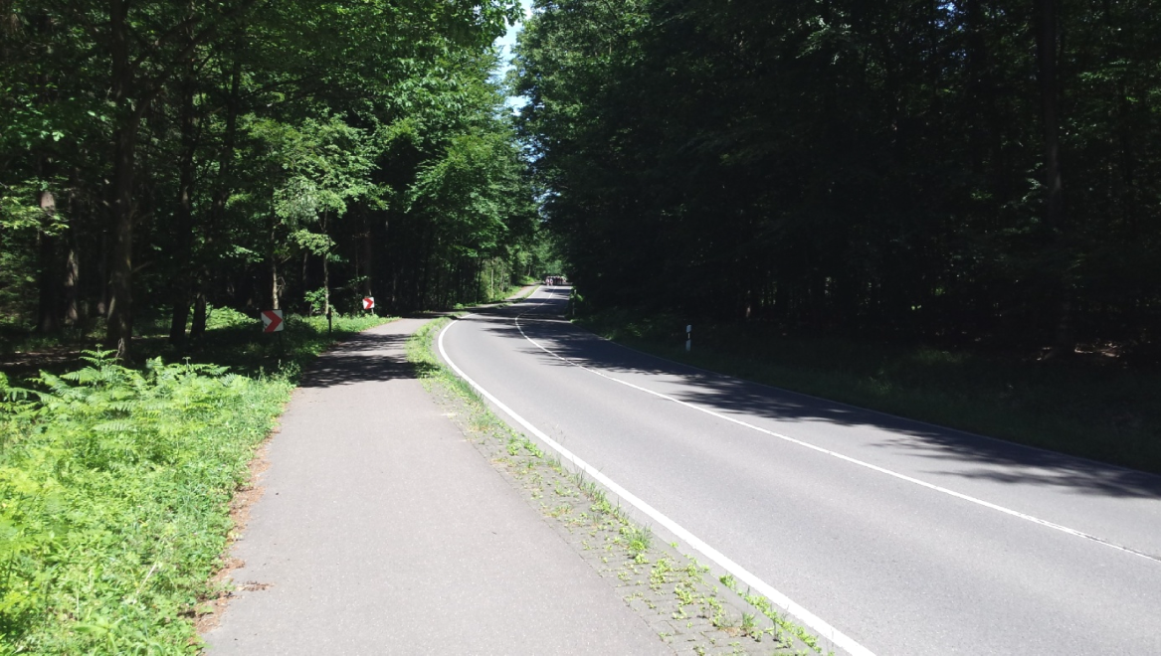
Figure 3: Example of forest road section

Minimum lengths
In order to determine the minimum required length (implementation) of a safety barrier, the regulations set forth in the current RPDI-RSB shall, in principle, apply. In this context, attention should be paid to the criteria of vehicle slipping over the barrier or passing of the vehicle behind it, always in combination with the prevailing local conditions.
This means that the safety barrier should be positioned to such a length that a diverted vehicle cannot reach the tree or obstacle. The lengths required for this purpose depend on the local conditions and regulations referred to in the RPDI-RSB. However, it is often the case that it is not possible to comply with the minimum lengths of the instructions due to the contribution of other roads and many other factors.
If it is not possible to fulfil the required barrier lengths in accordance with the RPDI-RSBs, a shorter length can be placed on the safety barrier, depending on the local conditions (see RPDI-RSB 2021). In such cases, care must be taken to reduce as far as possible the risk of the vehicle passing behind or slipping over it (better protection against the tree or obstacle object). This can be achieved e.g. by turning the barrier termination (BT) at the beginning or at the end, by a rounding of the barrier or of the termination within the contributing road or by applying non-lowered safety barrier terminations (energy absorbing terminations).
Where practicable, the reduced lengths of the barriers due to adaptation to local conditions shall not be less than the lengths of impact tests. If this is also not feasible, the length of the barrier should not be less than 20 m (5 plate lengths + BT, see RPDI-RSB 2021).

Configuration of the Contributing Roads, Access Roads and Traffic Connections
Due to the frequent road junctions and traffic connections along single-lane interurban roads, which hereinafter for the sake of brevity are summarized in the term "junctions", it is not possible to avoid interruptions in the continuation of the safety barriers. It is therefore necessary to consider the reduction of at least some rural roads in order to reduce the number of their contributions. Instructions for the configuration of junctions are given in RPDI-RSBs. The determining factor for the selection of a suitable way of placement of the safety provision is basically the local conditions of availability of space, the possible dangers regarding the passage behind the safety parapet or the fall as well as the geometric configurations of the road such as e.g. the construction of a parallel cycle path. In cases of installation of safety barriers with interruption in their continuity, the type of use of a road junction must be taken into account, such as e.g. any movement of agricultural or forestry machinery or vehicles.
If it is necessary to interrupt the continuation of a safety barrier along a road section, the relevant configuration should be as close as possible to the relevant RPDI-RSB Schemes. Reduced lengths of individual components of a barrier (of a special type of construction) or special solutions are possible only if no safety barrier is available on the basis of which safety can be arranged in accordance with the standard safety regulations as set forth in the RPDI-RSB. Paragraph 3.4 gives some typical examples of configuring junctions for which experience has confirmed their positive performance. Paragraph 3.5 gives examples of real cases which have led to negative effects of passive safety and should therefore no longer be applied in practice.

Additional protection for motorcyclists
In order to improve road safety for motorcyclists on road sections equipped with passive safety systems, an additional rider’s slip prevention system may be fitted under the safety barrier. It is proposed that this system should always be applied when the obstacle cannot be removed, when the road is often used by motorcyclists and when at the same time the curve sequence does not follow the regulations of homogeneity of the values of the radii of curvature (discontinuity of road marking). The same applies in cases where there is an increased chance of diversion, as reported in the RPDI-RSBs. In short, the special safety protection for motorcycles in a road is recommended when the radius of curvature is ≤ 300 m. Road sections with frequent use by motorcyclists means those parts in which the ADT of motorcycles is greater than average. In order to determine the exact numerical value of this average, knowledge of the traffic conditions of a region is required, which must be available and provided by the competent Technical Service of the Region or the municipality.
Where new safety barriers are installed on existing roads to protect its users against trees and other obstacles, the study must also provide for the possible protection of motorcyclists. The addition of a device to protect motorcycles against slipping under the barrier can only be accepted if the specific barrier is suitable to carry the specific addition. At the same time, it should be borne in mind that any addition of such a system to a barrier is likely to lead to a change in its behaviour against collisions by passenger vehicles.
Barrier terminations are generally not suitable for adding systems to protect against slip below them.

New connections to existing safety barriers
When a new safety barrier is to be installed, which should be directly linked to an existing safety barrier, it is recommended to assess whether the existing barrier should be maintained, or whether it is preferable to replace it by extending it simultaneously with the new one.
This assessment should take into account the functionality of the existing barrier (age of the barrier, possibly existing damage or wear, its compatibility with the regulations of the RPDI-RSB) and whether it is appropriate to maintain it in relation to a renewal thereof and whether this option is an economic solution.

Operation and maintenance
As regards the operation and maintenance of the road, the planning for carrying out the maintenance of the road and the way in which the maintenance is carried out, particularly during the winter months for certain areas of the country due to snow removal needs (where there is a high risk of creating snow layers) and any work related to the maintenance of the foundations, the sanitation facilities of the road and the care of the greenery, must be adapted.
The addition of safety barriers requires adjustments to the inspection and maintenance by maintenance services, whose work is hampered by road safety and the limitation of the space available (e.g. green care, road cleaning, winter maintenance). For this reason, account should also be taken of the corresponding impact on road maintenance to a certain reasonable extent in the safety study and the relevant decisions on it.

General indications when announcing safety projects
When announcing a road safety project with reference to the method of installation of the barriers, as mentioned in the relevant examples in this Volume of instructions, attention should be paid to the fact that it is not only a simple description of the performance of safety barriers but a clear description of the particular local conditions prevailing in the area of safety, particularly as regards the distances from the carriageway boundary line, for which the most appropriate solution must be found. The better the local conditions are described in the notice, the sooner all relevant data can be taken into account for the selection of the most appropriate and safest safety barrier in this particular case.
In many cases it may be that a safety barrier with a performance N2 and an operational width W1 is not sufficient to constitute acceptable protection against obstacles. The description of the required barrier on the basis of its performance data only as obtained from the impact tests is not sufficient to ensure the required protection against trees and other obstacles in confined space conditions by means of safety barriers.

Examples
In order to ensure protection against trees and other obstacles adjacent to the road by means of safety solutions in confined space conditions, which will provide the best possible road safety, the following are characteristic examples of safety, representing typical cases of a long-distance road. The resulting solution was based on the principles and regulations set forth in the previous paragraphs of these instructions.

Individual obstacles
S/n | Description | Supervisory representation
E1 | Individual tree with sufficient available length before it | 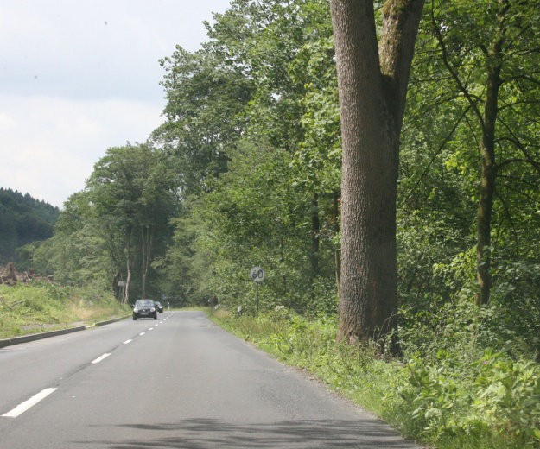
E2 | Individual tree without sufficient available length before it | 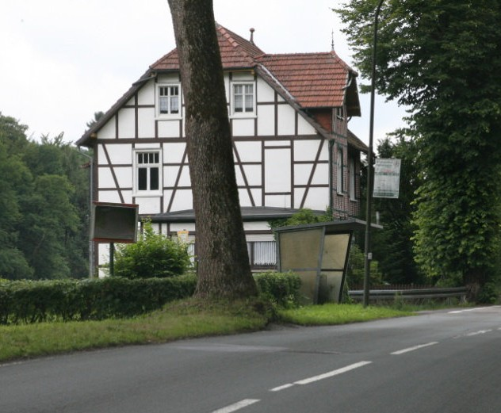
E3 | Multiple single trees and other dangerous obstacles | 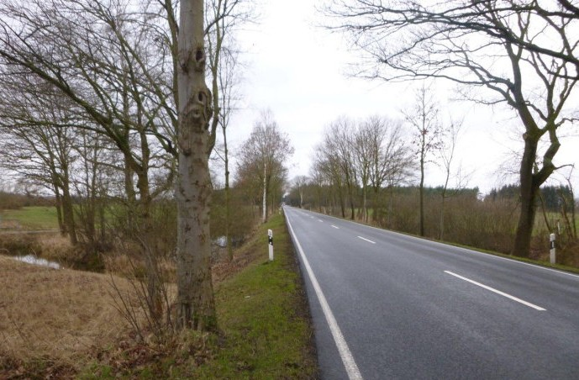

S/n | Description | Supervisory representation
E4 | Individual contributing tree (see example U4) | 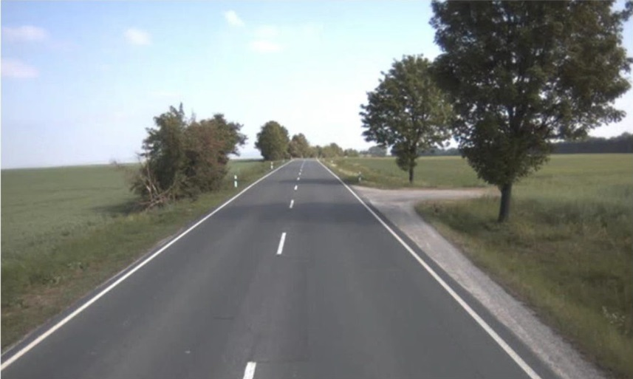
E5 | Technical pedestal, foreground (also pedestal or signpost) | 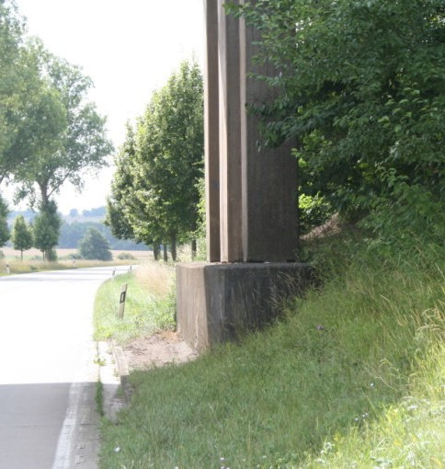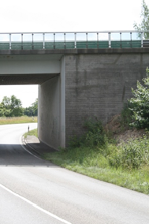
E6 | Post, pillar, power pole, telecommunications pole, etc. | 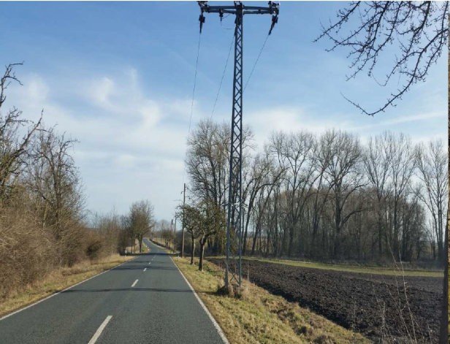
E7 | Wall as a protective measure against falls in a culvert | 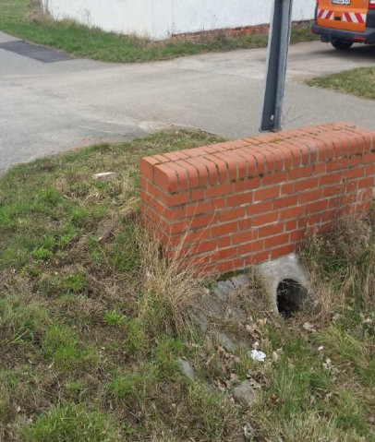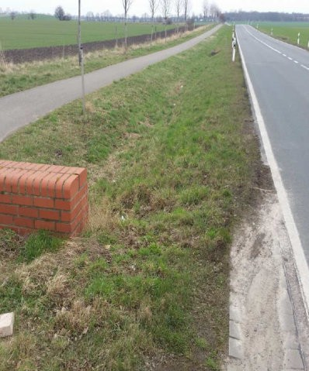

Treelines
S/n | Description | Supervisory representation
B1 | Tree line, distance from carriageway boundary line of 0.90 m to 1.50 m | 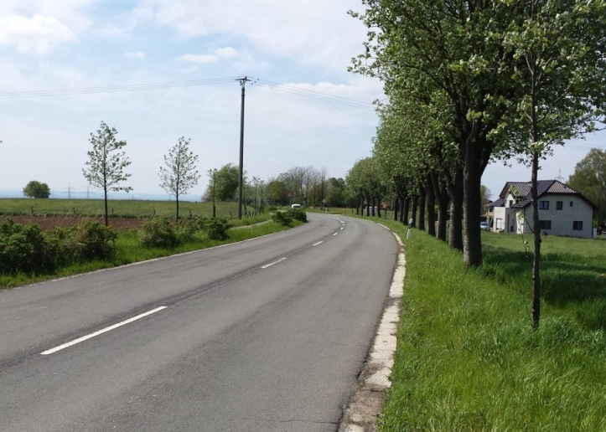
B2 | Tree line, distance from a carriageway boundary line of approximately 0.70 m | 
B3 | Tree line with varying distances between trees | 

Alleys
Safety in Alleys takes place in the same way as in the case of trees (see examples). In addition, only in this case, particular attention is paid to the available road width between safety barriers (see paragraph 2.4.1).

S/n | Description | Supervisory representation
A1 | Alley distance from carriageway boundary line to the left and right of approximately 0.90 m | 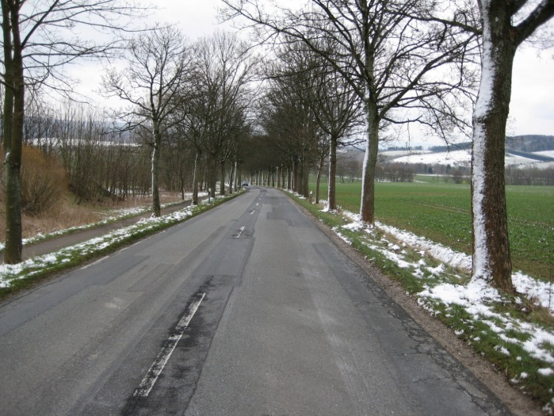
A2 | Alley, distance from a carriageway boundary line to the left of approximately 0.90 m, to the right of approximately 1.5 m | 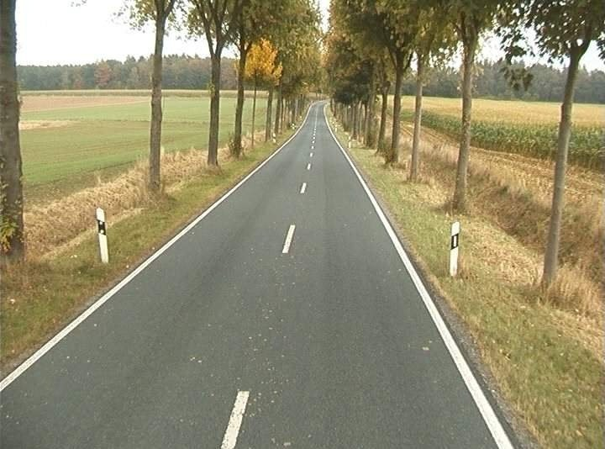
A3 | Alley, distance from carriageway boundary line to the right and left of approximately  0.25m | 

S/n | Description | Supervisory representation
A4 | Alley, distance from a carriageway boundary line to the right of approximately 0.15 m | 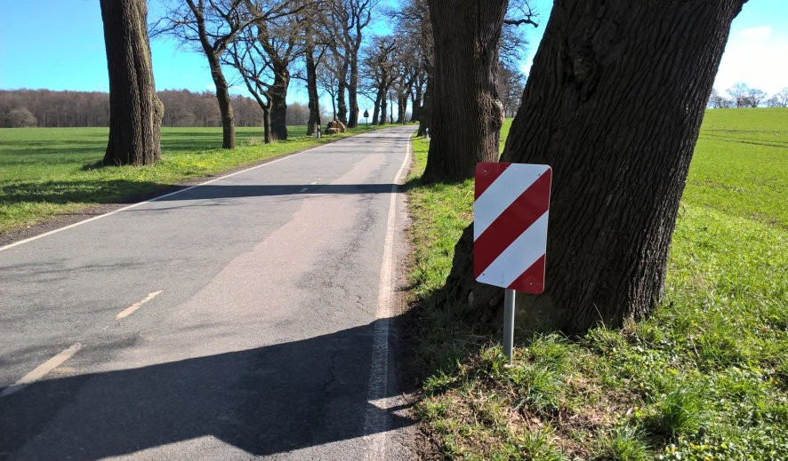

Contributing roads, access and traffic connections (discontinuation of barrier continuity)

S/n | Description | Supervisory representation
U1 | Discontinuation of barrier continuity by rounding (left) and turning (right) | 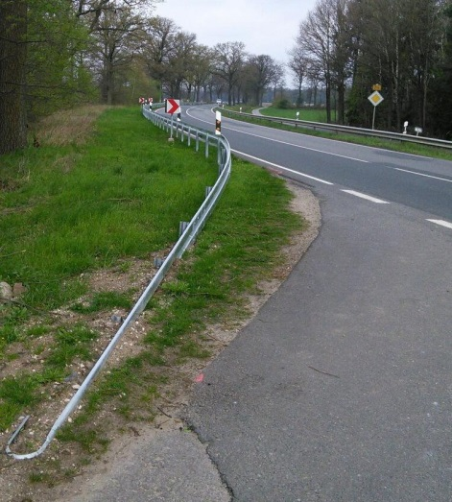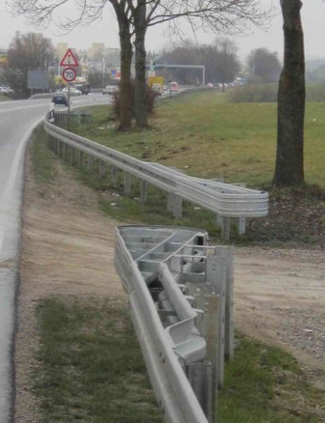
U2 | Discontinuation of barrier continuity due to access contribution combined with parallel cycling path | 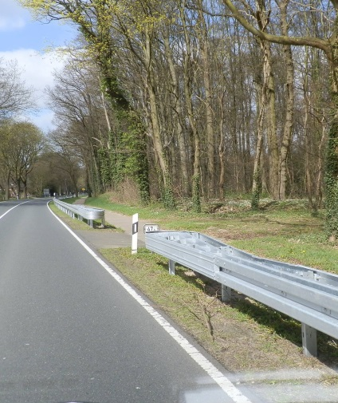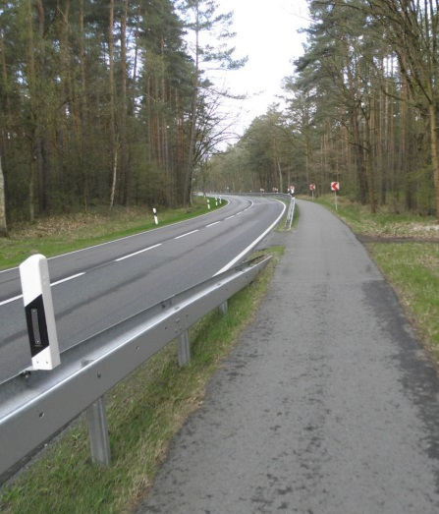

S/n | Description | Supervisory representation
U3 | Discontinuation of barrier continuity to the access junction without parallel laying of a bicycle path  (left: short length lowering – sinking of one-sided safety barrier with upright distance 2.0 m  right: special energy absorption termination without lowering this is Primus P2 type termination) | 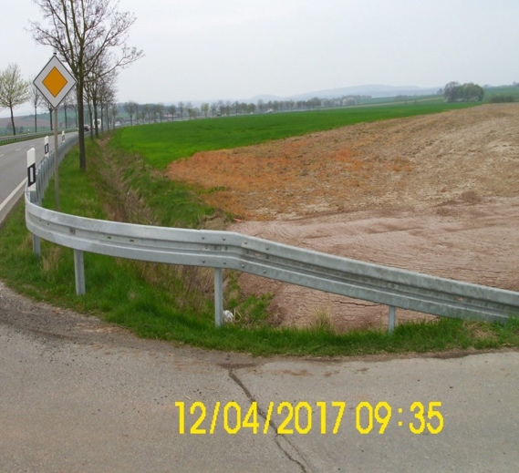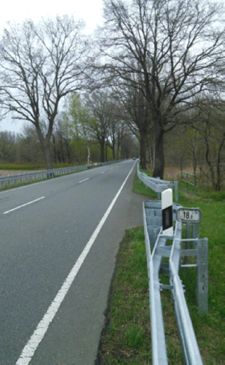
U4 | Individual tree with access contribution (see example E4) | 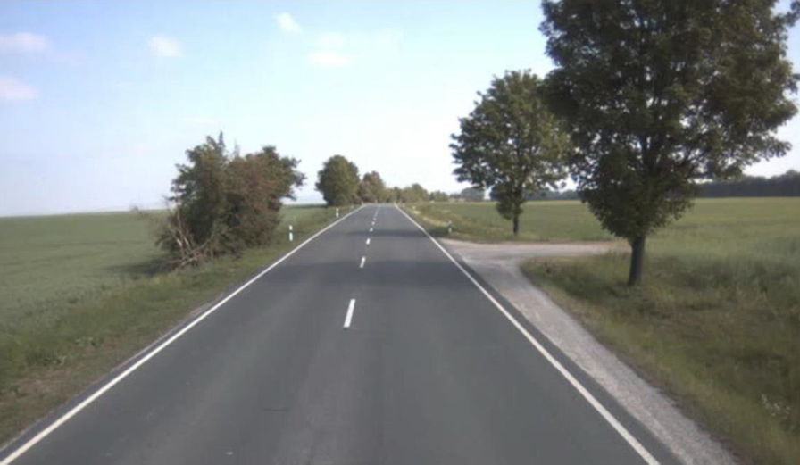

Examples of special solutions in the limits of violation of safe regulations
The following examples show specific solutions, which, despite the provision of safety for obstacles, include shortcomings in the road safety provided.

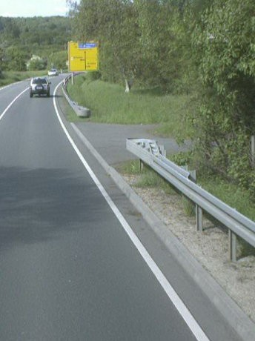
Example S1: Contribution with Primus P2 energy absorption BT
In this position, the Primus P2 type energy absorption termination in the junction area was selected. This avoids slipping on the barrier, which provides protection against impact on the information plate. However, the passage behind the barrier and the impact on the existing tree is not ensured with this solution.
Proposal for improvement:
Formation of a spine rounding with a typical lowering termination or a Primus P2 type termination selection (as a special type of construction) with parallel turning. This should take into account how the junction is used, so as not to hinder the possible use by agricultural or forestry machinery or vehicles.

Figure 4: Safety of junction with type Primus P2 energy absorption BT

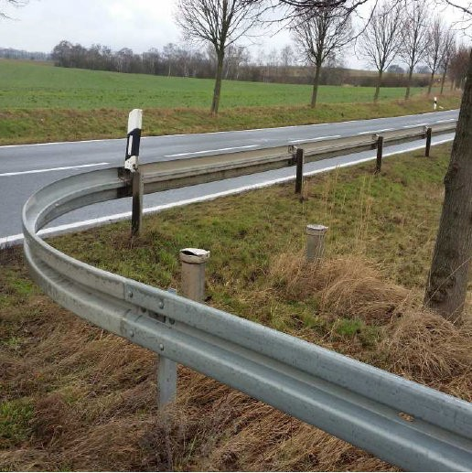
Example S2: Junction intrusion of cyclic static safety barrier configuration
A circular configuration of the barrier was created here to protect the ventilation pipes and the existing tree at the junction. With a distance of 4.0 m, however, the safety for a deflected vehicle is limited, because the barrier plate is easily deformed, while large deformations (up to the tree) or even breaking the plate are not excluded.
Proposal for improvement:
Supplement with 2 additional uprights in the circular arc area (1.33 m) and reduce the distance of the uprights in the area before the arc e.g. to 12 m length (improvement of ability to transfer tensile forces during impact.

Figure 5: Configuration of a safety barrier at the junction as a small radius circle arc without uprights

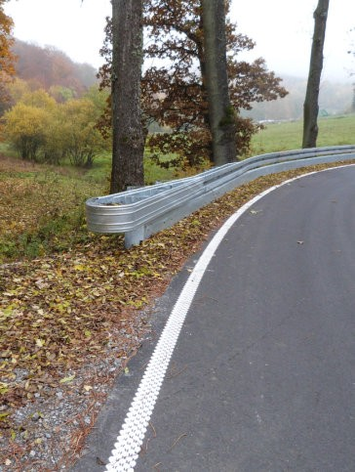
Example S3: Primus P2 end with additional motorcycle protection
Due to the special local conditions, an additional sliding blocking system under the barrier was adapted to the barrier especially for the protection of motorcyclists. This system was extended up to the BT (type Primus P2) in order to protect motorcyclists from the BT uprights.
Taking into account the mode of operation of the Primus P2 type BT, which in the event of a frontal impact is deformed, there is a risk that the vehicle will be punctured by the slip protection system under the barrier.
Proposal for improvement:
A distance of at least 4.0 m from the start of the slip protection system below the barrier at the Primus P2 type BT from the last upright.

Figure 6: BT equipment of Primus P2 type with motorcycle system for protection against slip under the BT.


Example S4: Extremely short safety barrier
For the safety of the flat embankment (downhill slope) a safety barrier was installed solely on the basis of the local conditions of the slope without taking into account the other obstacles. By lowering the barrier right in front of the tree, it is not at all protected from a vehicle impact.
Proposal for improvement:
Increase the length of the safety barrier so as to provide absolute protection against impact on the tree. The required lengths of the barrier shall be selected in accordance with the RPDI-RSBs, so as to exclude slipping over the barrier and passing behind it.

Figure 7: Extremely short safety barrier

Annex 1

References

BASt 2017: Einsatzempfehlungen für Fahrzeug-Rückhaltesysteme, Bundesanstalt fürStraßenwesen Stand 08/2017 (Einsatzempfehlungen FRS), Bergisch Glad- bach.

ESAB 2006: Empfehlungen zum Schutz vor Unfällen mit Aufprall auf Bäume, Ausgabe 2006, Forschungsgesellschaft für Straßen- und Verkehrswesen (2006), FGSV Verlag, Köln.

M Uko 2012: Merkblatt zur örtlichen Unfalluntersuchung in Unfallkommissionen, For- schungsgesellschaft für Straßen- und Verkehrswesen (2012), FGSV Ver- lag, Köln.

MVMot 2007: Merkblatt zur Verbesserung der Verkehrssicherheit auf Motorradstrecken, Forschungsgesellschaft für Straßen- und Verkehrswesen (2007), FGSV Verlag, Köln.

MVMot 2017: Entwurf Merkblatt zur Verbesserung der Straßeninfrastruktur für Motorrad- fahrende, Forschungsgesellschaft für Straßen- und Verkehrswesen, Ar-beitsgruppe Verkehrsmanagement, Stand 26.10.2017 (unveröffentlicht).

Maier, R. 2014: Maier, R., Berger, R., Schimpf, M., Lippold, Ch.: Entwicklung von Hand- lungsempfehlungen zur Anwendung der RPS 2009, Forschung Straßenbau und Straßenverkehrstechnik, Heft 1111, Bonn 2014

RAL 2012: Richtlinien für die Anlage von Landstraßen, Ausgabe 2012, Forschungsge- sellschaft für Straßen- und Verkehrswesen (2012), FGSV Verlag, Köln.

RPS 2009: Richtlinien für passiven Schutz an Straßen durch Fahrzeug-Rückhalte-systeme, Ausgabe 2009, Forschungsgesellschaft für Straßen- und Ver-kehrswesen (2009), FGSV Verlag, Köln.

V 193: Anprallversuche an motorradfahrerfreundlichen Schutzeinrichtungen, Be- richte der Bundesanstalt für Straßenwesen, Verkehrstechnik, Heft V 193, Bergisch-Gladbach, April 2010

RPDI-RSB-2021: Road Project Dedsign Instructions – Road safety barrier Vehicle restraint system MT&I, DRI (2021)

EN 1317 includes harmonised (mandatory) and non-harmonised (optional) parts.
what in ELOT EN 1317 is referred to as intrusion.
Condition introduced by Regulation (EU) No 305/2011. The term “performance” is used in these instructions for official vehicle restraint systems documents, while for the essential characteristics of the systems the term “performance” has been maintained.
According to the Technical Specification Traffic Lights Vehicle and Pedestrian Traffic Control , September 2012, Government Gazette 3154, 27.11.2012, traffic lights must be passive posts confirming to the standard ELOT EN 12767.
Template Safety Barrier Data Sheet in accordance with Annex 8.
Comment: A distinction should be made between the expected economically reasonable lifespan (use) of a product in terms of its durability, referred to in the technical descriptions and the actual lifespan of the product. The latter case depends on many factors over which a manufacturer cannot have any influence, e.g. mode of installation, location (stress), conditions of installation, mode of use and normal maintenance of a product. The stated lifetime of the product cannot therefore be considered to be a guarantee of use by the manufacturer (producer).
Harmonised standards do not yet exist for terminations and assemblies of barriers, so relevant certificates of performance in accordance with European standards cannot be issued. Until the terminations and assemblies are in line with European standards, the conditions and regulations set forth in Volume 1 of these instructions as a whole shall apply.
Wall type vehicle restraint systems (solid and full front) typically do not require height adjustments due to the inability of a vehicle to slide under the system.
Related instructions for new materials and parts of Vehicle Restraint Systems will be issued by the DRI of the MYME.
For these special attachments see relevant Volume of safety barrier assemblies
also applies to a central islet with inclines with two one-sided independently operating barriers
The relevant guidance of the DRI will be used for steel barrier material with properties at least those of steel type S 235 JR. Only full low relaxation steel may be used (minimum content of 0.02 %). For prefabricated concrete barriers at least C30/37 XC4, XD3, XF4, WA according to ELOT EN 206 and Greek Concrete Regulation will be used.
EN 1317-5:2007+A2:2012/AC:2012

