KINGDOM OF BELGIUM

FPS Interior Belgium (FEDERAL PUBLIC SERVICE HOME AFFAIRS)

Royal Decree of [date] 2022 amending the Royal Decree of 7 July 1994 adopting basic fire and explosion prevention standards for buildings

PHILIPPE, King of the Belgians,

To all who are here now or will be hereafter, Greetings.

Having regard to the Act of 30 July 1979 on fire and explosion prevention and mandatory civil liability insurance in such cases, Article 2(§ 1) as amended in the Act of 22 December 2003;

Having regard to the Royal Decree of 7 July 1994 adopting basic fire and explosion prevention standards for buildings;

Having regard to the opinions of the – Belgian High Council for Fire and Explosion
Safety of 17 January 2019 (façades), 16 May 2019 (car parks), 21 November 2019 (various provisions), 16 January 2020 (boiler sections and lifts) and 19 November 2020 (final text);

Having regard to completion of the formalities prescribed in the Directive 2015/1535/EC of the European Parliament and of the Council, which gives a procedure for the provision of information in the field of technical standards and regulations;

Having regard to the regulatory impact analysis conducted in accordance with the Articles 6 and 7 of the Act of 15 December 2013 setting out various provisions on administrative simplification;

Having regard to the opinion of the Inspector of Finance, issued on [date];

Having regard to opinion **.***/* of the Council of State, issued on [date], pursuant to Article 3,§ 1, of the coordinated Laws on the Council of State;

At the proposal of the Minister of Interior and on the recommendation of the Ministers convened in the Council,

We have decided and hereby decree:

Chapter 1. Amendments to the Royal Decree of 7 July 1994 adopting basic fire and explosion prevention standards for buildings

Article 1. The phrase ‘, without going beyond the date 1 July 2022’ is added to the first sentence of the Article 6/1 of the Royal Decree of 7 July 1994 adopting basic fire and explosion prevention standards for buildings, as amended by the Royal Decrees of 19 December 1997, 4 April 2003, 13 June 2007, 1 March 2009, 12 July 2012 and 7 December 2016.

Chapter 2. Amendments to the Annex 1 to the Royal Decree of 7 July 1994 laying down the basic fire and explosion prevention standards with which buildings must comply

Article 2. In point 1.6.1 of the Annex 1 to the same decree, a typographical correction is applied to the term ‘gross area’ in the Dutch version.

Article 3. Point 1.13 of the Annex 1 to the same decree is replaced with the following:
‘1.13 Subcompartment: part of a compartment bounded by walls that slow the spread of fire and limit the affected area.’.

Article 4. In point 1.15 of the Annex 1 to the same decree, a typographical correction is applied to all instances of the term ‘structural’ in the masculine plural in the French version.

Article 5. In the point 2.1, first paragraph 1, point 1° of the Annex 1 to the same decree, the word ‘information’ is replaced with a synonym in the Dutch version.

Article 6. Point 2.2 of the Annex 1 to the same decree is replaced with the following:

‘2.2 Special assessment of fire doors
§ 1. Door fire resistance must be tested according to standard NBN EN 1634-1 and classified according to standard NBN EN 13501-2.
The fire resistance of the door must be demonstrated using the data for the CE marking of the construction product.

A fire door without a CE marking must also meet the following requirements:

1° for tolerances for width, height, thickness and squareness, the minimum classes according to standard NBN EN 1529:
- after prior conditioning: Class 1;
- after exposure to high humidity: Class 1;
- after exposure to low humidity: Class 1;
2° for tolerances for general and local flatness, the minimum classes according to standard NBN EN 1530:
- after prior conditioning: Class 3;
- after exposure to high humidity: Class 2;
- after exposure to low humidity: Class 2;
3° for the mechanical resistance requirements, the minimum classes according to standard NBN EN 1192:
- in non-industrial applications: Class 1;
- in industrial applications: Class 2;
4° for mechanical durability, minimum Class 4 according to standard NBN EN 12400.
For the requirements under 1° and 2°, NBN EN 1294 specifies the climatic conditions of temperature and humidity.

Fire door must be assessed for the fire resistance requirements and minimum requirements set out in point 2°. Constancy of performance must be assessed and verified in accordance with system 1 as described in the point 1.2 of the Annex V to Regulation (EU) No 305/2011 laying down harmonised conditions for the marketing of construction products.
§ 2. Fire doors must be installed in accordance with the installation conditions for which they received their fire resistance classification.’
Article 7. The Point 3.1 of the Annex 1 to the same decree is now amended as follows:

1° in the first paragraph, the words “(NBN EN 13501-1)” are inserted between the words “The classification system of the fire reaction characteristics of construction products” and the words “is described in the tables 1, 2 mentioned below and 3”;

2° in the final row of Table 1, the cell with the phrase ‘No performance determined’ is replaced with the following 3 cells:
‘
NBN EN ISO 11925-2(⁸):  Exposure = 15s | Fs > 150 mm within 20 s
’;

3° in the final row of Table 2, the cell with the phrase ‘No performance determined’ is replaced with the following 3 cells:
‘
NBN EN ISO 11925-2(⁸):  Exposure = 15s | Fs > 150 mm within 20 s
’;

4° in the final row of Table 3, the cell with the phrase ‘No performance determined’ is replaced with the following 3 cells:
‘
NBN EN ISO 11925-2(⁸):  Exposure = 15s | Fs > 150 mm within 20 s
’.

Article 8. Point 3.2, paragraph 1, 2°, a) of the Annex 1 to the same decree is amended as follows:

1° all instances of the abbreviation ‘NBN’ are now removed;

2° the abbreviations ‘ISO/IEC’ are inserted between the abbreviation ‘EN’ and the number ‘17000’.

Article 9. The Point 3.4 of the Annex 1 to the same decree is now amended as follows:

1° in the paragraph 1, the phrase ‘of Tables I, II, III and IV’ is now removed;

2° paragraph 2 is replaced with the following:
‘However, the effect of the underlying storeys should not be assessed if they are protected with a building element with a fire protection ability K or a fire resistance EI that meets the requirements of Table 4 below. Fire protection ability and fire resistance must be determined according to the standard NBN EN 13501-2.’;

3° in the second row of Table 4, ‘or EI 30’ is added after ‘K₂ 30’ and ‘or EI 15’ is added after ‘K₂ 10’.

Article 10. The point 3bis.1 of the Annex 1 to the same decree is replaced with the following:

‘3bis.1 Classification system for the external fire performance of roofs and roof coverings
The classification system for the external fire performance of roofs and roof coverings (NBN EN 13501-5) is described below:

SYMBOLS

The classes according to the four test methods are:

CEN/TS 1187:2013 test 1: X_{ROOF} (t1), where t1 = burning brands only;

CEN/TS 1187:2013 test 2: X_{ROOF} (t2), where t2 = burning brands + wind;

CEN/TS 1187:2013 test 3: X_{ROOF} (t3), where t3 = burning brands + wind + radiation,

CEN/TS 1187:2013 test 4: X_{ROOF} (t4) where t4 = burning brands + wind + supplementary radiant heat

T_{E}: critical time for external fire spread

T_{p}: critical time for fire penetration
CEN/TS 1187:2013 test 1 | Class | Classification criteria
CEN/TS 1187:2013 test 1 | B_{ROOF} (t1) | All of the following conditions must be satisfied:  - external and internal fire spread upwards < 0.700 m;  - external and internal fire spread downwards < 0.600 m;  - maximum burned length external and internal < 0.800 m;  - no burning material (droplets or debris) falling from exposed side;  - no burning/glowing particles penetrating the roof construction;  - no single through opening > 2.5 × 10^{–5} m²;  - sum of all through openings < 4.5 × 10^{–3} m²;  - lateral fire spread does not reach the edges of the measurement zone;  - no internal glowing combustion;  - maximum radius of fire spread on ‘horizontal’ roofs, external and internal < 0.200 m.
CEN/TS 1187:2013 test 1 | F_{ROOF} (t1) | No performance determined

CEN/TS 1187:2013 test 2 | Class | Classification criteria
CEN/TS 1187:2013 test 2 | B_{ROOF} (t2) | For both test series at 2 m/s and 4 m/s wind speed:  - mean damaged length of the roofing and underlay ≤ 0.550 m;  - maximum damaged length of the roofing and underlay ≤ 0.800 m.
CEN/TS 1187:2013 test 2 | F_{ROOF} (t2) | No performance determined

CEN/TS 1187:2013 test 3 | Class | Classification criteria
CEN/TS 1187:2013 test 3 | B_{ROOF} (t3) | T_{E} ≥ 30 min and T_{p} ≥ 30 min
CEN/TS 1187:2013 test 3 | C_{ROOF} (t3) | T_{E} ≥ 10 min and T_{P} ≥ 15 min
CEN/TS 1187:2013 test 3 | D_{ROOF} (t3) | T_{P} > 5 min
CEN/TS 1187:2013 test 3 | F_{ROOF} (t3) | No performance determined

CEN/TS 1187:2013 test 4 | Class | Classification criteria
CEN/TS 1187:2013 test 4 | B_{ROOF} (t4) | All of the following conditions must be satisfied:  - no penetration of roof system within 1 hour;  - in the preliminary test, after withdrawal of test flame, specimens burn for < 5 minutes;  - in the preliminary test, flame spread < 0.38 m across the region of burning.
CEN/TS 1187:2013 test 4 | C_{ROOF} (t4) | All of the following conditions must be satisfied:  - no penetration of roof system within 30 minutes;  - in the preliminary test, after withdrawal of test flame, specimens burn for < 5 minutes;  - in the preliminary test, flame spread < 0.38 m across the region of burning.
CEN/TS 1187:2013 test 4 | D_{ROOF} (t4) | All of the following conditions must be satisfied:  - roof system is penetrated within 30 minutes but is not penetrated  in the preliminary flame test;  - in the preliminary test, after withdrawal of test flame, specimens burn for < 5 minutes;  - in the preliminary test, flame spread < 0.38 m across the region of burning.
CEN/TS 1187:2013 test 4 | E_{ROOF} (t4) | All of the following conditions must be satisfied:  - roof system is penetrated within 30 minutes but is not penetrated in the preliminary flame test;  - flame spread is not controlled.
CEN/TS 1187:2013 test 4 | F_{ROOF} (t4) | No performance determined
’.
Article 11. The point 3bis.2 of the Annex 1 to the same decree is now amended as follows:

1° in point 1°, the word ‘information’ is replaced with a synonym in the Dutch version;

2° in point 2°, the phrase ‘or in the absence of information on the fire performance of the entire roof structure for the CE marking’ is added after ‘in the absence of a CE marking’;

3° in point 2°a), all instances of the abbreviation ‘NBN’ are now removed and the abbreviation ‘ISO/IEC’ is inserted between the abbreviation ‘EN’ and the number ‘17000’;

4° in point 2°b), the phrase ‘tested according to the tests described in’ is replaced with ‘assessed according to’.

Article 12. Point 4.1 of the Annex 1 to the same decree is replaced with the following:
‘4.1 Boiler section: space consisting of the boiler room and any associated fuel storage space(s).’.

Article 13. Point 4.2 of the Annex 1 to the same decree is replaced with the following:
‘4.2 Boiler room: room where one or more fuel burning appliances intended for central heating or for the production of hot water are installed.’.

Article 14. Point 4.3 of the Annex 1 to the same decree is replaced with the following:
‘4.3 Fuel storage space: room intended to store a solid, liquid or gaseous fuel whose total fire load exceeds 15 GJ.’.

Article 15. A point 4.11 is inserted in the Annex 1 to the same decree, reading:
‘4.11 Combustion rate: amount of energy that the fuel supplies to the combustion chamber of the fuel burning appliance per unit of time, expressed based on the net calorific value H_{i}. Also called ‘burner capacity’ or ‘power consumption’.

If a fuel burning appliance has more than one combustion rate, the highest combustion rate is used.’.

Article 16. In point 5.1.2 of Annex 1 to the same decree, the number ‘14600’ is replaced with the number ‘16034’.

Article 17. In point 5.6.1 of the Annex 1 to the same decree, a typographical correction is applied to the term ‘staircases’ in the Dutch version.

Article 18. In the point 5.6.7 of the Annex 1 to the same decree, in the Dutch version, the word ‘required’ is inserted between the word ‘the’ and the phrase ‘clear widths of the evacuation spaces of the same compartment cannot differ from one another by more than one passage unit’.

Article 19. In the point 6.1 of the Annex 1 to the same decree, all instances of the word ‘floor’ are removed in the French version.

Article 20. In the Annex 1 to the same decree, a point 7 is inserted, containing points 7.1 to 7.7, reading:

‘7. CAR PARK TERMINOLOGY

7.1 Parking level: car park space between a floor and a ceiling containing the vehicle parking zones, circulation routes and possibly also rooms. The floor of this space may be horizontal or sloping.

7.2 Car park entrance: outdoor access intended for fire brigade operations.

7.3 Depth p of an underground car park:

The depth p of an underground car park is conventionally the greatest vertical distance between the finished floor level of a parking area on the deepest parking level and the level of each car park entrance intended for fire brigade operations at said parking area.

However, if the parking place for fire brigade vehicles in front of this car park entrance is located more than 1 m above this entrance, the distance between the level of this car park entrance and the floor level of this parking area must be added to obtain the depth p.

7.4 Open parking level: storey in a car park featuring two opposite façades that meet the following conditions:

1° these façades are no more than 60 m apart along their entire length;

2° each of these façades features openings with a useful area equal to at least 1/6 of the total area of the vertical inner and outer walls of the perimeter of this storey;

3° the openings are distributed evenly over the length of the two façades;

4° obstructions may be permitted between these two façades provided that the useful area for air flow is equal to at least the area of the openings required in each of these façades;

5° the outdoor horizontal distance between these façades and each external obstruction is at least 5 m.

7.5 Open car park: a car park where every level is an open parking level as defined in point 7.4.

7.6 Car lift: lift used to move the vehicles with their passengers between the different parking levels.

7.7 Parking box: indoor space in a car park, bounded by walls and intended for parking one or more vehicles.’.

Chapter 3. Amendments to the Annex 2/1 to the Royal Decree of 7 July 1994 laying down the basic fire and explosion prevention standards with which buildings must comply

Article 21. In the same decree, the Annex 2/1 is replaced with the Annex 1 to this Decree.

Chapter 4. Amendments to the Annex 3/1 to the Royal Decree of 7 July 1994 laying down the basic fire and explosion prevention standards with which buildings must comply

Article 22. In the same decree, the Annex 3/1 is replaced with the Annex 2 to this Decree.

Chapter 5. Amendments to the Annex 4/1 to the Royal Decree of 7 July 1994 laying down the basic fire and explosion prevention standards with which buildings must comply

Article 23. In the same decree, the Annex 4/1 is replaced with the Annex 3 to this Decree.

Chapter 6. Amendments to the Annex 5/1 to the Royal Decree of 7 July 1994 laying down the basic fire and explosion prevention standards with which buildings must comply

Article 24. The point 3, Table I, of the Annex 5/1 to the same decree is amended as follows:

1° in the ‘Floors’ row of the ‘Technical rooms, parking areas, machinery rooms, technical shafts’ row, ‘B_{Fl}-s2****’ is added to the ‘A2_{Fl}-s2’ formulas in the H.G., M.G. and L.G columns;

2° in the first column, the phrase ‘, shafts of passenger or cargo lifts’ is added to the phrase ‘Technical rooms, parking areas, machinery rooms, technical shafts’ and in the Dutch version, the term ‘parking areas’ is replaced with the term ‘car parks’;

3° the following footnote is added to the footnotes in the last row:
‘**** for parking areas’.

Article 25. In the point 4.2 of the Annex 5/1 to the same decree, the word ‘generalised’ is replaced with the word ‘total’ in the French version.

Article 26. The Point 6 of the Annex 5/1 to the same decree is replaced with a point 6, containing points 6.1 to 6.4, reading:

‘6. FAÇADES

6.1 Building façades

6.1.1 Table V gives the reaction to fire requirements that apply to products used for façade cladding.

TABLE V: FAÇADES

type |  |  | H.G. | M.G. | L.G.
 |  |  | H.G. | M.G. | 1 | 2 and 3
Façade component type⁽⁵⁾ |  | Conditions
Outer cladding⁽⁶⁾ |  | in final application conditions⁽¹⁾ | A2-s3, d0 | B-s3, d1 | C-s3, d1 | D-s3, d1
Essential components⁽³⁾ | All, except for outer cladding and studs of the support structure of the façade | Assessed separately⁽²⁾  Not fully protected from fire⁽⁴⁾ | A2-s3, d0 | A2-s3, d0  OR  E if the type of solutions⁽⁷⁾ | E
Essential components⁽³⁾ | Studs of the support structure of the façade | Assessed separately⁽²⁾  Not fully protected from fire⁽⁴⁾ | A1 | A1  OR  Wood | /
Essential components⁽³⁾ | All, except outer cladding | Assessed separately⁽²⁾  Fully protected from the fire⁽⁴⁾ | E if the type of solution⁽⁸⁾ | E | /
Non-essential components⁽³⁾ |  | - | / | / | /
H.G.: high-rise buildings
M.G.: mid-rise buildings
L.G.: low-rise buildings
/ no requirements
- in other words, including underlying storeys and implementation (see also point 3.4 of Annex 1). However, the underlying storeys should not be assessed when determining the reaction to fire of the outer cladding if they are externally protected by a building element with:
a fire protection ability of K₂ 30 or a fire resistance of EI 30 (high-rise buildings);
a fire protection ability of K₂ 10 or a fire resistance of EI 15 (low and mid-rise buildings).
- this means that the effect of the underlying storeys is not assessed for the product as marketed;
- see also the definitions in point 3.1 of Annex 1;
- fully protected from fire: the essential components are fully protected (along all sides, from both internal and external fire) by a building element with:
a fire protection ability of K₂ 30 or a fire resistance of EI 30 (high-rise buildings);
a fire protection ability of K₂ 10 or a fire resistance of EI 15 (mid-rise buildings).
- the requirements do not apply to window or door frames or glazing in the façade.
- the requirements do not apply to doors, façade decorations, joints or technical equipment in the façade, such as signs, lighting equipment, ventilation grilles, drains, planters or wall penetrations for heating systems, provided that their total visible area is less than 5% of the visible area of the façade in question.
- see also point 6.1.2 Type of solutions for mid-rise buildings.
- see also point 6.1.3 Type of solution for high-rise buildings.

6.1.2 Type of solutions for mid-rise buildings

For mid-rise buildings, the essential components of the façade can be of Class E if the façade meets one of the type of solutions below.

6.1.2.1 Type of solution for façade with continuous air cavity

The insulation cannot be EPS (expanded polystyrene) or XPS (extruded polystyrene).

A firescreen must be installed at the level of the first and second floor between the first and second storeys. If the vertical distance between this firescreen and ground level is greater than 8 m, one or more firescreens must be added every 8 m. (Drawing 5.2)

After the previous firescreen, a firescreen must be installed:
- either once every two stories;
- or around every opening.
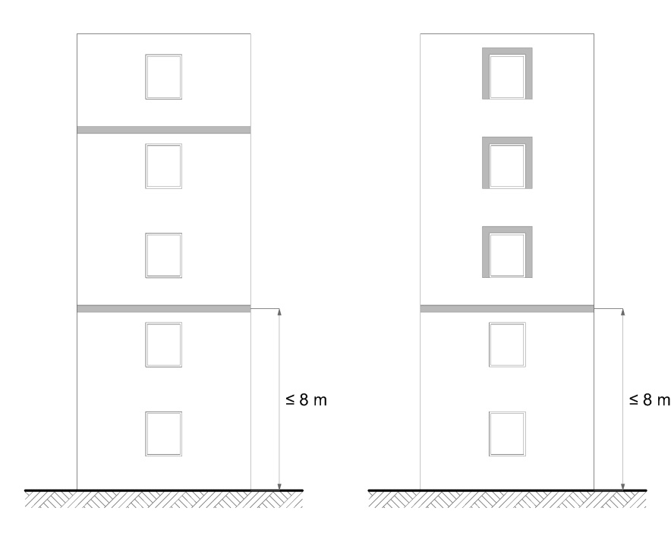
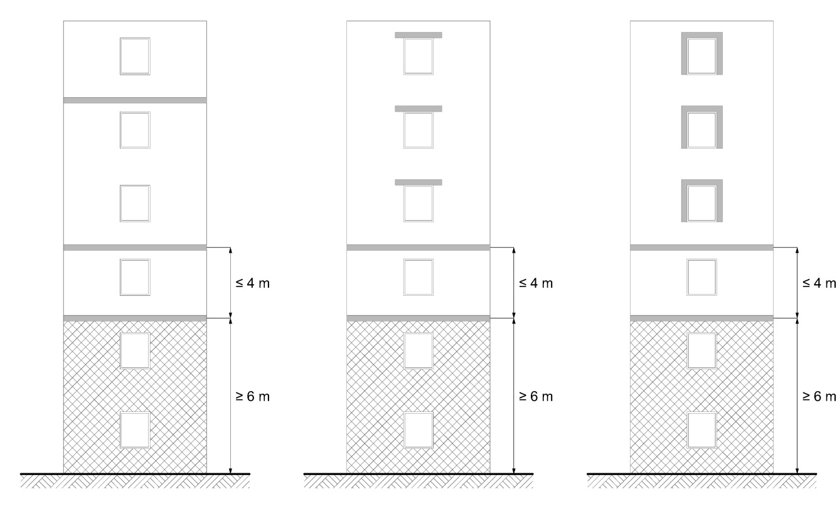 Firescreen

Drawing 5.2
A firescreen is a facility that interrupts the insulation and the air cavity to reduce the risk of fire spreading inside the façade.

The type of solutions described below enable compliance with this requirement:
a) an interruption across the entire width of the façade by a steel slab, a horizontal wooden slat or a horizontal strip of mineral wool;
b) each façade opening framed (top and sides) with steel or wood, or a horizontal and vertical strip of mineral wool.

The steel slab or frame must have at least the following characteristics:
- Thickness: 1 mm
- Mechanically attached

The mineral wool strip must have at least the following characteristics:
- Height/Width: 20 cm
- Fire performance class: A2-s3, d0
- Density: 60 kg/m³
- Mechanically attached

The wooden slat or frame shall have at least the following characteristics:
- Thickness: 25 mm
- Density: 390 kg/m³
- Mechanically attached

In addition, up to 100 cm² of ventilation openings are permitted in the firescreens per running metre.

6.1.2.2 Type of solutions for façade without continuous air cavity
6.1.2.2.1 Type of solution 1 for façade without continuous air cavity

The insulation cannot be EPS (expanded polystyrene) or XPS (extruded polystyrene).

6.1.2.2.2 Type of solution 2 for façade without continuous air cavity

A firescreen must be installed at the level of the floor between the ground floor and first storey. If the vertical distance between this firescreen and ground level is greater than 4 m, one or more firescreens must be added every 4 m. (Drawing 5.3)

A firescreen must be installed at the second and third level of the floor between the second and third storey. If the distance between this firescreen and the previous firescreen is greater than 8 m, one or more firescreens must be added every 8 m.

After the previous firescreen, a firescreen must be installed:
- either once every two stories;
- or above or around every opening.

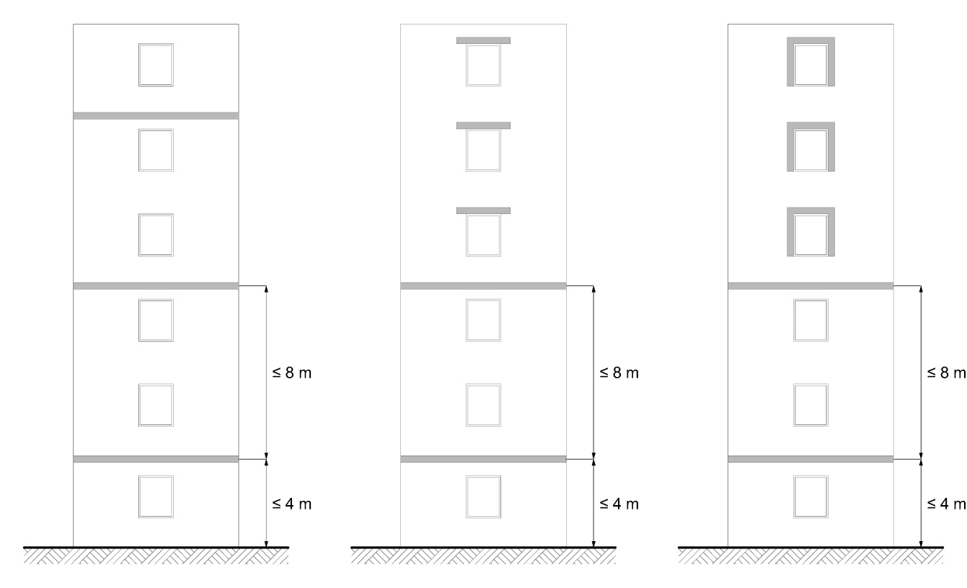
Firescreen

Drawing 5.3
A firescreen is a facility that interrupts the insulation to reduce the risk of fire spreading inside the façade.

The type of solutions described below enable compliance with this requirement:
a) an interruption across the entire width of the façade by a horizontal strip of mineral wool;
b) an interruption above each façade opening by a horizontal strip of mineral wool;
c) each façade opening framed (top and sides) with a horizontal and vertical strip of mineral wool.

The mineral wool strip must have at least the following characteristics:
- Height/Width: 20 cm
- Lateral overhang (for type of solution b): 30 cm
- Fire performance class: A2-s3, d0
- Density: 60 kg/m³
- Mechanically attached

6.1.3 Type of solution for high-rise buildings

For high-rise buildings, the essential components of the façade can be of Class E if all essential components, except for the outer cladding, are fully protected from fire (see also point ⁽⁴⁾ of Table V of point 6.1.1) and if the façade meets the type of solution below.

A firescreen must be installed at the level of the first and second floor between the first and second storeys. If the vertical distance between this firescreen and ground level is greater than 8 m, one or more firescreens must be added every 8 m. (Drawing 5.4)

After the previous firescreen, a firescreen must be installed once every two storeys.
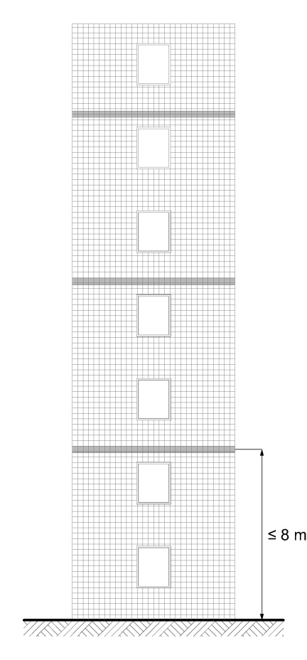
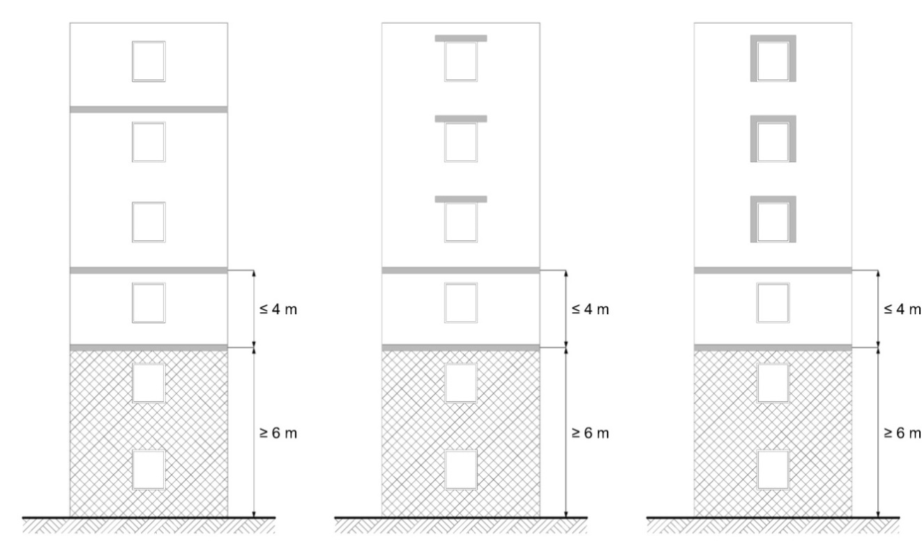 Firescreen
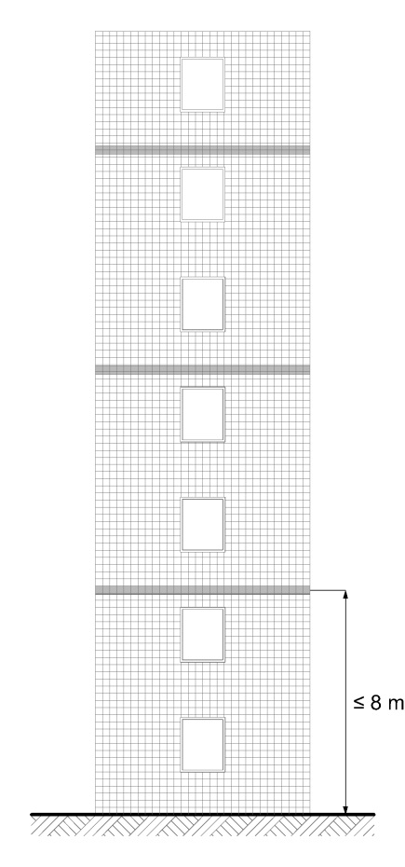 Building element with fire protection ability of K₂ 30 or a fire resistance of EI 30

.
Drawing 5.4
A firescreen is a facility that interrupts the insulation and any air cavity to reduce the risk of fire spreading inside the façade.

The type of solution described below enables compliance with this requirement:
- an interruption across the entire width of the façade by a horizontal strip of mineral wool.

The mineral wool strip must have at least the following characteristics:
- Height/Width: 20 cm
- Fire performance class: A2-s3, d0
- Density: 60 kg/m³
- Mechanically attached

In addition, up to 100 cm² of ventilation openings are permitted in the firescreens per running metre.

6.2 Large-scale test

Point 6.1 does not apply to façades tested according to one of the following test standards that meet the performance criteria defined in the following documents:

Test standard | Document indicating the performance criteria
Test standard | H.G. | M.G. | L.G.
BS 8414-1 | LPS 1581 | BRE 135
BS 8414-2 | LPS 1582 | BRE 135
DIN 4102-20 | / | Document HR 1882 of the Belgian High Council for Fire and Explosion Safety [Hoge Raad voor beveiliging tegen brand en ontploffing]
LEPIR 2 | French Order of 10 September 1970 on the fire hazard classification of glass façades [Arrêté français du 10 septembre 1970 relatif à la classification  des façades vitrées par rapport au danger d’incendie]
H.G.: high-rise buildings
M.G.: mid-rise buildings
L.G.: low-rise buildings

6.3 Buildings with different parts of different heights

Buildings featuring different parts of different heights may be divided vertically according to the conventional height of each building part.

The applicable provisions of points 6.1 and 6.2 are those corresponding to the conventional height of the part in question, but only from a horizontal distance of 5 m from the façade that dominates the part in question. (Drawing 5.5)

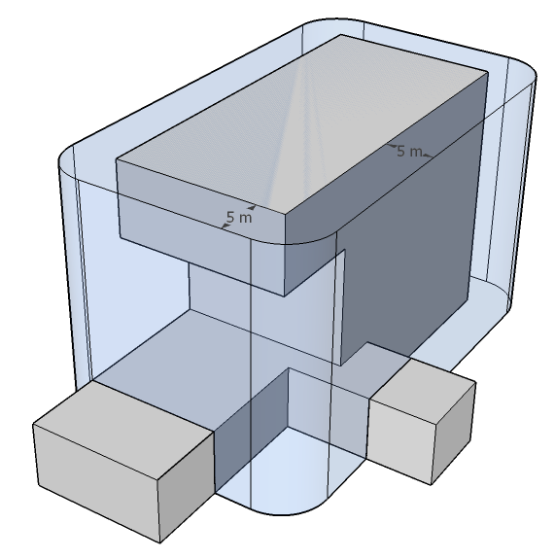
Drawing 5.5
6.4 Buildings for which an urban planning permit application was submitted before 1 July 2022

Points 6.1 to 6.3 do not apply to façades on a building for which an urban planning permit application was submitted before 1 July 2022 if it meets the conditions below.

The façade claddings of the low-rise buildings are of Class D-s3, d1.

The façade claddings of the mid and high-rise buildings are of Class B-s3, d1.

A maximum of 5% of the visible area of the façades is not subject to this requirement.’.

Article 27. A new paragraph is added to point 8.3 of the Annex 5/1 to the same decree, reading:
‘A wooden terrace on a flat roof is assumed to meet the requirements set out in point 8.1, i.e. Class B_{ROOF} (t1), if it meets the following conditions:
- wooden terrace boards: minimum density of 750 kg/m³, thickness of 21 to 40 mm, minimum width of 120 mm, mechanical attachment to a wooden support structure, parallel or perpendicular to the roof slope
- width of joints between boards: 4 to 6 mm
- wooden support structure: wooden joists (minimum density of 750 kg/m³, section of 60 x 40 mm), placed directly on the roof or with insertion of polypropylene floor pedestals (max. 6 per m²)
- roofs under the wooden terrace: all flat roofs (slope of 0 to 20°) belonging to Class B_{ROOF} (t1).’.

Article 28. In point 8.4.1 of the Annex 5/1 to the same decree, the abbreviation ‘NBN ENV’ is replaced with ‘CEN/TS’.

Chapter 7. Amendments to the Annex 6 to the Royal Decree of 7 July 1994 laying down the basic fire and explosion prevention standards with which buildings must comply
Article 29. In point 1.2.1, paragraph 1, 3, fifth indent, of the Annex 6 to the same decree, the word ‘general’ is replaced with the word ‘total’ in the Dutch version.

Article 30. In the title of point 3 of the Annex 6 to the same decree, a typographical correction is applied to the term ‘structural’ in the French version.

Article 31. In the title and text of point 3.1 of the Annex 6 to the same decree, a typographical correction is applied to all instances of the term ‘structural’ in the masculine plural in the French version.

Article 32. In the text and table in the point 3.3 of the Annex 6 to the same decree, a typographical correction is applied to all instances of the term ‘structural’ in the masculine singular and plural in the French version.

Article 33. The point 3.4.3 of the Annex 6 to the same decree is amended as follows:

1° in the second indent of paragraph 2, the word ‘horizontal’ is removed;

2° in the second indent of paragraph 2, ‘A1’ is replaced with ‘A1 and/or A2-s1, d0’;

3° in the second indent of paragraph 3, the word ‘horizontal’ is removed;

4° in the second indent of the paragraph 3, ‘A1’ is replaced with ‘A1 and/or A2-s1, d0’.

Article 34. In the point 5.2 of the Annex 6 to the same decree, the word ‘general’ is replaced with the word ‘total’ in the Dutch version.

Article 35. The point 5.2.1 of the Annex 6 to the same decree is amended as follows:

1° in paragraphs 1 and 2, a typographical correction is applied to every instance of the term ‘fire detection system’ in the Dutch version;

2° paragraph 3 is amended as follows:

a) in the Dutch version, a typographical correction is applied to the term ‘recognition procedure’;

b) in the French version, the phrase ‘during commissioning, and after this’ is inserted between ‘This system shall be inspected’ and ‘once every three years’;

c) in the French version, the phrase ‘starting from commissioning’ is now removed.

Article 36. The Point 5.3 of the Annex 6 to the same decree is now amended as follows:

1° in the paragraph 2, (1 and 2), all instances of the word ‘floor’ are removed in the French version;

2° in the paragraph 2, point 3, the phrase ‘automatic gas or water mist extinguishing system’ is replaced with ‘automatic water mist, foam or gas extinguishing system’.

Article 37. In point 5.3.1, paragraph 2 of the Annex 6 to the same decree, all instances of the word ‘floor’ are removed in the French version.

Article 38. In the point 7.2.2 of the Annex 6 to the same decree, ‘point 1.2.2’ is replaced with ‘point 1.2.1’.

Article 39. In point 8.1.1, paragraph 2, points 2° and 3°) of the Annex 6 to the same decree, all instances of the phrase ‘total area’ are replaced with ‘floor area’.

Chapter 8. Amendments to the Annex 7 to the Royal Decree of 7 July 1994 laying down the basic fire and explosion prevention standards with which buildings must comply

Article 40. In the second indent of the point 2.2, paragraph 2 of the Annex 7 to the same decree, the term ‘car parks’ is replaced with a synonym in the Dutch version.

Article 41. In the Annex 7 to the same decree, a point 3 is inserted, containing points 3.1 to 3.8, reading:

‘3. CAR PARKS

3.1 Subject matter
This chapter sets out the conditions that the design, construction and layout of a car park must meet in order to:

a) prevent fires from starting, growing and spreading;
b) guarantee the safety of persons present;
c) facilitate potential fire brigade operations.

3.2 Scope
The provisions of this chapter apply to the car parks referred to in the point 5.2.4 of the Annexes 2/1, 3/1 and 4/1 to this Decree.

3.3 Fire protection
The design, implementation, use and inspection of fire protection systems must meet good engineering practices and the applicable standards.

Active fire protection systems must be designed so the different components are compatible with one another. They must work together properly so the functioning or failure of one component does not jeopardise the functioning of the other systems and components.

A competent body or person must inspect and maintain the active fire protection systems at regular intervals.

The special requirements on electrical lines for the controls and power supply of active fire protection systems still apply.

3.3.1 Protection type
Different protection types are distinguished based on the fire protection concept applied:
- SHEV & sprinkler
- SHEV
- Sprinkler
- Ventilation opening
- Open
In car parks with a total area of over 250 m²(*), one of these protection types must be applied on every parking level, as shown in the table below.
 |  |  | Total area of car park S
 |  |  | S  ≤  250  m²  (*) | 250 m² (*) < S ≤ 60 000 m² |  |  |  | S  >  60 000 m²
 |  |  | S  ≤  250  m²  (*) | Area of the largest subcompartment S_{sc} |  |  |  | S  >  60 000 m²
 |  |  | S  ≤  250  m²  (*) | S_{sc} ≤  1 250 m² | 1 250 m²  < S_{sc} ≤  2 500 m² | 2 500 m²  < S_{sc} ≤  5 000 m² | 5 000 m²  < S_{sc} | S  >  60 000 m²
Above-ground  component layers |  |  | / | SHEV^{1,2,3}  OR  Sprinkler^{1.2}  OR  Ventilation opening  OR  Open | SHEV^{1,2}  OR  Sprinkler¹  OR  Open | SHEV¹  OR  Sprinkler¹  OR  Open | SHEV¹  &  Sprinkler¹  OR  Open | SHEV¹  &  Sprinkler¹  OR  Open
Underground component layers | 0 m  < p ≤  7 m |  | / | SHEV^{1,2,3}  OR  Sprinkler^{1.2}  OR  Ventilation opening  OR  Open | SHEV^{1,2}  OR  Sprinkler¹  OR  Open | SHEV¹  OR  Sprinkler¹  OR  Open | SHEV¹  &  Sprinkler¹  OR  Open | SHEV¹  &  Sprinkler¹  OR  Open
Underground component layers | 7 m  < p ≤  14 m |  | / | SHEV^{1,2}  OR  Sprinkler¹ | SHEV¹  OR  Sprinkler¹ | SHEV¹  &  Sprinkler¹ | SHEV¹  &  Sprinkler¹ | SHEV¹  &  Sprinkler¹
Underground component layers | 14 m  < p ≤  21 m |  | / | SHEV¹  OR  Sprinkler¹ | SHEV¹  &  Sprinkler¹ | SHEV¹  &  Sprinkler¹ | SHEV¹  &  Sprinkler¹ | SHEV¹  &  Sprinkler¹
Underground component layers | > 21 m |  | / | SHEV¹  &  Sprinkler¹

(*) For car parks without a car lift, this limit is increased to 625 m² provided that the car park does not feature any points located further than 45 m from the car park entrance intended for fire brigade operations (see also point 7.2 of the Annex 1).

SHEV# = SHEV type #
Sprinkler# = Sprinkler type #

All underground parking levels, except for open component layers, must feature the same protection type. All above-ground parking levels, except for open component layers, must feature the same protection type. However, the protection type of the above-ground storeys may differ from that of the underground storeys.

3.3.2 Fire detection and alarm system
Parking levels must be equipped with an automatic fire detection and alarm system that monitors the entire car park (including the rooms in the compartment).

This requirement does not apply to:
a) car parks with a total area less of than or equal to the limit indicated in point 3.3.1 for application of one the protection types on every parking level;
b) car parks exclusively of the ‘Ventilation opening’ or ‘Open’ type, provided that they do not feature any:
- subcompartments;
- equipment that requires fire detection control, aside from fire-activated self-closing doors; and
- car lifts.

3.3.2.1 Implementation of the fire detection system
The automatic fire detection system must be designed and implemented according to standard NBN S 21-100-1. The choice of detectors must be tailored to the relevant risks and rapid fire detection.

For parking levels fitted with a sprinkler system, this system can provide automatic fire detection in the zones it protects, provided that:
- the sprinklers have a nominal operating temperature not exceeding 68°C and are of the quick response type;
- the sprinkler system piping network is fitted with water flow detectors and/or pressure switches that divide the piping network into detection zones;
- these detection zones meet the corresponding requirements of standard NBN S 21-100-1;
- for parking levels of the ‘SHEV & sprinkler’ type, each detection zone contains no more than one SHEV zone;
- each subdivision of the piping network is fitted with a test valve; and
- this system is supplemented by smoke detectors in the vicinity of fire-activated self-closing doors.

The fire detection system must automatically indicate the fire alarm and its location.

3.3.2.2 Alarm system functioning
The system must inform all building users, in a timely manner, of a fire in the car park and the need to evacuate the building.

If one or more authorised persons monitors the car park, the system must send a prior warning to these persons, who will take the appropriate measures and notify the fire brigade.
3.3.3 SHEV system
For parking levels fitted with a smoke and heat exhaust ventilation (SHEV) system, this system must protect the vehicle parking spaces, the circulation routes and the ramps. A system i not required for the rooms and parking boxes located in the compartment.

3.3.3.1 Implementation of the SHEV system
SHEV systems must be designed and implemented:
- either according to standard NBN S 21-208-2 for a type 1 or 2 SHEV system;
- or according to the provisions of point 3.3.3.3 for a type 3 SHEV system.

Smoke removal from the affected subcompartment cannot pass through another subcompartment, except for smoke removal from ramps without vehicle parking zones. In contrast, the air supply to the affected subcompartment can in fact pass through another subcompartment.

3.3.3.1.1 Exception: autonomous power supply
Contrary to standard NBN S 21-208-2 and point 6.5.3 of Annexes 2/1, 3/1 and 4/1, a SHEV system cannot be powered by an autonomous power supply for car parks with a total area of less than or equal to 2500 m².

3.3.3.1.2 Exception: fire dampers

Contrary to the point 6.7.4 of the Annexes 2/1, 3/1 and 4/1, if the SHEV system serves several subcompartments, the smoke dampers and register valves may be placed on the boundaries of the subcompartments belong to the Class E600 60 (ve ho i↔o) MA single according to standard NBN EN 12101-8.

3.3.3.2 Type 2 SHEV system

For a subcompartment with protection type ‘SHEV’:
a) with an area less than or equal to 2500 m² and above ground;
b) with an area less than or equal to 2500 m² and a depth less than or equal to 7 m;
c) with an area less than or equal to 1250 m² and a depth less than or equal to 14 m; and
provided that the total area of the car park is less than or equal to 10 000 m²;
the following exceptions are granted from the Annex A to standard NBN S 21-208-2:
- the subcompartment is divided into SHEV zones with an area of less than or equal to 1250 m²;
- the width w_{ref} of the subcompartment may be greater than 20 m. In this case, Table A.1 gives the required speed to be applied for a width w of between 12 m and 20 m.
- the draft flow rate Q_{d} is the greatest of flow rates Q_{min} and Q_{in}.

3.3.3.3 Type 3 SHEV system

The principle is to allow the fire brigade to provide horizontal ventilation without using their own fans, to make a fire brigade route relatively smoke-free from the car park entrance to the vicinity of the seat of the fire.

This simplified type of solution only applies to a subcompartment of the ‘SHEV’ type:
a) with an area less than or equal to 1250 m² and above ground;
b) with an area less than or equal to 1250 m² and a depth less than or equal to 7 m; and
at the distance d of greater than or equal to 0.6 D (see Drawing 7.5);
provided that the total area of the car park is less than or equal to 60 000 m².

Drawing 7.5 Relative position of air inlets and outlets (schematics)

where

D is the shortest horizontal distance to be covered inside the subcompartment between the furthest points of this subcompartment;
d is the shortest horizontal distance to be covered inside the subcompartment between the centre of the air outlet nozzle and the nearest edge of the air inlet nozzle.

Each subcompartment constitutes a SHEV zone.
3.3.3.3.1 Implementation of a type 3 SHEV system
The smoke removal system must ensure an exhaust flow rate of at least 120 000 m³/h.

The smoke removal system can also be used to control the maximum concentration of harmful gases, specified in the regulations, as required for continuous ventilation (without fire). In the event of a fire, smoke removal system controls must take precedence over the continuous ventilation controls.

The smoke extractors must meet standard NBN EN 12101-3. Their accessories (smoke dampers, smoke registers, … etc.) that protect them from the outdoor environment must meet standard NBN EN 12101-2. The extractors and their accessories must also meet the performance requirements under the required classification given in the table below.

Performance requirements | Required classes | Reference standards
Heat resistance of the fan | F 300 | NBN EN 12101-3  (test: Annex C)
Functioning under snow load of a fan accessory located at the end of a network and in the outdoor environment, except in cases of heated buildings and accessories that are not thermally insulated | SL 125 | NBN EN 12101-3  (test: Annex E)
Functioning of a fan accessory that may be exposed to low ambient temperatures and that does not operate using the pressure difference produced by the fan | T (-15) | NBN EN 12101-2  (test: Annex E)
Reliability of a fan accessory that does not operate using the pressure difference produced by the fan | Re 1000 (*) | NBN EN 12101-2  (test: Annex C)
(*) If the exhaust system has two functions, 10 000 cycles must be run in the normal comfort ventilation position before conducting the test to determine its reliability class.
The exhaust ducts, their accessories and their mountings must be made of steel.

3.3.3.4 SHEV system controls

The automatic fire detection system provided for in point 3.3.2 must control the SHEV system.

The SHEV system must also be controllable manually.

3.3.3.4.1 Exception: standard NBN S 21-208-2

Contrary to standard NBN S 21-208-2, for parking levels with protection type ‘SHEV & sprinkler’:
- automatic control can be handled by a fire detection system whose automatic fire detection function is provided by the sprinkler system in the zones it protects, as per point 3.3.2.1;
- the fire scenario must be activated 3 minutes after receiving the signal from the water flow alarm of the sprinkler system.

3.3.4 Sprinkler system

In car parks fitted with a sprinkler system, this system must protect the vehicle parking areas, circulation routes and ramps as well as the rooms in the compartment, except those separated from the rest of the parking compartment by firewalls and fire doors.

3.3.4.1 Implementation of the sprinkler system

Sprinkler systems must be designed and implemented in accordance with standard NBN EN 12845, standard NFPA 13 or any other good engineering practice offering a comparable level of safety. These standards and good engineering practices must be applied in full, without mixing and matching specifications.

3.3.4.1.1 Exception: autonomous power supply

Contrary to the point 6.5.3 of the Annexes 2/1, 3/1 and 4/1, any electric pumps of the sprinkler system cannot be powered by an autonomous power supply for car parks with the protection type ‘Sprinkler’ and a total area of less than or equal to 2500 m².

3.3.4.2 Type 2 sprinkler system

For a subcompartment with protection type ‘Sprinkler’:
a) with an area less than or equal to 1250 m² and above ground;
b) with an area less than or equal to 1250 m² and a depth less than or equal to 7 m; and
provided that the total area of the car park is less than or equal to 10 000 m²;
the following exceptions are granted from standard NBN EN 12845 or NFPA 13:
- for standard NBN EN 12845, the risk class is OH1;
- for standard NFPA 13, the risk class is LH with a design airtightness of at least 4 mm/min;
- the water supply must offer adequate capacity to ensure the pressure/flow conditions required for the system for 30 minutes.

3.3.5 Subcompartmentalisation

The principle is to subdivide parking levels automatically into different subcompartments in the event of a fire, in order to slow its spread and limit the affected area.

The area of a subcompartment is limited according to its depth, to account for the difficultly of fire brigade operations in deeper storeys.

This requirement does not apply:
a) in car parks with a total area less than or equal to the limit given in point 3.3.1 for application of one of the protection types on every parking level;
b) in car parks with a total area less than or equal to 2500 m² that are no more than two component layers high;
c) in car parks with protection type ‘SHEV & sprinkler’ or ‘Open’.

A parking level can be a single subcompartment if it meets the requirements below.

3.3.5.1 Subcompartment dimensions
Parking compartments must be subdivided into different subcompartments so:
- the area of each subcompartment is less than or equal to the limit given in the point 3.3.1 according to the depth of the parking level and the protection type applied;
- each subcompartment only includes one parking level;
- the floor area of each subcompartment is continuous; the area can be horizontal or sloping, but cannot be interrupted (e.g.: scissor sections or split-levels).

3.3.5.2 Subcompartment walls

Subcompartment walls must be EI 60.

Every opening in a subcompartment wall intended to provide access for occupants and the fire brigade must be closed:
- either with a lock with walls rated EI 60 and self-closing or fire-activated self-closing doors rated EI1 30;
- or with a self-closing or fire-activated self-closing door rated EI1 60.

Openings in subcompartment walls to provide access for vehicles must be fitted with fire-activated self-closing devices rated E 60, such as revolving doors, sliding walls, roller shutters and screens.

If the closing devices referred to in the paragraph 3 of this point are activated, the system must continue to guarantee the connections to each subcompartment:
- either through an opening in accordance with the paragraph 2 of this point, provided in the vicinity of each of the openings referred to in the paragraph 3 of this point;
- or through another well-defined access, determined in consultation with the fire brigade.

Wall penetrations for fluid pipes or electrical lines and expansion joints of building elements cannot adversely affect the required level of fire resistance of these building elements.

3.3.5.3 Functioning in the event of fire

The subcompartment doors and closing devices must close automatically in the event of a fire, except for any that are necessary to the functioning of a SHEV system.

3.3.6 Ventilation opening

The principle is to allow the fire brigade to provide horizontal ventilation by using their own fans, in order to make a fire brigade route relatively smoke-free from the car park entrance to the vicinity of the seat of the fire.

This protection type only applies to a subcompartment:
a) with an area less than or equal to 1250 m² and above ground;
b) with an area less than or equal to 1250 m² and a depth less than or equal to 7 m;
at the distance d of greater than or equal to 0.6 D (see Drawing 7.5);
provided that the total area of the car park is less than or equal to 60 000 m².

where

D is the shortest horizontal distance to be covered inside the subcompartment between the furthest points of this subcompartment;
d is the shortest horizontal distance to be covered inside the subcompartment between the centre of the ventilation opening and the nearest edge of the subcompartment entrance intended for fire brigade access.

Smoke removal from and air supply to the affected subcompartment cannot pass through another subcompartment.

3.3.6.1 Implementation of the ventilation opening

The ventilation opening must open directly to the open air. This opening can be fitted with a valve or a valve register.

The ventilation opening must have a cross-section of at least 5 m². Calculation of the ventilation opening cross-section must deduct any obstructions inside the exhaust system, such as control elements, ventilation hatches and fan blades.

The smallest dimension of the ventilation opening must be greater than or equal to 1 m.

The ventilation opening can also be used to control the maximum concentration of harmful gases, specified in the regulations, as required for continuous ventilation (without fire). In the event of a fire, smoke removal system controls must take precedence over the continuous ventilation controls.

The performance of any with a valve or a valve register in the ventilation opening must be determined using the test methods specified in standard NBN EN 12101-2. The table below gives the classes that the with a valve or a valve register must meet.

Performance requirements | Required classes | Reference standards
Heat resistance | B 300 | NBN EN 12101-2  (test: Annex G)
Opening under snow load | SL 125 (**) (***) | NBN EN 12101-2  (test: Annex D)
Opening at low ambient temperature | T (-15) | NBN EN 12101-2  (test: Annex E)
Reliability | Re 50 (*) | NBN EN 12101-2  (test: Annex C)
Wind load resistance | WL 1500 | NBN EN 12101-2  (test: Annex F)
(*) If the exhaust system has two functions, 10 000 cycles must be run in the normal comfort ventilation position before conducting the test to determine its reliability class.

(**) An exhaust system classified as SL 0 can be installed in accordance with manufacturer instructions, with a minimum installation angle greater than 45° (inclines of the roof and evacuation system added in closed position), unless the snow cannot slide off exhaust system (such as due to wind deflectors).

(***) With the exception of exhaust systems classified as SL 0, a snow load class of at least SL = 2000 d will suffice for exhaust systems fitted with deflectors or similar elements, where d is the snow thickness, expressed in metres, that can be retained within the limits of the deflectors.

All with a valve or a valve register in all ventilation openings must be configured to open as follows:
- automatically in the event of a fire in the car park;
- automatically in the event of a failure in the energy source, power supply or control system (positive safety device);
- manually with a control device intended for the fire brigade.

3.3.7 Open parking levels

This protection type only applies to an open parking level (see also the point 7.4 of the Annex 1).

The principle is that an open parking level is adequately ventilated for proper removal of smoke and heat and supply of fresh air in the event of a fire, and that it does not require active protection measures.

3.3.8 Central monitoring and control station

The various active fire protection systems must be monitored and controlled from a central monitoring and control station.

The central monitoring and control station must feature a display allowing users to locate the fire, identify the various protective equipment and verify their activation.

The location of the central monitoring and control station must be determined in consultation with the competent local fire brigade.

The central monitoring and control station must be indicated with signalling that is clearly visible and recognisable to the fire brigade, and fitted with safety lighting.

3.4 Extinguishing equipment

Contrary to point 6.8.5.3 of the Annexes 2/1, 3/1 and 4/1, parking levels fitted with a sprinkler system do not require any wall reels. The special requirements for wall hydrants still apply.

3.5 Rooms in the compartment

A parking compartment can contain the following rooms:
- rooms not intended for occupation by persons (such as technical rooms, transformer rooms, storage rooms, archive rooms, waste storage rooms, metering rooms, heating rooms, etc.);
- rooms that serve directly for operation of the car park (payment booths, surveillance rooms, sanitary rooms, offices, workrooms, etc.).

Parking compartments are not permitted to accommodate additional activities, such as automatic car wash stations, loading bays, filling stations or refuelling stations.

3.5.1 Interior walls and doors

The interior walls of rooms in a compartment must have the same fire resistance as the walls of the parking compartment and:
- either provide access with a lock with walls with the same fire resistance as the walls of the parking compartment and self-closing or fire-activated self-closing doors rated EI₁ 30;
- or provide access to each room with a self-closing or fire-activated self-closing door rated EI₁ 60.

This requirement does not apply to payment items, surveillance rooms, sanitary facilities or offices that serve directly for operation of the car park.

3.5.2 Special rooms

The special requirements on boiler sections, transformer rooms and waste storage rooms still apply (see also points 5.1.2, 5.1.3 and 5.1.4 of Annexes 2/1, 3/1 and 4/1, respectively).

3.6 Equipment

3.6.1 Car lifts

The special requirements on lifts still apply (see also point 6.1 of the Annexes 2/1, 3/1 and 4/1), with the following exceptions:
- point 6.1.4.1 of the Annexes 2/1, 3/1 and 4/1 does not apply;
- if a fire is detected, the cages of the car lifts must go to the designated level so passengers can get off, and must then be taken out of normal service, except in the event of a power supply failure;
- in the event of a power supply failure, the cages of the lifts must go to the first level technically possible so passengers can get off, and must then be taken out of normal service. For this, each car lift must feature an autonomous power supply with adequate capacity and power.

3.6.2 Parking boxes

Parking boxes are part of the parking zones and their main activity must remain the vehicle parking.

The area of a parking box is limited to no more than two parking spaces.

Walls and doors separating parking boxes from vehicle parking zones and from circulation routes are not subject to any fire resistance requirement. Reaction to fire requirements still apply.

Each parking box must be fitted with two ventilation openings:
- one at the top, with an area of at least 500 cm² and a height of at least 15 cm;
- the other at the bottom, with an area of at least 200 cm².
These ventilation openings must connect each parking box directly to a car park circulation route.
These ventilation openings can be fitted with a security grille to prevent intrusion.

The walls separating the parking boxes from one another or from the vehicle parking zones cannot feature any ventilation openings or other openings.

3.6.3 Gas pipes

Gas pipes are permitted in a car park if:
- these gas pipes are made of steel and welded;
- the components and appliances of these gas pipes are of the RHT type, as defined in standards NBN D 51-003 and NBN D 51-004;
- these gas pipes are protected from potential impacts originating from vehicles;
- these gas pipes are installed above the circulation routes.
If the incoming or vertical connection is also located above a parking area, a connecting pipe to the pipes above the circulation routes is also permitted; and
- a gas supply shut-off valve is installed on the outside of the parking compartment, for use by the fire brigade.

3.7 Evacuation

3.7.1 Number of exits

Each parking level must feature at least two exits.

Car park exits must meet point 4.4.1.2, paragraph 1 of the Annexes 2/1, 3/1 and 4/1, with the following amendments:
- a connection to a staircase can take the form of fire-activated self-closing doors;
- the connection to an evacuation route from a parking compartment must be in accordance with the point 5.2.2 of the Annexes 2/1, 3/1 and 4/1.

The exits must be located in opposite zones of the parking levels and must remain accessible in the event of activation of any smoke curtains for the SHEV system and any closing devices of the subcompartment.

The doors to be opened to the exits cannot feature a locking device that prevents opening in the direction of evacuation.

3.7.2 Distance to be covered

The car park cannot feature any points located more than:
- 45 m from the access to an evacuation route leading to an exit, except for open parking levels;
- 60 m from the access to an exit.

These distances must be measured taking into account the closure of any closing devices in the subcompartment.

3.7.3 A single exit

Contrary to the point 3.7.1, a single exit per parking level will suffice if:
- the car park is no more than two component layers high;
- neither of these two component layers are located more than 7 m below or above ground;
- the car park does not feature any points located more than 15 m from the access to the evacuation route leading to the exit; and
- the car park does not feature any points located more than 30 m from the access to the exit.

3.7.4 Evacuation routes

Evacuation routes in a car park must meet point 4.4 of the Annexes 2/1, 3/1 and 4/1, with the following amendments:
- the interior walls of the evacuation routes must be EI 60 and their access doors must be EI1 30 and self-closing or fire-activated self-closing;
- it is not required for the connection between the stairs to take the form of evacuation routes or fire escapes;
- for open parking levels, the connection between the car park and an indoor staircase that only services the car park can take the form of a self-closing or fire-activated self-closing door rated EI1 30.

On an evacuation level, if the route from indoor staircases to the public roadway or an outdoor area enables access to a public roadway passes through a car park, this connection must take the form of an evacuation route.

3.7.5 Width of exits and evacuation routes

The clear width of the evacuation routes, fire escapes, exits and their access, exit or connecting doors must be at least 0.80 m for evacuation routes, exits and doors and at least 0.60 m for fire escapes.

3.7.6 Signalling and safety lighting

The exits, evacuation routes and fire protection facilities must be marked by clearly visible and recognisable signs that meet the provisions on health and safety signs at work. They must feature safety lighting. The special provisions on this still apply (see also the point 6.5.4 of the Annexes 2/1, 3/1 and 4/1).

The serial number of each component layer must be clearly indicated at landings and in evacuation spaces in staircases, lifts and ramps.

3.8 Fire brigade operations

3.8.1 Fire brigade routes

The special requirements on fire brigade routes depend on the protection type of the parking level.

3.8.1.1 Protection type ‘SHEV’

Fire brigade operations must be possible:
- either via a ramp without vehicle parking zones;
- or directly from the car park entrance intended for fire brigade operations (see also the point 7.2 of the Annex 1).

Access to an affected subcompartment from this ramp or the car park entrance intended for fire brigade operations must be:
- either direct;
- or through no more than one other subcompartment.

3.8.1.2 Protection type ‘Sprinkler’

Fire brigade operations must be possible:
- either via a ramp without vehicle parking zones;
- or via a car park exit (see also the point 3.7.1);
- or directly from the car park entrance intended for fire brigade operations (see also the point 7.2 of the Annex 1).

Access to an affected subcompartment from this ramp, the car park exit or the car park entrance intended for fire brigade operations must be direct.

3.8.1.3 Protection type ‘Ventilation opening’

Fire brigade operations must be possible:
- either via a ramp without vehicle parking zones;
- or directly from the car park entrance intended for fire brigade operations (see also the point 7.2 of the Annex 1).

Access to an affected subcompartment from this ramp or the car park entrance intended for fire brigade operations must be direct.

3.8.1.4 Protection type ‘SHEV & sprinkler’ or ‘Open’

Fire brigade operations must be possible:
- either via a ramp without vehicle parking zones;
- or via a car park exit (see also the point 3.7.1);
- or directly from the car park entrance intended for fire brigade operations (see also the point 7.2 of the Annex 1).

Subcompartmentalisation does not apply to car parks with the protection type ‘SHEV & sprinkler’ or ‘Open’ (see also the point 3.3.5).

3.8.2 Central monitoring and control station

Every car park entrance intended for fire brigade operations must bear signalling that is clearly visible and recognisable for the fire brigade and that indicates whether the car park features a central monitoring and control station and if so, its location in the building.

3.8.3 Car park plans

Copies of the car park plans (location, plans, sections, etc.) must be available for the fire brigade in the central monitoring and control station, or if the car park lacks a central monitoring and control station, at each car park entrance intended for fire brigade operations.

These plans must indicate the protection facilities, extinguishers and fire brigade routes.

Article 42. In the Annex 7 to the same decree, a point 4 is inserted, containing points 4.1 to 4.9, reading:

‘4. BOILER SECTIONS

4.1 Subject matter

This chapter sets out the conditions that the design, construction and layout of boiler sections must meet in order to:

- prevent fires from starting, growing and spreading;
- guarantee the safety of persons present;
- facilitate potential fire brigade operations.

4.2 Scope

The provisions of this chapter apply to the boiler sections referred to in the point 5.1.2.2 of the Annexes 2/1, 3/1 and 4/1 to this Decree.

4.3 General

Fuel burning appliances cannot be installed in staircases or evacuation routes.

4.4 Liquefied petroleum gas storage and pressure reduction facilities

Storage and pressure reduction facilities for liquefied petroleum gas used to heat the building and produce hot water must be located outside the building.

This requirement does not apply to individual second-stage pressure regulator(s) immediately before the fuel burning appliance of a facility with dual decompression that meets the requirements of standard NBN D 51-006.

4.5 Boiler rooms with fuel burning appliances with a cumulative combustion rate of greater than or equal to 75 kW

4.5.1 Permitted equipment

Only the following equipment is permitted in boiler rooms with fuel burning appliances with a cumulative combustion rate of greater than or equal to 75 kW:
equipment directly involved in operation of the fuel burning appliances, such as loaders, ash treatment equipment and individual second-stage pressure regulators as referred to in the exception in point 4.4;
electrical equipment intended for central heating or for hot water production, such as electric heat pumps, electric boilers and electric water heaters;
equipment that is part of the central heating system or hot water production system such as pumps, circulators, compression pump units, heat exchangers, hot water accumulator tanks, fuel treatment equipment (preheater, filter, pump, etc.), water meters and electrical panels dedicated to the boiler section;
task-oriented equipment, such as artificial lighting and gas meters, and safety equipment, such as firefighting facilities, dedicated to the boiler section;
ventilation equipment dedicated to the boiler section;
water treatment equipment, such as filters and water softeners.

4.5.2 Boiler rooms fired with gaseous fuel

4.5.2.1 The power supply (electricity and fuel) to the boiler room must be fitted with an automatic shut-off device.

The automatic shut-off device of the fuel supply must take the form of a solenoid valve located:
either where the gas supply line enters the boiler room;
or outdoors.

4.5.2.2 The boiler room must be fitted with two ventilation openings, one at top and one at bottom, each with a cross-section of at least 4 dm². These ventilation openings must connect the boiler room to the outside, either directly or through a duct system. In addition:
if the fuel is lighter than air:
the upper edge of the top ventilation opening must be less than 30 cm from the highest point in the boiler room;
the lower edge of the bottom ventilation opening must be less than 30 cm from the lowest point in the boiler room;
the duct or duct system of the top ventilation opening that connects the boiler room to the outside cannot feature any downward slopes.
if the fuel is heavier than air:
the upper edge of the top ventilation opening must be less than 30 cm from the highest point in the boiler room;
the lower edge of the bottom ventilation opening must be even with the floor of the boiler room;
the duct or duct system of the bottom ventilation opening that connects the boiler room to the outside cannot feature any upward slopes;
the floors of rooms adjacent and connected to a boiler room cannot be lower than the floor of the boiler room.

The ventilation openings can be fitted with motorised ventilation dampers.

4.5.2.3 The automatic shut-off device of the power supply and the opening of any motorised ventilation dampers must be activated as follows:
automatically on detection of a gas leak in the boiler room;
automatically on detection of a fire in the boiler room;
automatically in the event of a failure of the energy source, power supply or control system (positive safety device).

4.5.2.4 Moreover, it must be possible to switch off the power supply manually (electricity and fuel) from controls located outside the boiler room.

The manual shut-down device for the fuel supply must be a manually operated section valve installed in the gas supply to the boiler section, enabling emergency operation of the gas supply without tools from outside the boiler section, in an accessible location outside the building or an unlocked space within the building, at a distance of no more than 20 m from the boiler section.

The shut-off valve of the gas meter or intermediate gas meter can serve as this section valve if the above conditions are met.

4.6 Fuel storage spaces

4.6.1 Permitted equipment

Only the following equipment is permitted in fuel storage spaces:
equipment for fuel storage or transport;
task-oriented equipment, such as artificial lighting and gas meters, and safety equipment, such as firefighting facilities, dedicated to the boiler section;
ventilation equipment dedicated to the boiler section.

4.6.2 Storage spaces for liquid fuel

Fuel storage spaces must meet the requirements of Title 5 ‘Storage sites for flammable liquids’ of Book III of the Occupational Health and Safety Code [Codex over het welzijn op het werk].

These requirements also apply to fuel storage spaces in buildings without workplaces, with the following amendments:
Article III.5-8 and point 2.1 of Annex III.5-1, referring to the provisions of the Article 52 of the General Occupational Health and Safety Regulation [ARAB], do not apply;
the building manager must keep the reports from tests and airtightness checks available for the supervisory officials.

4.6.3 Storage spaces for solid fuel

4.6.3.1 Flashback protection

The supply system between the boiler room and the fuel storage space must be fitted with suitable equipment to prevent flashback, and thus also the spread of fire.

4.6.3.2 Storage space for large quantities of fuel

In fuel storage spaces with a capacity so large that the total fire load of the fuel storage space exceeds 187.5 GJ:
the equipment must be at least category 3 (equipment designed to provide a normal level of protection in an environment with an explosion risk that is low and of short duration) in accordance with the ATEX regulations;
the electrical equipment must be at least IP 54.

In addition, these fuel storage spaces must be accessible to enable the fire brigade to operate and to remove the fuel once the fire is extinguished.

4.6.3.3 Special provisions on pellet silos

Pellets must be stored in silos. In the building, these silos must be installed in a fuel storage space. The fuel storage space can also be used directly as a silo (custom silo).

4.6.3.3.1 Silo loading

Pneumatic filling cannot result in an overpressure or underpressure in a silo. The silo must be fitted with at least one connection to blow the pellets in and one connection to extract them.

The supply lines and their mountings must be made of steel and must be connected to the main earth terminal by a main equipotential conductor in accordance with the General Regulation on Electrical Installations [AREI].

4.6.3.3.2 Protection from toxic gases

Pellet degassing and fuel burning appliance faults may release toxic gases, such as carbon monoxide, into the silo. Therefore one of the following two provisions must be applied:
either the silo must be airtight;
or the fuel storage space must be airtight with respect to the rest of the building and vented to the outside, either directly or through a duct system, to prevent the accumulation of toxic gases.

At the entrance to the fuel storage space, special signalling must indicate the safety precautions:
only authorised persons are permitted to access fuel storage space;
before any person enters the fuel storage space, it must be vented to prevent dangerous concentrations of toxic gases.

4.7 Pipes, lines and ducts in boiler rooms with fuel burning appliances with an cumulative combustion rate of greater than or equal to 75 kW and fuel storage spaces

Pipes and lines for gases, liquids, solids, electricity or electromagnetic waves, as well as flues and ventilation and combustion air supply ducts, are only permitted if they exclusively serve for operation of the equipment installed in these boiler sections.

Water supply pipes and drains are permitted in these boiler sections.

All other lines and pipes are prohibited in these boiler sections.

4.8 Flues and combustion air supply ducts

Flues must either:
- offer the same fire resistance as required for service ducts; or
- be installed in their own service duct; or
- be installed in a service duct that is shared with other pipes, lines and ducts, but separated from these by a wall rated EI 30.

In cases 2 and 3, the combustion air supply ducts can be installed in the same service duct, or part thereof, as the flues.

The design, installation and implementation of the flues and combustion air supply ducts must meet good engineering practices and the applicable standards.

Penetrations through firewalls for flues and combustion air supply ducts designed and implemented in accordance with good engineering practices and the applicable standards are assumed to meet the requirements of the point 3.1 of the Annexes 2/1, 3/1 and 4/1.

4.9 Deviating provisions

The following deviating provisions apply for buildings whose building permit application is submitted before 1 July 2022:

- Point 4.3: Not applicable to fuel burning appliances installed before 1 July 2022;
- Points 4.5.1 and 4.6.1: Not applicable to equipment installed before 1 July 2022;
- Points 4.5.2.1, 4.5.2.3 and 4.5.2.4: Only applicable to boiler rooms where one or more fuel burning appliances were installed or modernised on or after 1 July 2022;
- Points 4.5.2.2, 4.6.2, 4.6.3 and 4.7: Not applicable.

Chapter 9. Final provisions

Article 43. This Decree shall come into force on 1 July 2022.

Article 44. The competent minister for internal affairs is hereby tasked with implementation of this Decree.

Brussels,
On behalf of the King:

The competent minister for internal affairs,

Annelies Verlinden

The annex 1 to the Royal Decree of [date] 2022 amending the Royal Decree of 7 July 1994 laying down the basic fire and explosion prevention standards with which buildings must comply

The annex 2/1 to the Royal Decree of 7 July 1994 laying down the basic fire and explosion prevention standards with which buildings must comply

Annex 2/1 LOW-RISE BUILDINGS

See other document

The annex 2 to the Royal Decree of [date] 2022 amending the Royal Decree of 7 July 1994 laying down the basic fire and explosion prevention standards with which buildings must comply

The annex 3/1 to the Royal Decree of 7 July 1994 laying down the basic fire and explosion prevention standards with which buildings must comply

Annex 3/1 MID-RISE BUILDINGS

See other document

The annex 3 to the Royal Decree of [date] 2022 amending the Royal Decree of 7 July 1994 laying down the basic fire and explosion prevention standards with which buildings must comply

The annex 4/1 to the Royal Decree of 7 July 1994 laying down the basic fire and explosion prevention standards with which buildings must comply

Annex 4/1 High-rise buildings

See other document

(Signature of Minister)

