Expert Commission for Building Supervision
of the Construction Ministers' Conference
Model Directive on fire protection
requirements for ventilation systems
(Model ventilation system directive M-LüAR)
Version: 29 September 2005,
as last amended by decision of the
Commission for Construction Supervision of 3 September 2020
Official Communications
Edition 2
30 April 2021
Model Directive on fire protection requirements
on ventilation systems (Muster-Lüftungsanlagen-Richtlinie M-LüAR)
Version: 29 September 2005, as last amended by decision of the Expert Commission for Construction Supervision of 3 September 2020

Official Communication No. 2/DD.MM.2021

Legal information

Publisher:
German Institute for Building Technology (DIBt)
represented by the President
Dipl.-Ing. Gerhard Breitschaft
Kolonnenstrasse 30 B
10829 Berlin

Tel.: +49 30 787 30 – 0
Fax: +49 30 787 30 - 320
E-mail: dibt@dibt.de
www.dibt.de

Editorial director:
Dr.-Ing. Doris Kirchner

Notice of publication: The Official Communications of the DIBt communications appear irregular.
They are published on the internet at www.dibt.de and are available free of charge.

Table of contents
1 Scope 6
2 Definitions 6
3 Requirements pertaining to the fire behaviour of building materials 6
3.1 Fundamental requirements 6
3.2 Use of combustible materials 6
3.2.1 Ventilation ducts 6
3.2.2 Coatings, claddings and insulating layers 7
3.2.3 Localised and small components of ventilation systems 7
3.2.4 Other components and equipment for ventilation systems 7
4 Requirements pertaining to the fire resistance of ventilation ducts and shut-off devices in ventilation systems 8
4.1 Fundamental requirements 8
4.2 Application and implementation provision for use 8
5 Requirements pertaining to the installation of ventilation ducts 9
5.1 Selection and arrangement of the building components 9
5.1.1 Ventilation ducts at an increased risk of fire, explosion or contamination as well as chemical contamination 9
5.1.2 Openings of outside air and exhaust air ducts 9
5.1.3 Supply air systems 10
5.1.4 Recirculated air systems 10
5.1.5 Ventilation ducts and other installations 10
5.2 Laying of ventilation ducts 11
5.2.1 All duct sections 11
5.2.1.1 Load restriction 11
5.2.1.2 Routing through fire-resistant components for sealing off areas 11
5.2.1.3 Distances to combustible materials 11
5.2.2 Duct sections that must be fire-resistant 11
5.2.3 Outdoor ducts 12
5.2.4 Ventilation ducts above suspended ceilings 12
5.2.5 Fire protection in the roof void 12
6 Air conditioning equipment and ventilation plants 12
6.1 Air heaters 12
6.2 Filter media, contact humidifiers and droplet separators 13
6.3 Heat recovery systems 13
6.4 Ventilation plants for fans and air conditioning equipment 13
6.4.1 Basic requirement 13
6.4.2 Components, floors and openings of ventilation plants 13
6.4.3 Exits from ventilation plants 13
6.4.4 Ventilation ducts in ventilation plants 14
7 Ventilation systems for special uses 14
7.1 Ventilation systems for ventilation to and air extraction from dwellings as well as closed functional units of no more than 200 m² 14
7.2 Ventilation systems with fans for the ventilation of bathrooms and toilets (bathroom/toilet ventilation systems) 15
7.3 Ventilation of private kitchens 16
8 Exhaust air ducts from commercial or equivalent kitchens, with the exception of kitchens designed for cold food preparation 16
8.1 Materials used in and fire resistance of exhaust air ducts 16
8.2 Fans 16
8.3 Grease resistance of exhaust air ducts 16
8.4 Prevention of contamination; openings for cleaning purposes 17
9 Combined removal of air extracted from kitchens and flue gases from fireplaces 17
9.1 Fundamental requirements 17
9.2 Air extracted from kitchens and flue gases from fireplaces using gaseous fuels 17
9.3 Air extracted from kitchens and flue gases from cookers using solid fuels 17
10 Requirements pertaining to ventilation systems in special structures 18
Schematic diagrams 19

Scope
This Guideline applies to fire protection of ventilation systems that are subject to the requirements laid down in Section 41 of the Model Building Regulation (MBO).
It does not apply to transporting equipment that works using air (e.g. shavings extraction, pneumatic tube systems).

For the use of building products and the application of building design types for the purpose of installing ventilation systems, the provisions under building regulations law and the specific regulations of the Model Administrative Rules – Technical Building Regulations (MVV TB) [Muster-Verwaltungsvorschrift Technische Baubestimmungen] in the currently valid version prevails.

Definitions
For the purposes of this Guideline, air conditioning systems, ventilation and air-conditioning systems, and hot air heating systems are also considered ventilation systems.

Ventilation systems comprise ventilation ducts and all the components and equipment necessary for their operation.

Ventilation ducts comprise all components through which air flows, such as ventilation pipes, ventilation fittings, ventilation shafts, ventilation channels, sound absorbers, fans, air conditioning equipment, fire protection flaps and other shut-off devices to prevent the spread of fire and smoke and shut-off devices to prevent the spread of smoke (smoke protection flaps), together with their connecting pieces, fixtures, insulating layers, fireproof casings, vapour barriers, films, coatings and claddings.

Requirements pertaining to the fire behaviour of building materials

Fundamental requirements
Ventilation ducts and their cladding and insulating materials must be made of non-combustible materials. Combustible materials may be used if there is no danger of the ventilation ducts starting a fire or causing a fire to spread further.

If a combination of materials is used, the compound effect should be taken into account according to the details in the proof of usability and proof of applicability.

Use of combustible materials

Ventilation ducts
Hardly flammable materials may be used for

- Ventilation ducts that are not routed through components that must be fire-resistant in order to seal off areas.

- Ventilation ducts with fire protection flaps at the points where they penetrate components that must be fire-resistant in order to seal off areas; the fire protection flaps must be at least fire-retardant; the more stringent requirements pertaining to fire resistance set out in Sections 4 to 6 remain unaffected, or
- Ventilation ducts that are at least fire-retardant (hardly flammable materials may only be used for the inner shell, however) and ventilation ducts that are laid in a shaft that is at least fire-retardant; the more stringent requirements pertaining to fire resistance set out in Sections 4 to 6 remain unaffected.

By way of derogation from sentence 1(1) and (2), combustible materials may not be used for ventilation ducts

  - in essential stairways, in areas between essential stairways and outside exits, in essential corridors, unless the ducts are at least fire-retardant, or
  - above suspended ceilings that have to provide fire protection for load-bearing components.

By way of derogation from sentence 1(1) to (3), combustible materials may not be used for ventilation ducts in which

- air is carried at temperatures of over 85 °C, or
- there is a particular likelihood that combustible materials will be deposited (e.g. exhaust air ducts for commercial kitchens, ventilation systems in wood-processing establishments).

Coatings, claddings and insulating layers
Section 3.2.1 shall apply, mutatis mutandis, to insulating layers, vapour barriers, films, coatings and claddings of ventilation ducts. Materials that have normal flammability when installed may be used instead of hardly flammable materials for vapour barriers, films and coatings that are no more than 0.5 mm thick.

Vapour barriers, films and coatings that are made of combustible materials and that are no more than 0.5 mm thick may be routed through components that must be fire-resistant in order to seal off areas.

Localised and small components of ventilation systems
Combustible materials may be used for localised components, such as those in air movement and conditioning equipment or in control devices for ventilation systems, and for small parts, such as operating handles, seals, bearings and measuring equipment.

The same applies to electric wires and pneumatic tubes, provided that they are located outside ventilation ducts and take the shortest possible route from outside to equipment in ventilation ducts belonging to the ventilation system.

Intakes and outlets of ventilation ducts may be made of combustible materials.

Other components and equipment for ventilation systems
Combustible materials may only be used for other components and equipment according to the requirements of the following Sections 5.2.3, 6.2 and 6.4.4 and the corresponding schematic diagrams .

Requirements pertaining to the fire resistance of ventilation ducts and shut-off devices in ventilation systems

Fundamental requirements
The requirements under building regulations law on preventing the spread of fire shall be deemed satisfied if the requirements of the following Sections 5 to 8 are met and the ventilation systems are designed in line with the schematic diagrams in Figures 1 to 6, according to the captions.

In this context, the rule applies that the fire resistance of the fire protection flaps must correspond to the specified fire resistance of the components which the ventilation ducts penetrate (see MVV TB, Annex 14, Section 6, Table 5), or the fire resistance of the ventilation ducts must correspond to the highest specified fire resistance of the building components that seal off areas which they penetrate, if they require a fire-resistant design.

In essential corridors with fire-retardant walls, ventilation ducts made of sheet steel, without openings and with steel suspending brackets (see Figures 3.1 and 3.2) may be used. The ventilation duct may only connect areas that do not have to be separated from one another in terms of fire protection.

Application and implementation provision for use
To prevent the spread of fire and smoke, only fire protection flaps may be used in the components that seal off areas with requirements for fire resistance that have the following characteristics or satisfy the following requirements:

Only fire protection flaps that primarily consist of non-combustible materials may be used.

The nominal triggering temperature of the thermal release mechanism of the fire protection flaps may be no more than 72 °C; in supply air ducts in hot air heating systems no more than 95 °C.

Fire protection flaps with a mechanical shut-off valve and powered by a motor, which also at need must be opened and closed independently from the safety function, must only be used in the ventilation ducts of ventilation systems including hot air heating installations, if the durability of operational safety was proven for at least 10 000 operations.

Fire protection flaps with a mechanical shut-off valve must only be used in the ventilation ducts of ventilation systems including hot air heating installations with the mechanical shut-off valve in the axial position, which has proven to be fire resistant according to EN 1366-2.

Fire protection flaps must also be controlled with triggering devices for thermal release, which respond to smoke (smoke detectors), if the usability of these smoke detectors has been verified. The smoke detectors must be suitably connected to the relevant fire protection flap and installed in ventilation ducts.

In order to use fire protection flaps, detailed product specifications compiled by the manufacturers or their representatives must be adhered to (assembly and operating guide). This also applies to the necessary information prepared by the manufacturers or their representatives in the operating guide for the installation, inspection, repair and checking of the function of the fire protection flaps.

Requirements pertaining to the installation of ventilation ducts

Selection and arrangement of the building components

Ventilation ducts at an increased risk of fire, explosion or contamination as well as chemical contamination
Ventilation ducts in which there is a particular likelihood that combustible materials will be deposited (e.g. exhaust air ducts from extractor hoods) or which ventilate rooms at an increased risk of fire or explosion may not be combined with each other or with other ventilation ducts unless fire and smoke are prevented from spreading by means of suitable fire protection flaps.

Exhaust air ducts which are designed to extract air contaminated with chemical components must be manufactured to the most stringent requirements of fire resistance of the building components that seal off areas through which they pass (see Figure 4).

Otherwise, fire protection flaps whose usability has also been verified for this type of pressure must be provided in these building components, of at least the corresponding fire resistance class.

Furthermore, there is no restriction against the use of fire protection flaps in laboratory fume hoods if the exhaust outflow is within the workplace limit values (Technical Regulations for Dangerous Substances [Arbeitsplatzgrenzwerte, TRGS 900]) and no restrictions on usage for the substances in question were made by the manufacturer of the fire protection flaps.

Openings of outside air and exhaust air ducts
Outside air and exhaust air ducts (openings) of ventilation ducts from which combustion gases can escape outside must be arranged or designed in such a way that they cannot spread fire or smoke to other floors, fire compartments, functional units, essential stairways, areas between the essential stairways and outside exits or essential corridors. This shall be deemed satisfied if one of the following requirements is met:

- Openings must be located at a distance of at least 2.5 m from windows, other external wall apertures and external walls with combustible materials and the relevant coverings; this does not apply to the wooden battens of facades ventilated at the rear.
The openings do not need to be located at a distance from windows and other similar wall apertures if the latter are protected from the opening by means of fire-resistant (in line with the ceilings) solid components that are made of non-combustible materials and that protrude at least 1.5 m.
The openings of ventilation ducts above the roof must project at least 1 m above components made of combustible materials, or be located at a horizontal distance of 1.5 m from such components. These distances may be dispensed with if the materials are protected against the risk of fire from the outer surfaces of the ventilation ducts to a distance of at least 1.5 m (e.g. by a layer of gravel at least 5 cm thick or by concrete slabs that are at least 3 cm thick and that are laid with sealed joints).
- The openings of the ventilation ducts are protected by means of fire protection flaps.

Supply air systems
No smoke may spread into a building via air supply systems.
Smoke is to be prevented from spreading via outside air by means of fire protection flaps with smoke-triggered mechanisms or by means of smoke protection flaps.
Flaps need not be fitted if there is no possibility of smoke being drawn in due to the position of the outside air opening.

Recirculated air systems
In the case of ventilation systems in which air is recirculated, smoke must be prevented from entering the supply air from the exhaust air by means of fire protection flaps with smoke-triggered mechanisms or by means of smoke protection flaps.

The smoke-triggered mechanisms used for this purpose may be located in the recirculated air duct or in the exhaust air duct. However, they may also be located in the supply air duct after the point where outside air and recirculated air are combined, provided that smoke is at the same time prevented from being drawn in with outside air.

Dilution caused by the location of smoke-triggered mechanisms must not impair their effectiveness.

Fans must be switched off when the smoke-triggered mechanisms are activated, unless the continued operation of the fans prevents the spread of smoke.

Ventilation ducts and other installations
Only equipment for ventilation systems and associated ducts may be present in the air-conducting cross sections of ventilation ducts. These ducts may not carry combustible or toxic substances (e.g. fuels, organic heat transfer media or fluids for hydraulic systems) or substances at temperatures of over 110 °C; however, ducts that carry heat transfer media at higher temperatures from outside to air heaters by the shortest possible route are permitted.

In shafts and channels of fire resistance class L 30/60/90 in accordance with DIN 4102-4:2016-05 Section 11.2 or an equivalent European classification, pipes for water, waste water, steam at a temperature of up to 110 °C and compressed air may be laid in addition to ventilation ducts, provided that the pipes and any insulating layers are made of non-combustible materials. No fireproof partition is necessary between the shaft and the ventilation plant (see Figure 1.2, arrangement 2). The penetration points from the shaft to the ventilation plant must be sealed tight.

Furthermore, shafts and channels whose walls meet the requirements of fire resistance class F 30/60/90 or an equivalent European classification (fire resistance pursuant to Section 4.1), and whose openings in these walls have closed seals (e.g. continuous seals) with the same fire resistance as the walls, may contain other (e.g. combustible) installations in addition to ventilation ducts, provided that all incoming and outgoing ventilation ducts are protected at the penetration points (including those to the ventilation plant) by means of fire protection flaps (see Figure 1.2, arrangement 1). Measures must still be taken to protect these other installations against fire.

Laying of ventilation ducts

All duct sections

Load restriction
Ventilation ducts shall be routed or manufactured in such a way that, if they are heated in the event of a fire, they cannot exert significant loads on load-bearing walls and supports or walls and supports that must be fire-resistant.

This requirement shall be deemed satisfied if expansion is possible to an adequate degree (approx. 10 mm per metre of duct length in the case of steel ventilation ducts).

The coefficient of linear expansion should be taken into account in the case of ventilation ducts made of other materials, such as high-alloy steels or non-ferrous metals.

In instances where ducts are fixed tight at both ends, sentence 1 shall be deemed satisfied if:

- the ducts are constructed in such a way that they are not longitudinally stiff to a significant extent (e.g. spiral seam pipes with plug connecting pieces with a diameter of not more than 250 mm, or flex pipes),
- changes in length caused by elbows or offsets in the ventilation ducts are accommodated by duct deformations (e.g. bends) (see Figure 5), or
- expansion joints (e.g. canvas connecting pieces) are used (reaction force < 1 kN).

Routing through fire-resistant components for sealing off areas
Duct sections that bridge sections that have to be separated for fire protection reasons must be constructed to comply with the most stringent fire resistance requirements for the components that are penetrated and that seal off areas; otherwise, the components must be equipped with fire protection flaps (schematic diagrams 1.1 (see Figures 1.1 to 1.4) and 1.2).
Fire protection flaps may only be installed outside of these building components if the fire protection partitioning of the sections is maintained.

In cases where ventilation ducts without fire protection flaps may be routed through components that must be fire resistant and that seal off areas, the remaining opening cross sections must be sealed tight with suitable non-combustible mineral materials and to the same thickness as these components. In the absence of other indications, mineral fibre filling with a melting point of > 1000 °C shall be deemed suitable if the remaining opening cross section is equivalent to a gap of no more than 50 mm. The amount of filling may not be reduced by further installations. Fire-resistant ventilation ducts must also be fire-resistant in fire-resistant components that seal off areas.

In the case of fire-resistant ventilation ducts, the fire resistance of the ducts must also be provided in the fire-resistant, room-enclosing components.

Distances to combustible materials
Duct sections whose outer surfaces can reach temperatures of over 85 °C during operation must be located at a distance of at least 40 cm from adjacent unprotected components containing combustible materials.

Duct sections that must be fire-resistant
Fire-resistant duct sections must be fixed to building components that have a corresponding fire-resistance.

Outdoor ducts
Outdoor duct sections that may carry combustion gases must

1. be fire-resistant pursuant to Section 4.1 sentence 2 second clause or
2. be made of sheet steel duct components, if there is a distance of at least 40 cm between the duct sections and components made of combustible materials; this distance may be reduced to 20 cm if the combustible materials are protected from catching fire by a layer of mineral non-combustible materials that is at least 2 cm thick.

By way of derogation from the above, duct sections on flat roofs that carry combustion gases in the event of fire may be constructed from hardly flammable materials if

- they are protected against falling down, even in the event of fire,
- there is a distance of at least 1.5 m between the duct sections and components made of combustible materials, unless these materials are protected to this distance from catching fire, and
- the roof surface under the duct section, which is made of combustible materials, is protected from catching fire to a width of 1.5 m in relation to the outer edge (e.g. by a layer of gravel at least 5 cm thick or by concrete slabs that are at least 3 cm thick and that are laid with sealed joints).

Ventilation ducts above suspended ceilings
If ventilation ducts are laid above suspended ceilings which are required to be fire-resistant as separate components, the ventilation ducts must be attached in such a way that they cannot fall down even in the event of fire (see DIN 4102-4:2016-05, Section 11.2.6.3).

Fire protection in the roof void
If ventilation ducts are routed through a roof void, and if a ceiling that must be fire-resistant is penetrated, the area between the uppermost floor and the roof void must meet the following requirements

- Fire protection flaps are used (see Figure 2.1),
- the parts of the ventilation system in the roof void must be equipped with a fire-resistant covering (to above the roofing skin in the case of ducts leading outside), or
- the ventilation ducts themselves must be of a fire-resistant design.

Air conditioning equipment and ventilation plants

Air heaters
If the heated surfaces of air heaters can reach temperatures of over 160 °C, a safety temperature limiter must be installed in the ventilation duct in the direction of flow at a distance of 50 cm to 100 cm behind the air heater in order to ensure that the air heater automatically switches off if the air temperature reaches 110 °C.

In the case of directly fired air heaters, a flow control device that automatically switches off the heating if the flow of air decreases or stops must also be present, unless the location of the safety temperature limiter means that the heating is also switched off promptly in such instances.

Filter media, contact humidifiers and droplet separators
If filter media, contact humidifiers or droplet separators made of combustible materials are present, a downstream close-mesh grate or a suitable downstream air-conditioning device made of non-combustible materials must be installed to ensure that burning parts cannot be carried along in the flow of air.

Heat recovery systems
Installation measures must be taken to prevent the spread of fire between exhaust air and supply air in heat recovery systems (e.g. separate heat exchange via heat transfer media in the case of supply air and exhaust air ducts, protection of supply air ducts by means of fire protection flaps with smoke-triggered mechanisms or by means of fire protection flaps). Other suitable precautionary measures may also be taken.

Ventilation plants for fans and air conditioning equipment

Basic requirement
Fans and air-conditioning equipment must be installed in special rooms inside buildings (ventilation plants) if ducts leading to several floors (not in class 3 buildings) or fire compartments are connected to fans or air-conditioning equipment in the direction of flow.

These rooms may themselves have air flowing through them (chamber design). The ventilation plants may not be used for any other purpose.

Components, floors and openings of ventilation plants
Load-bearing and supporting components and components that seal off areas from other rooms must meet the most stringent requirements pertaining to fire resistance for the ceilings and walls through which ventilation ducts leading out of the ventilation plant are routed; basement ceilings may be disregarded.

Other walls, ceilings and floors must be made of non-combustible materials or be protected from catching fire by layers of mineral non-combustible materials that are at least 2 cm thick.

Openings in the walls leading to other rooms must be protected by at least fire-retardant seals that close tightly and automatically; the seals to essential stairways must also be smoke-proof.

Ventilation plants may not have any openings to habitable areas.

Exits from ventilation plants
An exit to a corridor designed as an essential corridor, to a stairway designed as an essential stairway or leading directly outside must be located no further than 35 m away from each point in the ventilation plant.

Ventilation ducts in ventilation plants
Ventilation ducts in ventilation plants must

- be constructed of sheet steel (not with combustible insulating layers),
- meet the fire resistance requirements for the ceilings and walls between the ventilation plant and other rooms, or
- have fire protection flaps with a fire resistance pursuant to Section 6.4.2 sentence 1 at the entrance and exit of the ventilation plant (with the exception of outside air and exhaust air ducts that lead directly outside); the fire protection flaps must be equipped with smoke-triggered mechanisms.

Ventilation ducts made of hardly flammable materials may be used in ventilation plants without compliance with the requirements of sentence 1(2) and (3), provided that (see also Figure 4):

  - the ventilation plant is on the uppermost floor,
  - the ventilation plant in the roof has an automatically opening smoke extractor device triggered by smoke detectors in the ventilation plant, the free cross section of which must be at least 2.5 times that of the clear cross section of the largest exhaust air duct leading into the ventilation plant,
  - the ventilation ducts pass through the roof of the ventilation plant and lead directly outside, and
  - components of ventilation ducts made of combustible materials and located in the ventilation plant are protected from catching fire from the corresponding components of other ventilation ducts either by
  - a distance of at least 40 cm between the corresponding components of both ducts
  - a barrier protecting against radiated heat that is at least 2 cm thick, that is made of mineral non-combustible materials and that separates the components, or
  - other components that provide at least equivalent protection.

Ventilation systems for special uses

Ventilation systems for ventilation to and air extraction from dwellings as well as closed functional units of no more than 200 m²
By way of derogation from Sections 3 to 6 of this Guideline, shut-off devices are also acceptable instead of fire protection flaps – other than shut-off devices with general building inspection approval for use in exhaust ducts under DIN 18017-3:2009-09 – in dwellings as well as closed functional units of no more than 200 m², if the following conditions are met:

the provisions of Sections 3 to 6 of this Guideline shall be adhered to if the following derogating regulations for shut-off devices that can be used instead of fire protection flaps and for the maximum area of supply air ducts are not met.

The cross section of the supply air main duct is no greater than 2 000 cm² and complete inspection and cleaning can take place.

The possibility of complete inspection and cleaning is fulfilled if
a) the supply air main duct is fed through a shaft and the shut-off devices are installed in the respective connection ducts or
b) opened shut-off devices do not reduce the supply air cross section of the main duct.
The shut-off devices must have at least the classifications EI 30/60/90 (v_{e}h_{o} i↔o) in accordance with DIN EN 13501-3; together with the shut-off devices, barriers must be installed to prevent the transfer of smoke from one functional unit to other functional units (see Figure 6.1), and the supply air main duct must be routed in a shaft.

Ventilation systems with fans for the ventilation of bathrooms and toilets (bathroom/toilet ventilation systems)
Bathroom/toilet ventilation systems may be designed in accordance with Section 7.1.

In addition, the requirements for fire protection are also fulfilled if the following provisions are adhered to in the use of shut-off devices with general building inspection approval for use in exhaust ducts under DIN 18017-3:2009-09:

The shut-off devices may not be used to prevent fire spreading within floors (e.g. to bridge corridor walls or dividing walls).

The cross section of the shut-off devices (connection cross section) may not exceed 350 cm².
For the attached ventilation ducts, the following conditions must be fulfilled (see Figures 6.2 and 6.3):

1. Vertical fire-resistant ventilation ducts (main ducts) must be made of non-combustible materials and belong to a fire resistance class (L 30/60/90 or F 30/60/90 or equivalent European classifications) that corresponds to the fire resistance of the ceilings that are penetrated.
2. Shafts for ventilation ducts must be made of non-combustible materials and belong to a fire resistance class (L 30/60/90 or F 30/60/90 or equivalent European classifications) that corresponds to the fire resistance of the ceilings that are penetrated.
3. Main ducts within fire-resistant shafts and, where applicable, connecting ducts outside the shafts and between the shut-off device and the main air-conducting duct must be made of sheet steel. The connecting ducts between the shaft wall and any shut-off devices located outside the shaft may not be longer than 6 m in any instance; the connecting ducts may not bridge any components that are required to be fire-resistant. Connecting ducts within shafts must be made of non-combustible materials.

The cross section of supply air main ducts may not exceed 1000 cm². The ducts may

1. be designed as fire-resistant ventilation ducts or as a fire-resistant shaft; no installations may be placed inside this main air-conducting duct, and the shut-off devices must be made primarily of non-combustible materials (see Figure 6.3.1),
2. be laid in a fire-resistant shaft with a cross section that does not exceed 1000 cm²;the shut-off device must be made primarily of non-combustible materials; no further installations may be placed in the shaft (see Figure 6.3.2); or
3. be laid in a fire-resistant shaft with a cross section of 1000 cm², if the remaining cross section between the shaft and the main air-conducting duct is fully sealed with mortar grouting at least 100 mm thick to the same level as the relevant ceiling; further installations are only permitted if they are made of non-combustible materials and intended for non-combustible media (see Figure 6.3.3). Measures must still be taken to protect these other installations against fire.

The shut-off devices for air extraction systems may also be used in systems designed in accordance with DIN 18017-3:2009-09, in which supply air is brought in via ducts, as long as these ducts only serve the immediate ventilation of the bathrooms and toilets from which air is extracted. The shut-off devices must be suitable for this purpose.

Ventilation of private kitchens
The ventilation of and air extraction from kitchens can be accomplished by installations in accordance with

1. Section 7.1 or
2. Section 7.2, which otherwise only extract air from bathrooms and toilets.

The connection of exhaust extraction installation and exhaust extraction hoods is only permissible to separate exhaust ducts, which usually satisfy the regulations in Sections 8 and 9.

By way of derogation from Section 8.1, sentence 2, sheet steel exhaust air ducts from extractor hoods in domestic kitchens may be laid together in a fire-resistant shaft (fire resistance pursuant to Section 4.1); the shafts may not contain any other ducts.

Exhaust air ducts from commercial or equivalent kitchens, with the exception of kitchens designed for cold food preparation

Materials used in and fire resistance of exhaust air ducts
Exhaust air ducts must be made of non-combustible materials. They must meet the requirements of at least fire resistance class L 90 or an equivalent European classification from the point at which they leave the kitchen, provided that the spread of fire and smoke is not prevented in another way, e.g. by means of shut-off devices for which a proof of usability from the building inspectorate is available for this purpose.

Section 5.2.3 shall apply, mutatis mutandis, to outdoor duct sections.

Fans
Fans must be constructed and installed in such a way that they are readily accessible and may be easily checked and cleaned. It must be possible to switch them off from the kitchen. The drive motors must be located outside the flow of exhaust air.

Grease resistance of exhaust air ducts
It must not be possible for either grease or condensation to escape through the walls of the exhaust air ducts. Steel ventilation ducts with soldered or welded joints or joints constructed using permanently elastic sealing material that is resistant to chemical and mechanical stress may be regarded as grease-resistant.

Prevention of contamination; openings for cleaning purposes
Within one kitchen, the exhaust air from several extractor devices may be combined and removed via a ventilation duct leading out of the kitchen.

Suitable grease filters or other suitable grease separator devices are to be located in or immediately behind extractor devices such as hoods or ventilation ceilings. Filters and separators and their fixtures must be made of non-combustible materials. It must be possible to install and remove filters easily. The inner surface of the exhaust air ducts must be easy to clean. Ducts with moulded walls, such as flexible pipes, and ducts of porous or absorbent materials are not permitted.

Exhaust air ducts must have openings for cleaning at every change of direction, in front of and behind shut-off devices and, to a sufficient number, in straight duct sections.

Openings for cleaning must be located near to grease filters and other grease separator devices, unless these areas of the duct can be cleaned from the extractor device or technical measures mean that the duct is cleaned adequately.

The dimensions of the openings for cleaning must correspond at least to those of the clear cross section of the exhaust air duct; however, a clear cross section of 3 600 cm² is adequate.

The exhaust air ducts must have devices for collecting and releasing condensation and cleaning products at a suitable point.

Combined removal of air extracted from kitchens and flue gases from fireplaces

Fundamental requirements
Ventilation systems must not be introduced into exhaust systems. Ventilation ducts may be used for both ventilation and the removal of flue gases from fireplaces if there are no objections on grounds of operational safety and fire protection.

Air extracted from kitchens and flue gases from fireplaces using gaseous fuels
Within the meaning of Section 9.1, waste gases may be removed from kitchen-gas cookers via the extractor devices and exhaust air ducts of kitchens, provided that the removal complies with the technical standard set out in the DVGW [German Technical and Scientific Association for Gas and Water] ‘Work sheet G 631:2012-03 – Installation of commercial gas cookers in bakeries, confectioners, restaurants and kitchens, smokehouses and curing, drying and laundering establishments’.

Air extracted from kitchens and flue gases from cookers using solid fuels
Within the meaning of Section 9.1, waste gases from cookers using solid fuels (e.g. charcoal barbecues) may be removed via the extractor devices and exhaust air ducts of kitchens, provided that the ventilation ducts are constructed in a chimney design. It must not be possible for dangerous amounts of grease to penetrate the walls of these ventilation ducts.

This requirement shall be deemed satisfied in the case of ventilation ducts with inner pipes of welded or seamless pipes of stainless steel with seals resistant to chemical and mechanical stress. These ventilation ducts must have openings for cleaning at every change in direction.

Requirements pertaining to ventilation systems in special structures
The requirements of the above Sections 3 to 9 generally correspond to the fire protection requirements for ventilation systems in special structures.

For individual cases of special structures in particular locations, it must be checked whether additional or different fire protection measures are necessary, e.g. additional smoke-triggered mechanisms for fire protection flaps to prevent smoke from spreading. Dilution caused by the location of smoke-triggered mechanisms must not impair their effectiveness.

Schematic diagrams

Routing of ventilation ducts through components which seal off areas

Routing of vertical ventilation ducts through ceilings which seal off areas and which are subject to requirements pertaining to fire resistance

Figure 1.1: Bulkhead solution
Fire protection flaps at the penetration points of the fire-resistant ceilings

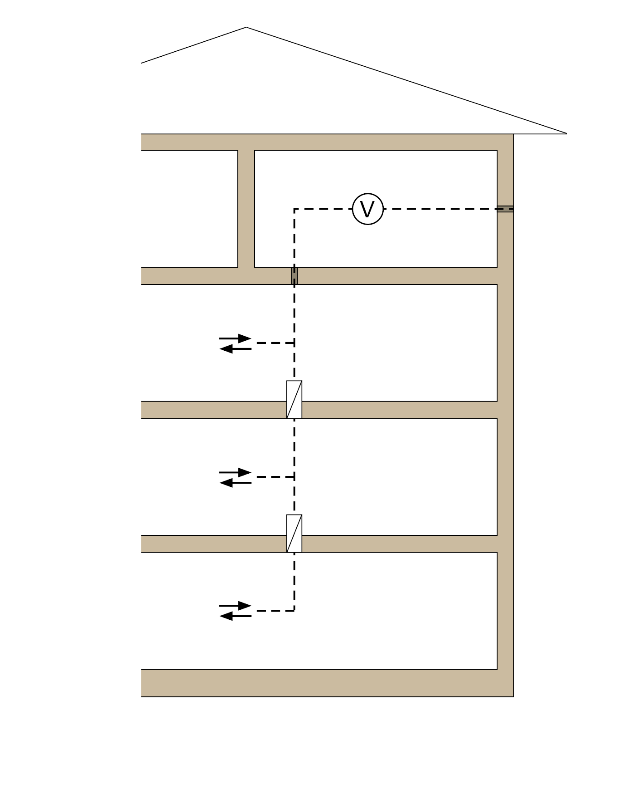

 | Ventilation plant, may also be located on other floors; for ducts see Section 6.4.4
 | Non-fire-resistant duct
 | Supply/exhaust air opening
 | Fan
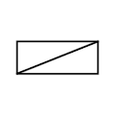 | Fire protection flap

Figure 1.2: Shaft solution
Fire protection flaps at the points where the fire-resistant shaft walls are penetrated
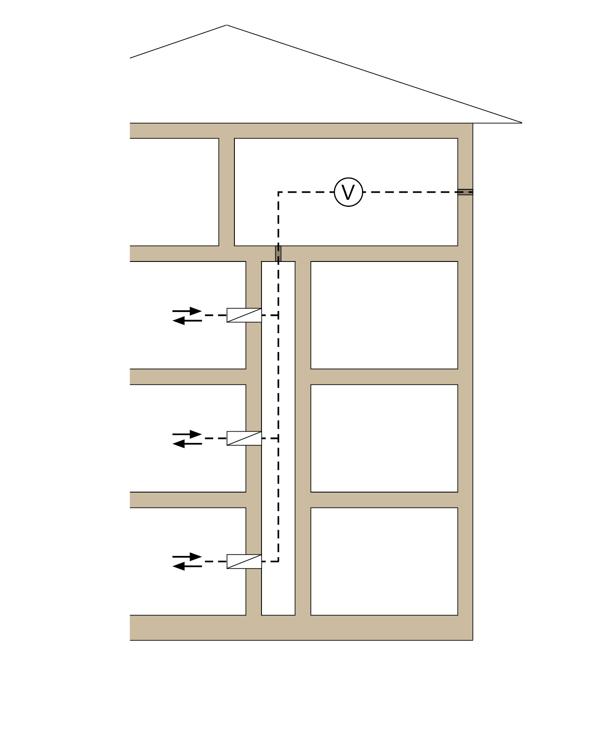

Ventilation plant, may also be located on other floors; For ducts, see Section 6.4.4

Non-fire-resistant duct
Supply/exhaust air opening
Fan
Fire protection flap

The following arrangements are permitted:

1) fire-resistant shaft with walls of fire resistance class F30/F60/F90 made of non-combustible materials e.g. in accordance with DIN 4102 Part 4, or
2) fire-resistant shaft pursuant to the L classifications, or
3) self-contained fire-resistant ventilation duct of classification L30/L60/L90
(shaft = supply air main duct)
and, in each case, fire protection flaps in the case of branch ducts leading to different floors at the points where the shaft is penetrated or at the junctions with the ventilation duct.
re 1) The shaft made of fire-resistant components is a separate building compartment for fire protection purposes and may contain other installations. These installations may also be made of combustible materials or carry combustible media if all entrances to and exits from the ventilation ducts (including those leading to the ventilation plant) are protected by fire protection flaps EI 30/60/90(v_{e}h_{o} i↔o)-S (see also Section 5.1.4). Entrance doors to shafts must meet the same fire resistance requirements (e.g. T30/T60/T90) as the shaft walls and also prevent smoke from escaping into essential escape routes.
re 2) Pursuant to the L classifications, in addition to ventilation ducts the shaft may only contain non-combustible installations with non-combustible media up to a temperature of 110 °C (see also Section 5.1.5). No fire protection partition is necessary between the shaft and the ventilation plant.
re 3) Only equipment for ventilation systems and associated ducts may be installed in the fire-resistant ventilation ducts themselves.
Figure 1.3: Ventilation systems with separate main ducts and separate outside air or exhaust air ducts without shut-off devices

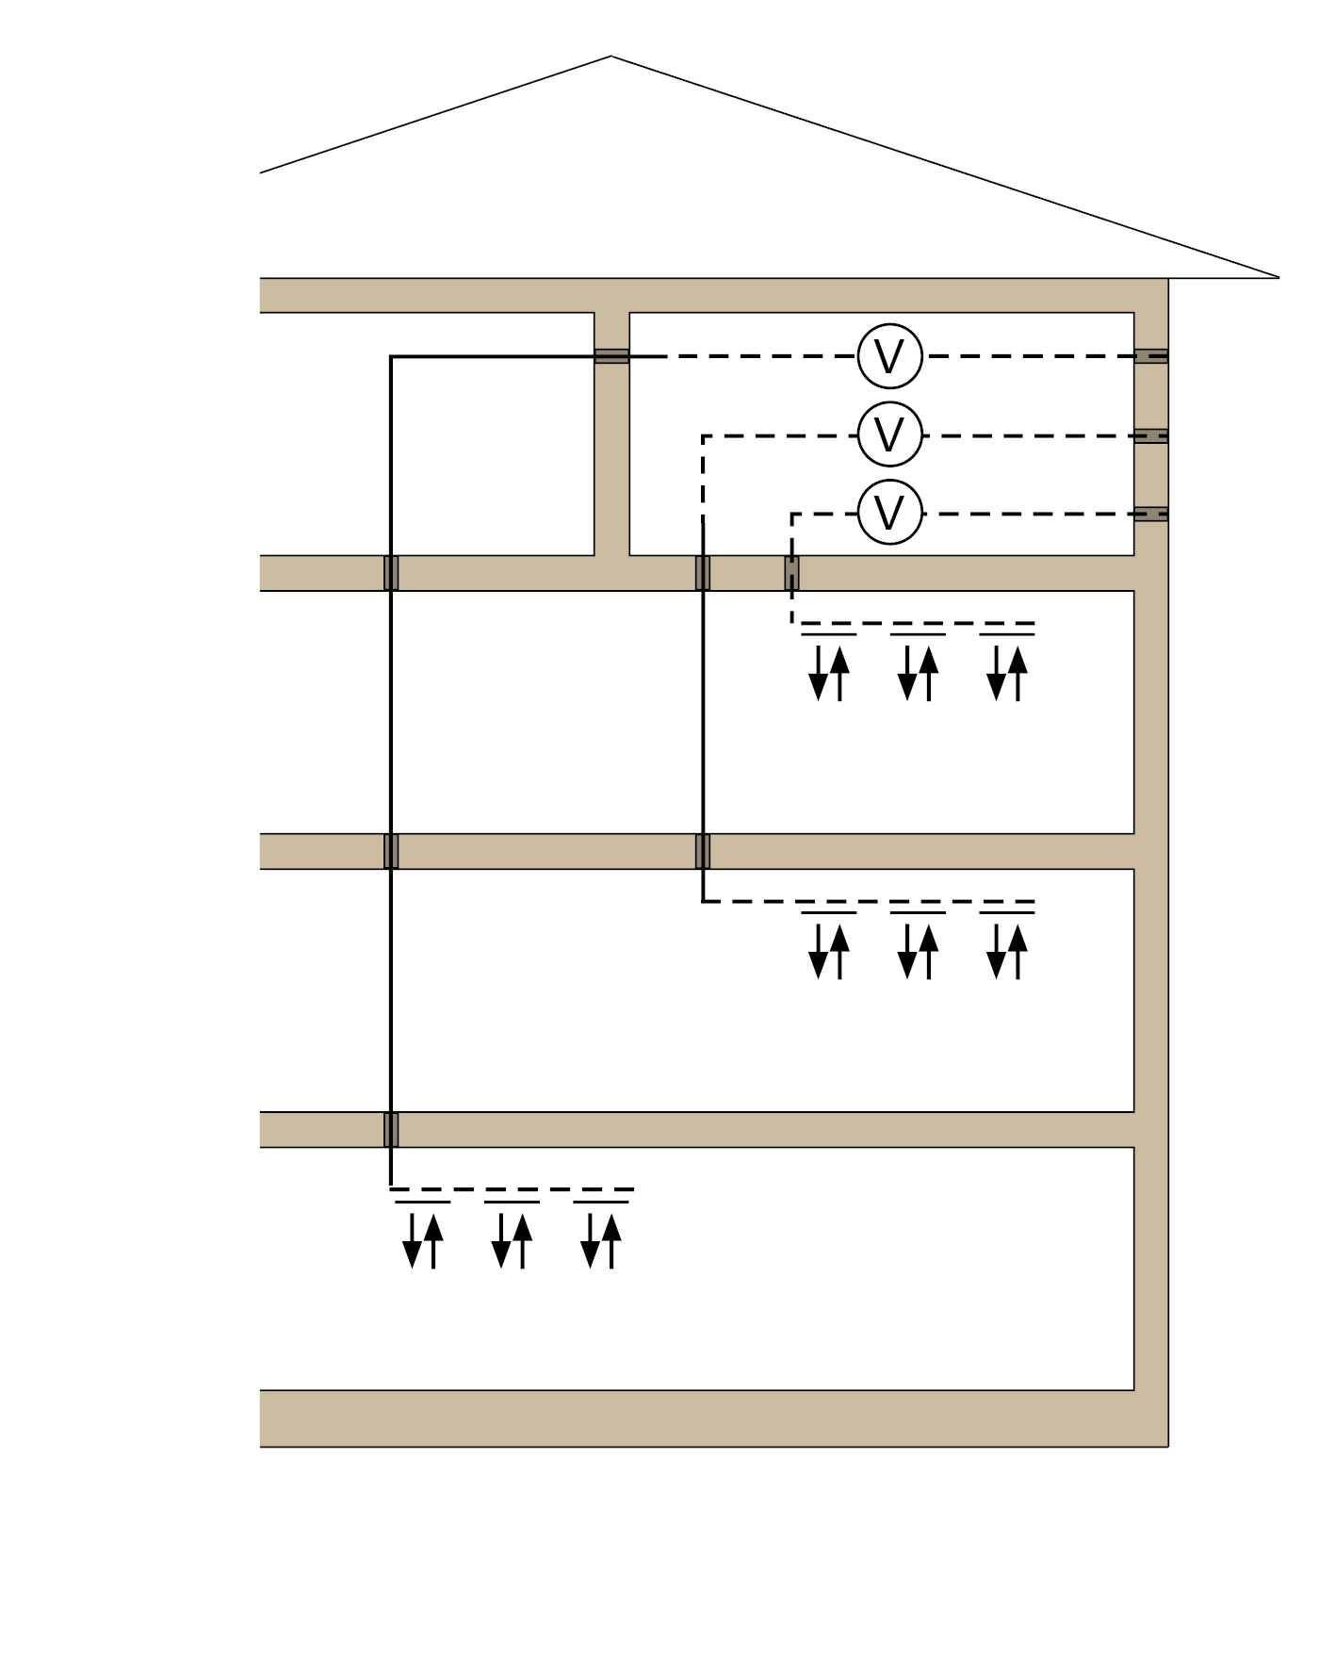

 | Ventilation plant, may also be located on other floors; for ducts see Section 6.4.4
 | Non-fire-resistant duct
 | Supply/exhaust air opening Fire-resistant duct1)
 | Supply/exhaust air opening
 | Fan

1) The ducts must also be fire-resistant at the points where the ceilings or walls are penetrated.

Figure 1.4: Ventilation systems with separate main ducts and combined outside air or exhaust air ducts with smoke protection

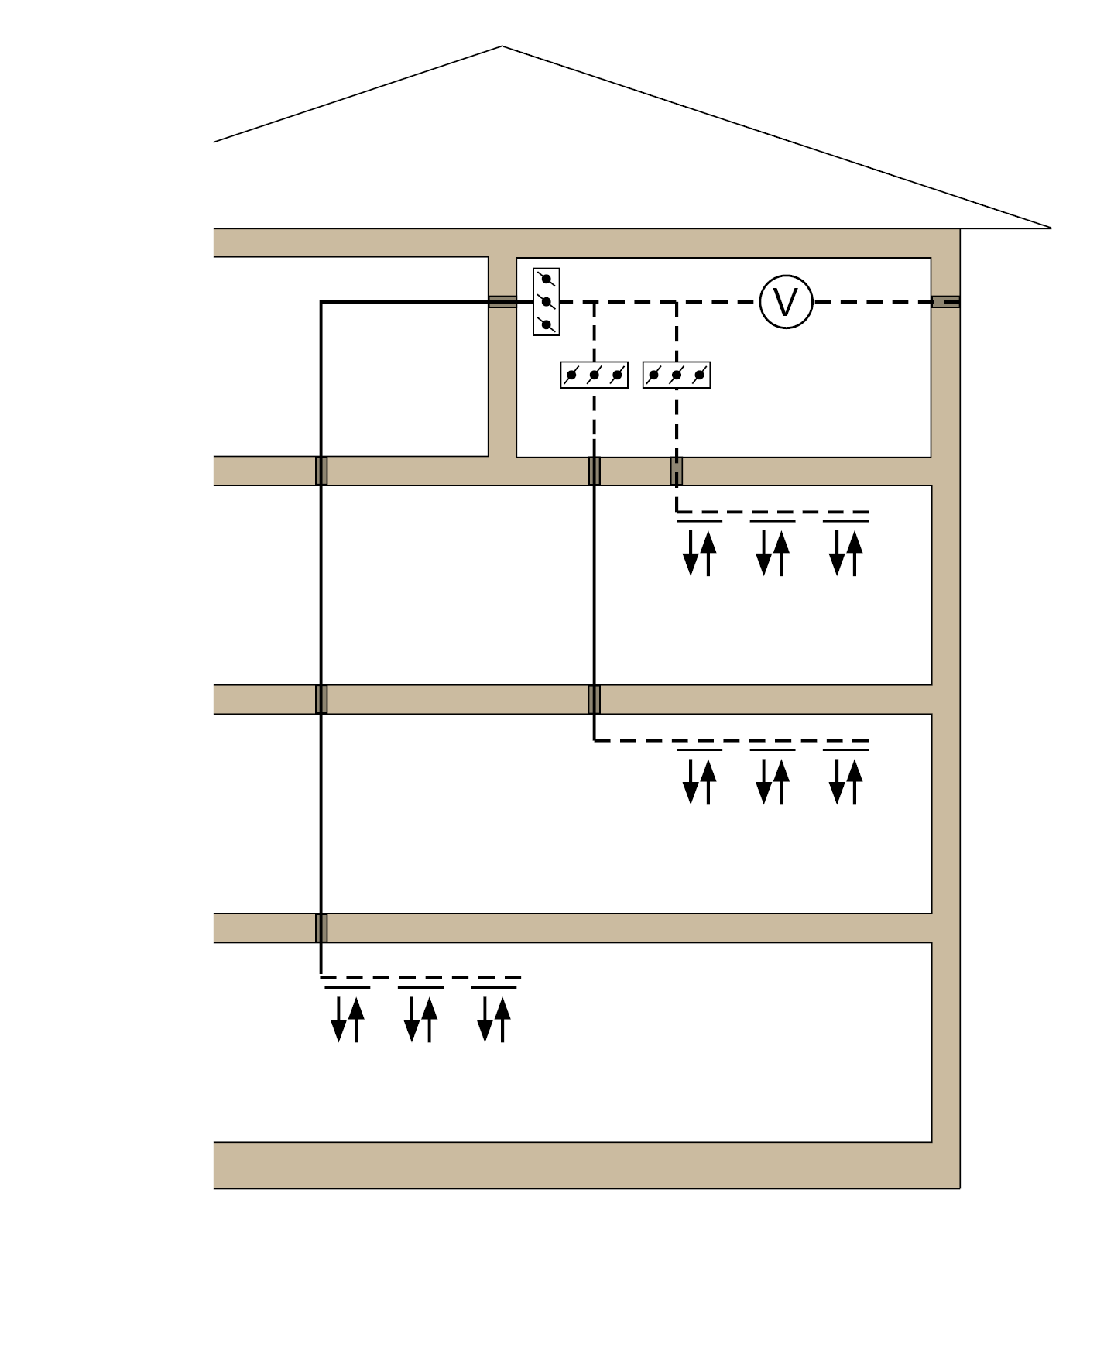

 | Ventilation plant, may also be located on other floors; for ducts see Section 6.4.4
 | Non-fire-resistant duct
 | Supply/exhaust air opening Fire-resistant duct1)
 | Supply/exhaust air opening
 | Fan
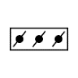 | Fire protection flaps with smoke detectors or smoke protection flaps

1) The ducts must also be fire-resistant at the points where the ceilings or walls are penetrated.

Routing of horizontal ventilation ducts through walls which seal off areas and which are subject to requirements pertaining to fire resistance
The solutions depicted in Figures 1.1 to 1.4 apply accordingly to ventilation systems with horizontally routed ducts that penetrate fire-resistant walls that seal off areas, with the exception of ventilation systems in accordance with DIN 18017-3:2009-09.

Figures 1.1 to 1.4 are to be used as horizontal cross sections through the building in such instances.
Figures 3.1 and 3.2 show the arrangements for routing ducts through fire-resistant walls of essential corridors.

Fire protection in the roof void
If ventilation ducts are routed through a roof void, and if a ceiling that must be fire-resistant is penetrated, the area between the uppermost floor and the roof void must meet the following requirements
  - shut-off devices must be installed (see Figure 2.1),
  - the parts of the ventilation system in the roof void must be equipped with a fire-resistant covering (to above the roofing skin in the case of ducts leading outside), or
  - the ventilation ducts themselves must be of a fire-resistant design.

Figure 2.1: Bulkhead solution

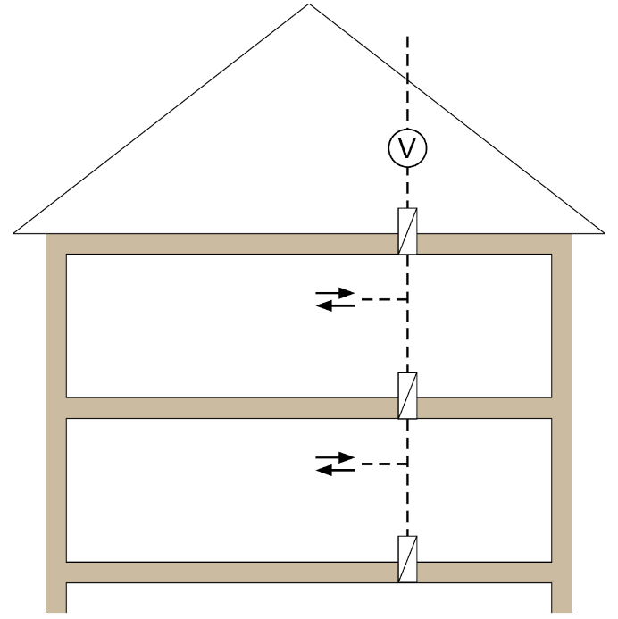

Non-fire-resistant duct
Supply/exhaust air opening
Fan
Fire protection flap

Figure 2.2: Shaft solution
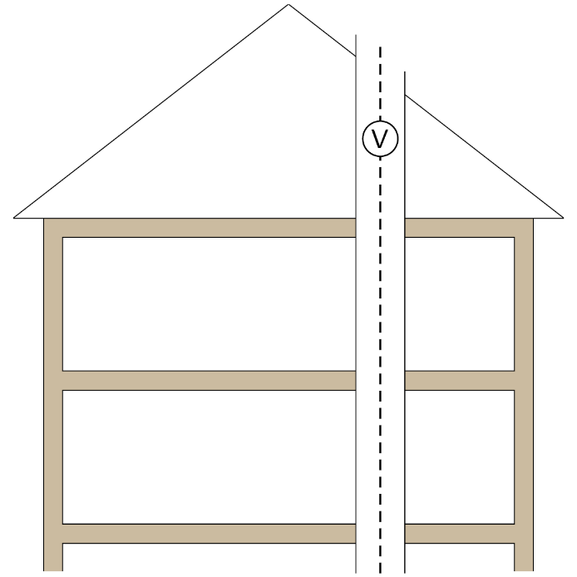

 | Non-fire-resistant duct
 | Supply/exhaust air opening
 | Fan
 | fire-resistant cladding

Routing of ducts through walls of essential corridors which are used for sealing off areas and which are subject to requirements pertaining to fire resistance

Figure 3.1: essential corridor, unventilated

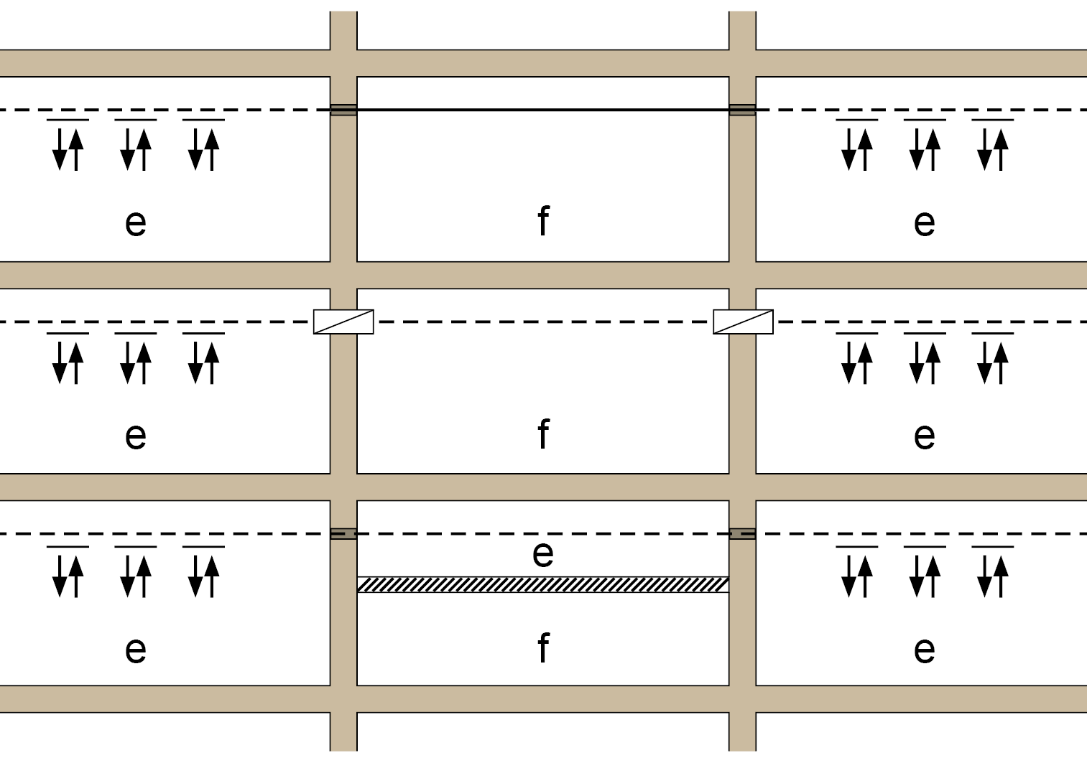

f | essential corridor
e | areas separated from f for fire protection purposes
 | Non-fire-resistant duct
 | fire-resistant duct; in corridors with fire-retardant walls, see Section 4 of the Guideline in the case of sheet steel ducts1)
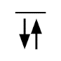 | Supply/exhaust air opening
 | Fire protection flap
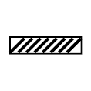 | ceiling with appropriate fire resistance in the case of loads from above and below; the ceiling entirely shuts off the duct from the inside of the fire compartment or escape route

1) The ducts must also be fire-resistant at the points where the ceilings or walls are penetrated.

Figure 3.2: essential corridor ventilated

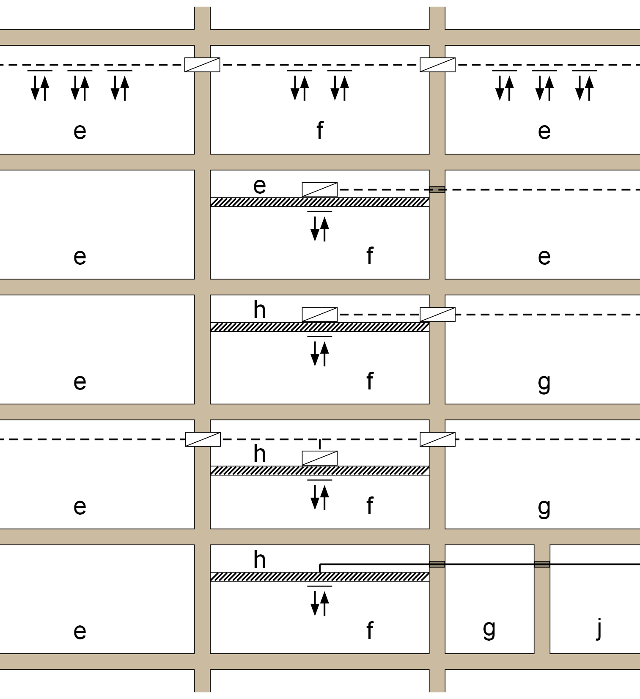

f | essential corridor
e, g, h, j | areas separated from f and from each other for fire protection purposes
 | Non-fire-resistant duct
 | fire-resistant duct; in corridors with fire-retardant walls, see Section 4 of the Guideline in the case of sheet steel ducts1)
 | Supply/exhaust air opening
 | Fire protection flap
 | suspended ceiling with fire resistance in the case of loads from above and below; the suspended ceiling entirely shuts off the duct from the inside of the fire compartment or escape route
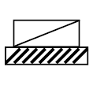 | fire-protection flap for installation in fire-resistance suspended ceilings

1) The ducts must also be fire-resistant at the points where the ceilings or walls are penetrated.

Exhaust air systems with ducts and fans made of combustible materials and without shut-off devices (see also Sections 5.1.1 and 6.4.4)
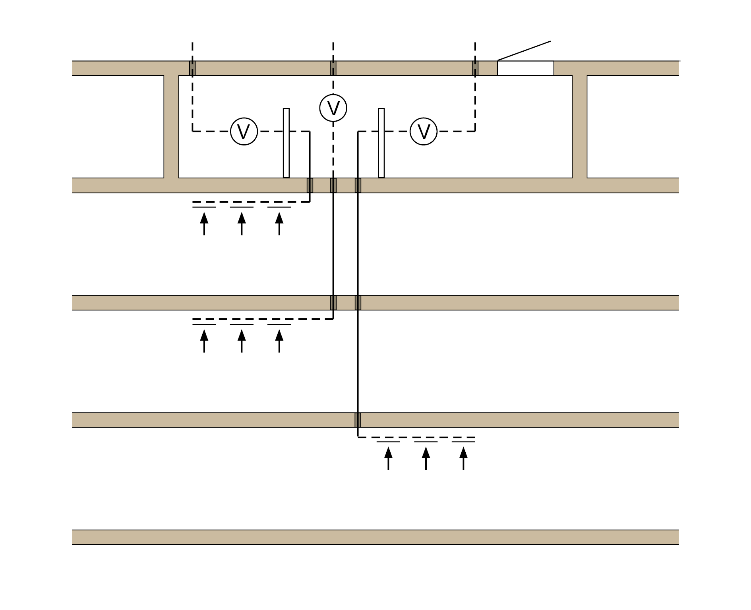
Ventilation plant
Smoke extractor device
(free cross section ≥ 2.5 AH)
Barrier protecting against radiated heat

Non-fire-resistant duct made of hardly flammable materials
Exhaust air opening Fan
 | Fire-resistant duct (fire-resistant ventilation duct with combustible inner shell)1)
 | Exhaust air opening
 | Fan
AH | clear cross section of the largest individual duct

1) The ducts must also be fire-resistant at the points where the ceilings or walls are penetrated.

Restriction of load transfer by ventilation ducts in building components in the event of fire by means of elbows and offsets (see also Section 5.2.1.1)

Figure 5.1: Restriction of load transfer by means of a duct offset
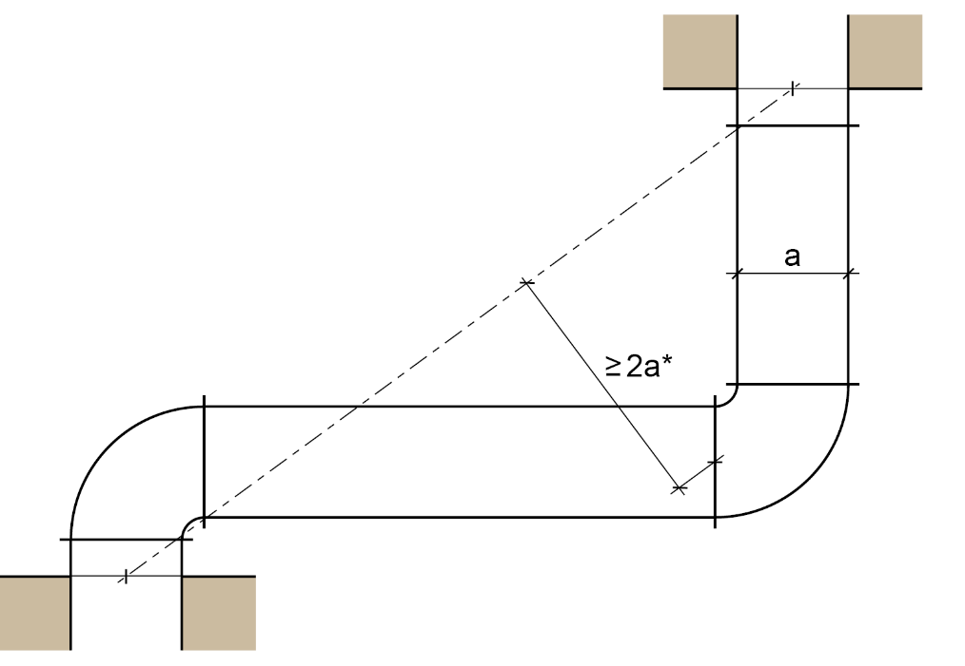

Figure 5.2: Restriction of load transfer by means of an elbow
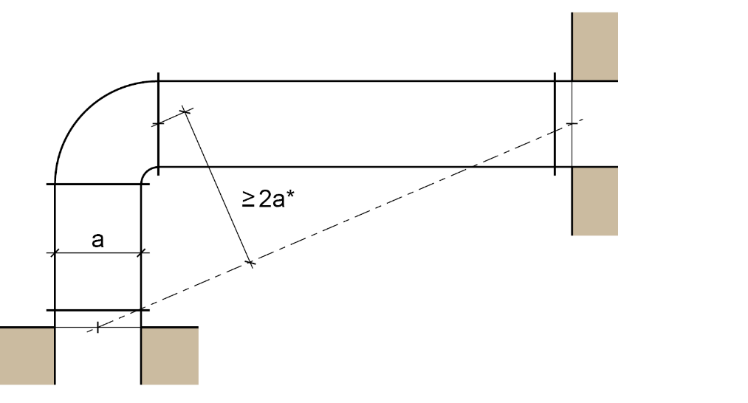

a | Edge length of the ventilation channel or diameter of the ventilation duct
* | The furthest point of contact between the elbow and the duct shall apply.

Sample diagram of elbows and offsets that accommodate any changes in length in the ventilation ducts by means of duct deformation, e.g. bends

Ventilation systems for special uses

Figure 6.1: Ventilation systems for ventilation to and air extraction from dwellings as well as closed functional units of no more than 200 m²

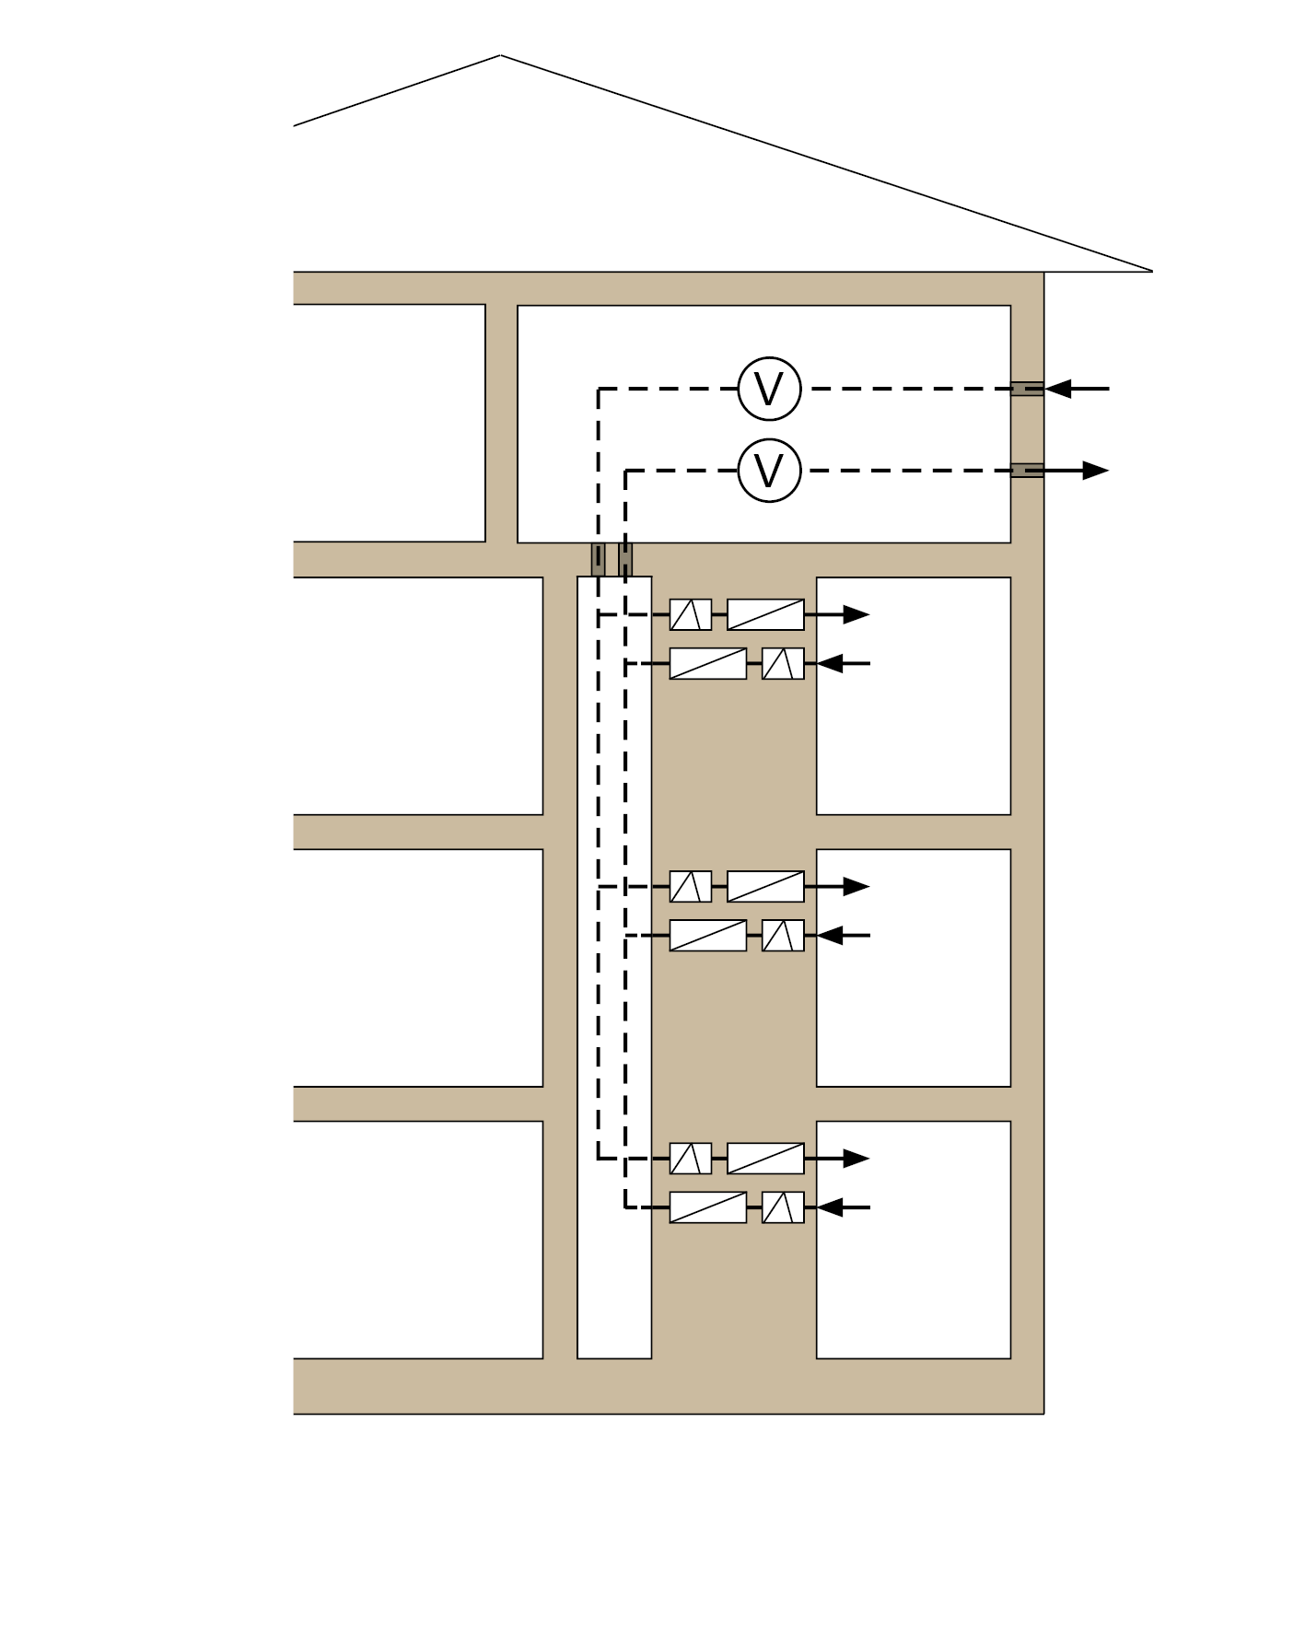

Ventilation plant, may also be located
on other floors; For ducts, see Section 6.4.4

 | Non-fire-resistant duct
 | Supply/exhaust air opening
 | Fan
 | Fire protection flap
 | Smoke barrier

Figure 6.2: Example of a bulkhead solution for ventilation systems according to DIN 18017- 3:2009-09
maximum connecting cross section of shut-off devices: 350 cm²
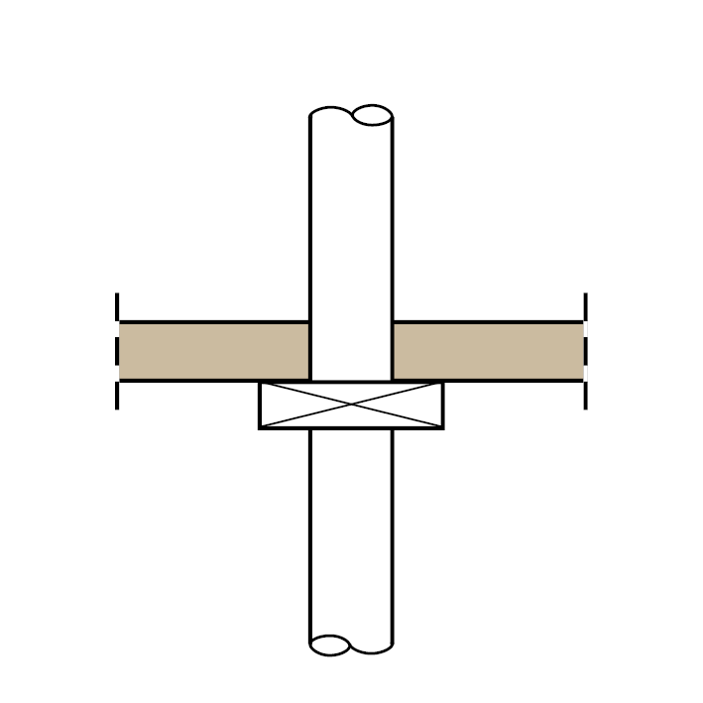

air-carrying main duct made of non-combustible building materials
floor ceiling
cross section of the shut-off device (connection cross section) max. 350 cm²

6.3: Shaft solution for ventilation systems in accordance with DIN 18017-3:2009-09

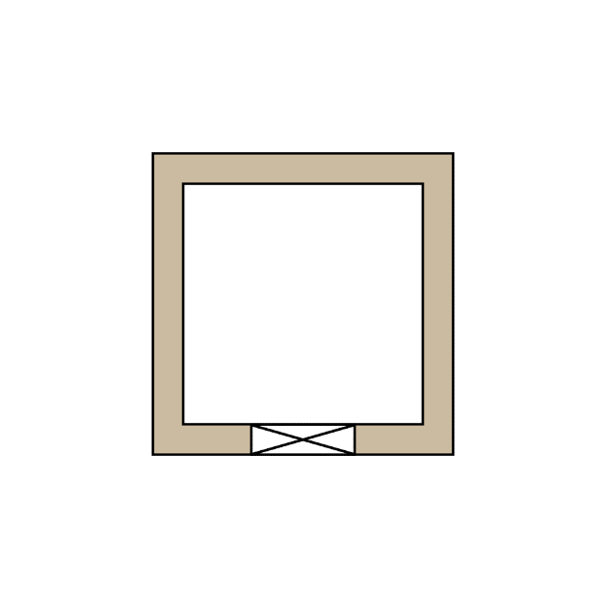

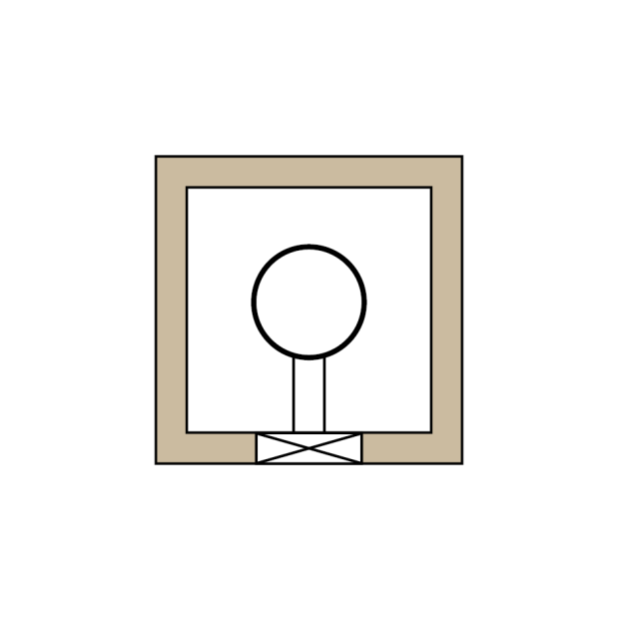
Shaft/
main duct
Shut-off
device
Shaft
Main duct
Mortar grouting
min. 100 mm
Shut-off
device
Connecting duct
Other installations
Main duct
Shut-off
device
Connecting duct
Shaft

 | Figure 6.3.1 | Figure 6.3.2 | Figure 6.3.3
Shaft: | - F30/F60/F90 or L30/L60/L90  - Maximum cross section 1 000 cm2 | - F30/F60/F90 or L30/L60/L90  - Maximum cross section 1 000 cm2 | - F30/F60/F90 or L30/L60/L90  - any cross section, including > 1000 cm²  - Mortar grouting of the free shaft cross section at least 100 mm thick
Main duct: | - Shaft = main duct | - No restrictions on cross section, provided the permissible shaft cross section is taken into account,  - Sheet steel | - Maximum cross section 1 000 cm2,  - Sheet steel
Shut-off device: | - Primarily made of non-combustible materials,  - Maximum cross section 350 cm2 | - Primarily made of non-combustible materials,  - Maximum cross section 350 cm2 | - combustible materials may also be used for essential parts of the shut-off device,  - Maximum cross section 350 cm2
Connecting duct: | ---- | - made of non-combustible materials | - made of non-combustible materials
Other installations | - not permissible | - not permissible | - only made of non-combustible materials and  - only for non-combustible media

Notified in accordance with Directive (EU) 2015/1535 of the European Parliament and of the Council of 9 September 2015 laying down a procedure for the provision of information in the field of technical regulations and of rules on Information Society services (OJ L 241, 17.9.2015, p. 1).
Depending on federal state law; for the Model Administrative Rules – Technical Building Regulations (MVV TB) in the current version, see the Deutsches Institut für Bautechnik (DIBt) official bulletin, distribution: http://www.dibt.de

