KINGDOM OF BELGIUM

FPS Interior Belgium (FEDERAL PUBLIC SERVICE HOME AFFAIRS)

Royal Decree of 20 May 2022 amending the Royal Decree of 7 July 1994 adopting basic fire and explosion prevention standards for buildings.

REPORT TO THE KING

Your Majesty,

The draft Decree contains various amendments to the fire safety regulations of new buildings to be constructed, including a including an extensive amendment to the fire safety regulations for façades, car parks, combustion departments and lifts installed in the buildings.

Royal Decree amending the regulations in the Royal Decree of 7 July 1994 adopting basic fire and explosion prevention standards for buildings. These rules govern the fire safety of new buildings to be built and the extensions of existing buildings.

This draft contains, among other things, numerous minor changes in many places of Annexes 2/1, 3/1 and 4/1 of the Royal Decree of 7 July 1994.
This draft details not every change, but the existing annexes are replaced in their entirety (see Articles 21, 22 and 23).

The annexes to this draft include an adaptation of the requirements for the distance between façades.
The regulations of points 1.3 and 3.5 of Annexes 2/1, 3/1 and 4/1 of the Royal Decree of 7 July 1994 that apply to limit flashover from one façade to another have been thoroughly adapted so that they both follow the same pattern regardless of whether these façades belong to different buildings or to different compartments of the same building.

On the one hand, a distance is prescribed which for low buildings also varies with the height of the building, and on the other hand the possibility is also provided to calculate the distance based on the objective of limiting the heat radiation on the opposite façade to 15 kW/m².

The annexes to this draft contain an amendment to the requirements for the suspended ceilings.
The requirements of point 3.4 of Annex 2/1, 3/1 and 4/1 of the Royal Decree of 7 July 1994 have been modified to eliminate fire stability in the evacuation paths of open compartments (e.g. landscape offices) or compartments equipped with an automatic sprinkler system.
The rules applicable to vertical screens that divide the suspended ceiling into different volumes are more clearly defined.

The annexes to this draft contain an adaptation of the requirements for self-closing fire doors in the event of fire.
In various places in Annex 2/1, 3/1 and 4/1 of the Royal Decree of 7 July 1994 the regulations for the self-closing nature of fire-resistant doors have been adapted so that, under certain conditions, self-closing doors can also be used in the event of fire. In these cases, this avoids placing cotter pins under the doors to keep them open.
Specifically, automatic fire detection of the type of total surveillance is always required in the entire building, but there are sometimes additional restrictions that are linked to the use of the building. For example, certain exceptions are limited to buildings with daytime occupancy, or in the event of a fire a fireproof door of an apartment must have a coasting function to prevent it from causing too much inconvenience for the residents.

The annexes to this draft contain an adaptation of the requirements for the duplexes and the triplexes.
The requirements of point 4.2.2.3 of Annex 2/1 and 3/1 of the Royal Decree of 7 July 1994 have been adjusted so that the ratio of the floor area of the duplex/triplex storeys no longer determines which storey should give at least access to the inner staircase, but the size of the floor area of the storey. This is a relaxation that particularly benefits the smaller apartments.

The annexes to this draft contain an amendment to the regulations for the interior stairwells.
Point 4.2.2.7 of Annex 3/1 of the Royal Decree of 7 July 1994, includes a solution in the regulations which allows for the enclosure of a lift and an internal staircase as a single fire resistant in medium-high buildings, instead of each having to be enclosed separately.
The regulations in 4.2.2.8 of Annex 3/1 of the Royal Decree of 7 July 1994 have been amended so that the number of apartments per storey no longer determines the direct access to the inner staircase, but the total number of apartments served by the same inner staircase. This number should be limited to a maximum of 10 apartments (and therefore no longer one apartment per storey). At the same time, it is also clarified that the door shutter must be equipped with a coasting function.
The regulations of points 4.2.2.8 and 4.2.2.9 of Annex 4/1 of the Royal Decree of 7 July 1994 have been amended to make it clearer that the exceptions can be applied for each common hall of the apartments.

The annexes to this draft contain an adaptation of the regulations for the route to be taken to an exit.
Point 4.4.1.1 and 4.4.1.2 of Annex 2/1, 3/1 and 4/1 of the Royal Decree of 7 July 1994 have been thoroughly amended to make it clearer that a connection to another compartment is not an exit. On the other hand, these connections to another compartment can be taken into account with regard to the route to be taken to an exit.
If, for example, a compartment is required to have two exits according to point 2.2, these are only the exits of the compartment itself and should not take into account the exits in another compartment. However, in order to meet the maximum distances to an exit specified in point 4.4.1.1., exits in another compartment may be taken into account.

The annexes to this draft contain an amendment of the requirements for evacuation routes at an evacuation level.
Point 4.4.2 of Annex 3/1 and 4/1 to the Royal Decree of 7 July 1994 has been amended so that the stricter regulations that apply to the fire-resistant separation of the evacuation routes at the evacuation level are limited to those evacuation routes connecting stairwells to the public road.
At the same time, as mentioned above, certain relaxations are provided for the self-closing character of the fire-resistant doors.

The annexes to this draft contain an amendment of the regulations on distance between stairwells.
Point 4.4.3 of Annex 3/1 and 4/1 of the Royal Decree of 7 July 1994 has been modified so that a minimum distance is no longer required between the entrances to the stairwells. However, according to point 2.2.2. of the respective annexes, the exits must still be in opposite zones.

The annexes to this draft contain an adaptation of the regulations for technical premises.
Point 5.1.1 of Annex 4/1 of the Royal Decree of 7 July 1994 has been modified so that for smaller technical compartments a connection by means of a fire-resistant door EI₁ 60 suffices and an air lock is no longer always required.

The annexes to this draft include an amendment of the regulations for the hydraulic lifts.
The existing regulations for hydraulic lifts are in conflict with the European Lifts Directive because they exclude the use of a hydraulic lift without a machine room. In order to avoid a conviction by the European Commission, the regulations set out in Annexes 2/1, 3/1 and 4/1 of the Royal Decree of 7 July 1994 have been amended so that hydraulic lifts without a machine room. are also possible.

The annexes to this draft contain an adaptation of the requirements for type C fire-resistant valves.
Type C valves are commonly used in retractors to limit the number of ducts and fans. The ducts equipped with valves type C usually operate different compartments. The opening or closing of these valves type C is controlled according to the choice of the compartment where smoke has to be withdrawn.
Point 6.7.4.1 of Annex 4/1 of the Royal Decree of 7 July 1994 is adjusted, since for the valves type C there are not one but two safety positions: fully open and completely closed. And the position of a valve type C can only be changed by a control from the central control post (see point 6.9.4.9 of Annex 4/1).

The annexes to this draft include an adjustment of the regulations for the notification, warning, alarm and fire-fighting equipment.
The regulations contained in point 6.8 of Annex 2/1, 3/1 and 4/1 of the Royal Decree of 7 July 1994 are only a guideline. The fire brigade is given broader powers to determine these regulations according to the risks in the building and its own needs
and options.
In point 6.8.4 of Annex 2/1, 3/1 and 4/1 of the Royal Decree of 7 July 1994, the outgoing provision that the electrical circuits of warning and alarm must differ from one another has been deleted.

Articles 1 and 6 of this draft contain an amendment to the regulations for fire-resistant doors.
In point 2.2 of Annex 1 of the Royal Decree of 7 July 1994, the regulations for fire-resistant doors are set up in such a way that the additional regulations concerning flatness, dimensional tolerances, mechanical resistance and durability only apply as long as there is no CE marking on the door.
And since it is unclear when the CE marking for fire-resistant interior doors will take effect and a lot of fire-resistant interior doors have already been tested and classified according to European standards, the
transitional provision in article 6/1 of the Royal Decree of 7 July 1994 is amended so that from 1 July 2022, only the European rankings apply.

Article 11 of this draft contains an amendment to the regulations for the roofs.
The regulations of point 3bis 2 of Annex 1 of the Royal Decree of 7 July 1994have been amended so that even if no information on the fire behaviour of the entire roof structure is included in the declaration of performance that accompanies the CE marking, it is possible to use classification reports or technical approvals to demonstrate the fire behaviour of the entire roof structure.

Article 27 of this draft contains an extensive adjustment of the regulations for the fire behaviour of the façades.
In 2017, a total of 72 residents died in a fire in the Grenfell Tower in London. This fire was a wake-up call for the burning behaviour of façades and the increasing presence of combustible materials in the façades. The evolution towards energy-neutral and sustainable buildings brings new risks that need to be addressed in an effective way.

Article 27 provides solutions and determines how façades can be constructed in a fire-safe manner.
The regulations of point 6 of Annex 5/1 to the Royal Decree of 7 July 1994 have been replaced by new regulations limiting the use of combustible materials as much is possible for tall buildings (although an alternative has also been provided through a large-scale trial), and additional measures are required for medium-sized buildings in the case of exterior wall insulation systems to limit fire propagation through the façade. These large-scale trials have been carried out using existing large-scale trials in France, the United Kingdom and Germany. In the latter case, the criteria are laid down separately in opinion HR 1882 of the Supreme Court for fire and explosion protection.

Article 29 of this draft contains an amendment to the regulations for the wooden terraces.
Punt 8.3 of Annex 5/1 supplemented by regulations ensuring an equivalent level of safety for wooden terraces placed on roofs.

Article 35 of this draft contains an adjustment of the regulations for the connection of the compartment wall to the roof or façade.
When the compartment wall does not protrude above the roof surface, the fireproof part of the roof with a length of 4 m no longer need to be equally distributed on either side of the compartment wall. The same applies to the part of the façade with a length of 2 m when the compartmentalisation wall does not cross out of the façade plane.

Article 51 of this draft, as well as point 5.2 of the annexes attached to this draft, contain an extensive adjustment of the regulations for the car parks.
In the event of fires in underground car parks, the increasing risks due to the evolution of vehicles lead to fires that are increasingly difficult to fight by the fire brigade. The increase in the use of plastics in vehicles, the use of alternative fuels and the innovations in the construction of the garages themselves mean the risks of vehicle fires in underground car parks are changing. Therefore, it is absolutely necessary to amend the regulations on car parks.

The new point 3 of Annex 7 to the Royal Decree of 7 July 1994 contains provisions for fire protection in car parks taking into account the size of the parking area and the depth of the car park. The fire safety measures to be taken and their reliability increase with the surface and/or depth of the car park.
This analysis did not specifically take into account risks arising from electric vehicles (or their charging) or hydrogen-powered vehicles. However, it is clear that many of the measures in this new chapter will also benefit fires from those vehicles. For example, a sprinkler system is now also possible as a fire protection system, while previously only a smoke and heat extraction system was prescribed.
The fire response requirement of the floor finish in a car park has also been adjusted from A2_{FL} to B_{FL} to apply floor coatings containing plastics.

Article 52 of this draft, as well as points 5.1.2 of the annexes to this draft, contain an extensive adaptation of the regulations for the combustion departments.
On the one hand, the latest revision of the Belgian standard NBN B 61-001 no longer contains requirements for fire safety. As a result, it is no longer sufficient to make the application of this Belgian standard mandatory, but rather to include the regulations on fire safety of combustion sites in the Royal Decree of 7 July 1994.
On the other hand, the fire safety regulations date from the previous version of the Belgian standard NBN B 61-001 from 1986. We must therefore also take into account the technological evolution of high-efficiency boilers, combined smoke and combustion air supply ducts, pellet heating, heat pumps and cogeneration installations.

The new point 5.1.2 of Annexes 2/1, 3/1 and 4/1 and the new point 4 of Annex 7 to the Royal Decree of 7 July 1994 lays down regulations for fire protection in combustion departments taking into account the combustion rate of the combustion device (instead of the rated power), the fire load of the fuel storage compartment and the type of fuel (gas, liquefied or solid).
The new point 4.8 of Annex 7 to the Royal Decree of 7 July 1994 complements the existing regulations on technical tubes and passages through walls by specifying that the design, installation and execution of the smoke and combustion air supply ducts, as well as their throughputs through walls, must comply with the rules of good craftsmanship and the standards in force. The current applicable rule of good craftsmanship is the WTCB file 2019/4.12 ‘Fire safety requirements of smoke ducts in technical tubes’.

The Articles 28, 30, 42 and 53 of this draft contain an amendment to the regulations for the green roofs.

The provisions of points 8.4.1 to 8.4.6 of Annex 5/1 to the Royal Decree of 7 July 1994 are moved to a new point 5 of Annex 7 to the same decree. A new section is also inserted in point 8.1 of Annex 5/1 and in point 6.6 of Annex 6 to the same decree which refers to those provisions.
Now the same rules apply to green roofs for non-industrial and industrial buildings. Except that in industrial buildings, only extensive green roofs are allowed (the thickness of the substrate layer should not exceed 10 cm).

The other articles of this draft contain various modifications and adaptations that improve and clarify the existing requirements on the fire safety of the newly constructed buildings, but also provide additional possibilities with equivalent solutions that were not previously permitted in these buildings.

The use of alternative measures for the Royal Decree of 7 July 1994 by the constructor requires an application for derogation. The purpose of this procedure is to ensure that the level of security of the proposed measures is equivalent to that laid down in the Royal Decree of 7 July 1994. However, this procedure is time-consuming, both for the applicant and for the officials.
The integration of these clarifications and these additional possibilities in the Royal Decree of 7 July 1994 allow to reduce the number of times that this derogation procedure is used.

The draft Royal Decree was submitted to the Council of State for advice. On 12 April 2022, the Council of State delivered Opinion 71.205/2 pursuant to Article 84(1)(1)(2) of the Laws on the Council of State, coordinated on 12 January 1973. The comments of the Council of State requiring additional explanation are set out below.

The Council of State has commented on the date of entry into force of the annexes which replaced Annexes 2/1, 3/1 and 4/1 by new Annexes 2/1, 3/1 and 4/1 and the dates set out in the Royal Decree which make those annexes applicable to certain buildings. The Council of State fears retroactivity. However, it should be taken into account here that certain buildings fell within the scope of the original annexes. These buildings must remain fire-safe, even after the entry into force of the new annexes and therefore the rules should still apply to those buildings. It was not opted to insert new Annexes 2/2, 3/2 and 4/2 in order to keep the regulation simple in terms of finding the correct annex that applies. In this way, the risk of error of correct annex for the fire brigade during the post-clearance inspection of the completed buildings is reduced. It was decided to replace Annexes 2/1, 3/1 and 4/1 with new annexes with the same numbering. The buildings already covered by these annexes are again covered by these annexes. The application of stricter regulations for existing buildings was avoided.

The large majority of the adjustments introduced by this draft are relaxations, clarifications and additional possibilities for the current provisions of the Royal Decree of 7 July 1994.
For the few adaptations that are stricter than the current provisions, transitional provisions have been provided so that the current provisions still apply to the buildings for which the construction application was submitted before 1 July 2022. This responds to the comments made by the Council of State which states that this draft should not undermine the general principle of non-retroactivity.

The Council of State notes that certain NBN standards are made binding. Article VIII.1 of the Code of Economic Law recalls the following:
‘Standards reflect the rules of good craftsmanship which, at the time they are adopted, apply to a particular product, process or service.
Compliance with the standards must be carried out on a voluntary basis, unless compliance is imposed by a legal, regulatory or contractual provision.’
In accordance with Article VIII.2 of the Code of Economic Law, it is true that:
‘[the] State and all other persons governed by public law may refer to the standards published by the Office for Standardisation by a simple reference to the reference to those standards.’
The Council of State notes that, nevertheless, reference is made to standards which have not been published in accordance with Article 190 of the Constitution and warns against the accessibility of the standards. However, I believe that those who have to apply these standards in practice are professionals who know or should know their way to find out the content of those standards.

The draft decree takes into account the other observations of the Council of State.

I have the honour of being,
Sire,
Your Majesty's,
very respectful
and very loyal servant,
The competent minister for internal affairs,

Annelies Verlinden

KINGDOM OF BELGIUM

FPS Interior Belgium (FEDERAL PUBLIC SERVICE HOME AFFAIRS)

Royal Decree of 20 May 2022 amending the Royal Decree of 7 July 1994 adopting basic fire and explosion prevention standards for buildings.

PHILIPPE, King of the Belgians,

To all who are here now or will be hereafter, Greetings.

Having regard to the Act of 30 July 1979 on fire and explosion prevention and mandatory civil liability insurance in such cases, Article 2(§ 1) as amended in the Act of 22 December 2003;

Having regard to the Royal Decree of 7 July 1994 adopting basic fire and explosion prevention standards for buildings;

Having regard to the opinions of the – Belgian High Council for Fire and Explosion Safety of 17 January 2019 (façades), 16 May 2019 (car parks), 21 November 2019 (various provisions), 16 January 2020 (boiler sections and lifts), 18 March 2021 (boiler sections) and 19 November 2020 (final text);

Having regard to completion of the formalities prescribed in the Directive 2015/1535/EC of the European Parliament and of the Council, which gives a procedure for the provision of information in the field of technical standards and regulations;

Having regard to the regulatory impact analysis conducted in accordance with the Articles 6 and 7 of the Act of 15 December 2013 setting out various provisions on administrative simplification;

Having regard to the opinion of the Inspector of Finance, issued on 14 January 2022;

Having regard to the agreement reached by the Secretary of State for Budget of 21 February 2022;

Having regard to opinion 71.205/2 of the Council of State, issued on 12 April 2022, pursuant to Article 84(1)(1)(2), of the Laws on the Council of State, coordinated on 12 January 1973;

At the proposal of the Minister of Interior and on the recommendation of the Ministers convened in the Council,

We have decided and hereby decree:

Chapter 1. Amendments to the Royal Decree of 7 July 1994 adopting basic fire and explosion prevention standards for buildings

Article 1. The phrase ‘, without going beyond the date 1 July 2022’ is added to the first sentence of the Article 6/1 of the Royal Decree of 7 July 1994 adopting basic fire and explosion prevention standards for buildings, as amended by the Royal Decrees of 19 December 1997, 4 April 2003, 13 June 2007, 1 March 2009, 12 July 2012 and 7 December 2016.

Chapter 2. Amendments to the Annex 1 to the Royal Decree of 7 July 1994 laying down the basic fire and explosion prevention standards with which buildings must comply

Article 2. In point 1.6.1 of the Annex 1 to the same decree, a typographical correction is applied to the term ‘gross area’ in the Dutch version.

Article 3. Point 1.13 of the Annex 1 to the same decree is replaced with the following:
‘1.13 Subcompartment: part of a compartment bounded by walls that slow the spread of fire and limit the affected area.’.

Article 4. In point 1.15 of the Annex 1 to the same decree, in the French text, the word ‘structurels’ is replaced by the word ‘structuraux’.

Article 5. In the point 2.1, first paragraph 1, point 1° of the Annex 1 to the same decree, the word ‘information’ is replaced with a synonym in the Dutch version.

Article 6. Point 2.2 of the Annex 1 to the same decree is replaced with the following:

‘2.2 Specific assessment of fire doors

§ 1. Door fire resistance must be tested according to standard NBN EN 1634-1 and classified according to standard NBN EN 13501-2.
The fire resistance of the door must be demonstrated using the data for the CE marking of the construction product.

A fire door without a CE marking must also meet the following requirements:

1° for tolerances for width, height, thickness and squareness, the minimum classes according to standard NBN EN 1529:
- after prior conditioning: Class 1;
- after exposure to high humidity: Class 1;
- after exposure to low humidity: Class 1;

2° for tolerances for general and local flatness, the minimum classes according to standard NBN EN 1530:
- after prior conditioning: Class 3;
- after exposure to high humidity: Class 2;
- after exposure to low humidity: Class 2;

3° for the mechanical resistance requirements, the minimum classes according to standard NBN EN 1192:
- in non-industrial applications: Class 1;

4° for mechanical durability, minimum Class 4 according to standard NBN EN 12400.

For the requirements under 1° and 2°, NBN EN 1294 specifies the climatic conditions of temperature and humidity.

Fire door must be assessed for the fire resistance requirements and minimum requirements set out in point 2°. Constancy of performance must be assessed and verified in accordance with system 1 as described in the point 1.2 of the Annex V to Regulation (EU) No 305/2011 laying down harmonised conditions for the marketing of construction products.

§ 2. Fire doors must be installed in accordance with the installation conditions for which they received their fire resistance classification.’

Article 7. The Point 3.1 of the Annex 1 to the same decree is now amended as follows:

1° in the first paragraph, the words “(NBN EN 13501-1)” are inserted between the words “The classification system of the fire reaction characteristics of construction products” and the words “is described in the tables 1, 2 mentioned below and 3”;

2° in the final row of Table 1, the cell with the phrase ‘No performance determined’ is replaced with the following 3 cells:
‘
NBN EN ISO 11925-2(⁸):  Exposure = 15s | Fs > 150 mm within 20 s
’;

3° in the final row of Table 2, the cell with the phrase ‘No performance determined’ is replaced with the following 3 cells:
‘
NBN EN ISO 11925-2(⁸):  Exposure = 15s | Fs > 150 mm within 20 s
’;

4° in the final row of Table 3, the cell with the phrase ‘No performance determined’ is replaced with the following 3 cells:
‘
NBN EN ISO 11925-2(⁸):  Exposure = 15s | Fs > 150 mm within 20 s
’.

Article 8. Point 3.2, paragraph 1, 2°, a) of the Annex 1 to the same decree is amended as follows:

1° all instances of the abbreviation ‘NBN’ are now removed;

2° the abbreviations ‘ISO/IEC’ are inserted between the abbreviation ‘EN’ and the number ‘17000’.

Article 9. The Point 3.4 of the Annex 1 to the same decree is now amended as follows:

1° in the paragraph 1, the phrase ‘of Tables I, II, III and IV’ is now removed;

2° paragraph 2 is replaced with the following:
‘However, the effect of the underlying storeys should not be assessed if they are protected with a building element with a fire protection ability K or a fire resistance EI that meets the requirements of Table 4 below. Fire protection ability and fire resistance must be determined according to the standard NBN EN 13501-2.’;

3° in the second row of Table 4, ‘or EI 30’ is added after ‘K₂ 30’ and ‘or EI 15’ is added after ‘K₂ 10’.

Article 10. The point 3bis.1 of the Annex 1 to the same decree is replaced with the following:

‘3Bis.13bis.1 [Classification system for the external fire performance of roofs and roof coverings]

The classification system for the external fire performance of roofs and roof coverings (NBN EN 13501-5) is described below:

SYMBOLS

The classes according to the four test methods are:

- CEN/TS 1187:2013 test 1: X_{ROOF} (t1), where t1 = burning brands only;

- CEN/TS 1187:2013 test 2: X_{ROOF} (t2), where t2 = burning brands + wind;

- CEN/TS 1187:2013 test 3: X_{ROOF} (t3), where t3 = burning brands + wind + radiation,

- CEN/TS 1187:2013 test 4: X_{ROOF} (t4) where t4 = burning brands + wind + supplementary radiant heat

T_{E}: critical time for external fire spread

T_{p}: critical time for fire penetration

CEN/TS 1187:2013 test 1 | Class | Classification criteria
CEN/TS 1187:2013 test 1 | B_{ROOF} (t1) | All of the following conditions must be satisfied:  - external and internal fire spread upwards < 0.700 m;  - external and internal fire spread downwards < 0.600 m;  - maximum burned length external and internal < 0.800 m;  - no burning material (droplets or debris) falling from exposed side;  - no burning/glowing particles penetrating the roof construction;  - no single through opening > 2.5 × 10^{–5} m²;  - sum of all through openings < 4.5 × 10^{–3} m²;  - lateral fire spread does not reach the edges of the measurement zone;  - no internal glowing combustion;  - maximum radius of fire spread on ‘horizontal’ roofs, external and internal < 0.200 m.
CEN/TS 1187:2013 test 1 | F_{ROOF} (t1) | No performance determined

CEN/TS 1187:2013 test 2 | Class | Classification criteria
CEN/TS 1187:2013 test 2 | B_{ROOF} (t2) | For both test series at 2 m/s and 4 m/s wind speed:  - mean damaged length of the roofing and underlay ≤ 0.550 m;  - maximum damaged length of the roofing and underlay ≤ 0.800 m.
CEN/TS 1187:2013 test 2 | F_{ROOF} (t2) | No performance determined

CEN/TS 187:2013 test 3 | Class | Classification criteria
CEN/TS 187:2013 test 3 | B_{ROOF} (t3) | T_{E} ≥ 30 min and T_{p} ≥ 30 min
CEN/TS 187:2013 test 3 | C_{ROOF} (t3) | T_{E} ≥ 10 min and T_{P} ≥ 15 min
CEN/TS 187:2013 test 3 | D_{ROOF} (t3) | T_{P} > 5 min
CEN/TS 187:2013 test 3 | F_{ROOF} (t3) | No performance determined

Article 11. The point 3bis.2 of the Annex 1 to the same decree is now amended as follows:

1° in point 1°, the word ‘information’ is replaced with a synonym in the Dutch version;

2° in point 2°, the phrase ‘or in the absence of information on the fire performance of the entire roof structure for the CE marking’ is added after ‘in the absence of a CE marking’;

3° in point 2°a), all instances of the abbreviation ‘NBN’ are now removed and the abbreviation ‘ISO/IEC’ is inserted between the abbreviation ‘EN’ and the number ‘17000’;

4° in point 2°b), the phrase ‘tested according to the tests described in’ is replaced with ‘assessed according to’.

Article 12. Point 4.1 of the Annex 1 to the same decree is replaced with the following:
‘4.1 Boiler section: space consisting of the boiler room and any associated fuel storage space(s).’.

Article 13. Point 4.2 of the Annex 1 to the same decree is replaced with the following:
‘4.2 Boiler room: room where one or more fuel burning appliances intended for central heating or for the production of hot water are installed.’.

Article 14. Point 4.3 of the Annex 1 to the same decree is replaced with the following:
‘4.3 Fuel storage space: room intended to store a solid, liquid or gaseous fuel whose total fire load exceeds 15 GJ.’.

Article 15. A point 4.11 is inserted in the Annex 1 to the same decree, reading:
‘4.11 Combustion rate: amount of energy that the fuel supplies to the combustion chamber of the fuel burning appliance per unit of time, expressed based on the net calorific value H_{i}. Also called ‘burner capacity’ or ‘power consumption’.

If a fuel burning appliance has more than one combustion rate, the highest combustion rate is used.’.

Article 16. In point 5.1.2 of Annex 1 to the same decree, the number ‘14600’ is replaced with the number ‘16034’.

Article 17. In point 5.6.1 of the Annex 1 to the same decree, a typographical correction is applied to the term ‘staircases’ in the Dutch version.

Article 18. In the point 5.6.7 of the Annex 1 to the same decree, in the Dutch version, the word ‘required’ is inserted between the word ‘the’ and the phrase ‘clear widths of the evacuation spaces of the same compartment cannot differ from one another by more than one passage unit’.

Article 19. In the point 6.1 of the Annex 1 to the same decree, all instances of the word ‘floor’ are removed in the French version.

Article 20. In the Annex 1 to the same decree, a point 7 is inserted, containing points 7.1 to 7.7, reading:

‘7 CAR PARK TERMINOLOGY.

7.1 Parking level: car park space between a floor and a ceiling containing the vehicle parking zones, circulation routes and possibly also rooms. The floor of this space may be horizontal or sloping.

7.2 Car park entrance: outdoor access intended for fire brigade operations.

7.3 Depth p of an underground car park:
The depth p of an underground car park is conventionally the greatest vertical distance between the finished floor level of a parking area on the deepest parking level and the level of each car park entrance intended for fire brigade operations at said parking area.

However, if the parking place for fire brigade vehicles in front of this car park entrance is located more than 1 m above this entrance, the distance between the level of this car park entrance and the floor level of this parking area must be added to obtain the depth p.

7.4 Open parking level: storey in a car park featuring two opposite façades that meet the following conditions:
1° these façades are no more than 60 m apart along their entire length;
2° each of these façades features openings with a usable area equal to at least 1/6 of the total area of the vertical inner and outer walls of the perimeter of this storey;
3° the openings are distributed evenly over the length of the two façades;
4° obstructions may be permitted between these two façades provided that the useful area for air flow is equal to at least the area of the openings required in each of these façades;
5° the outdoor horizontal distance between these façades and each external obstruction is at least 5 m.

7.5 Open car park: a car park where every level is an open parking level as defined in point 7.4.

7.6 Car lift: lift used to move the vehicles with their passengers between the different parking levels.

7.7 Parking box: indoor space in a car park, bounded by walls and intended for parking one or more vehicles.’.

Chapter 3. Amendments to the Annex 2/1 to the Royal Decree of 7 July 1994 laying down the basic fire and explosion prevention standards with which buildings must comply

Art. 21 In the same decree, Annex 2/1 is replaced with Annex 1 to this decree.

Chapter 4. Amendments to the Annex 3/1 to the Royal Decree of 7 July 1994 laying down the basic fire and explosion prevention standards with which buildings must comply

Art. 22 In the same decree, Annex 3/1 is replaced with Annex 2 to this decree.

Chapter 5. Amendments to the Annex 4/1 to the Royal Decree of 7 July 1994 laying down the basic fire and explosion prevention standards with which buildings must comply

Art. 23 In the same decree, Annex 4/1 is replaced with Annex 3 to this decree.
Chapter 6. Amendments to the Annex 5/1 to the Royal Decree of 7 July 1994 laying down the basic fire and explosion prevention standards with which buildings must comply

Article 24. Point 0 of the Annex 5/1 to the same decree is replaced with the following:

‘0 IMAGE [The images are included in the relevant text]
Image 5.1 - Type of solutions for medium-sized buildings - Type of solution for façade with continuous air duct
Image 5.2 - medium-high building type solutions - Type of solution 2 for façade without continuous air duct
Image 5.3 - Type of solution for high-rise buildings
Image 5.4 - Buildings with multiple parts of different heights’

Article 25. The point 3, Table I, of the Annex 5/1 to the same decree is amended as follows:

1° in the ‘Floors’ row of the ‘Technical rooms, parking areas, machinery rooms, technical shafts’ row, ‘BFl_{Fl}s2****’ is added to the ‘A2_{Fl}-s2’ formulas in the H.G., M.G. and L.G columns;

2° in the first column, the phrase ‘, shafts of passenger or cargo lifts’ is added to the phrase ‘Technical rooms, parking areas, machinery rooms, technical shafts’ and in the Dutch version, the term ‘parking areas’ is replaced with the term ‘car parks’;

3° the following footnote is added to the footnotes in the last row:
‘**** for car parks’.

Article 26. In the point 4.2 of the Annex 5/1 to the same decree, the word ‘generalised’ is replaced with the word ‘total’ in the French version.
Article 27. The Point 6 of the Annex 5/1 to the same decree is replaced with a point 6, containing points 6.1 to 6.4, reading:

‘6 FAÇADES

6.1 Building façades

6.1.1 Table V gives the reaction to fire requirements that apply to products used for façade cladding.

TABLE V: FAÇADES

type |  |  | H.G. | M.G. | L.G.
 |  |  | H.G. | M.G. | 1 | 2 and 3
Façade component type ⁽⁵⁾ |  | Conditions
Outer cladding⁽⁶⁾ |  | in final application conditions⁽¹⁾ | A2-s3, d0 | B-s3, d1 | C-s3, d1 | D-s3, d1
Essential components⁽³⁾ | All, except for outer cladding and studs of the support structure of the façade | Assessed separately⁽²⁾  Not fully protected from fire⁽⁴⁾ | A2-s3, d0 | A2-s3, d0  OR  E if the type of solutions⁽⁷⁾ | E
Essential components⁽³⁾ | Studs of the support structure of the façade | Assessed separately⁽²⁾  Not fully protected from fire⁽⁴⁾ | A1 | A1  OR  Wood | /
Essential components⁽³⁾ | All, except outer cladding | Assessed separately⁽²⁾  Fully protected from the fire⁽⁴⁾ | E if the type of solution⁽⁸⁾ | E | /
Non-essential components⁽³⁾ |  | - | / | / | /
H.G. high-rise buildings
M.G. mid-rise buildings
L.G. low-rise buildings
/ no requirements
- in other words, including underlying storeys and implementation (see also point 3.4 of Annex 1). However, the underlying storeys should not be assessed when determining the reaction to fire of the outer cladding if they are externally protected by a building element with:
a fire protection ability of K₂ 30 or a fire resistance of EI 30 (high-rise buildings);
a fire protection ability of K₂ 10 or a fire resistance of EI 15 (low and mid-rise buildings).
- this means that the effect of the underlying storeys is not assessed for the product as marketed;
- see also the definitions in point 3.1 of Annex 1;
- fully protected from fire: the essential components are fully protected (along all sides, from both internal and external fire) by a building element with:
a fire protection ability of K₂ 30 or a fire resistance of EI 30 (high-rise buildings);
a fire protection ability of K₂ 10 or a fire resistance of EI 15 (mid-rise buildings).
- the requirements do not apply to window or door frames or glazing in the façade.
- the requirements do not apply to doors, façade decorations, joints or technical equipment in the façade, such as signs, lighting equipment, ventilation grilles, drains, planters or wall penetrations for heating systems, provided that their total visible area is less than 5% of the visible area of the façade in question.
- see also point 6.1.2 Type of solutions for mid-rise buildings.
- see also point 6.1.3 Type of solution for high-rise buildings.

6.1.2 Type of solutions for mid-rise buildings

For mid-rise buildings, the essential components of the façade can be of Class E if the façade meets one of the type of solutions below.

6.1.2.1 Type of solution for façade with continuous air cavity

The insulation cannot be EPS (expanded polystyrene) or XPS (extruded polystyrene).

A firescreen must be installed at the level of the floor between the 1st and 2nd storey. If the vertical distance between this firescreen and ground level is greater than 8 m, one or more firescreens must be added every 8 m. (image 5.1)

After the previous firescreen, a firescreen must be installed:
- either once every two stories;
- or around every opening.

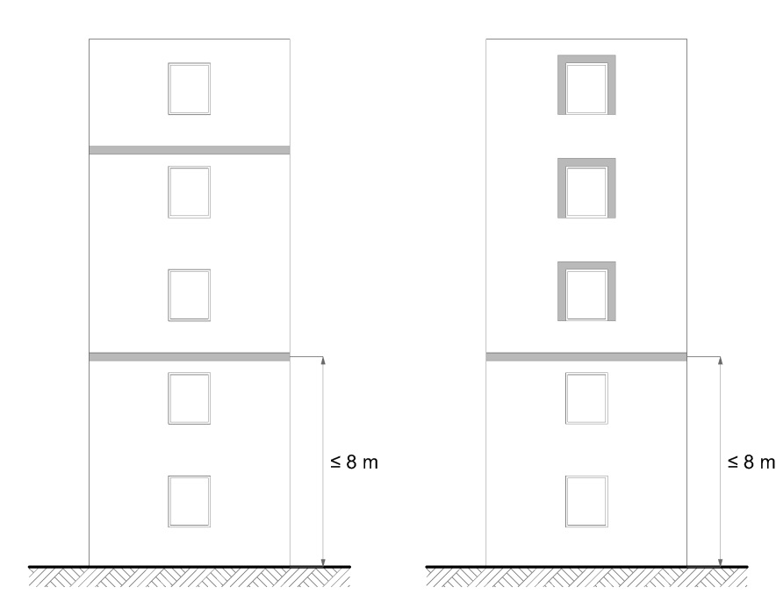
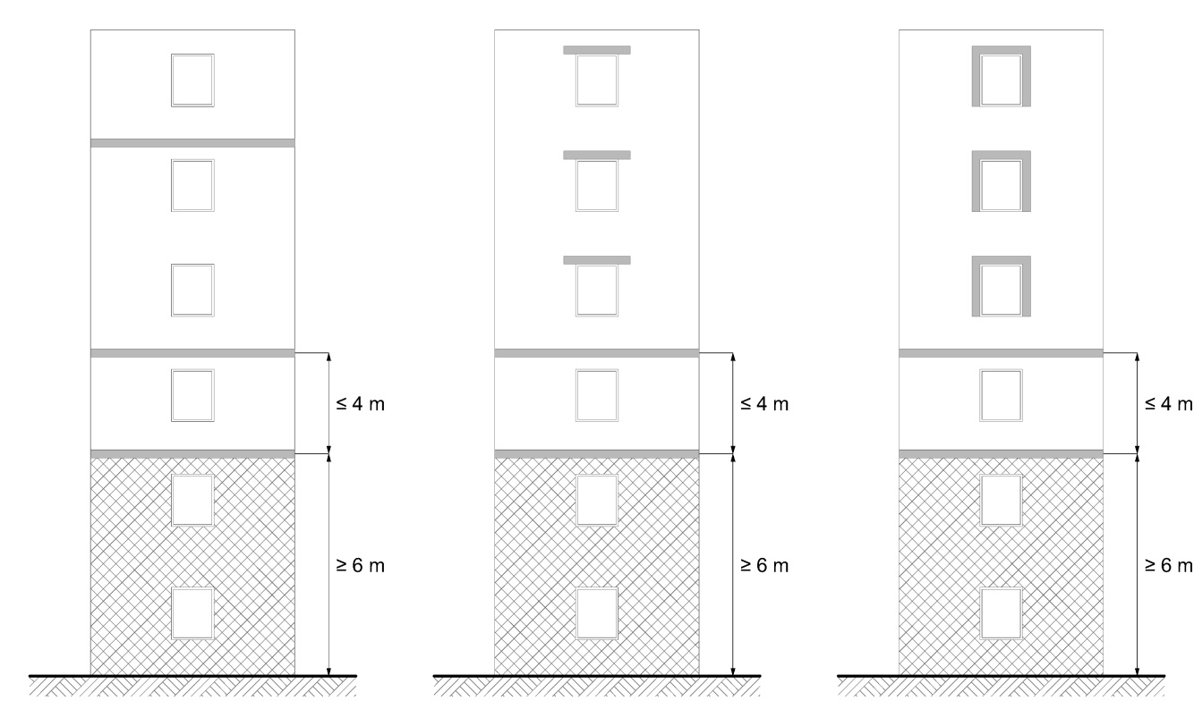 Firescreen

Barrière coupe-feu

A firescreen is a facility that interrupts the insulation and the air cavity to reduce the risk of fire spreading inside the façade.

The type of solutions described below enable compliance with this requirement:
a) an interruption across the entire width of the façade by a steel slab, a horizontal wooden slat or a horizontal strip of mineral wool;
b) each façade opening framed (top and sides) with steel or wood, or a horizontal and vertical strip of mineral wool.

The steel slab or frame must have at least the following characteristics:
- Thickness: 1 mm
- Mechanically attached

The mineral wool strip must have at least the following characteristics:
- Height/Width: 20 cm
- Fire reaction class: A2-s3, d0
- Density: 60 kg/m³
- Mechanically attached

The wooden slat or frame must have at least the following characteristics:
- Thickness: 25 mm
- Density: 390 kg/m³
- Mechanically attached

In addition, up to 100 cm² of ventilation openings are permitted in the firescreens per running metre.

6.1.2.2 Type of solutions for façade without continuous air cavity

6.1.2.2.1 Type of solution 1 for façade without continuous air cavity

The insulation cannot be EPS (expanded polystyrene) or XPS (extruded polystyrene).

6.1.2.2.2 Type of solution 2 for façade without continuous air cavity

A firescreen must be installed at the level of the floor between the ground floor and 1st storey. If the vertical distance between this firescreen and ground level is greater than 4 m, one or more firescreens must be added every 4 m. (image 5.2)

A firescreen must be installed at the level of the floor between 2nd and 3rd storey. If the distance between this firescreen and the previous firescreen is greater than 8 m, one or more firescreens must be added every 8 m.

After the previous firescreen, a firescreen must be installed:
- either once every two stories;
- or above or around every opening.

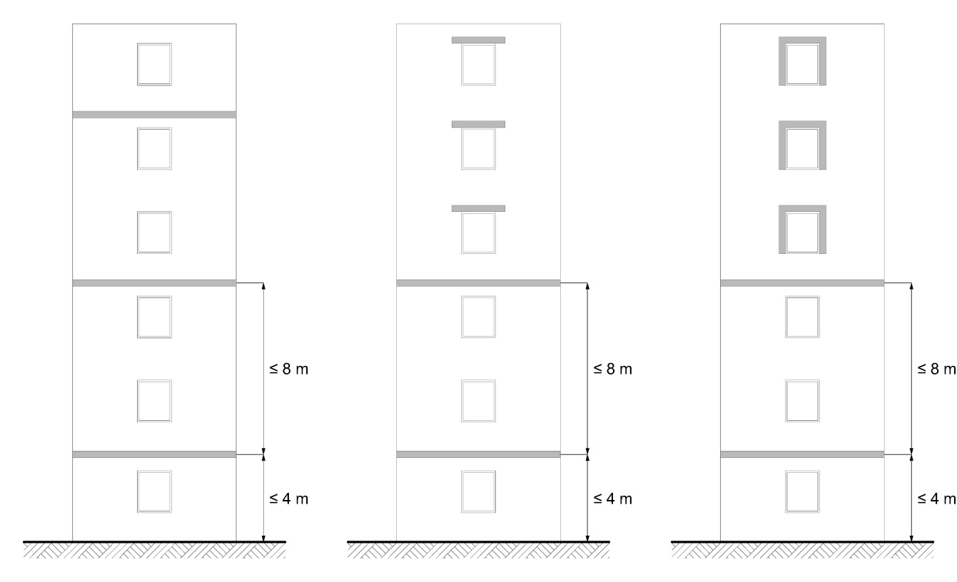
Firescreen

Barrière coupe-feu

A firescreen is a facility that interrupts the insulation to reduce the risk of fire spreading inside the façade.

The type of solutions described below enable compliance with this requirement:
a) an interruption across the entire width of the façade by a horizontal strip of mineral wool;
b) an interruption above each façade opening by a horizontal strip of mineral wool;
c) each façade opening framed (top and sides) with a horizontal and vertical strip of mineral wool.

The mineral wool strip must have at least the following characteristics:
- Height/Width: 20 cm
- Lateral overhang (for type of solution b): 30 cm
- Fire reaction class: A2-s3, d0
- Density: 60 kg/m³
- Mechanically attached

6.1.3 Type of solution for high-rise buildings

For high-rise buildings, the essential components of the façade can be of Class E if all essential components, except for the outer cladding, are fully protected from fire (see also point ⁽⁴⁾ of Table V of point 6.1.1) and if the façade meets the type of solution below.

A firescreen must be installed at the level of the floor between the 1st and 2nd storey. If the vertical distance between this firescreen and ground level is greater than 8 m, one or more firescreens must be added every 8 m. (image 5.3)

After the previous firescreen, a firescreen must be installed once every two storeys.

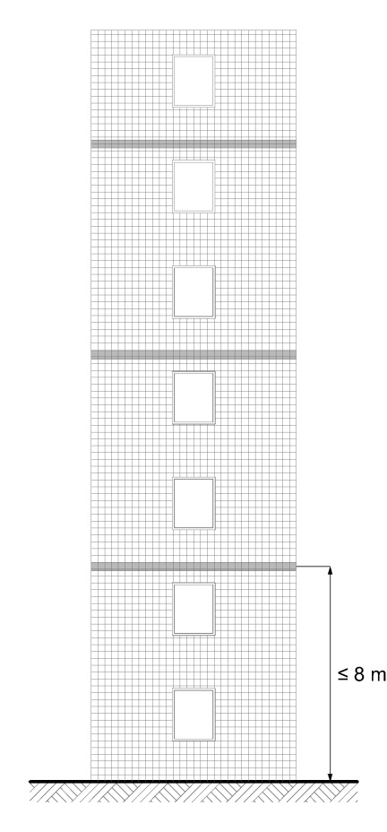
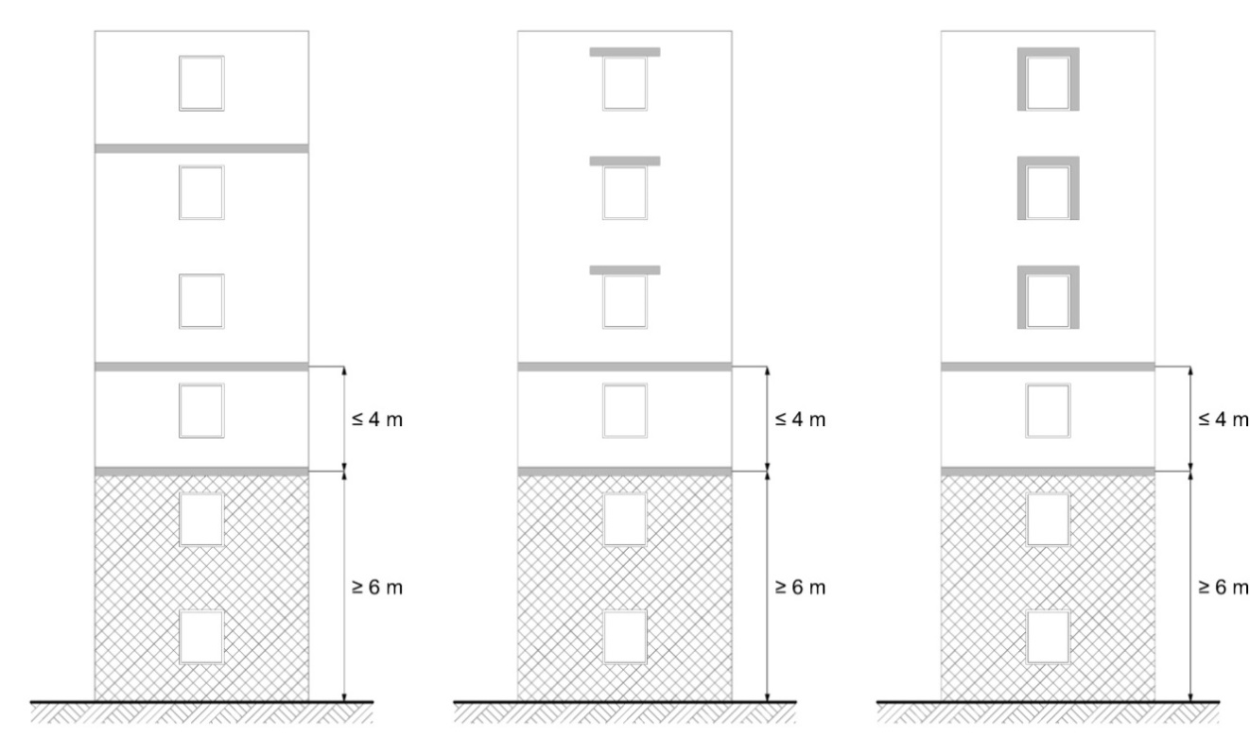 Firescreen
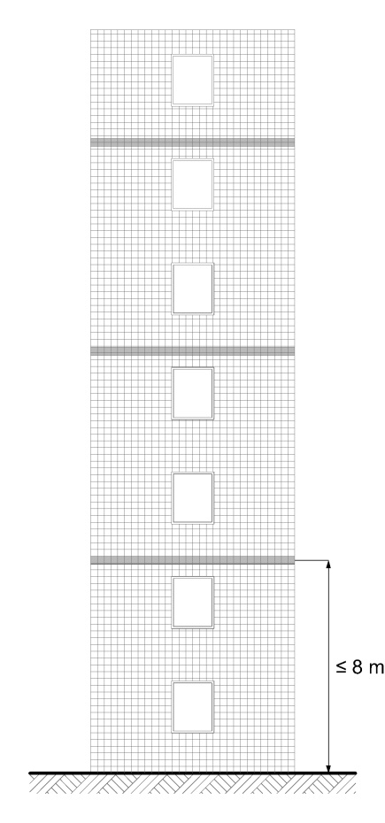 Building element with fire protection ability of K₂ 30 or a fire resistance of EI 30

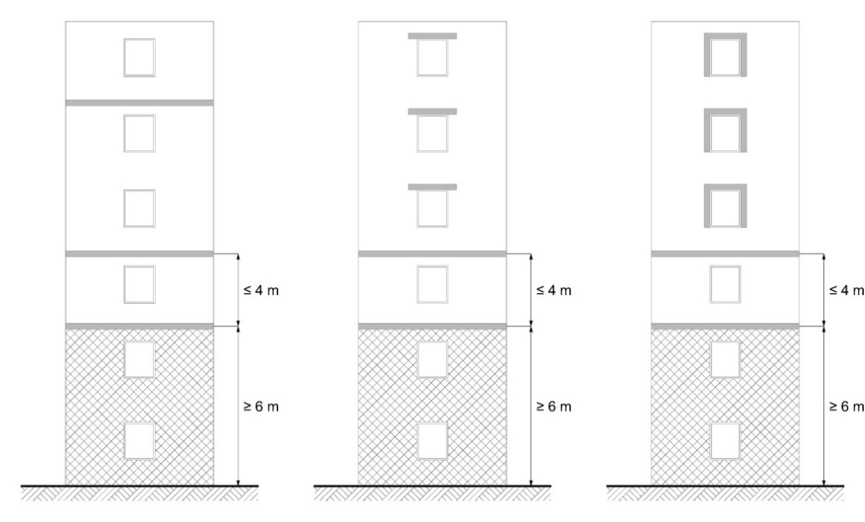 Barrière coupe-feu
Element of construction having a capacity of protection against fire K ₂ 30 or fire resistance EI 30

A firescreen is a facility that interrupts the insulation and any air cavity to reduce the risk of fire spreading inside the façade.

The type of solution described below enables compliance with this requirement:
- An interruption across the entire width of the façade by a horizontal strip of mineral wool.

The mineral wool strip must have at least the following characteristics:
- Height/Width: 20 cm
- Fire reaction class: A2-s3, d0
- Density: 60 kg/m³
- Mechanically attached

In addition, up to 100 cm² of ventilation openings are permitted in the firescreens per running metre.

6.2 Large-scale test

Point 6.1 does not apply to façades tested according to one of the following test standards that meet the performance criteria defined in the following documents:

Test standard | Document indicating the performance criteria
Test standard | H.G. | M.G. | L.G.
BS 8414-1 | LPS 1581 | BRE 135
BS 8414-2 | LPS 1582 | BRE 135
DIN 4102-20 | / | Document HR 1882 of the Belgian High Council for Fire and Explosion Safety [Hoge Raad voor beveiliging tegen brand en ontploffing]
LEPIR 2 | French Order of 10 September 1970 on the fire hazard classification of glass façades [Arrêté français du 10 septembre 1970 relatif à la classification  des façades vitrées par rapport au danger d’incendie]
H.G.: high-rise buildings
M.G.: mid-rise buildings
L.G.: low-rise buildings

6.3 Buildings with different parts of different heights

Buildings featuring different parts of different heights may be divided vertically according to the conventional height of each building part.

The applicable provisions of points 6.1 and 6.2 are those corresponding to the conventional height of the part in question, but only from a horizontal distance of 5 m from the façade that dominates the part in question. (image 5.4)

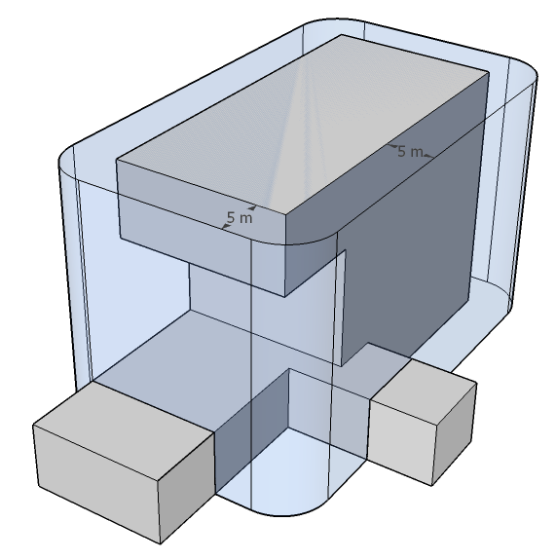
6.4 Deviating provisions

Points 6.1 to 6.3 do not apply to façades on a building for which an urban planning permit application was submitted before 1 July 2022 if it meets the conditions below.

The façade claddings of the low-rise buildings are of Class D-s3, d1.

The façade claddings of the mid and high-rise buildings are of Class B-s3, d1.

A maximum of 5% of the visible area of the façades is not subject to this requirement.’.

Article 28. A new paragraph is added to point 8.1 of the Annex 5/1 to the same decree, reading:
‘This requirement does not apply to green roofs complying with the provisions of point 5 of Annex 7.’.

Article 29. A new paragraph is added to point 8.3 of the Annex 5/1 to the same decree, reading:
‘A wooden terrace on a flat roof is assumed to meet the requirements set out in point 8.1, i.e. Class B_{ROOF} (t1), if it meets the following conditions:
- wooden terrace boards: minimum density of 750 kg/m³, thickness of 21 to 40 mm, minimum width of 120 mm, mechanical attachment to a wooden support structure, parallel or perpendicular to the roof slope
- width of joints between boards: 4 to 6 mm
- wooden support structure: wooden joists (minimum density of 750 kg/m³, section of 60 x 40 mm), placed directly on the roof or with insertion of polypropylene floor pedestals (max. 6 per m²)
- roofs under the wooden terrace: all flat roofs (slope of 0 to 20°) belonging to Class B_{ROOF} (t1).’.

Article 30. In point 8.4 of the Annex 5/1 to the same decree containing points 8.4.1 to 8.4.6 is removed.

Chapter 7. Amendments to the Annex 6 to the Royal Decree of 7 July 1994 laying down the basic fire and explosion prevention standards with which buildings must comply
Article 31. In point 1.2.1, paragraph 1, 3, fifth indent, of the Annex 6 to the same decree, the word ‘general’ is replaced with the word ‘total’ in the Dutch version.

Article 32. In the title of point 3 of the Annex 6 to the same decree, a typographical correction is applied to the term ‘structural’ in the French version.

Article 33. In the title and text of point 3.1 of the Annex 6 to the same decree, a typographical correction is applied to all instances of the term ‘structural’ in the masculine plural in the French version.

Article 34. In the text and table in the point 3.3 of the Annex 6 to the same decree, a typographical correction is applied to all instances of the term ‘structural’ in the masculine singular and plural in the French version.

Article 35. The point 3.4.3 of the Annex 6 to the same decree is amended as follows:

1° in the second indent of paragraph 2, the word ‘horizontal’ is removed;

2° in the second indent of paragraph 2, the words ‘on either side of the wall’ are removed;

3° in the second indent of paragraph 2, the word ‘local’ is inserted between the words ‘connecting with the roof’ and the words ‘over a distance of at least’;

4° in the second indent of paragraph 2, the word ‘2 m’ is replaced with the words ‘4 m (horizontal distance measured perpendicular to the compartment wall)’;

5° in the second indent of paragraph 2, ‘A1’ is replaced with ‘A1 and/or A2-s1, d0’;

6° in the second indent of paragraph 3, the word ‘horizontal’ is removed.

7° in the second indent of paragraph 3 the words ‘on either side of the wall’ must be lifted;

8 ° in the second indent of paragraph 3 the word ‘local’ is inserted between the words ‘connected with the façade’ and the words ‘over a distance of at least’;

9° in the second indent of paragraph 3 the word ‘1 m’ is replaced with the words ‘2 m (horizontal distance measured perpendicular to the compartment wall)’;

10° in the second indent of the paragraph 3, ‘A1’ is replaced with ‘A1 and/or A2-s1, d0’.

Article 36. In the point 5.2 of the Annex 6 to the same decree, the word ‘general’ is replaced with the word ‘total’ in the Dutch version.

Article 37. The point 5.2.1 of the Annex 6 to the same decree is amended as follows:

1° in paragraphs 1 and 2, a typographical correction is applied to every instance of the term ‘fire detection system’ in the Dutch version;

2° paragraph 3 is amended as follows:

a) in the Dutch version, a typographical correction is applied to the term ‘recognition procedure’;

b) in the French version, the phrase ‘during commissioning, and after this’ is inserted between ‘This system shall be inspected’ and ‘once every three years’;

c) in the French version, the phrase ‘starting from commissioning’ is now removed.

Article 38. The Point 5.3 of the Annex 6 to the same decree is now amended as follows:

1° in the paragraph 2, (1 and 2), all instances of the word ‘floor’ are removed in the French version;

2° in the paragraph 2, point 3, the phrase ‘automatic gas or water mist extinguishing system’ is replaced with ‘automatic water mist, foam or gas extinguishing system’.

Article 39. The point 5.3.1 of the Annex 6 to the same decree is amended as follows:

1° in the paragraph 2, the words ‘au sol’ are removed in the French version;

2 ° in paragraph 2, the word ‘total’ is inserted in the Dutch text between the words ‘For compartments whose’ and the words ‘is less than or equal to 2 000 m²’;

3 ° in paragraph 2, the word ‘aerodynamic’ is replaced with the word ‘geometric’;

4 ° in paragraph 2, the word ‘2 %’ is replaced by the word ‘3 %’;

5° in paragraph 2, the word ‘roof surface’ is replaced by the words ‘total floor surface’;

Article 40. In point 5.4 of the Annex 6 to the same decree, a typographical correction is applied to the term ‘staircases’ in the Dutch version.
Article 41. In point 5.6, paragraph 1 of the Annex 6 to the same decree, the word ‘kunnen’ is removed from the Dutch text.
Article 42. A new paragraph is added to point 6.6 of the Annex 6 to the same decree, reading:
‘This requirement does not apply to green roofs complying with the provisions of point 5 of Annex 7.’.

Article 43. In point 7.1.1 of the Annex 6 to the same decree, the words ‘du chemin’ in the French text are replaced with the words ‘de la distance’.

Article 44. The point 7.1.2 of the Annex 6 to the same decree is amended as follows:

1° in the second indent of paragraph 1, the words ‘le chemin’ are replaced with the words ‘la distance’;

2° in the second indent of paragraph 1, the words ‘inférieur à celui’ are replaced by the words ‘inférieure à celle’;

3° in the second indent of paragraph 1, the words ‘commun tel que défini’ are replaced by the words ‘commune telle que définie’.

Article 45. In the title of point 7.2 of the Annex 6 to the same decree, the words ‘Chemin’ are replaced with the word ‘Distance’.

Article 46. The point 7.2.1 of the Annex 6 to the same decree is amended as follows:

1° in paragraph 1, the words ‘Le chemin’ are replaced by the words ‘La distance’;

2° in the caption of Table 6, the word ‘Chemin’ is replaced by the word ‘Distance’.

Article 47. In the point 7.2.2 of the Annex 6 to the same decree, ‘point 1.2.2’ is replaced with ‘point 1.2.1’.

Article 48. In point 8.1.1, paragraph 2, points 2° and 3°) of the Annex 6 to the same decree, all instances of the phrase ‘total area’ are replaced with ‘floor area’.

Chapter 8. Amendments to the Annex 7 to the Royal Decree of 7 July 1994 laying down the basic fire and explosion prevention standards with which buildings must comply

Article 49. New paragraphs added to point 0.2 of the Annex 7 to the same decree, reading:
‘Image 7.5 - Relative position of air inlets and outlets (schematics)
Image 7.6 - Green roofs’.

Article 50. In the second indent of the point 2.2, paragraph 2 of the Annex 7 to the same decree, the term ‘car parks’ is replaced with a synonym in the Dutch version.

Article 51. In the Annex 7 to the same decree, a point 3 is inserted, containing points 3.1 to 3.8, reading:

‘3 CAR PARKS

3.1 Subject matter

This chapter sets out the conditions that the design, construction and layout of a car park must meet in order to:

a) prevent fires from starting, growing and spreading;
b) guarantee the safety of persons present;
c) facilitate potential fire brigade operations.

3.2 Scope

The provisions of this chapter apply to the car parks referred to in the point 5.2.4 of the Annexes 2/1, 3/1 and 4/1 to this Decree.

3.3 Fire protection

The design, implementation, use and inspection of fire protection systems must meet good engineering practices and the applicable standards.

Active fire protection systems must be designed so the different components are compatible with one another. They must work together properly so the functioning or failure of one component does not jeopardise the functioning of the other systems and components.

A competent body or person must inspect and maintain the active fire protection systems at regular intervals.

The special requirements on electrical lines for the controls and power supply of active fire protection systems still apply.

3.3.1 Protection type

Different protection types are distinguished based on the fire protection concept applied:
- RWA & Sprinkler
- RWA
- Sprinkler
- Ventilation opening
- Open

In car parks with a total area of over 250 m²(*), one of these protection types must be applied on every parking level, as shown in the table below.
 |  |  | Total area of car park S
 |  |  | S  ≤  250  m²  (*) | 250 m² (*) < S ≤ 60 000 m² |  |  |  | S  >  60 000 m²
 |  |  | S  ≤  250  m²  (*) | Area of the largest subcompartment S_{sc} |  |  |  | S  >  60 000 m²
 |  |  | S  ≤  250  m²  (*) | S_{sc} ≤  1 250 m² | 1 250 m²  < S_{sc} ≤  2 500 m² | 2 500 m²  < S_{sc} ≤  5 000 m² | 5 000 m²  < S_{sc} | S  >  60 000 m²
Above-ground  component layers |  |  | / | SHEV^{1,2,3}  OR  Sprinkler^{1.2}  OR  Ventilation opening  OR  Open | SHEV^{1,2}  OR  Sprinkler¹  OR  Open | SHEV¹  OR  Sprinkler¹  OR  Open | SHEV¹  &  Sprinkler¹  OR  Open | SHEV¹  &  Sprinkler¹  OR  Open
Underground component layers | 0 m  < p ≤  7 m |  | / | SHEV^{1,2,3}  OR  Sprinkler^{1.2}  OR  Ventilation opening  OR  Open | SHEV^{1,2}  OR  Sprinkler¹  OR  Open | SHEV¹  OR  Sprinkler¹  OR  Open | SHEV¹  &  Sprinkler¹  OR  Open | SHEV¹  &  Sprinkler¹  OR  Open
Underground component layers | 7 m  < p ≤  14 m |  | / | SHEV^{1,2}  OR  Sprinkler¹ | SHEV¹  OR  Sprinkler¹ | SHEV¹  &  Sprinkler¹ | SHEV¹  &  Sprinkler¹ | SHEV¹  &  Sprinkler¹
Underground component layers | 14 m  < p ≤  21 m |  | / | SHEV¹  OR  Sprinkler¹ | SHEV¹  &  Sprinkler¹ | SHEV¹  &  Sprinkler¹ | SHEV¹  &  Sprinkler¹ | SHEV¹  &  Sprinkler¹
Underground component layers | > 21 m |  | / | SHEV¹  &  Sprinkler¹

(*) For car parks without a car lift, this limit is increased to 625 m² provided that the car park does not feature any points located further than 45 m from the car park entrance intended for fire brigade operations (see also point 7.2 of the Annex 1).

SHEV# = SHEV type #
Sprinkler# = Sprinkler type #

All underground parking levels, except for open component layers, must feature the same protection type. All above-ground parking levels, except for open component layers, must feature the same protection type. However, the protection type of the above-ground storeys may differ from that of the underground storeys.

3.3.2 Fire detection and alarm system

Parking levels must be equipped with an automatic fire detection and alarm system that monitors the entire car park (including the rooms in the compartment).

This requirement does not apply to:
a) car parks with a total area less of than or equal to the limit indicated in point 3.3.1 for application of one the protection types on every parking level;
b) car parks exclusively of the ‘Ventilation opening’ or ‘Open’ type, provided that they do not feature any:
- subcompartments;
- equipment that requires fire detection control, aside from fire-activated self-closing doors; and
- car lifts.

3.3.2.1 Implementation of the fire detection system

The automatic fire detection system must be designed and implemented according to standard NBN S 21-100-1. The choice of detectors must be tailored to the relevant risks and rapid fire detection.

For parking levels fitted with a sprinkler system, this system can provide automatic fire detection in the zones it protects, provided that:
- the sprinklers have a nominal operating temperature not exceeding 68°C and are of the quick response type;
- the sprinkler system piping network is fitted with water flow detectors and/or pressure switches that divide the piping network into detection zones;
- that these detection zones meet the corresponding requirements of standard NBN S 21-100-1;
- for parking levels of the ‘SHEV & sprinkler’ type, each detection zone contains no more than one SHEV zone;
- each subdivision of the piping network is fitted with a test valve; and
- this system is supplemented by smoke detectors in the vicinity of fire-activated self-closing doors.

The fire detection system must automatically indicate the fire alarm and its location.

3.3.2.2 Alarm system functioning

The system must inform all building users, in a timely manner, of a fire in the car park and the need to evacuate the building.

If one or more authorised persons monitors the car park, the system must send a prior warning to these persons, who will take the appropriate measures and notify the fire brigade.

3.3.3 SHEV system

For parking levels fitted with a smoke and heat exhaust ventilation (SHEV) system, this system must protect the vehicle parking spaces, the circulation routes and the ramps. A system i not required for the rooms and parking boxes located in the compartment.

      - Implementation of the SHEV system

SHEV systems must be designed and implemented:
- either according to standard NBN S 21-208-2 for a type 1 or 2 SHEV system;
- or according to the provisions of point 3.3.3.3 for a type 3 SHEV system.

Smoke removal from the affected subcompartment cannot pass through another subcompartment, except for smoke removal from ramps without vehicle parking zones. In contrast, the air supply to the affected subcompartment can in fact pass through another subcompartment.

3.3.3.1.1 Exception: autonomous power supply

Contrary to standard NBN S 21-208-2 and point 6.5.3 of Annexes 2/1, 3/1 and 4/1, a SHEV system cannot be powered by an autonomous power supply for car parks with a total area of less than or equal to 2500 m².

3.3.3.1.2 Exception: fire dampers

Contrary to the point 6.7.4 of the Annexes 2/1, 3/1 and 4/1, if the SHEV system serves several subcompartments, the smoke dampers and register valves may be placed on the boundaries of the subcompartments belong to the Class E₆₀₀ 60 (ve-ho i↔o) MA single according to standard NBN EN 12101-8.

3.3.3.2 Type 2 SHEV system

For a subcompartment with protection type ‘SHEV’:
a) with an area less than or equal to 2500 m² and above ground;
b) with an area less than or equal to 2500 m² and a depth less than or equal to 7 m;
c) with an area less than or equal to 1250 m² and a depth less than or equal to 14 m; and
provided that the total area of the car park is less than or equal to 10 000 m²;
the following exceptions are granted from the Annex A to standard NBN S 21-208-2:
- the subcompartment is divided into SHEV zones with an area of less than or equal to 1250 m²;
- the width w_{ref} of the subcompartment may be greater than 20 m. In this case, Table A.1 gives the required speed to be applied for a width w of 20 m.
- the draft flow rate Q_{d} is the greatest of flow rates Q_{min} and Q_{in}.

3.3.3.3 Type 3 SHEV system

The principle is to allow the fire brigade to provide horizontal ventilation without using their own fans, to make a fire brigade route relatively smoke-free from the car park entrance to the vicinity of the seat of the fire.

This simplified type of solution only applies to a subcompartment of the ‘SHEV’ type:
with an area less than or equal to 1250 m² and above ground;
with an area less than or equal to 1250 m² and a depth less than or equal to 7 m; and
at the distance d of greater than or equal to 0.6 D (see Image 7.5);
provided that the total area of the car park is less than or equal to 60 000 m².

where

D is the shortest horizontal distance to be covered inside the subcompartment between the furthest points of this subcompartment;
d is the shortest horizontal distance to be covered inside the subcompartment between the centre of the air outlet nozzle and the nearest edge of the air inlet nozzle.

Each subcompartment constitutes a SHEV zone.

3.3.3.3.1 Implementation of a type 3 SHEV system

The smoke removal system must ensure an exhaust flow rate of at least 120 000 m³/h.

The smoke removal system can also be used to control the maximum concentration of harmful gases, specified in the regulations, as required for continuous ventilation (without fire). In the event of a fire, smoke removal system controls must take precedence over the continuous ventilation controls.

The smoke extractors must meet standard NBN EN 12101-3. Their accessories (smoke dampers, smoke registers, etc.) that protect them from the outdoor environment must meet standard NBN EN 12101-2. The extractors and their accessories must also meet the performance requirements under the required classification given in the table below.

Performance requirements | Required classes | Reference standards
Heat resistance of the fan | F 300 | NBN EN 12101-3  (test: Annex C)
Functioning under snow load of a fan accessory located at the end of a network and in the outdoor environment, except in cases of heated buildings and accessories that are not thermally insulated | SL 125 | NBN EN 12101-3  (test: Annex E)
Functioning of a fan accessory that may be exposed to low ambient temperatures and that does not operate using the pressure difference produced by the fan | T (-15) | NBN EN 12101-2  (test: Annex E)
Reliability of a fan accessory that does not operate using the pressure difference produced by the fan | Re 1000 (*) | NBN EN 12101-2  (test: Annex C)

(*) If the exhaust system has two functions, 10 000 cycles must be run in the normal comfort ventilation position before conducting the test to determine its reliability class.

The exhaust ducts, their accessories and their mountings must be made of steel.

3.3.3.4 SHEV system controls

The automatic fire detection system provided for in point 3.3.2 must control the SHEV system.

The SHEV system must also be controllable manually.

3.3.3.4.1 Exception: standard NBN S 21-208-2

Contrary to standard NBN S 21-208-2, for parking levels with protection type ‘SHEV & sprinkler’:
- automatic control can be handled by a fire detection system whose automatic fire detection function is provided by the sprinkler system in the zones it protects, as per point 3.3.2.1;
- the fire scenario must be activated 3 minutes after receiving the signal from the water flow alarm of the sprinkler system in use.

3.3.4 Sprinkler system

In car parks fitted with a sprinkler system, this system must protect the vehicle parking areas, circulation routes and ramps as well as the rooms in the compartment, except those separated from the rest of the parking compartment by firewalls and fire doors.

3.3.4.1 Implementation of the sprinkler system

Sprinkler systems must be designed and implemented in accordance with standard NBN EN 12845, standard NFPA 13 or any other good engineering practice offering a comparable level of safety. These standards and good engineering practices must be applied in full, without mixing and matching specifications.

3.3.4.1.1 Exception: autonomous power supply

Contrary to the point 6.5.3 of the Annexes 2/1, 3/1 and 4/1, any electric pumps of the sprinkler system cannot be powered by an autonomous power supply for car parks with the ‘Sprinkler’ protection type and a total area of less than or equal to 2500 m².

3.3.4.2 Type 2 sprinkler system

For a subcompartment with protection type ‘Sprinkler’:
a) with an area less than or equal to 1250 m² and above ground;
b) with an area less than or equal to 1250 m² and a depth less than or equal to 7 m;
provided that the total area of the car park is less than or equal to 10 000 m²;
the following exceptions are granted from standard NBN EN 12845 or NFPA 13:
- for standard NBN EN 12845, the risk class is OH1;
- for standard NFPA 13, the risk class is LH with a design airtightness of at least 4 mm/min;
- the water supply must offer adequate capacity to ensure the pressure/flow conditions required for the system for 30 minutes.

3.3.5 Subcompartmentalisation

The principle is to subdivide parking levels automatically into different subcompartments in the event of a fire, in order to slow its spread and limit the affected area.

The area of a subcompartment is limited according to its depth, to account for the difficultly of fire brigade operations in deeper storeys.

This requirement does not apply:
a) in car parks with a total area less than or equal to the limit given in point 3.3.1 for application of one of the protection types on every parking level;
b) in car parks with a total area less than or equal to 2 500 m² that are no more than two storeys high;
c) in car parks with protection type ‘SHEV & sprinkler’ or ‘Open’.

A parking level can be a single subcompartment if it meets the requirements below.

3.3.5.1 Subcompartment dimensions

Parking compartments must be subdivided into different subcompartments so:
- the surface of each subcompartment is less than or equal to the limit given in the point 3.3.1 according to the depth of the parking level and the protection type applied;
- each subcompartment only includes one parking level;
- the floor area of each subcompartment is continuous; the area can be horizontal or sloping, but cannot be interrupted (e.g.: scissor sections or split-levels).

3.3.5.2 Subcompartment walls

Subcompartment walls must be EI 60.

Every opening in a subcompartment wall intended to provide access for occupants and the fire brigade must be closed:
- either with an air lock with walls rated EI 60 and self-closing or fire-activated self-closing doors rated EI₁ 30;
- or with a self-closing or fire-activated self-closing door rated E₁ 60.

Openings in subcompartment walls to provide access for vehicles must be fitted with fire-activated self-closing devices rated E 60, such as revolving doors, sliding walls, roller shutters and screens.

If the closing devices referred to in the paragraph 3 of this point are activated, the system must continue to guarantee the connections to each subcompartment:
- either through an opening in accordance with the paragraph 2 of this point, provided in the vicinity of each of the openings referred to in the paragraph 3 of this point;
- or through another well-defined access, determined in consultation with the fire brigade.

Wall penetrations for fluid pipes or electrical lines and expansion joints of building elements cannot adversely affect the required level of fire resistance of these building elements.

3.3.5.3 Functioning in the event of fire

The subcompartment doors and closing devices must close automatically in the event of a fire, except for any that are necessary to the functioning of a SHEV system.

3.3.6 Ventilation opening

The principle is to allow the fire brigade to provide horizontal ventilation by using their own fans, in order to make a fire-brigade route relatively smoke-free from the car park entrance to the vicinity of the seat of the fire.

This protection type only applies to a subcompartment:
a) with an area less than or equal to 1250 m² and above ground;
b) with an area less than or equal to 1250 m² and a depth less than or equal to 7 m;
at the distance d of greater than or equal to 0.6 D (see Image 7.5);
provided that the total area of the car park is less than or equal to 60 000 m².

where

D is the shortest horizontal distance to be covered inside the subcompartment between the furthest points of this subcompartment;
d is the shortest horizontal distance to be covered inside the subcompartment between the centre of the ventilation opening and the nearest edge of the subcompartment entrance intended for fire brigade access.

Smoke removal from and air supply to the affected subcompartment cannot pass through another subcompartment.

3.3.6.1 Implementation of the ventilation opening

The ventilation opening must open directly to the open air. This opening can be fitted with a valve or a valve register.

The ventilation opening must have a cross-section of at least 5 m². Calculation of the ventilation opening cross-section must deduct any obstructions inside the exhaust system, such as control elements, ventilation hatches and fan blades.

The smallest dimension of the ventilation opening must be greater than or equal to 1 m.

The ventilation opening can also be used to control the maximum concentration of harmful gases, specified in the regulations, as required for continuous ventilation (without fire). In the event of a fire, smoke removal system controls must take precedence over the continuous ventilation controls.

The performance of any with a valve or a valve register in the ventilation opening must be determined using the test methods specified in standard NBN EN 12101-2. The table below gives the classes that the with a valve or a valve register must meet.

Performance requirements | Required classes | Reference standards
Heat resistance | B 300 | NBN EN 12101-2  (test: Annex G)
Opening under snow load | SL 125 (**) (***) | NBN EN 12101-2  (test: Annex D)
Opening at low ambient temperature | T (-15) | NBN EN 12101-2  (test: Annex E)
Reliability | Re 50 (*) | NBN EN 12101-2  (test: Annex C)
Wind load resistance | WL 1500 | NBN EN 12101-2  (test: Annex F)

(*) If the exhaust system has two functions, 10 000 cycles must be run in the normal comfort ventilation position before conducting the test to determine its reliability class.

(**) An exhaust system classified as SL 0 can be installed in accordance with manufacturer instructions, with a minimum installation angle greater than 45° (inclines of the roof and evacuation system added in closed position), unless the snow cannot slide off exhaust system (such as due to wind deflectors).

(***) With the exception of exhaust systems classified as SL 0, a snow load class of at least SL = 2000 d will suffice for exhaust systems fitted with deflectors or similar elements, where d is the snow thickness, expressed in metres, that can be retained within the limits of the deflectors.

All with a valve or a valve register in all ventilation openings must be configured to open as follows:
- automatically in the event of a fire in the car park;
- automatically in the event of a failure in the energy source, power supply or control system (positive safety device);
- manually with a control device intended for the fire brigade.

3.3.7 Open parking levels

This protection type only applies to an open parking level (see also the point 7.4 of the Annex 1).

The principle is that an open parking level is adequately ventilated for proper removal of smoke and heat and supply of fresh air in the event of a fire, and that it does not require active protection measures.

3.3.8 Central monitoring and control station

The various active fire protection systems must be monitored and controlled from a central monitoring and control station.

The central monitoring and control station must feature a synoptic panel allowing on which the fire can be located, the various protective measures identified and with which their activation can be verified.

The location of the central monitoring and control station must be determined in consultation with the competent local fire brigade.

The central monitoring and control station must be indicated with signalling that is clearly visible and recognisable to the fire brigade, and fitted with safety lighting.

3.4 Extinguishing equipment

Contrary to point 6.8.5.3 of the Annexes 2/1, 3/1 and 4/1, parking levels fitted with a sprinkler system do not require any wall-mounted reels. The special requirements for wall hydrants still apply.

3.5 Rooms in the compartment

A parking compartment can contain the following rooms:
- rooms not intended for occupation by persons (such as technical rooms, transformer rooms, storage rooms, archive rooms, waste storage rooms, metering rooms, heating rooms, etc.);
- rooms that serve directly for operation of the car park (payment booths, surveillance rooms, sanitary rooms, offices, workrooms, etc.).

Parking compartments are not permitted to accommodate additional activities, such as automatic car wash stations, loading bays, filling stations or refuelling stations.

3.5.1 Interior walls and doors

The interior walls of rooms in a compartment must have the same fire resistance as the walls of the parking compartment and:
- either provide access with a lock with walls with the same fire resistance as the walls of the parking compartment and self-closing or fire-activated self-closing doors rated EI₁ 30;
- or provide access to each room with a self-closing or fire-activated self-closing door rated EI₁ 60.

This requirement does not apply to payment items, surveillance rooms, sanitary facilities or offices that serve directly for operation of the car park.

3.5.2 Special rooms

The special requirements on boiler sections, transformer rooms and waste storage rooms still apply (see also points 5.1.2, 5.1.3 and 5.1.4 of Annexes 2/1, 3/1 and 4/1, respectively).

3.6 Equipment

3.6.1 Car lifts

The special requirements on lifts still apply (see also point 6.1 of the Annexes 2/1, 3/1 and 4/1), with the following exceptions:
- point 6.1.4.1 of the Annexes 2/1, 3/1 and 4/1 does not apply;
- if a fire is detected, the cages of the car lifts must go to the designated level so passengers can get off, and must then be taken out of normal service, except in the event of a power supply failure;
- in the event of a power supply failure, the cages of the lifts must go to the first level technically possible so passengers can get off, and must then be taken out of normal service. For this, each car lift must feature an autonomous power supply with adequate capacity and power.

3.6.2 Parking boxes

Parking boxes are part of the parking zones and their main activity must remain vehicle parking.

The area of a parking box is limited to no more than two parking spaces.

Walls and doors separating parking boxes from vehicle parking zones and from circulation routes are not subject to any fire resistance requirement. Reaction to fire requirements still apply.

Each parking box must be fitted with two ventilation openings:
- one at the top, with an area of at least 500 cm² and a height of at least 15 cm;
- the other at the bottom, with an area of at least 200 cm².
These ventilation openings must connect each parking box directly to a car park circulation route.
These ventilation openings can be fitted with a security grille to prevent intrusion.

The walls separating the parking boxes from one another or from the vehicle parking zones cannot feature any ventilation openings or other openings.

3.6.3 Gas pipes

Gas pipes are permitted in a car park if:
- these gas pipes are made of steel and welded;
- that the components and appliances of these gas pipes are of the R_{HT} type, as defined in standards NBN D 51-003 and NBN D 51-004;
- these gas pipes are protected from potential impacts originating from vehicles;
- these gas pipes are installed above the circulation routes.
If the incoming or vertical connection is also located above a parking area, a connecting pipe to the pipes above the circulation routes is also permitted; and
- a gas supply shut-off valve is installed on the outside of the parking compartment, for use by the fire brigade.

3.7 Evacuation

3.7.1 Number of exits

Each parking level must feature at least two exits.

Car park exits must meet point 4.4.1.2, paragraph 1 of the Annexes 2/1, 3/1 and 4/1, with the following amendments:
- a connection to a staircase can take the form of fire-activated self-closing doors;
- the connection to an evacuation route from a parking compartment must be in accordance with the point 5.2.2 of the Annexes 2/1, 3/1 and 4/1.

The exits must be located in opposite zones of the parking levels and must remain accessible in the event of activation of any smoke curtains for the SHEV system and any closing devices of the subcompartment.

The doors to be opened to the exits cannot feature a locking device that prevents opening in the direction of evacuation.

3.7.2 Distance to be covered

The car park cannot feature any points located more than:
- 45 m from the access to an evacuation route leading to an exit, except for open parking levels;
- 60 m from the access to an exit.

These distances must be measured taking into account the closure of any closing devices in the subcompartment.

3.7.3 A single exit

Contrary to the point 3.7.1, a single exit per parking level will suffice if:
- the car park is no more than two component layers high;
- neither of these two component layers are located more than 7 m below or above ground;
- the car park does not feature any points located more than 15 m from the access to the evacuation route leading to the exit; and
- the car park does not feature any points located more than 30 m from the access to the exit.

3.7.4 Evacuation routes

Evacuation routes in a car park must meet point 4.4 of the Annexes 2/1, 3/1 and 4/1, with the following amendments:
- the interior walls of the evacuation routes must be EI 60 and their access doors must be EI₁ 30 and self-closing or fire-activated self-closing;
- it is not required for the connection between the stairs to take the form of evacuation routes or fire escapes;
- for open parking levels, the connection between the car park and an indoor staircase that only services the car park can be a self-closing or fire-activated self-closing door rated EI₁ 30.

On an evacuation level, if the route from indoor staircases to the public roadway or an outdoor area enables access to a public roadway passes through a car park, this connection must take the form of an evacuation route.

3.7.5 Width of exits and evacuation routes

The clear width of the evacuation routes, fire escapes, exits and their access, exit or connecting doors must be at least 0.80 m for evacuation routes, exits and doors and at least 0.60 m for fire escapes.

3.7.6 Signalling and safety lighting

The exits, evacuation routes and fire protection facilities must be marked by clearly visible and recognisable signs that meet the provisions on health and safety signs at work. They must feature safety lighting. The special provisions on this still apply (see also the point 6.5.4 of the Annexes 2/1, 3/1 and 4/1).

The serial number of each component layer must be clearly indicated at landings and in evacuation spaces in staircases, lifts and ramps.

3.8 Fire brigade operations

3.8.1 Fire brigade routes

The special requirements on fire brigade routes depend on the protection type of the parking level.

3.8.1.1 Protection type ‘SHEV’

Fire brigade operations must be possible:
- either via a ramp without vehicle parking zones;
- or directly from the car park entrance intended for fire brigade operations (see also the point 7.2 of the Annex 1).

Access to an affected subcompartment from this ramp or the car park entrance intended for fire brigade operations must be:
- either direct;
- or through no more than one other subcompartment.

3.8.1.2 Protection type ‘Sprinkler’

Fire brigade operations must be possible:
- either via a ramp without vehicle parking zones;
- or via a car park exit (see also the point 3.7.1);
- or directly from the car park entrance intended for fire brigade operations (see also the point 7.2 of the Annex 1).

Access to an affected subcompartment from this ramp, the car park exit or the car park entrance intended for fire brigade operations must be direct.

3.8.1.3 Protection type ‘Ventilation opening’

Fire brigade operations must be possible:
- either via a ramp without vehicle parking zones;
- or directly from the car park entrance intended for fire brigade operations (see also the point 7.2 of the Annex 1).

Access to an affected subcompartment from this ramp or the car park entrance intended for fire brigade operations must be direct.

3.8.1.4 Protection type ‘SHEV & sprinkler’ or ‘Open’

Fire brigade operations must be possible:
- either via a ramp without vehicle parking zones;
- or via a car park exit (see also the point 3.7.1);
- or directly from the car park entrance intended for fire brigade operations (see also the point 7.2 of the Annex 1).

Subcompartmentalisation does not apply to car parks with the protection type ‘SHEV & sprinkler’ or ‘Open’ (see also the point 3.3.5).

3.8.2 Central monitoring and control station

Every car park entrance intended for fire brigade operations must bear signalling that is clearly visible and recognisable for the fire brigade and that indicates whether the car park features a central monitoring and control station and if so, its location in the building.

3.8.3 Car park plans

Copies of the car park plans (location, plans, sections, etc.) must be available for the fire brigade in the central monitoring and control station, or if the car park lacks a central monitoring and control station, at each car park entrance intended for fire brigade operations.

These plans must indicate the protection facilities, extinguishers and fire brigade routes.

Article 52. In the Annex 7 to the same decree, a point 4 is inserted, containing points 4.1 to 4.9, reading:

4 BOILER SECTIONS

4.1 Subject matter

This chapter sets out the conditions that the design, construction and layout of boiler sections must meet in order to:

a) prevent fires from starting, growing and spreading;
b) guarantee the safety of persons present;
c) facilitate potential fire brigade operations.

4.2 Scope

The provisions of this chapter apply to the boiler sections referred to in the point 5.1.2.2 of the Annexes 2/1, 3/1 and 4/1 of this Decree.

4.3 General

Fuel burning appliances cannot be installed in staircases or evacuation routes.

4.4 Liquefied petroleum gas storage and pressure reduction facilities

Storage and pressure reduction facilities for liquefied petroleum gas used to heat the building and produce hot water must be located outside the building.

This requirement does not apply to individual second-stage pressure regulator(s) immediately before the fuel burning appliance of a facility with dual decompression that meets the requirements of standard NBN D 51-006.

4.5 Boiler rooms with fuel burning appliances with a cumulative combustion rate of greater than or equal to 75 kW

4.5.1 Permitted equipment

Only the following equipment is permitted in boiler rooms with fuel burning appliances with a cumulative combustion rate of greater than or equal to 75 kW:
- equipment directly involved in operation of the fuel burning appliances, such as loaders, ash treatment equipment and individual second-stage pressure regulators as referred to in the exception in point 4.4;
electrical equipment intended for central heating or for hot water production, such as electric heat pumps, electric boilers and electric water heaters;
equipment that is part of the central heating system or hot water production system such as pumps, circulators, compression pump units, heat exchangers, hot water accumulator tanks, fuel treatment equipment (preheater, filter, pump, etc.), water meters and electrical panels dedicated to the boiler section;
task-oriented equipment, such as artificial lighting and gas meters, and safety equipment, such as firefighting facilities, dedicated to the boiler section;
ventilation equipment dedicated to the boiler section;
water treatment equipment, such as filters and water softeners.

4.5.2 Boiler rooms fired with gaseous fuel

4.5.2.1 The power supply (electricity and fuel) to the boiler room must be fitted with an automatic shut-off device.

The automatic shut-off device of the fuel supply must take the form of a solenoid valve located:
either where the gas supply line enters the boiler room;
or outdoors.

4.5.2.2 The boiler room must be fitted with two ventilation openings, one at top and one at bottom, each with a cross-section of at least 4 dm². These ventilation openings must connect the boiler room to the outside, either directly or through a duct system. In addition:
if the fuel is lighter than air:
the upper edge of the top ventilation opening must be less than 30 cm from the highest point in the boiler room;
the lower edge of the bottom ventilation opening must be less than 30 cm from the lowest point in the boiler room;
the duct or duct system of the top ventilation opening that connects the boiler room to the outside cannot feature any downward slopes.
if the fuel is heavier than air:
the upper edge of the top ventilation opening must be less than 30 cm from the highest point in the boiler room;
the lower edge of the bottom ventilation opening must be even with the floor of the boiler room;
the duct or duct system of the bottom ventilation opening that connects the boiler room to the outside cannot feature any upward slopes;
the floors of rooms adjacent and connected to a boiler room cannot be lower than the floor of the boiler room.

The ventilation openings can be fitted with motorised ventilation dampers.

4.5.2.3 The automatic shut-off device of the power supply and the opening of any motorised ventilation dampers must be activated as follows:
automatically on detection of a gas leak in the boiler room;
automatically on detection of a fire in the boiler room;
automatically in the event of a failure of the energy source, power supply or control system (positive safety device).

4.5.2.4 Moreover, it must be possible to switch off the power supply manually (electricity and fuel) from controls located outside the boiler room.

The manual shut-down device for the fuel supply must be a manually operated section valve installed in the gas supply to the boiler section, enabling emergency operation of the gas supply without tools from outside the boiler section, in an accessible location outside the building or an unlocked space within the building, at a distance of no more than 20 m from the boiler section.

The shut-off valve of the gas meter or intermediate gas meter can serve as this section valve if the above conditions are met.

4.6 Fuel storage spaces

4.6.1 Permitted equipment

Only the following equipment is permitted in fuel storage spaces:
equipment for fuel storage or transport;
task-oriented equipment, such as artificial lighting and gas meters, and safety equipment, such as firefighting facilities, dedicated to the boiler section;
ventilation equipment dedicated to the boiler section.

4.6.2 Storage spaces for liquid fuel

Fuel storage spaces must meet the requirements of Title 5 ‘Storage sites for flammable liquids’ of Book III of the Occupational Health and Safety Code [Codex over het welzijn op het werk].

These requirements also apply to fuel storage spaces in buildings without workplaces, with the following amendments:
Article III.5-8 and point 2.1 of Annex III.5-1, referring to the provisions of the Article 52 of the General Occupational Health and Safety Regulation [ARAB], do not apply;
the building manager must keep the reports from tests and airtightness checks available for the supervisory officials.

4.6.3 Storage spaces for solid fuel

4.6.3.1 Flashback protection

The supply system between the boiler room and the fuel storage space must be fitted with suitable equipment to prevent flashback, and thus also the spread of fire.

4.6.3.2 Storage space for large quantities of fuel

In fuel storage spaces with a capacity so large that the total fire load of the fuel storage space exceeds 187.5 GJ:
the equipment must be at least category 3 (equipment designed to provide a normal level of protection in an environment with an explosion risk that is low and of short duration) in accordance with the ATEX regulations;
the electrical equipment must be at least IP 54.

In addition, these fuel storage spaces must be accessible to enable the fire brigade to operate and to remove the fuel once the fire is extinguished.

4.6.3.3 Special provisions on pellet silos

Pellets must be stored in silos. In the building, these silos must be installed in a fuel storage space. The fuel storage space can also be used directly as a silo (custom silo).

4.6.3.3.1 Silo loading

Pneumatic filling cannot result in an overpressure or underpressure in a silo. The silo must be fitted with at least one connection to blow the pellets in and one connection to extract them.

The supply lines and their mountings must be made of steel and must be connected to the main earth terminal by a main equipotential conductor in accordance with the General Regulation on Electrical Installations (RGIE/AREI).

4.6.3.3.2 Protection from toxic gases

Pellet degassing and fuel burning appliance faults may release toxic gases, such as carbon monoxide, into the silo. Therefore one of the following two provisions must be applied:
either the silo must be airtight;
or the fuel storage space must be airtight with respect to the rest of the building and vented to the outside, either directly or through a duct system, to prevent the accumulation of toxic gases.

At the entrance to the fuel storage space, special signalling must indicate the safety precautions:
only authorised persons are permitted to access fuel storage space;
before any person enters the fuel storage space, it must be vented to prevent dangerous concentrations of toxic gases.

4.7 Pipes, lines and ducts in boiler rooms with fuel burning appliances with an cumulative combustion rate of greater than or equal to 75 kW and fuel storage spaces

Pipes and lines for gases, liquids, solids, electricity or electromagnetic waves, as well as flues and ventilation and combustion air supply ducts, are only permitted if they exclusively serve for operation of the equipment installed in these boiler sections.

Water supply pipes and drains are permitted in these boiler sections.

Any other pipe is prohibited in these heating departments.

4.8 Flues and combustion air supply ducts

Flues must either:
1. offer the same fire resistance as required for service ducts; or
2. be installed in their own service duct; or
3. be installed in a service sleeve that is shared with other pipes, lines and ducts, but separated from these by a wall rated EI 30.

In cases 2 and 3, the combustion air supply ducts can be installed in the same service duct, or part thereof, as the flues.

The design, installation and implementation of the flues and combustion air supply ducts must meet good engineering practices and the applicable standards.

Penetrations through firewalls for flues and combustion air supply ducts designed and implemented in accordance with good engineering practices and the applicable standards are assumed to meet the requirements of the point 3.1 of the Annexes 2/1, 3/1 and 4/1.

4.9 Deviating provisions

The following deviating provisions apply to buildings whose building permit application was submitted prior to 1 July 2022:

- Point 4.3: Not applicable to fuel burning appliances installed before 1 July 2022;
- Points 4.5.1 and 4.6.1: Not applicable to equipment installed before 1 July 2022;
- Points 4.5.2.1, 4.5.2.3 and 4.5.2.4: Only applicable to boiler rooms where one or more fuel burning appliances were installed or modernised on or after 1 July 2022;
- Points 4.5.2.2, 4.6.2, 4.6.3 and 4.7: Not applicable.

Article 53. In the Annex 7 to the same decree, a point 5 is inserted, containing points 5.1 to 5.8, reading:

5 GREEN ROOFS

5.1 Subject matter

This chapter sets out the conditions that the design, construction and layout of the green roofs must meet in order to:

a) prevent fires from starting, growing and spreading;
b) guarantee the safety of persons present;
c) facilitate potential fire brigade operations.

5.2 Scope

The provisions of this chapter apply to the boiler sections referred to in the point 8.1 of Annex 5/1 and point 6.6 of Annex 6 to this Decree.

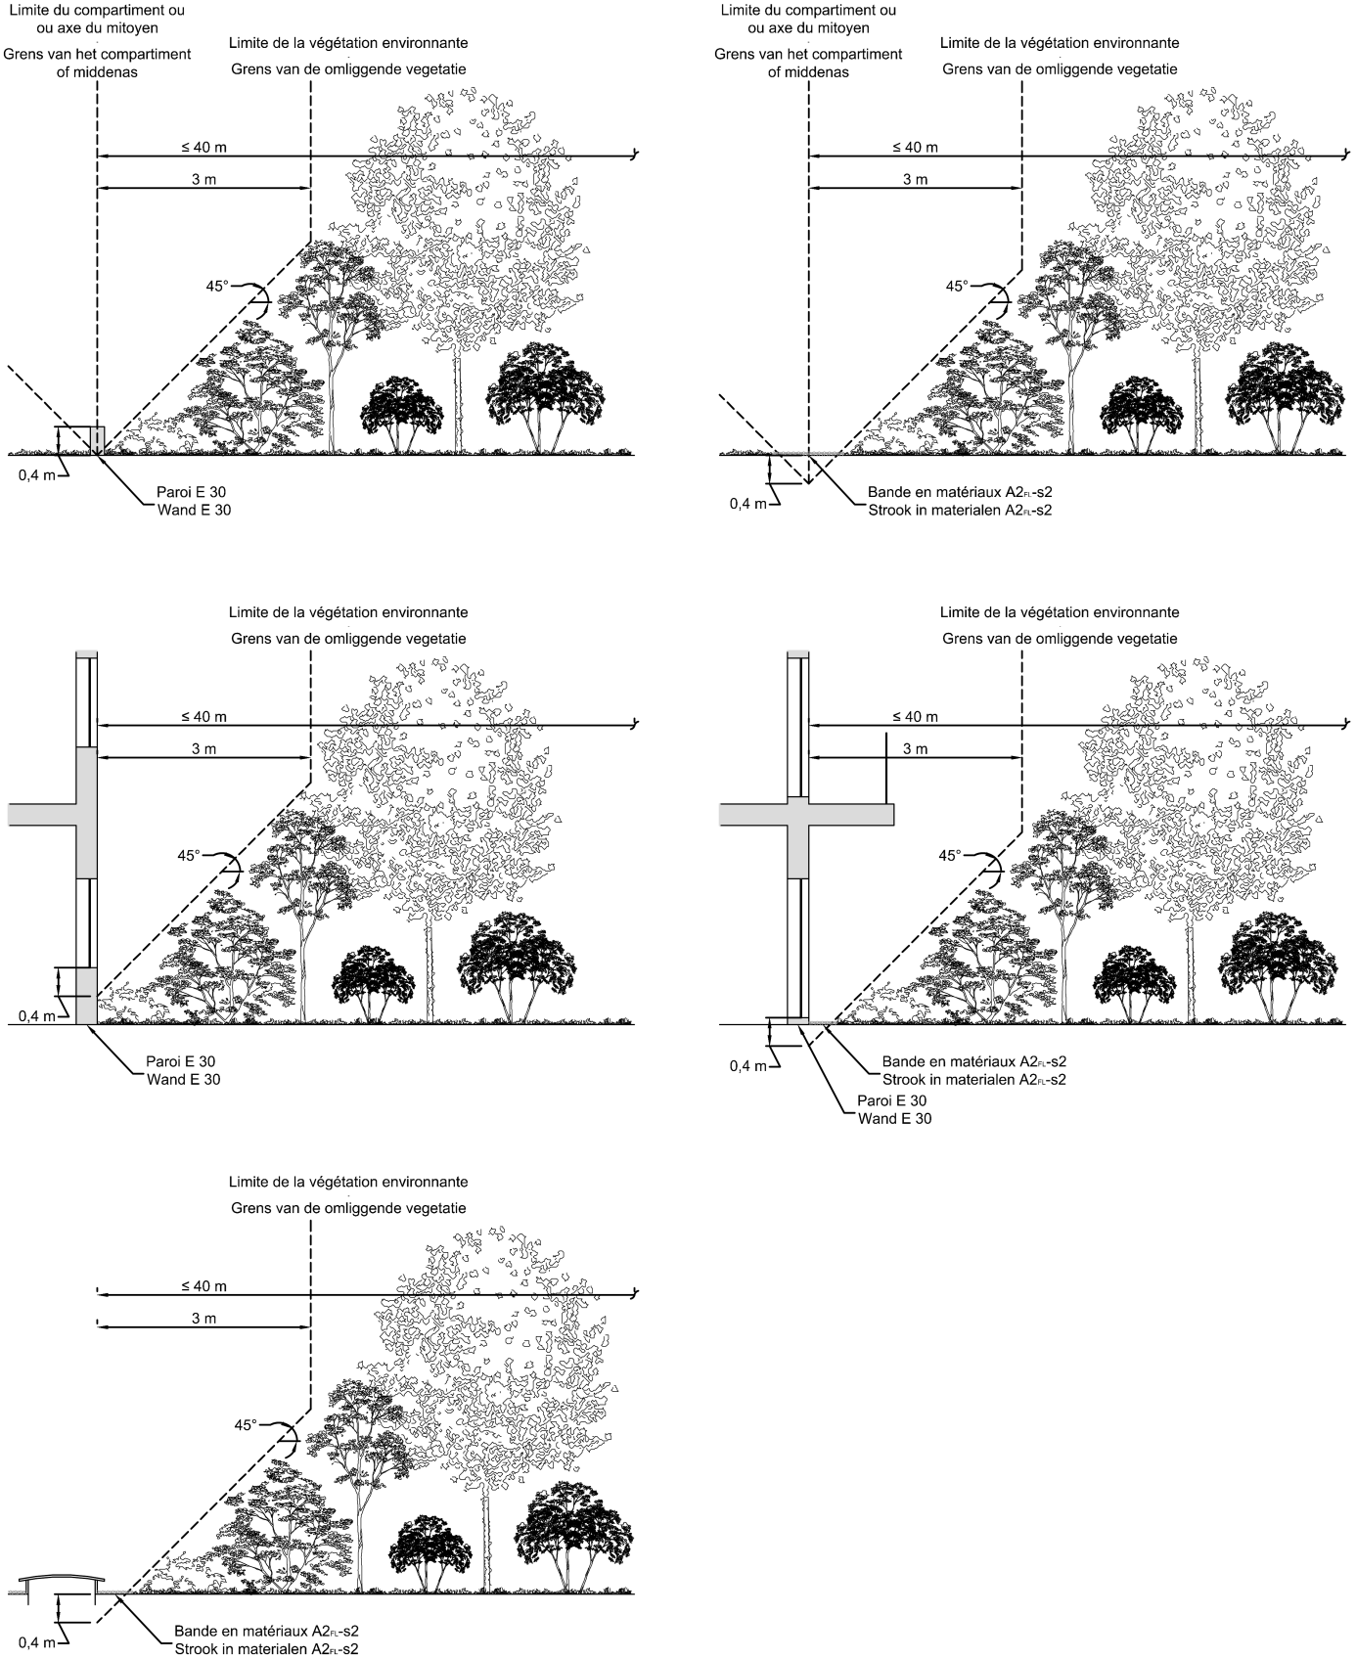

Grens van het compartiment of middenas | Boundary of the compartment or central axis
Grens van de omliggende vegetatie | Border of the surrounding vegetation
Wand E30 | Wall E30
Strook in materialen A2_{FL}-s2 | Strip in materials A2_{FL}-s2

5.3 Substrate layer.

The substrate layer is at least 3 cm thick.

If the substrate layer has a thickness of less than or equal to 10 cm, the substrate must contain a maximum of 20 % organic matter (by mass).

If the substrate layer does not meet the requirements set out in the first two paragraphs, this substrate layer can still be applied provided that the layer belongs to class B_{ROOF} (t1) according to a test according to standard CEN/TS 1187 at an angle of 15° in dry state and without plant vegetation.

In industrial buildings, the thickness of the substrate layer must not exceed 10 cm.

5.4 Compartmentalisation of the green roofs.

The green roofs are divided into compartments with a maximum length of 40 m.

On each side of the boundary of the compartment, the height of the surrounding vegetation is less than or equal to the boundary of the surrounding vegetation calculated in relation to the boundary of the compartment (see Annex 1 ‘Terminology’).

If there is a wall E 30 on the boundary of the compartment, then h_{e} is equal to its height.

5.5 Separation between the green roofs and the adjacent buildings.

On each side of the central axis, the height of the surrounding vegetation is less than or equal to the boundary of the surrounding vegetation calculated in relation to the central axis (see Annex 1 ‘Terminology’).

If there is a wall E 30 on the central axis, then h_{e} is equal to its height.

5.6 Light domes, fans, smoke drain pipes or openings in the green roofs.

The height of the surrounding vegetation is lower or equal to the boundary of the surrounding vegetation calculated in relation to the edge of the aperture (see Annex 1 ‘Terminology’).

If the opening is raised by walls E 30, then h_{e} is equal to their height.

5.7 Windows, fans, smoke drain pipes or openings built into the façades that run on the green roofs.

The height of the surrounding vegetation is lower than or equal to the boundary of the surrounding vegetation calculated in relation to the opening in the façade (see Annex 1 ‘Terminology’), both perpendicular and parallel to the façade.

If the opening has a support wall E 30, then h_{e} is equal to its height.

5.8 Non-flammable strip.

If there is a strip along the boundary of the compartment, the central axis or the opening in which there is no vegetation because the boundary of the surrounding vegetation is negative or too small, this strip must be realised in materials of minimum class A2_{FL}-s2.

Chapter 9. Final provisions

Article 54. This Decree shall come into force on 1 July 2022.

Article 55. The competent minister for internal affairs is hereby tasked with implementation of this Decree.

Brussels, 20 May 2022.
On behalf of the King:

The competent minister for internal affairs,

Annelies Verlinden

Annex 1 to the Royal Decree of 20 May 2022 amending the Royal Decree of 7 July 1994 laying down the basic fire and explosion prevention standards with which buildings must comply

The annex 2/1 to the Royal Decree of 7 July 1994 laying down the basic fire and explosion prevention standards with which buildings must comply

Annex 2/1 LOW-RISE BUILDINGS

0 GENERAL.

0.1 Objective.

This basic regulation lays down the minimum requirements to be met by the conception, construction and installation of low-rise buildings (LG) in order to:
prevent fires from starting, growing and spreading;
guarantee the safety of persons present;
facilitate potential fire brigade operations.

0.2 Scope.

0.2.1 This Annex applies to the following buildings to be constructed and the following extensions to existing buildings, for which the application for construction is submitted from 1 December 2012:
1. the low-rise buildings;
2. extensions of the buildings, which would, after the realisation of construction work, be low-rise building;
3. premises or parts of the medium-high buildings in which certain industrial activity takes place, and the total surface area of which is less than or equal to 500 m², under the following conditions:
- the building is exclusively used for non-industrial activities, and the total surface of the premises in which the industrial activity takes place is smaller than the remaining surface of the building;
- the industrial activities, which take place in these premises, support the non-industrial activities in the same compartment;
- there are no rooms with night occupancy in the compartment in which industrial activities take place.

0.2.2 However, excluded from the scope of this annex are:
1. industrial buildings;
2. the buildings consisting of a maximum of two floors and with a total surface area less than or equal to 100 m²;
3. the single-family homes.

0.3 Images (The images are included in the relevant text)

Image 2.1 - Façades between buildings
Image 2.2 - Façades between compartments

1 INSTALLATION AND ACCESS ROUTES.

The access routes referred to in point 1.1 must be determined in agreement with the fire brigade, in accordance with the following guidelines.

1.1 Accessibility and installation options fire brigade

For single-storey buildings, the fire brigade vehicles must be able to approach at least 60 m from a façade of the building.

For buildings with more than one storey, the fire brigade vehicles must be able to reach a façade at least at one point that gives access to each storey in recognisable places.

To this end, the vehicles must have access options and space for installation:
a) either on the drivable road of the public road;
b) or on a special access route from the drivable road of the public road and displaying the following characteristics:
- minimum free width: 4 m;
- minimum turning circle with radius 11 m (inside) and 15 m (outside);
- minimum free height: 4 m;
- maximum gradient: 6 %;
- load capacity: such that vehicles, without galvanising, with a maximum axle load of 13 t can drive and stand still, even when they distort the terrain.
For the constructions located on the access routes, the focus is on NBN B 03- 101.

1.2 Outbuildings

Outbuildings, protruding roofs, canopies, awnings or other similar additions are permitted only if they do not jeopardise the evacuation, safety of users nor the action of the fire brigade.

1.3 Horizontal distance between buildings

To prevent a fire from spreading between two buildings:

a) either, if façade are opposite each other or form an intrusive dihedral, the distance (in m) between the façade parts that do not have at least EI 60 or REI 60 must be at least:

$\frac{\text{h + 10}}{\text{2,5}}\text{cos}{\text{ α}}$ for 0° ≤ α ≤ 90°

0 for 90° <α ≤ 180°

where α is the enclosed corner and h is the height of the building in m (see image 2.1).

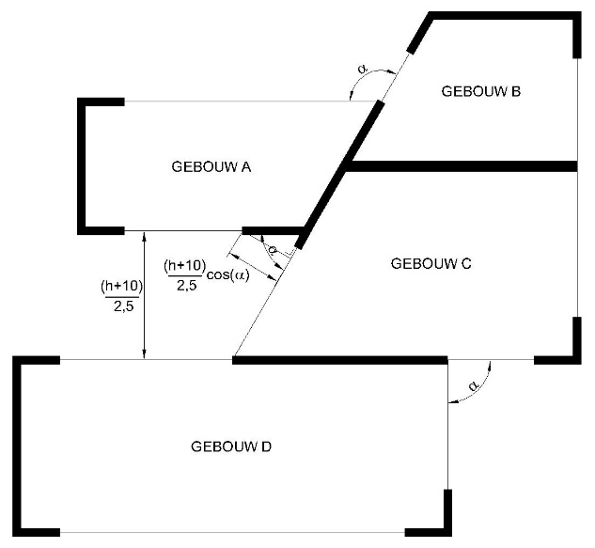

GEBOUW | BUILDING

For the buildings for which the construction application was submitted before 1 July 2022, a horizontal distance between the buildings of 6 m is sufficient.

b) or the radiation of a fire from a building to an opposite building, and vice versa, must not exceed 15 kW/m².

The walls that separate adjacent buildings have EI 60, or REI 60 when they are load-bearing.

In these walls, a connection between these buildings may exist by means of a door EI ₁ 30, self-closing or self-closing in the event of a fire.

The condition of the distance between a low-rise building and an opposite building does not apply to buildings separated by existing streets, roads,etc. belonging to the public domain.

2 COMPARTMENTALISATION AND EVACUATION.

2.1 Size of compartments

The building is divided into compartments the surface area is less than 2 500 m², with the exception of car parks (see 5.2).

The maximum surface area of a single-storey building consisting of one compartment may be 3 500 m². The length of this compartment must not exceed 90 m.

The maximum area of a compartment may be greater than either 2 500 m² or 3 500 m² if the compartment is equipped with an automatic extinguishing system and a smoke and heat extraction system.

The Minister of the Interior determines the conditions under which exceptions are possible to the size of the compartment, either 2 500 m² or 3 500 m² respectively, without the need to provide an automatic extinguishing installation and/or a smoke and heat dissipation system.

The height of a compartment corresponds to the height of one storey.

However, the following exceptions are permitted:

a) a car park with storeys (see 5.2);
b) a compartment may extend over two storeys above each other with an internal connecting staircase (duplex), if the accumulated area of those storeys does not exceed 2 500 m²;
c) the height of a compartment may extend over three superimposed storeys connected by means of one interior connecting stairway (triplex), as long as the sum of their cumulative surface does not exceed 300 m² and on condition that the subject compartment is equipped with an automatic fire detection device suitable for total protection, which device automatically emits fire alarm and the detectors of which are adjusted to the existing risks;
d) the height of a compartment may extend over several storeys above each other, if this compartment contains only technical premises (see 5.1.1).
e) the height of a compartment may extend over several storeys (atrium) provided that:
- that this compartment is equipped with an automatic extinguishing system and a smoke and heat extraction system. The Minister of the Interior determines the conditions under which exceptions are possible to the mandatory installation of an automatic extinguishing installation and a smoke and heat extraction installation;

The Minister of the Interior determines the conditions to be met by the automatic extinguishing system and smoke and heat extraction installation.

2.2 Evacuation of the compartments.

2.2.1 Number of exits.

Each compartment has minimum:

- one exit if the maximum occupancy is fewer than 100 persons;

- two exits if the occupancy is 100 or more than 100 and fewer than 500 persons;

- 2 + n exits where n the integer is immediately greater than the quotient of the division by 1 000 of the maximum occupancy of the compartment, if the occupancy is 500 or more than 500 persons.

The minimum number of exits can be increased by the fire brigade depending on the occupancy and configuration of the premises.

The number of exits from storeys and premises is determined as for the compartments.

2.2.2 Exits.

The exits are located in opposite zones of the compartment.

The evacuation routes lead either:
- outwards;
- to stairwells;
- to stairs, located inside or outside the building (for horizontal distances see 4.4).

As regards underground floors, one exit to the outside via an evacuation route with walls EI 30 and doors EI ₁ 30 may replace the required access to one of the stairwells.

For the car park: see 5.2.

On an evacuation level, every stairway leads outside, either directly or via an evacuation route that meets the requirements of 4.4.

3 REQUIREMENTS FOR CERTAIN CONSTRUCTION ELEMENTS.

3.1 Wall Penetrations.

Wall penetrations for fluid pipes or electrical lines and expansion joints of construction elements cannot adversely affect the required level of fire resistance of these construction elements.

The provisions of Annex 7 ‘Common provisions’, Chapter 1 apply.

3.2 Structural elements.

The structural elements, depending on their situation, have a fire resistance as shown in Table 2.1, in which E_{i} represents the lowest level of evacuation.

 | Structural elements of the roof | Other structural elements
Above the floor of E_{i}  One storey  Multiple storeys | R 30 (*)  R 30 (*) | R 30  R 60
Below E_{i},  including the floor of E_{i} | Not applicable. | R 60

Table 2.1 - Fire resistance of structural elements.

(*) No requirements for the structural elements of the roof if it is protected on the inside by means of a construction element EI 30.

3.3 Vertical interior walls and interior doors.

For the walls and doors, which demarcate compartments, 4.1 applies; if they mark evacuation routes, 4.4 applies.

The vertical interior walls that demarcate premises or the whole of night-occupied premises have a fire resistance, as shown in Table 2.2.

 | Walls
Above the floor of E_{i}  One storey  Multiple storeys | EI 30  EI 60
Below E_{i},  including the floor of E_{i} | EI 60

Table 2.2 - Fire resistance of vertical interior walls

The doors in these walls have EI₁ 30.

3.4 Ceilings and suspended ceilings.

3.4.1 On the evacuation routes, the premises accessible to the public and the collective kitchens, the suspended ceilings have EI 30 (a→b), EI 30 (b→a) or EI 30 (a ↔ b) according to NBN EN 13501-2 and NBN EN 1364-2 or have a fire stability of 1/2 h according to NBN 713-020.

This requirement does not apply to the exceptions set out in point 4.4.1.2 and to the compartments equipped with an automatic sprinkler type extinguishing system adapted to the risks present.

3.4.2 The walls that require fire resistance continue into the space between the ceiling and the suspended ceiling.

If the space between the ceiling and the suspended ceiling is not equipped with an automatic extinguishing system, this space must be divided into volumes whose horizontal projection can be inscribed in a square not exceeding 25 m side.

These volumes are separated by vertical screens with the following characteristics:
- they consist of a class A1 and/or A2-s1,d0 material;
- they cover the entire space between the pipes;
- they have EI 30.

3.5 Façades

3.5.1 Single-walled façades

3.5.1.1 Separation between compartments

The styles of the curtain wall skeleton are attached to the building skeleton at the level of each storey. With the exception of the buildings equipped with an automatic fire-prevention installation, these fittings will be R 60 in relation to a fire in an underlying and adjacent compartment.

The linear joint to the façade is closed so that no cold smoke can penetrate between the façade and the compartment walls.

In addition, the connection of the compartment walls to the façade, with the exception of a limited linear joint with a width of up to 20 mm to the façade, has at least EI 60 or EI 60 (i→o).

3.5.1.2 Opposite façade and façade that form a dihedral

To prevent a fire from spreading between two compartments:

a) either, if façade are opposite each other or form an intrusive dihedral, the distance (in m) between the façade parts not having at least E 30 or E 30 (o→i) must be at least:

$\frac{\text{h + 10}}{\text{2,5}}\text{cos}{\text{ α}}$ for 0° ≤ α ≤ 90°

0 for 90° <α ≤ 180°

where α is the enclosed corner and h is the height of the building in m (see image 2.2).

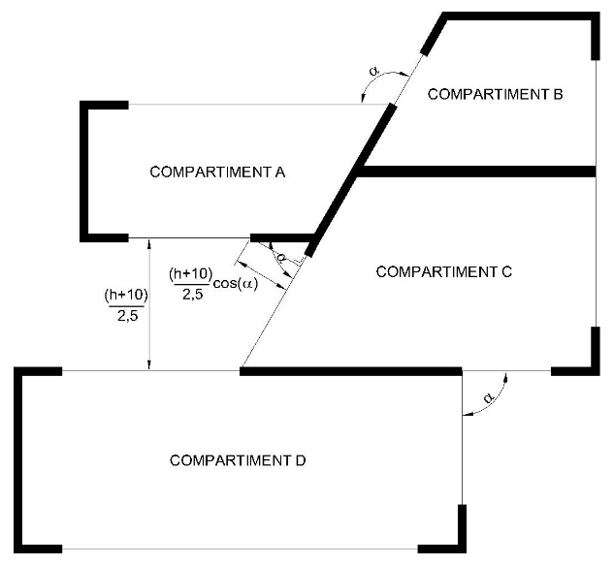
COMPARTIMENT | COMPARTMENT

The following formula may be used for buildings the building permit application for which was submitted prior to 1 July 2022:

$\frac{\text{h + 5}}{\text{2}}\text{cos}{\text{ α}}$

b) or the radiation of a fire between façades belonging to different compartments may not exceed 15 kW/m².

3.5.2 Double-walled façades.

3.5.2.1 Double-walled façade interrupted by a compartmentalisation.

The cavity of the double-walled façade is interrupted by an element that has at least E 60 in the extension of each compartment wall. This element covers the entire space included between the two walls and has a minimum length of 60 cm to be counted from the interior wall of the façade.

This element may contain openings, provided that the continuity of compartmentalisation through the cavity is ensured by a self-closing sealing device with a fire resistance E 60. This device must be tested in its bearing structure, in accordance with the direction of the compartment wall; its closure is commanded:

- either by thermal detection at the level of this device which reacts at a temperature of not more than 100°C.
- or by a smoke detector in the cavity or in all compartments along the façade, which meets the conditions set out in point 3.5.2.3.

When there are vents between the cavity of the double-walled façade and the interior environment of the building, only a smoke detector is allowed in the cavity or in all compartments along the façade. It meets the conditions set out in point 3.5.2.3.

3.5.2.2 Double-walled façade without compartmentalisation.

The double-walled façade without compartmentalisation must be consistent with one of the two options listed below.

3.5.2.2.1 Double-walled façade whose interior wall is fireproof.

The exterior wall of the double-walled façade consists of at least 50 % construction elements between the floors without specific fire resistance.

The inner wall has:
- either, over the full height, at least one fire resistance E 30 ( i↔o);
- or alternately every two storeys at least one fire resistance EI 30 (i↔o).

3.5.2.2.2 Double-walled façade open to the outside.

The requirements for single-walled façades may be applied to the interior wall when the outer wall contains fixed or mobile ventilation openings that automatically open in the event of fire.

The fixed vents are placed at 30 ± 10 degrees to the outside and upwards in relation to the horizontal, evenly distributed over at least 50 % of its surface area.

The mobile vents meet the same conditions as fixed ventilation openings in the event of fire.
The safety position of the mobile slats is triggered by a general fire detection system in the compartments along façades. The automatic operation must comply with the conditions laid down in paragraph 3.5.2.3.

3.5.2.3 Automatic closing/opening systems.

3.5.2.3.1 Operation

The closure/opening is commanded by an automatic fire detection system.

The installation is equipped with manual opening and closing systems. Its operation is reserved for the fire brigade. Its location must be determined in agreement with the fire brigade.

3.5.2.3.2 Operational security.

In the event of failure of the normal energy source (electrical energy, compressed air network), the detection system or the control system will put the closing/opening system in the safety position.

Any lack of energy source, power supply or electrical or pneumatic control must be reported automatically to the detection centre.

3.5.2.3.3 Operation in the event of fire in a neighbouring compartment.

If the closing/opening systems do not have a positive safety, the electrical lines connecting the closing/opening system must comply with paragraph 6.5.2.

4 REQUIREMENTS FOR THE CONSTRUCTION OF COMPARTMENTS AND EVACUATION AREAS.

4.1 Compartments.

The walls between compartments have at least the fire resistance indicated in Table 2.3.
 | Walls
Above the floor of E_{i}  One storey  Multiple storeys | EI 30  EI 60
Below E_{i},  including the floor of E_{i} | EI 60

Table 2.3 - Fire resistance of walls between compartments.

The connection between two compartments is permitted only if it is made by means of a self-closing or fire-closing door EI ₁ 30.

4.2 Internal stairwells.

4.2.1 General.

The stairs connecting several compartments are enclosed. The basic principles of 2 ‘Compartment and evacuation’ apply to it.

4.2.2 Design.

4.2.2.1 The interior walls of the stairwells have at least EI 60.

Their outer walls may be glazed if these openings are laterally deposited over at least 1 m with an element E 30.

4.2.2.2 The staircases must provide access to an evacuation level.

4.2.2.3 On each storey, the connection between the compartment and the stairwell is ensured by a door EI ₁ 30.

A direct connection of each storey of a duplex to the stairwell is not required, provided that:
- the total area of the duplex compartment or duplex apartment is less than or equal to 300 m²;
- the surface of the duplex storey that does not evacuate directly through the stairwell, is less than or equal to 150 m².

The direct connection of each layer of a triplex to the stairwell is not required, provided that:

- the area of each storey of the triplex that does not evacuate directly through the stairwell, is less than or equal to 100 m²;
- the connection to the triplex occurs at least:
- in the event of a triplex exclusively intended for daytime occupancy, which extends over the evacuation level (E), the floor situated immediately above it (E+1), as well as the floor situated immediately below it (E-1), it must be from the floor situated on the evacuation level;
- in the other cases, from the lowest level of construction and one of the other two storeys.

4.2.2.4 If several compartments are in the same horizontal plane, they may have one or more common stairwells provided that they are accessible from each compartment via a self-closing or fire-closing door EI ₁ 30.

4.2.2.5 The stairwells operating the underground storeys must not be directly extended to those operating the storeys above an evacuation level.

This does not preclude one being above the other, subject to the following conditions:
1. the walls they separate have EI 60.
2. access to each staircase is through a self-closing or fire-activated self-closing door rated EI₁ 30.

4.2.2.6 At the top of each interior staircase there is an ventilation opening with a diameter of at least 1 m² and flows into the open air. This opening is normally closed; Before opening, a manual control is used that is clearly visible at the evacuation level.

This requirement does not apply to stairwells between evacuation level and underground storeys.

If stairwells connect a maximum of two above-ground floors, with an area less than or equal to 300 m², to the evacuation level, the area of the ventilation opening may be limited to 0.5 m².

If, due to the presence of a duplex at the top of the building, the stairwell does not serve all the floors of the building, the vent will be connected to the stairwell by means of a tube the diameter of which is at least equal to the surface are required for the ventilation opening.

4.2.3 Stairs.

4.2.3.1 Construction provisions.

Stairs must have the following characteristics:
1. like the landings, they have R 30 or are designed in the same way as a concrete slab with R 30.
However, no fire stability is required for the stairs and landings composed exclusively of Class A1 materials with a melting temperature higher than 727°C (for example, steel meets this condition, aluminium and glass do not meet this condition);
2. they are equipped with handrails on both sides.
For stairways of a usable width, less than 1.20 m, one handrail is sufficient, provided that there is no risk of falling;
3. the tread of the steps is at least 20 cm at any point;
4. the rise of the steps should not exceed 18 cm;
5. their gradient must not exceed 75 % (maximum angle of gradient 37°);
6. they are of the ‘straight type’.
However, ‘spiral stairs’ are permitted if they have expelled steps and thus, in addition to the requirements mentioned above, (with the exception of paragraph 3) above, their steps have appeared at least 24 cm on the running line.

4.2.3.2 Useful width of stair arms, landings and air locks.

This usable width must be at least 0.80 m and reaches at least the required usable width b_{r} calculated in accordance with Annex 1 ‘Terminology’.

The stair arms and landings of the stairwells of the same compartment will not differ in their usable width by more than one passage unit.

If a compartment contains special-purpose premises, the theoretical useful stair width (according to Annex 1 ‘Terminology’) based on their number of users, is only calculated over the height between this compartment and the evacuation level.

4.3 Exterior staircases.

External stairs must provide access to an evacuation level.

The regulations of 4.2.3 apply, however, with the following derogation: no fire stability is required, but the material belongs to class A1.

The connection between the compartment and an external staircase is:
- either through a door;
- or via (an) escape terrace(s).

However, a step or part of stairway that is retractable or articulated may be used for the connection between the evacuation level and the immediately higher level of construction.

4.4 Evacuation routes and escape terraces.

4.4.1 General requirements

4.4.1.1 No point of a compartment must be further than:

a) in the case of premises with only daytime occupancy:
- 30 m from the evacuation route connecting the exits;
- 45 m from the access to the nearest exit;
- 80 m from the access to a second exit.

b) in the case of premises or all of the night-occupied premises:
- 20 m from the evacuation route connecting the exits;
- 30 m from the access to the nearest exit;
- 60 m from the access to a second exit.

The length of dead-end evacuation routes does not exceed 15 m.

The usable width of the evacuation routes, escape terraces and of their access, exit or passage doors is greater than or equal to the required usable width (see Annex 1 ‘Terminology’). It will be at least 0.80 m in the case of evacuation routes and doors and at least 0.60 m for flight terraces.

In a compartment, the connection between and to the stairs is via evacuation routes or over escape terraces.

The provisions of this point do not apply to car parks (see 5.2).

4.4.1.2 The following are deemed an exit from a compartment:
- an interior staircase in accordance with point 4.2;
- an external staircase in accordance with point 4.3;
- direct access to the open air at an evacuation level;
- an evacuation route at an evacuation level whose vertical inner walls have EI 60 and the doors of the premises issuing on these routes are self-closing or self-closing in the event of fire and have EI ₁ 30.

The route to be taken in the open air does not play a role in calculating these distances.

The doors on these routes do not have any locking device capable of obstructing the evacuation.

The possible vertical inner walls of the evacuation routes have EI 30 and the access doors to these routes EI ₁ 30.

This requirement, as well as the requirement set out in points 3.4.1 and 6.7.2.1, do not apply to compartments with only daytime occupancy whose surface does not reach 1 250 m².

This requirement, as well as the requirement set out in points 3.4.1 and 6.7.2.1, do also not apply on compartments with only daytime occupancy of which the surface area is less than 2 500 m² provided:
- that these compartments are equipped with an automatic sprinkler type extinguishing system adapted to the risks present;
- that the building is equipped with an automatic fire detection device suitable for total protection, which device automatically emits fire alarm and the detectors of which are adjusted to the existing risks;
- and that the products used for lining vertical walls, ceilings and floors of the compartments meet the fire response requirements of the evacuation routes.

The evacuation of premises or a set of premises with night occupancy takes place via evacuation routes whose vertical walls have EI 30 and the doors have EI ₁ 30.

This requirement does not apply to the evacuation of these premises if they are part of the operation of a building with a commercial function.

4.4.2 At an evacuation level

At an evacuation level, no display windows of building components with a commercial function, which do not have EI 30, may be issued on the evacuation route that connects the exits of other components of the building to the public road, with the exception of the last 3 m of this evacuation route.

4.5 Signalling.

The serial number of each storey must be clearly indicated at landings and in evacuation spaces in stairwells and lifts.

The indication of exits and emergency exits must comply with the provisions concerning health and safety signs at work.

5 CONSTRUCTION REQUIREMENTS FOR CERTAIN PREMISES AND TECHNICAL AREAS.

5.1 Technical premises and spaces.

5.1.1 General.

A technical room or a set of technical premises forms a compartment. This compartment can reach over several successive storeys.

Technical premises are subject to the regulations for compartments subject to the following changes:

1. access to two exits leading:
- either to an adjacent compartment via a door EI ₁ 30;
- or to a stairwell via a door EI ₁ 30;
- or to the open air, in such a way that an evacuation level can be reached;

2. deviating from 4.4.1, no point of the compartment must be further than:

- 45 m from the route connecting the two exits in the technical compartment;
- 60 m from the nearest exit;
- 100 m from the second exit;

However, if the area of the technical compartment does not exceed 1 000 m², one exit to a stairwell, to the outside or to another compartment is sufficient. In this case, the route to this exit must not exceed 60 m;

3. if the height of the technical compartment extends over several successive storeys (see 2.1) and if it includes several service floors connected by stairs or ladders:

- if the compartment surface area is less than 1 000 m², every two service floors, starting with the lowest, one access to a stairwell, to the outside or to another compartment, is sufficient;
- if the compartment surface exceeds 1 000 m², each service floor must provide access to at least one of the two exits; these exits vary from floor to floor;

4. the usable width of evacuation paths, stair arms, landings and air locks must not be less than 0.80 m.

5.1.2 Combustion units.

5.1.2.1 Combustion rooms with combustion appliances with a cumulative combustion rate greater than or equal to 75 kW and fuel storage spaces.

The combustion rooms with combustion appliances with a cumulative combustion rate greater than or equal to 75 kW and the fuel storage areas must be technical premises.

The regulations of point 5.1.1. apply, provided that the following changes are made:
- Each combustion room and fuel storage compartment forms a separate compartment;
- The interior walls of these combustion rooms and fuel storage spaces have EI 60;
- Access to these combustion rooms and fuel storage areas:
- Either through a self-closing door EI ₁ 60;
- Or by means of an air lock with the following characteristics:
1. it contains self-closing doors EI ₁ 30;
2. the walls have EI 60;
3. the surface area is at least 2 m²;
- Or via an open-air exit, such that an evacuation level is accessible.
The doors turn open in the escape direction.
- No point of these combustion rooms and fuel storage spaces must be more than 15 m from the nearest exit.

The capacity of a fuel storage space must be limited so that the total fire load of the fuel storage space is less than or equal to 750 GJ.

5.1.2.2 Common provisions.

The design, construction and fittings of the combustion divisions must comply with the provisions of paragraph 4 of Annex 7.

5.1.2.3 Deviating provisions.

The following deviating provisions apply for buildings whose building permit application is submitted before 1 July 2022:
- Point 5.1.2.1: Not applicable to combustion units with combustion appliances with a total useful heat output (also referred to as total rated power) less than 70 kW;
- Point 5.1.2.1: Not applicable to combustion units with combustion appliances having a total useful heat output (also called total rated power) greater than or equal to 70 kW if the access to the combustion department and the fire resistance of the walls, floors, ceilings and doors of the combustion department meet the requirements of standard NBN B 61- 001 +A1: 1996.

Contrary to this standard, the combustion departments and their annexes may be connected to the other parts of the building via a self-closing door EI ₁ 60 provided that it does not open to a stairwell or an lift landing or a room with particular risk. The door turns in the escape direction.

5.1.3 Transformer rooms.

5.1.3.1 General.

They comply with the requirements of the General Regulation on Electrical Installations (RGIE/AREI).

The following furthermore applies:
- the walls have EI 60, except the outer walls;
- the interior doors have EI ₁ 30;
- if water (from any origin, including extinguishing water) can reach the floor, e.g. by infiltration or via cable ducts, all measures must be taken to ensure that the water level is constantly and automatically below the level of the vital parts of the electrical installation, as long as it is in use.

If the oil content of the whole of the appliances reaches 50 litres or more, the regulations of NBN C 18-200 ‘Guidelines for the fire protection of the premises of electricity transformation’ apply.

5.1.3.2 On-site mounted or prefabricated posts.

An on-site installed post or prefabricated post is set up in a room with walls EI 60.

The access, if not from the outside, is via a door EI ₁ 30.

5.1.4 Domestic waste disposal.

5.1.4.1 Chutes are not permitted.

5.1.4.2 Room for domestic waste storage.

The walls have EI 60.

The room is accessible via a self-locking door EI ₁ 30.

5.1.5 Pipe sleeves.

5.1.5.1 Vertical sleeves.

When vertical sleeves penetrate through horizontal walls requiring fire resistance, one of the following three measures apply:

1. the walls of the vertical sleeves have a fire resistance EI 60; the hatches and doors are EI₁30.

They have decent ventilation at the top.
The free ventilation cross-section of the sleeve must be at least 10 % of the total horizontal cross-section of the sleeve, with a minimum of 4 dm².

The free aeration cross-section may be equipped with motorised ventilation valves, the opening of which is commanded as follows:
- automatically on detection of a fire in the sleeve;
- automatically, in the event that fire is detected in the building, if it is equipped with a fire-detection installation for general purposes;
- automatically in the event of a failure in the energy source, power supply or control system (positive safety device);
- manually, operated on evacuation level, in a place determined in mutual consent with the fire department.
If the free ventilation cross-section of a tube is equipped with a motorised ventilation valve, any gas pipes in this tube must comply with the requirements of standard NBN D 51-003 or the standard NBN D 51-006 for the pipes and connections in a non-ventilated technical tube.

2. a construction element with at least the required fire resistance of the horizontal wall is located at the level of the passage;

3. the walls of the vertical sleeves have EI 30; the trap doors and doors EI ₁ 30; At every compartment, vertical sleeves are interrupted by horizontal closures with the following characteristics:

- they consist of a class A1 and/or A2-s1,d0 material;
- they cover the entire space between the pipes;
- they have EI 30.

In cases 2 and 3, the sleeves must not be ventilated.

5.1.5.2 Horizontal sleeves.

Where horizontal ducts penetrate vertical walls that must be fire resistant, apply one of the following three measures:

1. the walls of the horizontal sleeves and the trapdoors and doors have at least the required fire resistance of the vertical wall;

2. at the level of the penetration there is a construction element with at least the required fire resistance of the vertical wall;

3. the walls of the horizontal sleeves have EI 30; the trap doors and doors EI ₁ 30; the sleeves are interrupted at each compartment by vertical screens with the following characteristics:
- they consist of a class A1 and/or A2-s1,d0 material;
- they cover all space between the cables/pipes;
- they have EI 30.

5.2 Car parks.

By way of derogation from the basic principle laid down in point 2.1, a car park can form a compartment whose surface area is not limited even if there are several communicating floors.

5.2.1 Structural elements.

By way of derogation from point 3.2, the structural elements of the car park have R 120 and the floors of the parking storeys and of the slopes have R 120.

If the roof has no other function than protecting the car park from the weather conditions:
- the structural elements of the roof have R 30;
or are the structural elements of the roof separated from the rest of the car park by an EI 30 construction element.

For the open parking storeys, the structural elements are not subjected to any Fire-resistance requirement, provided that:
- the floors of these open parking floors and the slopes between these open parking storeys have at least REI 60;
- and that these structural elements do not carry any other compartment.

5.2.2 Compartment.

The walls between the car park and the rest of the building have EI 60, and the connection between the car park and the rest of the building is ensured:
- either with an air lock with walls rated EI 60 and self-closing or fire-activated self-closing doors rated EI₁ 30;
- or with a self-closing or fire-activated self-closing door rated E₁ 60.

5.2.3 Car park under various buildings.

By way of derogation from point 1.3, parking spaces of adjacent buildings must not be separated by a wall. These car parks are therefore only one and the same car park.

In that case, the structural elements of the entire car park have R 120, including the structural elements of the open parking storeys.

5.2.4 Common provisions.

The design, construction and layout of the car park complies with the provisions of point 3 of Annex 7.

5.2.5 Deviating provisions.

Points 5.2.1 to 5.2.4 do not apply to façades on a building for which an urban planning permit application was submitted before 1 July 2022 if it meets the conditions below.

By way of derogation from point 3.2, no requirements for fire resistance are imposed on the structural elements of open car parks whose horizontal walls have REI 60.

The walls between the car park and the rest of the building have EI 60.

Certain non-residential premises may be included in the parking compartment, such as: transformer rooms, storage rooms, archive rooms, technical rooms, etc.

The walls of these rooms show EI 60 and access is through a self-closing or self-closing door in the event of fire EI ₁ 30.

The special requirements on boiler sections, transformer rooms and waste storage rooms still apply (see also points 5.1.2, 5.1.3 and 5.1.4 respectively).

Evacuation is arranged as follows on each storey:
- at least two stairwells or external staircases comply with the requirements set out in 4.2 or 4.3 and are accessible from any point of the storey; the distance to the nearest staircase must not exceed 45 m; the minimum usable width of these stairs is 0.80 m;
- as stated in 2.2.2, third paragraph, the required access to one of the two stairwells on the considered storey may be replaced by a direct exit to the open air;
- on the storey closest to the exit level, the inclined route may replace one of the stairwells or external steps if the slope measured in its centreline does not exceed 10 %;
- the limit of the slope to 10 % does not apply to compartments whose surface area is equal or less than 500 m², if evacuation via the slope remains possible;
- apart from the signalling determined in 4.5, the evacuation routes, on each storey, are also indicated on the floor or just above it.

However, a single exit per storey (interior staircase, external staircase, direct exit to the open air or inclined route on the storey closest to the exit level) is sufficient provided:
- the car park is no more than two component layers high;
- neither of these two storeys is located more than two floors above, or below the car exit level;
- the car park does not feature any points located more than 15 m from the access to the evacuation route leading to the exit;
- the car park does not feature any points located more than 30 m from the access to the exit.

In enclosed car parks with a total surface greater than 2 500 m², the measures necessary to prevent the spread of smoke must be taken.

5.3 Halls.

5.3.1 General.

If more than 500 people can be accommodated, these rooms may only be set up underground if the difference between the lowest floor level of these rooms and the nearest evacuation level is not greater than 3 m.

If the above-mentioned rooms are intended for a maximum of 500 persons, they may be set up underground provided that the lowest floor level accessible to the public is not more than 4 m below the average level of different evacuation levels of the establishment.

The number of exits is determined as for the compartments.

5.3.2 Structure.

In addition to complying with the regulatory requirements applicable to these spaces, the walls forming these premises or whole of premises also have the same fire resistance as the walls of a compartment.

Each passage in the vertical walls is closed with a self-closing or fire-activated self-closing door rated EI₁ 30.

These doors open in the escape direction.

No object may interfere with the evacuation to the exits.

5.4 Retail or commercial complex.

The establishment of retail premises opening onto indoor galleries is permitted at an evacuation level and on the adjacent storeys provided that:

1. the complex with its galleries is separated from the other building parts by walls with EI 60;
2. the other building parts have their own exits independent of the exits of the retail or commercial complex.

The partitions between the business premises have EI 30 and run through the possibly suspended ceiling. The latter requirement expires if the retail or commercial complex is equipped with an automatic extinguishing system of the type of sprinkler adapted to the risks present.

5.5 Collective kitchens.

The collective kitchens, potentially including the restaurant, are separated from the other building parts by walls EI 60.

Each passage is closed by a self-closing or fire-activated self-closing door rated EI₁ 30.

These doors turn in the escape direction of the kitchen.

When the kitchen and restaurant are separated from each other, the horizontal and vertical transport systems between kitchen and restaurant must meet the following conditions:
- this transport takes place in ducts with walls EI 60 when it passes through other premises;
- the transport system is closed at the height of the compartment wall(s) with a device EI ₁ 60.

When the kitchen is not compartmentalised in relation to the restaurant, each fixed frying appliance is equipped with a fixed automatic extinguishing system which is connected to an appliance that interrupts the supply of energy to the frying appliance.

6 EQUIPMENT OF THE BUILDINGS.

6.1 Lifts and freight lifts.

6.1.1 General.

6.1.1.1 The machinery and associated parts of a passenger or freight lift are only accessible for maintenance, inspection and emergencies. The drive is located:
- either in an engine room;
- or in the shaft.

Control bodies may be accessible from the platforms provided that they do not adversely affect the required fire integrity of the ramp wall or the wall of the shaft in which they are placed.

6.1.1.2 In the event of an abnormal increase in the temperature of the machine and/or of the other electrical equipment, the lifts must stop on a ramp so that passengers can alight.

Automatic return to normal operation will only be possible after sufficient cooling.

6.1.1.3 Extinguishing systems that use water are not permitted in the shaft(s).

6.1.2 Design.

6.1.2.1 The aggregate, consisting of one or more shafts and the engine room, if any, as well as lift platforms which should form an air lock for the underground floors, is enclosed by walls with EI 60.

Their walls may be made of glass, provided that they meet the requirements from point 3.5.

The access doors between the compartment and the air lock have EI₁ 30, and are self-closing, or fire-activated self-closing.

If the surface of the air lock is less than the surface of the lift cage or freight lift, the access door between the compartment and the air lock, a fire-activated self-closing revolving door EI ₁ 30 is operated by a fire detection system containing at least the following:
- a smoke detector in the shaft;
- a smoke detector in the compartment in the vicinity of the air lock access door.

The access platform may be part of the evacuation route.

6.1.2.2 The whole of the lift shaft doors or goods lift has E 30. The fire resistance according to the NBN EN 81-58 standard, whereby the platform wall on the side of the platform is exposed to the fire. The platform wall must be tested by means of possible operating and monitoring bodies, which make part of it.

The shaft doors tested by other methods are accepted in accordance with the Royal Decree of 12 April 2016 on the marketing of lifts and safety components for lifts, provided that they have at least the same degree of fire resistance.

These requirements must not apply where the lift(s) are set up in a stairwell serving the storeys above an evacuation level, provided:
- that on all storeys operated by this stairwell with lift(s), in each compartment, the connection to this stairwell with lift(s) is via evacuation routes;
- and that on all storeys served by this stairwell with lift(s), the connection between this evacuation route and this stairwell with lift(s) is ensured by a self-closing or fire-activated self-closing with EI1 30 which gives access to a landing in this stairwell with lift(s).

6.1.2.3 The regulations of points 6.1.2.1. and 6.1.2.2. are not be required in the following cases:

a) on all storeys operated by the lift or freight lift, if this lift or freight lift serves the storeys of only one compartment consisting of several storeys;
b) on the storey(s) of only one of the compartments operated by the lift or freight lift, provided that this compartment is not a parking compartment or an apartment, and that the layout of this lift or freight lift on the other storeys does comply with the regulations of points 6.1.2.1. and 6.1.2.2 or with point (c) below;
c) on the storey(s) where the lift or freight lift leads directly outdoors, provided that the layout of that lift or freight lift on the other storeys does comply with the regulations of points 6.1.2.1 and 6.1.2.2 or point (b) above.

6.1.2.4 Lifts and freight lifts whose drive is located in an engine room.

The interior walls of the engine room, which do not overlook the lift shaft have EI 60.

The doors or trapdoors in these walls have EI ₁ 30.

Access to the engine room must be guaranteed to the fire-fighters.

6.1.2.5 Oleohydraulic lifts and freight lifts.

The space in which the propulsion of an oleohydraulic lift or freight lift is fitted will be fitted with a volume of at least 1.2 times the oil capacity of the machinery and reservoirs.

If the propulsion of an oleohydraulic lift or freight lift is installed in an engine room, the electrical equipment, as well as the electrical and hydraulic lines running from the engine room to the lift shaft, must be positioned higher than the highest level that the run-out oil in the engine room can reach.

6.1.2.6 Lifts and escalators.

The platform of the lift(s) may be the platform of one or more escalators. The whole consisting of one or more shafts and any engine room, as well as access platforms of the lift(s) and escalator(s), then only form one whole.

6.1.3 Ventilation.

6.1.3.1 The shaft, the engine room or the entire shaft and engine room are naturally vented through outside air outlets in the upper section.

However, the shaft or the whole shaft and engine room may be ventilated through internal air vents provided that the layout of the lift or freight lift complies with:
- either the conditions described in point 6.1.2.3 under a);
- or the case described in (b) of point 6.1.2.3 to the extent that the storey(s) where the regulations of points 6.1.2.1 and 6.1.2.2 are not required is located above the other storey(s).

6.1.3.2 Minimum cross-section of the ventilation openings must be 1 % of the horizontal surface of the area from which the air is supplied.

6.1.3.3 The vents may be fitted with motorised ventilation valves, the opening of which is commanded as follows:
- it is automatically commanded to ensure adequate ventilation for the users of the lift, even in the event of a prolonged downtime;
- automatic openings are mandatory in case of abnormal temperature increase of the machine and/or monitoring bodies;
- automatic openings are mandatory in case when fire is detected in the lift shaft and/or in the engine room;
- is automatically commanded when a fire is detected in the building, if it is equipped with a general fire detection system;
- is automatically commanded in the event of a failure in the energy source, power supply or control system (positive safety device);
- manually operated at the evacuation level.

6.1.4 Operation in the event of fire.

The operation of the lifts in the event of fire complies with the following regulations or any other rule of good craftsmanship that provides an equivalent level of safety, in accordance with the Royal Decree of 12 April 2016 on the marketing of lifts and safety components for lifts.

The operating principle of the lifts in the event of fire is that when the fire detection system or a manual alarm facility receives a fire signal, the system moves the lift cage to the lift landing at the evacuation level, allows passengers to step out there and then removes the lift from normal service.

6.1.4.1 The operation of the lifts in the event of fire complies with the requirements of standard NBN EN 81- 73.

6.1.4.2 The platform of the lift at the evacuation level is recorded as designated lift platforms.

6.1.4.3 Each lift battery must be equipped at least with a manual call facility at an evacuation level.

In addition, if the building is equipped with a general fire detection system or with a fire detection system in the shafts and/or in the engine rooms, in the event of fire, this installation must transmit a signal to the lifts.

6.1.4.4 When a general or partial detection in the building is required in a building, and the machinery of the lifts or freight lifts is located in the shaft, a smoke detector should be installed in the shaft.

6.1.4.5 If a fire-detection installation detected fire on the platform that corresponds to the designated main platform, the lift must receive one or more additional electrical signals, so that the lift car could be diverted to the designated substitute platform.

6.1.4.6 When the lifts are on the designated platforms in the event of a fire, it should be possible that the fire brigade can easily check that the lift cages are there, and that no one is locked in the lift.

The lifts, which, at the time of their arrival to the designated platform,are stationary there with doors open and put out of normal operation, meet the said requirement.

6.1.4.7 The lift can only be returned to normal operation by an authorised person.

6.1.4.8 The following deviating provisions apply to buildings whose building permit application was submitted prior to 1 April 2017:

- Point 6.1.4.1: Applicable to the lifts designed or renovated after 31 March 2017 only.

6.2 Paternoster lift, container transport and freight lift with loading and unloading automation.

6.2.1 These devices have their own engine rooms, shafts and platforms.

The engine rooms are located at the top of the shaft. The inner walls of the engine rooms and shafts have EI 60.

The interior access doors have EI ₁ 30.

The shaft walls on the side of the platforms and the surveillance hatches in these walls have EI 30.

The shaft doors or access hatches of these devices operate automatically and are normally closed.

If the installation of the container transport follows a horizontal and/or vertical trajectory and thereby passes through floors or compartments, doors are provided at each of these passages.

Their hatches and doors have E 30. They operate automatically and are normally closed.

In the event of a fire, the installations are put out of service.

6.2.2 The installation of paternoster lifts for passenger transport is prohibited.

6.3 Escalators.

6.3.1 The stairwell of escalators has walls with EI 60.

6.3.2 Access to the stairwell takes place on each storey, via a self-closing or fire-activated self-closing EI ₁ 30.

6.3.3 The escalator is automatically switched off as soon as a fire is detected in a compartment to which it leads.

6.3.4 The regulations of points 6.3.1 and 6.3.2 are not required in the following cases:

a) on all storeys operated by the escalator, if this escalator serves the storeys of only one compartment consisting of several storeys;
b) on the storey(s) of only one of the compartments operated by the escalator, provided that this compartment is not a parking compartment, and that the layout of this escalator on the other storeys does comply with the regulations of points 6.3.1 and 6.3.2 or with point (c) below;
c) on the storey(s) where the escalator leads directly outdoors, provided that the layout of that escalator on the other storeys complies with the regulations of points 6.3.1 and 6.3.2 or point (b) above.

6.4 Special lifts.

The special lifts and their operation in the event of fire comply with the following regulations or any other rule of good workmanship that provides an equivalent level of safety, in accordance with the Royal Decree of 12 April 2016 on the marketing of lifts and safety components for lifts.

6.4.1 Lifts intended to evacuate persons with reduced mobility.

Where the lift intended for the evacuation of persons with reduced mobility is deemed mandatory in a building, the lift must be designed and constructed so to meet the following requirements, apart from the requirements included in point 6.1.

6.4.1.1 This lift must be designed and built in such a way that its structural features do not obstruct or impede access and use by persons with reduced mobility.

6.4.1.2 On all storeys the lift platforms form an air lock corresponding to the regulations from point 6.1.2.1, whereby the surface area is equal to, or larger than the surface of the cage.

6.4.1.3 The lift cages must be accessible at least to one person in a wheelchair and an accompanying person.

The minimum dimensions of the lift cage must be 1.1 m (width) x 1.4 m (depth).

6.4.1.4 The shaft doors open and close automatically and have usable width of at least 0.90 m.

6.4.1.5 The evacuation is carried out under the supervision of a competent person. For that purpose, the lift must be equipped with a switch with ‘evacuation key’, which enables the authorised person to take over the control of the lift.

6.4.1.6 The lifts intended for the evacuation of persons with reduced mobility must be marked by a clear and recognisable alarm.

6.4.1.7 The lift must contain an intercom system enabling a two-way communication process in situations when the lift is in the evacuation mode. Such a system must enable the communication between the lift car, the evacuation floor and the engine room, or the rescue operations dashboard.

The communication equipment in the lift cage and at the evacuation level must contain a built-in microphone and speaker, a telephone with receiver is not allowed.

The telecommunication wiring must be installed in the lift shaft and/or in the engine room, if appropriate.

6.4.1.8 With the exception of the lifts, which serve two storeys only, each lift platform must have an intercom system enabling a two-way communication process in situations when the lift is in the evacuation mode. Such a system must enable the communication between each lift platform, the evacuation floor and the engine room, or the rescue operations dashboard, so that the floors with evacuated persons with reduced mobility can be identified, and the information in that regard transmitted to the persons responsible for the evacuation procedure.

The communication equipment on each lift platform and at the evacuation level must contain a built-in microphone and speaker, a telephone with receiver is not allowed.

The communication system is designed in such a way that its operation remains guaranteed in the event of defect on the communication system of the lift cage mentioned in point 6.4.1.7.

6.4.2 Lifts intended for the fire brigade.

If a building is equipped with one or more lifts intended for fire brigade, it must meet the following regulations apart from the regulations included in point 6.1.

6.4.2.1 The lifts intended for fire brigades, and the operation of those lifts in the event of fire meet the requirements form NBN EN 81-72 standard.

6.4.2.2 On all storeys the lift platforms form an air lock corresponding to the regulations from point 6.1.2.1, whereby the surface area is equal to, or larger than the surface of the cage.

6.4.2.3 If there is no EI 60 wall in a lift battery to separate the lift intended for fire brigade from the other lifts in the same shaft, all lifts and their electrical equipment must have the same fire protection as the lift intended for the fire brigade.

6.4.2.4 The minimum dimensions of the lift cage must be 1.1 m (width) x 2.1 m (depth).

6.4.2.5 The shaft doors open and close automatically and have usable width of at least 0.80 m.

6.4.2.6 The platforms on the floor that provides access to fire brigade contains a switch with a ‘fire-brigade key’, which will allow the fire-brigade to take over the control of the lift.

6.4.2.7 The lift must be capable of reaching the farthest end of the fire-brigade access floor in less than 60 seconds after the door closes.

6.4.3 Deviating provisions.

The following deviating provisions apply to buildings whose building permit application was submitted prior to 1 April 2017:

- Point 6.4.1.4: The shaft doors to the lifts designed before 1 April 2017, open and close automatically and have usable width of at least 0.80 m.
- Points 6.4.1.6, 6.4.1.7 and 6.4.1.8: Applicable to the lifts designed or renovated after 31 March 2017 only.
- Points 6.4.2: Not applicable.

6.5 Low-voltage electrical installations for driving force, lighting and signalling.

6.5.1 They comply with the regulations of the legal and regulatory texts in force, as well as with the General Regulations
on the Electrical Installations (RGIE/AREI).

6.5.2 The electrical lines supplying installations or appliances which must absolutely remain in service in the event of fire are placed in such a way that the risks of complete shutdown are spread.

On their route up to the compartment where the installation is located, the electrical lines must have the following fire resistance:

a) either an intrinsic fire resistance which is at least
- PH 60 according to NBN EN 50200 for pipes the outer diameter of which is less than or equal to 20 mm and the cross-section of the conductors is less than or equal to 2.5 mm²;
- Rf 1 h is according to add. 3 of NBN 713-020 for pipes the outer diameter of which is greater than 20 mm or the diameter of the conductors is greater than 2.5 mm²;

b) or Rf 1 h, according to add. 3 of NBN 713-020, for pipes without intrinsic fire resistance placed in tubes.

These regulations do not apply if the operation of the installations or appliances remains assured even in the event of a failure of the power supply.

The installations or appliances referred to are:
a) the safety lighting and, where appropriate, the replacement lighting;
b) the notification, warning and alarm systems;
c) the smoke extraction installations;
d) water pumps for firefighting and any drain pumps;
e) the special purpose lifts mentioned in point 6.4.

6.5.3 Autonomous power sources.

The circuits referred to in 6.5.2 must be capable of being powered from one or more autonomous power sources; the power of those sources must be sufficient to simultaneously supply all installations connected to those circuits.

As soon as the normal power fails, the autonomous sources automatically and within one minute ensure the operation for one hour of the above-mentioned installations.

6.5.4 Safety lighting.

The safety lighting complies with the requirements of standards NBN EN 1838, NBN EN 60598-2-22 and NBN EN 50172.

This safety lighting may be supplied by the normal power source, but if it falls out, the power supply must be made by one or more autonomous power source(s).

Autonomous lighting devices connected to the circuit supplying the normal lighting concerned may also be used provided they offer all the guarantees for proper functioning.

6.6 Systems for flammable gas, distributed by pipes.

The combustible gas installations must comply with:
- NBN D 51-001 - Central heating, ventilation and air conditioning - Premises for pressure reducing equipment for natural gas;
- NBN D 51-003 - Installations for flammable gases lighter than air, distributed by pipes;
- NBN D 51-004 - Installations for flammable gas lighter than air, distributed by pipes - Special installations;
- NBN D 51-006 - Gas installations for commercial butane or commercial propane in a relaxed gas phase with a maximum working pressure (MOP) of 5 bar - Indoor pipes, installation and commissioning of consumables - General technical and safety regulations.

6.7 Aeraulic systems

If an aeronautical installation is present, it must comply with the following conditions.

6.7.1 System design

6.7.1.1 Integration of premises or closed spaces in the premises

No room or closed space, even in an attic or in a basement, may be integrated into the network of air ducts, unless these spaces comply with the regulations imposed on the ducts.

6.7.1.2 Use of staircases for air distribution

No stairwell may be used for the supply or discharge of air from other premises.

6.7.1.3 Air reuse restrictions

The air extracted from rooms with a particular fire hazard, storage area for flammable products, boiler room, kitchen, garage, car park, transformer room, garbage storage room, must not be redistributed and should be discharged outside.

The air extracted from other premises may:
- either be re-directed to the same premises, provided that a smoke valve is installed in the recycling duct in accordance with point 6.7.5;
- or be distributed to other premises to serve as compensation air for mechanical extraction systems with direct exhaust to the outside, provided that an additional smoke valve and a duct system for direct exhaust to the outside are provided with this recycling air.

In both cases, a smoke detector must be installed in the recycling air before the smoke valve. If smoke is detected in the recycling air, the air treatment groups discontinue their operation, the smoke valves close and, in the second case, the duct system intended to exhaust the recycling air open automatically and will be ready for operation once the fire brigade activate the air treatment groups.

However, the above devices (smoke valve on the recycling air and smoke detection in the extraction duct) are not required for air treatment groups operating only one single room with a total flow rate less than or equal to 5 000 m³/h.

6.7.2 Construction of the air ducts.

6.7.2.1 Air ducts on evacuation routes.

On the evacuation routes, as well as in the service ducts and in places that are inaccessible after the building is finished, the ducts are made from class A1 materials; the insulation products including their coatings are at least of class A2-s1,d0.

The flexible pipes must be at least class B-s1, d0 and their length does not exceed 1 m.

The air ducts in the evacuation routes with their suspensions have a fire stability of at least ½ h.

This provision is fulfilled if:
- either the ducts and their suspensions have EI 30 (ho io) or EI 30 (ve io) when placed horizontally or vertically respectively;
- or the ducts are suspended in order to comply with the following regulations:
- suspensions are made of steel
- distance axis on axis between suspensions ≤ 1 meter
- force per suspension point ≤ 500 N
- voltage in the suspensions ≤ 18N/mm²
- distance between ducts and suspensions ≤ 5 cm
- sliding voltage ≤ 10 N/mm²

The requirements of this paragraph do not apply to the exceptions set out in point 4.4.1.2 and to the compartments equipped with an automatic sprinkler type extinguishing system adapted to the risks present.

6.7.2.2 Extraction ducts from collective kitchens

The extraction ducts from collective kitchens are made from class A1 materials.

The extraction ducts located outside the collective kitchens are:
- either placed in tubes whose walls have EI 60;
- or have EI 60 (ho i ↔ o) or EI 60 (ve i ↔ o) when placed horizontally or vertically respectively.

The suction ducts in the collective kitchens with their suspensions have a fire stability of at least ½ h.

This provision is fulfilled if:
- either the ducts and their suspensions have EI 30 (ho io) or EI 30 (ve io) when placed horizontally or vertically respectively;
- either the ducts are suspended in order to comply with the following regulations:
- suspensions are made of steel
- distance axis on axis between suspensions ≤ 1 m
- force per suspension point ≤ 500 N
- voltage in the suspensions ≤ 18N/mm²
- distance between ducts and suspensions ≤ 5 cm
- sliding voltage ≤ 10 N/mm²

6.7.3 Passages of air ducts through walls.

6.7.3.1 General.

The wall passages of ducts must generally comply with 3.1.

This regulation does not apply to the passage of ducts through walls with EI 30, subject to the following conditions:
- the air ducts are made of materials of class A1 over a distance of at least 1 m on either side of the pierced wall;
- the air ducts connecting to these passageways and passing through horizontal evacuation routes must not be connected to the air mouths located in those evacuation routes;
- it is a compartment with only premises with daytime occupancy.

6.7.3.2 Passages with fire-resistant valves

No air duct may:
- pass through a wall requiring a fire resistance greater than or equal to EI 60;
- pass through a partition between two compartments for which a fire resistance greater than or equal to EI 30 is required or pass through a wall of a pipe sleeve requiring a fire resistance greater than or equal to EI 30;

unless it meets one of the following conditions:

a) a fire-resistant valve with the same fire resistance (EI-S) as required for the perforated wall and complying with 6.7.4 is installed at the level of the wall passage.
However, this valve can be placed off the axis of the wall and connected to this perforated wall by a duct provided that the whole of the duct and valve has the same fire resistance (EI-S) as required for the transit wall;

b) the duct has the same fire resistance EI i↔o as required for the perforated wall or is placed in a sleeve with the same fire resistance as required for the perforated wall along the entire length of the passage through the compartment or through the protected area. This duct must not have an opening unless provided with a valve described in paragraph (a) above;

c) the duct simultaneously meet the following conditions:
- the diameter of the passage does not exceed 130 cm²;
- in the passage of the wall, the duct is equipped with a device which, in the event of a fire, closes the passageway and then has the same fire resistance as required for the perforated wall.

The air ducts located in tubes reserved solely for them and culminating at their top end into a technical room containing only the air handling groups they connect may pass through the walls of the technical room without any additional equipment. In this case, the ventilation of the tubes as required in 5.1.5.1 must be achieved through the technical room.

6.7.4 Fireproof valves

6.7.4.1 Operation

Two types of operation are distinguished:

Type A: the valve is automatically closed when the temperature of the air flowing in the duct exceeds a limit value.

Type B: valve type A which can also be closed by a remote control by means of a system with positive safety.

Closing is performed by a system that does not require external energy.

If a general fire detection system is mandatory, the fire-resistant valves must be at the limits of the compartments of the control type B.

In case of detection, the valves of the infested compartment are automatically closed.

‘Limits of compartments’ means:
- the partitions to other compartments;
- the walls of pipe ducts passing through the compartment;
- the walls between the compartment and the stairwells.

6.7.4.2 Performance of the valve

The fire-resistant valve placed in the passageways of walls has the following performance:

Fire resistance of the wall | Fire resistance of the valve
EI 60 | EI 60 (ho i ↔ o) S  EI 60 (ve i ↔ o) S
EI 30 | EI 30 (ho i ↔ o) S  EI 30 (ve i ↔ o) S

Table 2.4 - Fire-resistant valves.

In the absence of CE marking, the valve meets the following requirements:
a) after 250 consecutive opening and closing cycles, a valve of the same manufacture may not be deformed or damaged;
b) the valve resists the corrosive atmosphere in which it is placed;
c) no periodic lubrication is required for the proper functioning of the valve;
d) the valve box contains a valve position indicator on the top and an indelible arrow that indicates the direction of the airflow. A plate indicates the inner dimensions of the valve, the manufacturer’s name, the manufacturing number and year of manufacture; it also bears a clearly visible and indelible mark indicating a fire protection device;
e) after operation of the valve, it must be able to be switched back off.

6.7.4.3 Installation of the valve

The valve must be fixed in the wall and secured in such a way that the stability of the valve is ensured independently of the two connecting ducts, even if one of the two ducts disappears.

For the inspection and maintenance of the valve, an easily accessible inspection door is placed on the valve cabinet or on the sleeve in the immediate vicinity of the valve. This door has the same fire resistance as required for the duct.

In order to facilitate the localisation of the fire-resistant valve, a clearly visible and indelible mark must be affixed indicating a fire protection device together with the words ‘fire-resistant valve’. This mark is placed on the inspection door or in the room perpendicular to the valve.

6.7.5 Smoke valves

A smoke valve meets the following conditions:
1. the density of the valve must have one of the following qualities:
a) when closed, and at static pressure difference of 500 Pa, the air loss may not exceed 60 l/s.m²;
b) class 3 according to standard NBN EN 1751;
2. the gasket used to obtain this density must withstand temperatures fluctuating from - 20 °C to 100 °C for 2 h, after which the valve still meets the above density test;
3. the smoke valve closing system has positive safety.

6.7.6 Operation in the event of fire of the aeraulic installations

In the areas of the building, which are equipped with a fire detection system, the air treatment groups operating only the infested compartment are shut down in the event fire is detected.

The installation of a central fire control board to operate certain elements from the aeronautical installations may be imposed in special cases by the competent fire service. In this case, this sign is placed at a point that is easily accessible to the fire brigade and located at the usual level of access.

6.8 Notification, warning, alarm and fire fighting equipment devices.

The notification, warning, alarm and fire fighting equipment is determined in agreement with the fire brigade, in accordance with the following guideline.

6.8.1 In the buildings, notification and firefighting devices are mandatory.

6.8.2 Number and location of fire alarm, warning, alarm and fire-fighting devices.

6.8.2.1 The number of devices is determined by the dimensions, condition and risk in the premises.

The devices must be judiciously spaced in sufficient numbers to enable them to serve every point of the space concerned.

6.8.2.2 Install devices requiring human intervention in visible or clearly indicated places that are freely accessible under all circumstances. They are located, among other things, near exits, landings, corridors and are fitted in such a way that they do not interfere with circulation and cannot be damaged or impacted.

The outdoor devices are protected from all weather conditions if necessary.

6.8.2.3 The signalling must comply with the applicable rules.

6.8.3 Fire alarm.

6.8.3.1 It must be possible to immediately notify the fire services of the discovery or detection of a fire through a reporting device in each compartment; in buildings whose surface area is less than 500 m² per storey, one reporting device for the building is sufficient.

6.8.3.2 The necessary connections must be continuously and immediately ensured by telephone or electrical lines, or by any other system providing the same operating guarantees and the same operating facilities.

6.8.3.3 All devices that can establish a connection following human intervention display an indication of their intended use and instructions for use.

If this is a telephone, this message must indicate the call number to be formed, unless the connection is made directly or automatically.

6.8.4 Warning and alarm.

The warning and alarm signals or messages must be receivable by all stakeholders and must not be confusable with other signals.

6.8.5 Firefighting equipment.

6.8.5.1 General.

The firefighting equipment consists of devices or systems that may or may not be automatic.

The quick-action extinguishers and the wall reels serve for first intervention, i.e. they are intended for use by residents.

6.8.5.2 Portable or mobile quick-action extinguishers.

These devices are determined by the nature and extent of the hazard.

6.8.5.3 Wall reels with axial feed supply, wall hydrants.

6.8.5.3.1 The number and location of these devices must be determined by the nature and extent of the fire hazard.

If the surface of a building is less than 500 m² no wall reel is required (except for special risks). In all other cases, the number of wall reels is determined as follows:
1. the water jet reaches each point of a compartment;
2. compartments larger than 500 m² have at least one wall reel.

The press coupling of any wall hydrants is adapted to the couplings used by the fire brigade.

6.8.5.3.2 The riser pipe supplying any appliances with pressurised water has the following characteristics:

the inner diameter and feed pressure must be such that the pressure at the least divided reel meets the requirements of NBN EN 671-1, taking into account that three reels with axial power supply must be able to operate simultaneously for ½ h.

6.8.5.3.3 Any appliances are supplied with pressurised water without prior operation. This pressure must be at least 2.5 bar at the most unfavourable point.

6.8.5.4 Underground and above-ground hydrants.

6.8.5.4.1 These above ground and underground hydrants are supplied by the public water supply network via a pipe with a minimum inner diameter of 80 mm.

If the public network is unable to meet these conditions, other supply sources with a minimum capacity of 50 m³ are used unless the entire building is equipped with an automatic extinguishing system of the type of sprinkler adapted to the risks present.

6.8.5.4.2 In industrial and commercial areas and in places with a high population density, the water connections are located at a maximum distance of 100 m from each other. Elsewhere, because of the location of the buildings or establishments to be protected against fire, they are distributed in such a way that the distance between the entrance of each building or establishment and the nearest hydrant does not exceed 200 m.

6.8.5.4.3 The underground or above-ground hydrants are fitted at a horizontally measured distance of at least 0.60 m from the side of the streets, roads or passageways allowing vehicles to drive and park.

Viewed and to be added to our Royal Decree of 20 May 2022 amending the Royal Decree of 7 July 1994 laying down the basic fire and explosion prevention standards with which buildings must comply.
On behalf of the King:
The competent minister for internal affairs,
Annelies Verlinden

Annex 2 to the Royal Decree of 20 May 2022 amending the Royal Decree of 7 July 1994 laying down the basic fire and explosion prevention standards with which buildings must comply

The annex 3/1 to the Royal Decree of 7 July 1994 laying down the basic fire and explosion prevention standards with which buildings must comply

Annex 3/1 MID-RISE BUILDINGS

0 GENERAL.

0.1 Objective.

This basic regulation determine the minimum requirements that the design, construction and layout of medium-high (MG) buildings must meet in order to:

prevent fires from starting, growing and spreading;
guarantee the safety of persons present;
facilitate potential fire brigade operations.

0.2 Scope

0.2.1 This annex applies to the following buildings to be constructed and the following extensions to existing buildings, for which the application for construction is submitted from 1 December 2012:

1. mid-rise buildings;

2. extensions of buildings that are a mid-rise building after completion;

3. premises or parts of the mid-rise buildings in which certain industrial activity takes place, and the surface of which is smaller than or equal to 500 m², on condition that:
- the building is exclusively used for non-industrial activities, and the total surface area of the premises in which the industrial activity takes place is smaller than the remaining surface of the building;
- the industrial activities, which take place in these premises, support the non-industrial activities in the same compartment;
- there are no rooms with night occupancy in the compartment in which industrial activities take place.

4. the high-rise buildings, and the extensions of buildings that are a high-rise building after completion, of which the top two floors have one or more duplex apartments under the following conditions:
- the underlying storey of each duplex apartment is located at an altitude of less than or equal to 25 m; this height is determined in the same way as the height of a building as described in point 1.2.1 of Annex 1;
- the highest floor of the building contains the top floor of these duplex apartments and technical premises only;
- the total area of each duplex apartment is less than or equal to 300 m²;
- each storey a duplex apartment has a direct connection to a stairwell that connects these storeys with evacuation level. This connection complies with point 4.2.2.3; however, the penultimate paragraph of point 4.2.2.3 does not apply to these duplex apartments;
- the lowest storeys of each duplex apartment contains a façade opening, or a terrace accessible to the fire brigade, as recommended in point 2.2.1.

0.2.2 However, excluded from the scope of this annex are:

1. industrial buildings;
2. the single-family homes.

0.3 Images [The images are included in the relevant text]

Image 3.1 - Roofs of the outbuildings
Image 3.2 - Façades between buildings
Image 3.3 - Façades
Image 3.4 - Façades
Image 3.5 - Façades
Image 3.6 - Façades between compartments
Image 3.7 - Roofs

1 INSTALLATION AND ACCESS ROUTES.

The access routes referred to in points 1.1 and 1.4 are determined in agreement with the fire brigade, in accordance with the following guidelines.

1.1 Accessibility and installation options fire brigade

The building is always accessible to motor vehicles.

To this end, the vehicles must have access options and space for installation:
a) either on the drivable road of the public road;
b) or on a special access route from the drivable road of the public road and displaying the following characteristics:
- minimum free width: 4 m; 8 m if the access route ends in a dead end;
- minimum turning circle with radius 11 m (inside) and 15 m (outside);
- minimum free height: 4 m;
- maximum gradient: 6 %;
- load capacity: such that vehicles, without galvanising, with a maximum axle load of 13 t can drive and stand still, even when they distort the terrain.
For the constructions located on the access routes, the focus is on NBN B 03- 101.
- possibility to carry three motor vehicles 15 t the same time.
- the distance from the edge of the route to the plane of the façade is between 4 m and 10 m.

Vehicles parked may not prevent the passage and set-up of fire brigade vehicles on these access routes.
On at least one of these access routes, the fire brigade’s equipment and vehicles must be able to drive, stand still and operate.

1.2 Outbuildings

Outbuildings, protruding roofs, canopies, awnings or other similar additions are permitted only if they do not jeopardise the evacuation, safety of users nor the action of the fire brigade.

If the glazed façades of the building overhang construction elements that may or may not form part of this building, then:

1. either the roofs of the building components must meet the following conditions:

Horizontal distance from the façades, a | Fire-resistance requirement
a < 1 m | EI 60
1 m < a < 5 m | E 60

If there are light domes, air fresheners, smoke outlets and openings in the roof over a distance of 5 meters that do not have the required fire resistance, they must meet the following conditions:

- either they are shielded from the openings in the façades by a building component meeting the following conditions (image 3.1):

Horizontal distance from the façades, a | Fire-resistance requirement
a < 1 m | EI 60
1 m < a < 5 m | E 60

- or the total area of openings in the roof does not exceed 100 cm²;

2. or the façades of the building must meet the following conditions:

Height measured from the roof, b | Fire-resistance requirement
b < 3 m | EI 60 _{( i o)}
3 m < b < 8 m | E 60 _{( i o)}

If windows, air fresheners, smoke outlets and openings do not have the required fire resistance in the façade over a height of 8 metres, they must comply with the following conditions:

- either they are shielded from the openings in the roof by a building component meeting the following conditions (image 3.1):

Horizontal distance from the façades, a | Fire-resistance requirement
a < 1 m | EI 60
1 m < a < 5 m | E 60

- or the total area of the openings in the façade is not greater than 100 cm².

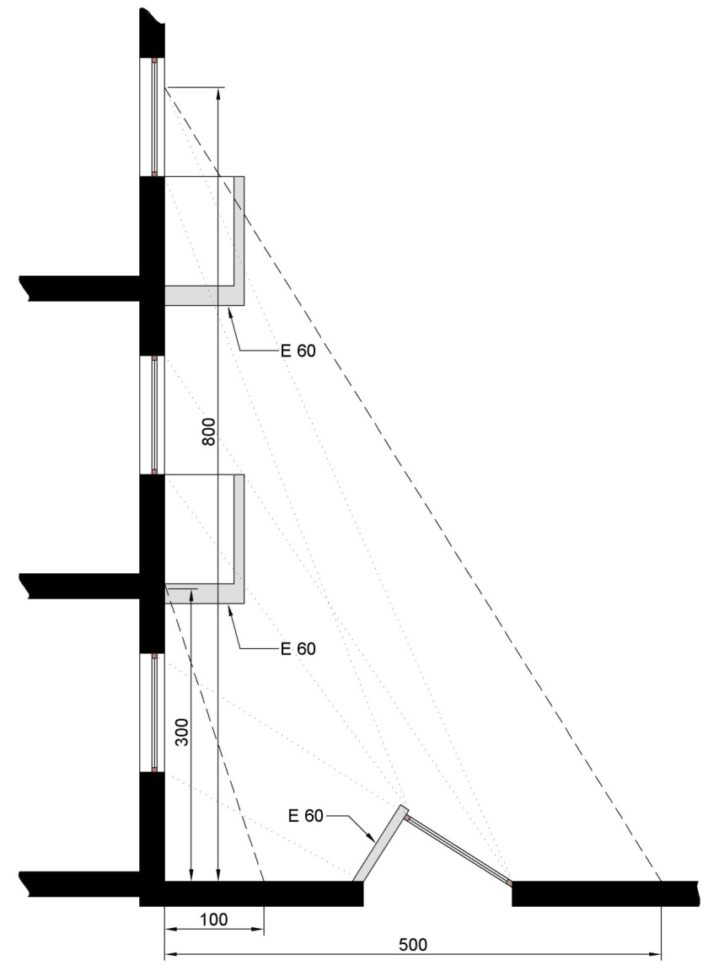
1.3 Horizontal distance between buildings

To prevent a fire from spreading between two buildings:

a) either, if façades are opposing each other or form an intrusive dihedral, the distance (in m) between the façade parts that do not have at least EI 120 or REI 120 must be at least:

1 + 7 cos α for 0° ≤ α ≤ 90°

1 for 90° α ≤ 180°

where α is the enclosed corner (image 3.2).

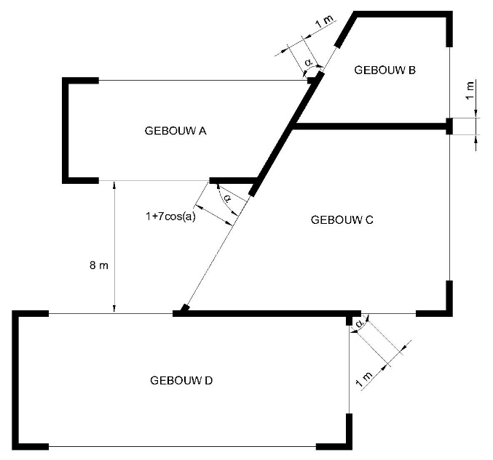

GEBOUW | BUILDING

b) or the radiation of a fire from a building to an opposite building, and vice versa, must not exceed 15 kW/m².

The walls that separate adjacent buildings have EI 120, or REI 120 when they are load-bearing.

In these walls, there can be a connection between these buildings through an air lock, provided that it has the following characteristics:

1. it must not lead to a stairwell;
2. It contains two self-closing doors EI₁ 30;
3. the walls have EI 60;
4. the surface area is at least 2 m².

The condition of the distance between an MG and an opposite building does not apply to buildings separated by existing streets, roads, etc. belonging to the public domain.

1.4 Accessibility of façades to the fire brigade

At least one of the long façades must run along a route accessible to the fire brigade vehicles and if the long façade does not contain a main entrance, the route must also run along a façade with such entrance.

The distance from the edge of this route to the plane of the façade should preferably be between 4 m and 10 m. If not, the façade openings are considered not accessible to the ladder vehicles of the fire brigade (see 2.2.1).

If a plinth supports one or more buildings, one of the following two provisions must apply:
- the platform of the plinth is accessible to the fire brigade vehicles, subject to the requirements of 1.1 but with the exception of the slope of the ramp which may be 12 %;
- at least one of the façades of each building must be accessed by an open-air route or in a tunnel containing an open-air segment of at least 15 m x 7 m every 25 m.

2 COMPARTMENTALISATION AND EVACUATION.

2.1 Size of compartments

The building is divided into compartments the surface area is less than 2 500 m², with the exception of car parks (see 5.2).

The area of a compartment may exceed 2 500 m² if it is equipped with an automatic extinguishing system and a smoke and heat extraction system. The Minister of the Interior determines the conditions under which a compartment may be larger than 2 500 m² without having to provide an automatic extinguishing system and a smoke and heat extraction system.
The height of a compartment corresponds to the height of one storey.

However, the following exceptions are permitted:

a) a car park with storeys (see 5.2);
b) a compartment may extend over two storeys above each other with an internal connecting staircase (duplex), if the accumulated area of those storeys does not exceed 2 500 m²;
for buildings for which the construction application was submitted prior to 1 April 2017, where the duplex is located on the highest two storeys of the building, the area of the compartment may be 2 500 m² per storey;
b/1) the height of a compartment may extend over three superimposed storeys connected by an internal connecting stairway (triplex), provided that the sum of their cumulative surface does not exceed 300 m² and that this compartment is equipped with an automatic fire detection device of the total surveillance type, which automatically emits fire alarm and whose detectors are adapted to the existing risks;
c) for buildings for which the construction application was submitted before 1 April 2017, the ground floor and the first floor (or mezzanine) may also form one compartment, provided that the total volume does not exceed 25 000 m³;
d) the height of a compartment may extend over several storeys above each other, if this compartment contains only technical premises (see 5.1.1).
e) the height of a compartment may extend over several storeys (atrium) provided that:
- that this compartment is equipped with an automatic extinguishing system and a smoke and heat extraction system. The Minister of the Interior determines the conditions under which exceptions are possible to the mandatory installation of an automatic extinguishing installation and a smoke and heat extraction installation;
- and that the evacuation possibilities of the building must comply with the provisions of this annex, whereby the evacuation via the atrium may not be taken into account.

The Minister of the Interior determines the conditions that the automatic extinguishing system and smoke and heat extraction system must meet.

2.2 Evacuation of the compartments.

2.2.1 Number of exits.

Each compartment has minimum:

- one exit if the users can reach a façade opening accessible to the fire brigade ladder vehicles without having to go through the stairwell or, if no such opening exists, a terrace accessible to the ladders of the fire brigade. The terrace with a surface area large enough to evacuate the users of the compartment, has a floor REI 60 and a façade element E 60 or a handrail that has been withdrawn 1 m from the façade.

- two exits if the occupancy is 50 or more than 50 and less than 500 persons;

- 2 + n exits where n the integer is immediately greater than the quotient of the division by 1 000 of the maximum occupancy of the compartment, if the occupancy is 500 or more than 500 persons.

The minimum number of exits can be increased by the fire brigade depending on the occupancy and configuration of the premises.

If the occupancy is 50 or more than 50 persons, the number of exits of storeys and premises is determined as for the compartments.

For the two underground levels immediately below the evacuation level, one exit is sufficient if these storeys contain only premises such as storage rooms and if the distance from each point of the compartment to the exit is less than 15 m.

In the event that a compartment extends over several storeys (atrium), the evacuation possibilities of the building must comply with the provisions of this annex which must not take account of evacuation via the atrium.

2.2.2 Exits.

The exits are located in opposite zones of the compartment.

Compartments not located at an evacuation level are connected to the evacuation level by means of stairs inside or outside the building (for horizontal distances see 4.4).

For underground storeys, an exit that meets the requirements of an evacuation level exit may replace the required access to a staircase.

For the car park: see 5.2.

At an evacuation level, each staircase leads outside, either directly or over an evacuation route which complies with the requirements of 4.4.2.

3 REQUIREMENTS FOR CERTAIN CONSTRUCTION ELEMENTS.

3.1 Wall Penetrations.

Wall penetrations for fluid pipes or electrical lines and expansion joints of construction elements cannot adversely affect the required level of fire resistance of these construction elements.

The provisions of Annex 7 ‘Common provisions’, Chapter 1 apply.

3.2 Structural elements.

The structural elements have a fire resistance as shown in Table 3.1, in which E represents the lowest level of evacuation:

 | Structural elements
Above the floor of E_{i} | R 60
Below E_{i},  including the floor of E_{i} | R 120

Table 3.1 - Fire resistance of structural elements.

3.3 Vertical interior walls and interior doors.

For the walls and doors, which demarcate compartments, 4.1 applies; if they mark evacuation routes, 4.4 applies.

The vertical interior walls delimiting premises or the whole of rooms with night occupation have EI 60.

The doors in these walls have EI ₁ 30.

The vertical interior walls of archive rooms have EI 60; Their doors are self-closing or fire-activated self-closing, rated EI₁ 30.

3.4 Ceilings and suspended ceilings.

3.4.1 On the evacuation routes, the premises accessible to the public and the collective kitchens, the suspended ceilings have EI 30 (a→b), EI 30 (b→a) or EI 30 (a ↔ b) according to NBN EN 13501-2 and NBN EN 1364-2, or have a fire stability of a ½ h according to NBN 713-020.

This requirement does not apply to the exceptions set out in point 4.4.3 and to the compartments equipped with an automatic sprinkler type extinguishing system adapted to the risks present.

3.4.2 The walls that require fire resistance continue into the space between the ceiling and the suspended ceiling.

If the space between the ceiling and the suspended ceiling is not equipped with an automatic extinguishing system, this space must be divided into volumes whose horizontal projection can be inscribed in a square not exceeding 25 m side.

These volumes are separated by vertical screens with the following characteristics:
- they consist of a class A1 and/or A2-s1,d0 material;
- they cover the entire space between the pipes;
- they have EI 30.

3.5 Façades

3.5.1 Single-walled façades

3.5.1.1 Separation between compartments

The styles of the curtain wall skeleton are attached to the building skeleton at the level of each storey. With the exception of the buildings equipped with an automatic fire-prevention installation, these fittings will be R 60 in relation to a fire in an underlying and adjacent compartment.

The connection of the compartment walls to the façade has at least EI 60 or EI 60 (i→o).

In order to reduce the risk of a fire extension along the façade between compartments in a vertical or horizontal plane, one of the following requirements must be met:

(1) either the façade at the level of the connection of the façade to the compartment wall (horizontal or vertical) is equipped with a fire-resistant construction element.

The figures of image 3.3 show how this construction element is applied in relation to a horizontal compartment wall.

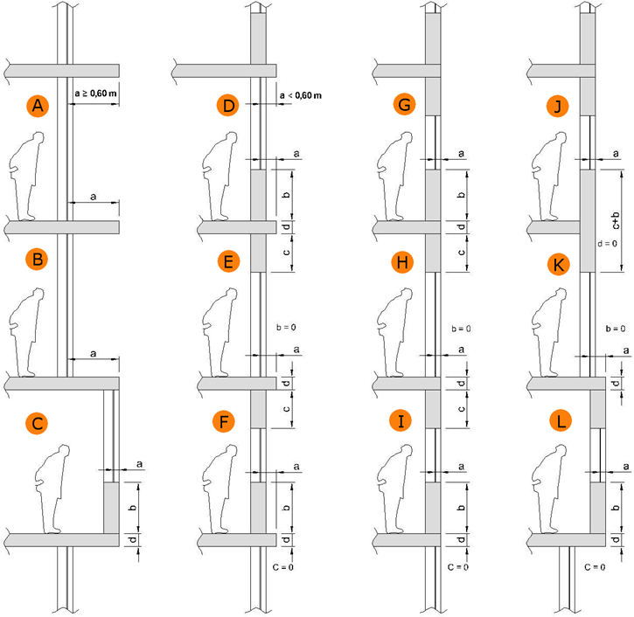
It includes:

- either a horizontal overhead, having at least E 60, width ‘a’ equal to or greater than 0.60 m and connected to the floor (image 3.3, figure A and B);

- either an element composed:
- from a horizontal overhang, having at least E 60, width ‘a’ and connected to the floor;
- in the overhead storey, from a parapet, which has at least E 60 - ef (o→i), with height ‘b’;
- in the underlying storey, from a lintel, which has at least E 60 (i→o), with height ‘c’.

The sum of dimensions a, b, c and d (floor thickness) is equal to or greater than 1 m; any of the dimensions a, b or c might be zero (image 3.3, figure C to L).

The figures of image 3.4 show how this construction element is applied in relation to a vertical compartment wall.

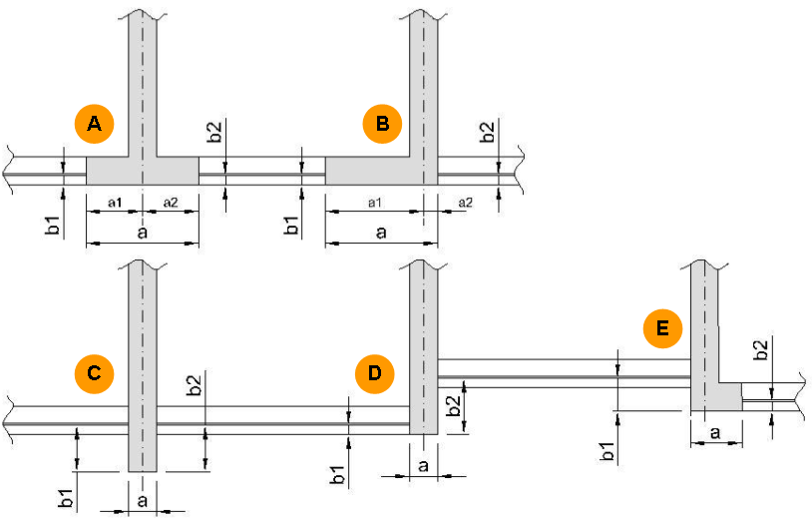
It includes:

- either an element which is an extension of the façade and which has at least E 60 (i)o; the width of this element (b1+b2+a) (image 3.4, figure A and B) must be at least 1 m; the parts of this element located to the left and to the right of the centre line of the common wall are at least 0.50 m wide in the case of two different buildings (a1 ≥ 0.50 m and a2 ≥ 0.50 m);

- either a vertical overhang located in the centre line of the wall forming the separation between the two buildings or compartments and having at least E 60 (o→i) (image 3.4, figure C) or E 60 (i→o) (image 3.4, figure D); the length of this element (b1+b2+a) is at least 1 m;

- or a combination of the previous elements in such a way that the sum of the lengths is at least 1 m (image 3.4, figure E).

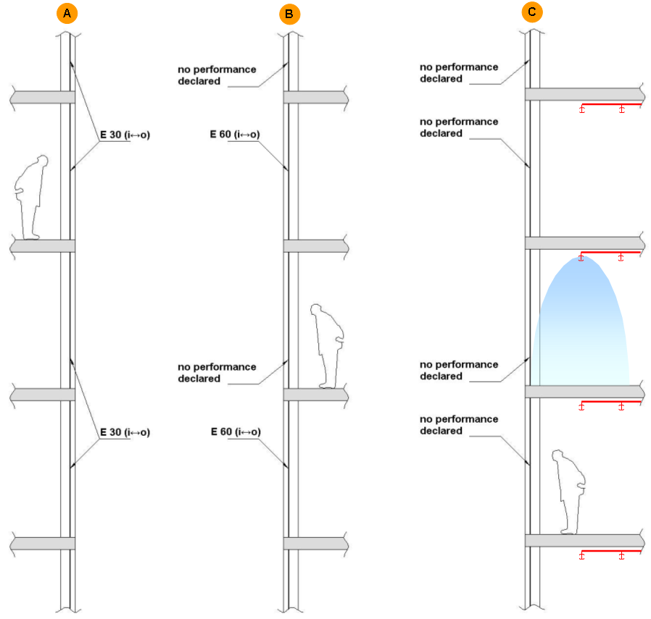
(2) or the façade has at least either E 30 (i) over the entire height of the building (image 3.5, Figure A), or E 60 (i) to the two storeys (image 3.5, Figure B).

(3) or the compartments located along the façades are equipped with an automatic sprinkler type extinguishing system adapted to the risks present (image 3.5, Figure C).

3.5.1.2 Opposite façade and façade that form a dihedral

To prevent a fire from spreading between two compartments:

a) either, if façade are opposite each other or form an intrusive dihedral, the distance (in m) between the façade parts not having at least E 60 or E 60 (o→i) must be at least:

1 + 7 cos α for 0° ≤ α ≤ 90°

1 for 90° α ≤ 180°

where α is the enclosed corner (image 3.6).

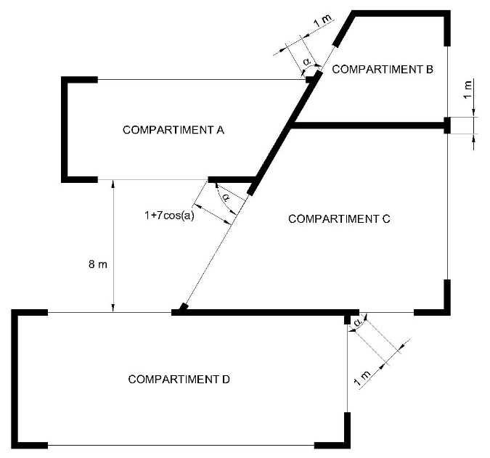

COMPARTIMENT | COMPARTMENT

b) or the radiation of a fire between façades belonging to different compartments may not exceed 15 kW/m².

3.5.2 Double-walled façades.

3.5.2.1 Double-walled façade interrupted by a compartmentalisation.

The cavity of the double-walled façade is interrupted by an element that has at least E 60 in the extension of each compartment wall. This element covers the entire space included between the two walls and has a minimum length of 60 cm to be counted from the interior wall of the façade.

This element may contain openings, provided that the continuity of compartmentalisation through the cavity is ensured by a self-closing sealing device with a fire resistance E 60. This device must be tested in its bearing structure, in accordance with the direction of the compartment wall; its closure is commanded:

- either by thermal detection at the level of this device which reacts at a temperature of not more than 100°C.
- or by a smoke detector in the cavity or in all compartments along the façade, which meets the conditions set out in point 3.5.2.3.

When there are vents between the cavity of the double-walled façade and the interior environment of the building, only a smoke detector is allowed in the cavity or in all compartments along the façade. It meets the conditions set out in point 3.5.2.3.

3.5.2.2 Double-walled façade without compartmentalisation.

The double-walled façade without compartmentalisation must be consistent with one of the two options listed below.

3.5.2.2.1 Double-walled façade whose interior wall is fireproof.

The exterior wall of the double-walled façade consists of at least 50 % construction elements between the floors without specific fire resistance.

The inner wall has:

- either, over the full height, at least one fire resistance E 30 ( i↔o);
- or alternately every two storeys at least one fire resistance EI 30 ( i↔o).

3.5.2.2.2 Double-walled façade open to the outside.

The requirements for single-walled façades may be applied to the interior wall when the outer wall contains fixed or mobile ventilation openings that automatically open in the event of fire.

The fixed vents are placed at 30 ± 10 degrees to the outside and upwards in relation to the horizontal, evenly distributed over at least 50 % of its surface area.

The mobile vents meet the same conditions as fixed ventilation openings in the event of fire.
The safety position of the mobile slats is triggered by a general fire detection system in the compartments along façades. The automatic operation must comply with the conditions laid down in paragraph 3.5.2.3.

3.5.2.3 Automatic closing/opening systems.

3.5.2.3.1 Operation

The closure/opening is commanded by an automatic fire detection system.

The installation is equipped with manual opening and closing systems. Its operation is reserved for the fire brigade. Its location must be determined in agreement with the fire brigade.

3.5.2.3.2 Operational security.

In the event of failure of the normal energy source (electrical energy, compressed air network), the detection system or the control system will put the closing/opening system in the safety position.

Any lack of energy source, power supply or electrical or pneumatic control must be reported automatically to the detection centre.

3.5.2.3.3 Operation in the event of fire in a neighbouring compartment.

If the closing/opening systems do not have a positive safety, the electrical lines connecting the closing/opening system must comply with paragraph 6.5.2.

3.6 Roofs.

The flat roofs and the roofs with a slight slope (gradient angle not more than 10°) have R 60.

This requirement does not apply if the roof floor has EI 60 (image 3.7) and if any access to the space under the roof, which must be empty, is via doors or hatches with EI ₁ 30.

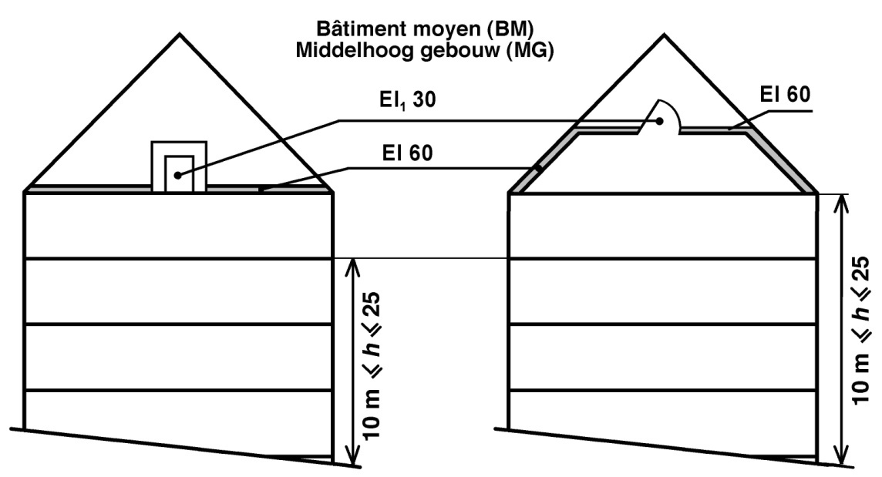

Middelhoog gebouw (MG) | Mid-rise building (MG)

This requirement also does not apply to roofs whose surface area is less than or equal to 100 m².

Inclined roofs may be fitted with window openings if the sections of the sloping roofs at the level of the compartment separation comply with paragraph 3.5.1.1 of the same annex.

4 REQUIREMENTS FOR THE CONSTRUCTION OF COMPARTMENTS AND EVACUATION AREAS.

4.1 Compartments.

Walls between compartment must be EI 60.

3.5 applies to the façade or outer walls.

The connection between two compartments is only be permitted if it is made via an air lock with the following characteristics:

1. it contains self-closing doors with EI ₁ 30;
2. the walls have EI 60;
3. the surface area is at least 2 m².

The doors may be self-closing in the event of fire provided that the building is equipped with an automatic fire detection of the total surveillance type which automatically indicates the fire alarm and its location, and whose detectors are adapted to the risks present.

4.2 Internal stairwells.

4.2.1 General.

The stairs connecting several compartments are enclosed. The basic principles of 2 ‘Compartment and evacuation’ apply to it.

4.2.2 Design.

4.2.2.1 The interior walls of the stairwells have at least EI 60.

Their walls may be made of glass, provided that they meet the requirements from point 3.5.

4.2.2.2 The stairwells must provide access to an evacuation level and to all overhead storeys, with the exception of the cases referred to in point 4.2.2.3, third and fourth paragraphs.

4.2.2.3 On each storey, the connection between the evacuation route and the stairwell is ensured by a self-closing door with EI ₁ 30 which gives access to a landing in the stairwell. This door turns open in the escape direction and must not be fitted with a locking system that would prevent from opening. Its usable width is greater than or equal to the required usable width and is at least 0.80 m.

The doors may be self-closing in the event of fire provided:
- that the building is equipped with an automatic fire detection of the total surveillance type, which automatically emits fire alarm and its location, and whose detectors are adapted to the risks present;
- and that all compartments operated by this stairwell have day occupancy only.

A direct connection of each storey of a duplex to the stairwell is not required, provided that:

- the total area of the duplex compartment or duplex apartment is less than or equal to 300 m²;
- the surface of the duplex storey that does not evacuate directly through the stairwell, is less than or equal to 150 m².

The direct connection of each layer of a triplex to the stairwell is not required, provided that:

- the area of each storey of the triplex that does not evacuate directly through the stairwell, is less than or equal to 100 m²;
- the connection to the triplex occurs at least:
- in the event of a triplex exclusively intended for daytime occupancy, which extends over the evacuation level (E), the floor situated immediately above it (E+1), as well as the floor situated immediately below it (E-1), it must be from the floor situated on the evacuation level;
- in the other cases, from the lowest level of construction and one of the other two storeys.

4.2.2.4 If several compartments are in the same horizontal plane, they may have one or more common stairwells provided that they are accessible from each compartment via a connection meeting the requirements of 4.2.2.3.

4.2.2.5 The stairwells operating the underground storeys must not be directly extended to those operating the storeys above an evacuation level.

This does not preclude one being above the other, subject to the following conditions:

1. the walls they separate have EI 60.
2. the access of each stairwell to the evacuation level is in accordance with the requirements of 4.2.2.3.

4.2.2.6 At the top of each interior staircase there is an ventilation opening with a diameter of at least 1 m² and flows into the open air. This opening is normally closed; before opening, a manual control is used that is clearly visible at the evacuation level.

This requirement does not apply to stairwells between evacuation level and underground storeys.

4.2.2.7 Only the following items are permitted in the stairwells:
- detection devices;
- extinguishing appliances, with the exception of wall reels;
- alarm devices;
- lighting equipment;
- heating appliances;
- ventilation devices;
- smoke evacuation devices.

The electrical cables, ventilation ducts and smoke evacuation devices are allowed only if their sole purpose is to operate the above-mentioned objects installed in the staircase.

Water pipes are permitted in the stairwells.

All other lines is not permitted in the stairwells.

Lifts are permitted in a stairwell serving the storeys above an evacuation level, subject to the following conditions:
1. that the compartments operated by this stairwell with lifts are also operated by other stairwells;
2. that these other stairwells do not have lifts;
3. and that the actual usable width of this stairwell is halved by lifts (according to Annex 1 ‘Terminology’).

4.2.2.8 In buildings with no more than 10 apartments served by the same interior staircase, the connection between each apartment and this staircase, deviating from point 4.2.2.3, may be ensured by a door EI ₁ 30 under the following conditions:
1. that the door in question is self-closing in the event of fire only. In daily use, this door is not self-closing (door shutter with free-swing function);
2. and that the building is equipped with an automatic fire detection system:
a) which monitors at least the following:
- communal inner stairwell;
- and in each apartment, the area in the vicinity of the door that provides the access to the staircase;
b) that provides an indication of the fire alarm;
c) and the detectors of which are adjusted to the existing risks.

The apartment doors that overlook the staircase may not open in the opposite direction of the escape route.

And derogating from point 4.2.2.7, the wall reels are permitted in the stairwells, just like the lifts without the conditions mentioned in the last paragraph of point 4.2.2.7.

4.2.3 Stairs.

4.2.3.1 Construction provisions.

Stairs must have the following characteristics:

1. As well as the landings, they have R 60 or are designed in the same way as a concrete slab with R 60;
2. They are equipped with solid risers;
3. On both sides they are, even along the landings, equipped with a handrail;
For stairways of a usable width, less than 1.20 m, one handrail is sufficient, provided that there is no risk of falling;
4. The tread of the steps is at least 20 cm at any point;
5. The rise of the steps should not exceed 18 cm;
6. Their gradient must not exceed 75 % (maximum angle of gradient 37°);
7. They are of the ‘straight type’.
However, ‘spiral staircases’ are permitted if they have expelled steps and thus, in addition to the requirements mentioned above, (with the exception of paragraph 4) above, their steps have appeared at least 24 cm on the running line.

4.2.3.2 Useful width of stair arms, landings and air locks.

This usable width must be at least 0.80 m and reaches at least the required usable width b_{r} calculated in accordance with Annex 1 ‘Terminology’.

The door swing may not limit the usable width of the overflow to a value less than b_{r}.

The stair arms and landings of the stairwells of the same compartment will not differ in their usable width by more than one passage unit.

If a compartment contains special-purpose premises, the theoretical useful stair width (according to Annex 1 ‘Terminology’) based on their number of users, is only calculated over the height between this compartment and the evacuation level.

4.3 Exterior staircases.

Exterior staircases meet the conditions of 4.2.2.2.

The exterior staircases are enclosed by walls; The outside air must be able to enter freely on at least one side on each storey.

No point of the staircase may be less than 1 m from a façade section that does not have EI 60.

The requirements of 4.2.3 apply, however, with the following derogation: the risers are not mandatory; no fire stability is required, but the material belongs to class A1.

The connection between the compartment and an exterior stairwell must be:
- either through a door;
- or via (an) escape terrace(s).

One stairwell may be replaced by two external staircases with straight stair arms; these stairs are connected by flight terraces on which transverse bulkheads may not form difficult obstacles.

These external steps have the following characteristics:

1. width minimum 0.60 m;
2. angle of gradient not exceeding 45°;
3. tread of steps at least 0.10 m;
4. tread of steps up to 0.20 m;
5. two handles at each staircase.

However, a step or part of stairway that is retractable or articulated may be used for the connection between the evacuation level and the immediately higher level of construction.

4.4 Evacuation routes and escape terraces.

4.4.1 General requirements

4.4.1.1 No point of a compartment must be further than:

a) in the case of premises with only daytime occupancy:
- 30 m from the evacuation route connecting the exits;
- 45 m from the access to the nearest exit;
- 80 m from the access to a second exit.

b) in the case of premises or all of the night-occupied premises:
- 20 m from the evacuation route connecting the exits;
- 30 m from the access to the nearest exit;
- 60 m from the access to a second exit.

The length of dead-end evacuation routes does not exceed 15 m.

The usable width of the evacuation routes, escape terraces and of their access, exit or passage doors is greater than or equal to the required usable width (see Annex 1 ‘Terminology’). It will be at least 0.80 m in the case of evacuation routes and doors and at least 0.60 m for flight terraces.

The provisions of this point do not apply to car parks (see 5.2).

4.4.1.2 The following are deemed an exit from a compartment:
- an interior staircase in accordance with point 4.2;
- an external staircase in accordance with point 4.3;
- direct access to the open air at an evacuation level;
- an evacuation route at an evacuation level meeting the requirements of paragraph 4.4.2 applicable to evacuation routes connecting stairwells to the public road.

The route to be taken in the open air does not play a role in calculating these distances.

The doors on these routes do not have any locking device capable of obstructing the evacuation.

4.4.2 At an evacuation level

The vertical interior walls of the evacuation routes connecting stairwells to the public road have EI 60, and the doors of the premises opening onto these routes are self-closing, and have EI ₁ 30.

The doors may be self-closing in the event of fire provided:
- that the building is equipped with an automatic fire detection of the total surveillance type, which automatically emits fire alarm and its location, and whose detectors are adapted to the risks present;
- and that all compartments operated by these evacuation routes, as well as all compartments operated by stairwells leading to these evacuation routes, have only day occupancy.

The apartment doors opening onto the evacuation route may nevertheless be self-closing in the event of fire provided:
- that these doors are self-closing only in the event of a fire. In daily use, these doors are not self-closing (door closer with free-swing function);
- and that the building is equipped with an automatic fire detection of the total surveillance type, which automatically emits fire alarm and its location and whose detectors are adapted to the risks present.

Evacuation routes which do not connect stairwells to the public road must comply with the requirements of 4.4.3.

At such level, access to the stairwell must be in accordance with 4.2.2.3.

The evacuation route may include the entrance hall. This hall may include access to lifts and non-enclosed areas intended for reception and associated services, drinking establishments or places to eat.

At an evacuation level, no display windows of building components with a commercial function, which do not have EI 60, may open onto the evacuation route connecting the exits of other building components to the public road, with the exception of the last 3 m of this evacuation route.

4.4.3 On a storey that is not an evacuation level.

In a compartment, the connection between and to the stairwells is via evacuation routes or over escape terraces. These routes are not allowed to pass through stairwells.

The route between the stairwell entrances is less than 60 m.

The vertical interior walls of the evacuation routes have EI 30 and the access doors to these routes EI ₁ 30.

This requirement, as well as the requirement set out in points 3.4.1 and 6.7.2.1, do not apply to compartments with only daytime occupancy whose surface does not reach 1 250 m².

This requirement, as well as the requirement set out in points 3.4.1 and 6.7.2.1, do also not apply on compartments with only daytime occupancy of which the surface area is less than 2 500 m² provided:
- that these compartments are equipped with an automatic sprinkler type extinguishing system adapted to the risks present;
- that the building is equipped with an automatic fire detection device suitable for total protection, which device automatically emits fire alarm and the detectors of which are adjusted to the existing risks;
- and that the products used for lining vertical walls, ceilings and floors of the compartments meet the fire response requirements of the evacuation routes.

4.5 Signalling.

The serial number of each storey must be clearly indicated at landings and in evacuation spaces in stairwells and lifts.

The indication of exits and emergency exits must comply with the provisions concerning health and safety signs at work.

5 CONSTRUCTION REQUIREMENTS FOR CERTAIN PREMISES AND TECHNICAL AREAS.

5.1 Technical premises and spaces.

5.1.1 General.

A technical room or a set of technical premises forms a compartment. This compartment can reach over several successive storeys.

Technical premises are subject to the regulations for compartments subject to the following changes:

1. access to two exits leading:

- either to an adjacent compartment via a door EI ₁ 60;
- or to a stairwell via an air lock according to 4.1;
- or to the open air, in such a way that an evacuation level can be reached;

2. deviating from 4.4.1, no point of the compartment must be further than:

- 45 m from the route connecting the two exits in the technical compartment;
- 60 m from the nearest exit;
- 100 m from the second exit;

However, if the area of the technical compartment does not exceed 1 000 m², one exit to a stairwell, to the outside or to another compartment is sufficient. In this case, the route to this exit must not exceed 60 m;

3. if the height of the technical compartment extends over several successive storeys (see 2.1) and if it includes several service floors connected by stairs or ladders:

- if the compartment surface area is less than 1 000 m², every two service floors, starting with the lowest, one access to a stairwell, to the outside or to another compartment, is sufficient;
- if the compartment surface exceeds 1 000 m², each service floor must provide access to at least one of the two exits; these exits vary from floor to floor;

4. the usable width of evacuation paths, stair arms, landings and air locks must not be less than 0.80 m.

5.1.2 Combustion units.

5.1.2.1 Combustion rooms with combustion appliances with a cumulative combustion rate greater than or equal to 75 kW and fuel storage spaces.

The combustion rooms with combustion appliances with a cumulative combustion rate greater than or equal to 75 kW and the fuel storage areas must be technical premises.

The regulations of point 5.1.1. apply, provided that the following changes are made:
- Each combustion room and fuel storage compartment forms a separate compartment;
- The access doors to these combustion rooms and fuel storage rooms are self-closing and open in the escape direction;
- No point of these combustion rooms and fuel storage spaces must be more than 15 m from the nearest exit.

The capacity of a fuel storage space must be limited so that the total fire load of the fuel storage space is less than or equal to 750 GJ.

5.1.2.2 Common provisions.

The design, construction and fittings of the combustion divisions must comply with the provisions of paragraph 4 of Annex 7.

5.1.2.3 Deviating provisions.

The following deviating provisions apply to buildings whose building permit application was submitted prior to 1 July 2022:

- Point 5.1.2.1: Not applicable to combustion units with combustion appliances with a total useful heat output (also referred to as total rated power) less than 70 kW;
- Point 5.1.2.1: Not applicable to combustion units with combustion appliances having a total useful heat output (also called total rated power) greater than or equal to 70 kW if the access to the combustion department and the fire resistance of the walls, floors, ceilings and doors of the combustion department meet the requirements of standard NBN B 61- 001 +A1: 1996.

5.1.3 Transformer rooms.

5.1.3.1 General.

They comply with the requirements of the General Regulation on electrical installations (RGIE/AREI).

The following furthermore applies:
- the walls have EI 120, except the outer walls;
- the interior doors have EI ₁ 60;
- if water (from any origin, including extinguishing water) can reach the floor, e.g. by infiltration or via cable ducts, all measures must be taken to ensure that the water level is constantly and automatically below the level of the vital parts of the electrical installation, as long as it is in use.

If the oil content of the whole of the appliances reaches 50 litres or more, the regulations of NBN C 18-200 ‘Guidelines for the fire protection of the premises of electricity transformation’ apply.

5.1.3.2 On-site mounted or prefabricated posts.

A post or prefab post installed on site is set up in a room intended for that purpose, with walls EI 120.

The access, if not from the outside, is via a door EI ₁ 60.

5.1.4 Domestic waste disposal.

5.1.4.1 Chutes are not permitted.

5.1.4.2 Room for domestic waste storage.

The walls have EI 60.

The room is accessible:

a) either by means of an air lock with the following characteristics:
1. self-closing doors EI₁ 30;
2. walls EI 60;
3. Minimum surface of 2 m²;

b) or, by one self-closing door EI₁ 30, on condition that the premise for garbage collection is equipped with an automatic fire extinguishing installation.
This automatic fire extinguishing installation is presumed to be in conformity, if it meets the requirements from point 5.1.4.3.

5.1.4.3 Type-solution for the premises for domestic refuse collection - Automatic fire-extinguishing system of sprinkler type, directly connected to the public water supply network.

This type of solution applies only to a room for the storage of household waste whose surface area is less than or equal to 24 m².

The subject type-solution describes an automatic fire-extinguishing system on water basis, connected to the public water supply network, without mandatory installation of overpressure equipment (for instance, a pump). The subject system is an installation with the pipelines constantly filled with water.

5.1.4.3.1 Environmental and operating conditions

The fully automatic extinguishing system, including the room for storing the household waste and pipes to it up to the building’s water counter, must be protected against frost.

The pressure of the water in this system may not exceed 12 bar.

This automatic extinguishing system must be able to operate permanently, except during testing, checks or maintenance (all taps in the supply lines and the cranes in the system itself in open position, parts maintained in good working condition, etc.).

5.1.4.3.2 Features for design and installation of sprinklers

The sprinklers meet the requirements of NBN EN 12259-1 standard and have the following characteristics:
- they are of the conventional type, suspended or standing;
- their nominal operating temperature is 68°C, or below;
- their K-factor is between 75 and 85. The K-factor corresponds to the flow, in L/min., of a sprinkler subject to the pressure of 1 bar.

The sprinklers are installed under the ceiling at a maximum distance of 30 cm from it or are built into the ceiling.

In the premises with the surface below 12 m², one sprinkler must be installed in the middle of the premise.

In the premises with the surface above 12 m² and below or equal to 24 m², two sprinklers must be installed in the middle of the premise, at no less than 2 m and no more than 4 m distance between them.

5.1.4.3.3 Characteristics of the pipelines

The pipelines in the system must be made of steel.

The nominal (internal) diameter of the pipelines in the system, and those leading from the system to the water meter of the building must be at least 25 mm.

The pipelines are attached to the walls or built-in, also in the room for the storage of the household waste.

5.1.4.3.4 Water-flow alarm

The water supply pipeline must be equipped with an alarm installation mounted outside the premise for the collection of domestic garbage, and it meets the requirements of NBN EN 12259-2 or NBN EN 12259-5.

The pipelines of the system may only be used downstream of the alarm device for the automatic extinguishing of the room for the storage of the household waste.

5.1.5 Pipe sleeves.

5.1.5.1 Vertical sleeves.

When vertical sleeves penetrate through horizontal walls requiring fire resistance, one of the following three measures apply:

1. the walls of the vertical sleeves have a fire resistance EI 60; the hatches and doors are EI₁60.

They have decent ventilation at the top.
The free ventilation cross-section of the sleeve must be at least 10 % of the total horizontal cross-section of the sleeve, with a minimum of 4 dm².

The free aeration cross-section may be equipped with motorised ventilation valves, the opening of which is commanded as follows:
- automatically on detection of a fire in the sleeve;
- automatically, in the event that fire is detected in the building, if it is equipped with a fire-detection installation for general purposes;
- automatically in the event of a failure in the energy source, power supply or control system (positive safety device);
- manually, operated on evacuation level, in a place determined in mutual consent with the fire department.
If the free ventilation cross-section of a tube is equipped with a motorised ventilation valve, any gas pipes in this tube must comply with the requirements of standard NBN D 51-003 or the standard NBN D 51-006 for the pipes and connections in a non-ventilated technical tube.

2. a construction element with at least the required fire resistance of the horizontal wall is located at the level of the passage;

3. the walls of the vertical sleeves have EI 30; the trap doors and doors EI ₁ 30; At every compartment, vertical sleeves are interrupted by horizontal closures with the following characteristics:

- they consist of a class A1 and/or A2-s1,d0 material;
- they cover the entire space between the pipes;
- they have EI 30.

In cases 2 and 3, the sleeves must not be ventilated.

5.1.5.2 Horizontal ducts.

Where horizontal ducts penetrate vertical walls that must be fire resistant, apply one of the following three measures:

1. the walls of the horizontal sleeves and the trapdoors and doors have at least the required fire resistance of the vertical wall;

2. at the level of the penetration there is a construction element with at least the required fire resistance of the vertical wall;

3. the walls of the horizontal sleeves have EI 30; the trap doors and doors EI ₁ 30; the sleeves are interrupted at each compartment by vertical screens with the following characteristics:

- they consist of a class A1 and/or A2-s1,d0 material;
- they cover all space between the cables/pipes;
- they have EI 30.

5.2 Car parks.

By way of derogation from the basic principle laid down in point 2.1, a car park can form a compartment whose surface area is not limited even if there are several communicating floors.

5.2.1 Structural elements.

By way of derogation from point 3.2, the structural elements of the car park R have R 120 and the floors of the parking storeys and of the slopes have R 120.

If the roof has no other function than protecting the car park from the weather conditions:
- the structural elements of the roof have R 60;
- or are the structural elements of the roof separated from the rest of the car park by an EI 60 construction element.

For the open parking storeys, the structural elements have R 60, provided:
- the floors of these open parking floors and the slopes between these open parking storeys have at least REI 60;
- and that these structural elements do not carry any other compartment.

5.2.2 Compartment.

The walls and connections between the car park and the rest of the building are in accordance with point 4.1, with the following adjustment: the doors of the connections can be self-closing in the event of a fire.

5.2.3 Car park under various buildings.

By way of derogation from point 1.3, parking spaces of adjacent buildings must not be separated by a wall. These car parks are therefore only one and the same car park.

In that case, the structural elements of the entire car park have R 120, including the structural elements of the open parking storeys.

5.2.4 Common provisions.

The design, construction and layout of the car park complies with the provisions of point 3 of Annex 7.

5.2.5 Deviating provisions.

Points 5.2.1 to 5.2.4 do not apply to façades on a building for which an urban planning permit application was submitted before 1 July 2022 if it meets the conditions below.

The walls between the car park and the rest of the building comply with the regulations of 4.1.

Certain non-residential premises may be included in the parking compartment, such as: transformer rooms, storage rooms, archive rooms, technical rooms, etc.

The walls of these premises have EI 60, and:
- access occurs through with an air lock with walls rated EI 60 and self-closing or fire-activated self-closing doors rated EI₁ 30;
- or access to each room occurs with a self-closing or fire-activated self-closing door rated EI₁ 60.

The special requirements on boiler sections, transformer rooms and waste storage rooms still apply (see also points 5.1.2, 5.1.3 and 5.1.4 respectively).

Evacuation is arranged as follows on each storey:
- at least two stairwells or external staircases comply with the requirements set out in 4.2 or 4.3 and are accessible from any point of the storey; the distance to the nearest staircase must not exceed 45 m; the minimum usable width of these stairs is 0.80 m;
- as stated in 2.2.2, third paragraph, the required access to one of the two stairwells on the considered storey may be replaced by a direct exit to the open air;
- on the storey closest to the exit level, the inclined route may replace one of the stairwells or external steps if its walls have EI 60 and the slope measured in its centreline does not exceed 10 %;
- the limit of the slope to 10 % does not apply to compartments whose surface area is equal or less than 500 m², if evacuation via the slope remains possible;
- apart from the signalling determined in 4.5, the evacuation routes, on each storey, are also indicated on the floor or just above it.

However, a single exit per storey (interior staircase, external staircase, direct exit to the open air or inclined route on the storey closest to the exit level) is sufficient provided:
- the car park is no more than two component layers high;
- neither of these two storeys is located more than two floors above, or below the car exit level;
- the car park does not feature any points located more than 15 m from the access to the evacuation route leading to the exit;
- the car park does not feature any points located more than 30 m from the access to the exit.

In enclosed car parks with a total surface greater than 2 500 m², the measures necessary to prevent the spread of smoke must be taken.

5.3 Halls.

5.3.1 General.

If more than 500 people can be accommodated, these rooms may only be set up underground if the difference between the lowest floor level of these rooms and the nearest evacuation level is not greater than 3 m.

If the above-mentioned rooms are intended for a maximum of 500 persons, they may be set up underground provided that the lowest floor level accessible to the public is not more than 4 m below the average level of different evacuation levels of the establishment.

The number of exits is determined as for the compartments.

5.3.2 Structure.

The walls that form these rooms or whole of rooms have EI 60.

Each passage in the vertical walls is closed with a self-closing or fire-activated self-closing door rated EI₁ 30.

These doors open in the escape direction.

No object may interfere with the evacuation to the exits.

5.4 Retail or commercial complex.

The establishment of retail premises opening onto indoor galleries is permitted at an evacuation level and on the adjacent storeys provided that:

1. the complex with its galleries is separated from the other building parts by walls with EI 60;
2. the other building parts have their own exits independent of the exits of the retail or commercial complex.

The partitions between the business premises have EI 30 and run through the possibly suspended ceiling. The latter requirement expires if the retail or commercial complex is equipped with an automatic extinguishing system of the type of sprinkler adapted to the risks present.

5.5 Collective kitchens.

The collective kitchens, potentially including the restaurant, are separated from the other building parts by walls EI 60.

Any passage between those premises and the rest of the building must be closed by a self-closing or fire-activated self-closing door EI ₁ 30.

These doors turn in the escape direction of the kitchen.

When the kitchen and restaurant are separated from each other, the horizontal and vertical transport systems between kitchen and restaurant must meet the following conditions:
- this transport takes place in ducts with walls EI 60 when it passes through other premises;
- the transport system is closed at the height of the compartment wall(s) with a device EI ₁ 60.

When the kitchen is not compartmentalised in relation to the restaurant, each fixed frying appliance is equipped with a fixed automatic extinguishing system which is connected to an appliance that interrupts the supply of energy to the frying appliance.

6 EQUIPMENT OF THE BUILDINGS.

6.1 Lifts and freight lifts.

6.1.1 General.

6.1.1.1 The machinery and associated parts of a passenger or freight lift are only accessible for maintenance, inspection and emergencies. The drive is located:
- either in an engine room;
- or in the shaft.

Control bodies may be accessible from the platforms provided that they do not adversely affect the required fire integrity of the ramp wall or the wall of the shaft in which they are placed.

6.1.1.2 In the event of an abnormal increase in the temperature of the machine and/or of the other electrical equipment, the lifts must stop on a ramp so that passengers can alight.

Automatic return to normal operation will only be possible after sufficient cooling.

6.1.1.3 Extinguishing systems that use water are not permitted in the shafts.

6.1.2 Design.

6.1.2.1 The whole consisting of one or more shafts and any engine room, as well as access platforms that must form an air lock, is enclosed by walls with EI 60.

Their walls may be made of glass, provided that they meet the requirements from point 3.5.

The access doors between the compartment and the air lock have EI₁ 30, and are self-closing, or fire-activated self-closing.

If the surface of the air lock is less than the surface of the lift cage or freight lift, the access door between the compartment and the air lock, a fire-activated self-closing revolving door EI ₁ 30 is operated by a fire detection system containing at least the following:
- a smoke detector in the shaft;
- a smoke detector in the compartment in the vicinity of the air lock access door.

The access platform of the lift(s) may be part of the evacuation route.

In the cases referred to in the last paragraph of point 4.2.2.7 and in point 4.2.2.8, the lift platforms and the stairway landing may be common. In that case, the staircase and the lift shaft must constitute a whole.

In a medium-high building, the common hall of the apartments served by one or more of the same internal staircases may be considered as an air lock of the lifts if the number of apartments evacuated via this common hall is less than or equal to six apartments.

The doors opening onto the common hall of those apartments may open in the opposite direction of the evacuation and must not be self-closing.

6.1.2.2 The whole of the lift shaft doors or goods lift has E 30. The fire resistance according to the NBN EN 81-58 standard, whereby the platform wall on the side of the platform is exposed to the fire. The platform wall must be tested by means of possible operating and monitoring bodies, which make part of it.

The shaft doors tested by other methods are accepted in accordance with the Royal Decree of 12 April 2016 on the marketing of lifts and safety components for lifts, provided that they have at least the same degree of fire resistance.

These requirements do not apply to the cases referred to in the last paragraph of point 4.2.2.7 and in point 4.2.2.8.

6.1.2.3 The regulations of points 6.1.2.1. and 6.1.2.2. are not be required in the following cases:

a) on all storeys operated by the lift or freight lift, if this lift or freight lift serves the storeys of only one compartment consisting of several storeys;
b) on the storey(s) of only one of the compartments operated by the lift or freight lift, provided that this compartment is not a parking compartment or an apartment, and that the layout of this lift or freight lift on the other storeys does comply with the regulations of points 6.1.2.1. and 6.1.2.2 or with point (c) below;
c) on the storey(s) where the lift or freight lift leads directly outdoors, provided that the layout of that lift or freight lift on the other storeys does comply with the regulations of points 6.1.2.1 and 6.1.2.2 or point (b) above.

6.1.2.4 Lifts and freight lifts whose drive is located in an engine room.

The interior walls of the engine room, which do not overlook the lift shaft have EI 60.

The doors or trapdoors in these walls have EI ₁ 30.

Access to the engine room must be guaranteed to the fire-fighters.

6.1.2.5 Oleohydraulic lifts and freight lifts.

The space in which the propulsion of an oleohydraulic lift or freight lift is fitted will be fitted with a volume of at least 1.2 times the oil capacity of the machinery and reservoirs.

If the propulsion of an oleohydraulic lift or freight lift is installed in an engine room, the electrical equipment, as well as the electrical and hydraulic lines running from the engine room to the lift shaft, must be positioned higher than the highest level that the run-out oil in the engine room can reach.

6.1.2.6 Lifts and escalators.

The platform of the lift(s) may be the platform of one or more escalators. The whole consisting of one or more shafts and any engine room, as well as access platforms of the lift(s) and escalator(s), then only form one whole.

6.1.3 Ventilation.

6.1.3.1 The shaft, the engine room or the entire shaft and engine room are naturally vented through outside air outlets in the upper section.

However, the shaft or the whole shaft and engine room may be ventilated through internal air vents provided that the layout of the lift or freight lift complies with:
- either the conditions described in point 6.1.2.3 under a);
- or the case described in (b) of point 6.1.2.3 to the extent that the storey(s) where the regulations of points 6.1.2.1 and 6.1.2.2 are not required is located above the other storey(s).

6.1.3.2 Minimum cross-section of the ventilation openings must be 1 % of the horizontal surface of the area from which the air is supplied.

6.1.3.3 The vents may be fitted with motorised ventilation valves, the opening of which is commanded as follows:
- it is automatically commanded to ensure adequate ventilation for the users of the lift, even in the event of a prolonged downtime;
- automatic openings are mandatory in case of abnormal temperature increase of the machine and/or monitoring bodies;
- automatic openings are mandatory in case when fire is detected in the lift shaft and/or in the engine room;
- is automatically ordered when a fire is detected in the building, if it is equipped with a general fire detection system;
- is automatically commanded in the event of a failure in the energy source, power supply or control system (positive safety device);
- manually operated at the evacuation level.

6.1.4 Operation in the event of fire.

The operation of the lifts in the event of fire complies with the following regulations or any other rule of good craftsmanship that provides an equivalent level of safety, in accordance with the Royal Decree of 12 April 2016 on the marketing of lifts and safety components for lifts.

The operating principle of the lifts in the event of fire is that when the fire detection system or a manual alarm facility receives a fire signal, the system moves the lift cage to the lift landing at the evacuation level, allows passengers to step out there and then removes the lift from normal service.

6.1.4.1 The operation of the lifts in the event of fire complies with the requirements of standard NBN EN 81- 73.

6.1.4.2 The platform of the lift at the evacuation level is recorded as designated lift platforms.

6.1.4.3 Each lift battery must be equipped at least with a manual call facility at an evacuation level.

In addition, if the building is equipped with a general fire detection system or with a fire detection system in the shafts and/or in the engine rooms, in the event of fire, this installation must transmit a signal to the lifts.

6.1.4.4 When a general or partial detection in the building is required and the machinery of the lifts and goods lifts is located in the shaft, a smoke detector must be placed in the shaft.

6.1.4.5 If a fire-detection installation detected fire on the platform that corresponds to the designated main platform, the lift must receive one or more additional electrical signals, so that the lift car could be diverted to the designated substitute platform.

6.1.4.6 When the lifts are on the designated platforms in the event of a fire, it should be possible that the fire brigade can easily check that the lift cages are there, and that no one is locked in the lift.

The lifts, which, at the time of their arrival to the designated platform,are stationary there with doors open and put out of normal operation, meet the said requirement.

6.1.4.7 The lift can only be returned to normal operation by an authorised person.

6.1.4.8 The following deviating provisions apply to buildings whose building permit application was submitted prior to 1 April 2017:

- Point 6.1.4.1: Applicable to the lifts designed or renovated after 31 March 2017 only.

6.2 Paternoster lift, container transport and freight lift with loading and unloading automation.

6.2.1 These devices have their own engine rooms, shafts and platforms.

The engine rooms are located at the top of the shaft. The inner walls of the engine rooms and shafts have EI 60.

Upon arrival at each level served, an air lock must exist with walls EI 60. The doors or access hatches are self-closing, and have E 30. These doors or access hatches are tested with the platform side facing the oven.

The surface area of this air lock, which may only be used for goods handling, is designed for a judicious arrangement of the loading and unloading installation and the ease of access of the service staff.

Between the air lock and the shaft there are doors or hatches.

The shaft walls on the side of the compartment and the entrances in these walls have EI 60.

The shaft doors or access hatches of these devices operate automatically and are normally closed. One element can only be opened when the other is closed.

Any passages of horizontal conveyor belts to the paternoster and freight lifts, as well as the passages from one compartment to the other, are via an air lock, closed by two hatches or doors with E 30.

These hatches operate automatically and are normally closed; when a container passes through, such hatch can only open if the other is closed.

If the installation of the container transport follows a horizontal and/or vertical trajectory and passes through storeys or compartments, air locks are provided at each of these passages. The air lock walls have EI 60.

Their two hatches or doors have E 30. They are tested with the platform side turned upward. They operate automatically and are normally closed. Such a hatch or door can only open if the other is closed.

In the event of a fire, the installations are put out of service.

6.2.2 The installation of paternoster lifts for passenger transport is prohibited.

6.3 Escalators.

6.3.1 The stairwell of escalators has walls with EI 60.

6.3.2 Access to the stairwell takes place on each storey, via a self-closing or fire-activated self-closing EI ₁ 30.

6.3.3 The escalator is automatically switched off as soon as a fire is detected in a compartment to which it leads.

6.3.4 The regulations of points 6.3.1 and 6.3.2 are not required in the following cases:

a) on all storeys operated by the escalator, if this escalator serves the storeys of only one compartment consisting of several storeys;
b) on the storey(s) of only one of the compartments operated by the escalator, provided that this compartment is not a parking compartment, and that the layout of this escalator on the other storeys does comply with the regulations of points 6.3.1 and 6.3.2 or with point (c) below;
c) on the storey(s) where the escalator leads directly outdoors, provided that the layout of that escalator on the other storeys complies with the regulations of points 6.3.1 and 6.3.2 or point (b) above.

6.4 Special lifts.

The special lifts and their operation in the event of fire comply with the following regulations or any other rule of good workmanship that provides an equivalent level of safety, in accordance with the Royal Decree of 12 April 2016 on the marketing of lifts and safety components for lifts.

6.4.1 Lifts intended to evacuate persons with reduced mobility.

Where the lift intended for the evacuation of persons with reduced mobility is deemed mandatory in a building, the lift must be designed and constructed so to meet the following requirements, apart from the requirements included in point 6.1.

6.4.1.1 This lift must be designed and built in such a way that its structural features do not obstruct or impede access and use by persons with reduced mobility.

6.4.1.2 On all storeys the lift platforms form an air lock corresponding to the regulations from point 6.1.2.1, whereby the surface area is equal to, or larger than the surface of the cage.

6.4.1.3 The lift cages must be accessible at least to one person in a wheelchair and an accompanying person.

The minimum dimensions of the lift cage must be 1.1 m (width) x 1.4 m (depth).

6.4.1.4 The shaft doors open and close automatically and have usable width of at least 0.90 m.

6.4.1.5 The evacuation is carried out under the supervision of a competent person. For that purpose, the lift must be equipped with a switch with ‘evacuation key’, which enables the authorised person to take over the control of the lift.

6.4.1.6 The lifts intended for the evacuation of persons with reduced mobility must be marked by a clear and recognisable alarm.

6.4.1.7 The lift must contain an intercom system enabling a two-way communication process in situations when the lift is in the evacuation mode. Such a system must enable the communication between the lift car, the evacuation floor and the engine room, or the rescue operations dashboard.

The communication equipment in the lift cage and at the evacuation level must contain a built-in microphone and speaker, a telephone with receiver is not allowed.

The telecommunication wiring must be installed in the lift shaft and/or in the engine room, if appropriate.

6.4.1.8 With the exception of the lifts, which serve two storeys only, each lift platform must have an intercom system enabling a two-way communication process in situations when the lift is in the evacuation mode. Such a system must enable the communication between each lift platform, the evacuation floor and the engine room, or the rescue operations dashboard, so that the floors with evacuated persons with reduced mobility can be identified, and the information in that regard transmitted to the persons responsible for the evacuation procedure.

The communication equipment on each lift platform and at the evacuation level must contain a built-in microphone and speaker, a telephone with receiver is not allowed.

The communication system is designed in such a way that its operation remains guaranteed in the event of defect on the communication system of the lift cage mentioned in point 6.4.1.7.

6.4.2 Lifts intended for the fire brigade.

If a building is equipped with one or more lifts intended for fire brigade, it must meet the following regulations apart from the regulations included in point 6.1.

6.4.2.1 The lifts intended for fire brigades, and the operation of those lifts in the event of fire meet the requirements form NBN EN 81-72 standard.

6.4.2.2 On all storeys the lift platforms form an air lock corresponding to the regulations from point 6.1.2.1, whereby the surface area is equal to, or larger than the surface of the cage.

6.4.2.3 If there is no EI 60 wall in a lift battery to separate the lift intended for fire brigade from the other lifts in the same shaft, all lifts and their electrical equipment must have the same fire protection as the lift intended for the fire brigade.

6.4.2.4 The minimum dimensions of the lift cage must be 1.1 m (width) x 2.1 m (depth).

6.4.2.5 The shaft doors open and close automatically and have usable width of at least 0.80 m.

6.4.2.6 The platforms on the floor that provides access to fire brigade contains a switch with a ‘fire-brigade key’, which will allow the fire-brigade to take over the control of the lift.

6.4.2.7 The lift must be capable of reaching the farthest end of the fire-brigade access floor in less than 60 seconds after the door closes.

6.4.3 Deviating provisions.

The following deviating provisions apply to buildings whose building permit application was submitted prior to 1 April 2017:

- Point 6.4.1.4: The shaft doors to the lifts designed before 1 April 2017, open and close automatically and have usable width of at least 0.80 m.
- Points 6.4.1.6, 6.4.1.7 and 6.4.1.8: Applicable to the lifts designed or renovated after 31 March 2017 only.
- Points 6.4.2: Not applicable.

6.5 Low-voltage electrical installations for driving force, lighting and signalling.

6.5.1 They comply with the requirements of the applicable legal and regulatory texts, as well as with the General Regulations on Electrical Installations (RGIE/AREI).

6.5.2 The electrical lines supplying installations or appliances which must absolutely remain in service in the event of fire are placed in such a way that the risks of complete shutdown are spread.

On their route up to the compartment where the installation is located, the electrical lines must have the following fire resistance:

a) either an intrinsic fire resistance which is at least
- PH 60 according to NBN EN 50200 for pipes the outer diameter of which is less than or equal to 20 mm and the cross-section of the conductors is less than or equal to 2.5 mm²;
- Rf 1 h is according to add. 3 of NBN 713-020 for pipes the outer diameter of which is greater than 20 mm or the diameter of the conductors is greater than 2.5 mm²;

b) or Rf 1 h, according to add. 3 of NBN 713-020, for pipes without intrinsic fire resistance placed in tubes.

These regulations do not apply if the operation of the installations or appliances remains assured even in the event of a failure of the power supply.

The installations or appliances referred to are:
a) the safety lighting and, where appropriate, the replacement lighting;
b) the notification, warning and alarm systems;
c) the smoke extraction installations;
d) water pumps for firefighting and any drain pumps;
e) the special purpose lifts mentioned in point 6.4.

6.5.3 Autonomous power sources.

The circuits referred to in 6.5.2 must be capable of being powered from one or more autonomous power sources; the power of those sources must be sufficient to simultaneously supply all installations connected to those circuits.

As soon as the normal power fails, the autonomous sources automatically and within one minute ensure the operation for one hour of the above-mentioned installations.

6.5.4 Safety lighting.

The safety lighting complies with the requirements of standards NBN EN 1838, NBN EN 60598-2-22 and NBN EN 50172.

This safety lighting may be supplied by the normal power source, but if it falls out, the power supply must be made by one or more autonomous power source(s).

Autonomous lighting devices connected to the circuit supplying the normal lighting concerned may also be used provided they offer all the guarantees for proper functioning.

6.6 Systems for flammable gas, distributed by pipes.

The combustible gas installations must comply with:
- NBN D 51-001 - Central heating, ventilation and air conditioning - Premises for pressure reducing equipment for natural gas;
- NBN D 51-003 - Installations for flammable gases lighter than air, distributed by pipes;
- NBN D 51-004 - Installations for flammable gas lighter than air, distributed by pipes - Special installations;
- NBN D 51-006 - Gas installations for commercial butane or commercial propane in a relaxed gas phase with a maximum working pressure (MOP) of 5 bar - Indoor pipes, installation and commissioning of consumables - General technical and safety regulations.

6.7 Aeraulic systems

If an aeronautical installation is present, it must comply with the following conditions.

6.7.1 System design

6.7.1.1 Integration of premises or closed spaces in the premises

No room or closed space, even in an attic or in a basement, may be integrated into the network of air ducts, unless these spaces comply with the regulations imposed on the ducts.

6.7.1.2 Use of staircases for air distribution

No stairwell may be used for the supply or discharge of air from other premises.

6.7.1.3 Air reuse restrictions

The air extracted from rooms with a particular fire hazard, storage area for flammable products, boiler room, kitchen, garage, car park, transformer room, refuse storage room, must not be redistributed and should be discharged outside.

The air extracted from other premises may:
- either be re-directed to the same premises, provided that a smoke valve is installed in the recycling duct in accordance with point 6.7.5;
- or be distributed to other premises to serve as compensation air for mechanical extraction systems with direct exhaust to the outside, provided that an additional smoke valve and a duct system for direct exhaust to the outside are provided with this recycling air.

In both cases, a smoke detector must be installed in the recycling air before the smoke valve. If smoke is detected in the recycling air, the air treatment groups discontinue their operation, the smoke valves close and, in the second case, the duct system intended to exhaust the recycling air open automatically and will be ready for operation once the fire brigade activate the air treatment groups.

However, the above devices (smoke valve on the recycling air and smoke detection in the extraction duct) are not required for air treatment groups operating only one single room with a total flow rate less than or equal to 5 000 m³/h.

6.7.2 Construction of the air ducts.

6.7.2.1 Air ducts on evacuation routes.

On the evacuation routes, as well as in the service ducts and in places that are inaccessible after the building is finished, the ducts are made from class A1 materials; the insulation products including their coatings are at least of class A2-s1,d0.

The flexible pipes must be at least class B-s1, d0 and their length does not exceed 1 m.

The air ducts in the evacuation routes with their suspensions have a fire stability of at least 1/2 h.

This provision is fulfilled if:
- either the ducts and their suspensions have EI 30 (ho io) or EI 30 (ve io) when placed horizontally or vertically respectively;
- either the ducts are suspended in order to comply with the following regulations:
- suspensions are made of steel
- distance axis on axis between suspensions ≤ 1 meter
- force per suspension point ≤ 500 N
- voltage in the suspensions ≤ 18N/mm²
- distance between ducts and suspensions ≤ 5 cm
- sliding voltage ≤ 10 N/mm²

The requirements of this paragraph do not apply to the exceptions set out in point 4.4.3 and to the compartments equipped with an automatic sprinkler type extinguishing system adapted to the risks present.

6.7.2.2 Extraction ducts from collective kitchens

The extraction ducts from collective kitchens are made from class A1 materials.

The extraction ducts located outside the collective kitchens are:
- either placed in tubes whose walls have EI 60;
- or have EI 60 (ho i ↔ o) or EI 60 (ve i ↔ o) when placed horizontally or vertically respectively.

The extraction ducts in the collective kitchens with their suspensions have a fire stability of at least ½ h.

This provision is fulfilled if:
- either the ducts and their suspensions have EI 30 (ho io) or EI 30 (ve io) when placed horizontally or vertically respectively;
- or the ducts are suspended in order to comply with the following regulations:
- suspensions are made of steel
- distance axis on axis between suspensions ≤ 1 m
- force per suspension point ≤ 500 N
- voltage in the suspensions ≤ 18N/mm²
- distance between ducts and suspensions ≤ 5 cm
- sliding voltage ≤ 10 N/mm²

6.7.3 Passages of air ducts through walls.

6.7.3.1 General.

The wall passages of ducts must generally comply with 3.1.

This regulation does not apply to the passage of ducts through walls with EI 30, subject to the following conditions:
- the air ducts are made of materials of class A1 over a distance of at least 1 m on either side of the pierced wall;
- the air ducts connecting to these passageways and passing through horizontal evacuation routes must not be connected to the air mouths located in those evacuation routes;
- it is a compartment with only premises with daytime occupancy.

6.7.3.2 Passages with fire-resistant valves

No air duct may:
- pass through a wall requiring a fire resistance greater than or equal to EI 60;
- pass through a partition between two compartments for which a fire resistance greater than or equal to EI 60 is required or pass through a wall of a pipe duct requiring a fire resistance greater than or equal to EI 30;

unless it meets one of the following conditions:

a) a fire-resistant valve with the same fire resistance (EI-S) as required for the perforated wall and complying with 6.7.4 is installed at the level of the wall passage.
However, this valve can be placed off the axis of the wall and connected to this perforated wall by a duct provided that the whole of the duct and valve has the same fire resistance (EI-S) as required for the transit wall;

b) the duct has the same fire resistance EI i↔o as required for the perforated wall or is placed in a sleeve with the same fire resistance as required for the perforated wall along the entire length of the passage through the compartment or through the protected area. This duct must not have an opening unless provided with a valve described in paragraph (a) above;

c) the duct simultaneously meet the following conditions:
- the diameter of the passage does not exceed 130 cm²;
- in the passage of the wall, the duct is equipped with a device which, in the event of a fire, closes the passageway and then has the same fire resistance as required for the perforated wall.

The air ducts located in tubes reserved solely for them and culminating at their top end into a technical room containing only the air handling groups they connect may pass through the walls of the technical room without any additional equipment. In this case, the ventilation of the tubes as required in 5.1.5.1 must be achieved through the technical room.

6.7.4 Fireproof valves

6.7.4.1 Operation

Two types of operation are distinguished:

Type A: the valve is automatically closed when the temperature of the air flowing in the duct exceeds a limit value.

Type B: valve type A which can also be closed by a remote control by means of a system with positive safety.

Closing is performed by a system that does not require external energy.

If a general fire detection system is mandatory, the fire-resistant valves must be at the limits of the compartments of the control type B.

In case of detection, the valves of the infested compartment are automatically closed.

‘Limits of compartments’ means:
- the partitions to other compartments;
- the walls of pipe ducts passing through the compartment;
- the walls between the compartment and the stairwells.

6.7.4.2 Performance of the valve

The fire-resistant valve placed in the passageways of walls has the following performance:

Fire resistance of the wall | Fire resistance of the valve
EI 120 | EI 120 (ho i ↔ o) S  EI 120 (ve i ↔ o) S
EI 60 | EI 60 ( ho i ↔ o) S  EI 60 ( ve i ↔ o) S
EI 30 | EI 30 ( ho i ↔ o) S  EI 30 ( ve i ↔ o) S

Table 3.2 - Fire-resistant valves.

In the absence of CE marking, the valve meets the following requirements:
a) after 250 consecutive opening and closing cycles, a valve of the same manufacture may not be deformed or damaged;
b) the valve resists the corrosive atmosphere in which it is placed;
c) no periodic lubrication is required for the proper functioning of the valve;
d) the valve box contains a valve position indicator on the top and an indelible arrow that indicates the direction of the airflow. A plate indicates the inner dimensions of the valve, the manufacturer’s name, the manufacturing number and year of manufacture; it also bears a clearly visible and indelible mark indicating a fire protection device;
e) after operation of the valve, it must be able to be switched back off.

6.7.4.3 Installation of the valve

The valve must be fixed in the wall and secured in such a way that the stability of the valve is ensured independently of the two connecting ducts, even if one of the two ducts disappears.

For the inspection and maintenance of the valve, an easily accessible inspection door is placed on the valve cabinet or on the sleeve in the immediate vicinity of the valve. This door has the same fire resistance as required for the duct.

In order to facilitate the localisation of the fire-resistant valve, a clearly visible and indelible mark must be affixed indicating a fire protection device together with the words ‘fire-resistant valve’. This mark is placed on the inspection door or in the room perpendicular to the valve.

6.7.5 Smoke valves

A smoke valve meets the following conditions:
1. the density of the valve must have one of the following qualities:
a) when closed, and at static pressure difference of 500 Pa, the air loss may not exceed 60 l/s.m²;
b) class 3 according to standard NBN EN 1751;
2. the gasket used to obtain this density must withstand temperatures fluctuating from - 20 °C to 100 °C for 2 h, after which the valve still meets the above density test;
3. the smoke valve closing system has positive safety.

6.7.6 Operation in the event of fire of the aeraulic installations

In the areas of the building, which are equipped with a fire detection system, the air treatment groups operating only the infested compartment are shut down in the event fire is detected.

The installation of a central fire control board to operate certain elements from the aeronautical installations may be imposed by the competent fire service, depending on the risk. In this case, this sign is placed at a point that is easily accessible to the fire brigade and located at the usual level of access.

6.8 Notification, warning, alarm and fire fighting equipment devices.

The notification, warning, alarm and fire fighting equipment is determined in agreement with the fire brigade, in accordance with the following guideline.

6.8.1 In the buildings, notification and firefighting devices are mandatory.

6.8.2 Number and location of fire alarm, warning, alarm and fire-fighting devices.

6.8.2.1 The number of devices is determined by the dimensions, condition and risk in the premises.

The devices must be judiciously spaced in sufficient numbers to enable them to serve every point of the space concerned.

6.8.2.2 Install devices requiring human intervention in visible or clearly indicated places that are freely accessible under all circumstances. They are located, among other things, near exits, landings, corridors and are fitted in such a way that they do not interfere with circulation and cannot be damaged or impacted.

The outdoor devices are protected from all weather conditions if necessary.

6.8.2.3 The signalling must comply with the applicable rules.

6.8.3 Fire alarm.

6.8.3.1 It must be possible to immediately notify the fire services of the discovery or detection of a fire through a reporting device in each compartment; in buildings whose surface area is less than 500 m² per storey, one reporting device for the building is sufficient.

6.8.3.2 The necessary connections must be continuously and immediately ensured by telephone or electrical lines, or by any other system providing the same operating guarantees and the same operating facilities.

6.8.3.3 All devices that can establish a connection following human intervention display an indication of their intended use and instructions for use.

If this is a telephone, this message must indicate the call number to be formed, unless the connection is made directly or automatically.

6.8.4 Warning and alarm.

The warning and alarm signals or messages must be receivable by all stakeholders and must not be confusable with other signals.

6.8.5 Firefighting equipment.

6.8.5.1 General.

The firefighting equipment consists of devices or systems that may or may not be automatic.

The quick-action extinguishers and the wall reels serve for first intervention, i.e. they are intended for use by residents.

6.8.5.2 Portable or mobile quick-action extinguishers.

For a special risk of fire, these devices are selected according depending on the nature and extent of this hazard.

6.8.5.3 Wall reels with axial feed supply, wall hydrants.

6.8.5.3.1 The number and location of these devices must be determined by the nature and extent of the fire hazard.

If the surface of a building is less than 500 m² no wall reel is required (except for special risks). In all other cases, the number of wall reels is determined as follows:
1. the water jet reaches each point of a compartment;
2. compartments larger than 500 m² have at least one wall reel.

The press coupling of any wall hydrants is adapted to the couplings used by the fire brigade.

6.8.5.3.2 The riser pipe supplying any appliances with pressurised water has the following characteristics:

the inner diameter and feed pressure must be such that the pressure at the least divided reel meets the requirements of NBN EN 671-1, taking into account that three reels with axial power supply must be able to operate simultaneously for ½ h.

6.8.5.3.3 Any appliances are supplied with pressurised water without prior operation. This pressure must be at least 2.5 bar at the most unfavourable point.

6.8.5.4 Underground and above-ground hydrants.

6.8.5.4.1 These above ground and underground hydrants are supplied by the public water supply network via a pipe with a minimum inner diameter of 80 mm.

If the public network is unable to meet these conditions, other supply sources with a minimum capacity of 50 m³ are used unless the entire building is equipped with an automatic extinguishing system of the type of sprinkler adapted to the risks present.

6.8.5.4.2 The location of the above and underground hydrants and immediately their number are determined in consultation with the territorially competent fire brigade.

In industrial and commercial areas and in places with a high population density, the water connections are located at a maximum distance of 100 m from each other. Elsewhere, because of the location of the buildings or establishments to be protected against fire, they are distributed in such a way that the distance between the entrance of each building or establishment and the nearest hydrant does not exceed 200 m.

6.8.5.4.3 The underground or above-ground hydrants are fitted at a horizontally measured distance of at least 0.60 m from the side of the streets, roads or passageways allowing vehicles to drive and park.

Viewed and to be added to our Royal Decree of 20 May 2022 amending the Royal Decree of 7 July 1994 laying down the basic fire and explosion prevention standards with which buildings must comply.

On behalf of the King:
The competent minister for internal affairs,

Annelies Verlinden

The 3 Annex to the Royal Decree of 20 May 2022 amending the Royal Decree of 7 July 1994 laying down the basic fire and explosion prevention standards with which buildings must comply

The annex 4/1 to the Royal Decree of 7 July 1994 laying down the basic fire and explosion prevention standards with which buildings must comply

Annex 4/1 High-rise buildings

0 GENERAL.

0.1 Objective.

This basic regulation sets out the minimum requirements to be met by the design, construction and installation of high-rise (HG) buildings in order to:

- prevent fires from starting, growing and spreading;
- guarantee the safety of persons present;
- facilitate potential fire brigade operations.

0.2 Scope.

0.2.1 This annex applies to the following buildings to be constructed and the following extensions to existing buildings, for which the application for construction is submitted from 1 December 2012:

1. high-rise buildings;

2. extensions of the buildings, which would, after performing construction work, be high-rise building;

3. premises or parts of the high-rise buildings in which an industrial activity takes place, and the surface of which is smaller than or equal to 500 m², on condition that:
- the building is exclusively used for non-industrial activities, and the total surface of the premises in which the industrial activity takes place is smaller than the remaining surface of the building;
- the industrial activities, which take place in these premises, support the non-industrial activities in the same compartment;
- there are no rooms with night occupancy in the compartment in which industrial activities take place.

0.2.2 However, excluded from the scope of this annex are:

1. industrial buildings;
2. buildings meant in point 4 of the point 0.2.1 of Annex 3/1.

0.3 Images [The images are included in the relevant text]

Image 4.1 - Roofs of the outbuildings
Image 4.2 - Façades between buildings
Image 4.3 - Façades
Image 4.4 - Façades
Image 4.5 - Façades
Image 4.6 - Façades between compartments
Image 4.7 - Roofs

1 INSTALLATION AND ACCESS ROUTES.

The access routes referred to in points 1.1, 1.4 and 1.5 must be determined in agreement with the fire brigade, in accordance with the following guidelines.

1.1 Accessibility and installation options fire brigade

The building is always accessible to motor vehicles.

To this end, the vehicles must have access options and space for installation:
a) either on the drivable road of the public road;
b) or on a special access route from the drivable road of the public road and displaying the following characteristics:
- minimum free width: 4 m; 8 m if the access route ends in a dead end;
- minimum turning circle with radius 11 m (inside) and 15 m (outside);
- minimum free height: 4 m;
- maximum gradient: 6 %;
- load capacity: such that vehicles, without galvanising, with a maximum axle load of 13 t can drive and stand still, even when they distort the terrain.
For the constructions located on the access routes, the focus is on NBN B 03- 101.
- possibility to carry three motor vehicles 15 t the same time.
- the distance from the edge of the route to the plane of the façade is between 4 m and 10 m.

1.2 Outbuildings

Outbuildings, protruding roofs, canopies, awnings or other similar additions are permitted only if they do not jeopardise the evacuation, safety of users nor the action of the fire brigade.

If the glazed façades of the building overhang construction elements that may or may not form part of this building, then:

1. either the roofs of the building components must meet the following conditions:

Horizontal distance from the façades, a | Fire-resistance requirement
a < 1 m | EI 120
1 m < a < 5 m | E 120

If there are light domes, air fresheners, smoke outlets and openings in the roof over a distance of 5 meters that do not have the required fire resistance, they must meet the following conditions:

- either they are shielded from the openings in the façades by a building component meeting the following conditions (image 4.1):

Horizontal distance from the façades, a | Fire-resistance requirement
a < 1 m | EI 120
1 m < a < 5 m | E 120

- or the total area of openings in the roof does not exceed 100 cm²;

2. or the façades of the building must meet the following conditions:

Height measured from the roof, b | Fire-resistance requirement
b < 3 m | EI 120 _{( i o)}
3 m < b < 8 m | E 120 _{( i o)}

If windows, air fresheners, smoke outlets and openings do not have the required fire resistance in the façade over a height of 8 metres, they must comply with the following conditions:

- either they are shielded from the openings in the roof by a building component meeting the following conditions (image 4.1):

Horizontal distance from the façades, a | Fire-resistance requirement
a < 1 m | EI 120
1 m < a < 5 m | E 120

- or the total area of the openings in the façade is not greater than 100 cm².

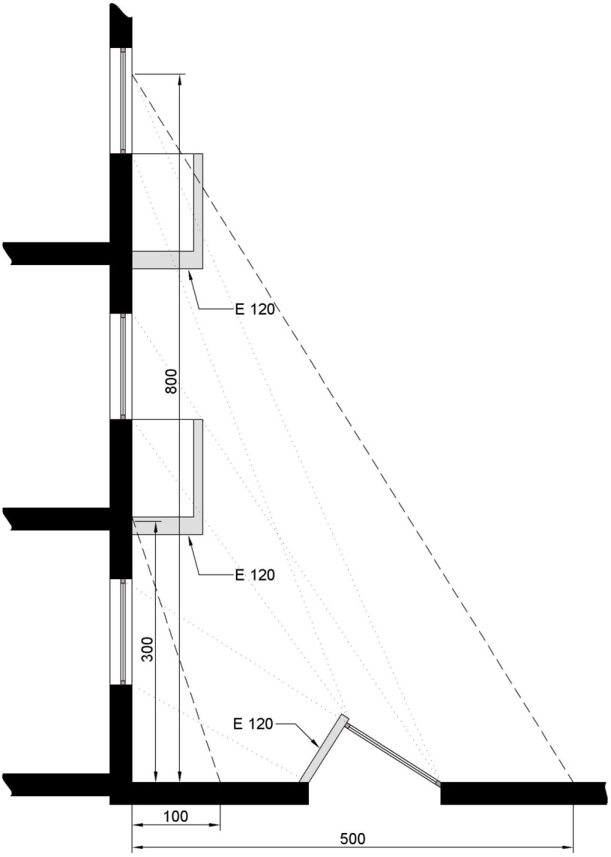

1.3 Horizontal distance between buildings

To prevent a fire from spreading between two buildings:

a) either, if façade are opposite each other or form an intrusive dihedral, the distance (in m) between the façade parts that do not have at least EI 240 or REI 240 must be at least:

1 + 7 cos α for 0° ≤ α ≤ 90°

1 for 90° α ≤ 180°

where α is the enclosed corner (image 4.2).

GEBOUW | BUILDING

b) or the radiation of a fire from a building to an opposite building, and vice versa, must not exceed 15 kW/m².

The walls that separate adjacent buildings have EI 240 or REI 240 when they are load-bearing.

In these walls, there can be a connection between these buildings through an air lock, provided that it has the following characteristics:

1. it must not lead to a stairwell;
2. it contains two self-closing doors EI ₁ 60;
3. the walls have EI 120;
4. the surface area is at least 2 m².

1.4 Accessibility of façades to the fire brigade

At least one of the long façades must run along a route accessible to the fire brigade vehicles and if the long façade does not contain a main entrance, the route must also run along a façade with such entrance.

The distance from the edge of this route to the plane of the façade should be between 4 m and 10 m.

The distance to be covered from the routes defined above to the lifts intended to the fire brigade (see 6.4.2) must not exceed 30 m.

If a plinth supports one or more buildings, one of the following two provisions must apply:
- the platform of the plinth is accessible to the fire brigade vehicles, subject to the requirements of 1.1 but with the exception of the slope of the ramp which may be 12 %;
- at least one of the façades of each building must be accessed by an open-air route or in a tunnel containing an open-air segment of at least 15 m x 7 m every 25 m.

1.5 Distance to fire station

The HG with a height of more than 50 m are implanted on less than 10 km, along drivable roads, from a fire station.

2 COMPARTMENTALISATION AND EVACUATION.

2.1 Size of compartments

The building is divided into compartments the surface area is less than 2 500 m², with the exception of car parks (see 5.2).

The area of a compartment may exceed 2 500 m² if it is equipped with an automatic extinguishing system and a smoke and heat extraction system. The Minister of the Interior determines the conditions under which a compartment may be larger than 2 500 m² without having to provide an automatic extinguishing system and a smoke and heat extraction system.

The height of a compartment corresponds to the height of one storey.

However, the following exceptions are permitted:

a) a car park with storeys (see 5.2);
b) a compartment may extend over two storeys above each other with an internal connecting staircase (duplex), if the accumulated area of those storeys does not exceed 2 500 m²;
for buildings for which the construction application was submitted before 1 April 2017, where the duplex is located on the highest two storeys of the building, the area of the compartment may be 2 500 m² per storey;
b/1) the height of a compartment may extend over three superimposed storeys connected by an internal connecting stairway (triplex), provided that the sum of their cumulative surface does not exceed 300 m² and that this compartment is equipped with an automatic fire detection device of the total surveillance type, which automatically emits fire alarm and whose detectors are adapted to the existing risks;
c) for buildings for which the construction application was submitted before 1 April 2017, the ground floor and the first floor (or mezzanine) may also form one compartment, provided that the total volume does not exceed 25 000 m³;
d) the height of a compartment may extend over several storeys above each other, if this compartment contains only technical premises (see 5.1.1).
e) the height of a compartment may extend over several storeys (atrium) provided that:
- that this compartment is equipped with an automatic extinguishing system and a smoke and heat extraction system. The Minister of the Interior determines the conditions under which exceptions are possible to the mandatory installation of an automatic extinguishing installation and a smoke and heat extraction installation;
- and that the evacuation possibilities of the building must comply with the provisions of this annex, whereby the evacuation via the atrium may not be taken into account.

The Minister of the Interior determines the conditions that the automatic extinguishing system and smoke and heat extraction system must meet.

2.2 Evacuation of the compartments.

2.2.1 Number of exits.

Each compartment has minimum:

- two exits;

- 2 + n exits where n the integer is immediately greater than the quotient of the division by 1 000 of the maximum occupancy of the compartment, if the occupancy is 500 or more than 500 persons.

The minimum number of exits can be increased by the fire brigade depending on the occupancy and configuration of the premises.

If the occupancy is 50 or more than 50 persons, the number of exits of storeys and premises is determined as for the compartments.

For the two underground levels immediately below the evacuation level, one exit is sufficient if these storeys contain only premises such as storage rooms and if the distance from each point of the compartment to the exit is less than 15 m.

In the event that a compartment extends over several storeys (atrium), the evacuation possibilities of the building must comply with the provisions of this annex which must not take account of evacuation via the atrium.

2.2.2 Exits.

The exits are located in opposite zones of the compartment.

Compartments not located at an evacuation level are connected to the evacuation level by means of stairs inside or outside the building (for horizontal distances see 4.4).

For underground storeys, an exit that meets the requirements of an evacuation level exit may replace the required access to a staircase.

For the car park: see 5.2.

At an evacuation level, each staircase leads outside, either directly or via a separate evacuation route meeting the requirements of 4.4.2.

3 REQUIREMENTS FOR CERTAIN CONSTRUCTION ELEMENTS.

3.1 Wall Penetrations.

Wall penetrations for fluid pipes or electrical lines and expansion joints of construction elements cannot adversely affect the required level of fire resistance of these construction elements.

The provisions of Annex 7 ‘Common provisions’, Chapter 1 apply.

3.2 Structural elements.

The structural elements have R 120.

3.3 Vertical interior walls and interior doors.

For the walls and doors, which demarcate compartments, 4.1 applies; if they mark evacuation routes, 4.4 applies.

The vertical interior walls delimiting premises or the whole of rooms with night occupation have EI 60.

The doors in these walls have EI ₁ 30.

The vertical interior walls of archive rooms have EI 60; Their doors are self-closing or fire-activated self-closing, rated EI₁ 30.

3.4 Ceilings and suspended ceilings.

3.4.1 On the evacuation routes, the premises accessible to the public and the collective kitchens, the suspended ceilings have EI 30 (a→b), EI 30 (b→a) or EI 30 (a ↔ b) according to NBN EN 13501-2 and NBN EN 1364-2, or have a fire stability of a ½ h according to NBN 713-020.

This requirement does not apply to the exceptions set out in point 4.4.3 and to the compartments equipped with an automatic sprinkler type extinguishing system adapted to the risks present.

3.4.2 The walls that require fire resistance continue into the space between the ceiling and the suspended ceiling.

If the space between the ceiling and the suspended ceiling is not equipped with an automatic extinguishing system, this space must be divided into volumes whose horizontal projection can be inscribed in a square not exceeding 25 m side.

These volumes are separated by vertical screens with the following characteristics:
- they consist of a class A1 and/or A2-s1,d0 material;
- they cover the entire space between the pipes;
- they have EI 30.

3.5 FAÇADES

3.5.1 Single-walled façades

3.5.1.1 Separation between compartments

The styles of the curtain wall skeleton are attached to the building skeleton at the level of each storey. With the exception of the buildings equipped with an automatic fire-prevention installation, these fittings will be R 60 in relation to a fire in an underlying and adjacent compartment.

The connection of the compartment walls to the façade has at least EI 60 or EI 60 (i→o).

In order to reduce the risk of a fire extension along the façade between compartments in a vertical or horizontal plane, one of the following requirements must be met:

(1) either the façade at the level of the connection of the façade to the compartment wall (horizontal or vertical) is equipped with a fire-resistant construction element.

The figures of image 4.3 show how this construction element is applied in relation to a horizontal compartment wall.

It includes:
- or a horizontal overhead, having at least E 60, width ‘a’ equal to or greater than 0.60 m and connected to the floor (image 4.3, figure A and B);

- either an element composed:
- from a horizontal overhang, having at least E 60, width ‘a’ and connected to the floor;
- in the overhead storey, from a parapet, which has at least E 60 - ef (o→i), with height ‘b’;
- in the underlying storey, from a lintel, which has at least E 60 (i→o), with height ‘c’.

The sum of dimensions a, b, c and d (floor thickness) is equal to or greater than 1 m; any dimensions a, b or c may be zero (image 4.3, Figure C to L).

The figures of image 4.4 show how this construction element is applied in relation to a vertical compartment wall.

It includes:
- either an element which is an extension of the façade and which has at least E 60 (i)o; the width of this element (b1+b2+a) (image 4.4, figure A and B) must be at least 1 m; the parts of this element located to the left and to the right of the centre line of the common wall are at least 0.50 m wide in the case of two different buildings (a1 ≥ 0.50 m and a2 ≥ 0.50 m);

- or a vertical overhang located in the centre line of the wall forming the separation between the two buildings or compartments and having at least E 60 (o→i) (image 4.4, figure C) or E 60 (i→o) (image 4.4, figure D); the length of this element (b1+b2+a) is at least 1 m;

- or a combination of the previous elements in such a way that the sum of the lengths is at least 1 m (image 4.4, Figure E).

(2) or the façade has at least either E 30 (i) over the entire height of the building (image 4.5, figure A), or E 60 (i) to the two storeys (image 4.5, Figure B).

(3) or the compartments located along the façades are equipped with an automatic sprinkler type extinguishing system adapted to the risks present (image 4.5, figure C).

3.5.1.2 Opposite façade and façade that form dihedral

To prevent a fire from spreading between two compartments:

a) either, if façade are opposite each other or form an intrusive dihedral, the distance (in m) between the façade parts not having at least E 60 or E 60 (o→i) must be at least:

1 + 7 cos α for 0° ≤ α ≤ 90°

1 for 90° α ≤ 180°

where α is the enclosed corner (image 4.6).

COMPARTIMENT | COMPARTMENT

b) or the radiation of a fire between façades belonging to different compartments may not exceed 15 kW/m².

3.5.2 Double-walled façades.

3.5.2.1 Double-walled façade interrupted by a compartmentalisation.

The cavity of the double-walled façade is interrupted by an element that has at least E 60 in the extension of each compartment wall. This element covers the entire space included between the two walls and has a minimum length of 60 cm to be counted from the interior wall of the façade.

This element may contain openings, provided that the continuity of compartmentalisation through the cavity is ensured by a self-closing sealing device with a fire resistance E 60. This device must be tested in its bearing structure, in accordance with the direction of the compartment wall; its closure is commanded:

- either by thermal detection at the level of this device which reacts at a temperature of not more than 100°C.
- or by a smoke detector in the cavity or in all compartments along the façade, which meets the conditions set out in point 3.5.2.3.

When there are vents between the cavity of the double-walled façade and the interior environment of the building, only a smoke detector is allowed in the cavity or in all compartments along the façade. It meets the conditions set out in point 3.5.2.3.

3.5.2.2 Double-walled façade without compartmentalisation.

The double-walled façade without compartmentalisation must be consistent with one of the two options listed below.

3.5.2.2.1 Double-walled façade whose interior wall is fireproof.

The exterior wall of the double-walled façade consists of at least 50 % construction elements between the floors without specific fire resistance.

The inner wall has:

- either, over the full height, at least one fire resistance E 30 ( i↔o);
- or alternately every two storeys at least one fire resistance EI 30 ( i↔o).

3.5.2.2.2 Double-walled façade open to the outside.

The requirements for single-walled façades may be applied to the interior wall when the outer wall contains fixed or mobile ventilation openings that automatically open in the event of fire.

The fixed vents are placed at 30 ± 10 degrees to the outside and upwards in relation to the horizontal, evenly distributed over at least 50 % of its surface area.

The mobile vents meet the same conditions as fixed ventilation openings in the event of fire.
The safety position of the mobile slats is triggered by a general fire detection system in the compartments along façades. The automatic operation must comply with the conditions laid down in paragraph 3.5.2.3.

3.5.2.3 Automatic closing/opening systems.

3.5.2.3.1 Operation

The closure/opening is commanded by an automatic fire detection system.

The installation is equipped with manual opening and closing systems. Its operation is reserved for the fire brigade. Its location must be determined in agreement with the fire brigade.

3.5.2.3.2 Operational security.

In the event of failure of the normal energy source (electrical energy, compressed air network), the detection system or the control system will put the closing/opening system in the safety position.

Any lack of energy source, power supply or electrical or pneumatic control must be reported automatically to the detection centre.

3.5.2.3.3 Operation in the event of fire in a neighbouring compartment.

If the closing/opening systems do not have a positive safety, the electrical lines connecting the closing/opening system must comply with paragraph 6.5.2.

3.6 Roofs.

The flat roofs and the roofs with a slight slope (gradient angle not more than 10°) have R 120.

This requirement does not apply if the roof floor has EI 120 (image 4.7) and if the access to the space under the roof, which should be empty, is through doors or hatches EI ₁ 60.

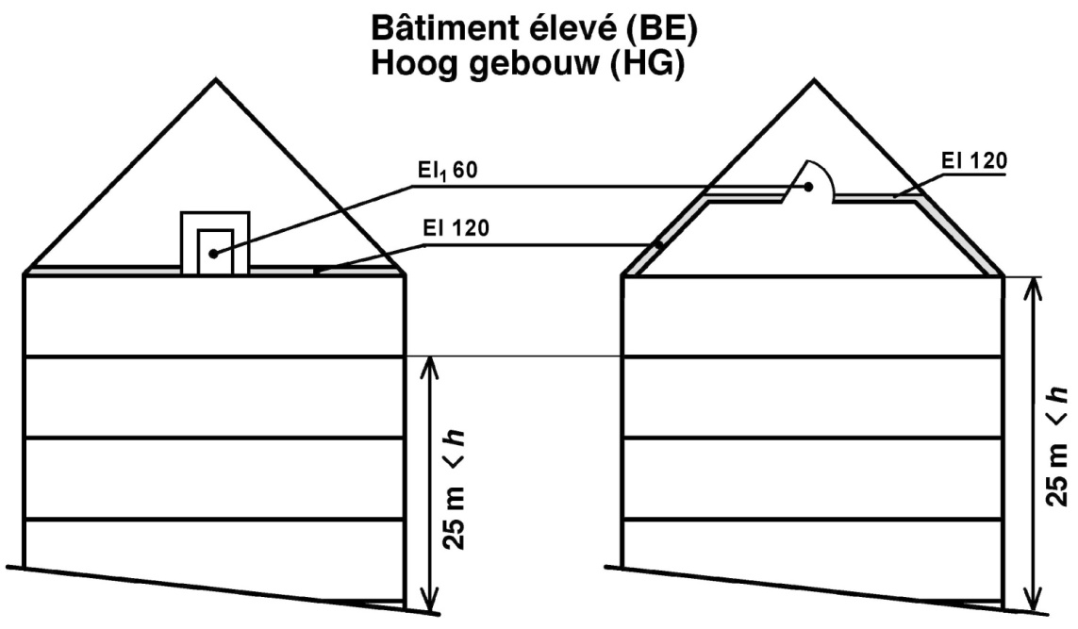

Hoog gebouw (HG) | High-rise building (HG)

This requirement also does not apply to roofs whose surface area is less than or equal to 100 m².

4 REQUIREMENTS FOR THE CONSTRUCTION OF COMPARTMENTS AND EVACUATION AREAS.

4.1 Compartments.

Compartments between walls must be EI 120.

3.5 applies to the façade or outer walls.

The connection between two compartments is only be permitted if it is made via an air lock with the following characteristics:

1. It contains self-closing doors with EI ₁ 30;
2. the walls have EI 120;
3. the surface area is at least 2 m².

The air lock can serve as an air lock for the stairwell but not as an air lock for lifts.

The doors may be self-closing in the event of fire provided that the building is equipped with an automatic fire detection of the total surveillance type which automatically indicates the fire alarm and its location, and whose detectors are adapted to the risks present.

4.2 Internal stairwells.

4.2.1 General.

The stairs connecting several compartments are enclosed. The basic principles of 2 ‘Compartment and evacuation’ apply to it.

4.2.2 Design.

4.2.2.1 The interior walls of the stairwells have at least EI 120.

Their walls may be made of glass, provided that they meet the requirements from point 3.5.

4.2.2.2 The stairwells must provide access to an evacuation level and to all overhead storeys.

If the building is equipped with a flat roof or a light gradient roof (see 3.6), each stairwell serving the floors above the evacuation level gives access to the roof, with the exception of those located in the parts of the building containing no more than three storeys above the level of evacuation.

If the access door to the roof is usually closed, it must carry both inside and outside a glazed cabinet containing the door key.

4.2.2.3 On each storey, the connection between the evacuation route and the stairwell is ensured by an air lock with the following characteristics:

1. It provides access to a single stairwell;
2. It contains self-closing doors EI ₁ 30 turning open in the escape direction; they must not be fitted with a locking system which would prevent its opening; their usable width is greater than or equal to the required usable width (calculated in accordance with Annex 1 ‘Terminology’) and is at least 0.80 m;
3. the walls have EI 120;
4. the surface area is at least 2 m².

At an evacuation level, this air lock can be replaced by a self-closing door with EI ₁ 60 and with the characteristics of the aforementioned air lock doors.

The doors may be self-closing in the event of fire provided:
- that the building is equipped with an automatic fire detection of the total surveillance type, which automatically emits fire alarm and its location, and whose detectors are adapted to the risks present;
- and that all compartments operated by this stairwell have day occupancy only.

A direct connection of each storey of a duplex or a triplex to the stairwell is required.

4.2.2.4 If several compartments are in the same horizontal plane, they may have one or more common stairwells provided that they are accessible from each compartment via a connection meeting the requirements of 4.2.2.3.

4.2.2.5 The stairwells operating the underground storeys must not be directly extended to those operating the storeys above an evacuation level.

This does not preclude one being above the other, subject to the following conditions:

1. the walls separating them have EI 120;
2. the access of each stairwell to the evacuation level must be in accordance with the requirements of 4.2.2.3 with the exception of the case referred to in 4.2.2.9 where access may be via a door with EI ₁ 30.

4.2.2.6 At the top of each interior staircase there is an ventilation opening with a diameter of at least 1 m² and flows into the open air. This opening is normally closed; Before opening, a manual control is used that is clearly visible at the evacuation level.

This requirement does not apply to stairwells between evacuation level and underground storeys.

4.2.2.7 Only the following items are permitted in the stairwells:
- detection devices;
- extinguishing appliances, with the exception of wall reels;
- alarm devices;
- lighting equipment;
- heating appliances;
- ventilation devices;
- smoke extraction devices;
- blow in devices.

Electrical pipes, ventilation ducts, smoke extraction ducts and blow in ducts are only permitted if they serve only for the operation of the aforementioned objects installed in the stairwell.

Water pipes are permitted in the stairwells.

All other lines is not permitted in the stairwells.

4.2.2.8 In high-rise buildings (HG), the common hall of the apartments served by one or more of the same internal staircases may be considered either as an air lock of the lifts or as an air lock of one or more stairwells, if the number of apartments evacuated via this common hall is less than or equal to six apartments.

Deviating from 4.2.2.3, an air lock (common hall) may give access to several stairwells, and the doors in the common hall may open against the escape direction and not be self-closing.

4.2.2.9 In the high-rise buildings (HG) of a maximum height of 36 m, the common hall of the apartments served by one or more of the same internal staircases may be considered at the same time as the air lock of the lifts and as an air lock of one or more stairwells, if the number of apartments evacuated via this common hall is less than or equal to four apartments.

Deviating from 4.2.2.3, an air lock (common hall) may give access to several stairwells, and the doors in the common hall may open against the escape direction and not be self-closing.

4.2.3 Stairs.

4.2.3.1 Construction provisions.

Stairs must have the following characteristics:

1. As well as the landings, they have R 60 or are designed in the same way as a concrete slab with R 60;
2. They are equipped with solid risers;
3. On both sides they are, even along the landings, equipped with a handrail;
For stairways of a usable width, less than 1.20 m, one handrail is sufficient, provided that there is no risk of falling;
4. The tread of the steps is at least 20 cm at any point;
5. The rise of the steps should not exceed 18 cm;
6. Their gradient must not exceed 75% (maximum gradient angle of 37°);
7. They are of the ‘straight type’.

4.2.3.2 Useful width of stair arms, landings and air locks.

This usable width must be at least 0.80 m and reaches at least the required usable width b_{r} calculated in accordance with Annex 1 ‘Terminology’.

The door swing may not limit the usable width of the overflow to a value less than b_{r}.

The stair arms and landings of the stairwells of the same compartment will not differ in their usable width by more than one passage unit.

If a compartment contains special-purpose premises, the theoretical useful stair width (according to Annex 1 ‘Terminology’) based on their number of users, is only calculated over the height between this compartment and the evacuation level.

4.3 Exterior staircases.

Exterior staircases meet the conditions of 4.2.2.2.

The exterior staircases are enclosed by walls; The outside air must be able to enter freely on at least one side on each storey.

No point of the staircase may be less than 1 m from a façade section that does not have EI 60.

The requirements of 4.2.3 apply, however, with the following derogation: the risers are not mandatory; no fire stability is required, but the material belongs to class A1.

The connection between the compartment and an exterior stairwell must be:
- either via a door EI ₁ 30;
- or via (an) escape terrace(s).

One stairwell may be replaced by two external staircases with straight stair arms; these stairs are connected by flight terraces on which transverse bulkheads may not form difficult obstacles.

A single external staircase is sufficient for the HG referred to in 4.2.2.9.

These external steps have the following characteristics:

1. width minimum 0.60 m;
2. angle of gradient not exceeding 45°;
3. tread of steps at least 0.10 m;
4. tread of steps up to 0.20 m;
5. two handles at each staircase.

However, a step or part of stairway that is retractable or articulated may be used for the connection between the evacuation level and the immediately higher level of construction.

4.4 Evacuation routes and escape terraces.

4.4.1 General requirements

4.4.1.1 No point of a compartment must be further than:

a) in the case of premises with only daytime occupancy:
- 30 m from the evacuation route connecting the exits;
- 45 m from the access to the nearest exit;
- 80 m from the access to a second exit.

b) in the case of premises or all of the night-occupied premises:
- 20 m from the evacuation route connecting the exits;
- 30 m from the access to the nearest exit;
- 60 m from the access to a second exit.

The length of dead-end evacuation routes does not exceed 15 m.

The usable width of the evacuation routes, escape terraces and of their access, exit or passage doors is greater than or equal to the required usable width (see Annex 1 ‘Terminology’). It will be at least 0.80 m in the case of evacuation routes and doors and at least 0.60 m for flight terraces.

The provisions of this point do not apply to car parks (see 5.2).

4.4.1.2 The following are deemed an exit from a compartment:
- an interior staircase in accordance with point 4.2;
- an external staircase in accordance with point 4.3;
- direct access to the open air at an evacuation level;
- an evacuation route at an evacuation level meeting the requirements of paragraph 4.4.2 applicable to evacuation routes connecting stairwells to the public road.

The route to be taken in the open air does not play a role in calculating these distances.

The doors on these routes do not have any locking device capable of obstructing the evacuation.

4.4.2 At an evacuation level

The vertical interior walls of the evacuation routes connecting stairwells to the public road have EI 120, and the doors of the premises opening onto these routes are self-closing, and have EI ₁ 60.

The doors may be self-closing in the event of fire provided:
- that the building is equipped with an automatic fire detection of the total surveillance type, which automatically emits fire alarm and its location, and whose detectors are adapted to the risks present;
- and that all compartments operated by these evacuation routes, as well as all compartments operated by stairwells leading to these evacuation routes, have only day occupancy.

The apartment doors opening onto the evacuation route may nevertheless be self-closing in the event of fire provided:
- that these doors are self-closing only in the event of a fire. In daily use, these doors are not self-closing (door closer with free-swing function);
- and that the building is equipped with an automatic fire detection of the total surveillance type, which automatically emits fire alarm and its location and whose detectors are adapted to the risks present.

Evacuation routes which do not connect stairwells to the public road must comply with the requirements of 4.4.3.

At such level, access to the stairwell must be in accordance with 4.2.2.3.

The evacuation route may include the entrance hall. This hall may include access to lifts and non-enclosed areas intended for reception and associated services, drinking establishments or places to eat.

At an evacuation level, no display windows of building components with a commercial function, which do not have EI 120, may be issued on the evacuation route that connects the exits of other components of the building to the public road, with the exception of the last 3 m of this evacuation route.

4.4.3 On a storey that is not an evacuation level.

In a compartment, the connection between and to the stairwells is via evacuation routes or over escape terraces. These routes may not pass through stairwells or through their air locks.

The route between the entrances to the airlocks of the stairwells is less than 60 m.

The vertical interior walls of the evacuation routes have EI 30 and the access doors to these routes EI ₁ 30.

This requirement, as well as the requirement set out in points 3.4.1 and 6.7.2.1 and of paragraph 2 of point 6.9.3.1, do not apply to compartments with only daytime occupancy with a surface area of less than 2 500 m² provided that:
- that these compartments are equipped with an automatic sprinkler type extinguishing system adapted to the risks present;
- that the building is equipped with an automatic fire detection device suitable for total protection, which device automatically emits fire alarm and the detectors of which are adjusted to the existing risks;
- and that the products used for lining vertical walls, ceilings and floors of the compartments meet the fire response requirements of the evacuation routes.

4.5 Signalling.

The serial number of each storey must be clearly indicated at landings and in evacuation spaces in stairwells and lifts.

The indication of exits and emergency exits must comply with the provisions concerning health and safety signs at work.

5 CONSTRUCTION REQUIREMENTS FOR CERTAIN PREMISES AND TECHNICAL AREAS.

5.1 Technical premises and spaces.

5.1.1 General.

A technical room or a set of technical premises forms a compartment. This compartment can reach over several successive storeys.

Technical premises are subject to the regulations for compartments subject to the following changes:

1. access to two exits leading:

- either for a technical compartment with an area of less than or equal to 100 m², to an adjacent compartment via a self-closing door EI ₁ 60;
- or to an adjacent compartment via an air lock according to 4.1;
- or to a stairwell via an air lock according to 4.2.2.3;
- or to the open air, in such a way that an evacuation level can be reached;

2. deviating from 4.4.1, no point of the compartment must be further than:

- 45 m from the route connecting the two exits in the technical compartment;
- 60 m from the nearest exit;
- 100 m from the second exit;

However, if the area of the technical compartment does not exceed 1 000 m², one exit to a stairwell, to the outside or to another compartment is sufficient. In this case, the route to this exit must not exceed 60 m;

3. if the height of the technical compartment extends over several successive storeys (see 2.1) and if it includes several service floors connected by stairs or ladders:

- if the compartment surface area is less than 1 000 m², every two service floors, starting with the lowest, one access to a stairwell, to the outside or to another compartment, is sufficient;
- if the compartment surface exceeds 1 000 m², each service floor must provide access to at least one of the two exits; these exits vary from floor to floor;

4. the usable width of evacuation paths, stair arms, landings and air locks must not be less than 0.80 m.

5.1.2 Combustion units.

5.1.2.1 Combustion rooms with combustion appliances with a cumulative combustion rate greater than or equal to 75 kW and fuel storage spaces.

The combustion rooms with combustion appliances with a cumulative combustion rate greater than or equal to 75 kW and the fuel storage areas must be technical premises.

The regulations of point 5.1.1. apply, provided that the following changes are made:
- Each combustion room and fuel storage compartment forms a separate compartment;
- The access doors to these combustion rooms and fuel storage rooms are self-closing and open in the escape direction;
- No point of these combustion rooms and fuel storage areas must be more than 15 m from the nearest exit;
- The combustion rooms are located in the two upper storeys of the building sections.

The capacity of a fuel storage space must be limited so that the total fire load of the fuel storage space is less than or equal to 750 GJ.

5.1.2.2 Common provisions.

The design, construction and fittings of the combustion divisions must comply with the provisions of paragraph 4 of Annex 7.

5.1.2.3 Deviating provisions.

The following deviating provisions apply to buildings whose building permit application was submitted prior to 1 July 2022:

- Point 5.1.2.1: Not applicable to combustion units with combustion appliances with a total useful heat output (also referred to as total rated power) less than 70 kW;
- Point 5.1.2.1: Not applicable to combustion units with combustion appliances having a total useful heat output (also called total rated power) greater than or equal to 70 kW if the access to the combustion department and the fire resistance of the walls, floors, ceilings and doors of the combustion department meet the requirements of standard NBN B 61- 001 +A1: 1996.

In addition, the combustion units and accessories are:

- either in a neighbouring building which is at a horizontal distance of at least 8 m and does not contain any combustible element referred to in point 1.3;

- or in the building, but under the following conditions:
- they must not be in or below the high part;
- combustion units with gas lighter than air may, however, be located on the highest storey;
- their connections to the other parts of the building are made via an air lock of the type described in point 1.3; their doors turn in the escape direction.

5.1.3 Transformer rooms.

5.1.3.1 General.

They comply with the requirements of the General Regulation on electrical installations (RGIE/AREI).

The following furthermore applies:
- the walls have EI 120, except the outer walls;
- the interior doors have EI ₁ 60;
- if water (from any origin, including extinguishing water) can reach the floor, e.g. by infiltration or via cable ducts, all measures must be taken to ensure that the water level is constantly and automatically below the level of the vital parts of the electrical installation, as long as it is in use.

If the oil content of the whole of the appliances reaches 50 litres or more, the regulations of NBN C 18-200 ‘Guidelines for the fire protection of the premises of electricity transformation’ apply.

5.1.3.2 On-site mounted or prefabricated posts.

A post or prefab post installed on site is set up in a room intended for that purpose, with walls EI 120.

The access, if not from the outside, is via a door EI ₁ 60.

5.1.4 Domestic waste disposal.

5.1.4.1 Chutes are not permitted.

5.1.4.2 Room for domestic waste storage.

The walls have EI 120.

The room is accessible

a) either by means of an air lock with the following characteristics:
1. self-closing doors EI ₁ 30;
2. walls EI 120;
3. minimum surface of 2 m²;

b) or, by one self-closing door EI₁ 30, on condition that the premise for garbage collection is equipped with an automatic fire extinguishing installation.
This automatic fire extinguishing installation is presumed to be in conformity, if it meets the requirements from point 5.1.4.3.

5.1.4.3 Type-solution for the premises for domestic garbage collection - Automatic fire-extinguishing system of sprinkler type, directly connected to the public water supply network.

This type of solution applies only to a room for the storage of household waste whose surface area is less than or equal to 24 m².

The subject type-solution describes an automatic fire-extinguishing system on water basis, connected to the public water supply network, without mandatory installation of overpressure equipment (for instance, a pump). The subject system is an installation with the pipelines constantly filled with water.

5.1.4.3.1 Environmental and operating conditions

The fully automatic extinguishing system, including the room for storing the household waste and pipes to it up to the building’s water counter, must be protected against frost.

The pressure of the water in this system may not exceed 12 bar.

This automatic extinguishing system must be able to operate permanently, except during testing, checks or maintenance (all taps in the supply lines and the cranes in the system itself in open position, parts maintained in good working condition, etc.).

5.1.4.3.2 Features for design and installation of sprinklers

The sprinklers meet the requirements of NBN EN 12259-1 standard and have the following characteristics:
- they are of the conventional type, suspended or standing;
- their nominal operating temperature is 68°C, or below;
- their K-factor is between 75 and 85. The K-factor corresponds to the flow, in L/min., of a sprinkler subject to the pressure of 1 bar.

The sprinklers are installed under the ceiling at a maximum distance of 30 cm from it or are built into the ceiling.

In the premises with the surface below 12 m², one sprinkler must be installed in the middle of the premise.

In the premises with the surface above 12 m² and below or equal to 24 m², two sprinklers must be installed in the middle of the premise, at no less than 2 m and no more than 4 m distance between them.

5.1.4.3.3 Characteristics of the pipelines

The pipelines in the system must be made of steel.

The nominal (internal) diameter of the pipelines in the system, and those leading from the system to the water meter of the building must be at least 25 mm.

The pipelines are attached to the walls or built-in, also in the room for the storage of the household waste.

5.1.4.3.4 Water-flow alarm

The water supply pipeline must be equipped with an alarm installation mounted outside the premise for the collection of domestic garbage, and it meets the requirements of NBN EN 12259-2 or NBN EN 12259-5.

The pipelines of the system may only be used downstream of the alarm device for the automatic extinguishing of the room for the storage of the household waste.

5.1.5 Pipe sleeves.

5.1.5.1 Vertical sleeves.

When vertical sleeves penetrate through horizontal walls requiring fire resistance, one of the following three measures apply:

1. the walls of the vertical shafts have EI 120 and the trapdoors and doors have EI ₁ 60.

They have decent ventilation at the top.
The free ventilation cross-section of the sleeve must be at least 10 % of the total horizontal cross-section of the sleeve, with a minimum of 4 dm².

The free aeration cross-section may be equipped with motorised ventilation valves, the opening of which is ordered as follows:
- automatically on detection of a fire in the sleeve;
- automatically, in the event that fire is detected in the building, if it is equipped with a fire-detection installation for general purposes;
- automatically in the event of a failure in the energy source, power supply or control system (positive safety device);
- manually, operated on evacuation level, in a place determined in mutual consent with the fire department.
If the free ventilation cross-section of a tube is equipped with a motorised ventilation valve, any gas pipes in this tube must comply with the requirements of standard NBN D 51-003 or the standard NBN D 51-006 for the pipes and connections in a non-ventilated technical tube.

The sleeves may not open onto the stairwells and their airlocks.

In the HG referred to in 4.2.2.9, the sleeves may be open onto the common hall.

2. a construction element with at least the required fire resistance of the horizontal wall is located at the level of the passage;

3. the walls of the vertical sleeves have EI 60 and the trapdoors and doors EI ₁ 30; At every compartment, vertical sleeves are interrupted by horizontal closures with the following characteristics:

- they consist of a class A1 and/or A2-s1,d0 material;
- they cover the entire space between the pipes;
- they have EI 60.

In cases 2 and 3, the sleeves must not be ventilated.

5.1.5.2 Horizontal ducts.

Where horizontal ducts penetrate vertical walls that must be fire resistant, apply one of the following three measures:

1. the walls of the horizontal sleeves and the trapdoors and doors have at least the required fire resistance of the vertical wall;

2. at the level of the penetration there is a construction element with at least the required fire resistance of the vertical wall;

3. The walls of the horizontal sleeves have EI 60 and the trapdoors and doors EI ₁ 30; the sleeves are interrupted at each compartment by vertical screens with the following characteristics:

- they consist of a class A1 and/or A2-s1,d0 material;
- they cover all space between the cables/pipes;
- they have EI 60.

5.2 Car parks.

By way of derogation from the basic principle laid down in point 2.1, a car park can form a compartment whose surface area is not limited even if there are several communicating floors.

5.2.1 Structural elements.

By way of derogation from point 3.2, the structural elements of the car park R have R 120 and the floors of the parking storeys and of the slopes have R 240.

If the roof has no other function than protecting the car park from the weather conditions:
the structural elements of the roof have R 120;
- or are the structural elements of the roof separated from the rest of the car park by an EI 120 construction element.

5.2.2 Compartment.

The walls and connections between the car park and the rest of the building are in accordance with point 4.1, with the following adjustment: the doors of the connections can be self-closing in the event of a fire.

5.2.3 Car park under various buildings.

By way of derogation from point 1.3, parking spaces of adjacent buildings must not be separated by a wall. These car parks are therefore only one and the same car park.

In such cases:
- the structural elements of the car park carrying it or the high buildings have R 240;
- the structural elements of the car park which, in case of collapse, can could cause damage to the structural elements supporting it or the tall buildings have R 240;
- the other structural elements of the car park have R 120.

5.2.4 Common provisions.

The design, construction and layout of the car park complies with the provisions of point 3 of Annex 7.

5.2.5 Deviating provisions.

Points 5.2.1 to 5.2.4 do not apply to façades on a building for which an urban planning permit application was submitted before 1 July 2022 if it meets the conditions below.

The walls between the car park and the rest of the building comply with the regulations of 4.1.

Certain non-residential premises may be included in the parking compartment, such as: transformer rooms, storage rooms, archive rooms, technical rooms, etc.

The walls of these premises have EI 120, and:
- access occurs through with an air lock with walls rated EI 120 and self-closing or fire-activated self-closing doors rated EI₁ 30;
- or access to each room occurs with a self-closing or fire-activated self-closing door rated EI₁ 60.

The special requirements on boiler sections, transformer rooms and waste storage rooms still apply (see also points 5.1.2, 5.1.3 and 5.1.4 respectively).

Evacuation is arranged as follows on each storey:
- at least two stairwells or external staircases comply with the requirements set out in 4.2 or 4.3 and are accessible from any point of the storey; the distance to the nearest staircase must not exceed 45 m; the minimum usable width of these stairs is 0.80 m;
- as stated in 2.2.2, third paragraph, the required access to one of the two stairwells on the considered storey may be replaced by a direct exit to the open air;
- on the storey closest to the exit level, the inclined route may replace one of the stairwells or external steps if its walls have EI 120 and the gradient measured in its centreline does not exceed 10 %;
- the limit of the slope to 10 % does not apply to compartments whose surface area is equal or less than 500 m², if evacuation via the slope remains possible;
- apart from the signalling determined in 4.5, the evacuation routes, on each storey, are also indicated on the floor or just above it.

However, a single exit per storey (interior staircase, external staircase, direct exit to the open air or inclined route on the storey closest to the exit level) is sufficient provided:
- the car park is no more than two component layers high;
- neither of these two storeys is located more than two floors above, or below the car exit level;
- the car park does not feature any points located more than 15 m from the access to the evacuation route leading to the exit;
- the car park does not feature any points located more than 30 m from the access to the exit.

In enclosed car parks with a total surface greater than 2 500 m², the measures necessary to prevent the spread of smoke must be taken.

5.3 Halls.

5.3.1 General.

If more than 500 people can be accommodated, these rooms may only be set up underground provided that the following conditions are met:
- the difference between the lowest floor level of these rooms and the nearest evacuation level may not exceed 3 m;
- the number of exits is determined as for compartments;
- the evacuation takes place: either via stairs or via slopes that reach a maximum of 10 % in the centre line. The overall width of these routes is greater than the theoretical usable width.

If the above-mentioned rooms are intended for a maximum of 500 persons, they may be set up underground provided that the lowest floor level accessible to the public is not more than 4 m below the average level of different evacuation levels of the establishment.

The number of exits is determined as for the compartments.

5.3.2 Structure.

The walls that form these rooms or whole of rooms have EI 120.

Each passage in the vertical walls is closed off with a self-closing or fire-activated self-closing door rated EI₁ 60; Either via a minimum 2 m² air lock bounded by walls EI 120 and by self-closing or by fire-activated self-closing doors EI ₁ 30.

These doors open in the escape direction.

No object may interfere with the evacuation to the exits.

5.4 Retail or commercial complex.

The establishment of shops opening onto indoor galleries is permitted at an evacuation level and at the adjacent levels provided that:

1. the complex with its galleries is separated from the other building parts by walls with EI 120;
2. the other building parts have their own exits independent of the exits of the retail or commercial complex.

The partitions between the business premises have EI 30 and run through the possibly suspended ceiling. The latter requirement expires if the retail or commercial complex is equipped with an automatic extinguishing system of the type of sprinkler adapted to the risks present.

5.5 Collective kitchens.

Collective kitchens, possibly including the restaurant, are separated from the other building parts by walls with EI 120.

Any passage to the rest of the building must be closed either by a self-closing or fire-activated self-closing door EI ₁ 60, or by a minimum 2 m² air lock bounded by walls EI 120 and by self-closing or by fire-activated self-closing doors EI ₁ 30.

These doors turn in the escape direction of the kitchen.

When the kitchen and restaurant are separated from each other, the horizontal and vertical transport systems between kitchen and restaurant must meet the following conditions:
- this transport takes place in ducts with walls EI 120 when it passes through other premises;
- the transport system is closed at the height of the compartment wall(s) with a device EI ₁ 120.

When the kitchen is not compartmentalised in relation to the restaurant, each fixed frying appliance is equipped with a fixed automatic extinguishing system which is connected to an appliance that interrupts the supply of energy to the frying appliance.

6 EQUIPMENT OF THE BUILDINGS.

6.1 Lifts and freight lifts.

6.1.1 General.

6.1.1.1 The machinery and associated parts of a passenger or freight lift are only accessible for maintenance, inspection and emergencies. The drive is located:
- either in an engine room;
- or in the shaft.

Control bodies may be accessible from the platforms provided that they do not adversely affect the required fire integrity of the ramp wall or the wall of the shaft in which they are placed.

6.1.1.2 In the event of an abnormal increase in the temperature of the machine and/or of the other electrical equipment, the lifts must stop on a ramp so that passengers can alight.

Automatic return to normal operation will only be possible after sufficient cooling.

6.1.1.3 Extinguishing systems that use water are not permitted in the shafts.

6.1.2 Design.

6.1.2.1 The whole consisting of one or more shafts and any engine room, as well as access platforms that must form an air lock, is enclosed by walls with EI 120.

Their walls may be made of glass, provided that they meet the requirements from point 3.5.

The access doors between the compartment and the air lock have EI₁ 30, and are self-closing, or fire-activated self-closing.

If the surface of the air lock is less than the surface of the lift cage or freight lift, the access door between the compartment and the air lock, a fire-activated self-closing revolving door EI ₁ 30 is operated by a fire detection system containing at least the following:
- a smoke detector in the shaft;
- a smoke detector in the compartment in the vicinity of the air lock access door.

The access platforms must be separated from the landings and airlocks of the stairwells, and may not form a part of the evacuation route, except for the cases referred to in 4.2.2.8 and 4.2.2.9.

6.1.2.2 The whole of the lift shaft doors or goods lift has E 30. The fire resistance according to the NBN EN 81-58 standard, whereby the platform wall on the side of the platform is exposed to the fire. The platform wall must be tested by means of possible operating and monitoring bodies, which make part of it.

The shaft doors tested by other methods are accepted in accordance with the Royal Decree of 12 April 2016 on the marketing of lifts and safety components for lifts, provided that they have at least the same degree of fire resistance.

6.1.2.3 The regulations of points 6.1.2.1. and 6.1.2.2. are not be required in the following cases:

a) on all storeys operated by the lift or freight lift, if this lift or freight lift serves the storeys of only one compartment consisting of several storeys;
b) on the storey(s) of only one of the compartments operated by the lift or freight lift, provided that this compartment is not a parking compartment or an apartment, and that the layout of this lift or freight lift on the other storeys does comply with the regulations of points 6.1.2.1. and 6.1.2.2 or with point (c) below;
c) on the storey(s) where the lift or freight lift leads directly outdoors, provided that the layout of that lift or freight lift on the other storeys does comply with the regulations of points 6.1.2.1 and 6.1.2.2 or point (b) above.

6.1.2.4 Lifts and freight lifts whose drive is located in an engine room.

The interior walls of the engine room, which do not overlook the lift shaft have EI 120.

The doors or trapdoors in these walls have EI ₁ 60.

Access to the engine room must be guaranteed to the fire-fighters.

6.1.2.5 Oleohydraulic lifts and freight lifts.

The space in which the propulsion of an oleohydraulic lift or freight lift is fitted will be fitted with a volume of at least 1.2 times the oil capacity of the machinery and reservoirs.

If the propulsion of an oleohydraulic lift or freight lift is installed in an engine room, the electrical equipment, as well as the electrical and hydraulic lines running from the engine room to the lift shaft, must be positioned higher than the highest level that the run-out oil in the engine room can reach.

6.1.2.6 Lifts and escalators.

The platform of the lift(s) may be the platform of one or more escalators. The whole consisting of one or more shafts and any engine room, as well as access platforms of the lift(s) and escalator(s), then only form one whole.

6.1.3 Ventilation.

6.1.3.1 The shaft, the engine room or the entire shaft and engine room are naturally vented through outside air outlets in the upper section.

However, the shaft or the whole shaft and engine room may be ventilated through internal air vents provided that the layout of the lift or freight lift complies with:
- either the conditions described in point 6.1.2.3 under a);
- or the case described in (b) of point 6.1.2.3 to the extent that the storey(s) where the regulations of points 6.1.2.1 and 6.1.2.2 are not required is located above the other storey(s).

6.1.3.2 Minimum cross-section of the ventilation openings must be 1 % of the horizontal surface of the area from which the air is supplied.

6.1.3.3 The vents may be fitted with motorised ventilation valves, the opening of which is commanded as follows:
- it is automatically commanded to ensure adequate ventilation for the users of the lift, even in the event of a prolonged downtime;
- automatic openings are mandatory in case of abnormal temperature increase of the machine and/or monitoring bodies;
- automatic openings are mandatory in case when fire is detected in the lift shaft and/or in the engine room;
- is automatically ordered when a fire is detected in the building, if it is equipped with a general fire detection system;
- is automatically commanded in the event of a failure in the energy source, power supply or control system (positive safety device);
- manually operated at the evacuation level.

6.1.4 Operation in the event of fire.

The operation of the lifts in the event of fire complies with the following regulations or any other rule of good craftsmanship that provides an equivalent level of safety, in accordance with the Royal Decree of 12 April 2016 on the marketing of lifts and safety components for lifts.

The operating principle of the lifts in the event of fire is that when the fire detection system or a manual alarm facility receives a fire signal, the system moves the lift cage to the lift landing at the evacuation level, allows passengers to step out there and then removes the lift from normal service.

6.1.4.1 The operation of the lifts in the event of fire complies with the requirements of standard NBN EN 81- 73.

6.1.4.2 The platform of the lift at the evacuation level is recorded as designated lift platforms.

6.1.4.3 Each lift battery must be equipped at least with a manual call facility at an evacuation level.

In addition, if the building is equipped with a general fire detection system or with a fire detection system in the shafts and/or in the engine rooms, in the event of fire, this installation must transmit a signal to the lifts.

6.1.4.4 When a general or partial detection in the building is required and the machinery of the lifts and goods lifts is located in the shaft, a smoke detector must be placed in the shaft.

6.1.4.5 If a fire-detection installation detected fire on the platform that corresponds to the designated main platform, the lift must receive one or more additional electrical signals, so that the lift car could be diverted to the designated substitute platform.

6.1.4.6 When the lifts are on the designated platforms in the event of a fire, it should be possible that the fire brigade can easily check that the lift cages are there, and that no one is locked in the lift.

The lifts, which, at the time of their arrival to the designated platform,are stationary there with doors open and put out of normal operation, meet the said requirement.

6.1.4.7 The lift can only be returned to normal operation by an authorised person.

6.1.4.8 The following deviating provisions apply to buildings whose building permit application was submitted prior to 1 April 2017:

- Point 6.1.4.1: Applicable to the lifts designed or renovated after 31 March 2017 only.

6.2 Paternoster lift, container transport and freight lift with loading and unloading automation.

6.2.1 These devices have their own engine rooms, shafts and platforms.

The engine rooms are located at the top of the shaft. The inner walls of engine rooms and shafts have EI 120.

Upon arrival at each level served, an air lock must exist with walls EI 120.

The doors or access hatches are self-closing, and have E 30. These doors or access hatches are tested with the platform side facing the oven.

The surface area of this air lock, which may only be used for goods handling, is designed for a judicious arrangement of the loading and unloading installation and the ease of access of the service staff.

Between the air lock and the shaft there are doors or hatches.

The shaft walls on the side of the compartment and the entrances in these walls have EI 60.

The shaft doors or access hatches of these devices operate automatically and are normally closed. One element can only be opened when the other is closed.

Any passages of horizontal conveyor belts to the paternoster and freight lifts, as well as the passages from one compartment to the other, are via an air lock, closed by two hatches or doors with E 30.

These hatches operate automatically and are normally closed; when a container passes through, such hatch can only open if the other is closed.

If the installation of the container transport follows a horizontal and/or vertical trajectory and passes through storeys or compartments, air locks are provided at each of these passages. The air lock walls have EI 120.

Their two hatches or doors have E 30. They are tested with the platform side turned upward. They operate automatically and are normally closed. Such a hatch or door can only open if the other is closed.

In the event of a fire, the installations are put out of service.

6.2.2 The installation of paternoster lifts for passenger transport is prohibited.

6.3 Escalators.

6.3.1 The stairwell of escalators has walls with EI 120.

6.3.2 Access to the stairwell must be carried out on each floor, via an air lock with the following characteristics:

1. It contains two self-closing or fire-activated self-closing door rated EI₁ 30;
2. the walls have EI 120;
3. the surface area is at least 2 m²;
4. it is distinguished from the landings and locks of stairwells and must not be part of the evacuation route.

6.3.3 The escalator is automatically switched off as soon as a fire is detected in a compartment to which it leads.

6.3.4 The regulations of points 6.3.1 and 6.3.2 are not required in the following cases:

a) on all storeys operated by the escalator, if this escalator serves the storeys of only one compartment consisting of several storeys;
b) on the storey(s) of only one of the compartments operated by the escalator, provided that this compartment is not a parking compartment, and that the layout of this escalator on the other storeys does comply with the regulations of points 6.3.1 and 6.3.2 or with point (c) below;
c) on the storey(s) where the escalator leads directly outdoors, provided that the layout of that escalator on the other storeys complies with the regulations of points 6.3.1 and 6.3.2 or point (b) above.

6.4 Special lifts.

The special lifts and their operation in the event of fire comply with the following regulations or any other rule of good workmanship that provides an equivalent level of safety, in accordance with the Royal Decree of 12 April 2016 on the marketing of lifts and safety components for lifts.

6.4.1 Lifts intended to evacuate persons with reduced mobility.

Where the lift intended for the evacuation of persons with reduced mobility is deemed mandatory in a building, the lift must be designed and constructed so to meet the following requirements, apart from the requirements included in point 6.1.

6.4.1.1 This lift must be designed and built in such a way that its structural features do not obstruct or impede access and use by persons with reduced mobility.

6.4.1.2 On all storeys the lift platforms form an air lock corresponding to the regulations from point 6.1.2.1, whereby the surface area is equal to, or larger than the surface of the cage.

6.4.1.3 The lift cages must be accessible at least to one person in a wheelchair and an accompanying person.

The minimum dimensions of the lift cage must be 1.1 m (width) x 1.4 m (depth).

6.4.1.4 The shaft doors open and close automatically and have usable width of at least 0.90 m.

6.4.1.5 The evacuation is carried out under the supervision of a competent person. For that purpose, the lift must be equipped with a switch with ‘evacuation key’, which enables the authorised person to take over the control of the lift.

6.4.1.6 The lifts intended for the evacuation of persons with reduced mobility must be marked by a clear and recognisable alarm.

6.4.1.7 The lift must contain an intercom system enabling a two-way communication process in situations when the lift is in the evacuation mode. Such a system must enable the communication between the lift car, the evacuation floor and the engine room, or the rescue operations dashboard.

The communication equipment in the lift cage and at the evacuation level must contain a built-in microphone and speaker, a telephone with receiver is not allowed.

The telecommunication wiring must be installed in the lift shaft and/or in the engine room, if appropriate.

6.4.1.8 With the exception of the lifts, which serve two storeys only, each lift platform must have an intercom system enabling a two-way communication process in situations when the lift is in the evacuation mode. Such a system must enable the communication between each lift platform, the evacuation floor and the engine room, or the rescue operations dashboard, so that the floors with evacuated persons with reduced mobility can be identified, and the information in that regard transmitted to the persons responsible for the evacuation procedure.

The communication equipment on each lift platform and at the evacuation level must contain a built-in microphone and speaker, a telephone with receiver is not allowed.

The communication system is designed in such a way that its operation remains guaranteed in the event of defect on the communication system of the lift cage mentioned in point 6.4.1.7.

6.4.2 Lifts intended for the fire brigade.

Each compartment and each floor equipped with a lift, with the exception of the technical compartment, if any, located on the top floor, must be accessible by, at least:
a) one lift intended for the fire brigade for buildings with a height of between 25 m and 100 m;
a) two lifts intended for the fire-brigade, in the case of buildings higher than 100 m.

These lifts intended for the fire brigade must comply with the following requirements in addition to the requirements set out in point 6.1.

By way of derogation from paragraph 1, a lift intended for the fire brigade is not required in the buildings referred to in point 4.2.2.9.

6.4.2.1 The lifts intended for fire brigades, and the operation of those lifts in the event of fire meet the requirements form NBN EN 81-72 standard.

6.4.2.2 On all storeys the lift platforms form an air lock corresponding to the regulations from point 6.1.2.1, whereby the surface area is equal to, or larger than the surface of the cage.

6.4.2.3 For buildings with a height of between 25 m and 75 m, all lifts and their electrical equipment must have the same fire protection as the lift intended for the fire service if a lift battery does not have an EI 60 wall around the lift intended to separate this lift for the fire brigade from the other lifts in the same shaft.

For buildings higher than 75 m, each unit comprised of the shaft, the engine room, if any, and the lift platforms, pertaining to the lift intended for the fire brigade, forms an independent unit, separate from the other lifts that meet the requirements from point 6.1.2.1.

6.4.2.4 The minimum dimensions of the lift cage must be 1.1 m (width) x 2.1 m (depth).

6.4.2.5 The shaft doors open and close automatically and have usable width of at least 0.80 m.

6.4.2.6 the platform on the access level for the fire brigade is equipped a switch with a ‘fire-brigade key’, that allows the fire-brigade to take over the operation of the lift.

6.4.2.7 The lift must be capable of reaching the farthest end of the fire-brigade access floor in less than 60 seconds after the door closes.

However, with respect to the buildings higher that 200 m, that time must be extended by one second per each 3 m extending above that 200 m height.

6.4.3 Deviating provisions.

The following deviating provisions apply to buildings whose building permit application was submitted prior to 1 April 2017:

- Point 6.4.1.4: The shaft doors to the lifts designed before 1 April 2017, open and close automatically and have usable width of at least 0.80 m.
- Points 6.4.1.6, 6.4.1.7 and 6.4.1.8: Applicable to the lifts designed or renovated after 31 March 2017 only.
- Point 6.4.2(1): Each compartment and level equipped with a lift, with the exception of the technical compartment of the higher level, is served by at least one lift intended for the fire brigade.
- Points 6.4.2.1 and 6.4.2.3: Not applicable.
- Point 6.4.2.4: The minimum dimensions of the lift cage must be 1.1 m (width) x 1.4 m (depth).

6.5 Low-voltage electrical installations for driving force, lighting and signalling.

6.5.1 They comply with the requirements of the applicable legal and regulatory texts, as well as with the General Regulations on Electrical Installations (RGIE/AREI).

6.5.2 The electrical lines supplying installations or appliances which must absolutely remain in service in the event of fire are placed in such a way that the risks of complete shutdown are spread.

On their route up to the compartment where the installation is located, the electrical lines must have the following fire resistance:

a) either an intrinsic fire resistance which is at least
- PH 60 according to NBN EN 50200 for pipes the outer diameter of which is less than or equal to 20 mm and the cross-section of the conductors is less than or equal to 2.5 mm²;
- Rf 1 h is according to add. 3 of NBN 713-020 for pipes the outer diameter of which is greater than 20 mm or the diameter of the conductors is greater than 2.5 mm²;

b) or Rf 1 h, according to add. 3 of NBN 713-020, for pipes without intrinsic fire resistance placed in tubes.

These regulations do not apply if the operation of the installations or appliances remains assured even in the event of a failure of the power supply.

The installations or appliances referred to are:
a) the safety lighting and, where appropriate, the replacement lighting;
b) the notification, warning and alarm systems;
c) the smoke extraction installations;
d) water pumps for firefighting and any drain pumps;
e) all lifts, except in the buildings referred to in point 4.2.2.9 of the non-special lifts not specified in paragraph 6.4.

6.5.3 Autonomous power sources.

The circuits referred to in 6.5.2 must be capable of being powered from one or more autonomous power sources; the power of those sources must be sufficient to simultaneously supply all installations connected to those circuits.

As soon as the normal power fails, the autonomous sources automatically and within one minute ensure the operation for one hour of the above-mentioned installations.

In the event that the autonomous electrical power source becomes activated, the non-special lifts, which are not intended by point 6.4, must be transported to the designated lift platform to allow the passengers to get off there and then take the lift out of normal operation.

6.5.4 Safety lighting.

The safety lighting complies with the requirements of standards NBN EN 1838, NBN EN 60598-2-22 and NBN EN 50172.

This safety lighting may be supplied by the normal power source, but if it falls out, the power supply must be made by one or more autonomous power source(s).

Autonomous lighting devices connected to the circuit supplying the normal lighting concerned may also be used provided they offer all the guarantees for proper functioning.

6.5.5 Lightning protection.

The buildings must be equipped with a lightning protection system chosen on the basis of a risk assessment.

6.6 Systems for flammable gas, distributed by pipes.

The combustible gas installations must comply with:
- NBN D 51-001 - Central heating, ventilation and air conditioning - Premises for pressure reducing equipment for natural gas;
- NBN D 51-003 - Installations for flammable gases lighter than air, distributed by pipes;
- NBN D 51-004 - Installations for flammable gases lighter than air, distributed by pipes - Special systems;
- NBN D 51-006 - Gas installations for commercial butane or commercial propane in a relaxed gas phase with a maximum working pressure (MOP) of 5 bar - Indoor pipes, installation and commissioning of consumables - General technical and safety regulations.

6.7 Aeraulic systems

If an aeronautical installation is present, it must comply with the following conditions.

6.7.1 System design

6.7.1.1 Integration of premises or closed spaces in the premises

No room or closed space, even in an attic or in a basement, may be integrated into the network of air ducts, unless these spaces comply with the regulations imposed on the ducts.

6.7.1.2 Use of staircases for air distribution

No stairwell may be used for the supply or discharge of air from other premises.

6.7.1.3 Air reuse restrictions

The air extracted from rooms with a particular fire hazard, storage area for flammable products, boiler room, kitchen, garage, car park, transformer room, garbage storage room, must not be redistributed and should be discharged outside.

The air extracted from other premises may:
- either be re-directed to the same premises, provided that a smoke valve is installed in the recycling duct in accordance with point 6.7.5;
- or be distributed to other premises to serve as compensation air for mechanical extraction systems with direct exhaust to the outside, provided that an additional smoke valve and a duct system for direct exhaust to the outside are provided with this recycling air.

In both cases, a smoke detector must be installed in the recycling air before the smoke valve. If smoke is detected in the recycling air, the air treatment groups discontinue their operation, the smoke valves close and, in the second case, the duct system intended to exhaust the recycling air open automatically and will be ready for operation once the fire brigade activate the air treatment groups.

However, the above devices (smoke valve on the recycling air and smoke detection in the extraction duct) are not required for air treatment groups operating only one single room with a total flow rate less than or equal to 5 000 m³/h.

6.7.2 Construction of the air ducts.

6.7.2.1 Air ducts on evacuation routes.

On the evacuation routes, as well as in the service ducts and in places that are inaccessible after the building is finished, the ducts are made from class A1 materials; the insulation products including their coatings are at least of class A2-s1,d0.

The flexible pipes must be at least class B-s1, d0 and their length does not exceed 1 m.

The air ducts in the evacuation routes with their suspensions have a fire stability of at least ½ h.

This provision is fulfilled if:
- either the ducts and their suspensions have EI 30 (ho io) or EI 30 (ve io) when placed horizontally or vertically respectively;
- or the ducts are suspended in order to comply with the following regulations:
- suspensions are made of steel
- distance axis on axis between suspensions ≤ 1 meter
- force per suspension point ≤ 500 N
- voltage in the suspensions ≤ 18N/mm²
- distance between ducts and suspensions ≤ 5 cm
- sliding voltage ≤ 10 N/mm²

The requirements of this paragraph do not apply to the exceptions set out in point 4.4.3 and to the compartments equipped with an automatic sprinkler type extinguishing system adapted to the risks present.

6.7.2.2 Extraction ducts from collective kitchens

The extraction ducts from collective kitchens are made from class A1 materials.

The extraction ducts located outside the collective kitchens are:
- either placed in tubes whose walls have EI 120;
- or have EI 120 (ho i ↔ o) or EI 120 (ve i ↔ o) when placed horizontally or vertically respectively.

The extraction ducts in the collective kitchens with their suspensions have a fire stability of at least ½ h.

This provision is fulfilled if:
- either the ducts and their suspensions have EI 30 (ho io) or EI 30 (ve io) when placed horizontally or vertically respectively;
- or the ducts are suspended in order to comply with the following regulations:
- suspensions are made of steel
- distance axis on axis between suspensions ≤ 1 m
- force per suspension point ≤ 500 N
- voltage in the suspensions ≤ 18N/mm²
- distance between ducts and suspensions ≤ 5 cm
- sliding voltage ≤ 10 N/mm²

6.7.3 Passages of air ducts through walls.

6.7.3.1 General.

The wall passages of ducts must generally comply with 3.1.

This regulation does not apply to the passage of ducts through walls with EI 30, subject to the following conditions:
- the air ducts are made of materials of class A1 over a distance of at least 1 m on either side of the pierced wall;
- the air ducts connecting to these passageways and passing through horizontal evacuation routes must not be connected to the air mouths located in those evacuation routes;
- it is a compartment with only premises with daytime occupancy.

6.7.3.2 Passages with fire-resistant valves

No air duct may:
- pass through a wall requiring a fire resistance greater than or equal to EI 60;
- pass through a partition between two compartments for which a fire resistance greater than or equal to EI 60 is required or pass through a wall of a pipe duct requiring a fire resistance greater than or equal to EI 60;

unless it meets one of the following conditions:

a) a fire-resistant valve with the same fire resistance (EI-S) as required for the perforated wall and complying with 6.7.4 is installed at the level of the wall passage.
However, this valve can be placed off the axis of the wall and connected to this perforated wall by a duct provided that the whole of the duct and valve has the same fire resistance (EI-S) as required for the transit wall;

b) the duct has the same fire resistance EI i↔o as required for the perforated wall or is placed in a sleeve with the same fire resistance as required for the perforated wall along the entire length of the passage through the compartment or through the protected area. This duct must not have an opening unless provided with a valve described in paragraph (a) above;

c) the duct simultaneously meet the following conditions:
- the diameter of the passage does not exceed 130 cm²;
- in the passage of the wall, the duct is equipped with a device which, in the event of a fire, closes the passageway and then has the same fire resistance as required for the perforated wall.

The air ducts located in tubes reserved solely for them and culminating at their top end into a technical room containing only the air handling groups they connect may pass through the walls of the technical room without any additional equipment. In this case, the ventilation of the tubes as required in 5.1.5.1 must be achieved through the technical room.

6.7.4 Fireproof valves

6.7.4.1 Operation

Three operating types are distinguished:

Type A: the valve is automatically closed when the temperature of the air flowing in the duct exceeds a limit value.

Type B: valve type A which can also be closed by a remote control by means of a system with positive safety.

Type C: the valve is normally closed but can be opened and closed by remote control.

This type applies only to retracting installations (see 6.9).

The closing of the valves type A and B is done by a system that does not require external energy.

If a general fire detection system is mandatory, the fire-resistant valves must be at the limits of the compartments of the control type B.

In case of detection, the type B valves of the infested compartment are automatically closed.

‘Limits of compartments’ means:
- the partitions to other compartments;
- the walls of pipe ducts passing through the compartment;
- the walls between the compartment and the stairwells.

6.7.4.2 Performance of the valve

The fire-resistant valve placed in the passageways of walls has the following performance:

Fire resistance of the wall | Fire resistance of the valve
EI 120 | EI 120 (ho i ↔ o) S  EI 120 (ve i ↔ o) S
EI 60 | EI 60 (ho i ↔ o) S  EI 60 (ve i ↔ o) S
EI 30 | EI 30 (ho i ↔ o) S  EI 30 (ve i ↔ o) S

Table 4.1- Fire-resistant valves.

In the absence of CE marking, the valve meets the following requirements:
a) after 250 consecutive opening and closing cycles, a valve of the same manufacture may not be deformed or damaged;
b) the valve resists the corrosive atmosphere in which it is placed;
c) no periodic lubrication is required for the proper functioning of the valve;
d) the valve box contains a valve position indicator on the top and an indelible arrow that indicates the direction of the airflow. A plate indicates the inner dimensions of the valve, the manufacturer’s name, the manufacturing number and year of manufacture; it also bears a clearly visible and indelible mark indicating a fire protection device;
e) after operation of the valve, it must be able to be switched back off.

6.7.4.3 Installation of the valve

The valve must be fixed in the wall and secured in such a way that the stability of the valve is ensured independently of the two connecting ducts, even if one of the two ducts disappears.

For the inspection and maintenance of the valve, an easily accessible inspection door is placed on the valve cabinet or on the sleeve in the immediate vicinity of the valve. This door has the same fire resistance as required for the duct.

In order to facilitate the localisation of the fire-resistant valve, a clearly visible and indelible mark must be affixed indicating a fire protection device together with the words ‘fire-resistant valve’. This mark is placed on the inspection door or in the room perpendicular to the valve.

6.7.5 Smoke valves

A smoke valve meets the following conditions:
1. the density of the valve must have one of the following qualities:
a) when closed, and at static pressure difference of 500 Pa, the air loss may not exceed 60 l/s.m²;
b) class 3 according to standard NBN EN 1751;
2. the gasket used to obtain this density must withstand temperatures fluctuating from - 20 °C to 100 °C for 2 h, after which the valve still meets the above density test;
3. the smoke valve closing system has positive safety.

6.7.6 Operation in the event of fire of the aeraulic installations

In the areas of the building, which are equipped with a fire detection system, the air treatment groups operating only the infested compartment are shut down in the event fire is detected.

The operation of certain elements of the aeronautical installations must be able to be controlled and operated from a point easily accessible to the fire brigade and located at the usual level of access.

The fire control board must contain at least the following elements:
- signalling the operation or downtime of the air handling units and fans (by unit or fan);
- control devices for the operation or shut-down of the above units and fans (by unit or fan);
- synoptic diagram of the building with clear localisation of the technical premises and of the air handling installations.

This fire control board is located in the same room and is combined with the central control panel for the retractors (see 6.9.4.9).

6.8 Notification, warning, alarm and fire fighting equipment devices.

The notification, warning, alarm and fire fighting equipment is determined in agreement with the fire brigade, in accordance with the following guideline.

6.8.1 In the buildings, notification and firefighting devices are mandatory.

6.8.2 Number and location of fire alarm, warning, alarm and fire-fighting devices.

6.8.2.1 The number of devices is determined by the dimensions, condition and risk in the premises.

The devices must be judiciously spaced in sufficient numbers to enable them to serve every point of the space concerned.

6.8.2.2 Install devices requiring human intervention in visible or clearly indicated places that are freely accessible under all circumstances. They are located, among other things, near exits, landings, corridors and are fitted in such a way that they do not interfere with circulation and cannot be damaged or impacted.

The outdoor devices are protected from all weather conditions if necessary.

6.8.2.3 The signalling must comply with the applicable rules.

6.8.3 Fire alarm.

6.8.3.1 The notification of the discovery or detection of a fire must be immediately communicated to the fire services by a reporting device on each storey and at least one in each compartment.

6.8.3.2 The necessary connections must be continuously and immediately ensured by telephone or electrical lines, or by any other system providing the same operating guarantees and the same operating facilities.

6.8.3.3 All devices that can establish a connection following human intervention display an indication of their intended use and instructions for use.

If this is a telephone, this message must indicate the call number to be formed, unless the connection is made directly or automatically.

6.8.4 Warning and alarm.

The warning and alarm signals or messages must be receivable by all stakeholders and must not be confusable with other signals.

6.8.5 Firefighting equipment.

6.8.5.1 General.

The firefighting equipment consists of devices or systems that may or may not be automatic.

The quick-action extinguishers and the wall reels serve for first intervention, i.e. they are intended for use by residents.

6.8.5.2 Portable or mobile quick-action extinguishers.

For a special risk of fire, these devices are selected according depending on the nature and extent of this hazard.

6.8.5.3 Wall reels with axial feed supply, wall hydrants.

6.8.5.3.1 The number and location of these devices must be determined by the nature and extent of the fire hazard.

If the surface of a building is less than 500 m² no wall reel is required (except for special risks). In all other cases, the number of wall reels is determined as follows:
1. the water jet reaches each point of a compartment;
2. compartments larger than 500 m² have at least one wall reel.

The press coupling of any wall hydrants is adapted to the couplings used by the fire brigade.

6.8.5.3.2 The riser feeding these devices with pressure water has the following characteristics:

- the inner diameter and feed pressure must be such that the pressure at the least divided reel meets the requirements of NBN EN 671-1;

- the inner diameter is at least 70 mm and the remaining pressure at the least allocated hydrant is at least 2.5 bar when the hydrant debits 500 l per minute without a hose or nozzle;

- in addition, the installation must provide a minimum water flow rate of 30 m³/h for at least 2 h.

6.8.5.3.3 The system supplies the devices with pressurised water without prior activation.

The branching of the public water supply network to the inner pipe can be carried out:

- either with direct passage without meter;

- or with a meter of the ‘Woltmann’ type or similar type, the conceptual and construction characteristics of which limit the loss of pressure to a low value.

The following regulations are valid:

- the general shut-off valves and all intermediate valves are sealed in open position;

- in the case of a direct outlet branch, the control of the extinguishers is sealed in a closed position;

- the pipes exposed to frost are carefully protected, without hindering or slowing down their operation;

- the pipes are equipped with the strictly necessary number of lock valves and drain valves to avoid danger and nuisance in the event of breakage;

- at the foot of each vertical pipe, a lock valve and a drain valve is fitted at the connection with the main line;

- the handwheels of the shut-off valves and drain valves bear clear indications of their opening direction;

- a pressure gauge with a three-way check valve is installed behind the general shut-off valve and a second beyond the highest device relative to the floor. These pressure gauges have a pressure of up to 10 bar with an accuracy of 0.2 bar (see NBN 363).

6.8.5.4 Underground and above-ground hydrants.

6.8.5.4.1 These above ground and underground hydrants are supplied by the public water supply network via a pipe with a minimum inner diameter of 80 mm.

If the public network cannot meet these conditions, other supply sources with a minimum capacity of 100 m³ must be used.

6.8.5.4.2 The location of the above and underground hydrants and their number are determined in such a way that, at each entrance to the building, the sum of the distances from that entrance to the two nearest hydrants is less than 100 m.

6.8.5.4.3 The underground or above-ground hydrants are installed at least 0.60 m (horizontally measured) from the side of the streets, roads or passageways on which vehicles can drive and park.

6.9 Aeronautical systems for smoke extraction.

6.9.1 General.

The buildings must be fitted with aeronautical smoke extraction installations from stairwells and, where appropriate, from horizontal evacuation routes or common halls.

If the following provisions refer to stairwells, they are meant to serve the upper sections of the building (i.e. located above the lowest level of evacuation).

6.9.1.1 Test conditions.

Each building is considered to be a single affected storey located at the evacuation level or on any storey above it.

The specified airflow rates are these under reference conditions, 20°Cand 1013 mbar.

The overpressure and air flow control tests must be carried out at an outside temperature exceeding 10°C and a wind speed lower than 4 m/s.

6.9.1.2 Airtightness of the stairwells

All doors opening onto the stairwells must be of class S ₂₀₀ (NBN EN 13501-2).

6.9.1.3 Characteristics of the air-injection fan.

The air-injection fan of a stairwell may not cause an overpressure of more than 80 Pa at a flow rate equal to the leakage rate of this stairwell with all doors closed.

The fan must provide a flow rate of at least 2 m³/s and in the stairwell the air must be changed at least 10 times per hour when the overpressure is zero there (doors or airlocks open).

6.9.1.4 Pressure balance.

The air-injection and extraction fans of the common halls or horizontal evacuation routes are interlocked so as not to cause uncontrolled pressures so that, in the absence of flow of the air-injection fan, the other stops.

In the absence of flow from the extraction fan, the overpressure generated in the common halls or horizontal evacuation routes must be lower than the overpressure in the stairwell.

6.9.2 Buildings the height of which exceeds 25 m and does not exceed 50 m.

6.9.2.1 Principle.

In the event of a fire, the inner stairwells are put in overpressure relative to the evacuation route.

The overpressure is achieved by mechanical ventilation. Ventilation is achieved by inflating outside air into the interior staircase by means of a fan and an air duct with one or more nozzles.

6.9.2.2 Pressures and flow rates.

a) In the case of closed doors and airlocks of the stairwell, the overpressure of the stairwell relative to the horizontal evacuation route of the affected storey must be between 40 and 80 Pa;
b) in the case of all open doors or airlocks of the stairwell, the flow rate of the blown air in the stairwell must be at least 2 m³/s and the air in the stairwell must be changed at least 10 times per hour.

6.9.3 Buildings with a height greater than 50 meters.

6.9.3.1 Principle.

In the event of a fire, the inner stairwells are put in overpressure in relation to their airlocks and in relation to the horizontal evacuation routes.

On the affected storey, the horizontal evacuation routes are also ventilated by blowing in fresh air and by extraction of smoke. The latter requirement does not apply to the exceptions set out in point 4.4.3 and to the compartments with only daytime occupancy which are equipped with an automatic fire detection of the total surveillance type, which automatically indicates an indication of the fire alarm and its location and whose detectors are adapted to the risks present and with an automatic sprinkler-type extinguishing system that is adapted to the risks present.

Pressurising, blowing in and extracting is done mechanically and only with outside air.

Ventilation is achieved by:

- injecting outdoor air into the inner staircase by means of a fan and an air duct with one or more blowing nozzles;
- injecting outdoor air into the common halls and in the horizontal evacuation routes, by means of a fan and an air duct with blowing nozzles, fitted with a valve opening only on the affected storey;
- the extraction and discharge of smoke by means of a fan, an air duct with valves opening only on the infested storey and possibly a network of air ducts, equipped with extraction nozzles in the horizontal evacuation routes.

6.9.3.2 Pressures and flow rates.

a) in the case of closed doors or airlocks of the stairwell, the overpressure between the stairwell and the horizontal evacuation route of the affected storey must be between 40 and 80 Pa;
b) in the case of all open doors or airlocks of the stairwell, the flow rate in the stairwell must be at least 2 m³/s and the air in the stairwell must be changed at least 10 times per hour.
the flow rate in the horizontal evacuation path of the affected storey must be at least 1 m³/s and the air must be changed at least 10 times per hour.

6.9.4 Technical provisions.

6.9.4.1 Outside air inlets.

The inlets for the smoke exhaust ventilation are installed on the façade, exposed to the prevailing wind in the lower half of the protected areas.

Each air inlet of the stairwell of the common halls or of the horizontal evacuation paths has separate grilles and ducts.

The fresh air supply ducts for the smoke extraction ventilation are fitted with a motorised smoke valve. This valve opens or closes when the associated fan starts or fails.

A smoke valve meets the requirements set out in 6.7.5.

6.9.4.2 Smoke evacuation.

The evacuation to the outside of the extracted smoke takes place along the roof of the building, or possibly at a lower roof.

6.9.4.3 Separate aeronautical circles.

Each air supply in a stairwell has a fan and ducts, separate from that of the other stairwells.

For the air supply in the horizontal evacuation routes, the vertical ducts operating the same common hall or horizontal evacuation route may have a common fan.

The same applies to the extraction in the horizontal evacuation routes.

The horizontal evacuation routes, operated by separate groups of vertical ducts per compartment, must have separate air-injection fans. The same applies to smoke extraction fans.

6.9.4.4 Smoke-extraction system fans.

If the fans of the smoke extraction system are installed within the building, they must be placed in their own room whose walls have EI 120. The doors of the room have EI ₁ 60.

The extraction fans belong to class F 300 (NBN EN 12101- 3).

6.9.4.5 Construction of the air ducts.

The air ducts, including their inner or outer cladding, are made of class A1 materials.
The smoke extraction ducts must be capable of discharging gases up to 300°C and must be able to withstand the expansion forces caused by these temperatures.

The air ducts for the smoke extraction ventilation have E-S 120 or are placed in their own tubes with walls EI 120.

By way of derogation from previous paragraph, a fire stability of 1/2 h is sufficient for the horizontal air ducts of the smoke extraction ventilation, placed in a compartment and which only operate this compartment.

6.9.4.6 Discharge nozzles in the stairwells.

The nozzle(s) of a stairwell is (are) placed in the lower half of that stairwell.

6.9.4.7 Nozzles and valves in the horizontal evacuation routes.

Where an injection duct enters the compartment, it is equipped with a fire-resistant valve which is closed in normal conditions and which opens automatically in the event of a fire in this compartment.

The valve is type C and meets the requirements set out in 6.7.4.

The upper edge of the blowing openings or nozzles must not more than 1.50 m above the floor.

6.9.4.8 Extraction nozzles and valves in the communal halls of apartments or in the horizontal evacuation routes.

6.9.4.8.1 Where an extractor duct leaves the compartment, it is equipped with a fire-resistant valve which is closed in normal conditions and which opens automatically in the event of a fire in this compartment.

This valve is type C and meets the requirements specified in 6.7.4.

6.9.4.8.2 The distance between two extraction nozzles or between an extraction nozzle and a nozzle must not exceed 10 m if the route followed is straight and not more than 7 m in the other case.

In the areas where there is no air circulation for the smoke exhaust (dead-run corridor), the distance between an extraction nozzle and the door of a room must not exceed 5 m.

Each nozzle ensures an equal suction flow rate with a tolerance of ± 10 %.

The extraction nozzles are installed as close as possible to the ceiling. Their lower edge is at least 1.80 m above the floor.

The horizontal ducts on which several extraction nozzles are placed have a maximum length of 20 m, measured from the vertical duct to which they are connected.

6.9.4.9 Operation of the smoke extraction ventilation.

As mentioned in point 6.7.6, a central control and control post must be installed in the building for all aeronautical installations for the benefit of the fire brigade.

This unit must also contain a control and control panel for the smoke extraction systems.

The smoke extraction ventilation system operates:
- automatically by combustion gas detectors distributed over the total length of the horizontal evacuation routes;
- manually by remote control from the central control post.

The central control post provides the possibility of:
- turning on or off any fan of a stairwell;
- to simultaneously switch on or off any blower or extraction fan of a common hall or horizontal evacuation route;
- to open the injection and extraction valves for the smoke extraction per compartment.

It must be possible to switch on the smoke extraction ventilation system again in order to put the automatisms in standby mode again.

If necessary, the operation of the smoke extraction system is signalled by sound and light signals.

Access to the controls of the central control post is carried out with a key.

6.9.4.10 Signalling.

6.9.4.10.1 A signalling board in the central control post indicates the position of the smoke extraction ventilation system.

6.9.4.10.2 Blower and extraction valves.

For the blow and extraction valves in the common hall of the apartments or horizontal evacuation paths, the signalling board for each compartment indicates the following positions:

- all valves are closed;
- all valves are open;
- all valves are not in the same position.

6.9.4.10.3 Fire detection.

The signalling board indicates for each compartment the operation of the fire detection, as well as the errors and malfunctions that occur in the fire detection system.

6.9.4.10.4 Smoke extraction fans.

The signalling board indicates the functioning and downtime of each fan. This signalling is performed with airflow detectors.

6.9.4.11 Electrical power supply.

The fire detection, the light signals and the device for operating the blower and extractor valves for the smoke extraction are designed in such a way that they remain in operation when the mains voltage is interrupted.

The blower and extraction valves for the smoke extraction open when there is no voltage.

6.9.5 Maintenance - Tests - Control.

6.9.5.1 Maintenance.

The appliances (detectors, valves, fans, etc.) are regularly maintained according to the manufacturer’s guidelines. The manufacturer provides, for each appliance, an instruction which includes the periodicity, the nature of the maintenance to be performed and any possible professional competence of the staff responsible for the maintenance. This instruction is attached to the safety register.

6.9.5.2 Periodic tests.

The devices of each storey must be subjected to periodic testing in accordance with their normal operation. The fans are tested quarterly and the other appliances at least once a year.

6.9.5.3 Monitoring.

The monitoring of the operation, including the measurement of flow rate and differential pressure, is carried out before occupancy, even partial, of the building and before any modification that may affect the smoke extraction.

Viewed and to be added to our Royal Decree of 20 May 2022 amending the Royal Decree of 7 July 1994 laying down the basic fire and explosion prevention standards with which buildings must comply.

On behalf of the King:
The competent minister for internal affairs,

Annelies Verlinden

