Feedback on the draft: Royal Decree on product standards for transport fuels from renewable sources

- One of the initial considerations of the Royal Decree states: “Whereas biofuels and biogases based on palm oil and soya bean oil cause widespread deforestation and indirect land use change and result in high greenhouse gas emissions.”

This statement is a generalized judgement on the palm oil industry that does not consider the significant regional differences regarding the impact that oil palm expansion has had on deforestation and ILUC.

Although oil palm cultivation has been associated with deforestation and its relationship with direct and indirect land-use change and greenhouse gas emissions in some producing countries (Ramdani and Hino, 2013) (Khasanah, 2019) (Thomas et al., 2015) (Khatun et al., 2017); there are studies that show a different reality for producing countries in regions such as Latin America and Africa:

- A recent study by Meijaard et al. (2018) of the IUCN Oil Palm Taskforce concluded that only Indonesia, Malaysia and Perú have had significant impacts on deforestation due to oil palm expansion, as shown on figure 1. For the rest of the oil palm producing regions, the weighed impact of oil palm expansion on deforestation has been less than 10%.

Figure 1. Significant regional differences in oil palm-related deforestation
Source: Meijaard et al. (2018) - IUCN Oil Palm Taskforce

- The study by Vijay et al. (2016), which was mentioned in the “Report from the Commission to the European Parliament, the Council, the European Economic and Social Committee and the Committee of the Regions on the Status of Production Expansion of Relevant Food and Feed Crops Worldwide” as the most relevant data source for oil palm, identified 12 oil palm producing countries with less than 10% deforestation due to oil palm expansion in the 1989-2013 period. The oil palm harvested area of 12 countries would meet the criteria set out in the Delegated Act to be considered as non-high iLUC risk feedstocks.

Colombia is one of several countries that has a consolidated palm oil industry with low impact on deforestation. Vijay et al. (2016) estimated that less than 1 % of oil palm expansion in Colombia between 1989 and 2013 had been associated with deforestation, and Furumo & Aide (2017) estimated that 9 % of oil palm expansion between 2000 and 2014 had been on forested areas, as shown on Figure 2.

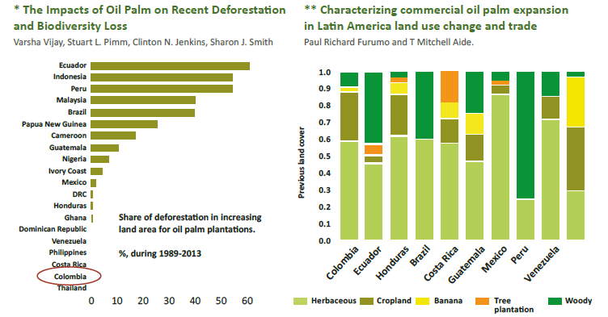
Figure 2. Impact of oil palm producing countries on deforestation
Source: Vijay et al. (2016); Furumo & Aide (2017)

Based on the previous comments, we suggest the wording of the consideration should be changed to avoid generalizing all palm oil as associated with deforestation and ILUC.

- In the Annex 1. Part A, a table with typical and standard values for biofuels produced without net carbon emissions from land use changes, describe a reduction of GEI for each biofuels according with the typical conditions for each product. This information is relevant for all producer countries because, only biofuels with a minimal emission reduction can enter a Belgium market.

Regarding this point, the Colombian palm industry makes the following comments:

As each country has a different impact on deforestation, this implies that its carbon footprint for biodiesel production is different. In the case of countries with low impact on deforestation, such as Colombia, that carbon footprint will be positive compared to countries with traces of deforestation.

In the case of Colombia, we have two studies on the carbon footprint associated with palm biodiesel with results very different from those mentioned in the table in Annex 1 Part A. Those are:

The Government of Colombia, with the support of the Inter-American Development Bank, commissioned a study on the sustainability of biofuels in the country. It was carried out by the CUE consortium, constituted for EMPA (Swiss Federal Institute of Materials Science, Science and Technology), the National Centre for Cleaner Production (NCPC), headquartered in Medellin, the Universidad Pontificia Bolivariana, and national and international experts. One of the more robust results of the study is that, compared to their fossil equivalents, palm biodiesel have a very high potential for reducing greenhouse gases, particularly carbon dioxide (CO2): 83% for biodiesel, without methane gas and 108% with methane gas. Considering the entire life cycle of biodiesel production.

Moreover, the most recent study of GHG emission carried out by Ramirez-Contreras et al. (2020) included the analysis of 70% of the national production of oil palm fresh fruit bunches (FFB) through on-site surveys in 28 oil palm mills. In this study, it was found that the average carbon footprint for the Colombian oil palm sector is -689.8 kg CO₂eq t⁻¹ CPO.

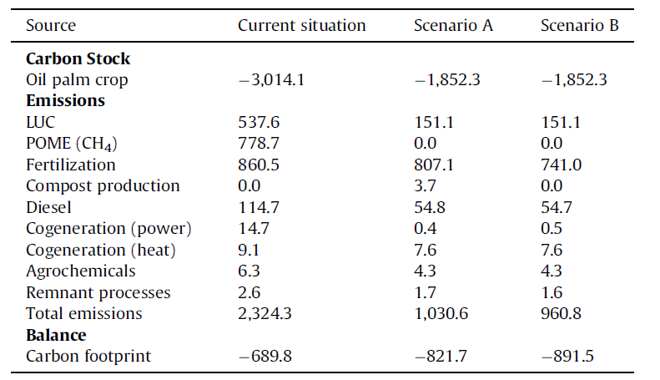
Figure 3. Comparison in GHG emissions and carbon footprint in the CPO production chain (kg CO₂eq t⁻¹ CPO).
Source: Ramirez-Contreras et al. (2020)

We therefore suggest that the data presented in the annexes, concerning the mitigation of greenhouse gases in the palm oil cycle, cannot be generalized and should be verified by country of origin.

Considering the scientific evidence from countries previously presented on the differences between palm oil producers and the impact on indirect land use and GHG reduction, we suggest the following:
- Eliminate article 24, as this restricts the palm oil market in Belgium and the European Union
- Do not generalize the information on the reduction of GHG from palm oil and consider countries with low deforestation.

References
Furumo, P., and Aide, T.M. (2017). Characterizing commercial oil palm expansion in Latin America: land use change and trade. Environmental Research Letters 12.
Meijaard, E., Garcia-Ulloa, J., Sheil, D., Wich, S.A., Carlson, K.M., Juffe-Bignoli, D., and Brooks, T.M. (eds.) (2018). Oil palm and biodiversity. A situation analysis by the IUCN Oil Palm Task Force. IUCN Oil Palm Task Force Gland, Switzerland: IUCN. xiii + 116pp.
Vijay, V., S. L. Pimm, C. N. Jenkins, S. J. Smith. (2016). The Impacts of Oil Palm on Recent Deforestation and Biodiversity Loss. PLoS ONE 11, e0159668. https://doi.org/10.1371/journal.pone.0159668
Khasanah, N., 2019. Oil palm (Elais guineensis) production in Indonesia: carbon footprint and diversification options. Wageningen University and Research, Wageningen, The Netherlands. https://doi.org/https://doi.org/10.18174/467425
Khatun, R., Iman, M., Moniruzzaman, M., Yaakob, Z., 2017. Sustainable oil palm industry: The possibilities. Renew. Sustain. Energy Rev. 76, 608–619. https://doi.org/10.1016/j.rser.2017.03.077
Ramdani, F., Hino, M., 2013. Land Use Changes and GHG Emissions from Tropical Forest Conversion by Oil Palm Plantations in Riau Province , Indonesia. PLoS One 8, 1–6. https://doi.org/10.1371/journal.pone.0070323
Ramirez-Contreras, N.E., Munar-Florez, D., Garcia-Nuñez, J., Mosquera-Montoya, M., Faaij, A.P.C., 2020. The GHG emissions and economic performance of the Colombian palm oil sector; current status and long-term perspectives. J. Clean. Prod. 258, 1–19. https://doi.org/10.1016/j.jclepro.2020.120757
Thomas, M., Buchanan, J., McLaughlin, D., Grubba, D., 2015. Sustainable Sourcing Guide for Palm Oil Users.

Meijaard, E., Garcia-Ulloa, J., Sheil, D., Wich, S.A., Carlson, K.M., Juffe-Bignoli, D., and Brooks, T.M. (eds.) (2018). Oil palm and biodiversity. A situation analysis by the IUCN Oil Palm Task Force. IUCN Oil Palm Task Force Gland, Switzerland: IUCN. xiii + 116pp.
Vijay, V., S. L. Pimm, C. N. Jenkins, S. J. Smith. (2016). The Impacts of Oil Palm on Recent Deforestation and Biodiversity Loss. PLoS ONE 11, e0159668. https://doi.org/10.1371/journal.pone.0159668
Furumo, P., and Aide, T.M. (2017). Characterizing commercial oil palm expansion in Latin America: land use change and trade. Environmental Research Letters 12.
Gauch Marcel. Representative of the CUE consortium, Life Cycle Analysis of Colombian Biodiesel Revista Palmas Vol. 34 No. Especial, Tomo II, 2013, , Pag 331-344

