

The Minister for the Ecological Transition

**HAVING REGARD TO** Law No 349 of 8 July 1986, which established the Ministry of the Environment and defined its functions;

**HAVING REGARD TO** Directive 94/62/EC of the European Parliament and of the Council of 20 December 1994 *on packaging and packaging waste* as last amended by Directive (EU) 2018/852 and, in particular, Article 8 containing marking requirements and packaging identification systems;

**HAVING REGARD TO** Legislative Decree No 152 of 3 April 2006  *laying down environmental rules*, as amended by Legislative Decree No 116 of 3 September 2020 on the *implementation of Directive (EU) 2018/851 amending Directive 2008/98/EC on waste and implementing Directive (EU) 2018/852 amending Directive 1994/62/EC on packaging and packaging waste*, and in particular Article 219(5) thereof, which lays down new labelling requirements for all packaging;

**HAVING REGARD TO** Article 182b(6) of the aforementioned Legislative Decree No 152 of 2006, as amended by Legislative Decree No 116 of 2020, which provides, in particular, that biodegradable and compostable packaging is to be collected and recycled together with organic waste if, inter alia, they ‘*are appropriately labelled and bear, in addition to the indication of compliance with the aforementioned European standards, elements identifying the producer and the certifier, as well as suitable instructions for consumers* *to take such waste to facilities for the separate collection and recycling of organic waste*’;

**HAVING REGARD TO** Article 11(2) of Decree-Law No 228 of 30 December 2021 *laying down urgent provisions on legislative terms*, which amended Article 219 of the aforementioned Legislative Decree No 152 of 2006, inserting the new paragraph 5.1, which provides for the adoption, by means of a non-regulatory decree of the Minister for the Ecological Transition, of the technical guidelines for the correct labelling of packaging referred to in Article 219(5) of the aforementioned Legislative Decree No 152 of 2006;

**HAVING REGARD TO** the last sentence of Article 261(3) of the aforementioned Legislative Decree No 152 of 2006, as amended by Article 15(3) of Legislative Decree No 196 of 8 November 2021, on the *implementation of Directive (EU) 2019/904 of the European Parliament and of the Council of 5 June 2019 on the reduction of the impact of certain plastic products on the environment*, which provides for specific administrative fines for infringements of the provisions on the labelling of packaging;

**HAVING REGARD TO** Article 15(6) of Decree-Law No 183 of 31 December 2020 *laying down urgent provisions on legislative terms, the creation of digital links, the implementation of Council Decision (EU, EURATOM) 2020/2053 of 14 December 2020 and on the withdrawal of the United Kingdom from the European Union*, converted, with amendments, by Law No 21 of 26 February 2021, which suspended until 31 December 2021 the application of the first sentence of Article 219(5) of Legislative Decree No 152 of 2006;

**HAVING REGARD TO** Article 39(1b) of Decree-Law No 41 of 22 March 2021 *laying down urgent measures to support businesses and economic and labour operators, health and territorial services, linked to the COVID-19 emergency*, converted, with amendments, by Law No 69 of 21 May 2021, which extended the suspension of the package labelling obligation in place until 31 December 2021 to the whole of Article 219(5) of Legislative Decree No 152 of 2006, providing, moreover, that packaging not compliant with the environmental labelling requirements already placed on the market or labelled on 1 January 2022 may be marketed until stocks are exhausted;

**HAVING REGARD TO** Article 11(1) of Decree-Law No 228 of 30 December 2021 *laying down urgent provisions on legislative terms,* converted with amendments by Law No 15 of 25 February 2022, which extended until 31 December 2022 the package labelling obligation laid down in Article 219(5) of Legislative Decree No 152 of 3 April 2006, providing, moreover, that packaging which does not meet the labelling requirements already placed on the market or labelled on 1 January 2023 may be marketed until stocks are exhausted;

**HAVING REGARD TO** Decree-Law No 22 of 1 March 2021, converted, with amendments, by Law No 55 of 22 April 2021, and, in particular, Article 2(1) thereof, which renamed the Ministry for the Environment and the Protection of Land and Sea as the Ministry for the Ecological Transition;

**HAVING REGARD TO** Prime Ministerial Decree No 128 of 29 July 2021 regulating the organisation of the Ministry for the Ecological Transition;

**WHEREAS** the entry into force of Article 219(5) of the aforementioned Legislative Decree No 152 of 2006 may lead to impacts on the organisational, management and economic and financial models of the national industrial and commercial sector, inter alia because of the possible penalties provided for in Article 261(3) of the aforementioned Legislative Decree;

**WHEREAS**, in order to provide some initial indications for the correct fulfilment of the package labelling obligation, the Ministry for the Ecological Transition published the note of 17 May 2021, Official Register No. 52445, entitled ‘*Legislative Decree No 116 of 3 September 2020: Clarifications on the environmental labelling of packaging referred to in Article 219(5) of Legislative Decree No 152 of 3 April 2006*’;

**WHEREAS** the rules laid down in Article 219(5) of the aforementioned Legislative Decree No 152 of 2006 on the environmental labelling of packaging require further clarification, inter alia with specific reference to the various industrial and commercial sectors with different needs andrequirements;

**HAVING CONSIDERED IT** necessary to provide for clear and specific rules on the correct fulfilment of the labelling obligation to ensure that operators do incur legal infringements and, therefore, do not incur the consequent administrative penalties imposed by environmental legislation;

**HAVING CONSIDERED IT** essential, therefore, to adopt technical guidelines, in order to specifically regulate the general environmental labelling obligation laid down in Article 219(5) of the aforementioned Legislative Decree No 152 of 2006, also in view of the additional marking requirements for biodegradable and compostable plastic packaging deriving from Article 182b(6)(b), of the same Legislative Decree;

**HEREBY DECREES**

**Article 1**

***(Adoption of the Guidelines on Packaging Labelling)***

1. This Decree, pursuant to Article 219(5) of Legislative Decree No 152 of 3 April 2006, governs the ‘*Guidelines on the labelling of packaging, pursuant to Article 219(5) of Legislative Decree No 152/2006, as amended*’, aimed at the correct fulfilment of the obligations laid down in Article 219(5) of the aforementioned Decree, as well as the additional package marking obligations laid down in Article 182b(6)(b) of the same Legislative Decree for biodegradable and compostable plastic packaging.

2. The ‘*Guidelines on the labelling of packaging, pursuant to Article 219(5) of Legislative Decree No 152/2006, as amended*’ are defined in Annex 1, which forms an integral part of this Decree.

3. Annex 1 may be updated or amended periodically by subsequent ministerial decrees, in light of new provisions of national and/or EU law, as well as new specific indications, technical simplifications and labelling application methods resulting from consultations and discussions with trade associations.

4. This Decree is addressed to those subject to the package labelling obligation referred to in paragraph 1.

5. This Decree, together with its Annex, is published on the institutional website of the Ministry for the Ecological Transition.

Rome,

Roberto Cingolani

Ministry for the Ecological Transition

Guidelines on the labelling of packaging, pursuant to Article 219(5) of Legislative Decree No 152/2006, as amended

15/3/2022

# **Introduction**

# **Approach to labelling**

# **Labelling contents: case studies**

# **How to form the label**

# **Entry into force of the obligation and exhaustion of stocks**

# **Labelling at a glance**

# **Glossary**

# **Introduction**

On 11 September 2020, Legislative Decree No 116 of 3 September 2020, transposing Directive 2018/851 on waste and Directive (EU) 2018/852 on packaging and packaging waste, was published in the Official Gazette.

In particular, Article 3(3)(c) of the Decree amended Article 219(5) of Legislative Decree No 152 of 3 April 2006 (as updated and amended), ‘Environmental rules’, concerning ‘*Guiding criteria for the management of packaging waste*’, which transposes and now reinforces the provisions of Article 8(2) of Directive 94/62/EC[1].

This text relating to the ‘*Guidelines on the labelling of packaging, pursuant to Article 219(5) of Legislative Decree No 152/2006, as amended*’ was drawn up taking into account the guidelines proposed by the National Packaging Consortium (CONAI), with the aim of supporting companies by providing operational and management guidelines to comply with the legal obligation. In fact, the proposal prepared by CONAI was formulated following a series of round table discussions, in particular with UNI, Confindustria and Federdistribuzione, to analyse and manage the most technical aspects and the most frequent reports received from individual companies, from producer associations, and from industrial and commercial users. In addition, this document was the subject of a public consultation, following which it was updated several times both in light of the constant dialogue and discussions with companies and associations, and as a result of legislative developments on the subject.

This version may be updated or amended periodically, in light of new legal provisions (at national and/or EU level), as well as new specific indications, technical simplifications and labelling application methods resulting from subsequent consultations and discussions with business associations.

# **Approach to labelling**

Legislative Decree No 116 of 3 September 2020 provides that all packaging must be ‘ *appropriately labelled in accordance with the methods set out in applicable UNI technical standards and in accordance with the decisions adopted by the European Commission, in order to facilitate the collection, re-use, recovery and recycling of packaging, and to provide consumers with accurate information on the final destinations of packaging. Producers are also required to indicate, for the purposes of the identification and classification of packaging, the nature of the packaging materials used, on the basis of Commission Decision 97/129/EC*’

The subject of Article 219(5) is labelling for the management of packaging waste, in accordance with Article 8 of Directive 94/62/CE, and is without prejudice to any other labelling obligation relating to the contained product to be displayed on the packaging.

The following is a reading of the various passages of the article, from whose interpretation result the clarifications and insights reported and declined with concrete examples. Let us look at them together.

*All packages shall be appropriately labelled in accordance with the methods set out in applicable UNI technical standards.*

* All packaging must be labelled ‘ *appropriately*’, i.e. **in the form and manner the company considers most suitable and effective** to achieve the aim.
* The reference to UNI standards is generic, also considering their voluntary nature. Therefore, the provision implies that, if certain content is to be communicated on environmental labelling, the reference UNI standards must be adopted. **But what information can be communicated through the UNI standards to which the provision refers?**
  + **The identification of packaging material for plastic packaging**. When Decision 129/1997 does not provide for a specific identification for a given polymer, **UNI EN ISO 1043-1** is applicable for the identification of plastics **not included in Decision 129/1997**, and **UNI 10667-1** is applicable to identify and recognise polymers from recycling.
  + **The** **identification of packaging material for multi-layer plastic packaging**. Decision 129/97/EC does not provide for specific identification codes in these cases either: the **UNI EN ISO 11469** standard offers an interesting support for communicating the composition of structures consisting of several polymers.
  + **Environmental self-declarations**. If you wish to provide additional voluntary information relating to the environmental qualities of the packaging (indications, symbols/pictograms or other similar messages, environmental claims), reference should be made to the **UNI EN ISO 14021** standard.

*and in accordance with the decisions adopted by the European Commission, in order to facilitate the collection, re-use, recovery and recycling of packaging,*

Currently, among the ‘*decisions*’ adopted by the European Commission which we can include on the subject of labelling in order to facilitate the collection, re-use, recovery and recycling of packaging, and to provide consumers with accurate information on its final destinations, we find only Decision 129/1997/EC, which is specifically mentioned below.

*and to provide consumers with accurate information on the final destinations of packaging.*

**Who are consumers?**

In the Consumer Code (Article 3(1)) the consumer or user is defined as ‘*the natural person acting for purposes unrelated to the entrepreneurial, commercial, craft or professional activity possibly carried out*...’

Similarly, Article 218(1)(v) of Legislative Decree 152/2006 essentially provides that a consumer is *a person who, outside the purpose of exercising a professional activity, purchases or imports packaging, packaged goods or articles for his own use.*

**What is the information on the final destinations of packaging?**

The information on the *final destinations of packaging* is information that communicates the correct delivery of the packaging at the end of its life (e.g. *Separate collection. Check the provisions in your municipality*).

**So what packaging does this concern?**

This information concerns:

* **packaging that is offered to the final consumer for sale or even free of charge;**
* **packaging which in the form of a pre-packaged product is offered to the final consumer for sale or even free of charge,**

while excluding packaging intended for commercial/industrial purposes, so-called B2B packaging (packaging which, unaltered or in the form of pre-packaged products, is sold to the ‘professional’, i.e. ‘*the natural or legal person, or its intermediary, acting for the purpose of exercising the entrepreneurial, commercial, craft or professional activity*’ (Article 3(1) of the Consumer Code).

*Producers are also required to indicate, for the purposes of the identification and classification of packaging, the nature of the packaging materials used, on the basis of Commission Decision 97/129/EC’*

* In the material identification, the legislator has not provided for the ‘consumer’ to discriminate between uses, therefore there is nothing to exclude packaging that is also intended for professional purposes from identification and classification under Decision 129/97/EC. All packaging is therefore subject to identification and classification.
* Only with regard to the affixing of material identification codes on the basis of Decision 97/129/EC is the obligation expressly imposed on *producers*.
* If Decision 129/97/EC does not provide for specific identification of plastic polymers in the composition of the packaging, the UNI EN ISO standards described above may be used voluntarily.

**In summary**

From the reading of the text of the law, important considerations result:

* On all packaging (primary, secondary and tertiary) **manufacturers must indicate the alpha-numeric code** provided for in Decision 97/129/EC;
* All packaging must be labelled **in the form and manner the company considers most suitable and effective** to achieve the aim;
* On **packaging aimed at consumers** there must also be **appropriate indications to support separate collection**;
* For plastic packaging made of polymers or combinations thereof not expressly provided for in Decision 97/129/EC, reference may be made to **UNI EN ISO 1043-1** for the identification of plastics which are not covered, and to **UNI EN ISO 10667-1** to identify and recognise polymers obtained from recycling.

**Regulatory references and reference guidelines**

Below are the results of the review carried out with reference to the existing technical legislation to be taken as a reference.

|  |  |  |  |  |  |
| --- | --- | --- | --- | --- | --- |
| ENVIRONMENTAL LABELLING OF PACKAGING | | | | | |
| *INFORMATION ON THE COMPOSITION MATERIAL AND THE FINAL DESTINATION OF THE PACKAGING* | | | | | |
|  | *Information* | *Mandatory and optional information* | *Scope* | *References* | |
| 1 | Packaging composition material code | Mandatory | For all packaging | **Decision 97/129/EC** | The Decision establishes a system for the identification of packaging materials by means of alpha-numeric codes, as set out in the specific Annexes. |
| 2 | *Plastics - Symbols and abbreviations - Basic polymers and special characteristics thereof* | Optional  (*possible supplement to Decision 97/129/EC*) | For plastic packaging | **UNI EN ISO 1043-1** | The standard confirms the identification system for plastic packaging established by Decision 129/97/EC. |
| 3 | *Secondary raw plastics – Part 1* | Optional  (*possible supplement to Decision 97/129/EC*) | For plastic packaging | **UNI 10667-1** | The standard indicates that for recycled polymers ‘R’ is inserted before the polymer code. |
| 4 | *Plastics – General identification and marking of plastic products* | Optional  (*possible supplement to Decision 97/129/EC*) | For multi-layer plastic packaging | **UNI EN ISO 11469** | Plastic products may be marked in accordance with this standard, which provides that the material code shall be enclosed within the two symbols ‘>’ and ‘<’. If there is more than one polymer, the character ‘+’ is interposed, or the character ‘–’ in the presence of additives and adjuvants. |
| 5 | *Indications for the consumer regarding separate collection* | Mandatory | For manually separable components of packaging intended for the final consumer | **Guide on Labelling for citizens** | The Guide suggests, in order to convey clear and complete information, that the following information be placed on the packaging:   * *FAMILY OF MATERIAL* * *INFORMATION ON COLLECTION*   Or   * *INFORMATION ON COLLECTION BY FAMILY OF MATERIAL*   With instructions to check the provisions of the municipality |
| 6 | *Environmental labels and declarations – Environmental self-declarations (type II environmental labelling)* | Optional | For all packaging | **UNI EN ISO 14021** | Self-declarations applicable to packaging include the Mobius Cycle, which is used to communicate the recyclability of the packaging or the content of secondary raw materials in its composition. Compliance with the biodegradability and compostability requirements shall also be declared in accordance with this standard.  In particular, according to Legislative Decree 152/2006 as amended for packaging, recyclability, compostability and reusability declarations are noted. |
| 7 | *Visual identification elements for municipal waste collection containers* | Optional | For all packaging which ends in separate collection (B2C) | **UNI 11686 – Waste management – *Waste visual elements*** | Defines a format for the information and colour codes to identify the correct separate collection of packaging material |

**? Let’s make it clear**

**When is a packaging considered recyclable?**

Packaging considered recyclable pursuant to **technical standard UNI EN ISO 13430** shall meet the eligibility criteria for existing recycling technologies, i.e.:

* the existence of an efficient packaging recycling technology;
* the existence of a critical mass to make an efficient recycling process manageable;
* the existence of a market for materials obtained downstream of the recycling process.

These criteria should be assessed by means of specific surveys and studies.

(For more information on design for recycling, the [Design for Recycling Guidelines](http://www.progettarericiclo.com) are available).

**When is a package considered compostable?**

A packaging is considered biodegradable and compostable when it complies with the **technical standard UNI EN ISO 13432**. This is the harmonised European standard which, in the context of Packaging Directive 94/62, specifies the ‘Requirements for packaging which can be recovered by composting...’. The certification of biodegradability and compostability shall be issued by accredited third party bodies. The accreditation of these bodies takes the form of a procedure to certify their independence and impartiality by the Single National Accreditation Body, which in Italy is Accredia. On the Accredia website, you can consult a database listing the bodies and laboratories accredited to issue such certificates of compliance (https://www.accredia.it/banche-dati/).

**Which packaging can be taken to separate collection?**

Packaging can be taken to separate collection, whether or not it is recyclable using current technology, subject to correct rules for quality separate collection (first and foremost the possibility of always emptying the packaging of its contents). In fact, thanks to the system of Supply Chain Consortia, packaging that can be sent and evaluated for recycling will follow that specific flow; the others will still be evaluated for energy recovery.

The assessment of the recyclability of the packaging is part of the additional information that the company may choose to put on the pack, but is independent of the information on the return of the packaging.

The only exception to this rule concerns paper-dominated composite packaging (and/or packaging with components made of different materials that cannot be separated manually), with a cellulose content of less than 60% of the total weight, a percentage that compromises the recyclability of the packaging by cancelling it out, with obvious consequences on the environmental impact. In the recycling process, in fact, 100 kg of this packaging produce more than 85 kg of dry waste and almost 150 kg of wet waste to be disposed of in landfills, after having consumed water and electricity. Since this paper and cardboard packaging is therefore not recyclable, the companies that produce and use it are invited to suggest on the label that it be taken to non-separated waste collection facilities, in order to minimise the environmental impact of its end-of-life management.

## Labelling contents: case studies

From reading the text of the law, therefore, **2 different situations for the structuring of the minimum contents of the label emerge, depending on the final destination circuit of the packaging: B2B (commercial/industrial) or B2C (consumer).** Starting from this assumption, in addition to presenting the different schemes for B2B or B2C destinations, the guideline also addresses the situations that can be configured according to the packaging structures: **single-component and multi-component** packaging/packaging systems.

The following schemes have 3 levels of information:

- Mandatory to comply with the standard

- Highly recommended, to make communication more effective

- Recommended, to enhance with useful content for quality collection

***Environmental labelling of single-component packaging intended for B2C***

For single-component packaging intended for the final consumer, the following information shall be provided:

1. The **identification code of the packaging material pursuant to Decision 129/97/EC**
2. The **collection information**. It is suggested:
   * to indicate the formula ‘*Collection (family of predominant material by weight)*’

or

* to indicate the family of the predominant material by weight, accompanied by the formula ‘*Separate collection*’,

and to invite consumers to check the provisions of their municipality.

The standard does not provide precise formulas but recommends that the packaging be *appropriately* labelled, with a view to achieving the aim. In particular, the second option proposed is already in line with Article 11 of the Waste Directive, whereby Member States must establish separate collection of waste for at least paper, metals, plastics and glass and, by 1 January 2025, for textiles.

Other information that can be voluntarily labelled concerns the type of packaging and indications to the consumer to support quality separate collection thereof.

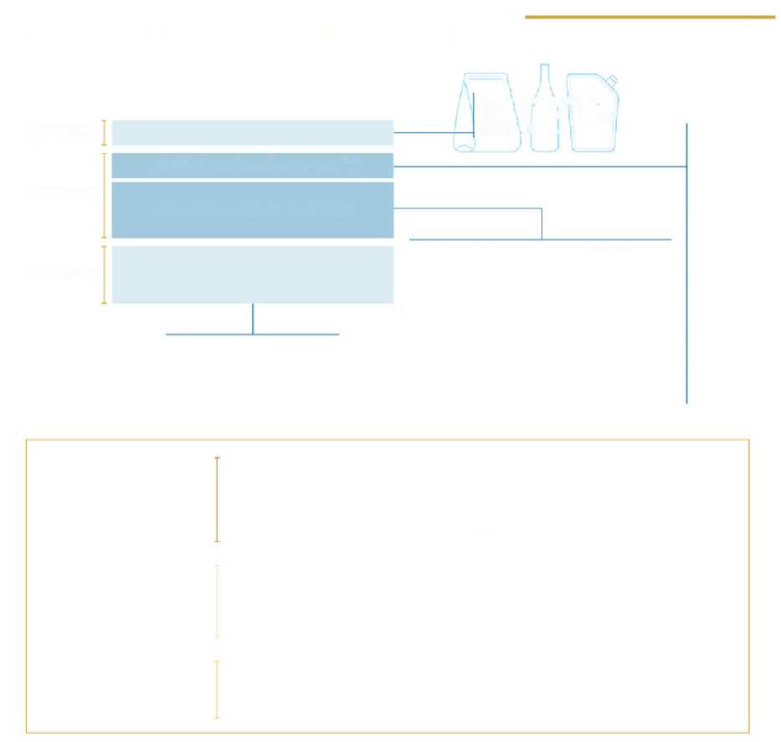

**INFORMATION ON THE ENVIRONMENTAL LABELLING OF SINGLE-COMPONENT PACKAGING INTENDED FOR THE FINAL CONSUMER**

**RECOMMENDED**

**NECESSARY**

**RECOMMENDED**

**TYPE OF PACKAGING**

**CODIFIED by Decision 97/129/EC**

**INFORMATION ON COLLECTION**

***Tips for quality separate collection***

***Empty the packaging  
Crush along the long side  
Separate the label  
...***

**BOTTLE/FLASK LABELING**

**CAN TRAY**

**...**

**PET 1**

**HDPE2**

**...**

**PAP 20**

**PAP 21**

**...**

**FE 40**

**ALU41**

**FOR 50**

**FOR 51**

**GL 70**

**GL 71**

**...**

**C/PAP 80**

**C/PAP 81**

**...**

**For example:**

**Or:**

**COLLECTION OF STEEL  
COLLECTION OF ALUMINIUM  
COLLECTION OF METALS**

**FAMILY  
OF MATERIAL**

**COLLECTION OF PAPER**

**INFORMATION ON COLLECTION**

**+**

**COLLECTION OF PLASTIC**

**COLLECTION OF WOOD**

**COLLECTION OF GLASS**

**NECESSARY**

**HIGHLY RECOMMENDED**

**RECOMMENDED**

**the information to be reported according to Article 219(5).**

**The codes refer to Decision 129/97/EC.**

**The instructions for waste disposal can be communicated using**

**the proposed formula 0 with other freely chosen methods, provided that they are effective.**

**In the case of multi-component packaging, the identification of the individual components, by means of a written description or graphic representation, helps the consumer to separate and dispose of them correctly.**

**This is voluntary information that can be provided to help the consumer in quality separate collection.**

***Labelling of multi-component packaging intended for B2C***

For multi-component packaging, it is necessary to distinguish between components that cannot be manually separated (e.g. a paper label attached to a glass bottle) and components that can be manually separated by the final consumer (e.g. multi-packs of snacks). This is because identification and classification pursuant to Decision 129/97/EC should be **for all manually separable components** of the packaging system.

This means that for each manually separable component of the packaging system, at least the following should be indicated:

1. **The identification code of the packaging material pursuant to Decision 129/97/EC**
2. **The collection information when not indicated on the outer packaging.** It is suggested:
   * to indicate the formula ‘*Collection (family of predominant material by weight)*’

or

* to indicate the family of the predominant material by weight, accompanied by the formula ‘*Separate collection*’,

and to invite consumers to check the provisions of their municipality.

The standard does not provide precise formulas but recommends that the packaging be *appropriately* labelled, with a view to achieving the aim. In particular, the second option proposed is already in line with Article 11 of the Waste Directive, whereby Member States must establish separate collection of waste for at least paper, metals, plastics and glass and, by 1 January 2025, for textiles.

Where it is not possible to indicate the mandatory information on each individual component, e.g. because of lack of space, or for other technologically significant limitations, it may be indicated on the main body, or on the presentation packaging.

In this case, the recommended format is as follows:

1. **Packaging type** (a full written description or graphic representation) of the different manually separable components;
2. **For each type of packaging, indicate the identification code of the packaging material of each component which can be manually separated in accordance with Decision 129/97/EC;**
3. **Referring to each type of packaging, give the collection information, clearly specifying the family of material(s) of each component.**

In this case too, it is possible to voluntarily support the consumer in quality separate collection, with specific information,.

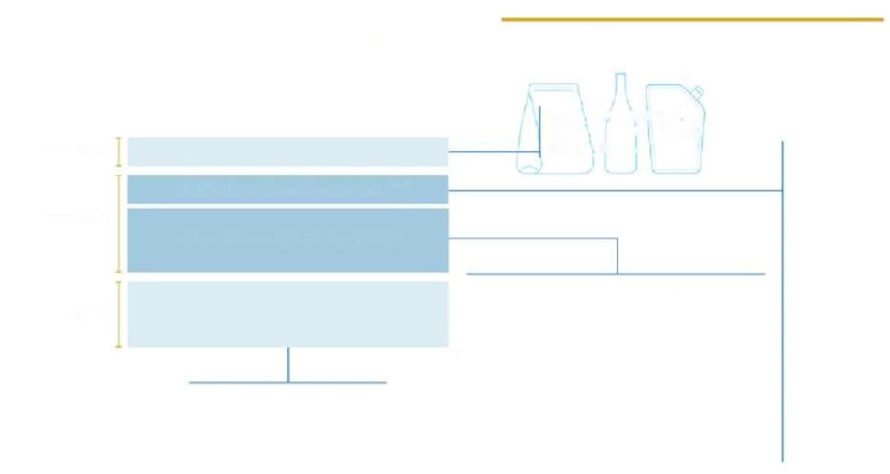

**NECESSARY**

**RECOMMENDED**

**TYPE OF PACKAGING**

**CODIFIED by Decision 97/129/EC**

**INFORMATION ON COLLECTION**

***Tips for quality separate collection***

***Empty the packaging  
Crush along the long side  
Separate the label  
...***

**BOTTLE/FLASK LABELING**

**CAN TRAY**

**...**

**PET 1**

**HDPE2**

**...**

**PAP 20**

**PAP 21**

**...**

**FE 40**

**ALU41**

**FOR 50**

**FOR 51**

**GL 70**

**GL 71**

**...**

**C/PAP 80**

**C/PAP 81**

**...**

**For example:**

**Or:**

**COLLECTION OF STEEL  
COLLECTION OF ALUMINIUM  
COLLECTION OF METALS**

**FAMILY  
OF MATERIAL**

**COLLECTION OF PAPER**

**INFORMATION ON COLLECTION**

**+**

**COLLECTION OF PLASTIC**

**COLLECTION OF WOOD**

**COLLECTION OF GLASS**

**INFORMATION FOR THE ENVIRONMENTAL LABELLING  
OF MULTI-COMPONENT PACKAGING (where the components are manually separable)  
INTENDED FOR THE END CONSUMER**

**HIGHLY RECOMMENDED**



**NECESSARY**

**HIGHLY RECOMMENDED**

**RECOMMENDED**

**the information to be reported according to Article 219(5).**

**The codes refer to Decision 129/97/EC.**

**The information for taking in waste can be communicated using the proposed formula 0 with other freely chosen methods, provided that they are effective.**

**In the case of multi-component packaging, the identification of the individual components, by means of a written description or graphic representation, helps the consumer to separate and dispose of them correctly.**

**This is voluntary information that can be provided to help the consumer in quality separate collection.**



**Single-material, composite, multi-component packaging?**

In order to understand effectively how to provide for environmental labelling especially on the most complex packaging systems, it is worth exploring the different definitions.

* *Single-material packaging* 🡪 is packaging consisting of only one material (e.g. a cardboard box, a plastic cap, an aluminium foil). This packaging also includes multi-layered packaging, i.e. those whose structure is made up of several plastic polymers that cannot be separated from each other (typically coupled or mixed).
* *Composite packaging* 🡪 is a packaging structurally made up of different materials that cannot be manually separated (they are mainly polycoupled or complex systems such as closures, consisting of different pieces of different materials).
* *Multi-component packaging* 🡪 is a system consisting of packaging known as the main body (e.g. a bottle), and other packaging, called components (such as the cap or label), which may or may not be manually separable from the main body.

**What is meant by manually separable components?**

A component is considered manually separable if the user can completely separate it from the main body (other than insignificant material residues that may remain after separation), without risk to their health and safety, with the sole use of hands and without having to resort to additional tools and utensils.

**What should be done with components which cannot be manually separable?**

Packaging systems with a main body and other ancillary components that cannot be manually separated (e.g. punch labels, non-separable caps and closures, windows) must mandatorily include the identification of the main body material and the information on the collection (following the main body material).

Where possible, only the identification code of the material as laid down in Decision 129/97/EC may be affixed to the components which cannot be separated manually, but no collection information should be given on them.

If the packaging system contains components that can be manually separated from the main body, each of these must necessarily bear the alpha-numeric code in accordance with Decision 129/97/EC and the collection information.

***Labelling of packaging intended for B2B***

Packaging intended for B2B, e.g. packaging for professional, or packaging for transport or related to logistics or exhibition activities, may not contain information on the final destination of the packaging, but must mandatorily include **the code of the composition materials in accordance with Decision 129/97/EC**.

However, all other information shall remain voluntarily applicable.

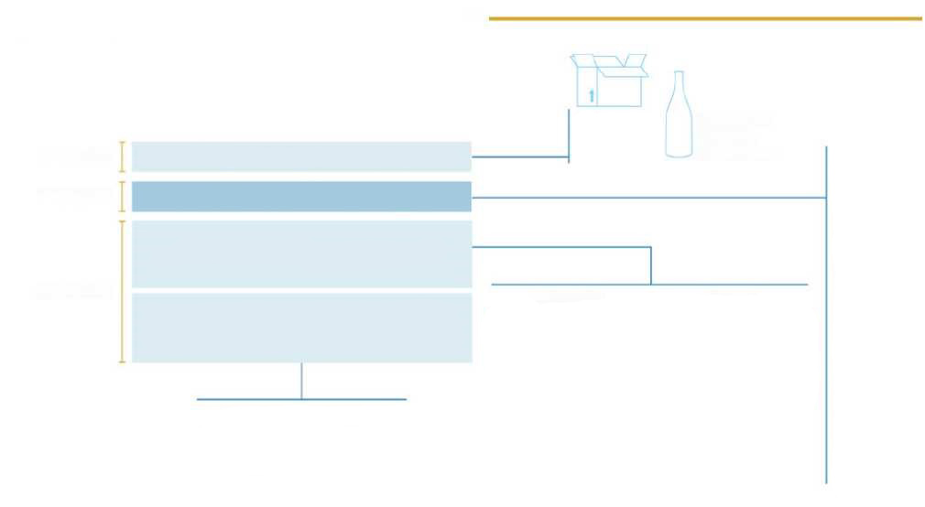

**NECESSARY**

**RECOMMENDED**

**TYPE OF PACKAGING**

**CODIFIED by Decision 97/129/EC**

**INFORMATION ON COLLECTION**

***Tips for quality separate collection***

***Empty the packaging  
Crush along the long side  
Separate the label  
...***

**PET 1**

**HDPE2**

**...**

**PAP 20**

**PAP 21**

**...**

**FE 40**

**ALU41**

**FOR 50**

**FOR 51**

**GL 70**

**GL 71**

**...**

**C/PAP 80**

**C/PAP 81**

**...**

**For example:**

**Or:**

**COLLECTION OF STEEL  
COLLECTION OF ALUMINIUM  
COLLECTION OF METALS**

**FAMILY  
OF MATERIAL**

**COLLECTION OF PAPER**

**INFORMATION ON COLLECTION**

**+**

**COLLECTION OF PLASTIC**

**COLLECTION OF WOOD**

**COLLECTION OF GLASS**



**NECESSARY**

**HIGHLY RECOMMENDED**

**RECOMMENDED**

**the information to be reported according to Article 219(5).**

**The codes refer to Decision 129/97/EC.**

**The information for taking in waste can be communicated using the proposed formula 0 with other freely chosen methods, provided that they are effective.**

**In the case of multi-component packaging, the identification of the individual components, by means of a written description or graphic representation, helps the consumer to separate and dispose of them correctly.**

**This is voluntary information that can be provided to help the consumer in quality separate collection.**

**INFORMATION ON THE ENVIRONMENTAL LABELLING OF PACKAGING INTENDED FOR B2B**

**CORRUGATED CARDBOARD BOX**

**RETURNABLE  
GLASS  
BOTTLE**

**RECOMMENDED**

## How to form the label

In this section, on the basis of the above, the guideline presents the information that may contribute to the contents of the label:

* The alpha-numeric code from Decision 129/97/EC
* The family of material
* Collection information

The Annexes to Decision 129/97/EC, for each material and for the polycoupled materials, which contain the codes to be used for the identification of the composition material of the packaging, are given below, together with some examples of complete labelling, showing both the information considered to be the minimum by the legislator and the optional information.

The **examples are not the only possible labelling structure**, but one of various solutions that the company can employ, and they do not cover all the possible voluntary information either. In fact, each company has the right **to communicate with freely chosen graphic and presentation methods, provided that they are effective and consistent with the objectives set out in Article 219(5)**.

**For the graphic rendering of indications and symbols, it is suggested, on packaging intended for the Italian market, to use colours codified by standard UNI 11686 – Waste management – Waste visual elements – Visual identification elements for municipal waste collection containers.**

In the following examples, the colour code provided for in the technical standard has been adopted.

**UNI 11686 STANDARD**

*The standard defines the colours of the waste in the different materials and the visual identification elements to be shown on the bins in order to make it easier and more automatic for the final consumer to recognise the bins in which the waste is to be placed.*

*Citizens increasingly find themselves separating their waste in different cities and municipalities. Therefore, colour codes can help identify the bins and make separate collection an easier task, even when one is not in their usual municipality.*

*The standard enables visual recognition by consumers, by adopting the following specific colour codes:*



**PAPER**

**ORGANIC**

**PLASTIC**

**METALS**

**GLASS**

**GENERAL**

**? Let’s make it clear**

**Coupling or treatment: the > 5% rule**

According to Decision 129/97/EC, packaging is defined as ‘*composite*’ when it is ‘*made up of different materials, and which cannot be separated by hand*’.

Such packaging can be made either by a treatment (e.g. coating, metallisation, lamination, lacquering) or by means of a real coupling.

For these packages, the alpha-numeric code of reference of Decision 129/97/EC is that provided for in Annex VII, which provides for the clarification of different codes depending on the family of materials prevailing by weight and the secondary material(s).

*The 5% threshold*

For the purpose of correctly identifying the materials of composite or multi-layer packaging, where the weight of the secondary material(s) is less than 5% of the total weight of the pack, the packaging is considered to be single-material packaging and labelled according to the predominant material by weight. Otherwise, the code will be that provided for in Annex VII to Decision 129/97/EC in the case of composite packaging, or code ‘7’ as set out in Annex I if the packaging is multi-layered plastic. This threshold is also applied in the case of packaging where more than one secondary material is present and one of them weighs < 5%: this material shall not be taken into account for the purposes of identification.

This threshold therefore also applies where two or more secondary materials are present: therefore, if the sum of the weights of these materials is < 5%, the packaging is considered to be single-material. On the contrary, if the sum of the weights of the secondary materials is > 5%, the packaging shall be labelled with the codes provided for in Annex VII to Decision 129/97/EC on composites, depending on the materials constituting the packaging.

This simplification builds on the approach adopted in IMPLEMENTING DECISION (EU) 2019/665, according to which Member States are required to report – for the purposes of release for consumption and recycling targets – individual composition materials for composite packaging, but may ‘*derogate from this requirement where a given material constitutes an insignificant part of the packaging unit, and in no case more than 5% of the total mass of the packaging unit*’.

*How should materials other than packaging (e.g. glues, adhesives and inks, ceramics, rubber) be treated?*

Where the packaging consists of one of the packaging materials (steel, aluminium, paper, wood, plastic, glass), coupled or treated with another material, other than packaging materials (e.g. glues, adhesives, inks, ceramics, rubber), it shall be considered to be a single-material packaging.

*For example, an HDPE packaging with a layer of ink and the use of glues that weigh more than 5% of the total weight of the packaging will report only the code provided for single-material HDPE packaging.*

**Special cases – Clarifications note from the Ministry for the Ecological Transition of 17 May 2021**

In view of the objective operational difficulties in providing for the direct affixing of environmental labelling on packaging for certain situations, the Ministry for the Ecological Transition clarified, in a note dated 17 May 2021:

* **Neutral packaging in general, with particular reference to packaging for transport and/or possible semi-finished packaging.**

In the case of B2B packaging, the identification of the packaging composition material may be conveyed and communicated by the manufacturer on the transport documents accompanying the goods, or on other external media, including digital media.

* **Pre-wrapped and variable weight distribution packaging**

Pre-wrapped packaging is defined in Circular No 165 of the then Ministry for Industry, Commerce and Crafts of 31 March 2000 published in Official Gazette No 92 of 19 April 2000, General Series of 19 April 2000, as variable-weight packaging, often used at fresh food counters or for self-service and which are intended to contain a food product once. This type of packaging also presents objective difficulties in physically affixing the label; it could be packaging for fresh foodstuffs (e.g. fishmonger’s products) that cannot be printed on, or packaging whose intended use is uncertain at the time of production and sale (i.e. packaging or products for domestic use), or packaging that has been prepared/cut to size at the point of sale (e.g. aluminium or plastic film) and therefore cannot be printed on immediately.

For these cases, the labelling obligation shall be deemed to have been fulfilled if the information on the composition of the packaging pursuant to Decision 129/97/EC and the information to help the consumer correctly separate the waste can be inferred from information sheets made available to final consumers at the point of sale (e.g. in addition to allergens information, or with special information sheets placed next to the counter), or through the provision of such information on websites with predefined standard sheets.

This solution may also be adopted for the labelling of other neutral packaging intended for the final consumer.

* **Small, multi-language, import packaging**

*Small packaging* means:

1. Packaging in which the largest surface area is less than 25 cm2 – definition taken from Regulation (EU) No 1169/2011, which indicates the obligation to include on food packs the nutritional information of the products contained and which provides for the possibility of exempting from this obligation small packages identified in this way;
2. Packaging with a capacity not exceeding 125 ml – definition taken from the CLP Regulation (Regulation (EC) No 1272/2008, Article 29(2) and point 1.5.2 of Part I of Annex I), which provides that substances classified as hazardous and contained in a packaging must bear a label containing specific elements, and considers certain exemptions from this requirement for small packages identified in this way.

In all these cases, the Ministry for the Ecological Transition has clarified that where actual physical and/or technological limits for the physical affixing of labelling on packaging can be found, such information may be transmitted via digital channels, or where this is not possible either, must be made available via the company’s and/or retailer’s websites.

In order to make mandatory environmental information on the composition and correct management of packaging at the end of its life more easily available and accessible to the final consumer, the indication is to provide clear information on the packaging or at the point of sale on how the consumer can search for them via digital tools or websites.

These solutions are also preferred to overcome problems related to multilingual and/or import packaging.

* **Use of digital technology**

In order to comply with the environmental labelling requirement for packaging, the use of digital channels is always allowed (e.g. apps, QR codes, websites), in line with the process of technological innovation and simplification, a fundamental aspect provided for in the National Recovery and Resilience Plan (NRRP). Such digital channels may replace or complement the information directly on the packaging.

These tools can be used both to facilitate the transmission of mandatory information along the supply chain in commercial and industrial channels, and to convey to the final consumer the nature of the packaging materials and information on how to correctly dispose of the waste. Where the packaging is intended for the final consumer, the obliged entity is required to indicate on the packaging or at the point of sale, whether it is physical or virtual, to which the consumer has access, instructions to enable the consumer to acquire the mandatory environmental information via the digital channels provided (apps, QR codes, websites, etc.).

In order to make environmental labelling information available, it is therefore possible to use a digital tool which redirects one to a page specifically dedicated to conveying environmental labelling content relating to the specific packaging, provided that access to the specific information for the packaging in question is easy and direct, and that this information is timely and not difficult to interpret. It is therefore recommended that the packaging in question be clearly indicated on these channels in order to make the information available to the final consumer more readily available and accessible.

**Steel packaging**

|  |  |
| --- | --- |
| Type of packaging | Can  Spray cannister  Box  .... |
| Decision 97/129/EC | |  |  |  | | --- | --- | --- | | *ANNEX III*  Numbering and abbreviation system for metals | | | | Material | Abbreviations | Numbering | | Steel  Aluminium | FE  ALU | 40  41  42  43  44  45  46  47  48  49 | |
| The family of material | Steel |
| Information on collection | Separate collection  Check the provisions in your municipality |

**Examples**

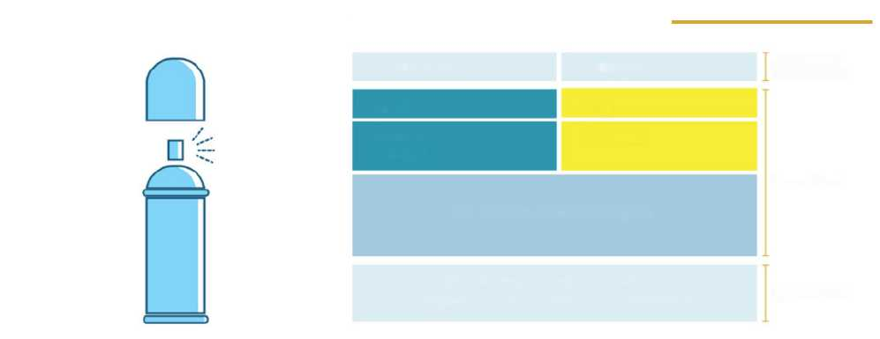

**Example**

**AEROSOL SPRAY CANISTERS WITH A PLASTIC CLOSURE**

**SPRAY CANISTER**

**CLOSURE**

**HIGHLY RECOMMENDED**

**NECESSARY**

**RECOMMENDED**

**FE 40**

**PP 5**

**Steel or metal**

**Plastic**

**SEPARATE COLLECTION**

***Check the provisions in your municipality. Return the empty container for collection.***

**Aluminium packaging**

|  |  |
| --- | --- |
| Type of packaging | Can  Spray cannister  Sheet  .... |
| Decision  97/129/CE | |  |  |  | | --- | --- | --- | | *ANNEX III*  Numbering and abbreviation system for metals | | | | Material | Abbreviations | Numbering | | Steel  Aluminium | FE  ALU | 40  41  42  43  44  45  46  47  48  49 | |
| The family of material | Aluminium |
| Information on collection | Separate collection  Check the provisions in your municipality |

**Examples**

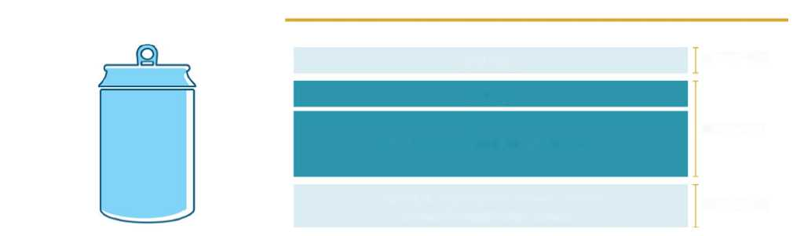

**Example**

**ALUMINIUM CAN**

**RECOMMENDED**

**NECESSARY**

**RECOMMENDED**

**CAN**

**ALU 41**

**COLLECTION OF ALUMINIUM OR METAL**

***Check the provisions in your municipality. Reduce the volume of the can.***

***Code 42: if the metal is not steel or aluminium***

If a packaging is composed of a type of metal, other than steel or aluminium, which is not accorded a specific code in Annex III to Decision 129/97/EC, it is suggested to adopt the number ‘42’, i.e. the first code with which no material is associated in the table, and therefore ‘available’ to be adopted for other types of metal not provided for.

**Paper packaging**

|  |  |
| --- | --- |
| **Type of packaging** | Box  Tray  Bag  Case  **….** |
| **Decision 97/129/EC** | |  |  |  |  | | --- | --- | --- | --- | | *ANNEX II*  Numbering and abbreviation system (1) for paper and cardboard | | | | | Material | | Abbreviations | Numbering | | Corrugated cardboard  Non-corrugated cardboard  Paper | | PAP  PAP  PAP | 20  21  22  23  24  25  26  27  28  29  30  31  32  33  34  35  36  37  38  39 | |  |  | | | | (1) Use capital letters only. | | | | |
| **The family of material** | **Paper** |
| **Information on collection** | **Separate collection**  **Check the provisions in your municipality** |

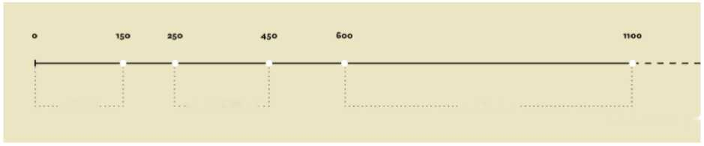

**Paper**

**Paperboard**

**Cardboard**

***Grammage: g/m2***

**Paper, paperboard or corrugated cardboard?**

Real and actual **paper** has a grammage of up to 150 g/m², while **cardboard** is characterised by a grammage of more than 600 g/m², which can reach up to 1 100 g/m². **Paperboard**, on the other hand, is a paper artefact of intermediate grammage between that of paper and cardboard, defined by a grammage of between 250 g/m² and 450 g/m². It is noted that the above ranges result in two apparently undefined ranges, such as the grammages between 150 and 250 g/m² and those between 450 and 600 g/m²: in these ranges the product can ambivalently be described as paper or paperboard for the first range and as paperboard or cardboard for the second.

<https://www.comieco.org/glossario/>

**Examples**

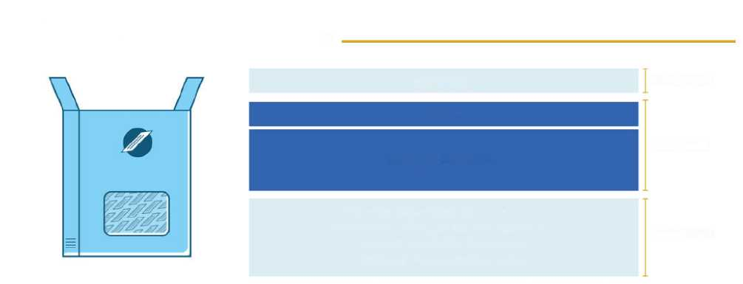

**Example**

**PAPER CASE WITH A PLASTIC WINDOW WHICH IS NOT MANUALLY SEPARABLE**

**CASE**

**RECOMMENDED**

**PAP 21**

**NECESSARY**

**COLLECTION OF PAPER**

***Check the provisions in your municipality. Empty the packaging of its contents before disposing of it in the waste collection.***

***Reduce the volume of the case.***

**RECOMMENDED**



**Example**

**PAPER BAG WITH A PLASTIC WINDOW WHICH IS MANUALLY SEPARABLE**

**BAG**

**WINDOW**

**PAP 22**

**LDPE 4**

**Paper**

**Plastic**

**HIGHLY RECOMMENDED**

**NECESSARY**

**RECOMMENDED**

**SEPARATE COLLECTION**

*Check the provisions in your municipality.*

*Separate the components and dispose of them correctly.*

**Example**

**PAPER LINER**

**LINER**

**PAP 22**

**COLLECTION OF PAPER**

*Check the provisions in your municipality. Remove the product residues before disposing of it.*

**RECOMMENDED**

**NECESSARY**

**RECOMMENDED**

NB: it is preferable not to dispose of packaging with consistent organic residues in the separate collection. In this case, you can consider disposing of it in Separate collection for organic waste if your packaging complies with the UNI 13432: 2002 standard

If **biodegradable and compostable** pursuant to technical standard uni en 13432

**RECOMMENDED**

**NECESSARY**

**SPECIFIC INFORMATION FOR COMPOSTABLE PACKAGING**

**RECOMMENDED**

**LINER**

**PAP 22**

**PAPER**

**SEPARATE COLLECTION FOR ORGANIC WASTE**

***Biodegradability and compostability certification logo EN 13432 (with identification elements of the certifier).***

***Identification elements of the manufacturer.***

*Check the provisions in your municipality.*

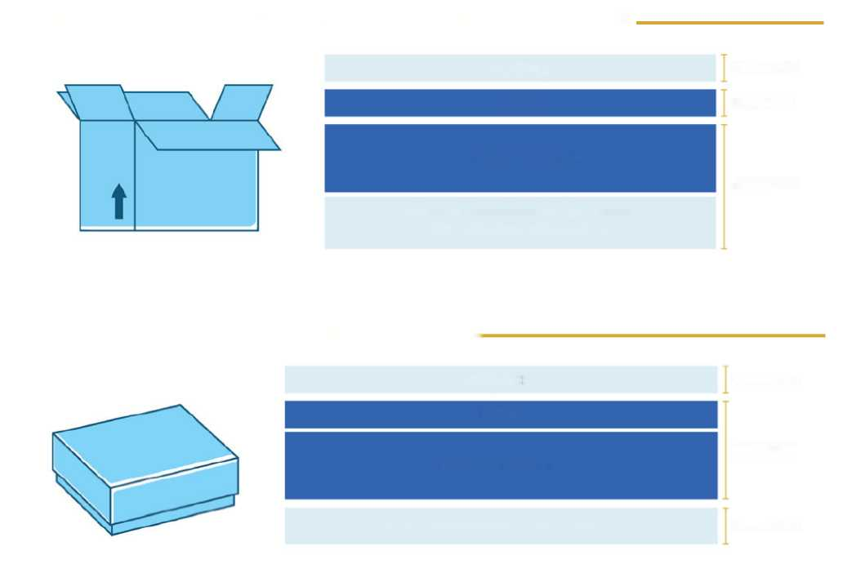

**Example**

**CORRUGATED CARDBOARD BOX FOR THE B2B TRANSPORT OF GOODS**

**RECOMMENDED**

**NECESSARY**

**RECOMMENDED**

**BOX**

**PAP 20**

**COLLECTION OF PAPER**

***Check the provisions in your municipality. Reduce the volume of the box.***

**Example**

**PAPER CASE WITH A PLASTIC COATING (with a weight of < 5% of the total weight of the case)**

**RECOMMENDED**

**CASE**

**PAP 21**

**COLLECTION OF PAPER**

***Check the provisions in your municipality.***

**NECESSARY**

**RECOMMENDED**

**Wooden packaging**

|  |  |
| --- | --- |
| **Type of packaging** | Cap  Box  **….** |
| **Decision 97/129/EC** | |  |  |  | | --- | --- | --- | | *ANNEX IV*  Numbering and abbreviation system (1) for wooden materials | | | | Material | Abbreviations | Numbering | | Wood  Cork | FOR  FOR | 50  51  52  53  54  55  56  57  58  59 | | _____________  (1) Use capital letters only. | | | |
| **The family of material** | **Wood** |
| **Information on collection** | **Separate collection**  **Check the provisions in your municipality** |

**Examples**

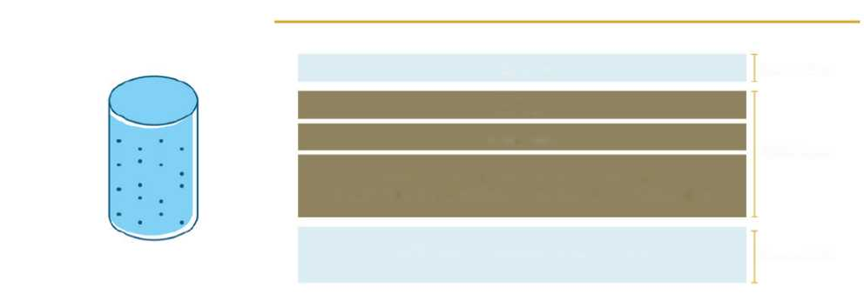

**Example**

**CORK CAP**

**RECOMMENDED**

**NECESSARY**

**RECOMMENDED**

**CAP**

**FOR 51**

**CORK**

**DEDICATED SEPARATE COLLECTION**

**OR SEPARATE COLLECTION FOR ORGANIC WASTE**

*Check the provisions in your municipality.*

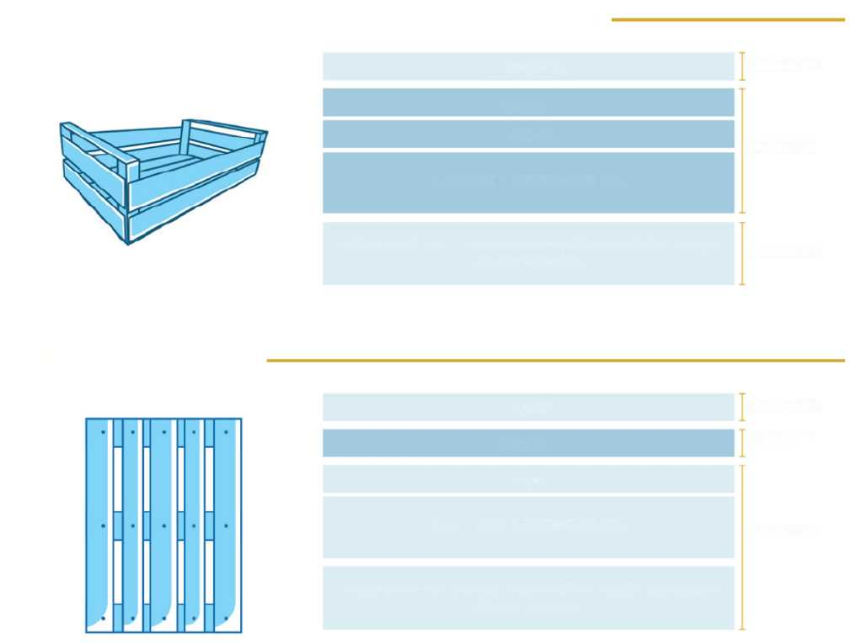

**Example**

**WOODEN BOX FOR THE FINAL CONSUMER**

**RECOMMENDED**

**NECESSARY**

**RECOMMENDED**

**RECOMMENDED**

**NECESSARY**

**BOX**

**FOR 50**

**Wood**

**SEPARATE COLLECTION**

*Check with your municipality on how to take this packaging in to the recycling centre.*

**Example**

**WOODEN PALLETS**

**PALLETS**

**FOR 50**

**Wood**

**SEPARATE COLLECTION**

*Check with your municipality on how to take this packaging in to the recycling centre.*

**RECOMMENDED**

**Plastic packaging**

|  |  |
| --- | --- |
| Type of packaging | Bottle  Cap  Label  Flask  Bag  Screen |
| Decision  97/129/CE | |  |  |  | | --- | --- | --- | | *ANNEX I* | | | | Numbering and abbreviation system (1) for plastic | | | | Material | Abbreviations | Numbering | | Polyethylene terephthalate | PET | 1 | | High Density Polyethylene | HDPE | 2 | | Polyvinyl chloride | PVC | 3 | | Low Density Polyethylene | LDPE | 4 | | Polypropylene | PP | 5 | | Polystyrene | PS | 6 | |  |  | 7 | |  |  | 8 | |  |  | 9 | |  |  | 10 | |  |  | 11 | |  |  | 12 | |  |  | 13 | |  |  | 14 | |  |  | 15 | |  |  | 16 | |  |  | 17 | |  |  | 18 | |  |  | 19 | | __________  (1) Use capital letters only | | | |
| The family of material | Plastic |
| Information on collection | Separate collection  Check the provisions in your municipality |

**How can the type of polymer of the plastic packaging be identified if it is not provided for in Decision 129/97/EC?**

* **Polymers for which no specific code is provided for in Decision 129/97/EC**

Decision 129/97/EC lays down alpha-numeric codes for the identification of the specific material for only 6 different polymers. In practice, there are many polymers used for the production of plastic packaging, and this number is bound to grow, precisely because it is a sector characterised by strong technological progress that aims to satisfy multiple needs.

Up to now, polymers other than those set out in Decision 129/97/EC have all been identified by code ‘7’. In order to provide more precise information with regard to the composition of plastic packaging, and in view of the significant number of different existing polymers that fall under the same code ‘7’, it is suggested that the ‘7’ be accompanied by:

* The abbreviation of the name of the polymer, as provided for in technical standard UNI EN ISO 1043-1, where available.

*For example, polyamide packaging can be identified with: PA 7*

* The extended name of the plastic or the acronym thereof, when commonly used in market practice, in cases where there is no abbreviation.

*For example, a modified PET packaging such as PETG can be identified with:*

*PETG 7*

* Packaging made of biodegradable and compostable polymers, in accordance with UNI EN ISO 13432, constitutes a special case for which no specific code is provided for at the moment even in the UNI technical standards. In these cases, it is highly recommended to use the words ‘Plastica compostabile’ (Compostable plastic) to avoid confusing it with traditional plastic packaging and for the correct management thereof at the end of its life.

*For example, polylactic acid packaging can be identified with: Plastica compostabile 7 (Compostable plastic 7).*

* **Multi-layer packaging composed of different polymers**

Packaging structurally composed of two or more polymers is identified by code ‘7’, since Decision 129/97/EC does not provide for specific codes for these materials either.

If you wish to provide more precise information with regard to the composition of the multi-layer plastic packaging, we recommend that you follow the provisions of technical standard UNI EN 11469, according to which the abbreviations of the packaging composition polymers shall be written between the symbols ‘>’ and ‘<’, and interposed by the sign ‘+’.

*For example, a multi-layer packaging composed of PET and HDPE can be identified in this way: >PET+HDPE< 7.*

**Examples**

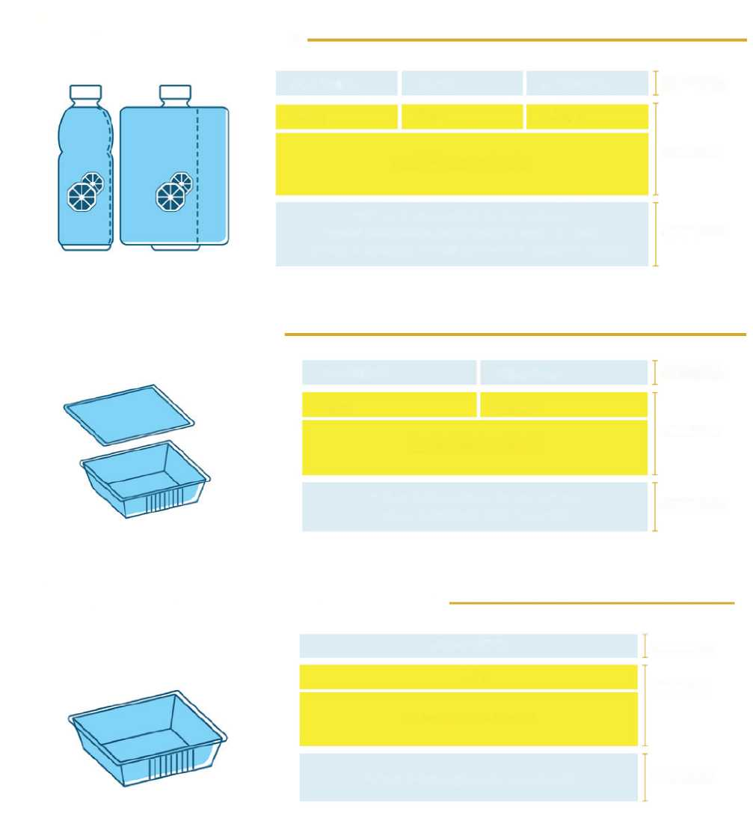

**Example**

**BOTTLE WITH AN OPAQUE LABEL AND A PLASTIC CAP WHICH CAN BE MANUALLY SEPARATED**

**BOTTLE**

**CAP**

**LABEL**

**PET 1**

**PP 5**

**PVC 3**

**COLLECTION OF PLASTIC**

*Check the provisions in your municipality.*

*Separate the label and dispose of it correctly.*

*Crush the bottle along the long side and do not separate the cap.*

**HIGHLY RECOMMENDED**

**NECESSARY**

**RECOMMENDED**

**Example**

**PLASTIC TRAY**

**HIGHLY RECOMMENDED**

**NECESSARY**

**RECOMMENDED**

**TRAY**

**FILM**

**PET 1**

**LDPE 4**

**COLLECTION OF PLASTIC**

*Check the provisions in your municipality.  
Separate the film from the tray.*

**Example**

**PLASTIC TRAY WITH AN EVOH LAYER (with a weight of < 5% of the total weight of the tray)**

**TRAY**

**PP5**

**COLLECTION OF PLASTIC**

*Check the provisions in your municipality.*

**RECOMMENDED**

**NECESSARY**

**RECOMMENDED**

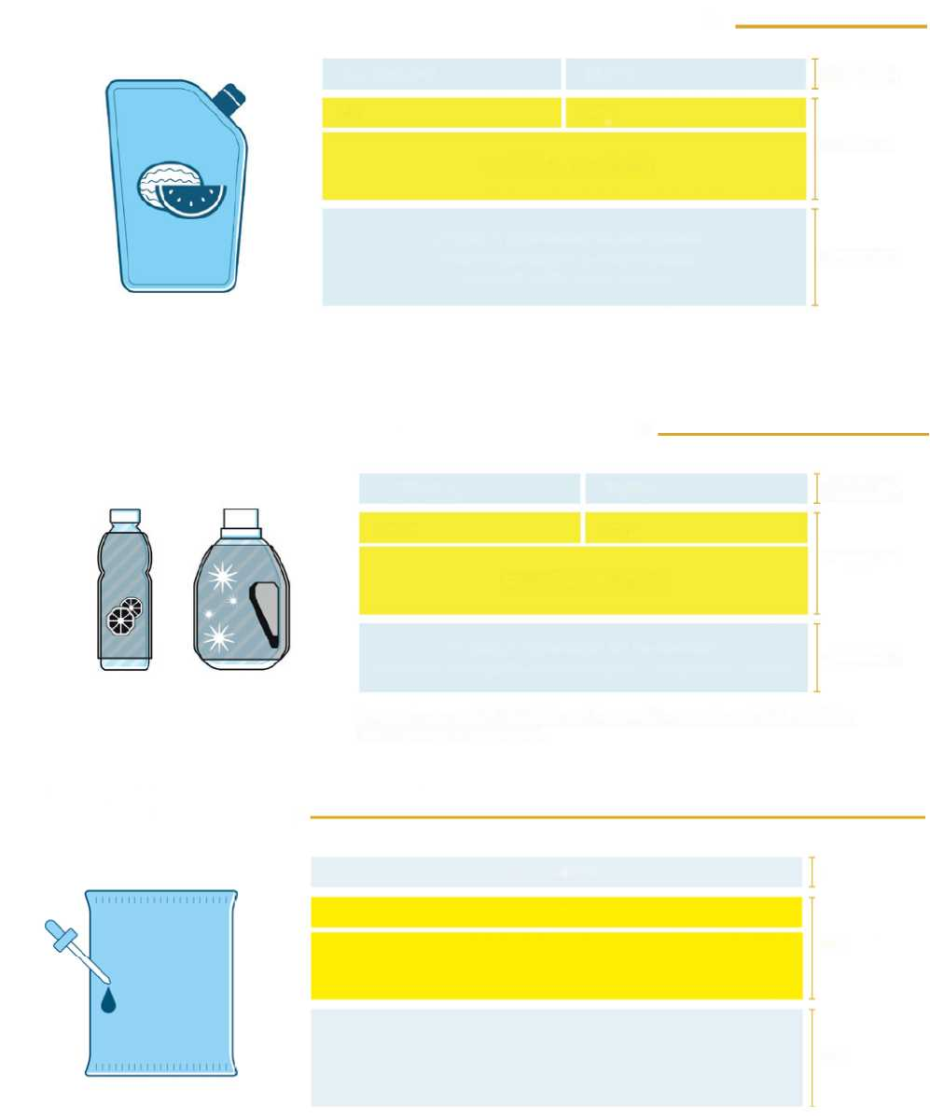

**Example**

**MULTI-LAYER PLASTIC BAG WITH A PLASTIC CLOSURE**

**HIGHLY RECOMMENDED**

**NECESSARY**

**RECOMMENDED**

**BAG**

**CAP**

**7\***

**PP5**

**COLLECTION OF PLASTIC**

*Check the provisions in your municipality. Empty the packaging of its contents before disposing of it in the waste collection.*

*\* Optional: >LDPE + PP< or >PET1+HDPE2< 7*

**Example**

**PLASTIC BOTTLE WITH A PLASTIC CAP AND AN OPAQUE LABEL WHICH CANNOT BE MANUALLY SEPARATED**

**HIGHLY RECOMMENDED**

**NECESSARY**

**RECOMMENDED**

**BOTTLE**

**CAP**

**PET 1**

**PP 5**

**COLLECTION OF PLASTIC**

*Check the provisions in your municipality.*

*Crush the bottle along the long side and do not separate the cap.*

*In this case, since the label is not manually separable from the bottle, it is not necessary to label it.*

**Example**

**PLASTIC BAG WITH INKS (> 5% of the total weight)**

**RECOMMENDED**

**NECESSARY**

**RECOMMENDED**

**BAG**

**PET 1**

**COLLECTION OF PLASTIC**

*Check the provisions in your municipality. Empty the packaging of its contents before disposing of it in the waste collection.*

Legislative Decree 116/2020 amended Article 182b of Legislative Decree No 152/2006 on organic waste, stating that waste, including packaging waste, having similar biodegradability and compostability properties with respect to organic waste must be collected and recycled together with the latter if:

a) it is certified as compliant, by accredited bodies, with the European standard UNI EN 13432 for packaging recoverable by composting or biodegradation;

b) **it is appropriately labelled and contains, in addition to the indication of compliance with the aforementioned European standards, elements identifying the manufacturer and the certifier, as well as appropriate instructions for consumers to dispose of such waste in separate collection and organic waste recycling facilities**.



**Example**

**BIODEGRADABLE AND COMPOSTABLE PLASTIC PACKAGING**

**PACKAGING (E.G. DISHWARE, TRAY)**

**7**

**Biodegradable and compostable plastic**

**SEPARATE COLLECTION FOR ORGANIC WASTE**

*Biodegradability and compostability certification logo EN 13432 (with identification elements of the certifier).*

*Identification elements of the manufacturer.*

**RECOMMENDED**

**SPECIFIC INFORMATION FOR COMPOSTABLE PACKAGING**

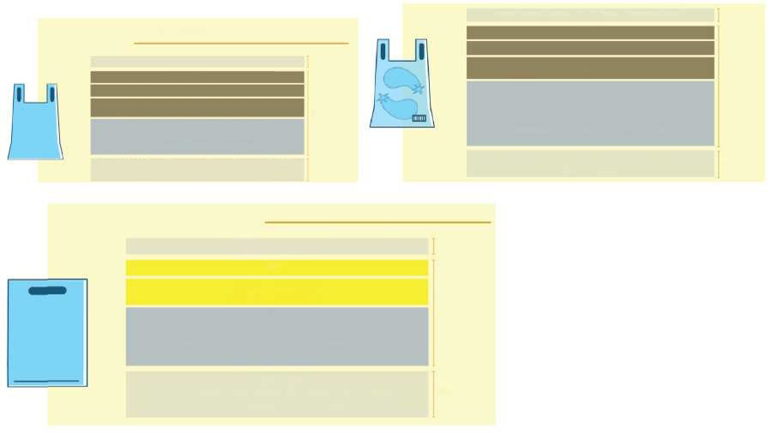

**BIODEGRADABLE AND COMPOSTABLE SHOPPING BAGS FOR CARRYING GOODS**

**REUSABLE PLASTIC SHOPPING BAGS**

**BIODEGRADABLE PLASTIC BAG**

**RECOMMENDED**

**Biodegradable and compostable plastic**

**SEPARATE COLLECTION FOR ORGANIC WASTE**

**Certification logo EN 13432 of biodegradability and compostability**

**(with identification elements of the certifier).**

**Producer identification elements (company name, REA number).**

**NECESSARY**

**RECOMMENDED**

**ULTRA-LIGHT BIODEGRADABLE PLASTIC BAG**

**Biodegradable and compostable plastic**

**SEPARATE COLLECTION FOR ORGANIC WASTE**

Biodegradability and compostability certification logo EN 13432 (with identification elements of the certifier).

Certification logo CEN/TS 16640 of the minimum content of renewable raw material.

Producer identification elements (company name, REA number).

**RECOMMENDED**

**NECESSARY**

**RECOMMENDED**

**PLASTIC BAG**

**LDPE 4**

**COLLECTION OF PLASTIC**

**Producer identification elements (company name, REA number). Reusable plastic bag for use with food or not with food with a thickness of more than XX µ and containing XX% recycled plastic.**

**RECOMMENDED**

**NECESSARY**

**RECOMMENDED**

*RE-USE ME!*

*At the end of my life, put me in separate collection: I’m made of plastic.*

*Check the provisions in your municipality*

*After the first use, you can use this bag for the collection of wet waste: check with your municipality.*

**7**

*After the first use, you can use this bag for the collection of wet waste: check with your municipality.*

**Environmental labelling for plastic shopping bags**

**The legislation (Legislative Decree 152/2006, Article 219(3a) had already introduced, in 2017, specific requirements for the marketing and labelling of biodegradable and compostable shopping bags, for ultra-light biodegradable and compostable plastic bags for hygiene purposes and/or for bulk food (e.g. bags for fruit and vegetables), to which are added the labelling requirements laid down in Decree 116 both in relation to the amendments to Article 219(5) on the environmental labelling of packaging, and for the provisions on organic waste with the amendments to Article 182b of Legislative Decree No 152/2006.**

In fact, plastic bags can be marketed with the following requirements:

* reusable plastic bags with specific characteristics regarding the thickness and content of recycled material, depending on the goods marketed, and which cannot be distributed free of charge.
* biodegradable and compostable plastic bags certified as compliant with EN 13432 for the transport of goods.
* ultra-light biodegradable and compostable plastic bags with a minimum renewable raw material content (from 1 January 2021 not less than 60%). Manufacturers of ultra-light biodegradable and compostable bags must also certify the percentage of renewable raw material contained in their products according to the standard EN 16640:2017.

None of the plastic bags mentioned above can be supplied/distributed free of charge, so as to avoid waste (so-called pricing), and must contain the identification elements of the manufacturer (Article 219(3a) of Legislative Decree No 152/2006).

The labelling requirements already laid down for this packaging with regard to the communication of its environmental characteristics) must be supplemented with those laid down in the new Decree, both with regard to the amendment of Article 219(5) on the environmental labelling of packaging and – as regards compostable shopping bags – the amendments made to Article 182b of Legislative Decree No 152/2006 concerning organic waste.

**Glass packaging**

|  |  |
| --- | --- |
| **Type of packaging** | Bottle  Jar  Vial  **….** |
| **Decision 97/129/EC** | |  |  |  |  | | --- | --- | --- | --- | | *ANNEX VI* | | | | | Numbering and abbreviation system (1) for glass | | | | | Matonaie | | Abbreviations | Numbering | | Colourless glass  Green glass  Brown glass | | GL  GL  GL | 70  71  72  73  74  75  76  77  78  79 | |  |  | | | | (1) Use capital letters only. | | | | |
| **The family of material** | **Glazing** |
| **Information on collection** | **Separate collection**  **Check the provisions in your municipality** |

**What if the colour of the glass packaging is other than transparent, green or brown?**

Annex VI on the identification codes of glass packaging provides identifiers for transparent, green and brown glass packaging.

For glass packagings of a different colour than those referred to in Annex VI, it is considered appropriate to use the code GL 73, which is the first number available and which does not identify any specific colour and can therefore be adopted in such cases.

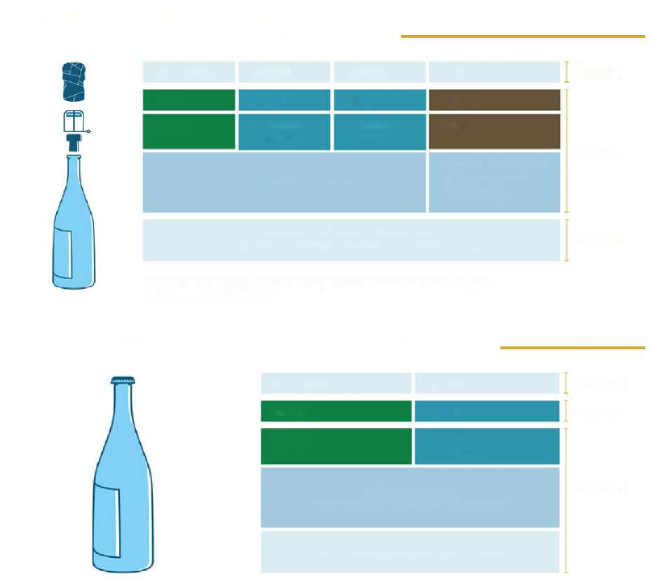

**Example**

**GLASS BOTTLE FOR SPARKLING WINE WITH A CORK STOPPER, ALUMINIUM CAPSULE AND STEEL CAGE**

**BOTTLE**

**CAPSULE**

**CAGE**

**CAP**

**GL71**

**ALU 41**

**FE 40**

**FOR 51**

**Glazing**

**Aluminium and metal**

**Aluminium and metal**

**Cork**

**SEPARATE COLLECTION**

**Dedicated separate collection or separate collection for organic waste**

*Check the provisions in your municipality. Separate the components and dispose of them correctly.*

*In this case, since the label is not manually separable from the bottle, it is not necessary to label it.*

**HIGHLY RECOMMENDED**

**NECESSARY**

**RECOMMENDED**

**Example**

**RETURNABLE GLASS BOTTLE FOR THE HORECA INDUSTRY**

**RECOMMENDED**

**NECESSARY**

**RECOMMENDED**

**BOTTLE**

**CAP**

**GL 70**

**FE 40**

**Glazing**

**Steel or metal**

**Returnable bottle.**

**SEPARATE COLLECTION at end-of-life**

*Check the provisions in your municipality.*

**Polycoupled or composite packaging**

|  |  |
| --- | --- |
| **Type of packaging** | Bag  Wrapper  Container  **….** |
| **Decision 97/129/EC** | |  |  |  | | --- | --- | --- | | *ANNEX VII*  Numbering and abbreviation system (1) for composite packaging | | | | Material | Abbreviations (*) | Numbering | | Paper and cardboard/miscellaneous metals  Paper and cardboard/plastic  Paper and cardboard/aluminium  Paper and cardboard/tin  Paper and cardboard/plastic/aluminium  Paper and cardboard/plastic/aluminium/tin |  | 80  81  82  83  84  85 | | PIastic/aluminium  Plastic/tin  Plastic/miscellaneous metals |  | 86  87  88  89  90  91  92 | |  |  | 93  94 | | Glass/plastic  Glass/aluminium  Glass/tin  Glass/miscellaneous metals |  | 95  96  97  96 | |  |  | 99 | | (*) Components: C plus the abbreviation corresponding to the predominant matter (C/ ) | | | |
| **The family of material** | **Steel, aluminium, paper, wood, plastic or glass – depending on the predominant material by weight** |
| **Information on collection** | **Separate collection**  **Check the provisions in your municipality** |

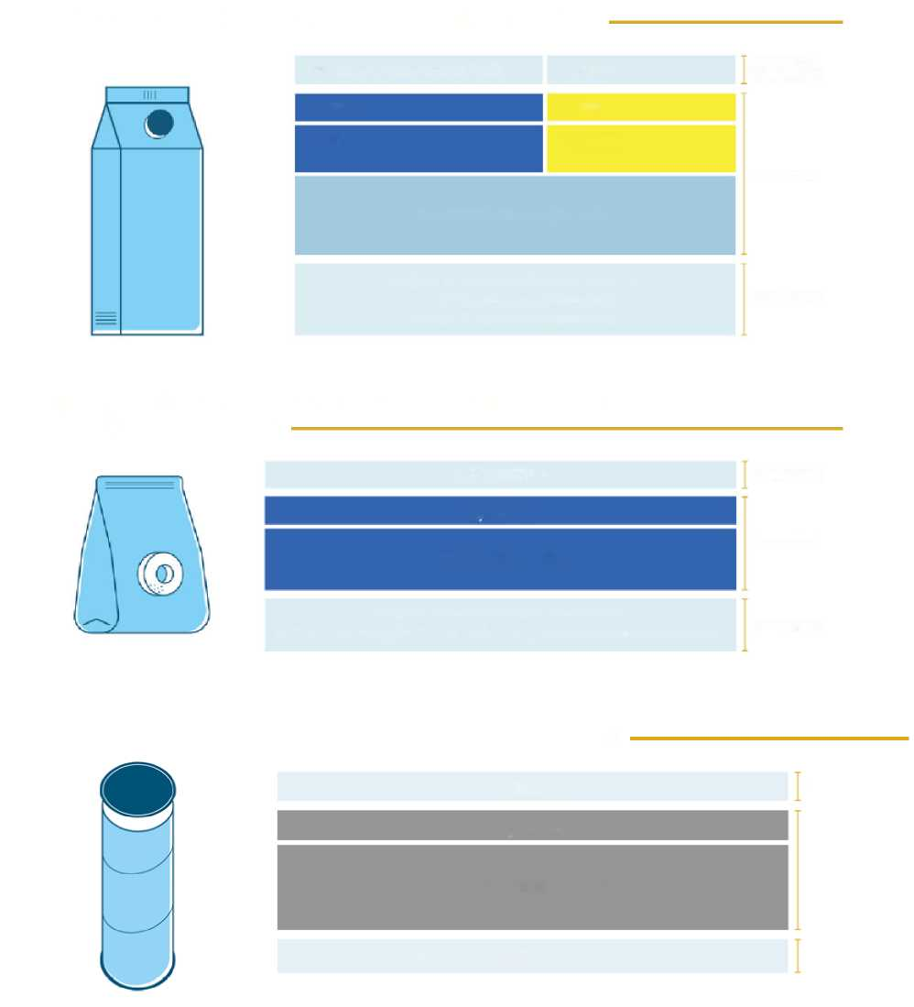

**Example**

**PAPER-BASED POLYCOUPLED CONTAINER FOR LIQUIDS**

**HIGHLY RECOMMENDED**

**NECESSARY**

**RECOMMENDED**

**CONTAINER FOR LIQUIDS**

**CAP**

**C/PAP 84**

**HDPE**

**Paper**

**Plastic**

**SEPARATE COLLECTION**

***Check the provisions in your municipality. www.tiriciclo.it/raccolta-e-riciclo/ Separate the cap from the container.***

**Example**

**PAPER-BASED COMPOSITE BAG + PLASTIC COATING, (< 5% of the total weight)**

**BAG**

**C/PAP 81**

**COLLECTION OF PAPER**

***Check the provisions in your municipality.***

***Empty the packaging of its contents before disposing of it in the waste collection.***

**RECOMMENDED**

**NECESSARY**

**RECOMMENDED**

**Example**

**PAPER- AND STEEL-BASED COMPOSITE TUBE WITH A CELLULOSE COMPONENT < 60% OF THE TOTAL WEIGHT**

**RECOMMENDED**

**NECESSARY**

**RECOMMENDED**

**TUBE**

**C/PAP 83**

**SEPARATE COLLECTION**

***Check the provisions in your municipality.***

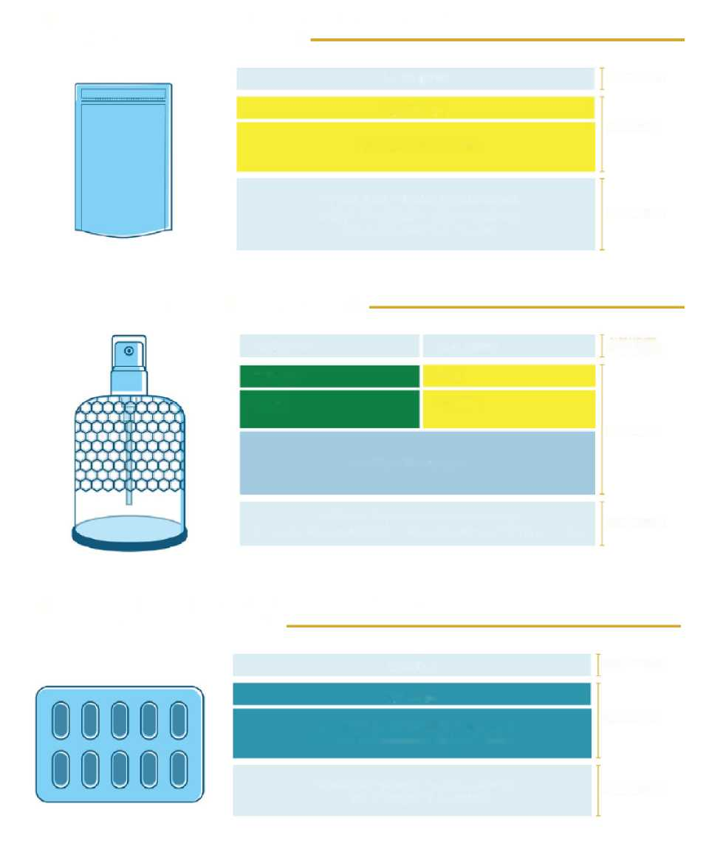

**Example**

**PLASTIC- AND ALUMINUM BASED COMPOSITE BAG (40% LDPE, 30% PET, 20% ALU)**

**BAG**

**C/LDPE 90**

**COLLECTION OF PLASTIC**

*Check the provisions in your municipality. Empty the packaging of its contents before disposing of it in the waste collection.*

**RECOMMENDED**

**NECESSARY**

**RECOMMENDED**

**Example**

**PERFUME BOTTLE MADE OF GLASS AND STEEL**

**HIGHLY RECOMMENDED**

**NECESSARY**

**RECOMMENDED**

**BOTTLE**

**CLOSURE**

**C/GL 97**

**PP 5**

**Glazing**

**Plastic**

**SEPARATE COLLECTION**

*Check the provisions in your municipality.*

*Separate the closure from the bottle before disposing of it in the waste collection*

**Example**

**ALUMINIUM- AND PLASTIC-BASED COMPOSITE BLISTER FOR FOOD SUPPLEMENTS**

**BLISTER**

**C/ALU 90**

**COLLECTION OF ALUMINIUM OR METAL**

Check the provisions in your municipality.

**RECOMMENDED**

**NECESSARY**

**RECOMMENDED**

Empty *the packaging of its contents before disposing of it in the waste collection*

**Textile packaging**

|  |  |  |
| --- | --- | --- |
| *ANNEX V* | | |
| Numbering and abbreviation system (') for textile materials | | |
| Material | Abbreviations | Numbering |
| Cotton  Jute | TEX  TEX | 60  61  62  63  64  65  66  67  68  69 |

For textile packaging, reference is made to Annex V to Decision 129/97/EC.

For textile materials not provided for in this table, therefore other than ‘cotton’ and ‘jute’, it is considered appropriate to use the code TEX 62, i.e. the first number available which does not identify any material.

This packaging is not part of the domestic separate collection circuit, but refers to dedicated collection circuits. Therefore, it is good to indicate, together with the code, the ‘textile material’ in full and an invitation to the consumer to check the provisions of their municipality.

## Entry into force of the obligation and exhaustion of stocks

By Decree-Law No 228 of 30 December 2021, the so-called ‘Milleproroghe’ [thousand extension], converted with amendments by Law No 15 of 25 February 2022 (in SO No 8, relating to the Official Gazette of 28/02/2022), Article 11 provides for the suspension of the environmental labelling requirement for packaging until 31 December 2022, as well as the possibility for operators in the sector to market products which do not meet the new environmental labelling requirements already placed on the market or labelled on 1 January 2023, until stocks are exhausted.

#### What does ‘products’ mean?

Since the requirements referred to in the legislation refer to packaging, the term ‘products’ is to be understood as referring to packaging and not to packaged products. As a result, companies will be able to use, until they are exhausted, stocks of finished packaging which do not comply with the labelling requirements as at 31/12/2022 even if they are empty.

#### Which packaging can be marketed after 31/12/2022?

Packaging – even if empty – already labelled (which is already printed, or for which the label has already been produced/affixed) before 31/12/2022 may be marketed; or packaging purchased by packaging users from their suppliers before 31/12/2022.

#### What documents can prove that these stocks are allowed to be marketed?

Whereas the date of ‘placing on the market’ of the packaging may be traced by means of the purchase documents of the goods, where a user (*according to Article 218(1)(s) of Legislative Decree 152/06, users are ‘traders, distributors, fillers, packaging users and importers of full packaging’*) buys packaging already labelled (which is already printed, or for which the label has already been produced/affixed) by a supplier, the date of these documents is valid (the actual physical transfer of the goods to the purchaser may take place at a later date; the important thing is to be able to prove that the goods were purchased before 31/12/2022).

Where a self-producer of packaging (*‘self-producers’ are defined as those who purchase raw materials and packaging materials in order to manufacture/repair packaging to make their own products (other than packaging). The self-producer is also considered to be a user as regards the raw material used for the repair of their packaging*) has in stock packaging already labelled (which is already printed, or for which the label has already been produced/affixed) before 31/12/2022, they may refer to the date of the production batch (in this case reference should be made to the production batch of the packaging or label, if it is envisaged to include mandatory information on the label).

With regard to packaging producers (*according to Article 218(1)(r) of Legislative Decree 152/06, packaging producers are ‘suppliers of packaging materials, manufacturers, processors and importers of empty packaging and packaging materials’*) who have in stock packaging which does not meet the requirements, it is assumed that they may:

* market packaging purchased by the customer before 31/12/2022. In this case, the date of the customer’s purchase document is valid.
* market stocks of neutral, unlabelled packaging – as already provided for in the Ministry for the Ecological Transition’s note of clarification of 17 May 2021 – accompanied by documentation containing the mandatory information to be given to customers (the composition of the packaging pursuant to Decision 129/97/EC).

In the case of packaging that will undergo a process of printing or affixing a label (through the different methods provided for in the specific cases), it will be necessary to enter into an agreement with the customer in which it is defined at which point in the supply chain such operations will take place.

#### Can packaging stocks held in other countries be marketed?

If the packaging was purchased before 31/12/2022, it can be marketed even if the stocks are held in another country. In this case, the date of the purchase document of the packaging supply shall be valid.

**Labelling at a glance**

The table below gives a summary of the contents of the Guidelines, representing in a schematic way the subjects that are of greatest interest: the contents, divided into mandatory and recommended; the methods, then the position and the format, for which we propose preferred, but not binding, choices, and the timing.

The scope of these indications includes all packaging.



**PACKAGING INTENDED FOR THE FINAL CONSUMER**

**B2B PACKAGING**

**Code as per Decision 129/97/EC**

**Information on collection.**

**The family of the corresponding material must be clear.**

Information on collection.

The family of the corresponding material must be clear.

**Mandatory information**

**CONTENT**

**Recommended optional information**

An instruction telling the consumer to check the provisions of their municipality

Type of packaging

For plastic packaging, reference to UNI standards for supplementary codes not provided for in Decision 129/97/EC, multi-layer packaging, plastic-dominant composites

Tips for quality separate collection

**Best choice**

**On each separable component**

**...If not possible**

Enter the identification code according to Decision 129/97/EC on each separable component, and the other information on the main body or presentation packaging, or on the label, or on the component that makes the information better visible to the consumer.

**...If not possible**

**WHERE?**

Enter the identification code according to Decision 129/97/EC and the other information on the main body or presentation packaging, or on the label, or on the component that makes the information better visible to the consumer.

**Font size**

Greater than 0 up to and including 1.2 mm

**Colours**

blue for paper,

brown for organic,

yellow for plastic,

turquoise for metal,

green for glass,

grey for general waste

**FORMAT AND VISUAL**

**(Guidelines)**

**TIMING**

The entry into force of the obligation was delayed to 1 July 2022. In addition, operators in the sector will have the opportunity to market products that do not meet the new labelling requirements already placed on the market or labelled until stocks last.

# **Glossary**

**SELF-PRODUCER**

‘Self-producers’ are defined as those who purchase raw materials and packaging materials in order to manufacture/repair packaging to make their own products (other than packaging). The self-producer is also considered to be a user as regards the raw material used for the repair of their packaging

**BIODEGRADATION** (Greene, J.P. (2014)). Sustainable Plastics: Environmental Assessments of Biobased, Biodegradable, and Recycled Plastics. (1st Ed). John Wiley & Sons.)

Biodegradation is a thermochemical process that takes place within a given time frame and under specific environmental conditions. During biodegradation, materials/products are converted into biomass, water and carbon dioxide

**COMPOSTABILITY** (Greene, J.P. (2014)). Sustainable Plastics: Environmental Assessments of Biobased, Biodegradable, and Recycled Plastics. (1st Ed). John Wiley & Sons.)

Compostability is the property of a material to generate compost (biomass) through the composting process, that is, an aerobic biological process that takes place under environmental conditions imposed from outside. Usually, temperatures between 50 °C and 60 °C and a moisture content of between 45 % and 55 % are used in industrial composting plants.

The technical standard **UNI EN 13432** indicates the requirements that packaging must meet in order to be recoverable in the form of compost:

* packaging shall be designed, produced and marketed in such a way as to enable its reuse or recovery, including recycling, and to minimise its impact on the environment if packaging waste or residues from packaging waste management operations are disposed of;
* packaging waste treated to produce compost must be sufficiently biodegradable so as not to hinder separate collection and the composting process or activity into which it is introduced;
* biodegradable packaging waste shall be of such a nature as to be capable of undergoing physical, chemical, thermal or biological decomposition resulting in most of the resulting compost being decomposed into carbon dioxide, biomass and water.

**SUPPLY CHAIN CONSORTIA**

Article 223 of Legislative Decree 152/06 provides that packaging producers are to form a consortium for each packaging material (steel, aluminium, paper, wood, plastic and glass). The seven Supply Chain Consortia are:

Ricrea – National Consortium for the Recycling and Recovery of Steel Packaging;

Cial – National Consortium for Aluminium Packaging;

Comieco – National Consortium for the Recovery and Recycling of Cellulose-based Packaging;

Rilegno – National Consortium for the Collection, Recovery and Recycling of wood packaging;

Corepla – National Consortium for the Collection, Recycling and Recovery of Plastic Packaging;

Biorepak – National Consortium Guaranteeing the Collection, Recovery and Organic Recycling of Biodegradable and Compostable Plastic Packaging Waste;

Coreve – Consortium for Glass Recovery.

As an alternative to registering with the Supply Chain Consortia, producers may, pursuant to Article 221(3) of the same Decree: ‘a) organise autonomously, including collectively, the management of their packaging waste throughout the national territory; [...] c) certify under their own responsibility that a system for returning their packaging has been put in place, with appropriate documentation demonstrating the self-sufficiency of the system [...]’.

**CONSUMER**

The consumer of packaging is the person who, outside for the purpose of exercising a professional activity, purchases or imports packaging, packaged goods or articles for their own use.

**WASTE MANAGEMENT**

According to the provisions of Article 183(1)(n) of Legislative Decree 152/06, waste management means: ‘the collection, transport, recovery and disposal of waste, including the monitoring of such operations and after-care of disposal sites, as well as operations carried out as a trader or intermediary’.

**PACKAGING** (Legislative Decree 152/06, Article 218 (3 April 2006).

According to Article 218 of Legislative Decree 152/06, packaging is defined as ‘a product, consisting of materials of any kind, intended to contain certain goods, from raw materials to finished products, to protect them, to enable their handling and delivery from the producer to the consumer or user, to ensure their presentation, as well as disposable articles used for the same purpose’.

**COMPOSITE PACKAGING** (Decision 129/97/CE [EUR-Lex](https://eur-lex.europa.eu/legal-content/EN/TXT/PDF/?uri=CELEX:31997D0129&from=EN))

Packaging is defined as ‘*composite*’ when it is ‘*made up of different materials, and which cannot be separated by hand*’.

**MULTI-MATERIAL PACKAGING**

The packaging consists of several independent components in different materials. Unlike composite packaging, in this case the different materials that make up the packaging can be separated. For example, multi-material packaging includes: chocolate boxes (paper for the box, plastic for the shaped container inside), sweet bags (plastic for bag, paper for the individual candy), coffee jars (aluminium for the jar, plastic for the lid), etc...

**FULL PACKAGING**

This refers to packaged goods and, in particular, to the individual packaging of the goods themselves. For example, in the case of an importer of canned beers, ‘full packaging’ refers to the aluminium constituting the cans and possibly to the other secondary and tertiary packaging.

**PRIMARY PACKAGING (OR PACKAGING FOR SALE)**

In Article 218(b) of Legislative Decree 152/06, primary packaging is defined as ‘packaging designed to constitute, at the point of sale, a sales unit for the end user or the consumer’. In general, the primary packaging is the one that packs the individual product ready for consumption.

**SECONDARY (OR MULTIPLE) PACKAGING**

In Article 218(c) of Legislative Decree 152/06, secondary packaging is defined as 'packaging designed to constitute, at the point of sale, the grouping of a number of sales units, irrespective of whether it is sold as such to the end user or to the consumer, or serves only to facilitate the restocking of shelves at the point of sale. It can be removed from the product without altering its characteristics.’ In general, the secondary packaging is the one that groups a number of individual products ready for consumption. The product, once removed from the secondary packaging, is presented in its primary packaging, unaltered and ready for use.

**TERTIARY PACKAGING (OR PACKAGING FOR TRANSPORT)**

In Article 218(d) of Legislative Decree 152/06, tertiary packaging is defined as ‘packaging designed in such a way as to facilitate the handling and transport of goods, from raw materials to finished products, of a number of sales units or of multiple packagings in order to avoid handling and damage during transport, excluding containers for road, rail, sea and air transport’. In general, tertiary packaging is intended to protect and facilitate the handling of goods during transport.

**SECONDARY RAW MATERIAL (MPS)**

All waste which ceases to be waste if it is subject to a recovery operation, including recycling, and if it meets specific criteria.

**UNI STANDARDS**

The acronym UNI distinguishes ‘voluntary standard documents (UNI standards, technical specifications, technical reports and good practices) in all industrial, commercial and tertiary sectors’.

Technical standards are techniques approved and published by an international, European or national standardisation body, compliance with which is based on voluntary action; they are identified as ‘*rules of good practice*’.

Therefore, compliance with them is not mandatory, and alternative and equivalent solutions are possible, provided they are effectively demonstrated.

**PACKAGING PRODUCER**

According to Article 218(1)(r) of Legislative Decree 152/06, packaging producers are ‘suppliers of packaging materials, manufacturers, processors and importers of empty packaging and packaging materials’.

**SEPARATE COLLECTION** (Legislative Decree 152/06, Article 183(1)(f) (3 April 2006).

Collection that is suitable, according to the criteria of cost-effectiveness, effectiveness, transparency and efficiency, to group municipal waste into homogeneous waste types, during collection or, for wet organic waste, also at the time of treatment, as well as to group packaging waste separately from other municipal waste, provided that all the aforementioned waste is actually intended for recovery.

**RECOVERY OF WASTE GENERATED FROM PACKAGING** (Directive 2008/98/EC, Article 3(15) (19 November 2008).

Recovery of generated waste means any operation the principal result of which is waste serving a useful purpose by replacing other materials which would otherwise have been used to fulfil a particular function, or waste being prepared to fulfil that function, in the plant or in the wider economy.

**ENERGY RECOVERY (WASTE-TO-ENERGY)**

According to Article 218(1)(n) of Legislative Decree 152/06, energy recovery of packaging waste occurs when such combustible packaging waste is used to produce energy through waste-to-energy processes (with or without other types of waste) involving heat recovery.

**RECYCLING OF PACKAGES** Directive 2008/98/EC, Article 3(17) (19 November 2008).

Any recovery operation by which waste materials are reprocessed into products, materials or substances whether for the original or other purposes. It includes the reprocessing of organic material but does not include energy recovery and the reprocessing into materials that are to be used as fuels or for backfilling operations.

**PACKAGING WASTE** Directive 2008/98/EC, Article 3(1) (19 November 2008).

Any substance or object which the holder discards or intends or is required to discard.

**PACKAGING USER**

According to Article 218(1)(s) of Legislative Decree 152/06, users are ‘traders, distributors, fillers, packaging users and importers of full packaging’.

1. (…) In order to facilitate the collection, reuse and recovery, including recycling, thereof, packaging must indicate, for the purpose of identification and classification by the industry concerned, the nature of the packaging material(s) used. (…)