# Reply from Nordic Nicotine Pouches Alliance (NNPA) regarding the Proposal for a Decree on the prohibition of products for oral use containing **nicotine**

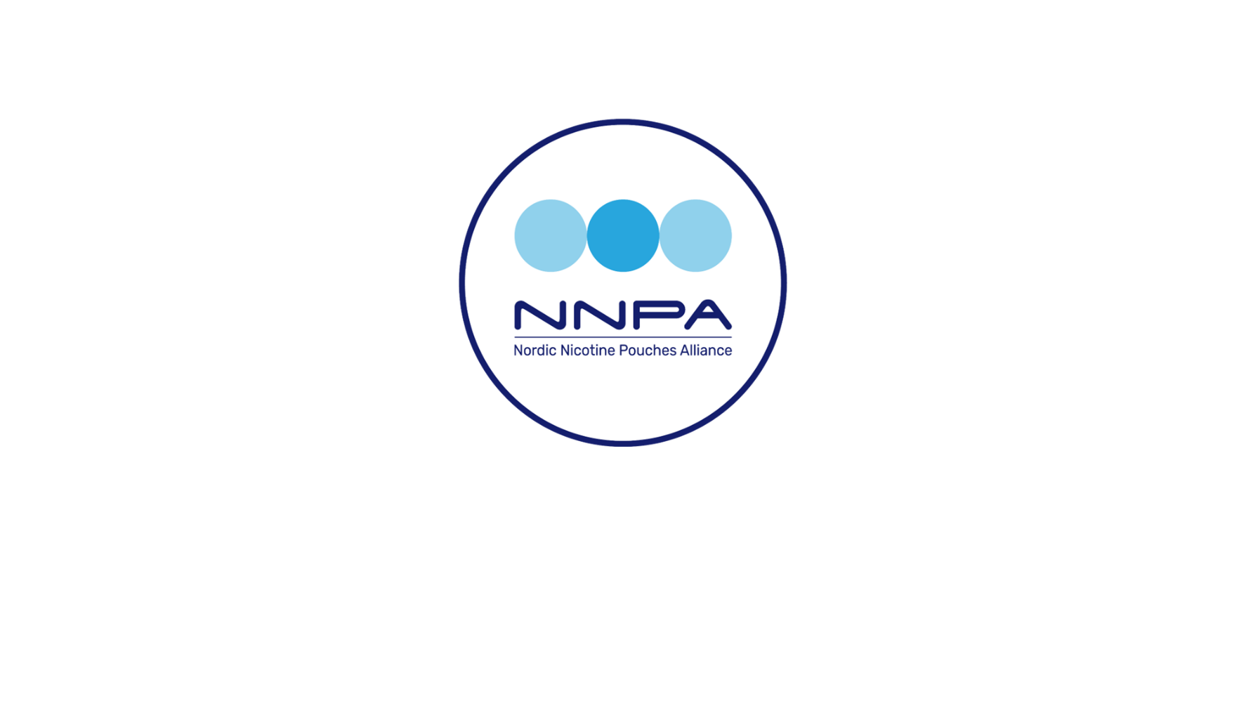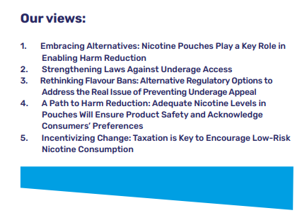

## The Nordic Nicotine Pouches Alliance (NNPA) is a Brussels-based platform for stakeholders advocating for nicotine pouches as an essential part of harm reduction among adult nicotine users within the EU. We promote responsible, effective, and harmonised European legislation that establishes clear guidelines for this product category to achieve specific goals, such as banning extreme nicotine levels or reducing usage among minors. Our main focus is information dissemination, but we continuously work to build support for our position from stakeholders who are representatives of a responsible value chain. NNPA is funded by European industry actors.

## Summary of our position:

The NNPA strongly objects to the proposed ban with the motivation that the proposed restrictions will have a significant negative impact on future public health. A ban of the product category cannot be considered motivated, balanced nor purposeful.

We conclude that the proposal, according to all available statistics and particularly considering France's smoking prevalence, would represent a profoundly misguided and counterproductive measure, highly unlikely to achieve its intended public health objectives and potentially exacerbating the very issues it seeks to address.

We also consider that the proposed restrictions pre-empt the revision of the Tobacco Products Directive, violate the principle of non-discrimination and the freedom of trade and industry (Article 34 TFEU) and that they without due justification contradict legislation recently introduced in other EU Member States.

# NNPA’s opinion on the proposed ban

The French government is proposing a ban on production, manufacture, transport, import, export, possession, offering, transfer, purchase, distribution, and use of nicotine products for oral use in France. This will not only deprive France’s smokers (31,1% of the adult population, or 23,1 % on a daily basis according to Santé Publique France, the national public health agency of France) a significantly lower risk alternative, but will also limit the private consumption of a regulated and legal product for 1,4 million EU citizens when visiting France.

It is highly inconsistent to argue that banning nicotine pouches would be beneficial for public health when a significant portion of the population in France continues to use nicotine from higher risk sources. While not risk-free, scientific evidence consistently demonstrates that the placing of nicotine pouches on the market does not pose any significant risk to public health[1][2][3] On the contrary, statistics from countries where affordable nicotine pouches are available indicate that their presence provides a viable and attractive alternative for adult smokers and that the benefits on a societal level are massive.

Nicotine pouches are among the least harmful nicotine products available, as they eliminate the risks associated with combustion. Prohibiting the least risky alternative is not only counterproductive from a harm reduction perspective but also undermines fundamental principles of public health policy, which should be based on relative risk assessment. Furthermore, such a ban would violate internal market regulations within the European Union, creating unnecessary barriers to trade and distorting competition between nicotine products. It also infringes on the rights of EU citizens by restricting their ability to choose a demonstrably less harmful alternative, contradicting the EU’s broader commitment to both consumer choice and evidence-based policymaking.

While NNPA shares the concern for tobacco related harm, the one main factor deciding risk connected to nicotine use, is how it is consumed. The relative risk of nicotine pouches compared to cigarettes is unanimously recognized as significantly lower.

Nicotine pouches have emerged as an effective alternative for consumers seeking to quit smoking. To achieve EU targets on smoking prevalence going from over 20% to below 5% in a situation with over 80 million smokers in the EU, it is essential for policymakers to acknowledge that many smokers are willing to transition away from cigarettes but not necessarily to quit nicotine. Traditional approaches to tobacco control that demand complete nicotine abstinence have proven ineffective for a significant part of the smoking population. Therefore, policymakers should embrace reduced-risk alternatives reaching all smokers, taking into account all factors, in particular risk.

According to EU statistics, Sweden has around the same percentage of nicotine users as the average in the Union, but all indicators of tobacco-related harm including lung cancer, Chronic Obstructive Pulmonary Disease (COPD) and general mortality rates related to tobacco use are significantly lower than in all other Member States (typically 40-50 percent lower).

The risks related to nicotine pouch use are very low (the risk profile is similar to products used in Nicotine Replacement Therapy i.e. patches, gums etc.) and even if complete abstinence from nicotine is the healthiest choice, the benefits of encouraging smokers to switch to nicotine pouches are undeniable and far outweigh potential drawbacks, even if measured on the total population.

Nicotine pouches do not contain tobacco, they are not burned, heated or in any other way chemically altered when used. As such, the risk is on the completely opposite side of the risk spectrum compared to smoking cigarettes. Tobacco smoke contains more than 7000 chemicals out of which at least 250 are known to be harmful and more than 70 identified as carcinogenic. Nicotine pouches typically contain 10-15 distinct compounds which are food grade and as opposed to combustion byproducts fully identified, non-carcinogenic and intended as well as approved for consumption.

The main three risks connected to smoking cigarettes are cancer, pulmonary disease and cardiovascular risk. These are well-established facts within the scientific and medical communities including the European Commission’s Knowledge for Policy resource and the World Health Organization (WHO) who both identify these as the primary consequences of smoking cigarettes.

**Since nicotine pouches do not contain carcinogenic substances and are not chemically altered when used, the risk in the context of cancer would be negligible.**

**Since nicotine pouches do not emit any byproducts of combustion and the lungs are not exposed, the risk for pulmonary disease would also be negligible.**

While both products contain nicotine that can contribute to elevated blood pressure, increased heart rate and vascular constriction, **the main risk of cardiovascular disease of smoking cigarettes does not derive from the nicotine content but rather from byproducts of combustion** i.e. carbon monoxide and oxidizing chemicals that significantly increases the risk of atherosclerosis, blood clot formation and chronic inflammation. **While nicotine pouches may carry a minimal cardiovascular risk relative to non-use, they are far safer for the cardiovascular system than smoking.**

If the aim is to discourage youth from purchasing nicotine pouches and to prevent nicotine addiction, several more proportionate measures could be considered, especially in the context of France where there is currently no regulatory framework in place to oversee nicotine pouches.

In this regard, a stricter regulatory framework for this category of products would be more appropriate, as it would allow them to deliver their full potential in terms of societal benefits.

These measures include aligning nicotine pouch regulations with those of vaping products—for example, prohibiting sales to minors, mandating health warnings on packaging and introducing a purposeful nicotine content cap to limit extreme products with potentially harmful levels of nicotine[4].

Another proportionate approach for France could be strictly regulating their distribution by entrusting sales exclusively to the tobacconists' monopoly, which already has experience controlling the age of purchasers.

Additional effective measures could also include introducing child-proof secure packaging, regulating flavor descriptors, and banning online and distance sales.

**From another perspective, regulating the nicotine pouch category instead of imposing a total ban would cause significantly less disruption to trade between EU Member States.**

It is also worth quoting the unfavourable opinion issued a few weeks ago by the French Council of State on the draft decree, which was based on the lack of necessity and proportionality of the restrictive measures proposed in the decree. In particular, in its unfavourable opinion, the Council of State emphasizes that “*while the Public Health Code allows the regulatory authority to impose stricter restrictions on the production, marketing, or consumption of substances than those applicable to all substances listed as poisonous—of which nicotine pouches are a part—any additional restrictions must be introduced only if they are deemed necessary and proportionate*”.

It therefore concludes that it is “*not in a position to assess the necessity of such a set of measures that are more restrictive than those currently applied to nicotine—and even less so their proportionality—due to the* ***lack of elements provided by the Government to justify their necessity and proportionality***”. (our emphasis)

We thus find the proposed restrictions, due to the lack of positive effects on public health, to be unjustified and in violation of the principle of free movement of goods. A ban on a product with significantly lower risk cannot be considered motivated, balanced nor purposeful.

Nicotine pouches are consumed daily by around 1.4 million citizens across 25 EU Member States. The overwhelming majority of these consumers are adults that have switched from smoking traditional tobacco cigarettes as pouches offer a less risky alternative of consuming nicotine. It’s to be noted that Czech Republic, Slovakia, Hungary, Finland, Italy, Lithuania, Romania, and Sweden have introduced regulation for nicotine pouches. The proposed ban on oral nicotine products is far more restrictive and discards the success of appropriate regulation for example in Sweden which has led to the lowest smoking rate in the EU (5.3% 2024) and the lowest levels of smoking-related disease and death[5], in large part due to availability of reduced-risk products such as the use of nicotine pouches. To further highlight the relevance of the data the Swedish Public Health Authority (Folkhälsomyndigheten) reports that daily smoking incidence among the 16–29-year-old bracket presently is 2.3%, representing a reduction of nearly 40% between 2022 and 2024 which is a clear indication that the presence of nicotine pouches does not contribute to the recruitment of young adult smokers.

Conclusions

With the above in mind as basis for our motivation, we conclude that the proposal, according to all available statistics and particularly considering Frances’s smoking prevalence, would represent a profoundly misguided and counterproductive measure, unlikely to achieve its intended public health objectives and potentially or even likely exacerbating the very issues it seeks to address.

The justification criteria cannot be met for the proposed restrictions and that the draft Law will restrict the free movement of goods (Article 34 TFEU)

* *There are no public health risks that could justify restrictions on the free movement of nicotine pouches. On the contrary, such restrictions are likely to have the opposite effect by reducing access to reduced risk alternatives that are beneficial to smokers, as recognized by BfR, COT and RIVM (footnote 3, 4 and 5)*
* *The ban is not proportionate since there is no scientific evidence or even statistical indications that suggest that nicotine users would be exposed to higher risk by placing nicotine pouches on the market. The Member States that clearly excel at reducing tobacco harm have nicotine pouches available on the market showing that France could achieve even more ambitious health objectives without this unwarranted, arbitrary and disproportionate ban.*
* *It is obvious to us that there are alternative, more purposeful measures that can be used to tackle real and present issues related to tobacco harm, instead of a ban, that by any definition will miss the target of* *improving the protection of public health.* *Policies should focus on incentivizing and facilitating smokers switching to nicotine pouches rather than restricting access, as this would maximize public health benefits and provide a clear pathway for smokers to adopt less harmful alternatives, potentially saving countless lives and reducing healthcare burdens.*
* *We consider that the proposed restrictions pre-empt the revision of the Tobacco Products Directive, violate the principle of non-discrimination and the freedom of trade and industry (Article 34 TFEU), and that they without due justification contradict legislation recently introduced in other EU Member States.*

**In conclusion, we strongly oppose the proposed restrictions and urge the Commission to give a detailed opinion requesting robust evidence, a thorough and objective impact assessment, and consideration to the latest research demonstrating the significant public health benefits of harm reduction strategies, including the use of nicotine pouches as a safer alternative for smokers**

För NNPA, Robert Casinge

Senior partner, regulatory affairs Brussels 2025-03-20

1. <https://www.bfr.bund.de/cm/349/health-risk-assessment-of-nicotine-pouches.pdf>
2. <https://cot.food.gov.uk/sites/default/files/2023-04/Publishable%20%20COT%20Oral%20nicotine%20pouches%20-%20final%20v1-0%20Acc%20V.pdf>
3. <https://www.rivm.nl/publicaties/nicotineproducten-zonder-tabak-voor-recreatief-gebruik>
4. In terms of the nicotine content per pouch, the conclusions that were reached by the German Federal Institute for Risk Assessment (BfR) in its recent report “Health Assessment of Nicotine Pouches” (October 7, 2022) are scientifically well argued. According to [technical specifications outlined by the Swedish Institute for Standards (SIS)](https://www.sis.se/en/produkter/agriculture/tobacco-tobacco-products-and-related-equipment/sists-722020/), it is recommended that nicotine pouches should not exceed 20 milligrams of nicotine per consumable. In response to these standards, several countries have implemented limits, capping nicotine concentration at, or close to 20 milligrams per consumable or per gram of product weight: Iceland (20mg/gram), Latvia (20 mg/gram), Slovakia (20 mg/pouch), Finland (16,6 mg/gram).
5. Global Burden of Disease, survey: [VizHub - GBD Compare](https://vizhub.healthdata.org/gbd-compare/)