Transportstyrelsens logotyp.Τhe Swedish Transport Agency’s   
Code of Statutes

**THE SWEDISH TRANSPORT AGENCY**

The Swedish Transport Agency’s regulations   
on technical requirements for road trains with a length of more than 25.25 meters;

adopted on [Select a date].

TSFS 20[Year]:[No]

Published  
on [Select a date]

ROAD

[Enter sub-series]

By virtue of Chapter 4 Sections 12, 13 and 17 f in the Traffic Regulation (1998:1276) and Chapter 8 Section 16 of the Vehicle Regulation (2009:211), the Swedish Transport Agency lays down[1] the following.

### Introductory provisions

Section 1 These Regulations lays down detailed rules for the construction of and equipment for road trains exceeding 25.25 metres but not exceeding 34.5 metres as well as for the vehicles included in the road train. The Regulations apply when travelling on roads where the road operator, pursuant to Chapter 4 Section 17 f of the Traffic Regulation (1998:1276), has issued regulations that the length of a road train may not exceed 34.5 metres.

Section 2 Goods that are lawfully marketed in another Member State of the European Union or in Turkey, or that originate from and are lawfully marketed in an EFTA State that is party to the EEA Agreement, are presumed to be in compliance with these provisions. The application of these provisions is covered by Regulation (EU) 2019/515 of the European Parliament and of the Council of 19 March 2019 on the mutual recognition of goods lawfully marketed in another Member State and repealing Regulation (EC) No 764/2008.

Section 3 The terms used in these Regulations have the meaning set out in the Road Traffic Definitions Act (2001:559).

Otherwise, for the purposes of these Regulations, the following terms and definitions are used.

|  |  |
| --- | --- |
| *A-double* | vehicle combination consisting of a *tractor* coupled to a semi-trailer and a dolly with an attached semi-trailer |
| *AB-double* | vehicle combination consisting of a heavy-duty vehicle coupled to a dolly with coupled with a *link semi-trailer*, which in turn is coupled to a semi-trailer |
| *tractor* | heavy-duty vehicle equipped with a coupling device (fifth wheel) for a semi-trailer |
| *link semi-trailer* | semi-trailer with a rear fifth wheel for coupling to another semi-trailer |
| *performance value* | value determined by the manufacturer, indicating the load a vehicle and its coupling device can withstand |
| *self-tracking axle* | steering axle, whose delay angle is changed by tyre-road friction |

Section 4 For the purposes of these regulations, the following definitions apply:

– ECE Regulation 13: Uniform provisions concerning the approval of vehicles of categories M, N and O with regard to braking,

– ECE Regulation 55: Uniform provisions concerning the approval of mechanical coupling components of combinations of vehicles.

### General requirements

Section 5 The road train shall consist of an A-double or an AB-double combination. Vehicles and road trains shall comply with the conditions set out in Sections 6 to 12. In addition, an A-double combination shall comply with the conditions laid down in Sections 13 to 23, and an AB-double combination shall comply with the conditions laid down in Sections 24 to 31.

Section 6 The heavy-duty vehicle must have at least three axles. The trailers included in the road train shall have at least two axles.

Section 7 Vehicles with no more than three axles shall have a stability system according to ECE Regulation 13, amendment series 11 Appendix 3, or later.

Section 8 The heavy-duty vehicle shall have equipment that allows the driver to observe the right side of the road train from the driver’s seat.

Section 9 All vehicles of the road train shall be equipped with electronic braking systems with anti-lock function and automatic brake adaptation according to ECE Regulation 13 amendments series 11, or later.

Section 10 The dolly’s fifth wheel shall pivot around a vertical axis through the coupling point.

### Signs

Section 11 The road train shall be fitted towards the front and the rear with signs as shown in Figure 1. The lower edge of the signs shall be no more than 2.0 metres above the road. The forward-facing sign shall be located below the lower edge of the windscreen. The rearward-facing sign shall be to the left of the centre line of the vehicle.

The signs shall have:

1. a yellow bottom and a red border, which are is retro-reflective,

2. a border width of 3.0 centimeters,

3. text with the font Tratexsvart, text size 75 millimetres, and

4. a width of not less than 0,90 metres and a height of not less than 0.45 metres.

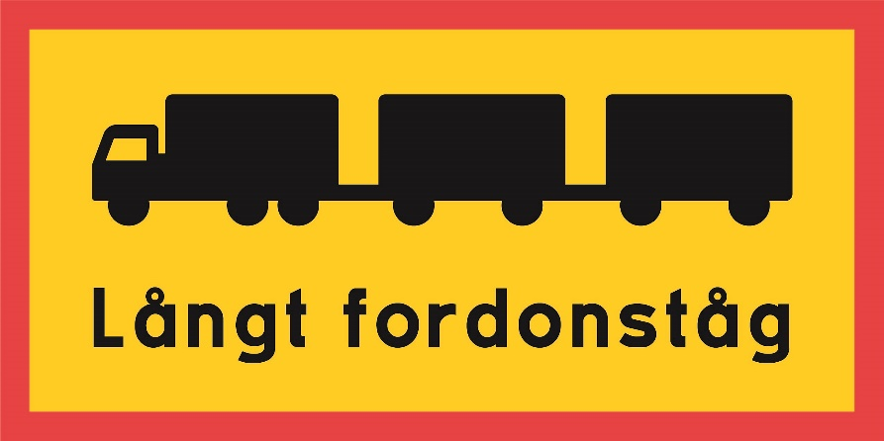The ratio of width to height shall be 2:1. If the size of the sign is increased, the width of the border and the text size shall also be increased accordingly.

**Long road train**

Figure 1. Sign design for a long road train.

### Driving axles and engine power

Section 12 If the total gross weight of the road train exceeds 64 tonnes, the heavy duty vehicle shall have at least two driving axles and an engine power of at least 310 kW.

### Special conditions for A-double combination

Figure 2. A-Double combination

#### Front semi-trailer

Section 13 The last axle of the front semi-trailer of an A-double combination shall be self-tracking at speeds up to a minimum of 30 kilometres per hour but not more than 40 kilometres per hour.

Section 14 If the front semi-trailer has two axles, the distance between the front coupling device and the centre of the first axle shall be at least 7.7 metres.

If the front semi-trailer has three axles, the distance between the front coupling device and the centre of the first axle shall be at least 7.0 metres.

Section 15 The distance between the last axle and the rear coupling device of the front semi-trailer shall not exceed 1.4 metres.

Section 16 If the front semi-trailer has at least three axles, the first axle shall be retractable. It shall be possible to raise and lower the axle from the driver’s seat during the journey.

#### Rear semi-trailer

Section 17 The distance between the front coupling device and the centre of the first axle of the rear semi-trailer shall be at least 6.2 metres.

#### Coupling devices

Section 18 The coupling devices shall be approved according to ECE Regulation 55 amendment series 01, or later. The devices shall comply with the Transport Agency’s regulations (TSFS 2019:127) on the coupling of cars and trailers with respect to performance values, or Sections 19 to 22.

Section 19 The coupling device of the tractor shall have a D value of at least 130 kN.

Section 20 The front coupling device of the front semi-trailer shall have a D value of at least 130 kN. The rear coupling device shall have a DC value of at least 120 kN, a D value of at least 130 kN and a V value of at least 32 kN.

Section 21 The dolly’s front coupling device shall have a DC value of at least 120 kN, a D value of at least 130 kN and a V value of at least 32 kN. The rear coupling device shall have a D value of at least 130 kN.

Section 22 The coupling device of the rear semi-trailer shall have a D value of at least 130 kN.

#### Derogation from provisions on distances between axles

Section 23 Notwithstanding Chapter 4 Section 13 first paragraph point 4 of the Traffic Regulation (1998:1276), the distance between axles on the road belonging to load capacity class 1 may be less than 5 metres but not 4 metres. This applies if the total weight of bogie and triple axle is less than the maximum permissible gross mass for the corresponding distance between the first and last axles for those axle groups as set out in Annex 1 to that Regulation.

### Special conditions for AB double combinations

Figure 3. AB double combination

#### Front link semi-trailer

Section 24 The last axle of the link semi-trailer in an AB double combination shall be self-tracking at speeds up to a minimum of 30 kilometres per hour but not more than 40 kilometres per hour.

#### Rear semi-trailer

Section 25 The distance between the front coupling device and the centre of the first axle of the rear semi-trailer shall be at least 6.2 metres.

#### Coupling devices

**Section 26** The coupling devices shall be approved according to ECE Regulation 55 amendment series 01, or later. With regard to performance values, the devices shall comply with Sections 27 to 31.

Section 27 The heavy vehicle’s coupling device shall have a DC value of at least 150 kN and a V value of at least 35 kN. However, the DC value may be less than 150 kN but not less than 130 kN, if the coupling device has a D value of at least 180 kN and a V value of at least 60 kN.

If the total gross mass of the road train is more than 64 tonnes but not more than 70 tonnes, the coupling device shall have a DC value of at least 160 kN and a V value of at least 35 kN. However, the DC value may be less than 160 kN but not less than 130 kN, if the coupling device has a D value of at least 180 kN and a V value of at least 60 kN.

If the total gross mass of the road train is more than 70 tonnes but not more than 74 tonnes, the coupling device shall have a DC value of at least 180 kN and a V value of at least 35 kN. However, the DC value may be less than 180 kN but not less than 130 kN if the coupling device has a D value of at least 200 kN and a V value of at least 60 kN.

Section 28 The dolly’s front coupling device shall have a DC value of at least 150 kN and a V value of at least 35 kN. However, the DC value may be less than 150 kN but not less than 130 kN, if the coupling device has a D value of at least 180 kN and a V value of at least 60 kN.

If the total gross mass of the road train is more than 64 tonnes but not more than 70 tonnes, the coupling device shall have a DC value of at least 160 kN and a V value of at least 35 kN. However, the DC value may be less than 160 kN but not less than 130 kN, if the coupling device has a D value of at least 180 kN and a V value of at least 60 kN.

If the total gross mass of the road train is more than 70 tonnes but not more than 74 tonnes, the coupling device shall have a DC value of at least 180 kN and a V value of at least 35 kN. However, the DC value may be less than 180 kN but not less than 130 kN if the coupling device has a D value of at least 200 kN and a V value of at least 60 kN.

Section 29 The rear coupling device of the dolly shall have a D value of at least 130 kN.

Section 30 The front coupling device of the link semi-trailer shall have a D value of at least 130 kN. The rear coupling device shall have a D value of at least 130 kN.

Section 31 The coupling device of the rear semi-trailer shall have a D value of at least 130 kN.

___________

These regulations shall enter into force on day month year.

On behalf of the Swedish Transport Agency  
  
JONAS BJELFVENSTAM  
 Omar Bagdadi  
 (Road and Rail)

1. See Directive (EU) 2015/1535 of the European Parliamentand of the Council of 9 September 2015 laying down a procedure for the provision of information in the field of technical regulations and of rules on Information Society services.