

The Swedish Work Environment Authority's regulations and general advice (AFS 2023:9) on products – Ladders, scaffolding, and certain other equipment for work at height, as well as certain pressurised equipment

Table of contents
Chapter 1 General provisions 3
Why the regulations exist 3
When the regulations apply 4
Those to whom the regulations are directed 4
Chapter 2 Product requirements for suspended baskets for temporary person lifts with truck or crane 5
Scope 5
Product requirements 5
Special requirements on suspended baskets designed for use with cranes 6
Special requirements on suspended baskets designed for use with forklift trucks 7
Chapter 3. Product requirements for safety nets for personal protection 8
Scope 8
Definitions 8
Product requirements 8
Chapter 4. Product requirements for ladders and trestles 11
Scope 11
Definitions 11
Product requirements 13
Chapter 5. Product requirements for scaffolding
and weather protection 16
Scope 16
Definitions 18
Product requirements 20
Chapter 6. Product requirements for pressurised equipment not covered by European Union product directives 26
Scope 26
Product requirements 27
Appendix 1 Product requirements for ladders 30
Appendix 2 Testing of trestles 32
Appendix 3 Product provisions for prefabricated scaffolding and couplers 35
Appendix 4 Type-examination certificates for prefabricated scaffolding, components for prefabricated scaffolding, and couplers 40
Appendix 5 Design requirements for floor rack 42

The Swedish Work Environment Authority's Code of Statutes |  | 
The Swedish Work Environment Authority's regulations and general advice on products — Ladders, scaffolding, and certain other equipment for work at height, as well as certain pressurised equipment; |  | AFS 2023:9 Published on xx xxxx 202X.
adopted on XX XXXXX 202X.

The Swedish Work Environment Authority hereby lays down the following by virtue of Section 18 of the Work Environment Ordinance (1977:1166) and Section 3, second paragraph, of the Ordinance (2011:811) on Accreditation and Conformity Assessment, and adopts the following general advice.

Chapter 1 General provisions
Chapter 1
Chapter 1

Why the regulations exist
Section 1 The purpose of these regulations is to ensure that the tools and other technical devices subject to the regulations comply with the product requirements therein so as to provide adequate protection against ill health and accidents when they are:
- placed on the market,
- provided to be put into service,
- put into service by the manufacturer, or
- displayed for sale.

When the regulations apply
Section 2 The product requirements in these regulations apply to ladders, scaffolding, and certain other equipment for working at height, as well as pressurised equipment not covered by any of the European Union product directives or regulations. The product requirements on such products are detailed in the respective chapters.

Goods lawfully marketed in another Member State of the European Union or Turkey or originating and lawfully marketed in an EFTA State that is a party to the EEA Agreement are presumed to be compatible with these rules. The application of these regulations is covered by Regulation (EU) 2019/515 of the European Parliament and of the Council of 19 March 2019 on the mutual recognition of goods lawfully marketed in another Member State and repealing Regulation (EC) No 764/2008.

Those to whom the regulations are directed
Section 3 These regulations are directed at entities that manufacture, import, provide, or lease tools or other technical devices that are subject to these regulations.

In addition, Chapters 4 and 5 are directed, mutatis mutandis, at entities that perform type examinations of tools or other technical devices that are subject to these regulations.

Chapter 2 Product requirements for suspended baskets for temporary person lifts with truck or crane
Chapter 2

Scope

Products
Section 1 The product requirements in this chapter apply to suspended baskets for temporary person lifts with truck or crane that were not originally designed and manufactured to lift persons.

Those to whom the regulations are directed
Section 2 Entities that manufacture, import, provide or lease suspended baskets shall ensure that the products comply with the provisions of this Chapter when they are:
- placed on the market,
- provided to be put into service,
- put into service by the manufacturer, or
- displayed for sale.

Product requirements

Design
Section 3 A suspended basket shall
- be designed such that it is compatible with the base machine with which it is intended to be used,
- be designed and manufactured so a person can be lifted safely,
- be able to be securely attached to a base machine, and
- have a protective roof that is sufficiently large and strong, if it is designed for use where there is a clear risk of objects falling down on to the basket.

Section 4 A suspended basket shall have attachments for personal protective fall arrest equipment, normally one per person for which the basket is intended. If an attachment is intended for several people, the number of attachments may be less than the number of persons for which the basket is intended.

Section 5 A suspended basket shall have a clearly visible sign with the following information:
- maximum load,
- unladen basket weight,
- maximum number of persons,
- the base machines with which the basket is intended to be used,
- the checks to be performed before the basket is used, and
- serial number or other type of identification data.

Section 6 A suspended basket shall be indelibly marked with the manufacturer's name and year of manufacture.

Special requirements on suspended baskets designed for use with cranes

Container baskets
Section 7 A container basket shall:
- be designed to be attached to the container spreader's twist lock,
- able to be secured to the container spreader, with a mechanical lock that prevents the basket from falling, if the container spreader's twist lock is opened inadvertently, and
- be designed to allow from work in the basket to assemble and disassemble twist lock and other lashing of containers.

Suspended baskets other than container baskets
Section 8 A suspended basket, other than a container basket, that is intended for use with a crane, shall be designed to be suspended on a crane hook.

Section 9 A suspended basket, other than a container basket, that is suspended on a crane hook shall:
- have a rigid suspension frame with an eye or similar for coupling to the hook, or
- be suspended on steel cable slings or chain slings that are securely attached to the top edge of the basket and which are of a length such that the angle in the vertical plane between the units does not exceed 90°.

Section 10 A suspended basket, other than a container basket, shall be designed to prevent it tipping or leaning to a difficult slope during work or when stepping onto or off of it.

Special requirements on suspended baskets designed for use with forklift trucks
Section 11 A suspended basket for forklift trucks shall be designed to be carried by the forklift truck's fork arms.

Chapter 3. Product requirements for safety nets for personal protection
Chapter 3

Scope

Products
Section 1 The product requirements in this chapter apply to safety nets for personal protection in building and civil engineering work.

Those to whom the regulations are directed
Section 2 Entities that manufacture, import, provide or lease safety nets shall ensure that the products comply with the provisions of this Chapter when they are:
- placed on the market,
- provided to be put into service,
- put into service by the manufacturer, or
- displayed for sale.

Definitions
Section 3 For the purposes of this chapter, the following term has this meaning.

Term | Meaning
Safety net | Net, including suspension devices, edge ropes, and mounting ropes and brackets intended to catch falling persons.

Product requirements

Design
Section 4 A safety net shall provide adequate safety for a person caught in a fall. It shall be designed and manufactured so as to achieve the same safety levels as the requirements in SS-EN 1263-1:2014 Temporary works equipment – Safety nets – Part 1: Safety requirements, test methods, edition 3.

The net shall bear the name or logo of the manufacturer or importer as well as the year and month of manufacture.

Instructions
Section 5 A safety net shall be accompanied by instructions in Swedish describing how the net is to be
- mounted,
- used,
- removed,
- stored,
- maintained, and
- inspected.

The instructions shall also contain warning information on anything that may impair the performance of the net, and conditions for disposal.

The mounting instructions shall include information on at least:
- the maximum fall height for different parts of the net,
- the minimum clearance height below the net,
- the required anchoring forces, and
- how the net can be spliced.

General advice
High or low temperatures and chemicals are examples of things that can impair the performance of the net.

Inspection
Section 6 If a safety net has one or several test ropes for checking the condition of the net, these shall be from the same production batch as the ropes in the net. The instructions shall state when and how the test ropes are to be tensile tested and how the results are to be interpreted in order to assess the condition of the safety net.

For a safety net without test ropes, the instructions shall indicate when the net no longer provides adequate protection.

Chapter 4. Product requirements for ladders and trestles
Chapter 4

Scope

Products
Section 1 The product requirements of this chapter apply to portable ladders and trestles.

The requirements in Sections 5 and 7–9 only apply to ladders and trestles of which more than 20 units have been manufactured.

Those to whom the regulations are directed
Section 2 Entities that manufacture, import, provide or lease ladders and trestles shall ensure that the products comply with the provisions of this Chapter when they are:
- placed on the market,
- provided to be put into service,
- put into service by the manufacturer, or
- displayed for sale.

The requirements in Sections 5–8 do not apply to ladders or trestles put into service by the manufacturer.

Entities that perform type examinations of ladders or trestles are subject to Sections 6–8.

Definitions
Section 3 In this chapter and associated appendices, the following terms have these meanings.

Term | Meaning
Trestle | Freestanding working platform with steps where the height to the platform is not more than 1250 mm and the sides of the platform are not less than 600 mm and 250 mm respectively.
Employed | includes full-time and part-time workers:  - employed workers, and  - temporary workers (see Chapter 3 Section 12 of the Work Environment Act (1977:1160)).  In the case of enterprises without employees (see Chapter 3 Section 5 of the Work Environment Act), the term employed, regardless of whether they work full-time or part-time, means:  - the persons operating the enterprise, and  - temporary workers.  The relevant natural person's personal identity number or the legal person's corporate identity number determines which persons are to be regarded as included in the enterprise.
Type examination | An activity in which an accredited conformity assessment body has examined and found that a product meets the requirements of the regulations in force, and then issues a type-examination certificate.

Product requirements

Design
Section 4 Ladders and trestles shall be:
- dimensioned to ensure that they are safe at the maximum load for which they are intended,
- stable and as easy as possible to handle and transport,
- designed to prevent them from unintentionally sliding apart or collapsing during use,
- made from materials of good quality and sufficiently resistant to, or protected from, corrosion and ageing for their intended use, and
- designed so that it is not needlessly tiring to use them.

In application of the first paragraph:
- ladders shall achieve the safety levels as set out in Appendix 1, and
- trestles shall pass the testing in accordance with Appendix 2.

Instructions and marking
Section 5 Ladders and trestles provided to be put into service shall be clearly and indelibly marked with:
- the name of the manufacturer or importer,
- model identifier,
- year of manufacture,
- information that they have been type-examined in accordance with these regulations,
- information about the body that performed the type-examination,
- the type-examination certificate number, and
- mounting instructions, if necessary.

In addition, ladders that have been type-examined in accordance with standards shall be marked accordingly.

General advice
Three-section ladders, extension ladders, and multiple hinge-joint ladders are examples of ladders for which mounting instructions are normally required, in accordance with the section above.

Type examination
Section 6 New ladders and trestles shall be covered by a current type-examination certificate.

Second-hand ladders and trestles shall be covered by a current or expired type-examination certificate.

The type-examination certificate shall be issued by a conformity assessment body which
- is accredited in accordance with Regulation 765/2008 of the European Parliament and of the Council of 9 July 2008 setting out the requirements for accreditation and market surveillance relating to the marketing of products and repealing Regulation (EEC) No 339/93. After 16 July 2021, Regulation (EC) No 765/2008 of the European Parliament and of the Council of 9 July 2008 setting out the requirements for accreditation and repealing Regulation (EEC) No 339/93 applies to type examinations of the appropriate product type, or
- otherwise offers equivalent guarantees in terms of technical and professional competence and independence.

Entities that provide one or more ladders or trestles to be put into service, without being able to present a type-examination certificate in accordance with the first and second paragraphs of this section, shall be fined. The number of employees includes persons at all of an enterprise's workplaces. The amount of the fine is calculated on the basis of the number of employees on the day of the violation.

The minimum fine is SEK 15,000 and the maximum fine is SEK 150,000. The fine for entities with 500 or more employees is SEK 150,000. For entities with fewer than 500 employees, the fine is calculated as follows:

Fine = SEK 15,000 + (number of employees –1) × 271.

The sum is rounded down to the nearest hundred.

Section 7 A conformity assessment body may issue a type-examination certificate if it has performed a type-examination and found that the ladder or trestle meets the requirements of Sections 4 and 5.

A type examination in accordance with this section only applies to ladders or trestles that match the examined unit in terms of materials, dimensions, and execution. However, a type examination also applies to ladders or trestles that are shorter and lower than the examined unit, if they are otherwise consistent with it.

Section 8 A type-examination certificate for a ladder or trestle is valid for five years, and may then be extended.

Chapter 5. Product requirements for scaffolding and weather protection
Chapter 5

Scope

Products
Section 1 The product requirements in this chapter cover scaffolding and weather protection intended to be used as:
- a place of work,
- means of access,
- protection against falls when working on roofs or other heights,
- protective roofs, or
- weather protection erected on scaffolding or other temporary works.

The product requirements also apply to components of scaffolding and weather protection as referred to in the first section.

The requirements in this chapter do not apply to:
- temporary structures for storage;
- temporary structures at conventions, festivals, and the like;
- stages and grandstands;
- weather protection less than 3 metres high, unless on scaffolding or other temporary works;
- weather protection with a horizontal surface of less than 6 m², unless on scaffolding or other temporary works;
- bracing and bracing structures and the like;
- support structures;
- sign stands; or
- structures constructed from scaffolding components, but which do not fall within the definition of scaffolding or weather protection.

A type examination in accordance with Section 9 is not required for:
- prefabricated scaffolding manufactured in a quantity of less than 10 units and for which no single component is manufactured in a quantity of more than 100 units;
- couplers manufactured in a quantity of less than 100 units; or
- floor rack designed in accordance with Appendix 5.

Those to whom the regulations are directed
Section 2 Entities that manufacture, import, or provide scaffolding, weather protection, and components thereof shall ensure that the products comply with the requirements in Sections 4–9, 13, 14, 16, 18, and 19 of this chapter when unused products are;
- placed on the market,
- provided to be put into service,
- put into service by the manufacturer, or
- displayed for sale.

The requirements in Section 9 do not apply to scaffolding put into service by the manufacturer.

Entities that provide scaffolding and weather protection shall ensure that the requirements in
- Sections 4–8 are met at the time of delivery, and
- Sections 10, 13, and 14 have been met throughout the duration of the lease.
Entities that provide scaffolding and weather protection shall have instructions in accordance with Section 19 available at the time of delivery.

Entities that transfer second-hand products shall ensure compliance with the requirements in Sections 4–9.

Accredited conformity assessment bodies that perform type examinations of scaffolding are subject to the requirements in Sections 11, 12, and 14–17.

Definitions
Section 3 In this chapter and associated appendices, the following terms have these meanings.

Term | Meaning
Working platform | A horizontal surface in scaffolding, consisting of working platform components, which can be walked on and bear loads. A working platform is usually intended for work or as a means of access, but does not have to be.
Component | An individual part of a scaffolding or weather protection, and which cannot function independently. A component may be prefabricated, but does not have to be.
Coupler | A loose technical device used to connect two pipes, where at least one of the pipes has a nominal external diameter of approximately 48.3 mm (also known as pipe coupler).
Prefabricated facade scaffolding | Prefabricated scaffolding, without wheels, intended primarily for use on facades.
Prefabricated scaffoldings tower | A prefabricated scaffold, with or without wheels, intended to be used independently, and with a maximum height of 1.25 to 2.0 m to the working platform.
Prefabricated mobile scaffolding tower | A prefabricated scaffold, with wheels, intended to be used independently, and with a maximum height of 2.0 to 12.0 m to the working platform.
Prefabricated scaffolding | Scaffolding in which all or some parts are prefabricated with given dimensions and the parts interlock without separate couplers (also known as system scaffolding).
Pipe scaffolding | Scaffolding where the frame consists of pipes connected by loose couplers (also known as tube and coupler scaffolding).
Protective roof | A solid and lined or boarded structure on a scaffold that is intended as protection from objects falling from above. Protective roofs are usually cantilevered, but may also be inside the scaffolding.
Scaffolding | A technical device temporarily erected or suspended which consists of at least two components intended as a workplace, means of access, protective roof, or protection against falls when working on roofs or other heights. Height from the ground or other underlying plane to a horizontal working platform or equivalent is at least 1.25 metres.
Scaffolding product | Prefabricated scaffolding, coupler, or component of prefabricated scaffolding.
Type examination | An activity in which an accredited body has examined and found that a product meets the requirements of the regulations in force, and then issues a type-examination certificate.
Weather protection | A temporary structure intended to cover or enclose an area where work is being carried out on a building or facility in order to protect workers and construction works from climatic effects. Weather protection always includes a roof, but walls can also be included. Lined facade scaffolding is not weather protection, even if the lining is drawn over the top of the scaffolding to the facade.  Construction sites often have temporary buildings, such as storage sheds, workshops, and personnel spaces. Such buildings are not weather protection.

Product requirements

Design
Section 4 Prefabricated scaffolding, weather protection, couplers and other components for scaffolding and weather protection shall provide adequate safety during erection, use, and dismantling, in particular as regards:
- load-bearing capacity, strength, stability, and protection against deformations;
- protection against falls; and
- ergonomics and manageability.

Material requirements
Section 5 Prefabricated scaffolding, weather protection, couplers and other components for scaffolding and weather protection shall have a material quality that is suitable for the purpose. The material shall be protected from external influences to the extent necessary to avoid an adverse impact on its load-bearing capacity.

Components that will be walked on must not be treated in a way that makes them slippery.

Rimmed steel materials may not be used in scaffolding.

General advice
Materials in accordance with the standards of the SS-EN 12811 series are normally acceptable.

Steel materials should be:
  - hot-dip galvanised,
  - painted, or
  - treated in a way that provides good corrosion resistance.

Section 6 Pipes for pipe scaffolding shall have material quality and dimensions that are suited to pipe couplers in normal use. The nominal material thickness shall be at least 3.2 mm for steel pipes and at least 4.0 mm for aluminium pipes.

Section 7 Timber for scaffolding, or other load-bearing timber components, shall be made of structural timber. The quality of the timber shall be at least equivalent to class C24 in accordance with the standard SS-EN 338:2016 Structural timber - Strength classes. Edition 4.

Components consisting wholly or partly of timber may not be surface-treated in a way that conceals the structure of the material.

Finger-jointed timber may not be used in scaffolding planks used as load-bearing parts.

Section 8 Prefabricated scaffolding, couplers, and components shall achieve a safety level at least equivalent to the applicable requirements set out in Appendix 3.

Type examination
Section 9 Scaffolding products may only be made available on the market or displayed for sale if they are covered by a valid type-examination certificate and the examination pursuant to Section 15 has been performed.

The type-examination certificate for a scaffolding product in accordance with the first paragraph shall be issued by a conformity assessment body that is accredited to perform type examinations for the types of products in question. The body shall be accredited in accordance with Regulation (EC) No 765/2008 of the European Parliament and of the Council of 9 July 2008 setting out the requirements for accreditation and market surveillance relating to the marketing of products and repealing Regulation (EEC) No 339/93. After 16 July 2021, Regulation (EC) No 765/2008 of the European Parliament and of the Council of 9 July 2008 setting out the requirements for accreditation and repealing Regulation (EEC) No 339/93 shall apply.

Second-hand prefabricated scaffolding, components for prefabricated scaffolding, and couplers may only be transferred if they are covered by a type-examination certificate or have been covered by a type-examination certificate that has now expired.

Entities that make a scaffolding product available on the market without complying with the requirements of the first and second paragraphs shall be fined SEK 2000 for each individual component that has been delivered, however, a maximum of SEK 100,000 for each delivery instance.

Section 10 Scaffolding products may only be provided if they are covered by a type-examination certificate or have been covered by a type-examination certificate that has now expired.

Section 11 The accredited body that performs type examinations of scaffolding products shall assess whether the respective scaffolding products examined attain the safety levels as set out in Appendix 3.

Section 12 The accredited body that has examined a scaffolding product and found that it attains the safety level as set out in Appendix 3 may issue a type-examination certificate in Swedish. Appendix 4 specifies the content to be included on the certificate.

Section 13 A type-examination certificate applies to all scaffolding products that
- have the same design as the type-examined sample unit, and
- are consistent with it in terms of safety.

Section 14 A type-examination certificate is valid for a maximum of ten years from the date on which it was initially issued

The type-examination certificate may be supplemented or amended during the ten-year period, but this does not entail an extension of the period of validity.

Section 15 An accredited body that performs type examinations of scaffolding products shall verify at least once a year that the products are consistent with the type-examined example. Such verification shall be carried out by random sampling. The body shall document the results in a report.

The verification shall be performed by the body that performed the type examination of the scaffolding product. If that body has ceased operations, a different accredited body may perform the verification.

If there are deviations, the body shall require the manufacturer to rectify them immediately. The body shall perform a follow-up verification if necessary. If the manufacturer fails to comply with the requirement, the body shall revoke the type-examination certificate.

Section 16 Entities that manufacture, import, or transfer type-examined scaffolding products and make them available on the Swedish market shall have access to the documents on which the type-examination was based, including reports from the verification pursuant to Section 15. These documents shall provide the following in Swedish or English:
- descriptions of the scaffolding product as a whole as well as its components;
- statements and reports on tests and calculations;
- assessments of the scaffolding product;
- draft instructions for erection, use, dismantling, and maintenance; and
- reports from the verification in accordance with Section 15.

Section 17 The conformity assessment body that performed the type examination of a scaffolding product shall participate in the consultation meetings and similar activities organised by the supervisory authority.

Marking
Section 18 Type-examined scaffolding products shall be marked in accordance with the applicable marking requirements in accordance with the standards specified in Appendix 3.

Instructions
Section 19 Instructions for erection, use, dismantling, and maintenance shall be available in Swedish for type-examined scaffolding products. The instructions shall be in accordance with the applicable standards in Appendix 3. They shall illustrate proper erection, use, dismantling, and maintenance.

The instructions shall clearly show how to erect, adapt, and dismantle the scaffolding product in order to minimise the risk of falls. The particular restrictions on use, including maximum vertical and horizontal loads, shall be specified in detail.

Chapter 6. Product requirements for pressurised equipment not covered by European Union product directives
Chapter 6

Scope

Products
Section 1 The product requirements in this chapter apply to pressurised equipment not covered by any European Union product directives and which belong to class A or B when applying Chapter 9 on pressurised equipment in the Swedish Work Environment Authority's Regulations (AFS 2023:11) on work equipment and personal protective equipment – safe use.

Exemptions
Section 2 The following devices are not subject to the requirements of this Chapter:
- Cisterns and piping for flammable liquids subject to inspection requirements in regulations issued by virtue of the Ordinance (2010:1075) on Flammable and Explosive Goods.
- Piping as referred to in Section 2a in the Swedish Work Environment Authority's Regulations (AFS 2023:5) on products – pressurised equipment, if they are intended to contain a gas mixture that consists predominantly of methane.

Those to whom the regulations are directed
Section 3 Entities that manufacture, import, provide or lease pressurised equipment that are subject to this chapter shall ensure that the products comply with the provisions of this chapter when they are:
- placed on the market,
- provided to be put into service,
- put into service by the manufacturer, or
- displayed for sale.

Product requirements

Manufacture of certain Class A or B pressurised equipment
Section 4 Entities that manufacture a pressurised device that is subject to this chapter, by joining pressurised devices or by other means, shall prepare documentation in accordance with Section 5.

The first paragraph does not apply to manufacturing that is carried out in accordance with the essential safety requirements of any of the European Union product directives.

Section 5 The documentation referred to in Section 4 shall include:
- design and manufacturing drawings as well as flowcharts for the device, together with descriptions and explanations necessary to understand the drawings and flowchart;
- the methods used to join the devices that mean the device or devices can only be separated by destructive methods;
- calculations demonstrating that the selected safety equipment is adequate; and
- any design calculations for the manufacturing.

The manufacturing documentation shall, where appropriate, show that:
- the joints, which mean that the device or devices can only be separated by destructive methods, are made in the same way as if the joint had been made during manufacturing in accordance with the Swedish Work Environment Authority's Regulations (AFS 2023:5) on products – pressurised equipment, Appendix 1, point 3.1.2 on permanent joints;
- the personnel who perform the joining in accordance with point 1 or who perform the non-destructive testing of the joint are qualified or approved to perform equivalent manufacturing in accordance with the Swedish Work Environment Authority's Regulations (AFS 2023:5) on products – pressurised equipment, Appendix 1, point 3.1.2 or 3.1.3;
- any heat treatment is carried out in the same way as if performed during manufacturing in accordance with the Swedish Work Environment Authority's Regulations (AFS 2023:5) on products – pressurised equipment, Appendix 1, point 3.1.4, and that the heat treatment is carried out at an appropriate stage of the manufacturing in cases where the properties of the material may be affected to such an extent that it affects the safety of the device;
- non-destructive testing has been successfully carried out;
- pressure testing has been performed after manufacturing; and
- the necessary safety equipment is included and functioning.

Transitional provisions
- This statute enters into force on XX month 2023.
- This statute repeals the Swedish Work Environment Authority's Regulations (AFS 2004:3) on ladders and trestles.
- This statute repeals the Swedish Work Environment Authority's Regulations and general advice (AFS 2013:4) on scaffolding.
- Authorisations, approvals, exemptions, dispensations, injunctions, bans, penalties, reports, statements, certificates, records, and other documentation, as well as other decisions or measures on a case-by-case basis, assessments, examinations, operational tests, and verifications pursuant to the repealed regulations shall remain valid under the corresponding provisions of the new regulations. However, second-hand scaffolding, couplers, and components with type-approval from the National Board of Occupational Safety and Health based on the Regulations (AFS 1990:12) on scaffolding, or other equivalent old regulations, may not be transferred after XX month 2024.
ERNA ZELMIN
Eva Nilsson

Appendix 1 Product requirements for ladders

General requirements
Regardless of whether any standard is applied, all ladders covered by Chapter 4, Ladders and trestles, shall at minimum achieve the safety levels that follow from the following standards, with derogations for Sweden in accordance with Annex A of the respective standard:
- SS-EN 131-1:2015+A1:2019–Part 1: Terms, types, functional sizes. Edition 1.
- SS-EN 131-2:2010+A2:2017 Ladders – Part 2: Requirements, testing, marking. Edition 1.
- SS-EN 131-3:2018 Ladders – Part 3: Marking and user instructions. Edition 2.

Single or multiple hinge-joint ladders
Regardless of whether any standard is applied, single or multiple hinge-joint ladders shall also at minimum achieve the safety level that follows from the following standard, with derogations for Sweden in accordance with Annex A to the standard:
- SS-EN 131-4:2020 Ladders – Part 4: Single or multiple hinge-joint ladders: Edition 2.

Telescopic ladders
Regardless of whether any standard is applied, telescopic ladders shall also at minimum achieve the safety level that follows from the following standard, with derogations for Sweden in accordance with Annex A to the standard:
- SS-EN 131-6:2019 Ladders – Part 6: Telescopic ladders. Edition 2.

Mobile ladders
Regardless of whether any standard is applied, mobile ladders with platform shall also at minimum achieve the safety level that follows from the following standard, with derogations for Sweden in accordance with Annex A to the standard:
- SS-EN 131-7:2013 Ladders – Part 7: Mobile ladders with platform. Edition 1.

Appendix 2 Testing of trestles

General
During testing, lengths shall be measured in mm, angles in degrees, and test loads in Newtons (N).

Measuring instruments used in testing shall have at least the following accuracy:
- 1 mm for lengths.
- 1° for angles.
- 10 percent for test loads, but not more than 20 N.

- Testing of the trestle's legs and platform
  - A wheeled plate shall be placed under each leg of the trestle.
  - A test load of 3500 N shall be applied vertically in the centre of the platform for 1 minute. The load shall be applied over the entire width of the platform and over a length of 100 mm.
  - After removal of the test load, the trestle must not have any residual deformations.
- Testing of the trestle's steps
  - A test load of 3500 N shall be applied vertically in the centre of the longest unbraced step, or to the longest step if all of the steps are braced (reinforced). The trestle shall be loaded with the test load for 1 minute. The load shall be applied over the entire width of the trestle step and over a length of 100 mm.
  - After removal of the test load, there must not be any residual deformations to either the step itself or the angle between the leg and the step.
- Torsional test of steps
  - A twisting torque of 100 Nm shall be applied in the centre of the step, with an 80 mm wide clamp. The torque shall be applied alternately in both directions, a total of 10 times in each direction, for 1 minute each time.
  - During testing, there shall be no more than ± 1° relative movement in the angle between the leg and the step.
  - After testing, there must not be any residual deformations to either the step itself or in the angle between the leg and the step.
- Stability test (measurement of functional dimensions)
  - The external dimension at the base (b₂), height (H), and the width of the platform (b₁) shall be measured. The following shall then apply: b₂ ≥ b₁ + 0.1 H. See Figure A.
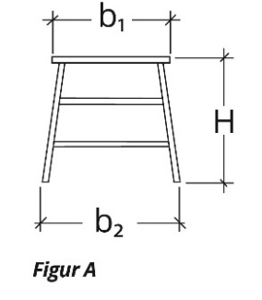
Figure A. Trestle with dimensions for stability testing.
Figure A
  - The slope of the step section and support section shall be measured. The slope shall be 60-70° (α) for the step section and 65-85° (ß) for the support section. See Figure B.
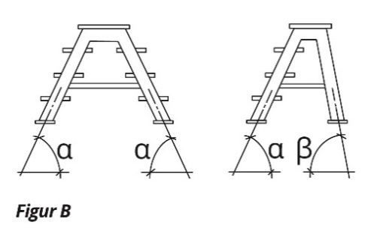
Figure B. Trestle with angle points for slope of step section and support section during stability testing.
Figure Β

Appendix 3 Product provisions for prefabricated scaffolding and couplers

Prefabricated facade scaffolding and components for prefabricated facade scaffolding
Prefabricated facade scaffolding shall achieve the safety levels that follow from these Swedish standards:
- SS-EN 12810-1:2004 Temporary works equipment – Facade scaffolds made of prefabricated components – Part 1: Product specifications. Edition 1.
- SS-EN 12811-1:2004 Temporary works equipment – Part 1: Scaffolds - Performance requirements and general design. Edition 1.

The standards apply in accordance with these regulations with the following clarifications:
- Clearance height between working platforms: shall be height class H2 in accordance with these two standards:
  - point 4 in SS-EN 12810-1:2004 Temporary works equipment – Facade scaffolds made of prefabricated components – Part 1: Product specifications. Edition 1.
  - point 5.3 in SS-EN 12811-1:2004 Temporary works equipment – Part 1: Scaffolds - Performance requirements and general design. Edition 1.
- Access to working platform: the vertical access class shall be ST or LS in accordance with point 4 of SS-EN 12810-1:2004 Temporary works equipment – Facade scaffolds made of prefabricated components – Part 1: Product specifications. Edition 1.
- Load class: the load class shall be at least Class 2 in accordance with point 6 of SS-EN 12811-1:2004 Temporary works equipment – Part 1: Scaffolds - Performance requirements and general design. Edition 1.
- Construction height for load class: the minimum construction height of 24 metres applies to at least one configuration for each load class specified in the type-examination certificate, in accordance with point 7.2.2 of SS-EN 12810-1:2004 Temporary works equipment – Facade scaffolds made of prefabricated components – Part 1: Product specifications. Edition 1.

Instructions for prefabricated facade scaffolding and components for prefabricated facade scaffolding shall, mutatis mutandis, be in accordance with Swedish Standard SS-EN 12810-1:2004.

Mobile access and working towers made of prefabricated elements
Mobile access and working towers made of prefabricated elements shall achieve the safety levels that follow from Swedish Standard SS-EN 1004-1:2020 Mobile access and working towers made of prefabricated elements – Part 1: Materials, dimensions, design loads, safety and performance requirements. Edition 1.

The standard applies in accordance with these regulations with the following clarifications:
- Clearance height between working platforms: shall be height class H2 in accordance with Chapter 7.2.
- Access to working platform: at least Class A, B, or C in accordance with Chapter 7.6.1 shall be available, that is to say, not solely Class D.
- Maximum distance between platforms: in the case of access by ladder (Class C and D in accordance with Chapter 7.6.3), the intermediate platforms shall be fully decked with working platform components.
- Loads: all specified loads in accordance with Chapter 8.1 shall be presumed to be characteristic static loads.

In addition, when dimensioning scaffolding as a whole, the friction coefficient between rakers or outriggers and sills/ground must not be presumed to be greater than 0.2.

Instructions for mobile access and working towers made of prefabricated elements shall, mutatis mutandis, be in accordance with SS-EN 1004-2:2021 Mobile access and working towers made of prefabricated elements - Part 2: Rules and guidelines for the preparation of an instruction manual. Edition 1.

Prefabricated scaffolding tower
Scaffolding towers shall meet the following requirements:
- The load-bearing capacity shall be safe by having a load class that corresponds to at least Class 2 in accordance with SS-EN 1004-1:2020 Mobile access and working towers made of prefabricated elements - Part 1: Materials, dimensions, design loads, safety and performance requirements, Edition 1, or considered safe in another way.
- All wheels shall be lockable.
- Stability shall be adequate with a safety factor for tipping of at least 1.20 under the following load:
  - A tipping horizontal load of 100 N at the level of the working platform and in the most unfavourable direction.
  - A stabilising vertical load of 750 N placed 0.100 metres from the side of the working platform.
  - These loads shall be placed in the most unfavourable manner.
  - The scaffolding shall be complete but normally without a railing, and with the components and any wheels placed in the most unfavourable positions.
- All the main components of a prefabricated scaffolding tower shall be marked to indicate the product to which the component belongs, the manufacturer, and the year of manufacture.

It shall be possible to safely ascend to and descend from the working platform of the tower.

Instructions for prefabricated scaffold towers shall, mutatis mutandis, be in accordance with SS-EN 1004-2:2021 Mobile access and working towers made of prefabricated elements - Part 2: Rules and guidelines for the preparation of an instruction manual. Edition 1.

Couplers
Couplers shall achieve the safety levels that follow from these Swedish standards:
- SS-EN 74-1: 2022 Temporary works equipment – Couplers, spigot pins and baseplates for use in falsework and scaffolds - Part 1: Couplers for tubes - Requirements and test procedures. Edition 2.
- SS-EN 74-2: 2022 Temporary works equipment – Couplers, spigot pins and baseplates for use in falsework and scaffolds - Part 2: Special couplers – Requirements and test procedures. Edition 2.
- SS-EN 74-3:2007 Temporary works equipment – Couplers, spigot pins and baseplates for use in falsework and scaffolds – Part 3: Plain base plates and spigot pins – Requirements and test procedures. Edition 1.

The standards apply in accordance with these regulations with the following clarifications:
- Couplers – mode of action: All couplers shall be screw couplers (not wedge couplers) in accordance with Chapter 3(i)(c) and Chapter 3(i)(d).
- Classes of couplers: All couplers shall be Class B or BB in accordance with Chapter 4.2.1(i)(c) and Chapter 5(i)(d).
- Joint couplers: Couplers intended for axial pipe unions shall be of type SF in accordance with Chapter 4.1(i)(c); that is, neither loose pins in accordance with Chapter 3(i)(e) nor expanding pins.

Instructions for couplers shall be in accordance with the applicable Swedish Standard, SS-EN 74-1:2022, SS-EN 74-2:2022, or SS-EN 74-3:2007.

Alternative designs
Departures may be made from the requirements of the standards if a product is demonstrably as safe as if it had been designed in accordance with the standards.

Appendix 4 Type-examination certificates for prefabricated scaffolding, components for prefabricated scaffolding, and couplers
All type-examination certificates for prefabricated scaffolding, components for prefabricated scaffolding, and couplers shall contain the following information:
- the name and address of the manufacturer and at least one distributor;
- the type designation on the scaffolding product;
- description of the scaffolding product and all of its parts or components, respectively;
- general information on the materials of which the various components are made;
- marking;
- reference to instructions for erection, use, dismantling, and maintenance; and
- information on how to carry out the annual inspection in accordance with Chapter 5, Section 16.

The type-examination certificate for prefabricated scaffolding shall also contain the following information:
- description of the various standard configurations of the scaffolding product; including dimensions, load classes, and construction heights;
- means of access;
- where personal protective equipment can be attached, if relevant; and
- components that can be used with the scaffolding but which are not provided by the manufacturer (non-system components), if relevant.

The type-examination certificate for individual components of prefabricated scaffolding shall also contain the following information:
- the scaffolding in which the component can be used, or the relevant specific requirements of the scaffolding where the component can be used;
- the permissible loads or equivalent for the component; and
- support reactions that the component can transfer to the scaffolding, if relevant.

Type-examination certificates for prefabricated scaffolding may also include, if necessary, information and instructions on how to calculate the load-bearing capacity for specified departures from the standard configurations.

Appendix 5 Design requirements for floor rack
Floor rack designed in accordance with Figures A and B need not be type-examined. Timber shall be selected in accordance with Chapter 5, Section 7.

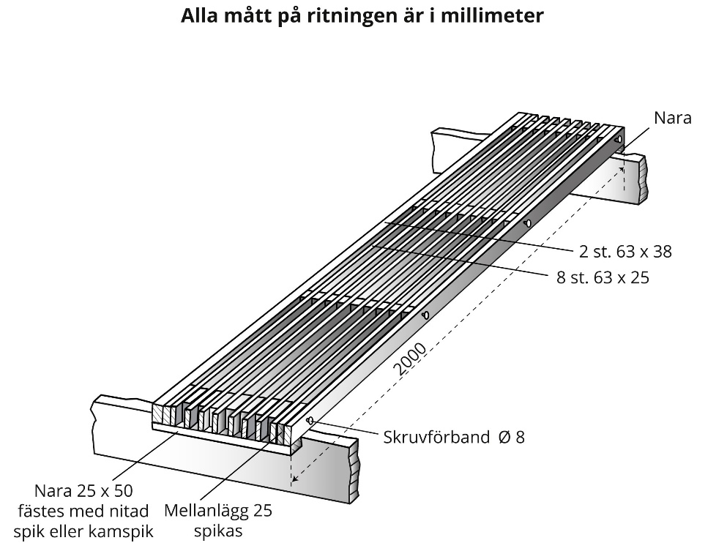
Alla mått på ritningen är i millimeter | All dimensions in millimetres
Nara | Ledge
Skruvförband ∅ 8 | Screw joint ∅ 8
Nara 25 x 50 fästes med nitad spik eller kampspik | Ledge 25 x 50 fastened with rivet nails or annular ring nails
Mellanlägg 25 spikas | Spacers 25 nailed

Figure A Dimensions for floor rack that is 2000 mm long
Ledges 25 x 50 x 2000 mm are attached with rivet nails or annular ring nails.
Spacers 25 mm shall be nailed in.
Screw joints with a diameter of 8 mm in diameter shall be used in the floor rack.
8 transverse ledges measuring 63 x 38 mm.
2 transverse ledges measuring 63 x 25 mm.

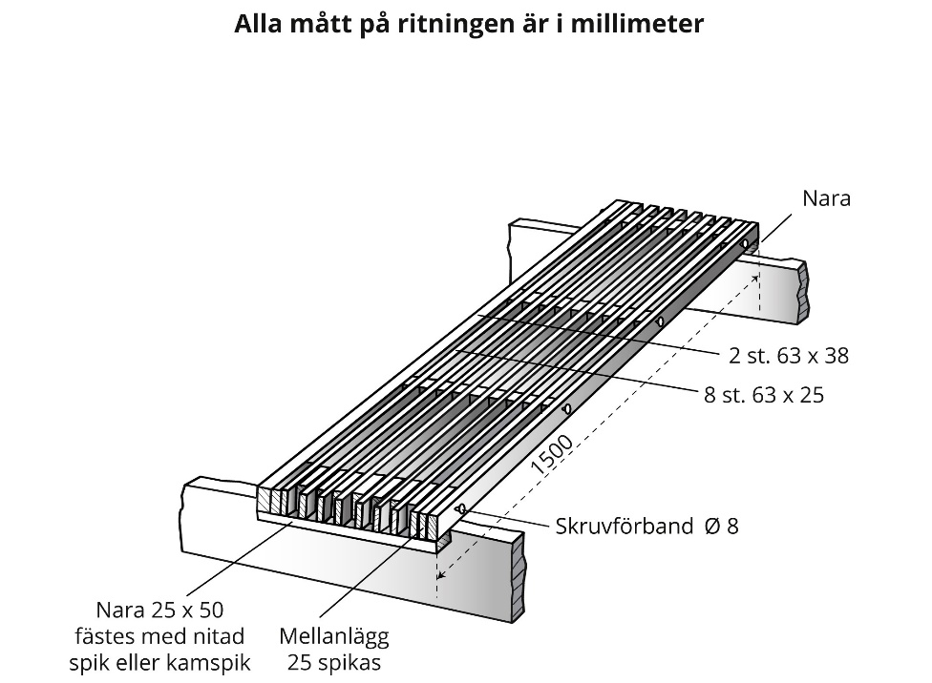
Alla mått på ritningen är i millimeter | All dimensions in millimetres
Nara | Ledge
Skruvförband ∅ 8 | Screw joint ∅ 8
Nara 25 x 50 fästes med nitad spik eller kampspik | Ledge 25 x 50 fastened with rivet nails or annular ring nails
Mellanlägg 25 spikas | Spacers 25 nailed

Figure B Dimensions for floor rack that is 1500 mm long
Ledges 25 x 50 x 2000 mm are attached with rivet nails or annular ring nails.
Spacers 25 mm shall be nailed in.
Screw joints with a diameter of 8 mm shall be used in the floor rack.
8 transverse ledges measuring 50 x 25 mm.
2 transverse ledges measuring 50 x 38 mm.

See Directive (EU) 2015/1535 of the European Parliament and of the Council of 9 September 2015 laying down a procedure for the provision of information in the field of technical regulations and of rules on Information Society services.

