The Swedish Transport   
Agency's Code of Statutes Transportstyrelsens logotyp.

**The Swedish Transport Agency**

The Swedish Transport Agency's general advice   
on exemptions for journeys with long vehicles, vehicle combinations or long indivisible loads;

adopted on 5 april 2024.

TSFS 2024:17

Published  
on 19 April 2024

ROAD TRAFFIC

The Swedish Transport Agency adopts[1] the following general advice.

General

1 This general advice concerns the examination of applications for exemptions from the provisions on the length of vehicles or vehicle combinations in Chapter 4, Section 17, first paragraph, first sentence, of the Road Traffic Ordinance (1998:1276) and in local traffic regulations pursuant to Chapter 10, Section 1, second paragraph, point 20, of said Ordinance, concerning vehicles or vehicle combinations exceeding 24.0 metres in length.

2 Chapter 13, Sections 3-5 of the Road Traffic Ordinance (1998:1276) contain provisions authorising authorities to examine applications for exemptions from traffic rules and the conditions under which exemptions may be granted.

3 The Swedish Transport Agency's regulations and general advice (TSFS 2023:37) on long indivisible loads contain provisions on exemptions for the transport of long indivisible loads with a maximum length of 30.0 metres.

### Definitions

4 For the purposes of this general advice:

|  |  |
| --- | --- |
| *side marker lamps* | lamps emitting orange-yellow light to the side; |
| *side marker reflector* | a reflector that, when illuminated, reflects orange-yellow light to the side. |

Other terms used in this general advice have the same meaning as in the Driving Licence Act (1998:488), the Road Traffic Definitions Act (2001:559), the Certification of Road Transport Escorts Act (2004:1167), the Road Traffic Ordinance (1998:1276) and the Ordinance (2001:651) on Road Traffic Definitions.

Conditions for granting exemption

Route certificate

5 If the length of the vehicle combination exceeds 35.0 metres, the applicant should attach a description allowing the route to be checked (route certificate). The route and any foreseeable obstacles on the road should be clear from the description.

### Long vehicles and transport of long loads

6 Exemptions for a vehicle or unladen vehicle combination should only be granted if such exceeds 24.0 metres because it is specially adapted for the transport of long indivisible loads.

7 If the maximum length is exceeded due to the load, an exemption should not be granted if another vehicle or vehicle combination can be used and the total length can thereby be significantly reduced.

8 Exemptions for transporting loads that project more than 5.0 metres behind the centre of the last axle of the vehicle combination should only be granted if the vehicle combination is longer than 35.0 metres. The concept of ‘5.0 metres behind the centre of the last axle’ is illustrated in Figure 1 of the annex.

### Consultation

Road management authorities

9 Before deciding on an exemption, other road management authorities affected by the exemption should be given the opportunity to comment on the matter.

#### The Swedish Police Authority

10 When the length of a vehicle combination exceeds 35.0 metres, the Swedish Police Authority should be given the opportunity to comment on whether an exemption can be granted without endangering road safety or causing significant inconvenience.

#### Authorities that issue local traffic regulations

11 Before granting an exemption from local traffic regulations with special traffic rules restricting the width or length of motorised vehicles, vehicle combinations or loads other than as permitted in Chapter 4, Sections 15, 17 and 17a of the Road Traffic Ordinance (1998:1276), the authority that issued the regulations should be consulted.

#### Railway or tramway managers

12 If the transport has to pass over a railway or tramway level crossing and the length of the vehicle combination exceeds 35.0 metres, the railway or tramway manager should be given the opportunity to comment before an exemption is granted.

Period of validity and duration of transport

Period of validity

13 If an exception is to be granted for a single journey, the period of validity should normally be determined in a way that allows the journey to take place within one month. If the exemption concerns multiple journeys, the period of validity should not exceed five years.

### Duration of transport

14 If the length exceeds 30.0 metres, an exemption under Chapter 13, Section 3 of the Road Traffic Ordinance (1998:1276) should not be granted:

– where heavy traffic can be expected, such as during rush hour in and adjacent to major agglomerations, during major local events and for parts of days connected with major holidays such as Easter, Midsummer and Christmas; or

– for journeys in the dark Monday through Friday, from 6 am to 9 am and from 3 pm to 8 pm.

Conditions in the decision

15 Decisions should be conditional, for example:

– prior to commencement of the journey, the driver ascertains that the route is passable, taking into account roadworks, vertical and lateral obstacles and other similar foreseeable circumstances;

– the transport does not take place when visibility is severely reduced due to weather conditions such as dense fog, heavy snowfall or whiteout; and

– compliance with marking and warning lamp requirements in accordance with 19–28.

16 For transports where the towing vehicle and trailer are connected by intermediate load, the decision, in addition to 15, should be subject to conditions in accordance with 29–32.

17 For journeys with a vehicle combination with a length exceeding 30.0 metres, but no longer than 35.0 metres, the decision should, in addition to 15, be subject to conditions in accordance with in 33–43.

18 For journeys with a vehicle combination with a length exceeding 35.0 metres, the decision should, in addition to 15, be subject to conditions in accordance with 33–45.

### Marking

19 To the extent set out in 20, 23 to 24, 27 and 29, vehicles or vehicle combinations with a length exceeding 24.0 metres are equipped with warning lamps and marked with other lamps, length marking signs, warning signs, and reflectors.

Signs, lamps and reflectors are in such a condition that they are noticeable and understandable for other road users. Length marking signs are clearly visible from behind and warning signs are clearly visible from the front and rear.

The warning signs are illuminated during travel at night, at dusk or dawn and otherwise when required by weather or other circumstances.

#### Length marking signs

20 Loads protruding behind the vehicle combination are marked with one or more length marking signs that are located at the rear limit line of the load.

The signs are normally positioned no more than 2.0 metres above the carriageway.

21 The signs

1. have alternately red and white fields with an angle of 45-60 $°$ and with a width of 7-10 centimetres;

2. have fields of the same width, with the exception of the outermost fields; and

3. are E-marked in accordance with ECE Regulations 104 or 150.

22 The signs have the following size.

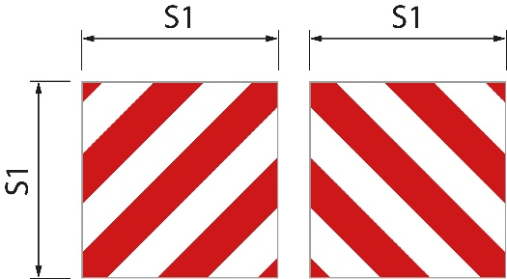S1 is at least 0.42 metres (Figure 1). The ratio between width and height is 1:1.

Figure 1

If only one sign is used, the diagonal fields slope downwards to the left in the longitudinal direction of the load. If more than one sign is used, the diagonal fields slope outwards and downwards from each other.

#### Lamps and reflectors

23 Loads that project from the rear of the vehicle or vehicle combination are marked with at least one lamp and reflector while travelling at night, at dusk or dawn and otherwise when required by weather or other circumstances. The marking is made at the rear limit line of the load with one rearward-facing red lamp and with red reflector.

The lamp has a luminous intensity such that it is clearly visible at a distance of 300 meters.

#### Warning signs

24 The vehicle or vehicle combination is marked at the front and rear with warning signs.

The forward-facing sign is located below the lower edge of the windscreen or with the lower edge of the sign no more than 2.0 metres above the carriageway.

25 The signs have:

1. yellow base colour that is retro-reflecting;

2. fluorescent red border with a width of 5.5 centimetres; and

3. text in the TratexSvart font with a text size of 0.17 metres.

26 The signs have the following sizes.

|  |  |  |
| --- | --- | --- |
| Signs with one row | Figure 1 | S1 is at least 1.2 metres and S2 is at least 0.4 metres. The ratio between width and height is 3:1 |
| Signs with two rows | Figure 2 | S1 is at least 0.6 metres and S2 is at least 0.5 metres. |

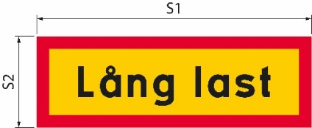If the size of the sign is increased, the text size and border width also increase accordingly.

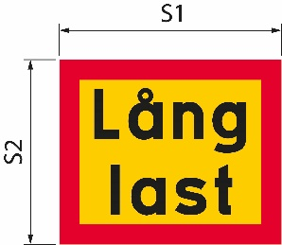Figure 1

Figure 2

|  |  |
| --- | --- |
| Lång last | Long load |

### Warning lights

27 The vehicle or vehicle combination is equipped with at least one warning lamp.

28 The warning lamp is switched on during travel at night, at dusk or dawn and otherwise when required by weather or other circumstances. However, when travelling in daylight, the warning lamp is only switched on when the vehicle combination encroaches on other traffic lanes.

Special marking of intermediate loads

29 If a towing vehicle and a trailer are connected by a common load, the intermediate load is marked with side marker lamps and side marker reflectors that meet the requirements of regulations issued pursuant to the Vehicle Ordinance (2009:211).

30 The lamps and reflectors are located no more than 2.0 metres behind the front edge of the load. The distance between lamps and reflectors on the same side does not exceed 6.0 metres. The rearmost lamps and reflectors are located at the rear of the load, if it projects behind the vehicle (Figure 2 of the appendix).

31 The lamps are located 0.35–1.5 metres above the carriageway. If the design of the load precludes such placement, the lamps are located less than 0.35 metres above the carriageway or more than 1.5 metres, but not more than 2.1 metres above the carriageway.

32 The reflectors are located 0.35–0.9 metres above the carriageway. If the design of the load prevents such placement, the reflectors are placed:

– less than 0.35 metres above the carriageway, or

– higher than 0.9 m, but not more than 1,2 metres, or, if the reflectors are combined with lamps, not more than 1,5 metres above the carriageway.

Additional conditions for journeys with a vehicle combination with a length exceeding 30.0 metres

Steerable axles

33 At least one axle of the trailer is steerable.

### Hazard warning vehicle

34 A hazard warning vehicle warns other road users about the long vehicle combination.

The hazard warning vehicle drives behind the vehicle combination on roads with lanes separated by separator, median barrier or equivalent. If there is no physical separation of the lanes, it drives in front of the vehicle combination instead.

Except for in built-up areas, the distance between the hazard warning vehicle and the transport is approximately 200 meters. In built-up areas, the distance is shorter.

35 A hazard warning vehicle warns for a maximum of three vehicles or vehicle combinations.

36 The hazard warning vehicle is a passenger car or a lorry with a total weight not exceeding 4.5 tonnes. The vehicle does not have a connected vehicle.

#### Driving licence

37 The driver of the warning vehicle holds a C1 or C driving licence.

#### Warning signs

38 The hazard warning vehicle is marked with warning signs. The signs are located higher than the upper edge of the windscreen and are clearly visible from the front and rear. The signs are in such a condition that they are noticeable and understandable for other road users. When travelling at night, at dusk or at dawn and otherwise when required by the weather or other circumstances, the warning signs are illuminated.

39 The signs have:

1. yellow base colour that is retro-reflecting;

2. fluorescent red border with a width of 5.5 centimetres; and

3. text in the TratexSvart font with a text size of 0.17 metres.

40 The signs have the following size.

S1 is at least 1.2 metres and S2 is at least 0.4 metres (Figure 1). The ratio between width and height is 3:1.

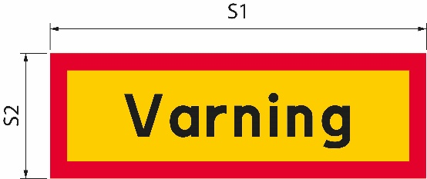If the size of the sign is increased, the text size and border width also increase accordingly.

Figure 1

|  |  |
| --- | --- |
| Varning | Warning |

#### Warning lights

41 The hazard warning vehicle is equipped with at least one warning lamp.

42 The warning lamp is switched on during travel at night, at dusk or dawn and otherwise when required by weather or other circumstances. However, when travelling in daylight, the warning lamp is only switched on when the long vehicle combination encroaches on the lanes for oncoming traffic.

### Communication between the hazard warning vehicle and the long vehicle combination

43 Drivers in a hazard warning vehicle and in a long vehicle combination can communicate with each other via a radio or mobile phone connection. The drivers can communicate with each other in a language that both comprehend.

Additional conditions for journeys with a vehicle combination with a length exceeding 35.0 metres

**44**The transport is escorted by a road transport escort or police officer. If the transport is to be escorted by the police, the decision should include an instruction that the Swedish Police Authority shall be contacted at least one week before the planned transport.

45 The driver of the transport ensures that a radio or telephone connection is established with the driver of the hazard warning vehicle, the escorting road transport escort or the escorting police. They communicate with each other in a language that all of them comprehend.

___________

This general advice replaces the Swedish Road Administration's general advice (VVFS 2004:142) on exemptions from the provisions on the length of vehicles or vehicle combinations and the Swedish Transport Agency's general advice (TSFS 2009:62) on exemptions for journeys with long vehicles.

On behalf of the Swedish Transport Agency  
  
JONAS BJELFVENSTAM  
 Pär Ekström  
 (Road and Rail)

Published by: Kristina Nilsson, Swedish Transport Agency, Norrköping ISSN 2000-1975

Annex

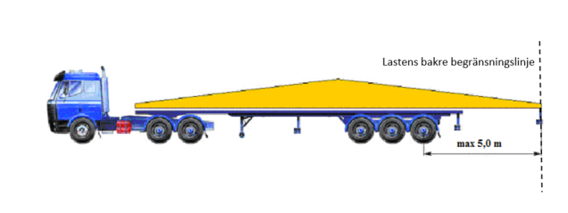Figure 1. Explanation of what is meant by more than 5.0 metres behind the centre of the rearmost axle and the rear limit line of the load.

|  |  |
| --- | --- |
| Lastens bakre begränsningslinje | Rear limit line of the load |

Figure 2. Explanation of the position of side marker lamps and side marker reflectors on intermediate loads and at the rear of the side of loads that project behind the vehicle when the towing vehicle and trailer are connected by common load.

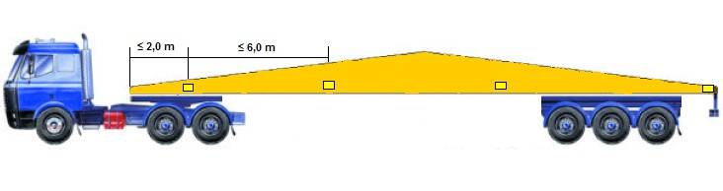

1. See Directive (EU) 2015/1535 of the European Parliament and of the Council of 9 September 2015 laying down a procedure for the provision of information in the field of technical regulations and of rules on Information Society services.