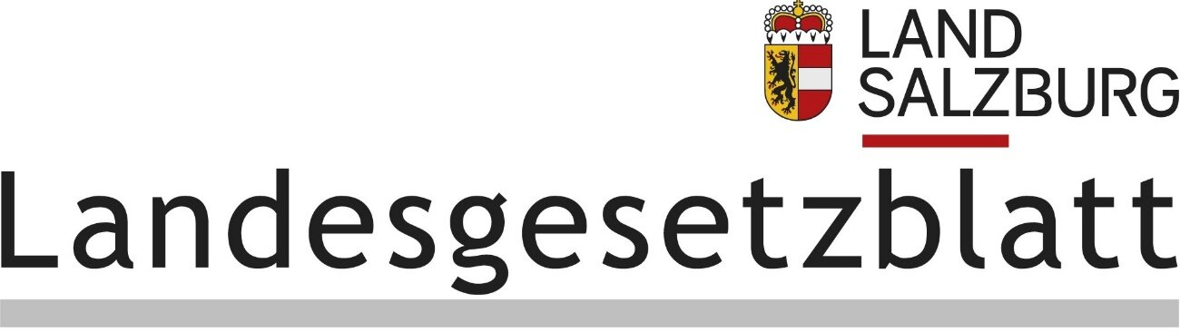

Provincial Law Gazette

PROVINCE OF SALZBURG

Year 2024 Published on 28 May 2024 www.ris.bka.gv.at

49. Act: Salzburg Protection of Young People Act; Amendment

49. Act of 20 March 2024 amending the Salzburg Protection of Young People Act

The Salzburg Parliament has adopted the following amending Act:

The Salzburg Protection of Young People Act, Provincial Law Gazette (LGBl.) No 24/1999, as last amended by the Act promulgated in LGBl. No 13/2019, is amended as follows:

1. In § 36, the following is inserted after paragraph (2):

‘(2a) Children and young people are not allowed to acquire, possess or consume nicotine-containing products which are not covered by the prohibition laid down in paragraph (2) but are intended for the consumption of nicotine, in particular nicotine pouches. Nor shall such products be offered, supplied or given to them.’ This shall not apply to products the use of which has been medically prescribed to children or young people.’

2. In § 41, after the bracketed reference ‘(§ 36(2)),’ the phrase ‘nicotine-containing products (§ 36(2a)),’ is inserted.

3. § 43a reads as follows:

‘References to federal law

§ 43a

Unless expressly stipulated otherwise, references to federal law in this Act are references to the most recently cited version:

1. Trade Regulations 1994 – GewO 1994, Federal Law Gazette (BGBl.) No 194; Promulgation BGBl. I No 75/2023;

2. Pyrotechnics Act 2010 – PyroTG 2010, BGBl. I 131/2009; Act BGBl. I 32/2018;

3. Addictive Substances Act – SMG, BGBl. 112/1997; Act, BGBl. I 70/2023;

4. Tobacco Marketing and Non-Smoker Protection Act – TNRSG, BGBl. No 431/1995; Act, BGBl. I No 66/2019.’

4. In § 43b, the previous text is designated as paragraph ‘(1)’ and the following is added:

‘(2) The amendment promulgated as LGBl. No 49/2024 has been notified in accordance with the provisions of Directive (EU) 2015/1535 of the European Parliament and of the Council of 9 September 2015 laying down a procedure for the provision of information in the field of technical regulations and of rules on Information Society services, under notification number 2023/0584/AT.’

5. After § 45, the following is added:

‘(9) § 36(2a), § 41, § 43a and § 43b, as amended by the Act promulgated as LGBl No 49/2024, shall enter into force on the first day of the month following promulgation of this Act.’

Pallauf

Haslauer