Draft bill

of the Federal Ministry of Health

Fifth Ordinance amending the Annex to the New Psychoactive Substances Act

A. Problem and objective

The emergence and spread of ever new chemical variants of new psychoactive substances (NPS) on the drug market directly or indirectly jeopardise the health of individuals and the population.

Due to the molecular structural diversity and complexity of NPS, the new variants of these substances are (in part) not covered by the existing substance groups in the New Psychoactive Substances Act (NPSA). In order to cover all variants which, according to new scientific evidence, present a risk comparable to those already covered by the existing substance groups, a continuous update of the substance groups in the Annex to the NPSA is required.

The aim of this Ordinance is to include these new psychoactive substances in the NPSA and thereby to curb the spread and abuse of these new harmful variants and to enable or, depending on the case, facilitate prosecution.

B. Solution

The Annex to the NPSA will be adapted to the current state of scientific knowledge by updating certain groups of substances to include further NPS. The extension concerns the substance groups of cannabimimetic agents/synthetic cannabinoids and benzodiazepines and the substance group of the compounds derived from tryptamine. The necessary revision of the Annex to the NPSA is also taken as an opportunity to recast and clarify it.

C. Alternatives

None.

D. Budgetary expenditure exclusive of compliance costs

Additional requirements due to compliance costs at federal level are to be covered both financially and in terms of staffing plans in the respective sections of the budget.

E. Compliance costs

E.1 Compliance costs for citizens

Citizens shall not incur any additional compliance costs.

E.2 Compliance costs for businesses

Businesses shall not incur any additional compliance costs.

E.3 Compliance costs for administration

The administration shall not incur any additional compliance costs.

F. Additional costs

None.

Draft bill of the Federal Ministry of Health

Fifth Ordinance amending the Annex to the New Psychoactive Substances Act [1]*

Dated...

On the basis of Section 7 of the New Psychoactive Substances Act, which was amended by Article 93 of the Ordinance of 19 June 2020 (Federal Law Gazette (BGBl.) I p. 1328), in conjunction with Section 1(2) of the Competence Adjustment Act of 16 August 2002 (BGBl. I p. 3165) and the Organisational Order of 8 December 2021 (BGBl. I p. 5176), the Federal Ministry of Health, in agreement with the Federal Ministry of the Interior and Community, the Federal Ministry of Justice and the Federal Ministry of Finance, and after consulting experts, orders as follows:

Article 1

The Annex to the New Psychoactive Substances Act of 21 November 2016 (Federal Law Gazette (BGBl.) I, p. 2615), last amended by Article 1 of the Ordinance of 14 March 2023 (BGBl. 2023 I No 69), shall be replaced by the text in the Annex to this Ordinance.

Article 2

This ordinance shall enter into force on the day following its promulgation.

This has been approved by the Bundesrat (Federal Council).

Annex to Article 1

Annex

**Preliminary remarks**

The substance group definitions in points 1 to 7 include all possible charged forms, stereoisomers and salts of a listed substance. For charged forms and salts, any molecular weight limits comprised in the substance group definitions apply only to the part of the molecule that excludes the counter-ion. The substance group definitions also cover all possible isotope-substituted compounds according to the following substance group definitions.

# 1. Compounds derived from 2-phenethylamine

A compound derived from 2-phenethylamine is any chemical compound which can be derived from a basic 2-phenylethane-1-amine structure (excluding 2-phenethylamine itself), has a maximum molecular mass of 500 u, and corresponds to the modular structure of structural element A and structural element B described below.

Ring

system

R

n

R1

N

R2

R4

R3

R5

R6

|  |  |
| --- | --- |
| **Structural element A** | **Structural element B** |

This includes chemical compounds with a cathinone basic structure (2-amino-1-phenyl-1-propanone):

Ring

system

R,

n)

R1

N

R2

R4

R3

O

|  |  |
| --- | --- |
| **Structural element A** | **Structural element B** |

Substances which, while meeting a definition of this substance group, have a core or basic structure specified in the substance group definitions set out in points 2 to 7 and are not covered by the substance group definition of that number are not included in substance group number 1.

## 1.1 Structural element A

The following ring systems or structures are included for structural element A, where structural element B can be located at any position on structural element A: Phenyl‑, Naphthyl‑, Tetralinyl‑, Methylendioxyphenyl‑, Ethylendioxyphenyl‑, Furyl‑, Pyrrolyl‑, Thienyl‑,   
Pyridyl‑, Benzofuranyl‑, Dihydrobenzofuranyl‑, Indanyl‑, Indenyl‑, Tetrahydrobenzodifuranyl‑, Benzodifuranyl‑, Tetrahydrobenzodipyranyl‑, Cyclopentyl‑ and cyclohexyl ring.

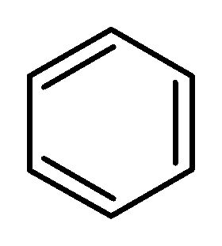 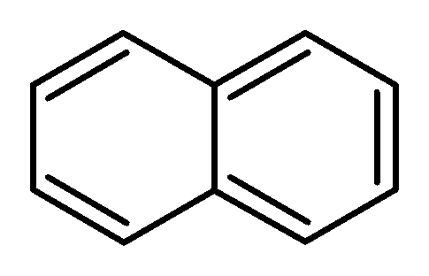

Phenyl- Naphthyl-

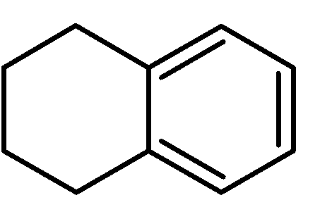 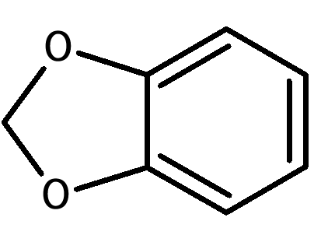

Tetralinyl- Methylendioxyphenyl-

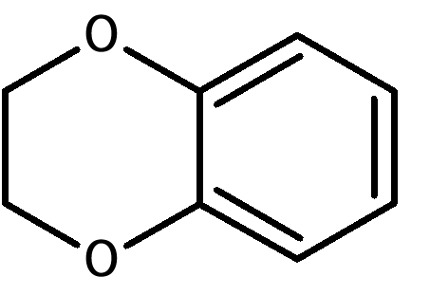 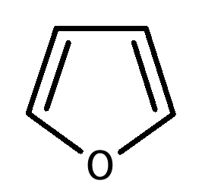

Ethylendioxyphenyl- Furyl-

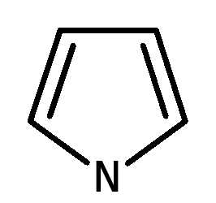 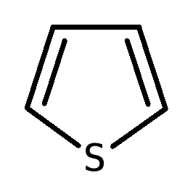 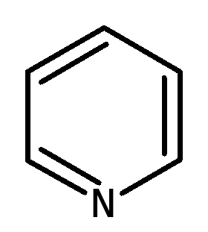

Pyrrolyl- Thienyl- Pyridyl-

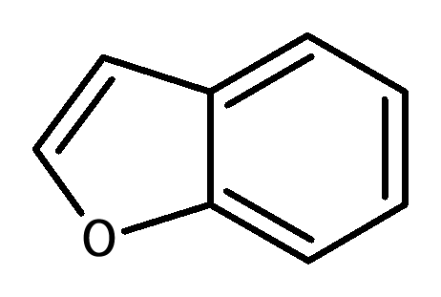 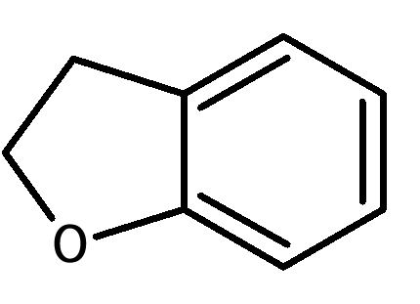

Benzofuranyl- Dihydrobenzofuranyl-

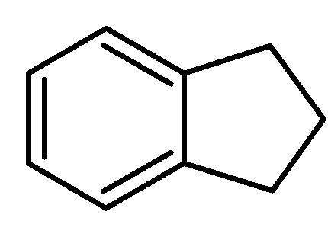 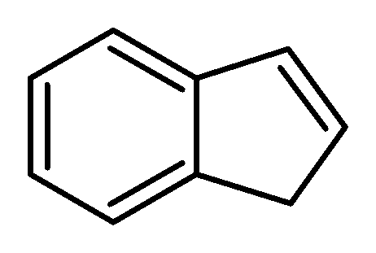

Indanyl- Indenyl-

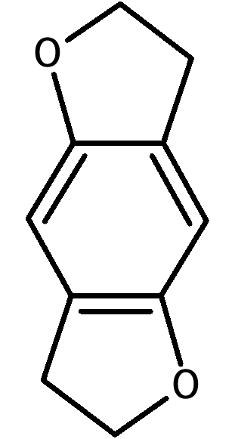 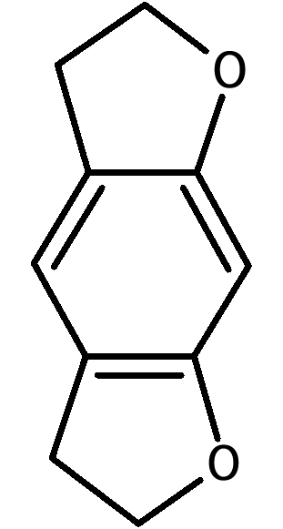 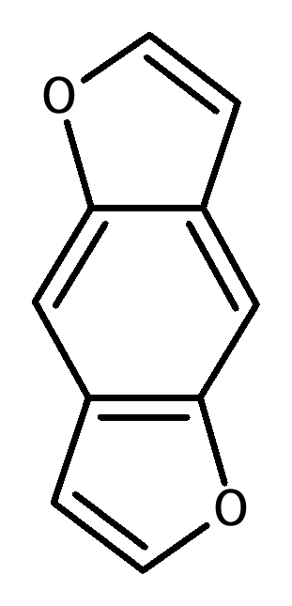 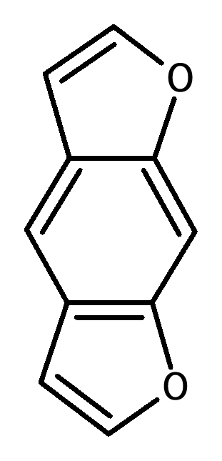

Tetrahydrobenzodifuranyl- Benzodifuranyl-

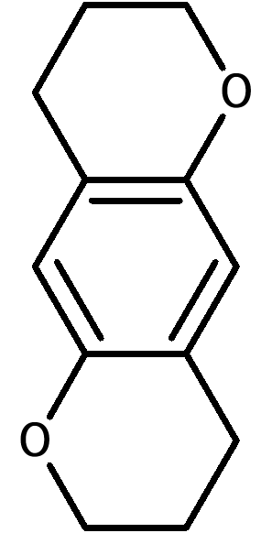 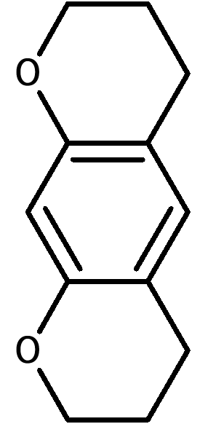  

Tetrahydrobenzodipyranyl- Cyclopentyl- Cyclohexyl-

These ring systems can be substituted in any position with the following atoms or atom groups (Rn):

Hydrogen, fluorine, chlorine, bromine, iodine, alkyl (up to C8), Alkenyl (up to C8), Alkinyl (up to C8),   
Alkoxy (up to C7), Carboxy, alkylsulfanyl (up to C7) and nitro groups.

The atom groups listed can also be substituted with arbitrary chemically possible combinations of the elements carbon, hydrogen, nitrogen, oxygen, sulphur, fluorine, chlorine, bromine and iodine. The substituents formed in this way may have a continuous chain length of a maximum of eight atoms (not counting hydrogen atoms). Atoms of ring structures are not included in the count.

Molecules in which Rn creates cyclic systems that are annelated to the structural element A are not covered by the substance group definition.

## 1.2 Structural element B

The 2-aminoethyl side chain of structural element B can be substituted with the following atoms, atom groups or ring systems:

a) R1 and R2 on the nitrogen atom:

Hydrogen, alkyl (up to C6), Cycloalkyl (ring size up to C6), Benzyl, Alkenyl (up to C6), Alkinyl (up to C6), Alkylcarbonyl (up to C6), Alkyloxycarbonyl- (alkyl residue up to C6), Alkylthiocarbonyl- (alkyl residue up to C6), Alkylcarbamoyl- (alkyl residue up to C6), Arylcarbonyl- (aryl residue up to C10), Hydroxy and amino groups. It also includes substances in which the nitrogen atom is part of a non-aromatic saturated or unsaturated cyclic system (e.g. pyrrolidinyl, piperidinyl rings). A ring closure of the nitrogen atom including parts of the structural element B (residues R3 to R6) is possible. The resulting molecular structure must conform to 1.2 (a) with regard to the substituents even without the ring closure to structural element B. The resulting ring systems can contain the elements carbon, oxygen, sulphur, nitrogen and hydrogen. These ring systems may contain five to seven atoms. A double bond as a bridge to structural element B is possible. The residues R1/R2 can only be present as a double-bonded radical (imine structure) in the ring system resulting from a ring closure with parts of the structural element B.

Not included in the substance group of 2-phenethylamine-derived compounds are compounds where the nitrogen atom is integrated directly into a cyclic system that is annelated to structural element A.

The substituents R1 and R2 can continue to be substituted (in the case of ring closure only after ring closure) with any chemically possible combinations of the elements carbon, hydrogen, nitrogen, oxygen, sulphur, fluorine, chlorine, bromine and iodine. The resulting substituents R1/R2 may have a continuous chain length of a maximum of ten atoms (without counting hydrogen atoms). Atoms of ring structures are not included in the count.

b) R3 and R4 on the C1 atom and R5 and R6 on the C2 atom:

Hydrogen, fluorine, chlorine, bromine, iodine, alkyl (up to C10), Cycloalkyl (ring size up to C10), Benzyl, Phenyl, Alkenyl (up to C10), Alkinyl (up to C10), Hydroxy, Alkoxy (up to C10), Alkylsulfanyl- (up to C10) and alkyloxycarbonyl groups (alkyl residue up to C10), including chemical compounds where substitutions can lead to a ring closure with structural element A or ring systems containing the residues R3 up to R6. These ring systems may comprise four to six atoms.

The atom groups and ring systems listed can also be substituted with any chemically possible combinations of the elements carbon, hydrogen, nitrogen, oxygen, sulphur, fluorine, chlorine, bromine and iodine. The resulting substituents R3 to R6 may have a continuous chain length of a maximum of twelve atoms (without counting hydrogen atoms). Atoms of ring structures are not included in the count.

If the residues R3 to R6 are part of a ring system containing the nitrogen atom of structural element B, the restrictions set out in point (a) shall apply to other substituents.

c) Carbonyl group in beta position with respect to the nitrogen atom (so-called ‘bk derivatives’, see figure of the cathinone base structure in point 1: R5 and R6 on the C2 atom:   
Carbonyl group (C=O)

## 2. Cannabimimetic agents/synthetic cannabinoids

**2.1 Compounds derived from indol, pyrazole and 4-chinolone**

A cannabimimetic agent or a synthetic cannabinoid of the compounds derived from indole, pyrazole or 4‑chinolone is any chemical compound that corresponds to the modular structure described below using a structural example with a core structure. The compound is linked to a bridge residue at a defined position over a bridge and carries a side chain at a defined position of the core structure.

The figure shows the modular design for 1-fluoro-JWH-018:

Bridge



Side chain

Core structure

Bridge residue

1-fluoro-JWH-018 has a core structure of indole-1,3-diyl, a carbonyl bridge in position 3, a 1-naphthyl bridged radical and a 1-fluorpentyl side chain in position 1.

Core structure, bridge, bridged radical and side chain are defined as follows:

## 2.1.1 Core structure

The core structure includes the ring systems described below in letters a to h. The ring systems of the letters a to g may be substituted in the positions shown in the following figures with any combination of the atoms hydrogen, fluorine, chlorine, bromine, iodine and phenyl, methyl, methoxy and nitro-groups as atom groups (residues R1 to R3).

The residue R of the 4-chinolone-derived compounds (letter h) may consist of one of the following atoms or the following atom group: Hydrogen, fluorine, chlorine, bromine, iodine and phenylthiogroup (attachment via sulphur to the core structure).

The wavy line indicates the binding site for the bridge. The broken line indicates the binding site for the side chain:

1. Indole-1,3-diyl (X = CH,C-CH3, C-F, C-Cl, C-Br and C-I) and indazole-1,3-diyl (X = N) (binding site for the bridge in position 3, binding site for the side chain at position 1)

X = CH, C-CH3, C-F, C-Cl, C-Br, C-I or N

1. 4-, 5-, 6- or 7-Azaindol-1,3-diyl (X = CH, C-CH3, C-F, C-Cl, C-Br and C-I) and 4-, 5-, 6- or 7-azaindazole-1,3-diyl (X = N) (binding site for the bridge at position 3, binding site for the side chain at position 1)



respectively:

X = CH, C-CH3, C-F, C-Cl, C-Br, C-I

or N

4-aza derivatives

5-aza derivatives

7-aza derivatives

6-aza derivatives

1. 1*H*-indole-2-on-1,3-diyl

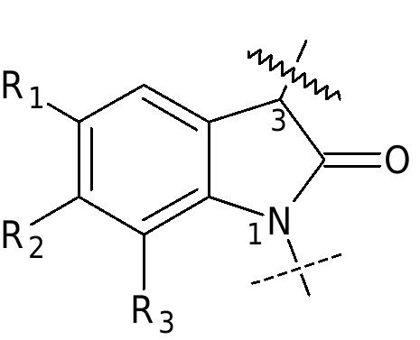

1. Carbazole-1,4-diyl  
   (binding site for the bridge at position 4,   
   binding site for the side chain at position 1)
2. benzimidazole-1,2-diyl-isomer I   
   (binding site for the bridge at position 2,   
   binding site for the side chain at position 1)



1. benzimidazole-1,2-diyl-isomer II   
   (binding site for the bridge at position 1,   
   binding site for the side chain at position 2)

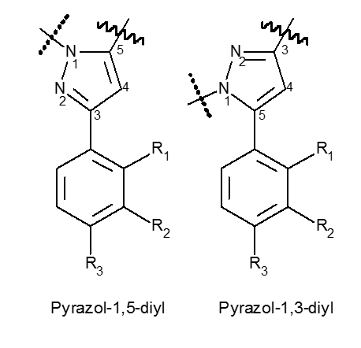

1. Pyrazole-1,5-diyl  
   (binding site for the bridge at position 5,  
   binding site for the side chain at position 1)  
   and

Pyrazole-1,3-diyl  
(binding site for the bridge in position 3,  
binding site for the side chain in position 1)

Pyrazol-1,3-diyl

Pyrazol-1,5-diyl



1. 4-chinolone-1,3-diyl  
   (binding site for the bridge at position 3,   
   binding site for the side chain at position 1)

## 2.1.2 Bridge on the core structure

The bridge on the core structure includes the following structural elements, which are bound to the site on the core structure given in paragraph 2.1.1:

1. Carbonyl, methylene-carbonyl (CH2 group linked to the core structure) and aza-carbonyl group,
2. Carboxamide group (carbonyl group linked to the core structure) including carbon- and hydrogen-containing substituents on the amide nitrogen which together with position 2 of the indole core structure (point 2.1.1(a): X = CH) form a six-membered ring, and methylene carboxamido group (CH2 group linked to core structure),
3. Carboxyl (carbonyl group tied to core structure) and methylene carboxyl group (CH2 group linked to core structure),
4. nitrogen heterocycles directly attached to the core structure, which may also contain other nitrogen, oxygen or sulphur atoms, with a ring size of up to five atoms and a double bond to the nitrogen atom at the connecting point,
5. hydrazone group with double bonding from nitrogen to position 3 of the core structure to the point 2.1.1(c).

## 2.1.3 Bridge residue

a) The bridge residue may contain combinations of the atoms carbon, hydrogen, nitrogen, oxygen, sulphur, fluorine, chlorine, bromine or iodine, which may have a maximum molecular mass of 400 u and may include the following structural elements:

aa) any substituted saturated, unsaturated or aromatic ring structures, including polycycles and heterocycles, with connection to the bridge also via a substituent;

bb) arbitrarily substituted chain structures with at least one carbon atom, including the heteroatoms, having a continuous chain length of no more than twelve atoms (without counting hydrogen atoms).

b) Bridges with the possibility of connecting multiple bridge residues, e.g. bridges to 2.1.2(b), (d) or (e) may also bear several bridge residues as defined in point 2.1.3(a)(aa) and 2.1.3(a)(bb). The molecular mass restriction of a total of 400 u applies to the sum of the bridge residues.

## 2.1.4 Side chain

The side chain may contain any combination of the atoms carbon, hydrogen, nitrogen, oxygen, sulphur, silicon, fluorine, chlorine, bromine and iodine unless they are restricted in (a) and (b). The side chain shall have a maximum molecular mass of 300 u and shall be connected to the point of the core structure specified in point 2.1.1. The side chain may contain the following structural elements:

a) arbitrarily substituted chain structures with at least one carbon atom, which can only contain oxygen, sulphur and silicon atoms within the chain in addition to other carbon atoms and have a continuous chain length of three to a maximum of ten atoms (without counting hydrogen atoms) taking into account the heteroatoms,

b) saturated, unsaturated or aromatic ring structures with a total of one to four carbon atoms that are directly attached or coupled via a hydrocarbon bridge (saturated or monounsaturated, branched or unbranched, optionally oxo-substituted in position 2) and have three to seven ring atoms, including polycycles and heterocycles. In polycycles, each ring may have three to seven ring atoms. In addition to carbon, heterocycles may have oxygen, nitrogen and sulphur in the ring. A possible free valence of a nitrogen atom in the ring can carry a hydrogen atom or a methyl or ethyl residue.

**2.2 Compounds derived from 3-sulfonylamidobenzoic acid**

This separate group of cannabimimetics/synthetic cannabinoids not having the modular composition described in Paragraph 2.1 includes the substances that have one of the core structures described in Paragraph 2.2.1, that may contain the substituents described in Paragraph 2.2.2, and that have a maximum molecular weight of 500 u.

**2.2.1 Core structure**

The core structure includes the molecules described below in (a) and (b). These may be substituted in the positions shown in the following figures with the atoms or atom groups as specified in point 2.2.2 (residues R1 to R4):



1. 3-Sulfonylamido benzoates
2. 3-Sulfonylamido benzamides

**2.2.2 Residues R1, R2, R3 and R4**

a) Residue R1 may consist of one of the following atoms or one of the following atom groups: Hydrogen, fluorine, chlorine, bromine, iodine, methyl, ethyl and methoxy group.

b) Residue R2 may consist of one of the following ring systems: Phenyl, pyridyl, cumyl, 8-chinolinyl, 3-isochinolinyl, 1-naphthyl, or adamantyl residue. These ring systems may furthermore be substituted with arbitrary combinations of the following atoms or atom groups: Hydrogen, fluorine, chlorine, bromine, iodine, methoxy, amino, hydroxy, cyano, methyl and phenoxy groups.

c) Residues R3 and R4 may consist of hydrogen atoms, methyl, ethyl, propyl, and isopropyl groups in any combination. Residues R3 and R4 may also form a saturated ring system with a size of up to seven atoms including the nitrogen atom. This ring system can contain the other elements nitrogen, oxygen and sulphur and carry any combination of hydrogen, fluorine, chlorine, bromine and iodine. Substitution of the nitrogen atom in such a ring is governed by the substitution options indicated for residues R3 and R4 in sentence 1 of (c).

**2.3 Compounds derived from 6*H*-benzo(c)chromene-1-ol (6*H*-dibenzo(b,d)pyran-1-ol)**

This separate group of cannabimimetic agents/synthetic cannabinoids, which are not composed according to the modular structure described under points 2.1 and 2.2, include the substances having a nuclear structure described in point 2.3.1, may be occupied with the substituents described in point 2.3.2 and have a maximum molecular mass of 600 u.

**2.3.1 Core structure**

The core structure includes the following compounds derived from 6*H*-benzo(c)chromene-1-ol (6*H*-dibenzo(b,d)pyran-1-ol), regardless of the degree of hydrogenation of the aromatic ring A and the position of the remaining double bonds, where appropriate. The compounds can be substituted at the marked positions with the atoms and atomic groups referred to in point 2.3.2 (residues R1 to R5):



**2.3.2 Residues R1, R2, R3, R4 and R5**

1. The residue R1 may consist of hydrogen or one of the following atom groups: Hydroxymethyl group, methyl group and hydrocarbon chain (saturated or unsaturated, branched or not branched) up to C10). The atom groups above may be substituted with the following atoms: Hydrogen, fluorine, chlorine, bromine and iodine.
2. The residues R2 and R3 may consist of hydrogen or of the following atom groups: Methyl groups and alkyl chains (branched or not branched, up to C5). The atom groups above may be substituted with the following atoms: Hydrogen, fluorine, chlorine, bromine and iodine.
3. The residue R4 may consist of hydrogen or one of the following atom groups: Methyl group and hydrocarbon chain (saturated or unsaturated, branched or not branched) up to C12). The atom groups above may be substituted with the following atoms: Hydrogen, fluorine, chlorine, bromine and iodine.
4. The residue R5 may consist of hydrogen or one of the following atom groups: Alkyl carbonyl (branched or not branched, alkyl residue up to C7), Cycloalkylmethylcarbonyl with three to seven ring atoms including polycycles, aryl carbonyl with three to six ring atoms including polycycles and heterocycles, arylmethylcarbonyl with three to six ring atoms including polycycles and heterocycles. For the polycycles, each ring may have three to seven ring atoms. In addition to carbon, heterocycles may have oxygen, nitrogen and sulphur in the ring. A possible free valence of a nitrogen atom in the ring can carry a hydrogen atom or a methyl or ethyl residue.

**3. Benzodiazepines**

The group of benzodiazepines comprises 1,4- and 1,5-benzodiazepines and their triazolo and imidazolo derivatives (point 3.1(a) and (b)) as well as some specially substituted subgroups of these benzodiazepines (point 3.1(c) to (f)). The maximum molecular weight is 600 u in each case.

**3.1 Core structure**

The core structure includes the ring systems described below in (a) to (f). These ring systems may be substituted in the positions shown in the following figures with the atoms or atom groups as specified in point 3.2 (residues R1 to R7 and X):

1. 1,4-benzodiazepines



1. 1,5-benzodiazepines



1. Loprazolam derivatives
2. Ketazolam derivatives



1. Oxazolam derivatives



1. Chlorodiazepoxide derivatives



**3.2 Residue R1 to R7 and X**

a) Residue R1 includes one of the following ring systems, anellated to the seven-membered rings of the core structures:

Phenyl, thienyl, 4,5,6,7-tetrahydrobenzo[b]thienyl, furanyl and pyridyl ring; the heteroatoms in the thienyl, furanyl and pyridyl ring can be located at any position outside the seven ring of the core structure.

Residue R1 may continue to be substituted with one or more of the following atoms or atom groups, in arbitrary combinations and in arbitrary positions outside the seven-membered ring: Hydrogen, fluorine, chlorine, bromine, iodine, methyl, ethyl, nitro and amino groups.

b) The residue R2 shall include one of the following ring systems:

Phenyl, pyridyl (with nitrogen atom at arbitrary position in the pyridyl ring) and cyclohexenyl ring (with double bond at arbitrary position in the cyclohexenyl ring).

Phenyl and pyridyl ring may bear one or more of the following substituents in an arbitrary combination and at arbitrary position: Hydrogen, fluorine, chlorine, bromine, iodine, methyl, ethyl, nitro and amino groups.

c) The residue R3 may consist of hydrogen or one of the following atom groups:

Hydroxy, carboxyl, ethoxycarbonyl, (N,N-dimethyl)carbamoyl, succinyloxy and methyl group.

d) The residue R4 may consist of hydrogen or one of the following atom groups:

Methyl and ethyl group.

e) Residues R3 and R4 may also form a carbonyl group (C=O) together.

f) The residue R5 may consist of hydrogen or one of the following atom groups:

Methyl, ethyl, (N,N-dimethylamino)methyl, (N,N-diethylamino)methyl, (N,N-dimethylamino)ethyl-, (N,N-diethylamino)ethyl-, (cyclopropyl)methyl-, (trifluoromethyl)methyl-, hydrazidomethyl- and prop-2-in-1-yl group.

g) The residue R6 may consist of hydrogen or one of the following atom groups:

Hydroxy, and methyl group.

h) The residue R7 may consist of hydrogen or one of the following atom groups:

Methyl and ethyl group.

i) Residues R6 and R7 may also form a carbonyl group (C=O) for the 1,5-benzodiazepines.

j) The 1,5-benzodiazepines may also have a R6-substituted (instead of R2 and R7) double bond to the 5-nitrogen atom.

k) the residue X includes one of the following atoms or one of the following atom groups:

Oxygen, sulphur, imino and N-methylimino group. If R3, R4 or R5 consist of hydrogen, the corresponding enols, thioenols or enamines can also be present as tautomeric forms.

**4. N-(2-aminocyclohexyl)amide** **-derived compounds**

A compound derived from N- (2-aminocyclohexyl) amide is any chemical compound which can be derived from the basic structure shown below, has a maximum molecular weight of 500 u and can be occupied by the substituents described below.



The base structure N-(2-aminocyclohexyl)amide may be substituted at the positions shown in the figure with an arbitrary combination of the following atoms, branched or unbranched atom groups, or ring systems (residues R1 to R6):

1. R1 and R2:

Hydrogen and alkyl group (up to C7).

It also includes substances in which the nitrogen atom is part of a cyclic system (e.g. pyrrolidinyl).

Residue R1 or R2 can also connect to the binding site of the NR1R2 group at the six-membered ring (by forming a so-called spiro compound). These nitrogen-containing rings may have a ring size of 3 to 7 atoms (one nitrogen atom and 2 to 6 carbon atoms).

1. R3:

Hydrogen and oxaspiro group (ring size of three to eight atoms including the oxygen atom).

1. R4:

Hydrogen and alkyl group (up to C5).

1. R5 and R6:

The phenyl ring may contain arbitrary combinations of the following substituents at positions 2, 3, 4, 5 and 6: Hydrogen, bromine, chlorine, fluorine, iodine and trifluoromethyl group.

Included are also substances where R5 and R6together form a ring system (up to C6) on neighbouring C atoms while including heteroatoms (oxygen, sulphur, nitrogen). If there is a nitrogen in this ring system, it may bear the substituents hydrogen and methyl group.

The number(s) of the methylene groups (CH2)n between the phenyl ring and the carbonyl group in the core structure can be zero or one.

**5. Tryptamine-derived compounds**

**5.1 Indole-3-alkylamine**

An indole-3-alkylamine-derived compound is any chemical compound that can be derived from the base structure shown below, has a maximum molecular weight of 500 u, and may bear the substituents as described below. Except for tryptamin, the naturally occurring neurotransmitters serotonin and melatonin as well as their active metabolites (example: 6-hydroxymelatonin).



The base structure indole-3-alkylamine may be substituted at the positions shown in the figure with the following atoms, branched or unbranched atom groups, or ring systems (residues R1 to R5 and Rn):

1. R1 and R2:

Hydrogen, alkyl (up to C6), Cycloalkyl (ring size up to C6), Cycloalkylmethyl- (ring size up to C6) and allyl groups.

Furthermore, substances in which the nitrogen atom is part of a pyrrolidinyl ring system are also included.

1. R3:

Hydrogen and alkyl group (up to C3).

1. R4:

Hydrogen and alkyl group (up to C2).

1. R5:

Hydrogen, alkyl (up to C3), Alkylcarbonyl (up to C10), Cycloalkylcarbonyl (ring size C3 to C6), Cycloalkylmethylcarbonyl (ring size C3 to C6), Cycloalkylethylcarbonyl (ring size C3 to C6), Cycloalkylpropylcarbonyl- (ring size C3 up to C6) and benzyl carbonyl group.

1. Rn:

The indole ring system may be substituted at headings 4, 5, 6 and 7 with the following atoms or groups of atoms: Hydrogen, fluorine, chlorine, bromine, iodine, alkyl (up to C4), Alkyloxy- (up to C10), Benzyloxy, carboxamido, methoxy, acetoxy, hydroxy and methylthio groups, in position 4 with dihydrogen phosphate.

Substances where Rn bridges two neighbouring carbon atoms in positions 4, 5, 6 and 7 with a methylenedioxy group are also included.

**5.2** Δ**9,10-Ergolene**

A compound derived from Δ9.10-ergolene is any chemical compound that can be derived from the basic structure shown below, has a maximum molecular mass of 600 u and may bear the substituents described below.



The base structure Δ9,10-ergolene may be substituted at the positions shown in the figure with the following atoms, branched or unbranched atom groups, or ring systems (residues R1 to R4):

a) R1:

The rest of R1 may consist of any combination of the atoms carbon, hydrogen, nitrogen, oxygen, sulphur, fluorine, chlorine, bromine and iodine, unless they are restricted in accordance with (aa) and (bb). Residue R1 may have a maximum molecular mass of 300 u and the following structural elements:

aa) Hydrogen or arbitrarily substituted chain structures with at least one carbon atom, which can only contain oxygen and sulphur atoms within the chain in addition to other carbon atoms.

bb) directly attached or via a hydrocarbon bridge (saturated or monounsaturated, branched or not branched with a total of one to five carbon atoms) or a carbonyl group or an alkyl carbonyl group (alkyl residue up to C4, bindingthe carbonyl group to the nitrogen of the ergolene) or an alkyloxycarbonyl group (alkyl residue up to C4, bindingthe carbonyl group to the nitrogen of the ergolene) or a sulfonyl group coupled, any substituted saturated, unsaturated or aromatic ring structures with three to seven ring atoms including polycycles and heterocycles. In polycycles, each ring may have three to seven ring atoms. In addition to carbon, heterocycles may have oxygen, nitrogen and sulphur in the ring. A possible free valence of a nitrogen atom in the ring can carry a hydrogen atom or a methyl or ethyl residue.

b) R2:

Hydrogen, alkyl (up to C4), Allyl and prop-2-in-1-yl group.

c) R3 and R4:

Hydrogen, alkyl (up to C5), Cyclopropyl, 1-hydroxyalkyl- (up to C2) and allyl groups.  
Furthermore, substances are included in which the amide nitrogen atom is part of a morpholino, pyrrolidino or dimethylazetidid ring system.

**6. Compounds derived from arylcyclohexylamine**

A compound derived from arylcyclohexylamine is any chemical compound that can be derived from the base structure shown below, has a maximum molecular mass of 500 u and may bear the substituents described below.



The basic structure of arylcyclohexylamine may be substituted at the positions indicated in the figure with the following atoms, branched or non-branched atom groups or ring systems (residues R1 to R3 and Rn):

a) R1/R2:

Hydrogen, alkyl (up to C6), Cycloalkyl (ring size up to C6), Alkenyl (up to C6) and alkinyl groups (up to C6).

The atom groups listed may continue to be substituted with any chemically possible combinations of the elements carbon, hydrogen, nitrogen and oxygen. The resulting substituents R1/R2 may have a continuous chain length of a maximum of nine atoms (without counting hydrogen atoms). Atoms of ring structures are not included in the count.

In addition, these include substances in which the nitrogen atom is part of a cyclic system (e.g. pyrrolyl, pyrrolidinyl, piperidinyl, morpholino-). These ring systems may contain the elements carbon, oxygen, sulphur and nitrogen in the ring and have a ring size of up to seven atoms. The ring systems may be substituted at any position with the following atoms or atom groups: Hydrogen, fluorine, chlorine, bromine, iodine, hydroxy, alkyl (up to C6) and phenyl groups.

b) R3:

Alkyl (up to C6), Alkyl group (up to C6) or one of the following ring systems: Phenyl, pyrrolyl, pyridyl, thienyl, furanyl, methylenedioxyphenyl, ethylene dioxyphenyl, dihydrobenzofuranyl and benzothiophenyl residues.

The ring systems may be connected to the core structure at any chemical position as R3 and may be substituted at any position with the following atoms or atom groups: Hydrogen, fluorine, chlorine, bromine, iodine, hydroxy, thiol, alkyl (up to C6), Alkoxy (up to C6), Alkylsulfanyl- (up to C6) and amino groups, including chemical compounds where substitutions or direct connection lead to a ring closure with the cyclohexyl ring. These ring systems may have a ring size of four to six atoms.

c) Rn:

The cyclohexyl ring system may be substituted at positions 2 to 6 with the following atoms or atom groups: Hydrogen, alkyl (up to C6); Alkoxy (up to C6), Hydroxy, phenylalkyl groups (in the alkyl chain C1 to C4) and oxo (=O, double bound oxygen atom at the ring).

**7. Compounds derived from benzimidazole**

A compound derived from benzimidazole is any chemical compound that can be derived from the basic structure shown below, has a maximum molecular mass of 500 u and may bear the substituents described below:



The basic structure may be substituted at the positions indicated in the figure with the following atoms, branched or non-branched atomic groups or ring systems (residues R1 to R4 and Rn):

a) R1 and R2:

Hydrogen, alkyl groups (up to C3),

It also includes substances in which the amine nitrogen atom is part of a morpholino, pyrrolidino or piperidinyl ring system.

b) R3 and R4:

Hydrogen, nitro-, trifluoromethyl-, methoxy-, trifluoromethoxy-, cyanogroups, fluorine, chlorine, bromine and iodine.

c) Rn:

The phenyl ring may be substituted at positions 2 to 6 with the following atoms or atom groups: Hydrogen, alkyl (up to C6), Alkoxy (up to C 5), Trifluoromethoxy, acetoxy, alkylsulfanyl (up to C5), Trifluoromethyl, hydroxy, cyano groups, fluorine, chlorine, bromine and iodine.

Explanatory notes

A. General part

1. Objective of and need for the provisions

The emergence and spread of ever new chemical variants of new psychoactive substances (NPS) on the drug market directly or indirectly poses a threat to the health of individuals and the population.

The New Psychoactive Substances Act (NPSA) in addition to the single-substance approach of the Narcotics Act (NA) contains a substance group regulation in order to be able to counter the appearance of these substances more effectively and to limit their distribution and availability.

Since the entry into force of the NPSA on 26 November 2016, the substance groups have been further developed and adapted in line with the findings of the continued monitoring of market developments. Most recently, the Third Ordinance amending the Annex to the New Psychoactive Substances Act of 27 September 2022 (Federal Law Gazette (BGBl.) I p. 1552) updated the groups of substances to cover further new psychoactive substances (NPS) (including the substance group of synthetic cannabinoids and the substance group of compounds derived from N-(2-aminocyclohexyl)amide). The Fourth Ordinance of 14 March 2023 amending the Annex to the New Psychoactive Substances Act (Federal Law Gazette (BGBl.) 2023 I No. 69) corrected an editorial punctuation error in point 5.2(a) of the Annex to the NPSA.

With the present Ordinance, further clarifications and additions to the existing substance groups are made, as the limits of substance group definitions have again been breached by the actors involved in the drug market through targeted changes.

The experts to be involved under section 7 NPSA were consulted. Taking into account their positive votes, the Annex to the NPSA will be revised by Article 1 of this ordinance on the basis of the authorisation in section 7 NPSA and taking into account the scope of the amendments.

In recent years, the European Early Warning System on NPS has increasingly recorded and transmitted information about psychoactive substances that have not yet appeared in Europe and are therefore new. The information system operated by the European Monitoring Centre for Drugs and Drug Addiction (EMCDDA) and by Europol is compiled from national data. In Germany, information about newly appearing substances is gathered in particular by criminal authorities.

Scientific findings are available on the new psychoactive substances. These findings include pharmacological-clinical data on the mode of action and toxicity and also data on the extent of misuse and the associated direct or indirect risk to human health. Due to the mode of action, the extent of abuse and the associated health risks of other NPS, it is necessary to add these NPS to the existing seven groups of substances in the NPSA annex.

The dissemination of new substances is favoured by a rapid exchange of information and corresponding offers by those active in the drug market via the Internet and social media. The protection of public health therefore requires a rapid response from the authority responsible for issuing relevant ordinances to the changing market conditions.

1. Main Content of the Draft

Article 1 recasts the Annex of the NPSA on the basis of the authorisation to issue ordinances in § 7 NPSA. The existing seven substance groups will be updated in order to be able to effectively curb the risky misuse of newly emerging psychoactive substances.

1. Alternatives

None.

1. Regulatory power

The regulatory competence of the Federal Ministry of Health for the recast of the Annex to the NPSA arises under § 7 NPSA.

1. Compatibility with European Union law and international treaties

This Ordinance is compatible with European Union law and with international treaties concluded by the Federal Republic of Germany. The changes in Articles 1 were notified in accordance with Directive (EU) 2015/1535 of the European Parliament and of the Council of 9 September 2015 laying down a procedure for the provision of information in the field of technical regulations and of rules on Information Society services (OJ L 241 of 17.9.2015, p. 1).

1. Impact of the Ordinance

The updating of the groups of substances previously included in the Annex to the NPSA means that the administrative ban on handling NPS regulated in Section 3 Paragraph 1 of the NPSA is extended to all substances that fall under the updated groups of substances in the Annex. The same applies to the criminal offences set out in Section 4 NPSA of the prohibition of handling NPS, placing them on the market, prescribing them, manufacturing them and importing them into the territory to which the Act applies for the purpose of placing them on the market. This will allow customs and police authorities to intervene against illicit handling, in particular against trade, in the NPS covered by the Annex of the NPSA in future.

* 1. Legislative and administrative simplification

The Ordinance does not involve rescinding any provisions or streamlining any administrative procedures.

* 1. Sustainability aspects

The draft regulation takes into account the objectives and principles of the German Sustainability Strategy (DNS). In particular, it serves the sustainability objective 3 ‘Ensure healthy life for all people of all ages and promote their well-being’ by limiting the spread and abuse of the synthetic substances hazardous to health by updating the groups of substances contained in the Annex to the NPSA. The proposed regulations thus serve to protect the health of individuals and the general public as a whole and thus comply with the guiding principle 3b of the DNS, 'Avoid dangers and unacceptable risks to human health'.

* 1. Budgetary expenditures exclusive of compliance costs

The federal, state and local authorities are not charged with additional costs.

* 1. Compliance costs

Citizens shall not incur any additional compliance costs.

Businesses shall not incur any additional compliance costs.

For the Federal Administration, the extension of the monitoring by the newly added NPS as a result of the continuation of the substance group definitions contained in the annex to the NPSA creates only a small additional enforcement effort for prosecution by the customs authorities and the Federal Criminal Police Office. The number of checks is the same.

For the regional surveillance authorities and police authorities, the above-mentioned extension of NPS monitoring may result in an increased but currently non-quantifiable enforcement effort. Here too, the additional burden is assumed to be very low in individual cases.

* 1. Additional costs

None.

* 1. Other consequences of the ordinance

This Ordinance has no impact on demographic or equal opportunities policies.

1. Time limits; Evaluation

The Ordinance is not intended to have a time limit. The Annex to the NPSA is subject to ongoing reviews based on the experience gained with its enforcement as well as on the basis of new scientific insights.

B. Specific part

**Re Article 1**

Due to the scope and complexity of the updating of the groups of substances previously contained in the annex to the NPSA caused by this ordinance, it is necessary to rewrite the annex. No change shall be made by modification commands relating to individual points or sub-items of the Annex. With a view to the experience gained from enforcement practice after the entry into force of the NPSA, the update of the previous substance groups serves both to clarify the interpretation of the respective substance group definition and to expand the substance groups to include other market-relevant, health-endangering psychoactive substances.

**The preliminary remarks**

The preliminary remark is extended in the first paragraph by the explanation of isotope-modified compounds. Isotope-labelled compounds have similar pharmacological properties, but may be less degradable and therefore effective for longer. The adaptation is a clarification that clarifies that isotope-modified compounds are covered by the substance group definitions. This clarification addresses possible legal uncertainties from practice.

**To point 1 ‘Compounds derived from 2-phenethylamine’**

The newly inserted paragraph takes account of the fact that the phenethylamino group is a widely used structural element in many pharmacologically active compounds and may also occur in the substance group definitions of points 2 to 7. In that regard, it is clarified by the supplemented preliminary remark within the substance group definition that molecules which, although they may be covered by the substance group definition of point 1, but whose core or basic structure is attributable to the groups of substances in points 2 to 7, are not covered by the Annex to the NPSA if they are not covered by the definitions listed therein.

Subparagraph 1.1

In the first paragraph, in the list of structural elements between the penultimate and the last rest, the comma is replaced by a 'and' and on the last rest the addition 'ring' is inserted. This serves to unify the language within the Annex.

The subsequent paragraphs of point 1.1 are not amended.

Regarding point 1.2

In point 1.2(a), in the first sentence of paragraph 1, the definition of alkyloxycarbonyl- (alkyl residue up to C6), Alkylthiocarbonyl- (alkyl residue up to C6), Alkylcarbamoyl- (alkyl residue up to C6) and arylcarbonyl groups (aryl residue up to C10) is supplemented and clarified. The inclusion of these substituents includes important so-called protection groups. A protective group can be easily attached to amino groups and just as easily split off. By amendment of the Annex, in this way, modified molecules will be included by the definition in the future. In particular, the extension records the newly occurring protection group tertiary-butylcarboxy group e.g. in MDMA and methampehetamine and prohibits its sale. In addition, the addition ‘rings’ shall be added to the last residue in the second sentence of paragraph 1. This serves to unify the language within the Annex.

In point 1.2(a) and (b), the word ‘ring size’ is added to the first sentence of paragraph 1 in the bracket for the cycloalkyl residue. After the alkylsulfanyl residue, the comma is deleted and 'and' is inserted. In the case of the alkyloxycarbonyl group substituent, the word ‘alkyl residue’ is added within the bracket. The three adjustments within the first paragraph are intended to clarify the existing rules.

In addition, the content of the regulations corresponds to the previous regulations.

**Point 2 “Cannabimimetic agents / synthetic cannabinoids”**

Subparagraph 2.1

In point 2.1.1, in the second paragraph, the addition ‘g’ in brackets is changed to ‘h’, in order to make the correct reference, and clarified linguistically.

Point 2.1.2(a) is clarified linguistically.

In point 2.1.2, in both (b) and (c) the methylene carbonyl substituent is supplemented, to which a pharmacological effect is attributed.

In point 2.1.3, which describes the bridge residue, the bridge residue defined in (a)(bb), is limited to the fact that the chain structure must have at least one carbon atom. This insert excludes non-carbon substituents.

In point 2.1.4, the silicon atom is included in the list of possible atoms in the first paragraph. This expansion takes account of the emergence of two new silicon-containing derivatives.

In point 2.1.4, the chain structure defined in (a) is limited to the fact that the chain structure must have at least one carbon atom. This insert clearly excludes non-carbon substituents. This adaptation serves to clarify the possible molecular structures. In addition, the number of maximum atoms is increased from seven to ten. This adjustment includes the existing derivative ADMB-D-5Br-INACA.

Regarding point 2.2

Point 2.2.2 is revised editorially and linguistically clarified.

Re point 2.3

A new point 2.3 is added. The newly introduced subgroup of cannabimimetic agents is entitled ‘Compounds derived from 6*H* benzo(c)chromene-1-ol (6*H*-dibenzo(b,d)pyran-1-ol)’. It includes the newly launched semisynthetic, tetrahydrocannabinol-derived designer drugs. These designer drugs are harmful and injurious to health. Among other things, hexahydrocannabinol (HHC) and derivatives derived therefrom (HHC-AC, HHC-H and HHC-P) are included. The newly introduced point is divided into two subpoints: Point 2.3.1 Core structure and point 2.3.2 Residues R1, R2, R3, R4 and R5. The description of the substituents covers the acetates that have already occurred, their extended variants as well as the cyclically saturated and aromatic variants. The inclusion in the Annex is intended to prevent trade in these psychoactive products, which are currently placed on the market with unclear composition without any quality control, without criminalising consumers.

Moreover, the provisions of point 2 are not amended.

**Re point 3 'Benzodiazepines'**

Point 3.2(a), (b), (c), (d), (f), (g), (h) and (k) is linguistically clarified.

In point 3.2(f), the residue ‘hydrazidomethyl-’ is included in the list of atoms or atomic groups of the residue R5. Since October 2022, the EMCDDA monitors 35 benzodiazepines. Most of these NPS benzodiazepines that are monitored are orphan drugs that have been patented by drug manufacturers but then abandoned without bringing them to market. By the uptake of the hydrazidomethyl group, the psychoactive acting benzodiazepine gidazepam is detected, which at higher doses shows significantly serious and harmful effects. Side effects reported include drowsiness, weakness, dependence, dysmenorrhea and allergic reactions. The triggering of myasthenia gravis, an autoimmune disease, has also been reported. Recreational use of gidazepam carries a significantly higher risk of adverse effects, especially when combinations with other substances are used. High doses of gidazepam can, especially in the elderly, trigger coordination disorders, ataxia, and severe muscle weakness. The interactions described with other substances include the amplification of the effects of alcohol, hypnotic drugs, neuroleptics, antipsychotics and analgesics. Gidazepam is a prescription drug under the trade name Gidazepam IC® available in Ukraine and Russia and launched in 1997. There is no marketing authorisation for psychoactive benzodiazepine in Germany and Europe. In addition, letter (f) is editorially adjusted.

Moreover, the provisions of point 3 are not amended.

**Re point 4 ‘Compounds derived from N-(2-aminocyclohexyl)amide’**

Point 4(a), (b), (c) and (d) are revised editorially.

**Re point 5 “Compounds derived from tryptamine”**

In point 5.1, letters (b), (c) and (d) are linguistically clarified.

In the first paragraph of point 5.2, the maximum molecular mass due is increased to the extension of the residue R1 from 500 u to 600 u in point 5.2(a).

Point 5.2(a) is recast. Residue R1 is reworded to include the newly occurring 1-(2-thienoyl)-LSD and other LSD precursors, which are converted into LSD by hydrolytic cleavage in the body after absorption into the body. The recast of the paragraph is based on the substance group of cannabimimetic agents. The newly occurring LSD derivatives are psychedelic substances that are converted to LSD in body passage and are already present in the drug market for abuse purposes. Reports of intoxications with the new derivatives are already available.

Point 5.2(b) is linguistically clarified.

Moreover, the provisions of point 5 are not amended.

**Re point 6 ‘Compounds derived from arylcyclohexylamine’**

Point 6(a), (b) and (c) are linguistically clarified.

Apart from the aforementioned linguistic clarifications, the provisions of point 6 are not amended.

**Re point 7 ‘Compounds derived from benzimidazole’**

Point 7 corresponds to the previous point 7.

**Article 2**

Article 2 lays down the entry into force of the Ordinance.

1. * Notified in accordance with Directive (EU) 2015/1535 of the European Parliament and of the Council of 9 September 2015 laying down a procedure for the provision of information in the field of technical regulations and of rules on Information Society services (OJ L 241, 17.9.2015, p. 1).