# Reply from Nordic Nicotine Pouches Alliance (NNPA) Regarding Draft Royal Decree amending Royal Decree 579/2017 of 9 June 2017 regulating certain aspects relating to the manufacture, presentation and marketing of tobacco and related products

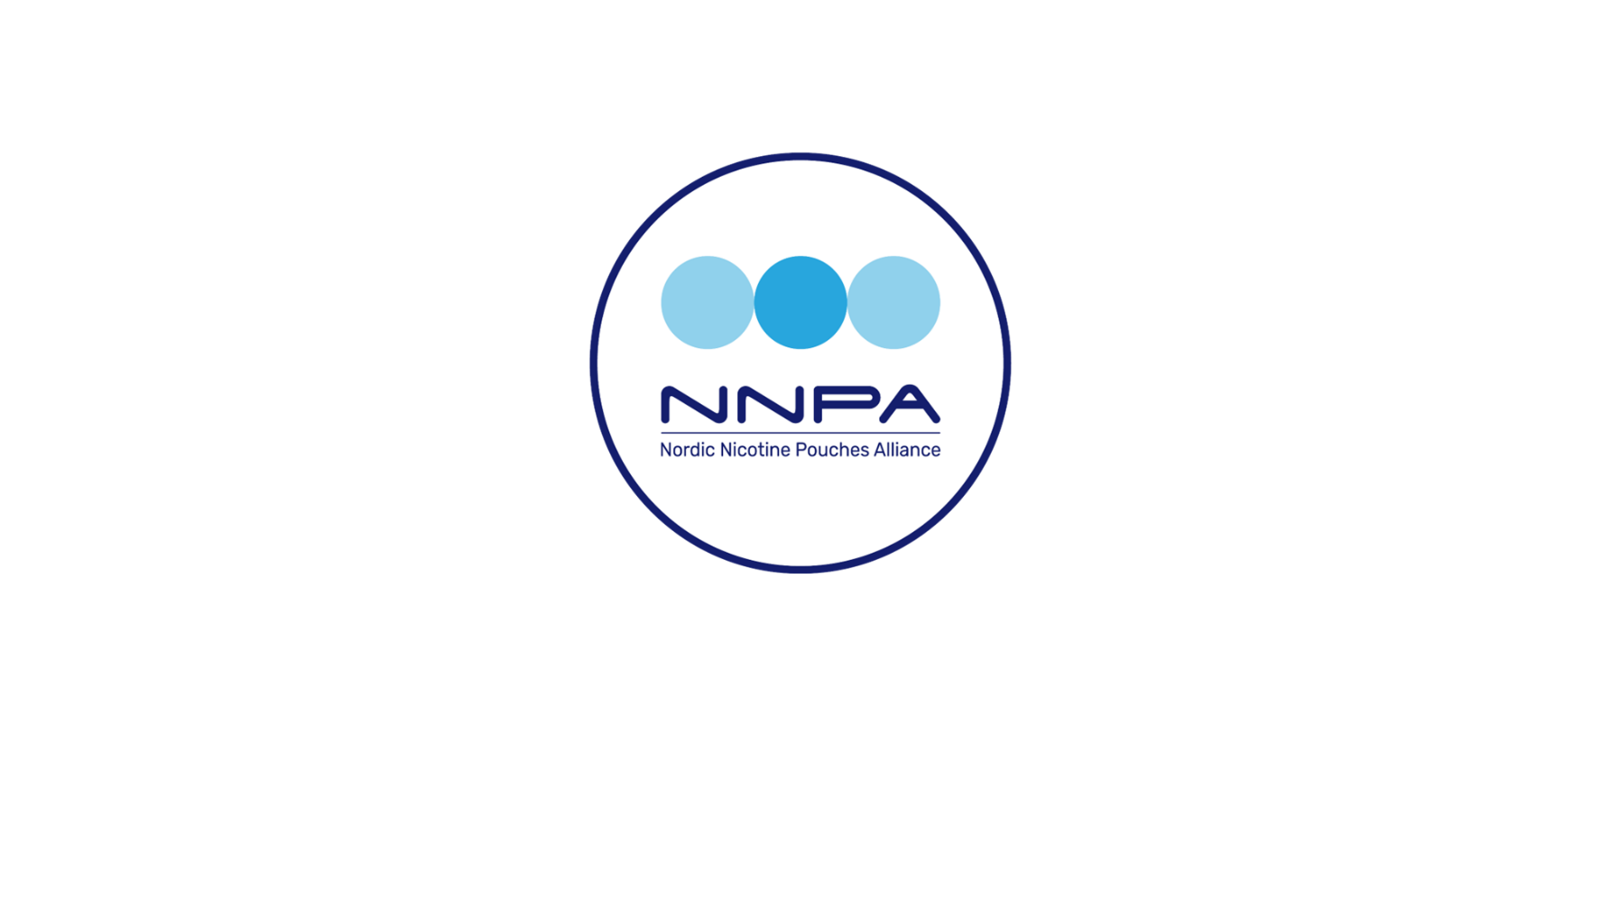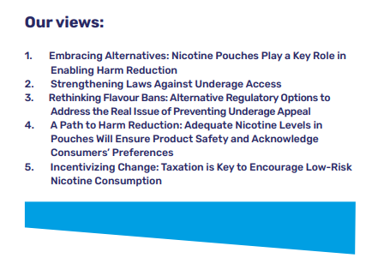

## The Nordic Nicotine Pouches Alliance (NNPA) is a Brussels-based platform for stakeholders advocating for nicotine pouches as an essential part of harm reduction among adult nicotine users within the EU. We promote responsible, effective, and harmonised European legislation that establishes clear guidelines for this product category to achieve specific goals, such as banning extreme nicotine levels or reducing usage among minors. Our main focus is information dissemination, but we continuously work to build support for our position from stakeholders who are representatives of a responsible value chain. NNPA is funded by European industry actors.

## Summary of our position:

NNPA questions the validity of both the impact assessment as well as the scientific foundation of the proposal. We strongly object to the proposed nicotine limit with the motivation that the proposed restrictions will have a significant negative impact on future public health. A 0,99mg/per pouch nicotine limit is equal to a ban of the product which cannot be considered motivated, balanced nor purposeful..

We conclude that the proposal, according to all available statistics and particularly considering Spain's smoking prevalence, presents a profoundly misguided and counterproductive measure, highly unlikely to achieve its intended public health objectives and potentially exacerbating the very issues it seeks to address.

We also consider that the proposed restrictions pre-empt the revision of the Tobacco Products Directive, violate the principle of non-discrimination and the freedom of trade and industry (Article 36 TFEU) and that they without due justification contradict legislation recently introduced in other EU Member States.

To ban all flavours and aromas except one can by definition not be considered a purposeful and proportional measure, nor can all, or even most, flavours be considered unduly attractive to underage consumer nor any other risk group.

Flavour diversity is integral to the acceptance of nicotine pouches among adult smokers. Any restrictions deemed necessary to curb underage appeal should focus on specific measures targeting the intended group.

# NNPA’s opinion on the proposed nicotine content limit

The government has updated Spain’s laws on tobacco control and notified the Commission of an exception from internal market rules with reference to public health. The impact assessment made by the Ministry of Health makes claims that in the context of nicotine pouches should be considered, in the best case, unsubstantiated. The ministry also claims that no alternative can be considered even though the proposed measures for nicotine pouches are overly strict and clearly incompatible with existing legislation in several other member states. We challenge the notion that the impact assessment and proposal rely on robust evidence specific to nicotine pouches.

For example: the draft text proposes a nicotine content limit set at 0.99 mg per pouch with an expressed intent of improving the protection of public health. While the NNPA shares the concern for tobacco-related harm, the one main factor deciding risk connected to nicotine use is how it is consumed and the relative risk of nicotine pouches compared to cigarettes is unanimously recognized as significantly lower.

Nicotine pouches have emerged as an effective alternative for consumers seeking to quit smoking. To achieve EU targets on smoking prevalence going from over 20% to below 5% in a situation with over 80 million smokers in the EU, it is essential for policymakers to acknowledge that many smokers are willing to transition away from cigarettes but not necessarily to quit nicotine. Traditional approaches to tobacco control that demand complete nicotine abstinence have proven ineffective for a significant part of the smoking population. Therefore, policymakers should embrace reduced-risk alternatives to reach all smokers, taking into account factors such as taste preferences, ease of use, and nicotine delivery methods.

**With a maximum nicotine content of 0,99 mg per pouch, nicotine pouches would have a minimal or no effect on a regular smoker and effectively remove the category as a valid, low risk alternative for the 25.8% of the Spanish population that are daily smokers**. Such a low limit would in effect be equal to a ban of the product category and effectively remove all potential for attracting smokers to switch, without creating any benefit or positive effect.

While not risk free, the placing of nicotine pouches on the market does not contribute to any significant risk to public health.[1][2][3] On the contrary, statistics from countries that have available and affordable nicotine pouches (including products at 20 mg per pouch which is approximately 20 times stronger than the Spanish proposal) indicate that their presence on the market provides a viable and attractive alternative for adult smokers and that the benefits on a societal level are massive.

In terms of the nicotine content per pouch, the conclusions that were reached by the German Federal Institute for Risk Assessment (BfR) in its recent report “Health Assessment of Nicotine Pouches” (October 7, 2022) are scientifically well argued. According to technical specifications outlined by the Swedish Institute for Standards (SIS)[4], it is recommended that nicotine pouches should not exceed 20 milligrams of nicotine per consumable. In response to these standards, several countries[5] have implemented limits, capping nicotine concentration at, or close to 20 mg per consumable or per gram of product weight.

According to EU statistics, Sweden has around the same percentage of nicotine users as the average in the union, but all indicators of tobacco-related harm including lung cancer, Chronic Obstructive Pulmonary Disease (COPD) and general mortality rates related to tobacco use are significantly lower than in all other Member States (typically 40-50% lower).

The risks related to nicotine pouch use are very low (the risk profile is similar to products used in Nicotine Replacement Therapy i.e. patches, gums etc.) and even if complete abstinence from nicotine is the healthiest choice, the benefits of encouraging smokers to switch to nicotine pouches are undeniable and far outweigh potential drawbacks, even if measured on the total population. Policies should focus on incentivizing and facilitating this switch rather than restricting access, as this would maximize public health benefits and provide a clear pathway for smokers to adopt less harmful alternatives, potentially saving countless lives and reducing healthcare burdens.

Nicotine pouches do not contain tobacco, they are not burned, heated or in any other way chemically altered when used. As such the risk is on the completely opposite side of the risk spectrum compared to smoking cigarettes. Tobacco smoke contains more than 7000 chemicals out of which at least 250 are known to be harmful and more than 70 identified as carcinogenic. Nicotine pouches typically contain 10-15 distinct compounds which are food grade and as opposed to combustion byproducts fully identified, non-carcinogenic and intended as well as approved for consumption.

The nicotine is absorbed by exposing a few square centimetres of the oral mucosa to nicotine. Absorption through the oral mucosa bypasses the lungs and directly enters the bloodstream, but it takes longer to reach peak levels due to the slower release as opposed to cigarettes that expose the alveoli that are directly connected to the capillaries and normally have an area of 70 to 100 square meters. The effective exposure of the lungs varies but the exposed area would be between 100 000 and 300 000 times larger. This difference in exposed area is critical not only for understanding the relative safety of nicotine pouches but also for determining a reasonable nicotine cap, as the slower, limited absorption through the oral mucosa requires different standards than those set for inhaled products.

The main three risks connected to smoking cigarettes are cancer, pulmonary disease and cardiovascular risk. These are well-established facts within the scientific and medical communities including the European Commission’s Knowledge for Policy resource and the World Health Organization (WHO) who both identify these as the primary consequences of smoking cigarettes.

**Since nicotine pouches do not contain carcinogenic substances and are not chemically altered when used, the risk in the context of cancer would be negligible.**

**Since nicotine pouches do not emit any byproducts of combustion and the lungs are not exposed the risk for pulmonary disease would also be negligible.**

While both products contain nicotine that can contribute to elevated blood pressure, increased heart rate and vascular constriction, **the main risk of cardiovascular disease of smoking cigarettes does not derive from the nicotine content but rather from byproducts of combustion** i.e. carbon monoxide and oxidizing chemicals that significantly increases the risk of atherosclerosis, blood clot formation and chronic inflammation. **While nicotine pouches may carry a minimal cardiovascular risk relative to non-use, they are far safer for the cardiovascular system than smoking.**

NNPA does advocate for a purposeful nicotine content cap to limit extreme products with potentially harmful levels of nicotine, but this level must be set in context with scientific evidence and without undue thresholds that could disincentivize smokers from switching to nicotine pouches. Setting a nicotine content limit at 0,99mg per pouch, making the product inviable as a low-risk alternative or cessation tool as a means to protect public health is a poorly targeted approach that fails to address the underlying issue effectively.

We also find the proposed restrictions, due to the lack of positive effects on public health, to be unjustified and in violation of the principle of free movement of goods and to imposes disproportionate restrictions that go beyond what is necessary. A de-facto ban cannot be considered motivated, balanced nor purposeful.

Nicotine pouches are consumed daily by around 1.4 million citizens across 25 EU Member States. The overwhelming majority of these consumers are adults that have switched away from smoking traditional tobacco cigarettes as pouches offer an alternative and less risky way of consuming nicotine. It’s to be noted that Czech Republic, Slovakia, Hungary, Romania have introduced regulation for nicotine pouches, introducing a limit for nicotine content which is set at a higher level than proposed in Spain. Finland, Italy, and Lithuania are in the process of doing so. The proposed nicotine content cap in Spain is far more restrictive and discards the success of appropriate regulation in Sweden which, even without a statutory nicotine limit, has led to the lowest smoking rate in the EU (5.3% 2024) and the lowest levels of smoking-related disease and death[6], in large part due to availability of reduced-risk products such as nicotine pouches. To further highlight the relevance of the data to the Spanish proposal: the Swedish Public Health Authority (Folkhälsomyndigheten) reports that daily smoking incidence among the 16–29-year-old bracket presently is 2.3%, representing a reduction of nearly 40% between 2022 and 2024 which is a clear indication that the presence of nicotine pouches does not contribute to the recruitment of young adult smokers.

## NNPAs opinion on restrictions of flavours in nicotine pouches

The Spanish proposal for restrictions on nicotine pouches also includes a ban on all flavouring ingredients other than those that impart tobacco aromas and/or flavours.

To ban all flavours and aromas except one cannot by definition be considered a purposeful and proportional measure, nor can all, or even most, flavours be considered unduly attractive to underage consumer nor any other risk group.

Flavour diversity is integral to the acceptance of nicotine pouches among adult smokers. Instead of outright flavour restrictions, NNPA suggests regulating flavour descriptors and marketing to mitigate potential appeal to underage individuals.

How products taste is an element that defines whether people will choose to use them and as such an important factor for how they can contribute to improve public health by providing adult smokers with a viable alternative. Oral-use products risk facing complete rejection from consumers since there is no natural flavour in tobacco-free pouches. Consequently, restricting different flavours in nicotine pouches presents an acute challenge since appropriate flavourings hold greater significance for oral use products compared to those inhaled.

Any restrictions deemed necessary to curb underage appeal should focus on unsuitable flavour descriptors and similar criteria such as references or illustrations on packages and in product marketing. There is no need to use flavour names or descriptors that can be linked with underage culture or depict situations, environments or objects that are typical of the world of children and youth, such as comic or cartoon characters, toys, or sweets.

Legislators must find an balance between shielding young people from nicotine dependency and providing reduced-risk alternatives for adult smokers. The primary line of defence against underage nicotine addiction lies in strict and consistent enforcement of minimum age limits for the purchase, possession, and consumption of all nicotine-containing products. Not in imposing broad restrictions of flavours that would make the product less attractive to adult smokers.

Conclusions

With the above in mind as basis for our motivation, we conclude that the proposal, according to all available statistics and particularly considering Spain's smoking prevalence, would represent a profoundly misguided and counterproductive measure, unlikely to achieve its intended public health objectives and potentially or even likely exacerbating the very issues it seeks to address.

The justification criteria cannot be met for the proposed restrictions and that the draft Law will restrict the free movement of goods (Article 34 TFEU)

* *There are no public health risks that could justify restrictions on the free movement of nicotine pouches. On the contrary, such restrictions are likely to have the opposite effect by reducing access to reduced risk alternatives that are beneficial to smokers, as recognized by Bfr, COT and RIVM (footnote 4,5 and 6).*
* *The de facto ban is not proportionate since there is no scientific evidence or even statistical indications that suggests that nicotine users would be exposed to higher risk by placing nicotine pouches on the market. The Member States that clearly excel at reducing tobacco harm have nicotine pouches available on the market with nicotine concentration higher than the one proposed, showing that Spain could achieve even more ambitious health objectives without this unwarranted, arbitrary and disproportionate restriction in nicotine content.*
* *There are more purposeful measures that can be used to tackle real and present issues related to tobacco harm, instead of an unduly low nicotine content limit that by any definition will miss the target of* *improving the protection of public health.* *Policies should focus on incentivizing and facilitating smokers switching to nicotine pouches rather than restricting access, as this would maximize public health benefits and provide a clear pathway for smokers to adopt less harmful alternatives, potentially saving countless lives and reducing healthcare burdens.*
* *Targeted restrictions on descriptors, marketing and design can be motivated to limit attracting underage persons, as the main line of public health defence should be to limit access (for example effective age verification), and not broad bans on the vast majority of flavours. to make the product category less attractive or less competitive than cigarettes to any nicotine consumer.*

We consider that the proposed restrictions pre-empt the revision of the Tobacco Products Directive, violate the principle of non-discrimination and the freedom of trade and industry (Article 36 TFEU), and that they without due justification contradict legislation recently introduced in other EU Member States.

**In conclusion, we strongly oppose the proposed restrictions and urge the Spanish government to base its policies on robust evidence, to conduct a thorough and objective impact assessment, and to take into consideration the latest research demonstrating the significant public health benefits of harm reduction strategies, including the use of nicotine pouches as a safer alternative for smokers.**

For NNPA, Robert Casinge

Senior partner, regulatory affairs Brussels 2025-03-20

1. <https://www.bfr.bund.de/cm/349/health-risk-assessment-of-nicotine-pouches.pdf>
2. <https://cot.food.gov.uk/sites/default/files/2023-04/Publishable%20%20COT%20Oral%20nicotine%20pouches%20-%20final%20v1-0%20Acc%20V.pdf>
3. <https://www.rivm.nl/publicaties/nicotineproducten-zonder-tabak-voor-recreatief-gebruik>
4. <https://www.sis.se/en/produkter/agriculture/tobacco-tobacco-products-and-related-equipment/sists-722020/>
5. Iceland (20mg/gram), Latvia (20 mg/gram), Slovakia (20 mg/pouch)Finland (16,6 mg/gram)
6. Global Burden of Disease, survey: [VizHub - GBD Compare](https://vizhub.healthdata.org/gbd-compare/)