1. ------IND- 2020 0111 D- EN- ------ 20200318 --- --- PROJET

Draft bill of the Federal Ministry of Food and Agriculture

First Ordinance amending the Food Information Implementing Ordinance

A. Problem and objective

In Germany, 47 percent of women, 62 percent of men and 15 percent of children and adolescents are overweight. One reason for this is the consumption of too much food with poor nutritional content.

Against this background, the Federal Government has set itself the goal of further developing nutritional labelling for Germany in order to provide simple and understandable information about the nutritional properties of a foodstuff.

Comprehensive studies (preliminary report by the Max Rubner Institute: ‘Bewertung ausgewählter Front-of-Pack-Nährwertkennzeichnungsmodelle’ [Evaluation of selected front-of-pack nutritional labelling models]; ‘Evaluation von erweiterten Nährwertkennzeichnungsmodellen’ [Evaluation of extended nutritional labelling models]: Results of INFO GmbH’s representative survey and focus group discussions) show that the Nutri-Score label is scientifically valid and the most perceptible and understandable one for consumers.

The Nutri-Score is a Community collective mark registered as a mark proprietor with the European Union Intellectual Property Office (EUIPO) for the French Agènce nationale de la santé publique (Santé publique France – National Agency for Public Health, an organisation of the French Ministry of Health). For use of the Nutri-Score mark by third parties, the relevant trade mark law requirements, including the conditions set out by the mark proprietor, must be taken into account.

The Nutri-Score has a five-point scale from A to E that shows a total value for the nutritional value of a product. For this purpose, the number of calories and various nutritional values are offset against each other.

An opening clause is to create the food labelling law requirements for using the Nutri-Score label in Germany.

B. Solution

Legal basis for the voluntary use of the Nutri-Score label in Germany.

C. Alternatives

A number of extended nutritional labelling models were examined (including Keyhole®, model of the food industry, model of the Max Rubner Institute) in the studies mentioned under A. The studies show that the Nutri-Score label is scientifically valid and the most perceptible and understandable one for consumers.

D. Budgetary expenditure exclusive of implementing costs

E. Compliance costs

E.1 Compliance costs for citizens

Citizens will not incur any compliance costs.

E.2 Compliance costs for businesses

Businesses will not incur any additional compliance costs.

E.3 Administrative compliance costs

No additional administrative compliance costs will arise.

F. Additional costs

A minimal impact on individual prices cannot be completely ruled out. However, an impact on the general price level, in particular on the consumer price level, is not to be expected.

Companies may incur additional costs through by using the Nutri-Score symbol, which, however, can be considered to be minor overall.

Draft bill of the Federal Ministry of Food and Agriculture

First Ordinance amending the Food Information Implementing Ordinance[1]*)

Dated ...

On the basis of § 35(1) of the Foodstuffs and Animal Feed Code [Lebens- und Futtermittelgestzbuch] in the version as promulgated on 3 June 2013 (Federal Law Gazette I p. 1426), as last amended by Article 67(6) of the Ordinance of 31 August 2015 (Federal Law Gazette I p. 1474), the Federal Ministry of Food and Agriculture, in consultation with the Federal Ministry of Economic Affairs and Energy, decrees the following:

Article 1

Amendment of the Food Information Implementing Ordinance

The Food Information Implementing Ordinance of 5 July 2017 (Federal Law Gazette I p. 2272) is amended as follows:

* + - 1. The following § 4a is inserted after § 4:

‘§ 4a

Extended nutritional labelling

* + 1. The party responsible as per Article 8(1) or (4)(2) of Regulation (EU) No 1169/2011 may place food with the Nutri-Score label shown in the annex, which is registered as a Community collective mark with the European Union Intellectual Property Office, on the market.
    2. The use of the Nutri-Score label is voluntary.
    3. The use of the Nutri-Score label requires that the party responsible as per Article 8(1) or (4)(2) of Regulation (EU) No 1169/2011, in particular,
       1. obtained the necessary consent from the mark proprietor and
       2. complies with the mark proprietor’s conditions for using the mark.
    4. The Federal Ministry of Food and Agriculture can publish the following in the Federal Gazette for obtaining consent as per paragraph 3(1):

1. Sample forms in German,

2. Input data in German and an email address that is set so that incoming emails are automatically forwarded to the mark proprietor.’

* + - 1. The following annex is added:

‘Annex

(to § 4a(1))

Illustration of the Nutri-Score label

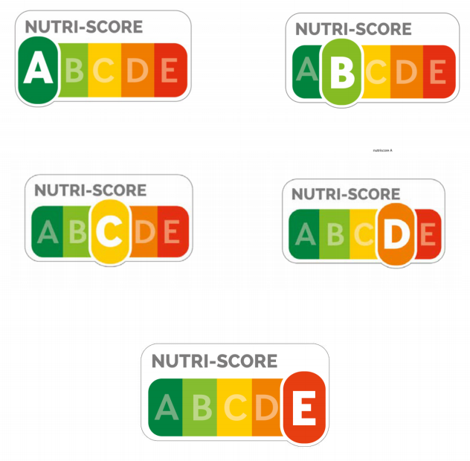’.

Article 2

Entry into force

This Ordinance shall enter into force on the day following its promulgation.

Approved by the Federal Council of Germany.

Explanatory notes

A. General part

1. Objective of and need for the regulations

In Germany, 47 percent of women, 62 percent of men and 15 percent of children and adolescents are overweight. One reason for this is the consumption of too much food with poor nutritional content.

Against this background, the Federal Government has set itself the goal of further developing nutritional labelling for Germany in order to provide simple and understandable information about the nutritional properties of a foodstuff. Following extensive research, which examined both the nutritional issues as well as consumer understanding and perception, the voluntary use of the Nutri-Score label is to be allowed in Germany.

Regulation (EC) No 1924/2006 on nutritional and health claims made on foods (HCR) contains a general prohibition subject to exceptions for nutritional and health claims made on foods. According to widespread legal opinion, the Nutri-Score is regarded as nutritional information within the meaning of Article 2(2)(4) of the HCR. As such, the Nutri-Score requires special approval, which is not available at the European level. As per Article 23(1) of the HCR, a Member State of the European Union wishing to enact new legislation within the scope of the HCR must notify the Commission and the other Member States. In addition, the purpose of this Ordinance is to clarify the obstacle of a ‘blocking effect’ that may have to be introduced under Regulation (EU) No 1169/2011 for certain forms of voluntary nutritional labelling.

The Nutri-Score is a Community collective mark registered as a mark proprietor with the European Union Intellectual Property Office (EUIPO) for the French Santé publique France. For use of the Nutri-Score mark by private third parties, the relevant trade mark law requirements, including the conditions set out by the mark proprietor for the use of the mark by authorised persons, are therefore decisive.Because of this integration of the Nutri-Score in private intellectual property law, the trade mark law, fair trading law and criminal law provisions to be checked in general for trade mark protection purposes must also be taken into account when ensuring proper use of the Nutri-Score mark by third parties.

The Nutri-Score has a five-point scale from A to E that shows a total value for the nutritional value of a product. For this purpose, the number of calories and various nutritional values are offset against each other.

An opening clause is to create the food labelling law basis for using the Nutri-Score label in Germany.

1. Main content of the draft

This Ordinance permits the voluntary use of the Nutri-Score label in the labelling of food.

1. Alternatives

A number of extended nutritional labelling models were examined (including Keyhole®, model of the food industry, model of the Max Rubner Institute) in the studies mentioned under A. The studies show that the Nutri-Score label is scientifically valid and the most perceptible and understandable one for consumers.

1. Regulatory powers

The regulatory powers of the Federal Ministry of Food and Agriculture are established by § 35(1) of the Foodstuffs and Animal Feed Code, which is based on Article 74(1)(20) of the Basic Law.

1. Compatibility with European Union law and international treaties

The Ordinance is compatible with European Union law. The provisions meet the requirements of Regulation (EU) No 1169/2011 for expanded nutritional labelling and Regulation (EC) No 1924/2006 for regulation at the Member State level.

1. Legal consequences
   1. Legal and administrative simplification

The provisions of this Ordinance are intended to enable food to be labelled with the Nutri-Score label on a voluntary basis.

* 1. Sustainability aspects

The provisions particularly support the German government’s sustainability goals 2 with regard to better nutrition and 3 ‘Ensure a healthy life for all people of all ages and promote their well-being’ by facilitating an informed decision with information about the nutritional properties of a food that is easy to understand and easy to see. The more nutritionally beneficial food can be identified more quickly with a simple comparison. Labelling thus contributes to healthy nutrition and is therefore in line with the principle of sustainable development number 4.c., which aims at consumer health protection.

* 1. Budget expenditure without implementing costs
  2. Implementing costs

**a) Compliance costs for citizens**

Citizens will not incur any implementing costs.

**b) Compliance costs for businesses**

Since the provision only makes it possible for businesses to use the Nutri-Score label, the requirements of which are regulated by trade mark law, there are no direct compliance costs for businesses.

**c) Administrative compliance costs**

Permission to use the label does not give rise to additional costs for the administration of the federal government, the states or the municipalities.

* 1. Additional costs

A minimal impact on individual prices cannot be completely ruled out; however, an impact on the general price level, in particular on the consumer price level, is not to be expected.

By participating in the voluntary labelling system, companies will at most incur minimal costs for registering and identifying the information required to calculate the label. The digital application process is limited to a few questions regarding the identification of the label user and the products and is free of charge overall, that is, there are no fees for registration or for using the label. The calculation as to which labelling will specifically come into consideration is based on the data that is already included in existing nutritional labelling and recipes. It is therefore not necessary to collect new data. Online calculators are available for the calculation.

One-off additional costs may arise for businesses from the fact that the Nutri-Score symbol has to be added to the packaging printing. One part of the food industry has stated that there would be no costs for this. Another part of the industry has argued that additional costs will arise without naming verifiable amounts or bases for calculation. Experience from food labelling shows that the costs incurred for a one-time conversion of the printing templates are generally rather low.

* 1. Other legal consequences

The demographic consequences and risks of the Ordinance were examined using the demographic check published by the Federal Ministry of the Interior. The proposal has no direct impact on demographics.

The Ordinance has no impact on the equal treatment of men and women.

B. Specific part

**Re § 4a:**

The new § 4a creates the legal basis for the voluntary labelling of foods with the Nutri-Score label and indicates the trade mark requirements for using the Nutri-Score Community collective mark.

Paragraph 3 clarifies that when using the label, existing industrial property rights, copyrights or other property rights of the European Union or one of its Member States must be observed.

The mark proprietor is Santé publique France. According to its conditions of use, registration is required. In addition, the individual conditions of use specified by the mark proprietor must be observed by the user of the label.

The requirements of the mark proprietor for the use of the mark are currently available in French and/or English. To facilitate labelling and as an aid for small and medium-sized companies, it should be possible to facilitate electronically contact with the French mark proprietor and to publish German translations of input samples or data in the Federal Gazette, for example.

1. *) Notified in accordance with Directive (EU) 2015/1535 of the European Parliament and of the Council of 9 September 2015 laying down a procedure for the provision of information in the field of technical regulations and of rules on Information Society services (OJ L 241 of 17 September 2015, p. 1).