1. ------IND- 2020 0111 D-- EN- ------ 20210114 --- --- FINAL

First Ordinance amending the Food Information Implementing Ordinance[1]*)

of 21 October 2020

On the basis of § 35(1) of the Foodstuffs and Animal Feed Code [Lebens- und Futtermittelgestzbuch] in the version as promulgated on 3 June 2013 (Federal Law Gazette I p. 1426), as last amended by Article 67(6) of the Ordinance of 31 August 2015 (Federal Law Gazette I p. 1474), the Federal Ministry of Food and Agriculture, in consultation with the Federal Ministry of Economic Affairs and Energy, decrees the following:

Article 1

Amendment of the Food Information Implementing Ordinance

The Food Information Implementing Ordinance of 5 July 2017 (Federal Law Gazette I p. 2272) is amended as follows:

* + - 1. The following § 4a is inserted after § 4:

‘§ 4a

Extended nutritional labelling

* + 1. The party responsible as per Article 8(1) or (4)(2) of Regulation (EU) No 1169/2011 may place food with the Nutri-Score label shown in the annex, which is registered as a Community collective mark with the European Union Intellectual Property Office, on the market.
    2. The use of the Nutri-Score label is voluntary.
    3. The use of the Nutri-Score label requires that the party responsible as per Article 8(1) or (4)(2) of Regulation (EU) No 1169/2011, in particular,
       1. obtained the necessary consent from the mark proprietor and
       2. complies with the mark proprietor’s conditions for using the mark.
    4. The Federal Ministry of Food and Agriculture can publish the following in the Federal Gazette for obtaining consent as per paragraph 3(1):
       1. Sample forms in German,
       2. Input data in German and an email address that is set so that incoming emails are automatically forwarded to the mark proprietor.’
       3. The following annex is added:

**‘Annex**

(to § 4a(1))

**Illustration of the Nutri-Score label**

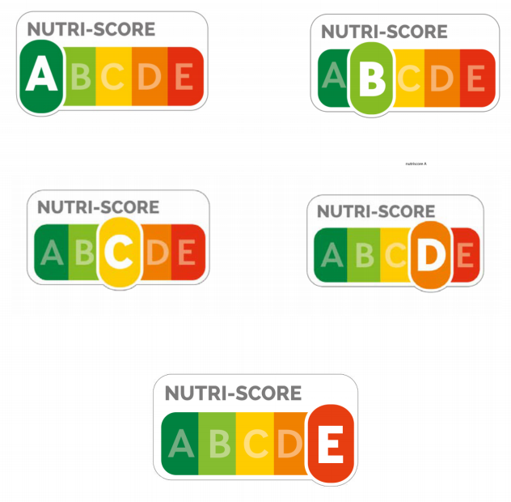**’.**

|  |  |
| --- | --- |
| NUTRI-SCORE | NUTRI-SCORE |

Article 2

Entry into force

This Ordinance shall enter into force on the day following its promulgation.

Approved by the Federal Council of Germany.

Bonn, 21 October 2020

The Federal Minister

for Food and Agriculture

Julia Klöckner

1. *) Notified in accordance with Directive (EU) 2015/1535 of the European Parliament and of the Council of 9 September 2015 laying down a procedure for the provision of information in the field of technical regulations and of rules on Information Society services (OJ L 241 of 17 September 2015, p. 1).