1. ------IND- 2020 0019 A-- EN- ------ 20200206 --- --- IMPACT

|  |  |  |
| --- | --- | --- |
| To the | | Rathausstraße 14-16,  1010 Vienna  Telephone +43 1 4000 88305  Fax +43 1 4000 88304  post@ma20.wien.gv.at  energie.wien.gv.at |
| **1.Municipal Council Committee** **Urban Development, Transport, Climate Protection,** **Energy Planning and Citizen Participation** | |
|  | |  |
|  | |  |
|  | |  |
| **Ref. no.: MA 20 – 1092131/2019** | | Vienna, 19 December 2019 |
|  | |  |
|  | |  |
| Establishment of the Spatial Energy Plan  for the 16th District,  Zones 16/001 – 16/004  Plan no.: Bez16_E_Plan1_v1.0 | **For information in advance:**   1. Magistrate Directorate – Legal Division 2. Executive City Councillor for Urban Development, Transport, Climate Protection, Energy Planning and Citizen Participation Deputy Mayor Birgit Hebein | |

**Enclosures:**

1. Proposal and plan 1:5,000
2. State of proceedings as per § 2 Vienna Building Code

(Draft plans and proposals, explanatory reports)

1. Stock plans
2. Expert opinions, statements
3. Presentation of changes
4. Promulgation records
5. Notification form as per Directive (EU) 2015-1535

Submission Report

after completion of the procedure as per § 2b of the Vienna Building Code to define spatial energy plans.

Table of Contents

I. General Part 3

1. New legal basis for new buildings 3

2. Background 3

2.1. Overarching strategies and guidelines: EU, Federal government, City of Vienna 4

2.1.1. EU 4

2.1.2. Federal Government 5

2.1.3. City of Vienna 6

2.2. Starting position: Gas and district heating dominate the Vienna spatial heating market 9

2.2.1. Historical development of the heat supply in Vienna 9

2.2.2. Outlook on the future heat supply in Vienna 12

2.3. Expected impact of the Spatial Energy Plan Ordinance 13

2.3.1. Effects on greenhouse gas emissions in the building sector and/or non-emissions trading sector and thus on Vienna’s climate protection goals 13

2.3.2. Unbundling of infrastructure 15

2.3.3. Estimated economic impact 15

3. Methodological approach for the creation of spatial energy plans 17

3.1. Territorial delineation 17

3.1.1. Technical evaluation: 18

3.1.2. Economic evaluation of the individual connections: 19

3.1.3. Formation of consolidation zone: 19

3.2. Analysis of other highly efficient alternative systems 23

4. Content, procedure and legal consequences 24

II. Specific Part 24

5. Area description 24

5.1. Area under observation: district 24

5.2. District heating infrastructure and designation of zones 25

5.2.1. Zones 25

General Part

1. New legal basis for new buildings

In accordance with the § 2b Vienna Building Code, the municipal council can define spatial energy plans for parts of the urban area if:

* district heating infrastructure is already available as a highly efficient alternative system (§ 118(3) Vienna Building Code) or
* there is sufficient technical capacity to expand the district heating infrastructure and
* at least one other highly efficient alternative system [taking into account the aims defined in § 1(1) of the Emission Control Act – Air (IG-L), Federal Law Gazette No 115/1997, as amended by Federal Law Gazette I No 58/2017] can be implemented.

In these areas, only the highly efficient alternative systems specified in § 118 (3) Vienna Building Code[1] are permitted for heating and water heating systems in new buildings. These are:

* decentralised energy supply systems based on energy from renewable sources,
* cogeneration,
* district/local heating or district/local cooling systems, especially where these are based wholly or partly on energy from renewable sources or highly-efficient cogeneration plants, and
* heat pumps.

In the course of preparing this Ordinance of the City of Vienna, those areas were identified in which there is potential for the consolidation of existing network sections or expansion of district heating and at least one other highly efficient energy system can be used. There is no need to connect to district heating.

1. Background

With the spatial energy plan, the Amendment of the Vienna Building Code 2018 (Provincial Law Gazette 2018/69) introduced an instrument which enables the use of energy sources for the provision of space heating and hot water in new buildings to be controlled in a targeted and sustainable manner.

This is intended to support the achievement of climate and energy goals, particularly with regard to decarbonisation (i.e. avoiding fossil fuels at least in new buildings) and the decentralisation of the pipeline infrastructure (district heating and gas), which makes sense for cost reasons. Furthermore, an affordable energy supply and planning security for investors should be guaranteed.

The spatial energy plans can be seen as sectoral planning, comparable to the topic of a productive city[2]. As stated in § 2b(1) Vienna Building Code, the spatial energy plans of the *forward-looking planning and sustainable design of energy supply* and show the will of the city of Vienna to incrementally phase out fossil fuels.

The extent to which the above-mentioned goals in general and the new instrument of the ‘spatial energy plans’ in particular fit into the context of the strategies and guidelines adopted in recent years at global, EU, Federal and Viennese levels is explained in the following:

* 1. Overarching strategies and guidelines: EU, Federal government, City of Vienna

For climate protection policy, which since at least the Kyoto Protocol has been of great importance at international and thus at EU and Federal level, came into force in 2005, the general conditions under international and EU law have changed in recent years:

December 2015 saw the historical conclusion of the Paris Climate Protection Agreement. It has been in force since November 2016 and is therefore binding under international law. In the meantime (almost) all countries have acceded to the convention, whose main goal is to limit man-made global warming to well below 2 °C compared to the pre-industrial value. The Agreement and the resolutions at the annual conferences of the contracting parties (COP) to the UN Framework Convention on Climate Change (UNFCCC) have created a set of rules that also have an impact on the climate and energy policy of the European Union and thus on Austria as well.

* + 1. EU

As part of its climate and energy policy, the EU has three main goals by 2030:

* To lower the **greenhouse gas emissions** by at least 40% (compared to 1990 levels)
* To increase the share **renewable energy sources** to at least 32%
* To increase in **energy efficiency** by at least 32.5%

With the binding goal of reducing greenhouse gas emissions in the EU by at least 40% by 2030, the EU seeks to

* make a fair and ambitious contribution to [Paris Agreement](https://ec.europa.eu/clima/policies/international/negotiations/paris_en);
* take cost-effective measures to reduce emissions by 80 to 95% in the long term by 2050 as part of the necessary reductions by the group of industrialised countries.

The legislation on burden sharing (‘effort sharing’) set binding annual targets for the EU Member States for reducing greenhouse gas emissions in the periods 2013-2020 and 2021-2030. These targets apply to emissions from most sectors that are not covered by the EU Emissions Trading Scheme, such as the transport, buildings, agriculture and waste sectors. Effort-sharing legislation is part of a range of climate change and energy policies and measures designed to help transition to a low-carbon economy and improve energy security in Europe. The national targets will reduce total EU emissions from the sectors covered by 30% by 2030 compared to 2005 levels. This way, together with the emissions reduction by the EU emissions trading system (by 43% by 2030), the EU will be able to achieve its climate targets for 2030.

The Regulation issued in 2018, laying down binding national annual targets for reducing greenhouse gas emissions in the period 2021 to 2030 (**Effort Sharing Regulation**), is part of the strategy for the [Energy Union](https://ec.europa.eu/commission/priorities/energy-union-and-climate_en) and the implementation of the [Paris Agreement](https://ec.europa.eu/clima/policies/international/negotiations/paris_en) by the EU. It will define national [emission reduction targets for 2030](https://eur-lex.europa.eu/legal-content/DE/TXT/?uri=uriserv:OJ.L_.2018.156.01.0026.01.DEU) between 0% and -40% of the 2005 level for all Member States.

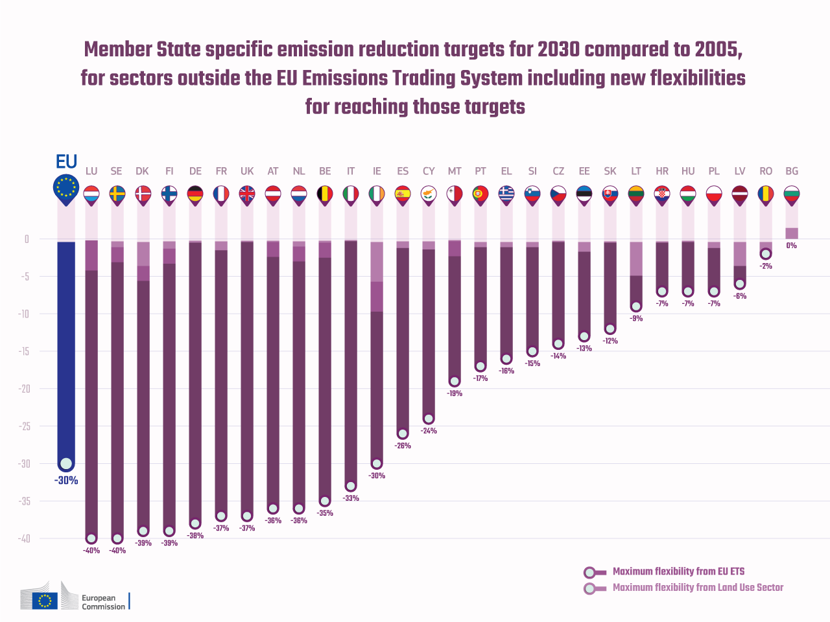

Figure 1: The EU Member States’ targets for reducing greenhouse gas emissions in the non-emissions trading sector (non-ETS) for the period 2005 to 2030

According to the EU Effort Sharing Regulation, Austria must reduce its greenhouse gas emissions in the non-emissions trading sector by 36% by 2030 compared to the initial value in 2005.

In contrast to the sectors under EU emissions trading, which are regulated at EU level, Member States are responsible for national strategies and measures to limit emissions in the sectors covered by the effort-sharing provisions.

Since the CO2 emissions from fossil-fuelled buildings addressed by the Spatial Energy Plan Ordinance fall into the regime of the non-emissions trading sector, this measure helps to reduce CO2 emissions in the Austrian area of responsibility.

* + 1. Federal Government

The following quotes are from the **Federal Government's Climate and Energy Strategy #mission2030** enacted by the Council of Ministers in 2018 and should show that the project pursued by Vienna is a – spatially differentiated – approach against CO2 emissions from fossil heating systems is also in the interest of the national climate and energy strategy:

* ‘Further development of the energy system to a modern, **resource-saving and decarbonised energy supply by 2050**.’ […] ‘Austria will reduce its greenhouse gas emissions by 36% by 2030 compared to 2005.’ (p. 15)
* ‘The building sector must [...] drastically reduce energy requirements. At the same time, fossil fuels are gradually being replaced by renewable ones.’ (P. 52)
* ‘[...] **No fossil fuels in new buildings** as well as switching to renewable energy sources and highly efficient district heating in existing buildings.’ (p. 14)
* ‘[...]highest thermal quality **in new buildings** in combination with **energy supply without fossil energy**.’ (p. 28)
* ‘Waste heat utilisation: Supplying buildings and businesses with efficiently consumed **district heating will continue to play an important role in the future, especially in metropolitan areas**. In addition to provision from renewable energy sources and combined heat and power, the supply of waste heat from production plants is also of great importance.’ (p. 25)
* ‘Spatial energy planning also enables the implementation of innovative energy concepts with a focus on locally available, inexpensive, renewable energy, the use of waste heat. [...] Analysis and location of energy consumption and potential for recovery provide essential insights into their spatial dimensions for climate-friendly planning. Modern, integrated energy concepts can be used in spatial planning for decision-making in the case of land use, investment in infrastructure and awarding grants such as housing subsidies.’ (p. 45/46)
* ‘For energy-efficient urban development, **energy standards must be defined for districts and neighbourhoods in connection with climate-friendly energy supply systems** and the fields of urban development, buildings, energy and energy systems are dealt with together. To do this, the processes of urban planning, infrastructure planning, network planning, spatial planning and energy planning must be further developed at all levels of local authority.’ (p. 45)

Vienna is thus implementing a measure that supports the federal goals, but the implementation of these measures is the sole responsibility of the province, both legally and financially.

* + 1. City of Vienna

The following is intended to show how the Spatial Energy Plan Ordinance is in line with the (political) strategic concepts and regulations that have been adopted in the city of Vienna in recent years.

1. **Smart City Vienna Framework Strategy**

The ‘Smart City Vienna Framework Strategy’ is the long-term umbrella strategy until 2050. The updated strategy – decided by the Vienna City Council in June 2019 – includes the following as a key objective: ***‘Vienna to lower local greenhouse gas emissions*** (in the non-emissions trading area) ***by 50% per capita by 2030 and by 85% by 2050.’***

As a contribution to the achievement of this key objective, the following sectoral goals (among other things) have been set for the building sector:

* *‘The final energy consumption for heating, cooling and hot water in the buildings drops by one percent, the associated CO2 emissions decrease by two percent per capita per year*.’
* *‘Starting 2025, the heat consumption of new buildings will generally be covered by renewable energy or district heating.’*

In a growing city like Vienna, the building sector, in addition to transport, the second major sector, must make a significant contribution to achieving the goal. With the spatial energy plans, after the ban on oil and coal, the next logical step is the gradual phasing out of fossil fuels for space heating and hot water.

1. **Urban development plan STEP 2025**

The subject of spatial energy planning was first formulated in Vienna in 2014 in STEP 2025. In particular, the initiative can be found in STEP 2025 ‘*Integrated spatial energy planning’,* whose aims are described as follows: *‘Spatial and energy planning are brought together at the district level in a joint process in order to find optimal infrastructure and energy system solutions that are adapted to the needs of the location. The goals: Avoiding CO2 emissions, increasing energy efficiency, economy, security of supply, the use of renewable energies on site, the intelligent and optimised use of line-bound energy sources (e.g. decentralised heating networks, waste heat etc.) and the implementation of energy storage options to optimise the use of local potential.’*

These and other orders in STEP 2025 formed the starting point for the preparatory work that culminated in the development of the ‘Technical concept for spatial energy planning’ and in the preparatory work for the Spatial Energy Plan Ordinance.

1. **Energy Framework Strategy 2030 for Vienna**

The key statements of the ‘Vienna Energy Framework Strategy 2030’ adopted in 2017 for spatial energy planning are cited below. A large part of the goals or targets envisaged therein can be achieved or at least supported by the Spatial Energy Plan Ordinance.

*‘Spatial energy planning for Vienna is based on the following prioritisation, taking into account the five points of energy policy: 1. Efficiency, 2. Waste heat, 3. Renewable energy,*

* *the* ***avoidance*** *and continuous unbundling* ***of double infrastructures****,*
* *the* ***definition of planning areas*** *for district heating, natural gas, decentralised or individual heat supply, taking into account criteria such as economy and local conditions and*
* *a differentiation in* ***use of energy sources depending on the city typology*** *(stock, development area, compacted or loosened construction),*
* *early consideration of the subject of energy in urban planning processes (e.g. land use) and promotion of compact and mixed-functional settlement structures,*
* *the* ***creation of suitable instruments to support long-term investments, decarbonisation and planning security in the construction of energy supply systems****.’ [p. 21]*

1. **Climate Protection Programme of the City of Vienna - KliP II**

The topic of spatial energy planning was already anchored in KliP II (resolution 2009) under the title ‘Consideration of energy-related aspects in spatial and urban planning’. The following four measures were formulated for this purpose:

* C1.10 Consideration of energy aspects in all urban development competitions
* C1.11 Systematic urban development along the high-ranking public transport network and the district heating network
* C1.12 Definition of waste heat, tunnel thermal and district heating areas
* C1.13 Coordination with the Energy Department of the City of Vienna[3] in urban planning competitions or similar urban planning processes

The determination of the spatial energy plans supports these measures or can be seen as an implementation of measure C1.12 in particular.

1. **Technical concept for spatial energy planning**

In April 2019, the municipal council decided on the ‘Technical concept for spatial energy planning’. It lays the foundation for the integration of energy issues into urban planning processes. This ensures that energy supply is considered an essential parameter for climate protection at an early planning stage.

Guidelines anchored in the technical concept are intended to help, as is the development of climate-friendly district energy concepts. These are useful for all major new building developments and must be created wherever the total gross floor area is over 30,000 m² accounts. They are not compulsory in areas for which a spatial energy plan is enacted.

In the course of developing the technical concept, it became clear, among other things, that a spatially differentiated procedure for the further development of the pipeline infrastructure required for heating (district heating and gas network) has many advantages and that suitable legal framework conditions are required. These were created by the Amendment of the Vienna Building Code already created in autumn 2018, not least as a ‘side effect’ of the political coordination of the ‘Technical concept for spatial energy planning’.

1. **Amendment of the Vienna Building Code**

The amendment of the 2018 Vienna Building Code has brought some significant progress in terms of climate protection, support for more energy efficiency and renewable energies.

In addition to the authorisation for the Spatial Energy Plan Ordinance (the new § 2b), which is the basis for this Ordinance, the amendment brought the following further improvements:

* A public interest in climate protection and greenhouse gas reduction is documented with the following two goals from § 1(2), which were adapted for the Amendment of the Vienna Building Code:

*‘Preserving or creating environmental conditions that ensure healthy livelihoods, especially for living, work and leisure, and creating conditions for the most economical and ecological* ***as well as climate-friendly handling of energy resources and*** *other natural resources and the land and soil’*

*‘Provision for* ***climate-friendly*** *and modern facilities for supply and disposal, especially with regard to water, energy and waste* ***with special attention to the efficient use of the potential of waste heat and renewable energies and avoiding an unreasonable burden due to redundant infrastructure****’*

* Ban on gas floor and oil heating in new buildings
* Doubled and no longer ‘exchangeable’ minimum proportion for solar energy if a gas central heating is installed in new buildings
* Ban on oil heating even after extensive renovation

With these measures, Vienna has proven that the formulations of intent and objectives in the above-mentioned strategy papers are also followed by corresponding adjustments to the relevant legal provisions, which make it clear that climate-friendly energy supply and the avoidance of parallel pipeline infrastructures are in the public interest.

1. **Red-green intergovernmental agreement of 2015**

Significant energy and climate targets have also already been agreed upon in the red-green intergovernmental agreement[4] (pp. 98-99), including:

* ‘The development and integration of alternative heat supply options should be promoted in the heating sector, in addition to the district heating and cooling expansion (existing waste heat potential)...’
* ‘The new building should cause minimal additional CO2 emissions.’

With the spatial energy plans, the Vienna city government is implementing an effective measure in line with these two goals of the intergovernmental agreement.

* 1. Starting position: Gas and district heating dominate the Vienna spatial heating market
     1. Historical development of the heat supply in Vienna

The centuries-old dominance of wood, mainly drifted across the Danube to Vienna, was replaced by coal as the most important heating material in the second half of the 19th century. Coal remained ‘market leader’ in Vienna until after World War II. It came to Vienna both via the Danube and by rail, especially with the northern railway from the Polish coalfields. Many people still worked in the distribution of these fuels in the urban area in the interwar and post-war period. The triumphant advance of wired and clean energy sources (gas, district heating, electricity) ushered in the decline of this fuel business – and a drastic improvement in air quality in Vienna.

It was only after World War II that natural gas was established as the most important fuel in the heating sector, thanks to the almost nationwide expansion of the gas network. Natural gas today heats around half of all apartments in Vienna, a share that has remained fairly constant for around 30 years. Relevant gas heating systems are gas central heating systems for residential complexes and gas baths (‘floor heating’) in Viennese apartments, of which there are over 400,000. In recent decades, gas has gained market share at the expense of solid fuel (coal or wood) and oil heating, but at the same time – like solid fuel heating – it has lost market share due to the conversion of gas central heating to district heating. District heating has gained around one percentage point of market share a year in the past few decades. In any case, Vienna is the front-runner when it comes to the exit from coal and oil.

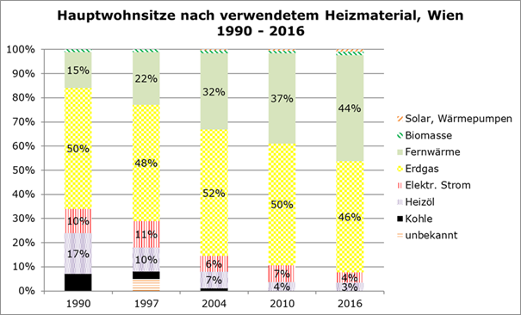

Figure 2: Proportion of heating materials / energy sources used in Vienna's main residences since 1990 (source: Statistics Austria)

|  |  |
| --- | --- |
| Hauptwohnsitze nach verwendetem Heizmaterial, Wien | Main residences based on the heating material used, Vienna |
| Solar, Wärmepumpen | Solar, heat pumps |
| Biomasse | Biomass |
| Fernwärme | District heating |
| Erdgas | Natural gas |
| Elektr. Strom | Electricity |
| Heizöl | Fuel oil |
| Kohle | Coal |
| unbekannt | Not known |

With the development shown in the figure, there was also a considerable reduction in air pollutant emissions (fine dust, NOx etc.), the climate-damaging CO2 emissions and the use of primary energy.

While the construction and expansion of a gas infrastructure (first city gas, then natural gas) began early on in Vienna, the district heating expansion did not begin until the 1970s, when the waste heat from the waste incineration plants and the power plants were used in the form of district heating for heating and water heating was fed. Today, the district heating network is 1,200 kilometres long, making it one of the largest district heating networks in Europe. More than 380,000 apartments – around a third of all households in Vienna – and more than 6,800 major customers are supplied with environmentally friendly heat.

As shown in the figure for 2017, about a third of the district heating produced comes from the [waste incineration plants](https://www.wienenergie.at/eportal2/ep/channelView.do?channelId=-49065) [Flötzersteig](https://www.wienenergie.at/eportal2/ep/channelView.do?channelId=-49103), [Spittelau](https://www.wienenergie.at/eportal2/ep/channelView.do?channelId=-49106), [Simmeringer Haide](https://www.wienenergie.at/eportal2/ep/channelView.do?channelId=-49104) and [Pfaffenau](https://www.wienenergie.at/eportal2/ep/channelView.do?channelId=-49105) as well as the [Forest biomass power plant](https://www.wienenergie.at/eportal2/ep/channelView.do?channelId=-48494) in Simmering. Around two thirds are delivered by combined heat and power plants (CHP) and industrial waste heat sources (OMV-Schwechat, Manner). Natural gas-powered hot water boilers and, more recently, a large heat storage, electric heater and heat pumps are used to cover peak loads.

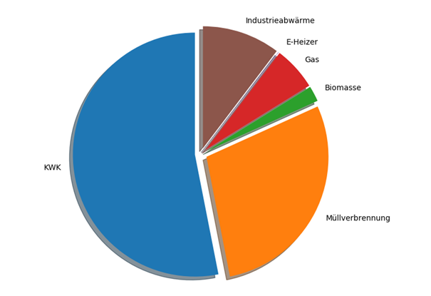

Figure 3: Generation structure of district heating in Vienna in 2017 (source: Wien Energie).

(CHP = [gas] combined heat and power plants for the combined generation of electricity and district heating)

|  |  |
| --- | --- |
| KWK | CHP |
| industrieabwärme | Industrial waste heat |
| E-Heizer | E-heater |
| Gas | Gas |
| Biomasse | Biomass |
| Müllverbrennung | Waste incineration |

The general conditions on the European energy markets have changed over the past few years, and thus for forced district heating expansion as well. Above all, the fall in the electricity market price has affected the efficiency of electricity generation in all European (gas) CHP plants. This also had an impact on the production and cost situation of the by-product district heating. This situation is one of the reasons why higher demands are now being made on the cost-effectiveness of district heating expansion in Vienna than was the case around ten or more years ago. This aspect is particularly relevant against the background of the parallel pipeline infrastructure existing in many parts of the city. The expansion of gas and district heating pipelines has led to the fact that part of the apartments in a building, street or network area are often supplied with natural gas and others with district heating. This results in unsatisfactory degrees of connection and overall higher economic costs for both networks. (For comparison: In Copenhagen, around 99% of all households are supplied with just one line-bound energy source, in this case district heating. From a SINGLE infrastructure – instead of a dual infrastructure – results in lower costs and – if suitably regulated – also a lower district heating price.)

Heating systems with heat pumps or other decentralised renewable energy sources still play a small role in terms of quantity. Heat pumps in particular are being used more and more frequently because the technology has developed rapidly and, above all, offers the great advantages of lower running costs and efficient cooling. The energy planning department is expecting great market growth here, which is also necessary for decarbonisation, since heat pumps can be operated with electricity from renewable sources.

* + 1. Outlook on the future heat supply in Vienna

The Smart City Vienna Framework Strategy (2019) has anchored the following sectoral guiding principle for the Vienna building sector: ‘The final energy consumption for heating, cooling and hot water in buildings drops by one percent, the associated CO2 emissions decrease by two percent per capita per year.’ From 2005 to 2016, the per capita average CO2 emissions decreased by more than two percent per capita and year (see following figure). A continuation of this trend and thus the achievement of the Smart City framework strategy goal is only possible if both the renovation of buildings and the replacement of fossil heating systems with highly efficient alternative heating systems continue to be given high priority. And of course it helps to achieve the goal if no further fossil heating systems are used in the new building (or are only used in exceptional cases).

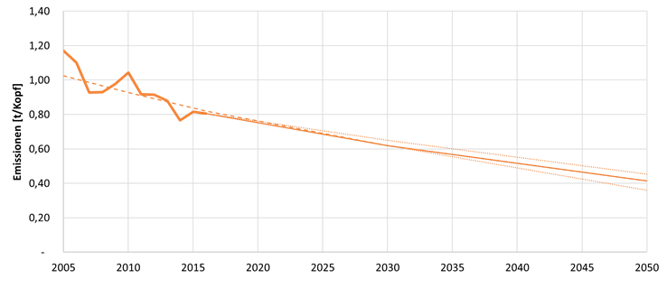

Figure 4: Development of the CO2 emissions in the Vienna building sector: Historical course in the period 2005 to 2016 and future course according to the goal (minus 2% per capita and year) of the Smart City Vienna framework strategy

|  |  |
| --- | --- |
| Emissionen [t/Kopf] | Emissions [ton per capita] |

Calculations by the Energy Centre (Urban Innovation Vienna), which were carried out in connection with the definition of the above-mentioned target path in the Smart City framework strategy, show that in order to maintain the target path, gas consumption in domestic fuel must be reduced by around a quarter in the period from 2005 to 2030. New gas heating systems in new buildings make it difficult to achieve the goal. That is why the Smart City Vienna Framework Strategy also includes the following goal: ***‘From 2025, the heat consumption of new buildings will generally be covered by renewable energy or district heating.’***The achievement of this goal, as well as that of the above-mentioned key objective regarding the reduction of CO2 emissions **in the entire Vienna building sector**, is supported by the enactment of the spatial energy plans, which prescribe exactly that.

At the same time, it is the goal of both the city and Wiener Stadtwerke (Vienna Municipal Works) to diversify and decarbonise the generation structure of Vienna’s district heating. For instance, Wien Energie plans to source around 40% of the district heating generated in 2030 from renewable sources. The central role here is the integration of waste heat sources at a low temperature level, which are raised to the supply temperatures of the primary or secondary network by large heat pumps. In 2018, the first large heat pump with an installed capacity of 30 MW went into operation at the Simmering power plant. Deep geothermal energy is in the focus in the east of Vienna as the potentially most important renewable heat source and is the subject of a current research project.

Since both the city and the municipal utilities are working on a gradual decarbonisation of the district heating generation structure, it is also logical to expand the district heating supply in an incremental and coordinated manner. The spatial energy plans follow this strategy and are defined for areas in which a consolidation (especially in the ‘existing city’) or an expansion (especially in new urban development zones) of the district heating supply is possible on the basis of the current capacities.

* 1. Expected impact of the Spatial Energy Plan Ordinance
     1. Effects on greenhouse gas emissions in the building sector and/or non-emissions trading sector and thus on Vienna’s climate protection goals

Several assumptions on future volume development in Vienna’s housing market must be made in order to estimate the impact of the Energy Spatial Plan Ordinance on greenhouse gas emissions (and/or energy consumption) per capita – the goals of the Smart City Vienna framework strategy and the climate protection programme are based on the indicator ‘CO2 emissions per capita’. Like every look into the future, it is fraught with uncertainties, on the one hand regarding the population development in the next few years, and on the other hand concerning the effects of the legislation on the proportion of subsidised housing that came into force with the last Amendment of the Vienna Building Code (subsidised housing dedication category).

First of all, based on the figures from the past few years, it is assumed that, from 2020 onwards, new buildings with around 10,000 apartments will be built in Vienna each year. It is also assumed that 70% of them will be built within the areas affected by spatial energy plans. As a result, new buildings with around 7,000 residential units would be covered by the spatial energy plans each year.

For subsidised housing, it can be assumed that – as before – the majority of all new buildings will be connected to district heating anyway (see figure) or that all buildings are connected to district heating wherever a connection is possible. In this respect, there would be no relevant change for this real estate sector. On the one hand, this is due to the fact that subsidised housing mainly takes place in medium-sized and large urban development zones, where district heating is usually available. On the other hand, the connection to district heating (if it is available on the building site) or the use of highly efficient alternative systems based on renewable energies is also a requirement for subsidy.

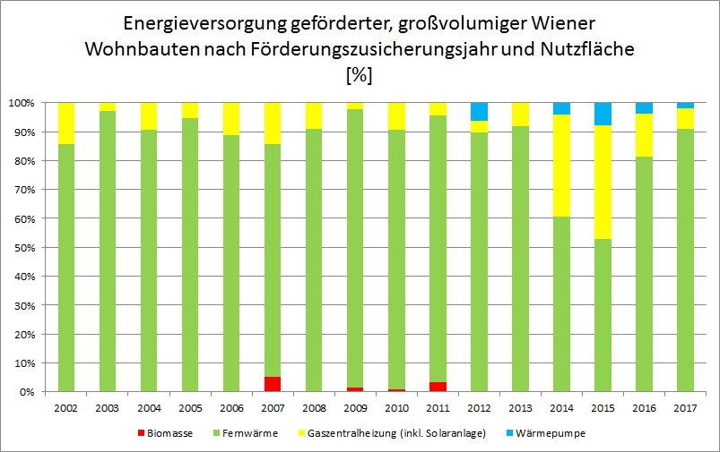

Figure 5: Energy supply for large-scale subsidised new buildings in Vienna according to subsidy year and usable area (in %). (Source: City of Vienna Energy Report 2018, based on data from MA 25)

|  |  |
| --- | --- |
| Energieversorgung geförderter, großvolumiger Wiener Wohnbauten nach Förderungszusicherungsjahr und Nutzfläche | Energy supply of subsidised, large-scale residential buildings in Vienna according to the subsidy year and usable area |
| Biomasse | Biomass |
| Fernwärme | District heating |
| Gaszentralheizung (inkl. Solaranlage) | Central gas heating (including solar system) |
| Wärmepumpe | Heat pump |

The spatial energy plans could become more relevant for the freely financed residential construction sector, which has increased significantly in recent years, primarily due to ‘gap closures’ in inner-city areas or on private properties on the periphery. The freely financed new residential construction has recently reached a proportion of almost 50% of new construction output. In the past, new buildings were also equipped with gas heating in this segment, even though the installation of a highly efficient alternative system would have been possible and reasonable.

It is therefore assumed that the Energy Spatial Plan Ordinance (for all 23 districts) can be used to redirect new construction projects with a total of 1,000 residential units from a gas supply to a highly efficient alternative heating system. The annual gas consumption avoided from these 1,000 new apartments would be around 6 GWh and the CO2 emissions avoided in the non-emissions trading sector would be around 1,400 tons per year.

By applying the regulations, around 10,000 fewer residential units could already be supplied with highly efficient alternative heating systems instead of gas heating after ten years. This would result in a saving of over 60 GWh of natural gas in domestic fuel in the tenth year and accordingly would avoid over 14,000 tons of CO2 (in the non-emissions trading sector relevant for Vienna).

The Ordinance will support the Smart City Framework Strategy goal of a ‘two percent annual reduction in per capita CO2 emissions in the building sector’: The zero emission of the new construction sector covered by the regulations automatically lowers the average value for CO2 emissions of the entire Viennese building sector, both per capita (relevant target indicator in the area of the city of Vienna) and per square meter, for example.

* + 1. Unbundling of infrastructure

The Amendment of the Vienna Building Code 2018 has also formulated the new planning objective ‘*Provision of climate-friendly [...] institutions related to [...] energy [...] while avoiding an unreasonable burden due to redundant infrastructure’.*

This goal can (for the time being) only be achieved by developing new urban development zones that are not equipped with natural gas or district heating at the start of planning. In these cases, the regulations in question can be used to prevent both pipeline-bound energy sources from being introduced into such areas and thus creating redundant infrastructure.

Regarding the infrastructure in the area of the existing building structure, the regulations in question cannot be used to separate the redundant pipeline infrastructure in the short to medium term. Suitable regulations for the conversion of fossil heating systems in existing buildings would have to be adopted in order to achieve this. Nonetheless, the Spatial Energy Plan Ordinance is also intended to increase the district heating connection density in the existing city by connecting new buildings. This should support cost-effective operation and thus contribute to the affordability of the energy supply.

* + 1. Estimated economic impact

In-depth analyses of the economic effects were carried out in preparation for the Ordinance. OIB Guideline 6 – Energy saving and heat protection and their implementation in the Vienna Building Code implements the requirements of the EU Buildings Directive[5] in Austria and Vienna. According to this Directive, natural gas should only be used in new buildings on an exceptional basis and can therefore only be approved if the highly efficient alternative systems cannot be implemented at economic costs (see EU Buildings Directive 2018, OIB Guideline 6 and Vienna Building Code).

For that reason, highly efficient alternative systems are generally to be used if the costs are within an economically reasonable range, in relation to the goals that are to be achieved with them, such as climate protection, CO2 reduction.

**Natural gas situation – there are still fossil heating systems in new buildings despite dedicated climate goals**

The technical developments, the OIB Guideline newly adopted in 2019 and also Vienna regulations, such as most recently the Vienna Building Code, have significantly shifted the economic comparison in favour of the highly efficient, alternative systems.

The use of natural gas (on an exceptional basis) now also requires a relatively high proportion of renewable energy sources (in Vienna 20% of the final energy requirement for hot water), which means that heat supply with gas can no longer be deemed to be cost-effective anyway.

Nevertheless, fossil natural gas heating remains the reference system for comparing economic efficiency, since it corresponds to the standard solutions currently being implemented on the market. These are characterised above all by low investment costs, without necessarily leading to optimal costs for the customers. These standard buildings are erected with a minimum standard for building envelopes permitted by the Vienna Building Code and a gas condensing boiler plus a (mandatory) supplementary ‘renewable energy system’ (e.g. a solar system) is partially supplied with heat. These buildings are currently the building standard for three reasons:

1. The housing companies save 2 to 5% of investment and thus optimise their profits.
2. Gas generally has to be made available in accordance with the Natural Gas Sector Act.
3. Gas heating is a simple technology that is mastered and offered by many companies.

Although this standard solution is used as a reference for the economic comparison, it should be noted here that it is not optimal for three reasons:

1. it is not compatible with climate protection goals
2. it is not necessarily optimal from the customer's point of view
3. it is not adapted to climate change, because cooling of the buildings in summer is not possible

**Cost-effective district heating within the spatial energy plans**

As far as district heating is concerned, the Energy Spatial Plan Ordinance should go hand in hand with clear cost structures. The following prerequisite applies in areas where a spatial energy plan is established:

The respective energy supply company must publish comprehensible costs and affordable tariffs for both the district heating connection and the running costs. District heating is therefore available in these areas at comparable costs, such as gas plus a solar system. From the authority's point of view, there can therefore no longer be any economically justified exceptions for gas plus the proportion of renewable energy within the spatial energy plan areas.

**Expert reports show: renewable energies are economical**

The expert reports commissioned by the Magistrate Department 20, practical experience from residential and school construction and various studies carried out in recent years all show that systems based on renewable energy sources are now economically comparable and competitive. Such systems are even cheaper today, especially under certain assumptions such as a total cost analysis over 20 years or taking into account the possibility of cooling by heat pumps on hot summer days. As a result, the use of renewable energy systems does not generate any unreasonable additional costs – as shown below – which makes the this Ordinance justifiable from a technical point of view.

The detailed analyses show:

With an optimised new building, the additional structural costs for the better building envelope are around 2-2.7% compared to the standard building. The reduced energy consumption or the lowest energy standard is an essential prerequisite for the implementation of a renewable and thus climate-friendly heat supply, because low consumption greatly reduces the costs of the renewable supply system. Depending on the system combination used, the total additional costs (building services engineering) of the investment range from approx. 2.6 to 5.7%. Usually, in the course of design planning for a construction project, a manufacturing cost fluctuation range of 5-10% is expected. The above-mentioned additional costs thus lie within this fluctuation range and in any case well below 10%.

However, the advantages of such systems must be compared with these additional investment costs. For example, heat pump systems based on geothermal energy – according to expert reports, up to approx. 5.7% more investment costs – offer the enormous advantage that the buildings can be cooled in the summer by feeding the excess heat into the ground and storing it there for the winter.[6] This solution relieves the urban climate because, unlike conventional air-conditioning systems, the heat is not released into the environment. This significantly increases the building’s utility value and suitability for the future, since, in view of the climate change, considerably more hot days must be expected. This benefit for residents, especially for vulnerable social groups (senior citizens, children, ill people) can no longer be negated in the face of climate change. According to real estate experts (such as Malloth in June 2019), it can be assumed that the possibility of cooling apartments has a significant impact on their market value. If the economy of a building is considered so comprehensively climate-friendly buildings with a higher quality of life can already be built very economically today.

There is also the advantage for end customers that the operating costs of the renewable systems in consideration are cheaper, since the majority of the energy is provided from local sources – which are available free of charge. In addition, these systems are less maintenance-intensive.

1. Methodological approach for the creation of spatial energy plans

The basis for the analysis to determine the areas to which a spatial energy plan applies is – as explained above – the availability or feasibility of highly efficient alternative systems in accordance with § 118(3) of the Vienna Building Code. The analysis method is explained below.

* 1. Territorial delineation

District heating plays an important role in determining the zones. The district heating of Wien Energie GmbH is a highly efficient energy supply system in accordance with § 118(3) Vienna Building Code. For district heating, ‘highly efficient’ means: The energy fed into a heating network must (at least 80%) come from combined heat and power plants and/or from waste heat and/or from renewable energies (ambient heat, biomass, etc.). The currently available district heating or local heating from other providers as well as the decentralised networks with gas boilers operated by Wien Energie GmbH do not meet these criteria.

In structurally dense areas, the use of highly efficient district heating must be assessed as a climate protection measure. From a business and economic point of view, the supply of loosely built-up areas such as allotments, single-family homes or terraced housing estates with pipeline-bound energy sources is unsuitable, since long line lengths in relation to low heat consumption result in high investment and maintenance costs that cannot be refinanced. Buildings of this type can be supplied decentrally very well using heat pumps or pellet boilers.

In the densely built-up urban area, the situation is as follows: Under the premise of making the best possible use of the existing network infrastructure and its capacities, **zones have been defined in which the existing district heating network can be consolidated or expanded.** For this, technical-economic analyses of the district heating network were necessary as a fundamental basis decision-making. The result of these analyses includes an assessment of the suitability of potential new buildings. It does not matter whether a property is currently under construction or undeveloped.

To identify the areas of a highly efficient district heating infrastructure to be demarcated, data from both the city of Vienna and the network operator, in this case Wiener Netze GmbH, were required for the territory of Vienna. These data were processed both by the City of Vienna and by the network operator.

On the basis of building data such as age, use, etc. as well as probable construction development in selected areas by 2025, the extent to which a supply of district heating is fundamentally possible was examined. The evaluation of the individual properties and subsequently the zones were defined according to the following methodology (see Figure 9):

* + 1. Technical evaluation:

First, the technical restrictions of the existing network were assessed. This includes the type of installation and dimension of the cables, the performance of the area heat exchange and transfer stations (see the figures below). For example, some secondary networks have already fully utilised lines that can no longer accommodate other buildings, or an area heat exchange station that has already reached the capacity limit. In this assessment, connectivity to the existing network is assumed without additional investments.

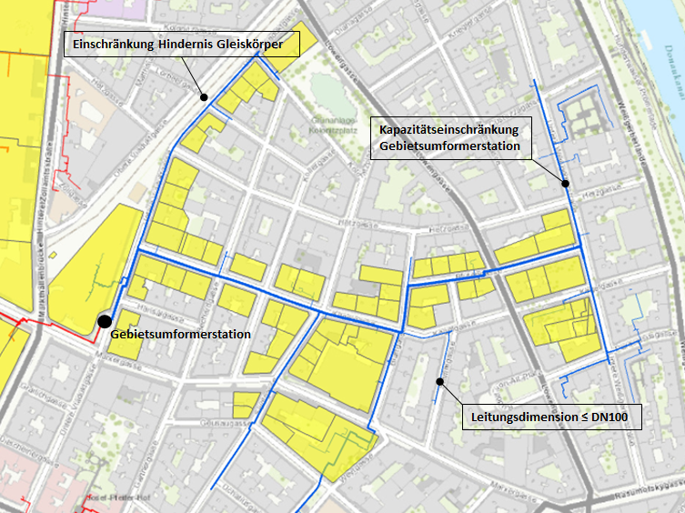

Figure 6: Example of the effect of different technical restrictions (blue lines – secondary network)

|  |  |
| --- | --- |
| Einschränkung Hindernis Gleiskörper | Restriction obstacle track body |
| Kapazitätseinschränkung Gebietsumformerstation | Capacity restriction area heat exchange station |
| Gebietsumformerstation | Area heat exchange station |
| Leitungsdimension ≤ DN100 | Pipe dimension ≤ DN100 |



Figure 7: Examples of the effect of different technical restrictions on the primary network

|  |  |
| --- | --- |
| Leitungsdimension < DN80 | Pipe dimension < DN80 |
| Verlegeart: Pressung | Installation type: Pressing |
| Geringe Leitungskapazität | Low line capacity |

* + 1. Economic evaluation of the individual connections:

In the case of a new building, the costs of a connection are examined based on this technical connectivity of a property. This includes all costs incurred by the energy supplier and network operator, such as investment costs in connection with the connection of the building to the heating network or ongoing costs in connection with the generation and transport of the heat to the supplied property. If the income from the sale of heat covers the costs and thus there is amortisation, the economic assessment of a property is generally positive on the part of the companies. The cost-effectiveness of district heating connection is ultimately also relevant for the costs on the part of the end customer, i.e. for affordable heat supply.

* + 1. Formation of consolidation zone:

Areas of the network are defined as consolidation zones in the sense of a superordinate, forward-looking and sustainable design and development of energy supply. The sum of the properties recorded along a line section must lead to a positive assessment of the technical-economic connectivity. For this, the heat density or heat consumption along a network section must be sufficient and the area heat exchange station and the existing lines must have the necessary capacities. The hydraulics of the network infrastructure, especially the transfer stations, must also be able to withstand the loads if multiple new buildings are connected.

**In the built-up urban area** (‘existing city’), the structural development is difficult to estimate. New construction and renovation rates are fraught with great uncertainties, making it difficult to simulate the expected/changing heat densities using the available data. Therefore, the evaluation shown above always refers to a potential new building without taking into account a change in the heat densities in the rest of the area.

**In completely undeveloped areas** in the urban development (‘new development area’), the expected construction density was a decision criterion for the potential connectivity. The probable construction development until predominantly 2025 was used for this.

The consolidation zones ultimately result in the sub-areas specified in the spatial energy plan in which the Ordinance applies.

The Ordinance has no effect on buildings already connected to district heating. Nothing changes even for buildings outside the consolidation zones that are already supplied with district heating. They can usually be supplied with district heating again in new buildings. Due to technical restrictions (see figure), however, additional surrounding buildings cannot be supplied, the district heating supply cannot be consolidated in these areas, so no area-wide zone was formed.[7]

Instead, new connections have to be forced in consolidation zones in order to increase the overall efficiency of the network and, overall, to make a greater contribution to climate protection.



Figure 8: Zoning in the sense of §2b of the Spatial Energy Plans – no area-wide zone can be defined in the red area due to the technical restrictions (insufficient dimension of the line).

|  |  |
| --- | --- |
| Gebiet für Fernwärme/Erneuerbare | Area for district heating/renewable |
| Bereits mit Fernwärme versorgt | Already supplied with district heating |
| GUFO | Area heat exchange station |

The following figure shows an overview of the procedure for forming the consolidation zones.

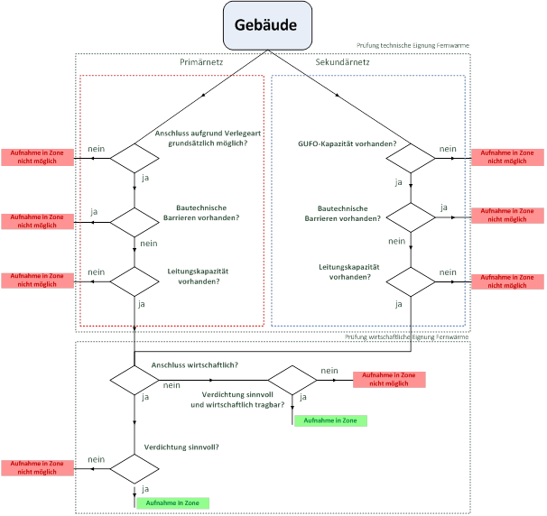

Figure 9: Decision tree and assessment steps for connecting the property to the district heating network (source: Wiener Netze)

|  |  |
| --- | --- |
| Gebäude | Building |
| Prufung technische Eignung Fernwarme | Analysis of technical suitability for district heating |
| Primärnetz | Primary network |
| Sekundärnetz | Secondary network |
| Aufnahme In Zone nicht möglich | Cannot be added to zone |
| nein | no |
| ja | yes |
| Anschluss aufgrund Verlegeart grundsätzlich möglich? | Connection possible due to the type of installation? |
| Bautechnische Barrieren vorhanden? | Are there any technical barriers? |
| Leitungskapazität vorhanden? | Line capacity available? |
| GUFO-Kapazität vorhanden? | Area heat exchange station capacity available? |
| Prufung wirtschaftliche Eignung Fernwarme | Analysis of economic suitability for district heating |
| Anschluss wirtschaftlich? | Connection economical? |
| Verdichtung sinnvoll und wirtschaftlich tragbar? | Is consolidation useful and economically viable? |
| Aufnahme In Zone | Addition to zone |
| Verdichtung sinnvoll? | Does consolidation makes sense? |

The test methodology was reviewed by an expert appraiser[8].

* 1. Analysis of other highly efficient alternative systems

Renewable heating systems such as biomass, heat pump systems (geothermal energy, thermal groundwater use, air) and ultimately also combined heat and power plants (CHP) are further highly efficient alternative systems in accordance with § 118(3) Vienna Building Code.

Since an individual analysis cannot be carried out in the same evaluation depth of an approval process for a specific project at the level of the spatial energy plans, the following approach was chosen:

* Calculations by the Federal Institute of Geology (GBA) show that geothermal energy (geothermal probes) can generally be used via heat pumps, even in large-scale new buildings.[9]
* At locations where this variant cannot be implemented for technical reasons (due to installations or underground structures), systems with air-source heat pumps can be used.
* A first report commissioned by the MA20 in the course of drawing up the spatial energy plans shows that both heat pump systems (geothermal, air) can be implemented economically.[10]
* A second report shows that biomass and ultimately also gas CHP are technically and economically feasible.[11]

Legally, there are restrictive factors in some areas, such as water legislation, noise protection or air pollution control, which must be checked in individual cases.

A sensible prerequisite for the cost-effective and efficient use of renewable heating systems is a new building with high building standards and therefore reduced energy requirements for heating and hot water.

Said calculation by the Federal Institute of Geology shows that sufficient heat is available in the ground (up to 300m depth) to supply buildings and building fields with a good building envelope to a certain (heat) density with heat and hot water. The amount of heat removed depends on the drilling depth and the number of geothermal probes. If the soil is additionally regenerated in summer, the probe field can be configured and operated more efficiently and a higher structural density can be supplied. Regeneration takes place primarily by cooling the building in summer by removing excess heat from the building and releasing it to the probe field, which has cooled down in winter. In addition, other heat sources such as waste heat from companies, waste water, district heating, solar thermal energy etc. can be used for regeneration. Buildings that are equipped with such a system also have the immense advantage that the apartments or premises can be cooled and thus overheating in the summer can be prevented in a very comfortable and cost-effective manner.

An initial assessment of the geothermal potential in Vienna's urban area can be found at <https://www.wien.gv.at/umweltgut/public/grafik.aspx?bookmark=CuAcRDJmhkPNtwlHcSynRjnCzpYzRcmAG9PhyFndEuR6S6-cHaP-cYbMgAOp6YgBrnIiZA-cQA-b>. The potential for thermal groundwater use can be found there.

Therefore, at least one other alternative system or a combination of different systems is technically feasible in the areas for which a spatial energy plan is established.

1. Content, procedure and legal consequences

The orange hatched and orange outlined areas demarcated down to the parcel based on the current property boundaries (digital cadastral map, Federal Office of Metrology and Surveying). The traffic areas within the demarcation are not subject to the Ordinance. The presentation is based on the administrative map of Vienna (MA41 city survey) and the digital cadastral map.

With the Energy Spatial Plan Ordinance, the City of Vienna complies with the legal authorisation according to §2b(2) Vienna Building Code. The implementation takes place in accordance with the provisions of the Vienna Building Code.

The procedure for enacting the spatial energy plans must be carried out in accordance with § 2b(5) Vienna Building Code. § 2(1), (5), (6), (7), (8) and (9) apply mutatis mutandis, i.e. the procedure is similar to the zoning and development plan procedure.

After the determination has been resolved by the municipal council the resolution will be promulgated in the Official Journal of the City of Vienna. Anyone may request a copy of the resolutions and associated plan appendices upon promulgation.

Transitional provisions:

In accordance with § 5, this Ordinance shall enter into force three months following promulgation hereof. In accordance with § 6, this Ordinance does not apply to all building permit procedures pending at the time this Ordinance enters into effect.

The transitional provision (three months) is based on the fact that the empowerment to enact the Ordinance was already announced with the Amendment of the Building Code at the end of 2018 and was also implemented with a three-month delay. Pending construction procedures are exempt from the Ordinance for the sake of planning security for submitters.

Specific Part

1. Area description
   1. Area under observation: district

Ottakring is the 16th District of Vienna and is made up of the cadastral communities 01403 Neulerchenfeld and 01405 Ottakring. The district is 867 hectares in size and takes up 2% of the total city area. Ottakring is bordered by Lerchenfelder Gürtel in the east, and the foothills of the Wienerwald in the west. Adjoined by the 17th District – Hernals to the north, Ottakring borders on the 14th District – Penzing and the 15th District – Rudolfsheim-Fünfhaus in the south.

A third of Ottakring consists of green areas, which in turn are about 75% forested. About 1.2% of the district’s area is still used for agriculture. Over half of the district is dedicated to building land, about 86% of which is used for residential areas.

The development of the district shows significant differences. Near the Lerchenfelder Gürtel is a densely built, grid-shaped Wilhelminian-style district with residential buildings in predominantly enclosed construction. Around Vorortelinie, there are industrial plants and workshops with factory halls from the Wilhelminian period which are mostly spacious and imposing, and some are still in operation today. These include the Ottakringer brewery, the Meinl factory – the coffee roasting house is still at this location today (since 1912) – as well as the Austria Tabak Fabrik Ottakring. To the west is the villa district with Ottakringer cemetery, followed by the Wienerwald. Allotment settlements are grouped around the Wilhelminenspital. The Wilhelminenspital and Vienna's oldest waste incineration plant on the Flötzersteig are also located in Ottakring.

* 1. District heating infrastructure and designation of zones

Most of the district heating buildings of the 16th District are supplied via two lines, which are fed by a large transport line along the Lerchenfelder Gürtel. One of these lines extends along the southern boundary of the district and the other connects to the supply area from the north. Both lines are connected to each other and form a ring that feeds several smaller and larger secondary networks. The Flötzersteig waste incineration plant is located in the district and is connected to the primary supply network.

4 consolidation zones (= zones) were identified based on the methodology described in Chapter 3. These consolidation zones are characterised by the already well-developed district heating infrastructure. This enables a high connection density over the long term and thus an unbundling of the infrastructure.

The designation thus encompasses zones in which the prerequisites as per § 2b(2) Vienna Building Code apply. District heating infrastructure is available or can be made available and at least one other highly efficient alternative system (such as heat pumps) can be used.

The zones are described below:

* + 1. Zones

**16/001/1**

Territorial delineation: The zone lies between Sautergasse (district border) in the north and Seeböckgasse in the south. The zone extends to Heigerleinstrasse in the west, part of it along the S 45 tracks to Beringgasse. A small part of the zone stretches to Wattgasse in the east; furthermore Wurlitzergasse, Redtenbachergasse and Römergasse form the eastern borders.

Seitenberggasse and Albrechtskreithgasse form the core area of the zone.

Current stock: The zone is characterised by a Wilhelminian block perimeter with a great deal of old stock mostly three to four floors high. Around Seitenberggasse, there are several large blocks with buildings built after 2000.

Developments: Between the S 45 tracks and Heigerleinstrasse, there are already dedicated areas for new building developments with a focus on business and office.

**16/002/1**

Territorial delineation: The zone extends west of Sandleitengasse from Ottakringerstrasse in the south to Steinmüllergasse in the north and is bordered to the west by Pllitzergasse, the allotment garden of Kulturfreunde Weiskerngasse and the WAT Ottakring tennis court. To the east, the area runs along Sandleitengasse between Lobmeyergasse and Wögingergasse, in some parts up to the S45 tracks, and along Arnethgasse almost to Römergasse.

Current stock: The building development west of Sandleitengasse between Ottakringerstrasse and Degengasse took place around 1962. The further development along Sandleitengasse took place in the interwar period in the form of block perimeter development. Around the year 2000, business buildings were erected between Roterdstrasse and Nietzscheplatz, beyond which they are adjoined by Adolf-Schärf-Hof, which was built in 1983. Sandleitenhof is located in the area between Sandleitengasse, Rosenackerstraße, Pollitzergasse and Baumeistergasse and was built from 1924 to 1928. The building development east of Sandleitenstraße along Seeböckgasse consists roughly equally of Wilhelminian-style block edge buildings mostly three to four storeys high and buildings that were built after 1945. A similar mixture can be found along Arnethgasse.

Developments: No major structural developments are expected in the zone. Consolidation could only take place in the foreseeable future in Lobmeyrgasse 1-3 (Meinl-Gründe).

**16/003/1**

Territorial delineation: The zone encompasses the premises of Wilhelminenspital between Flötzersteig, Montleartstrasse, Thaliastraße and Johann-Staud-Strasse and ends at the allotment gardens to the west.

Current stock: Wilhelminenspital was founded around 1850 and the premises were built with individual pavilions, some of which are under historical preservation. Renovations and new constructions are taking place on a constant basis. There are residential buildings in the northern part of the zone.

Developments: There are no known urban development projects in the zone.

**16/004/1**

Territorial delineation: The zone is bordered to the east by Maroltingergasse; the parking facilities of Wiener Linien were included. In the north, the territorial delineation follows Hasnerstrasse, runs into most of Lorenz-Mandl-Gasse, then follows Hasnerstrasse again, includes HTL Ottakring and encompasses both sides of the building development on Hettenkofergasse and Redtenbachergasse to Arnethgasse in the north. From Schuhmeierplatz, the zone follows Wichtelgasse north to the district boundary at Geblergasse. At Brüßlgasse, the territorial delineation runs southward to Koppstraße and then ends at Hyrtlgasse to the west. In the south, the zone is bordered by Gablenzgasse and, following Huttengasse, ends at Steinbruchstrasse further south.

Current stock: The construction within the area between Steinbruchgasse, Huttengasse, Wernhardstraße and Maroltingergasse largely took place in block perimeter development between 1946 and 1976. Only the block between Roseggergasse, Maderspergerstraße and Lorenz-Mandl-Gasse dates back to the Wilhelminian period.

The block perimeter development within the area between Hasnerstraße, Huttengasse, Wernhardstraße and Maroltingergasse largely originates from the Wilhelminian period. In smaller areas, the building development was replaced by new buildings, in which the urban structure has been preserved.

The buildings along Gablenzgasse and south of Koppstrasse date mainly back to the interwar and post-war period. North of Koppstraße and along the northern expanse of the zone, there are predominantly buildings from the Wilhelminian period. In small areas, the buildings were replaced by buildings from the interwar and post-war periods. There are various large industrial structures along the subway line (Kendlergasse-Paltaufgasse).

Developments: There are no known urban development projects in the zone.

A consolidation zone could not be defined in the area north-east and east outside of zone 16/004/1, because the criteria for forming a consolidation zone are not met, firstly due to the way the district heating lines are laid and secondly due to the area exchanger capacity available there. The prerequisites under § 2b(2) Vienna Building Code are therefore not met.

Two consolidation zones were identified in the northern part of the 16th district. Additional buildings could not be included in the zone due to the limited area exchanger capacity there.

Buildings that have already been supplied in the undesignated areas are not suitable for a consolidation zone due to the low density of the district heating infrastructure currently available there.

Magistrate Department 20 submits this report with a request that the application contained in Appendix 1 be approved by the Municipal Council Committee on Urban Development, Transport, Climate Protection, Energy Planning and Citizens' Participation, the City Senate and the Municipal Council.

|  |  |
| --- | --- |
| Contact:  DI Andrea Kinsperger  Tel.: (+43 1) 4000 - 88322  DI Stefan Sattler  Tel.: (+43 1) 4000 - 88308 | Best regards,  Head of Department:  electronically prepared  Mag. Bernd Vogl  Senate Councillor |

For information:

Urban Planning Director

Magistrate Directorate Building Director – Competence Centre for Building Research, Construction Regulation, Engineering Services, Standards

1. This refers to new buildings pursuant to § 60 (1)(a) Vienna Building Code: *‘[…] New building refers to the construction of new buildings; this is also at hand if all or part of the foundations or basement walls are reused after the removal of existing structures. […]‘.*Additions and conversions are not affected by this Ordinance.
2. Technical concept productive city, workshop reports of Vienna Urban Development (Number 171), City of Vienna (2017)
3. At the time the KliP II was passed, the Energy Department was a unit of Magistrate Department 27. Since 2011, the agendas have been with Magistrate Department 20 Energy Planning.
4. ‘One city, two million opportunities. The red-green intergovernmental agreement for a social, cosmopolitan and liveable Vienna’
5. Directive 2010/31/EU of the European Parliament and of the Council of 19 May 2010 on the energy performance of buildings (as amended by Directive (EU) 2018/844 of the European Parliament and of the Council of 30 May 2018).
6. The use of near-surface geothermal energy (up to a depth of 300 m) works by extracting heat from the ground via geothermal probes. Seasonal storage is when the heat from the buildings is fed into the geothermal probes in summer and can be removed for heating in winter.
7. Development and structure of the district heating network: The district heating network extends across large parts of the city. District heating was initially designed to supply hospitals and public buildings. It was continuously expanded from various central plants, such as waste incineration plants, until all subnetworks could be connected. District heating is distributed in the city from central systems via a primary network with temperatures of up to 150 degrees Celsius. Depending on the type of installation, a connection to district heating may not be economically viable. Area heat exchangers distribute the heat from the primary lines at a temperature of 70 to 90 degrees C secondary networks. These area exchangers have a defined thermal capacity that they can distribute. The construction of a new area exchanger is very cost-intensive and can only be supported if a corresponding expansion of the heat demand is foreseeable. The district heating is then transferred directly to a property or building through the connection line and the transfer station.
8. Technical energy management report on the amendment of Vienna Building Code 2018 (§2b Spatial Energy plans) – FERNWÄRME (District Heating), Univ. Prof. Dr. Dipl. Ing. Reinhard Haas, attached to the file.
9. Source: Bund- Bundesländer Kooperation WC-35, Geologische Bundesanstalt, Wien; März 2019 [Federal-Provincial Cooperation WC-35, Geological Survey, Vienna; March 2019]
10. Gutachten Büro Treberspurg & Partner, attached to the file
11. Technical energy management report on the amendment of Vienna Building Code 2018 (§2b Spatial Energy Plans) – HOCHEFFIZIENTE ALTERNATIVE SYSTEME [Highly Efficient Alternative Systems] Univ. Prof. Dr. Dipl. Ing. Reinhard Haas, attached to the file