1. ------IND- 2009 0568 D-- EN- ------ 20091105 --- --- PROJET

Technical specification

on lasers as or in consumer products

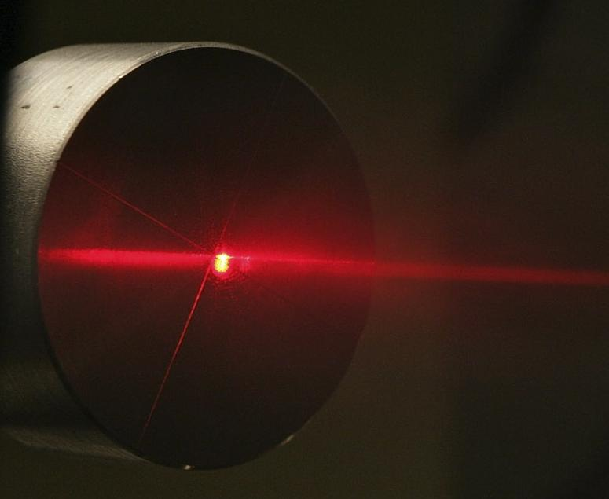

The obligations from European Parliament and Council Directive 98/34/EC of 22 June 1998 on an information procedure in the fields of standards and technical regulations and the regulations for the services of the information society (OJ EC No. 204 pg. 37), amended by Directive 98/48/EC of the European Parliament and Council dated 20 July 1998 (OJ L EC No. L 217 S. 18) have been observed.
Legal notice

Technical specification on lasers as or in consumer products

Authors: Working Committee ‘Lasers as consumer products’

Publisher: Bundesanstalt für Arbeitsschutz und Arbeitsmedizin (BAuA - Federal Institute for Occupational Safety and Health)
Friedrich-Henkel-Weg 1-25
D-44149 Dortmund
Tel.: +49 (0) 231 9071-0
Fax: +49 (0) 231 9071-2364
E-mail: physical.agents@baua.de
Internet: http://www.baua.de

Photo: Fox Agency – Uwe Völkner, Lindlar/Cologne

This technical specification is copyright protected. Any reuse, even in excerpts, requires the prior consent of the BAuA; any form of dissemination in return for payment is prohibited. This work shall be made available to any party interested in using it free of charge for private, non-commercial purposes. The Bundesanstalt für Arbeitsschutz und Arbeitsmedizin (BAuA - Federal Institute for Occupational Safety and Health) reserves all rights thereto, including rights to photomechanical reproduction and re-printing in excerpt.
This technical specification was compiled with great care and to the best knowledge of its authors. However, the Federal Institute for Occupational Safety and Health assumes no liability for its correctness or completeness.

As of: August 2009

Preamble
This technical specification serves in assessing the risks of consumer products which are lasers or which contain lasers and is directed at manufacturers, authorised agents and importers. It defines requirements on lasers as or in consumer products so that the safety and health of users or third persons are not jeopardised during intended use as well as in the event of foreseeable misuse.

Background
Lasers are increasingly being used in the private sector in tools such as laser pointers, alignment lasers and distance measurement devices. These are frequently used by persons without sufficient knowledge of the risks of laser radiation.
The risk assessment of laser devices is conducted under use of the classification rules for lasers pursuant to DIN EN 60825-1, ‘Safety of laser devices, Part 1: Classification of systems and requirements’. The division of lasers into classes takes the risk potential of lasers into consideration, and the optical power and/or energy of lasers in particular. The following generally applies: the higher the class number, the greater the risk. Particular requirements for the laser product manufacturer are placed on the classes, such as requirements on the design and user information. The safety measures tied to the laser classes are binding for commercial use and should also be complied with in private use. Therefore, the basic principles of the class division have immediate effects on the safety and health protection of persons using lasers.
Potentially dangerous lasers of higher classes (> laser class 2M) can increasingly be found on the market, although the use of lower output lasers (laser classes 1, 1M, 2 and 2M) would suffice for the intended application.

This technical specification also establishes the requirements for consumer products which had previously been missing.

Scope of application
This technical specification applies to lasers placed on the market as consumer products or in consumer products. It does not apply to products subject to special European Community harmonisation legislation and the national legislation (such as the Medicinal Products Act, regulations pursuant to Section 3 Para. 1 of the Equipment and Product Safety Act (Geräte- und Produktsicherheitsgesetz, GPSG) implementing it (see Annex 5).
Note:
Reference is made to the application of the Electromagnetic Compatibility Act in Annex 4.
Definitions
The definitions established in DIN EN 60825-1:2008-05, ‘Safety of laser devices, Part 1: Classification of systems and requirements’ shall apply.

Requirements
Technical requirements
Consumer products which are lasers or contain lasers may only be placed on the market if they have been classified in accordance with DIN EN 60825-1 and correspond to laser classes 1, 1M, 2 or 2M.
Only lasers which adhere to the accessible radiation limits of class 1 under all operating conditions are exempt from compulsory classification.
Consumer products which are or contain class 3R, 3B or 4 lasers may not be placed on the market.
All laser devices freely operated in a moveable manner in a room (such as laser pointers, range finders, levelling lasers, etc.) which are used solely for projecting light may belong to a laser class no higher than 2M.
The least favourable conditions (such as full batteries) are to be taken into account during classification pursuant to DIN EN 60825-1.

Note:
Class 3R, 3B and 4 lasers may exceed the exposure limit values for the eyes and skin. Such lasers may only be used in the commercial sector if special safety measures are taken (see accident prevention regulation ‘Laser Radiation’ BGV B2 (Berufsgenossenschaftliche Vorschrift – Employer’s Liability Insurance Association Regulation). In the event of private use, the manufacturers, their authorised agents and the importer of such laser devices cannot guarantee compliance with these special safety measures in order for these products to be used safely.

Formal requirements
During placement on the market, steps must be taken to ensure that the user receives all the information (user manual and labelling) for safe use in German. The user manual must contain at least the rules of conduct pursuant to Annex 1. Consumer products which are lasers or contain lasers must be labelled in accordance with DIN EN 60825-1. As an example, the labelling of the various laser classes is listed in Annex 2.
The name of the manufacturer or of the authorised agent or importer and their addresses, if the manufacturer is not based in the European Economic Area, must be attached to the consumer product or its packaging. In addition, the consumer product must be labelled in such a manner (i.e. with the item number) that it can be unambiguously identified.
Note:
Reference is made to the practical information in Annex 6.
Annex 1:
User manual
The following laser-specific rules of conduct must be followed when compiling a user manual for lasers of classes 1, 1M, 2 and 2M:
- Do not point the laser beam at people (even class 1 lasers may not be pointed at people, since accidents from dazzling may occur).
- Do not look directly into the beam or into the reflected beam.
- If a laser beam of class 1M (if visible), 2 or 2M comes into contact with the eye, the eyes must be closed consciously and the head must immediately be moved away from the beam.
Note: The results on hand on the investigations on the eyelid closure reflex and gaze aversion reactions are to be taken into consideration (see Annex 3).
- No optical instruments for viewing the source of the laser beam may be used during the use of class 1M and 2M laser devices. This may cause the exposure limit values to be exceeded.
- Manipulations (modifications) of the laser device are not permissible.
- This user manual is to be kept and passed on if the laser device is transferred.

Annex 2
Labelling examples
Note: Graphic symbols, labels and borders must be printed in black, the backgrounds in yellow.

1. Labelling of a class 1 laser
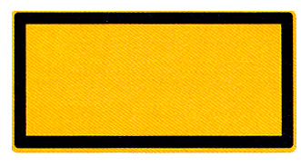

Laser Klasse 1

nach DIN EN 60825-1:2008-05

Laser class 1

in line with DIN EN 60825-1:2008-05

2. Labelling of a class 1M laser

Laserstrahlung
Nicht direkt mit optischen
Instrumenten betrachten
Laser Klasse 1M
nach DIN EN 60825-1:2008-05

Laser radiation
Do not view directly with optical instruments
Laser class 1M
in line with DIN EN 60825-1:2008-05

Note: With lasers of classes 1 and 1M, the manufacturer may omit the labelling on the laser device and include only these statements in the user manual.
Laser devices of classes 2 through 4 must be described pursuant to Section 5.8 of DIN EN 60825-1 on a notice sign with specifications on the maximum output values of the laser radiation, the impulse duration (if applicable) and the wavelength(s) being emitted. These specifications may be described together with the specification of the class on a single notice sign, or they may be described on a separate notice sign.

3. Labelling of a class 2 laser

a) or b)

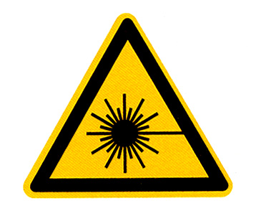

Laserstrahlung
Nicht in den Strahl blicken
Laser Klasse 2
nach DIN EN 60825-1:2008-05
Laserstrahlung
Nicht in den Strahl blicken
Laser Klasse 2
nach DIN EN 60825-1:2008-05
P ≤ 1 mW
λ = 650 nm

P ≤ 1 mW
λ = 650 nm

Laser radiation
Do not look into the beam
Laser class 2
in line with DIN EN 60825-1:2008-05

Laser radiation
Do not look into the beam
Laser class 2
in line with DIN EN 60825-1:2008-05
P ≤ 1 mW
λ = 650 nm

4. Labelling of a class 2M laser

Laserstrahlung
Nicht in den Strahl blicken oder
direkt mit optischen
Instrumenten betrachten
Laser Klasse 2M
nach DIN EN 60825-1:2008-05

λ = 650 nm
E ≤ 25 W/m²

Laser radiation
Do not look into the beam or
view directly with
optical instruments
Laser class 2M
in line with DIN EN 60825-1:2008-05

Annex 3 (informative)
Scientific findings on eyelid closure reflex and gaze aversion reactions
.
In DIN EN 60825-1, the safety concept for classes 2, 2M and 3R is based on a time basis of 0.25 s (brief exposure). Until DIN EN 60825-1:2003-10 was issued, a physiological limitation was simulated through gaze aversion reactions including the eyelid closure reflex. Examinations of approximately 1,800 test subjects have indicated that, depending on the wavelength, an eyelid closure reflex was only present in around 16-22% of the test subjects when they were exposed to 250 ms (for example) of laser radiation at 80% of the maximum permissible radiation level. Gaze aversion reactions such as movements of the head and eyes upon exposure to a laser beam occurred even less frequently, with less than 9% in approximately 600 test subjects. As a result, no certain statements could be made on eye protection via eyelid closure reflex and gaze aversion reactions in terms of prevention.
In spite of absent or insufficient gaze aversion reactions, including the eyelid closure reflex, there is no definite evidence of eye injury from brief unconscious exposure.
In the event of consciously gazing into a beam from a class 2 or 3A laser, the risk of eye injury increases as the duration of exposure rises. Even severe dazzling connected to an exposure does not necessarily induce gaze aversion reactions, meaning that the duration of exposition is not reduced.
Investigations have shown that protection from exposure to laser beams from class 2 lasers can be increased significantly by means of active protective reactions. Active protective reactions are the conscious, active closure of the eyes and turning of the head.
In the meantime, reference is made to the aforementioned interrelations in an informative annex describing the laser classes in the second edition of the DIN EN 60825-1 standard. It reads:
- The labelling instructs users not to gaze into the beam, that is, to perform active protective reactions by moving the head or closing the eyes and avoiding prolonged intentional gazing into the beam.
Even class 1 lasers can have a high secondary-risk potential as a result of their dazzling effect. Just as with the effects of gazing into other bright sources of light, such as the sun or headlights, temporarily impaired vision and after-images can, depending on the situation, cause irritation, annoyance, disturbances and even lead to accidents. The degree of severity and decay time are not easily quantifiable. But they depend to a large degree on the difference in brightness between the source of the dazzling light and the surroundings and on the exposure parameters such as power density (irradiation intensity) and duration of exposure.
Annex 4 (informative)

Application of Electromagnetic Compatibility Act to consumer products with lasers

Consumer products which contain electrical or electronic parts may cause electromagnetic disturbances, or their normal operation may be impaired by such disturbances. Therefore, consumer products which contain electrical or electronic parts fall under the Electromagnetic Compatibility Act.

Note: Further details on this matter can be found in the document ‘Guidelines on the application of Council Directive 2004/108/EC of 15 December 2004 for adapting the statutory regulations of the Member States on electromagnetic compatibility (EMC guidelines – as of 21 May 2007)’.

Annex 5 (informative)
Standards for products subject to a statutory regulation pursuant to Section 3, Para. 1 of the Equipment and Product Safety Act, which contain requirements for safe use, such as a limitation to a maximum laser class

DIN EN 60065 (VDE 0860):2006-12 Audio, video and similar electronic devices – Safety requirements (IEC 60065:2001, modified + A1:2005, modified); German version EN 60065:2002 + A1:2006 + Corrigendum: 2006

DIN EN 62115 (VDE 0700-210):2006-01 Electric toys – Safety (IEC 62115:2003 + A1:2004, modified); German version EN 62115:2005

Annex 6 (informative)
Practical information

Lasers are frequently supplied on the market in consumer products which are designated class ‘IIIa’, ‘IIIA’ or ‘3a’. These do not correspond to the applicable DIN EN 60825-1, but are classified in accordance with the American ANSI/CDRH regulations. These essentially correspond to class 3R lasers in accordance with DIN EN 60825-1 and thus do not meet the requirements of this technical specification.
In the commercial sector or within the scope of application of BGV B2, the handling of lasers in this class, for instance, is linked to an array of safety measures extending to the appointment of a laser safety officer.
Important information on the subject can also be found in the accident prevention regulation ‘Laser Radiation’ BGV B2.

