KINGDOM OF BELGIUM
FEDERAL PUBLIC SERVICE FOR THE ECONOMY, SMEs, THE SELF-EMPLOYED AND ENERGY

10 July 2022 - Royal Decree inserting Chapter 7.22. of Book 1 and amending certain parts of Books 1 and 3, introduced by the Royal Decree of 8 September 2019 establishing Book 1 on low-voltage and extra-low-voltage electrical installations, Book 2 on high-voltage electrical installations and Book 3 on electricity transmission and distribution installations

PHILIPPE, King of the Belgians,
To all those present and to come, Greetings

Having regard to the Law of 10 March 1925 on electrical energy distribution, Article 21(1);
Having regard to the Act of 4 August 1996 on the well-being of workers in the performance of their work, Article 4, Section 1, paragraph 1, as amended by the Act of 7 April 1999, and Article 5, Section 3;
Having regard to the Royal Decree of 8 September 2019 establishing Book 1 on low voltage and extra low voltage electrical installations, Book 2 on high voltage electrical installations and Book 3 on electricity transmission and distribution installations;
Having regard to the opinion of the Inspector of Finance issued on 25 February 2021;

Having regard to the opinion of the High Council for Prevention and Protection at Work, issued on 17 November 2021, pursuant to Article 95, paragraph 1, of the Act of 4 August 1996 on the well-being of workers in the performance of their work;

Having regard to the opinion of the High Council for Protection against Fire and Explosions, issued on 22 December 2021, pursuant to Article 6, Section 1, paragraph 2 (b), of the Act of 30 July 1979 on the prevention of fires and explosions and on mandatory civil liability insurance in the circumstances thereof;

Having regard to the Communication to the European Commission, dated 2 March 2021, pursuant to Article 5(1) of Directive (EU) 2015/1535 of the European Parliament and of the Council of 9 September 2015 laying down a procedure for the provision of information in the field of technical regulations and rules relating to information society services;

Having regard to the opinion of the Standing Committee on Electricity, issued on 24 March 2022, pursuant to Article 22(5) of the Law of 10 March 1925 on the distribution of electricity, as amended by the Law of 8 May 2014;
Having regard to Opinion 71.421/3 of the Council of State, issued on 25 May 2022, pursuant to Article 84, § 1(2) of the Laws on the Council of State, consolidated on 12 January 1973;

On the proposal of the Minister of Labour and the Minister of Energy,
WE HAVE DECREED AND HEREBY DECREE:

Article 2. The following amendments are made to Annex 1 to the same Decree:

1. in Book 1, Part 2, Chapter 2.6., section 2.6.1., the following definition is introduced between the definitions of “elementary circuit” and “circuit”:

“Exclusively dedicated circuit (herein also referred to as dedicated circuit Book): elemental circuit (main circuit or terminal circuit) intended for the exclusive supply of one or more appliances intended for a specific purpose.”;

2. in the French text of Book 1, the words “dispositif(s) à courant différentiel résiduel”, “dispositif(s) à courant différentiel-résiduel”, “dispositif(s) de protection à courant différentiel”, “dispositif(s) de protection à courant différentiel résiduel” and “dispositif différentiel” are each time replaced by the words “dispositif(s) de protection à courant différentiel-résiduel”;

3. in the Dutch text of Book 1, the word “differentieelstroominrichting(en)” is each time replaced by “differentieelstroombeschermings-inrichting(en)”;

4. in the French text of Book 1, Part 5, Chapter 5.2., section 5.2.1., subsection 5.2.1.2., paragraph 7, the words “circuit(s) exclusivement dédié(s)” are each time replaced by the words “circuit(s) dédié(s)”;

5. in the French text of Book 1, Part 5, Chapter 5.2., section 5.2.9., subsection 5.2.9.13., points b.11. and c.11., the words “circuit exclusivement dédié” are replaced by the words “circuit dédié”;

6. in the Dutch text of Book 1, Part 5, Chapter 5.2., section 5.2.1., subsection 5.2.1.2., paragraph 7, the words “exclusief toegekende stroombaan (stroombanen)” are replaced by the words “toegekende stroombaan (stroombanen)”;

7. in the Dutch text of Book 1, Part 5, Chapter 5.2., section 5.2.9., subsection 5.2.9.13., points b.11. and c.11., the words “gescheiden stroombaan” are replaced by the words “toegekende stroombaan”;

8. in the Dutch text of Book 1, Part 5, Chapter 5.5., section 5.5.7., subsection 5.5.7.2., paragraphs 5 and 6, the words “afzonderlijke stroombaan (stroombanen)” are replaced by the words “toegekende stroombaan (stroombanen)”;

9. iin the Dutch text of Book 1, Part 5, Chapter 5.6., section 5.6.2., subsection 5.6.2.1., paragraphs 3 and 4, the words “afzonderlijke stroombaan (stroombanen)” are replaced by the words “afzonderlijke stroombaan (stroombanen).”
Article 3. The following amendments are made to Annex 3 to the same Decree:

1. in Book 3, Part 2, Chapter 2.6., section 2.6.1., subsection 2.6.1.1., the following definition is inserted between the definitions of “elementary circuit” and “circuit”:

“Exclusively dedicated circuit (herein also referred to as dedicated circuit Book): elemental circuit (main circuit or terminal circuit) intended for the exclusive supply of one or more appliances intended for a specific purpose.”;

2. in the French text of Book 3, the words “dispositif(s) à courant différentiel résiduel”, “dispositif(s) à courant différentiel-résiduel”, “dispositif(s) de protection à courant différentiel”, “dispositif(s) de protection à courant différentiel résiduel” and “dispositif différentiel” are each time replaced by the words “dispositif(s) de protection à courant différentiel-résiduel”;

3. in the Dutch text of Book 3, the words “differentieelstroominrichting(en)” and “differentieelinrichting” are each time replaced by the words “differentieelstroombeschermingsinrichting(en)”;
4. in the Dutch text of Book 3, Part 5, Chapter 5.6., section 5.6.7., subsection 5.6.7.2., paragraphs 5 and 6, the words “afzonderlijke stroombaan (stroombanen)” are replaced by the words “toegekende stroombaan (stroombanen)”;

5. in the Dutch text of Book 3, Part 5, Chapter 5.7., section 5.7.2., subsection 5.7.2.1., paragraphs 3 and 4, the words “afzonderlijke stroombaan (stroombanen)” are replaced by the words “toegekende stroombaan (stroombanen).”
Article 4. This Decree shall come into force on the first day of the third month following its publication in the Official Belgian Gazette.

Article 5. The Minister of Labour and the Minister of Energy shall be responsible for the execution of this Decree, each as far as they are concerned.
Issued
By the King:
The Minister for Labour,
Pierre-Yves Dermagne

The Minister of Energy,
Tinne Van der Straeten

Annex

Chapter 7.22. Power supply for road electric vehicles

Section 7.22.1. Scope

The general requirements of the other parts of this Book will also be applicable to special facilities and locations mentioned in this Chapter 7.22. The requirements of this Chapter supplement these general requirements.

This Chapter shall apply to electric road vehicles charging stations whose construction or replacement has commenced as from the entry into force of this Chapter, and shall also apply to circuits:

1. intended to supply electrical power to electric vehicles; and possibly

2. intended to re-inject electricity from batteries of electric vehicles.

The circuits referred to in the preceding paragraph shall end at the connection point.

Therefore, the provisions of Book 1, with the exception of this Chapter, shall continue to apply:

1. to existing charging stations for road electric vehicles whose construction commenced before the entry into force of this Chapter;

2. to charging stations for road electric vehicles whose project construction, installation or replacement work commenced before the entry into force of this Chapter, without prejudice to the fact that the compliance check to be carried out before its entry into use will take place when this Chapter comes into force.

If an existing charging station mentioned in the 4th paragraph, Section 1 is adapted to comply with the provisions of Chapter 7.22., it shall be subject to a compliance check prior to its entry into use, in accordance with the provisions of Chapter 7.22.

If a charging station mentioned in the 4th paragraph, Section 2 is adapted to comply with the provisions of Chapter 7.22., the approved organisation in charge of the compliance check prior to its entry into use shall be informed accordingly. The latter will be mentioned in the inspection report.

The fixed electrical installation intended to supply energy to an electric vehicle which is connected to a source of electricity without a fixed charging station specific for electric vehicles falls under the general requirements of the other parts of this Book.

Section 7.22.2. Terms and definitions

Road electric vehicle (referred to in this chapter as electric vehicle): any vehicle powered by an electric motor whose electric current comes from a rechargeable energy storage system, primarily intended for use on public roads.

Charging station for electric vehicles (referred to in this chapter as charging station): equipment or set of equipment of the permanently connected fixed installation with functions dedicated to the transfer of electric energy between an electric vehicle and the source of electricity.

Point of connection of a charging station for electric vehicles (referred to in this chapter as connection point): termination point forming part of the charging station through which the energy is transmitted to or from an electric vehicle.

Example: A power socket on a charging station or a mobile vehicle socket.

Section 7.22.3. Determination of general characteristics—installations division

It is prohibited to connect a charging station to a fixed electrical installation by means of a power outlet.

A dedicated circuit is provided for each connection point.

The requirement of the preceding paragraph is met by the implementation of the appropriate protective devices either in the fixed electrical installation upstream or in the charging station (or a combination of both).

Figures 7.17. to 7.20. illustrate some possible configurations for clarification purposes. These are not exhaustive:

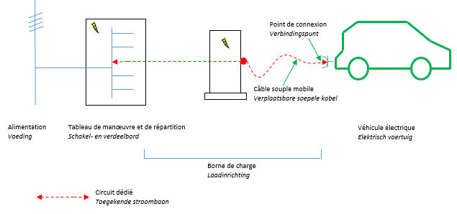
Point de connexion | Connection point
Câble souple mobile | Mobile flexible cable
Alimentation | Supply
Tableau de manœuvre et de répartition | Operation and distribution panel
Borne de charge | Charging station
Véhicule électrique | Electric vehicle
Circuit dédié | Dedicated circuit

Figure 7.17. Charging station with a “mobile vehicle socket” connection point forming part of the charging station (overcurrent protection device of the dedicated circuit integrated into the operation and distribution panel)

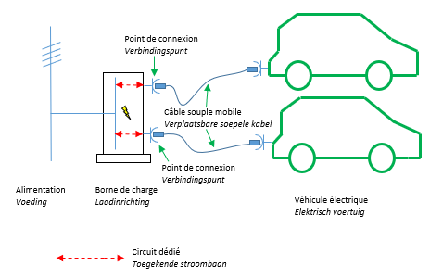
Point de connexion | Connection point
Câble souple mobile | Mobile flexible cable
Alimentation | Supply
Borne de charge | Charging station
Véhicule électrique | Electric vehicle
Circuit dédié | Dedicated circuit

Figure 7.18. Charging station with two connection points “portable sockets on charging station” forming part of the charging station (overcurrent protection devices for dedicated circuits integrated into the charging station)

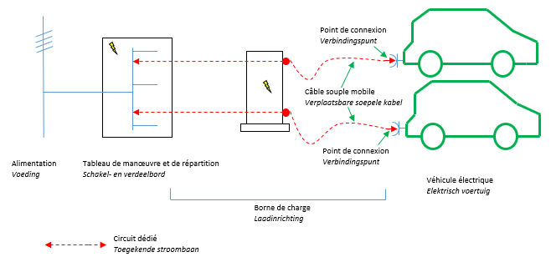
Point de connexion | Connection point
Câble souple mobile | Mobile flexible cable
Alimentation | Supply
Tableau de manœuvre et de répartition | Operation and distribution panel
Borne de charge | Charging station
Véhicule électrique | Electric vehicle
Circuit dédié | Dedicated circuit

Figure 7.19. Charging station with two “automotive portable sockets” connection points forming part of the charging station (overcurrent protection devices for dedicated circuits integrated into the operation and distribution panel)

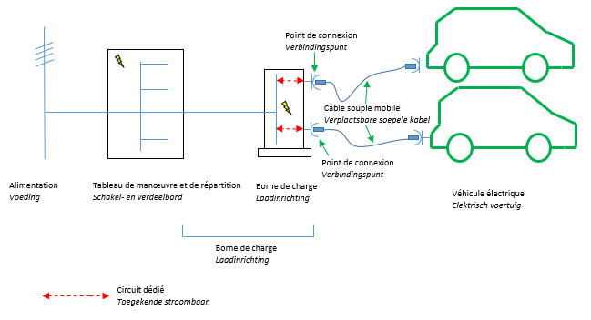
Point de connexion | Connection point
Câble souple mobile | Mobile flexible cable
Alimentation | Supply
Tableau de manœuvre et de répartition | Operation and distribution panel
Borne de charge | Charging station
Véhicule électrique | Electric vehicle
Circuit dédié | Dedicated circuit
Figure 7.20. Charging station with two connection points “portable sockets on charging station” forming part of the charging station (overcurrent protection devices for dedicated circuits integrated into the charging station)

Section 7.22.4. Protective measures

Subsection 7.22.4.1. Protection against indirect contact

At least one of the following protective measures shall apply:

a. Passive protection without automatic disconnection of the power supply

The dedicated circuit shall be protected by the safety separation of the circuits in accordance with point C of subsection 4.2.3.3. and by means of an isolation transformer.

b. Active protection with automatic disconnection of supply

The application of a TN-C earthing system for the dedicated circuit is prohibited.

Each dedicated alternating current circuit is individually protected by a differential-residual current protection device with a working current of up to 30mA.
The connection point is therefore protected:

1. by means of a differential-residual current protection device which is constructed in such a way that its operation remains guaranteed when an insulation error occurs with a continuous component causing disturbance; or

2. by a differential-residual current protection device jointly and in coordination with a continuous differential-residual current detection device that disengages the charging station when an insulation error occurs with a continuous component causing disturbance.

The requirement mentioned in the second and third paragraphs shall be met by the implementation of the protective devices mentioned above either in the fixed electrical installation upstream or in the charging station (or a combination of the two).

For an IT earthing system is used, it is allowed:

1. to omit the differential-residual current protection device mentioned in the second paragraph, provided that each dedicated circuit is supplied separately by an individual source of electricity, for example by a separate winding transformer;

2. to provide for a permanent insulation monitor for more than one dedicated circuit, if these circuits are powered by the same source of electricity, such as, for example, a transformer. This requirement is met by the implementation of this device either in the fixed electrical installation upstream or in the charging station. As soon as a permanent insulation monitor has reported the existence of a single fault in the grounding or earthing, the necessary steps for the investigation and elimination of this fault shall be taken.

Subsection 7.22.4.2. Electrical protection against overcurrents

Each dedicated circuit is individually protected by an adequate overcurrent protection device.

This is carried out accordingly by the implementation of an adequate overcurrent protection device meeting the requirements of Chapter 4.4. and placed either in the fixed electrical installation upstream or in the charging station (or a combination of both).

As an exception to the 1st paragraph, if the charging station has several connection points which are not used simultaneously, it shall be allowed for the latter to have common overcurrent protection devices, provided that such devices offer the protection required for each of the connection points (for example, when the rated current of the common protection device is not higher than the lowest rated current of the connecting points).

Section 7.22.5. Choice and implementation of electrical equipment

Subsection 7.22.5.1. External influences

The charging station is protected against the foreseeable external influences of the place where the charging station is installed.

When the charging station is installed outdoors, the hardware has a protection level of at least IP44.

In addition to measures against foreseeable external influences, additional measures are taken to protect against mechanical stresses due to any reasonably foreseeable collision.

Subsection 7.22.5.2. Emergency cut-off

The charging stations installed in a building shall be provided with an emergency power cut-off in accordance with point C of subsection 5.3.3.1. Each control unit of the emergency power cut-off is clearly visible and labelled accordingly, as well as easily accessible and ready to be operated. They will be available at each entrance accessible to the vehicles towards the common parking space, unless the contractor determines another place upon agreement with the fire department, before the design and construction of the installation. The fire department notice is archived within the electrical installation file and is kept on site at the disposal of anyone who is in charge of the installation, maintenance, monitoring and control work.

The emergency power cut-off ensures a load-break function.

This subsection does not apply to charging stations that are part of the electrical installation of a housing unit.

Subsection 7.22.5.3. Connection point

The connection point is located as close as possible to the electric vehicle parking space designated for charging.

Each connection point can only be electrically connected to one electric vehicle at a time.

Subsection 7.22.5.4. Decentralised low-voltage production units

In the case where the charging station allows for the re-injection of electrical energy into the fixed electrical installation upstream:

1. the requirements for decentralised production units should be met, in particular for the protection against electrical shocks, protection against overcurrents, and safety cut-offs;

2. the warning: “ Caution: possible re-injection of electrical energy into the installation" is applied to the charging station(s) and the operation and distribution panel(s) that are powered by it.

Subsection 7.22.5.5. Location of charging stations and their adjacent parking spaces

The charging stations and their adjacent parking spaces are not located in places with external influences BE3.

Seen to be annexed to our Decree of 10 July 2022 inserting Chapter 7.22 of Book 1 and amending certain parts of Books 1 and 3, introduced by the Royal Decree of 8 September 2019 establishing Book 1 on low-voltage and extra-low-voltage electrical installations, Book 2 on high-voltage electrical installations and Book 3 on installations for the transmission and distribution of electrical energy.

By the King:
The Minister for Labour,

Pierre-Yves Dermagne

The Minister of Energy,

Tinne Van der Straeten

