1. ------IND- 2016 0416 D-- EN- ------ 20160822 --- --- PROJET

Version: 21 July 2016

Draft
ASSESSMENT GUIDELINE
Assessment Guideline for enamels and ceramic materials in contact with drinking water (Enamel and Ceramics Assessment Guideline)

Introduction
Under §17(2)(1) of the TrinkwV 2001, materials for the construction or maintenance of installations for the production, processing or distribution of drinking water to be used in contact with drinking water, may not
1. directly or indirectly reduce the protection of human health provided for in the TrinkwV 2001,
2. negatively impact the aroma or taste of water, or
3. release substances into the drinking water in greater volumes than are considered unavoidable under the generally accepted technical regulations .
This basis for assessment specifies the above general hygiene requirements for materials listed within the scope of application pursuant to § 17(3) of the TrinkwV 2001.
Materials within the scope of this basis for assessment are in accordance with the requirements of §17(2)(1) of the TrinkwV 2001 if they comply with the requirements set out here.

Pursuant to § 17(3)(4), TrinkwV 2001, the present assessment guideline is binding for two years after its publication (i.e. from [insert: Date of publication plus two years]). From such date, undertakings and other proprietor of water supply systems pursuant to § 17(2)(2) TrinkwV 2001 must ensure that for the construction or maintenance of installations for the production, processing or distribution of drinking water only such enamels and ceramic materials are used that meet the requirements of the present assessment guideline. Proof of compliance of a product with the requirements of this assessment guideline may be given e.g. in form of a certificate from a certifying body accredited for drinking water. With the provisions of § 17(3) of the TrinkwV 2001 and the specific requirements pursuant to this basis for assessment, the Federal Republic of Germany has transposed Article 10 of Council Directive 98/83/EC of 3 November 1998 on the quality of water intended for human consumption, which requires Member States of the European Union to lay down requirements for materials in contact with drinking water. There is currently no harmonised European legislation for products in contact with drinking water. The four EU Member States Germany, France, the Netherlands and the United Kingdom (4MS) are cooperating in this area in order to achieve an alignment of their national requirements. This assessment guideline is being introduced into the aforementioned cooperative framework as a proposal for laying down common rules.

Scope of application
This assessment guideline applies to all enamels and ceramic materials in contact with drinking water.

Assessment principle
Enamels and ceramic materials must contain only the ingredients listed in this assessment guideline.
By means of a migration test on the finished product or a representative sample (e.g. an enamelled plate), the release of specific elements is examined.
The requirements with respect to the release of elements are designed such that the corresponding limits defined in the TrinkwV 2001, or if there are none, the relevant guidance values established by the Federal Environmental Agency or the World Health Organisation are not entirely exhausted by the quantities released from enamels or ceramic materials (see also 7.2).

Inclusion of other materials
In order to take account of other materials in the positive lists of this assessment guideline, the Federal Environmental Agency has published an informational document.
(http://www.umweltbundesamt.de/dokument/information-beruecksichtigung-weiterer-werkstoffe)

Terms
Product
is a uniquely identifiable, manufactured component in its final form, placed on the market by a manufacturer.

Criterion
is the maximum concentration of an element in drinking water that is permitted to occur due to migration from enamels or ceramic materials.

Elements
in the context of this assessment guideline, are all the dissolved species of an element.

Conversion factor (F_{C})
is a component-specific conversion factor that is required, taking account of the experimental surface/volume ratio and the contact time used in the trial to determine the maximum expected concentration at the tap (C_{Tap}).

Component
is a finished component used for contact with drinking water either directly or after being embedded in another product.

Test water
is the fully demineralised water used for the migration test.

Migration water
is the test water after contact with the test specimen(s) after the defined contact conditions.

Enamel manufacturer
is the factory manufacturing the vitreous enamel.

Enameller
is the plant applying the vitreous enamel on work pieces to form a cohesive material.

Description of materials

Enamel
Enamel is a vitreous material produced by melting at 1200 °C – 1300 °C and quenching (fritting) with inorganic, mostly oxide composition (see Table 1).
Table 1: Positive list of permitted ingredients of enamel
Substance | Content in % |  | Substance | Content in % |  | Substance | Content in %
 | Min. | Max. |  | Min. | Max. |  | Min. | Max.
SiO₂ | 25 | 80 | MgO | 0 | 5 | Fe₂O₃ | 0 | 5
B₂O₃ | 0 | 20 | CeO₂ | 0 | 15 | MoO₃ | 0 | 5
Na₂O | 0 | 30 | ZnO | 0 | 10 | P₂O₅ | 0 | 5
K₂O | 0 | 10 | Al₂O₃ | 0 | 5 | SnO₂ | 0 | 5
Li₂O | 0 | 10 | CoO | 0 | 5 | TiO₂ | 0 | 10
CaO | 0 | 10 | NiO | 0 | 3 | ZrO₂ | 0 | 30
BaO | 0 | 15 | CuO | 0 | 3 | F | 0 | 10
SrO | 0 | 5 | MnO₂ | 0 | 5 | Cr₂O₃ | 0 | 3

The ground enamel frit is applied to iron-containing metallic materials by firing at over 480 °C. The enamel layer produced in this way combines the strength and elasticity of metals with the hardness and chemical resistance of glass. In the enamelling process, the enamel and metal undergo an electrochemical reaction to form a cohesive material. This causes the enamel to bind to the metal surface with a force of up to 100 N/mm². The enamel layer cannot be infiltrated, is non-diffusible and thermally stable up to 300 °C.
Enamels used in drinking water applications should have a high level of resistance to water. The aspect or taste of drinking water is not affected by enamel, such that relevant testing is not required. Tests of microbial growth are also not required, since the smoothness of the surface and the absence of organic nutrients in the material do not allow any such growth to develop.
Enamelled components that meet the requirements of this assessment guideline are hygienically suitable for use with all drinking water types.

Ceramic materials
A ceramic is an inorganic, non-metallic material. Ceramic products are commonly shaped at room temperature from a ceramic base material (such as kaolin or clay) available either in granulate form for dry pressing or in plastic form. The subsequent sintering process then produces the typical characteristics such as diffusion resistance or chemical stability. Sintering temperatures are between 1 250 °C and 2 500 °C depending on material. Crystalline structures are formed, which also contain some proportion of a vitreous phase. Ceramics exhibit high strength and hardness, are corrosion-resistant, and can generally be used at temperatures up to near the sintering temperature. Ceramics are also very resistant to water. Neither aspect nor taste of drinking water is affected by ceramics, and as such relevant testing is not required. Tests of microbial growth are also not required, since the smoothness of the surface (typically produced by grinding and polishing) and the absence of organic nutrients in the material do not allow any such growth to develop.

Oxide ceramics
Oxide ceramics include ceramics made of Al₂O₃and SiO₂ (see Table 2), ZrO₂ (see Table 3) or hard ferrites (see Table 4). Hard ferrites are compounds of an iron oxide with other metallic oxides of the general form: Me_{x}Fe_{y}O_{z}. They are the basis of oxide-ceramic materials with magnetic properties, which are therefore used for specific products in contact with drinking water.

Table 2: Positive list of permitted ingredients of Al₂O₃and SiO₂ ceramics
Substance | Content in % |  | Substance | Content in %
 | Min. | Max. |  |  | Min.
Al₂O₃ | 0 | 99.99 | MgO | 0 | 3.0
SiO₂ | 0 | 92 | MnO₂ | 0 | 3.5
B₂O₃ | 0 | 2.0 | Na₂O | 0 | 3.0
BaO | 0 | 0.2 | P₂O₅ | 0 | 0.1
CaO | 0 | 8.0 | SrO | 0 | 0.5
Cr₂O₃ | 0 | 2.0 | TiO₂ | 0 | 2.5
Fe₂O₃ | 0 | 4.0 | ZrO₂ | 0 | 3.0
K₂O | 0 | 3.0

Inorganic sulphur species as contaminants with contents up to 0.5 % may be disregarded.
Table 3: Positive list of permitted ingredients of ZrO₂ ceramics
Substance | Content in % |  | Substance | Content in %
 | Min. | Max. |  | Min. | Max.
Al₂O₃ | 0 | 95 | SiO₂ | 0 | 5.0
ZrO₂ | 5 | 99 | TiO₂ | 0 | 0.5
HfO₂ | 0 | 2.0 | Y₃O₂ | 0 | 8.5
MgO | 0 | 4.0
Table 4: Positive list of permitted ingredients of hard ferrite ceramics
Substance | Content in % |  | Substance | Content in %
 | Min. | Max. |  | Min. | Max.
FeO/Fe₂O₃ | 85 | 95 | MnO | 0 | 3.0
Al₂O₃ | 0 | 3.0 | Ni | 0 | 0.1
BaO | 0 | 12 | P₂O₅ | 0 | 0.1
CaO | 0 | 3.0 | SiO₂ | 0 | 3.0
Cr₂O₃ | 0 | 0.1 | SrO | 0 | 12

Inorganic sulphur species and chloride as contaminants with contents up to 0.5 % each may be disregarded.

Non-oxide ceramics
The non-oxide ceramics, silicon carbides (see Table 5 and Table 6), tungsten carbides (see Table 7) and silicon nitrides (see Table 8) are used for contact with drinking water.
Table 5: Positive list of permitted ingredients of silicon carbide (SiC) ceramics
Substance | Content in % |  | Substance | Content in %
 | Min. | Max. |  | Min. | Max.
SiC | 78 | 100 | Fe₂O₃ | 0 | 3.0
Si | 0 | 22 | Na | 0 | 0.1
Al | 0 | 2.0 | Ni | 0 | 0.1
Al₂O₃ | 0 | 5.0 | SiO₂ | 0 | 3.0
B | 0 | 3.0 | Ti | 0 | 0.2
C | 0 | 5.0 | Y₂O₃ | 0 | 3.0
Ca | 0 | 0.1 | ZrB₂ | 0 | 11
Fe | 0 | 0.2
Table 6: Positive list of permitted ingredients of silicon carbide with free carbon (SISIC-C) ceramics
Substance | Content in % |  | Substance | Content in %
 | Min. | Max. |  | Min. | Max.
SiC | 55 | 90 | Fe | 0 | 0.2
C | 5 | 40 | Ni | 0 | 0.1
Al | 0 | 0.2 | Si | 2 | 15
B | 0 | 0.5 | SiO₂ | 0 | 2.5
Ca | 0 | 0.1 | Ti | 0 | 0.2
Table 7: Positive list of permitted ingredients of tungsten carbide (WC) ceramics
Substance | Content in % |  | Substance | Content in %
 | Min. | Max. |  | Min. | Max.
WC | 90 | 100 | Mo | 0 | 1
Cr₃C₂ | 0 | 1 | Ni | 0 | 8
Table 8: Positive list of permitted ingredients of silicon nitride (SN) ceramics
Substance | Content in % |  | Substance | Content in %
 | Min. | Max. |  | Min. | Max.
Si₃N₄ | 78 | 97 | MgO | 0 | 4.0
Al₂O₃ | 0 | 7.0 | SiO₂ | 0 | 7.0
CaO | 0 | 2.0 | TiO₂ | 0 | 5.0
Fe₂O₃ | 0 | 1.0 | Y₂O₃ | 0 | 3.0
La₂O₃ | 0 | 6.0 | ZrO₂ | 0 | 3.0

Carbon ceramics

Graphites
Graphites have specific technical properties. The base materials include lignite, coal or petrol cokes, which are mixed with a binding agent such as tar or a plastic resin, and then annealed at 600 °C to 1 000 °C. This produces the substances known as carbon graphites, which are used for such applications as slide bearings, sealing rings or pump parts. In a second manufacturing step, referred to as graphitisation, these carbon graphites are annealed once again at up to 3 000 °C. This causes the individual graphite crystals to enlarge, thereby increasing the density. Contaminants are burned off to improve purity. These electro-graphites exhibit good sliding properties and improved thermal and electrical conductivity. For graphites that have been impregnated with an organic resin, the resin should be assessed separately based on the coating guideline.

Amorphous carbon layers
Ceramic or metal materials may be covered with a carbon coating to achieve good sliding properties. These coatings may be produced using a number of different methods. This leads to the formation of crystalline layers of graphite and diamond. Amorphous carbon layers (diamond-like carbon, DLC) are subdivided into several types in accordance with the VDI Guideline: VDI 2840 Carbon layers - Principles, layer types and characteristics .

Carbon fibres
In order to improve the strength of ceramic materials, carbon fibres may be used. These are made of organic fibres, such as viscose or polyacrylonitrile fibres, that are transformed into carbon through pyrolysis.

Hygienic requirements for enamels and ceramic materials

Composition requirements
All ingredients with a content exceeding 0.02 % (m/m) in the material must be specified.

Enamels may contain only the ingredients listed inTable 1 . The specified content is mandatory but may be modified upon request. Lead and cadmium may be present only as auxiliary substances in small quantities that are technically unavoidable and have not been added intentionally. The content of these elements must be less than 0.02 % (m/m).

Ceramic materials must contain only the ingredients listed for the relevant material in Table 2 to Table 8 . The specified content is mandatory but may be modified upon request. Lead and cadmium may be present only as auxiliary substances in small quantities that are technically unavoidable and have not been added intentionally. The content of these elements must be less than 0.02 % (m/m).

For ceramic materials made of carbon, there are no specific composition requirements provided that the manufacturing methods meets the requirements listed under 6.2.3 .

These requirements do not apply to marginal products (see 7.3).

Requirements for release of elements
The release of elements from enamelled products or products with ceramic components must not in normal use cause the limits of the TrinkwV 2001 to be exceeded in supplied drinking water. Where the TrinkwV 2001 does not define a limit for a specific element, the guidance value as published by the World Health Organisation or the Federal Environmental Agency should be observed. The criteria (Table 9) have been reduced to a relative proportion of the respective limit or guidance value in order to allow for other possible sources. These relative proportions are different for each element. Substance absorption must be kept as low as possible in accordance with the minimisation requirement (§6(3), TrinkwV 2001, §17(2)(3), TrinkwV 2001. As a consequence, the criterion for enamel and ceramic materials is typically limited to 10 % of the respective limit or guidance value. For prohibited ingredients (lead and cadmium) that may be present in the product as contaminants, the relative proportion of the criterion has been reduced to 5 %. Cobalt, manganese and aluminium are important ingredients of enamels. For cobalt there are no other known routes of entry into the drinking water. For this reason, the relative proportion of the criterion in terms of the guidance value may be set to 90 % for cobalt. Since for lanthanum there are also no other known routes of entry into the drinking water, a 90 % relative proportion is assumed for the criterion here as well. For manganese and aluminium there are no expected routes of entry from other materials used in drinking water supply. For this reason, the criterion for manganese and aluminium may be set to 50 % of the limit defined in the TrinkwV 2001. The 50 % relative proportion also applies to cerium, titanium and zirconium, since these elements also have no other known relevant routes of entry into the drinking water. Based on test results hitherto submitted to the Federal Environmental Agency, the maximum expected concentrations of hafnium and tungsten at the tap are assumed to be less than 0.1 µg/l. A criterion of 0.1 µg/l is therefore defined for these elements. This will be followed unless additional information on the toxicology of the substance is available. The criteria have been compiled in the following Table 9 .
Table 9: Criteria for various elements
Element | Reference value for the criterion | Criterion as a proportion of the limit/  Guidance value | Criterion in µg/l
Aluminium* | TrinkwV 2001 | 50 % | 100
Barium* | WHO | 10 % | 70
Lead* | TrinkwV 2001 | 5 % | 0.5
Boron* | TrinkwV 2001 | 10 % | 100
Cadmium* | TrinkwV 2001 | 5 % | 0.15
Chromium* | TrinkwV 2001 | 10 % | 5
Cerium* | FEA | 50 % | 20
Hafnium | FEA |  | 0.1
Cobalt* | FEA | 90 % | 9
Copper* | TrinkwV 2001 | 10 % | 200
Lanthanum | FEA | 90% | 2.7
Manganese* | TrinkwV 2001 | 50 % | 25
Molybdenum* | WHO | 10 % | 7
Nickel* | TrinkwV 2001 | 10 % | 2
Strontium* | FEA | 10 % | 210
Titanium* | FEA | 50 % | 70
Tungsten | FEA |  | 0.1
Yttrium | FEA | 10 % | 3.5
Zirconium* | FEA | 50 % | 5.0
* Parameters in the migration water that must always be tested for enamels.

Carbon-containing ceramics (all ceramics that contain carbon, including carbides) must be assessed for release of benzo-(a)-pyrene as well as polycyclic aromatic hydrocarbons (PAHs). This should be subject to the criteria of theTable 10.
Table 10: Criteria for PAH
Polycyclic aromatic hydrocarbons | Reference value for the criterion | Criterion as a proportion of the limit/guidance value | Criterion in µg/l
Benzo-(B)-fluoranthene | TrinkwV 2001 | 10 % | The sum of 4 PAH 0.01.
Benzo-(k)-fluoranthene | TrinkwV 2001 | 10 % | The sum of 4 PAH 0.01.
Benzo-(ghi)-perylene | TrinkwV 2001 | 10 % | The sum of 4 PAH 0.01.
Indeno-(1,2,3-cd)-pyrene | TrinkwV 2001 | 10 % | The sum of 4 PAH 0.01.
Benzo-(a)-pyrene | TrinkwV 2001 | 10 % | 0.001

These requirements do not need to be tested for marginal products (see 7.3).

Marginal products
Products for which a conversion factor less than or equal to 0.001 d/dm applies (seeTable 12) may be considered to be marginal products. These are small-size fittings components, made of materials that are used in only one location within the drinking water distribution system. No requirements are defined for the composition of these products. Testing of these products is not required.

Testing

Component testing – material testing
The hygienic suitability for use in drinking water systems for enamelled or ceramics components must be tested on a component basis.
With respect to enamel however, testing may be done on commercial enamel frit instead of the enamelled components produced from it, provided that its composition is subject to a control assurance system and account is taken of the specific conditions of the enamelling process. In that case, the relevant enamelled components no longer need to be tested for the same assessment criterion.

Composition testing

Enamel
An analysis of the composition of the component or sample must be undertaken. This may be done using X-ray fluorescence analysis or a wet chemical method.

The objective of composition testing is:
- to verify the requirement that enamels contain only the ingredients listed inTable 1 (see 7.1) and
- to identify the product.

Ceramic materials
An analysis of the composition of the component or sample must be undertaken. The objective of composition testing is:
- to verify the requirement that ceramic materials have the composition specified in the respective positive list (Table 2 toTable 8),
- to define the elements to be assessed in the migration water, and
- to identify the product.

Carbon ceramics
For carbon ceramics an analysis of the composition is not required.

Migration testing

Method
In repeated contact tests with fully demineralised water (= test water) at 23 °C ± 2 °C (cold-water test), 60 °C ± 2 °C (warm-water test) or 85 °C ± 2 °C (hot-water test), the samples are assessed for migration of the ingredients. In Table 11 , the test conditions for the various components are listed depending on their intended use.
Table 11: Test conditions for component groups
Component group | Test conditions
Components intended exclusively for cold-water use | Cold-water test at 23 °C ± 2 °C
Components normally in contact with both warm and cold water (e.g. mixing blocks on a tap) | Warm-water test at 60 °C ± 2 °C
Components for drinking-water heaters | Warm-water test at 60 °C ± 2 °C
Components for drinking-water heaters that normally dispense hot water near the boiling point | Hot-water test at 85 °C ± 2 °C

The migration test is carried out pursuant to DIN EN 12873-1. Each sample is subjected to a specific sample pre-treatment consisting of a rinsing phase, a stagnation phase and a second rinsing phase. The pre-treatment of the sample is followed by migration periods at a defined ratio of sample surface to water volume. At the end of each migration period, the migration water must be replaced with fresh test water. The migration water obtained from the defined migration periods is used for subsequent testing.

Sample
The respective component or product is to be used as the test sample.

For testing enamels, purposely produced plates (test plates) may be used instead of test samples. These must be made of the same material as the component to be enamelled. Plates of dimensions 105 x 105 mm should be used. For attachment, a hole of about 5 mm in diameter should be drilled in the samples, with the centre 4 mm from the edge. Pre-treatment and enamelling must reflect normal production conditions. The obverse of the sample is protected against corrosion by means of a thin enamel layer. After drying, the enamel layer is fired onto the sample together with the regular products, under otherwise normal conditions. In the case that the test is done not on the component but instead on purposely produced test plates, a report of the production of the sample shall be compiled and attached to the test report (see chapter 9).

Implementation
Sample preparation and subsequent migration testing shall be done pursuant to DIN EN 12873-1.
The test water used shall be fully demineralised water with conductivity < 1 µS cm⁻¹ .
To determine the release of elements from enamelled products or products with ceramic components, glass containers or recipients must not be used. The migration testing of carbon-containing ceramics and the subsequent analysis of polycyclic aromatic hydrocarbons shall be done exclusively in glass containers or glass recipients.
At least two parallel migration tests and one blind test shall be undertaken simultaneously.
When testing components, a test surface to water volume (S/V) ratio of at least 5 dm⁻¹ shall be configured. When testing purposely produced test plates as referred to in section 8.3.2 , the test setup shall be dimensioned such that a test surface to water volume (S/V) ratio of 5 dm⁻¹ ± 10 % is obtained.
Figure 1 shows an effective setup for migration testing on enamelled plates. Of the three test chambers in the setup, the test water is in contact with one of two enamelled plates in two of the chambers, whereas the blank trial occurs in the middle chamber.
However, different test setups are possible. shows a test setup where funnels containing the migration water are pressed against the enamel plates.
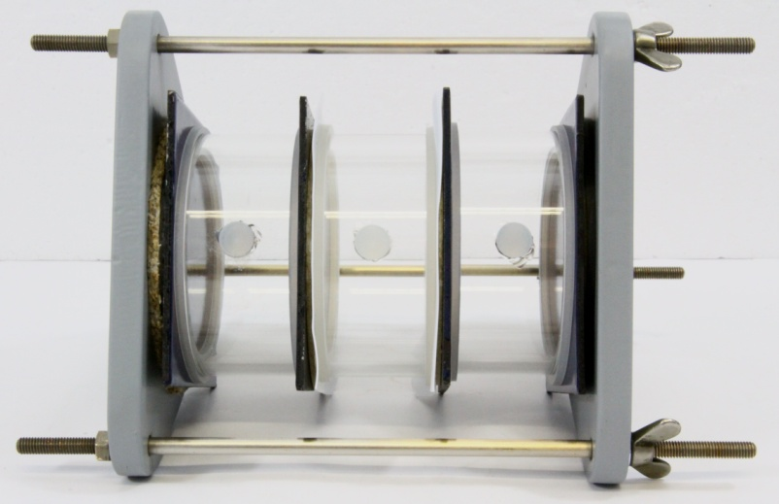
Figure 1: Example setup for migration testing of enamelled test plates (for a better view, the setup shown contains glass parts, which should not be used in actual testing) (photo: TÜV Süd)
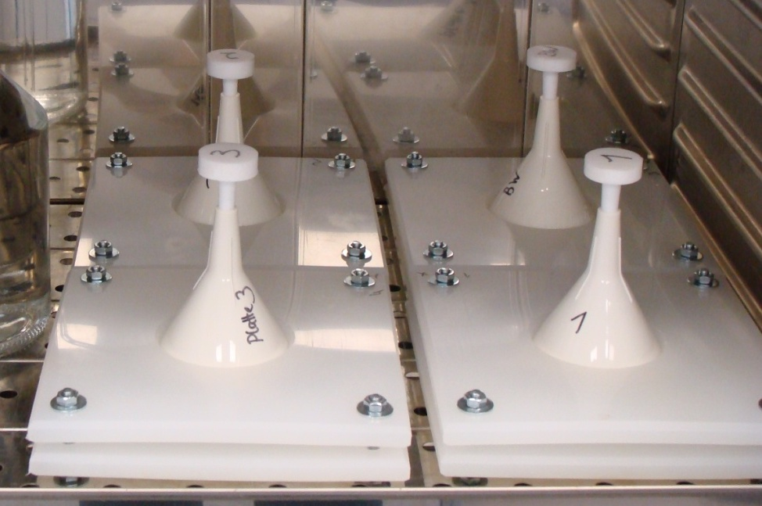
Figure 2: Alternative test setup (photo: Federal Environmental Agency)
In the warm-water and hot-water test, the test water must reach the required test temperature after at most one hour. This may be ensured e.g. by using pre-heated test water.
In the cold-water test, at least the three migration periods described in DIN EN 12873-1 should be implemented. If C_{Tap} (for calculation see 8.3.5) is above the criterion for one or several parameters in the third migration period (seeTable 9) or shows a rising trend, the test may be implemented with 9 migration periods pursuant to Annex 1 of this assessment guideline. In the additional migration periods, the migration water quantities to be analysed should be tested only for those parameters that have failed to meet the requirements during the regular test.
For the warm-water and hot-water tests, at least the first seven migration periods as defined in Annex 2 to this assessment guideline should be implemented. If C_{Tap} (for calculation see 8.3.5) is above the criterion for one or several elements in the seventh migration period (seeTable 9) or shows a rising trend, the test may be extended to 22 migration periods pursuant to Annex 2 of this assessment guideline. In the additional migration periods, the migration water quantities to be analysed should be tested only for those parameters that have failed to meet the requirements during the regular test.

Analysis of migration water
Annex 1 lists the migration water quantities to be sampled for the relevant migration periods in the analyses of the cold-water test and pursuant to Annex 2 for the warm-water and hot-water tests. The migration water quantities should be acidified immediately with concentrated HNO₃ on 2 % in preparation for the determination of the element content (not for PAH testing).

Enamels
When testing enamels, the elements designated in Table 9 should be assessed by means of ICP-MS as described in DIN EN ISO 17294-1, irrespective of the composition of the enamel.

Ceramic materials
Those ingredients of the ceramic material for which a criterion has been defined pursuant toTable 9 should be assessed. The lead and cadmium content of the migration water quantities being analysed should also be determined. The analysis should be undertaken by means of ICP-MS as described in DIN EN ISO 17294-1.

Carbon ceramics
When testing carbon ceramics, the PAH content of the migration water quantities being analysed should be determined pursuant toTable 10.

Analysis of test results
The concentrations measured in the migration tests (C_{measured}) should converted into maximum expected concentrations at the tap (C_{tap}):

$c_{\text{Tap}}=\frac{F (c_{\text{gemessen}}−c_{\text{Blind}})}{OV t}$ (1)
c _{measured} respective element concentration in µg/l
c _{blind} respective element concentration of the blind trial in µg/l
F_{C} component-specific conversion factor pursuant toTable 12 in d/dm
S/V the surface-to-volume ratio in dm⁻¹, where S is the surface area of the component in dm² , and V the volume brought into contact with the component in dm³
t Contact time in d
Table 12: Component groups with corresponding conversion factors
Component group | Conversion factor  FC in d/dm
Pipes with DN < 80 mm (drinking water system) | 20
Pipes with 80 mm ≤ DN and < 300 mm (supply pipes) | 10
Pipes with DN ≥ 300 mm (main pipes) | 5
Fittings (fittings, equipment, pipe connectors, pumps) for
Pipes with DN < 80 mm | 4
Pipes with 80 mm ≤ DN < 300 mm | 2
Pipes with DN ≥ 300 mm | 1
Components of fittings (fittings, equipments, pipe connectors, pumps) whose combined surface area does not exceed 10 % of the entire surface of the equipment that is in contact with water, for
Pipes with DN < 80 mm | 0.4
Pipes with 80 mm ≤ DN < 300 mm | 0.2
Pipes with DN ≥ 300 mm | 0.1
Small-size fittings components, made of materials that are used in only one location within the drinking water distribution system (e.g. shaft seals on a pump) for
Pipes with DN < 80 mm | 0.004
Pipes with 80 mm ≤ DN < 300 mm | 0.002
Pipes with DN ≥ 300 mm | 0.001
Tanks in drinking water systems including repair systems | 4
Tanks outside drinking water systems including repair systems | 1

The results of the parallel migration tests (duplicate testing) shall be reported individually in the test report. For purposes of assessment, the average () of the duplicate test results shall be used.
The requirements are deemed to be fulfilled for the cold-water test if the following is true of all parameters to be determined:

for the third or ninth migration period

The requirements are deemed to be fulfilled for the warm-water and hot-water tests if the following is true of all elements to be determined:

for the seventh or 22nd migration period

In addition, the concentrations of the elements to be determined must not show an increasing trend.

Test report
The test report prepared for this assessment guideline must meet the requirements for test reports pursuant to DIN EN 12873-1.
When testing purposely produced test plates, the report shall in particular specify under which conditions, where and by whom the test plates were produced.

Annex 1: Migration cycles for the extended cold-water test

Week | Migration cycle | Total contact time  in days | End of the migration period | Contact period in days per migration | Analysis
1 | 0 (preliminary treatment) | 1 | Tuesday | 1 | No
1 | 1 | 4 | Friday | 3 | Yes
2 | 2 | 7 | Monday | 3 | Yes
2 | 3 | 10 | Thursday | 3 | Yes
3 | 4 | 14 | Monday | 4 | No
3 | 5 | 17 | Thursday | 3 | Yes
4 | 6 | 21 | Monday | 4 | No
4 | 7 | 24 | Thursday | 3 | Yes
5 | 8 | 28 | Monday | 4 | No
5 | 9 | 31 | Thursday | 3 | Yes

Annex 2: Migration cycles for the extended warm-water or hot-water test

Week | Migration cycle | Total contact time in days | End of the migration period | Contact period in days per migration | Analysis
1 | 0 (preliminary treatment) | 1 | Tuesday | 1 | No
1 | 1 | 2 | Wednesday | 1 | Yes
1 | 2 | 3 | Thursday | 1 | Yes
1 | 3 | 4 | Friday | 1 | Yes
2 | 4 | 7 | Monday | 3 | No
2 | 5 | 8 | Tuesday | 1 | No
2 | 6 | 9 | Wednesday | 1 | Yes
2 | 7 | 10 | Thursday | 1 | Yes
2 | 8 | 11 | Friday | 1 | No
3 | 9 | 14 | Monday | 3 | No
3 | 10 | 15 | Tuesday | 1 | No
3 | 11 | 16 | Wednesday | 1 | Yes
3 | 12 | 17 | Thursday | 1 | Yes
3 | 13 | 18 | Friday | 1 | No
4 | 14 | 21 | Monday | 3 | No
4 | 15 | 22 | Tuesday | 1 | No
4 | 16 | 23 | Wednesday | 1 | Yes
4 | 17 | 24 | Thursday | 1 | Yes
4 | 18 | 25 | Friday | 1 | No
5 | 19 | 28 | Monday | 3 | No
5 | 20 | 29 | Tuesday | 1 | No
5 | 21 | 30 | Wednesday | 1 | Yes
5 | 22 | 31 | Thursday | 1 | Yes

Notified in accordance with Directive (EU) 2015/1535 of the European Parliament and of the Council of 9 September 2015 laying down a procedure for the provision of information in the field of technical regulations and of rules on Information Society services (OJ L 241 of 17 September 2015, p. 1).
The limit in the Drinking Water Regulation currently applies to total chromium. New toxicological insights may in the future lead to a stricter limit for chromium VI.
Samples must reflect the requirements for samples pursuant to DIN 4753-3: 2011.
Internal diameter

