1. ------IND- 2017 0322 SK- EN- ------ 20190416 --- --- FINAL

COLLECTION 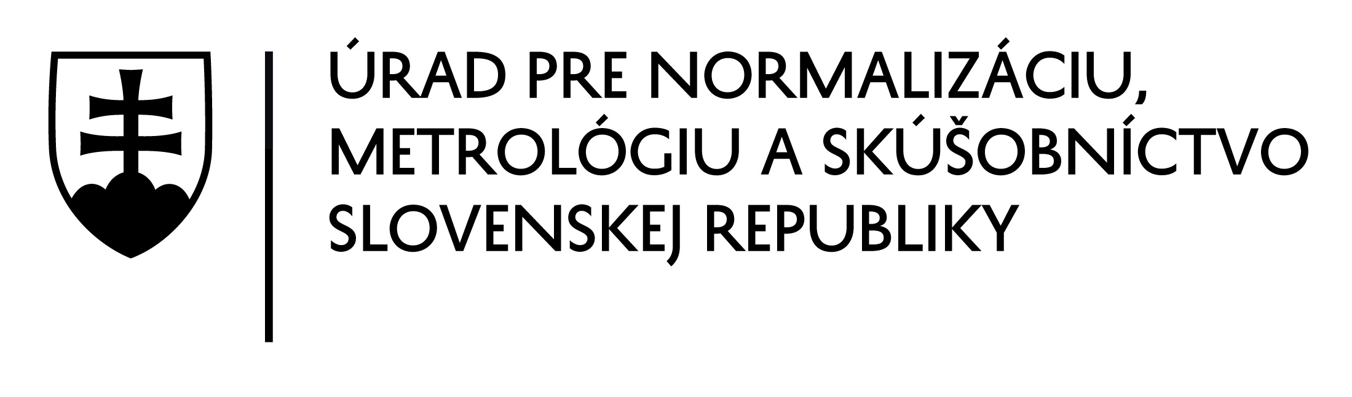 OF LAWS
OF THE SLOVAK REPUBLIC
Volume 2018
Promulgated: 7 March 2018 Time version of the legislation effective from: 1 April 2018 to: 31 March 2020
The content of the document is legally binding.
60
ACT
of 6 February 2018
on technical standardisation
The National Council of the Slovak Republic has passed the following act:
§ 1
Subject matter
This Act governs
a) the scope of authority of the Slovak Office of Standards, Metrology and Testing (hereinafter referred to as the ‘Office’) in the field of technical standardisation,
b) the rights and obligations of the Office as the Slovak national standardisation body,
c) the development, provision, reproduction, distribution, verification and cancellation of Slovak technical standards and technical standard information,
d) costs for developing Slovak technical standards and technical standard information,
e) the protection of Slovak technical standards and technical standard information,
f) the provision of other technical standards and other technical standard information,
g) supervision of compliance with this act,
h) imposition of fines.
§ 2
Definitions
For the purposes of this Act, the following definitions shall apply
- ‘other technical standard’ means a technical standard referred to in separate legislation¹⁾ other than an original Slovak technical standard,
- ‘other technical standard information’ means a standardisation document developed by an international standardisation body that has not been accepted by the Office as the Slovak national standardisation body, as part of the system of Slovak technical standards under § 4(1)(g),
- ‘legitimate interest’ means the safety, health, life and property of persons and a favourable environment.
§ 3
Technical standard and technical standard information
- ‘Technical standard’ means a technical standard referred to in separate legislation.²⁾ A technical standard is not a technical regulation.³⁾
- ‘Slovak technical standard’ means a technical standard accepted by the Office, as the Slovak national standardisation body, under this act as part of the system of Slovak technical standards.
- ‘Slovak technical pre-standard’ means a Slovak technical standard with time-limited validity, the purpose of which is to verify the suitability and expediency of the standard’s technical content.
- ‘Original Slovak technical standard’ means a Slovak technical standard governing a field not covered by the provisions of European standards⁴⁾ or international standards⁵⁾ that has been developed based on demand from the public or a public authority.
- ‘Technical standard information’ means a standardisation document developed by a European standardisation organisation,⁶⁾ an international standardisation body⁷⁾ or the Office, as the Slovak national standardisation body, and accepted by the Office, as the Slovak national standardisation body, as part of the system of Slovak technical standards. Technical standard information shall not be considered to be Slovak technical standards.
- ‘Original technical standard information’ means a technical standard information document that governs a field not covered by any provisions of standardisation documents developed by a European standardisation organisation or an international standardisation body and has been developed based on demand from the public or a public authority.
- ‘Amendment of a technical standard’ means a technical standard designated as an amendment by a European standardisation organisation, an international standardisation body or the Office, as the Slovak national standardisation body, making substantive amendments to a technical standard.
- ‘Correction of a technical standard’ or ‘correction of a technical standard information’ means a document correcting a formal error in a technical standard or technical standard information designated as a correction by a European standardisation organisation, an international standardisation body or the Office, as the Slovak national standardisation body.
- ‘System of Slovak technical standards’ is the set of the full versions of Slovak technical standards, technical standard information and their corrections.
- Compliance with Slovak technical standards and technical standard information is voluntary.
- Slovak technical standards shall use the symbol ‘STN’ and Slovak technical pre-standards shall use the symbol ‘STN P’. Technical standard information shall use the symbol ‘TNI’. Standard symbols ‘STN’, ‘STN P’ and ‘TNI’ are provided in the Annex. Additional markings that may be added to the symbols ‘STN’ or ‘TNI’ shall be published by the Office, as the Slovak national standardisation body, on its website.
- Slovak technical standards and technical standard information shall not be made available in accordance with separate legislation⁸⁾ except the Slovak technical standard referred to in § 12(2).
- If a government authority intends to provide a reference to a Slovak technical standard in the draft text of an act of general application, it shall notify the Office, as the Slovak national standardisation body, to this effect at the latest before adopting the act of general application; the government authority shall proceed in accordance with separate legislation.⁹⁾
§ 4
The Office
- The Office
- shall designate the Slovak technical standards suitable for conformity assessment,
- publish notices of the adoption, cancellation and correction of Slovak technical standards and the adoption, cancellation and correction of technical standard information and notices of Slovak technical standards suitable for conformity assessment in the Official Journal of the Slovak Office of Standards, Metrology and Testing (hereinafter referred to as the ‘Official Journal’) or, in justified cases, on its website,
- notify¹⁰⁾ the Commission of the Slovak national standardisation body,
- finance the operation of the Slovak national standardisation body and pay the Slovak national standardisation body’s fees for membership in European standardisation organisations and international standardisation bodies,
- oversee compliance with this act,
- deal with infractions and other administrative offences and impose fines in accordance with § 16 and § 17,
- be the Slovak national standardisation body.¹¹⁾
- The Office, as the Slovak national standardisation body, shall
- meet obligations arising from its membership in European standardisation organisations and international standardisation bodies,
- facilitate participation in the development and cancellation of European standards, European standardisation deliverables,¹²⁾ international standards and other technical standard information by any person meeting the requirements and rules of the European standardisation organisation and the international standardisation body or the requirements of the Office, as the Slovak national standardisation body, published on the website of the Office, as the Slovak national standardisation body, by
- posting on its website notices of draft European standards, draft European standardisation deliverables, draft international standards and drafts of other technical standard information for public consultation no later than one month before the deadline specified in the notice,
- ensuring public consultation on draft European standards, draft European standardisation deliverables, draft international standards and drafts of other technical standard information with anyone who requests participation in the public consultation by the deadline specified in the notice posted on the Office’s website,
- providing notifications on its website of any European standards, European standardisation deliverables, international standards and other technical standard information that has been issued,
- make available on its website the criteria for the development of Slovak technical standards and technical standard information in the State language once approved by the Technical Standardisation Council (hereinafter referred to as the ‘Council’) set up in accordance with § 5,
- ensure that Slovak technical standards and technical standard information are developed and cancelled in accordance with the rules laid down by European standardisation organisations or international standardisation bodies, or in accordance with the rules laid down by the Office, as the Slovak national standardisation body,
- mark Slovak technical standards, Slovak technical pre-standards and technical standard information in accordance with § 3(11),
- verify, in cooperation with stakeholders,¹³⁾ whether the content of original Slovak technical standards and original technical standard information complies with the state of the art of science and technology,
- notify European standardisation organisations of the intent to adopt a new original Slovak technical standard,
- provide, in accordance with § 15, Slovak technical standards and their corrections, technical standard information and its correction, and other technical standards and their amendments and corrections,
- collect fees for the provision of Slovak technical standards, technical standard information and other technical standards and their amendments,
- post on its website on a monthly basis a list of Slovak technical standards and technical standard information and their corrections accepted as part of the system of Slovak technical standards, which shall not be deemed to be publicly available pursuant to in § 10(2),
- protect Slovak technical standards, technical standard information, and other technical standards and their amendments in accordance with this Act,
- provide methodological guidance on and direct the development and provision of Slovak technical standards and their corrections, technical standard information and its corrections, and other technical standards and their amendments and corrections; it shall make methodical guidelines available on its website,
- operate on its website a publicly accessible portal of Slovak technical standards and technical standard information and their corrections (hereinafter referred to as the ‘portal’),
- be responsible for the linguistic and terminological accuracy of Slovak technical standards and technical standard information adopted in the State language.
§ 5
The Council
- The Council, as the expert and advisory body to the Chairperson of the Office, shall
- safeguard the independence of the Office, as the Slovak national standardisation body,
- oversee the operation of the Office, as the Slovak national standardisation body, in carrying out the tasks referred to in § 4(2)(a),
- assess conceptual matters relating to technical standardisation at national, European and international levels,
- submit to the Chairperson of the Office strategic recommendations regarding the concept of the State policy on technical standardisation in the Slovak Republic in view of current national, European and international standardisation requirements and the requirements of the national economy,
- assess whether the Office, as the Slovak national standardisation body, meets the criteria for membership of European standardisation organisations,
- approve the criteria for the development of Slovak technical standards in the State language,
- evaluate, on a regular basis, the operation of the Office, as the national standardisation body, including compliance with the monthly list of standardisation tasks (hereinafter referred to as the ‘technical standardisation plan’),
- monitor the procedures of the Office, as the Slovak national standardisation body, related to the operation of the technical committee,
- provide its opinion on the statute of the technical committee and the rules of procedure of the technical committee,
- respond to the demand of the public or public authorities regarding the development and inclusion of drafts of original Slovak technical standards in the technical standardisation plan,
- approve the Council’s statute and the Council’s rules of procedure,
- perform other duties specified in the Council’s statute.
- The Council shall have a maximum of 15 members. The members of the Council shall comprise representatives of stakeholders and representatives of public authorities. The number of representatives of public authorities on the Council shall not exceed one third of the total number of members of the Council.
- The members of the Council shall be appointed and removed by the Chairperson of the Office.
- The position of a member of the Council shall be honorary and non-substitutable.
- The Council’s composition, tasks, organisational framework and procedural method shall be laid down in its statute and rules of procedure, to be issued by the Office.
§ 6
Technical committee
The technical committee shall be an advisory body to the Office, as the Slovak national standardisation body, and shall participate in the development of Slovak technical standards and technical standard information, the consultation procedure referred to in § 9(2)(b) and (3)(c) and other activities related to technical standardisation. The technical committee’s composition, tasks, organisational framework and procedural method shall be laid down in its statute and rules of procedure, to be issued by the Office, as the Slovak national standardisation body.
Development of Slovak technical standards and technical standard information documents
§ 7
- In ensuring the performance of activities pursuant to § 4(2)(d), the Office, as the Slovak national standardisation body, shall cooperate with the technical committee and stakeholders, including small enterprises¹⁴⁾ and medium enterprises,¹⁵⁾ the public authority, and the legal or natural person responsible for carrying out the standardisation task (hereinafter referred to as the ‘author’) on the basis of an agreement with the Office, as the Slovak national standardisation body.
- When developing Slovak technical standards and technical standard information, the author and the Office, as the Slovak national standardisation body, shall proceed in accordance with § 8 to § 10, the rules of European standardisation organisations, rules of the international standardisation body, and the methodical guidelines of the Office, as the Slovak national standardisation body, made available on the website of the Office, as the Slovak national standardisation body.
- The development of Slovak technical standards and technical standard information shall involve
- drawing up the technical standardisation plan,
- drafting the Slovak technical standard or the technical standard information,
- adoption and notification of the Slovak technical standard or technical standard information.
§ 8
Drawing up of the technical standardisation plan
- The Office, as the Slovak national standardisation body, shall draw up the technical standardisation plan and post it on its website no later than on the tenth day of the calendar month following the month in which the technical standardisation plan was drawn up.
- For European standards, European standardisation deliverables, international standards and other technical standard information, the Office, as the Slovak national standardisation body, shall specify in the technical standardisation plan how they shall be accepted as part of the system of Slovak technical standards, which may involve transposition
- via translation into the State language,
- without translation into the State language, or
- without translation into the State language, with annotation in the State language.
- The Office, as the Slovak national standardisation body, shall indicate in the technical standardisation plan the intention to draft an original Slovak technical standard or the original technical standard information that it has decided to draft and accept as part of the system of Slovak technical standards.
§ 9
Drafting Slovak technical standards and technical standard information
- When drafting original Slovak technical standards or original technical standard information, or when drafting Slovak technical standards or technical standard information in the manner referred to in § 8(2)(a) or (c), the Office, as the Slovak national standardisation body, shall select the author in accordance with separate legislation.¹⁶⁾ This procedure shall not be applied if the costs of drafting the Slovak technical standard or technical standard information are not covered by the Office.
- When drafting an original Slovak technical standard or original technical standard information, the author or the Office, as the Slovak national standardisation body, shall
- prepare the draft of the original Slovak technical standard or original technical standard information,
- present the draft original Slovak technical standard or draft original technical standard information for comments to members of the technical committee or members of the working group set up for this purpose,
- modify the draft original Slovak technical standard or draft original technical standard information according to the comments raised by the technical committee or the working group set up for this purpose; the modified draft shall then be presented by the Office, as the Slovak national standardisation body, for public consultation by posting a notice thereof on its website within 15 days of receiving the draft original Slovak technical standard or draft original technical standard information; if drafted by the Office, as the Slovak national standardisation body, the Office shall present the draft original Slovak technical standard or draft original technical standard information for public consultation by posting a notice thereof on its website without delay, no later than within 15 days of completing the draft, and
- modify the draft original Slovak technical standard or draft original technical standard information according to the comments from the public consultation.
- When drafting Slovak technical standards or technical standard information in the manner referred to in § 8(2)(a) or (c), the author or the Office, as the Slovak national standardisation body, shall
- prepare the draft of the Slovak technical standard or technical standard information,
- present the prepared draft Slovak technical standard or technical standard information for comments to members of the technical committee and any person who requests to participate in the consultations within the time limit specified in the technical standardisation plan posted on the website of the Office, as the Slovak national standardisation body,
- modify the draft Slovak technical standard or draft technical standard information according to the comments raised by the technical committee or persons who requested to participate in the consultations.
- When drafting Slovak technical standards or technical standard information in the manner referred to in § 8(2)(b), the Office, as the Slovak national standardisation body, shall draft the title of the Slovak technical standard or technical standard information in the State language.
- When drafting a Slovak technical standard or technical standard information, the author or the Office, as the Slovak national standardisation body, shall ensure compliance of the draft Slovak technical standard and draft technical standard information with Slovak technical standards and technical standard information that have been adopted and notified, and compliance of the draft Slovak technical standard and draft technical standard information document with acts of general application and legally binding acts of the European Union.
- After completing the steps under paragraphs (2), (3) or (4), the Office, as the Slovak national standardisation body, shall ensure linguistic and terminological revision of the draft.
§ 10
Adoption and notification of the adoption of Slovak technical standards and technical standard information
- Once the draft Slovak technical standard or draft technical standard information has been completed in accordance with § 9, the Office, as the Slovak national standardisation body, shall accept the Slovak technical standard or technical standard information as part of the system of Slovak technical standards.
- The Office shall notify the adoption of a Slovak technical standard or technical standard information in the Official Journal or, in justified cases, on its website.
- Slovak technical standards or technical standard information shall enter into force on the first day of the calendar month following the month in which they were notified in the Official Journal or, if notified on the Office’s website, on the date of notification on the Office’s website.
§ 11
Amendments to Slovak technical standards and correction and cancellation of Slovak technical standards and technical standard information
When amending, correcting or cancelling Slovak technical standards or technical standard information, the Office, as the Slovak national standardisation body, shall proceed mutatis mutandis pursuant to § 8 to § 10.
§ 12
Costs for developing Slovak technical standards and technical standard information
- Costs for developing in the State language and correcting Slovak technical standards and technical standard information that comply with the criteria adopted and published pursuant to § 4(2)(c) shall be borne by the Office. Otherwise, costs for drafting Slovak technical standards and technical standard information in the State language shall be borne by the party that requested them.
- Costs for drafting, in the State language, Slovak technical standards directly referred to in the text of an act of general application and costs for providing Slovak technical standards directly referred to in the text of an act of general application shall be borne by the government authority responsible for submitting the draft act of general application in which the Slovak technical standard is directly referenced.
§ 13
Harmonised technical standards and Slovak technical standards suitable for conformity assessment
- Compliance with a harmonised technical standard¹⁷⁾ or Slovak technical standard suitable for conformity assessment or part thereof shall be deemed to be in compliance with the technical requirements laid down by the technical regulation to which the harmonised technical standard or Slovak technical standard suitable for conformity assessment or part thereof apply.
- Where no harmonised technical standard exists, the Office, after consulting the relevant ministry or other central government authority, shall designate the Slovak technical standard suitable for conformity assessment. The designation of the Slovak technical standard suitable for conformity assessment shall be notified by the Office in the Official Journal. In the notification, the Office shall provide the title of the technical regulation to which the Slovak technical standard suitable for conformity assessment applies.
- Objections to harmonised technical standards referred to in separate legislation¹⁸⁾ shall be raised by the Office at the initiative of the relevant ministry, other central government authorities or the supervision authority.
- Proposals to repeal the designation of a Slovak technical standard as suitable for conformity assessment shall be submitted by the relevant ministry or other central government authority to the Office, which shall notify the repeal of the designation of the Slovak technical standard as suitable for conformity assessment in the Official Journal.
§ 14
Means of protecting Slovak technical standards and technical standard information
- The name ‘Slovak technical standard’ and the symbol ‘STN’, the name ‘Slovak technical pre-standard’ and the symbol ‘STN P’ and the name ‘technical standard information’ and symbol ‘TNI’ may not be used for identifying other documents.
- The Office, as the Slovak national standardisation body, shall be entitled to compensation for any payments received for the provision of a Slovak technical standard, Slovak technical pre-standard technical standard or technical standard information, or any reproduction of a Slovak technical standard, Slovak technical pre-standard or technical standard information by the person who has reproduced the Slovak technical standard, Slovak technical pre-standard or technical standard information without permission of the Office, as the Slovak national standardisation body.
- Unauthorised distribution of Slovak technical standards or technical standard information means the provision of a Slovak technical standard or technical standard information or parts thereof, including an offer to provide them, regardless of means and form, without permission of the Office, as the Slovak national standardisation body.
- The following shall not be deemed unauthorised reproduction or unauthorised distribution of Slovak technical standards or technical standard information documents:
- citation of a passage from a Slovak technical standard or technical standard information if the Office, as the Slovak national standardisation body, has granted permission to cite the passage from the Slovak technical standard or technical standard information based on an application;
- information about a Slovak technical standard and technical standard information notified in the Official Journal or posted on the Office’s website in accordance with § 10(2).
- The Office, as the Slovak national standardisation body, shall grant permission to cite a passage from a Slovak technical standard or technical standard information for payment without delay, no later than within 30 days of receiving the application for permission. The application shall contain, in particular, identification details of the applicant, the purpose and scope of the citation of a passage from a Slovak technical standard or technical standard information, and the title of the Slovak technical standard or technical standard information to be cited from.
- The Office, as the Slovak national standardisation body, shall grant permission for citation of a passage from a Slovak technical standard or technical standard information free of charge without delay, no later than within ten days of receiving the application for permission, for the purposes of
  - providing
- education and training in accordance with separate legislation,¹⁹⁾
- education as part of an accredited university study programme, or
- continuous education and attestation of teachers and specialised school staff²⁰⁾ of a non-commercial nature,
  - preparing and defending
- a comprehensive technical paper, project, competition paper or school-leaving examination paper in the context of education and training.²¹⁾
- university graduation thesis²²⁾. or
- a final paper in the context of continuous education of teachers and specialised school staff of a non-commercial nature and attestation papers of teachers and specialised school staff.²³⁾
§ 15
Provision of Slovak technical standards, technical standard information documents, other technical standards and the Official Journal
- Slovak technical standards, technical standard information, other technical standards and their amendments, and the Official Journal shall be provided for a fee, unless stipulated otherwise in paragraph (4).
- Slovak technical standards and technical standard information and their corrections shall be provided in paper form, electronic form or via the portal. Other technical standards and their amendments and corrections and other technical standard information documents and their corrections shall be provided in paper form. Further details of the portal shall be posted by the Office, as the Slovak national standardisation body, on its website.
- The Office, as the Slovak national standardisation body, shall provide Slovak technical standards free of charge in accordance with § 12(2) via the portal to anyone who requests them; this shall be without obligation to the government authorities referred to in § 12(2).
- Authors of original Slovak technical standards or original technical standard information shall be entitled to one free paper copy of the original Slovak technical standard or original technical standard information in the drafting of which they took part.
- Corrections of Slovak technical standards, technical standard information, other technical standards and other technical standard information shall be provided by the Office, as the Slovak national standardisation body, free of charge.
- Entitlement to a refund of the fee for the provision of Slovak technical standards, technical standard information and other technical standards and their amendments in paper form shall arise if
- part of the text or page is missing, or
- the binding is damaged.
- Entitlement to a refund of the fee for the provision of Slovak technical standards or technical standard information in electronic form shall arise if the storage medium on which the Slovak technical standard or technical standard information is recorded is damaged.
- Entitlement to a refund referred to in paragraph (6) and paragraph (7) may be claimed upon receipt of the Slovak technical standard, technical standard information or other technical standard and their amendments; instead of refunding the fee for the provision of the Slovak technical standard, technical standard information or other technical standard and their amendments, the Office, as the Slovak national standardisation body, may provide a complete or undamaged replacement of the paper copy of the Slovak technical standard, technical standard information or other technical standard and their amendments, or an undamaged storage medium on which the Slovak technical standard or technical standard information is recorded in electronic form.
Infractions and other administrative offences
§ 16
- An infraction will be committed by a person who
- distributes a Slovak technical pre-standard or technical standard information or part thereof without authorisation,
- marks a document with the ‘STN P’ symbol without authorisation,
- distributes free of charge a Slovak technical standard or part thereof without authorisation,
- marks a document with the ‘STN’ symbol without authorisation,
- distributes a Slovak technical standard or part thereof for a fee.
- The Office shall impose a fine of EUR 30 to EUR 1 500 for the infractions referred to in paragraph (1)(a) or (b), a fine of EUR 45 to EUR 3 000 for the infraction referred to in paragraph 1(c), and a fine of EUR 175 to EUR 10 000 for the infractions referred to in paragraph 1(d) or (e).
- The infractions and the related proceedings shall be subject to general legislation on infractions.²⁴⁾
§ 17
- The Office shall impose a fine of EUR 30 to EUR 500 on a sole trader or legal person who distributes a Slovak technical pre-standard or technical standard information or part thereof without authorisation or who marks a document with the ‘STN P’ symbol without authorisation.
- The Office shall impose a fine of EUR 50 to EUR 5 000 on a sole trader or legal person who distributes a Slovak technical standard or part thereof free of charge without authorisation.
- The Office shall impose a fine of EUR 350 to EUR 35 000 on a sole trader or legal person who without authorisation
- marks a document with the ‘STN’ symbol or
- distributes a Slovak technical standard or part thereof for a fee.
§ 18
- Proceedings on the imposition of a fine may commence within three years of the day of the unlawful action.
- When imposing a fine, the severity, manner, duration and consequences of the unlawful action shall be considered.
- The fines shall be paid into the State budget.
- If the unlawful action is repeated within one year of the date the decision on the imposition of a fine becomes final, the Office shall impose a fine of up to twice the amount of the fine imposed.
§ 19
Authorisation provisions
The Office shall issue an act of general application in which it shall establish
- the amount of the user fee for the provision of Slovak technical standards, technical standard information, other technical standards and their amendments, and the Official Journal, and for granting permissions to cite passages from Slovak technical standards or technical standard information,
- the amount of the user fee for activities related to the provision of Slovak technical standards, technical standard information and other technical standards and their amendments,
- the minimum payment for the provision of the STN-online service via the portal and the amount of the user fee for the provision of the STN-online service via the portal,
- how Slovak technical standards, technical standard information and other technical standards and their amendments shall be provided,
- the details of granting permission to cite passages from Slovak technical standards or technical standard information, the application form for permission to cite passages from Slovak technical standards or technical standard information and the form of the permission to cite passages from Slovak technical standards or technical standard information,
- discounts from the fees referred to in (a) and (b).
§ 20
Transitional provisions
- Proceedings commenced prior to 1 April 2018 shall be completed in accordance with legislation in effect until 31 March 2018.
- The Office shall, no later than by 31 March 2019, align the legal relationships related to the provision of Slovak technical standards and other technical standards provided before 1 April 2018 with legislation in effect as of 1 April 2018.
- Slovak technical standards, Slovak technical pre-standards and technical standard information accepted as part of the system of Slovak technical standards prior to 1 April 2018 shall be deemed to be Slovak technical standards, Slovak technical pre-standards and technical standard information under this act.
- Existing technical committees shall be deemed to be technical committees under this act.
- Implementing legislation issued based on authorisation provisions under the existing act shall be deemed to be implementing legislation under this act until implementing legislation referred to in § 19 is issued, but no later than until 1 April 2019.
§ 21
Entry into force
This act shall enter into force on 1 April 2018, except for the sentence after the semicolon in § 14(4)(a), which shall enter into force on 1 April 2020.
Andrej Kiska, m.p.
Andrej Danko, m.p.
Robert Fico, m.p.
1) Article 2(1)(a) and (d) of Regulation (EU) No 1025/2012 of the European Parliament and of the Council of 25 October 2012 on European standardisation, amending Council Directives 89/686/EEC and 93/15/EEC and Directives 94/9/EC, 94/25/EC, 95/16/EC, 97/23/EC, 98/34/EC, 2004/22/EC, 2007/23/EC, 2009/23/EC and 2009/105/EC of the European Parliament and of the Council and repealing Council Decision 87/95/EEC and Decision No 1673/2006/EC of the European Parliament and of the Council (OJ L 316, 14 November 2012), as amended.
2) Article 2(1) of Regulation (EU) No 1025/2012, as amended.
3) § 2(i) of Act No 55/2018 on the provision of information on technical regulations and obstacles to the free movement of goods.
4) Article 2(1)(b) of Regulation (EU) No 1025/2012, as amended.
5) Article 2(1)(a) of Regulation (EU) No 1025/2012, as amended.
6) Annex 1 to Regulation (EU) No 1025/2012, as amended.
7) Article 2(9) of Regulation (EU) No 1025/2012, as amended.
8) Act No 211/2000 on free access to information and on amendments to certain acts (Freedom of Information Act), as amended.
9) § 4(1)(c), second point of Act No 55/2018.
10) Article 27 of Regulation (EC) No 1025/2012, as amended.
11) Article 2(10) of Regulation (EU) No 1025/2012, as amended.
12) Article 2(2) of Regulation (EU) No 1025/2012, as amended.
13) Article 5 of Regulation (EU) No 1025/2012, as amended.
14) Article 2(2) of Annex I to Regulation (EU) No 651/2014 of 17 June 2014 declaring certain categories of aid compatible with the single market in application of Articles 107 and 108 of the Treaty.
15) Article 2 of Annex I to Regulation (EU) No 651/2014.
16) Act No 343/2015 on public procurement and on amendments to certain acts, as amended.
17) Article 2(1)(c) of Regulation (EU) No 1025/2012, as amended.
18) Article 11 of Regulation (EC) No 1025/2012, as amended.
19) Act No 245/2008 on education and training (Schools Act) and on amendments to certain acts, as amended.
20) Act No 317/2009 on teachers and specialised staff and on amendments to certain acts, as amended.
21) § 73, § 76 and § 79 of Act No 245/2008, as amended.
22) § 51 of Act No 131/2002 on higher education and on amendments to certain acts, as amended.
23) § 49(6) of Act No 317/2009, as amended by Act No 390/2011.
24) Act No 372/1990 of the Slovak National Council on infractions, as amended.
Annex to Act No 60/2018
1. The ‘STN’ symbol:
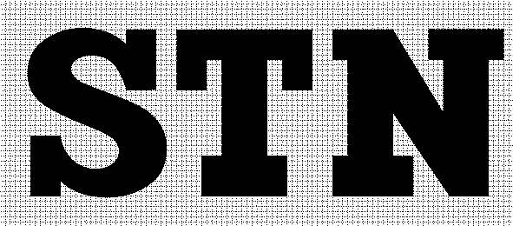

2. The ‘STN P’ symbol:
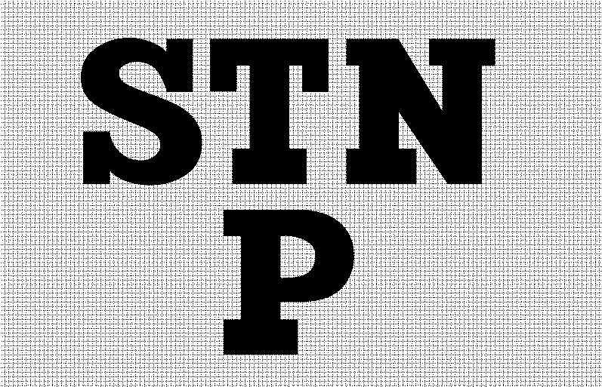

3. The ‘TNI’ symbol:
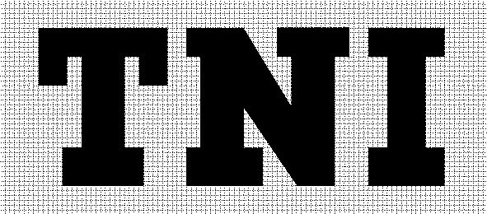

The Ministry of Justice of the Slovak Republic, Župné námestie 13, 813 11 Bratislava,
phone: +421 2 888 91 137, fax: +421 2 52442853, email: helpdesk@slov-lex.sk is the publisher of the Collection of Laws of the Slovak Republic and the content administrator and operator of the legal
and information portal Slov-Lex available at www.slov-lex.sk.

