It is proposed that the Council of Ministers approve the following draft provision:

Draft Royal Decree amending the Low-Voltage Electrotechnical Regulation approved by Royal Decree 842/2002 of 2 August 2002 and the Regulation on technical conditions and safety guarantees in high-voltage electrical installations and its Supplementary Technical Instructions ITC-RAT 01 to 23, approved by Royal Decree 337/2014 of 9 May 2014.

Article 12(5) of Law 21/1992 of 16 July 1992 on Industry establishes that the Industrial Safety Regulations at state level are to be approved by the Government of the Nation, without prejudice to the fact that Autonomous Communities with legislative jurisdiction over industry may introduce additional requirements on the same matters where they relate to installations located within their territory.
The current Low-Voltage Electrotechnical Regulation, approved by Royal Decree 842/2002 of 2 August 2002, hereinafter the REBT, has contributed greatly to promoting and fostering safety in the low-voltage electrical installations included within its scope. It introduced new types of installations: from those pertaining to agricultural and horticultural establishments to those in automation, technical energy management and safety for dwellings within collective buildings, in accordance with the most advanced techniques of the time, including a new concept of installations in swimming pools, for which voltages were introduced that provided intrinsic safety, among many other improvements in safety, such as increasing the minimum number of circuits in dwellings.
However, the experience of applying this Regulation and continuing technical advances make it necessary to review these safety conditions and include other types of installations that emerge over time. Royal Decree 1053/2014 of 12 December 2014 approving a new Supplementary Technical Instruction (ITC) BT 52 ‘Special purpose installations. Infrastructure for recharging electrical vehicles’ of the Low-Voltage Electrotechnical Regulation is a good example of this.
In addition, following the publication of Royal Decree 244/2019 of 5 April 2019 regulating the administrative, technical and economic conditions for the self-consumption of electrical energy, it is necessary to adapt the REBT to the conditions set out in the aforementioned Royal Decree.

This is done, on the one hand, from the point of view of electricity generation, by modifying the REBT instructions relating directly to self-consumption generators, their requirements, possible typologies and essential tests to guarantee the safety of all possible options that might be envisaged in the immediate future, based on the new legislation on the use and installation of renewable generation and, in particular, those options deriving from the new national decrees on self-consumption and the European Network Code regulations, which regulate the technical requirements to be met by generation and demand installations seeking connection to the network.
On the other hand, from the point of view of installations, the REBT instructions are amended or supplemented in relation to installation conditions directly affected by the new regulations on the use and installation of generators with self-consumption and their essential requirements. As such, they supplement the supplementary technical instructions (ITCs) relating to generation to ensure the safety of all options covered therein and include other related aspects of the installation, such as possible network connection configurations, the use of direct-current installations, or energy storage installations, which are also envisaged as complementary to renewable generation.
In addition, as installations advance and the proportion of electronic loads connected to them grows, it is considered appropriate to update the types of differential circuit breakers provided for in the Regulation. In particular, the AC type is eliminated, this change being facilitated by the establishment of a two-year transition period during which they may continue to be used.
The profiles of installers and installation companies do not vary substantially with respect to those that already exist and the execution and commissioning of installations continues to require the preparation of technical documentation, in the form of a plan or report depending on the characteristics of the installations and their communication to the Administration.
In addition, the opportunity is taken to describe in more detail the procedure to be followed by the inspection bodies accredited as collaborating agents of the Administration for the inspection of installations, as provided for in Article 14 of Law 21/1992 of 16 July 1992 on Industry. For all types of installations, the obligation of their operators to keep them in good condition through appropriate maintenance and the periodic inspections established by regulation remains in place.
On the other hand, it has been detected that the introduction of the real-time load monitoring techniques provided for in the Regulation on technical conditions and safety guarantees in high-voltage electrical installations, approved by Royal Decree 337/2014 of 9 May 2014 as a substitute for overcurrent protection in HT/LT distribution transformers does not always ensure that transformers are effectively protected, especially given the increasingly high summer temperatures in large areas of Spain. This has caused a number of accidents and incidents at installations in service in recent years. For this reason, the use of the overcurrent protection required for these transformers has been changed and upgrades to certain existing installations have been regulated to ensure the adequate protection of transformers currently in service.
In addition, and given that those affected by the Regulations referred to in this Royal Decree (the Low-Voltage Electrotechnical Regulation, approved by Royal Decree 842/2002 of 2 August 2002, and the Regulation on technical conditions and safety guarantees in high-voltage electrical installations and its Supplementary Technical Instructions ITC-RAT 01 to 23, approved by Royal Decree 337/2014 of 9 May 2014) have the necessary technical capacity, it is established that all communications with the Administration must be made by electronic means.
In view of the above, it is necessary to adapt and update the Low-Voltage Electrotechnical Regulation, approved by Royal Decree 842/2002 of 2 August 2002, and the Regulation on technical conditions and safety guarantees in high-voltage electrical installations and its Supplementary Technical Instructions ITC-RAT 01 to 23, approved by Royal Decree 337/2014 of 9 May 2014.
This legislation constitutes an industrial safety regulation and is adopted by virtue of powers in the area of industrial safety under Article 149(1)(13) of the Spanish Constitution, which grants the state power over the basic rules and coordination of general economic planning, without prejudice to the powers of the Autonomous Communities with regard to industry, granted to the Public Administration, as repeatedly affirmed in constitutional case law. In this respect, it should be noted that the regulation being adopted is basic legislation that combines exclusively and distinctly technical provisions, which means that the law is not an appropriate instrument for its establishment and its adoption by royal decree is justified.
This draft meets the principles of sound regulation according to which public authorities must act in exercising legislative initiative and regulatory powers, such as the principles of necessity, effectiveness, proportionality, legal certainty, transparency and efficiency provided for in Article 129 of Law 39/2015 of 1 October 2015 on common administrative procedures in public administration.
To this end, it is clear that the principles of necessity and effectiveness are complied with and that the standard is in accordance with the principle of proportionality, since it contains the regulations essential for the achievement of the aforementioned objectives, and also complies with the principle of legal certainty. As for the principle of transparency, the various public participation procedures, i.e. public consultation and information procedures, have been completed. With regard to the principle of efficiency, the main objective of the standard is to improve the regulations, taking into account advances in technology and the experience gained from applying them. In addition, with regard to public expenditure, it should be noted that the budgetary impact is zero.
The Autonomous Communities were consulted on the drafting of this Royal Decree, as were the entities in the sector that are known and considered the most representative, in accordance with the provisions of Article 26(6) of Law 50/1997 of 27 November 1997 on the Government. Additionally, this Royal Decree has been the subject of a report by the Industrial Safety Coordination Council, in accordance with the provisions of Article 18(4)(c) of Law 21/1992 of 16 July 1992 and of Article 2(d) of Royal Decree 251/1997 of 21 February 1997 approving the Regulations of the Industrial Safety Coordination Council.
Similarly, this Royal Decree has been notified to the European Commission and to the other Member States in accordance with Royal Decree 1337/1999 of 31 July 1999 regulating the provision of information on technical standards and regulations and rules on information society services, in application of Directive (EU) 2015/1535 of the European Parliament and of the Council of 9 September 2015 laying down a procedure for the provision of information in the field of technical regulations and of rules on information society services.
Accordingly, on a proposal from the Minister for Industry and Tourism, with the prior approval of the Minister for Digital Transformation and the Civil Service, in agreement with the Council of State and after deliberation by the Council of Ministers at its meeting on [xx of x of xxxx ],
I HEREBY DECREE THE FOLLOWING:

Article 1. Amendment of the Low-Voltage Electrotechnical Regulation approved by Royal Decree 842/2002 of 2 August 2002.
The Low-Voltage Electrotechnical Regulation, approved by Royal Decree 842/2002 of 2 August 2002, as well as its Supplementary Technical Instructions, is amended as follows:

One. Article 2 is amended to read as follows:
‘Article 2. Scope.
- This Regulation shall apply to distribution networks and connection installations distributing electrical energy, as well as to internal installations, both electricity generators and receivers, within the following nominal voltage limits:
a) Alternating current: less than or equal to 1 000 volts.
b) Direct current: less than or equal to 1 500 volts.
- This Regulation shall apply to:
  - new installations executed after its entry into force, as well as any subsequent modifications, repairs and extensions to them;
  - changes, repairs and extensions, whether or not significant, to installations existing prior to its entry into force, only as regards the modified, repaired or extended part, and provided that the necessary measures are taken to ensure the safety conditions of the entire installation;
  - installations existing prior to its entry into force, with regard to the inspection regime, although the technical criteria applicable to such inspections shall be those corresponding to the regulation under which they were approved.
A major modification or repair shall be understood as one that affects more than 50 % of the installed power, even with a power reduction.
- Similarly, it shall apply to installations existing prior to its entry into force that, due to their condition, situation or characteristics, pose a serious risk to persons or property, or cause significant disruption to the normal operation of other installations, in the view of the competent body of the Autonomous Community.
- This Regulation does not apply to installations and equipment for exclusive use in mines, traction equipment, cars, ships, aircraft, communication systems, and for military use, and other installations and equipment that are subject to specific regulation.
- The requirements of this Regulation and its supplementary technical instructions (hereinafter ITCs) are general and specific. The specific ones shall replace, amend or supplement the general ones, as applicable.
- The general requirements shall not apply (only specific requirements, which shall be covered by the corresponding ITCs) to installations or equipment using ‘very low voltage’ (up to 50 V for alternating current and up to 75 V for direct current), for example, computer networks and similar, provided that their energy source is autonomous, that they are not supplied by networks intended for other supplies and that such installations are absolutely independent of low-voltage networks with values above those fixed for such small voltages.’

Two. Article 6 is amended to read as follows:
‘Article 6. Equipment and materials.
- The materials and equipment used in the installations covered by this Regulation must be used in the form and for the purpose for which they were manufactured and must comply with the stipulations of European Union and, where applicable, national provisions that do not contradict the above and which are applicable.
- In the absence of the provisions described in the previous Section, they must comply with the requirements set out in this Regulation and in the ITCs developing it. As such, equipment and materials shall be considered compliant if they are covered by product standard certificates and conformity marks granted by the certification bodies referred to in Chapter III of Royal Decree 2200/1995, of 28 December 1995, approving the Regulation on Industrial Quality and Safety Infrastructure.
All necessary information and instructions for the installation and use of the material or equipment shall be included with the equipment and materials. These shall be written in Spanish, may be repeated in other languages and must include the following minimum details:
- identity of the manufacturer, legal representative or person responsible for placing them on the market;
- make and model;
- applicable assigned characteristics, according to the type of equipment or material, including at least the following where applicable: voltage, power and current;
- any other information relating to the specific use of the material or equipment assigned by the manufacturer.
Information concerning the safety of the equipment and materials should be provided in printed format, while other information and instructions can be provided electronically, in another data storage format or via a website.
The competent bodies of the Autonomous Communities shall check the compliance of materials and equipment subject to this Regulation with the technical requirements. This check may be performed by sampling.’

Three. Article 14(1) is hereby amended to read as follows:
‘1. Electricity distribution companies may propose particular specifications for the construction and assembly of service connections and connection installations. These specifications shall be used exclusively across the entire distribution territory of the distribution company and shall set out the specific technical conditions necessary to achieve greater homogeneity in the safety and operation of distribution networks and consumer installations.
Under no circumstances shall these specifications include specific brands or models of equipment or materials that might lead the consumer to a single supplier, nor shall they include any administrative or economic requirements that would place additional burdens on the owner of the private installation over and above those provided for in this Regulation or in any other legislation that might be applicable.
In any case, the specifications shall include the possibility that, in duly justified situations, subject to equivalent security accreditation, the operator of the installation provide alternative solutions to specific situations in which it is impossible to comply with the requirements of the specifications approved by the Administration.’

Four. Article 15 is amended to read as follows:
‘Article 15. Service connections and connection installations.
- The part of the distribution network that connects to the main protection box(es) or equivalent functional unit is referred to as the service connection. It ends at the input terminals of the main protection box or equivalent functional unit. The service connection shall be the responsibility of the distribution company, which shall perform the final check on it.
- Connection installations are those that link the main protection box(es) or equivalent functional unit, including the latter, with users’ internal installations. They begin at the terminals receiving the service connection and end at the output terminals to which the individual branches marking the beginning of the internal installation are connected. They shall be the property and responsibility of the owner of the property or building. They consist of a main protection box or equivalent functional unit, a general power supply line and the elements necessary for fitting and protecting the meters. The individual branch forms part of the user’s internal installation but not part of the connection installation.
The main protection boxes house the general power supply line protection components and mark the point at which the users’ ownership of the installations begins. The general power supply line is the part of the installation that links a main protection box with the individual measuring points and branches to which it is connected.
- Distribution companies shall provide the maximum foreseeable values of the power or short-circuit currents of their distribution networks so that the designer can take this information into account in their calculations.’

Five. Article 16 is amended to read as follows:
‘16. Internal installations.
- Internal installations are those whose purpose is the use or, as applicable, the generation of low-voltage electrical energy. They may be connected to a distribution network or to their own energy source. When connected to a low-voltage distribution network, they begin at the output terminals at which the connection installation ends. When connected to a high-voltage distribution network with a privately owned transformer, they begin at the low-voltage terminals of the transformer. When the installation is isolated rather than being connected to a distribution network, the entire installation is an internal installation and there is no connection installation. The entire internal installation or parts thereof may be located outdoors.

- In any internal installation that is planned and executed, the maximum balance shall be achieved in the loads borne by its various component conductors and it shall be subdivided in such a way that the disturbances caused by any faults occurring at any point within it affect a minimum part of the installation. This subdivision must also permit troubleshooting and facilitate monitoring of the insulation of the affected part of the installation.
- Protection systems for low-voltage internal installations shall prevent the effects of the overcurrents and overvoltages that, for various reasons, may be expected in such installations and shall protect their materials and equipment from the actions and effects of external agents. Accordingly, and for general safety purposes, the conditions to be met by such installations to protect against direct and indirect contacts shall be determined.
- In the use of electrical energy for internal installations, safety measures shall be adopted to protect both users and the networks, which are proportionate to the characteristics and power of the receiving or generating apparatus used in these installations.
- In addition to the precepts applicable to premises for public use under this and other regulations, specific measures and provisions must be implemented according to the risk that defective operation of the electrical installation implies for these premises.’

Six. The wording of Article 18 is amended to read as follows:
‘Article 18. Execution and commissioning of installations.
1. Design of installations.
Before each installation is executed, technical documentation must be drawn up defining the characteristics of the installation and demonstrating compliance with the regulatory requirements. Depending on the characteristics of the installation, as determined by the corresponding ITC, the technical documentation shall take the form of a plan signed by a qualified technical person, or a technical report that may be signed by the installer, as applicable. When it takes the form of a specific plan, the necessary coordination will be maintained with the other construction and installation chapters so that there is no duplication of documentation, thereby avoiding unnecessary overlaps.
The competent qualified technical person or the installation person, as applicable, who signs such technical documentation shall be directly responsible for ensuring that it meets the regulatory requirements.
2. Execution of the installations.
The installations covered by this regulation shall only be carried out by installation companies.
Where electrical installations coincide with those corresponding to other services or forms of energy, precautionary measures shall be adopted, particularly with regard to ductwork and spacing at junctions and parallel routing, as laid down in the specific regulations and ITCs applicable to them.
3. Tests and inspections prior to commissioning of the installations.
Upon completion of the installation, the installation company responsible for execution, supervised by the project manager where applicable, must check the correct execution, safe operation and regulatory compliance of the installation.
If so stipulated in the corresponding ITC, depending on the characteristics of the installation, an initial inspection must be performed by an inspection body, which will check compliance with the corresponding safety requirements.
4. Certificates.
Once the installation is complete and, where appropriate, the prior tests have been carried out, with favourable results, the following steps must be taken.
  - The installation company responsible for execution shall issue an installation certificate, electronically signed by an installer belonging to the company, stating that the installation has been carried out in accordance with the provisions of the Regulation and its supplementary technical instructions and in accordance with the technical documentation. Where applicable, it shall identify and justify any deviation from the provisions of said documentation that has occurred during execution.
  - The installation must be checked by the installer, and supervised by the project manager where appropriate, in order to check its correct execution and safe operation.
  - In the case of installations requiring a plan, the project manager shall issue the corresponding project management certificate reflecting the final state of the installation, in compliance with the requirements of the Regulation and the relevant ITCs. It shall also attest that the corresponding tests, checks and inspections have been carried out in each case. In this case, the certificate shall be attached to the certificate referred to in paragraph a) above, depending on the type of installation.
  - Where the corresponding ITC of this Regulation so requires, the inspection body carrying out the initial inspection with a favourable result shall issue an inspection certificate.
5. Communication to the Administration.
In order to register the electrical installation, the installation company, in its capacity as the owner’s representative, the owner themselves or another person with a signed power of attorney from the owner, shall submit the installation certificate to the competent body of the Autonomous Community, either via its physical registry or by telematic means, together with the technical documentation and, where appropriate, the project management certificate and the initial inspection certificate.
The competent body of the Autonomous Community shall issue an authenticated copy of the installation certificate as well as an acknowledgement of receipt of the documentation or equivalent document, if this is not issued automatically, without this implying technical conformity thereof.
6. Commissioning.
1. Once the installation has been registered by the competent body of the Autonomous Community, during the commissioning procedure, the installation company or installation developer shall issue the owner of the installation with the documentation listed below, which must be included in the Building Register (Libro del Edificio) whenever this is compulsory:

- the project or technical report of the installation actually executed;
- the ‘Use and Maintenance Manual’ for the installations actually executed;
- a list of the materials and equipment actually installed, indicating their technical and operational characteristics, together with the corresponding documentation of origin and guarantee;
- the installation certificate, certified by the competent body of the Autonomous Community;
- the initial inspection certificate, where required.
- The distribution company shall not connect the installation to the distribution network unless it is provided with one of the following alternatives:
- a certified copy of the installation certificate issued by the competent body of the Autonomous Community;
- the acknowledgement of receipt issued by the competent body of the Autonomous Community, attesting submission of the mandatory documentation, as well as a copy of the installation certificate submitted to the competent body of the Autonomous Community in accordance with the first paragraph of Section 5;
- Notwithstanding the provisions of the preceding section, in the event that objective circumstances require electricity to be supplied before completion of administrative processing of the installations, these circumstances, which must be duly reasoned and accompanied by guarantees of the continuing safety of persons and property and the non-disturbance of other installations or equipment, shall be presented to the competent body of the Autonomous Community, which may, by reasoned decision, authorise the provisional supply strictly in order to meet those needs.
- In the case of temporary installations (congresses and exhibitions with distinct stands, travelling fairs, festivals, open-air dances, etc.), the competent body of the Autonomous Community may allow the various partial installations to be processed jointly. In the same way, it may be accepted that the technical documentation be replaced by a declaration initially issued by the Administration, in the case of installations carried out systematically on a repetitive basis.’

Seven. The wording of Article 19 is amended to read as follows:
‘Article 19. User information.
As an annex to the installation certificate issued by the competent body of the Autonomous Community and issued to the owner of any electrical installation, the installation company must draw up instructions for its correct use and maintenance. These instructions shall include, as a minimum, a single-line diagram of the installation with the basic technical characteristics of the electrical equipment and materials installed, a sketch of its layout, the regulatory obligations regarding periodic inspections and recommendations for correct conservation and maintenance of the installation throughout its useful life.
Any modification or extension will require the preparation of a supplement to the above, to the extent necessary.’

Eight. Article 20 is amended to read as follows:
‘Article 20. Maintenance of installations.
The operators or, by default, the users of the installations must maintain them in good, safe, operational condition, using them in accordance with their characteristics and refraining from making any modifications to them. Corrective maintenance work and modifications necessary for safety and correct operation shall be carried out by installation companies.
Those installations required to sign a maintenance contract are listed in ITC BT 05. As a result of this maintenance carried out by the installation company, the latter shall provide the user with a verification report documenting the actions carried out and the condition of the installation.’

Nine. Article 21 is amended to read as follows:
‘Article 21. Inspections.
Without prejudice to the power of the competent Public Administration, pursuant to the provisions of Article 14 of Law 21/1992 on Industry, to carry out, on its own account, such inspection and control operations as it deems necessary, fulfilment of the safety requirements and provisions laid down by this Regulation and its supplementary technical instructions, pursuant to the provisions of Article 12(3) of that Law, must be checked, where applicable, by an accredited inspection body in this regulatory field.
To this end, the relevant supplementary technical instruction shall determine:
  - which installations and modifications, repairs or extensions to installations should be subject to initial inspection, before they are put into service;
  - which installations should be subject to periodic inspection;
  - the criteria for assessing these inspections, as well as the measures to be taken in response to the inspections;
  - the procedure for communication to the public administration;
  - the deadlines for periodic inspections.’

Ten. Article 26(1) is hereby amended to read as follows:
‘1. The complementary technical instructions may stipulate the application of UNE or other internationally recognised standards, totally or partially, with a view to facilitating adaptation to the state of technology at any given moment. This reference shall, generally speaking, be made without indicating the year of publication of the standards in question.
ITC BT-02 of this Regulation contains the list of all of the standards cited in the text of the instructions, including the titles, numbering and year of publication of the standards.’

Eleven. Article 27 is amended to read as follows:
‘Article 27. Accidents.
When an accident or incident occurs that is attributable to or involves an installation falling within the scope of this Regulation that causes significant damage or harm to people, property or the environment or affects delivery of the electricity supply service, the owner or user of the installation must notify the competent body of the Autonomous Community of the incident immediately and, in any case, within a period of less than 48 hours.
Once the incident has been reported, a competent qualified technical person designated by the operator or user of the installation shall submit a report on the accident, within 30 days of the date on which it occurred, to the competent body of the Autonomous Community, attaching a copy of all relevant information on the installation that is in their possession (including installation certificates, inspection or periodic review certificates, maintenance records or contracts, etc.).
The content of the report referred to in the preceding paragraph must include at least the following information:
  - identity of the owner of the installation, including contact details;
  - the municipality, province and address of the affected installation;
  - the date and time of the accident or incident;
  - the place where the accident or incident occurred;
  - the technical characteristics of the installation and description of its installation site;
  - a chronological description of the facts;
  - the class or type of accident or incident;
  - the possible cause;
  - personal injuries:
    - number of persons with minor injuries;
    - number of persons with serious injuries;
    - number of deaths;
  - physical damage;
  - environmental impact;
  - impact on the supply (number of users affected);
  - impact on own activity or that of other installations;
  - corrective measures implemented or proposed.’

Twelve. Article 28 is amended to read as follows:
‘Article 28. Infringements and penalties.
In relation to the provisions of this Regulation, the system of infringements and penalties provided for in Title V of Law 21/1992 of 16 July 1992 on Industry and Title VI, ‘Infringements and penalties’, of Law 24/2013 of 26 December 2013 on the Electricity Sector shall apply.’

Thirteen. Supplementary Technical Instruction ITC BT-01, ‘Terminology’, is amended and the following definitions are introduced: ‘Switchgear and controlgear set’, after ‘equipotential connection’ and before ‘contact with automatic opening’, and ‘critical load current’ after ‘conventional operating current of a protection device’ and before ‘short-circuit current’.
‘SWITCHGEAR AND CONTROLGEAR SET
Combination of one or more low-voltage connection devices with the associated control, measuring, signalling, protection and regulation equipment including all of their internal mechanical and electrical connections and their construction elements, as defined by the original manufacturer, which may be assembled in accordance with the instructions of the original manufacturer and which, depending on their construction type, if transportable, may be prepared to be moved without modification from one installation to another.’
‘CRITICAL LOAD CURRENT, I_{crit}
Value of the cut-off current, within the range of service conditions, for which the arc time is significantly extended.’

Fourteen. In Supplementary Technical Instruction ITC BT-01, ‘Terminology’, the definition of ‘planned or installed power’ is amended, distinguishing between receiving and internal installations.
‘PLANNED OR INSTALLED POWER OF A RECEIVING INSTALLATION
This is the maximum active power that the installation is capable of supplying to the equipment and appliances connected to it, either in the design of the installation or once executed, respectively. It shall be expressed as the single-phase or three-phase active power, calculated at the nominal voltage of the network, with a current equal to the rated current of the circuit breaker or equivalent device and with a unit power factor. It shall correspond to the power used for the design and calculation of the installation under regulatory conditions.
PLANNED OR INSTALLED POWER OF AN INTERNAL INSTALLATION
This is the higher of the planned or installed powers corresponding to the receiving installation and the generating installation, which may exist in the same internal installation.’

Fifteen. Supplementary Technical Instruction ITC BT-02, ‘Reference standards in the low-voltage electrotechnical regulation’, is amended as follows:

‘ITC BT-02

REFERENCE STANDARDS IN THE LOW-VOLTAGE ELECTROTECHNICAL REGULATION
List of ITC BT-02 standards, which, in accordance with Article 26 of the Low-Voltage Electrotechnical Regulation, approved by Royal Decree 842/2002 of 2 August 2002, are considered to meet the regulatory conditions:
UNE Standard reference and editions | Title
UNE Specification 0048  EDIT.:2017 | Electric vehicle charging infrastructure. Protection System for the general power supply Line (PSL).
UNE Specification 0082  EDIT.:2024 | Distribution cables of rated voltage 0.6/1 kV. XLPE insulated cables unarmoured. Polyolefin sheathed cables with concentric conductor (Type 5W)
UNE 20062  EDIT.: 1993 | Incandescence self-contained emergency luminaires. operating requirements.
UNE 201011  EDIT.:2023 | Low-voltage switchgear and controlgear. Ancillary equipment. Terminal block assemblies for testing kW-h meters.
UNE 20315-1-1  EDIT.: 2017; 2009; 2009 ERRATUM:2011; 2004; 2004 ERRATUM:2011 | Plugs and sockets-outlets for household and similar purposes. Part 1-1: General requirements.
UNE 20315-1-2  EDIT.: 2017; 2009; 2004 | Plugs and sockets-outlets for household and similar purposes. Part 1-2: Dimensional requirements for Spanish System.
UNE 20315-2-10  EDIT.: 2012 | Plugs and socket-outlets for household and similar purposes. Part 2-­10: Particular requirements for shaver socket-outlets.
UNE 20315-2-11  EDIT.: 2012 | Plugs and socket-outlets for household and similar purposes. Part 2-­11: Particular requirements for protection degree IP65/IP67.
UNE 20392  EDIT.: 1993 | Fluorescent self-contained emergency luminaires. Requirements.
UNE 20460-4-45  EDIT.: 1990 | Electrical installations of buildings. Protection for safety. Protection against undervoltage.
UNE 20460-7-703  EDIT.: 2006 | Electrical installations of buildings. Part 7-703: Requirements for special installations or locations. Rooms and cabins containing sauna heaters.
UNE 207016  EDIT.: 2007 | HV and HVH type concrete poles for overhead electrical lines.
UNE 207017  EDIT.: 2010 | Lattice steel towers for distribution overhead electrical lines.
UNE 207018  EDIT.: 2018 | Sheet metal supports for overhead distribution electric lines.
UNE 21027-9  EDIT.: 2017 | Low voltage energy cables of rated voltages up to and including 450/750 V (U0/U). Single core non-sheathed cables with crosslinked insulation and having high performances concerning reaction to fire, for fixed wiring.
UNE 21030-0  EDIT.: 2003 | Bundle assembled cores of rated voltage 0.6/1 kV for overhead distribution, service and similar uses. Part 0: Index.
UNE 21030-1  EDIT.: 2014 | Bundle assembled cores of rated voltage 0.6/1 kV for overhead distribution, service and similar uses. Part 1: Aluminium conductors.
UNE 21030-2  EDIT.: 2003; 2003/1M:2007 | Bundle assembled cores of rated voltage 0.6/1 kV for overhead distribution, service and similar uses. Part 2: Copper conductors.
UNE 211002  EDIT.: 2017 | Low voltage energy cables of rated voltages up to and including 450/750 V (U0/U). Single core non-sheathed cables with thermoplastic insulation and having high performances concerning reaction to fire, for fixed wiring
UNE 211022  EDIT.:2021 | Cable accessories. Isolated connectors for use on underground distribution cables for rated voltage 0.6/1 kV.
UNE 211024-2  EDIT.:2024 | Cable accessories. Elements of connection to be used in low and medium voltage underground distribution networks up to 18/30 (36) kV. Part 2: Compression fittings.
UNE 211024-3  EDIT.:2024 | Cable accessories. Elements of connection to be used in low and medium voltage underground distribution networks up to 18/30 (36) kV. Part 3: Mechanical clamping fittings.
UNE 211029  EDIT.:2021 | Cable accessories. Connection assemblies to be used in underground distribution networks with cables of rated voltage 0.6/1 kV.
UNE 21123-1  EDIT.: 2017 | Industrial cables of rated voltage 0.6/1 kV. Part 1: PVC insulated and sheathed cables.
UNE 21123-2  EDIT.: 2017 | Industrial cables of rated voltage 0.6/1 kV. Part 2: XLPE insulated and PVC Sheathed cables
UNE 21123-3  EDIT.: 2017 | Industrial cables of rated voltage 0.6/1 kV. Part 3: EPR insulated and PVC sheathed cables.
UNE 21123-4  EDIT.: 2017 | Industrial cables of rated voltage 0.6/1 kV. Part 4: XLPE insulated and polyolefin sheathed cables.
UNE 21123-5  EDIT.: 2017 | Industrial cables of rated voltage 0.6/1 kV. Part 5: EPR insulated and polyolefin sheathed cables.
UNE 211435-1  EDIT.:2021 | Guidance on the selection of distribution cables Part 1: Cables with rated voltages of 0.6/1 kV.
UNE 21144-1-1  EDIT.: 2012; 2012/1M:2015 | Electric cables. Calculation of the current rating. Part 1-1: Current rating equations (100 % load factor) and calculation of losses. General.
UNE 21144-1-2  EDIT.: 1997 | Electric cables. Calculation of the current rating. Part 1: Current rating equations (100 % load factor) and calculation of losses. Section 2: Sheath eddy current loss factors for two circuits in flat formation.
UNE 21144-2-1  EDIT.: 1997; 1997/1M:2002; 1997/2M:2007 | Electric cables. Calculation of the current rating. Part 2: Thermal resistance. Section 1: Calculation of thermal resistance.
UNE 21144-2-2  EDIT.: 1997 | Electric cables. Calculation of the current rating. Part 2: Thermal resistance. Section 2: A method for calculating reduction factors for groups of cables in free air, protected from solar radiation.
UNE 21144-3-1  EDIT.: 2018 | Electric cables. Calculation of the current rating. Part 3-1: Operating conditions. Site reference conditions.
UNE 21150⁽¹⁾  EDIT.: 2025 | Flexible cables with cross-linked elastomer insulation and reinforced cross-linked elastomer sheath with rated voltage 0.6/1 kV.
UNE 21155  EDIT.: 2022 | Heating cables with a rated voltage up to and including 300 V/500 V for comfort heating and prevention of ice formation.
UNE 21192  EDIT.:1992; 1992/1M:2009 | Calculation of thermally permissible short-circuit currents, taking into account non-adiabatic heating effects.
UNE 212002-2  EDIT.: 2014 | Low-frequency cables and wires with PVC insulation and PVC sheath. Part 2: Cables in pairs, triples, quads and quintuples for inside installations.
UNE 21302-601  EDIT.: 1991; 1M:2000 | Electrotechnical vocabulary. Generation, transmission and distribution of electricity. General.
UNE 21302-602  EDIT.: 1991 | Electrotechnical vocabulary. Generation, transmission and distribution of electricity. Generation.
UNE 21302-603  EDIT.: 1991; 1M:2000 | Electrotechnical vocabulary. Generation, transmission and distribution of electricity. Power system planning and management.
UNE 21302-604  EDIT.: 1991; 1M/2000 | Electrotechnical vocabulary. Generation, transmission and distribution of electricity. Operation.
UNE 21302-605  EDIT.: 1991 | Electrotechnical vocabulary. Generation, transmission and distribution of electricity. Substations.
UNE 21302-826  EDIT.: 2005 | International Electrotechnical Vocabulary (IEV). Part 826: Electrical installations.
UNE 21302-841  EDIT.: 2006 | International Electrotechnical Vocabulary (IEV). Part 841: Industrial electroheat.
UNE 21302-845  EDIT.: 1995 | Electrotechnical vocabulary. Lighting.
UNE 217001  EDIT.: 2020 | Tests for systems intended to avoid the energy transmission to the distribution network.
UNE 217002  EDIT.: 2020 | Grid connected inverters. Testing of requirements for DC grid injection, overvoltage generation and island operation detection system.
UNE 36582  EDIT.: 1986 | Rigid steel conduit, zinc coated for use in electrical raceway. (‘Conduit’ pipe).
UNE 56547  EDIT.: 2019 | Visual classification for wood overhead poles.
UNE-EN 12613  EDIT.: 2022 | Plastics warning devices for underground cables and pipelines with visual characteristics.
UNE-EN 14229  EDIT.: 2011 | Structural timber. Wood poles for overhead lines.
UNE-EN 50065-1  EDIT.: 2012 | Signalling on low-voltage electrical installations in the frequency range 3 kHz to 148.5 kHz. Part 1: General requirements, frequency bands and electromagnetic disturbances.
UNE-EN 50075  EDIT.: 1993 | Flat non-wireable two-pole plugs, 2.5 A 250 V with cord, for the connection of Class II equipment for household and similar purposes.
UNE-EN 50107-1  EDIT.: 2003; 2003/A1:2004 | Signs and luminous-discharge-tube installations operating from a no-load rated output voltage exceeding 1 kV but not exceeding 10 kV: Part 1: General requirements.
UNE-EN 50200  EDIT.: 2016 | Method of test for resistance to fire of unprotected small cables for use in emergency circuits.
UNE-EN 50395  EDIT.: 2005; 2005/A1:2011 | Electrical test methods for low voltage energy cables.
UNE-EN 50396  EDIT.: 2006; 2006/A1:2011 | Non electrical test methods for low voltage energy cables.
UNE-EN 50483-2  EDIT.: 2013 | Test requirements for low voltage aerial bundled cable accessories. Part 2: Tension and suspension clamps for self supporting system
UNE-EN 50483-4  EDIT.:2013 | Test requirements for low voltage aerial bundled cable accessories. Part 4: Connectors.
UNE-EN 50525-1  EDIT.: 2012; 2012/A1:2023 | Electric cables. Low voltage energy cables of rated voltages up to and including 450/750 V (Uo/U). Part 1: General requirements.
UNE-EN 50525-2-11  EDIT.: 2012 | Electric cables. Low voltage energy cables of rated voltages up to and including 450/750 V (Uo/U). Part 2-­11: Cables for general applications. Flexible cables with thermoplastic PVC insulation.
UNE-EN 50525-2-12  EDIT.: 2012 | Electric cables. Low voltage energy cables of rated voltages up to and including 450/750 V (Uo/U). Part 2-­12: Cables for general applications. Cables with thermoplastic PVC insulation for extensible leads.
UNE-EN 50525-2-21  EDIT.: 2012 | Electric cables. Low voltage energy cables of rated voltages up to and including 450/750 V (Uo/U). Part 2-­21: Cables for general applications. Flexible cables with cross-linked elastomeric insulation.
UNE-EN 50525-2-22  EDIT.: 2012 | Electric cables. Low voltage energy cables of rated voltages up to and including 450/750 V (Uo/U). Part 2­-22: Cables for general applications. High flexibility braided cables with crosslinked elastomeric insulation.
UNE-EN 50525-2-31  EDIT.: 2012 | Electric cables. Low voltage energy cables of rated voltages up to and including 450/750 V (Uo/U). Part 2­-31: Cables for general applications. Single core non-sheathed cables with thermoplastic PVC insulation.
UNE-EN 50525-2-41  EDIT.: 2012 | Electric cables. Low voltage energy cables of rated voltages up to and including 450/750 V (Uo/U). Part 2­41: Cables for general applications. Single-core cables with cross-linked silicone rubber insulation.
UNE-EN 50525-2-42  EDIT.: 2012 | Electric cables. Low voltage energy cables of rated voltages up to and including 450/750 V (Uo/U). Part 2-­42: Cables for general applications. Single core non-sheathed cables with crosslinked EVA insulation.
UNE-EN 50525-2-51  EDIT.: 2012 | Electric cables. Low voltage energy cables of rated voltages up to and including 450/750 V (Uo/U). Part 2­51: Cables for general applications. Oil resistant control cables with thermoplastic PVC insulation.
UNE-EN 50525-2-71  EDIT.: 2012 | Electric cables. Low voltage energy cables of rated voltages up to and including 450/750 V (Uo/U). Part 2­-71: Cables for general applications. Flat tinsel cables (cords) with thermoplastic PVC insulation.
UNE-EN 50525-2-72  EDIT.: 2012 | Electric cables. Low voltage energy cables of rated voltages up to and including 450/750 V (Uo/U). Part 2­-72: Cables for general applications. Flat divisible cables (cords) with thermoplastic PVC insulation.
UNE-EN 50525-2-81  EDIT.: 2012 | Electric cables. Low voltage energy cables of rated voltages up to and including 450/750 V (Uo/U). Part 2-­81: Cables for general applications. Cables with crosslinked elastomeric covering for arc welding.
UNE-EN 50525-2-82  EDIT.: 2012 | Electric cables. Low voltage energy cables of rated voltages up to and including 450/750 V (Uo/U). Part 2-82: Cables for general applications. Cables with crosslinked elastomeric insulation for decorative chains.
UNE-EN 50525-2-83  EDIT.: 2012 | Electric cables. Low voltage energy cables of rated voltages up to and including 450/750 V (Uo/U). Part 2-83: Cables for general applications. Multicore cables with crosslinked silicone rubber insulation.
UNE-EN 50525-3-21  EDIT.: 2012 | Electric cables. Low voltage energy cables of rated voltages up to and including 450/750 V (Uo/U). Part 3-21: Cables with special fire performance. Flexible cables with halogen-free crosslinked insulation, and low emission of smoke.
UNE-EN 50575  EDIT.: 2015; 2015/A1:2016 | Power, control and communication cables. Cables for general applications in construction works subject to reaction to fire requirements.
UNE-EN 50618  EDIT.:2015 | Electric cables for photovoltaic systems.
UNE-EN 50626-1⁽²⁾  EDIT.: 2024 | Conduit systems buried underground for the protection and management of insulated electrical cables or communication cables. Part 1: General requirements.
UNE-EN 60061-2  EDIT.: 1996, with subsequent amendments | Lamp caps and holders together with gauges for the control of interchangeability and safety. Part 2: Lampholders.
UNE-EN 60079-1  EDIT.: 2015; 2015/AC:2018-09; 2015/A11:2024 | Explosive atmospheres. Part 1: Equipment protection by flameproof enclosures ‘d’.
UNE-EN 60079-10-2  EDIT.: 2016 | Explosive atmospheres. Part 10-2: Classification of areas. Explosive dust atmospheres.
UNE-EN 60079-11  EDIT.: 2013 | Explosive atmospheres. Part 11: Equipment protection by intrinsic safety 'i'.
UNE-EN 60079-14  EDIT.: 2016 | Explosive atmospheres. Part 14: Electrical installations design, selection and erection
UNE-EN 60079-6  EDIT.: 2016 | Explosive atmospheres. Part 6: Equipment protection by liquid immersion ‘o’.
UNE-EN 60099-1  EDIT.: 1996; A1:2001 | Surge arresters. Part 1: Non-linear resistor type gapped surge arresters for a.c. systems.
UNE-EN 60099-4  EDIT.:2016 | Surge arresters. Part 4: Metal-oxide surge arresters without gaps for a.c. systems
UNE-EN 60269-1  EDIT.:2008; 2008/A1:2010; 2008/A2:2014 | Low-voltage fuses. Part 1: General requirements.
UNE-EN 60269-4  ED.:2011; 2011/A1:2013; 2011/A2:2017 | Low-voltage fuses. Part 4: Supplementary requirements for fuse-links for the protection of semiconductor devices.
UNE-EN 60269-6  EDIT.:2012; 2012/A1:2024 | Low-voltage fuses. Part 6: Supplementary requirements for fuse-links for the protection of solar photovoltaic energy systems.
UNE-EN 60309-1  EDIT.: 2023; 2023/AC:2023-06 | Plugs, fixed or portable socket-outlets and appliance inlets for industrial purposes. Part 1: General requirements.
UNE-EN 60309-2  EDIT.: 2023 | Plugs, fixed or portable socket-outlets and appliance inlets for industrial purposes. Part 2: Dimensional interchangeability requirements for pin and contact-tube accessories.
UNE-EN 60335-2-41  EDIT.: 2022; 2022/A11:2022 | Household and similar electrical appliances. Safety. Part 2­41: Particular requirements for pumps.
UNE-EN 60335-2-60⁽³⁾  EDIT.: 2024; 2024/A11:2024 | Household and similar electrical devices. Safety. Part 2: Particular requirements for whirlpool baths and whirlpool spas
UNE-EN 60335-2-76  EDIT.: 2022; 2022/A11:2022 | Household and similar electrical devices. Safety. Part 2-76: Particular requirements for electric fence energizers.
UNE-EN 60423  EDIT.: 2008 | Conduit systems for cable management. Outside diameters of conduits for electrical installations and threads for conduits and fittings.
UNE-EN 60529  EDIT.: 2018; 2018/A1:2018; 2018/A2:2018; 2018/AC:2019-02 | Degrees of protection provided by enclosures (IP Code).
UNE-EN 60570  EDIT.: 2004; 2004/A1:2018; 2004/A2:2020 | Electrical supply track systems for luminaires.
UNE-EN 60598-2-3  EDIT.: 2003; 2003 CORR:2005; 2003/A1:2011 | Luminaires. Part 2-­3: Particular requirements. Luminaires for road and street lighting.
UNE-EN 60669-1  EDIT.: 2018; 2018/AC:2020-02 | Switches for household and similar fixed electrical installations. Part 1: General requirements.
UNE-EN 60670-1  EDIT.:2022; 2022/A11:2022 | Boxes and enclosures for electrical accessories for household and similar fixed electrical installations. Part 1: General requirements.
UNE-EN 60670-24  EDIT.:2013; 2013/A11:2023 | Boxes and enclosures for electrical accessories for household and similar fixed electrical installations. Part 24: Particular requirements for enclosures for housing protective devices and other power dissipating electrical equipment.
UNE-EN 60695-11-10  EDIT.: 2014; 2014/AC:2015 | Fire hazard testing. Part 11-10: Test flames. 50 W horizontal and vertical flame test methods.
UNE-EN 60702-1  EDIT.: 2002; 2002/A1:2015 | Mineral insulated cables and their terminations with a rated voltage not exceeding 750 V. Part 1: Cables.
UNE-EN 60742  EDIT.: 1996 | Isolating transformers and safety isolating transformers. Requirements.
UNE-EN 60831-1  EDIT.: 2014; 2014/AC:2014 | Shunt power capacitors of the self-healing type for a.c. systems having a rated voltage up to and including 1 000 V. Part 1: General. Performance, testing and rating. Safety requirements. Guide for installation and operation.
UNE-EN 60831-2  EDIT.: 2014 | Shunt power capacitors of the self-healing type for a.c. systems having a rated voltage up to and including 1 000 V. Part 2: Ageing test, self-healing test and destruction test.
UNE-EN 60898-1  EDIT.: 2020; 2020/A1:2025; 2020/A11:2025 | Electrical accessories. Circuit-breakers for overcurrent protection for household and similar installations. Part 1: Circuit-breakers for a.c. operation.
UNE-EN 60898-2  EDIT.:2022 | Electrical accessories. Circuit breakers for overcurrent protection for household and similar installations. Part 2: Circuit-breakers for a.c. and d.c. operation.
UNE-EN 60947-2  EDIT.: 2018; 2018/A1:2020 | Low-voltage switchgear and controlgear. Part 2: Circuit-breakers.
UNE-EN 60998-2-1  EDIT.: 2005 | Connecting devices for low-voltage circuits for household and similar purposes. Part 2­1: Particular requirements for connecting devices as separate entities with screw-type clamping units.
UNE-EN 61008-1  EDIT.: 2013; 2013/A1:2015; 2013/A2:2015; 2013/A11:2016; 2013/A12:2017 | Residual current operated circuit-breakers without integral overcurrent protection for household and similar uses (RCCBs). Part 1: General rules.
UNE-EN 61008-2-1  EDIT.: 1996; 1996/A11:1999 | Residual current operated circuit-breakers without integral overcurrent protection for household and similar uses (RCCBs). Part 2­-1: Applicability of the general rules to RCCB's functionally independent of line voltage.
UNE-EN 61009-1  EDIT.: 2013; 2013/A1:2015; 2013/A2:2015; 2013/A11:2016; 2013/A12:2016 | Residual current operated circuit-breakers with integral overcurrent protection for household and similar uses (RCBOs). Part 1: General rules.
UNE-EN 61009-2-1  EDIT.: 1996; 1996/A11:1999 | Residual current operated circuit-breakers with integral overcurrent protection for household and similar uses (RCBOs). Part 2­-1: Applicability of the general rules to RCBO's functionally independent of line voltage.
UNE-EN 61140  EDIT.: 2017 | Protection against electric shock. Common aspects for installation and equipment.
UNE-EN 61196-10  EDIT.: 2016 | Coaxial communication cables. Part 10: Sectional specification for semi-rigid cables with polytetrafluoroethylene (PTFE) dielectric.
UNE-EN 61196-3  EDIT.: 2003 | Radio frequency cables. Part 3: Sectional specification for coaxial cables for local area networks.
UNE-EN 61196-3-2  EDIT.: 2003 | Radio frequency cables. Part 3-2: Coaxial cables for digital communication in horizontal floor wiring. Detail specification for coaxial cables with solid dielectric for local area networks of 185 m reach and up to 10 Mb/s.
UNE-EN 61196-3-3  EDIT.: 2003 | Radio frequency cables. Part 3-3: Coaxial cables for digital communication in horizontal floor wiring. Detail specification for coaxial cables with foamed dielectric for local area networks of 185 m reach and up to 10 Mb/s.
UNE-EN 61386-1  EDIT.: 2008; 2008 ERRATUM:2010; 2008/A1:2020 | Conduit systems for cable management. Part 1: General requirements.
UNE-EN 61400-2  EDIT.: 2015; 2015/AC:2019-11 | Wind turbines. Part 2: Small wind turbines.
UNE-EN 61439-3  EDIT.: 2012; 2012 CORR 1:2019; 2012/AC:2019-04 | Low-voltage switchgear and controlgear assemblies. Part 3: Distribution boards intended to be operated by ordinary persons (DBO).
UNE-EN 61439-4  EDIT.: 2013 | Low-voltage switchgear and controlgear assemblies. Part 4: Particular requirements for assemblies for construction sites (ACS).
UNE-EN 61439-6  EDIT.: 2013 | Low-voltage switchgear and controlgear assemblies. Part 6: Busbar trunking systems (busways).
UNE-EN 61534-1  EDIT.:2011; 2011/A1:2015; 2011/A2:2022; 2011/A11:2022 | Powertrack systems. Part 1: General requirements.
UNE-EN 61534-21  EDIT.:2015; 2015/A1:2022; 2015/A11:2022 | Powertrack systems. Part 21: Particular requirements for powertrack systems intended for wall and ceiling mounting.
UNE-EN 61534-22  EDIT.:2015; 2015/A1:2022; 2015/A11:2022 | Powertrack systems. Part 22: Particular requirements for powertrack systems intended for onfloor or underfloor installation.
UNE-EN 61537  EDIT.:2007 | Cable management. Cable tray systems and cable ladder systems.
UNE-EN 61557-8  EDIT.: 2016 | Electrical safety in low-voltage distribution systems up to 1 000 V a.c. and 1 500 V d.c. Equipment for testing, measuring or monitoring of protective measures. Part 8: Insulation monitoring devices for IT systems.
UNE-EN 61558-2-15  EDIT.: 2012 | Safety of transformers, reactors, power supply units and combinations thereof. Part 2­-15: Particular requirements and tests for isolating transformers for the supply of medical locations.
UNE-EN 61558-2-4  EDIT.: 2010 | Safety of transformers, reactors, power supply units and similar products for supply voltages up to 1 100 V. Part 2-4: Particular requirements and tests for isolating transformers and power supply units incorporating isolating transformers.
UNE-EN 61558-2-5  EDIT.: 2011 | Safety of transformers, reactors, power supply units and similar products for supply voltages up to 1 100 V. Part 2-5: Particular requirements and tests for shaver transformers, power supply units incorporating a shaver transformer and shaver supply units.
UNE-EN 61643-11  EDIT.: 2013; 2013/A11:2018 | Low-voltage surge protective devices. Part 11: Surge protective devices connected to low-voltage power systems. Requirements and test methods.
UNE-EN 61643-31  EDIT.:2021; 2021/AC:2022-07 | Low-voltage surge protective devices. Part 31: Requirements and test methods for SPDs for photovoltaic installations.
UNE-EN 62109-2  EDIT.:2013 | Safety of power converters for use in photovoltaic power systems. Part 2: Particular requirements for inverters.
UNE-EN 62116  EDIT.:2014 V2 | Utility-interconnected photovoltaic inverters. Test procedure of islanding prevention measures.
UNE-EN 62196-1  EDIT.: 2023 | Plugs, socket-outlets, vehicle connectors and vehicle inlets. Conductive charging of electric vehicles. Part 1: General requirements.
UNE-EN 62196-2  EDIT.: 2023 | Plugs, socket-outlets, vehicle connectors and vehicle inlets. Conductive charging of electric vehicles. Part 2: Dimensional compatibility requirements for AC pin and contact-tube accessories
UNE-EN 62196-3  EDIT.: 2023 | Plugs, socket-outlets, vehicle connectors and vehicle inlets. Conductive charging of electric vehicles. Part 3: Dimensional compatibility requirements for DC and AC/DC pin and contact-tube vehicle couplers.
UNE-EN 62262  EDIT.:2002; 2002/A1:2022 | Degrees of protection provided by enclosures for electrical equipment against external mechanical impacts (IK code).
UNE-EN 62423  EDIT.: 2013; 2013/A11:2022; 2013/A12:2023 | Type F and type B residual current operated circuit-breakers with and without integral overcurrent protection for household and similar uses.
UNE-EN 62852  EDIT.: 2015; 2015/AC:2019-02; 2015/A1:2020 | Connectors for DC-application in photovoltaic systems. Safety requirements and tests.
UNE-EN IEC 60079-10-1  EDIT.: 2022 | Explosive atmospheres. Part 10-1: Classification of areas. Explosive gas atmospheres.
UNE-EN IEC 60079-17  EDIT.: 2024 | Explosive atmospheres. Part 17: Electrical installations inspection and maintenance.
UNE-EN IEC 60079-19  EDIT.: 2021 | Explosive atmospheres. Part 19: Equipment repair, overhaul and reclamation.
UNE-EN IEC 60079-25  EDIT.: 2023 | Explosive atmospheres. Part 25: Intrinsically safe electrical systems.
UNE-EN IEC 60228⁽⁴⁾  EDIT.: 2025 | Conductors of insulated cables
UNE-EN IEC 60332-3-10  EDIT.: 2019; 2019/A11:2021 | Tests on electric and optical fibre cables under fire conditions. Part 3-24: Test for vertical flame spread of vertically-mounted bunched wires or cables. Category C.
UNE-EN IEC 60332-3-21  EDIT.: 2019 | Tests on electric and optical fibre cables under fire conditions. Part 3-21: Test for vertical flame spread of vertically-mounted bunched wires or cables. Category A F/R.
UNE-EN IEC 60332-3-22  EDIT.: 2019 | Tests on electric and optical fibre cables under fire conditions. Part 3-22: Test for vertical flame spread of vertically-mounted bunched wires or cables. Category A.
UNE-EN IEC 60332-3-23  EDIT.: 2019 | Tests on electric and optical fibre cables under fire conditions. Part 3-23: Test for vertical flame spread of vertically-mounted bunched wires or cables. Category B.
UNE-EN IEC 60332-3-24  EDIT.: 2019 | Tests on electric and optical fibre cables under fire conditions. Part 3-24: Test for vertical flame spread of vertically-mounted bunched wires or cables. Category C.
UNE-EN IEC 60598-1  EDIT.: 2022; 2022/A11:2023 | Luminaires. Part 1: General requirements and tests.
UNE-EN IEC 60598-2-18  EDIT.: 2023 | Luminaires. Part 2: Particular requirements Section 18: Luminaires for swimming pools and similar applications.
UNE-EN IEC 60598-2-22  EDIT.: 2023 | Luminaires. Part 2­-22: Particular requirements. Luminaires for emergency lighting.
UNE-EN IEC 60670-1  EDIT.: 2022; 2022/A11:2022 | Boxes and enclosures for electrical accessories for household and similar fixed electrical installations. Part 1: General requirements.
UNE-EN IEC 60695-2-10  EDIT.: 2022; 2022/AC:2024-01 | Fire hazard testing. Part 2­-10: Glowing/hot-wire based test methods. Glow-wire apparatus and common test procedure.
UNE-EN IEC 60695-2-11  EDIT.: 2022 | Fire hazard testing. Part 2-­11: Glowing/hot-wire based test methods. Glow-wire flammability test method for end products (GWEPT)
UNE-EN IEC 60695-2-12  EDIT.: 2022 | Fire hazard testing. Part 2­-12: Glowing/hot-wire based test methods. Glow-wire flammability index (GWFI) test method for materials.
UNE-EN IEC 60695-2-13  EDIT.: 2022 | Fire hazard testing. Part 2­-13: Glowing/hot-wire based test methods. Glow-wire ignition temperature (GWIT) test method for materials.
UNE-EN IEC 60904-3  EDIT.: 2019 | Photovoltaic devices. Part 3: Measurement principles for terrestrial photovoltaic (PV) solar devices with reference spectral irradiance data. (Endorsed by Asociación Española de Normalización in September of 2019.)
UNE-EN IEC 60947-1  EDIT.:2022; 2022/AC:2023-01; 2022/AC:2024-05 | Low-voltage switchgear and controlgear. Part 1: General rules.
UNE-EN IEC 60947-3  EDIT.: 2022 | Low-voltage switchgear and controlgear. Part 3: Switches, disconnectors, switch-disconnectors and fuse-combination units.
UNE-EN IEC 61084-1⁽⁵⁾  EDIT.: 2025; 2025/A11:2025 | Cable trunking systems and cable ducting systems for electrical installations. Part 1: General requirements.
UNE-EN IEC 61084-2-1⁽⁶⁾  EDIT.: 2025; 2025/A11:2025 | Cable trunking systems and cable ducting systems for electrical installations. Part 2­-1: Particular requirements. Cable trunking systems and cable ducting systems intended for mounting on walls and ceilings.
UNE-EN IEC 61386-21  EDIT.: 2022; 2022/A11:2022 | Conduit systems for cable management. Part 21: Particular requirements. Rigid conduit systems.
UNE-EN IEC 61386-22  EDIT.: 2022; 2022/A11:2022 | Conduit systems for cable management. Part 22: Particular requirements. Pliable conduit systems.
UNE-EN IEC 61386-23  EDIT.: 2022; 2022/A11:2022 | Conduit systems for cable management. Part 23: Particular requirements. Flexible conduit systems.
UNE-EN IEC 61439-1  EDIT.: 2021; 2021/AC:2022-01 | Low-voltage switchgear and controlgear assemblies. Part 1: General rules.
UNE-EN IEC 61439-2  EDIT.:2021 | Low-voltage switchgear and controlgear assemblies. Part 2: Power switchgear and controlgear assemblies.
UNE-EN IEC 61439-5⁽⁷⁾  EDIT.:2024; 2024/AC:2025-02 | Low-voltage switchgear and controlgear assemblies. Part 5: Assemblies for power distribution in public networks.
UNE-EN IEC 61557-9⁽⁸⁾  EDIT.:2025 | Electrical safety in low voltage distribution systems up to 1 000 V AC and 1 500 V DC Equipment for testing, measuring or monitoring of protective measures. Part 9: Equipment for insulation fault location in IT systems. (Endorsed by Asociación Española de Normalización in May of 2025.)
UNE-EN IEC 61914  EDIT.:2022 | Cable cleats for electrical installations.
UNE-EN IEC 62275  EDIT.:2020 | Cable management systems. Cable ties for electrical installations.
UNE-EN IEC 63027  EDIT.: 2024 | Photovoltaic power systems. DC arc detection and interruption.
UNE-EN IEC 63052  EDIT.:2022 | Power frequency overvoltage protective devices (POPs) for household and similar applications.
UNE-EN IEC 63056  EDIT.:2020; 2020/AC:2021-07 | Secondary cells and batteries containing alkaline or other non-acid electrolytes. Safety requirements for secondary lithium cells and batteries for use in electrical energy storage systems. (Endorsed by Asociación Española de Normalización in September of 2021.)
UNE-EN ISO/IEC 17024  EDIT.:2012 | Conformity assessment. General requirements for bodies operating certification of persons. (ISO/IEC 17024:2012).
UNE-EN ISO/IEC 17025  EDIT.:2017 | General requirements for the competence of testing and calibration laboratories. (ISO/IEC 17025:2017).
UNE-HD 60269-2  EDIT.:2014; 2014/A1:2023 | Low-voltage fuses. Part 2: Supplementary requirements for fuses for use by authorized persons (fuses mainly for industrial application). Examples of standardized systems of fuses A to K.
UNE-HD 60269-3  EDIT.:2010; 2010/A1:2013; 2010/A2:2022 | Low-voltage fuses. Part 3: Supplementary requirements for fuses for use by unskilled persons (fuses mainly for household and similar applications). Examples of standardized systems of fuses A to F (Endorsed by AENOR in June of 2011.)
UNE-HD 603-5N  EDIT.:2007/1M:2023 | Distribution cables of rated voltage 0.6/1 kV. Part 5: XLPE insulated cables unarmoured. Section N: PVC sheathed cables without concentric conductor (Type 5N)
UNE-HD 603-5X  EDIT.:2007/1M:2023 | Distribution cables of rated voltage 0.6/1 kV. Part 5: XLPE insulated cables unarmoured. Section X: Polyolefin sheathed cables without concentric conductor (Type 5X-1 and 5X-2).
UNE-HD 60364-1  EDIT.: 2009; 2009/A11:2018 | Low-voltage electrical installations. Part 1: Fundamental principles, assessment of general characteristics, definitions.
UNE-HD 60364-4-41  EDIT.: 2018; 2018/A11:2018; 2018/A12:2019 | Low-voltage electrical installations. Part 4-41: Protection for safety. Protection against electric shock.
UNE-HD 60364-4-43⁽⁹⁾  EDIT.: 2024 | Low-voltage electrical installations. Part 4-43: Protection for safety. Protection against overcurrent.
UNE-HD 60364-4-443  EDIT.:2016 | Low-voltage electrical installations. Part 4-44: Protection for safety. Protection against voltage disturbances and electromagnetic disturbances. Clause 443: Protection against transient overvoltages of atmospheric origin or due to switching.
UNE-HD 60364-5-51  EDIT.: 2010; 2010/A11:2013; 2010/A12:2018 | Electrical installations of buildings. Part 5-51: Selection and erection of electrical equipment. Common rules.
UNE-HD 60364-5-52  EDIT.: 2022; 2022/A12:2023 | Low-voltage electrical installations. Part 5-52: Selection and erection of electrical equipment. Wiring systems.
UNE-HD 60364-5-54  EDIT.: 2015; 2015/A11:2018; 2015/A1:2023 | Low-voltage electrical installations. Part 5-54: Selection and erection of electrical equipment. Earthing arrangements and protective conductors.
UNE-HD 60364-6  EDIT.: 2017; 2017/A11:2018; 2017/A12:2018 | Low-voltage electrical installations. Part 6: Verification:
UNE-HD 60364-7-704  EDIT.: 2018 | Low-voltage electrical installations. Part 7-704: Requirements for special installations or locations. Construction and demolition site installations.
UNE-HD 60364-7-705  EDIT.: 2011; 2011/A12:2017 | Low-voltage electrical installations. Part 7-705: Requirements for special installations or locations. Agricultural and horticultural premises.
UNE-HD 60364-7-708  EDIT.: 2018; 2018/A11:2025 | Low-voltage electrical installations. Part 7-708: Requirements for special installations or locations: Caravan parks, camping parks and similar locations.
UNE-HD 60364-7-712  EDIT.:2017 | Low-voltage electrical installations. Part 7-712: Requirements for special installations or locations. Photovoltaic (PV) systems.
UNE-HD 60364-7-721  EDIT.: 2020 | Low-voltage electrical installations. Part 7-721: Requirements for special installations or locations. Electrical installations in caravans and motor caravans.
UNE-IEC 60050-461  EDIT.: 2009 | International Electrotechnical Vocabulary (IEV). Part 461: Electric cables.
UNE-IEC 60479-1  EDIT.: 2022 | Effects of current on human beings and livestock. Part 1: General aspects.
(1): Coexists with Standard UNE 21150:2022 until 30-01-2026.
(2): Coexists with Standard UNE-EN 61386-24:2011 until 22-07-2026.
(3): Coexists with Standard UNE-EN 60335-2-60:2005 and its subsequent amendments until 30-05-2026.
(4): Coexists with Standard UNE-EN 60228:2005 and its subsequent amendments until 13-06-2027.
(5): Coexists with Standard UNE-EN 50085-1:2006 and its subsequent amendments until 06-08-2029.
(6): Coexists with Standard UNE-EN 50085-2-1:2008 and its subsequent amendments until 06-08-2029.
(7): Coexists with Standard UNE-EN 61439-5:2015 until 07-09-2026.
(8): Coexists with Standard UNE-EN 61557-9:2015 and its subsequent amendments until 30-04-2028.
(9): Coexists with Standard UNE-HD 60364-4-43:2013 until 24-08-2026.’

Sixteen. Supplementary Technical Instruction ITC BT-03 ‘Low-voltage installation undertakings’ is amended to read as follows:

‘ITC BT-03

LOW-VOLTAGE INSTALLATION UNDERTAKINGS
TABLE OF CONTENTS
- PURPOSE
- LOW-VOLTAGE INSTALLATION UNDERTAKING
- CLASSIFICATION OF LOW-VOLTAGE INSTALLATION UNDERTAKINGS
  - Basic category (IBTB)
  - Specialist category (IBTE)
- LOW-VOLTAGE INSTALLER
- AUTHORISATION OF LOW-VOLTAGE INSTALLATION UNDERTAKINGS
- OBLIGATIONS OF LOW-VOLTAGE INSTALLATION UNDERTAKINGS
APPENDIX I: Minimum technical and human resources required for low-voltage installation undertakings
APPENDIX II: Minimum knowledge required for low-voltage installers

PURPOSE
The purpose of this Supplementary Technical Instruction is to develop the provisions of Article 22 of the Low-Voltage Electrotechnical Regulation, approved by this Royal Decree, establishing the conditions and requirements to be observed to certify competence and to be authorised as an installation undertaking within the scope of that Regulation.

INSTALLATION UNDERTAKING AND LOW-VOLTAGE INSTALLER
A low-voltage installation undertaking is the natural or legal person who carries out, maintains or repairs electrical installations within the scope of the Low-Voltage Electrotechnical Regulations, approved by this Royal Decree, having submitted the corresponding sworn statement of commencement of activity as prescribed in this Supplementary Technical Instruction.
A low-voltage installer is a natural person who has the knowledge to carry out any of the activities corresponding to the categories indicated in Section 3 and in compliance with the provisions of Section 4 of this Supplementary Technical Instruction.

CLASSIFICATION OF LOW-VOLTAGE INSTALLATION UNDERTAKINGS
Low-voltage installation undertakings are classified into the following categories.

Basic category (Basic Category Low-Voltage Installation Undertaking – IBTB)
Installation undertakings in this category may carry out, maintain and repair low-voltage electrical installations in buildings, industries, infrastructure and, in general, all those falling within the scope of this Regulation, which are not reserved for the specialist category (IBTE).

Specialist category (Specialist Category Low-Voltage Installation Undertaking – IBTE)
Installation undertakings in the specialist category may carry out, maintain and repair installations in the basic category and, in addition, those corresponding to:
- automation systems, technical energy and safety management for dwellings and buildings; distributed control systems; systems for monitoring, controlling and acquiring data; and process control;
- overhead and underground lines for energy distribution;
- premises at risk of fire or explosion;
- operating theatres and treatment rooms;
- high-intensity discharge lamps, illuminated signs and the like;
- low-voltage generating installations of a power greater than or equal to 15 kW;
contained in the scope of this Low-Voltage Electrotechnical Regulation and its supplementary technical instructions.

LOW-VOLTAGE INSTALLER
The low-voltage installer must carry out their activity within an authorised low-voltage installation undertaking and must comply with and be able to prove to the competent authority, when required to do so, in exercising its inspection, verification and control authority, one of the following situations.
- Hold a university degree for which the scope of competence, legal authority or syllabus covers the subjects covered by the Low-Voltage Electrotechnical Regulations, approved by Royal Decree 842/2002 of 2 August 2002, and its supplementary technical instructions.
- Have a professional training qualification or a professional certificate included in the National Catalogue of Professional Certificates, the scope of which includes the subjects covered by the Low-Voltage Electrotechnical Regulation, approved by Royal Decree 842/2002 of 2 August 2002, and its supplementary technical instructions.
- Have recognised professional competence acquired by work experience, in accordance with the provisions of Royal Decree 659/2023 of 18 July 2023, on the recognition of professional competences acquired by work experience, in the subjects covered by the Low-Voltage Electrotechnical Regulation, approved by Royal Decree 842/2002 of 2 August 2002, and its supplementary technical instructions.
- Have a recognised professional qualification for a low-voltage installer acquired in one or more other Member States of the European Union, in accordance with the provisions of Royal Decree 581/2017 of 9 June 2017 transposing into Spanish legal order Directive 2013/55/EU of the European Parliament and of the Council of 20 November 2013, amending Directive 2005/36/EC on the recognition of professional qualifications and Regulation (EU) No 1024/2012 on administrative cooperation by means of the Internal Market Information System (IMI Regulation).
- Possess a certificate granted by an entity accredited to certify persons by ENAC or any other National Accreditation Body designated in accordance with the provisions of Regulation (EC) No 765/2008 of the European Parliament and of the Council of 9 July 2008 setting out the requirements for accreditation and market surveillance relating to the marketing of products and repealing Regulation (EEC) No 339/93, in accordance with Standard UNE-EN ISO/IEC 17024.
All entities accredited for the certification of persons wishing to grant these certifications shall include in their certification scheme an evaluation system including the minimum contents set out in Appendix II to this supplementary technical instruction.
Any of the situations or qualifications envisaged (university degree, professional qualification or professional certificate, recognised work experience or certification awarded by an accredited body) are valid without distinction for the different categories of low-voltage installer, depending on the proven knowledge.
In accordance with Spanish Law 17/2009 of 23 November 2009 on free access to service activities and exercising these, personnel authorised by an Autonomous Community may carry out this activity within an installation undertaking throughout Spain, without any additional requirements or conditions being imposed.

QUALIFICATION OF LOW VOLTAGE INSTALLATION UNDERTAKINGS
- Before starting their activities as low-voltage installation undertakings, natural persons or legal entities wishing to establish themselves in Spain shall provide the competent body of the Autonomous Community in which they will be established with a sworn statement in which the undertaking operator or their legal representative declares for which category, and, where applicable, modality, the activity is to be carried out, that they meet the requirements of this supplementary technical instruction, that they have the documentation demonstrating this, that they undertake to keep this documentation during the activity period and that they accept responsibility for execution of the installations in accordance with the regulations and requirements set out in the Low-Voltage Electrotechnical Regulation approved by Royal Decree 842/2002 of 2 August 2002. This sworn statement shall be submitted electronically.
- Low-voltage installation undertakings legally established to carry out this activity in any other Member State of the European Union that wish to carry out the activity with the freedom to provide services in Spanish territory shall, prior to starting the activity, submit a sworn statement to the competent body of the Autonomous Community where they wish to start their activity, in which the operator of the undertaking or their legal representative declares under which category, and where applicable, modality, activities will be carried out, that they meet the requirements of this supplementary technical instruction, that they have the documentation to prove it, that they undertake to keep it during the activity period and that they accept responsibility for executing the installations in accordance with the regulations and requirements set out in the Low-Voltage Electrotechnical Regulations approved by Royal Decree 842/2002 of 2 August 2002 and its respective supplementary technical instructions.
To demonstrate compliance with the requirement for qualified personnel, the statement shall indicate that the undertaking has the documentation attesting to the training of the allocated personnel, according to the regulations of the country of establishment and those of the European Union on recognition of professional qualifications, implemented in Spain by Royal Decree 581/2017 of 9 June 2017. The competent authority may verify this capacity as per the provisions of Article 15 of said Royal Decree.
- In accordance with Article 14 of Law 39/2015 of 1 October 2015 on the Common Administrative Procedure of Public Administrations, the sworn statement and the relations of installation undertakings with the Autonomous Communities shall be presented electronically.
Submission of documentation proving compliance with the requirements may not be required together with the sworn statement. However, this documentation shall be available for immediate submission to the competent authority if it requires such in the exercise of its powers of inspection, verification and supervision.
- The competent body of the Autonomous Community shall assign an identification number ex officio to the undertaking and shall send the necessary information for its entry in the Integrated Industrial Register regulated in Title IV of Law 21/1992 of 16 July 1992 and in its implementing regulations.
- In accordance with Spanish Law 21/1992 of 16 July 1992 on industry, the sworn statement entitles the installation undertaking, from the moment of its presentation to the competent authority, to carry out the activity throughout the Spanish territory for an indefinite period of time, without any additional requirements or conditions being imposed.
- Under the provisions of Article 69(3) of Law 39/2015 of 1 October 2015, the competent authority may regulate a procedure for subsequent verification of the statements of the person concerned.
In any case, failure to submit the statement, as well as the inaccuracy, falsehood or omission, of an essential nature, of data or statements that must appear in that statement, shall enable the competent authority to issue a decision, which must be reasoned and, after hearing the person concerned, declare the impossibility of continuing to carry out the activity, notwithstanding the responsibilities that may arise from the actions carried out, and the application of the sanctioning regime provided for in Law 21/1992 of 16 July 1992 on industry.
- The person concerned shall report any fact that entails changes to any of the information included in the original statement, as well as the cessation of activities, to the competent body of the Autonomous Community to which it submitted the sworn statement, within a period of one month.
- Installation undertakings shall comply with the following.
- Have documentation that identifies the installation undertaking, which, in the case of a legal entity, shall be legally constituted.
- Have the technical and human resources necessary to carry out their activity in safe conditions which, as a minimum, shall be those determined in Appendix I of this Supplementary Technical Instruction.
- Have taken out a professional indemnity insurance policy or other equivalent guarantee that covers any damages that may be caused in the performance of the service for at least EUR 600 000 per claim for the basic category and EUR 900 000 per claim for the specialist category. These minimum amounts shall be updated by order of the head of the Ministry of Industry and Tourism, as necessary to maintain the economic equivalence of the guarantee, having consulted with the Government Executive Committee for Economic Affairs.
- The authorised installation undertaking may not provide, transfer or dispose of certificates for installations in progress not carried out by itself, except in those cases in which the installation undertaking executing the installations has ceased its activity, or ceases to provide the service without justified cause without having completed the execution of said installations, or without having carried out the legalisation procedure of the same. These circumstances, duly justified, must be presented to the competent body of the Autonomous Community when the legalisation procedure is carried out.
In cases where the electrical installation certificate is issued as part of a regulatory procedure for the administrative regularisation of installations already in service, an authorised installation undertaking may be requested to issue the corresponding installation certificate, provided that it verifies and analyses compliance with all the requirements of the applicable legislation.
- Failure to meet the above requirements and others required by the current regulations, verified by the competent authority and declared in a reasoned decision, shall entail cessation of the activity, unless an error correction file can be opened, without prejudice to any penalties arising from the seriousness of the actions taken.
In this case, the competent authority may open an information file for the natural person or legal entity that owns the authorised installation undertaking, which shall have 15 calendar days from the date of communication to provide the corresponding evidence or rebuttals.
- The competent body of the Autonomous Community shall immediately notify the Ministry of Industry and Tourism of the temporary disqualification, amendments and cessation of activity referred to in the preceding paragraphs, for the updating of the information in the Integrated Industrial Register governed by Title IV of Law 21/1992 of 16 July 1992 on industry, as set out in its implementing regulations.

OBLIGATIONS OF LOW-VOLTAGE INSTALLATION UNDERTAKINGS
Low-voltage installation undertakings must, in their respective categories, do as follows.
- Execute, modify, extend, maintain or repair the installations awarded or entrusted to them, in accordance with the regulations in force and with the design documentation of the installation, using, where appropriate, materials and equipment that comply with the applicable legislation.
- Carry out the regulatory testing assigned to them.
- Carry out the review and maintenance operations entrusted to them, in the manner and within the period laid down.
- Issue installation or maintenance certificates, where applicable, compiling the certificates and evidence of regulatory compliance with the elements of the installation, as established in the corresponding applicable technical instructions.
- Coordinate, where appropriate, with the distribution company and the users, operations that involve interruption of the supply.
- Notify the competent authority of any possible regulatory non-compliance of materials or installations, which they observe in the performance of their activity. In the event of manifest danger, they shall immediately inform the users and, where appropriate, the distribution company, and shall inform the competent body of the Autonomous Community within 24 hours.
- Attend the inspections established by the Regulation or those carried out ex officio by the authority, if required by the procedure.
- Keep an up-to-date record of the installations executed or maintained.
- Inform the competent authority about accidents occurring in the installations under their responsibility.
- Make available to the authority copies of the maintenance contracts for at least five years immediately after their completion.

APPENDIX I
MINIMUM TECHNICAL AND HUMAN RESOURCES REQUIRED FOR LOW-VOLTAGE INSTALLATION UNDERTAKINGS
- Human resources
Have the necessary contracted personnel to carry out the activity in safe conditions, in sufficient numbers to attend to the contracted installations, with a minimum of one low-voltage installer in the same category for which the undertaking is authorised.
The requirement of the previous paragraph shall be deemed to be satisfied when the personnel necessary to carry out the activity is contracted through any of the contractual modalities permitted by law.
- Technical resources
  - Basic category
It shall have the necessary equipment to carry out the following measures:
- earth resistance measurement (tellurometer);
- insulation resistance measurement, according to ITC BT-19;
- measurement of voltage, current and resistance for the following ranges:
  - alternating and continuous voltage up to 500 V;
  - minimum AC and DC current up to 100 A;
  - resistance up to 1 MΩ with sensitivity better than or equal to 0.1 Ω;
- measurement of leakage current, with resolution better than or equal to 1 mA;
- voltage tester;
- analysis and recording of power and energy for three-phase alternating current for the following quantities: active power; alternating voltage; alternating current and power factor;
- network analyser, harmonics analyser and disturbance analyser; for generating installations up to 15 kW;
- testing of the trip sensitivity of the circuit breakers and the current-time characteristic;
- continuity of conductors;
- loop impedance measurement, with independent measurement system or with compensation of the resistance value of the test leads and with a resolution better than or equal to 0.1 Ω;
- illuminance measurement (lux meter) with a measuring range suitable for emergency lighting.
The above technical resources must be the property of the installation undertaking, which must at all times ensure that they are in proper working order and calibration.
  - Specialist Category
In addition to the above resources, they must have the following, as appropriate:
- network analyser, harmonics analyser and disturbance analyser;
- electrodes for measuring the insulation resistance of floors;
- testing apparatus for the device for monitoring the insulation level in operating theatres (only for the category operating theatres and treatment rooms).
The above technical resources may be owned, leased or rented by the installation undertaking, provided that the undertaking ensures that they are in proper working order and calibrated at all times when in use.
  - Tools, equipment and personal protection resources
Shall be in accordance with the regulations in force, the needs of the installation and its measurements.

APPENDIX II
MINIMUM KNOWLEDGE REQUIRED FOR LOW-VOLTAGE INSTALLERS
I. BASIC CATEGORY INSTALLER
A) Theoretical knowledge
THEMATIC UNIT 1: REQUIREMENTS FOR ELECTRICAL INSTALLATIONS
- Basic concepts of electrical engineering:
  - alternating current and direct current;
  - three-phase and single-phase systems;
  - electrical installation components;
  - cables and conductors;
  - protection shields;
  - electrical receivers and machines: motors and transformers.
- Electrical calculation of LV lines:
  - heat-capacity criterion;
  - voltage-drop criterion;
  - short-circuit current criterion;
  - open and closed lines; uniform and non-uniform lines section.
- Regulations for electrical installations: REBT and its ITCs:
  - low-voltage installers (ITC BT-03);
  - installation documentation (ITC BT-04);
  - commissioning (ITC BT-04);
  - verifications and inspections (ITC BT-05).
- International regulations for low-voltage electrical installations.
THEMATIC UNIT 2: SUPPLY CONNECTION INSTALLATIONS
- Load prediction for LV supplies (ITC BT-10).
- Connection installation diagrams (ITC BT-12).
- Constituent parts of the connection installations:
  - main protection boxes (GPC) (ITC BT-13);
  - general power line (GPL) (ITC BT-14);
  - centralised metering (CM) (ITC BT-15).
- Calculation and assembly of connection installations:
  - voltage dip;
  - types and location of electric panel boards;
  - symbols, plans and electrical diagrams of the installations.
THEMATIC UNIT 3: INTERNAL INSTALLATIONS
- Individual branches (ITC BT-16).
- General and individual control and protection devices (ITC BT-17).
- General requirements for internal installations (ITC BT-19).
- Installation systems (ITC BT-20; ITC BT-21).
- Installations in dwellings and residential buildings (ITC BT-25):
  - degrees of electrification, number of circuits and characteristics;
  - earthing and protection against indirect contacts (ITC BT-26);
  - installations in premises containing a bath or shower (ITC BT-27);
  - common installations in residential buildings;
  - installation systems (ITC BT-26).
- Installations in commercial buildings, offices and industries:
  - corresponding total load of commercial buildings, offices and industries;
  - distribution of electrification in the building; load balancing;
  - conductors, circuits and cross-sections.
- Installations in garages and declassification of garages.
THEMATIC UNIT 4: PROTECTION OF THE INSTALLATIONS
- Neutral and earthing connection systems in LV distribution installations (ITC BT-08).
- Earthing installations (ITC BT-18).
- Protection against electric shock – direct and indirect contacts (ITC BT-24).
- Overcurrent protection – overload and short circuits (ITC BT-22).
- Overvoltage protection (ITC BT-23).
THEMATIC UNIT 5: INSTALLATIONS WITH SPECIAL CHARACTERISTICS
- External lighting installations (ITC BT-09):
  - introduction to lighting concepts and REEAE;
  - electrical lighting calculations;
  - basic lighting calculations.
- Installations in public areas (ITC BT-28):
  - supplementary supplies;
  - emergency lighting.
- Infrastructure installations for electric vehicle charging (ITC BT-52):
  - connection diagrams;
  - load prediction;
  - general requirements and protective measures;
  - types of connection and charging modes of the electric vehicle.
- Installations in premises with special characteristics (ITC BT-30):
  - humid areas;
  - damp areas;
  - other premises with special characteristics.
- Swimming pool and fountain installations (ITC BT-31).
- Installations at very low voltage and at special voltages (ITC BT-36; ITC BT-37).
- Lifting and transport machinery installations (ITC BT-32).
- Provisional and temporary installations for works (ITC BT-33).
- Trade fair and stand installations (ITC BT-34).
- Installations in agricultural and horticultural establishments (ITC BT-35).
- Electric fencing installations for livestock (ITC BT-39).
- Installations in caravans and caravan parks (ITC BT-41).
- Installations in ports and marinas for recreational vessels (ITC BT-42).
- Installations in premises with radiators for saunas (ITC BT-50).
- Electrical installations in furniture (ITC BT-49).
THEMATIC UNIT 6: INSTALLATION OF RECEIVERS
- General requirements for the installation of receivers (ITC BT-43).
- Lighting receivers (ITC BT-44).
- Heating equipment (ITC BT-45).
- Cables and foil in dwellings (ITC BT-46).
- Motors, transformers, reactors and condensers (ITC BT-47; ITC BT-48).
THEMATIC UNIT 7: LOW-VOLTAGE GENERATING INSTALLATIONS WITH A POWER NOT EXCEEDING 15 kW (ITC BT-40; ITC BT-53)
- Types and classification.
- Assembly and maintenance.
- Zero-injection systems for installations without surplus.
- General and specific conditions for connection:
  - insulated installations;
  - assisted installations;
  - interconnected installations.
- Protection and earthing installations.
- Direct current installations.
B) Practical knowledge
1. Installation and commissioning of low-voltage installations which fall within the scope of this Regulation and which are not reserved for the specialist category.
2. Verification, maintenance and repair of low-voltage installations which fall within the scope of this Regulation and which are not reserved for the specialist category:
2.1 initial verification of installations, depending on their characteristics, and in accordance with the regulations in force;
2.2 maintenance and repair of installations;
2.3 maintenance or repair of protective switchgear, control, sectioning or connection.
3. Operation of measuring apparatus and tools:
3.1 tools used in low-voltage electrical installations: types and handling;
3.2 operation of apparatus for measuring electrical quantities.
II. SPECIALIST CATEGORY INSTALLER
In addition to the theoretical and practical knowledge indicated for the basic category, the specialist category installer for each speciality shall have the following knowledge:
A) Theoretical knowledge
THEMATIC UNIT 1 (Specialist): LV DISTRIBUTION LINES
- Types of distribution networks: radial, loop.
- Overhead lines (ITC BT-06):
  - components: insulated conductors, supports, insulators and fittings, fastening accessories;
  - mechanical calculation of lines: conductors and supports;
  - permissible currents in steady-state and short-circuit.
- Underground lines (ITC BT-07):
  - insulated cables;
  - permissible currents in steady-state and short-circuit: correction factors by type of installation.
- Connections (ITC BT-11).
- Regulations specific to the distribution companies.
THEMATIC UNIT 2 (Specialist): AUTOMATION SYSTEMS (ITC BT-51)
- Electrical automation:
  - elements that make up the installations: sensors, actuators, control devices and auxiliary elements; types and characteristics;
  - electricity boards;
  - standard symbols on the installations;
  - standard electrical drawings and diagrams; types.
- Automated installations:
  - types of sensors; characteristics and applications;
  - actuators: relays, contactors, solenoids, electrovalves, etc.;
  - power control: motor start-up (single-phase and three-phase, among others);
  - protection against short circuits, branches and overload;
  - static starters and electronic variable speed drives;
  - programmable controllers; automated systems;
  - control programmes; programming.
THEMATIC UNIT 3 (Specialist): INSTALLATIONS IN PREMISES AT FIRE AND EXPLOSION RISK (ITC BT-29)
- Classification of sites and modes of protection.
- Installation conditions for all hazardous areas.
- Material selection criteria.
THEMATIC UNIT 4 (Specialist): INSTALLATIONS IN OPERATING THEATRES AND TREATMENT ROOMS (ITC BT-38)
- Protective measures.
- Earthing and equipotentiality.
- Power supply with isolation transformer.
- Differential and overcurrent protection.
- Supplementary supplies.
- Fire and explosion hazard.
- Supervision and maintenance.
- Distribution boards and special receivers.
THEMATIC UNIT 5 (Specialist): LOW-VOLTAGE GENERATING INSTALLATIONS WITH A POWER SUPPLY GREATER THAN OR EQUAL TO 15 kW (ITC BT-40; ITC BT-53)
- Types and classification.
- General and specific conditions for connection:
  - insulated installations;
  - assisted installations;
  - interconnected installations.
- Protection and earthing installations.
- Direct current installations.
THEMATIC UNIT 6 (Specialist): INSTALLATIONS OF HIGH-VOLTAGE DISCHARGE LAMPS AND ILLUMINATED SIGNS (ITC BT-44)
- Signs and luminous pipes supplied between 1 kV and 10 kV: installation rules, enclosures, supports.
- Protection against indirect contacts, protection against leakage and opening of circuits.
- Transformers, converters and inverters.
B) Practical knowledge
- Installation and commissioning of low-voltage installations which fall within the scope of this Regulation and which are reserved for the specialist category.
- Verification, maintenance and repair of low-voltage installations which fall within the scope of this Regulation and which are reserved for the specialist category:
  - initial verification of installations according to their characteristics and in accordance with the regulations in force;
  - maintenance and repair of installations;
  - maintenance or repair of protective switchgear, control, sectioning or connection.
- In addition, for each specialist category:
  - THEMATIC UNIT 1: LV DISTRIBUTION LINES:
    - Execution of aerial installations: insulated conductors; separation distances; crossing, proximity and parallel lines.
    - Execution of underground installations: types of installation and conditions for crossing, parallel lines and proximity.
  - THEMATIC UNIT 2: AUTOMATION SYSTEMS:
    - Automation systems, technical energy management and security for dwellings and buildings.
    - Distributed control systems.
    - Installation and programming of monitoring, control and data acquisition systems.
    - Process control.
  - THEMATIC UNIT 3: INSTALLATIONS IN PREMISES AT RISK OF FIRE AND EXPLOSION:
    - Selection of material for working in classified environments.
    - Installations of service stations, garages and repair shops.
  - THEMATIC UNIT 4: INSTALLATIONS IN OPERATING THEATRES AND TREATMENT ROOMS:
    - Selection of material for working in classified environments.
    - Installation of special receivers.
  - THEMATIC UNIT 5: LOW-VOLTAGE GENERATING INSTALLATIONS WITH A POWER GREATER THAN OR EQUAL TO 15 kW:
    - Execution of the different self-consumption installations.
    - Installation of zero-injection systems for installations without surplus.
  - THEMATIC UNIT 6: INSTALLATIONS OF HIGH-VOLTAGE DISCHARGE LAMPS AND ILLUMINATED SIGNS:
    - Installation of signs and luminous pipes powered between 1 kV and 10 kV.
    - Safeguards against leaks.’

Seventeen. Supplementary Technical Instruction ITC BT-04 ‘Documentation and commissioning of installations’ is amended to read as follows:

‘ITC BT-04

DOCUMENTATION AND COMMISSIONING OF INSTALLATIONS
TABLE OF CONTENTS
- PURPOSE
- DOCUMENTATION OF THE INSTALLATIONS
  - Plan
  - Technical design report
- INSTALLATIONS REQUIRING A PLAN
  - New installations
  - Extensions and modifications
- INSTALLATIONS REQUIRING A TECHNICAL DESIGN REPORT
- EXECUTION AND PROCESSING OF INSTALLATIONS
  - Execution of the installations
  - Preliminary actions and generation of documentation
  - Submitting the documentation
  - Temporary installations at trade fairs, exhibitions and similar events
  - LV distribution networks and connections
- COMMISSIONING INSTALLATIONS

PURPOSE
The purpose of this Instruction is to develop the requirements of Article 18 of the Low-Voltage Electrotechnical Regulation (hereinafter the Regulation) by determining the technical documentation that installations must have in order to be lawfully commissioned, as well as their processing before the competent administrative body.

DOCUMENTATION OF THE INSTALLATIONS
Installations within the scope of the Regulation must be implemented based on technical documentation which, depending on their importance, must adopt one of the following modalities:

Plan
Where a plan is required in accordance with Section 3, it shall be drawn up and signed by a qualified technical person, who shall be directly responsible for its compliance with the regulations. The installation plan shall be developed either as part of the general building plan or in the form of one or more specific plans.
In the plan report, the following shall be expressed in particular:
- data relating to the undertaking or person owning it;
- location, basic characteristics and intended use;
- characteristics and sections of the conductors to be used;
- characteristics and diameters of pipes for conduits;
- nominal list of the receivers to be installed and their power, safety systems and devices adopted and as many details as necessary in accordance with the importance of the planned installation and in order to demonstrate compliance with the requirements of the Regulation and its supplementary technical instructions;
- single-line diagram of the installation and characteristics of the cut-off and protective devices adopted, points of use and cross-sections of the conductors;
- sketch of its layout;
- calculations justifying the design.
The drawings shall be sufficient in number and detail, both to give a clear picture of the provisions intended to be adopted in the installations and to ensure that the installation undertaking carrying out the installation has all the information necessary to carry it out.

Technical design report
The technical design report shall be drawn up, according to a template determined by the competent body of the Autonomous Community, in order to provide the main data and design characteristics of the installations. The installation undertaking for the category of the corresponding installation or the competent qualified technical person who signs this report shall be directly responsible for adapting it to the regulatory requirements.
In particular, the following data shall be included:
- those relating to the undertaking or owner;
- identification of the installation undertaking responsible for the installation and the person signing the report and justification of their competence;
- installation location;
- intended use;
- nominal list of the receivers to be installed and their power;
- calculations justifying the characteristics of the general supply line, individual branches and secondary lines, their protective elements and their points of use;
- small descriptive report;
- single-line diagram of the installation and characteristics of the cut-off and protective devices adopted, points of use and cross-sections of the conductors;
- sketch of its layout.

INSTALLATIONS REQUIRING A PLAN

New installations
The following new installations shall require the preparation of a plan in order for them to be carried out:

Group | Type of installation | Limits
a | Those for industry, in general | P > 20 kW
b | Those for:  - wet or dusty premises or premises at risk of corrosion;  - pumps for the extraction or raising of water, whether industrial or not. | P > 10 kW
c | Those for:  - damp areas;  - heat-insulated conductors, excluding those for homes. | P > 10 kW
d | Those for:  - transformers and converters;  - direct-current installations for generation or storage of energy. | P > 15 kW
e | Those of a temporary nature:  - for supply of construction-site machinery;  - in open premises or sites. | P > 50 kW
f | Those for buildings intended mainly for homes, commercial premises, warehouses and offices, which are not considered to be public premises, in vertical or horizontal buildings. | P > 50 kW per main protection box or in buildings with more than 16 supplies, regardless of power
g | Those corresponding to single-family homes. | P > 50 kW
h | Those for car parks or parking spaces that require forced ventilation. | Regardless of occupation
i | Those for car parks or parking spaces that have natural ventilation. | More than five parking spaces
j | Those corresponding to public premises. | No limit
k | Those for:  - low-voltage lines with shared supports with high-voltage lines;  - lifting and transportation machinery;  - those that use special voltages;  - those intended for illuminated signs unless they are considered low-voltage installations in accordance with the provisions of ITC BT-44;  - electric fences;  - aerial or subterranean distribution networks; | No power limit
l | Installations for outdoor lighting. | P > 0.8 kW in LED and  P > 5 kW in other cases
m | Those for premises where there is a risk of fire or explosion, other than car parks or parking spaces. | No limit
n | Those for operating theatres and treatment rooms. | No limit
o | Those for swimming pools and fountains. | P > 5 kW
p | Those for infrastructure for recharging electric vehicles. | P > 50 kW
p | Single-phase charging installations located outdoors. | P > 10 kW
p | Three-phase charging installations located outdoors | P > 22 kW
(P = Power envisaged at installation, taking into account the stipulations of (ITC) BT-10)
No plan shall be required for recharging installations in installation groups (h) and (i) that already exist in residential buildings, wherever the new installations are not included in group (p).
Nor will it be necessary to draw up a plan in the event that the installation consists solely of any of the elements included in the above table that have a CE marking assessed as a system or own installation regulation and is used under the conditions indicated in that marking or regulation.

Extensions and modifications
Extensions and modifications to the following installations shall also require the preparation of a plan.
- Extensions to installations of types (a, b, c, h, j, k, m, n) and significant modifications to all installations indicated in Table 3.1 with a power greater than that indicated in that table prior to the extension or modification.
- Extensions of installations which, being of the types indicated in 3.1, do not reach the planned power limits established for them, but which exceed them when the extension takes place.
- Extensions of installations that originally required a plan if one or more extensions exceed 50 % of the capacity already installed or which would result in the installation exceeding the limits set out in Table 3.1.
If an installation consists of more than one group of the items specified in 3.1, the most stringent of the requirements laid down for such groups shall apply.

INSTALLATIONS REQUIRING A TECHNICAL DESIGN REPORT
A technical design report shall be required for all new installations, extensions or modifications not included in the groups indicated in Section 3.

EXECUTION AND PROCESSING OF INSTALLATIONS

Execution of the installations
All installations within the scope of the Regulation must be carried out by the low-voltage installation undertakings referred to in the supplementary technical instruction ITC BT-03.
In the case of installations that required a plan, their execution must be supervised by a qualified technical person.
If, in the course of the execution of the installation, the installation undertaking considers that the plan or technical design report does not comply with the provisions of the Regulation, it shall inform the author of the plan or report and the operator of the installation of this circumstance, in writing. If there is no agreement between the parties, the matter shall be referred to the competent body of the Autonomous Community for a decision as soon as possible.

Preliminary actions and generation of documentation
At the end of the execution of the installation, the installation undertaking shall carry out the appropriate verifications, depending on the characteristics of the installation, as specified in ITC BT-05 and, where appropriate, all those determined by the project management.
In addition, the installations specified in ITC BT-05 shall be subject to the corresponding initial inspection by a control authority.
Once the works have been completed and the verifications referred to in the preceding sections have been carried out, the procedure laid down in Article 18 of the Regulation shall be followed.
The installation certificate shall be issued by the installation undertaking and signed by a low-voltage installer from the undertaking, according to the template established by the Administration, which shall include at least the following:
- Details concerning the main characteristics of the installation, including at least the following:
- details of the operator;
- details of the distribution company;
- installation characteristics:
  - details of the site of the installation (address and, if available, cadastral reference);
  - border point location (MPB/PMB if different from cadastral reference);
  - CUPS (if applicable or available);
  - installed power;
  - non-interruptible power (if applicable);
  - installation (new, repair, modification or extension);
  - installation-specific risks;
  - type of procedure (new installation, repair, modification, extension);
  - generation type if applicable (insulated, assisted or interconnected);
  - ZIS Zero-injection system if applicable (YES, NO);
  - protection according to ITC BT-40 if applicable (YES, NO);
  - recharging diagram if applicable (1a, 1b, 1c, 2, 4a, 4b, 3a, 3b);
  - PSM MSL Protection System if applicable (YES, NO);
  - type of supply (single or three-phase);
  - power section (from MSL or IB);
  - neutral system (TT, IT, TN-S, TN-C, TN-C-S);
  - connection point (CT, RBTA, RBTS, connection installation, MCPS);
  - type of connection (overhead, underground or mixed);
  - current rating of the IGA or fuses;
  - protection against transient overvoltage (Type 1, 1+2, 2);
  - protection against temporary overvoltage (YES, NO);
  - differential switch (AC, A, A-SI, B, etc.).

- Details of the installation undertaking:
  - name or company name of the installation undertaking, VAT number;
  - name of the installer signing the installation certificate, VAT number.
- Type of installation (it must be possible to include, among others, all those included in Section 3.1 of ITC BT-04), e.g. dwellings, industry, warehouse, external lighting, etc.).
- Certification:
  - in accordance with regulations;
  - best available techniques or plan compliant;
  - having carried out tests (insulation resistance, earth resistance);
  - electronic signature of the installer holding the individual qualification certificate.
- Registration details of the certificate:
  - certificate number;
  - submission date.
- Electronic seal proving the authenticity of the document.

- Details relating to verifications and tests:
- earthing resistance (Ω);
- insulation resistance (MΩ);
- others if applicable (switching, galvanic isolation, etc.).

- Identity of the installation undertaking responsible for the installation and of the low-voltage installer signing the installation certificate.
- Express statement that the installation has been executed in accordance with the requirements of the Low-Voltage Electrotechnical Regulations approved by this Royal Decree and, where applicable, with the particular specifications approved by the electricity company, as well as, where appropriate, with the plan or technical design report.
Where a low-voltage installation with a single point of access and connection to the distribution network is shared by several owners, e.g. one for a consumer installation and another for a generation installation connected to the internal network, separate installation certificates shall be issued for each operator, identifying in the documentation the part of the installation included in each of the certificates.

Submitting the documentation
As provided for in Article 18 of the Regulation, before the installations are commissioned, the installation undertaking acting as the representative of the operator, the operator themselves or another person with a signed power of attorney from the owner must submit the following documents electronically to the competent body of the Autonomous Community for entry into the relevant register.
- Installation certificate with its corresponding appendix of information to the user.
- Relevant technical documentation: plan or technical design report.
- Project management certificate signed by the relevant qualified technical person, where applicable.
- For installations requiring initial inspection according to ITC BT-05, the initial inspection certificate from the inspection body.
- In all generating installations, a copy of the test reports of the mandatory tests in Table 2, Chapter 9 of ITC BT-40 carried out on the generator as a whole or on its elements, as applicable. The Autonomous Community may decide to replace this documentation with a sworn statement once this is available.
The competent body of the Autonomous Community shall issue an authenticated copy of the installation certificate electronically. If this is not issued automatically, additionally, it shall issue an acknowledgement of receipt of the submission of the documentation to the person who submitted it and to the installation undertaking, where applicable. This person must deliver a copy (also electronic) of the document to the natural or legal person owning the installation and keep another copy for archiving purposes.
For the commissioning of the installation, it is necessary to proceed in accordance with the provisions of Article 18 of the Regulation, and the installation cannot be connected to the distribution network without the documentation indicated therein, except in the case indicated in the aforementioned article.

Temporary installations at trade fairs, exhibitions and similar events
When, in this type of event, there is a common project manager for the entire installation of the fair or exhibition, all the documentation of the partial power supply installations for the different stands or elements of the fair, exhibition, etc., may be grouped together and submitted in a single document to the competent body of the Autonomous Community, under an overall installation certificate signed by the person technically responsible for the aforementioned management.
In the case of repeated identical installations, the design documentation may be dispensed with after registration of the first installation, and this circumstance shall be stated in the installation certificate, which shall be valid for one year, provided that no significant modifications have been made, understood as those affecting the intended power, service and operating voltages and the elements of protection against direct and indirect contacts and against overcurrent and overvoltage.

COMMISSIONING INSTALLATIONS
The natural person or legal entity owning the installation, either directly or through the installation undertaking, must apply to the distribution company for connection to the distribution network by submitting one of the following alternatives:
- a certified copy of the installation certificate issued by the competent body of the Autonomous Community;
- the acknowledgement of receipt issued by the competent body of the Autonomous Community, attesting submission of the mandatory documentation, as well as a copy of the installation certificate submitted to the competent body of the Autonomous Community in accordance with the first paragraph of Section 5.
The distribution company may perform the checks it deems appropriate for compliance with the requirements of this Regulation.
The distribution company shall always be responsible for such checks, and may not impose any burdens on the installation undertaking and/or the operator of the installation, such as a request for graphic documents or other documents beyond the installation certificate itself.
When the values obtained in the aforementioned verification are lower or higher than those indicated respectively for insulation and leakage currents in the ITC BT-19, distribution companies may not connect internal installations to their networks.
In such cases, they shall draw up a report, stating the results of the checks, which shall also be signed by the operator of the installation, who shall be deemed to be aware of them. This report shall, as soon as possible, be brought to the attention of the competent body of the Autonomous Community, which shall determine the appropriate action to be taken.’

Eighteen. Supplementary Technical Instruction ITC BT-05, ‘Verifications and inspections’, is amended as follows:

‘ITC BT-05

VERIFICATIONS, INSPECTIONS AND MAINTENANCE
TABLE OF CONTENTS
- PURPOSE
- AGENTS INVOLVED
- PRE-COMMISSIONING CHECKS
  - Verification by examination
  - Verification by measurements or tests
- INSPECTIONS
  - Initial inspections
  - Periodic inspections
- OUTCOMES OF INSPECTIONS
- COMMUNICATION TO THE AUTHORITY
- MAINTENANCE
  - Installations requiring signing a maintenance contract
  - Duties of maintenance undertakings
- CLASSIFICATION OF DEFECTS
  - Very serious defect
  - Serious defect
  - Slight defect

PURPOSE
The purpose of this Instruction is to develop the provisions of Articles 18 and 21 of the Low-Voltage Electrotechnical Regulation (hereinafter the Regulation), in relation to checks prior to commissioning and inspections of electrical installations included in its scope.

AGENTS INVOLVED
Verifications prior to the commissioning of installations must be carried out by the installation undertakings that implement them.
In accordance with the provisions of Article 21 of this Regulation, without prejudice to the powers of the public administration in any case, agents carrying out inspections of low-voltage electrical installations must have the status of control bodies, in accordance with the provisions of Royal Decree 2200/1995 of 28 December 1995, authorised in this regulatory field.

PRE-COMMISSIONING CHECKS
Low-voltage electrical installations must be verified, prior to their commissioning and as appropriate according to their characteristics, in accordance with the provisions of the corresponding ITC and following the methodology of Standard UNE-HD 60364-6 where not specified in the ITC.
For installations that require a plan, verifying the installer and supervising the site management will be carried out jointly, in order to verify the proper execution of the installation and its safe operation, avoiding discrepancies between the two certifications.
In general, the following aspects should be included during the verifications, in addition to those indicated in the ITCs that apply to each particular type of installation:

Verification by examination
It shall precede the tests and measurements and shall normally be carried out for the whole installation when it is de-energised.
It is intended to check:
  - whether the permanently installed electrical equipment complies with the requirements set out in the plan or technical design report;
  - whether the material has been chosen and installed correctly in accordance with the requirements of the Regulation and the material manufacturer;
  - that the material does not show any visible damage that could affect safety.
In particular, this type of verification should take into account the following qualitative aspects.
  - The existence of protection measures against electrical shocks due to the contact of live parts or direct contacts, such as insulation of live parts, use of enclosures, barriers, obstacles or remoteness of live parts.
  - The existence of protection measures against electrical shocks resulting from insulation failure of the active parts of the installation, i.e. indirect contacts. Such measures may include the use of automatic power cut-off devices such as maximum current switches, fuses or differentials, the use of class II equipment and materials, the arrangement of insulating walls and ceilings or, alternatively, equipotential connections in premises that do not use protective conductors.
  - The existence of resources for protecting against overvoltage.
  - The existence and calibration of protection and signalling devices. In particular:
    - characteristics of the conductors according to their permissible currents;
    - characteristics, adjustment, selectivity and coordination of protection and monitoring devices;
    - characteristics, placement and installation of appropriate isolating and circuit-breaking devices;
    - identification of neutral conductors and protective conductors;
    - suitability of terminals and cable and conductor connections;
    - characteristics of earthing installations, protective conductors and their connections;
    - characteristics and installation of the conduits.
  - Where applicable, the presence of fire barriers and other provisions preventing the spread of fire, as well as protection against thermal effects.
  - The use of protective materials and measures appropriate to external influences.
  - The existence and availability of diagrams, warnings and similar information.
  - The identification of circuits, fuses, switches, terminals, etc.
  - The correct execution of the conductor connections.
  - Accessibility for ease of operation and maintenance.

Verifications by measurements or tests.
The general verifications to be carried out are as follows:
  - continuity measure of protective conductors;
  - measurement of earthing resistance;
  - measurement of the insulation resistance of conductors;
  - measurement of the insulation resistance of floors and walls, when this protection system is used;
  - measurement of dielectric strength.
In addition, it is necessary to consider other measures and checks that are necessary to ensure that the requirements for protection against electric shocks have been properly adopted. One or more of the following measures shall be carried out depending on the protection system used:
  - measuring leakage currents;
  - checking the trip intensity of the differentials;
  - measuring loop impedance;
  - checking phase sequence.

INSPECTIONS
The low-voltage electrical installations of particular relevance listed below shall be subject to inspection by a control body, in order to ensure, as far as possible, regulatory compliance throughout the life of these installations. The inspection shall be carried out in accordance with the provisions of the corresponding ITC and following the methodology of Standard UNE-HD 60364-6 where not specified therein.
Inspections may be:
- initial: before commissioning of the installations;
- periodic.

Initial inspections
The following installations shall be subject to inspection once they have been installed or have undergone major extensions or modifications, and before being submitted to the competent body of the Autonomous Community:
- industrial installations requiring a plan, with a maximum installed power greater than 100 kW;
- public premises;
- class I premises with a fire or explosion hazard, except car parks or parking areas with less than 25 parking spaces, and those of premises with a class II hazard;
- wet areas with installed power exceeding 25 kW;
- swimming pools with installed power greater than 10 kW;
- operating theatres and treatment rooms;
- outdoor lighting installations with an installed power greater than 5 kW or 0.8 kW for installations with LED lamps;
- installations for electric vehicle recharging stations, the execution of which requires the preparation of a plan;
- interconnected generation installations, with or without storage, with a surplus power greater than 15 kW, and self-consumption installations without a surplus power greater than 100 kW;
- temporary installations that, under the same ownership, are carried out for musical or cultural performances, congresses, exhibitions, fairs or festivities and other similar events, in which the sum of the installed power of all the supplies exceeds 100 kW.

Periodic inspections
All low-voltage electrical installations that required initial inspection, as per Section 4.1 above, except those indicated in subparagraph j, shall be subject to periodic inspections every five years.
Periodic inspections shall be carried out every 10 years on the following installations.
a) Common electrical installations of residential buildings with a total installed power per main protection box of the building exceeding 50 kW or more than 16 supplies per building.
For these purposes, common electrical installations in residential buildings shall be considered to be the connection installations and the electrical installations of the general services of the building, such as lifts, pumps, boilers, swimming pools or lighting in common areas.
b) Installations generating collective self-consumption without surpluses greater than 15 kW and up to 100 kW.

OUTCOMES OF INSPECTIONS
The control bodies shall carry out the inspection of the installations based on the requirements laid down in the implementing regulation and, where appropriate, that specified in the technical documentation, applying the criteria for the classification of defects listed in the following section. The installation undertaking, if it deems it appropriate, may attend these inspections.
As a result of the inspection, the inspection body shall issue an inspection certificate, which shall contain the identification data of the installation and the possible list of defects, with their classification, and the rating of the installation, which may be as follows.
- Satisfactory: where no very serious or serious defect is established. In this case, any minor defects shall be noted for the record of the operator, with the indication that they shall take steps to remedy them as soon as possible and, in any case, before the next periodic inspection. They may also serve as a basis for statistical purposes and for monitoring the performance of installation undertakings.
- Conditional: where at least one serious defect or minor defect from a previous inspection is found which has not been corrected. In this case:
- installations subject to initial inspection that are the subject of this rating may not be supplied with electrical energy until the indicated defects have been corrected and they can obtain a favourable rating;
- in the case of installations already in service, they shall be corrected immediately, and the correction period shall not exceed six months.
- Negative: when at least one very serious defect is observed. In this case:
- installations subject to initial inspection may not be put into service until the defects indicated have been corrected and they can obtain a favourable rating;
- for installations already in service, if immediate correction of the defect is not possible, the operator shall take the installation or elements causing the risk out of service.

COMMUNICATION TO THE AUTHORITY
Pursuant to Article 14 of Law 39/2015 of 1 October 2015 on the Common Administrative Procedure for Public Administrations, the inspection body shall be obliged to send the periodic inspection certificate to the competent body of the Autonomous Community where the installation is located, within the deadlines set by said body, electronically, and in the event that said inspection body is qualified to do so, with an electronic signature and seal.
- Where the competent body has not set deadlines, if the inspection rating is favourable, it shall be communicated in less than three days and, where the inspection rating is negative, in less than 24 hours. The correction of very serious defects requires a new inspection in which the disappearance of the defect must be reflected. The installation or part of the installation concerned shall be kept out of service by the operator of the installation until a certificate with a favourable result is issued.
- In the event that the rating of the inspection is conditional, the correction of serious defects and minor defects from a previous inspection must be verified by a second inspection visit from the same inspection body, within the rectification period laid down in the previous article, with the inspection body being responsible for checking that this period is not exceeded.
  - If the defects are remedied before the indicated deadline, this circumstance shall be recorded and the documentation shall be sent to the competent body of the Autonomous Community.
  - Once the period has elapsed without the defects having been rectified, the inspection body must issue the certificate with a negative rating, and as a consequence, the operator must take the installation or affected part of the installation out of service, at which time the competent body of the Autonomous Community shall be notified of the result. In these cases, an authorised installation undertaking of sufficient category shall carry out the closure of the installation and assist the inspection body.

MAINTENANCE

Installations requiring a maintenance contract to be entered into.
Operators of installations requiring periodic inspection in accordance with Section 4.2 shall contract a maintenance service provided by an authorised installation undertaking of the corresponding category in accordance with ITC BT-03 of the Low-Voltage Electrotechnical Regulation.
Notwithstanding the above, public premises and car parks or parking spaces shall only be subject to the obligation to contract a maintenance service for the installations included in Appendix I to this Supplementary Technical Instruction.
Alternatively, if the operator of the installation is qualified and has the minimum means and knowledge necessary to carry out their own maintenance in accordance with ITC BT-03, and assumes its execution and responsibility for it, they will be exempted from contracting it, and must submit a sworn statement to the competent authority of the Autonomous Community.
Within the framework of the maintenance contract, all those revisions, tests, measurements and actions that are necessary to maintain the installation in good condition must be carried out, guaranteeing the good working order of all parts of the installation in accordance with the applicable legislation, following the guidelines established in the corresponding regulations. These actions shall be carried out at least annually, and the earthing installation must be specifically checked, as required by ITC BT-18.
After the checks, the installation undertaking that carried them out shall issue and submit to the operator of the installation the corresponding verification report, dated and signed, containing the actions carried out and the status of the installation. The operator of the installation shall make the verification report, together with the maintenance contract, available to the competent body of the Autonomous Community.
The repair of faults or correction of defects identified may be carried out by the undertaking that carried out the maintenance or by any other installation undertaking of the corresponding category, at the choice of the operator. In the event that these actions are carried out by an undertaking other than the undertaking that has carried out the maintenance, this undertaking shall complete the verification report with the date on which the defects were rectified or the faults repaired, the signature of the installer who carried it out and the seal of the installation undertaking.

Duties of maintenance undertakings
The authorised installation undertaking that has entered into a maintenance contract with the operator of an electrical installation or, where appropriate, the operator of an electrical installation that carries out its own maintenance, shall have the following obligations, without prejudice to those that may be established by any other applicable legislation.
- Permanently maintain the installations in an adequate state of safety and operation.
- Issue the verification report annually in accordance with the requirements of Section 7.1 and keep a copy available to the competent body of the Autonomous Community, for at least five years.
- Have technical and human resources commensurate with the number of installations they maintain and the level of activity they carry out.
- Immediately notify the operator of the installation and the competent body of the Autonomous Community of any deficiencies that constitute a serious and imminent risk to persons or property.
- Report immediately to the competent body of the Autonomous Community the accidents that have occurred at the installations, indicating the possible causes and the damage caused.
- Respond to the requirements of the operator of the installations to correct any faults that may occur in the electricity service.
- Inform the operator, in writing, of any deficiencies in the installation that affect the safety of persons or things, so that they may be rectified, and notify the competent body of the Autonomous Community in those cases in which the operator refuses to allow the necessary repairs to be carried out.
- Keep at the disposal of the competent body of the Autonomous Community a list of the additions and removals from maintenance contracts that occur.
- Communicate with the operator of the installation, at least one month in advance, the date on which it is responsible for carrying out the periodic inspection to be performed by an authorised inspection body, where required, as well as facilitating its execution, carrying out the necessary manipulations to perform regulatory tests.

CLASSIFICATION OF DEFECTS
Defects in installations shall be classified as: very serious defects, serious defects and minor defects.

Very serious defect
This is anything that reason or experience determines constitutes an immediate danger to the safety of persons or property. Very serious defects consist of non-compliance with safety measures that may lead to the triggering of the hazards that such measures are intended to prevent, in relation to:
  - direct contacts, in any type of installation;
  - public premises;
  - premises at risk of fire or explosion;
  - premises with special characteristics;
  - installations for special purposes;
  - operating theatres and treatment rooms;
  - anti-islanding, overvoltage or frequency protection systems in any generating installations, or in zero-injection systems in generating installations without surpluses.

Serious defect
This is one that does not pose an immediate danger to the safety of persons or property, but may do so in the event of a failure in the installation. Also included in this rating is a defect that may substantially reduce the usability of the electrical installation. Some serious defects in this group include:
  - lack of equipotential connections, where required;
  - absence of adequate security measures against indirect contact;
  - lack of insulation of the installation;
  - lack of adequate protection against short-circuits and overloads on conductors, depending on their maximum permissible current, in accordance with their characteristics and installation conditions;
  - lack of continuity of protective conductors;
  - high earth resistance values in relation to the safety measures taken;
  - defects in the connection of protective earthing conductors, when these connections are mandatory;
  - insufficient cross-section of protective conductors;
  - existence of parts or points of the installation for which the defective execution could be the cause of faults or damage;
  - unsuitable nature or characteristics of the conductors used;
  - lack of conductor cross-section, in relation to the admissible voltage drops for the foreseen loads;
  - lack of identification of ‘neutral’ and ‘protective’ conductors;
  - use of materials, devices or receivers that do not comply with the specifications in force;
  - extensions or modifications to an installation that have not been processed in accordance with the provisions of ITC BT-04;
  - lack of the stipulated minimum number of circuits;
  - successive repetition or accumulation of minor defects;
  - lack of maintenance contracts in those cases in which they are mandatory, in accordance with the provisions of Section 7.1 of this Instruction;
  - lack of verification reports in accordance with the provisions of Section 7 of this Instruction.

Minor defect
This is one that does not pose a danger to persons or property, does not disrupt the operation of the installation and where deviation from the regulations is of no significant value for the actual use or operation of the installation.’

APPENDIX I
PUBLIC PREMISES AND CAR PARKS SUBJECT TO A MAINTENANCE CONTRACT
- Kindergartens, schools, universities and other formal educational establishments
- Nursing homes, student residences and halls of residence
- Cinemas, theatres and auditoriums
- Amusement parks and water parks
- Hospitals, health centres and outpatient clinics
- Airports
- Gaming rooms, party rooms and discotheques with entertainment
- Stadiums, sports halls and bullrings with a power greater than 25 kW or a capacity greater than 1 000 persons
- Racetracks and racecourses with a power exceeding 50 kW or a seating capacity exceeding 1000 persons
- Nightclubs and discotheques without shows with a power exceeding 10 kW
- Societies and social and/or recreational clubs with more than 50 kW of power or a capacity greater than 500 people
- Restaurants, bars and cafés with a power greater than 50 kW
- Hotels, hostels, accommodation, tourist resorts and public office buildings with an output exceeding 100 kW
- Museums and libraries with a capacity greater than 300 people
- Passenger stations and service stations with a power exceeding 50 kW
- Commercial establishments with a surface area greater than 2 000 m² or a capacity greater than 300 people
- Public car parks and parking spaces with an area greater than 1 000 m²
- Private car parks and parking spaces with an area greater than 5 000 m²

Nineteen. Supplementary Technical Instruction ITC BT-06 ‘Overhead networks for low-voltage distribution’ is amended to read as follows:

‘ITC BT-06

OVERHEAD NETWORKS FOR LOW-VOLTAGE DISTRIBUTION
TABLE OF CONTENTS
- MATERIALS
  - Conductors
  - Cables
  - Fittings
  - Fastening accessories
  - Supports
  - Braces and struts
- MECHANICAL CALCULATION
  - Loads and overloads to be considered in the calculation
    - Permanent loads
    - Forces due to wind
    - Ice-induced overloads
  - Mechanical calculation of cables
    - Maximum permissible traction
    - Testing of vibration phenomena
    - Maximum deflection
  - Mechanical bearing calculation
- EXECUTION OF THE INSTALLATIONS
  - Cable installation
    - Installation of laid cables
    - Installation of tensioned cables
  - Connection of conductors
  - Minimum neutral conductor cross-section
  - Neutral conductor identification
  - Neutral conductor continuity
  - Neutral earthing
  - Installation of supports
  - General conditions for crossing and parallel lines
    - Crossing lines
    - Proximity and parallel lines
- MAXIMUM PERMISSIBLE CURRENT FOR CONDUCTORS
  - Overview
  - Cables with an aluminium-magnesium-silicon alloy neutral conductor for tensioned cable installations
  - Cables without a neutral messenger for installations of laid cables or tensioned cables with a steel messenger
  - Correction factors
  - Maximum allowable short-circuit currents in the cable conductors
  - Other cables or other installation systems
- ELECTRICAL TESTS AFTER INSTALLATION

MATERIALS

Conductors
Conductors used in overhead networks shall be made of copper, aluminium or other materials or alloys with suitable electrical and mechanical characteristics and shall be insulated.
The minimum permitted cross-section in aluminium conductors shall be 16 mm², and 10 mm² in copper conductors. The minimum cross-section corresponding to other materials shall be that ensuring mechanical resistance and electrical conductivity not less than those corresponding to copper conductors of 10 mm². Copper conductors may be used for connections, such that they will not be used in distribution networks, except in special cases duly justified by the electrical designer.
Bare conductors shall not be used in the laying of overhead networks for low-voltage distribution.

Cables
Cables for these overhead distribution networks shall have a rated voltage of no less than 0.6/1 kV. They shall consist of insulated conductors bundled together and shall be so coated as to ensure good resistance to weathering. To install laid cables, concentric conductor cables may also be used.
Cables complying with Standard UNE 21030 part 1 (aluminium conductor) or part 2 (copper conductor) and concentric cables complying with specification UNE 0082 shall be presumed to comply with the requirements of this ITC.

Fittings
Splices and conductor connections (splices, branches and terminations) shall be made with appropriate fittings that are resistant to corrosion and prevent moisture from penetrating the insulated conductors.
Fittings must ensure the integrity of the cable insulation and effective electrical contact so that, in them, neither the electrical resistance nor the temperature rise is greater than that of the conductors.
Connection elements that comply with Standard UNE-EN 50483-4 shall be presumed to comply with this ITC.

Fastening accessories
These shall be suitable for the nature, composition and dimensions of the cables. If so, the electrical resistance of the cables does not need to be increased. Fastening accessories for anchoring and suspension of overhead twisted cable lines shall be as follows.
  - Anchor clamps: clamping devices intended to attach an insulated overhead cable to a support and designed to transmit the specified mechanical stress of the cable or carrier to this support.
  - Suspension clamps: devices intended to fasten an insulated overhead cable to transmit its weight, as well as any specified loads, to a support.
Fastening accessories, anchoring or suspension claws used on overhead networks shall be adequately protected against corrosion and ageing, and shall withstand the mechanical stresses to which they may be subjected, with a safety coefficient not less than that corresponding to the anchorage device where they are installed.
Anchoring and suspension clamps that comply with Standard UNE-EN 50483 part 2 or 3 shall be presumed to comply with the requirements of this ITC.

Supports
The supports may be made of metal, concrete, wood, glass-reinforced polyester or any other material duly authorised by the competent authority, and shall be dimensioned in accordance with the calculation assumption set out in Section 2.3 of this Instruction. They shall have a high resistance to weathering and, if they do not have such resistance themselves, they shall be treated accordingly.

Braces and struts
The braces shall be made of metal rods or cables, duly protected against corrosion, and shall have a minimum breaking load of 1 400 daN.
The braces may be made of metal, concrete, wood or any other material capable of withstanding the stresses to which they are subjected, and must be duly protected against the effects of the weather.
The use of braces and struts should be restricted.

MECHANICAL CALCULATION

Loads and overloads to be considered in the calculation
The mechanical calculation of the constituent parts of the line, whatever their nature, shall be carried out under the action of the following loads and overloads, combined in the manner and under the conditions laid down in the following sections.
In the event that more unfavourable actions than those set out below are envisaged, the electrical designer must justifiably adopt values higher than the minimum established.

Permanent loads
These are vertical loads due to the weight of the different elements themselves: conductors, fastening accessories, supports and foundations.

Forces due to wind
This is a minimum reference wind, V_{v}, of 120 km/hour (33.3 m/s) speed. Horizontal wind shall be assumed to act perpendicular to the surfaces on which it strikes.
The action of this wind gives rise to pressures, q, which are indicated below on the different elements of the network.
  - On cables: 50 daN/m²
  - On flat surfaces: 100 daN/m²
  - On cylindrical support surfaces: 70 daN/m²
  - On lattice towers: 170 daN/m²
The pressures indicated above shall be considered to be applied on the projections of the real surfaces in a plane normal to the wind direction.
The wind force on the supports is the wind pressure multiplied by the area of the support exposed to the wind. The support area exposed to wind shall be considered to be the actual surface area of the windward side of the support projected onto the plane normal to the wind direction.
The wind action on the cables shall not be taken into account in those places where, due to the configuration of the terrain or the layout of the buildings, it acts in the longitudinal direction of the line.

Ice-induced overloads
For the purposes of ice-induced overloads, the country shall be classified into three zones.
  - Zone A: located less than 500 m above sea level.
  - Zone B: located between 500 m and 1 000 m.
  - Zone C: located above 1 000 m.
The overloads for each zone shall be as follows.
  - Zone A: any ice-induced overloads shall not be taken into account.
  - Zone B: cables shall be considered to be subjected to an ice-sleeve overload value of 0.06∙√d, in daN/m units.
  - Zone C: cables shall be considered to be subjected to an ice-sleeve overload value of 0.12∙√d, in daN/m units.
Where d is the diameter of the bundle (phase conductors and messenger or neutral messenger) in mm.
Figure 1. Diameter of the bundle of insulated conductors bundled together
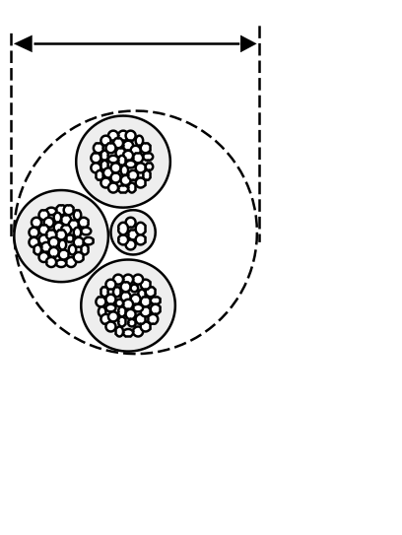

The established overload values are the minimum, which may be modified by the electrical designer when justified or when the particular specifications of the distribution companies, approved by the competent body of the authority, so establish for geographical areas with wind or ice weather events that justify the use of higher overloads.

Mechanical calculation of cables

Maximum permissible traction
The maximum traction of the messenger or neutral messenger shall not exceed its breaking load divided by 2.5, taking account of the following scenarios.
  - Zone A:
- subjected to the action of its own weight and to wind overload, at a temperature of 15°C;
- subjected to the action of its own weight and to wind overload divided by 3, at a temperature of 0°C.
  - Zones B and C:
- subjected to the action of its own weight and to wind overload, at a temperature of 15°C;
- subjected to the action of its own weight and the ice overload corresponding to the zone, at a temperature of 0°C.

Testing of vibration phenomena
In general, these phenomena do not have to be considered in low-voltage distribution networks.
However, if vibrations are expected to appear in the cable in the area crossed by the line, the stress state of the messenger or neutral messenger shall be checked for this purpose.
For this purpose, it shall be verified that the working traction of the messenger or neutral messenger, at a temperature of 15 °C without any overload, solely considering the weight of the bundle itself, does not exceed 21 % of the breaking load of the messenger or neutral messenger.

Maximum deflection
The maximum deflection of the conductors shall be taken as the greatest value resulting from the comparison between the two assumptions corresponding to the climate zone considered, and a third temperature assumption (valid for the three zones), consisting of considering the conductors subjected to the action of their own weight and the maximum foreseeable temperature, taking into account the climate and service conditions of the network. This temperature shall under no circumstances be less than 50 C.

Mechanical calculation of supports
For the mechanical calculation of the supports, the assumptions indicated in Tables 1, 2, 3 and 4 shall be taken into account, depending on the function of the support and the zone.
If self-supporting dielectric fibre cables are installed or are planned for future installation, the load due to their weight must be taken into account in calculating the vertical stresses and the wind pressure on the cables in the transverse stresses.

Table 1. Supports located in Zone A
Type of support | Type of stress | First scenario  (wind) | Second scenario  (wind/3)
Alignment | Vertical | Permanent loads (Sect. 2.1.1) considering the weight of the bundle itself, together with the accessories. | Permanent loads (Sect. 2.1.1) considering the weight of the bundle itself, together with the accessories.
Alignment | Transverse | Wind force (Sect. 2.1.2), corresponding to the pressure of 120 km/h wind on the conductor bundle and on the support. | Wind force (Sect. 2.1.2) corresponding to one third of the pressure of 120 km/h wind on the conductor bundle and on the support.
Alignment | Longitudinal | Not applicable | In mooring alignment support consider the stress due to the imbalance of the tension, in the steel messenger or neutral messenger, in the adjacent sections. (**)
Angle | Vertical | Permanent loads (Sect. 2.1.1) considering the weight of the bundle itself, together with the accessories on the support. | Permanent loads (Sect. 2.1.1) considering the weight of the bundle itself, together with the accessories on the support.
Angle | Transverse | Stress due to the resultant angle, plus the stress corresponding to the 120 km/h wind pressure on the conductor bundle in the adjacent spans projected in the direction of the resultant angle and the wind stress on the support. (*) | Stress due to the resultant angle, plus the stress corresponding to one third of 120 km/h wind pressure on the conductor bundle in the adjacent spans projected in the direction of the resultant angle and the wind stress on the support. (**)
Angle | Longitudinal | Not applicable | Not applicable
(*) Traction to be considered on the steel messenger or neutral messenger at a temperature of 15 °C with wind pressure corresponding to 120 km/h.
(**) Traction to be considered on the steel messenger or neutral messenger at a temperature of 0 °C with one third of the wind pressure corresponding to 120 km/h.

Table 2. Supports located in zone A
Type of support | Type of stress | First scenario  (wind) | Second scenario  (wind/3)
Branching | Vertical | Permanent loads (Sect. 2.1.1) considering the weight of the bundle itself, together with the accessories. | Permanent loads (Sect. 2.1.1) considering the weight of the bundle itself, together with the accessories.
Branching | Transverse | Two thirds of the resultant stresses on the support, in addition to the stress caused by the wind (Sect. 2.1.2, corresponding to 120 km/h wind pressure) on a conductor bundle of a length equal to the projection of each half span, adjacent to the support, on the normal of the resultant and the wind stress on the support (*). | Resulting from the stresses on the support, in addition to the stress caused by the wind (Sect. 2.1.2), corresponding to one third of 120 km/h wind pressure on a conductor bundle of a length equal to the projection of each half span, adjacent to the support, on the normal of the resultant and the wind stress on the support. (**).
Branching | Longitudinal | Not applicable | Not applicable
End of line | Vertical | Permanent loads (Sect. 2.1.1) considering the weight of the bundle itself, together with the accessories. | Permanent loads (Sect. 2.1.1) considering the weight of the bundle itself, together with the accessories.
End of line | Transverse | Wind force (Sect. 2.1.2), corresponding to the pressure of 120 km/h wind on the conductor bundle and the wind force on the support. | Wind force (Sect. 2.1.2) corresponding to one third of 120 km/h wind pressure on the conductor bundle and the wind force on the support.
End of line | Longitudinal | Stress due to tension of the steel messenger or neutral messenger. (*) | Stress due to tension of the steel messenger or neutral messenger (**)
(*) Traction to be considered on the steel messenger or neutral messenger at a temperature of 15 °C with wind pressure corresponding to 120 km/h.
(**) Traction to be considered on the steel messenger or neutral messenger at a temperature of 0 °C with one third of the wind pressure corresponding to 120 km/h.

Table 3. Supports located in zones B and C
Type of support | Type of stress | First scenario  (wind) | Second scenario  (ice)
Alignment | Vertical | Permanent loads (Sect. 2.1.1) considering the weight of the bundle itself, together with the accessories. | Permanent loads (Sect. 2.1.1) considering the weight of the bundle itself, together with the accessories, plus ice overload on the conductor bundle (Sect. 2.1. 3)
Alignment | Transverse | Wind force (Sect. 2.1.2), corresponding to the pressure of 120 km/h wind on the conductor bundle and the wind force on the support. | Not applicable
Alignment | Longitudinal | Not applicable | In mooring alignment support consider the stress due to the imbalance of the tension, in the steel messenger or neutral messenger, in the adjacent sections. (**)
Angle | Vertical | Permanent loads (Sect. 2.1.1) considering the weight of the bundle itself, together with the accessories on the support. | Permanent loads (Sect. 2.1.1) considering the weight of the bundle itself, together with the accessories, plus ice overload on the conductor bundle (Sect. 2.1. 3)
Angle | Transverse | Stress due to the resultant angle, plus the stress corresponding to the 120 km/h wind pressure on the conductor bundle in the adjacent spans projected in the direction of the resultant angle and the wind stress on the support. (*) | Stress due to the resultant angle. (**)
Angle | Longitudinal | Not applicable | Not applicable
(*) Traction to be considered on the steel messenger or neutral messenger at a temperature of 15 °C with wind pressure corresponding to 120 km/h.
(**) Tension to be considered on the steel messenger or neutral messenger at a temperature of 0 °C with the regulatory ice load, depending on the area.

Table 4. Supports located in zones B and C
Type of support | Type of stress | First scenario  (wind) | Second scenario  (ice)
Branching | Vertical | Permanent loads (Sect. 2.1.1) considering the weight of the bundle itself, together with the accessories on the support. | Permanent loads (Sect. 2.1.1) considering the weight of the bundle itself, together with the accessories, plus ice overload on the conductor bundle (Sect. 2.1. 3)
Branching | Transverse | Two thirds of the resultant stresses on the support, in addition to the stress caused by the wind (Sect. 2.1.2, corresponding to 120 km/h wind pressure) on a conductor bundle of a length equal to the projection of each half span, adjacent to the support, on the normal of the resultant and the wind stress on the support (*). | Resulting from stress on the support. (**).
Branching | Longitudinal | Not applicable | Not applicable
End of line | Vertical | Permanent loads (Sect. 2.1.1) considering the weight of the bundle itself, together with the accessories on the support. | Permanent loads (Sect. 2.1.1) considering the weight of the bundle itself, together with the accessories, plus ice overload on the conductor bundle (Sect. 2.1. 3)
End of line | Transverse | Wind force (Sect. 2.1.2), corresponding to the pressure of 120 km/h wind on the conductor bundle and the wind force on the support. | Not applicable
End of line | Longitudinal | Stress due to tension of the steel messenger or neutral messenger. (*) | Stress due to tension of the steel messenger or neutral messenger (**)
(*) Traction to be considered on the steel messenger or neutral messenger at a temperature of 15 °C with wind pressure corresponding to 120 km/h.
(**) Tension to be considered on the steel messenger or neutral messenger at a temperature of 0 °C with the regulatory ice load, depending on the area.

To calculate the branch and angle supports, the applicable diagrams to calculate the stress are given.
- Resulting tensile stresses on the support (F_{t}).
Figure 2. Graphical calculation of the result (Ft) of tensile stresses on branch or angle support.
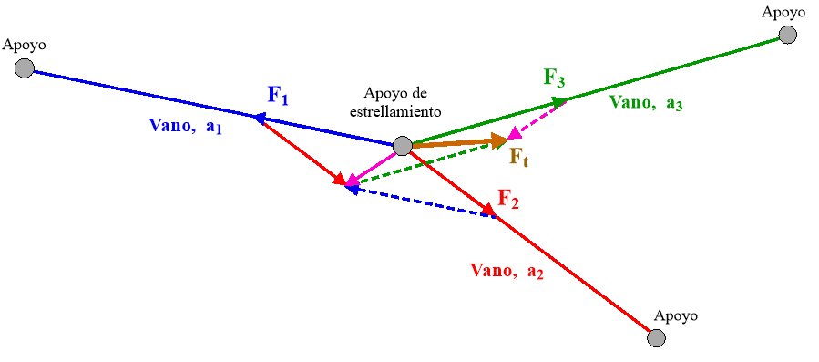

- Resulting tensile stress (F_{t}) support and of the wind on the conductor bundle of each span (F_{v}).

To perform the calculation, the absolute value of the tensile stress result (F_{t}), or two thirds of this result depending on the assumption, is added to the transverse wind stress result, (F_{v}), due to the wind pressure on each conductor bundle. The wind stress on each conductor bundle is calculated assuming a bundle length (l₁, l₂ and l₃) equal to the projection of each half span in the normal direction to the resulting tensile stresses on the support.
Figure 3. Graphical calculation of the stress on a branch or angle support resulting from the tensile and wind forces on the conductor bundle of each span.
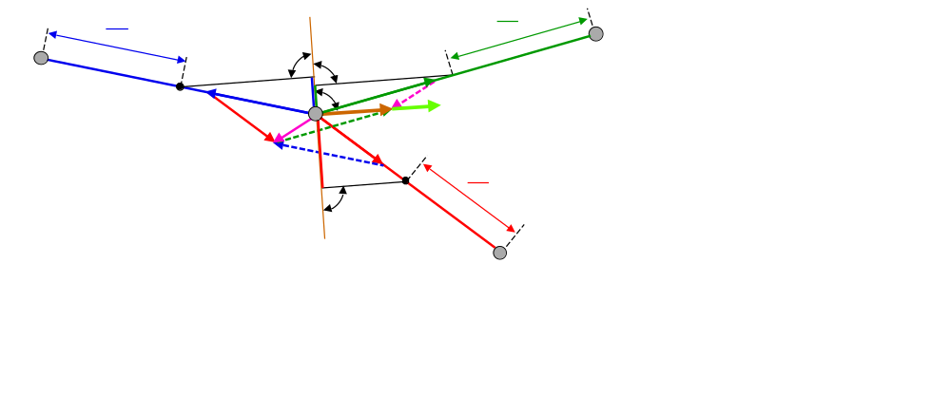
When the spans are less than 15 m, the permanent loads have very little influence, so they can generally be dispensed with in the calculation.
The safety coefficient at breakage shall be different depending on the material of the supports according to Table 5.
Table 5. Safety coefficient at breakage as a function of the material of the supports
Safety coefficient at breakage
Support material | Coefficient
Metallic | 1.5
Reinforced vibrated concrete | 2.25
Glass-fibre-reinforced polyester | 2.0
Wood | 3.5
Other non-metallic materials | 2.5
NB: In the case of metal or reinforced vibrated concrete supports for which the mechanical strength has been verified by true magnitude tests, the safety coefficients may be reduced to 1.45 and 2 respectively.
Where, for extraordinary weather reasons, temperatures or ice sleeves are to be assumed to be higher than those indicated, it shall be sufficient to check that the resulting stresses are lower than the yield strength.

EXECUTION OF THE INSTALLATIONS

Installation of insulated conductors
Cables consisting of insulated conductors bundled together may be installed either laid or tensioned.

Installation of laid cables
In urban land and especially in buildings of historical or artistic interest or declared as such or under some other form of protection, the aim will be to avoid this form of installation.
Cables shall be directly laid on the façades, walls or surface area of the supports, by means of cable ties that withstand weathering. Cables shall be adequately protected in places where they may suffer mechanical deterioration of any kind, preferably under rigid pipes, closed non-circular cross-section ducts or protective channels the cover of which can only be dismantled with a tool, which comply with the requirements of ITC BT-21.
Cable ties complying with Standard UNE-EN IEC 62275 and cable tie clamps complying with Standard UNE-EN IEC 61914, classified as resistant to ultraviolet light, are presumed to comply with the requirements of this ITC.
Rigid protection pipes in accordance with Standard UNE-EN IEC 61386-21 and protective channels and closed non-circular cross-section ducts in accordance with Standard UNE-EN IEC 61084-2-1 shall be presumed to comply with the requirements of this ITC.
In the empty spaces (cables not resting on the façade or wall) the cables shall have the status of tensioned cables and shall be governed by the provisions of Section 3.1.2.
In general, a minimum height to the ground of 2.5 metres must be observed. If a particular circumstance such as that indicated in the previous paragraph occurs, the minimum height must be that indicated in Sections 3.1.2 and 3.8 for each particular case. Routes below this minimum ground clearance (e.g. for service connections) shall be protected by rigid pipes, closed non-circular cross-section ducts or channels with the characteristics indicated in the table below and appropriate measures shall be taken to prevent the storage of water in them. Cables shall be prevented from passing in front of any existing openings in façades or walls.
Table 6. Characteristics of pipes, closed non-circular cross-section ducts or channels to be used when the distribution network is at a height above the ground of less than 2.5 m.
Characteristic | Pipes | Closed non-circular cross-section ducts | Channels
Characteristic | Code / grade | Grade | Grade
Compression strength | 4 / Strong | 1250 N | --
Impact resistance | 4 / Strong | 5 J | 5 J
Minimum installation and service temperature | 2/ -5 °C | -5 °C | -5 °C
Maximum installation and service temperature | 1/+60 °C | +60 °C | +60 °C
Electrical properties | 1/ 2  Electrical continuity / insulation | Electrical continuity / insulation | Electrical continuity / insulation
Resistance to penetration by solid objects | 4  Protected against objects of Φ ≥ 1 mm | IP 4X | IP 4X
Corrosion resistance (metallic conduits) | 3  Medium interior protection and high exterior protection | -- | --
Resistance to flame propagation | 1  Non-propagator | Non-propagator | Non-propagator

Compliance with these characteristics shall be verified according to the tests indicated in Standards UNE-EN IEC 61386-21 for rigid protective pipes and UNE-EN IEC 61084-2-1 for protective channels or closed non-circular cross-section ducts.
The following minimum distances must be respected in the vicinity of openings in façades.
  - Windows: 0.30 metres to the upper edge of the opening and 0.50 metres to the lower edge and lateral edges of the opening.
  - Balconies: 0.30 metres to the upper edge of the opening and 1.00 metre to the side edges of the balcony.
Account shall be taken of the existence of overhangs or canopies which may facilitate the laying of cables, in which case a reduction in the distances indicated above may be permitted.
A minimum distance of 0.05 m shall also be respected to the metal elements present on the façades, such as stairs, unless the cable has protection in accordance with Table 6 above.

Installation of tensioned cables
Cables with a neutral messenger may be tensioned between special parts placed on supports, façades or walls, with an appropriate mechanical tension, without considering the insulation as a resistant element for this purpose.
For the rest of the tensioned cables, galvanised steel messenger cables shall be used, with a breaking strength of at least 800 daN, to which the insulated conductors shall be fixed by means of clamps or other suitable devices.
Ground clearance: 4 m, except as specified in Section 3.8.1 for crossing lines.

Conductor connections
The conductors shall be connected in such a way as to avoid mechanical traction on the fittings, and it is not permissible to make connections by welding or by direct twisting of the conductors.
Branches shall be connected in the vicinity of the line supports and shall not cause mechanical traction on the line.
With conductors of a different nature, all necessary precautions shall be taken to avoid the disadvantages arising from their special characteristics, avoiding electrolytic corrosion by means of suitable parts.

Minimum neutral conductor cross-section.
Depending on the number of conductors distributed, the minimum neutral conductor cross-section shall be as follows.
- With two or three conductors: equal to that of phase conductors.
- With four conductors: as indicated in Table 7. Where there are imbalances between phase currents or a significant presence of harmonics, the electrical designer shall check whether the neutral cross-section should be increased.
Table 7. Neutral conductor cross-section on overhead networks
Phase section | Cables without neutral messenger, neutral cross-section | Cables with neutral messenger, neutral cross-section
16 Al | 16 Al | Not applicable
25 Al | 25 Al | 29.5 Alm  54.6 Alm
50 Al | 50 Al | 29.5 Alm  54.6 Alm
95 Al | 50 Al | 54.6 Alm
150 Al | 95 Al | 80 Alm
10 Cu | 10 Cu | Not applicable
16 Cu | 16 Cu | Not applicable
The neutral messenger also has a mechanical function so for the same phase section two different neutral sections can be used.
‘Alm’ is an alloy of aluminium, magnesium and silicon (Almelec).

Identification of the neutral conductor.
The neutral conductor must be identified as indicated in Standard UNE 21030.

Neutral conductor continuity.
The neutral conductor may not be interrupted in the distribution networks, unless this interruption is carried out with any of the following devices:
- Multipole switches or disconnectors that act on the neutral and the phases at the same time (simultaneous multipole cut-off), or that connect the neutral before the phases and disconnect the phases before the neutral.
- Removable joints in the neutral close to the switches or disconnectors of the phase conductors, duly marked, and which can only be manoeuvred by means of suitable tools, and in this case, the neutral must not be disconnected without the phases being disconnected beforehand, nor the phases connected without the neutral having been connected beforehand.

Neutral earthing.
The neutral conductor of distribution networks of distribution companies shall be earthed at the transformer station or power station in the manner provided for in the Regulation on Technical Conditions and Safety Guarantees in High-Voltage Electrical Installations. In addition, in type TT and TN distribution systems, the neutral conductor and the protective conductor for the TN-S system shall be earthed to at least one other point, and at least once every 500 metres of line length. In order to carry out this earthing, preference shall be given to the points from which the main branches originate, as well as to the place where the main protection box or protection and measurement box is located.
In private distribution networks, originating from own generation plants for which the earthing of the neutral is envisaged, the above specifications for the distribution networks of the distribution companies shall be followed.

Installation of supports
The supports shall be consolidated by suitable foundations or directly embedded in the ground, ensuring their stability against the acting stresses and the nature of the soil. The following must be observed when installing them.
- The concrete poles shall be placed in monolithic concrete foundations.
- The metal supports shall be founded in concrete slabs or by other technically proven methods, e.g. bolting. The foundation must be constructed in such a way as to facilitate the sliding of the water and to cover, where they exist, the heads of the bolts.
- Wooden posts shall be placed directly on the ground and shall not be embedded in concrete beds. They may be fixed to metal or concrete bases by means of appropriate joining elements that allow easy replacement, with the pole being separated from the ground by at least 0.15 m.
- Glass fibre reinforced polyester supports shall be founded in concrete beds or directly embedded in the ground.

General conditions for crossing and parallel lines
Overhead power lines shall comply with the conditions specified in Sections 3.8.1 and 3.8.2. of this Instruction. Self-supporting dielectric fibre cables shall be considered for the purpose of crossing and parallel lines and in general as low-voltage overhead electricity lines with insulated conductors, with the exceptions indicated in this section.

Crossing lines
The lines shall meet the conditions indicated for each case of the spans crossing the routes and installations.

With bare conductor overhead high-voltage power lines
The provisions of ITC LAT-07 of the Regulation on technical conditions and safety guarantees for high-voltage power lines, hereinafter RLAT, shall be followed with regard to the distances of high-voltage lines from other overhead power lines.
The low-voltage line must cross below the high-voltage line.
When the resulting stresses of the low-voltage cable at any of the crossing supports has an ascending vertical component, due precautions shall be taken so that the conductors or fastening accessories do not become detached.
Crossing may take place without the high-voltage line meeting any special conditions when the low-voltage line is protected at the crossing by a bundle of steel cables, located between the conductors of both lines, with sufficient mechanical strength to withstand the fall of the conductors of the high-voltage line, in the event that they are broken or detached. The protective cables shall be made of galvanised steel, and shall be earthed.
In the event that, due to unique circumstances, it is necessary for the low-voltage line to cross above the high-voltage line, express authorisation must be obtained from the competent body of the authority. In order to carry out these crossing lines, all the precautions and criteria set out in the aforementioned RLAT must be considered.

With high-voltage overhead power lines with insulated conductors
The high-voltage line with bundled single-pole insulated cable may cross either above or below the low-voltage power lines, while high-voltage lines with sheathed conductors cross above them. However, considering the foreseeable handling frequency of high-voltage lines with bundled single-pole insulated cable, it is recommended that the higher voltage line crosses over it. The crossing may or may not be carried out on a shared support.
The minimum vertical separation distance at the crossing point for crossings with low-voltage lines under the most unfavourable conditions shall be no less than 0.5 m in the case of high-voltage lines with bundled insulated cables.
The minimum vertical separation distance at the crossing point for crossings with low-voltage lines under the most unfavourable conditions shall be no less than 1 m in the case of high-tension lines with coated conductors.

With other low-voltage overhead power lines
When the crossing is with an old line of bare conductors and the crossing is made on different supports, the distance between the nearest conductors of the two lines shall be greater than 0.50 m; and if the crossing is made on a shared support, this distance shall be greater than 0.3 m.
The minimum vertical separation distance at the crossing point between two low-voltage lines with insulated conductors in tensioned installation shall be such that, under the most unfavourable operating conditions, there is no contact between them. If the installation is laid, the two lines may be in contact.

With overhead telecommunication lines
Low-voltage lines, with bare conductors, corresponding to old lines, shall cross above telecommunication lines. Exceptionally, they may cross below, in which case one of the following solutions must be adopted.
- Placement between the lines of a protection device consisting of a bundle of steel cables, placed between the conductors of both lines, with sufficient mechanical strength to withstand the fall of the conductors of the telecommunication line in the event of breakage or detachment. The protective cables shall be made of galvanised steel, and shall be earthed.
- Use of insulated conductors for 0.6/1 kV in the crossing span for low-voltage lines.
- Use of insulated conductors for 0.6/1 kV in the crossing span for the telecommunications line.
When the crossing is carried out in different supports, the minimum distance between the bare conductors of the old low-voltage lines and those of the telecommunication lines shall be 1 metre. If the crossing is on shared supports, this distance may be reduced to 0.50 metres.

With unelectrified roads and railways
The conductors shall have a breaking load of not less than 410 daN, although in the case of connections with insulated conductors this value may be reduced to 280 daN.
The minimum height of the lowest conductor under the most unfavourable arrow conditions shall be 6 m.
The conductors shall not have any splices in the crossing span, and during operation, and for the purpose of repairing the fault, the existence of one splice per span shall be permitted.

With electrified railways, trams and trolleybuses
The minimum height of the conductors above the supporting cables or wires or conductors of the contact line shall be 2 m.
In addition, in the case of railways, trams or trolleybuses equipped with a trolley, or other electrical outlet elements that can accidentally be separated from the contact line, the power line conductors shall be located at such a height that, when the electrical outlet element is disconnected, it does not reach, in the most unfavourable position it may adopt, a separation of less than 0.30 metres with the conductors of the low-voltage line.

With cable cars and conveyor cables
Where the low-voltage line passes overhead, the minimum distance between the conductors and any element of the cable car installation shall be 2 m. Where the low-voltage overhead line passes underneath, this distance shall not be less than 3 metres. Adjacent supports of the cable car corresponding to the crossing with the low-voltage line shall be earthed.

With rivers and canals that are navigable or suitable for timber rafting
The minimum height of conductors above the water surface for the maximum level they can reach shall be: H= G +1 m, where G is the clearance gauge.
In the event that there is no defined gauge, it shall be considered to be equal to 6 m.

With radio and television receiving antennas.
Low-voltage line conductors, when bare, shall have a minimum distance of 1 m from the antenna itself, its braces and its down conductors, when these are not fixed to the walls in such a way as to avoid possible contact with the low-voltage line.
The use of low-voltage line supports for attaching radio or television antennas or their guide wires is prohibited.

With water and gas conduits
The minimum distance between electrical power cables and water or gas pipelines shall be 0.20 m. The vertical crossing of the joints of the water or gas pipelines, or the joints of the electrical conduit, shall be avoided, placing them at a distance of more than 1 m from the crossing. For old bare overhead lines the minimum distance shall be 1 m.

Proximity and parallel lines

With overhead high-voltage electrical lines
It is mandatory to comply with the RLAT to avoid the construction of parallel lines with high-voltage lines at distances less than 1.5 times the height of the highest support between the traces of the nearest conductors.
Access lines to power stations, transformer stations and transformer centres are exempted from the above requirement. In these cases, the provisions of the regulations applicable to high-voltage installations shall apply. However, where there are parallel lines of voltage equal to or lower than 66 kV there shall not be a separation of less than 2 metres between adjacent conductors of parallel lines, and 3 metres for higher voltages.
Low-voltage power lines may run on the same supports as high-voltage power lines when the following conditions are met.
  - The conductors of the high-voltage line shall have a minimum breaking load of 480 daN, and shall be placed above the low-voltage conductors.
  - The distance between the nearest conductors of the two lines shall be at least equal to the separation of the conductors of the high-voltage line.
  - On shared supports, a sign shall be placed between the low-voltage and high-voltage lines warning personnel carrying out low-voltage work of the dangers posed by the presence of an overhead high-voltage line.
  - The insulation of the low-voltage line shall not be less than the corresponding earthing of the high-voltage line.

With other low-voltage or telecommunication lines
When both lines are of insulated conductors, the minimum distance shall be 0.10 m. When either of the lines is of bare conductors, the minimum distance shall be 1 m. In this case, if both lines are on the same supports, the minimum distance may be reduced to 0.50 m. These minimum distances do not apply to fibre optic cables with dielectric sheaths which could be in contact with low-voltage lines with insulated conductors or with other telecommunication lines.
The insulation level of the telecommunication line shall be at least equal to that of the low-voltage line. Otherwise it shall be considered a line of bare conductors.

With streets and roads
Overhead networks with insulated conductors in tensioned installation may be established close to streets and roads, and their installation must maintain a minimum distance of 6 m when they are close to potential traffic zones or spaces; and a distance of 4 m when they are not next to potential traffic zones or spaces.

With electrified railways, trams and trolleybuses
The horizontal distance of conductors to the contact line installation shall be at least 1.5 m.

With wooded areas
There must be no contact between the power lines and the trees to prevent branches blowing in the wind from damaging the insulation of the cable.

With water pipes
The minimum distance between electric power cables and water pipelines shall be 0.20 m. The minimum distance between the splices of electric power cables or between bare cables and the joints of water pipelines shall be 1 m.
A minimum distance of 0.20 m in horizontal projection shall be maintained, and care shall be taken to ensure that the water pipeline is below the level of the power cable.
On the other hand, the main water arteries shall be arranged in such a way as to ensure distances of more than 1 m from low-voltage electrical cables.

With gas pipelines
The minimum distance between electrical power cables and gas pipelines shall be 0.20 m, except for high-pressure gas pipelines (more than 4 bar), where the distance shall be 0.40 m. The minimum distance between the splices of electrical power cables and the joints of gas pipelines shall be 1 m.
For all gas pipelines, regardless of their pressure, a minimum distance of 0.20 m in a horizontal projection shall be maintained.
On the other hand, important gas arteries shall be arranged in such a way as to ensure distances of more than 1 m from low-voltage electrical cables.

MAXIMUM PERMISSIBLE CURRENTS FOR CONDUCTORS

Overview
The maximum permissible currents given in the following sections of this Instruction apply to cables formed by conductors with a cross-linked polyethylene insulating cover (XLPE) assembled in a visible spiral bundle, with a rated voltage of 0.6/1 kV.
Under permanent conditions, the maximum permissible current of the cables for standard installation conditions is that calculated according to the UNE 21144 series of standards.
Tables 8, 9 and 10 correspond to the maximum permissible current values indicated in Standard UNE 211435-1 calculated by applying the methodology of the UNE 21144 series of standards and for the following standard installation conditions:
  - a single cable installed outdoors;
  - exposed to solar radiation of 1 kW/m²; and
  - ambient temperature of 40 °C.

Cables with an aluminium-magnesium-silicon alloy neutral conductor for tensioned cable installations
Table 8. 0.6/1 kV RZ-type overhead distribution cables (aluminium conductor with neutral messenger)
Maximum permissible current, in A
Construction | Protected  from the sun | Exposed  to the sun
1 x 25 Al/54.6 Alm | 105 | 95
1 x 50 Al/54.6 Alm | 160 | 145
3 X 25 Al/29.5 Alm | 90 | 76
3 x 25 Al/54.6 Alm | 90 | 76
3 x 50 Al/29.5 Alm | 135 | 115
3 x 50 Al/54.6 Alm | 135 | 115
3 x 95 Al/54.6 Alm | 215 | 185
3 x 150 Al/80 Alm | 300 | 250

Cables without a neutral messenger for installations of laid cables or tensioned cables with a steel messenger
Table 9. 0.6/1 kV RZ-type overhead distribution cables (aluminium conductor without neutral messenger)
Maximum permissible current, in A
Construction | Protected  from the sun | Exposed  to the sun
2 x 16 Al | 78 | 72
2 x 25 Al | 105 | 95
4 x 16 Al | 64 | 56
4 x 25 Al | 90 | 76
4 x 50 Al | 135 | 115
3 x 95/50 Al | 215 | 185
3 x 150/95 Al | 300 | 250

Table 10. 0.6/1 kV RZ-type overhead cables (copper conductor)
Maximum permissible current, in A
Construction | Protected  from the sun | Exposed  to the sun
2 x 10 | 76 | 70
4 x 10 | 62 | 54
4 x 16 | 84 | 72

Correction factors
When the service conditions envisaged for the low-voltage line are different from those considered standard, the electrical designer must apply the corresponding correction factors, taking Standard UNE 211435-1 as a reference.
Table 11. Correction factors for different air temperatures
Maximum conductor temperature in °C | Ambient air temperature in °C
Maximum conductor temperature in °C | 20 | 25 | 30 | 35 | 40 | 45 | 50
90 | 1.18 | 1.14 | 1.10 | 1.05 | 1.00 | 0.95 | 0.89

Table 12. Correction factors in case of cable grouping
Number of cables | 1 | 2 | 3 | more than 3
Correction factor | 1.00 | 0.89 | 0.8 | 0.75
Cables with two circuits (e.g. 4 x 10 + 2 x 2.5 mm²), are considered two cables for the purposes of calculating the maximum current, so it is appropriate to apply the correction factor corresponding to two cables to each of the circuits.

Maximum permissible short-circuit currents in cable conductors.
Tables 13 and 14 indicate the permissible short-circuit currents, depending on the different duration times of the short-circuit.
Table 13. Maximum short-circuit currents in kA, for aluminium conductors
Cross-section of the conductor in mm² | Short-circuit duration in seconds
Cross-section of the conductor in mm² | 0.1 | 0.2 | 0.3 | 0.5 | 1.0 | 1.5 | 2.0 | 2.5 | 3.0
16 | 4.7 | 3.2 | 2.7 | 2.1 | 1.4 | 1.2 | 1.0 | 0.9 | 0.8
25 | 7.3 | 5.0 | 4.2 | 3.3 | 2.3 | 1.9 | 1.6 | 1.4 | 1.3
50 | 14.7 | 10.1 | 8.5 | 6.6 | 4.6 | 3.8 | 3.3 | 2.9 | 2.7
95 | 27.9 | 19.2 | 16.1 | 12.5 | 8.8 | 7.2 | 6.2 | 5.6 | 5.1
150 | 44.1 | 30.4 | 25.5 | 19.8 | 13.9 | 11.4 | 9.9 | 8.8 | 8.1

Table 14. Maximum short-circuit currents in kA for copper conductors
Cross-section of the conductor in mm² | Short-circuit duration in seconds
Cross-section of the conductor in mm² | 0.1 | 0.2 | 0.3 | 0.5 | 1.0 | 1.5 | 2.0 | 2.5 | 3.0
10 | 4.81 | 3.29 | 2.70 | 2.11 | 1.52 | 1.26 | 1.11 | 1.00 | 0.92
16 | 7.34 | 5.23 | 4.29 | 3.35 | 2.40 | 1.99 | 1.74 | 1.57 | 1.44

Other cables or other installation systems
For any other type of cable or composition or other installation system not covered by this Instruction, as well as for cables not included in the tables above, the maximum permissible current must be calculated according to the UNE 21144 series of standards.

ELECTRICAL TESTS AFTER INSTALLATION
Once the installation has been completed, the undertaking installing the networks shall verify, by means of an insulation resistance test, that the laying and assembly of the accessories (connections, terminals, etc.) has been carried out correctly. The test shall be carried out without interconnecting the new distribution network with the existing network.
The test determines the insulation of the active conductors (phases and neutral) in order to check whether the values of the insulation resistance, between each conductor and the rest, are higher than those indicated in Table 15.
Table 15. Minimum insulation resistance values
Rated voltage of the Uo/U cable (kV) | Test voltage to be applied, DC (V)  (see Note 1) | Conductor cross-section  (mm²) | Minimum insulation resistance for 1 km in length (see Note 2)  (MΩ)
0.6/ 1 | 500 | ≤ 25  > 25 and ≤ 95  > 95 | 30  20  15
Note 1: The test voltage shall be applied for a sufficient period of time, from 1 to 5 minutes, to obtain a stable reading of the insulation resistance.
Note 2: The insulation resistance values in the table correspond to a length of 1 km. For other lengths, the minimum value of the insulation resistance is obtained by dividing the value in the table by the length of the line in km.
’

Twenty. Supplementary Technical Instruction ITC BT-07, ‘Underground networks for low-voltage distribution’, is amended to read as follows:

‘ITC BT-07

UNDERGROUND NETWORKS FOR LOW-VOLTAGE DISTRIBUTION
TABLE OF CONTENTS
- MATERIALS
  - Conductors
  - Cables
  - Fittings
- EXECUTION OF THE INSTALLATIONS
  - Cable installation
    - Directly buried
    - In buried pipelines
    - In tunnels
    - In inspectable drains or channels
    - In trays, supports, wall brackets or wall fasteners with flanges
    - Circuits with parallel cables
  - General conditions for crossing, proximity and parallel lines
    - Crossing
    - Proximity and parallel lines
    - Connections (service connections)
  - Earthing and neutral continuity
  - Conductor connection
- MAXIMUM PERMISSIBLE CURRENTS IN CABLE CONDUCTORS
  - Overview
  - Cables installed underground
  - Cables buried in trenches inside pipes
  - Cables installed outdoors
  - (in tunnels, accessible trenches, inspectable drains or channels)
  - Cables installed outdoors in confined spaces
  - Permissible short-circuit currents in conductors
  - Other types of cable or installation systems
- ELECTRICAL TESTS AFTER INSTALLATION

MATERIALS

Conductors
Cable conductors used in underground lines shall be made of copper or aluminium and shall be insulated with appropriate mixtures of polymeric compounds. They shall also be adequately protected against corrosion which may be caused by the terrain where they are installed and they shall have sufficient mechanical strength to withstand the stresses to which they may be subjected.
The cross-section of the conductors shall be suitable for the currents and voltage drops envisaged and, in any event, this cross-section shall not be less than 10 mm² for copper conductors and 25 mm² for aluminium conductors. Copper conductors may be used for connections, such that they will not be used in distribution networks, except in special cases duly justified by the electrical designer.
Depending on the number of conductors with which the distribution is made, the minimum cross-section of the neutral conductor will be as follows.
  - With two or three conductors, the cross-section of the neutral conductor shall be equal to that of the phases.
  - With four conductors, the cross-section of the neutral conductor shall be at least that of Table 1. Where there are imbalances between phase currents or a significant presence of harmonics, the electrical designer shall check whether the neutral cross-section should be increased.
Table 1. Minimum neutral conductor cross-section as a function of the cross-section of the phase conductors
Cross-section of phase conductors  (mm²) | Cross-section of neutral conductor  (mm²)
10 (Cu) | 10 (Cu)
16 (Cu) | 16 (Cu)
25 | 25
50 | 25
95 | 50
150 | 70
240 | 120

Cables
Cables shall have a rated voltage of not less than 0.6/1 kV. Aluminium conductor wires shall be constructed in accordance with the corresponding part of Standard UNE-HD 603-5N for cables with cross-linked polyethylene insulation and a PVC cover, or Standard UNE-HD 603-5X for cables with cross-linked polyethylene insulation and a polyolefin cover. Cables with a concentric conductor shall be constructed in accordance with the corresponding part of the UNE 0082 specification. Cables with aluminium conductors complying with Standards UNE-HD 603-5N or UNE-HD 603-5X and concentric cables complying with the 0082 specification shall be presumed to comply with the requirements of this ITC.

Fittings
Splices, branches and terminations of conductors shall be completed by using the appropriate fittings, which resistant to corrosion and moisture penetration and which ensure effective electrical contact, so that neither the electrical resistance nor the temperature rise in them is greater than that of the conductors.
Where heat sources are required to install the fitting, appropriate measures shall be taken to minimise safety risks, in particular in the event of proximity to other pipes and at all times by following the fitting manufacturer’s implementation instructions.
Insulated fittings and connection assemblies shall ensure the electrical connection and the integrity of the cable insulation.
Insulated connection elements, defined as connecting devices to simultaneously perform the connector and insulating enclosure functions (splices, branches and terminations), complying with Standard UNE 211022 shall be presumed to be in conformity with this ITC.
Connection assemblies consisting of an enclosure and a connection element that comply with Standard UNE 211029 shall be presumed to comply with this ITC.
Connecting metal elements that comply with the applicable requirements of UNE 211024 part 2 (compression tightening) or part 3 (screw tightening) shall be presumed to comply with this ITC.

EXECUTION OF THE INSTALLATIONS

Cable installation
The pipelines shall generally be located on land in the public domain and in clearly defined areas, preferably under the pavements. The layout shall be as straight as possible and may be parallel to fixed references such as lines on the façade and curbs.
The laying of the cables shall take into account the user guide included in the standard applicable to the type of cable to be installed, which includes, for example, requirements for bending radius during installation, minimum installation temperature and maximum tensile stress.
At the design stage, public service undertakings and potential service owners should be consulted in order to ascertain the position of their installations in the affected area. Once known, before opening the trenches, test pits will be opened to confirm or rectify the route provided for in the project.
The cables may be installed in any of the following ways.

Directly buried
The depth to the top of the cable shall not be less than 0.60 m on the pavement or ground or 0.80 m on the road. The depth must be increased when the conditions laid down in Section 2.2 of this Instruction so require.
In order to ensure that the cable is correctly installed without any damage, and that it provides safety against excavations carried out by third parties, the installation of the cables shall follow the instructions described below.
  - The bed of the trench receiving the cable shall be smooth and free of sharp edges, pebbles, stones, etc. It shall contain a layer of mine sand or washed river sand, of a minimum thickness of 0.05 m, on which the cable shall be placed. Above the cable shall be another layer of sand or sifted earth about 0.10 m thick. Both layers shall cover the total width of the trench, which shall be sufficient to maintain 0.05 m between the cables and the side walls.
  - Above the sand, all cables shall have mechanical protection, e.g. concrete tiles, prefabricated protective plates, bricks laid crosswise. The use of other equivalent mechanical protections may be permitted.
  - A signalling tape shall also be placed to warn of the existence of the low-voltage electric cable. Its minimum distance to the ground shall be 0.10 m, and 0.25 m to the top of the cable. Warning devices with visual signs in plastic materials that comply with Standard UNE-EN 12613 are presumed to comply with the requirements of this ITC.
  - Placement of plates with the dual purpose of providing mechanical protection and signalling is also permitted, with a minimum distance to the ground of 0.25 m, and also 0.25 to the top of the cable.

In buried pipelines.
The pipes shall be double-walled insulating pipes with a red corrugated outer surface and a smooth inner surface so as not to damage the cable sheath. Their characteristics shall be in accordance with the specifications of ITC BT-21 in its section on pipes for buried conduits. The minimum outer diameter of the pipe shall be 90 mm for channelling cables up to 50 mm² and 160 mm for cables up to 240 mm². No more than one circuit per pipe shall be installed.
The depth, to the top of the pipe, shall not be less than 0.60 m on the pavement or ground, or less than 0.80 m on the road.
Changes in the direction of the pipes shall be avoided as far as possible. In the points where they are produced and to facilitate cable handling, there shall be laying channels or manholes with covers, which may or may not be accessible, although the installation of curved pipes without the need for channels or manholes is also permitted, provided that the minimum curvature radius of the pipes or cables is not reduced. In the straight sections, to facilitate cable laying, intermediate, accessible, blind manholes or simply pulling pits may be installed. Where manholes are used, the pipes must be properly sealed at their ends to prevent the entry of rodents and water. In the joints between pipes, suitable sleeves must be used to ensure their watertightness.

In tunnels
Two tunnel types are considered: a visitable tunnel, with sufficient internal dimensions for the movement of people, and an accessible tunnel, or prefabricated trench, in which the movement of people is not foreseen and where the access covers require mechanical means for handling.
The tunnels shall be made of reinforced concrete or other materials of equivalent rigidity, watertightness and durability. They shall be dimensioned to withstand the load of overlying earth and pavements and the corresponding traffic loads.

Visitable tunnels
- Limitation of existing services
Visitable tunnels shall preferably be used for electrical power installations, control cables and telecommunications. Under no circumstances may electrical installations and gas installations coexist in the same tunnel.
It is also not recommended that there be water pipes, although in those cases where this is necessary, the water pipes will be located at a lower level than the rest of the installations. It is essential for the tunnel to have a drain located above the sewerage system level or the sanitation pipe level into which it drains.
- General conditions
Cables installed in visitable tunnels shall have the following minimum classification for reaction to fire: Cca, s1b, d2, a1.
Visitable tunnels shall have corridors with a minimum width of 0.90 m and a minimum height of 2 m, with exceptions to be justified. At critical points, junctions, special steps, personnel access points, among others, both the correct passage of the channels and the safety of movement of people will be studied.
The entrances to the tunnel shall be closed in such a way as to prevent the entry of unauthorised persons, but to allow those inside the tunnel to leave. Access points must be provided at the ends of the tunnels. The ventilation of tunnels shall be sufficient to ensure that the air is changed six times per hour, to avoid accumulation of gas and moisture condensation, and to help ensure that the maximum temperature of the tunnel is compatible with the services it contains. This temperature shall not exceed 40 °C.
The floors of the tunnels shall be non-slip and have an adequate slope and an effective drainage system, which prevents the formation of puddles. The user companies shall take the appropriate measures to avoid the presence of rodents in the tunnels.
- Configuration and identification of cables
It is advisable to arrange the cables of different services and different operators on different supports and maintain distances between them that allow their correct installation and maintenance. Within the same service, they should be grouped according to voltage (for example, low-voltage, control, signalling and other cables should be installed on one side, while the other side should be reserved for high-voltage cables).
Cables shall be arranged in such a way that their route is straight, seeking to maintain their relative position with the others. The entrances and exits of the cables in the tunnels shall be made in such a way that they do not hinder the maintenance of existing cables or the installation of new cables.
Once installed, all cables must be properly marked and identified. The identification shall also indicate the company to which they belong.
- Securing of cables
The cables must be fixed to the walls or structures of the tunnel by fastening and support elements (cable ties, brackets, trays, etc.) to prevent the electrodynamic stresses that may occur during the operation of low-voltage networks from moving or deforming them. These stresses, under the most unfavourable foreseeable conditions, shall be used to dimension the strength of the fastening elements, as well as their spacing, taking into account what is indicated in the guide for use of the standard applicable to the type of cable.
Cable ties complying with Standard UNE-EN IEC 62275, cable ties complying with Standard UNE-EN IEC 61914, and cable trays complying with Standard UNE-EN 61537 are presumed to be in compliance with the requirements of this ITC.
If cable conduction systems such as pipes, protective channels or closed non-circular cross-section ducts are used, they shall comply with the requirements of ITC BT-21 and shall be flame retardant.
In the case of single-core cables grouped in a harness, the greatest electrodynamic forces appear between phases of the same line, as a repulsion force of one phase in relation to the others. In this case, the cable fastenings may be supplemented with others that keep the harness together.
- Equipotential bonding of accessible metal masses
All metallic elements for fastening and supporting cables or other metallic elements accessible to persons passing through the tunnels (pavements, railings, metallic structures or pipes, etc.) shall be electrically connected to the tunnel earthing conductor in such a way as to avoid dangerous voltage differences in the event of defects.
- Tunnels with a length greater than 400 m.
Tunnels longer than 400 m shall, in addition to the above provisions, be fitted with:
  - fixed lighting inside;
  - fixed toxic gas detection installations, with a minimum sensitivity of 300 ppm;
  - light indicators regulating access at the entrances;
  - access to people every 400 m maximum;
  - interior signage lighting to inform of the exits and external references;
  - fire partitions every 400 m maximum, in accordance with the technical building code and with a fire resistance of 120 minutes;
  - fire doors every 400 m maximum, in accordance with the technical building code and with a fire resistance of 60 minutes.

Accessible tunnels or trenches
In such tunnels, the installation of high-voltage, low-voltage and lighting, control and communication power cables is permitted. The existence of gas pipelines is not accepted. The existence of water pipes is only permitted if it can be ensured that, in the event of a leak, the water does not affect the other services (e.g. in a double-body design, in which a water pipe is laid in one body, and in the other body, which must be watertight in relation to the previous one when the accessible cover is in place, low-voltage, high-voltage, public lighting, traffic lights, control and communication cables are laid).
The most notable safety conditions to be met by this type of installation are:
  - watertightness of closures; and
  - the air inside the conduit occupied by electrical cables must be efficiently changed in order to prevent the accumulation of gas and moisture condensation and improve heat dissipation.

In inspectable drains or channels
This type of installation may be used in locations with access restricted to trained persons, such as within industries or premises intended exclusively for containing electrical installations such as substations or transformer centres. This type of installation consists of construction channels with covers (usually flush with the ground level) that can be opened and closed by hand.
When cables are installed in inspectable drains or channels inside buildings, they must have the following minimum classification in relation to the reaction to fire: Cca, s1b, d2, a1.
It is advisable to separate the cables of different tensions (taking advantage of the bottom and the two walls). It may even be preferable to use different channels.
The channel must allow for air changes. However, if there are gas pipelines near the channel, there is a risk of explosion caused by possible gas leaks that reach the channel. In any case, the electrical designer must study the particular characteristics of the environment and justify the solution adopted.

On trays, supports, wall brackets or attached to the wall with flanges.
This type of installation shall be used inside substations, transformer stations or other premises used for electrical services, where access is restricted to authorised personnel. Cables installed inside buildings shall have the following minimum classification with respect to reaction to fire: Cca-s1b, d2, a1. Where the areas through which the cable runs are accessible to persons or vehicles, mechanical protections shall be provided to hinder accessibility.
Cable ties complying with Standard UNE-EN IEC 62275, cable ties complying with Standard UNE-EN IEC 61914, and cable trays complying with Standard UNE-EN 61537 are presumed to be in compliance with the requirements of this ITC.
If cable conduction systems such as pipes, protective channels or closed non-circular cross-section ducts are used, they shall comply with the requirements of ITC BT-21 and shall be flame retardant.

Circuits with parallel cables
Where the current to be carried exceeds that permitted by a single conductor, more than one conductor may be installed per phase, according to the following criteria.
  - Conductors of the same material, cross-section and length shall be used.
  - The cables shall be grouped into a trefoil, in triads arranged in one or more levels, for example:
    - three triads on one level: RST, TSR, RST
    - three trefoils stacked on three levels:
R^{S}T
T^{S}R
R^{S}T

General conditions for crossing, proximity and parallel lines.
Underground cables, when buried directly in the ground, must, in addition to the requirements set out in this section, comply with the conditions that may be imposed by other competent bodies, as a result of legal provisions, when their installations were affected by the laying of low-voltage underground cables.
The requirements set out in this section shall not apply to cables arranged in tunnels, channels, trays, stands, wall brackets or directly attached to the wall. In such cases, the arrangement of the cables shall be at the discretion of the operator; however, in order to establish the permissible currents in the cables, the correction factors defined in Section 3 shall be applied.
In order to cross areas where it is not possible or which poses a serious inconvenience and difficulty to dig trenches (railway crossings, roads with high traffic density, etc.), impact-type boring machines, pipe drilling machines or auger drilling machines may be used. In these cases, the trench design described above will be dispensed with since the drilling process considered most appropriate is used. Its installation requires large, unobstructed areas on both sides of the obstacle to be crossed to position the machinery.
In order to avoid the inconvenience of a new trench opening, provision must be made during the laying of the underground network for the installation of a reserve pipe between two manholes in the following cases:
  - in municipalities for which municipal ordinances or regional legislation so require;
  - in areas classified as historical heritage, architectural ensemble, property of cultural interest or archaeological monitoring;
  - crossing and parallel lines with roads of the general state network, including their crossing through populated areas;
  - pedestrian streets and squares, or with special and unusual pavements;
  - main squares and narrow streets with vehicular traffic located in the urban centre of the municipality.

Crossing lines
For each of the cases indicated, below are the conditions to which the crossing of directly buried low-voltage underground cables must respond.
- Streets and roads
The cables shall be laid inside protective pipes in accordance with the provisions of ITC BT-21, covered with concrete along their entire length to a minimum depth of 0.80 m. Whenever possible, the crossing shall be perpendicular to the axis of the road.
- Railways
The cables shall be laid inside protective pipes in accordance with the provisions of ITC BT-21, covered with concrete and, whenever possible, perpendicular to the road, and at a minimum depth of 1.3 m in relation to the underside of the sleeper. These pipes shall overlap the railway tracks by 1.5 m at each end.
- Other electric power cables
Whenever possible, it shall be ensured that low-voltage cables run above high-voltage cables.
The minimum distance between a low-voltage cable and other electrical power cables shall be: 0.25 m with high-voltage cables and 0.10 m with low-voltage cables.
The distance from the crossing point to the splices shall be greater than 1 m. Where these distances cannot be respected on directly buried cables, the most recently installed cable shall be arranged in pipelines as set out in Section 2.1.2.
- Telecommunication cables
The minimum spacing between electrical and telecommunications cables shall be 0.20 m. The distance from the crossing point to the junctions of both the power cable and the telecommunications cable shall be greater than 1 m. Where these distances cannot be respected in directly buried cables, the most recently installed cable shall be arranged in pipework as set out in Section 2.1.2.
These restrictions should not apply to fibre optic cables with dielectric sheaths. Any type of protection on the cable sheath must be insulating.
- Water and gas piping
Wherever possible, the cables shall be installed above the water pipes.
The minimum distance between electrical power cables and water or gas pipelines shall be 0.20 m. The vertical crossing of the joints of the water or gas pipelines, or the joints of the electrical conduit, shall be avoided, placing them at a distance of more than 1 m from the crossing. Where these distances cannot be respected in the directly buried cables, the most recently installed cable piping shall be arranged in a pipe duct as set out in Section 2.1.2.
- Sewerage systems
Efforts shall be made to pass the cables above sewerage lines. It shall not be permitted to contact its inside. It is permissible to contact its wall (e.g. by installing pipes), provided that it is ensured that the wall has not been weakened.
If this is not possible, it shall be passed underneath, and the cables shall be arranged in piping as set out in Section 2.1.2.
- Fuel tanks
Cables shall be arranged in piping as set out in Section 2.1.2 and shall be at least 0.20 m away from the tank. The ends of the pipes shall extend beyond the tank by at least 1.5 m on each end.

Proximity and parallel lines
Directly buried low-voltage underground cables shall comply with the following conditions and distances of proximity, taking care to ensure that they are not located in the same vertical plane as other conduits.
- Other electric power cables
Low-voltage cables may be installed parallel to other low- or high-voltage cables, keeping between them a minimum distance of 0.10 m from low-voltage cables and 0.25 m from high-voltage cables.
Where these distances cannot be respected in the directly buried cables, the most recently installed cable shall be arranged in piping as set out in Section 2.1.2.
If several low-voltage cables are channelled at the same time by the same operator, they may be installed at a shorter distance, even when in contact.
- Telecommunication cables
The minimum distance between electric power cables and telecommunication cables shall be 0.20 m. Where these distances cannot be met in directly buried cables, the most recently installed cable shall be arranged piping as set out in Section 2.1.2. This minimum distance does not apply to fibre optic cables with dielectric sheaths that may come into contact with electrical power cables, without the need for casing.
- Water pipes
The minimum distance between electric power cables and water pipes shall be 0.20 m. The minimum distance between the splices of electric power cables and the joints of water pipes shall be 1 m. Where these distances cannot be respected in directly buried cables, the most recently installed piping shall be arranged in a pipe duct as set out in Section 2.1.2.
Care shall be taken to maintain a minimum distance of 0.20 m in a horizontal projection and to keep the water pipeline below the level of the electric cable.
On the other hand, the main water arteries shall be arranged in such a way as to ensure distances of more than 1 m from low-voltage electrical cables.
- Gas pipelines
The minimum distance between electrical power cables and gas pipelines shall be 0.20 m, except for high-pressure gas pipelines (more than 4 bar), where the distance shall be 0.40 m.
The minimum distance between the splices of electrical power cables and gas pipeline joints shall be 1 m. Where these distances cannot be respected in directly buried cables, the most recently installed pipeline shall be arranged in pipe duct as set out in Section 2.1.2.
Care shall be taken to maintain a minimum distance of 0.20 m in a horizontal projection. On the other hand, important gas arteries shall be arranged in such a way as to ensure distances of more than 1 m from low-voltage electrical cables.

Connections (service connections)
In the event that the crossing or parallel line between electrical cables and pipes of the services described above occurs in the connection section to a building, a minimum distance of 0.20 m must be maintained.
Where these distances cannot be respected in the directly buried cables, the most recently installed cable piping shall be arranged in a pipe duct as set out in Section 2.1.2.
The electrical connection piping at the entrance to the building must be covered until adequate watertightness is achieved.

Earthing and neutral continuity
The earthing and continuity of the neutral shall comply with the requirements set out in ITC BT-06 on these same aspects.

Conductor connection
The conductors shall be connected in such a way as to avoid mechanical traction on the fittings, and it is not permissible to make connections by welding or by direct twisting of the conductors.
With conductors of a different nature, all necessary precautions shall be taken to avoid the disadvantages arising from their special characteristics, avoiding electrolytic corrosion by means of suitable parts.

MAXIMUM PERMISSIBLE CURRENTS

Overview
The maximum permissible current of steady-state cables is that corresponding to the calculations carried out according to the UNE 21144 series of standards for the installation conditions considered as standard. The following sections indicate the permissible currents for single-core and multicore cables with concentric neutral conductors according to their installation conditions.

Cables installed underground
Table 2 corresponds to the maximum permissible current values for the cable sections most commonly used in low-voltage networks, among those included in Standard UNE 211435-1, calculated by applying the UNE 21144 series of standards and with the standard conditions of buried installation indicated below:
  - a set of three single-core cables in mutual contact;
  - an entire length of cables directly buried in a trench with a depth of 0.70 m to the bottom of the cable;
  - when the cables are installed in a buried pipeline, it is a circuit inside the pipe;
  - average soil thermal resistivity of 1.5 K.m/W;
  - ambient temperature of the soil at this depth of 25 °C;
  - cables with primary insulation of cross-linked polyethylene (XLPE), which implies a maximum permissible temperature in the conductor under steady-state conditions of 90 °C.

Table 2. RV, XZ1(S) or XZ1(AS) type distribution cables of 0.6/1 kV XLPE insulation and copper or aluminium conductor
Maximum permissible current, in A Cables in a triangle configuration in contact
Cross-section mm² | Directly buried | In buried pipeline

Aluminium
25 | 98 | 82
50 | 135 | 115
95 | 200 | 175
150 | 260 | 230
240 | 340 | 305

Copper
10 | 78 | 64
16 | 100 | 82
Soil temperature, in °C |  |  | 25
Soil thermal resistivity, in K ⋅m/W |  |  | 1.5
Pipe thermal resistivity, in K ⋅ m/W |  |  | 3.5
Burying depth to the bottom of the cables, in m |  |  | 0.7
Table 3 corresponds to the maximum permissible current values for the cable sections most used in low-voltage networks, with concentric neutral and multicore cables, calculated by applying the UNE 21144 series of standards and with the standard conditions of buried installations indicated in the table itself.
Table 3. 0.6/1 kV multicore type distribution cables XLPE insulation, aluminium conductor and concentric copper neutral conductor.
Maximum permissible current, in A Cables in a triangle configuration in contact
Cable formation | No of phase conductors | Phase section (mm²) | Directly buried | Buried piping
1x50 Al + 25 | 1 | 50 | 135 | 110
3x95 Al + 35 | 3 | 95 | 200 | 165
3x150 Al + 50 | 3 | 150 | 260 | 210
3x240 Al + 95 | 3 | 240 | 340 | 270
Soil temperature in °C 25
Soil thermal resistivity, in K · m/W 1.5
Pipe thermal resistivity, in K · m/W 3.5
Burying depth to the bottom of the cables, in m 0.7
The permissible current of a cable indicated in Tables 2 and 3 is determined by the standard conditions of buried installation specified in this section. This current shall be corrected for each of the conditions of the actual installation which differ from the standard conditions, so that the temperature increase caused by the circulation of the corrected current value does not raise the temperature of the conductor under steady-state conditions above the maximum permissible temperature.
To make this correction, the correction factors set out in Standard UNE 211435-1 shall be applied for:
  - soil temperature other than 25 °C;
  - soil thermal resistivity other than 1.5 K  m/W;
  - burying depths other than 0.70 m;
  - grouping of underground cables.
The corresponding correction factors applicable under these conditions are indicated in Tables 4, 5, 6, 8 and 9.
Table 4. Correction factors for soil temperature other than 25 °C
Maximum conductor temperature in °C | Soil temperature in underground cables in °C
Maximum conductor temperature in °C | 10 | 15 | 20 | 25 | 30 | 35 | 40 | 45 | 50
90 | 1.11 | 1.07 | 1.04 | 1.00 | 0.96 | 0.92 | 0.88 | 0.83 | 0.78
Table 5: Correction factors for soil thermal resistivity other than 1.5 K m/W, for distribution cables of type RV, XZ1(S) or XZ1(AS) of 0.6/1 kV
 | Soil resistivity, in K · m/W
Cross-section of the conductor in mm² | 0.8 | 0.9 | 1.0 | 1.5 | 2.0 | 2.5 | 3.0
 | Cables installed in buried pipelines. One circuit per pipe
10 (Cu) | 1.12 | 1.10 | 1.08 | 1.00 | 0.93 | 0.88 | 0.83
16 (Cu) | 1.12 | 1.10 | 1.08 | 1.00 | 0.93 | 0.88 | 0.83
25 | 1.12 | 1.10 | 1.08 | 1.00 | 0.93 | 0.88 | 0.83
35 | 1.13 | 1.11 | 1.09 | 1.00 | 0.93 | 0.88 | 0.83
50 | 1.13 | 1.11 | 1.09 | 1.00 | 0.93 | 0.87 | 0.83
70 | 1.13 | 1.11 | 1.09 | 1.00 | 0.93 | 0.87 | 0.82
95 | 1.14 | 1.12 | 1.09 | 1.00 | 0.93 | 0.87 | 0.82
120 | 1.14 | 1.12 | 1.10 | 1.00 | 0.93 | 0.87 | 0.82
150 | 1.14 | 1.12 | 1.10 | 1.00 | 0.93 | 0.87 | 0.82
185 | 1.14 | 1.12 | 1.10 | 1.00 | 0.93 | 0.87 | 0.82
240 | 1.15 | 1.12 | 1.10 | 1.00 | 0.92 | 0.86 | 0.81
300 | 1.15 | 1.13 | 1.10 | 1.00 | 0.92 | 0.86 | 0.81
400 | 1.16 | 1.13 | 1.10 | 1.00 | 0.92 | 0.86 | 0.81
 | Directly buried cables connected in the shape of a triangle
10 (Cu) | 1.24 | 1.19 | 1.15 | 1.00 | 0.89 | 0.82 | 0.75
16 (Cu) | 1.24 | 1.19 | 1.15 | 1.00 | 0.89 | 0.82 | 0.75
25 | 1.25 | 1.20 | 1.16 | 1.00 | 0.89 | 0.81 | 0.75
35 | 1.25 | 1.21 | 1.16 | 1.00 | 0.89 | 0.81 | 0.75
50 | 1.26 | 1.21 | 1.16 | 1.00 | 0.89 | 0.81 | 0.74
70 | 1.27 | 1.22 | 1.17 | 1.00 | 0.89 | 0.81 | 0.74
95 | 1.28 | 1.22 | 1.18 | 1.00 | 0.89 | 0.80 | 0.74
120 | 1.28 | 1.22 | 1.18 | 1.00 | 0.88 | 0.80 | 0.74
150 | 1.28 | 1.23 | 1.18 | 1.00 | 0.88 | 0.80 | 0.74
185 | 1.29 | 1.23 | 1.18 | 1.00 | 0.88 | 0.80 | 0.74
240 | 1.29 | 1.23 | 1.18 | 1.00 | 0.88 | 0.80 | 0.73
300 | 1.30 | 1.24 | 1.19 | 1.00 | 0.88 | 0.80 | 0.73
400 | 1.30 | 1.24 | 1.19 | 1.00 | 0.88 | 0.79 | 0.73

Table 6: Correction factors for ground thermal resistivity other than 1.5 K ·m/W, for multicore distribution cables with 0.6/1 kV copper concentric neutral
 | Soil resistivity, in K · m/W
 | 0.8 | 0.9 | 1.0 | 1.5 | 2.0 | 2.5 | 3.0
Cables installed in buried pipelines | 1.14 | 1.12 | 1.10 | 1.00 | 0.93 | 0.87 | 0.82
Directly buried cables | 1.28 | 1.22 | 1.18 | 1.00 | 0.88 | 0.80 | 0.74

The soil thermal resistivity depends on the type of soil and its moisture content, increasing when the soil is drier. Table 7 shows the indicative values of the soil resistivity that can be used by the electrical designer in cases where a specific study or field measurements of the soil thermal resistivity are not available.
Table 7: Soil thermal resistivity Indicative values according to the nature and degree of soil moisture content
Thermal resistivity (K.m/W) | Status of the soil | Atmospheric conditions
0.7 | Very damp | Permanently wet
1.0 | Damp | Regular rainfall
2.0 | Dry | Infrequent rainfall
3.0 | Very dry | Little or no rain

Table 8: Correction factors for burial depths other than 0.70 m.
Depth, m | Directly buried | In buried pipeline
0.60 | 1.02 | 1.01
0.70 | 1.00 | 1.00
0.80 | 0.99 | 0.99
1.00 | 0.97 | 0.97
1.25 | 0.95 | 0.96
1.50 | 0.93 | 0.95
1.75 | 0.92 | 0.94
2.00 | 0.91 | 0.93

Table 9: Correction factors for buried cable grouping
Directly buried single-core cable circuits connected in a triangle configuration
 | Distance between groups in mm
No of circuits | In contact | 200 | 400 | 600 | 800
2 | 0.82 | 0.88 | 0.92 | 0.94 | 0.96
3 | 0.71 | 0.79 | 0.84 | 0.88 | 0.91
4 | 0.64 | 0.74 | 0.81 | 0.85 | 0.89
5 | 0.59 | 0.70 | 0.78 | 0.83 | 0.87
6 | 0.56 | 0.67 | 0.76 | 0.82 | 0.86
7 | 0.53 | 0.65 | 0.74 | 0.80 | 0.85
8 | 0.51 | 0.63 | 0.73 | 0.80 | –
9 | 0.49 | 0.62 | 0.72 | 0.79 | –
10 | 0.48 | 0.61 | 0.71 | – | –
Circuits in a buried pipeline (one three-phase circuit with neutral per pipe)
 | Distance between pipes in mm
No of circuits | In contact | 200 | 400 | 600 | 800
2 | 0.87 | 0.90 | 0.94 | 0.96 | 0.97
3 | 0.77 | 0.82 | 0.87 | 0.90 | 0.93
4 | 0.71 | 0.77 | 0.84 | 0.88 | 0.91
5 | 0.67 | 0.74 | 0.81 | 0.86 | 0.89
6 | 0.64 | 0.71 | 0.79 | 0.85 | 0.88
7 | 0.61 | 0.69 | 0.78 | 0.84 | –
8 | 0.59 | 0.67 | 0.77 | 0.83 | –
9 | 0.57 | 0.66 | 0.76 | 0.82 | –
10 | 0.56 | 0.65 | 0.75 | – | –

Cables buried in trenches inside pipes
In this type of installation, the provisions of Section 3.2 in relation to cables in buried piping apply, in addition to the provisions of this section.
One circuit per pipe shall be installed. The ratio between the inner diameter of the pipe and the apparent diameter of the circuit shall be greater than 2, while exceptionally 1.5 may be accepted.
In the case of a single-circuit line with four single-core cables located in two pipes, the currents in Table 2 do not apply and each case shall be examined individually.
In the case of a grouping of more than 10 pipes, the factor depends on the type of grouping and will vary for each cable depending on whether it is placed in a central or peripheral pipe. Each case must be studied individually.
In the case of buried piping not exceeding 15 m, if the pipe is filled with special agglomerates, it is not necessary to use the permissible current value corresponding to cables in buried piping, and the value corresponding to directly buried cables may be used.

Cables in outdoor installations (in tunnels, accessible trenches, inspectable drains or channels)
Table 10 corresponds to the maximum permissible current values for the cable sections most commonly used in low-voltage networks, among those included in Standard UNE 211435-1, calculated by applying the UNE 21144 series of standards and with the standard conditions of outdoor installations (in tunnels, accessible trenches, etc.), indicated below:
  - a set of three single-core cables in mutual contact, with a position such as to allow effective air changes;
  - ambient temperature of 40 °C;
  - cables with primary insulation of cross-linked polyethylene (XLPE), which implies a maximum permissible temperature in the conductor under steady-state conditions of 90 °C.
Table 10: RV, XZ1(S) or XZ1(AS) type distribution cables of 0.6/1 kV XLPE insulation and copper or aluminium conductor
Maximum permissible current, in A
Cross-section mm² | Outdoors, in tunnels, accessible trenches, inspectable drains or channels
Aluminium
25 | 88
50 | 125
95 | 200
150 | 290
240 | 390
Copper
10 | 66
16 | 88
Cables in a triangle configuration in contact
Ambient air temperature 40 °C
Table 11 corresponds to the maximum permissible current values for standardised cable formations in low-voltage networks of multicore cables with a concentric neutral conductor, calculated by applying the UNE 21144 series of standards and with the standard outdoor installation conditions (in tunnels, accessible trenches, etc.) indicated below:
  - cables installed in such a way as to allow effective air changes;
  - ambient temperature of 40 °C;
  - cables with primary insulation of cross-linked polyethylene (XLPE), which implies a maximum permissible temperature in the conductor under steady-state conditions of 90 °C.
Table 11: Multiconductor-type distribution cables with 0.6/1 kV copper concentric neutral conductor XLPE insulation, aluminium conductor and concentric copper neutral conductor
Maximum permissible current, in A
Cable formation | Outdoors, in tunnels, accessible trenches, inspectable drains or channels
1x50 Al + 25 | 125
3x95 Al + 35 | 200
3x150 Al + 50 | 280
3x240 Al + 95 | 370
Ambient air temperature 40 °C
The permissible current of a cable indicated in the tables above is determined by the standard outdoor installation conditions specified in this section. This current shall be corrected for each of the conditions of the actual installation which differ from the standard conditions, so that the temperature increase caused by the circulation of the corrected current value does not raise the temperature of the conductor under steady-state conditions above the maximum permissible temperature.
To make this correction, the correction factors set out in Standard UNE 211435-1 shall be applied for:
  - ambient temperature other than 40 °C;
  - grouping of cables in outdoor installations.
The corresponding correction factors applicable under these conditions are indicated in Tables 12 and 13 below.
Table 12: Correction factors for environmental temperature other than 40 °C.
Maximum conductor temperature in °C | Ambient air temperature in °C
Maximum conductor temperature in °C | 20 | 25 | 30 | 35 | 40 | 45 | 50 | 55 | 60
90 | 1.18 | 1.14 | 1.10 | 1.05 | 1.00 | 0.95 | 0.89 | 0.84 | 0.77
Table 13: Correction factors for cable grouping in outdoor installations, to be used with a three-wire circuit of cables in a triangle configuration in contact.
Installation method |  |  | Number of trays | Number of three-phase circuits
 |  |  | Number of trays | 1 | 2 | 3
Perforated trays installed horizontally (Note 3) |  | 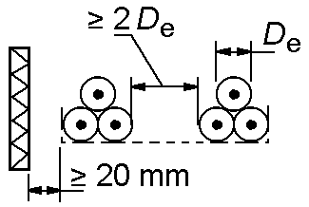  Separated | 1 | 1.00 | 0.98 | 0.96
 |  |  | 2 | 0.97 | 0.93 | 0.89
 |  |  | 3 | 0.96 | 0.92 | 0.86
Perforated trays installed vertically  (Note 4) |  | 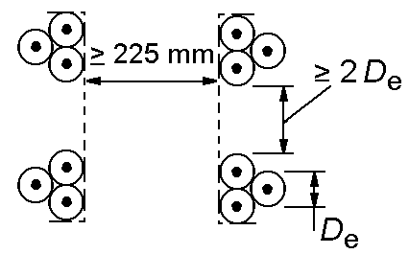  Separated | 1 | 1.00 | 0.91 | 0.89
 |  |  | 2 | 1.00 | 0.90 | 0.86
Flanges, supports, rails  (Note 3) |  | 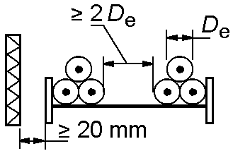  Separated | 1 | 1.00 | 1.00 | 1.00
 |  |  | 2 | 0.97 | 0.95 | 0.93
Note 1 | The values are the average for the types of cables and the range of sections considered. The dispersion of values is less than 5 % overall.
Note 2 | The factors apply to cables in separate layers, or in cables in a triangle configuration in separate layers. They do not apply if the cables are installed in several layers in contact. In this case, the factors may be significantly lower.
Note 3 | The values are intended for a vertical separation of 300 mm between trays or supports installed horizontally. For lower separations, the factors must be reduced.
Note 4 | The values are provided for a horizontal separation of 225 mm between the trays installed vertically and mounted from back to back. For lower separations, the factors must be reduced.
Note 5 | For circuits that have more than one cable in parallel per phase, it is appropriate to consider each set of three cables as a circuit in the application of this table.
Note 6 | In the case of cables installed in several layers in contact, the correction factors in this table do not apply. Each case must be studied individually.

Cables installed outdoors in confined spaces
For cables installed outdoor in channels or small tunnels, the following particularities must be taken into account, as it has been observed that under certain installation conditions (in channels, small tunnels, etc.), where there is no effective air change, the heat dissipated by the cables cannot diffuse freely and causes an increase in the air temperature.
The magnitude of this increase depends on many factors and should be determined in each case as a rough estimate. It should be noted that the temperature increase for this reason may be in the order of 15 K. The permissible current under steady-state conditions must therefore be reduced by the coefficients for ambient air temperature other than 40 °C.

Permissible short-circuit currents in conductors
Taking into account the cable construction and the initial and final short-circuit temperatures in Table 14, Table 15 shows the values of the admissible short-circuit currents for cables in normal use, calculated according to the UNE 21192 methodology.
The initial temperatures have been assumed from the maximum permanent regime load prior to short-circuit.
Table 14: Initial and final short-circuit temperatures
Insulating material | Initial temperature | Final temperature
XLPE | 90 °C | 250 °C
Covering material | Initial temperature | Final temperature
PVC | 85 °C | 200 °C
Z1 | 85 °C | 180 °C

Table 15: Maximum short-circuit current at A in the cable conductor with
XLPE insulation

 | Copper conductor |  |  |  | Aluminium conductor
Cross-section  mm² | Short-circuit time, s |  |  |  | Short-circuit time, s
Cross-section  mm² | 0.2 | 0.5 | 1 | 2 | 0.2 | 0.5 | 1 | 2
2.5 | 850 | 560 | 410 | 310
4 | 1 340 | 870 | 640 | 470
6 | 1 990 | 1 290 | 940 | 690
10 | 3 290 | 2 120 | 1 530 | 1 110
16 | 5 240 | 3 360 | 2 410 | 1 740
25 | 8 150 | 5 200 | 3 750 | 2 700 | 5 400 | 3 500 | 2 500 | 1 800
35 | 11 350 | 7 250 | 5 200 | 3 700 | 7 550 | 4 850 | 3 450 | 2 500
50 | 16 200 | 10 350 | 7 350 | 5 250 | 10 750 | 6 850 | 4 900 | 3 550
70 | 22 650 | 14 400 | 10 250 | 7 350 | 15 000 | 9 600 | 6 850 | 4 900
95 | 30 700 | 19 500 | 13 900 | 9 900 | 20 350 | 12 950 | 9 250 | 6 600
120 | 38 700 | 24 600 | 17 500 | 12 450 | 25 650 | 16 350 | 11 650 | 8 300
150 | 48 350 | 30 700 | 21 850 | 15 550 | 32 000 | 20 400 | 14 500 | 10 350
185 | 59 600 | 37 850 | 26 850 | 19 100 | 39 450 | 25 100 | 17 850 | 12 750
240 | 77 250 | 49 000 | 34 800 | 24 750 | 51 100 | 32 500 | 23 100 | 16 450
300 | 96 500 | 61 200 | 43 450 | 30 850 | 63 850 | 40 550 | 28 800 | 20 500
400 | 128 550 | 81 550 | 57 850 | 41 050 | 85 050 | 54 000 | 38 350 | 27 250
Initial insulation temperature 90 °C; final insulation temperature 250 °C

Other types of cable or installation systems
For any other cable construction type or other installation system not covered by this Instruction, the maximum current in permanent and short-circuit mode shall be calculated according to the UNE 21144 series of standards.

ELECTRICAL TESTS AFTER INSTALLATION
Once the installation has been completed, the undertaking installing the networks shall verify, by means of an insulation resistance test, that the laying and assembly of the fittings (splices, branches, terminals, etc.) has been carried out correctly. The test shall be carried out without interconnecting the new distribution network with the existing network.
The test determines the insulation of the active conductors (phases and neutral), in order to check whether the insulation resistance values between each conductor and the rest are higher than those indicated in Table 16.
Table 16: Minimum insulation resistance values
Rated voltage of the Uo/U cable (kV) | Test voltage to be applied, DC (V)  (see Note 1) | Conductor cross-section  (mm²) | Minimum insulation resistance for 1 km in length (see Note 2)  (MΩ)
0.6/ 1 | 500 | ≤ 25  > 25 and ≤ 95  > 95 | 30  20  15
Note 1: The test voltage shall be applied for a sufficient period of time, from 1 to 5 minutes, to obtain a stable reading of the insulation resistance.
Note 2: The insulation resistance values in the table correspond to a length of 1 km. For other lengths, the minimum value of the insulation resistance is obtained by dividing the value in the table by the length of the line in km.
’

Twenty-one. The Supplementary Technical Instruction ITC BT-11, ‘Power Line Distribution Systems. Service Connections’, is amended to read as follows:

‘ITC BT-11

POWER LINE DISTRIBUTION SYSTEMS. SERVICE CONNECTIONS
TABLE OF CONTENTS
- SERVICE CONNECTIONS
  - Definition
  - Types of service connections
  - Installation
    - Overhead service line fixed to a façade
    - Overhead service line tensioned between poles
    - Underground connection
    - Mixed service connection
  - Cable characteristics

SERVICE CONNECTIONS

Definition
It is the final part of the distribution network that individually connects the three-phase distribution network with the switch box of the supply connection installations (MPB or PMB). It ends at the input terminals of the MPB or an equivalent functional unit.
Depending on the expected loads of the installation, the service connections may be three-phase or single-phase.

Types of service connections
Depending on their layout, the installation system and the way in which they are connected to the rest of the distribution network, the service connections may be of the types indicated in Table 1.
Table 1. Type of service connection depending on the installation system and connection method.
Type | Installation system | Connection method
Overhead | Fixed to façades, or tensioned between supports, or a combination of both | - Overhead distribution branch connection.
Overhead |  | - Directly from the low-voltage switchboard of the transformer substation.
Underground | Underground installation, overhead installation or a combination of both | - With input and output from the underground distribution network.
Underground |  | - Underground distribution branch connection.
Underground |  | - Directly from the low-voltage switchboard of the transformer substation
Mixed | Overhead and underground part | - Depending on whether the section where the connection to the distribution network is made is overhead or underground.

Installation
Unless this ITC indicates a particular requirement, the conditions for installation, crossings, proximity and parallelisms shall comply with the requirements laid down in the applicable ITC according to the type of distribution network: ITC BT-06 (overhead networks) and ITC BT-07 (underground networks), respectively.
In general, the service connections will be made following the shortest paths, making connections when it is necessary through appropriate systems or devices. In any case, they shall be carried out in such a way that the insulation of the conductors is maintained up to the connecting elements of the MPB or PMB. In order to prevent extensions of the distribution network starting from service connections not intended for this purpose, the maximum length of the branch connections shall be limited to 40 m.
The service connection will run through publicly owned land, except in the case of overhead or underground connections, where the corresponding rights of way have been authorised.
Service connections through, inter alia, interior courtyards, garages, private gardens and roads in private gated communities, shall be avoided.
In general, there will be a single service connection per building or property, however, when the loads are expected to be high or it is necessary to install infrastructure for recharging electric vehicles in existing buildings or properties, more than one connection may be provided if the plan or technical design report justifies the technical difficulty of a single service connection, if the cost of modifying the existing service connection is higher than that of installing a new one. Independent service connections shall be installed for the complementary supplies established in the Low-Voltage Electrotechnical Regulation or for those whose special characteristics so recommend.
To ensure the safety of the distribution networks, different service connections may not be coupled through the supply connection installations or the internal installations, even if these connections originate from the same transformer substation, except with prior approval by the distribution company, since such coupling or connection would increase the short-circuit level values and could lead to overload in the coupled distribution networks. Non-approval shall be justified on the basis of the security of the distribution networks.

Overhead service line fixed to a façade
Before proceeding, if possible, a preliminary study of the façade should be carried out so that it is affected as little as possible by the conducting route, which should be sufficiently protected and secured.
In this type of service connection, the cables laid directly on façades shall be installed at a distance from the wall and shall be fixed to the wall with appropriate support, fixing or suspension brackets.
Cables fixed on façades may also be surface mounted, in conduit pipes, in cable ducting or in protective trunking with lids that can only be disassembled with tools. If installed in conduit pipes, trunks or ducts, these shall comply with the requirements of ITC BT-21 and shall preferably be visible in order to facilitate the installation inspection, without it being necessary to distance the cable management system from the wall.
Sections where the service connection is at a height above the ground of less than 2.5 m shall be protected by pipes, ducts or trunks, the cover of which can only be removed with tools of the specific characteristics indicated in ITC BT-06.
Rigid protection pipes in accordance with Standard UNE-EN IEC 61386-21 and protective channels and closed non-circular cross-section ducts in accordance with Standard UNE-EN IEC 61084-2-1 shall be presumed to comply with the requirements of this ITC.
At the junctions of public roads and open spaces, the cables shall be tethered at both ends, either using a neutral messenger conductor or using an independent securing cable, complying with the conditions of ITC BT-06.
In buildings of historical or artistic interest or declared as such or under some other form of protection, efforts will be made to avoid this type of service connections.

Overhead service line tensioned between poles
Cables may be installed suspended from a messenger cable, independent and duly tensioned or also by the use of a neutral messenger conductor with adequate mechanical strength, and duly calculated for this function.
All supports shall be fitted with suitable elements enabling the cables to be fastened by means of suspension or anchoring clamps, depending on the type of fastening required. A façade may also be used to replace a support for fastening the anchor clamps.

Underground connection
The minimum separations indicated in the ITC BT-07 shall be taken into account in crossings and parallel runs with other pipelines for water, gas, telecommunication lines and with other electrical energy conductors.

Mixed service connection
These are service connections that are partly installed overhead and partly underground.
The design and installation of the different sections of the service connection will be carried out according to its layout, in accordance with the sections of this Instruction that correspond to it, taking into account the conditions for its installation.
In mixed service connections, in the passage from overhead to underground, the cable shall be protected by protective pipes, protective trunking or enclosed ducts of the characteristics indicated in ITC BT-06, from a minimum height of 2.5 m above ground level to the depth established in accordance with ITC BT-07.

Cable characteristics
The cables to be used should correspond to the minimum types and sections indicated in ITC BT-06 (overhead networks) and ITC BT-07 (underground networks), respectively.
As regards the cross-sections of conductors and their number, they shall be calculated taking into account the following aspects:
  - Maximum expected load in accordance with ITC BT-10.
  - Supply voltage.
  - Type of supply (single-phase with two conductors and three-phase with four conductors).
  - Maximum permissible intensities for the type of conductor and the conditions for its installation, in accordance to ITC BT-06 (overhead networks) and ITC BT-07 (underground networks), respectively.
  - The maximum permissible voltage drop. This voltage drop will be the one established by the distribution company, in its distribution of voltage drops in the elements that constitute the network, so that in the main protection box or equivalent functioning unit, the voltage is within the limits established by the Regulation on the transmission, distribution, marketing, supply and the authorisation procedures of electrical energy facilities.
’

Twenty-two. The Supplementary Technical Instruction ITC BT-12, ‘Supply connection installations. Diagrams’, is amended to read as follows:

‘ITC BT-12

SUPPLY CONNECTION INSTALLATIONS. DIAGRAMS
TABLE OF CONTENTS
- SUPPLY CONNECTION INSTALLATIONS
  - Definition
  - Main parts constituting the supply connection installations
- SUPPLY CONNECTION INSTALLATION DIAGRAMS
  - Diagrams for supply connection installations for a single supply
  - Diagrams for supply connection installations for dual-fed supplies from the same place
  - Diagrams for supply connection installations for multi-supply properties or buildings.
    - MPB and MSL schemes
    - MP, IMM schemes.
- DIAGRAMS FOR THE CONNECTION OF GENERATING AND SELF-CONSUMPTION FACILITIES
  - Specific elements for schemes with collective self-consumption and a meters panel
- MODIFICATION OR EXTENSION OF EXISTING INSTALLATIONS.

SUPPLY CONNECTION INSTALLATIONS

Definition
Supply connection installations are installations connecting the main protection box or, in the absence of such, the protection and metering box, including these, to internal installations, whether for consumption or generation.
They will therefore begin at the end of the LV service connection and end at the exit terminals from which the individual branch starts. In the case of high-voltage supplies where the HV/LV transformer is part of the user installation, there is no supply connection installation for the LV and the entire LV installation is considered to be an internal installation.
These facilities shall always be located and run through places of common use of the property or building and shall remain the property of their owner, who shall be responsible for their preservation and maintenance. In the case of temporary or provisional supplies, subject to prior authorisation of the competent authority, they may also pass through land in the public domain.

Main parts constituting the supply connection installations
  - Main Protection Box (MPB) and, where applicable, Protection and Metering Box (PMB).
  - Main Supply Line (MSL), where applicable.
  - MSL branching and metering box (BMB), where applicable.
  - Elements for the Location of Meters (in PMB, MP or IMM), up to the terminals for connection of the individual branches.

From the terminals for its connection, the individual branch (IB), and the Main Control and Protection Devices (MCPD) are part of the internal installation.
Throughout this ITC, the term ‘user’ may refer to a person who is a consumer, generator or self-consumer. Similarly, the term ‘supply’ may be associated with a person who is a consumer, generator or self-consumer.

SUPPLY CONNECTION INSTALLATION DIAGRAMS
The diagrams included in this ITC illustrate the main parts of the supply connection installations, but do not necessarily contain all the elements of the installation, and the representation in the figures does not imply a particular physical location or dimensional requirements of the elements or their connections, or design technologies of the elements.

Diagrams for supply connection installations for a single supply
Diagrams for a single-supply shall have a PMB, but they are differentiated depending on whether the service connection is an overhead or underground connection. In the case of an overhead service connection, an MPB will be superficially mounted at height, which will be connected in derivation, and an MSL up to the PMB. These MPBs and MSLs shall not be required in underground service connections where the PMB may be connected by input and output from the distribution network or by diversion.
Key to Figures 1, 2, 3, and 4:
- Distribution network.
- Distribution network service connection (see note 1).
- Main Protection Box (MPB).
- MPB fuses.
- Main supply line (MSL).
- Protection and metering box (PMB)
- Selective general safety fuses specific to PMB for two users (its installation is optional with overhead service connection).
- Safety fuse for the protection of the meter and the individual branch.
- Type 1 surge protection device (SPD) (including its protections, where applicable).
- Meter for direct measurement or indirect metering system (three current transformers, test terminal block and meter).
- Space for PLC filter, other equipment for load management or communications equipment (not represented in the figures, see note 2).
- Safety switch disconnector, also called individual switch-disconnector, ISD.
- Output terminals for the connection of an individual branch (end of the supply connection installations)
- Individual branch.
- Zero-Injection System (ZIS) (optional). Alternative placement when no space is available for its positioning in the MCPD box

Note 1: according to the network architecture and management criteria of the distribution company, the elements for input and output connection for the underground distribution network may be inside the PMB, or outside it, inside a service disconnector, control and distribution box which will be the responsibility of the distribution company, and whose installation under the PMB must be permitted by the user.

Note 2: the distribution company may, if necessary, install its own communications equipment in the boxes (PMB, MPB, or other equivalent units). Such communications equipment shall be connected upstream of the meters in such a way as not to alter the measurement of the users’ energy consumption.

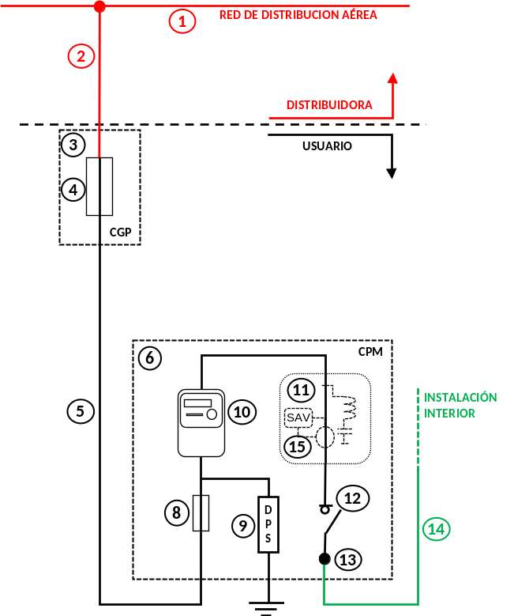
Figure 1. Diagram for a single supply with overhead service connection

Figure 2. Diagram for a single supply with underground service connection
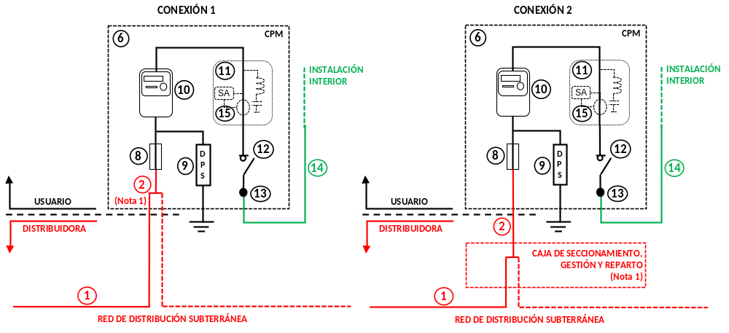

Diagrams for supply connection installations for dual-fed supplies from the same place.
The diagram in Section 2.1 can be used for up to two supplies coming from the same place, with the same requirements depending on whether the supply service connection is an overhead or underground connection and using a single PMB for the two supplies. Optionally, two individual PMBs could be installed as per the diagrams in 2.1.
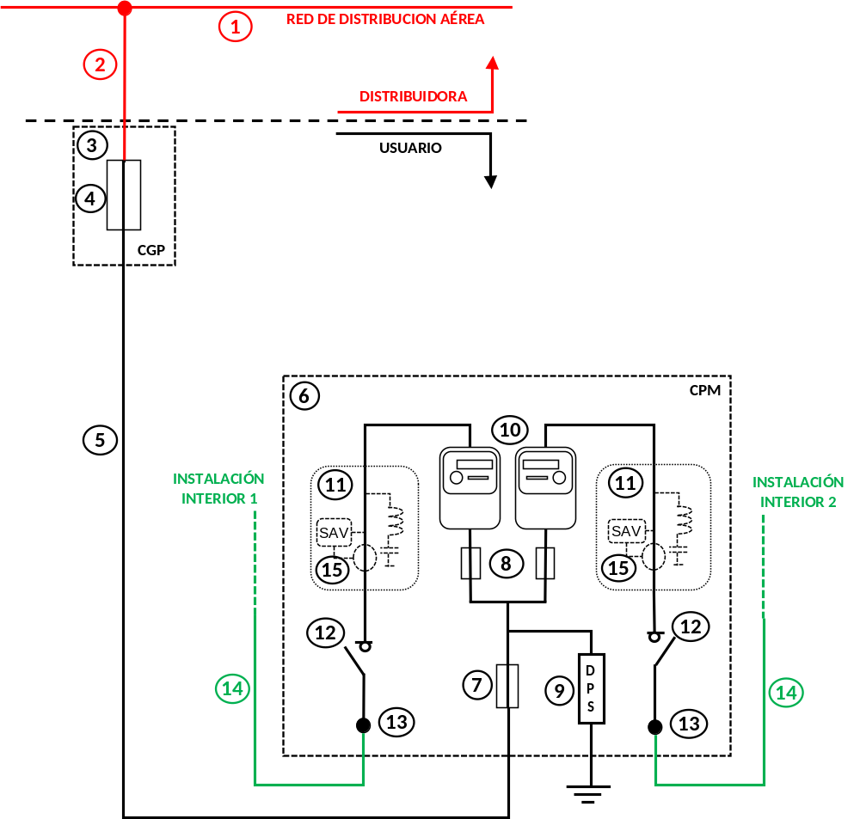
Figure 3. Diagram for two supplies fed from the same location with overhead service connection.

Figure 4. Diagram for two supplies fed from the same place with underground service connection
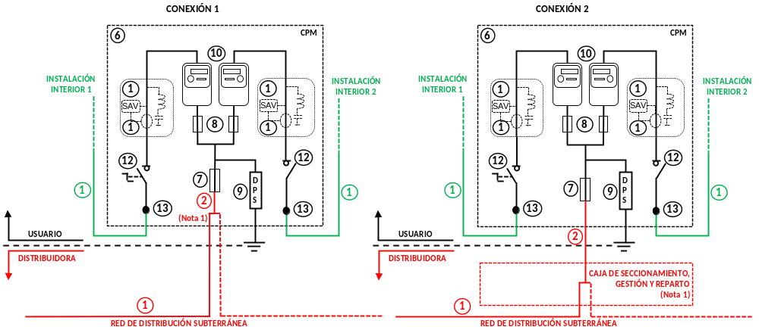

Diagrams for supply connection installations for multi-supply properties or buildings.
The properties or buildings with multiple supplies are sets of vertical or horizontal building units, mainly intended to be used as dwellings, shops, offices or combinations of these uses, as well as those intended for industrial areas, which share the service connection to the distribution network.
The schemes of the installations shall regard the following criteria:
  - In general, properties or buildings with multiple supplies will have a single MPB to which a single main supply line will be connected to supply a meters panel, or several main supply lines, each of which will supply a set of meters panel or an indirect metering module.
  - When an MPB feeds a single main supply line, this line may be branched into several lines, by means of branching boxes for the main supply line, BMB, with each branch line being intended to feed a meters panel or an indirect metering module, IMM, and no new branches may be made from these lines.
  - For properties or buildings in which, due to their expected loads or voltage drops, it is not possible to feed them from a single MPB, two or more MPBs may be installed, which shall supply different supply connection installations.
  - Supplies corresponding to direct measuring must be connected to a meters panel (MC).
  - Supplies that are indirectly metered by means of an indirect metering module (IMM) can be connected to the meters panel, to an MSL Branching and Metering Box (BMB), or directly to a MSL of their own.
  - Within a property, there may be one or more metering rooms or cabinets, and in each of these, there may be one or more MPs or IMMs.
  - The earthing point of the exposed-conductive-parts of low-voltage equipment located in the meters panel room or cabinet shall be used to connect the protective conductors of the individual branches.
The following sections set out the schemes corresponding to the MPB and MSL, and the schemes corresponding to an MP or IMM.

MPB and MSL schemes
The supply connection installations of a multi-supply property shall start at the MPB installed at the property limit of the electrical installations from which one or more MSLs are fed.
The scheme of supply connection installations with a single MSL differ depending on whether the distribution network is overhead or underground. In overhead service connections, an MPB shall be installed, which will be connected in a branch. In underground service connections, an MPB shall be installed, which can be connected by means of an input and output or by means of a branch.
Key for Figures 5 and 6
- Distribution network
- Distribution network service connection (see note)
- Main Protection Box (MPB)
- MPB fuses for MSL protection
- Main supply line (MSL)
- Meter room or cabinet
- Meters panel (MP)
Note: according to the network architecture and management criteria of the distribution company, the elements for input and output connection for the underground distribution network may be inside the MPB, or outside it, inside a service disconnector, control and distribution box which will be the responsibility of the distribution company, and whose installation under the MPB must be permitted by the user.
Figure 5. Diagram of supply connection installations with a single MSL connected to overhead service connections.

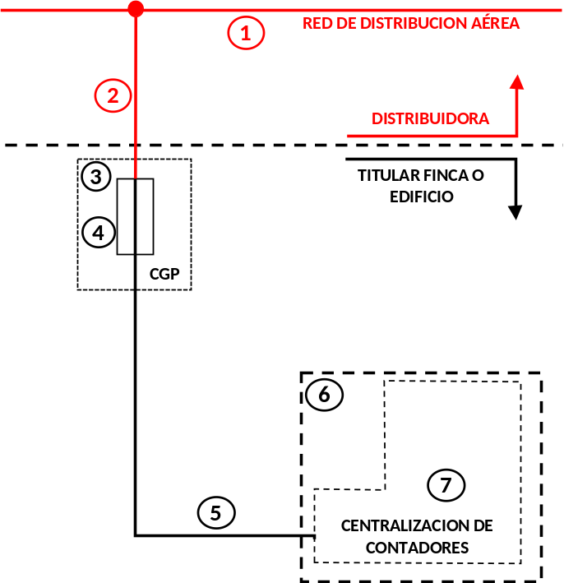

Figure 6. Diagram of supply connection installations with a single MSL connected to underground service connections.
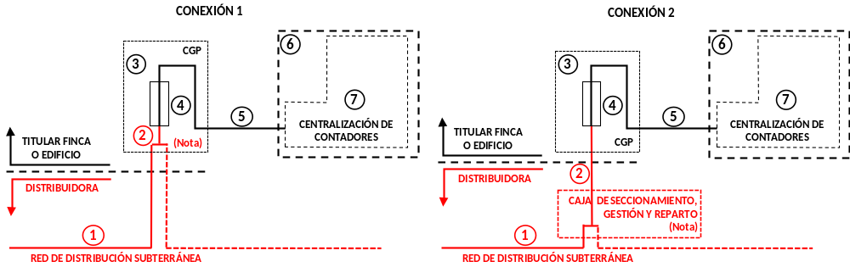

In properties or buildings where the expected loads or the installed power requires the installation of a meters panel and indirect metering modules, or where it is advisable to place the meters in more than one place or floor and it is admissible according to the ITC BT-15, it will be necessary to have several MSLs or MSL branches. The placing of meters in more than one location applies to both vertical and horizontal buildings for groups of dwellings, commercial or industrial buildings.
In schemes with several MSLs, each main line may have a different section provided that it is sized for the expected currents, the voltage drop limits are met and it is protected against overload.
Supply connection installation schemes with several MSLs may have an MPB that feeds a single MSL that is subsequently branched into several MSLs in an BMB, or an MPB that directly feeds several MSLs. Figures 7 and 8 show examples of these schemes.
Key for Figures 7 and 8
- Distribution network service connection (see note)
- Main Protection Box (MPB)
- MPB fuses for MSL protection
- Main supply line (MSL)
- Meter room or cabinet
- MSL Branching and Metering Box (BMB)
- Current transformer or measuring probe (optional)
- Verification device terminals (where there is a current transformer)
- Protection system of the MSL (PSM) for electric vehicle recharging installations or zero-injection system (ZIS) for collective self-consumption generation facilities without surpluses (optional)
- Fuses for the protection of each MSL branch
- MSL branch
- Meters panel (MP) for direct metered supplies
- Indirect Measuring Module (IMM)
Note: according to the network architecture and management criteria of the distribution company, the elements for input and output connection for the underground distribution network may be inside the MPB, or outside it, inside a service disconnector, control and distribution box which will be the responsibility of the distribution company, and whose installation under the MPB must be permitted by the user.

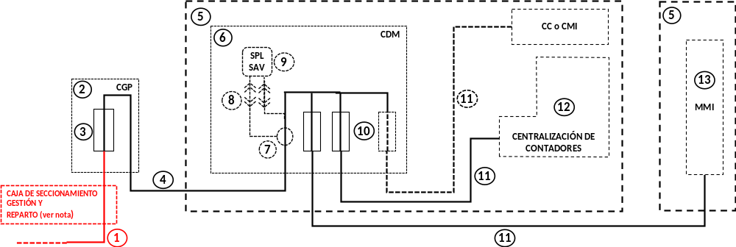
Figure 7. Diagram of supply connection installations with several MSLs branched from a BMB.

Figure 8 shows a schematic example of a supply connection installation with an MPB from which several MSLs are directly connected to one or more meter rooms or cabinets.
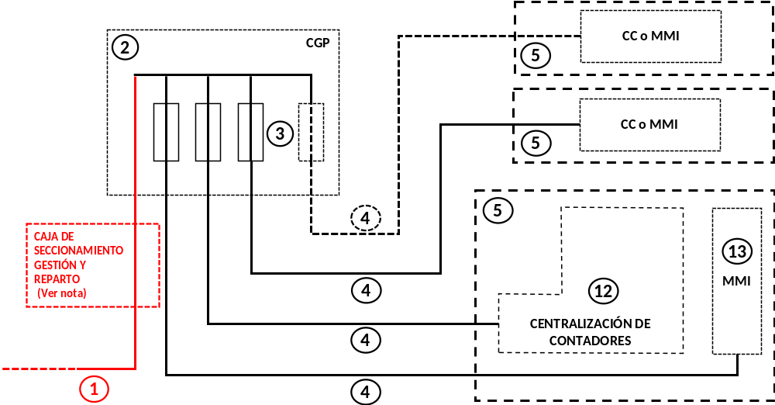
Figure 8. Diagram of a supply connection installations connected directly from an MPB.

MP and IMM schemes.
The general scheme of the meters panels or indirect measurement modules will depend on the type of supplies (with direct or indirect measurement), the existence of electric vehicle recharging circuits, the existence of generation facilities and the number of individual connections to be connected in the same MP. Figure 9 shows examples of the positioning of the control and general protection elements of a centralised meter system.
Figure 9. Main control and protection module of the meters panel (MP)
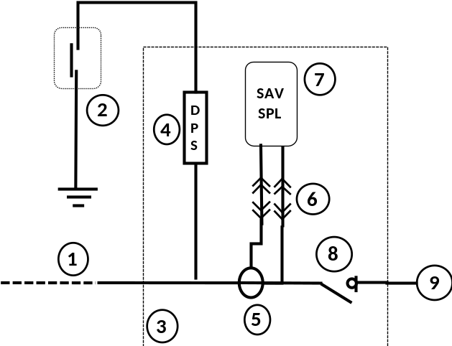

Key
- Main supply line (MSL)
- Earthing switch-disconnector box of the meter room or cabinet
- Main control and protection module of the meters panel (MP)
- Type 1 surge protection device (SPD) (including its protections, where applicable)
- Current transformers or measuring probe (optional)
- Verification device terminals (where there is a current transformer)
- Protection system of the MSL (PSM) for electric vehicle recharging installations (optional) or zero-injection system (ZIS) for collective self-consumption generation facilities without surpluses (optional)
- Main Switch Disconnector (MSD)
- Connection to the main busbar functional unit of the MP

The control and protection elements are connected to the main busbar of the meters panel, which shall follow the type scheme indicated in Figure 10.
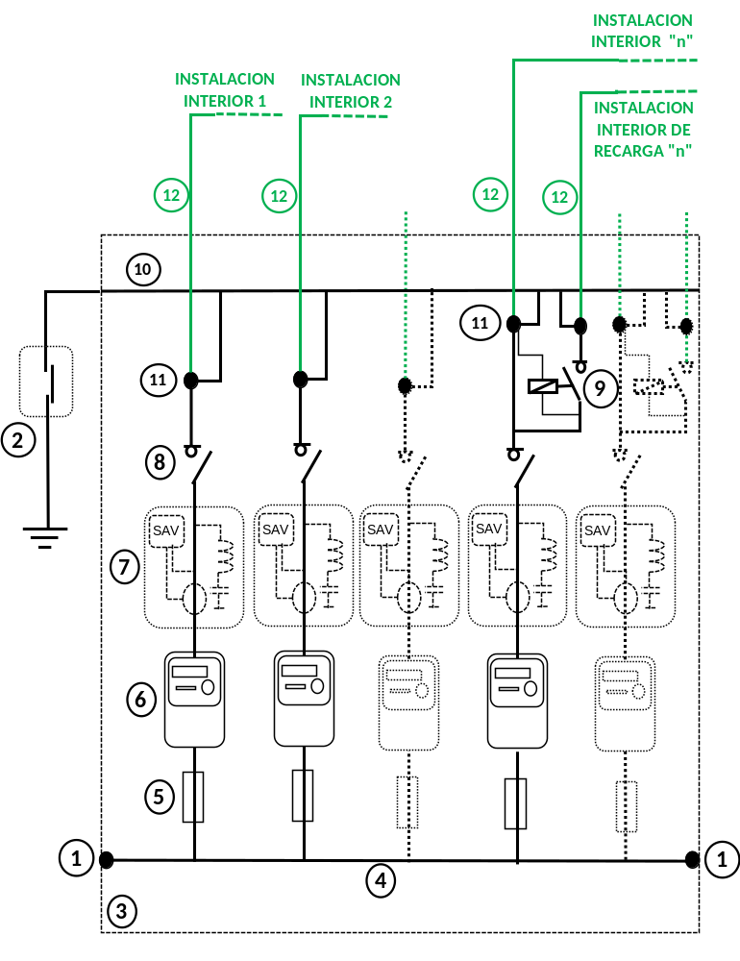
Figure 10. Functional metering unit of a meters panel with direct measurement (direct measurement module)
Key
- Connection with the general control and protection module or other measuring modules of the MS.
- Earthing switch-disconnector box of the meter room or cabinet
- Functional unit or direct measurement module of the MP
- Main busbar of the MP
- Safety fuses for the protection of the meter and the individual branch.
- Direct Connected Meter
- Space for PLC filter, load management equipment or for the placement of the optional zero-injection system (ZIS) when there is no space to place it in the general control and protection panel of the internal installation.
- Safety switch-disconnector of the individual branch, ISD.
- Contactor or high-impedance device for individual EV recharging scheme 2 (optional)
- Protective functional busbar unit
- Output terminals for the connection of an individual branch (end of the supply connection installations)
- Individual branch

Figure 11 shows a schematic example of an indirect measurement module powered directly from an MSL.
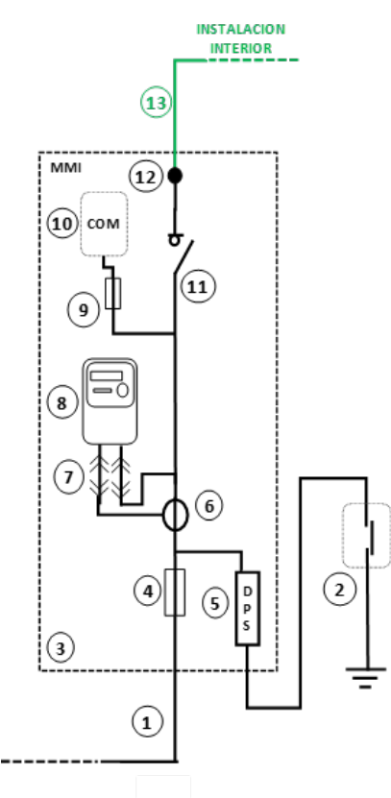
Figure 11. Diagram of an indirect measurement module powered directly from an MSL

Key
- Main supply line (MSL)
- Earthing switch-disconnector box of the meter room or cabinet
- Indirect Measuring Module (IMM)
- Safety fuses for the protection of the meter and the individual branch
- Type 1 surge protection device (SPD) (including its protections, where applicable)
- Current transformers
- Terminals of the verification device for indirect measuring (where there is a current transformer)
- CT-Operated Meter
- Fuse for the protection of communications equipment (optional)
- Communications equipment for remote metering (optional)
- Safety switch-disconnector of the individual branch, ISD.
- Output terminals for the connection of an individual branch (end of the supply connection installations)
- Individual branch.

DIAGRAMS FOR THE CONNECTION OF GENERATING AND SELF-CONSUMPTION FACILITIES
Supplies associated with any type of self-consumption shall be connected to the distribution network in accordance with the supply connection installation schemes referred to in Section 2, as for any other supply.

Specific elements for schemes with collective self-consumption and a meters panel.
In the case of collective self-consumption, it will be necessary to install a specific element in the following circumstances:
  - In the collective self-consumption without surpluses modality, the current measurement system of the zero-injection system shall be placed in the branching and metering box (BMB) in accordance with Figure 7, or in the general control and protection unit of the MP, in accordance with Figure 9.
  - In the modality of collective self-consumption with separate operation, the switching system in dependent-separate mode described in ITC BT-40 shall be positioned as shown in Figure 12.
Figure 12. Possible placement of the switching system in dependent-separate mode (SDSM) in installations with collective self-consumption

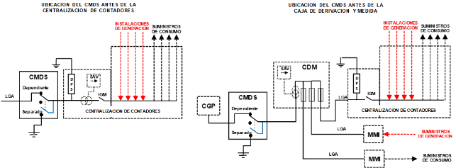

MODIFICATION OR EXTENSION OF EXISTING INSTALLATIONS.
Self-consumption installations in existing dwellings or buildings will be considered for the purposes of the certification of the installation, and provided that it is not necessary to modify the MSL or the IB, as an extension of the existing installation (not as a modification), without prejudice to the fact that according to the applicable ITC BT-13, ITC BT-14 and ITC BT-15 certain safety elements have to be incorporated in the existing installations. The installation extension certificate shall also include the safety elements incorporated into the existing installation.
A PMB specifically designed to accommodate three supplies fed from the same location may be used, without the need to install an MPB upstream of the PMB, in the modification or extension of existing installations complying with the following requirements:
  - There are two supplies intended to power adjoining dwellings or premises, with a third supply intended for the joint services of both dwellings or premises.
  - There are two supplies intended to supply adjacent dwellings or premises and, in addition, a generation installation with a net energy meter for collective self-consumption is located in one of the premises or dwellings.
’

Twenty-three. The Supplementary Technical Instruction ITC BT-13, ‘Supply connection installations. Main protection boxes’, is amended to read as follows:

‘ITC BT-13

SUPPLY CONNECTION INSTALLATIONS. SUPPLY CONNECTION INSTALLATION PROTECTION BOXES
- SUPPLY CONNECTION INSTALLATION PROTECTION BOXES.
- MAIN PROTECTION BOXES
  - Placement and installation
    - MPB powered from an overhead network.
    - MPB powered from an underground network.
  - Types and characteristics
- PROTECTION AND METERING BOXES
  - Placement and installation
  - Types and characteristics
  - Self-consumption installations.
- BRANCHING AND METERING BOXES FOR THE MAIN SUPPLY LINE
  - Placement and installation.
  - Types and characteristics.
- MINIMUM SPECIAL RE QUIREMENTS FOR THE MODIFICATION OF EXISTING INSTALLATIONS.
- REFERENCE STANDARDS

SUPPLY CONNECTION INSTALLATION PROTECTION BOXES
The protection boxes of the supply connection installations may be of the following types:
  - Main protection boxes (MPBs).
  - Protection and metering boxes (PMBs).
  - Branching and metering boxes for the main supply line (BMBs).
The MPBs and PMBs are installed at the boundary between the distribution network and the electrical installation of the property or building and house the general protection elements of the supply connection installation. The BMB is a box used based on the architecture of the supply connection installations, which is interposed into the main supply line (MSL) in order to be able to measure the load of the MSL and branch it into several main lines, each of these lines being connected to meters panels (MP), or with indirect measurement modules (IMM).

MAIN PROTECTION BOXES
These are the boxes that house the protection elements of one or more main supply lines. Its input is connected to service connection and its output to one or more main supply lines. The connection to the service connection can be either a branch connection or an input and output connection. The MPB shall have individual protection for each MSL starting from the MPB, and it is not allowed for the same protection to be used for more than one MSL. When the MPB supplies several MSLs, these must be assigned to the same property or building.
The MPB shall generally be three-phased, although it may be single-phased if it supplies one or two single-phase supplies from an overhead distribution network.

Placement and installation
These boxes shall preferably be installed in places with free and permanent access, which can be accessed directly from the public road without the need to pass through any kind of gate, enclosure, fence, premise or private enclosure such as gardens, courtyards, common areas or gates. If such a location is not possible, specific measures may be adopted to allow for the permanent and free access from the public road, by mutual agreement between the property owner and the distribution company.
The MPB shall preferably be installed on the façades of buildings or inside open entrances. When these façades do not border the public road and there are no open entrances, it will be installed on a support, a plinth or on a building wall, located on the boundary between the private property and the public road and which, like the MPB itself, will be the property and responsibility of the user.
It shall be ensured that the chosen location is as close as possible to the distribution company’s low-voltage network and that it is away from other water, gas or telecommunications installations, making sure that the distances between the MPB and these installations is as indicated in ITC BT-06 and ITC BT-07 for the proximity of these installations to the distribution network. The urban development plans established in local or regional regulations that may condition their location will also be taken into account.
In the case of temporary or provisional supplies and after obtaining the relevant permits, the MPB, and the MSL that is part of it, may also be installed in areas of public domain near the point of connection with the distribution network. The MPB should then be installed either on a private pole when the MSL is overhead or on a plinth or on a building wall when the MSL is underground.
The specific location of the MPB will be chosen by the property owner in accordance with the requirements of this section and the urban plans that affect the development of the distribution networks. Any disagreement between the parties on the location of the MPB shall be resolved by the competent body of the government.
In buildings housing a low-voltage transformer substation, the fuses for the low-voltage switchboard of that substation may not be used as protection for the main supply line, and the building’s MPB must be installed according to the same location and access criteria as for any other building.
If the building or property, in addition to the ‘Normal’ supply, also has a complementary low-voltage supply (Emergency, Reserve or Duplicate), each supply will have an MPB and they shall both be located in separate places, sufficiently far apart to comply with the distance established for separation of fire sectors on the façade by the Technical Building Code, so that in the event of a fire in one of them it is guaranteed that its effects will not have repercussions on the other.
In buildings of historical or artistic interest or under some other form of protection, to minimize the visual impact, particular solutions may be adopted for the installation of the MPB by mutual agreement between the property owner, the competent government body in matters of protection measures and the distribution company, but without reducing the levels of security established in this regulation.
Authorised installation companies commissioned by the user will have access and will be able to work on the MPB itself, the fuses and the connections of the main line, after informing the distribution company.
The placement and installation of the PMB shall depend on the type of network (overhead or underground) to which the PMB is connected, in accordance with the following sections:

MPB powered from an overhead network
When the building or property is connected to an overhead network, the connection to the distribution network shall be made by means of a branch connection to the MPB.
If the façade of the building or the enclosure of the property directly borders the public road and is of sufficient height (h ≥ 3.5 metres), the MPB shall be surface mounted at a height above the ground of between 3 and 4 metres as shown in Figure 1.
Figure 1. Example of installation of MPB in surface mounting on façade or enclosure
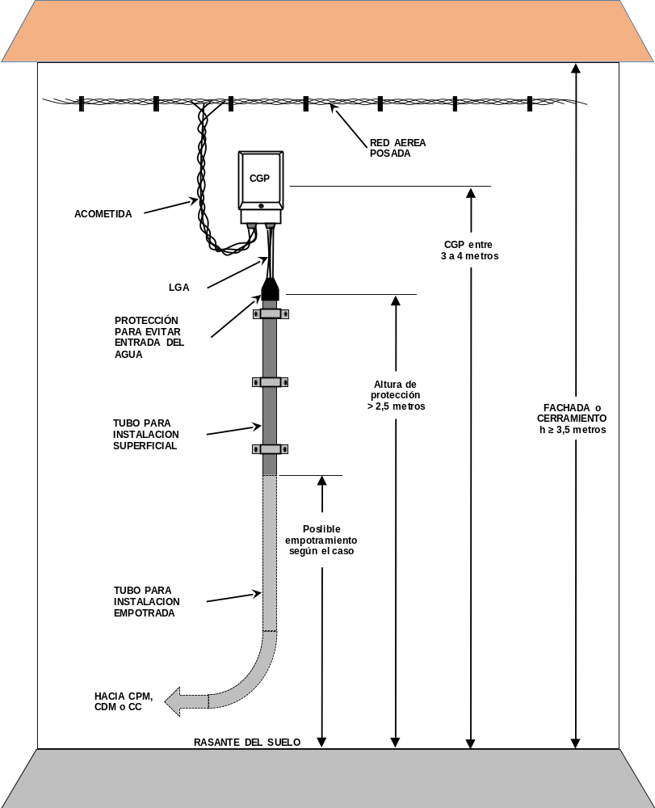
When the MPB is superficially mounted at height, it may not be installed above openings in the building façade such as: doorways, gates, ramps or accesses to garages, arcades, doors, windows, terraces, balconies or verandas and must be installed at a minimum distance of 1 metre from the sides of any opening and 0.5 metres from the lower part.
When the façade of the building or the building envelope directly borders the public road but is not sufficiently high or does not have the minimum clearances to the sides or to the lower part of any opening, the MPB may be installed on a bracket, post or support flush with the building envelope to maintain a height above the ground of between 3 and 4 metres, as shown in Figure 2.
Figure 2. Examples of MPB installation at height (mounting on brackets, posts or supports)
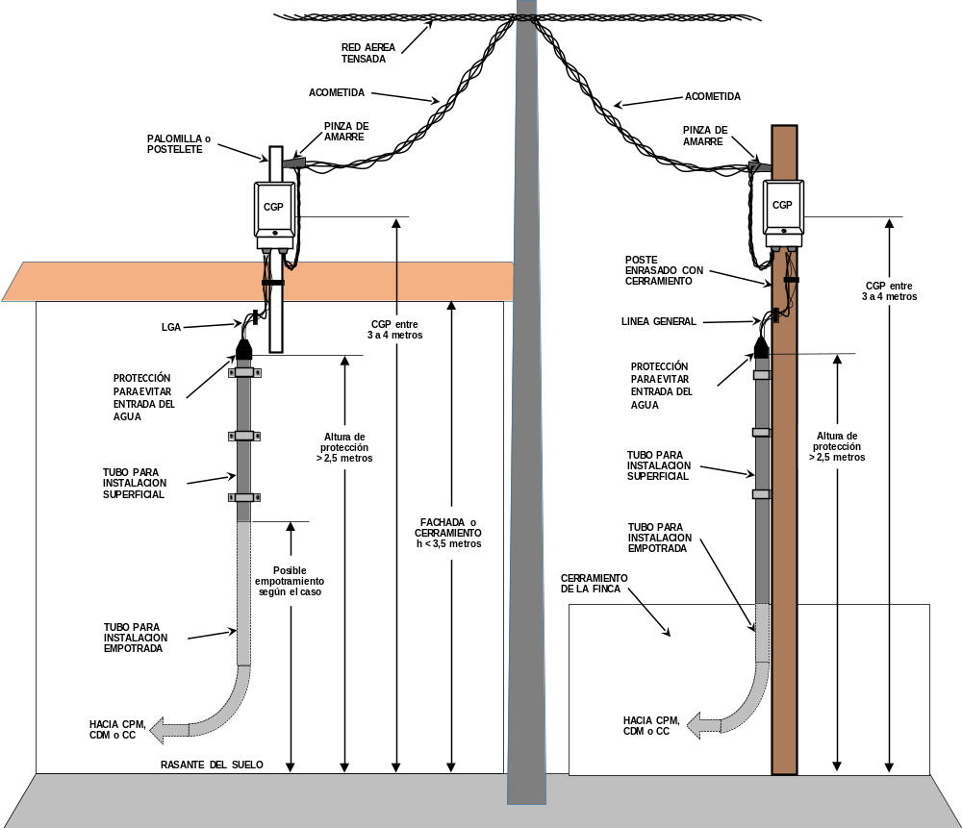
If the building or property requires more than two MSLs starting from the MPB, or if the façade or enclosure do not border directly with the public road, or if it isn’t sufficiently high, or if the minimum distances to the openings are not achieved, or if no bracket, post or support is used to reach that height, the MPB shall be installed in a wall recess or cabinet directly accessible from the ground, as if it were a service connection from the underground network.
For installation in a wall recess or cabinet, if the distribution network is fixed, the service connection will initially be supported and then protected by a pipe, and if the distribution network is tensioned, an overhead-underground passage will be made at the support closest to the building or property. In both cases, the service connection shall reach the bottom of the wall recess or cabinet, the placement and installation of which shall be the same as when powered from an underground network.
Figure 3. Example of installation of MPB in wall recess or cabinet powered from overhead network
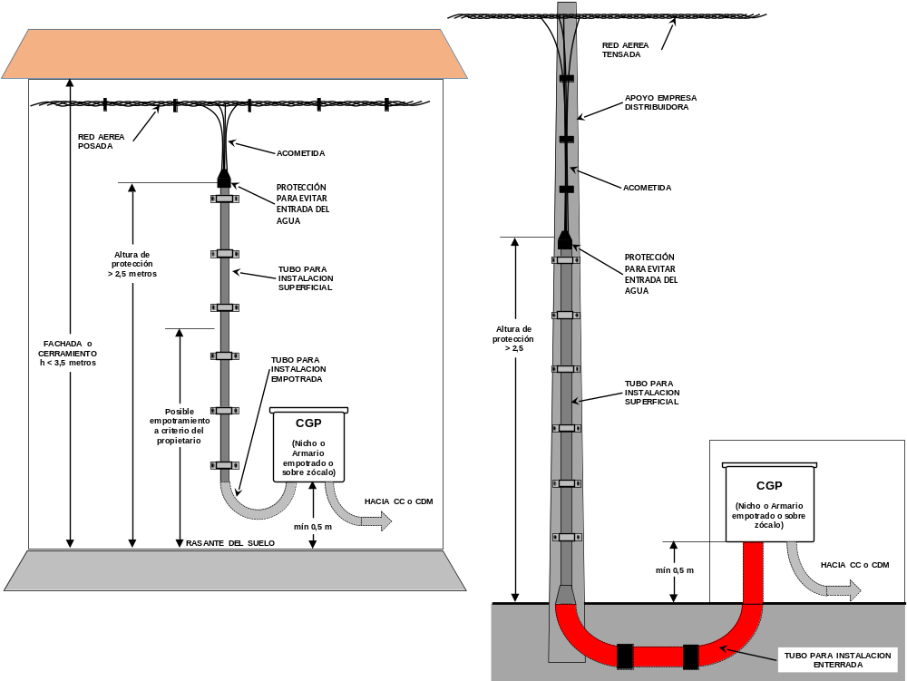
Sections where the service connection is at a height above the ground of less than 2.5 m shall be protected by protective pipes, trunks or enclosed ducts with the specific characteristics indicated in ITC BT-06.
In an area where it is planned that the overhead network is to transition to an underground network, the MPB shall be located as if it the service connection was underground. To provide for future supply from an underground connection, a 25 mm diameter conduit for neutral earthing and two 160 mm reserve pipes shall be installed in the lower part of the wall recess or cabinet, if the connection is three-phase, or a 90 mm reserve pipe, if it is single-phase.

MPB powered from an underground network
The MPB will be accessible from the ground.
Where the building or property is connected to an underground network, or where, due to the characteristics of the supply connection installations, it is necessary for more than two MSLs to run from the MPB, that MPB shall be installed in a wall recess or cabinet directly accessible from the ground. The cabinet shall be flush-mounted or fixed on a plinth.
Where the MPB is a cabinet, it shall have an insulated door opening directly to the outside. When the MPB is installed inside a wall recess, the door of the wall recess shall preferably be made of metal and be protected against corrosion, it may also be externally coated according to the characteristics of its surrounding and shall be fitted with a lock or padlock standardised by the distribution company. In both cases, the doors shall have a protection degree of at least IK 10 according to Standard UNE-EN 50102, and shall, on the outside, have an electrical hazard warning sign and a device that allows for their attachment and prevents them from accidentally closing, with an opening angle of at least 120°.
The lower part of the cabinet or wall recess door shall be at a height between 0.5 m and 1.0 m above ground level, and when a service disconnector, control and distribution box is installed under the MPB, it shall be at a mounting height between 0.3 m and 0.5 m. The operating handles of the fuse bases shall be at a height between 1.0 m and 1.8 m, as shown in the figure:
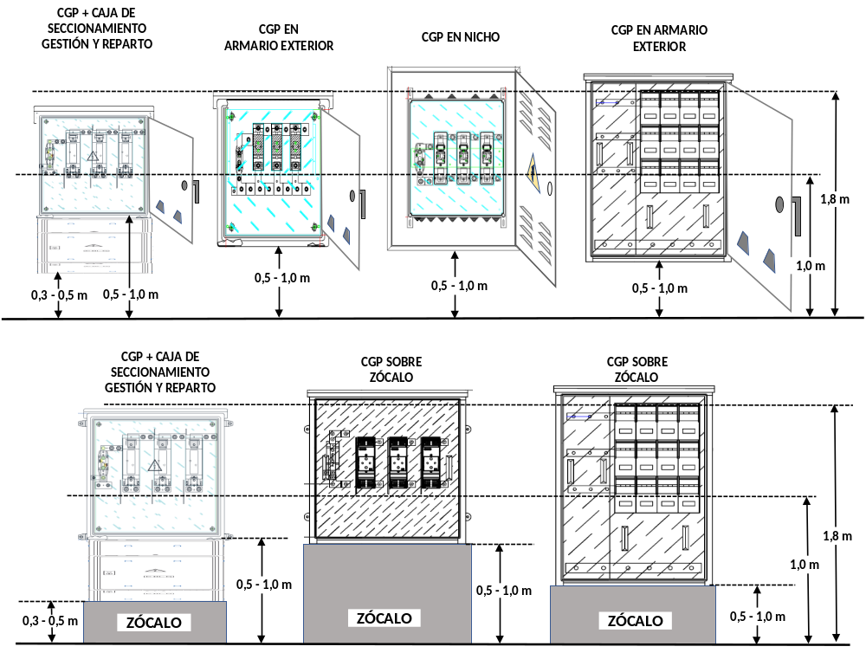
Figure 4. Example of installation of MPB in wall recess or cabinet
Note: the shown images are indicative and do not represent the final design of the switchgear, nor its spatial arrangement.
The enclosure shall be located in such a way that its interior is accessible from its front for inspection, manoeuvring and maintenance, leaving a free space in front of the enclosure of at least the width of the door plus 0.35 m, with a minimum of 1.10 meters.
When the PMB is installed inside a wall recess, it shall be fixed to the back wall of the wall recess by at least four fixing points, and in order to facilitate its assembly and the connection of the cables, minimum distances must be maintained between the PMB and the walls of the wall recess: Top (S) ≥ 15 cm, Side (L) ≥ 7,5 cm and Bottom (I) ≥ 30 cm. The wall recess shall be at least 30 cm deep.
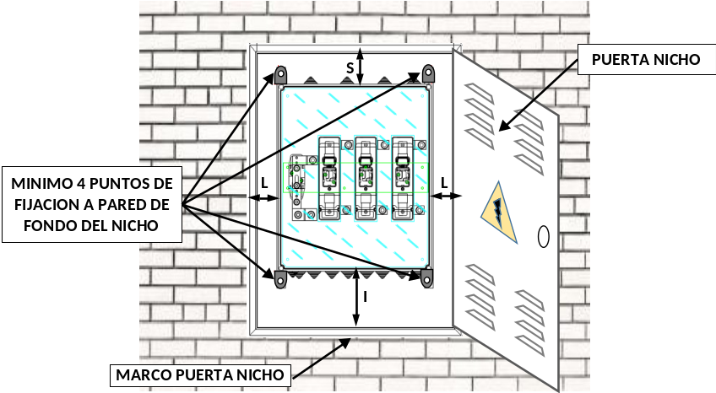
Figure 5. Example of installation of MPB inside a wall recess

Note: the shown images are indicative and do not represent the final design of the switchgear, nor its spatial arrangement.
Depending on the dimensions of the wall recess, the door may consist of one or two panels with a maximum width of 1 metre each. Both the doors and the frames or racks supporting them shall be made of weather-resistant material and protected against corrosion and rust. The doors of the wall recess shall include ventilation devices or grilles to prevent condensation inside the recess, designed in such a way as to protect from penetration of water through splashing.
Where the MPB is of the ‘Cabinet’ type and is flush-mounted in a façade or enclosure, it shall be attached in at least four points, either to the wall forming the back of the aperture or to its base by means of specific mounting lugs and fixing holes

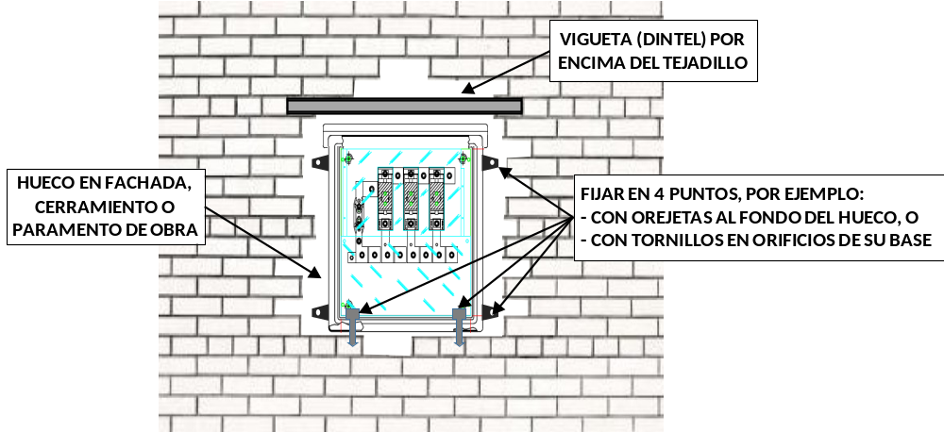
Figure 6. Example of installation of flush-mounted MPB

Note: the shown images are indicative and do not represent the final design of the switchgear, nor its spatial arrangement.
To facilitate the connection of the cables with the MPB, free space shall be provided below the MPB to act as a cable compartment with minimum dimensions of 30 cm in hight, 20 cm in depth, and as wide as the MPB. If a service distribution, control and disconnector box is installed under the MPB for input to and output from the distribution network, the cable compartment will be built under this service distribution, control and disconnector box, and the owner of the property must allow for its installation in the same façade, wall recess or plinth where the MPB is located.
In the bottom part of the cable compartment, a floor slab shall be formed in which all the necessary holes shall be provided to house the input pipes of the different circuits (service connection, distribution network, neutral earthing or main supply lines) in accordance with the provisions of the ITC BT-21 for flush-mounted or buried wiring.
For the connection of the supply connection or distribution network, two 160 mm diameter pipes shall be installed, so that, if only one is necessary, the second will remain as a reserve. In addition, a third pipe of 25 mm diameter will be installed to lay the neutral earthing cable from the MPB. When, due to the existence of a ring beam, girder or another construction element, there is no space for two pipes of 160 mm diameter, the diameters resulting from applying BT-21 shall be used. The top ends of the pipes shall be sealed once the cables are connected, while the lower ends shall be at a depth of approximately 70 cm and shall be closed with a stopper until they are connected to the distribution network. The conduit pipes shall extend beyond the vertical line of the façade, enclosure, plinth or wall of the work by at least 30 cm.
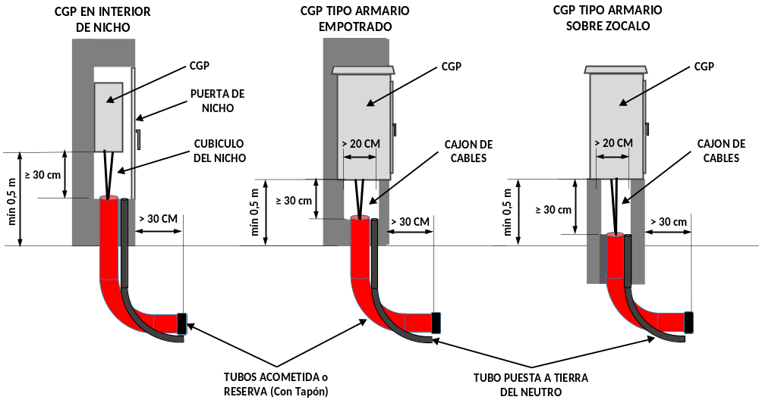
Figure 7. Example of cable compartment and arrangement of pipes for connecting to the distribution network

No more than two general protective boxes shall be housed inside the same wall recess. When two or more boxes are required for a property, cabinet-type boxes with three-pole enclosed vertical fuse bases, TEVFB, designed to supply several MSLs, may be used.
The plinths on which the ‘Cabinet’ type enclosures can be installed may be made of bricks or of reinforced or lightweight concrete, however they shall always have four studs for fixing the cupboard at their corners.

Types and characteristics
The MPBs to be used shall correspond to one of the types and schemes set out in the special technical specifications of the distribution company, which have been approved by the competent government authority, without those specifications limiting the forms of installation provided for in this ITC. The type and scheme of the MPB to be used will depend on the characteristics of the required supply, the type of distribution network to which it is to be connected and the type of enclosure at the property boundary between the property or building and the public road.
In the case of connection to the underground distribution network, the main protection boxes may be arranged to allow for the input into and output from the distribution network, in accordance with the criteria set out in the special technical specifications of the distribution company that have been approved by the authority. In this case, the elements for the network distribution connection are incorporated in the MPB and no separate box is necessary.
Depending on the location of their installation, several types of main protection boxes may be used:
  - Boxes for surface installation at height.
  - Boxes for installation inside a wall recess.
  - Cabinet-type boxes for flush-mounting.
  - Cabinet-type boxes for mounting in a plinth.
Enclosed fuse bases shall be installed within the MPB, and these shall house fuse switches in all phase or pole conductors, with a breaking capacity that is at least equal to the foreseen short-circuit current at the point of installation. The element for the connection of the neutral conductor shall consist of a detachable connection to the left of the phases or of a horizontal bar below the TEVFB, with the MPB being in operating position. The MPBs shall also have a connection terminal for the earthing of the distribution network neutral conductor. In TT networks, this earthing shall be separate from the earthing of the building, also called exposed-conductive-parts of low-voltage equipment, and should therefore not be used to connect protection conductors of the MSL or of the internal installation.
The switchgear assembly constituting the MPB shall provide double or reinforced insulation (Class II), or full insulation according to Standard UNE-EN 61439-2, and shall be sealable.
The degree of protection provided by the enclosure of the MPB against mechanical impacts according to Standard UNE-EN 50102 shall be at least:
  - IK 08 for boxes to be installed superficially at height or intended to be installed within a wall recess.
  - IK 10 for cabinet-type boxes to be installed directly outside.
The degree of protection provided by the enclosure of the MPB against penetration by foreign objects according to Standard UNE-EN 60529 shall be at least:
  - IP 43 for boxes to be installed superficially at height or within a wall recess.
  - IP 54 for cabinet-type boxes that are not installed superficially at height or within a wall recess.
The fuse bases in the interior for the protection of the main line shall be enclosed (SPEFB or TEVFB) and intended for the installation of NH blade type fuses. The rating of fuse-links to be installed shall depend on the power allocated to the main supply line to be protected.

Preservation and maintenance.
The owners, or in their absence, the users, of a PMB are responsible for its preservation and maintenance.
The maintenance measures to be carried out on these will be carried out by an installation company. If there is a problem in the connection to the service connection that compromises the safety or continuity of supply to the users, the installation company, as long as it complies with the requirements established in ANNEX III of Royal Decree 614/2001 of 8 June on minimum provisions for the protection of the health and for the safety of workers against electrical hazard, may repair, replace or intervene on the elements of the MPB, as well as retighten its connection terminals.
If, in order to repair, replace or intervene in the elements of the MPB, it is necessary to affect the supply to users other than those fed from the MPB itself, the installation company must coordinate with the distribution company, which may be the one to disconnect and subsequently reconnect the supply.

PROTECTION AND METERING BOXES
In the case of single-fed or dual-fed supplies from the same place, the installation shall be simplified by placing the individual branch protection elements and measuring equipment in a single box to be directly accessible from the public road. This box shall be called the protection and metering box and shall follow the diagrams 2.1 and 2.2 of Instruction ITC BT-12, including the components indicated in those schemes.

Placement and installation
The provisions of Section 2.1 of this TSI shall apply, except that no surface mounting shall be permitted, nor installation at height on a bracket, post or support. The installation shall be made by means of a box inside a wall recess, or with a flush-mounted cabinet or on a plinth, and shall be accessible from the ground at the boundary between the private property and the public road.
As an exception to the general rule, temporary or provisional supplies may also be installed on the surface on a support accessible from the ground, which, with the corresponding authorisations, even can be installed in areas of public domain near the point of connection to the distribution network.
The lower part of the cabinet or wall recess door shall be at a height between 0.5 m and 1.0 m above ground level, except when a service distribution, control and disconnector box is installed below the PMB or for PMBs for indirect metering, in which case the lower door shall be at a height between 0.3 m and 0.5 m. The metering equipment reading devices shall be installed at a height between 0.7 m and 1.80 m, as shown in the examples in the figure:

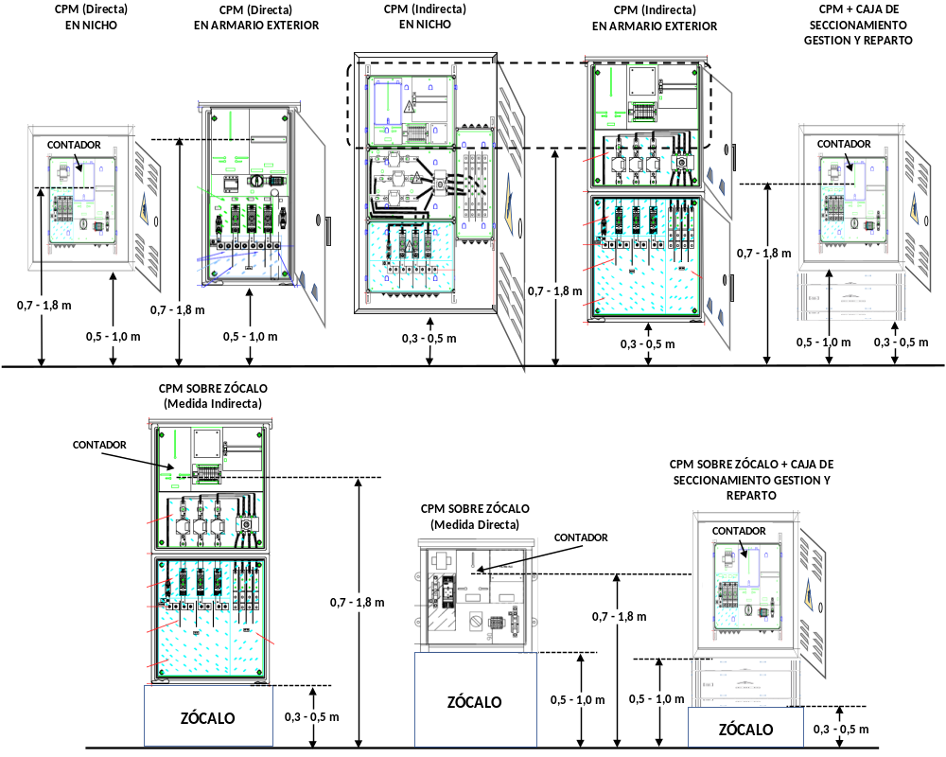
Figure 8. Example of installation of MPB in wall recess or cabinet
Note: the shown images are indicative and do not represent the final design of the switchgear, nor its spatial arrangement.
When the PMB is installed inside a wall recess, it shall be fixed to the bottom wall of the wall recess by at least four fixing points, and in order to facilitate its assembly and the connection of the cables, minimum distances must be respected between the PMB and the walls of the wall recess: Top (S) ≥ 15 cm, Side (L) ≥ 7.5 cm and Bottom (I) ≥ 30 cm. The wall recess shall have a depth of at least 30 cm.

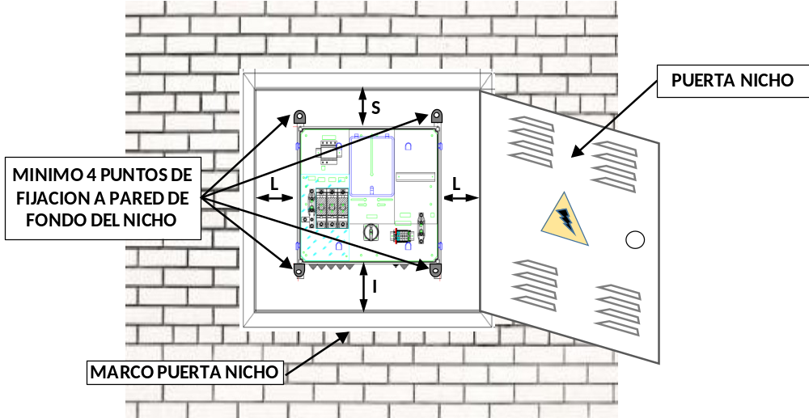
Figure 9. Example of installation of MPB inside a wall recess.

Note: the shown images are indicative and do not represent the final design of the switchgear, nor its spatial arrangement.

Types and characteristics
The protection and metering boxes to be used shall correspond to one of the types and diagrams set out in the technical specifications of the distribution company, which have been approved by the competent government authority. The type of the PMB to be used will depend on the characteristics of the required supply, the type of distribution network to which it is to be connected and the type of enclosure at the property boundary between the property or building and the public road.
In the case of connection to the underground distribution network, the protection and metering boxes may be arranged to allow for the input into and output from the distribution network, in accordance with the criteria set out in the special technical specifications of the distribution company that have been approved by the authority. In this case, the elements for the connection to and distribution of the service connection are incorporated in the PMB and no separate box is necessary.
The switchgear assembly constituting the PMB shall provide double or reinforced insulation (Class II), or full insulation according to Standard UNE-EN 61439-2, and shall be sealable.
The degree of protection provided by the enclosure of the PMB against mechanical impacts according to Standard UNE-EN 50102 shall be at least:
  - IK 08 for boxes intended to be installed within a wall recess.
  - IK 10 for cabinet-type boxes to be installed directly outside.
The degree of protection provided by the enclosure of the PMB against penetration by foreign objects according to Standard UNE-EN 60529 shall be at least:
  - IP 43 for boxes to be installed within a wall recess.
  - IP 54 for cabinet-type boxes to be installed directly outside.
The enclosure must have the necessary internal ventilation to ensure there is no condensation. The closing door of the PMB or, where applicable, of the recess, shall be solid without any inspection panels for reading the meter.
The PMB shall have a functional surge protection device, as set out in ITC BT-23, including a connection terminal for the earthing of such protection, which shall be linked to the earthing of the exposed-conductive-parts of the internal installation but which shall not be used for the earthing of the neutral conductor of the distribution network in TT networks.
The fuse bases in the interior for the protection of the individual branch shall be closed (SPEFB) and intended for the installation of NH blade type fuses. The rating of fuse-links to be installed shall depend on the power allocated to the individual branch to be protected.
Direct metering PMCs shall have a space reserved for mounting PLC filters or other load management equipment, and those for indirect metering shall have a space reserved to allow for the mounting of a communication modem associated with telemetry. The dimensions of these reserve spaces shall be in accordance with the particular specifications of the distribution companies approved by the authority.
The PMBs shall have a mechanised base plate for mounting the meter and for the wiring to be factory-wired and protected behind the plate, in accordance with the provisions of ITC BT-15 for meter enclosures and wiring.
Prior to the connection to the individual branch of a switch, PMBs shall include a safety switch-disconnector, also called individual switch-disconnector, ISD, choosing a standardised rated current immediately higher than that corresponding to the expected power. The ISD shall be multipole and the pole corresponding to neutral shall not cut the current before the other poles and shall not supply any current after the other poles.
Table 1. Minimum ISD characteristics according to their assigned intensity.

Characteristics according to their assigned intensity | ISD (A)
Characteristics according to their assigned intensity | 80 A | 160 A | 250 A | 400 A | 630 A
Rated insulation voltage (V) | 500 | 500 | 500 | 500 | 500
Dielectric strength at 50 Hz, 1 min, kV | 3.5 | 4 | 5 | 5 | 8
Rated impulse withstand voltage (kV peak) | 8 | 8 | 8 | 12 | 12

Self-consumption installations
When modifying or extending an existing installation for self-consumption purposes, the distribution company responsible for the reading can allow for the net-generation metering equipment to be located in a place other than that provided for a PMB, as long as the equipment meets the conditions and the special nature provided for in the unified Regulation on electrical power system measuring points, in the supplementary technical instructions implementing it or in the specific regulations applicable to self-consumption, and as long as the already existing PMB is maintained at its installation site.

BRANCHING AND METERING BOXES FOR THE MAIN SUPPLY LINE

Placement and installation
The BMB shall be installed in the meter rooms or cabinets, or in corridors, gates, courtyards or common areas of the building, and shall never be installed in closed premises for which a key is required to gain access, except in the meter room.
The BMB shall be installed on a plinth or fixed to the wall so that its lower part is at a height between 0.5 and 1.0 metres above the ground.
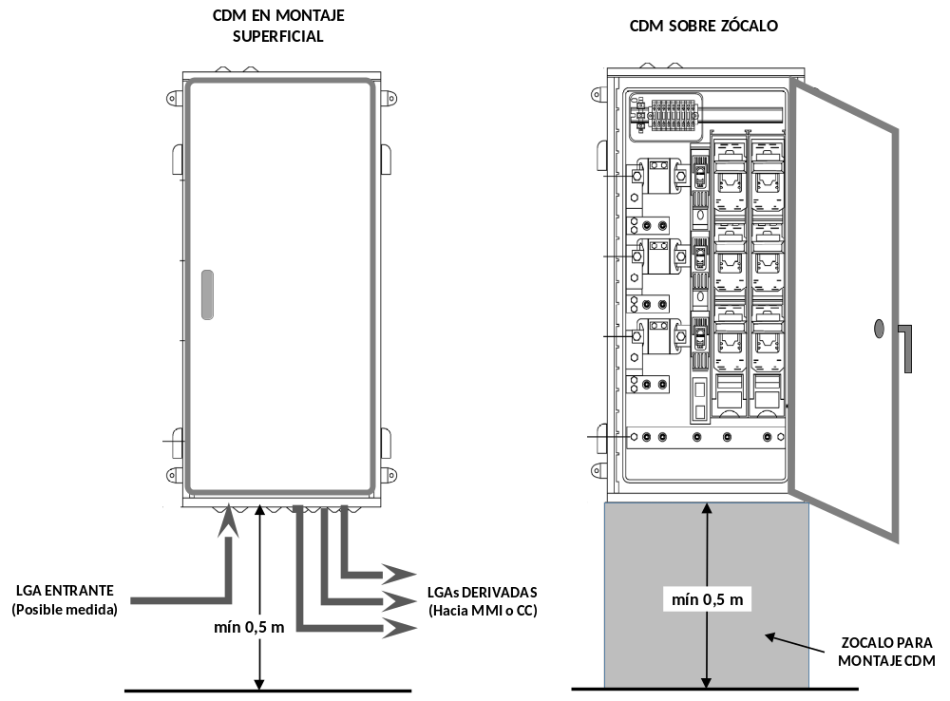
Figure 10. Example of MBM installation.
Note: the shown images are indicative and do not represent the final design of the switchgear, nor its spatial arrangement
The BMB shall have individual protection for each branched line connected to it, and it is not allowed for the same protection to be used for more than one branched MSL. Each main line shall be protected by fuses in a three-pole enclosed vertical fuse base (TEVFB), which shall house fuse switches in all phase or pole conductors, with a breaking capacity that is at least equal to the foreseen short-circuit current at the point of installation. The element for the connection of the neutral conductor shall consist of a horizontal bar below the TEVFB, with the BMB being in operating position.

Types and characteristics of the BMB
The branching and measurement boxes (BMB) of the main line to be used shall correspond to one of the types set out in the special technical specifications of the distribution company, which have been approved by the competent government authority.
The BMB to be used will consist of a cabinet, whose layout will depend on how many main lines need to be branched from the MPB main line, as recorded in the corresponding plan.
The BMB shall have all the necessary elements for carrying out an indirect measurement of the current passing through the supplying MPB main line. This measure will be carried out either to install an PSM (Protection System of the MSL) associated with electric vehicle recharging systems, or to install a ZIS (Zero-Injection System) associated with collective self-consumption without surpluses.
The switchgear assembly constituting the BMB shall provide double or reinforced insulation (Class II), or full insulation according to Standard UNE-EN 61439-2, and shall be sealable.
The degree of protection provided by the enclosure of the MPB against mechanical impacts according to Standard UNE-EN 50102 shall be at least IK 10, and for the protection against penetration by foreign objects according to Standard UNE-EN 60529, shall be at least IP 54.
The rating of fuse-links to be installed shall depend on the power allocated to each MSL branch to be protected. The fuse bases shall be enclosed and be ready for the installation of NH blade type fuses.

MINIMUM SPECIAL RE QUIREMENTS FOR THE MODIFICATION OF EXISTING INSTALLATIONS
When modifying an internal installation due to the installation of a new circuit for generation or for electric vehicle charging, the following exceptions to the general requirements in this ITC shall be taken into consideration.
  - For supply connection installations for a single supply or for two supplies powered from the same place, if there is no space inside the PMB to install the Type 1 surge protector, it may be installed in the main control and protection panel of the installation. In this case it will be possible to combine the Type 1 and Type 2 protectors in a single device.
  - If there is no space in the protection and metering box, PMB, to install the safety switch-disconnector for the individual branch, ISD, that switch-disconnector may be occupy the space for the output terminals of the individual branch or, if this space is insufficient, in a cabinet attached to the existing PMB.
When the modification of the internal installation is not due to a new generation or electric vehicle charging installation, the following exceptions to the general requirements in this ITC shall be taken into consideration.
  - It shall not be mandatory to install surge protection devices if the original installation did not have such devices.
  - It shall not be necessary to incorporate a safety switch-disconnector for the individual branch, ISD, into the PMB.

REFERENCE STANDARDS
Products that comply with their corresponding product standard, as indicated below, and also have the characteristics specified in this ITC (e.g. IP grade, single-line diagram), shall be presumed to comply with the requirements of this ITC:
  - MPBs, PMBs and BMBs forming a switchgear and control gear assembly complying with Standard UNE-EN 61439-2
  - Fuse-links complying with Standards UNE-EN 60269-1 and UNE-HD 60269-2.
  - Single-pole enclosed fuse bases (SPEFB) and three-pole enclosed vertical fuse bases (TEVFB) with contacts for NH blade type fuses, comply with the standards UNE-EN 60269 (series) and UNE-EN IEC 60947-3.
’

Twenty-four. The Supplementary Technical Instruction ITC BT-14, ‘Connection installations. Main supply line’, is amended to read as follows:

‘ITC BT-14

SUPPLY CONNECTION INSTALLATIONS. MAIN SUPPLY LINE
- DEFINITION
- INSTALLATION
  - Installation in embedded conduits
  - Installation in pipes
  - Installation inside protective trunking or ducting.
  - Installation in cable trays
  - Installation in prefabricated electrical wiring duct systems
- CABLES
  - Main supply lines cross-section
  - Load to be conducted by the MSL
- FIRE PERFORMANCE OF CABLES AND CABLE MANAGEMENT SYSTEMS
- MODIFICATION OF EXISTING INSTALLATIONS

DEFINITION
This is the line that connects the main protection box to the meters panel, MP, or to an indirect metering module, IMM, or to a PMB, in the case of supply connection installations for single-fed or dual-fed overhead supplies fed from the same place.
In multi-supply connection installations, branches from the MSL can be made from a BMB to connect to meters panels, MPs, or to indirect metering modules, IMM.
In accordance with Sections 2.1 and 2.2 of the ITC BT-12, for supply connection installations for single-fed or dual-fed supplies from underground networks or from overhead networks where it is not possible to install a MPB at height, there is no MSL since the PMB contains the electricity meter inside it.
MSLs shall consist of the number of phase and neutral cables intended for the supply. Only for connection installations with meter rooms or cabinets in several locations must the MSLs provide for the protective conductor from the meter room or cabinet where the main earthing terminal is located to the remaining meter rooms or cabinets. The protective conductor shall be placed in the same conduit as the rest of the cables.

INSTALLATION
The installation system, which may vary in different sections, will be chosen depending on the routing of the MSL and the characteristics of the building or property. The possible systems depending on the placement of the MSL conduits, are as follows.
a) Wiring in accessible building gaps:
  - protective pipes
  - ducting
  - trunking
  - cable trays.
b) Wiring in non-accessible building gaps:
  - cables not directly fastened
  - protective pipes
  - ducting.
c) Wiring in enclosed concealed conduits, designed and constructed for this purpose:
  - cables directly or non-directly fastened
  - protective pipes
  - ducting
  - trunking
  - cable trays.
d) Buried wiring duct systems:
  - protective pipes.
e) Wiring duct systems embedded in structures:
  - protective pipes
  - ducting
  - trunking.
f) Surface-mounted wiring duct systems:
  - protective pipes
  - ducting
  - protective trunking, the lid of which can only be opened with tools
  - cable tray systems with a lid that can only be opened with tools.
g) Prefabricated electrical wiring duct systems.
The routing of the MSL shall be as short and straight as possible, running through jointly used and easily accessible areas inside the building or property. Curves, changes of direction and thermal influence from other ductwork in the building shall be avoided. In crossings and parallel runs with water and gas pipelines, the MSL wiring duct systems shall pass over those, maintaining a minimum distance of 20 cm from these pipelines. This distance may be reduced to a minimum distance of 3 cm if the MSL is installed inside protective pipes, ducting or protective trunking.
Exceptionally, in the case of temporary or provisional supplies where, subject to prior authorisation of the competent authority, the MSL passes through land in the public domain, that MSL shall have the same characteristics as low-voltage distribution networks in compliance with all the provisions of ITC BT-06 or ITC BT-07, depending on whether the MSL installation is overhead or underground.
The MSL may not share conduits with other circuits or installations in the building such as gas, water or communications, nor may it pass through transformer substations, storage rooms or technical rooms such as boiler rooms, lift shafts, pumping stations or engine rooms.
In the enclosure of a protected stairway, in the enclosure of a specially protected stairway or in an independence vestibule, as well as in a minimum risk sector, an MSL may be installed, provided that it is separated from these areas with EI 120 elements and EI 60 access panels.
The planner shall prevent the MSL from passing through garages or other places for which a key is required to gain access. If the planner justifies that, for layout reasons, the MSL must be routed through a garage or locked area, it must be passed inside pipes, ducting or embedded conduits.
The dimensions of the conduit system shall allow for the conductor cross-section to be expanded by 100 %.
Cable conduction systems must comply with the general requirements of ITC BT-20 and 21 and also with the particular requirements of the following sections, according to their form of installation.

Installation in embedded conduits
Concealed conduits are intended solely and exclusively to house MSLs and possibly protective conductors. Where MSLs and IBs have the same routing, they shall be installed in different conduits or in the same conduit with partitions of the same characteristics as the rest of the concealed conduit.
When the main line runs vertically between different floors of the building, it shall run inside a masonry conduit that is flush-mounted in or attached to the stairwell or in jointly used areas that have not been defined as ‘protected’ according to the DB-SI technical building code. When the vertical section of the MSL routing is short and does not connect different floors, it is possible to do the vertical installation of the main line inside pipes, protective trunking or closed ducting, either surface-mounted on or flush-mounted in a wall, without it being necessary to pass such a section through an embedded conduit.
The vertical embedded conduit shall be able to be inspected on each floor, and firewalls shall be established on every three floors. Horizontally, it shall be able to be inspected every 30 metres if there are no changes of direction, which shall be reduced to 15 metres when there are changes of direction. Hatches shall be located approximately 20 cm from the ceiling in corridors or jointly used areas, and shall be at least 30 cm high. The lids of the hatch shall be made of metal and have a lock or a securing system that requires a key or tool to open them. They may also be covered with other materials for aesthetic purposes, ensuring at all times a fire resistance of at least EI 30.
The flame traps inside the embedded conduit shall be installed about 15 cm below the hatch of that floor. The flame traps shall provide closure in such a way that subsequent modifications to the installation can be carried out without deforming the existing conduits.
The walls of the embedded ducts shall have a fire resistance as set out in the DB-SI technical building code. The minimum dimensions of the conduit shall be 30 x 30 cm (width x depth) when housing up to two main supply lines and 60 x 30 cm (width x depth) when housing up to four lines.
Inside vertical ducts, the cables, protective pipes, protective ducting, protective trunking, closed ducting or cable trays shall be fixed directly at each floor level.
The following figure shows several possible arrangements for these elements inside the vertical embedded ducts.
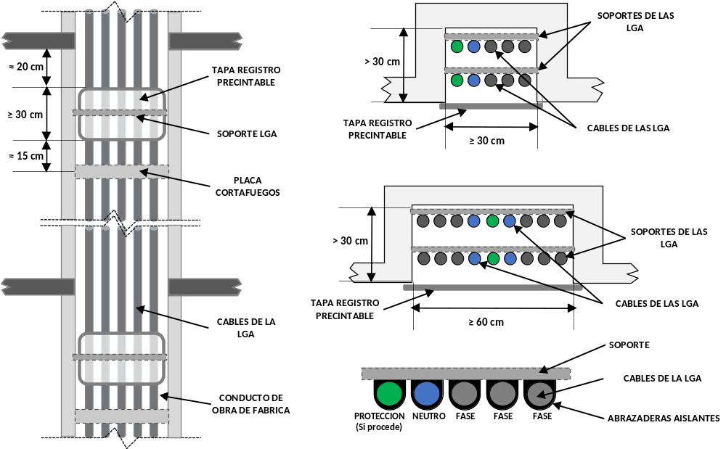
Figure 1. Example of vertical concealed conduits for main lines.
CABLE TIES OR CABLE CLEATS

Note on Figure 1: Single-core cables with a rated voltage of 0.6/1 kV with insulation and sheathing do not have different colours their coverings, so the installer must thus identify the conductors by appropriate means, e.g. by a flag, a ring or a label, at each cable end.
Where the MSL runs inside enclosed concealed conduits, it is not necessary for the cables to be housed inside protective pipes, protective trunking, closed ducting or cable trays inside the embedded duct as shown in Figure 1, although their use is useful to minimise effects caused by friction, as well as to facilitate the replacement or extension of the MSL cables. Where cables are fixed directly to the construction cavity, cable ties or cable cleats shall be used for their attachment, and for the attachment of protective pipes, protective trunking, ducting or cable trays, the systems provided for by the manufacturer shall be used.

Installation in pipes
Where the MSL is installed inside pipes, its diameter shall depend on the cross-section of the cable to be installed as indicated in Table 1. When several MSLs are installed with the same routing, they shall be passed through independent pipes.
Table 1. Pipe diameters for MSL wiring.
MSL phase conductor cross-section  (mm²) | Outer diameter of the MSL pipe  (mm)
≤ 16 | 75
25 | 110
35 | 110
50 | 125
70 | 140
95 | 140
120 | 160
150 | 160
185 | 180
240 | 200
The joints of the rigid pipe shall be threaded or spigoted, so that the ends cannot be separated.
In wiring inside buried pipes, the specifications in Section 2.1.2 of ITC BT-07 shall also be complied with.

Installation inside protective trunking or ducting.
Where main lines are installed inside protective trunking or ducting, these must be insulated. If several main lines run through the same protective trunking or ducting, the protective trunking or ducting shall incorporate partitions to establish a separation between each of them.
If the protective trunking and ducting are accessible from the exterior, as is the case with surface-mounting, they shall comply with the characteristics of Table 2. Protective trunking and ducting that meet these characteristics and comply with Standard UNE-EN IEC 61084-2-1 shall be presumed to meet the requirements of this ITC.
Table 2. Characteristics of protective trunking with a lid that can be opened with tools and of ducting.
Characteristic/ | Rating
Impact resistance | 5 J
Opening of the access lid to the system  (not applicable to ducting) | With access lid that can only be opened with tools
Protection against penetration by solid foreign objects | IP2X
Electrical insulation (non-metallic protective trunking) | With electrical insulation

Installation on cable trays
Where the MSL wiring is accessible from the outside, as is the case in surface mounting, the tray shall be fitted with a lid that can only be opened with tools.
Trays systems shall have the same additional characteristics as indicated in Table 2. Trays that meet these characteristics and comply with Standard UNE-EN 61537 shall be presumed to meet the requirements of this ITC.
If several main supply lines pass through the same tray, the tray must have partitions establishing a separation between each line.

Installation in prefabricated electrical wiring duct systems
Where the MSL is installed inside prefabricated electrical conduits, these must be insulated. If several main supply lines pass through the same wiring duct systems, the wiring duct systems must have partitions or construction element establishing a separation between each line.
Prefabricated electrical wiring duct systems that meet these characteristics and comply with the UNE-EN 61534 series standards or Standard UNE-EN 61439-6 shall be presumed to meet the requirements of this ITC.

CABLES
MSL, phase, neutral and protective cables shall be of a rated voltage of 0.6/1 kV, single-core and have copper or aluminium conductors.
Wherever aluminium conductors are used, the connections must be made using appropriate techniques that avoid deteriorating the conductor owing to dangerous power levels originating from the effects of galvanic pairs.
The cross-section of the conductors must be uniform throughout their length and without splices, except for the branches made inside the junction boxes, BMB.

Main supply lines cross-section
The minimum cross-section for copper shall be 10 mm² or 16 mm² for aluminium. The cross-section of the conductors to be used will be established according to the expected loads of the installation, the voltage drop allowed, the installation system used and the characteristics of the protection devices.
The maximum permitted voltage drop shall be:
- 0.5 %. For main lines to meter rooms or cabinets located on the ground floor, mezzanine or first basement.
- 1 %. For main supply lines to meter rooms or cabinets located on the upper floors.
The maximum permissible intensity of the MSL will be higher than the corresponding one according to the expected power forecast established in the ITC BT-10. The maximum permissible intensity shall be calculated according to Standard UNE-HD 60364-5-52 establishing standard conditions for two or three charged single-core cable installations, an ambient temperature of 40 °C and a ground temperature of 25 °C with a thermal resistivity of 2.5 K.m/W for buried installations. In the plan or technical design report, appropriate correction factors shall be applied according to the type of assembly and when the installation conditions, temperature or resistivity of the ground do not adapt to the above standard conditions, adequately justifying the projected conditions that deviate from the standard conditions.
The neutral conductor shall have at least the same cross-section as the phase conductors, except where it is justified in the plan or in the technical design report that there can be no unbalance or harmonic currents due to non-linear loads and that the overload and short-circuit protections are adequate for the reduced neutral cross-section.
Table 3 shows the cross-sections of the protective conductor according to the cross-section of the phase conductor.
Table 3. Protective conductor cross-section.
Cross-sections (mm²)
PHASE | PROTECTION  (Where applicable)
10 (Cu) | 10
16 (Cu) | 10
16 (Al) | 16
25 | 16
35 | 25
50 | 25
70 | 35
95 | 50
120 | 70
150 | 95
185 | 95
240 | 150

If the 240 mm² cross-section is insufficient to carry the intended load or due to voltage drop, the MSL may consist of two cables of the same cross-section and length connected in parallel to the same fuse base. In this case, the planner shall take into account the recommendations for overcurrent protection of parallel conductors in Standard UNE-HD 60364-4-43.

Load to be conducted by the MSL
The intensity by an MSL or by a branched MSL shall correspond to a maximum load forecast of 250 kW. This limit may be increased up to 400 kW if the MSL is intended to supply a branching and measuring box (BMB) from which several MSLs are branched. This is without prejudice to other constraints of the distribution network that may limit the power available for a low voltage supply.
MSLs shall be protected against overcurrent at their source by the fuses of the MPB and downstream MSLs by the fuses of the BMB. The maximum rated current of protective fuses of an MSL or a derived MSL shall be 400 A, except if they protect an MSL intended to supply a BMB, in which case the maximum rated current may also be 500 A or 630 A.
When an MSL feeds a BMB, the load forecast shall be equal to the sum of the loads from each of the derived MSLs fed from said BMB, applying the corresponding simultaneity coefficients if either of them feeds infrastructure for recharging electric vehicles according to ITC BT-52, as well as all that is indicated in ITC BT-10.

FIRE PERFORMANCE OF CABLES AND CABLE MANAGEMENT SYSTEMS
Cables and cable management systems shall be installed in such a way that the fire safety characteristics of the building structure are not reduced.
Cable management systems with characteristics equivalent to those classified as ‘flame retardant’ in accordance with the UNE-EN IEC 61084 or UNE-EN 61386 series of standards or Standard UNE-EN 61537 are presumed to comply with this requirement.
The cables must comply at least with class C_{ca}-s1b, d1, a1, in accordance with the section of Standard UNE-EN 50575 relating to the reaction to fire of cables. Cables with characteristics equivalent to those of Standard UNE 21123, part 4 or 5 are presumed to comply this requirement.

MODIFICATION OF EXISTING INSTALLATIONS
In the case of modifications or replacements of main supply lines in already constructed buildings in which masonry ducts cannot be used between different floors, surface-mounted or flush-mounted installation in a wall shall be permitted, in accordance with Sections 2.2, 2.3 and 2.4 of this ITC.
Self-consumption installations may be connected to the supply connection installation or to the internal installation downstream of the existing MSL if their foreseen generation capacity is compatible with the capacity of the MSL.
’

Twenty-five. The Supplementary Technical Instruction ITC BT-15, ‘Supply connection installations. Individual branches’, is amended to read as follows and is renumbered:

‘ITC BT-16

INTERNAL INSTALLATIONS. INDIVIDUAL BRANCHES
- DEFINITION
- INSTALLATION CHARACTERISTICS
  - Installation in embedded conduits.
  - Installation in pipes.
  - Installation inside protective trunking or ducting.
  - Installation inside cable trays.
  - Installation in prefabricated wiring duct systems
- CABLES
- FIRE PERFORMANCE OF CABLES AND CABLE MANAGEMENT SYSTEMS
- MODIFICATION OR EXTENSION OF EXISTING INSTALLATIONS.

DEFINITION
The individual branch is the part of the internal installation of a user (consumer, generator or self-consumer) that connects its metering point to the switchboard containing the general control and protection devices of the installation. Therefore, the individual branch starts at the output terminals or plates of the measuring point (MP, IMM or PMB) and ends at the input terminals of the main automatic circuit-breaker located in the main control and protection board to which the internal circuits of the installation are connected.

INSTALLATION CHARACTERISTICS
Each individual branch shall be entirely independent of the individual branches corresponding to other users.
The most suitable installation system, which may vary in the different sections, will be chosen depending on the routing of the IB and the characteristics of the building or property. The possible systems depending on the placement of the IB conduits, are as follows.
- Wiring in accessible building gaps:
  - protective pipes
  - ducting
  - trunking
  - cable trays.
- Wiring in non-accessible building gaps:
  - cables not directly fastened
  - protective pipes
  - ducting.
- Wiring in enclosed concealed conduits, designed and constructed for this purpose:
  - cables directly or non-directly fastened
  - protective pipes
  - ducting
  - trunking
  - cable trays.
- Buried wiring duct systems:
  - protective pipes.
- Wiring duct systems embedded in structures:
  - protective pipes
  - ducting
  - trunking.
- Surface-mounted wiring duct systems:
  - protective pipes
  - ducting
  - protective trunking, the lid of which can only be opened with tools
  - cable trays with a lid that can only be opened with tools.
- Prefabricated electrical wiring duct systems complying with Standard UNE-EN 61439-6 or the UNE-EN 61534 series of standards.
The routing of the IB shall be as short and straight as possible, running through jointly used and easily accessible areas inside the building or property; otherwise, their corresponding wayleaves will be determined. Curves, changes of direction and thermal influence from other ductwork in the building shall be avoided. In crossings and parallel runs with water and gas pipelines, the IB wiring duct systems shall pass over those, maintaining a minimum distance of 20 cm from these pipelines. This distance may be reduced to a minimum distance of 3 cm if the IB is installed inside protective pipes, ducting or protective trunking.
Exceptionally, in the case of temporary or provisional supplies where, subject to prior authorisation of the competent authority, the IB passes through land in the public domain, that individual branch shall have the same characteristics as low-voltage distribution networks in compliance with all the provisions of ITC BT-06 or ITC BT-07, depending on whether the individual branch is overhead or underground.
The IB may not share conduits with other circuits or installations in the building such as gas, water or communications, nor may it pass through transformer substations, storage rooms or technical rooms such as boiler rooms, lift shafts, pumping stations or engine rooms.
In the enclosure of a protected stairway, in the enclosure of a specially protected stairway or in an independence vestibule, as well as in a minimum risk sector, an IB may be installed, provided that it is separated from these areas with EI 120 elements and EI 60 access panels.
The dimensions of the conduit system shall allow for the cross-section of the initially installed conductors to be expanded by 100 %.
In addition, there shall be a reserve pipe or ducting or of the corresponding space in the cable wiring duct systems (trunk, tray or embedded conduits) to install a new individual branch for every ten individual branches, or part thereof, so as to facilitate possible expansions, as well as other reserve wiring duct systems (pipe, duct or space in the wiring duct system) linking the meters panel with the roof of the building. In premises where partitioning is not defined, the cable management system is prepared to allow for the installation of an individual branch for every 50 m² of floor area.
The specific requirements applicable to the installation of individual branches corresponding to electric vehicle charging circuits inside garages shall comply with the provisions of ITC BT-52.
Except as specifically indicated in Sections 2.1 to 2.5 of this ITC, cable wiring duct systems must comply with the general requirements of ITC BT-20 and 21 and, in addition, with the requirements applicable to the MSL according to ITC BT-14, Sections 2.1 to 2.5.

Installation in embedded conduits
Where individual branches run vertically between different floors of the building, they shall run inside a concealed conduit in or attached to the stairwell or other communal area.
The minimum dimensions of the concealed conduit shall be in accordance with the following table.
Table 1. Minimum dimensions of the concealed duct or conduit.
DIMENSIONS (m)
Number of branches | WIDTH L (m)
Number of branches | Depth  D = 0.15 m  one row | Depth  D = 0.30 m  two rows
Not more than 12 | 0.65 | 0.50
13–24 | 1.25 | 0.65
25–36 | 1.85 | 0.95
37–48 | 2.45 | 1.35

For more than the specified number of individual branches, the necessary number of concealed conduits or ductwork shall be provided.

Installation in pipes
If individual branches are installed inside pipes, their diameter shall depend on the cross-section and number of cables that make up each individual branch, in accordance with the provisions of ITC BT-21. The minimum nominal outer diameter of the pipes for the wire ducting of the individual branches shall be 32 mm. When several IBs are installed with the same routing, they shall be passed through independent pipes.

Installation inside protective trunking or ducting.
Due to their routing, several individual branches may be installed through the same protective trunking or ducting, without the need to incorporate a partition wall between them.

Installation inside cable trays.
Due to their routing, several individual branches may be passed through the same cable tray, without the need to incorporate a partition wall between them.

Installation in prefabricated wiring duct systems
Due to their routing, several individual branches may be passed through the same prefabricated wiring duct system, without the need to incorporate a partition wall between them.

CABLES
The number of conductors in each individual branch shall be established by the number of phases necessary for the use of the equipment of its internal installation and by its power, each individual branch bearing a corresponding neutral conductor, as well as a protective conductor.
Each individual branch shall include a control cable that can be used to control the electric vehicle charging circuit. It is not permitted to use a common neutral conductor or a common protective conductor for different users.
In the case of users with the meters installed in a PMB, the connection point of the protective conductor shall be left to the discretion of the planner of the installation, and in all other cases, it shall be located at the meters panel or in the place where the IMM is installed.
In order to determine the number of phases that make up the individual branch, the single-phase power that the distribution company is obliged to supply will be taken into account if the user so wishes.
The conductors shall not have joints and their cross-section shall be uniform, except in the case of connections made at the measuring point and at the protection devices.
IB cables shall be of a minimum rated voltage of 450/750 V, be single-core and have copper or aluminium conductors. The colour code indicated in ITC BT-19 shall be followed and the control cable shall be red.
Where, due to the overlap in their routing, several individual branches are installed inside the same protective trunking or ducting, on the same tray or inside the same concealed conduit, without housing the cables inside protective pipes, multicore cables shall be used to ensure independence between the branches. Multicore cables and cables inside buried pipes shall have a rated voltage of 0.6/1 kV.
The cross-section of the conductors to be used will be established according to the expected loads of the installation, the voltage drop allowed, the installation system used and the characteristics of the protection devices. However, the minimum cross-section shall be 10 mm² for copper or 16 mm² for aluminium phase, neutral and protective cables and 1.5 mm² for the control cable, except where the IB forms a charging circuit, in which case the minimum cross-section shall be that indicated in ITC BT-52.
The maximum permitted voltage drop shall be:
- 1 % for individual branches connected in meter rooms or cabinets located on the ground floor, mezzanine or first basement.
- 0.5 % for individual branches connected in meter rooms or cabinets located on the upper floors.
- 1.5 % for individual branches for the supply to a single user, when there is no MSL.
- For all charging infrastructure from the metering point to any of the charging stations, the maximum voltage drop permitted shall be as indicated in ITC BT-52.
However, the voltage drop in the individual branch may be compensated for by the voltage drop in the internal installation part originating from the general control and protection devices, so that the sum of the two is less than the sum of the permissible values for the individual sections.
The maximum permissible intensity of the IB will be higher than the corresponding one according to expected power forecasts established in ITC BT-10.
The maximum permissible intensity shall be calculated according to Standard UNE-HD 60364-5-52 establishing standard conditions for two or three charged conductor installations, an ambient temperature of 40 °C and a ground temperature of 25 °C with a thermal resistivity of 2.5 K.m/W for buried installations.
In the plan or technical design report, appropriate correction factors that shall be implemented according to the type of assembly and when the installation conditions, temperature or resistivity of the ground do not adapt to the above standard conditions, adequately justifying the projected conditions that deviate from the standard conditions.
For the cross-section of the neutral conductor in three-phase IBs, the foreseen maximum imbalance, the harmonic currents and their behaviour will be taken into account, depending on the established protections against overloads and short-circuits that could occur. The cross-section of the neutral conductor shall be at least the same as that of the phase conductors, except where the planner justifies that there cannot be imbalances or harmonic currents due to non-linear loads.

FIRE PERFORMANCE OF CABLES AND CABLE MANAGEMENT SYSTEMS
Cables and cable management systems shall be installed in such a way that the fire safety characteristics of the building structure are not reduced.
Cable management systems with characteristics equivalent to those classified as ‘flame retardant’ in accordance with the UNE-EN IEC 61084 or UNE-EN 61386 series of standards or Standard UNE-EN 61537 are presumed to comply with this requirement.
The cables must comply at least with class C_{ca}-s1b, d1, a1, in accordance with the section of Standard UNE-EN 50575 relating to the reaction to fire of cables. Cables with characteristics equivalent to those of Standard UNE 21123 part 4 or 5 or to Standard UNE 211002 (according to the rated voltage of the cable) are assumed to meet this requirement.

MODIFICATION OR EXTENSION OF EXISTING INSTALLATIONS
In the case of modification or extension of individual branches in buildings already constructed in which it is physically impossible to install ducting between different floors, the installation in flush-mounting or surface-mounting on a wall may be permitted in accordance with the requirements indicated in Section 2 of this ITC, subject to an exemption request submitted to the competent body, in which alternative measures are proposed which have an equivalent level of safety, including fire safety measures.
Self-consumption installations connected to existing supplies shall be considered as an extension of the installations. Self-consumption installations may be connected to the internal installation downstream of the existing individual branch, if their foreseen generation capacity is compatible with the capacity of the individual branch. Otherwise, it will be necessary to modify the existing individual branch or to install a new individual branch. Where the new generation or electric vehicle charging installation has its own individual branch, no modification to the existing individual branch shall be necessary.’

Twenty-six. The Supplementary Technical Instruction ITC BT-16, ‘Supply connection installations. Meters: placement and installation systems’, is amended to read as follows and is renumbered:

‘ITC BT-15

SUPPLY CONNECTION INSTALLATIONS. METERS AND MEASURING SYSTEMS. PLACEMENT AND INSTALLATION
- OVERVIEW
- TYPES OF ENCLOSURES FOR METERS AND METERING SYSTEMS
- WIRING OF METERS PANELS AND INDIRECT METERING MODULES
- METERING ASSEMBLIES AND REQUIREMENTS FOR METER ROOMS AND CABINETS
  - Placement for single- or dual-fed supplies from the same location
  - Placement for multiple supplies
    - Meter rooms
    - Meter cabinets
- TYPES AND CHARACTERISTICS OF METERS PANELS AND INDIRECT METERING MODULES
  - Meters panel (MP)
    - Functional surge protection device
    - Functional main switch disconnector (MSD)
    - Functional MSL current measuring device (optional)
    - Functional main busbar and safety fuse unit
    - Functional measurement unit
    - Functional filtering and load management unit
    - Functional individual switch-disconnector (ISD)
    - Functional protective busbar and output terminal unit
  - Indirect measuring modules
    - Functional surge protection device
    - Functional safety fuse unit
    - Functional measurement unit
    - Functional individual switch-disconnector (ISD)
- SYSTEM SELECTION
- MODIFICATION OF EXISTING INSTALLATIONS
- REFERENCE STANDARDS

OVERVIEW
Meters and other devices for measuring low-voltage electrical energy may be located in protection and measurement boxes (PMBs), meters panels (MPs) or indirect measurement modules (IMMs). The characteristics and installation conditions of the MPs and IMMs are included in this ITC, while those applicable to the PMB are included in ITC BT-13.
A meters panel (MP) is an assembly consisting of several functional units installed inside a meter room or cabinet of a multi-supply property and fed by a main supply line. A meters panel includes several meters with direct metering.
The indirect measurement module (IMM) is an assembly consisting of several functional units that includes the equipment necessary for the indirect measurement of energy of a single supply. It shall be installed inside a meter room or cabinet and may be fed by a main supply line or integrated in a meters panel.

TYPES OF ENCLOSURES FOR METERS AND METERING SYSTEMS
Meters and other devices for measuring low-voltage electrical energy, and their protection and control elements, may be located inside meter rooms or cabinets in the following types of enclosures:
  - modules (boxes with sealable lids) or panels, surface-mounted or flush-mounted;
  - cabinets with a sealable door, surface mounted, indoors.
The degree of protection against mechanical impact, in accordance with Standard UNE-EN 50102, provided by the enclosures installed inside the meter rooms or cabinets, shall be at least:
  - IK 08 for modules, panels and cabinets installed indoors.
The degree of protection against the penetration of foreign materials, according to Standard UNE-EN 60529, provided by the modules and cabinets installed inside shall be IP 43.
For basic protection and fault protection in the event of a defect, the enclosures shall be of double or reinforced insulation (class II) or of total insulation in accordance with Standard UNE-EN 61439-2. The verification of the flammability category shall be carried out in accordance with the tests defined for that purpose in Standard UNE-EN 61439-5 and the materials used in the manufacture of the different parts shall, with regard to fire risks, also comply with the provisions of Standard UNE-EN 61439-5.
With regard to flame propagation, enclosures shall comply with the glow-wire test described in Standard UNE-EN 60695-2-11, at a temperature of 960 C for insulating materials that are in contact with current-carrying parts and 850 C for other materials such as enclosures, lids, etc.
The dimensions of the enclosures shall be appropriate for the type and number of meters, as well as the rest of the devices necessary for energy billing, depending on the type of supply. In addition, they must allow access to other protection, control or load management elements, when necessary. Modules and cabinets shall have internal ventilation to prevent condensation without their degree of protection being reduced.
The lids of the modules and panels shall be sealable and shall have an electrical risk warning sign on the outside. The lids of the modules shall be made of a transparent material that allows for the interior to be seen and the counters to be read without the need to open the lid, and the lids of the panels may be opaque.
The enclosures shall have insulating mounting plates on the inside for securing the various elements. For the assembly of meters, the mounting plates shall comply with the same flammability category as the enclosures, considering that they are in contact with current-carrying parts. Figure 1 shows the indicative dimensions of the mounting plates for the assembly of meters, although it is possible for distribution companies to specify different dimensions.
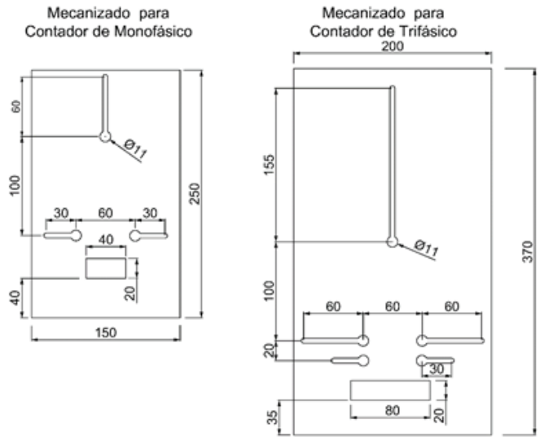
Figure 1. Meter mounting arrangements.

WIRING OF METERS PANELS AND INDIRECT METERING MODULES
In order to minimise future modifications to meters panels when power expansions occur, their wiring shall have a minimum cross-section of 16 mm². However, due to load prediction or to achieve a voltage drop within the regulatory limits, a larger cross-section may be necessary.
The cables will have a rated voltage of 450/750 V and copper conductors, which shall be class 2 in accordance with Standard UNE-EN IEC 60228, with dry insulation, extruded from heat-resistant or thermoplastic compounds, and they will be identified according to the colours laid down in ITC BT-19.
The cables must comply at least with class C_{ca}-s1b, d1, a1, in accordance with the section of Standard UNE-EN 50575 relating to the reaction to fire of cables. Cables with characteristics equivalent to those of Standard UNE 21027- 9 (heat-resistant compounds) or to Standard UNE 211002 (thermoplastic compounds) meet this requirement.
The rest of the wiring shall have the same characteristics as indicated above. The control cable starting from the MP or IMM shall have a cross-section of 1.5 mm² and be red. The power supply to the communications equipment for remote metering shall have a cross-section of 2.5 mm², and for indirect measurement circuits connected to the secondary winding of the current transformers the minimum cross-section shall be 6 mm².
The wiring shall be carried out behind the mounting plate using single-pole conductors, the connections shall be direct and the conductors shall not require special preparation or terminals.

METERING ASSEMBLIES AND REQUIREMENTS FOR METER ROOMS AND CABINETS
The placement and installation of the meters will depend on the number of supplies to be fed from the service connection. For single-fed or dual-fed supplies from the same location, the meters shall be located in a PMC installed at the property boundary, whereas for more than two supplies they shall be located in meter rooms or cabinets installed at the property boundary or inside the building or property.

Placement for single- or dual-fed supplies from the same location
This provision shall be used only for the supply to a single independent user or to two users supplied from the same location.
A protection and metering box shall be used, of the types and characteristics indicated in Section 3.2 of ITC BT-13, which brings together, within the same enclosure, the protection, measuring and manoeuvring elements described in the diagrams of ITC BT-12. The protection and metering box shall be placed in accordance with Section 3.1 of ITC BT-13.

Placement for multiple supplies
Multi-supplies are vertical or horizontal building units, mainly intended to be used as dwellings, shops, offices or combinations of these uses, as well as those intended for industrial areas, which share the service connection to the distribution network and the supply connection installation.
In the case of vertical or horizontal building units with multiple supplies sharing a connection to the distribution network, the meters and the other necessary measuring, control and protection elements may be grouped in one or more places, for each of which a meter room or cabinet must be provided.
A meters panel shall include reserved space for additional meters in accordance with ITC BT-52, or according to the following criterion when even more space is required:
- for single-phase meters panels, one space shall be reserved for every five meters to be installed, with a minimum of one reserve space;
- for three-phase meters panels, one space shall be reserved for every 10 meters to be installed, with a minimum of one reserve space.
When the number of meters to be installed in the same location, counting the reserve spaces as meters, is greater than 16 single-phase meters, or 12 three-phase meters for direct metering, or 3 three-phase meters plus 12 single-phase meters, or 4 three-phase meters for indirect metering, they must be located in a meter room with the characteristics indicated in Section 4.2.1. However, for lower numbers, the meters may also be located in a meter cabinet with the characteristics indicated in Section 4.2.2.
Depending on the nature and number of meters, as well as the number of storeys of the building, the meter rooms or cabinets shall be located as indicated in the following tables.
Table 1. Location of meter rooms and cabinets in buildings of 12 or fewer storeys.
Number of meters in the building ⁽¹⁾ | Location of meters in: | Location of meter rooms or meter cabinets
≤ 16 single-phase or  ≤ 12 three-phase for direct measurement or  ≤ 3 three-phase for direct measurement + 9 single-phase or  ≤ 4 three-phase for indirect measurement | In a meter room or cabinet | ground floor, mezzanine or first basement  (cannot be placed on intermediate floors)
> 16 single-phase or  > 12 three-phase for direct measurement or  > 3 three-phase for direct measurement + 9 single-phase or  > 4 three-phase for indirect measurement | Only in a meter room
⁽¹⁾ Including reserve spaces for single-phase or three-phase meters.

Table 2. Location of meter rooms and cabinets in buildings of 12 or more storeys.
Number of meters in the building per 6 floors ⁽¹⁾ | Location of meters in: | Location of meter rooms or meter cabinets
≤ 16 single-phase or  ≤ 12 three-phase for direct measurement or  ≤ 3 three-phase for direct measurement + 9 single-phase or  ≤ 4 three-phase for indirect measurement | In a meter room or cabinet | ground floor, mezzanine or first basement or in areas of joint use of every 6 or more intermediate floors
> 16 single-phase or  > 12 three-phase for direct measurement or  > 3 three-phase for direct measurement + 9 single-phase or  > 4 three-phase for indirect measurement | Only in a meter room
⁽¹⁾ Including reserve spaces for single-phase or three-phase meters.

Modular assemblies shall be installed on the walls of meter rooms or cabinets in such a way that they are accessible for maintenance, inspection and operation from their front.
In the meter rooms and cabinets, a box shall be placed for the sectioning of the earthing of the exposed conductive parts of low-voltage equipment of the building to which the following shall be connected:
- the protective bar for the measurement columns of meters panels
- the surge protection device of each panel
- the earthing strip and the surge protection device of each IMM.
The meter rooms or cabinets may house, depending on the needs of the distribution company for the management of supplies and to be installed by the distribution company itself, different communications and data acquisition equipment.
A 21A/113B fire extinguisher shall be provided outside every meters room or cabinet, as close as possible to the door, and inside a 16 A power collector with earthing connected to the general services of the property. The installation and maintenance of both shall be the responsibility of the owner of the building.
The main particular constructive characteristics that meter rooms or cabinets must comply with are those indicated in the following sections.

Meter rooms
Electrical meter rooms shall meet the following requirements.
- The construction of the meter rooms shall comply with the fire protection conditions set out in the Technical Building Code (TBC).
- They shall be adequately ventilated, with ventilation grilles in the wall or in the access door. The free section of the grilles shall be 50 cm² for every m², or part thereof, of the meter room’s surface. The characteristics of the ventilation grilles shall comply with the fire protection conditions laid down in the TBC.
- Whenever there is a flooding risk, or when the floor elevation of the meter room is equal to or less than that of adjacent corridors or jointly used areas, it shall have a drainage gully, so that, in the event of water pipe breakdown, neglect or breakage, flooding cannot occur in the meter room.
- They shall be located on the ground floor, mezzanine or first basement, except where there are floor-based groupings, and shall be easily and freely accessible, located in places such as the entrance hall, porter’s lodge or common areas of the building, which are not exposed to vibration or dampness. They shall also be separated from other premises presenting fire hazards or producing corrosive vapours.
- They may not be used for other purposes such as the installation of water or gas meters, telecommunications equipment not related to electricity distribution, lift machinery, boilers, water treatment plants, or any other use such as storage, storerooms, refuse rooms, etc.
- If its dimensions allow, the main control and protection switchboard for the main services of the property or the control and protection switchboard for the collective electric vehicle charging circuits may be installed inside it.
- They shall not serve as a passage or access area to other premises or technical rooms.
- They shall have sufficient lighting to allow for the control of the proper functioning of all components of the panel. For this purpose, each meter room shall have a minimum illuminance of 250 lux measured at a height of 1 m and at floor level. It shall also be equipped with an auxiliary emergency lighting equipment, which shall have a duration of not less than 1 hour and provide a minimum illumination level of 5 lux. At least one of the emergency lights shall be located inside, above the access door to the meter room.
- The walls on which a modular assembly or cabinet is to be fixed shall have a resistance of not less than that of a half-foot-thick hollow brick partition wall. Modular assemblies shall be surface mounted or flush mounted to the wall at a height of at least 0.25 m above floor level, and cabinets shall be surface mounted at a height of between 0.5 m and 1 m above floor level, so that the equipment to be installed in them is at a maximum height of 1.8 m.
- If a meters panel fed from a MSL occupies several walls of the meter room, these walls must be adjacent, forming a corner, and the main busbars of the two parts must be joined by cables connected to terminals and of such cross-section as to withstand the same intensity as the busbar.
- The access door shall open outwards and shall have a minimum dimension of 0.70 x 2 m, its fire resistance shall correspond to that established by the TBC and it shall be equipped with a lock standardised by the distribution company. On the exterior side it shall include an electrical hazard warning sign of size AE-10 and another plate indicating ‘CUARTO DE CONTADORES ELECTRICOS’ (ELECTRICAL METER ROOM). On its inside it will have a panic exit bar to open it.
- The meter room shall have a minimum height of 2.30 m and a minimum width of 1.50 m on walls occupied by meters. Its dimensions shall be such that the distance from the wall where a modular assembly is installed to the first obstacle in front of it is at least 1.10 m. The distance between the sides of any modular assembly and its adjoining walls shall be at least 30 cm. To enable future extension of panels and the installation of charging circuits, on at least one of the walls, a clear distance of 1.25 m shall be left.

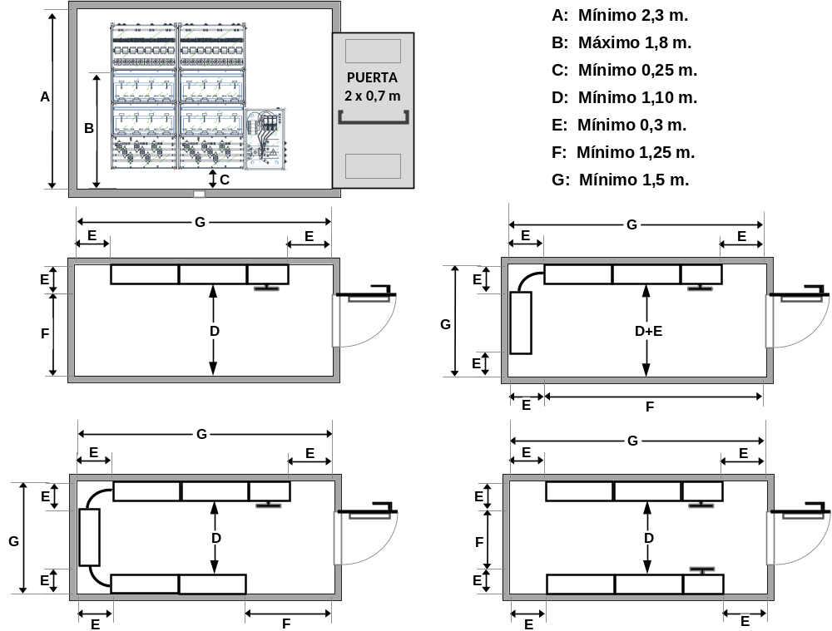
Figure 2. Example of arrangement of modules inside the meter room.

Meter cabinets
Electrical meter cabinets shall meet the following requirements.
- They shall be located on the ground floor, mezzanine or first basement, except where there are groupings by floor. The cabinet shall be installed in or attached to a wall in the common area of the building, as close as possible to the entrance of the building and to the trunking of the individual branch, located in an easily and freely accessible place, which is not exposed to vibrations or dampness. It shall also be separated from other premises presenting fire hazards or producing corrosive vapours.
- In the enclosure of a protected stairway, in the enclosure of a specially protected stairway or in a ventilated fire lobby, as well as in a minimum risk sector, an electricity meter cabinet may be installed, provided that it is separated from these areas with EI 120 elements and EI 60 access panels.
- They may not be used for other purposes such as the installation of water or gas meters, or telecommunications equipment not related to electricity distribution.
- From the most protruding part to the opposite wall there must be a corridor of at least 1.5 m.
- The door shall have the same dimensions as the wall making up the cabinet, and may have one or two panels, such that there is no threshold, frame or intermediate element that hinders access to any modular assembly inside it or to the installation and reading of meters and other devices.
- The doors shall be openable 180° onto the wall of the corridor or portal where the cabinet is installed and shall have an interlocking latch system once open.
- The closing doors shall be fitted with a lock standardised by the distribution company. On its exterior, it shall have an electrical hazard warning sign of size AE-10 and another plate indicating ‘ARMARIO DE CONTADORES ELECTRICOS’ (ELECTRICAL METER CABINET).
- Modular assemblies shall be surface-mounted to the wall at a height of at least 0.25 m above the floor level of the corridor, doorway or pavement where the meters are located, so that the equipment to be installed inside (meters, filters or control equipment) is located at a maximum height of 1.8 m.
- It shall have sufficient ventilation by means of intumescent grilles with a minimum free cross-section of 50 cm² on each door panel.
- The doorway, corridor, pavement or passageway where it is located shall have a minimum illumination of 250 lux, measured at the mounting height of the meters.
- The internal width of the back wall must be such that, once the modular assemblies have been installed inside, there is a free clearance of at least 0.15 m is maintained on both sides. The maximum width of the meter cabinet shall be 2.30 m, and its maximum height shall be 2.40 m, as shown in the figure below:
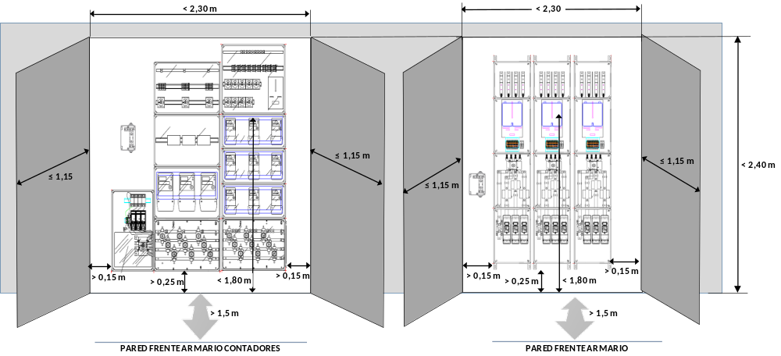
Figure 3. Example of arrangement of modular assemblies in meter cabinets.

TYPES AND CHARACTERISTICS OF METERS PANELS AND INDIRECT METERING MODULES
The owner of the building or the user shall be responsible for, where applicable, any damage to the seals attached or for any tampering with the installed elements under his/her custody in the meter room or cabinet in which the central metering unit or the indirect metering module is located.
The lids of the enclosures located upstream of the meter shall be fitted with sealable devices to prevent any manipulation of the elements inside.
The main characteristics to be met by the functional units to be installed inside the meter rooms or cabinets are indicated in the following sections.

Meters panels
Meters panels shall be designed to house the metering, control, monitoring and protection equipment of the individual branches that are fed from the meters panel itself.
The meters panels will allow for the installation of the metering elements and equipment necessary for the application of the tariff provisions in force and will allow the incorporation of PLC filters or management and communications systems, a PSM (Protection system of the MSL) for charging infrastructure, as well as a ZIS (zero-injection system) for collective self-consumption installations without surpluses as an alternative position when there is no space available for its placement in the MCPD switchboard.
Safety fuses, PLC filters, individual zero-injection systems and the switch-disconnector of the individual branch (ISD) shall be marked in such a way as to allow easy and correct identification of the supply to which they correspond.
In meters panels, the wiring connecting the busbar to the output terminals of the individual branch shall be routed under the mounting plate and may be in a pipe or duct.
Meters panels shall consist, electrically, of the following functional units.

Functional surge protection device
Its characteristics shall comply with the provisions of ITC BT-23 and it placement shall be subject to the provisions of ITC BT-12.

Functional main switch disconnector (MSD)
Its function is to take out of service, if necessary, the entire meters panel, ensuring safe sectioning.
This unit, which is to be installed in a separate enclosure, consists of a multipole switch-disconnector, which can be locked by means of a padlock or equivalent device. The pole corresponding to neutral shall not cut the current before the other poles and shall not supply any current after the other poles.
It shall be installed between the main supply line and the main busbar of the meters panel, and a switch shall be installed for each meters panel.
The rated voltage of the MSD shall be 160 A for forecast loads up to 100 kW, 250 A for forecast loads between 100 kW and 160 kW and 400 A between 160 kW and 250 kW.
Table 3. Minimum characteristics for the MSD according to its assigned intensity and for a nominal network voltage of 230 V / 400 V
Rated network voltage | 230 V / 400 V
Type of switch-disconnector | Three-phase
Rated voltage | 160 A, 250 A, 400 A
Rated operational voltage, U_{e} | 400 V
Rated insulation voltage | 500 V
Rated impulse withstand voltage | 6 kV peak
Open-pole leakage current at 1.1 U_{e} | ≤ 0.5 mA

Functional MSL current measuring device (optional).
Its function is to measure the current flowing through the MSL, so that it can be used either by a PSM (MSL protection system) or by a ZIS (zero-injection system) in the case of collective self-consumption installations without surpluses.

Functional main busbar and safety fuse unit.
It contains the general busbar of the panel and the security fuses corresponding to all supplies that are connected to it.
Each individual branch must have its own protection installed at its origin, consisting of safety fuses, regardless of the protections corresponding to the circuits of the installation of each supply. These fuses shall be installed upstream of the meter and shall be placed in each of the phase or pole wires leading to the meter. They shall have the appropriate breaking capacity according to the maximum short-circuit current that may occur at that point, and the safety fuse bases that house them may be sealed by the distribution company.
The fuses to be installed will depend on the expected power of each individual branch to be protected. This functional unit shall have additional insulating protection in front of the energised elements to prevent accidental contact with the general busbar when accessing safety fuses. Insulating protection combined with the use of closed fuse bases shall provide a minimum protection rating of IP 2X.

Functional measurement unit.
It contains the meters for the measurement of electrical energy, which may be single-phase or three-phase.
The indirect measurement modules shall also include the current transformers and a set of terminal blocks for meter verification. Current transformers shall not be toroidal and shall have an accuracy power such that the power of the load they supply is between 25 % and 100 % of the accuracy power.

Functional filtering and load management unit.
In this unit, PLC filters may be installed to prevent electrical disturbances emitted by certain supplies from introducing noise into the network in the PLC frequency range used for the remote control of meters. Load management equipment such as contactors associated with the operation of a PSM, dynamic charging power managers or secondary meters may also be installed in supplies if required by their owner.
For this purpose, a space of certain dimensions shall be reserved downstream of each meter, depending on whether it is a single-phase or three-phase supply, as shown in Figure 4. The dimensions in Figure 4 are indicative. The minimum dimensions required may be set out in the particular specifications of the distribution companies approved by the authority.
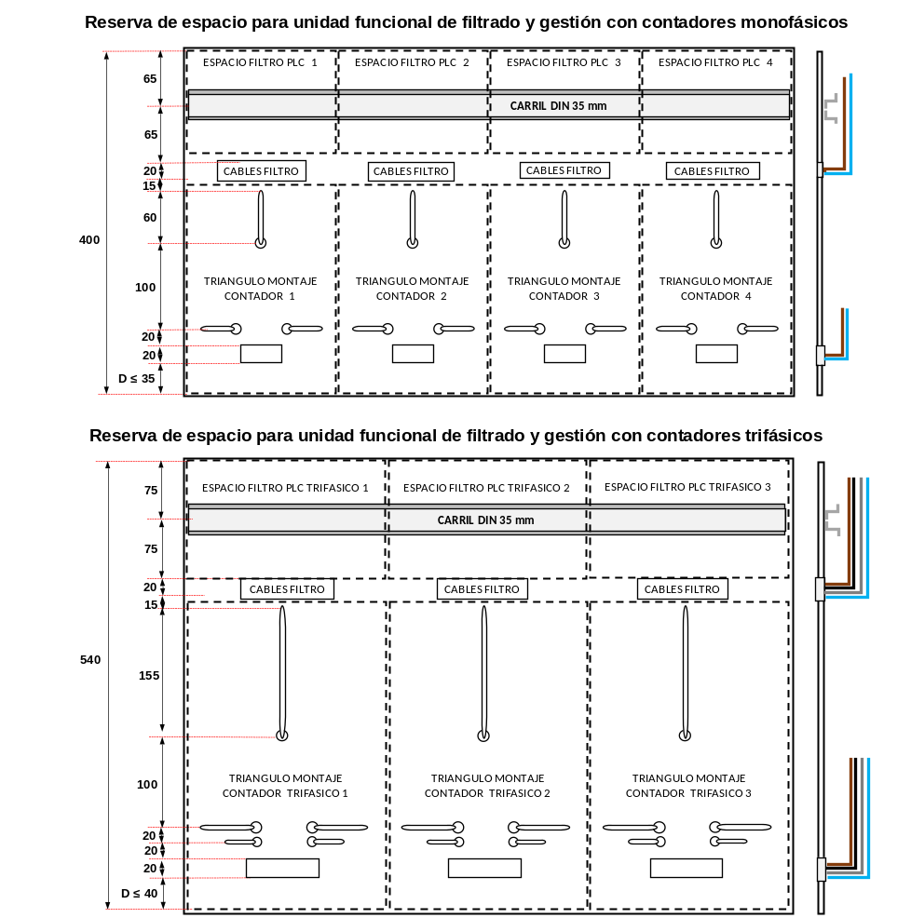
Figure 4. Space for mounting PLC filters and other management equipment (indicative dimensions, not mandatory).

Functional individual switch-disconnector (ISD).

It consists of a safety switch-disconnector whose function is to be able to manoeuvre the individual branches. It must be able to load-cut and reconnect individual branches, while ensuring their safe isolation. The ISD shall be a multipole cut-off switch and shall be lockable by means of a padlock or equivalent device. The pole corresponding to neutral shall not cut the current before the other poles and shall not supply any current after the other poles.
Table 4. Minimum ISD characteristics for a nominal network voltage of 230 V / 400 V

Rated network voltage | 230 V / 400 V
Type of switch-disconnector | Single-phase or three-phase depending on the type of supply
Rated voltage | 40 A, 50 A, 63 A, 80 A, 160 A, 250 A, 400 A
Rated operational voltage, U_{e} | 400 V
Rated insulation voltage | 500 V
Rated impulse withstand voltage | 6 kV peak
Open-pole leakage current at 1.1 U_{e} | ≤ 0.5 mA

Functional protective busbar and output terminal unit.

It contains the protective busbar to which the protective cables of each individual branch will be connected, as well as the output terminals of the individual branches. The functional unit may also contain control elements such as contactors or high-impedance devices for the management of the electric vehicle charging circuit according to diagram 2 of ITC BT-52 and may allow the meter power limiter to be reset from the dwelling.
The terminals must allow at least the connection of cables with the cross-sections indicated below.
- For phases and neutral: 16 mm² for single-phase individual branches and 35 mm² for three-phase individual branches.
- For the protective conductor: 16 mm².
- For the red control thread: 2.5 mm².

The protective busbar shall be marked with the standardised earthing symbol and shall be connected to the box for the earthing of the exposed conductive parts of low-voltage equipment, which shall be provided in the meter rooms or near the meter cabinets.
The figure below represents two examples of generic configurations that can be assumed by meters panels.
Figure 5. Generic configurations of meters panels
Key:
- MSD and surge protection
- MSD, surge protection and measurement of current in the MSL
- Modular measuring assemblies
- Modular metering assemblies for supplies with recharge system ‘2’
- Main switch disconnector (MSD)
- Installation of transformers for PSM or ZIS
- Space for mounting the PSM or ZIS
- PSM verification terminals, or ZIS
- Protection of the surge protection device
- Earthing of exposed conductive parts of low-voltage equipment
- Surge protection device (SPD)
- Functional main busbar and safety fuse unit
- Functional measurement unit
- Functional filtering and load management unit
- Functional individual switch-disconnectors, ISDs
- Functional protective busbar and output terminal unit
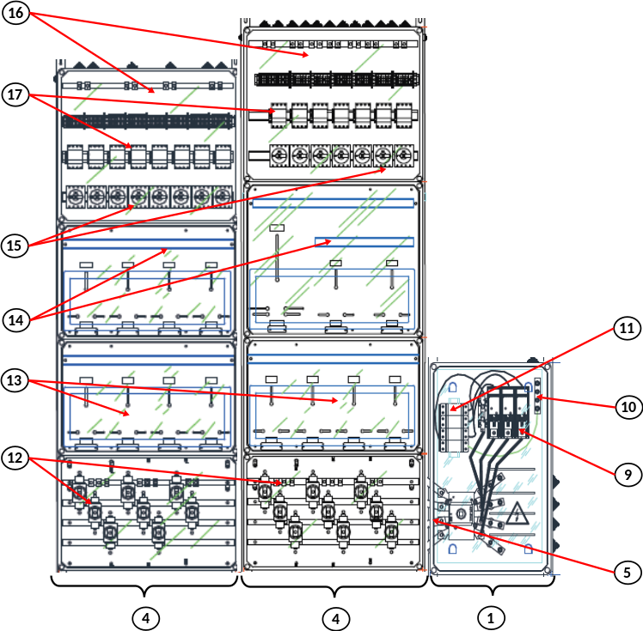
- Contactors for the management of charging circuits (system 2)

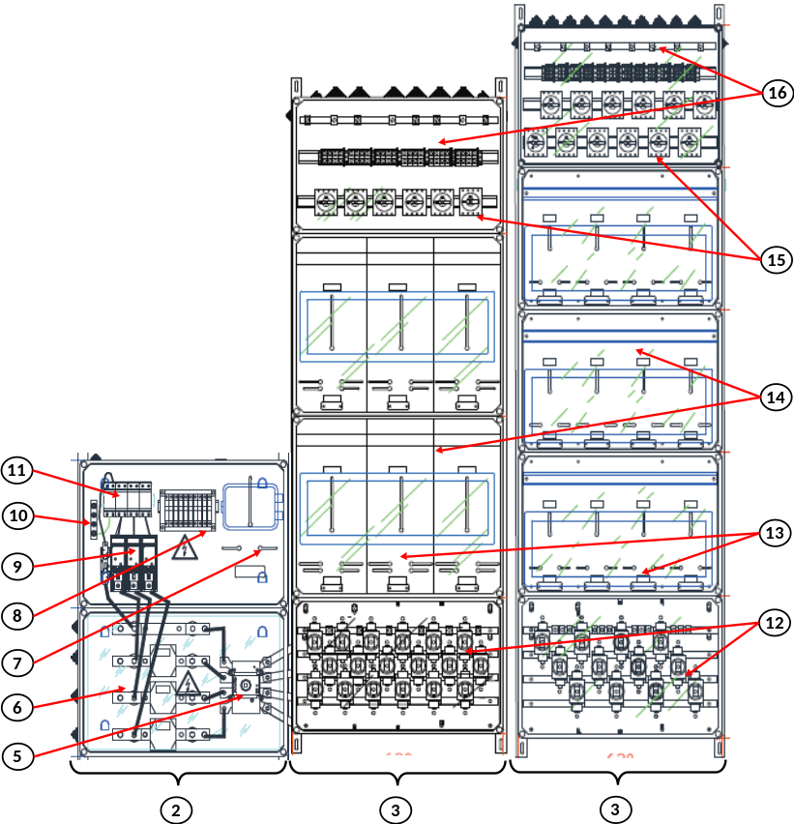

In the event that, in order to ensure the correct state of operation of this unit, maintenance actions are required, these operations will be carried out by an installation company, with particular attention paid to the correct tightening of the connections, the condition of the fuses and the possible hot points.

Indirect measuring modules
The indirect measuring modules shall be formed, electrically, by the following functional units.

Functional surge protection device.
Its characteristics shall comply with the provisions of ITC BT-23.

Functional safety fuse unit.
The fuses to be installed will depend on the foreseen power of the individual branch to be protected. The fuse bases shall be enclosed for the installation of NH blade type fuses.

Functional measurement unit.
This unit consists of the three-phase meter, the current transformers and a set of terminal blocks for verification of the meters. Current transformers shall not be toroidal and shall have an accuracy power such that the power of the load they supply is between 25 % and 100 % of the accuracy power.
This unit may incorporate communications equipment for remote metering together with its protection fuses and a 230 V socket for its power supply.

Functional individual switch-disconnector (ISD).
It consists of a safety switch-disconnector whose function is to be able to manoeuvre the individual branch. It must be able to load-cut and reconnect individual branches, while ensuring their safe isolation. It shall be a multipole cut-off switch and shall be lockable by means of a padlock or equivalent device. The characteristics of the ISD shall be those already indicated for the same functional unit of the meters panel.
The figure below represents an example of a generic configuration of an IMM.
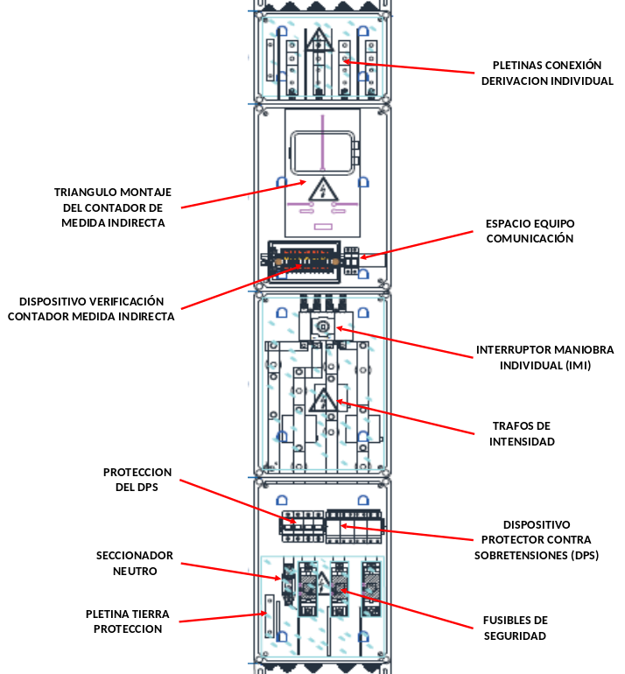
Figure 6. Generic configuration of an indirect measurement module, IMM.

SYSTEM SELECTION
The owner, with the advice of the distribution company, shall choose from the solutions proposed in this ITC the one that best suits the characteristics of the building, the installation and the requested supply. In the event of a disagreement between the building owner and the distribution company, it shall be resolved by the competent body of the authority.
The meters panels and indirect measuring modules to be used shall correspond to one of the types and diagrams set out in the specific technical specifications of the distribution company, which have been approved by the competent government authority.

MODIFICATION OF EXISTING INSTALLATIONS
In the case of existing installations in which a modification or extension is to be carried out, involving the construction of a new meter room or the installation of a new meter cabinet, in which it is impossible to comply with the requirements above, after agreement with the distribution company and authorisation from the competent authority, the dimensions of the meter room and clearances may be accepted up to the following minimums.
- The dimensions of the new meter room may be reduced to 1.8 m for height, 1.2 m for the total width occupied by the meters panel and 0.8 m of free space in front of the modular assemblies.
- In the case of meter cabinets, it is acceptable to reduce the free space in front of the cabinet to 1.2 metres.
When modifying or extending an existing installation for self-consumption purposes, the distribution company responsible for the reading can allow for the equipment for metering the net-generation required for self-consumption to be located in a place other than that provided for in this ITC, as long as the equipment meets the conditions and the special nature provided for in the unified Regulation on electrical power system measuring points, in the supplementary technical instructions implementing it or in the specific regulations applicable to self-consumption, and that meters in already existing rooms or cabinets remain in those rooms or cabinets.
When modifying an internal installation due to the installation of a new circuit for generation or for electric vehicle charging, the following exceptions to the general requirements in this ITC shall be taken into consideration.
  - Where there is no space in the meters panel to install a Type 1 surge protection device, the surge protector may be installed in the control and protection panel of the new internal generation or electric vehicle charging circuits, so that the new circuits are protected. In this case it will be possible to combine the Type 1 and Type 2 protectors in a single device.
  - If there is no space in the meters panel (MP) or in the indirect measuring module (IMM) to install the safety switch-disconnector for the individual branch (ISD), that switch-disconnector may be occupy the space for the output terminals of the individual branch.
  - The individual branch safety switch-disconnector (ISD) shall only be installed in the MP for the IBs whose internal installation has been modified.
When the modification of the internal installation is not due to a new generation or electric vehicle charging installation, the following exceptions to the general requirements in this ITC shall be taken into consideration.
  - It shall not be necessary to install surge protection devices if the original installation did not have such devices.
  - It shall not be necessary to incorporate a safety switch-disconnector for the individual branch (ISD) into the MP or the IMM.
Regardless of the cause for the modification of the internal installation, if there is no possibility of placing the meters in a specific room, due to the fact that the existing room is full and there are no other rooms available with sufficient dimensions, the meters shall be housed in cabinets in common areas that meet the requirements of this ITC.

REFERENCE STANDARDS
Products that comply with their corresponding product standard, as indicated below, and also have the characteristics specified in this ITC (e.g. IP grade, electrical characteristics or resistance to the propagation of flame), shall be presumed to comply with the requirements of this ITC.
- Modular assemblies for meters complying with Standard UNE-EN 61439-2.
- MSDs and IMMs that comply with standards UNE-EN IEC 60947-1 and UNE-EN IEC 60947-3.
- Terminal block assemblies for the verification of meters that comply with Standard UNE 201011.
- Fuse-links complying with Standards UNE-EN 60269-1 and UNE-HD 60269-2.
- Single-pole enclosed fuse bases (SPEFB) complying with Standard (series) UNE-EN 60269.
’

Twenty-seven. The Supplementary Technical Instruction ITC BT-17, ‘Supply connection installations. Main and individual control and protection devices. Power control switch’, is amended to read as follows:

‘ITC BT-17

CONSUMER INSTALLATIONS: MAIN AND INDIVIDUAL CONTROL AND PROTECTION DEVICES
- DEFINITIONS.
- LOCATION.
- COMPOSITION AND CHARACTERISTICS OF THE SWITCHBOARDS
- MAIN CHARACTERISTICS OF THE PROTECTION DEVICES
- MODIFICATION OR EXTENSION OF EXISTING INSTALLATIONS.
- REFERENCE STANDARDS.

DEFINITIONS
Main control and protection devices are the manoeuvring and protection elements of the installation to enable the connection and disconnection of the entire internal installation and its protection against overcurrents, overvoltages and indirect contacts.
Individual control and protection devices are the individual manoeuvring and protection elements of the internal circuits of the installation to enable the connection and disconnection of each individual circuit and its protection against overcurrents, and possibly also against overvoltages and indirect contacts.

LOCATION
The main control and protection devices shall be installed within the Main Control and Protection Switchboard (MCPS), which shall be located as close as possible to the input point of the individual branch in the premises or dwelling of the user. In dwellings, they shall be located next to the entrance door and may not be placed in bedrooms, bathrooms, toilets, etc. In premises used for industrial or commercial activities, they shall be located as close as possible to an entrance door to the premises. The Main Control and Protection Switchboard corresponding to the main services of the building or estate will be located in the common areas of the building.
The individual control and protection devices of each of the internal circuits may be installed in the same box as the main control and protection devices, or on other separate switchboards which may be located elsewhere.
In premises for common or public use, the necessary precautions shall be taken so that the control and protection devices are not accessible to the general public.
The height at which the main and individual circuit control and protection devices, measured from ground level, shall be placed shall be between 1.4 and 2 m, for dwellings.

COMPOSITION AND CHARACTERISTICS OF THE SWITCHBOARDS
The main and individual control and protection devices shall be located inside the switchboards in a vertical service position, although in industrial installations it is possible that the control and protection devices (according to the UNE-EN IEC 60947 series) are arranged in a horizontal position, provided that this mounting position is provided for in the assembly instructions of the manufacturer of the device, applying, where appropriate, the intensity reducing coefficients indicated in those instructions.
Enclosures shall have a minimum protection rating of IP 30 according to Standard UNE-EN 60529, and IK07 according to Standard UNE-EN 50102.
The switchboards shall have a door on which an identifying plate or label shall be placed, which shall include the following information:
  - name of the installer and the authorised installation company
  - registration number of the certificate of the electrical installation
  - rated voltage of the main automatic circuit-breaker (IGA).

The IGA shall be placed to the left and at the top of the switchboard, and to its right and below it, the rest of the devices, as shown in Figure 1.
Figure 1: Characteristics of the main control and protection switchboard and placement of the IGA.

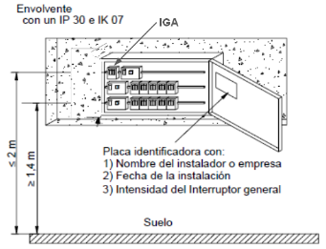
Behind the door, the switchboards shall be fitted with a plate or cover, fixed to the switchboard structure itself, preventing direct access to the wiring and connection terminals of the various devices, allowing access only to the protection devices for manual operation. All the elements necessary for the individual identification of each of the main control and protection devices and of each of the internal circuits of the installation shall be provided on the plate or cover.
Identification plate or label with all the required information

For switchboards installed in dwellings or similar installations in which the protective devices may be operated by non-qualified personnel, the minimum degree of protection of the switchboard with the door open shall be IP 30 according to Standard UNE-EN 60529, while in other cases, such as switchboards installed in technical premises or in switchboards for industrial installations intended to be manoeuvred only by qualified and authorised personnel, the minimum degree of protection shall be that indicated in ITC BT-24 for protection against direct contact by means of enclosures.
Main and individual control and protection devices shall be at least:
  - a main automatic circuit-breaker (IGA) with multipole cut-off that allows its manual actuation and that is equipped with protection elements against overload and short circuits;
  - protective devices against transitory and temporary surges, the characteristics of which comply with the provisions of ITC BT-23;
  - a main residual current device, intended for the protection of all circuits against indirect contacts; unless protection against indirect contacts is provided by other devices in accordance with ITC BT-24;
  - multipole cut-off devices, intended for the protection of each of the internal circuits of the installation against overloads and short-circuits.
If, due to the type or nature of the installation, a residual current device is installed for each circuit or group of circuits, the main residual current device may be omitted, as long as all circuits are protected. Residual current devices for household uses and similar purposes, both the main one and those intended to protect one or more branch circuits, shall be at least of type A, and may also be of type F or B if so specified in the relevant ITC for the circuit to be protected. In the event that more than one residual current device is installed in a series, selectivity between them shall be sought, for which the following conditions must be met.

  - The non-operating time of the device installed upstream must be greater than the total operating time of the device located downstream. S-type devices or devices with adjustable time delay shall meet this condition.
  - The differential-residual intensity of the device installed upstream shall be higher than that of the device located downstream, with a value that avoids overlap between tripping zones.
  - In order to ensure that the contact voltage is not dangerous, full selectivity between the devices may not be possible in large installations with three or more devices in series.
The following devices can also be optionally installed in the Main Control and Protection Switchboard:

  - a separate mode-selector switch in individual self-consumption units that choose to be able to operate in separate mode from the distribution network, which have an auxiliary contact to make the interconnection between the neutral of the internal installation and the earthing of exposed-conductive-parts of low-voltage equipment when operating in separate mode;
  - a switch for remote control of the charging circuit in supplies with charging system ‘2’ according to ITC BT-52 using the control cable of the individual branch;
  - measurement equipment for the zero-injection system (ZIS) in those individual self-consumptions in the ‘No Surpluses’ mode, in which the generation installation is connected to the internal installation;
  - load control or home automation devices to optimise load control according to the electricity tariff to be applied;
  - control and protection devices for low-voltage generating installations as set out in ITC BT-40.
The IGA shall be the first device in the Main Control and Protection Switchboard to which the phases and the neutral of the individual branch are connected. Protective devices against surges may be located upstream or downstream of the residual current device. If installed downstream, in order not to cause accidental tripping of the residual current device, the device shall be of type S or time delayed. Where a separate mode switch or a switch for manoeuvring the charging circuit has to be installed, they shall be located upstream of the residual current device so as not to cause untimely tripping of the device. All other devices shall be installed downstream of the residual current device, and in the specific case of the measuring equipment of the zero-injection system (ZIS), immediately downstream of the residual current device before any other individual protection device.
Several possible configurations of the Main Control and Protection Switchboard are represented as examples in the following figures.
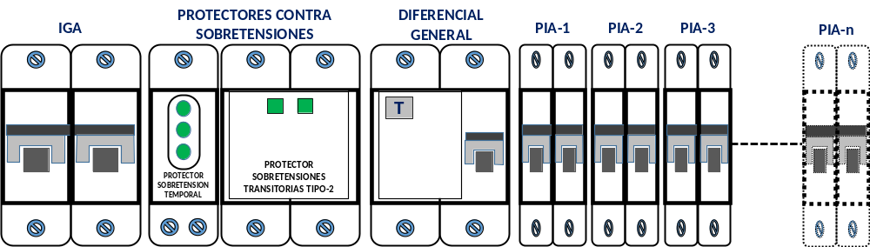
Figure 2: Example of MCPS configuration.

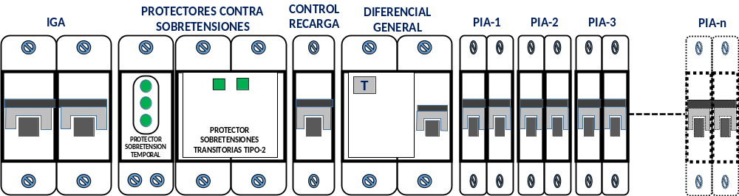
Figure 3: Example of MCPS configuration of a supply with charge system ‘2’.

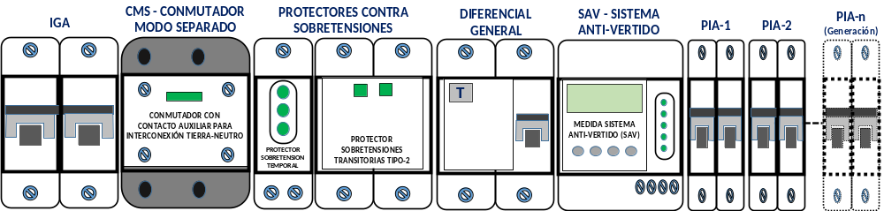
Figure 4: Example of MCPS configuration of a supply with storage or generation systems without surpluses.

The cables connecting the main control and protection devices to the individual control and protection devices shall have the same reaction to fire characteristics as the individual branch cables.
The Main Control and Protection Switchboard shall have a terminal or similar element to connect the protection cable of the individual branch to the protection cables of the internal circuits. That terminal or element shall be located behind the insulating plate or cover, so that its connections are not directly accessible.

MAIN CHARACTERISTICS OF THE PROTECTION DEVICES
The main automatic circuit-breaker (IGA) with multipole cut-off shall have sufficient cutting power for the short-circuit intensity that may occur at the point of its installation, of at least 4 500 A.
The value of the assigned intensity of the IGA determines the installed power of a supply which is the expected power to be used for the calculation of the load forecast for buildings or properties with multiple supplies. The installed power of a supply with direct measurement is calculated in Table 1 according to whether the supply is single-phase or three-phase, and according to the rated voltage of the IGA.
Table 1. Calculation of the installed power of the supply depending on the rated voltage of the IGA.
Rated IGA voltage, (A) | Installed power for a single-phase supply, P (kW) | Installed power for a three-phase supply, P (kW)
16 A | 3.68 kW | 11.08 kW
20 A | 4.60 kW | 13.86 kW
25 A | 5.75 kW | 17.32 kW
32 A | 7.36 kW | 22.17 kW
40 A | 9.20 kW | 27.71 kW
50 A | 11.50 kW | 34.64 kW
63 A | 14.49 kW | 43.65 kW
80 A | -- | 55.42 kW

All other devices on switchboards in the internal installation, such as automatic circuit-breakers, residual current devices, remote management of the charging circuit or of generation protection, overvoltage protectors, switches or meters, shall withstand the short-circuit currents that may occur at the point of installation.
Surge and short-circuit protection devices in internal circuits shall be multipole cut-off devices with protected poles corresponding to the number of phases of the circuit they protect. Their breaking characteristics shall be in accordance with the permissible currents of the conductors of the circuit they protect.

MODIFICATION OR EXTENSION OF EXISTING INSTALLATIONS
When carrying out important modifications or expansions of an internal installation, or due to the installation of a new circuit for generation or for electric vehicle charging, the following exceptions to the general requirements in this ITC shall be taken into consideration:
Type 2 and temporary power-frequency overvoltage protective devices (POP) shall be installed in the main control and protection switchboard so that the new circuits are protected. In this case it will be possible to combine the Type 1 and Type 2 protectors in a single device.
When modifications or extensions are made to the internal installation, due to the installation of a new circuit for other uses than generation or charging of electric vehicles, the installation of surge protectors will not be necessary if they did not exist in the original installation. However, when the modifications or extensions are significant, the installation of the surge protectors will be necessary, while it is also possible to combine the Type 1 and Type 2 protectors in a single device.

REFERENCE STANDARDS
The products set out below shall be presumed to comply with the requirements of this ITC:
  - empty boxes complying with Standard UNE-EN 60670-1
  - low-voltage switchgear assemblies complying with Standard UNE-EN 61439-3
  - main residual current devices complying with Standard UNE-EN 61008-1 and UNE-EN 61008-2-1; UNE-EN 61009-1 and UNE-EN 61009-2-1; UNE-EN 60947-2; or UNE-EN 62423, as applicable.
’

Twenty-eight. The titles of the following Supplementary Technical Instructions are amended.
- The title of ITC BT-19 is worded as follows: ‘Internal installations. General provisions’.
- The title of ITC BT-20 is worded as follows: ‘Internal installations. Installation systems’.
- The title of ITC BT-21 is worded as follows: ‘Internal installations. Protective pipes and channels’.
- The title of ITC BT-22 is worded as follows: ‘Internal installations. Overvoltage protection’.

Twenty-nine. The title of the Supplementary Technical Instruction ITC BT-23, ‘Internal or receiving installations. Overvoltage protection’, is amended to read as follows:

‘ITC BT-23

INTERNAL INSTALLATIONS. OVERVOLTAGE PROTECTION
- PURPOSE AND SCOPE
- DEFINITIONS
  - Definitions relating to protection against transient surges
    - Transient surge protection device (SPD)
    - Mode of protection of an SPD
    - Voltage protection level, U_{p}
    - Maximum continuous operating voltage, U_{c}
    - Nominal discharge current, I_{n}
    - Impulse current, I_{imp}
    - Rated impulse voltage, U_{w}
    - SPD disconnection device
    - Status indicator
    - Assigned value of short-circuit current, I_{sccr}
  - Definitions relating to protection against temporal surges
    - Power-frequency overvoltage protective device, POP
    - Tripping unit
    - POP unit
    - Operating voltage, U_{a}
- TRANSIENT SURGE PROTECTION
  - Types of transient surges
  - Surge categories
  - Types of transient surge protection devices (SPD)
  - Type selection and SPD installation
    - SPD selection
      - Selecting the voltage protection level (Up) based on the assigned impulse voltage (UW) of the equipment
      - Selection of the SPDs according to the continuous operating voltage (U_{c})
      - Selection of SPDs based on discharging pulse current (I_{imp}) for type 1 SPDs and rated discharge current (I_{n}) for type 2 SPDs
      - Selection of SPD based on the assigned value of the short-circuit current I_{sccr}
    - Coordination between transient surge protection devices
    - Connection of conductors to the SPDs
    - SPD disconnection devices
    - Protection of the SPD against surges
- TEMPORARY SURGES
  - Causes
  - Selection and installation

PURPOSE AND SCOPE
This Instruction deals with the protection of internal electrical installations of alternating current against overvoltages.
  - Transient, which are transmitted by distribution networks or are induced by lightning strikes and originate, mainly, as a result of atmospheric discharges and manoeuvres or actions due to defects in the networks.
  - Temporary, also called permanent or of industrial frequency, for example, due to the breakage or disconnection of the neutral.
This Instruction does not contemplate the characteristics of the external lightning protection system of buildings that are included in the Technical Building Code (Safety against hazards caused by lightning). However, the systems for protecting installations against transient surges, which are the subject of this Instruction, reduce the electrical and magnetic effects of the current of atmospheric discharges.
This Instruction contains general requirements for surge protection, applicable to all types of internal installations connected to the distribution network. However, there may be specific requirements in other Instructions which, in case of conflict, shall prevail over the corresponding general requirements.

DEFINITIONS

Definitions relating to protection against transient surges

Transient surge protection device (SPD)
A device containing at least one non-linear component intended to limit transient overvoltages and divert discharge currents.
Note: An SPD is a complete assembly with the appropriate means of connection and possibly the protection means associated with the SPD itself.

Type 1 SPD
SPD that is placed at the origin of the low-voltage electrical installation, capable of absorbing, during its operation, more energy than type 2 devices, but with lower limiting residual voltage than a type 2. It is characterised by the impulse current supported.

Type 2 SPD
SPD that is placed in the internal low-voltage installation, capable of absorbing, during its operation, less energy than type 1 devices, but with higher limiting residual voltage than a type 1. It is characterised by the nominal discharge current.

Type 3 SPD
SPD that is placed close to sensitive loads, with little energy absorption capacity during its operation and that is installed as a complement to a type 2 device. It is characterised by a combination of voltage waves (1.2/50 μs) and current waves (8/20 μs).

Short-circuit type SPD
Type 2 SPD that changes its characteristic due to an intentional internal short-circuit due to an impulse current higher than its nominal discharge current, I_{n}.

Mode of protection of an SPD
Mode of discharge of the current, expected between the terminals containing the protective components, e.g. between phases, phase to earth, phase to neutral, neutral to earth.

Voltage protection level, U_{p}
Maximum transient voltage that is expected at the SPD terminals due to a voltage impulse limitation with a defined voltage gradient and a voltage impulse limitation with a discharge current with a given waveform and amplitude.

Maximum continuous operating voltage, U_{c}
Maximum value of the voltage that can be continuously applied to the SPD.

Nominal discharge current, I_{n}
Peak value of the current through the SPD, with a waveform of 8/20 μs, which characterises Type 2 SPDs.

Impulse current, I_{imp}
Peak value of the discharge current that the SPD can withstand without failure. Usually, the waveform of the applied current normalised as 10/350 μs is used. This parameter characterises Type 1 SPDs.

Transition impulse current for short-circuit type SPDs, I_{trans}
Impulse current waveform value of 8/20 μs, greater than the nominal discharge current, I_{n}, which will cause a short-circuit type SPD to be short-circuited.

Rated impulse voltage, U_{w}
Impulse withstand voltage value assigned by the manufacturer to the equipment or a part thereof, which characterises the specified ability of its insulation to withstand transient surges.

SPD disconnection device
Device for the disconnection of an SPD, or part of an SPD, from the supply system in the event of an SPD failure.
Note: This disconnection device is not required to have sectioning capability for safety purposes. The function of the device is to prevent a continuing failure in the system and is used to give an indication of SPD failure. The disconnection devices may be internal (incorporated), or external (required by the manufacturer) or both. There may be more than one disconnection function, e.g. an overcurrent protection function and a thermal protection function. These functions may be in separate units.

Status indicator
Device indicating the operation status of an SPD, or part of an SPD.
Note: These indicators may be local, with visual and/or audible alarms, and/or may have remote signalling and/or output contact.

Assigned value of short-circuit current, I_{sccr}
Maximum assigned value of the expected short-circuit current of the power supply system for which, in conjunction with the disconnection device, the SPD is specified.

Definitions relating to protection against temporal surges

Power-Frequency Overvoltage Protective Device, POP
Device to mitigate the effects of overvoltages at industrial frequency between phase and neutral conductor (e.g. caused by loss of neutral conductor in the three-phase supply upstream of the POP) on equipment downstream of the point where it is installed.
Note: The POPs (power-frequency overvoltage protection) controlling a line can also be used to mitigate the effects of surges at industrial frequency between two phase conductors in a phase-to-phase power supply system.

Tripping unit
Device mechanically connected to the main protective device, which releases the means of attachment and enables the automatic opening of the protected circuits.
Note: The tripping unit can be incorporated into a device with which the POP unit is intended to be integrated, or to be coupled mechanically, or electrically, and which trips under specified conditions.

POP unit
Part of the POP that ensures the function of detecting overvoltages at industrial frequency and initiates the action of the device causing the cutting of the current.

Operating voltage, U_{a}
Voltage values, measured between phase and neutral conductors, at which the POP device must act on the tripping unit.

TRANSIENT SURGE PROTECTION
All internal installations must be protected against transient overvoltages in accordance with the criteria set out in this section.

Types of transient surges
Different types of transient overvoltages must be distinguished according to their origin. The most frequent causes of transient overvoltages are the following.
  - Of atmospheric origin:
  - Lightning strike on or near the distribution line
  - The impact of a lightning strike on the external lightning protection system (lightning rods, Franklin type lightning rods, Faraday cages, etc.), located in the building itself or in its vicinity.
  - The direct impact of an atmospheric discharge in the building itself, which is more likely the higher the building is compared to the buildings surrounding it or in proximity to it.
For these purposes, a distance of approximately 50 m is considered to be in proximity.
  - Owing to manoeuvres or actions due to defects in the network:
  - Operation of overcurrent protection devices (connection/disconnection) and switches (inside and/or outside the installation).
  - Third-party actions.
  - Connection or disconnection of capacitor banks for power factor correction.
  - Connection or disconnection of receivers in the installation.

Surge categories
Protective devices against transient overvoltage must be selected in such a way that their protection level is lower than the impulse withstand voltage corresponding to the overvoltage category of the equipment and materials expected to be installed.
The reduction of the input overvoltages to values lower than those indicated in each category is achieved with a cascade protection strategy, which can integrate up to three protection levels – sufficient, medium and fine – thus achieving a non-hazardous residual voltage level for the equipment and an energy derivation capacity that extends the life and effectiveness of the protective devices.
By appropriate selection of the category and type of the SPDs applicable in each part of the installation, coordination of the required insulation in the whole installation can be achieved, reducing the risk of failure to an acceptable level and providing a basis for surge control.
Four different overvoltage categories are distinguished, indicating in each case the assigned impulse voltage between active conductors and earth required of the equipment (Uw), in kV, according to the nominal voltage of the network that powers the installation.
The values of the impulse voltages assigned to the equipment (Uw) for the different overvoltage categories are applicable to installations connected to 230/400 V nominal voltage distribution networks. For other voltages in special distribution networks, the values in Table 443.2 of Standard UNE-HD 60364-4-443 shall be applied.

Category I
Applies to equipment which is very sensitive to overvoltage and which is intended to be connected to the fixed electrical installation. In this case, protective measures are taken outside the equipment to be protected, either in the fixed installation or between the fixed installation and the equipment, in order to limit the surges to a specific level. Examples of equipment in this category are laboratory equipment, large fixed-installation computers and other particularly sensitive electronic equipment, all designed to work in protected environments.
The impulse voltage assigned to surge category I (Uw) equipment in installations connected in low-voltage distribution networks is 1.5 kV.

Category II
Applies to equipment intended to be connected to a fixed electrical installation.
Examples of equipment in this category are household appliances, portable tools and other similar equipment.
The impulse voltage assigned to surge category II (Uw) equipment in installations connected in low-voltage distribution networks is 2.5 kV.

Category III
Applies to equipment and materials that are part of the fixed electrical installation and to other equipment for which a high level of reliability is required.
Examples of equipment in this category are distribution cabinets, busbars, switchgear (switches, disconnectors, sockets, etc.), trunking and its accessories (cables, branching boxes, etc.), motors with fixed electrical connection (lifts, industrial machines, etc.), etc.
The impulse voltage assigned to surge category III (Uw) equipment in installations connected in low-voltage distribution networks is 4 kV.

Category IV
Applies to equipment and materials that are connected at the source or very close to the source of the installation, upstream of the distribution switchboard.
Examples of equipment in this category are energy meters, remote metering appliances, main surge protection equipment, among others.
The impulse voltage assigned to surge category IV (Uw) equipment in installations connected in low-voltage distribution networks is 6 kV.

Types of transient surge protection devices (SPD)
There are three types of transient surge protectors: Type 1, Type 2 and Type 3.
It is possible to combine two types of protection devices into a single device provided that they comply with the requirements and tests laid down in the standard for both types.
For alternating current installations, devices according to Standard UNE-EN 61643-11 shall be deemed to comply with the requirements of this Instruction.
For photovoltaic installations, devices in accordance with Standard UNE-EN 61643-31 are considered to comply with the requirements of this Instruction and ITC BT-53.

SPD type selection and installation.
The operation of the SPD shall reduce the transient overvoltage to a voltage value not higher than the rated impulse voltage required for Uw equipment (according to its overvoltage category). In order to achieve this objective, it may be necessary to use more than one protective device.
A Type 2 SPD shall be installed as close as possible to the source of the internal installation, in the main control and protection switchboard.
In addition, a Type 1 SPD must be installed as close as possible to the origin of the installation, next to the meter and upstream of it, its location shall comply with the provisions of the ITC BT-12.
In direct-measurement PMBs, the Type 1 surge protector may use the fuses of the PMB itself for its protection, while in indirect-measurement PMBs, as well as in IMMs and meters panels, they shall have their own protection. In all cases, all PMBs, IMMs and meters panels shall have a disconnectable earthing plate for overvoltage discharge and connection to the protective earth of the property.
Depending on the lengths and paths of the circuits protected by an SPD, it may be necessary to design the installation with an additional SPD connected in the vicinity of a device to be protected. In this case, the corresponding SPDs shall be coordinated with each other in accordance with Section 3.4.2.
Transient surge protection can be provided:
  - between active conductors and protective conductors (common mode protection);
  - between active conductors (differential mode protection).
The SPDs must be chosen so that they are suitable for the neutral earthing system of the installation (TT, TN-S, TN-C or IT) and the connection shall be made according to the manufacturer’s instructions.
Where protection is afforded to the installation by main residual current devices, Type 2 SPDs shall be suitable for connecting upstream of such main residual current devices, shall be positioned downstream of the IGA, and shall be provided with an automatic disconnection device and a protection status indicator, which shall be visible from the outside.
When additional SPDs are installed downstream of the main residual current devices (e.g. Type 3 to protect particularly sensitive equipment), these devices shall be of Type S or time-delayed. These SPDs shall be coordinated with the SPDs installed upstream in accordance with Section 3.4.2.

SPD selection.
The selection of SPDs shall be based on the following parameters:
  - voltage protection level (U_{p}) and the assigned impulse voltage (U_{W}) of the equipment to be protected;
  - continuous operating voltage (U_{c});
  - nominal discharge current (In) and the discharge impulse current (I_{imp});
  - SPD coordination (see 3.4.2);
  - assigned value of short-circuit current I_{sccr}.

Selecting the voltage protection level (Up) based on the assigned impulse voltage (UW) of the equipment
The Up voltage protection level of the SPDs must be chosen according to the rated impulse voltage (UW) in accordance with the applicable surge category. In order to provide adequate protection of the equipment, the level of protection in voltage between the active conductors and the conductor or protective terminal (CP) shall under no circumstances exceed the assigned impulse voltage of the equipment in accordance with Section 3.2.
The appropriate level of voltage protection must be assessed on the basis of the immunity and availability requirements of the equipment. Several SPDs between active conductors may be necessary to achieve the required level of protection.
When the required level of voltage protection cannot be achieved with a single SPD assembly, coordinated cascade SPDs must be installed to ensure the required level of voltage protection.

Selection of the SPDs according to the continuous operating voltage (U_{c})
In alternating current, the maximum continuous operating voltage U_{c} of the SPDs shall be equal to or greater than that required in Table 1.
Table 1. U_{c} of the SPD depending on the power supply system configuration
SPD connected between (as applicable) | Distribution network system configuration
SPD connected between (as applicable) | TN system | TT system | IT system
Phase conductor and neutral conductor | 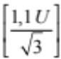
Phase conductor and CP conductor |  |  | [1.1 U]
Phase conductor and CPN conductor |  | Not applicable | Not applicable
Neutral conductor and CP conductor | 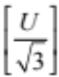
Phase conductor | [1.1 U] | [1.1 U] | [1.1 U]
Note: U is 400 V for distribution networks. For networks of other voltages, U is the phase-phase voltage of the low-voltage system.

Selection of SPDs based on discharge impulse current (I_{imp}) for Type 1 SPD and rated discharge current (I_{n}) for Type 2 SPD
The discharge impulse current (I_{imp}) of Type 1 SPDs shall not be lower than that provided in the following tables, as applicable.
  - Where the structure of the building or craft is equipped with an external lightning protection system (lightning rod) or when the installation is located within a radius of approximately 50 m around an external lightning protection system, the discharge impulse current (I_{imp}) of Type 1 SPDs should not be less than the one provided in Table 2.
Table 2. Selection of the discharge impulse current (I_{imp}) in kA of the Type 1 SPDs when the building is protected against direct lightning strike
Connection  (as applicable) | Iimp in kA
Connection  (as applicable) | Power supply system
Connection  (as applicable) | Single-phase | Three-phase
L − N  L − CP  N – CP | 12.5  12.5  12.5* | 12.5  12.5  12.5*
* In the case of a neutral TT network, the I_{imp} value of N-CP must not be less than 25 kA for a single-phase power supply system and 50 kA for a three-phase power supply system

  - For all other cases, the discharge impulse current (I_{imp}) of Type 1 SPDs shall not be lower than that provided in table 3.
Table 3. Selection of the discharge impulse current (I_{imp}) in kA of the Type 1 SPDs when the building is not protected against direct lightning strike
Connection  (as applicable) | I_{imp} in kA
Connection  (as applicable) | Power supply system
Connection  (as applicable) | Single-phase | Three-phase
L − N  L − CP  N – CP | 5  5  5* | 5  5  5*
* In the case of a neutral TT network, the Iimp value of N-CP must not be less than 10 kA for a single-phase power supply system and 20 kA for a three-phase power supply system

The nominal discharge current (I_{n}) of Type 2 SPDs connected at the source of the installation or in its proximity must not be less than that given in Table 4.
Table 4. Nominal discharge current (I_{n}) of type 2 SPD depending on the supply system and the type of connection
Connection  (as applicable) | In in kA
Connection  (as applicable) | Power supply system
Connection  (as applicable) | Single-phase | Three-phase
L − N  L − CP  N – CP | 5  5  5* | 5  5  5*
* In the case of a neutral TT network, the In value of N-CP must not be less than 10 kA for a single-phase power supply system and 20 kA for a three-phase power supply system

Where the installed SPD is of short-circuit type, I_{n} may have lower values than those shown in Table 4, provided that the value of I_{trans} declared in the SPD is higher than the value of I_{n} for the same connection (L-CP or N-CP.).
Additional SPDs installed downstream of the SPD installed at the source of the installation or in its vicinity must also comply with the coordination requirements of Section 3.4.2.

Selection of SPD based on the assigned value of the short-circuit current I_{sccr}
In general, the assigned value of the short-circuit current I_{sccr} of the SPS, as declared by the manufacturer, shall not be less than the maximum short-circuit current expected at the connection points of the SPS assembly. This requirement does not apply to SPDs connected between the neutral conductor and CP.

Coordination between transient surge protection devices
If several cascading SPDs are installed (e.g. one general or main and others in certain output circuits), their coordination must be ensured from the values assigned to the SPDs, taking into account the manufacturer's instructions to achieve adequate coordination.
Where so established, in order to ensure coordination between the cascade installed protection devices, the installation of decoupling inductors may be necessary, if the length of the cable connecting them is less than the minimum specified by the manufacturer. For this reason, and in order to verify that there is coordination between the devices located in main switchboards and secondary switchboards, the distance of the cable between them must be checked.

Connection of conductors to the SPDs.
The minimum cross-section of the conductors connected to the SPDs shall be in accordance with those indicated in Table 5.

Table 5. Cross-section of conductors connected to SPDs
Type of device | Conductor minimum cross-section (mm²)  (Copper) | Connection between the device and
Type 1 | 16 | the main earthing terminal or earthing point of the building
Type 1 | 6 | the surge protection device
Type 2 | 6 | the earth input terminal of the internal installation
Type 2 | 2.5 | the surge protection device
Type 3 | 2.5 or as specified by the manufacturer | a terminal of the protective conductor of the internal installation

The connection of the overvoltage protector shall be made by means of insulated wires with the colour coding in ITC BT-19.
The length of the connecting conductors, defined as the sum of the length of the path used by the conductors from the active conductor to the input of the SPD to the CP, must be as short as possible (preferably less than 0.5 metres).

SPD disconnection devices
The SPD must have disconnection devices (which may be internal/external or both, see 2.1.8), except for SPDs for N-CP connection only in TN and/or TT systems. Its operation must be indicated by the corresponding status indicator (see 2.1.9)

Protection of the SPD against surges
The SPDs must be protected against overcurrents with respect to short-circuit currents. This protection may be internal and/or external to the SPD and must be carried out in accordance with the manufacturer’s instructions.

TEMPORARY SURGES
All internal installations must be protected against temporary overvoltages in accordance with the criteria set out in this section.

Causes
Normally, temporary overvoltages, also known as industrial frequency overvoltages, are caused by events that are difficult to prevent, such as those due to breakage or disconnection of the neutral, or failures at different points of the electricity network.
Power-frequency overvoltage protective devices (POP) are intended to mitigate the effects due to industrial frequency overvoltages in equipment installed downstream of it.

Selection and installation
Power-frequency overvoltage protection devices (POP) are intended to mitigate the effects of over-voltages at network frequency between phase and neutral in equipment installed downstream of the system, by opening the protected circuit when an overvoltage between phase and neutral is detected. Like other protective devices, these devices cause the cut-off of the supply due to the disconnection of an protective or manoeuvring element. This fact must be taken into account in those facilities that require special continuity of service.
In particular, installations in residential or similar environments and any other internal installation with a distributed neutral must be adequately protected against the effects of temporary overvoltages. To this end, power-frequency overvoltage protection devices must be installed in the internal installations. The installation of these devices shall not interfere with the proper functioning of the other devices.
For residential and similar environments, devices that comply with or meet the standard UNE-EN IEC 63052 meet the requirements of this ITC, since all necessary safety requirements are taken into account, such as tripping times and voltages, short-circuit capacities, sectioning, etc.
Power-frequency overvoltage protection devices are normally installed in the main control and protection switchboard, downstream of the IGA and always upstream of any of the individual control and protection devices. The selection and installation of these devices must be carried out in accordance with the instructions of the POP manufacturer.’

Thirty. The title of the Supplementary Technical Instruction ITC BT-24, ‘Interior or receiving facilities. Protection against direct and indirect contact’ is amended to read as follows: ITC BT-24, ‘Consumer installations. Protection against direct and indirect contact’.

Thirty-one. Supplementary Technical Instruction ITC BT-40 is amended to read as follows:

‘ITC BT-40

LOW-VOLTAGE GENERATION INSTALLATIONS
- PURPOSE AND SCOPE
- CLASSIFICATION
- GENERAL CONDITIONS
  - Design of the generation installations
- CONNECTION CONDITIONS
  - Isolated generation installations
  - Assisted generation installations
  - Interconnected generation installations
    - Maximum powers of interconnected generation installations that feed into the network
    - Specific conditions for coupling to the distribution network
    - Switching and protection equipment to be available at the connection or interconnection point
    - Reactive energy control
- CONNECTION CABLES
- WAVEFORM
- PROTECTION
  - Installation protection
  - Functional protection of the generation installation
  - Non-conventional generator protection
- EARTHING INSTALLATIONS
  - Overview
  - Earthing characteristics according to the operation of the generation installation with respect to the low-voltage distribution network
    - Generation installations in isolated operating mode
    - Generation installations in assisted operation mode
    - Generation installations in interconnected operation mode
  - Wind generators
- COMMISSIONING
- SYSTEMS TO PREVENT ENERGY BEING FED INTO THE NETWORK
  - Overview
  - Configurations and conformity requirements
    - Installations with equipment for measuring power exchange with the network
    - Installations with consumption measurement equipment
    - Determining the maximum number of generators to be connected to a power-limited anti-feed-in system
  - Conformity assessment tests
    - Steady-state tolerance test
    - Load disconnection response test
    - Primary energy source power increase response test
    - Communication loss response test
- CONFORMITY REQUIREMENTS FOR THE LIMITATION OF DIRECT-CURRENT INJECTION INTO THE NETWORK
- CONFORMITY REQUIREMENTS FOR THE LIMITATION OF OVERVOLTAGES GENERATED
- CONFORMITY REQUIREMENTS FOR THE ISLANDING OPERATION DETECTION SYSTEM
- OTHER PROVISIONS

PURPOSE AND SCOPE
This Instruction applies to generation installations, defined as those intended to transform any type of non-electrical energy into electrical energy in order to guarantee the safety of both the generation installations and the receiving installations connected to their internal network directly or via the distribution network.
For the purposes of this Instruction, ‘distribution network’ means an electricity network that belongs to or is operated by a company whose main purpose is the distribution of electrical energy for sale to third parties.
This ITC applies to all low-voltage generation installations producing energy from:
  - combustion engines;
  - turbines;
  - photovoltaic (PV) generators;
  - wind generators;
  - energy storage installations such as mechanical, electrical or electrochemical accumulators (batteries, including electric vehicle batteries that return energy to the network);
  - fuel cells;
  - other energy sources.

CLASSIFICATION
Generation installations are classified, according to their mode of connection to the distribution network, as follows.
- Isolated generation installations: those in which there is at no time any physical capacity for electrical connection to the transmission or distribution network, whether directly or indirectly through their own or a third-party installation. Installations disconnected from the network by means of circuit-breakers or equivalent devices are not considered isolated.
- Assisted generation installations: those in which there is a connection to the distribution network, but the generators cannot work in parallel with it. The preferred supply source may be either the generation units or the distribution network, with the other source remaining as back-up or support. To prevent simultaneous connection of both, the corresponding switching systems must be installed. However, carrying out load transfer switching without cut-off (without zero-cross) is possible, provided that the technical requirements described in Section 4.2 are met.
- Interconnected generation installations: those that can work in parallel with the distribution network, including generation installations associated with any type of self-consumption, according to Article 9 of Law 24/2013 and Article 4 of Royal Decree 244/2019. This type of generation installation includes those that have an associated consumer and those that do not.
Interconnected (type c) generation installations are further classified into the following types.
c1) Generation installations of any of the following types:
  - self-consumption installations described as operating ‘without surplus’, regardless of their power and voltage level and their point of connection to the distribution network;
  - installations with surpluses and a connection point in the low-voltage distribution network, whether directly or through the connection installation of a property or of the internal installation of a supply connected at low voltage;
  - installations with surpluses of up to 100 kW with a connection point in the high-voltage distribution network, both directly and through the high- or low-voltage internal installation of a supply connected at high voltage.
c2) Generation installations feeding into the network, including self-consumption with surpluses, and with a connection point in the high-voltage distribution network, both directly and through the high- or low-voltage internal installation of a supply connected at high-voltage, whose power or total installed power exceeds 100 kW.
The interconnection point is defined as the point of connection of the generator to the electrical installation and which may be a distribution network, a connection installation or an internal high- or low-voltage supply installation, which therefore may or may not coincide with the point of connection of the generation installation to the distribution network.
In interconnected installations, when the distribution network disconnects, self- or associated consumption may be supplied in island mode, isolated from the distribution network, provided that the disconnection and connection conditions of the generation installation are met in this mode, as required by this ITC. The auxiliary services of the generation installation, which do not involve an injection of current into the internal installation, are not considered to constitute self-consumption or consumption associated with the operation of the installation in island mode.
Type c2) installations additionally require special connection conditions, in accordance with current regulations on high-voltage protection and connection conditions.
Some explanatory diagrams of types of interconnected generation installations (type c) are shown in the following figures.
Figure 1. Type c1) interconnected generation installations
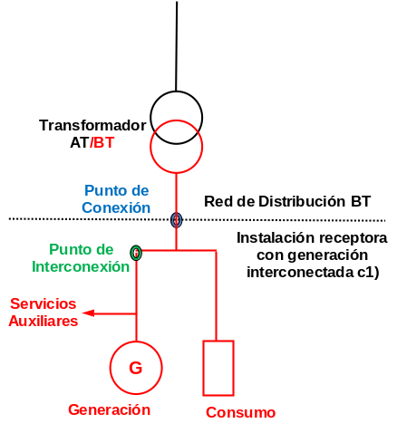
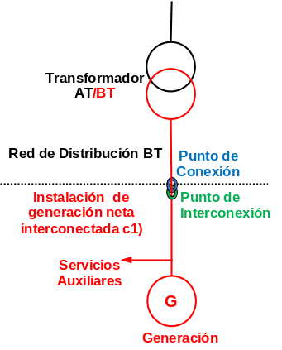
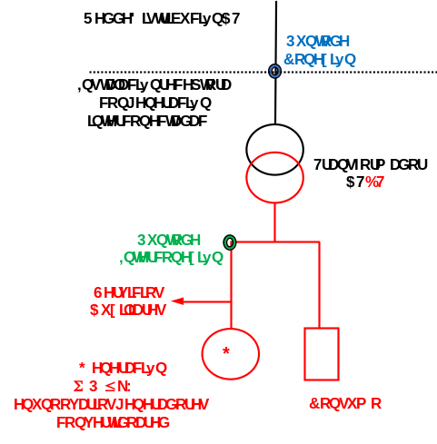
Figure 2. Type c2) interconnected generation installations
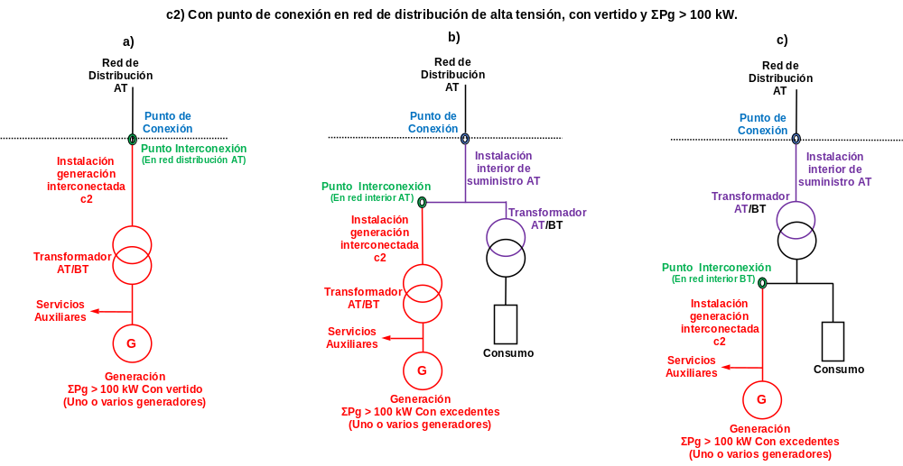

GENERAL CONDITIONS
Generation installations, as well as their auxiliary services (AS) and additional installations, such as fuel tanks and liquid or gas pipelines, among others, must also comply with all of the provisions laid down in the specific Regulations and Directives applicable to them.

Design of the generation installations
The generators must be constructed and designed in accordance with the provisions of the Low-Voltage Directive or other Directives, as applicable to them. Where the generators are configured as a union of different physically separate parts, the wiring, interconnection and protection elements shall be installed in accordance with any standards applicable to the generator, or with the essential safety requirements of the Low-Voltage Directive.
The connection systems between the different parts of the generation installations shall comply with the applicable requirements of the REBT. Specifically, for the direct-current connection systems of the generators (photovoltaic panels, batteries, fuel cells, etc.), ITC BT-53 shall apply, while for small wind generators the applicable standard is UNE-EN 61400-2.
Those components of generation installations that are liable to emit corrosive gases, fumes or vapours must be housed in dedicated premises, must comply with the relevant fire protection regulations and must be adequately ventilated. The ventilation system must ensure that there is no accumulation of toxic substances in the environment and that no potentially explosive atmospheres are created. Combustion gas exhaust ducts shall evacuate to the exterior directly or via an energy recovery system.
The operator of the generation installation shall be responsible for maintaining the protection in correct working order and for monitoring safety and network connection conditions.
Generation installations falling within the scope of Regulation (EU) 2016/631 and the legislation in force developing it for national implementation, or subsequent legislation amending or replacing it, or which, alternatively, fall within the scope of Operating Procedure Regulation 12.2 of the Electricity Systems of the Non-Peninsular Territories (OP 12.2 of the SENPs), or subsequent regulations amending or replacing it, in which requirements are established for the connection of generators to the network, must certify compliance with the aforementioned requirements. Likewise, if the nominal power of these generation installations to be connected to the distribution network is greater than 15 kW, the network connection of the installation shall be three-phase, with a phase imbalance less than or equal to 5 kW.

CONNECTION CONDITIONS
Figure 3 schematically illustrates all of the types of generation installations covered by this Instruction. The diagrams of the generation installations are represented in the following parts of this Instruction. The diagrams of the connection installations affecting the generation installations are included in ITC BT-12.
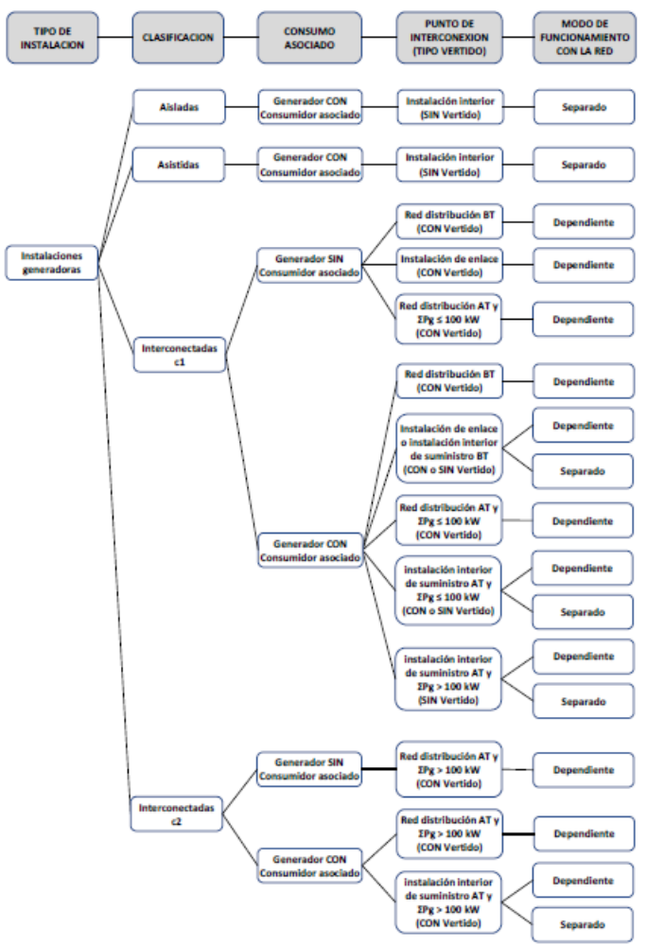
Figure 3. Types of generation installations

Isolated generation installations
The connection to the receivers, in installations for which there can be no possibility of coupling with the distribution network or with another generator, shall require the installation of a device that allows the load to be connected and disconnected in the output circuits of the generator. This device may be the main circuit breaker (IGA) of the generation installation provided that it has isolating capacity.
Where there is more than one generator and its connection requires synchronisation, manual or automatic equipment, which may be integrated into the generators, must be provided to perform this operation.
Portable generators must incorporate the general protection against overcurrent and direct and indirect contacts necessary for the installation they supply.
Figure 4 shows an example schematic diagram of an isolated generation installation.
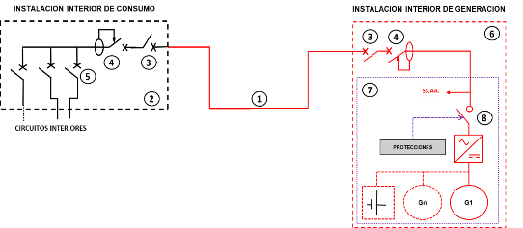
Figure 4. Connection diagram of an isolated generation installation
Key:
- Individual connection line for each generation installation
- Internal consumer installation – main control and protection switchboard
- Main circuit breaker (IGA)
- Type A, B or F differential circuit breaker
- Individual control and protection devices
- Internal generation installation – generation control and protection switchboard
- Generation installation (generation-storage-inverter set)
- Generation protection circuit breaker (can be integrated into the generator and be electronic without contacts)
NB: AS: Auxiliary services of the generation installation
Despite the fact that generation installations of this type are permanently connected to the consumer installation, the protection of the generation installation may not be used as protection for the internal consumer installation; each must have its own protection.
The protection corresponding to the generation installation is described in Section 7 of ITC BT-40, including that corresponding to the generation protection switch actuated by the various protection systems, which may be an independent switch or form part of the inverters associated with the generation and storage set.
The electric shock protection shall be chosen in accordance with ITC BT-24, taking into account, in the case of automatic power cut-off protection, the earthing regime of the neutral of the generation installation and the short-circuit power that it is able to provide. In TN configurations, protection against indirect contacts by automatic disconnection of the power supply by means of residual current circuit breaker requires the connection configuration to be of the TN-S type.
The protection of the receiver installation shall be that indicated in the corresponding ITCs for internal installations. In the case of overcurrent protection, the overload currents and short-circuit currents shall be determined at each point of the installation at which a device is to be installed, taking into account all possible configurations of the installation (type of generation, presence of batteries, etc.).
In addition, when choosing the overcurrent protection device, the following must be taken into account:
  - the maximum short-circuit level for selection of the cut-off power
  - the minimum short-circuit level for adjustment of the tripping characteristics of the short-circuit protection devices.

Assisted generation installations
In the internal or receiving installation, the alternative supply (distribution network or generator connected to the internal installation) may be input at several points, which shall be provided with a switching system for all active conductors and the neutral line.
To prevent simultaneous coupling in load transfer switching with cut-off, there must be an automatic or manual interlock. The switchgear actuation device shall be accessible to the operator of the generation installation. Except in installations with IT configuration, the switchgear shall have an auxiliary contact permitting the generation neutral to be connected to earth, guaranteeing actuation of the protection of the internal or receiving installation.
In order to avoid the effects of overvoltage due to switching, it will be necessary to install suitable transient overvoltage protectors for the installation they supply.
Load transfer switching may be carried out without cut-off if the assisted generation installation is connected to the distribution network at a single point and the following requirements are met.
  - The power of the generators must exceed 100 kW.
  - Immediately after interconnection of the generator and the distribution network or an internal network with TT configuration and for the duration of interconnection, the neutral of the generation installation shall be disconnected from earth.
  - It shall be ensured that the initial switching parameters, in particular the interconnection time, cannot be changed.
  - It shall have synchronisation equipment. It shall prevent interconnection with the distribution network outside the permissible conditions for the generator or in the absence of voltage in the distribution network.
  - The necessary automation shall be provided to prevent the interconnection being maintained for more than 5 seconds.
An example of an assisted installation configuration with load transfer with cut-off is shown in Figure 5.
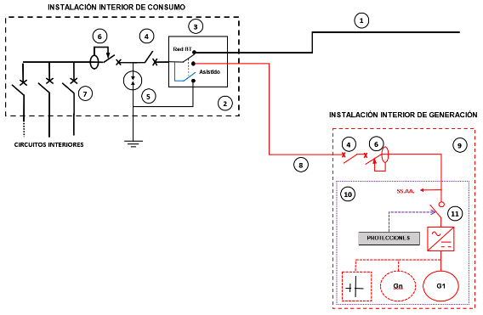
Figure 5. Diagram of an assisted installation with load transfer with cut-off
Key:
- Network supply
- Internal consumer installation – main control and protection switchboard
- Switching system (neutral-earth interconnection in assisted operation)
- Main circuit breaker (IGA)
- Transient overvoltage arrester (type 2)
- Type A, B or F differential circuit breaker
- Individual control and protection devices
- Individual connection line to generation installation
- Internal generation installation – generation control and protection switchboard
- Generation installation (generation-storage-inverter set)
- Generation protection circuit breaker (can be integrated into the generator and be electronic without contacts)
NB: AS: Auxiliary services of the generation installation

Interconnected generation installations
The requirements of ITC BT-40 are applicable to all interconnected generation installations regardless of their power, including self-consumption installations. All interconnected generation installations must have devices which, on the one hand, limit the injection of direct current and the generation of overvoltages within the ranges established in the regulations and, on the other hand, prevent the installation from operating as an island with the distribution network, so that the connection of the generation installation does not affect the normal operation of the distribution network or the quality of supply to the customers connected to it.
Self-consumption installations without surplus, regardless of whether they are connected to the low-voltage network or to the high-voltage network, with generation and regulation at low voltage, shall have a system that prevents energy being fed into the distribution network and which complies with the requirements and tests indicated in Section 10.
However, these generation installations, like the rest of the generation installations, shall comply with the provisions of ITC BT-04 in terms of their documentation and commissioning and, regardless of their power and mode of connection, shall have the documentation required in accordance with Section 9 of this ITC.
In all generation installations, including generation for self-consumption, the connection shall be made through a control and protection panel that includes the protection described in Section 7 of ITC BT-40 that applies to it.
The generation installation may be connected at the connection installation: at a main protection box (MPB), a protection and metering box (PMB), a branching and metering box (BMB) or at a meters panel or directly to the distribution network via a separate MPB, PMB or BMB. In the case of individual self-consumption, the connection may also be made in the internal installation (in the main control and protection switchboard) of any of the associated consumption supplies.
In cases of collective self-consumption in condominium buildings or, in general, in dwellings that share the same service connection, the generation installation may not be connected directly to the internal installation of any of the consumers associated with the collective self-consumption installation.
Collective self-consumption may not interconnect supplies if it is associated with different distribution networks (or service connections), unless it can be ensured that the effects arising from that connection cannot affect the security of those networks. The distribution company shall be informed and give its consent for this coupling. Non-approval shall be justified on the basis of distribution network security criteria.
All generators for self-consumption that are connected to internal user installations (see Figure 6), shall be so connected through an independent and dedicated circuit from a control and protection box that includes type A, B or F differential protection; they may not be connected by means of plugs.
In installations in housing, or installations accessible to the general public and in residential or similar areas, the sensitivity of the generation differential shall be 30 mA or less, although it may be up to 300 mA when the following conditions are met:
  - the inverter has a permanent function monitoring the differential current and sudden changes in the differential current, which complies with the requirements of UNE-EN 62109-2 for network-connected inverters;
  - the earth resistance of the installation measured with a tellurometer or loop impedance meter is less than 30 ohms, in order to ensure a non-dangerous contact voltage.
The generation differential switch must be type B in accordance with Standard UNE-EN 62423 or UNE-EN 60947-2. It may only be Type A or Type F if one of the following conditions is met:
  - the manufacturer’s instructions state that the inverter provides at least a simple separation between the AC side and the DC side; or
  - the installation provides at least a simple separation between the inverter and the differential switch, by means of an isolation transformer; or
  - the inverter complies with Standard UNE-EN 62109-2 and the manufacturer’s instructions do not require the use of a Type B differential switch, in which case the differential type shall be in accordance with the manufacturer’s instructions (Type A or Type F).
Installation must always be carried out by an authorised installation company. This information must be provided at the point of sale and supplied together with the generator.
Figure 6. Schematic diagram of an interconnected installation with a dedicated circuit
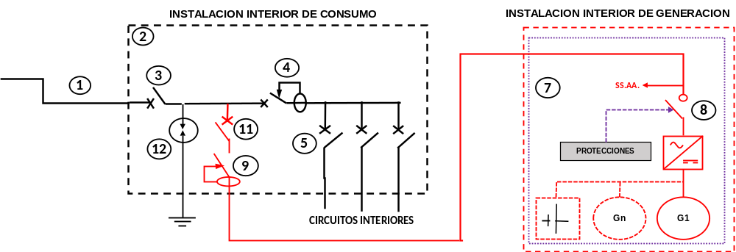
Key:
- Individual branch (IB)
- Internal consumer installation – main control and protection switchboard
- Main circuit breaker (IGA)
- Type A, B or F differential circuit breaker
- Individual load control and protection devices
- Control and external generation protection switchboard
- Generation installation (generation-storage-inverter set)
- Generation protection circuit breaker (can be integrated into the generator and be electronic without contacts)
- Type A, B or F differential breaker for generation
- Generation disconnector
- Individual generation control and protection device
- Transient overvoltage arrester (type 2)
Notes:
- If switchboard 6 is integrated into switchboard 2, components 10 and 11 are the same component.
- The figure shows a single generation installation (7), but there may be other additional installations that would be connected to the general control and protection panel with their corresponding protections.
- AS: Auxiliary services of the generation installation
Interconnected generation installations without associated consumption or connected to distribution networks shall always have a dependent mode of operation, so that in the absence of voltage in the distribution network they cannot supply any load. However, generation installations for self-consumption connected in an internal network may be designed to operate well in either dependent or island operating mode.
In interconnected generation installations for self-consumption that are designed to be capable of operating in island mode, the connection may be transferred from the mode of operation involving interconnection with the distribution network to the island mode of operation by means of a switching system in either of the following two ways, depending on whether or not the loads remain supplied.
  - With cut-off or zero-cross: the generation will be stopped or disconnected and subsequently the network installation will be disconnected using the switching system. Subsequently, the generator will be connected, which will regulate power and frequency within the margins permitted by the loads.
  - Without cut-off or zero-cross: the network installation will be disconnected using the switching system, while the generator is kept connected. The generator shall have the necessary automatic systems to switch to regular power and frequency, so that both transitional switching and steady-state operation are within the margins permitted by the loads. This form of connection transfer shall only be permitted for generation installations with an installed capacity of more than 100 kW.
In both cases, the switching system and its control shall comply with the island operation detection requirements included in Standard UNE-EN 62116.
Similarly, reconnection to the distribution network may also be achieved in either of the following two ways.
  - With cut-off or zero-cross: generation will be stopped or disconnected and then the loads will subsequently be connected to the grid via the switching system. In this case, the switching system shall have a lock that prevents it from closing with the generation connected. Finally, the generation installation will be reconnected.
  - Without cut-off or zero-cross: voltage and frequency shall be measured on the network side of the switching system for synchronisation of the generator with the network. In this case, the closure of the switching system shall be conditional on synchronisation of the generator with the network or on the disconnection of the generator.
In island mode operation, the generator must be connected upstream of the indirect contact protection of the internal installation circuits and the coupling switch shall have an auxiliary contact or other device enabling the neutral of the generation line to be connected to earth when the neutral of the distribution network is disconnected. When the generation neutral-earth connection in island mode is made to the earth of the accessible conductive parts, it must be checked that the installation is configured as TN-S and that the indirect contact protection is guaranteed.
In island mode operation, the anti-feed-in system may be disabled provided that it is automatically restored when it returns to dependent operation mode.
Figure 7 shows an example of the location of the switching system for transfer of the connection from the mode of operation interconnected with the distribution network to the island mode of operation.
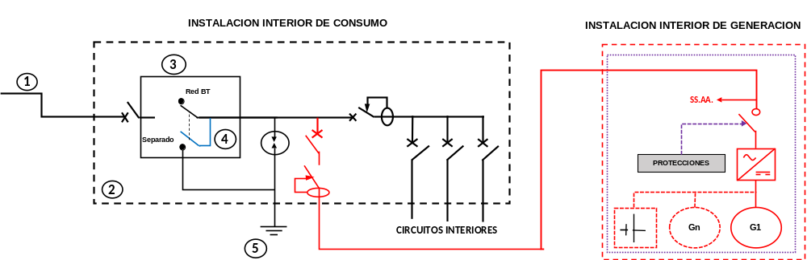
Figure 7. Location of the dependent mode-island mode switching system

Key:
- Connection to the LV network
- Internal consumer installation – main control and protection switchboard
- Dependent-island mode switching system
- Neutral of the internal installation
- Earth of the internal installation
Notes:
- The switching system (3) may be integrated into the internal generation installation, provided that the electrical configuration in the figure is respected.
- AS: Auxiliary services of the generation installation
The requirements of the following section for interconnected generation installations shall apply insofar as they do not prevent the compliance of those installations that are within the scope of Regulation (EU) 2016/631 and the regulations that develop it for national implementation, which establish requirements for the connection of generators to the network.

Maximum powers of interconnected generation installations with surpluses.
The maximum installed power of the generation installations to be interconnected with the distribution network, both high- and low-voltage, and with feed-in capacity thereto, shall be that permitted by the applicable regulations in the electricity sector.
On the other hand, in order to avoid overloads in all segments of the low voltage distribution networks due to the connection of loads and generators along the lines, one of the following measures shall be adopted.
  - Provision of adequate overcurrent protection elements on the distribution network protecting all segments of the network.
  - Adequate design of all segments of the network, coordinated with the control of supplies or generators by the distribution company, taking into account actual consumption, the power control systems of the supplies and the topology of the line to ensure that the design current of any segment of the line is not exceeded.
  - Connection of the generation installation directly to one of the outlets of the LV switchboard of the transformer substation used exclusively for generation.

Specific conditions for coupling to the distribution network
In order to be able to connect the generation installation to the distribution network, the following conditions must be met in full.
- The generation installation must have automatic or manual synchronisation equipment according to the technology of the generator.
- Its contribution to the increase or reduction in voltage on the distribution network, between the transformation centre or substation where the voltage is regulated and its connection point, in the worst case scenario for the network, must not be greater than 3 % of the nominal voltage of the distribution network.
- The generation installation may only be connected to the distribution network when the differences between the electrical magnitudes of the generator and the distribution network during the synchronisation operation are lower than those indicated by the generator manufacturer and in any case lower than the following:
  - Voltage difference ± 8 %
  - Frequency difference ± 0.1Hz
  - Phase difference ± 10º

Switching and protection equipment to be available at the connection or interconnection point
Connection of the generation installation must not affect the normal operation of the network or the quality of the supply of the customers connected to it or their remote management systems, nor must it lead to changes in the way it is exploited, protected and developed. The connection point must have elements that fulfil the load-shedding and switching functions of the distribution network, in order to be able to disconnect the generation installation.
Type c1) installations with a connection point to the low-voltage distribution network shall have a safety switch-disconnector (ISD) in the meters panel, in the indirect measurement module (IMM), or in the protection and metering box (PMB), which shall be permanently accessible to the distribution company.
In the case of type c2) generation installations with network feed-in and a connection point to the high-voltage network, the generation installation shall have the protection and switching and isolation components established in the Regulation on technical conditions and safety guarantees in high-voltage electrical installations, in addition to incorporating the protection applicable to them in accordance with the current regulations on technical requirements for connection to the network.
In order to ensure that internal faults in the installation do not disturb the correct operation of the installations to which they are connected, whether they are internal, connection or distribution installations, there shall be an individual generation control and protection device at the point of interconnection with the generation installation.
In the event that any of these circuit breakers allows automatic reconnection, it will not be able to reset until there is a stable voltage in the distribution system.

Control of the reactive energy of interconnected generation installations with surpluses
The load factor of the energy supplied to the network of the distribution company should be as close as possible to 1, and in any case greater than 0.98 when the installation is working at powers greater than 25 % of its nominal load. Consequently, in these installations, where the generation regulation does not permit it, reactive power compensation equipment (e.g. capacitor banks) shall be installed to achieve this power factor.
In addition, if the generation installation is required to comply with the technical requirements in this area established in Royal Decree 413/2014 regulating the production of electricity generation from renewable energy, cogeneration and waste, or the subsequent legislation replacing it, it must have the reactive power absorption and injection capacities and the technical capacities to control reactive power established under that legislation.
Likewise, if the generation facility is required to comply with the technical requirements of Regulation (EU) 2016/631 and its implementation at national level, or those of subsequent regulations amending or replacing them, or, where applicable, if it is required to comply with the technical requirements of OP 12.2 of the SENPs, or subsequent regulations amending or replacing it, shall have the reactive power absorption and injection capabilities and the technical reactive power control capabilities established in those regulations.

CONNECTION CABLES
The cables linking the internal generation installation to the interconnection point must be dimensioned for a current no lower than 125 % of the maximum current of the generation installation and so that the voltage drop is not more than 1.5 %, with the nominal current of the generation installation.

WAVEFORM
The voltage generated by the generation installation shall be practically sinusoidal, and with a maximum harmonic rate (ratio in % between the effective value of the nth order harmonic and the effective value of the nominal voltage), under any load regime, of:
  - Even-order harmonics: 4/n %
  - Third-order harmonics: 5 %
  - Odd-order harmonics (≥ 5): 25/n %
Likewise, in any mode of operation, both the injection of direct current and the generation of overvoltages that the operation of the generation installations may produce shall be avoided. The requirements to be met and the assessment methods must comply with the provisions of Sections 11 and 12 of this ITC.
These requirements shall apply insofar as they do not prevent compliance with the technical requirements of those installations falling within the scope of Regulation (EU) 2016/631 and the regulations that develop it for national implementation, or of subsequent regulations that modify or replace them, or which, where applicable, fall within the scope of OP 12.2 of the SENPs, or subsequent legislation amending or replacing it, in which requirements are established for the connection of generators to the network, if those requirements apply to the generation installation.

PROTECTION
Generation installations shall be provided with the specific safeguards necessary to reduce damage as a result of faults internal or external to them.

Installation protection
The circuits for interconnecting the generators to the internal installation shall be equipped with the protection established in the corresponding ITCs applicable to them, as if they were a receiving installation.
Generation installations must have the following switching and protection components.
- An individual generation control and protection device for protection against overcurrent, with general switching characteristics that provide insulation to protect workers from electrical risk.
- A type A, B or F differential circuit breaker, in order to protect people against indirect contacts in the event of any component becoming earthed. When the generation installation is connected to the internal installation through an isolation transformer, this transformer shall be connected between the generation circuit differential output on the consumer installation main control and protection switchboard and the generation installation protection switchboard, preferably placed in or next to the generation installation switchboard. In other types of installations that are not connected to networks with a TT-neutral system, the provisions of ITC BT-24 on automatic supply cut-off shall apply.
- Type 1 transient overvoltage arresters upstream of the meter and type 2 transient overvoltage arresters in the Control and Protection switchboard and overvoltage surge protection in accordance with ITC BT-23.
- A generation protection switch for automatic disconnection-connection of the installation in the event of an anomaly or absence of voltage or frequency and, where appropriate, an interlocking relay to prevent connection of the generator to the installation.
Component (d) may be integrated into the converter/inverter associated with the generator.
Components (a) and (d) may be integrated into a single element, in which case this element may not be integrated in the converter/inverter associated with the generator.
Component (c), in extensions or modifications to existing installations where it is not possible to install the Type 1 arrester upstream of the measuring equipment, may be installed in the main control and protection switchboard so that the new internal generation circuit is protected. In this case, Type 1 and Type 2 surge protection devices (SPDs) may be combined in a single device combining both types of protection, provided that it complies with the requirements and tests established in Standard UNE-EN 61643-11 for both types.
The above components must be accessible to the operator of the generation installation and will be located in the internal installation. In this respect, the internal installation shall be deemed to refer to the private dwelling or premises of the installation, which may be different from the location of the meters.
The generators must be connected in such a way that protection against indirect contacts provided by differential circuit breakers remains effective for each intended combination of power sources. This protection against indirect contact shall be dimensioned in such a way as to take into account the different values of the fault impedance for the different earthing points (network or generator) that may occur according to the operating mode (see Sections 8.2.2 and 8.2.3).

Functional protection of the generation installation
The functional protection system of the generation installation shall have at least the maximum and minimum frequency protection functions (51 Hz and 48 Hz) with a maximum time delay of 0.5 s and 3 s respectively) and maximum and minimum voltage between phases (between 1.15 Un and 0.85 Un), as shown in Table 1.
Table 1. Parameters for disconnection due to voltage or frequency being outside limits
Parameter | Protection threshold | Maximum timing
Overvoltage 1 | Un + 10 % | 1.5 s
Overvoltage 2 | Un + 15 % | 0.2 s
Minimum voltage | Un - 15 % | 1.5 s*
Maximum frequency | 51 Hz | 0.5 s
Minimum frequency | 48 Hz | 3 s
(*) In the case of installations required to comply with the voltage dip response requirements, the tripping time shall be equal to 1.5 seconds.

The protection of generation installations that are required to comply with the technical requirements of the legislation implementing Regulation (EU) 2016/631 or subsequent European Union regulations amending or replacing it, or which, where appropriate, fall within the scope of OP 12.2 of the SENPs, or subsequent legislation amending or replacing it, must coordinate the setting values of the minimum and maximum frequency relays in accordance with the technical capabilities required in the legislation developing it for national implementation, which establishes requirements for the connection of generators to the network. In the event of activation of the maximum frequency protection, reconnection will only be made when the frequency reaches a value that is less than or equal to 50 Hz.
In order to protect the installation and people in the absence of voltage in the distribution network, all interconnected generators must have an anti-islanding function that disconnects the generator from the distribution network within a maximum time of 2 s in the case of low voltage and 1 s in the case of high voltage, and which only permits their own consumption to be supplied when operating in island mode. The functions indicated in Table 1 may be incorporated into the island operation detection device.
In addition, it shall be checked that the islanding detection system functions correctly, both when the inverter is operating individually and when multiple inverters are operating in parallel. This check shall be performed in accordance with the provisions of Section 13 of this ITC.
In addition, some generators may require specific protection associated with their own technology. One example is the power inversion protection in synchronous generators. This type of protection should be installed as close as possible to the generator terminals.
A disconnected generator shall only be able to reconnect to the network once the voltage and frequency of the distribution network have remained within normal ranges for at least three minutes.

Non-conventional generator protection
The generator, depending on its characteristics and form of connection, will need to incorporate its own additional protection against overcurrent, against indirect contact and against insulation faults. This protection may be achieved with conventional installation material or be integrated into the generator as non-conventional protection.
For these non-conventional protection devices, the applicable functional characteristics (e.g. magnetothermal or differential action curves) shall be checked in accordance with the equivalent requirements of the harmonised standards applicable to conventional installation equipment. In addition, account shall be taken of the analysis of the effect on protection of possible electrical or electronic faults in both the generator and the installation to which it is connected, the influence of electromagnetic disturbance phenomena to be expected in the environment in which the generation installation is located, and even the influence which errors in the equipment's software may have on the protection characteristics, where applicable.
For equipment incorporating non-conventional protection, the protection conditions check shall be carried out by means of a test report on the following aspects:
- applicable functional characteristics
- protection against possible electrical or electronic faults
- protection against electromagnetic disturbance phenomena
- protection against faults and/or errors in the equipment software.
The commonly used non-conventional protection that must be checked according to the previous paragraph is:
- synchronisation between multiple AC sources
- emergency operation stops (including stop sequence)
- switching system (connection/disconnection between sources) and safety interlocks (valid voltage and frequency range)
- functions of residual current devices for protection of the generator
- generator overcurrent protection.

EARTHING INSTALLATIONS

Overview
The earthing systems of generation installations must have the appropriate technical conditions so that there are no transfers of faults to the distribution network or to private installations in accordance with the provisions of ITC BT-18, regardless of their operation with respect to the latter: isolated, assisted or interconnected.
Generation installations with HV interconnection points must additionally be equipped with earthing systems that, at all times, ensure that the voltages that may occur in the accessible conductive parts of the installation do not exceed the values established in ITC RAT-13 of the Regulation on technical conditions and safety guarantees in high-voltage electrical installations.

Earthing characteristics according to the operation of the generation installation with respect to the low-voltage distribution network

Generation installations in isolated operating mode.
The earth network of the installation connected to the generation system shall be independent of any other earth network. Earth networks shall be considered independent when the maximum fault current can pass through one of them without causing voltage differences greater than 50 V in the other, relative to the reference earth.
In installations of this type, the neutral of the generator and the accessible conductive parts of the installation shall be earthed in accordance with one of the systems included in ITC BT-08.
When the generator neutral is not accessible, the system can be earthed using a three-phase star transformer, usable for other auxiliary functions.
Where several generators are working in parallel, the neutral points of the generators must be connected together and earthed at a single point.

Generation installations in assisted operation mode.
When the distribution network has the neutral earthed, the earthing configuration shall be TT and the neutral and the accessible conductive parts of the generation installation shall be connected to an earth independent of those of the receiving installation. The neutral earth of the distribution network can be used for this purpose. If it is technically impossible to make a separate earth for the neutral of the generator, subject to specific authorisation from the Competent Body of the Autonomous Community, the same earth may be used for the neutral and the accessible conductive parts of the receiving installation.
When switching so that the receiving installation is supplied exclusively from the generation installation, the neutral of the generation installation shall always be kept connected to the neutral of the receiving installation.
In order to supply the installation from its own generation in cases where load transfer without cut-off is envisaged, the interconnection switch shall have an auxiliary pole which, when it goes to supply the installation from its own generation, connects the generation neutral to earth.

Generation installations in interconnected operation mode
The earth protecting the accessible conductive parts of the generator installation shall be connected to the earth of the accessible conductive parts of the property or premises in which they are located. Its neutral shall always be kept connected to the neutral of the receiving installation.
When the generation installation operates interconnected with the low-voltage distribution system, the earthing system shall be the TT system and the masses of the generating and receiving installation shall be connected together to an earth independent of that of the neutral of the distribution system.
If the installation is operating in island mode, supplied exclusively by its generation installation, the switching system shall have an auxiliary pole that, after disconnecting the neutral from the distribution network, will connect the neutral of the generation installation to the earth of the accessible conductive parts of the property or premises in which it is located.
For the protection of three-phase generation installations consisting of single-phase generators, a device shall be provided to detect the current flowing through the connection of the generator neutrals to the distribution network neutral, which will disconnect the installation if the maximum admissible current of the neutral conductor is exceeded.
The generation installation shall be galvanically isolated from the distribution network, by means of either an isolation transformer, a converter/inverter with or without isolation transformers, or any other method that ensures compliance with the following functions:
- to isolate the generation installation to prevent the transfer of faults between the distribution network and the generation installation;
- to provide personal safety, in compliance with the provisions of ITC BT-24;
- to avoid injecting direct current into the grid, complying with the provisions of Section 11 of this ITC.
The transfer of faults between the network and the generation installation is considered resolved, regardless of the converter used, provided that the following configuration is adopted, applied separately to the different parts of the installation, basically converter and generator components (e.g. in the case of photovoltaic generation, inverters and each of the photovoltaic panels), unless they are joined together.
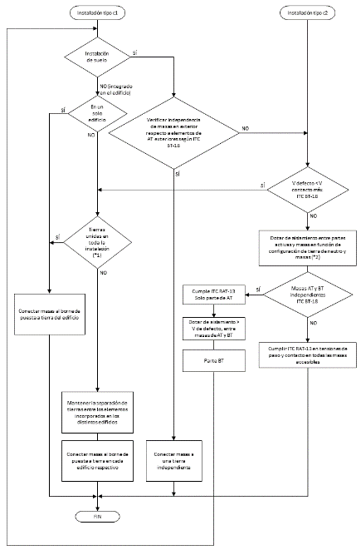
Figure 8. Flow diagram for earthing
NOTE 1: In C2 installations with an LV interconnection port at BT and P>100 kW, the C1 conditions shall apply for the purposes of the flow diagram.
NOTE 2: In C1 installations with an LV interconnection port at AT and P<100 kW, the C2 conditions shall apply for the purposes of the flow diagram.
(*1) Equipotential bonding between earths of different buildings is covered in the regulation in ITC BT-26, Section 3.1.
(*2) If overvoltage protectors are installed between phases and earth, their continuous operating voltage will be greater than the voltage assigned to the insulation.

Wind generators
The protective earthing of the tower and the equipment mounted on it against atmospheric discharges shall be independent of the rest of the earths of the installation.

COMMISSIONING
For the commissioning of generation installations, the authorised installation company shall issue the installation certificate in accordance with the provisions of ITC BT-04, which shall necessarily include a report on passing the tests indicated in Table 2. The report shall be delivered to the owner of the installation by the authorised installation company, together with the installation certificate signed by the low-voltage installer belonging to said company.
In addition, for those installations that require access and connection permits according to the legislation in force, the owner or the authorised installation company must submit the installation certificate to the electrical energy distribution company including the test pass report and all the technical information of those parts that affect the conditions of connection, coupling, measurement and security of electricity supply.
For generation installations, the distribution company may check, at its own expense, prior to commissioning and within the legally established deadlines for connecting the installation, that the interconnection installations and other elements affecting the security, reliability and quality of supply comply with the applicable regulations. In the event of disagreement, it shall be communicated to the competent bodies of the Administration, for resolution.
Table 2. Checks and tests to be carried out on generation installations or their parts
 | Documentation/testing | Applicable to: | Check according to: | Affected installations
1 | Operation of the islanding detection system when multiple inverters are operating in parallel | Anti-island protection in generator | Section 13 of ITC BT-40 | Interconnected
2 | Checking the island operation detection system, the thresholds and actuation times | Individual inverters | Section 13 of ITC BT-40 | Interconnected
3 | Functional check of the network synchronisation system and the functional protections of the generation installation | Synchronisation system for coupling to the network | Section 4.3.2. and Section 7.2. of ITC BT-40 | Interconnected
4 | Check of the protection and switching conditions of the following aspects:  - applicable functional characteristics  - protection against possible electrical or electronic faults  - protection against electromagnetic disturbance phenomena  - protection against faults and/or errors in the equipment software. | Protection integrated into the generator and its switchgear system | Section 7.3 of ITC BT-40 | All
5 | Direct-current injection test | Generator  via inverter | Section 11 of ITC BT-40 | All
6 | Surge generation test | Generator via inverter | Section 12 of ITC BT-40 | Interconnected
7 | Testing the system to prevent energy being fed into the network. | Anti-feed-in system in self-consumption without surpluses | Section 10 of ITC BT-40 | Interconnected without surpluses
8 | Compliance with EU regulations and operating procedures of network connection legislation | - Type A and B generation installations according to network codes that have to comply with the requirements of Regulation (EU) 2016/631 and the legislation developing it for its implementation, or subsequent legislation that amends or replaces it  - generation installations that are required to comply with the requirements of OP 12.2 of the SENPs or subsequent legislation amending or replacing it | Technical standard for monitoring the conformity of electricity generation modules according to the relevant standards | Interconnected according to the specific legislation applicable
9 | Check of switching conditions of Assisted Generating Facilities. | Switching system in the installation | Section 4.2 of ITC BT-40 | Assisted
10 | Checking the switching conditions of Interconnected generation installations that can operate in island mode | Switching system in the installation | Section 4.3 of ITC BT-40 | Interconnected installations that can operate in island mode
11 | Checking the galvanic separation or absence of fault transfer between the network and the generation installation | Installation as a whole | Section 8.2.3 of ITC BT-40 | Interconnected

The test pass report, with regard to rows 1, 2, 3, 4, 5, 6 and 7 of Table 2, must include the complete tests carried out on the type of generator or protection installed by a laboratory accredited for such tests, according to Standard UNE-EN ISO/IEC 17025. It must include, in addition to the test results, the following information provided by the manufacturer or the person responsible for the design of the generation installation.
  - The basic configuration of the system, including the form of connection of the generator, the protection that must be present or be installed in the installation and the precautions applicable to the power of the loads and types of receivers that can be connected in the circuits simultaneously supplied by the network and the generator, depending on their connection to the self-consumption installation.
  - The power-measuring equipment and class of the measuring transformers used for power measurement, where applicable.
  - The control component. If it is included in any of the devices in the system, for example, in the power measurement equipment or in the generator, this must be reflected.
  - The type of communications used between the different components, where applicable.
  - The standard generators for which the anti-feed-in system is valid, where applicable.
  - The power and other electrical characteristics of the generator type tested.
  - The control algorithm, where applicable.
  - The maximum number of generators to be connected, where applicable.
The accredited laboratory shall issue a report with the conformity assessment of the test results, including the decision ‘compliant’ or ‘non-compliant’ for the applicable tests.
The reports or certificates corresponding to compliance with Regulation (EU) 2016/631 and the legislation developing it for its national implementation (row 8 of Table 2), shall be issued by the conformity assessment bodies, according to the procedure described in their supervision technical standard.
The test pass report, as regards rows 9, 10 and 11 of Table 2, must include the checks carried out by the authorised installation company, or by the inspection body if an initial inspection is required according to ITC BT-05.

SYSTEMS TO PREVENT ENERGY BEING FED INTO THE NETWORK

Overview
Systems to prevent energy being fed into the network can be based on two different operating principles.
- Prevent feed into the network by means of a current cut-off or limitation component.
In order to prevent energy being fed into the network, there must be systems for measuring the power exchanged with it, located upstream of the generation installation and the loads, which permit disconnection of the generation system from the network or regulation of the generation systems.
- Power exchange regulation through action on the generation-consumption system.
This type of system is based on a control component that adjusts the generation-consumption balance, preventing energy from being fed into the network. This can be done by load control, generation control, energy storage, or other means.
Two types of generation system should be considered for the purposes of establishing requirements for systems to prevent feed-in:
  - generation installations based on synchronous alternators connected directly to the network;
  - wind and photovoltaic installations and, in general, all those generation installations whose technology does not use a synchronous alternator connected directly to the network.

Configurations and conformity requirements
Two types of installations are considered: one in which the energy exchange with the network is measured (Figures 9 and 10) and another in which the consumption of all or part of the loads is measured (Figures 11 and 12).
The tolerance of the measuring system, calculated as the sum of the accuracy class of the equipment for measuring anti-feed-in power and the class of the current-measuring transformers or probes, shall be greater than or equal to 100 W or 1 % of the rated power of the generator, for generators of more than 10 kW.

Installations with equipment for measuring power exchange with the network
Figures 9 and 10 show the configurations of this type of installation depending on whether they are connected to the low-voltage or high-voltage networks, respectively.
The installation must always operate with a consumer-side balance at the network connection point, for which the internal consumption must be greater than the tolerance value of the anti-feed-in measurement system. Any value that does not comply with the above requirement must be corrected in less than two seconds by limiting generation or by triggering it.
In addition, there may be a piece of equipment or set of equipment that performs the regulatory functions, although it is not represented in the figures. The regulation component may be independent or integrated into other devices of the installation, such as the power measurement equipment or the generator.
The system for measuring energy exchange with the network may be located:
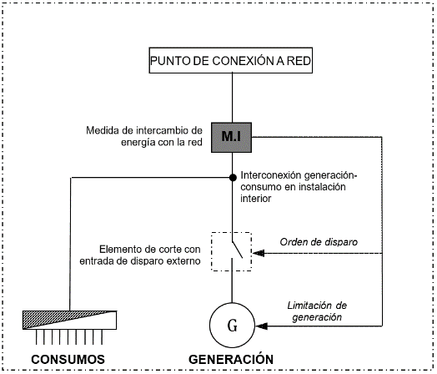
Figure 9. Configuration with equipment for measuring energy exchange with the network in installations interconnected with low-voltage networks

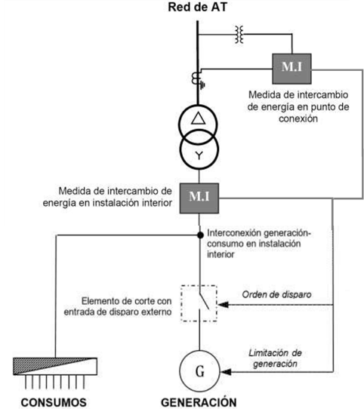
Figure 10. Configuration with equipment for measuring energy exchange with the network in installations interconnected with high-voltage networks

Installations with consumption measurement equipment
Figures 11 and 12 show the configurations of this type of installation depending on whether they are connected to the low-voltage or high-voltage networks, respectively. The consumption measurement may correspond to the total consumption of the installation or to part of the consumption thereof. The control component may be independent or be included in other devices of the installation, such as the power measurement equipment, the generator or the loads.
At all times, the power measured at the point of consumption must be higher than the power generated. The difference between the consumption and generation powers must exceed the sum of the tolerances of the consumption measurement and generation limitation systems. Any value that does not comply with the above requirement must be corrected in less than two seconds by controlling the loads or generation, by storing energy or by other means.
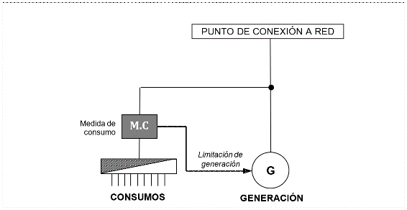
Figure 11. Configuration for measuring energy consumption in installations connected to low-voltage networks

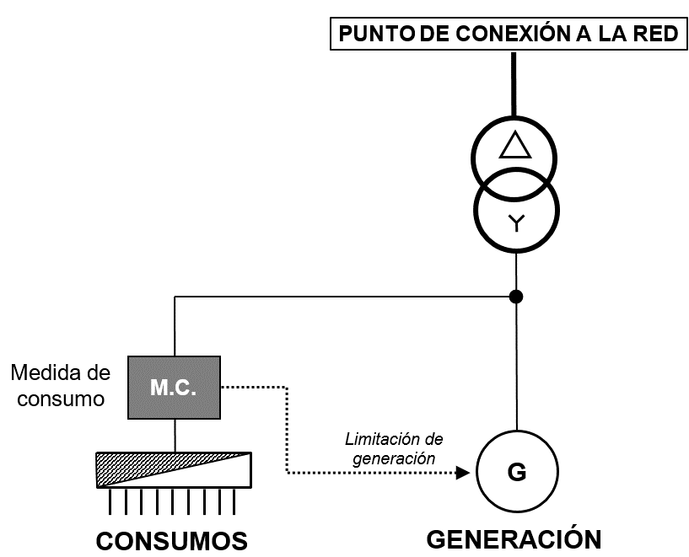
Figure 12. Configuration for measuring energy consumption in installations connected to high-voltage networks

Determining the maximum number of generators to be connected to a power-limited anti-feed-in system
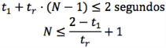
The response time of the anti-feed-in system must be considered with several generators and compared with the time obtained for a single generator. The resulting time difference will make it possible to determine the maximum number of generators that can be connected to the installation, according to:
seconds
Where:
N: maximum number of generators that can be included in the system
t₁: response time with a single generator. The maximum response time obtained shall be used.
t_{r}: difference between the maximum response times with one and two generators.
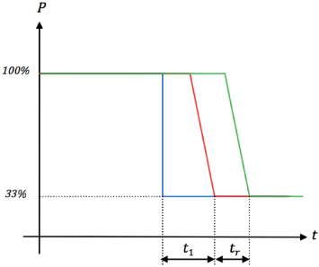
Figure 12. Example of response times of the system to a load disconnection of from 100 % to 33 % with one or two
Blue: power consumed by the load
Red: power produced in installation with a generator
Green: power produced in installations with two generators

Conformity assessment tests
The tests to be carried out to assess the conformity of the system preventing energy feed-in to the network are as follows.

Steady-state tolerance test
The power limitation system must ensure that power production in steady-state operation complies with the requirements of Section 10.2, according to the type of installation being tested.
The test must be repeated for the different standard generators to be assessed for the system and each of them can be tested separately.
To check that this condition is met, the test is performed in accordance with Section 4.1 of Standard UNE 217001.

Load disconnection response test
The power limitation system must ensure that, in the event of a load disconnection, the generator readjusts its production to return to the steady state in less than two seconds.
The test must be repeated for the different standard generators to be assessed for the system and each of them can be tested separately.
To check that this condition is met, the test is performed in accordance with Section 4.2 of Standard UNE 217001.

Primary energy source power increase response test
The power limitation system must ensure that, in the event of an increase in power at the primary energy source, e.g. an increase in irradiance in a photovoltaic installation, leading to a situation where there is more energy available than consumption, the generator readjusts its production to return to the steady state in less than two seconds.
The test must be repeated for the different standard generators to be assessed for the system and each of them can be tested separately.
To check that this condition is met, the test is performed in accordance with Section 4.3 of Standard UNE 217001.

Communication loss response test
The generator must stop generating in less than five seconds in the event of loss of communication, whether wireless or not, between the different system components. In the event that the control element is integrated into one of the required devices (power or generator measuring equipment), then communication between the components integrated into the same device does not need to be checked.
To check that this condition is met, the test is performed in accordance with Section 4.4 of Standard UNE 217001.

CONFORMITY REQUIREMENTS FOR THE LIMITATION OF DIRECT-CURRENT INJECTION INTO THE NETWORK
The generator must limit the direct current injected into the network below a certain value.
Generators incorporating a low-frequency (50 Hz) transformer that provides galvanic separation, ensure that there is no direct-current injection into the network, so they do not need to undergo any test to demonstrate that they comply with this requirement.
If the generator incorporates a high-frequency transformer (incorporating a DC/DC converter in its conversion stage) or does not have a transformer, it must be demonstrated that the direct current injected into the grid by the generator does not exceed 0.5 % of the RMS value of the generator output current, when the generator is operating between 25 % and 100 % of its rated power.
To check that this condition is met, the test is performed in accordance with Section 4.1 of Standard UNE 217002.

CONFORMITY REQUIREMENTS FOR THE LIMITATION OF OVERVOLTAGES GENERATED
A generator must not cause overvoltages when connected to an alternating-current network supplying other electrical installations.
Depending on the type of electrical installation being connected, there are two groups of generators.
- Group 1: generators for type c1) interconnected installations.
- Group 2: generators for type c2) interconnected installations.
The maximum value of the overvoltage caused by the Group 1 generators in the network to which they are connected must be lower than the values indicated in Table 3.
Table 3. Maximum permissible overvoltages for Group 1 generators
Overvoltage duration  (ms) | Permissible overvoltage value  (% peak Un)
≤ 0.2 | 280
≤ 0.6 | 218
≤ 2 | 178
≤ 6 | 145
≤ 20 | 129
≤ 600 | 120

The maximum value of the overvoltage caused by Group 2 generators shall be as indicated in ITC RAT-09 of the Regulations on technical conditions and safety guarantees in high-voltage electrical installations.
The conformity tests shall be performed in accordance with Section 4.2 of Standard UNE 217002.

CONFORMITY REQUIREMENTS FOR THE ISLANDING OPERATION DETECTION SYSTEM
Inverters incorporating island operation detection systems are described in Standard UNE-EN 62116. Island operation detection must be checked according to this standard, with quality factor Q = 1 ± 0.05 detecting islanding in less than two seconds.
In addition, it must be checked that the island operation detection system functions correctly when two or more inverters are working in parallel with the network and do not have an individual anti-feed-in system for each inverter. The conformity tests shall be performed in accordance with Chapter 4.3 of Standard UNE 217002.
The test is considered compliant if the tested inverter disconnects in less than two seconds in the situations and at the nominal power levels of the test.

OTHER PROVISIONS
All actions relating to establishment of the connection point, the plans, the commissioning and operation of the generation installations shall follow the criteria established by the legislation in force.
The electrical energy distribution company may, when it detects an immediate risk to people, animals and property, disconnect the interconnected generation installations, subsequently communicating the fact to the competent body of the Administration.’

Thirty-two. A new Supplementary Technical Instruction ITC BT-53, ‘Direct-current systems installations’, of the Low-Voltage Electrotechnical Regulation, approved by Royal Decree 842/2002 of 2 August 2002, is approved:

‘ITC BT-53

DIRECT-CURRENT SYSTEM INSTALLATIONS
- SCOPE
- TERMS AND DEFINITIONS
- PROTECTION TO ENSURE SAFETY FROM ELECTRIC SHOCKS
- PROTECTION TO ENSURE SAFETY FROM FIRE CAUSED BY ELECTRICAL EQUIPMENT
- PROTECTION TO ENSURE SAFETY FROM OVERCURRENT
  - Protection of photovoltaic modules against overcurrent
  - Protection of cables against overload
    - Protection of cables for a photovoltaic string
    - Protection of cables for the photovoltaic subarray
    - Protection of cables for the photovoltaic array
- PROTECTION AGAINST OVERVOLTAGES OF ATMOSPHERIC ORIGIN OR DUE TO SWITCHING
- SELECTION AND INSTALLATION OF ELECTRICAL EQUIPMENT
  - Common rules
  - Installations and enclosures
  - Service conditions
  - Electrical cables
  - Ducts
  - Electrical connections on the direct-current side
  - Overcurrent protection devices on the direct-current side
- ISOLATING AND SWITCHING
- EARTHING INSTALLATIONS AND PROTECTION CONDUCTORS

SCOPE
The particular requirements of this Instruction apply to direct-current electrical installations that are part of the internal installation of a consumer or of an electricity generator connected to the distribution network or to the consumer’s internal installation.
The direct-current installations or systems referred to in this Instruction are as follows (list not exhaustive).
  - The electrical installations of a direct-current generation system, from a module or set of generating modules, through their connection circuits, to their connection in the inverter that converts direct current into alternating current or to their point of use in direct current.
  - The electrical installations of a direct-current storage system, using batteries for domestic or industrial use or for the propulsion of electric vehicles, from a module or set of storage modules, through their connection circuits, to their connection in the inverter that converts direct current into alternating current. In the case of storage installations using batteries for the propulsion of electric vehicles, this Instruction shall apply only from the connection of the battery to the rest of the installation.
  - Other technologies used in direct-current generation or storage systems.
Generally speaking, when the term ‘photovoltaic’ is referred to in the text of this Instruction, it may also be understood to include any other direct-current generation source or storage system. Nevertheless, the definitions and requirements of this ITC are based on photovoltaic generation technologies and should be adapted to the particularities of other technologies to the extent necessary.
The requirements of this ITC shall not apply to green hydrogen production installations, due to their specific characteristics. Likewise, they shall not apply to self-consumption installations using the technology of microinverters that connect directly to photovoltaic modules.

TERMS AND DEFINITIONS
For the purposes of this document, the terms and definitions included in ITC BT-01 apply, in addition to the following:
  - Photovoltaic module
The smallest set of interconnected photovoltaic cells that is fully protected against the environment.
  - Photovoltaic string
A circuit of one or more modules connected in series.
  - Photovoltaic array
A set of photovoltaic modules, photovoltaic strings, photovoltaic subarrays and connection boxes of electrically interconnected photovoltaic groups.
For the purposes of this ITC, a photovoltaic array represents all components up to the means of connection on the direct-current side of the inverter or other electrical equipment for the conversion of power or direct-current loads. A photovoltaic array does not include the structure of the supports and their anchorage systems, the monitoring system, thermal control or other accessories.
A photovoltaic array may consist of a single photovoltaic module, a single photovoltaic string, or several strings connected in parallel, or several photovoltaic subarrays mounted in parallel and their associated electrical components.
  - Photovoltaic generator
A photovoltaic array that includes the inverter and the alternating current photovoltaic power supply circuit.
  - Photovoltaic junction box
Electrical switchgear to which photovoltaic subgroups or photovoltaic strings are connected and which may also contain other electrical accessories.
  - Photovoltaic subarray
An electrical sub-assembly of a photovoltaic array consisting of photovoltaic strings connected in parallel.
  - Standard test conditions, STC
Test conditions specified in Standard EN 60904-3 for photovoltaic cells and modules.
  - Open-circuit voltage under standard test conditions, U_{OC STC}
The voltage under standard test conditions of an unloaded (open) photovoltaic module, photovoltaic string, photovoltaic array or photovoltaic subarray.
  - Maximum open-circuit voltage U_{OC MAX.}
The maximum voltage of a photovoltaic module, photovoltaic string, photovoltaic array or photovoltaic subarray, without load (open circuit).
The method for determining U_{OC MAX} is described in Annex B to Standard UNE-HD 60364-7-712.
  - Short-circuit current under standard test conditions, I_{SC STC}
The short-circuit current of a photovoltaic module, photovoltaic string, photovoltaic subarray or photovoltaic array under standard test conditions.
  - Maximum short-circuit current of a photovoltaic array, I_{SC MAX.}
The maximum short-circuit current of a photovoltaic module, photovoltaic string or photovoltaic array.
The method for determining I_{SC MAX.} is described in Annex B to Standard UNE-HD 60364-7-712.
  - Direct-current side.
The part of a photovoltaic installation located between the photovoltaic modules and the direct-current connection terminals of the photovoltaic inverter.
  - Alternating-current side.
The part of a photovoltaic installation located between the alternating-current connection terminals of the photovoltaic inverter and the connection point of the photovoltaic power supply cable of the electrical installation.
  - Maximum power point tracking (MPPT).
An internal control method used in an inverter ensuring that it always seeks to operate at maximum power.
  - MOD_MAX._OCPR.
The maximum assigned protection value against overcurrent in the photovoltaic module.
  - Functional connection.
The connection of one or more points in a system or inside electrical equipment, for reasons other than electrical safety.

PROTECTION TO ENSURE SAFETY FROM ELECTRIC SHOCKS
Electrical equipment on the direct-current side must be considered to be live, both when the alternating-current side is disconnected from the network and when the inverter is disconnected from the direct-current side.
The general measures for protection against electric shocks shall be those indicated in ITC BT-24, with the following exceptions:
For protection against indirect contacts in direct-current installations, only the following measures shall be permitted:
  - protection through double or reinforced insulation (Section 4.2 of ITC BT-24);
  - protection through the use of safety extra-low voltage (SELV).
For protection against direct contacts in direct-current installations, measures based on the following shall not be permitted:
  - protection by means of obstacles;
  - protection by placement at a distance that is out of reach;
  - protection in non-conductive premises or locations;
  - protection by means of local equipotential connections not earthed;
  - protection by electrical separation.
Additionally, when using the double or reinforced insulation protection measure, the electrical equipment (e.g. photovoltaic modules), the duct system (e.g. junction box) used on the direct-current side (up to the direct-current connection terminals of the inverter or converter) must be Class II insulation or equivalent. The cables must be suitable for use with Class II equipment.
When using the safety extra-low voltage (SELV) and protection extra-low voltage (PELV) protection measures on the DC side, the maximum open-circuit voltage U_{OC MAX.} must not exceed 75 VDC.
If the nominal voltage exceeds 30 VDC, protection against direct contact must be provided for the SELV and PELV circuits.

PROTECTION TO ENSURE SAFETY FROM FIRE CAUSED BY ELECTRICAL EQUIPMENT
The heat generated by electrical equipment must not cause damage or detrimental effects to adjacent fixed materials or to materials that might foreseeably be in the vicinity of such equipment. Electrical equipment must not present a fire hazard to adjacent materials.
Fixed equipment causing a concentration of heat must be at sufficient distance from any fixed object or construction element that the object or element, under normal conditions, is not subjected to dangerous temperatures, for example, a temperature higher than its ignition temperature. This may be achieved by natural or forced ventilation of the equipment or any other effective method.
Non-flame-propagating electrical ducts (cables, closed ducts of non-circular cross-section, channels, pipes, cable trays and other electrical conduit systems) shall be used. Cable management systems with characteristics equivalent to those classified as ‘flame retardant’ in accordance with the UNE-EN IEC 61084 or UNE-EN 61386 series of standards or UNE-EN 61537 are presumed to comply with this requirement.
The cables used in the photovoltaic array shall be in the minimum fire reaction class E_{ca}.
In order to ensure fire protection due to current caused by insulation defects, it is necessary that the defect be detected and eliminated as quickly as possible, both on the direct-current side and on the alternating-current side. Devices compliant with Standard UNE-EN IEC 63027 shall be deemed to meet this requirement.
How the defect is detected and eliminated depends on the characteristics of the inverter:
  - If all active conductors on the direct-current side of the inverter have only basic insulation from earth, an insulation monitoring device (IMD) must be installed to check the state of this insulation during the service life of the installation, selected in accordance with Standard UNE-EN 61557-8 or Standard UNE-EN IEC 61557-9. Where the IMD is an integral part of the inverter, it shall be selected in accordance with Standard UNE-EN 62109-2.
  - If the inverter has a functional earth connection for an active conductor on the DC side and it is used, an automatic earth fault current disconnection device must be installed in series with the conductor of this functional connection, the assigned values of which correspond to the maximum short-circuit current of the ISC MAX photovoltaic array, the maximum voltage of the UOC MAX photovoltaic array and the maximum rated current indicated in the table below.
Table 1. Rated current of the automatic disconnection device in the conductor of the functional connection
Total rated power of the photovoltaic array  (peak value)  kW | Maximum rated current (In) of the automatic disconnection device  A
≤ 25 | 1
> 25–50 | 2
> 50–100 | 3
> 100–250 | 4
> 250 | 5

In order to ensure protection against faults caused by an electric arc, direct current electric arc detection and protection equipment shall be used.
Execution of the installations is subject to compliance with any applicable requirements under specific or sectoral legislation and, in particular, for installations in buildings of industrial establishments, compliance with the requirements imposed by the Regulation on Fire Safety in Industrial Establishments.
For the design and implementation of installations with stationary battery energy storage systems, also called ‘stand-alone energy storage systems’, as long as there is no specific regulation that develops the safety requirements, Standard NFPA 855 shall be taken as a reference.

PROTECTION TO ENSURE SAFETY FROM OVERCURRENT
The general measures for overcurrent protection shall be those indicated in ITC BT-22, taking into account the following particularities for direct-current photovoltaic systems.
  - Protection of photovoltaic modules against overcurrent.
All strings connected in parallel must have the same nominal voltage. In practice this means that each string has the same number of modules connected in series, using equivalent modules.
In a photovoltaic array with one or two photovoltaic strings in parallel, N_{s}, no overcurrent protection device is required.
In other cases, each string must be protected by a protection device, which may be fitted to the individual string or to a grouping of several strings in parallel.
If the inverter has multiple independent maximum power point tracking (MPPT) systems, and the reverse current cannot flow from one input to the other due to the design of the inverter, N_{s} is the number of strings connected to an individual direct-current input.
When individual protection devices are used for each string, its rated current I_{n} must meet the following conditions:
1.1 · I_{SC MAX.} of the string ≤ In ≤ I_{MOD_MAX_OCPR}
1.35 · I_{MOD_MAX._OCPR} < (N_{s} – 1) · I_{SC MAX.}
The coefficient 1.1 is used as a safety margin to avoid untimely operation of the protection devices, taking into account the voltage conditions. This coefficient of 1.1 may be adapted in the case of special conditions, for example in the case of reflections or special photovoltaic module technologies.
When a protection device is used for a grouping of several strings in parallel, its rated current, I_{n}, must comply with the following formula and its use does not eliminate the need for individual protection for each string (in the event that there are more than two strings connected in parallel), with N_{p} being the number of parallel strings connected to the same overcurrent protection device:
N_{p} · 1.1 I_{SC MAX.} ≤ I_{n} ≤ I_{MOD_MAX._OCPR} – (N_{p} – 1) · I_{SC MAX.}
Overcurrent protection devices used on the direct-current side must protect both polarities, regardless of the configuration of the installation. Blocking diodes used to connect photovoltaic strings in parallel should not be considered a means of protection against overcurrent.
The overcurrent protection devices on the direct-current side shall either be fuses for the protection of solar photovoltaic energy systems or automatic switches for industrial or household use, suitable for operation with direct current, reverse current and critical current. The rated voltage of the protection devices must be higher than the value of the maximum open-circuit voltage U_{OC MAX} of the photovoltaic string being protected.
Fuses of ‘gPV’ type, in accordance with Standard UNE-EN 60269-6, and automatic switches conforming to Standard UNE-EN IEC 60947-3 or UNE-EN 60898-2, are presumed to comply with this requirement.
  - Protection of the cables against overload.
    - Protection of the cables for a photovoltaic string.
In a photovoltaic array with one or two photovoltaic strings in parallel, no overcurrent protection device is required. In this case, the permissible continuous current I_{z} in the cable of the photovoltaic string must be greater than or equal to the maximum short-circuit current of the string (I_{SC MAX} of the string):
I_{z} ≥ I_{SC MAX.} of the string
In a photovoltaic array with more than two strings (N_{s}) in parallel, the maximum reverse current through the cable of the photovoltaic string is (N_{s} – 1) · I_{SC MAX .}
If the cable is not capable of withstanding this maximum reverse current, it will be necessary to install a protection device, which may be fitted to the individual string or common to a grouping of several strings in parallel, provided that the current rating of the protection device I_{n} is greater than or equal to the permissible continuous current I_{z} of the cables of the photovoltaic string:
I_{z} ≤ I_{n}
    - Protection of the cables for the photovoltaic subarray.
In a photovoltaic array consisting of two subarrays, there is no need for cable overcurrent protection for each photovoltaic subarray. The permissible permanent current I_{z} in the cable of each photovoltaic subarray must be greater than or equal to the maximum short-circuit current of the subarray (I_{SC MAX.} of the subarray):
I_{z} ≥ I_{SC MAX.} of the subarray
In a photovoltaic array with more than two subarrays (N_{a}) in parallel, the maximum inverse current passing through a cable for the photovoltaic subarray is (N_{a} – 1) · I_{SC MAX.} of the subarray.
Where the cable is not able to withstand this maximum inverse current, it is necessary to fit an overcurrent protection device on the cables of the photovoltaic subarray; their rated current I_{n} and the permissible continuous current I_{z} through the cables of the subarray must meet the following conditions:
1.1 I_{SC MAX.} of subarray ≤ I_{n} ≤ I_{z}
    - Cable protection for the photovoltaic array.
The permissible permanent current I_{z} of the cable for the photovoltaic group must be greater than or equal to the maximum direct current of the photovoltaic array:
I_{SC MAX.} of group ≤ I_{z}
- PROTECTION AGAINST OVERVOLTAGES OF ATMOSPHERIC ORIGIN OR DUE TO SWITCHING
In general, protection against overvoltages in direct-current installations shall be performed on the basis of an assessment of the risk of transient overvoltages.
For photovoltaic installations, overvoltage protection devices shall be installed on the direct-current side when the maximum length, L, of the route between the inverter and the connection points of the photovoltaic modules of the different strings, expressed in metres and excluding any length of cable with an earthed or buried armour, screen or metal sheath is greater than the value of the critical length L_{crit}. This critical length will be evaluated according to the density of lightning strikes on the land (discharges/km²/year) on which the photovoltaic installation is located, following the risk assessment method of Standard UNE-HD 60364-7-712.
If the risk analysis is not carried out, the electrical installation must be provided with protection against transient overvoltages.
Where the use of surge protection devices (SPDs) is required on the continuous side, these must be of a standardised type for photovoltaic installations. The rated voltage of the protection devices must be higher than the value of the maximum open-circuit voltage U_{OC MAX} of the photovoltaic string being protected.
SPDs shall incorporate a device for disconnection in the event of failure of the SPD. This disconnection device is not required to have sectioning capability for safety purposes. Disconnection devices may be internal (incorporated), or external when required by the SPD manufacturer. There may be more than one disconnection function, e.g. an overcurrent protection function and a thermal protection function.
- SELECTION AND INSTALLATION OF ELECTRICAL EQUIPMENT
  - Common rules
All electrical elements and equipment of the direct-current installation, including photovoltaic modules, shall comply with the essential safety objectives of the LT Directive, as well as with the general requirements of the REBT, regardless of their operating voltage, and with any other European Union directives that are applicable to them. The positives and negatives of the continuous side of the installation shall be routed separately, properly protected and marked (colour coded, labelled, etc.).
  - Installations and enclosures
Electrical equipment enclosures installed outdoors must have a degree of protection of not less than IP44 in accordance with Standard UNE-EN 60529 and a degree of protection against external mechanical impact of not less than IK07 in accordance with Standard UNE-EN 62262.
Enclosures conforming to the UNE-EN 61439 series of standards or, for domestic and similar environments, to the UNE-EN 60670-24 standard, and additionally having the characteristics specified in this section, are presumed to meet this requirement.
Energy storage systems to be used in residential, commercial and light industrial environments must be constructed in such a way that they do not pose a danger to the environment in which they are installed, according to their technology. Lithium-ion energy storage systems complying with the requirements of Standard UNE-EN IEC 63056 shall be presumed to meet the requirements of this ITC.
Energy storage systems incorporating cells or batteries with the possibility of gas release shall comply with the provisions of ITC BT-30 as regards their installation conditions.
Other energy storage systems for use in residential, commercial and light industrial environments and which have no possibility of gas release must be installed in garages or in technical rooms specifically designed for that purpose and may not be installed in other premises within the dwellings. They shall be protected by enclosures that prevent the spread of fire or explosion to the outside, as well as the spread of fire from the outside to the inside, for which such enclosures shall be metallic or have a minimum fire resistance of 90 minutes, both from the inside to the outside and the outside to the inside.
  - Service conditions
For the selection of devices in photovoltaic groups,
  - U_{OC MAX.} should be considered to be the nominal voltage.
  - I_{SC MAX.} should be considered to be the design current.
If blocking diodes are used, the assigned value of their reverse voltage must correspond to 2·U_{OC MAX}. of the photovoltaic string and their rated current must not be less than 1.1·I_{SC MAX.}
The blocking diodes must be connected in series with the photovoltaic strings.
  - Electrical cables
Cables on the DC side should be selected and implemented in such a way as to minimise the risk of earth faults and short circuits. This should be achieved by using:
  - single-core cables with non-metallic coverings; or
  - insulated conductors (single-core) installed individually in insulating pipes or ducts.
Single-core cables with non-metallic coverings should not be installed directly on the surface of the roof of the building.
The cables to be used on the direct current (DC) side shall be of standard types with a DC voltage rating no lower than 1.5 kV between conductors and between conductor and earth. In addition, they shall have the appropriate characteristics to withstand the intended conditions of use, such as the installation systems and environmental conditions to which they may be exposed. Cables meeting Standard UNE-EN 50618 are presumed to meet the requirements of this ITC.
To determine the maximum admissible current in steady state I_{z}, the provisions of ITC BT-19 shall be followed. For cables subject to direct heating from the underside of the photovoltaic modules, an ambient temperature of at least 70 °C shall be considered.
  - Ducts
Ducts must be arranged in such a way that no force is exerted on the cable connections unless they are specially designed for this purpose. Their selection and installation shall be in accordance with ITC BT-20 and ITC BT-21.
To minimise induced voltages due to lightning, the surface area of all loops must be as small as possible, in particular for the wiring of photovoltaic strings. For this purpose, the DC cables and the equipotential bonding conductor should be placed next to each other.
When batteries are installed, DC cables of different polarity shall be routed through separate cable management systems, e.g. through independent protective pipes or ducts, one for positive polarity cables and one for negative polarity cables. They may only share the duct if there is a wall or insulating partition that separates the cables of different polarities.
Direct-current installations located outdoors must comply with the requirements established in ITC BT-30 for wet premises. In addition to the solutions permitted in ITC BT-30 (insulating ducts and pipes), for outdoor ducts the following may be used:
  - cable trays, provided that their use is limited to premises of restricted use;
  - metal channels.
Where cable trays or metal channels are used, only cables with insulation and sheathing of standard types with a rated DC voltage no lower than 1.5 kV should be used. Cables that comply with Standard UNE-EN 50618 are considered to meet these requirements.
Splices or junctions shall be made inside splice or junction boxes with a minimum protection rating of IP 44.
Metal ducts shall have a corrosion resistance of Class 5 or equivalent.
  - Electrical connections on the direct-current side
In photovoltaic installations, standard connectors for direct-current applications in photovoltaic systems shall be used.
Connectors located in a place accessible to unqualified or untrained persons must be of a type that can only be disconnected by means of a key or tool, or be installed inside an enclosure that can only be opened by means of a key or tool.
Connectors conforming to Standard UNE-EN 62852 shall be presumed to comply with this requirement.
  - Overcurrent protection devices on the direct-current side
Overcurrent protection devices on the direct-current side shall be fuses or automatic switches or combined breaker-fuse units.
In photovoltaic installations, they must be selected according to the following conditions:
  - the nominal operating voltage (Ue) must be greater than or equal to the UOC MAX. voltage of the photovoltaic array;
  - the nominal current In as defined in Section 5;
  - the nominal cut-off power must be at least equal to ISC MAX. of the photovoltaic array;
  - overcurrent protection devices must be bidirectional.

- ISOLATING AND SWITCHING
To enable maintenance of the direct current installation, isolating and switching devices must be provided, using a disconnector switch, combined breaker-fuse units, or an automatic switch suitable for isolating. The isolating mechanism cannot be an electronic device integrated into the inverter.
In order to prevent electric arcs caused by devices without cut-off power that can be used to open a direct-current circuit, measures shall be taken to prevent interruption of the direct current under load in such a way as to prevent the untimely or unauthorised operation of such devices. This may be achieved by placing the device inside a space or enclosure that can be closed with a key or tool and must be marked indicating that the device is not suitable for interrupting direct current under load.
- EARTHING INSTALLATIONS AND PROTECTION CONDUCTORS
Direct-current installations must be earthed in accordance with the conditions laid down in Section 8.2 of ITC BT-40. ITC BT-18 shall be followed when calculating the cross-sections of the earthing rod and earth conductors.
Where equipotential bonding of metal photovoltaic structures is necessary, for example, because of a separation of less than 2.5 m between metal structures, because of installation on the direct-current side of an SPD, because of the possibility of the inverter inducing electrostatic charges, or for other reasons, all metal structures supporting the photovoltaic modules, including metal ducts, must be bonded. The equipotential bonding conductor must be connected to any suitable earth terminal.
The conductors of the equipotential connection of the photovoltaic assemblies should run as close as possible to the positive or negative conductors of the photovoltaic modules or groups in order to reduce the voltages induced by atmospheric discharges.
If these metal structures are made of aluminium, appropriate connecting devices that take account of the appearance of electrochemical pairs should be used to ensure adequate equipotential connection of all metal parts.’

Article 2. Amendment of the Regulation on technical conditions and safety guarantees in high-voltage electrical installations and its Supplementary Technical Instructions ITC RAT-01 to 23, approved by Royal Decree 337/2014 of 9 May 2014.

One. Section 4.7 of Supplementary Technical Instruction ITC RAT-09 ‘Protection’ is amended, the full text of which reads as follows:

‘ITC RAT-09

PROTECTION
- OVERCURRENT PROTECTION
- OVERVOLTAGE PROTECTION
- OVERHEATING PROTECTION
- SPECIFIC PROTECTION FOR MACHINES AND INSTALLATIONS
  - Rotary generators
  - Power transformers and autotransformers
    - HT/LT transformers
    - HT/HT transformation ratio power transformers and autotransformers
    - Protection components
  - Line outputs
  - Capacitor banks
  - Ballasts and resistances
  - High voltage motors
  - Generators connected to distribution networks
    - General protection criteria
    - Protection
    - Remote disconnection
    - Automatic resetting
    - Generators connected via electronic inverters
  - Wind farms

OVERCURRENT PROTECTION
All installations referred to in this Regulation must be adequately protected against the hazardous thermal and dynamic effects liable to result from short-circuit currents and overloads, where these might cause faults and damage to said installations.
Automatic switches or fuses with operating characteristics corresponding to the requirements of the installation they protect shall be used for overcurrent protection.
Overcurrents must be eliminated by a protection device that does not cause explosions or dangerous projections of materials that might cause damage to people or property.
The various overcurrent protection devices associated with a given installation or with others related to it shall be appropriately coordinated so that the part that is disconnected in the event of short circuit or overload is as small as possible.

OVERVOLTAGE PROTECTION
Electrical installations must be protected against dangerous transient overvoltages of both internal and atmospheric origin when the importance of the installation, the magnitude of the overvoltages and their frequency of occurrence make it advisable to take such measures.
Lightning conductors shall be used for protection against transient overvoltages, in accordance with Standards UNE-EN 60099-1 and UNE-EN 60099-4. The earth terminals of the lightning conductors and, where applicable, the guard cables, shall be connected to the earth connection in accordance with the provisions of ITC RAT-13.
In general, in third-category networks or installations not connected to overhead lines, this protection shall not be required if their insulation level is in list 2 in ITC RAT-12.
- OVERHEATING PROTECTION
If necessary, the installations must be duly protected against overheating, in accordance with the provisions of Section 4.

SPECIFIC PROTECTION FOR MACHINES AND INSTALLATIONS

Rotary generators
Rotary generators and their engines shall be equipped with devices to protect them against both mechanical and electrical faults.
The necessary protection and alarms against lubrication and cooling faults must be installed.
Similarly, turbine generator units must be fitted with a device that detects excess speed or runaways and brings the unit safely to a stop.
As regards protection against electrical faults, regardless of the power of the generator, it will be necessary to install overcurrent protection against short circuits or overload, protection against overvoltages of atmospheric or internal origin and protection against earth faults in the stator.
Generators whose power exceeds 5 MVA shall have, inter alia, differential protection, maximum and minimum frequency protection, as well as protection against power inversion, rotor earth fault, excitation fault, overvoltage, stator earth fault and regulator power supply voltage failure, although they shall always be equipped with devices to monitor the temperature of the windings and the magnetic field circuit, so that they can cause the machine to be disconnected from the network if necessary.
In electrical energy production installations with generators whose power exceeds 5 MVA, a fire protection system shall be installed that is actuated by the differential protection relay or by appropriately located thermostats.
In the plan and assembly, vibration problems will be studied; the use of vibration detectors is recommended.
Asynchronous generators connected to public networks, equipped with capacitor banks, shall be protected against self-excitation overvoltage in the event of a power failure on the public network.
The generators in the electrical system shall be protected according to the general protection criteria applicable to them in accordance with the sectoral regulations.

Power transformers and autotransformers

HT/LT transformers
HT/LT transformers shall be protected against overcurrent in accordance with the following criteria:
- Transformers shall be protected against overload by means of circuit breakers operated in either of the following two ways:
  - by means of thermal devices that detect the temperature of the windings or the cooling medium,
  - by means of thermal image relays or intensity monitoring systems that make a thermal image of the transformer and which, in both cases, take into account the ambient temperature inside the centre, premises or place in which the transformer is installed.
By way of an exception, transformers up to 50 kVA or which are mounted on poles may also be protected by switches operated by overcurrent relays or thermal relays, which ensure that the switch is actuated in less than one hour for a current equal to that assigned to the transformer.
- All HT/LT transformers shall be protected against short circuits of external origin on the output side. There shall always be adequate protection in the power supply circuit against internal short circuits. Transformers whose power exceeds 1 000 kVA shall always be provided with short-circuit protection in the form of an automatic switch.
- When transformers are frequently operated without load (more than three times a month), e.g. in photovoltaic installations that are periodically disconnected, protection shall be installed against switching overvoltages that may occur due to interruption of the magnetising current of the transformer itself, unless they have a switching overvoltage monitoring or control system ensuring the integrity of the insulation.
Where a particular installation has several HT/LT transformers, there shall be general protection to back up the individual transformer protection and protect the measuring cell. This protection shall take the form either of appropriate fuses for the total power of the installation or an automatic circuit breaker. When the sum of the powers of the transformers is greater than 1 000 kVA, the general protection shall always take the form of an automatic switch.

HT/HT transformation ratio power transformers and autotransformers
These transformers shall be equipped with protection against any type of overcurrent, located on the most convenient side.
Regardless of their power, transformers and autotransformers shall be equipped with thermal devices that detect the temperature of the windings or cooling medium and pressure-release devices that evacuate gases from the inside of the tank in the event of internal arcing. Transformers whose power exceeds 2.5 MVA and autotransformers whose power exceeds 4 MVA shall be equipped with a relay that detects the release of gases into the cooling liquid.
For power ratings above 10 MVA, transformers must be fitted with a differential protection or tank relay that causes the circuit breakers of all windings to open simultaneously. The relay shall have a manual rearming mechanism that prevents the switches from being closed after the relay has been actuated, in order to check the seriousness of the fault before the relay is rearmed.

Protection components
Transformers shall be protected against overcurrents in any of the following ways.
- Individually, with the protection elements located next to the transformer they protect, or inside the transformer itself.
- Individually, with the protective elements located at the line output of the substation supplying the transformer at an appropriate point on the branch, provided that this line or branch supplies only one transformer.
For the purposes of paragraphs a) and b) above, the parallel connection of several three-phase transformers or the connection of three single-phase transformers to form a three-phase unit is considered to constitute a single transformer.
- Grouped, in the case of transformer centres for public distribution, placing the protection components at the line output of the power substation or at an appropriate point on the network.
In case c), all of the transformers shall be protected from a three-phase short circuit at their low-voltage terminals, the number of transformers in each group shall not exceed eight, the sum of the nominal powers of all transformers in the group shall not exceed 800 kVA and the maximum distance between any of the transformers and the point where the protective element is located shall not exceed 4 km. If overloads are expected, each transformer must be individually protected in LT. The maximum unitary power shall be 250 kVA.

Line outputs
The line outputs from any substation shall be protected against short circuits and, where appropriate, overloads. In networks in categories 1 and 2, this protection shall take the form of automatic switches.
Overhead transmission or public distribution lines for which there is considered to be a possibility of numerous transient faults shall be protected by systems that rapidly eliminate the transient faults, equipped with automatic reconnection devices, which may be omitted or blocked where technically justified.
For category 3 public distribution networks, the distribution companies shall establish standardised values for the maximum short-circuit powers in the output bars, for the various voltages.

Line protection in networks configured with neutral to earth
These networks must be provided with protection components against short circuits that might occur in any of the phases. Operation of the protection system must not isolate the neutral from earth.

Line protection in networks with neutral isolated from earth
In these networks, when automatic circuit breakers are used for short-circuit protection, it is sufficient to have relays on only two of the phases.
In the case of overhead lines, there shall always be a homopolar voltage detector system in the substation at the head of the line. In addition, in the case of substations without direct or remote monitoring, automatic devices shall be installed that are sensitive to the electrical effects produced by fault currents flowing to earth and that cause the cut-off devices to open.

Capacitor banks
Capacitor banks shall be designed to prevent the failure of one cell from spreading to the other cells in the battery. In addition, an imbalance relay shall be provided that will trigger disconnection of the battery via the main switch. In batteries with several steps, the imbalance in each of the steps shall be analysed independently.
All capacitor banks shall be equipped with devices to detect overcurrent, overvoltage and earth defects, whose relays shall in turn cause the main switch mentioned above to be disconnected.
Each capacitor element shall have a discharge system that reduces the voltage between terminals to a value less than or equal to 75 V from its disconnection after 10 minutes for capacitor batteries with a rated voltage greater than 1 kV and after 3 minutes for capacitor batteries with a rated voltage lower than or equal to 1 kV.

Ballasts and resistances
Ballasts connected to the neutrals of transformers or generators whose mission is to create an artificial neutral shall not be equipped with specific protective devices that cause their individual disconnection from the network.
Ballasts intended to control the reactive energy of the network, since in terms of their constructive technique they may be comparable to the transformers, shall be protected by devices similar to those indicated for transformers in Section 4.2.

High voltage motors
In general, motors shall be protected against the following faults.
Synchronous and asynchronous motors and compensators:
- short circuit in the supply cable and between windings
- excessive overloads (by overcurrent detection, by temperature probe, or by thermal imaging)
- rotor blocked in operation
- excessively long start
- minimum voltage and overvoltage
- phase imbalance or reversal
- stator earth fault
- unprimed pumps (if operating with this type of loads).
Synchronous motors and compensators shall be protected against:
- loss of synchronisation
- loss of excitation
- rotor earth fault
- excessively long asynchronous running
- overvoltage and underfrequency
- underpower and reversed power.
The decision regarding the protection to be provided in each case will depend on the potential risks of the aforementioned faults, the size of the motor and the importance of the function that said motor provides.

Generators connected to distribution networks
This part shall apply to high-voltage generators and interconnected generation installations classified as c2)
Interconnected generation installations are defined as those that can work in parallel with the distribution network, including generation installations associated with any self-consumption mode and storage installations, which for all purposes shall be considered as a generation installation.
The type c2) interconnected generation installations to which the requirements of this ITC apply are generation installations feeding into the network, including self-consumption with surpluses and with a connection point to a high-voltage distribution network, both directly, through the high- or low-voltage internal installation of a connected high-voltage supply, whose power or total installed power exceeds 100 kW.
The figure below shows three explanatory diagrams of the types of interconnected generation installations to which this section applies.
Figure 1 Interconnected generation installations affected by ITC RAT-09

Generation installations shall be connected to the distribution network, in an internal installation or through direct lines in such a way as to prevent the coupling of points other than the high-voltage distribution network.

General protection criteria
In both normal operation and abnormal conditions such as short-circuit, generators of any kind connected to high-voltage distribution networks shall not disturb the proper functioning of the networks to which they are connected. To this end, each generator or group of generators shall be equipped with a protection system and a circuit breaker placed at the point of connection to the distribution network or at the point of interconnection with the internal installation.
The protection system of the generator or generator set shall ensure its disconnection in the following cases.
- In the event that network operations cause the generators to operate as an island with part of the network.
- In the event of internal faults in the installation.
- In the event of certain faults in the network, without this impeding the contribution of these generators to the stability of the electricity system required by the applicable regulations on technical requirements for the connection of generators to the network. It shall only be possible to disconnect generators before faults in the network if the following conditions are simultaneously met:
  - the failure causes the generators to exceed the required minimum no-disconnect time, in the relevant voltage and frequency ranges established for this purpose, or to exceed the required capabilities to withstand voltage dips, transient overvoltages or other robustness requirements applicable under the technical requirements for the network connection of generators;
  - the protection is adjusted in accordance with the regulations applicable to the generator regarding technical requirements for connection to the network or, failing that, are those established by the distribution system operator taking into account the operation of the system.
The anti-island protection may act on switches placed in the internal installation.
In order to improve the reliability of the protection system, the output contacts of the protection relays shall be connected directly to the trip circuit of the high- or low-voltage automatic switch on which they are to operate, ensuring that the circuit supplying the output contacts of the relay and the trip coil of the switch share the same earth network (equipotentiality condition). Alternatively, or when this condition of equipotentiality is not met, the relay command shall be sent to the trip coil of the switch by a means that prevents the transfer of potential between non-equipotential systems, for example by optical fibre.
In order to ensure the reliability of the protection system, an alarm system shall be installed that actuates in the absence of an auxiliary power supply to the protection, with tripping that actuates before the reserve energy becomes insufficient to open the generation circuit breaker.
When the automatic switch trips, it will reconnect once the voltage and frequency of the distribution network have been restored, with a delay period specified according to the conditions in the section on automatic resetting.
The protection and control system shall adapt to the distribution network to which it is connected and shall be equipped with the necessary means to allow reconnection of the distribution network, up to a maximum reconnection time of one second. The generator shall not be allowed to operate as an island for a duration longer than the previous maximum reconnection time.
The high-voltage measuring point of installations incorporating generation must have components enabling it to be isolated from both the distribution network side and the internal installation side and also enabling it to be earthed.
In the exceptional event that it becomes evident that the installation poses an imminent risk to people, causes damage or impedes the operation of third-party equipment, the distribution company, or transmission company as the case may be, may immediately disconnect the installation and must communicate and justify this exceptional action, in detail, to the body of the Administration responsible for energy matters and to the interested party, within 24 hours.

Protection
The installation shall have relays to detect island operation and to detect and distinguish faults in the supply network and internal faults, in accordance with the protection criteria of the distribution network to which it is connected. At least the following protection shall be installed:
- minimum voltage, with measurement of the voltage between phases or phase and earth, according to the protection criteria of the network to which the installation is connected;
- maximum voltage, with measurement of the voltage between phases or phase and earth, according to the protection criteria of the network to which the installation is connected;
- maximum homopolar voltage;
- maximum and minimum frequency;
- phase and neutral overcurrent, both timed and instantaneous. In the case of networks with isolated neutral, earth directional overcurrent (67N relay) shall also be installed.
The voltage and current measurements necessary for the operation of the above protections shall be taken at high voltage.
- Depending on the protection and operation criteria of the distribution network to which the installation is connected, in addition to the above protection, it may be necessary to install additional protection that actuates in the event of disconnection of the network, to avoid island operation and prevent damage in the event of unsynchronised reconnection. Depending on the technology of the generator, this protection function may be carried out by means of communications-based systems, such as remote triggering or relays that capture the voltage and current measured at the voltage level at which the connection point is located, all in accordance with the protection criteria of the distribution network to which it is connected.
If the operation of the generator causes a voltage in its network connection that exceeds the regulatory limits, the generator must disconnect. This disconnection may be effected by means of an additional maximum voltage relay, adjusted with times longer than the protection against maximum voltage due to faults or the anti-island protection.
If the installation is connected to the high-voltage distribution network by means of an automatic switch, the overcurrent relays shall act on the high-voltage automatic switch, but if it is connected by means of a fuse they shall act on the low-voltage automatic switch.
The voltage and frequency relays may act on the automatic switch at the interconnection point of the generation installation, usually located at low voltage, provided that the condition of equipotentiality is met or a transmission medium, e.g. optical fibre, is used to prevent transfer of potential. If these conditions cannot be met, the relays shall act on a high-voltage automatic switch.
The auxiliary generation services shall generally be connected in the generation installation itself, sharing the measurement and its protection and switching components, except where a measurement configuration is chosen that requires a measurement to be made independently of the consumption of the auxiliary services, in which case they shall be connected directly to the internal network or to the distribution network and their protection shall correspond to that required for a consumption installation.

Remote disconnection
The function of the remote disconnection system is to act on the connection element of the generator so that it can be disconnected remotely. All generators shall be equipped with a remote disconnection system compatible with the distribution network to which they are connected.

Automatic resetting
Any automatic resetting system will only be permitted to close the generator circuit breaker if the following conditions are met:
- the previous opening of the automatic switch has not been due to an internal fault within the generator;
- the network voltage remains within normal operational limits for a specified period according to the characteristics of the distribution network to which it is connected (three minutes by default);
- no command is sent by the distribution network protection and control systems to lock the automatic switch of the generator in the open position.
In self-consumption systems able to operate in island mode, i.e. with the generation installation exclusively supplying the consumption of the internal network but disconnected from the distribution network, a switching system shall be installed that includes the necessary interlocks and synchronisation equipment. The switching may be installed in low voltage as indicated in the ITC BT-40 of the Low-Voltage Electrotechnical Regulation (REBT), although in the case of supplies with self-consumption that have several power transformers, this switching will be carried out in high voltage.

Generators connected via electronic inverters
Generators connected to the high-voltage network that use electronic inverters must comply with all of the requirements set out in Section 4.7.
In order to limit the injection of both direct current and overvoltages into the distribution network and ensure the correct detection of island operation with that distribution network, the inverters must pass the tests established in Standards UNE-EN 62116 (for individual operation) and UNE 217002 (for parallel operation) for which they must have a positive test report from a laboratory accredited for such tests according to Standard UNE-EN ISO/IEC 17025.
In the case of self-consumption without surpluses, the systems to prevent energy being fed into the distribution network shall comply with the provisions of ITC BT-40 of the Low-Voltage Electrotechnical Regulation (REBT).
Once installed, they must also comply with the interference emission limits set out in national and international electromagnetic compatibility standards. The operation of the inverter shall not result in overvoltages greater than those indicated in the table below, even during transition to island mode operation in low-load situations.
Table 1. Maximum permissible overvoltages between phases according to the duration of the overvoltage
Duration, t, of the overvoltage | Permissible overvoltage value (% Un)
0 < t < 1 ms | 200
1 ms ≤ t < 3 ms | 140
3 ms ≤ t < 500 ms | 120
t ≥ 500 ms | 110

Wind farms
In the case of wind farms, and bearing in mind the possible impact of atmospheric discharges to which these installations are subject, the risks arising for this reason must be taken into account, and lightning-type overvoltage protection systems must be provided.’

Sole additional provision. Updating of normative references in the regulatory text.
The references to UNE standards in the regulatory text are updated, with the exception of those contained in ITC BT-02 updated by this Royal Decree, as follows:

One. Where it reads ‘IEC 60.189-2’ it should read ‘UNE 212002-2’.

Two. Where it reads ‘IEC 60079-19’ it should read ‘UNE-EN IEC 60079-19’.

Three. Where it reads ‘IEC 61241-3’ it should read ‘UNE-EN 60079-10-2’.

Four. Where it reads ‘EN 50281-1-2’ it should read ‘UNE-EN 60079-14’.

Five. Where it reads ‘Standard UNE 20.460’ it should read ‘the UNE-HD 60364 series of standards’.

Six. Where it reads ‘Standard UNE 20.615’ it should read ‘Standards UNE-EN 61558-2-15 and UNE-EN 61557-8’.

Seven. Where it reads ‘Standard UNE 20315’ it should read ‘Standards UNE 20315-1-1 and UNE 20315-1-2’.

Eight. Where it reads ‘Standard UNE 20315’ it should read ‘Standards UNE 20315-1-1 and UNE 20315-1-2’.

Nine. Where it reads ‘Standard UNE 20432-3’ it should read ‘Standards UNE-EN IEC 60332-3-21, UNE-EN IEC 60332-3-22, UNE-EN IEC 60332-3-23, UNE-EN IEC 60332-3-24 and UNE-EN IEC 60332-3-10’.

Ten. Where it reads ‘Standard UNE-EN 60.598’ it should read ‘the UNE-EN IEC 60598 series of standards’.

Eleven. Where it reads ‘series UNE-EN 60598’ it should read ‘series UNE-EN IEC 60598’.

Twelve. Where it reads ‘UNE 20.324 (EN 60529)’ it should read ‘UNE-EN 60529’.

Thirteen. Where it reads ‘UNE 20.324’ it should read ‘UNE-EN 60529’.

Fourteen. Where it reads ‘UNE 20.460-5-52’ it should read ‘UNE-HD 60364-5-52’.

Fifteen. Where it reads ‘UNE 20.460-5-523’ it should read ‘UNE-HD 60364-5-52’.

Sixteen. Where it reads ‘UNE 20.460-5-54’ it should read ‘UNE-HD 60364-5-54’.

Seventeen. The words ‘UNE 20.460, part 4-41 and part 4-47’ should read ‘UNE-HD 60364-4-41’.

Eighteen. Where it reads ‘UNE 20.460-3’ it should read ‘UNE-HD 60364-1’.

Nineteen. Where it reads ‘UNE 20.460-4-41’ it should read ‘UNE-HD 60364-4-41’.

Twenty. Where it reads ‘UNE 20.460-4-43’ it should read ‘UNE-HD 60364-4-43’.

Twenty-one. Where it reads ‘UNE 20.460-4-473’ it should read ‘UNE-HD 60364-4-43’.

Twenty-two. Where it reads ‘UNE 20.460-5-52’ it should read ‘UNE-HD 60364-5-52’.

Twenty-three. Where it reads ‘UNE 20.460-5-523’ it should read ‘UNE-HD 60364-5-52’.

Twenty-four. Where it reads ‘UNE 20.460-5-54’ it should read ‘UNE-HD 60364-5-54’.

Twenty-five. Where it reads ‘UNE 20.460-5-54’ it should read ‘UNE-HD 60364-5-54’.

Twenty-six. Where it reads ‘UNE 20.460-6-61, Annex A’ it should read ‘UNE-HD 60364-6, Annex B’.

Twenty-seven. Where it reads ‘UNE 20.460-7-705’ it should read ‘UNE-HD 60364-7-705’.

Twenty-eight. Where it reads ‘UNE 20.460-7-708’ it should read ‘UNE-HD 60364-7-708’.

Twenty-nine. Where it reads ‘UNE 20.481’ it should read ‘UNE-EN 61140’.

Thirty. Where it reads ‘UNE 20.572-1’ it should read ‘UNE-IEC 60479-1’.

Thirty-one. Where it reads ‘UNE 20.324’ it should read ‘UNE-EN 60529’.

Thirty-two. Where it reads ‘UNE 21.022’ it should read ‘UNE-EN IEC 60228’.

Thirty-three. Where it reads ‘UNE 21.027 or UNE 21.031’ it should read ‘the UNE-EN 50525 series of standards’.

Thirty-four. Where it reads ‘UNE 21.027’ it should read ‘UNE-EN 50525 series of standards’.

Thirty-five. Where it reads ‘UNE 21.027-16’ it should read ‘UNE-EN 50525-2-21’.

Thirty-six. Where it reads ‘UNE 21027 part 4’ it should read ‘UNE-EN 50525-2-21’.

Thirty-seven. Where it reads ‘UNE 21157 part 1’ it should read ‘UNE-EN 60702-1’.

Thirty-eight. Where it reads ‘UNE EN 50085-1’ it should read ‘UNE-EN IEC 61084-1’.

Thirty-nine. Where it reads ‘UNE EN 50102’ it should read ‘UNE-EN 62262’.

Forty. Where it reads ‘UNE EN 60598-1’ it should read ‘UNE-EN IEC 60598-1’.

Forty-one. Where it reads ‘UNE EN’ it should read ‘UNE-EN’.

Forty-two. Where it reads ‘UNE-EN 50.085’ it should read ‘UNE-EN IEC 61084’.

Forty-three. Where it reads ‘UNE-EN 50.086-2-1’ it should read ‘UNE-EN IEC 61386-21’.

Forty-four. Where it reads ‘UNE-EN 50.086-2-2’ it should read ‘UNE-EN IEC 61386-22’.

Forty-five. Where it reads ‘UNE-EN 50.086-2-3’ it should read ‘UNE-EN IEC 61386-23’.

Forty-six. Where it reads ‘UNE-EN 50.200’ it should read ‘UNE-EN 50200’.

Forty-seven. Where it reads ‘UNE-EN 60.598-2-18’ it should read ‘UNE-EN IEC 60598-2-18’

Forty-eight. Where it reads ‘UNE-EN 60.598-2-22’ it should read ‘UNE-EN IEC 60598-2-22’

Forty-nine. Where it reads ‘UNE-EN 60079-1’ it should read ‘UNE-EN IEC 60079-10-1’.

Fifty. Where it reads ‘UNE-EN 60079-17’ it should read ‘UNE-EN IEC 60079-17’.

Fifty-one. Where it reads ‘20.062’ it should read ‘20062’.

Fifty-two. Where it reads ‘20.392’ it should read ‘20392’.

Fifty-three. Where it reads ‘20.460-4-45’ it should read ‘20460-4-45’.

Fifty-four. Where it reads ‘21.1002’ it should read ‘211002’.

Fifty-five. Where it reads ‘21.123’ it should read ‘21123’.

Fifty-six. Where it reads ‘21.150’ it should read ‘21150’.

Fifty-seven. Where it reads ‘21.155’ it should read ‘21155’.

Fifty-eight. Where it reads ‘21.166’ it should read ‘21150’.

Fifty-nine. Where it reads ‘21.302’ it should read ‘21302’.

Sixty. Where it reads ‘50.015’ it should read ‘60079-6’.

Sixty-one. Where it reads ‘50.018’ it should read ‘60079-1’.

Sixty-two. Where it reads ‘50.020’ it should read ‘60079-11’.

Sixty-three. Where it reads ‘50.039’ it should read ‘60079-25’.

Sixty-four. Where it reads ‘50.065’ it should read ‘50065’.

Sixty-five. Where it reads ‘50.086-1’ it should read ‘61386-1’.

Sixty-six. Where it reads ‘50.086-2-4’ it should read '50626-1’.

Sixty-seven. Where it reads ‘50.102’ it should read ‘62262’.

Sixty-eight. Where it reads ‘50.107’ it should read ‘50107’.

Sixty-nine. Where it reads ‘50039’ it should read ‘60079-25’.

Seventy. Where it reads ‘50086’ it should read ‘61386-1’.

Seventy-one. Where it reads ‘50086-1’ it should read ‘61386-1’.

Seventy-two. Where it reads ‘50102’ it should read ‘62262’.

Seventy-three. Where it reads ‘60.061’ it should read ‘60061’.

Seventy-four. Where it reads ‘60.079’ it should read ‘60079’.

Seventy-five. Where it reads ‘60.309’ it should read ‘60309’.

Seventy-six. Where it reads ‘60.335’ it should read ‘60335’.

Seventy-seven. Where it reads ‘60.423’ it should read ‘60423’.

Seventy-eight. Where it reads ‘60.439-4’ it should read ‘61439-4’.

Seventy-nine. Where it reads ‘60.669’ it should read ‘60669’.

Eighty. Where it reads ‘60.742’ it should read ‘60742’.

Eighty-one. Where it reads ‘60.831’ it should read ‘60831’.

Eighty-two. Where it reads ‘60.947’ it should read ‘60947’.

Eighty-three. Where it reads ‘60.998’ it should read ‘60998’.

Eighty-four. Where it reads ‘60439-2’ it should read ‘61439-6’.

Eighty-five. Where it reads ‘61.196’ it should read ‘61196’.

First transitional provision. Inspection bodies accredited prior to the entry into force of this Royal Decree.
Inspection bodies accredited in accordance with the provisions of the Low-Voltage Electrotechnical Regulation adopted by Royal Decree 842/2002 of 2 August 2002 may continue to perform the activities for which they are accredited for a period of 18 months after the date of entry into force of this Royal Decree.
Once this period has elapsed, these bodies must be authorised and accredited in accordance with the Low-Voltage Electrotechnical Regulation approved by this Royal Decree and, where applicable, its implementing regulations.

Second transitional provision. Administrative regularisation of installations.
Owners of installations falling within the scope of the Low-Voltage Electrotechnical Regulation, the execution and subsequent commissioning of which took place prior to the entry into force of this Royal Decree, but for which, for various reasons – and given that its communication is mandatory – there is no record of submission to the competent body of the respective Autonomous Communities of the documentation required for its commissioning, must submit the following documentation to the competent body of the Autonomous Community.
- The owner’s statement of compliance, indicating the year of installation and commissioning.
- A technical report describing the actual situation of the installation and including, as a minimum:
  - a description of the installation;
  - its use;
  - the CUPS number, where applicable;
  - the cadastral reference of the location of the installation;
  - the schematic diagram of the installation;
  - the plans;
  - evidence of compliance with the regulations in force at the time of execution of the installation or with the current regulations and that it is in good working order.
The technical report for installations requiring a plan shall be signed by a competent qualified technical person when so required under the regulations that were in force at the time of commissioning of that type of installation. In all other cases, the technical documentation shall be signed by an accredited installer in that regulatory area.
- An inspection certificate with a favourable result, issued by an inspection body, attesting that the safety conditions of the installation have been checked in accordance with the regulations under which it was commissioned. This certificate is not required for installations for which said regulations require only a technical design report.

Third transitional provision. Periodic inspections of existing installations within the scope of the Low-Voltage Electrotechnical Regulation.
- Installations already existing at the time of entry into force of this Royal Decree shall be inspected in accordance with the technical requirements of the regulations and the complementary technical instructions according to which they were executed and commissioned. The frequency and criteria for carrying out the inspections will be those indicated in Supplementary Technical Instruction ITC BT-05 of the Low-Voltage Electrotechnical Regulation consolidated after the amendments made under this Royal Decree.
- The period for carrying out the first inspection, starting from the entry into force of this Royal Decree, will be counted from the last periodic inspection carried out, in accordance with Royal Decree 842/2002 of 2 August 2002 approving the Low-Voltage Electrotechnical Regulation, or from the commissioning date of the installation or, failing that, from the administrative regularisation of the installation as indicated in the second transitional provision.
- Without prejudice to part 2, communal electrical installations of residential buildings with a total installed power per main protection box in the building of more than 50 kW and less than 100 kW and which, in accordance with ITC BT-05, must be periodically inspected every 10 years, shall have their first periodic inspection within the following deadlines:
  - those whose power exceeds 85 kW but does not exceed 100 kW shall have 18 months from the entry into force of this Royal Decree;
  - those whose power exceeds 70 kW but does not exceed 85 kW shall have 24 months from the entry into force of this Royal Decree;
  - those whose power exceeds 50 kW but does not exceed 70 kW shall have 36 months from the entry into force of this Royal Decree.
- Collective generation installations for self-consumption without surpluses, which exceed 15 kW but do not exceed 100 kW, which – in accordance with ITC BT-05 – must be inspected periodically every 10 years, must have their first periodic inspection within the following deadlines:
  - those whose power exceeds 75 kW but does not exceed 100 kW shall have 18 months from the entry into force of this Royal Decree;
  - those whose power exceeds 35 kW but does not exceed 75 kW shall have 24 months from the entry into force of this Royal Decree;
  - those whose power exceeds 15 kW but does not exceed 35 kW shall have 36 months from the entry into force of this Royal Decree.

Fourth transitional provision. Installations in progress on the date of entry into force of the Royal Decree.
- As regards installations in the execution phase, provided that the corresponding installation plan was signed electronically or endorsed before the entry into force of this Royal Decree or, in the case of installations that do not require a plan, if the construction permit was requested before the entry into force of this Royal Decree or the technical report was signed electronically before said entry into force, these installations shall be granted a maximum period of two years during which they may be commissioned in accordance with the provisions of the regulations in force at the time of signature of the plan or report, endorsement of the plan or application for a construction permit, as applicable.
The installation documentation shall indicate that the installation is subject to the application of this transitional provision.
- Without prejudice to the provisions of part 1, the sixth transitional provision shall apply to the HT/LT transformers of installations falling within the scope of the Regulation on technical conditions and safety guarantees in high-voltage electrical installations, approved by Royal Decree 337/2014 of 9 May 2014, whose technical design pre-dates the entry into force of this Royal Decree.

Fifth transitional provision. Previously authorised low-voltage installation companies.
Low-voltage installation companies authorised at the date of entry into force of this Royal Decree may continue to carry out the activity covered by the authorisation without having to submit the statement of compliance regulated under ITC BT-03 of the consolidated Low-Voltage Electrotechnical Regulation following the amendments made by this Royal Decree.

Sixth transitional provision. High-voltage installations existing at the time of entry into force of this Royal Decree.
- HT/LT transformers of installations existing at the time of entry into force of this Royal Decree, included in the scope of application of the Regulation on technical conditions and safety guarantees in high-voltage electrical installations, approved by Royal Decree 337/2014 of 9 May 2014, must have the means of protection against overloads indicated in Section 4.2.1 of ITC RAT-09 within six years of entry into force of this Royal Decree.
- Notwithstanding the above, it shall not be necessary to install the protection devices indicated in Section 4.2.1 of ITC RAT-09 in the case of HT/LT transformers in existing installations that are equipped with continuous load-monitoring systems. The HT/LT transformers of existing installations shall be fitted with continuous load-monitoring systems within the following deadlines:
  - installations already existing at the time of entry into force of Royal Decree 337/2014 of 9 May 2014 adopting the Regulation on technical conditions and safety guarantees in high-voltage electrical installations and its Supplementary Technical Instructions ITC-RAT-01 to 23: three years;
  - other installations: on the date of entry into force of this Royal Decree.
In these cases, continuous hourly monitoring of the load current shall be permitted as an alternative to the indications of Section 4.2.1 of ITC RAT-09, provided that its load factor determined as an average of instantaneous measurements for one hour is permanently below 80 % of the rated load of the transformer. If 80 % of the rated load of the transformer is exceeded, the overload protection devices indicated in Section 4.2.1 of ITC RAT-09 shall be installed within the time limit indicated in Section 1.

Seventh transitional provision. AC residual current circuit breakers.
In those installations for which, prior to the entry into force of this Royal Decree, the use of AC residual current circuit breakers was provided for in the Low-Voltage Electrotechnical Regulation, these devices may continue to be installed for a period of two years from the entry into force of this Royal Decree.

Eighth transitional provision. Maintenance of installations.
Installations that, in accordance with ITC BT-05, have the regulatory obligation to enter into a maintenance contract with a qualified installation company shall have a period of 12 months to comply with this requirement as of the entry into force of this Royal Decree.
The technical criteria and requirements to be met by maintenance activities and the corresponding verification reports shall be regulated according to the standards drawn up for this purpose when they are included in the list of reference standards set out in ITC BT-02 of this Regulation. Until such time, maintenance checks shall be carried out in accordance with Standard UNE-HD 60364-6.

Sole repealing provision. Repeal of regulations.
Provisions of equal or lower status that run contrary to the provisions of this Royal Decree are hereby repealed.
Article 14 of Royal Decree 1699/2011 of 18 November 2011 regulating the network connection of low-power electrical energy production installations is hereby repealed.

First final provision. Attribution of powers.
This Royal Decree is issued under the provisions of Article 149(1)(13) of the Spanish Constitution, which grants the State exclusive powers over the basic rules and coordination of general economic planning.

Second final provision. Regulatory powers.
The head of the Ministry of Industry and Tourism is hereby empowered to:
- issue, within the scope of their competences, the necessary provisions to ensure the correct application and development of the regulations affected by this Royal Decree;
- amend and update the regulations affected by this Royal Decree and its supplementary technical instructions, in order to keep them permanently up to date with technological advances and with the provisions of international and European Union law in the field;
- approve supplementary technical instructions in addition to those that already exist, to regulate such other types of installations as might arise as a result of technological advances and new technologies and which fall within the scope of this Regulation;
- approve, by order, new technical requirements which, having the nature of critical safety requirements, must be applied to pre-existing installations and installations in progress falling within the scope of the regulations affected by this Royal Decree;
- approve new mandatory technical requirements, by order, when they are imposed by a European Union regulation or directive;
- declare mandatory, by order, standards issued by European Union or international standardisation bodies, provided that they fall within the scope of the regulations affected by this Royal Decree and its supplementary technical instructions.

Third final provision. Entry into force.
This Royal Decree shall enter into force on 2 January 2026. However, it may be applied voluntarily as of the date of its publication in the Official State Gazette.

Issued in Madrid, on xx of xx of xxxx

TO BE SUBMITTED TO THE COUNCIL OF MINISTERS

Madrid,

THE MINISTER FOR INDUSTRY AND TOURISM

Jordi Hereu i Boher

The standard applies only to switchgear assemblies as defined in ITC BT-01 and not to distribution boards assembled on-site
The standard applies only to prefabricated switchgear assemblies as defined in ITC BT-01 and not to distribution boards assembled on site.
The standard applies only to prefabricated switchgear assemblies as defined in ITC BT-01 and not to distribution boards assembled on site.

