|  |  |  |
| --- | --- | --- |
| **The Swedish Transport Agency’s  Code of Statutes** |  | Swedish Transport Agency |

The Swedish Transport Agency’s general advice  
on exemptions for journeys with wide vehicles and vehicles with wide indivisible loads;

adopted on 5 april 2024.

TSFS 2024:16

Published on  
19 April 2024

ROAD TRAFFIC

The Swedish Transport Agency adopts[1] the following general advice.

General

1 This general advice concerns the examination of applications for exemptions from provisions on the width of vehicles or vehicle combinations in Chapter 4, Section 15 of the Road Traffic Ordinance (1998:1276) and in local traffic regulations issued by virtue of Chapter 10, Section 1, second paragraph, point 20 of said Ordinance.

2 Chapter 13, Sections 3-5 of the Road Traffic Ordinance (1998:1276) contain provisions authorising authorities to examine applications for exemptions from traffic rules and the conditions under which exemptions may be granted.

3 The Swedish Transport Agency's regulations and general advice (TSFS 2023:36) on journeys with wide indivisible loads contain provisions on exemptions for the transport of wide indivisible loads with a maximum width of 350 centimetres.

Definitions

4 The terms used in this general advice have the same meaning as in the Driving Licence Act (1998:488), the Road Traffic Definitions Act (2001:559), the Certification of Road Transport Escorts Act (2004:1167), the Road Traffic Ordinance (1998:1276) and the Ordinance (2001:651) on Road Traffic Definitions.

Conditions for granting exemptions

Route certificate

5 If the width of the vehicle exceeds 450 centimetres, or if the width exceeds 350 centimetres and the total height exceeds 450 centimetres, the applicant should attach a description allowing the route to be checked (route certificate). The route and any foreseeable obstacles on the road should be clear from the description.

### **Wide vehicles and transport of wide indivisible loads**

6 Exemptions should only be granted for journeys with vehicles that:

– because of their function must be wider than 260 centimetres; or

– transport, or are specially adapted to transport, wide indivisible loads and therefore need to be wider than 260 cm when unladen.

### Consultation

Road management authorities

7 Before deciding on an exemption, other road management authorities affected by the exemption should be given the opportunity to comment on the matter.

#### The Swedish Police Authority

8 When the width of a vehicle or a vehicle combinations exceeds 450 centimetres, the Swedish Police Authority should be given the opportunity to comment on whether exemptions can be granted without endangering road safety or causing any other significant inconvenience.

#### Authority that issued local traffic regulations

9 Before granting an exemption from local traffic regulations with special traffic rules restricting the width or length of motorised vehicles, vehicle combinations or loads other than as permitted in Chapter 4, Sections 15, 17 or 17a of the Road Traffic Ordinance (1998:1276), the authority that issued the regulations should be consulted.

Period of validity and duration of transport

Period of validity

10 If an exception is to be granted for a single journey, the period of validity should normally be determined in a way that allows the journey to take place within one month. If the exemption concerns multiple journeys, the period of validity should not exceed five years.

### Duration of transport

11 If the width exceeds 310 centimetres, an exemption under Chapter 13, Section 3 of the Road Traffic Ordinance (1998:1276) should not be granted:

– where heavy traffic can be expected, such as during rush hour in and adjacent to major agglomerations, during major local events and for parts of days connected with major holidays such as Easter, Midsummer and Christmas; or

– for journeys in the dark Monday through Friday, from 6 am to 9 am and from 3 pm to 8 pm.

Conditions in the decision

12 Decisions should be conditional, for example:

– prior to commencement of the journey, the driver ascertains that the route is passable, taking into account roadworks, vertical and lateral obstacles and other similar foreseeable circumstances;

– the transport does not take place when visibility is severely reduced due to weather conditions such as dense fog, heavy snowfall or whiteout; and

– compliance with marking and warning lamp requirements in accordance with 15–25.

13 For journeys with vehicles wider than 310 cm, but not wider than 450 centimetres, the decision, in addition to 12, should be subject to conditions in accordance with in 26–37.

14 For journeys with vehicles wider than 450 centimetres, the decision should, in addition to 12, be subject to conditions in accordance with 26–39.

### **Marking**

15 Vehicles or vehicle combinations, the width of which exceeds 260 cm, are equipped with warning lamps and marked with other lamps, width marking signs, warning signs and reflectors as set out in 16, 19–21 and 24.

Signs, lamps and reflectors are in such a condition that they are noticeable and understandable for other road users. Width marking signs and warning signs are clearly visible from the front and rear.

When travelling at night, at dusk or at dawn and otherwise when required by the weather or other circumstances, the warning signs are illuminated. Width marking signs on EC mobile cranes and motorised equipment are not illuminated.

Figure 1 of the Annex provides examples of how loads projecting laterally from the vehicle should be marked in order to be clearly visible from the front and rear.

#### Width marking signs

16 On vehicles whose unladen width exceeds 260 centimetres, width marking signs are located on the outer edges of the vehicle.

On vehicles with loads that project laterally from the vehicle, the outer edges of the width marker signs in the horizontal direction are not located within the outermost edge of the load. In the longitudinal direction of the load, the signs are placed before, or on, that part of the load which causes the permissible width to be exceeded.

The signs are normally positioned no more than 2.0 metres above the carriageway.

Figure 1 of the Annex provides examples of the appropriate positioning of the width marking signs in the horizontal direction.

Figure 2 of the Annex provides examples of the appropriate positioning of the signs in the longitudinal direction of the load.

17 The signs

1. have alternately red and white fields with an angle of 45-60 $°$ and with a width of 7-10 centimetres;

2. have fields of the same width, with the exception of the outermost fields;

3. are E-marked in accordance with ECE Regulations 104 or 150; and

4. are positioned so that the fields slope outwards and downwards from the vehicle or load.

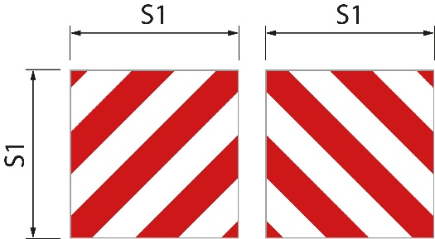18 The signs have the following sizes.

|  |  |  |
| --- | --- | --- |
| Square signs | Figure 1 | S1 is at least 0.42 metres. The ratio between width and height is 1:1 |
| Rectangular signs | Figure 2 | S1 is at least 0.28 metres and S2 is at least 0.56 metres. The ratio between width and height is 1:2. |
| Rectangular signs | Figure 3 | S1 is 0.14 meters and S2 is 0.8 meters |

Figure 1

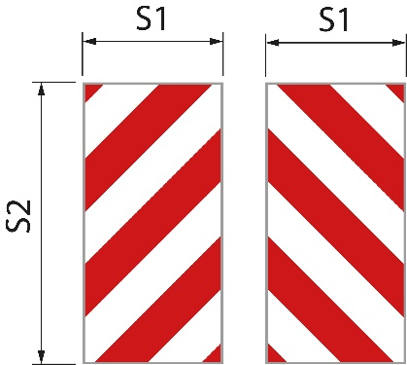Figure 2

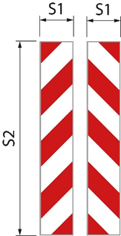

Figure 3

The width marking signs on an EC mobile crane and motorised equipment may have different sizes than specified above and may be made as stickers.

#### Marking of thin load units

19 Plates, boards, building slabs and other similar thin load units, in addition to width marking signs at the front and rear, are provided with a sign or equivalent on those parts of the load that result in excess width. It has alternately reflective red and white colours and a visible surface of at least 250 centimetres²;

The first paragraph shall not apply if the width marking signs are placed next to the protruding load. The meaning of ‘next to the protruding load’ is illustrated in Figure 2 of the Annex.

#### Lamps and reflectors

20 When travelling at night, at dusk or at dawn and otherwise when required by the weather or other circumstances, the outermost edge of the vehicle or load is marked with lamps and reflectors. The marking is both front and rear with two lamps on each side. At the front, the lamps show white light forwards and with white reflectors. At the rear, the lamps show red light backwards and with red reflectors.

The lamps are located above and below the width marker signs and as close as possible to the outer edge. They have a luminous intensity such that they can be seen clearly at a distance of 300 meters.

EC mobile cranes and the motorised equipment are not equipped with lamps and reflectors as referred to in the first paragraph.

#### Warning signs

21 The vehicle or the vehicle combination is equipped with warning signs at the front and rear.

The forward-facing sign is located below the lower edge of the windscreen or with the lower edge of the sign no more than 2.0 metres above the carriageway.

22 The signs have:

1. yellow base colour that is retro-reflecting;

2. fluorescent red border with a width of 5.5 centimetres; and

3. text in the TratexSvart font with a text size of 0.17 metres.

23 The signs have the following sizes.

|  |  |  |
| --- | --- | --- |
| Signs with one row | Figure 1 | S1 is at least 1.2 metres and S2 is at least 0.4 metres. The ratio between width and height is 3:1 |
| Signs with two rows | Figure 2 | S1 is at least 0.6 metres and S2 is at least 0.5 metres. |

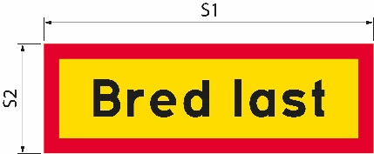If the size of the sign is increased, the text size and border width also increase accordingly.

Figure 1

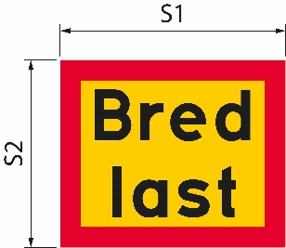Figure 2

|  |  |
| --- | --- |
| Bred last | Wide load |

### Warning lamps

24 The vehicle or vehicle combination is equipped with at least one warning lamp.

25 The warning lamps are switched on only when the vehicle or vehicle combination is using more than one traffic lane at a time.

Additional conditions for journeys with vehicles or vehicle combinations wider than 310 centimetres

Warning lamps

26 When travelling at night, at dusk or at dawn and otherwise when required by weather or other circumstances, the warning lamps, in addition to 25, are switched on.

### Hazard warning vehicle

27 A hazard warning vehicle warns other road users of the wide vehicle or vehicle combination.

The hazard warning vehicle drives behind the vehicle or vehicle combination when on roads with lanes separated by separator, median barrier or equivalent. If there is no physical separation of the lanes, it drives in front of the vehicle or vehicle combination instead.

Except for in built-up areas, the distance between the hazard warning vehicle and the transport is approximately 200 meters. In built-up areas, the distance is shorter.

28 A hazard warning vehicle warns for a maximum of three vehicles or vehicle combinations.

29 The hazard warning vehicle is a passenger car or a lorry with a total weight not exceeding 4.5 tonnes. The vehicle does not have a connected vehicle.

#### Driving licence

30 The driver of the warning vehicle holds a C1 or C driving licence.

#### Warning signs

31 The hazard warning vehicle is marked with warning signs. The signs are located higher than the upper edge of the windscreen and are clearly visible from the front and rear. The signs are in such a condition that they are noticeable and understandable for other road users. When travelling at night, at dusk or at dawn and otherwise when required by the weather or other circumstances, the warning signs are illuminated.

32 The signs have:

1. yellow base colour that is retro-reflecting;

2. fluorescent red border with a width of 5.5 centimetres; and

3. text in the TratexSvart font with a text size of 0.17 metres.

33 The signs have the following size.

S1 is at least 1.2 metres and S2 is at least 0.4 metres (Figure 1). The ratio between width and height is 3:1.

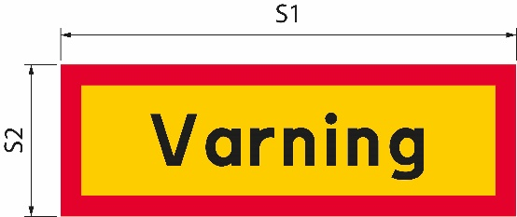If the size of the sign is increased, the text size and border width also increase accordingly.

Figure 1

|  |  |
| --- | --- |
| Varning | Warning |

#### Warning lamp

34 The hazard warning vehicle is equipped with at least one warning lamp.

35 When travelling in daylight, the warning lamp is only switched on when the wide vehicle or vehicle combination encroaches on a lane for oncoming traffic.

36 When traveling at night, at dusk or at dawn and otherwise when required by weather or other circumstances, the warning lamp is always switched on.

### Communication between the hazard warning vehicle and the wide vehicle or vehicle combination

37 Drivers in a hazard warning vehicle and in a wide vehicle or vehicle combination can communicate with each other via a radio or mobile phone connection. The drivers can communicate with each other in a language that both comprehend.

Additional conditions for journeys with vehicles wider than 450 centimetres

38 The transport is escorted by a road transport escort or police officer. If the transport is to be escorted by the police, the decision should include an instruction that the Swedish Police Authority shall be contacted at least one week before the planned transport.

39 The driver of the transport ensures that a radio or telephone connection is established with the driver of the hazard warning vehicle, the escorting road transport escort or the police. They communicate with each other in a language that all of them comprehend.

___________

This general advice replaces the Swedish Road Administration’s general advice (VVFS 2000:126) on exemptions from the provisions of the Road Traffic Ordinance (1998:1276) on the width of vehicles and the Swedish Transport Agency’s general advice (TSFS 2009:64) on exemptions for journeys with wide vehicles.

On behalf of the Swedish Transport Agency  
JONAS BJELFVENSTAM  
Pär Ekström  
(Road and rail)

Published by: Kristina Nilsson, Swedish Transport Agency, Norrköping ISSN 2000-1975

### Annex

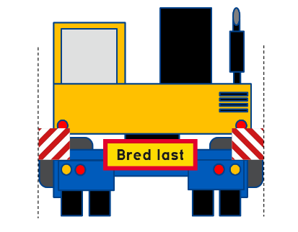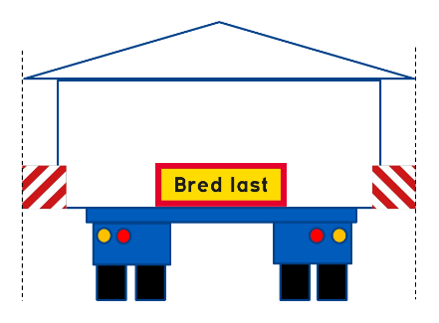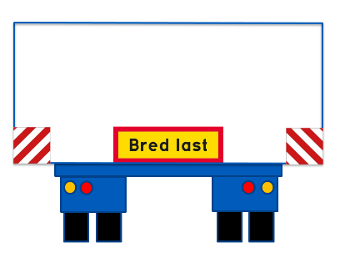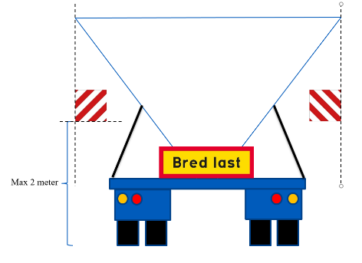Figure 1. The position of the width marking signs in the horizontal direction.

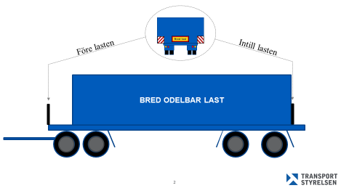Figure 2. The position of the width marking signs in the lengthwise direction on the load.

|  |  |
| --- | --- |
| Bred last | Wide load |
| Före lasten | Before the load |
| Intill lasten | Next to the load |
| BRED ODELBAR LAST | WIDE INDIVISIBLE LOAD |

1. See Directive (EU) 2015/1535 of the European Parliament and of the Council of 9 September 2015 laying down a procedure for the provision of information in the field of technical regulations and of rules on Information Society services.