Copenhagen, 22nd November 2017.

Comments to notification Number 2017/391/GR:

TRIS Notification – 2017/391/GR – (Greece) Production and sale of fermented beverages with Combined Nomenclature tariff heading 22.06 - Amendment of Ministry of Finance Decision No ΔΕΦΚΦ Β 5026381 ΕΞ 2015/16.12.2015 (Government Gazette 2785/B)

The Danish Brewers’ Association’s comments to the above notification can be summarized as follows:

The draft decision lays down very detailed regulation for the domestic production and import of other fermented beverages classified under the Combined Nomenclature heading (CN) 2206.

The heading CN 2206 “Other fermented beverages” include for example, cider, perry, mead and mixtures of fermented beverages and mixtures of fermented beverages with non-alcoholic beverages, not elsewhere specified in the Combined Nomenclature for example under CN 2203 (beer made of malt) or under CN 2204 wine of fresh grapes. To illustrate (CN 2206):

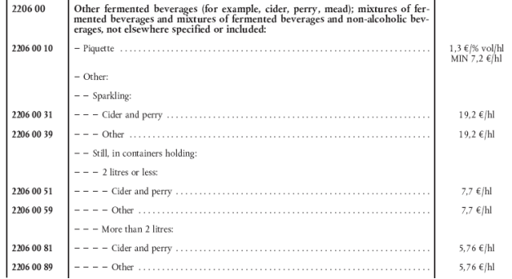

The EU Combined Nomenclature (CN) is a replicate of the World Customs Organisation’s (WCO) Harmonised System (HS). They both use the same headings and subheadings in order to ensure the same classification of a given product, either for statistical purposes, tariffs and custom duties or for excise duties. Both WCO and the EU provide explanatory notes to ensure a common classification.

An economic operator may request a ruling with regards to the correct tariff classification for Customs duty purposes of products that it imports or exports. The main benefit to the holder is legal certainty with regard to the classification. Also a Binding Tariff Information is issued on request to economic operators by the customs authorities of the Member States. It is valid throughout the Community, regardless of the Member State which issued it.

However, this common classification will be jeopardized if each Member State may put in place its own definitions or interpretation of the headings and subheadings of the Combined Nomenclature as is the case with the notified draft text, in particular its Annex B.

According to the explanatory notes to the Combined Nomenclature (CN) 2206 “… All these beverages … remain classified in the heading when fortified with added alcohol …, provided that they retain the character of products falling in the heading” (underscore added). This is furthermore confirmed by ECJ in its ruling of 16th December 2010 (Case C-339/09, Skoma-Lux). Thus, a cider that has been added small amounts of alcohol may continue to be produced and sold as a “cider” under the heading CN 2206. However, according to Annex B, point 1, e of the notified draft text a “…Cider is a fermented beverage produced through alcoholic fermentation of the must or juice of apples, which …has not had ethyl alcohol added to it”. A similar ban is introduced for perry.

A cider product that has been lawfully produced (and added alcohol) or imported as a “cider” may not be produced or imported for sale in Greece as a “cider”. Only products meeting the requirements (and bans) in Annex B may be sold as a “cider”. Furthermore, according to article 3.a, “ … the production of products of a category which is not listed in Annex B is not permitted”.

Article 4.5 of the notified draft text only ensure a conditional “equal recognition” of products that have been lawfully produced in other Member States, because the producer or the importer is requested to ensure that the product has “… been produced in accordance with the standards, specifications or production and testing/inspecting procedures which have been proven to guarantee a level of quality and safety equivalent to the one ensured by the requirements of this decision as regards the protection of human health, saftety and the environment”, ref. article 4.5.

In summary, we believe that the measures proposed discriminate amongst foreign and domestic products of the same category, and are not in conformity with product definitions as generally understood throughout the EU.

Other examples from the notified draft text:
- The Annex B of the draft text sets a very strict cider/perry definition which is not in line with the widely used industry Code of practice. The ratio between fresh and concentrated juice should not be defined, as cider/perry can be made from juice freshly prepared or reconstituted from

concentrate without prescribing the minimum amount of fresh juice. This is particularly important so that it is possible to take account of the fluctuation of the raw material availability during the season.
- According to the industry code of practice, juice, water and sugar may be added before and/or after fermentation, which is not reflected in the notified draft text.
- The amount of alcohol coming from fermentation of sugar should not be limited to 20%.
- A possibility to add a certain amount of pear juice to apple cider and a certain amount of apple juice to perry should be allowed.
- Article 9.5 b and c are respectively prohibiting the use of product denominations for flavoured product as e.g. x-fruit flavoured cider, and for fruit wine, both being well established product categories in the European market.
Finally, the notified draft text provide extremely detailed requirements for the production and/or imports of “other fermented beverages” with regard to production and administration (e.g. authorization, production facilities, distribution, sale, raw material control, import, bottling of imported products, sampling and chemical testing, inspections, sanctions) to such an extent that it will restrict the import and free circulation of the products lawfully produced in other Member States.

Yours sincerely,
DANISH BREWERS’ ASSOCIATION
Knud Loftlund

