# Reply from Nordic Nicotine Pouches Alliance (NNPA) Regarding TRIS Notification: 2024/0481/DK (Denmark) *Draft Order on nicotine content limits in tobacco substitutes.*

## Nordic Nicotine Pouches Alliance (NNPA)

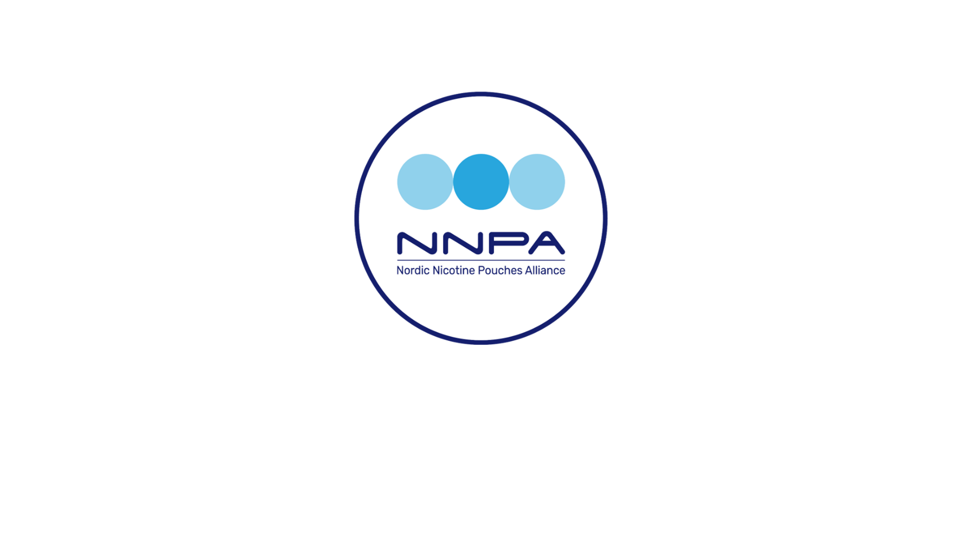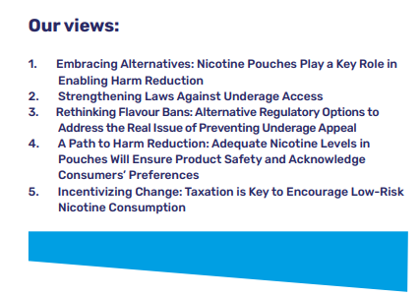

## The Nordic Nicotine Pouches Alliance (NNPA) is a Brussels-based platform for stakeholders advocating for nicotine pouches as an essential part of harm reduction among adult nicotine users within the EU. We promote responsible, effective, and harmonised European legislation that establishes clear guidelines for this product category to achieve specific goals, such as banning extreme nicotine levels or reducing usage among minors. Our main focus is information dissemination, but we continuously work to build support for our position from stakeholders who are representatives of a responsible value chain. NNPA is funded by European industry actors.

## Summary of our position:

NNPA strongly object to the proposed nicotine limit with the motivation that justification criteria cannot be met for the proposed restrictions. We also consider that the proposed restrictions preempt the revision of the Tobacco Products Directive, violate the principle of non-discrimination and the freedom of trade and industry (Article 36 TFEU) and that they without due justification contradict legislation recently introduced in other EU Member States.

# NNPA’s opinion on the proposed nicotine content limit

The government is updating Denmark’s laws on tobacco control and has notified the European Commission of the proposed changes. The bill proposes a nicotine content limit set at 9.0 mg per pouch with an expressed intent of protecting children and young people by addressing the present situation where there is no nicotine content limit set. While NNPA shares the concern for all nicotine use among all risk groups, we fail to see how the proposed nicotine content level for nicotine pouches will contribute to this end, and we are equally concerned how the same measure will limit accessibility for adult smokers looking for a reduced risk alternative to smoking.

Underage persons are, by default, a risk group and should not use any nicotine at all. There is no relevant level of nicotine content limit that is considered safe for underage use.

Underage use should therefore be addressed by other more purposeful means that can limit access to all tobacco/nicotine. The broader Danish prevention plan already includes increased penalties for those who provide nicotine to underage individuals, improved age verification, enforcement and supervision of retail schemes. Those measures are, as opposed to a 9mg/pouch limit, targeted at achieving the specific purpose while ensuring that the negative effects on the vast majority of users—who are not part of a risk group and could benefit significantly from a reduced-risk product—are balanced and proportional.

For the NNPA the most obvious objection to the notified restrictions is that **there is no public health benefit to be made from an unduly low nicotine cap and as such the 9mg /pouch limit cannot be justified**.

NNPA does advocate for a purposeful nicotine content cap to limit extreme products with potentially harmful levels of nicotine, but this level must be set in context with scientific evidence and without undue thresholds that could disincentivize smokers from switching to nicotine pouches. Setting a nicotine content limit as a means to protect individuals who should not be exposed to any nicotine at all is a poorly targeted approach that fails to address the underlying issue effectively.

## Further concerns and objections

We find the proposed restrictions to be unjustified and in violation of the principle of free movement of goods. Nicotine pouches are consumed daily by around 1.4 million citizens across 25 EU Member States. **The overwhelming majority of these consumers are adults that have switched away from smoking traditional tobacco cigarettes** as pouches offer an alternative and less risky way of consuming nicotine. It’s to be noted that Czech Republic, Slovakia, Hungary, Romania, and Sweden have introduced regulation for nicotine pouches, introducing a limit for nicotine content which is set at a higher level than proposed in Denmark. Finland, Italy, and Lithuania are in the process of doing so. The proposed nicotine content cap in Denmark is far more restrictive and discards the success of appropriate regulation in Sweden which has led to the lowest smoking rate in the EU (5.3% 2024) and the lowest levels of smoking-related disease and death[1], in large part due to availability of reduced-risk products such as the use of nicotine pouches.

The above statistics are calculated for the full population aged 16 and above, but to further highlight the relevance of the data to the Danish proposal: the Swedish Public Health Authority (Folkhälsomyndigheten) reports that daily smoking incidence among the 16–29-year-old bracket presently is 2.3%, representing a reduction of nearly 40% between 2022 and 2024.

Production is largely concentrated in Hungary, Sweden, Denmark, and Italy, but nicotine pouches are manufactured in several countries and widely exported across the EU and beyond. The industry contributed just over €1 billion to the EU economy in 2021, with an extensive network of around 76,000 retail stores, many of which are SMEs, alongside 137 websites offering these products across Europe. [2]Hungary, Czechia, Denmark, Slovakia, Sweden, Estonia and Italy have introduced category specific regulations and / or apply excise tax to the products. As such, and in view of the above, the proposed restrictions breach EU law on the free movement of goods, as they will restrict the sale and use of nicotine pouches that can be lawfully sold in other Member States. It should also be noted that the market for nicotine pouches is highly dynamic and holds considerable growth potential, **largely driven by increasing consumer demand for reduced-risk products**. The proposed restrictions would not only dampen investments and limit the free movement of goods within the Single Market, but could also close off significant export markets, stifling a sector with undeniable economic and public health potential.

We consider the legislative approaches taken in Belgium and the Netherlands to be similarly misguided. As such, the bans in Belgium and the Netherlands do not serve as sound precedents but rather highlight the risks of adopting overly restrictive measures without a comprehensive assessment. By relying on an interpretation that contradicts both the broader body of scientific evidence and the more balanced approaches taken by other EU Member States, these laws fail to align with the EU’s objectives of proportional, evidence-based policy, internal market rules as well as EU targets for a smoke free Europe

Considering the expressed purpose, it seems irrational to impose a maximum nicotine content limit that differs significantly from neighbouring countries, especially when the Commission has expressed its intention to include nicotine pouches and other novel products in the imminent revision of the Tobacco Products Directive. By restricting supply to approximately half[3] of adult users' preferences for nicotine content, there will inevitably be sufficient demand to sustain extensive illicit trade, which could further facilitate access for underage individuals as opposed to the intended limitation. This effect could be avoided, and the purpose further strengthened, if the legislation is specifically focused on the intended, smaller target group that, in this case, generally exhibits very low purchasing power.

## Relative risk

While no nicotine product can be considered completely risk-free, the NNPA regards relative risk as a highly relevant factor when assessing the proportionality of legislation on nicotine pouches. In the context of the Danish proposal, it should be made clear that the primary determinant of the risk associated with nicotine consumption is by what means it is consumed, as opposed to other publicly available products considered societal risk factors, such as alcohol, where the determining factor for risk is the amount consumed, both for short- and long-term risk. Given this distinction, it becomes evident that assessing the risks associated with nicotine pouches requires a fundamentally different framework than that used for products like alcohol.

It is also imperative to account for the fact that the majority of nicotine pouch users are former smokers. Ignoring this context would overlook a critical factor in evaluating the net public health impact of nicotine pouches. Furthermore, while some level of new recruitment into nicotine pouch use may occur, it is reasonable—and indeed necessary—to consider that these individuals might otherwise have started smoking. This assumption is supported by the historical patterns of nicotine consumption and the documented appeal of combustible tobacco products in the absence of reduced-risk alternatives. Thus, any policy or regulatory framework should reflect the nuanced dynamics of nicotine use and acknowledge the harm reduction potential of preserving access to less harmful products for individuals that are currently smoking.

The relative risk of nicotine pouches compared to cigarettes is unanimously recognized as significantly lower. **Nicotine pouches do not contain tobacco, they are not burned, heated or in any other way chemically altered when used**. The nicotine is absorbed by exposing a few square centimeters of the oral mucosa to nicotine. Absorption through the oral mucosa bypasses the lungs and directly enters the bloodstream, but it takes longer to reach peak levels due to the slower release as opposed to cigarettes that expose the alveoli that are directly connected to the capillaries and normally have an area of 70 to 100 square meters. The effective exposure of the lungs varies but the exposed area would be between 100 000 and 300 000 times larger. **This difference in exposed area is critical not only for understanding the relative safety of nicotine pouches but also for determining a reasonable nicotine cap, as the slower, limited absorption through the oral mucosa requires different standards than those set for inhaled products**

The main three risks connected to smoking cigarettes are **cancer, pulmonary disease and cardiovascular risk**. These are well-established facts within the scientific and medical communities including the European Commission’s Knowledge for Policy resource and the World Health Organization (WHO) who both identify these as the primary consequences of smoking cigarettes.

Since nicotine pouches do not **contain carcinogenic substances** and are not chemically altered when used, the risk in the context of cancer would be **negligible**.

Since nicotine pouches do not emit any byproducts of combustion and the **lungs are not exposed** the risk for pulmonary disease would also be **negligible.**

While both products contain nicotine that can contribute to elevated blood pressure, increased heart rate and vascular constriction, **the main risk of cardiovascular disease of smoking cigarettes does not derive from the nicotine content** but rather from byproducts of combustion i.e. carbon monoxide and oxidizing chemicals that significantly increases the risk of atherosclerosis, blood clot formation and chronic inflammation. **While nicotine pouches may carry a minimal cardiovascular risk relative to non-use, they are far safer for the cardiovascular system than smoking.**

While not risk free, **the placing of nicotine pouches on the internal market does not contribute to any significant risk to public health[4]**[5][6] On the contrary, statistics from countries that have available and affordable nicotine pouches indicate that their presence on the market provides a viable and attractive alternative for adult smokers and that the benefits on a societal level are massive. According to EU statistics, Sweden has around the same percentage of nicotine users as the average in the union, but all indicators of tobacco-related harm including lung cancer, Chronic Obstructive Pulmonary Disease (COPD and general mortality rates related to tobacco use are significantly lower than in all other Member States (typically 40-50 percent lower).

Conclusions

With the above in mind as basis for our motivation, we conclude that the justification criteria cannot be met for the proposed restrictions and that the draft Law will restrict the free movement of goods (Article 34 TFEU)

* *There are no public health risks that could justify restrictions on the free movement of nicotine pouches. On the contrary, such restrictions are likely to have the opposite effect by reducing access to reduced risk alternatives that are beneficial to smokers, as recognized by Bfr, COT and RIVM (footnote 4,5 and 6)*
* *The ban is not proportionate since there is no scientific evidence or even statistical indications that suggests that nicotine users would be exposed to higher risk by placing nicotine pouches on the market. The Member States that clearly excel at reducing tobacco harm have nicotine pouches with higher nicotine concentration available on the market showing that Denmark could achieve even more ambitious health objectives without this unwarranted, arbitrary and disproportionate nicotine content limit*
* *It is obvious to us that there are more purposeful measures that can be used to tackle real and present issues related to the underage consumption of tobacco and/or nicotine, instead of an unduly low nicotine content limit, that by any definition will miss the target of no nicotine to underage persons.* *The broader Danish prevention package already contain a number of far more effective and targeted measures, such as improved age verification and supervision, that does not have an undue effect outside the intended target group (i.e. underage persons) and whose enforcement should be further enhanced.*

We consider that the proposed restrictions preempt the revision of the Tobacco Products Directive, violate the principle of non-discrimination and the freedom of trade and industry (Article 36 TFEU), and that they without due justification contradict legislation recently introduced in other EU Member States.

In conclusion, we strongly oppose the proposed restrictions.

För NNPA, Robert Casinge

Senior partner, regulatory affairs

**Brussels 2024-12-02**

1. Global Burden of Disease, survey: [VizHub - GBD Compare](https://vizhub.healthdata.org/gbd-compare/)
2. TobaccoIntelligence.com
3. According to 2023 EU market sales data from leading 15 nicotine pouch online retailers, Tobacco Intelligence
4. <https://www.bfr.bund.de/cm/349/health-risk-assessment-of-nicotine-pouches.pdf>
5. <https://cot.food.gov.uk/sites/default/files/2023-04/Publishable%20%20COT%20Oral%20nicotine%20pouches%20-%20final%20v1-0%20Acc%20V.pdf>
6. <https://www.rivm.nl/publicaties/nicotineproducten-zonder-tabak-voor-recreatief-gebruik>